CHALLENGES OF MAPPING, MODELLING AND QUANTIFYING SEDIMENT CONNECTIVITY
Janet Hooke¹,
¹School of Environmental Sciences, University of Liverpool, Roxby Building, Liverpool, L69 7ZT, UK;
Corr. Author; email: janet.hooke@liverpool.ac.uk
Jonas Souza²,
²Geoscience Department, Center for Exact and Natural Sciences, Paraiba Federal University, João Pessoa, Brazil.

Abstract
Major advances continue to be made in development and application of the connectivity concept as a framework for analysis of runoff and sediment fluxes in catchments and landscapes and it is becoming a major paradigm in geomorphology and hydrology. It involves the identification of the locations and patterns of pathways of water and sediment movement and extent of their linkage. However, significant issues and challenges remain. Various approaches to identification and quantification of connectivity in a landscape are taken, involving mapping and modelling of various types. It is important in applying techniques that the purpose and basis is clear. A differentiation is made here between direct mapping of known situations, which elucidates patterns and can then be the basis for quantification, and that of modelling, which is predictive and often explanatory but requires validation. Thus, there is a synergy between the two. Various aspects of the spatial arrangements may be of interest, such as sources of sediment to a point in a catchment, pathway position, hotspots of erosion and deposition, controls on the connectivity, positions of disconnectors, influence of human activities, and natural variability with rainfall, seasons and other factors. The approach and styles of mapping usually entail recording all links at a particular time, possibly with differentiation of type of link, and commonly based on field surveys, but developments are taking place to test the effectiveness of drones for this purpose. Much modelling has used Connectivity Indices to generate patterns, with varying weighting of factors, and additional factors are now being introduced to indices to add functionality to the modelling. The other major approach to modelling is that of graph theory, based on network analysis, which is particularly applied to larger river systems. Both types of modelling have benefitted from availability of open-access software. Deficiencies and problems in use of modelling and indices persist, including: need for validation; ability to recognise disconnections; variability of connectivity over time; distinguishing sediment from flow connectivity; and clarity of representation. Challenges remain of spatial scale, particularly in validation/ field surveys but also base data for modelling; in identifying link status and functioning or dynamics at various timescales, and incorporation of feedback arising from those dynamics; in incorporating processes as a step to this functionality, and in testing indices. Methods and approaches to addressing these challenges are discussed and evaluated here.

Keywords: Connectivity Index; sediment; runoff; disconnectivity; catchment; landscape dynamics

- INTRODUCTION
Connectivity has become a major paradigm for analysis of aspects of hydrological and sediment flux in catchments in recent years (Wohl, 2017). Some confusion still surrounds the concept and various definitions are available. Much development of techniques for identifying, analysing and quantifying connectivity has taken place but challenges, particularly in implementation and in assessing modes of application to particular environments or research and management problems, remain. This paper seeks to examine how these challenges are and can be addressed. In particular, it discusses issues associated with validation, identification of disconnectivity, and approaches to analysing dynamic/functional connectivity and the actual functioning. In application of the concept, it is very important that differences from, and advantages over preceding approaches are recognised, otherwise it becomes simply another term applied to long-standing types of analyses. It is also important to recognise the purposes and stages of analysis to which the techniques are applied; this paper seeks to clarify these distinctions.

Connectivity analysis emphasises the extent to which parts of a system are linked together. It entails identifying pathways or routes and whether material can move through all these, ie are they spatially continuous and potentially functionally continuous. Connectivity, a long-existing concept in ecology, has been applied in geomorphology explicitly over the past 20 years and to fluxes of both water and sediments. This paper focuses on sediment connectivity in catchments. Hooke (2003, p79) defined this as ‘the physical linkage of sediment through the channel system, which is the transfer of sediment from one zone or location to another and the potential for a specific particle to move through the system’. Connectivity thus differs from prior approaches to understanding, quantifying and modelling sediment fluxes in that it does not assume that all parts of the catchment are supplying sediment and lump characteristics of the areas together, rather it highlights the sources and the pathways of transfer, the sinks or stores of water and /or sediment, and the presence of distinct barriers or discontinuities. The Sediment Delivery Ratio (SDR) (Roehl, 1962) has long recognised that not all eroded sediment is delivered to any specific point downstream but connectivity focuses on the spatial patterns and the links between each part of the pathways, and whether sediment can or is getting through each part. Connectivity can simply involve mapping or assessing whether a pathway exists and has the potential, or appears, to function to transmit the sediment from the link above. If it supplies water or sediment to the next part of the pathway downstream/downslope then it is connected. Connectivity indices (IC) of various types have been developed to quantify the degree of connection and modelling, using various indices is the focus of much of the current research.

The difference that application of the connectivity concept and framework can make to analysis is demonstrated by the following example. If research is aiming to assess sediment flux to a lake, then conventional or standard hydrological and geomorphological analysis would tend to examine the catchment characteristics and relate flux to these, notably area, slope, cover and land use. In connectivity analysis, the pathways of supply and conveyance of water and sediment are examined and the sequential processes downstream calculated or documented. Such an analysis might, for example, show that much of the sediment being delivered to a lake is from the reach of channel just upstream rather than being from catchment sources.

A primary distinction is between structural and functional connectivity (Turnbull et al., 2008), which was inherited from landscape ecology. Structural connectivity was understood as the physical link between habitat patches and the functional connectivity as the flow of organisms. Nowadays, these are termed structural/static/potential connectivity and functional/dynamic/actual connectivity (Hooke 2003; Antoine et al., 2009; Lexartza-Artza and Wainwright, 2009; Sandercock and Hooke, 2011; Bracken et al., 2013) in geomorphology. The structural/static/potential connectivity is an assessment of the features and structures present likely to affect connectivity, which can be done at any time (Sandercock and Hooke, 2006, 2011). It is essentially a mapping and documentation of the state at a particular time but not in relation to temporary flow features; it emphasises the structural components and features present in the system. The functional/dynamic/actual connectivity is the connectivity's operation, usually, after a specific event, or a summary of activity over time. It can be identified by the signs of flow paths recorded after an event (Sandercock and Hooke, 2006, 2011). However, Bracken et al. (2013) later advocate use of the term 'process-based' instead of functional connectivity and distinguish functional as being the processes involved whereas the actual operation of the system is the functioning. Najafi et al. (2021) have discussed the use of this term more fully. Turnbull et al. (2008) consider that structural and functional are not synonymous with static and dynamic and that dynamic connectivity is produced by the interaction. Wainwright et al. (2011) emphasise the feedback effects between functional and structural connectivity but arguably feedback is still not well incorporated in models or approaches. Most of the published maps combine structural and functional elements, though Turnbull et al. (2008) pointed out that structural elements are much better identified than functional and Najafi et al. (2021) have found that most modelling and indices involve structural elements rather than functional.

Various approaches to the quantification of connectivity have been taken. Heckmann et al. (2018) produced a comprehensive review of available indices and some of their characteristics and limitations. More recently, Najafi et al. (2021) have undertaken a comprehensive analysis of the literature on sediment connectivity. Indices for runoff connectivity were developed relatively early (e.g. Western et al., 2001). The first IC for sediment was developed by Borselli et al. (2008). Cavalli et al. (2013) then modified this and their index has been widely applied, especially since the development of free software for calculation (Crema & Cavalli, 2018). Pathways can also be analysed as networks with use of network parameters such as length, e.g. Mayor (2008), Puttock et al. (2013) and Marchamalo et al. (2016). A network-scale model developed by Schmitt et al. (2016) is the basis for an online tool, the CASCADE model, produced by Tangi et al. (2019). Graph theory has been applied, notably by Heckmann and Schwanghart (2013), and further developed and applied by Cossart and Fressard (2017) and Fressard and Cossart (2019). Several indices have been related to stream power (e.g., D'Haen et al., 2013: Kuo and Brierley, 2014). It is now apparent that different indices and various applications are serving different purposes, with different interpretations, and the index number produced may not be quantifying connectivity as intended. Various challenges in quantification of connectivity have become apparent and these are reviewed here, together with some of the rapid advances being made to overcome the challenges. However, in terms of identifying connectivity and patterns, and for some management applications, then the use of classification and qualitative analysis of sequences may be what is required, or is an important first step, and such approaches are also illustrated and evaluated here.

The purpose of this paper is to reflect on the various approaches to description, modelling, quantification, and analysis of connectivity within fluvial systems evident in published research, and to seek to clarify and differentiate the purposes and types of methodological application. It evaluates the outcome of applications of various methods and brings together deficiencies identified. It reviews the challenges in developing and applying meaningful indices and how these are being and may be met. It focuses on the implementation of techniques and making the use of connectivity approaches operational, and discusses how some of the deficiencies of present methods identified in published research and in the experience of using techniques may be overcome, with recommendations on methodological strategies. The major challenges surround the issues of validation, identification of disconnectivity, and approaches to analysing dynamic/functional connectivity and the actual functioning. These issues of approaches to directly addressing these challenges and operationalising methods have not been the focus and are somewhat neglected in previous reviews of connectivity.

- PURPOSE OF CONNECTIVITY INDICES

2.1 Connectivity characteristics
Connectivity is essentially a spatial concept and analysis framework. Various characteristics of connectivity in a system can be identified and it will depend much on the aim and purpose of the study as to which are described and quantified. These include:
- Pattern, distribution and locations - mapping
  - position of pathways;
  - areas contributing to a certain point
  - hotspots, sources and sinks;
  - sequences of types of link
- Degree and length of connectivity – quantification and indices
  - degree of connectivity to any point;
  - changes in degree over time;
- Factors influencing
  - types of factors
  - controls and locations
  - disconnectors
- Functioning
  - functioning in different events, dynamics
  - connectivity thresholds, prediction

For example, if the purpose is to calculate sediment flux and sediment yield from a catchment and identify parts of the catchment likely to be producing more sediment then the development of the indices for the whole catchment is suitable. If the purpose is to identify specific sources, position of eroding pathways, zones of sedimentation or effects of structures then the mapping at particular locations is the main focus. Of course, to assess connectivity, then the whole area upstream/ upslope of the point of interest has to be assessed. In the case of sediment connectivity then whether sediment is being transmitted from one link / pathway section/ reach to another may be the critical issue. In some cases, simply a qualitative identification of where pathways exist and whether they are connected is appropriate, but in many cases, quantification is needed to understand the whole pattern. Therefore, much of the focus here is on this quantification and the use of indices.

2.2 Types of approach
The connectivity quantification applications diverge in focus depending on whether they generate descriptive or predictive results and analyse structural or functioning connectivity. These foci are not exclusive so that the same analysis can show structural and functional information and results, or descriptive and predictive results. Initially, there is a difference between descriptive spatial indices, that unify what is observed, and the modelled indices that predict the pathway or different scenarios, though, both lines converge to produce the pattern of connectivity and provide the basis to quantify the degree of connectedness.

It is suggested here that two distinctive types of application of connectivity quantification are apparent in the research and applications of indices: 1. As quantitative descriptors of connectivity from acquired evidence; 2. As models and predictors of connectivity. These two types of application serve different purposes and are used at different stages and with different bases in analyses. The first essentially takes evidence of a pathway, derived either from direct mapping or from the modelled patterns, and quantifies this. An initial main step is to identify a pathway and if it is connected. Direct mapping may be of the potential for connectivity, ie using the characteristics and structures present and signs of pathways, or may be functional, ie made after a hydrological event and using evidence of actual processes that have taken place. The direct mapping provides the spatial pattern information as above but requires some quantification to accumulate or symbolise as fluxes move downstream and to show the relative fluxes. The second type takes some key factors that influence transfer of sediment and calculates the ability of the cell or pixel or link to transfer the material and cumulates that. To a large extent it predicts the pathways, though it will be influenced by the pre-existing topography and channels input to the model. IC models use factors or conditions for calculation, and these can be changed in any particular area to test scenarios. The types and scales of factors have been shown to make a significant difference and are the focus of much research (see Modelling below). Fig. 1 shows how these two types of index differ in their stage of use and basis for quantification. These two approaches can be combined since the direct mapping is necessary for validation of any modelling.
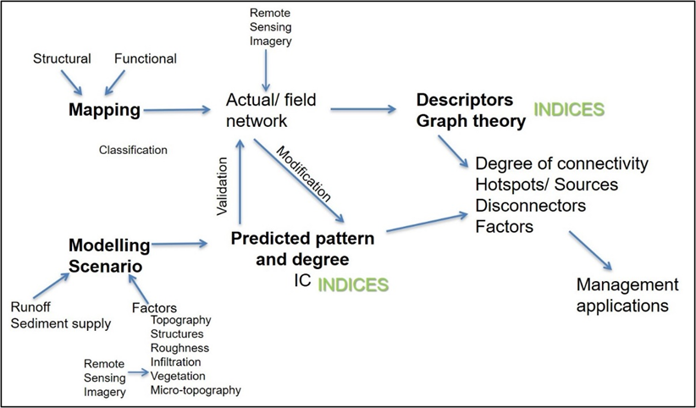
Fig. 1: Types of approaches and their interrelations in use of connectivity analyses and quantification

These two types or stages of quantification vary in how they are applied and in what they tend to produce; dichotomies in approaches are apparent. The mapping and descriptors tend not to provide explanation, they use known or modelled or assumed pathways whereas the models generate the pathways (though conditioned by the DEM and existing channels) and thus can be predictive. They can provide an explanation in that factors can be tested. The mapping can be dynamic and can incorporate the effects of structures present. Some descriptors tend simply to indicate the existence of a connected link, not necessarily quantify the pathway itself and may focus on the location of pathways and pattern of connectivity rather than the degree of connectivity (Fig. 2), though these may be very important in management and identifying hotspots of erosion or sedimentation. The patterns and extent of connectivity can be quantified by various indices and methods. In contrast, the modelling tends to produce a quantified pattern. Both types of approach vary in the extent of areas to which they are applied, though both types are more often applied to hillslopes and very small catchments than larger channel systems, except for the network approaches which are often applied to large systems. However, the application and testing of connectivity analyses and indices is expanding, for example, to large channel systems (e.g. Schmitt et al., 2018a), large lowland flood-prone watersheds (Gay et al., 2016), large wetlands (Singh & Sinha, 2019), mega fans (Kumar et al., 2014) and volcanic landscapes (Ortiz-Rodriguez et al., 2017).).

2.3 Mapping approaches
Most mapping shows the relation of pathways to structural features (Fig. 2). Repeated mapping can show changes and varying dynamics associated with conditions and events, including rainstorms (e.g. Meerkerk et al., 2009, Fig. 2a; Wainwright et al., 2011, Fig. 2d) land use changes, channel changes, and structural changes to terraces, check dams and roads (e.g., Foerster et al., 2014; Marchamalo et al., 2016; Lopez-Vicente et al., 2017a; Lizaga et al., 2018; Llena et al., 2019; Marchi, et al. 2019).
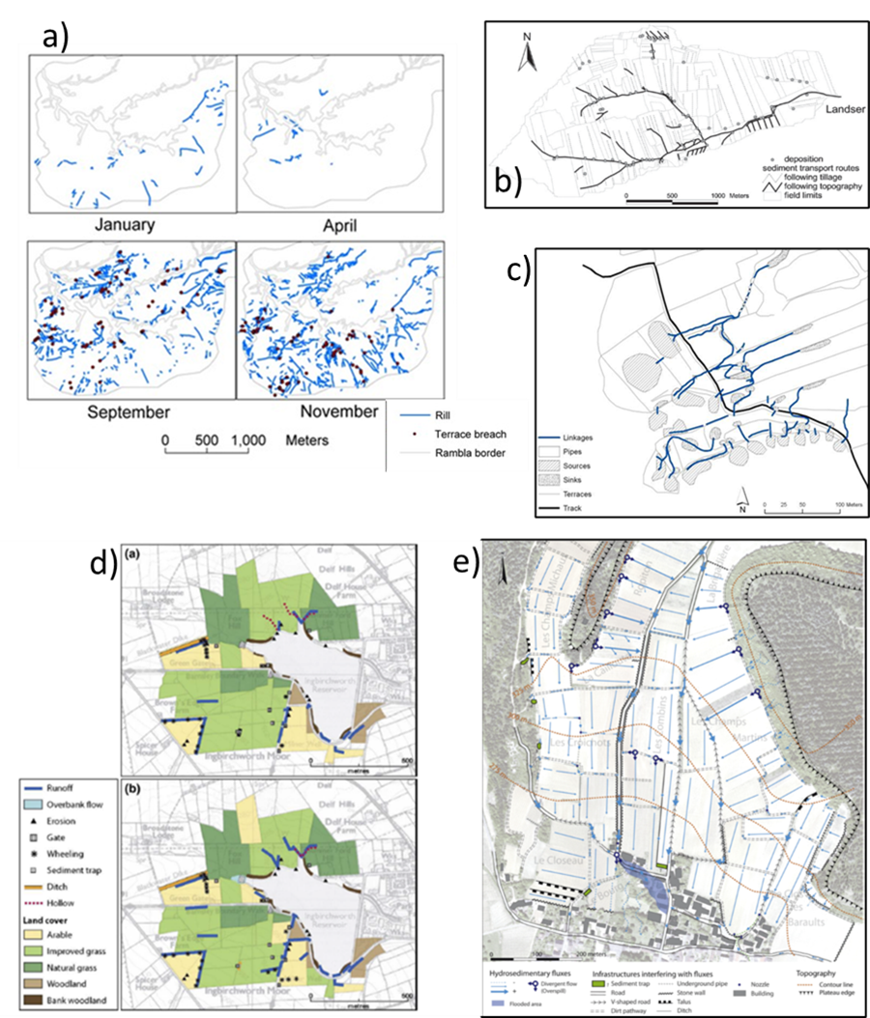
Fig. 2 Examples of direct field mapping and various styles of depiction, without quantification, that indicate position of pathways and patterns of connections and their relations to structure: a) Meerkerk et al. (2009); b) van Dijk et al. (2005); c) Marchamalo et al. (2016); d) Wainwright et al., 2011 (a) extreme storm rainfall, (b) prolonged rainfall; e) Fressard and Cossart (2019).

In terms of direct mapping of evidence, two major approaches to how connectivity is recognised, classified and then quantified are apparent: 1. Involves making a prior classification of connectivity with guidelines to identify categories that are then applied to field mapping; this entails categorising the connectivity in the field; 2. Entails mapping signs of features and processes and then applying analysis and classification of the connectivity after completion of the mapping; this involves creation of some kind of mapping system and legend to map the features.

An example of the first type which produced guidelines on a rapid field method was that of van Dijk et al. (2005) (Fig. 2b) (Table 1) who identified four steps: 1. Definition of and identification of four erosion intensity classes; 2. Measurement of incision on sample fields; 3. Erosion mapping – against criteria – field layout, soil surface conditions, erosion and deposition in field, field limits and headlands; 4. Entry of data related to field polygons in GIS. Sediment deposition is classified on the basis of quantity indicators and abundance. For all fields in the catchment, a form has to be filled in which classifies topographic factors, soil surface conditions and erosion and deposition features. Moreover, the form allows for a simplified sketch of the observed incisions and runoff pathways and the location of eventual deposits.

Table 1 Simplified classification scheme as applied to each arable field in the catchment (after van Dijk et al., 2005)
Classification
Theme | Feature | 1 | 2 | 3 | 4
Field layout | slope (%)  slope shape  tillage direction relative to slope | <2  rectilinear  parallel | 2-5  convex  perpendicular | 5-10  concave  oblique | >10  convex-concave
Soil surface conditions | crop cover (%)  crop residue cover (%)  surface roughness (cm)  structural crusts (%)  sedimentary crusts (%) | 0-1  0-1  R0 (0-1)  0  0 | 1-5  1-5  R1 (1-2)  100  0 | 5-20  5-20  R2 (2-5)  >50  <50 | >20  >20  R3 (5-10)  <50  >50
Erosion and deposition in the field | incision abundance  incision dimensions (cm)  erosion intensity class  deposition abundance  deposition dimensions (m) | low  <5  zero  wheel tracks  <1 (small) | moderate  5-15  weak (2)  seedbed  1-5 (average) | high  >15  moderate (3,4)  tracks & seedbed  >5 (big) | strong (5,6)
Field limits and headlands | incision dimensions (cm)  deposition dimensions (m)  deposition at field border | <5  <1 (small)  no | 5-15  1-5 (average)  yes | >15  >5 (big)
*Erosion intensity class is determined from the sum of the rank numbers of the incision abundance and dimensions.

Other classifications are based on the signs of flow and the physical features created, which produce a categorisation or scoring. For example, Croke et al (2005) consider that a range of types of connectivity exists and determine whether a pathway is fully or partially linked to the stream. Linkage pathways are broadly classified as (a) gully or channelised and (b) dispersive. Several authors have combined observations into grades or categories of erosion or effects; for example, Bracken and Kirkby (2005) suggested categories of morphological runoff zones, also used by Smith et al. (2010)). Some guidance on methods, or at least checklists of features to be recorded, are provided by Lexartza-Artza and Wainwright (2009) who list all the factors to be noted but the details of how the characteristics or process signs are to be recognised are largely taken for granted. In other cases, the mapping entails following each pathway and compiling the pattern of connectivity, with, in some cases some differentiation of pathways or features, e.g., Marchamalo et al. (2016) (Fig. 2c), or indication of intensity, e.g., Fressard and Cossart (2019) (Fig. 2e).

Few specific guidelines of how to carry out observation-based connectivity assessments to map or verify modelled maps have been produced but exceptions include van Dijk et al. (2005) and Cammeraat et al. (2005) on hillslopes, and Hooke (2003) for channels. Whether the approach involves a pre- or post-mapping connectivity classification, features and signs of activity have to be identified in the field (or from photographs/imagery showing features). Almost all the approaches to connectivity mapping entail some identification and interpretation of signs of water flow, erosion and deposition in the field to classify the features and pathways and thus allow interpretation of the connectivity status. Geomorphologists learn this through field training, but explicit guidelines are rare. Cammeraat’s protocol was developed for the EU RECONDES project (http://www.port.ac.uk/research/recondes ) and used also by Borselli et al. (2008), Lesschen et al. (2009), Meerkerk et al 2009 (Fig. 2a), Sandercock and Hooke (2011), Hooke and Sandercock (2012) and Marchamalo et al. (2016) (Fig. 2c). Observed traces include splash pedestals, flow lines delineated by alignment of dead leaves, bent grass, rills and sediment deposits on fields and dirt roads, erosion and sedimentation in existing gullies, new gullies, pipes, mud drapes after ponding of water on terraces and in depressions. These erosion signs are the basis for a scoring method applied to the upslope and downslope components in Borselli et al.'s (2008) method of connectivity assessment. Sandercock and Hooke (2011), and Marchamalo et al. (2016) in hillslope mapping have distinguished between flow-only pathways where signs of water flow are visible and sediment pathways where signs of erosion and deposition are visible.

Some approaches involve simply mapping the presence of a pathway or its characteristics then working out connectivity afterwards when the whole network and area has been surveyed, including application of techniques of classification. The mapping need not necessarily be quantified at that stage (Fig. 2), especially if it is presence and position of pathways or existence of disconnectors or influence of structures that matter. Post-map classification of the connectivity includes that of Hooke (2003, 2004), and Sandercock and Hooke (2006), applied to channels, in which lateral sediment sources (tributaries, bank erosion) and state of channel bed are mapped, functioning in terms of erosional, stable or depositional are assessed, and then status in terms of sediment transfer is classified to produce a downstream sequence in which sources, transfer and storage zones and boundaries of reaches with different connectivity are identified (Fig. 3). Poeppl et al. (2012) ) also mapped valley floors, with particular attention to lateral transfers and the influence of riparian vegetation. Sediment source areas were delineated by land use mapping from air photographs. Sediment transport pathways were modelled in GIS to produce detailed maps then validated by field ground truthing using a check list.
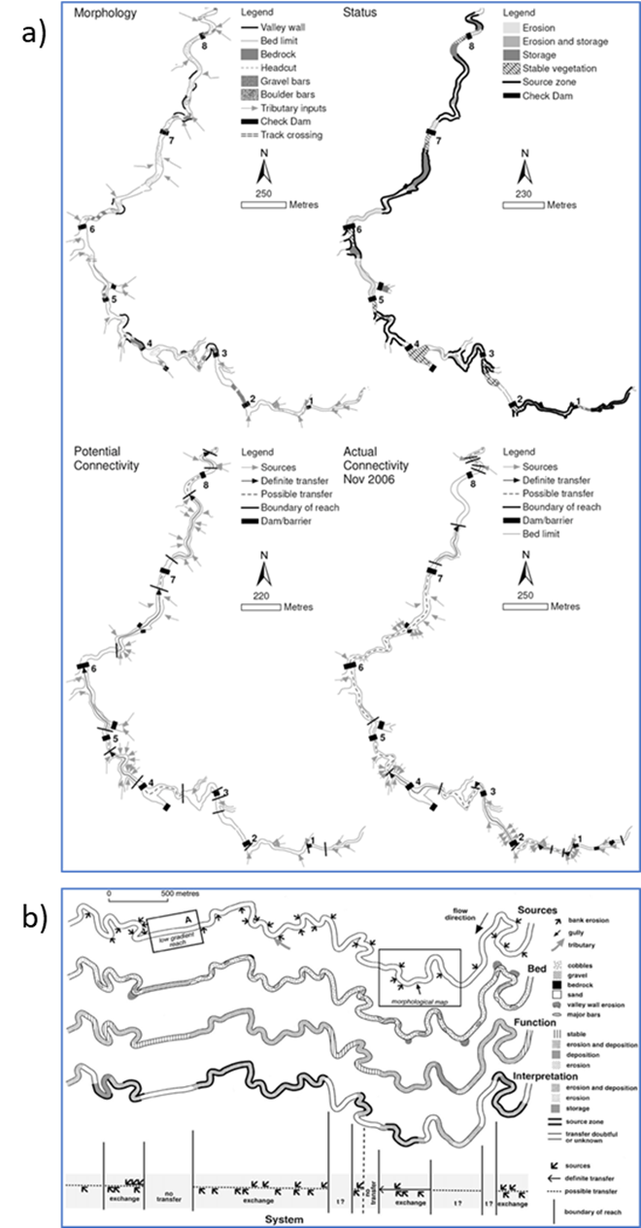
Fig. 3 Channel mapping of connectivity, a) ephemeral stream in SE Spain (Sandercock and Hooke, 2011), b) River Dane, UK (Hooke, 2003)

  - Modelling approaches
    - Connectivity indices

Obviously, runoff connectivity is the driver of sediment connectivity (SC) for most of the environments so far considered, and thus modelling of the hydrological component is an integral part of assessing sediment connectivity. Several researchers have produced algorithms for calculating likely pathways of flow from characteristics of pixels. Western et al. (2001) developed a connectivity index, which was used by Meerkerk et al. (2009), to overcome the problem that geostatistics describe patterns but do not distinguish connectivity. Lane et al. (2009) and Bracken et al. (2013) assessed the extent to which a topographically defined description of the spatial arrangement of catchment wetness can be used to represent the hydrological connectivity in temperate catchments. They found that a static descriptor based on topography can be successfully used to generalise spatial variability in hydrological connectivity.

Ludwig et al. (2006) developed a Leakiness index which was derived from analysis of pixels using remote sensing. This leakiness index is a monitoring tool, rather than modelling tool. Although leakiness indices relate in a general way to soil loss as a landscape process, they are not intended to mimic or model all the complex processes required to predict actual amounts of soil loss from a landscape; they are indicators. Modification of the directional leakiness index (DLI) of Ludwig et al. (2002) was used to produce the Landscape Function Analysis (Tongway and Hindley, 2004). Several of these approaches have in common the recognition that, at least in dryland environments, it is bare areas that generate the runoff, but the water may then infiltrate in vegetation patches. (e.g. Cammeraat and Imeson, 1999; Ludwig and Tongway, 1996; Puigdefabregas, 2005). At the plot and vegetation patchiness scale, Mayor et al. (2008) use flow length of pathways as measure of connectivity in runoff source areas.

A major step forward in terms of quantifying and predicting connectivity took place with the development of the Connectivity Index (IC) by Borselli et al. (2008) (Fig. 4a) (referred to from here on as the Borselli Index). This Index calculates the continuous potential connectivity between different points on the surface. It uses a GIS model approach to define the potential connectivity on a pixel/cell scale and combines downslope and upslope components. The downslope component is related to the distance and impediments between a point and the nearest sink. These downslope impediments are defined by the cell slope angle and the cell surface roughness, characterised by vegetation and land use properties, classified as the Weight factor (W). The upslope component is based on potential runoff/discharge, calculated by discharge area, and on sediment yield potential, controlled by upslope average slope angle and upslope average surface roughness (W). This index was then used as the basis for modifications and extension in a version of the Index by Cavalli et al. (2013) (Fig. 4b), (referred to from here on as the Cavalli Index), specifically to make it more suited to the mountain environment in which they were working. Cavalli et al. (2013), made changes to the flow direction, slope parameters and the weighting factors of roughness. The development of a free open-source tool – SedInConnect (Crema & Cavalli, 2018) allowed this index to become widely used (e.g., Messenzehl, et al., 2014; Nicoll & Brierley, 2017; Calsamiglia, et al., 2018; Marchi, et al., 2019; Schopper, et al., 2019). Other modifications have since been made, incorporating different weightings (e.g., Ortiz-Rodriguez et al. 2017) and a wider range of factors (e.g., Persichillo et al., 2018; Cislaghi and Bischetti, 2019; López-Vicente and Salem, 2019; Bombino et al., 2020).

Borselli et al. (2008) quantified the Weight factor (W) as vegetation and land use characteristics, related to the C-factor used in USLE/MUSLE models (Renard et al., 1997). The original Cavalli index (Cavalli et al., 2013) used roughness index and only topography data, not vegetation explicitly. Cavalli et al. (2013), made three relevant changes to Borselli et al.’s (2008) IC (CI-RI model): from a single direction to a D-infinity flow direction algorithm; created a slope angle limit; and changed the C-factor to a topographic roughness index (RI), derived from the HR-DTM, using a 2.5 m DTM. Subsequently, vegetation and land cover data were re-introduced as W, based on Manning’s n roughness coefficient, following the idea to use RI for unvegetated areas and Manning's n roughness coefficient for vegetated areas (Surian, et al., 2016; Persichillo, et al., 2018; Llena, et al., 2019; Zanandrea, et al., 2019). The effects of the different weightings used in the indices and their suitability for different environments began to emerge from subsequent assessments (e.g., López-Vicente, et al., 2017a; Ortiz-Rodriguez et al. 2017). Several variants or new indices have now been developed based on the original Borselli and Cavalli indices, many of them incorporating a wider range of factors (e.g., Persichillo et al., 2018; Cislaghi and Bischatti, 2019; López-Vicente and Ben-Salem, 2019; Zingaro et al., 2019; Bombino et al., 2020). The original indices and many of the applications were by structural assessment but recent developments are incorporating factors that allow some functionality, for example soil moisture, soil permeability and stability, and rainfall characteristics (Chartin et al., 2017 Kalantari et al., 2019; López-Vicente & Ben-Salem, 2019).

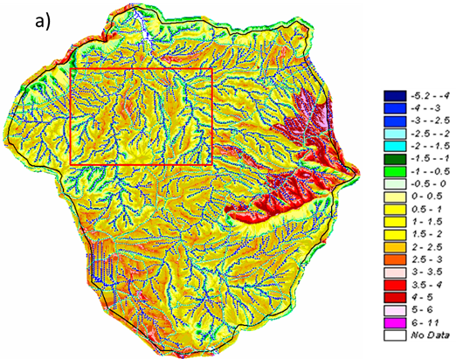
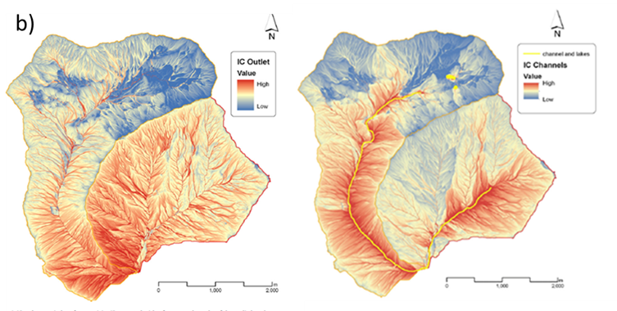
Fig. 4 a) Original modelling of preliminary connectivity index by Borselli in Recondes (2007b), reprinted in Hooke and Sandercock (2017); b) Modellling using a revised version of the Connecivity Index and two different target sinks, outlet and channels (Cavalli et al., 2013).

Running of models with different baselines of DEM, sink patterns, cover and topography can be used to test effects of conditions and sensitivity of models to factors; for example, Cantreul et al. (2018), Graf, et al. (2018), López-Vicente & Álvarez (2018), and Zanandrea et al., (2019) analyse the IC sensitivity to different DEM spatial resolution, trying to identify the optimal pixel size for each analysis. Much testing of the effects of vegetation has taken place in recent years; for example, Foerster et al. (2014) tested the effects of seasonal variations in vegetation cover by altering the weighting in the Borselli index. Also, the effectiveness of data sources for vegetation cover has been assessed, e.g., use of NDVI from remote sensing imagery (Foerster et al., 2014; Mishra et al., 2019). Asadi et al. (2019) found that use of NDVI and IC to model rainfall-runoff greatly improves performance. Lizaga et al. (2018) use a novel total aerial biomass equation. A few papers report comparison of Cavalli roughness IC and Borselli vegetation weighted IC, for example, Lizaga et al. (2018), Cislaghi & Bischetti (2019), Hooke et al. (submitted). Gay et al. (2016) applied sediment IC in a lowland area and added infiltration rate. They found that topography alone is not adequate in lowlands. Ortiz-Rodriguez et al. (2017) calculated connectivity in volcanic areas and used the Borselli index with C for vegetated areas, and Cavalli roughness for bare areas to produce a new joint index. Apart from the weighting factor and flow direction algorithm, the presence (Cavalli et al., 2013) or absence of slope limit (Borselli et al, 2008) is variable in the IC model applications. Hooke et al. (submitted) showed that slope limit (1 m/m - 45º degree) could conceal steep slope effects on connectivity and ignore erosion hotspots in non-alpine/mountainous environments.

Present commonly used methods for calculating IC Index are influenced by type of outlet/sink/target selected so it is important to be clear what is wanted in an application, whether it is simply a single quantification at on outlet, ie where sediment is coming from, or whether the user wishes to know what each part is doing and where it ends and what the resultant cumulative value is. The widely used Cavalli version of the IC has two types of outcome, IC Channel and IC outlet (Fig. 4b). Persichillo et al. (2018) have used different stream networks as sinks and different catchment area thresholds to start a channel, and Mishra et al. (2019) have shown in the Himalayas that choice of outlet can make a significant difference to the pattern generated. The Cavalli IC channel calculates the probability of sediment eroded from hillslopes reaching the nearest sediment sink (streams) and primarily reflects hillslope-channel connectivity. IC outlet calculates the optimal path - controlled by catchment shape, size and channel gradient and rainfall intensity. The downstream distance to the nearest outlet/sink/target affects the IC values inversely, the IC values are higher closer to the target. This effect, combined with the downstream accumulation area increase, generates a continuous rise in IC value on downstream paths, without representation of possible upstream impediments/sinks. We suggest that the modelling needs to decrease the influence of downstream element because it is whether the flux is able to exit the pixel that has control on the connectivity. Thus, arguably, the neighbouring pixel has an influence but not distant characteristics. Arguably, the present indices give undue influence to the downstream component and it is recommended that indices should simply cumulate to a point and not be influenced by downstream. If they are able to enter the next pixel/ zone/ reach then they go on cumulating. Ideally, this sequencing becomes combined with a crude budgeting of gains and losses through each link/reach since sections may not be completely connected or disconnected but partially (Hooke, 2003).

Another characteristic apparent in style of output of the connectivity models is the detail and density of pathways produced. The field mapping or high-resolution remote sensing imagery tends to identify distinct paths that have functioned (Fig 2), whereas in much of the connectivity index modelling numerous pathways are indicated, even near the top of slopes (e.g. Fig 4b). Obviously, the water over all areas has to go somewhere but it is suggested that the upslope zones where flow is not in distinct pathways should be mapped in wider systems as areas of diffuse flow as Croke et al. (2005) distinguished. In very high rainfall events in some environments, flow may be over much of the surface. It is suggested that applications of connectivity analysis are much more useful where distinct pathways are developed, which may, in many instances, be only a short distance downslope. It is also useful to combine connectivity classes to map low connectivity as areas and not pathways as Tiranti et al. (2016) and Persichillo et al. (2018) have done.

2.4.2 Network approaches
Connectivity pathways can also be treated as a drainage network and therefore standard methods of network analysis can be applied. For example, Mayor et al. (2008) used flow length of pathways and Puttock (2013) calculated average pathway lengths of runoff from a raster map based on topography and vegetation. Graph and network theory appear to offer a very promising way forward for analysing connectivity patterns. Graph theory involves representing the channel network as a series of nodes, edges and pathways. Heckmann and Schwanghart (2013), in one of the earliest applications to sediment connectivity, used raster cells of a DEM as nodes and used sediment trajectories simulated from process relations to produce edges. Graph theory explicitly deals with sources and sinks, and use of variable process relations can incorporate a functional element. Two indices were developed by Fressard and Cossart (2018) from graph theory to assess structural sediment connectivity and applied to a vineyard. They demonstrated how such indices can be used to identify hotspots of erosion and sedimentation, and can be used in targeting management actions. Cossart et al. (2018) also point out that connectivity analysed by graph theory may be an effective framework for analysis of transmission of perturbations in sediment systems.

Use of network-scale sediment connectivity modelling also enabled Czuba and Foufoula- Georgiou, (2015) to identify hotspots in a large channel system as zones of sediment accumulation modelled by spatial relations of sediment flux (Fig. 5). Multiple sediment source-sink transfers were modelled in the research by Schmitt et al. (2016) in which each source is denoted as a sediment input and transported through the system according to channel capacity, derived from standard sediment transport equations (Fig. 6). Disconnection can occur if local transport capacity becomes insufficient. It has been applied to large river systems in SE Asia (Schmitt et al., 2018a, b). This research became the basis for the development of the CASCADE model as a toolbox, available as open-source software (Tangi et al., 2019); it can use available global data sets for inputs, which increases its applicability to data-scarce regions. It involves defining a network then combining that with sediment input data and calculations of sediment connectivity based on empirical sediment transport formulae (Fig. 6).
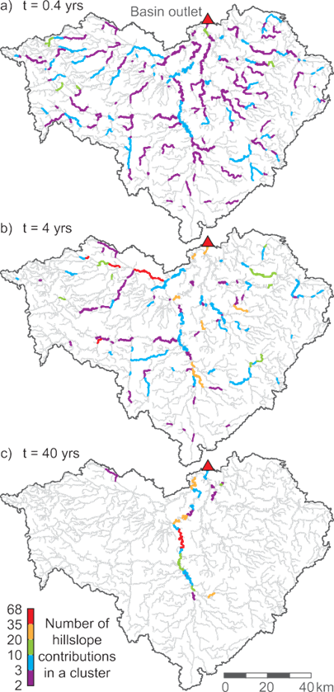

Figure 5. Dynamic connectivity of sand transport on the Greater Blue Earth River Network, Minnesota River Basin. Organization of sand transported on the network into clusters at time (a) 0.4, (b) 4, and (c) 40 years (Czuba et al., 2015)

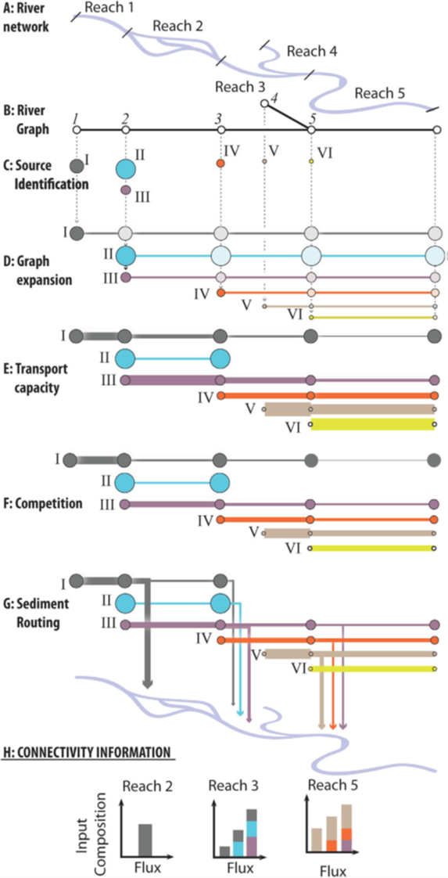
Fig. 6 Key concepts and steps behind the CASCADE modelling framework: (a and b) Original river network and graph representation; (c) Identifying source locations and grain sizes; (d) Graph expansion; (e) Transport capacity scaling, line width indicates transport capacity; (f) Competition reduces the original transport capacity (compare linewidth in Figures 1e and 1f); (g) Cascade specific, edge-to-edge sediment routing discriminates cascade sediment fluxes; (h) Edges receive fluxes from multiple cascades, defining sediment flux, provenance, and sorting; and thereby connectivity of an edge (Schmitt et al., 2016).

- CHALLENGES
Implementation of identification, modelling and quantification of connectivity, especially sediment connectivity, poses various challenges using present methods, though developments are taking place rapidly. Much research is ongoing to fulfil the deficiencies in present methods, but considerable challenges remain.

3.1 Validation
Connectivity modelling, like any model, is dependent on assumptions and input conditions. The model output needs validation so a combined approach of mapping and modelling is recommended. Without testing, the model outcomes remain as hypotheses. Many authors have remarked on the need for field mapping or actual observations for validation or ground truthing, even when the main focus has been on the modelling. Borselli et al. (2008) pointed it out and proposed the Field Connectivity Index. Hooke (2003, 2004), Brierley and Fryirs (2005), Lesschen et al. (2009), and Lexartza-Artza and Wainwright, (2009, 2011), all state that field-based approaches are crucial to understanding connectivity and Messenzehl et al. (2014, p226), after a comparison of automated and field mapping, concluded that 'Traditional geomorphic field maps remain indispensable for validation and improvement of modelling results'. Other more recent examples of field mapping or recognition of the need include Cossart et al. (2018), Mahoney et al. (2018), Fressard and Cossart (2019) and Skarpich et al. (2019). Several of the comparisons or validations have exposed deficiencies in modelling approaches, e.g., Messenzehl et al. (2014) in the Alps, and Nicoll and Brierley (2017) in the Upper Yellow River, China. Even after these efforts, there is not a clear framework to validate the indexes, mainly due to the different research approaches and goals. It shows the necessity of guidance to validate the ICs, that can be adapted to each necessity/goal and refinement of approaches to mapping.

3.1.1 Approaches to validation and scale issues
One of the major challenges in assessing and quantifying connectivity is that every part of the system needs to be assessed, otherwise you do not know if it is connected; it may only take one small area or a structure to make the disconnection in a pathway or alter the path. Every pathway needs to be followed in order to assess whether it links. Of course, space has to be divided up in some way and this is commonly into pixels but it can also be by classification of homogeneous areas on hillslopes such as hydrological units (e.g. Smith et al., 2010) or homogenous reaches in channel systems (e.g. Hooke, 2003; Czuba and Foufoula-Georgiou, 2015). Connectivity requires that every link is quantified and this is cumulative as far as disconnectors. If the interest is in sediment delivery and knowing where an area is supplying sediment to a particular point then one strategy is to follow all visible pathways upstream until a definite disconnector is reached (either a structure/ impediment or, if after an event, then functional sink). The part of the catchment above is then irrelevant, disconnected. This was done in field mapping/ checking in the Carcavo system, where, after an event, signs of flow and sediment delivery along a main channel (and also direct sediment inputs from channel/valley sides via slides and falls) were checked (Fig. 3a) (Sandercock and Hooke, 2011). Several tributaries were found to have made no connection (Fig. 7a), with flow and sediment being deposited on a fan on the floodplain or tributary exit (Fig.7b, c). If the aspect of interest is where the sediment is coming from to that disconnection point then the location and nature of that sink and the sources and pathways above it can be examined. This is the coupling concept discussed and exemplified by Harvey (2001, 2002) and Brunsden (2001). The basic mapping and identification of connection pattern along the main channel can provide the framework for more detailed investigation. The differing nature of the connectivity in the uppermost part of slopes, where pathways are not visible or ‘permanent’ may mean different approaches for this zone of diffusive supply are appropriate. In this zone, the use of predictive models may be the only way to establish supply but this requires very high resolution topographic and surface inputs as well as runoff modelling. The models appear best suited to those hillslope zones where pathways are created but are ephemeral and changeable.
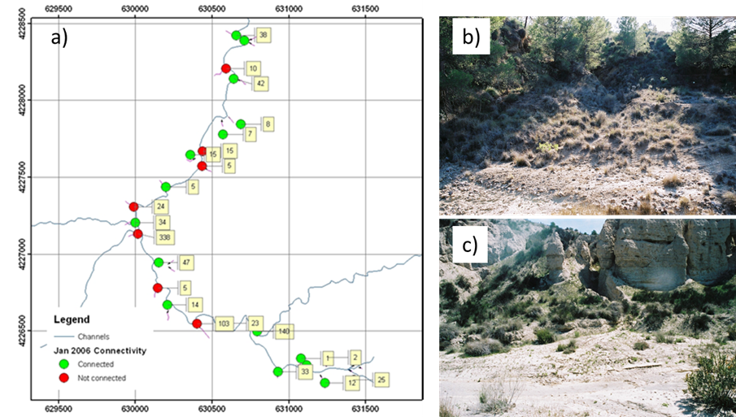
Fig. 7 a) Connection status of tributaries in Cárcavo catchment, SE Spain, after a rainstorm (mapped by Sandercock and Hooke (Recondes, 2007b)); the yellow boxes indicate the tributary catchment area; b) Disconnected tributary and c) Connected tributary at time of photography.

Another challenge in quantifying and modelling or predicting connectivity pathways is that small scale features can have a large effect, even in otherwise large pathways. Examples include small dips at the side of tracks where water flowing down a track then flows off down a slope (Fig. 8). Another example is in urban areas where the height of kerbs can make a difference, as shown by Sampson et al. (2012) who mapped patterns of inundation using TLS (Terrestrial Laser Scanning) and 10 cm DEMs as well as 1 m DEMs and found that modelled flood flow responded to small-scale topographic features such as kerbs and road camber. Calculation of amounts and therefore whether exceedance of a threshold or barrier occurs requires incorporation of capacities and application of a routing model.

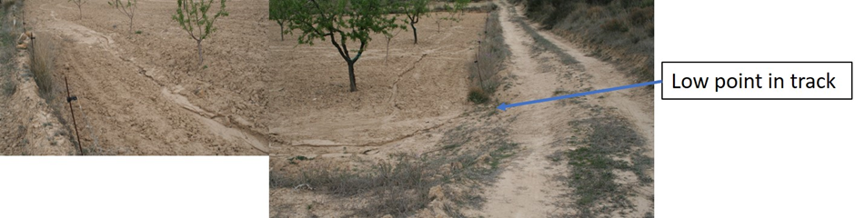
Fig. 8 Photograph of a small dip in a track and lack of vegetation influencing the connectivity pathway (photo: Hooke)

The challenge is how to solve this dilemma that large areas need to be covered and yet in very great detail. Problems of spatial scale are particularly challenging if mapping or validation are by ground survey. Availability of remote sensing and capabilities of UAV surveys and software are now diminishing this problem but the challenge is then the resolution required of the imagery. Several recent papers discuss the effect of DEM resolution. Lopez-Vicente and Alvarez (2018) found that 0.2m resolution was optimal in an area of Spain but Cantreul et al. (2018) and Graf et al. (2018) found the best IC results came from a 1m resolution DEM. Obviously, much depends on the topography and size of area, and it can affect the processing capacity. Questions also remain on the extent to which UAV Surveys can detect functioning but Cantreul et al., 2018 and Estrany et al. (2019) use drone photography for validation. Much research is going into production of high-resolution DEMs from various sources now. In general, in terms of the factors or characteristics influencing connectivity, the scale of their influence varies, with a suggested general hierarchy from large to small-scale from overall topography, (including valley confinement), through structures, roughness and vegetation, infiltration rate, to micro-topography.

One of the difficulties with the modelling and use of high resolution DEMs may be that they incorporate features which are the ones to be modelled. For example, pre-existing rills or orientation of plough lines influence and predetermine the pattern of connectivity. It does so in reality but the modelling may be required for conditions without these features, but still including other small-scale features. So, the challenge may be to identify those features which are ephemeral and created by the processes themselves, such as rills, and those that are more permanent and imposed, though at a range of scales from hillslope topography to track unevenness, and also those that are variable but more systematic such as seasonal vegetation (Souza and Hooke, submitted). Lisenby et al. (2017b) found that DEM resolution has a significant effect on a simple model of bed load sediment connectivity in the Lockyer Valley, Queensland. They advocate that coarse resolution DEMs should not be thrown out and that resolution must fit the scale of investigation.

In order to make mapping practical and to upscale results then a hierarchy of scales of assessment is recommended by Brierley and Fryirs (2005), Hooke and Sandercock (2012, 2017) and Lexartza-Artza and Wainwright (2009). Hooke and Sandercock (2017) give examples of mapping connectivity at different scales from plot to catchment. Cammeraat (2002) addressed the issue of scale, examining processes and connectivity across a range of scales and their hierarchical relationships. He also signalled the challenge of thresholds in upscaling and identified these for processes in SE Spain (Cammeraat, 2004). Some of the typologies and techniques are much more applicable to one scale than another. López-Vicente et al. (2017a), Schneider et al. (2013) and Sougnez et al. (2011) compare IC results with plot scale monitoring data. Even for mapping at catchment scale, observations need to be localised and continuous. The modelling tends to be applied at hillslope or large catchment scale, though it is possible to focus on small areas. Overall, it is essential to examine connectivity at a range of scales since it can be an emergent property (Wohl et al., 2019) and is only meaningfully identified at scales of connections of homogenous sections of pathways.

3.1.2 Tests of connectivity indices
Various methods have been investigated to try to monitor water flows and sediment flux to provide evidence of pathways of flow. For example, Barberá in the Recondes project (Hooke and Sandercock, 2017, p19) put out a series of stakes over a hillslope but few flows actually touched the markers. With small, shallow flows on unrilled hillslopes or ephemeral rills this is especially challenging. Of course, the standard methods of stream gauging with sediment instrumentation or sediment flux can be used in defined pathways but, even with decrease in the price of sensors, it is challenging to deploy enough instruments except in small numbers of channel reaches. This is the same kind of challenge as was met by sediment budgeting early on and ideally connectivity frameworks need to be combined with such approaches. Rapid technological progress in developments of cheap sensors may be decreasing this problem; likewise, real -time remote sensing monitoring may provide information on fluxes. Research by Rodrigo-Comino et al. (2020) and Wolstenholme et al. (2020) illustrate new approaches to the direct measurement of fluxes and connectivity.

The overall output from the catchment can be measured and this has been done in various studies. For example, Jamshidi et al. (2014) compared modelled IC and SDR in an Australian subtropical catchment. Testing simply of SDR at the outlet does not necessarily say more about internal operation of the catchment system but Heckmann and Vericat (2018) have found that incorporation of connectivity or use of ICs improves predictions or models of SDR. Vigiak et al. (2012) compared IC with different sediment transport capacity methods and found it to be the most promising of four approaches and Nicoll and Brierley (2017), working in the upper Yellow River region, found that effective catchment area is better than the Cavalli IC for assessing connectivity in that environment. Schopper et al. (2019) tested Effective Catchment Area (ECA) and IC for the Fella River, NE Italy, and found agreement except where human structures are present. Correlation of debris flow and IC was low for intensity of flows but high for debris flows reaching the channel due to the IC focus on river connection.

3.2 Disconnectivity and sediment sinks
Connectivity arguably only matters to the point where disconnection, if any, takes place. What happens downstream of that point is then not affected if it is a complete disconnection, or is less affected by upstream if partial. Thus, identifying and quantifying the connectivity in a system vitally requires identification of these disconnections. This was recognised by Fryirs et al. (2007a) with the different types of disconnector and in the idea of Effective Catchment area. It was the whole premise of the EU Recondes project that vegetation could be used as disconnectors, to reduce sediment connectivity downstream (Sandercock and Hooke, 2006, 2011). Messenzehl et al. (2014), examining slope-valley coupling found that 29% of the basin was disconnected and Lisenby et al. (2017a) have shown how important are the disconnectors and variations between catchments in influencing tributary -trunk relationships and sediment connectivity. Mahoney et al.’s (2018) modelling, using a probability approach and simply mapping connected and disconnected areas, indicated very little of a rolling topography area to be connected.

Various types of disconnector have been identified (Fryirs et al., 2007a) and various types of sediment store, reducing the sediment delivery downstream. The forgoing discussion implies that the disconnectors are simple on /off switches which is often not the case. The functioning of most disconnectors will vary with magnitude of an event and state of the disconnector (e.g., vegetation density, amount of storage space still available). However, the pattern and quantity of connection needs to be established for particular conditions. For sediment connectivity, rather than water flow, then the switches are more often on and off. A crucial point of connection and control is the hillslope/ main channel or tributary/ main channel connection or what has been called coupling in earlier research (Harvey 2001, 2002; Brunsden, 2001). Any modelling or calculation needs to calculate when stores are full, and this is mostly lacking. However, the degree of disconnectivity can vary, for example with porosity of the barrier, state of the stores, integrity of the structure, and also vary in their differential degree of disconnection of water, fine sediment and coarse sediment. Embankments can also be breached, immediately altering a pathway. This is very difficult to model and predict and mostly requires monitoring over time. Some assessment can be made by calculations of force and relative vulnerability, which is related to amount of flow, for which the connectivity to that point can be a proxy combined with area, and the resistance at the point is partially represented by gradient and vegetation as present in Borselli’s index.

Much of the IC modelling or other automated and GIS approaches to mapping do not identify these disconnections or decreases in fluxes in pathways (partial disconnection) very adequately, if at all. A pixel with very low IC value probably will be a sink isolating, partially or totally, the upstream processes from downstream. Nevertheless, it barely affects the IC values to downstream pixels, as if there is not any impediment upstream. Nicoll and Brierley (2017) in the Upper Yellow River, using GIS, satellite imagery and field mapping found that the methods did not distinguish disconnectivity adequately.

The various IC modelling methods differ in their incorporation and weighting of factors which have indirect effects through vegetation and roughness but a mechanism for modelling ponding and storage is needed. A recent test of the main versions of the connectivity index modelling against field mapping over several years in a small agricultural-terraced catchment in SE Spain indicated that ponding and sedimentation associated with the terraces tends not to be modelled, even with very detailed DEMs (Hooke et al., submitted). Some softwares are now allowing input of sinks into the initial DEM and assumptions but these are pre-determined/mapped sinks and not predicted. It requires prior knowledge, presumably from mapping or field observations or use of remote sensing imagery, to detect structures. In order to model ponding and transmission loss, ideally infiltration rates as well as gradient are needed. Data on the state and capacity of potential store areas are also needed. This therefore implies a requirement for surface / soil data and for a combination with hydrological modelling. These deficiencies are particularly notable in lowland and agricultural areas where topography alone is not adequate. Even if a structural/ potential disconnector is identified, it is often not known the extent or conditions under which it operates. Some progress is being made in incorporation of deposition zones in modelling and calculation of connectivity, though it is still not adequate within most indices and in application to certain kinds of environment. Gay et al. (2016) applied the Borselli et al. (2008) method to the Loire catchment, incorporating an infiltration parameter, and particularly focussing on the applicability to lowland areas and gentle slopes. López-Vicente and Ben-Salem (2019) include rainfall erosivity, and soil permeability and Kalantari et al. (2017) include a runoff index to model very flat areas.

Different types of sink thresholds could be combined with the classical IC models, a slope limit or a IC value limit that below this limit creates sinks in an initial modelling phase. These sinks could be used to separate totally or partially the upstream area in a similar way to the Effective Catchment Area approach. Slope limit can be useful for complex relief areas but is limited for flat regions. IC value limit is difficult to set, probably needing field information to compare an IC pre-model to known sinks. Weighting factor threshold value could be used in environments with well-known vegetation control on erosion, such as in dryland vegetation with patch and bare land patterns.

3.3 Degree of connectivity and link status
A major challenge in assessing and quantifying connectivity is the degree of functioning or disconnection. This may differ in various magnitude rainstorms as shown by Meerkerk et al (2009) and Marchamalo et al. (2016) and may vary with antecedent moisture conditions, vegetation state (Souza and Hooke, submitted) or other conditions. In early research, Lane et al. (2004) coupled high resolution DEM, initial soil moisture conditions, and event characteristics to classify and predict runoff connectivity. More recently, López-Vicente and Ben-Salem (2019) include rainfall erosivity, and soil permeability and Kalantari et al. (2019), in Sweden, include soil moisture state. Again, a difficulty is in areas of non-channelled flow, but a solution is simply to map these as diffusive or contributing areas. A difficulty in sediment connectivity assessment is if there is direct input from other processes such as landslides, debris flows, rockfall or riparian slip, though research is tackling those challenges (e.g., Bordoni et al., 2018; Persichillo et al., 2018; Scorpio et al., 2018; Schopper et al., 2019). These can usually be detected in field or aerial surveys. Most modelling and mapping do not yet address variations and differences between fine and coarse sediment components. Ideally, assessment of functionality will incorporate calculation of cumulative amounts of runoff and sediment, and developments are now taking place as shown above. The Cascade model (Tangi et al., 2019) does allow for different sediment sizes and degrees of transmission downstream in river channels and Heckmann and Vericat (2018) and Calle et al. (2020) have inferred sediment transfers and functional connectivity of rivers from repeat topographic surveys or DEMs of difference (DoDs).

It may be that a classification of connectivity, as used by Bray et al. (1995) in analysis of sediment connectivity and cells in coastal systems, and the types identified by Hooke (2003) (Table 2) for channels, is a way of classifying degree and representing different scenarios, especially as detailed quantification throughout the whole system is rarely possible and entails full-scale hydrological and hydraulic routing models, or multiple observations over large areas. However, evidence is needed to apply the classification. Souza et al. (2016) working with channel connectivity, separated (dis) connectivity into partially and totally disconnected based on the known impediment impacts on flow and sediment dynamics. Bracken et al. (2015) suggested a framework for sediment connectivity analysed based on process components.

Table 2 Classification of channel reach connectivity for coarse sediment (Hooke, 2003).
Unconnected | Local sources and stores/sinks.  Incompetent reaches between
Partially connected | Transfer only in extreme flood events
Connected | Coarse sediment transfer during ‘normal’ flood events
Potentially connected | Competence to transport but lack of supply
Disconnected | Formerly connected but transfer is now obstructed (e.g. by dams)

  - Incorporating functionality, dynamics and feedbacks
Indices do not clearly distinguish sediment connectivity from runoff, even where purporting to be of sediment connectivity. Water / runoff has much higher connectivity than sediment due to transport conditions. It could be said that the models are indicating the potential for runoff and flow pathways and that sediment erosion and movement will be related to this. However, the models also need to represent sources and supply of sediment, which are not solely due to runoff generation. Therefore, applications in areas vulnerable to soil erosion require an element of erodibility of surface or an assumption of threshold power for removal of sediment. Again, the connectivity modelling ideally needs to be combined with sediment routing and budgeting to cumulate. It requires components on hydraulics and sediment processes and on resistance of surfaces. This quickly turns into more conventional modelling. However, from the other direction, some researchers have found that including an element of connectivity in sediment yield/ erosion models improves the validity of the outcomes; for example, De Walque et al. (2017) improved the prediction of muddy flood hazards in Wallonia, Belgium, by inclusion of artificial surfaces and sediment connectivity. Soil erosion models are notorious in using factors of soil and cover as areas and excluding presence of gullies, which may be the main location of erosion and sediment supply. This is likewise a major deficiency of plot studies. Gullies are the connectivity pathways and the sources and means of the delivery of the sediment downslope. Conoscenti et al. (2018) found that incorporation of hydrological connectivity improves gully prediction and Zegeye et al. (2018) emphasise the importance of gullies in sediment connectivity. Similarly, until relatively recently, the proportion of sediment, even fine material, coming from channel sources in mainstream systems has tended to be underestimated (e.g. Kronvang et al., 2013; Neal and Anders, 2015). Poeppl et al. (2019) have combined soil erosion modelling with connectivity analyses to assess lateral fine sediment input into agricultural streams and other research is using hydraulics and sediment modelling in channels to quantify inputs, transfers and sinks (e.g., Vigiak et al, 2012; Skarpich et al., 2019; Tangi et al, 2019). Cislaghi and Bischetti (2019) developed a modular approach to assess the sediment source areas and the probability of mobilisation from hillslope, and to estimate the probability of sediment input to the streams, proposing a new connectivity index. Assessment of the extent to which sediments travel in more disconnected ways than the flows that transport them was also the objective of Fressard and Cossart’s (2019) research, which developed new indices in graph theory and applied them to a vineyard area.

As outlined above, much of the modelling and mapping of connectivity concerns or portrays structural and static connectivity, or what Sandercock and Hooke (2006) have called potential connectivity, a point recently highlighted by Najafi et al. (2021) in a comprehensive classification of publications on sediment connectivity. As indicated above, the models may be calculating the maximum possible connectivity and may therefore be used in assessment of the potential for a pathway to develop, with the likelihood directly related to the connectivity value. What is actually needed for many purposes is functioning connectivity, i.e. the presence of actual flow of water and sediment or the connectivity difference between different rainfall events. Challenges arise in identifying that functioning. Again, the main solution to this is to map or record connectivity under different conditions, as for example demonstrated by Marchamalo et al. (2016). Methods of functioning path recognition were outlined above and the mapping can be supplemented by measurements of dimensions of rills and channels, wetted areas, and sediment deposits. The network of pattern of connectivity can then be quantified using other measures such as network parameters, length, and graph theory techniques once the mapping is complete for an area, as discussed above. A combination of connectivity modelling with other hydrological models may allow some variations in modelling outcome, though this still needs validation. Developments are rapidly taking place to produce methods that model functionality or combine structural and functional (e.g. López-Vicente and Ben-Salem, 2019; Zingaro et al., 2019). Several researchers are using flow accumulation for functionality and other soil and rainfall characteristics as input for either structural or functional components and these have been applied at a range of scales, (e.g., Heckmann and Vericat, 2018; Zingaro et al., 2019; Moreno-de-las-Heras et al., 2020). Baartman et al. (2020) have tested a range of scenarios and using various soil erosion models and spatial distributions in landscapes. They found that functional aspects of connectivity were more important than structural connectivity, with rainfall being the most influential factor on runoff and sediment export. Chartin el. (2017) used a revised IC incorporating rainfall erosivity of specific extreme events (typhoons), as a secondary weighting factor, to identify the momentous functional connectivity during these events.

To achieve a fully functioning connectivity model that can apply over a series of events, feedbacks need to be incorporated such that the processes change the morphology and structural conditions and these then affect the connectivity. Various channel flooding and hydraulic and landscape change models already do this and these need to be coupled with the connectivity framework. The importance of connectivity feedbacks has been demonstrated by Saco et al. (2020) in semi-arid environments. Connectivity can vary and change over various timescales, depending on the controlling factors, and structures and the system state. Changes can take place within an event and this requires relating process to hydrographs. At event scale, surface condition, infiltration rate, and soil moisture can vary. At seasonal scale the density and properties of vegetation cover can vary (Singh et al 2017; Souza and Hooke, submitted) and state of crops varies in agricultural land (López-Vicente et al., 2013). Lopes and Pinheiro (2013) did recognise dynamics in processes, with connectivity in dryland showing a cyclic pattern where the same location is a deposition site in one moment and an erosion/transmission site in another, and this dynamic could be related to vegetation. Over time, there can also be trends in these characteristics, e.g. growth of trees (Hooke 2015). Sandercock and Hooke (2011) showed that the presence of vegetation itself can induce sedimentation and thus alter morphology and hydraulics. For connectivity itself, then it is the state of the pathway that matters with its influence on roughness, and therefore velocity, and erodibility, rather than influence on hydrological balance and runoff generation. In the longer term, morphological change and adjustment take place, affecting water and sediment transmission. The overall long-term dynamics of the larger system depends on the availability of storage zones, or accommodation space (Brierley et al., 2006) and the filling of those zones. Alteration of major structural controls can take place, e.g. breaching of embankments, sedimentation of lakes, reservoirs and check dams. In the even longer-term of 1000s of years then the presence and destruction and backfilling of rocksteps can affect the connectivity (Oldknow & Hooke, 2017).

If changes take place as a result of flows, e.g. breaching of embankments or structures, then the structural base map needs to be altered for the next mapping, if the structures are not repaired. Lexartza-Artza and Wainwright (2009) emphasise the need for updating of the structural status of systems and exemplify feedbacks between functional and structural connectivity, both within and between events, including the role of sediment delivery. Likewise, Marchamalo et al. (2016) and Meerkerk et al. (2009) demonstrate the effects of breaching and incision of pathways on connectivity in different storms.

A fully functioning connectivity model requires modelling of processes. This could entail hydraulic modelling of all pathways, as used by Czuba and Foufoula-Georgiou (2015) in modelling of the dynamics of sediment connectivity in a channel to identify hotspots of sediment flux, which are locations of channel change. The particular challenge in connectivity modelling and index calculations is still the depositional and sedimentation processes in sinks, whether small fans on hillslopes or sedimentation on agriculture terraces or deposition behind weirs and steps and in major structures. These are the kinds of locations and features that form buffers, barriers and blankets (Fryirs et al., 2007a) or disconnectors. At present, even with detailed DEMs, topography alone seems insufficient to simulate depositional processes so some sediment transport function or threshold needs to be incorporated.

In larger perennial rivers it may be difficult to assess processes and status without detailed measurements and bathymetric surveys. Sediment sampling can be an important part of assessment at all scales. Hooke (2003) used evidence of processes to classify each reach then work out connectivity given those characteristics. She combined that with calculations of sediment competence and evidence of sediment size on bars, as did Skarpich et al. (2019) much more recently. Modelling of these processes and of sediment input ideally needs a factor of erodibility of surfaces and boundaries. Cislaghi and Bischetti (2019) criticise the IC for not including materials of source areas. Likewise, elements of rainfall erosivity as well as amount ideally need to be included (Chartin et al., 2017). Vegetation effects within pathways still need greater quantification and incorporation in connectivity models. Mahoney et al. (2020b) have demonstrated how sediment transport formulae need to be combined with connectivity modelling to predict sediment flux at event scale.

- MANAGEMENT APPLICATIONS OF CONNECTIVITY ANALYSES AND INDICES
The purpose of many of the developments and applications of connectivity analysis is to inform management of fluvial systems and land areas. Many of these applications have demonstrated the advantages of using or incorporating connectivity approaches but some have also demonstrated the challenges and weaknesses, represented in the challenges above, often helping to stimulate further developments. Assessments of sediment yield, contributing areas and sediment delivery ratios have been improved by use of connectivity and indices (Jamshadi et al., 2014) and thus can provide a stronger basis for sediment management in catchments. Application of connectivity concepts or more specific indices has included much analysis of the effects of change in land cover, land use and topography, (e.g. López-Vicente et al. 2013; López-Vicente et al. 2017a; Calsamiglia et al., 2018; Lizaga et al., 2018; van der Waal and Rowntree, 2018; Llena et al. 2019). This obviously helps with management of problems created by sediment delivery and load and with the identification of source areas. It has also been applied to many cases of analysis of effects of wildfire and regrowth/ rehabilitation (e.g., Calsamiglia, et al., 2017; Ortíz-Rodríguez et al., 2019). López-Vicente et al. (2020) tested four indices, IC-Borselli, IC-Cavalli, IC-Persichillo and aggregated index of connectivity (AIC). They found different conditions of indices are needed to assess various aspects of fire effects. Martini et al. (2020) found that occurrence of two wildfires in central Chile severely affected connectivity and use of the weighting factor in IC was able to model the effects of the changes in vegetation, potentially providing a tool for land management and risk mitigation. Incorporation of sediment connectivity in a fingerprinting approach was shown to alter the identification of which areas supplied most sediment in a catchment in Nepal (Upadhayay et al., 2020).

The mapping approaches of documenting and analysing evidence of pathways, sources and sinks have potential for identifying hotspots of erosion and sedimentation. This then provides a basis for strategic action to manage problems created by these processes. This was the major premise and aim of the RECONDES project, which produced recommendations on locations for use of vegetation to reduce sediment fluxes downstream and integration into spatial strategies (Sandercock and Hooke, 2006; Recondes, 2007a,b; Hooke and Sandercock, 2017). Connectivity patterns and erosion hotspots were identified and could then be targeted with spatial strategies using vegetation. This approach is now being tested in Ethiopia, an area undergoing devastating degradation and severe soil erosion, but a very different environment to that of the original research, especially in terms of soils and rainfall regimes. Blake et al. (2020) have also demonstrated the value of connectivity frameworks in soil erosion management in Tanzania.

Connectivity analysis and modelling has been applied to management and prediction of other hazards, notably flooding, landslides, debris flows and muddy flows. The modelling has the potential to identify pathways that might develop or function in extreme events and could be applied to flood prediction (Sampson et al., 2012; Zingaro et al., 2020). Applications of the connectivity principles include those in Flanders for land management where management strategies have been tested for some time (Aminal 2002, Evrard et al., 2007) and been shown to reduce muddy flooding in villages (De Walque et al., 2017). Estrany et al. (2020) used topography-based connectivity indices and geomorphic change detection as rapid post-catastrophe decision-making tools, after a devastating and fatal extreme flood in Mallorca. In channels, connectivity concepts have been used to develop methods to identify hotspots of erosion and sedimentation in channels (Czuba and Foufoula-Georgiou, 2015), and also experiments are ongoing in developing flooding prediction by Zingaro et al. (2020) who have proposed a sediment flow connectivity index (SCI) that identifies hotspot areas for monitoring of occurrence of flooding. It has been used as a framework for understanding sediment transmission, including at bar scale in river channels (Hooke, 2003; Lehotsky et al., 2019; Skarpich et al., 2019). Connectivity could offer the potential for assessing river sensitivity and future channel behaviour and Poeppl et al. (2020) have emphasised the importance of understanding disconnectivity in river conservation and recovery to predict effects of management actions. The goals of management strategies need to be clear because in some cases the aim is to reduce connectivity, as in the case of controlling erosion, sediment flux and flooding, but in other cases, notably in ecology, the aim is to enhance connectivity and species mobility. Hooke (2003) and Cossart et al. (2018) note that use of connectivity has the potential to assess propagation of perturbations in the sediment system.

Connectivity modelling has been applied in assessment of effects of structures, such as reservoirs (Zhao et al 2020), and check dams Martinez‐Murillo et al. (2018) and possible management strategies of removing structures such as dams, check dams, weirs, and levees. Cucchiaro et al. (2019) use DoD maps of check dams to assess change in IC. They show the alteration of sediment pathways and strong link between structural and functional connectivity. The effects of agricultural terraces have also received attention, where Calsamiglia et al. (2018) used IC to identify vulnerable locations. Tracks and roads had previously been shown in much research to play a significant role in sediment delivery but understanding has been enhanced by use of connectivity frameworks and techniques in various environments (Hooke and Sanderock, 2012; López-Vicente et al. 2017b; Marchi et al., 2019; Kroese et al., 2020). Bombino et al. (2020), highlight the importance of developing tools for land management and discuss how their index (mCCI) can be used as an analytical tool to evaluate the influence of past or future changes in natural and human-induced changes in land use and climate actions by comparing scenarios of torrent connectivity.

These examples of applications illustrate the kinds of purposes of connectivity analysis and the kinds of characteristics that need to be identified. Overcoming some of the challenges discussed in this paper will enhance the applicability and utility of connectivity analysis to an even greater extent, to the benefit of all in sustainably managing systems and in reducing detrimental effects of extreme events and of human activities.

- CONCLUSIONS

Various challenges in the use and operationalisation of application of approaches and techniques to analysis of connectivity have been identified here and some recommendations on overcoming deficiencies have been made. The key element of connectivity analysis is the identification of flow and sediment pathways, their position in the landscape and their status in terms of transferring water and/or sediment. Various characteristics of the patterns and connections may be of interest, but the goals of the analysis need to be clear and different types of approach are appropriate for these different purposes. Two main approaches are distinguished here, mapping and modelling. Both produce maps of connectivity patterns but tend to differ in their origins. Mapping of connectivity patterns tends to be used to document what is actually present or the potential for fluxes and can be subject to various degrees of quantification. Various approaches to the field mapping are apparent, with a major division between a priori classification of link connectivity and post-mapping identification of link connectivity status. Methods of field identification vary and only a few explicit methodological guidelines are available. Modelling tends to be used for predictive purposes of sources, pathways and connections and to test scenarios but requires validation, which is commonly by field mapping. Indices have been developed to generate and quantify relations and patterns. The connectivity Indices (ICs) developed by Borselli et al. (2008) and Cavalli et al. (2013) are most widely used but also applications of graph theory and network analysis have been developed and applied, in particular to main river channels, rather than hillslopes. The connectivity index models mostly use weightings related to topography and surface cover and the effects of various weightings have been tested. The two main indices have been found to be most suitable in differing environments, the Borselli index for vegetated environments and pathways and the Cavalli index for bare and rocky surfaces, particularly in mountain environments.

Various deficiencies in the efficacy of the index modelling to identify some characteristics of connectivity patterns have been exposed, most notably the occurrence of disconnectors and sediment stores or sinks. Models have been found to need field validation but challenges in field mapping include the requirements of extensive spatial coverage and yet high resolution. In order to understand and quantify the connectivity pattern and pathways then the whole area must be covered and every pathway checked potentially. On the other hand, if disconnectors are identified then arguably only the zones downstream need to be analysed in terms of sediment flux. A hierarchical approach, working from downstream to upstream could therefore be used. If the interest is the fate of the sediments removed on the hillslopes or upstream reaches of channels, then those only need to be followed until a disconnector is found. That assumes an absolute state of connection or disconnection but establishment of its status presents challenges. Most analyses of connectivity patterns are structural and therefore show the potential for connectivity and fluxes and their disconnection. However, much more needs to be known about characteristics of disconnectors and thresholds for disconnection need to be identified. This would help in the move towards functional connectivity analysis, which is actually what is needed in many cases. Many refinements are taking place at present that try to incorporate other factors that influence the degree and type of connectivity. Many of the indices and models purport to quantify the sediment connectivity whereas many of the maps produced by those techniques are arguably much more closely related to runoff connectivity. Factors of erodibility of the surface as well as quantities and power of the flows are needed. Graph theory approaches do tend to incorporate sediment transport process functions. Validation of the functioning of pathways is also challenging in spite of advances in technology of ground and remote sensors.

The indices also vary in the degree of influence of downstream sinks and outlets but it is usually the local characteristics and immediate downstream link which are the important controls and that relates back to identification of disconnectors. Catchment sediment yield and sediment delivery are not a validation in themselves that the connectivity patterns have been modelled or identified correctly but it has been found that incorporation of connectivity frameworks in analysis can improve predictions of downstream sediment flux. Various scenarios of change in land surface factors and conditions have been modelled and some tested by changes arising from land uses or fire. The fluxes of water and sediment can themselves change the connectivity and pathway characteristics and such feedbacks are rarely incorporated yet in models. However, connectivity is proving valuable as a conceptual and methodological framework in management application related to water and sediment flux and occurrence of hazards. Further refinements of both the modelling and the mapping and validation approaches should further enhance its capabilities.

Acknowledgements
JMH did not receive any specific grant from funding agencies in the public, commercial, or not-for-profit sectors for this research. Jonas Souza would like to thank University of Liverpool for provision of facilities during a year’s visit and The Brazilian Council of Technological and Scientific Development (Conselho Nacional de Desenvolvimento Científico e Tecnológico - CNPq, grant number 203959/2018-3) for financial support.

REFERENCE LIST
Aminal, (2002). Kleinschalige Erosiebestrijdingswerken: Een praktijkvoorbeeld. Ministerie van de Vlaamse Gemeenschap, Brussel.
Antoine, M., Javaux, M., & Bielders, C. (2009). What indicators can capture runoff-relevant connectivity properties of the micro-topography at the plot scale? Advances in Water Resources, 32(8). https://doi.org/10.1016/j.advwatres.2009.05.006
Asadi, H., Shahedi, K., Jarihani, B., & Sidle, R. C. (2019). Rainfall-runoff modelling using hydrological connectivity index and artificial neural network approach. Water (Switzerland), 11(2). https://doi.org/10.3390/w11020212
Baartman, J.E.M., Nunes, J.P., Masselink, R., Darboux, F., Bielders, C., Degré, A., Cantreul, V., Cerdan, O., Grangeon, T., Fiener, P., Wilken, F., Schindewolf, M., Wainwright, J., (2020). What do models tell us about water and sediment connectivity? Geomorphology 367, 107300. https://doi.org/10.1016/j.geomorph.2020.107300
Blake, W.H., Kelly, C., Wynants, M., Patrick, A., Lewin, S., Lawson, J., Nasolwa, E., Page, A., Nasseri, M., Marks, C., Gilvear, D., Mtei, K., Munishi, L., Ndakidemi, P., (2020). Integrating land-water-people connectivity concepts across disciplines for co-design of soil erosion solutions. L. Degrad. Dev. 1–16. https://doi.org/10.1002/ldr.3791
Bombino, G., Boix-Fayos, C., Cataldo, M. F., D’Agostino, D., Denisi, P., de Vente, J., Labate, A., & Zema, D. A. (2020). A modified Catchment Connectivity Index for applications in semi-arid torrents of the Mediterranean environment. River Research and Applications, 36(5). https://doi.org/10.1002/rra.3606
Bordoni, M., Giuseppina Persichillo, M., Meisina, C., Crema, S., Cavalli, M., Bartelletti, C., Galanti, Y., Barsanti, M., Giannecchini, R., & D’Amato Avanzi, G. (2018). Estimation of the susceptibility of a road network to shallow landslides with the integration of the sediment connectivity. Natural Hazards and Earth System Sciences, 18(6). https://doi.org/10.5194/nhess-18-1735-2018
Borselli, L., Cassi, P., & Torri, D. (2008). Prolegomena to sediment and flow connectivity in the landscape: A GIS and field numerical assessment. Catena, 75(3). https://doi.org/10.1016/j.catena.2008.07.006
Bracken, L. J., & Kirkby, M. J. (2005). Differences in hillslope runoff and sediment transport rates within two semi-arid catchments in southeast Spain. Geomorphology, 68(3–4). https://doi.org/10.1016/j.geomorph.2004.11.013
Bracken, L. J., & Croke, J. (2007). The concept of hydrological connectivity and its contribution to understanding runoff-dominated geomorphic systems. Hydrological Processes, 21(13). https://doi.org/10.1002/hyp.6313
Bracken, L. J., Wainwright, J., Ali, G. A., Tetzlaff, D., Smith, M. W., Reaney, S. M., & Roy, A. G. (2013). Concepts of hydrological connectivity: Research approaches, Pathways and future agendas. In Earth-Science Reviews (Vol. 119). https://doi.org/10.1016/j.earscirev.2013.02.001
Bracken, L. J., Turnbull, L., Wainwright, J., & Bogaart, P. (2015). Sediment connectivity: a framework for understanding sediment transfer at multiple scales. Earth Surface Processes and Landforms, 40(2), 177-188. doi: 10.1002/esp.3635
Bray, M.J., Carter D.J., Hooke, J.M., 1995. Littoral cell definition and budgets: shoreline management applications for central Southern England. J. Coastal Research, 11, 381-400
Brierley, Gary J., & Fryirs, K. (1999). Tributary-trunk stream relations in a cut-and-fill landscape: A case study from Wolumla catchment, New South Wales, Australia. Geomorphology, 28(1–2). https://doi.org/10.1016/S0169-555X(98)00103-2
Brierley, G. J., & Fryirs, K. A. (2005). Geomorphology and River Management (Gary J. Brierley & K. A. Fryirs, Eds.). Blackwell Publishing. https://doi.org/10.1002/9780470751367
Brierley, G., Fryirs, K., & Jain, V. (2006). Landscape connectivity: The geographic basis of geomorphic applications. Area, 38(2). https://doi.org/10.1111/j.1475-4762.2006.00671.x
Brunsden, D. (2001). A critical assessment of the sensitivity concept in geomorphology. Catena, 42(2–4). https://doi.org/10.1016/S0341-8162(00)00134-X
Calle, M., Calle, J., Alho, P., & Benito, G. (2020). Inferring sediment transfers and functional connectivity of rivers from repeat topographic surveys. Earth Surface Processes and Landforms, 45(3). https://doi.org/10.1002/esp.4765
Calsamiglia, A., Lucas-Borja, M.E., Fortesa, J., García-Comendador, J., Estrany, J., (2017). Changes in soil quality and hydrological connectivity caused by the abandonment of terraces in a Mediterranean burned catchment. Forests 8, 333. https://doi.org/10.3390/f8090333
Calsamiglia, A.leix, Fortesa, J., García-Comendador, J., Lucas-Borja, M.E., Calvo-Cases, A., Estrany, J., (2018). Spatial patterns of sediment connectivity in terraced lands: Anthropogenic controls of catchment sensitivity. L. Degrad. Dev. 29, 1198–1210. https://doi.org/10.1002/ldr.2840
Cammeraat, L.H., 2002. A review of two strongly contrasting geomorphological systems within the context of scale. Earth Surf. Process. Landforms 27, 1201–1222. https://doi.org/10.1002/esp.421
Cammeraat, E.L.H., 2004. Scale dependent thresholds in hydrological and erosion response of a semi-arid catchment in southeast Spain. Agriculture, Ecosystems and Environment. pp. 317–332. https://doi.org/10.1016/j.agee.2004.01.032
Cammeraat, L. H., & Imeson, A. C. (1999). The evolution and significance of soil-vegetation patterns following land abandonment and fire in Spain. Catena, 37(1–2). https://doi.org/10.1016/S0341-8162(98)00072-1
Cammeraat LH, van Beek LPH, Dorren L, Torri D, de Baets S, Poesen J, Hooke J, Sandercock S, Stokes A, Sharman M, Norris J, Greenwood J, Andreu V, Clark S, Imeson A, van Wesemael B, J., B (2005) RECONDES field protocol version 1.0: unpublished Recondes project report, University of Amsterdam, p 58
Cantreul, V., Bielders, C., Calsamiglia, A., & Degré, A. (2018). How pixel size affects a sediment connectivity index in central Belgium. Earth Surface Processes and Landforms, 43(4). https://doi.org/10.1002/esp.4295
Cavalli, M., Trevisani, S., Comiti, F., & Marchi, L. (2013). Geomorphometric assessment of spatial sediment connectivity in small Alpine catchments. Geomorphology, 188. https://doi.org/10.1016/j.geomorph.2012.05.007
Chartin, C., Evrard, O., Laceby, J. P., Onda, Y., Ottlé, C., Lefèvre, I., & Cerdan, O. (2017). The impact of typhoons on sediment connectivity: lessons learnt from contaminated coastal catchments of the Fukushima Prefecture (Japan). Earth Surface Processes and Landforms, 42(2). https://doi.org/10.1002/esp.4056
Cislaghi, A., & Bischetti, G. B. (2019). Source areas, connectivity, and delivery rate of sediments in mountainous-forested hillslopes: A probabilistic approach. Science of the Total Environment, 652. https://doi.org/10.1016/j.scitotenv.2018.10.318
Conoscenti, C., Agnesi, V., Cama, M., Caraballo-Arias, N.A., Rotigliano, E., 2018. Assessment of Gully Erosion Susceptibility Using Multivariate Adaptive Regression Splines and Accounting for Terrain Connectivity. L. Degrad. Dev. 29, 724–736. https://doi.org/10.1002/ldr.2772
Cossart, É., & Fressard, M. (2017). Assessment of structural sediment connectivity within catchments: Insights from graph theory. Earth Surface Dynamics, 5(2). https://doi.org/10.5194/esurf-5-253-2017
Cossart, E., Viel, V., Lissak, C., Reulier, R., Fressard, M., & Delahaye, D. (2018). How might sediment connectivity change in space and time? Land Degradation and Development, 29(8). https://doi.org/10.1002/ldr.3022
Crema, S., & Cavalli, M. (2018). SedInConnect: a stand-alone, free and open source tool for the assessment of sediment connectivity. Computers and Geosciences, 111. https://doi.org/10.1016/j.cageo.2017.10.009
Croke, J., Mockler, S., Fogarty, P., & Takken, I. (2005). Sediment concentration changes in runoff pathways from a forest road network and the resultant spatial pattern of catchment connectivity. Geomorphology, 68(3–4). https://doi.org/10.1016/j.geomorph.2004.11.020
Cucchiaro, S., Cazorzi, F., Marchi, L., Crema, S., Beinat, A., & Cavalli, M. (2019). Multi-temporal analysis of the role of check dams in a debris-flow channel: Linking structural and functional connectivity. Geomorphology, 345. https://doi.org/10.1016/j.geomorph.2019.106844
Czuba, J. A., & Foufoula-Georgiou, E. (2015). Dynamic connectivity in a fluvial network for identifying hotspots of geomorphic change. Water Resources Research, 51(3). https://doi.org/10.1002/2014WR016139
D’Haen, K., Dusar, B., Verstraeten, G., Degryse, P., De Brue, H., 2013. A sediment fingerprinting approach to understand the geomorphic coupling in an eastern Mediterranean mountainous river catchment. Geomorphology 197, 64–75. https://doi.org/10.1016/j.geomorph.2013.04.038
de Walque, B., Degré, A., Maugnard, A., & Bielders, C. L. (2017). Artificial surfaces characteristics and sediment connectivity explain muddy flood hazard in Wallonia. Catena, 158. https://doi.org/10.1016/j.catena.2017.06.016
Estrany, J., Ruiz, M., Calsamiglia, A., Carriquí, M., García-Comendador, J., Nadal, M., Fortesa, J., López-Tarazón, J. A., Medrano, H., & Gago, J. (2019). Sediment connectivity linked to vegetation using UAVs: High-resolution imagery for ecosystem management. Science of the Total Environment, 671. https://doi.org/10.1016/j.scitotenv.2019.03.399
Evrard, O., Bielders, C.L., Vandaele, K., van Wesemael, B., 2007. Spatial and temporal variation of muddy floods in central Belgium, off-site impacts and potential control measures. Catena 70, 443–454. https://doi.org/10.1016/j.catena.2006.11.011
Foerster, S., Wilczok, C., Brosinsky, A., & Segl, K. (2014). Assessment of sediment connectivity from vegetation cover and topography using remotely sensed data in a dryland catchment in the Spanish Pyrenees. Journal of Soils and Sediments, 14(12). https://doi.org/10.1007/s11368-014-0992-3
Fressard, M., Cossart, E., 2019. A graph theory tool for assessing structural sediment connectivity: Development and application in the Mercurey vineyards (France). Sci. Total Environ. 651, 2566–2584. https://doi.org/10.1016/j.scitotenv.2018.10.158
Fryirs, K. (2013). (Dis)Connectivity in catchment sediment cascades: A fresh look at the sediment delivery problem. Earth Surface Processes and Landforms, 38(1). https://doi.org/10.1002/esp.3242
Fryirs, K. A., Brierley, G. J., Preston, N. J., & Kasai, M. (2007). Buffers, barriers and blankets: The (dis)connectivity of catchment-scale sediment cascades. Catena, 70(1). https://doi.org/10.1016/j.catena.2006.07.007
Fryirs, K. A., Brierley, G. J., Preston, N. J., & Spencer, J. (2007). Catchment-scale (dis)connectivity in sediment flux in the upper Hunter catchment, New South Wales, Australia. Geomorphology, 84(3–4). https://doi.org/10.1016/j.geomorph.2006.01.044
Gay, A., Cerdan, O., Mardhel, V., & Desmet, M. (2016). Application of an index of sediment connectivity in a lowland area. Journal of Soils and Sediments, 16(1). https://doi.org/10.1007/s11368-015-1235-y
Graf, L., Moreno-de-las-Heras, M., Ruiz, M., Calsamiglia, A., García-Comendador, J., Fortesa, J., López-Tarazón, J. A., & Estrany, J. (2018). Accuracy assessment of digital terrain model dataset sources for hydrogeomorphological modelling in small Mediterranean catchments. Remote Sensing, 10(12). https://doi.org/10.3390/rs10122014
Harvey, A. M. (2001). Coupling between hillslopes and channels in upland fluvial systems: implications for landscape sensitivity, illustrated from Howgill Fells, nothwest England. Catena, 42, 225–250.
Harvey, A. M. (2002). Effective timescales of coupling within fluvial systems. Geomorphology, 44(3–4). https://doi.org/10.1016/S0169-555X(01)00174-X
Harvey, A. M. (2012). The coupling status of alluvial fans and debris cones: A review and synthesis. In Earth Surface Processes and Landforms (Vol. 37, Issue 1). https://doi.org/10.1002/esp.2213
Heckmann, T., & Schwanghart, W. (2013). Geomorphic coupling and sediment connectivity in an alpine catchment - Exploring sediment cascades using graph theory. Geomorphology, 182. https://doi.org/10.1016/j.geomorph.2012.10.033
Heckmann, T., & Vericat, D. (2018). Computing spatially distributed sediment delivery ratios: inferring functional sediment connectivity from repeat high-resolution digital elevation models. In Earth Surface Processes and Landforms (Vol. 43, Issue 7). https://doi.org/10.1002/esp.4334
Heckmann, T., Cavalli, M., Cerdan, O., Foerster, S., Javaux, M., Lode, E., Smetanová, A., Vericat, D., & Brardinoni, F. (2018). Indices of sediment connectivity: opportunities, challenges and limitations. Earth-Science Reviews (Vol. 187). https://doi.org/10.1016/j.earscirev.2018.08.004
Hooke, J. (2003). Coarse sediment connectivity in river channel systems: A conceptual framework and methodology. Geomorphology, 56(1–2) , 79-94. https://doi.org/10.1016/S0169-555X(03)00047.
Hooke, J.M., 2004. Analysis of coarse sediment connectivity in semi-arid river channels. In IAHS Publn 288, Sediment Transfer through the Fluvial System, Moscow Conference August 2004, 269-275.
Hooke, J.M., 2015. Variations in flood magnitude-effect relations and the implications for flood risk assessment and river management. Geomorphology 251, 91–107.
Hooke, J., Sandercock, P., 2012. Use of vegetation to combat desertification and land degradation: Recommendations and guidelines for spatial strategies in Mediterranean lands. Landsc. Urban Plan. 107, 389–400. https://doi.org/10.1016/j.landurbplan.2012.07.007
Hooke JM and Sandercock PJ (Eds.) (2017). Combating Desertification and Land Degradation: Spatial Strategies Using Vegetation. Springer Briefing. 110pp.
Hooke, J. M. (2016). Morphological impacts of flow events of varying magnitude on ephemeral channels in a semiarid region. Geomorphology, 252. https://doi.org/10.1016/j.geomorph.2015.07.014
Hooke, J., Souza,J., Marchamalo, M., (submitted). Evaluation of connectivity indices applied to a Mediterranean agricultural catchment. Catena.
Jamshidi, R., Dragovich, D., & Webb, A. A. (2014). Distributed empirical algorithms to estimate catchment scale sediment connectivity and yield in a subtropical region. Hydrological Processes, 28(4). https://doi.org/10.1002/hyp.9805
Kalantari, Z., Cavalli, M., Cantone, C., Crema, S., & Destouni, G. (2017). Flood probability quantification for road infrastructure: Data-driven spatial-statistical approach and case study applications. Science of the Total Environment, 581–582. https://doi.org/10.1016/j.scitotenv.2016.12.147
Kalantari, Z., Ferreira, C. S. S., Koutsouris, A. J., Ahmer, A. K., Cerdà, A., & Destouni, G. (2019). Assessing flood probability for transportation infrastructure based on catchment characteristics, sediment connectivity and remotely sensed soil moisture. Science of the Total Environment, 661. https://doi.org/10.1016/j.scitotenv.2019.01.009
Kroese, J., Jacobs, S.R., Tych, W., Breuer, L., Quinton, J.N., Rufino, M.C., 2020. Tropical Montane Forest Conversion Is a Critical Driver for Sediment Supply in East African Catchments. Water Resour. Res. 56, e202 0WR027495. https://doi.org/10.1029/2020WR027495
Kronvang, B., Andersen, H.E., Larsen, S.E., Audet, J., 2013. Importance of bank erosion for sediment input, storage and export at the catchment scale. J. Soils Sediments 13, 230–241. https://doi.org/10.1007/s11368-012-0597-7
Kumar, R., Jain, V., Prasad Babu, G., & Sinha, R. (2014). Connectivity structure of the Kosi megafan and role of rail-road transport network. Geomorphology, 227. https://doi.org/10.1016/j.geomorph.2014.04.031
Kuo, C. W., & Brierley, G. J. (2013). The influence of landscape configuration upon patterns of sediment storage in a highly connected river system. Geomorphology, 180–181. https://doi.org/10.1016/j.geomorph.2012.10.015
Lane, S. N., Brookes, C. J., Kirkby, M. J., & Holden, J. (2004). A network-index-based version of TOPMODEL for use with high-resolution digital topographic data. Hydrological Processes, 18(1). https://doi.org/10.1002/hyp.5208
Lane, S. N., Reaney, S. M., & Heathwaite, A. L. (2009). Representation of landscape hydrological connectivity using a topographically driven surface flow index. Water Resources Research, 45(8). https://doi.org/10.1029/2008WR007336
Lehotský, M., Rusnák, M., Kidová, A., & Dudžák, J. (2019). Multitemporal assessment of coarse sediment connectivity along a braided‐wandering river. Land Degradation & Development, 29, 1249– 1261. https://doi-org.liverpool.idm.oclc.org/10.1002/ldr.2870
Lesschen, J. P., Schoorl, J. M., & Cammeraat, L. H. (2009). Modelling runoff and erosion for a semi-arid catchment using a multi-scale approach based on hydrological connectivity. Geomorphology, 109(3–4). https://doi.org/10.1016/j.geomorph.2009.02.030
Lexartza-Artza, I., & Wainwright, J. (2009). Hydrological connectivity: Linking concepts with practical implications. Catena, 79(2). https://doi.org/10.1016/j.catena.2009.07.001
Lexartza-Artza, I., & Wainwright, J. (2011). Making connections: Changing sediment sources and sinks in an upland catchment. Earth Surface Processes and Landforms, 36(8). https://doi.org/10.1002/esp.2134
Lisenby, P. E., & Fryirs, K. A. (2017a). ‘Out with the Old?’ Why coarse spatial datasets are still useful for catchment-scale investigations of sediment (dis)connectivity. In Earth Surface Processes and Landforms (Vol. 42, Issue 10). https://doi.org/10.1002/esp.4131
Lisenby, P. E., & Fryirs, K. A. (2017b). Sedimentologically significant tributaries: catchment-scale controls on sediment (dis)connectivity in the Lockyer Valley, SEQ, Australia. Earth Surface Processes and Landforms, 42(10). https://doi.org/10.1002/esp.4130
Lizaga, I., Quijano, L., Palazón, L., Gaspar, L., & Navas, A. (2018). Enhancing Connectivity Index to Assess the Effects of Land Use Changes in a Mediterranean Catchment. Land Degradation and Development, 29(3). https://doi.org/10.1002/ldr.2676
Llena, M., Vericat, D., Cavalli, M., Crema, S., & Smith, M. W. (2019). The effects of land use and topographic changes on sediment connectivity in mountain catchments. Science of the Total Environment, 660. https://doi.org/10.1016/j.scitotenv.2018.12.479
Lopes, J.W.B., Pinheiro, E.A.R., 2013. Análise temporal da conectividade e da capacidade de transporte potencial de sedimentos em meso-bacia semiárida, CE, Brasil. Rev. AGRO@MBIENTE ON-LINE 7, 136. https://doi.org/10.18227/1982-8470ragro.v7i2.1030
López-Vicente, M., & Álvarez, S. (2018). Influence of DEM resolution on modelling hydrological connectivity in a complex agricultural catchment with woody crops. Earth Surface Processes and Landforms, 43(7). https://doi.org/10.1002/esp.4321
López-Vicente, Manuel, & Ben-Salem, N. (2019). Computing structural and functional flow and sediment connectivity with a new aggregated index: A case study in a large Mediterranean catchment. Science of the Total Environment, 651. https://doi.org/10.1016/j.scitotenv.2018.09.170
López-Vicente, M., Poesen, J., Navas, A., & Gaspar, L. (2013). Predicting runoff and sediment connectivity and soil erosion by water for different land use scenarios in the Spanish Pre-Pyrenees. Catena, 102. https://doi.org/10.1016/j.catena.2011.01.001
López-Vicente, M., Quijano, L., Palazón, L., Gaspar, L., & Navas, A. (2015). Assessment of soil redistribution at catchment scale by coupling a soil erosion model and a sediment connectivity index (central spanish pre-pyrenees). Cuadernos de Investigación Geográfica, 41(1). https://doi.org/10.18172/cig.2649
López-Vicente, Manuel, Nadal-Romero, E., & Cammeraat, E. L. H. (2017a). Hydrological Connectivity Does Change Over 70 Years of Abandonment and Afforestation in the Spanish Pyrenees. Land Degradation and Development, 28(4). https://doi.org/10.1002/ldr.2531
López-Vicente, Manuel, Sun, X., Onda, Y., Kato, H., Gomi, T., & Hiraoka, M. (2017b). Effect of tree thinning and skidding trails on hydrological connectivity in two Japanese forest catchments. Geomorphology, 292. https://doi.org/10.1016/j.geomorph.2017.05.006
López-Vicente, M., González-Romero, J., & Lucas-Borja, M. E. (2020). Forest fire effects on sediment connectivity in headwater sub-catchments: Evaluation of indices performance. Science of the Total Environment, 732. https://doi.org/10.1016/j.scitotenv.2020.139206
Lu, X., Li, Y., Washington-Allen, R. A., & Li, Y. (2019). Structural and sedimentological connectivity on a rilled hillslope. Science of the Total Environment, 655. https://doi.org/10.1016/j.scitotenv.2018.11.137
Ludwig, J.A., Tongway, D.J., (1996). Rehabilitation of semiarid landscapes in Australia. II. Restoring vegetation patches. Restor. Ecol. 4, 398–406. https://doi.org/10.1111/j.1526-100X.1996.tb00192.x
Ludwig, J.A., Eager, R.W., Bastin, G.N., Chewings, V.H., Liedloff, A.C., (2002). A leakiness index for assessing landscape function using remote sensing. Landsc. Ecol. 17, 157–171. https://doi.org/10.1023/A:1016579010499
Ludwig, J.A., Eager, R.W., Liedloff, A.C., Bastin, G.N., Chewings, V.H., (2006). A new landscape leakiness index based on remotely sensed ground-cover data. Ecol. Indic. 6, 327–336. https://doi.org/10.1016/j.ecolind.2005.03.010
Mahoney, David Tyler, Fox, J. F., & al Aamery, N. (2018). Watershed erosion modeling using the probability of sediment connectivity in a gently rolling system. Journal of Hydrology, 561. https://doi.org/10.1016/j.jhydrol.2018.04.034
Mahoney, D. T., Fox, J., Al-Aamery, N., & Clare, E. (2020a). Integrating connectivity theory within watershed modelling part I: Model formulation and investigating the timing of sediment connectivity. Science of the Total Environment, 740. https://doi.org/10.1016/j.scitotenv.2020.140385
Mahoney, D. T., Fox, J., Al-Aamery, N., & Clare, E. (2020b). Integrating connectivity theory within watershed modelling part II: Application and evaluating structural and functional connectivity. Science of the Total Environment, 740. https://doi.org/10.1016/j.scitotenv.2020.140386
Marchamalo, M., Hooke, J. M., & Sandercock, P. J. (2016). Flow and Sediment Connectivity in Semi-arid Landscapes in SE Spain: Patterns and Controls. Land Degradation and Development, 27(4), 1032-1044. https://doi.org/10.1002/ldr.2352
Marchi, L., Comiti, F., Crema, S., & Cavalli, M. (2019). Channel control works and sediment connectivity in the European Alps. Science of the Total Environment, 668. https://doi.org/10.1016/j.scitotenv.2019.02.416
Martínez-Murillo, J. F., & López-Vicente, M. (2018). Effect of Salvage Logging and Check Dams on Simulated Hydrological Connectivity in a Burned Area. Land Degradation and Development, 29(3). https://doi.org/10.1002/ldr.2735
Martini, L., Faes, L., Picco, L., Iroumé, A., Lingua, E., Garbarino, M., & Cavalli, M. (2020). Assessing the effect of fire severity on sediment connectivity in central Chile. Science of the Total Environment, 728. https://doi.org/10.1016/j.scitotenv.2020.139006
Mayor, Á.G., Bautista, S., Small, E.E., Dixon, M., Bellot, J., (2008). Measurement of the connectivity of runoff source areas as determined by vegetation pattern and topography: A tool for assessing potential water and soil losses in drylands. Water Resour. Res. 44, W10423. https://doi.org/10.1029/2007WR006367
Meerkerk, A.L., van Wesemael, B., Bellin, N., (2009). Application of connectivity theory to model the impact of terrace failure on runoff in semi-arid catchments. Hydrol. Process. 23, 2792–2803. https://doi.org/10.1002/hyp.7376
Messenzehl, K., Hoffmann, T., & Dikau, R. (2014). Sediment connectivity in the high-alpine valley of Val Müschauns, Swiss National Park - linking geomorphic field mapping with geomorphometric modelling. Geomorphology, 221. https://doi.org/10.1016/j.geomorph.2014.05.033
Michaelides, K., & Chappell, A. (2009). Connectivity as a concept for characterising hydrological behaviour. Hydrological Processes 23, Issue 3. https://doi.org/10.1002/hyp.7214
Mishra, K., Sinha, R., Jain, V., Nepal, S., & Uddin, K. (2019). Towards the assessment of sediment connectivity in a large Himalayan river basin. Science of the Total Environment, 661. https://doi.org/10.1016/j.scitotenv.2019.01.118
Moreno-De-Las-Heras, M., Merino-Martín, L., Saco, P. M., Espigares, T., Gallart, F., & Nicolau, J. M. (2020). Structural and functional control of surface-patch to hillslope runoff and sediment connectivity in Mediterranean dry reclaimed slope systems. Hydrology and Earth System Sciences, 24(5). https://doi.org/10.5194/hess-24-2855-2020
Najafi, S., Dragovich, D., Heckmann, T., & Sadeghi, S. H. (2021). Sediment connectivity concepts and approaches. In Catena (Vol. 196). https://doi.org/10.1016/j.catena.2020.104880
Neal, C.W.M., Anders, A.M., (2015). Suspended sediment supply dominated by bank erosion in a low-gradient agricultural watershed, Wildcat Slough, Fisher, Illinois, United States. J. Soil Water Conserv. 70, 145–155. https://doi.org/10.2489/jswc.70.3.145
Nicoll, T., & Brierley, G. (2017). Within-catchment variability in landscape connectivity measures in the Garang catchment, upper Yellow River. Geomorphology, 277. https://doi.org/10.1016/j.geomorph.2016.03.014
Oldknow, C. J., & Hooke, J. M. (2017). Alluvial terrace development and changing landscape connectivity in the Great Karoo, South Africa. Insights from the Wilgerbosch River catchment, Sneeuberg. Geomorphology, 288. https://doi.org/10.1016/j.geomorph.2017.03.009
Ortíz-Rodríguez, A. J., Borselli, L., & Sarocchi, D. (2017). Flow connectivity in active volcanic areas: Use of index of connectivity in the assessment of lateral flow contribution to main streams. Catena, 157. https://doi.org/10.1016/j.catena.2017.05.009
Ortíz-Rodríguez, Azalea Judith, Muñoz-Robles, C., & Borselli, L. (2019). Changes in connectivity and hydrological efficiency following wildland fires in Sierra Madre Oriental, Mexico. Science of the Total Environment, 655. https://doi.org/10.1016/j.scitotenv.2018.11.236
Persichillo, M. G., Bordoni, M., Cavalli, M., Crema, S., & Meisina, C. (2018). The role of human activities on sediment connectivity of shallow landslides. Catena, 160. https://doi.org/10.1016/j.catena.2017.09.025
Poeppl, R. E., & Parsons, A. J. (2018). The geomorphic cell: a basis for studying connectivity. Earth Surface Processes and Landforms, 43(5). https://doi.org/10.1002/esp.4300
Poeppl, R. E., Fryirs, K. A., Tunnicliffe, J., & Brierley, G. J. (2020). Managing sediment (dis)connectivity in fluvial systems. Science of the Total Environment, 736. https://doi.org/10.1016/j.scitotenv.2020.139627
Poeppl, R. E., Keesstra, S. D., & Maroulis, J. (2017). A conceptual connectivity framework for understanding geomorphic change in human-impacted fluvial systems. Geomorphology, 277. https://doi.org/10.1016/j.geomorph.2016.07.033
Poeppl, R. E., Keiler, M., von Elverfeldt, K., Zweimueller, I., & Glade, T. (2012). The influence of riparian vegetation cover on diffuse lateral sediment connectivity and biogeomorphic processes in a medium-sized agricultural catchment, Austria. Geografiska Annaler, Series A: Physical Geography, 94(4). https://doi.org/10.1111/j.1468-0459.2012.00476.x
Poeppl, R. E., Dilly, L. A., Haselberger, S., Renschler, C. S., & Baartman, J. E. M. (2019). Combining soil erosion modeling with connectivity analyses to assess lateral fine sediment input into agricultural streams. Water (Switzerland), 11(9). https://doi.org/10.3390/w11091793
Prosdocimi, M., Burguet, M., di Prima, S., Sofia, G., Terol, E., Rodrigo Comino, J., Cerdà, A., & Tarolli, P. (2017). Rainfall simulation and Structure-from-Motion photogrammetry for the analysis of soil water erosion in Mediterranean vineyards. Science of the Total Environment, 574. https://doi.org/10.1016/j.scitotenv.2016.09.036
Puigdefábregas, J. (2005). The role of vegetation patterns in structuring runoff and sediment fluxes in drylands. In Earth Surface Processes and Landforms (Vol. 30, Issue 2). https://doi.org/10.1002/esp.1181
Puttock, A., Macleod, C. J. A., Bol, R., Sessford, P., Dungait, J., & Brazier, R. E. (2013). Changes in ecosystem structure, function and hydrological connectivity control water, soil and carbon losses in semi-arid grass to woody vegetation transitions. Earth Surface Processes and Landforms, 38(13). https://doi.org/10.1002/esp.3455
Recondes, (2007a). Combating land degradation by minimal intervention: The connectivity reduction approach. Practical guidelines. University of Portsmouth.
Recondes, (2007b). Conditions for restoration and mitigation of desertified areas in Southern Europe using vegetation. Final Report. European Commission.
Rodrigo-Comino, J., Lucas-Borja, M. E., Bertalan, L., & Cerdà, A. (2020). Integrating in situ measurements of an index of connectivity to assess soil erosion processes in vineyards. Hydrological Sciences Journal, 65(4). https://doi.org/10.1080/02626667.2020.1711914
Roehl, J. W. (1962). Sediment source areas, delivery ratios and influencing morphological factors. In Symposium of Bari (Vol. 59, Issue 59).
Saco, P. M., Rodríguez, J. F., Moreno-de las Heras, M., Keesstra, S., Azadi, S., Sandi, S., Baartman, J., Rodrigo-Comino, J., & Rossi, M. J. (2020). Using hydrological connectivity to detect transitions and degradation thresholds: Applications to dryland systems. Catena, 186. https://doi.org/10.1016/j.catena.2019.104354
Sandercock, P., & Hooke, J. (2006). Strategies for reducing sediment connectivity and land degradation in desertified areas using vegetation: The RECONDES project. IAHS-AISH Publication, 306.
Sandercock, P. J., & Hooke, J. M. (2011). Vegetation effects on sediment connectivity and processes in an ephemeral channel in SE Spain. Journal of Arid Environments, 75(3). https://doi.org/10.1016/j.jaridenv.2010.10.005
Sandercock, Peter J., Hooke, J. M., & Mant, J. M. (2007). Vegetation in dryland river channels and its interaction with fluvial processes. Progress in Physical Geography, 31(2). https://doi.org/10.1177/0309133307076106
Schmitt, R.J.P., Bizzi, S., Castelletti, A., (2016). Tracking multiple sediment cascades at the river network scale identifies controls and emerging patterns of sediment connectivity. Water Resour. Res. 52, 3941–3965. https://doi.org/10.1002/2015WR018097
Schmitt, R.J.P., Bizzi, S., Castelletti, A., Kondolf, G.M., (2018a). Improved trade-offs of hydropower and sand connectivity by strategic dam planning in the Mekong. Nat. Sustain. 1, 96–104. https://doi.org/10.1038/s41893-018-0022-3
Schmitt, R.J.P., Bizzi, S., Castelletti, A.F., Kondolf, G.M., (2018b). Stochastic Modeling of Sediment Connectivity for Reconstructing Sand Fluxes and Origins in the Unmonitored Se Kong, Se San, and Sre Pok Tributaries of the Mekong River. J. Geophys. Res. Earth Surf. 123, 2–25. https://doi.org/10.1002/2016JF004105
Schneider, A., Gerke, H. H., Maurer, T., & Nenov, R. (2013). Initial hydro-geomorphic development and rill network evolution in an artificial catchment. Earth Surface Processes and Landforms, 38(13). https://doi.org/10.1002/esp.3384
Schopper, N., Mergili, M., Frigerio, S., Cavalli, M., & Poeppl, R. (2019). Analysis of lateral sediment connectivity and its connection to debris flow intensity patterns at different return periods in the Fella River system in northeastern Italy. Science of the Total Environment, 658. https://doi.org/10.1016/j.scitotenv.2018.12.288
Scorpio, V., Crema, S., Marra, F., Righini, M., Ciccarese, G., Borga, M., Cavalli, M., Corsini, A., Marchi, L., Surian, N., & Comiti, F. (2018). Basin-scale analysis of the geomorphic effectiveness of flash floods: A study in the northern Apennines (Italy). Science of the Total Environment, 640–641. https://doi.org/10.1016/j.scitotenv.2018.05.252
Singh, M., & Sinha, R. (2019). Evaluating dynamic hydrological connectivity of a floodplain wetland in North Bihar, India using geostatistical methods. Science of the Total Environment, 651. https://doi.org/10.1016/j.scitotenv.2018.10.139
Singh, M., Tandon, S. K., & Sinha, R. (2017). Assessment of connectivity in a water-stressed wetland (Kaabar Tal) of Kosi-Gandak interfan, north Bihar Plains, India. Earth Surface Processes and Landforms, 42(13). https://doi.org/10.1002/esp.4156
Škarpich, V., Galia, T., Ruman, S., Máčka, Z., (2019). Variations in bar material grain-size and hydraulic conditions of managed and re-naturalized reaches of the gravel-bed Bečva River (Czech Republic). Sci. Total Environ. 649, 672–685. https://doi.org/10.1016/j.scitotenv.2018.08.329
Smith, M.W., Bracken, L.J., Cox, N.J., (2010). Toward a dynamic representation of hydrological connectivity at the hillslope scale in semiarid areas. Water Resour. Res. 46, W12540. https://doi.org/10.1029/2009WR008496
Sougnez, N., van Wesemael, B., & Vanacker, V. (2011). Low erosion rates measured for steep, sparsely vegetated catchments in southeast Spain. Catena (Vol. 84, Issues 1–2). https://doi.org/10.1016/j.catena.2010.08.010
Souza, J., Hooke, J., (submitted). Influence of seasonal vegetation dynamics on hydrological connectivity in tropical drylands
Surian, N., Righini, M., Lucía, A., Nardi, L., Amponsah, W., Benvenuti, M., Borga, M., Cavalli, M., Comiti, F., Marchi, L., Rinaldi, M., & Viero, A. (2016). Channel response to extreme floods: Insights on controlling factors from six mountain rivers in northern Apennines, Italy. Geomorphology, 272. https://doi.org/10.1016/j.geomorph.2016.02.002
Tangi, M., Schmitt, R., Bizzi, S., & Castelletti, A. (2019). The CASCADE toolbox for analyzing river sediment connectivity and management. Environmental Modelling and Software, 119. https://doi.org/10.1016/j.envsoft.2019.07.008
Tiranti, D., Cavalli, M., Crema, S., Zerbato, M., Graziadei, M., Barbero, S., Cremonini, R., Silvestro, C., Bodrato, G., & Tresso, F. (2016). Semi-quantitative method for the assessment of debris supply from slopes to river in ungauged catchments. Science of the Total Environment, 554–555. https://doi.org/10.1016/j.scitotenv.2016.02.150
Tongway, D., & Hindley, N. (2004). Landscape function analysis: A system for monitoring rangeland function. African Journal of Range and Forage Science, 21(2). https://doi.org/10.2989/10220110409485841
Turnbull, L., Wainwright, J., & Brazier, R. E. (2008). A conceptual framework for understanding semi-arid land degradation: ecohydrological interactions across multiple-space and time scales. Ecohydrology, 1(1). https://doi.org/10.1002/eco.4
van der Waal, B., & Rowntree, K. (2018). Landscape Connectivity in the Upper Mzimvubu River Catchment: An Assessment of Anthropogenic Influences on Sediment Connectivity. Land Degradation and Development, 29(3). https://doi.org/10.1002/ldr.2766
van Dijk, P. M., Auzet, A. v., & Lemmel, M. (2005). Rapid assessment of field erosion and sediment transport pathways in cultivated catchments after heavy rainfall events. Earth Surface Processes and Landforms, 30(2). https://doi.org/10.1002/esp.1182
Vigiak, O., Borselli, L., Newham, L. T. H., McInnes, J., & Roberts, A. M. (2012). Comparison of conceptual landscape metrics to define hillslope-scale sediment delivery ratio. Geomorphology, 138(1). https://doi.org/10.1016/j.geomorph.2011.08.026
Vigiak, Olga, Beverly, C., Roberts, A., Thayalakumaran, T., Dickson, M., McInnes, J., & Borselli, L. (2016). Detecting changes in sediment sources in drought periods: The Latrobe River case study. Environmental Modelling and Software, 85. https://doi.org/10.1016/j.envsoft.2016.08.011
Wainwright J, Turnbull L., Ibrahim T.G., Lexartza-Artza I., Thornton S.F., Brazier R.E. (2011). Linking environmental regimes, space and time: interpretations of structural and functional connectivity. Geomorphology 126: 387–404
Western, A.W., Blöschl, G., Grayson, R.B., 2001. Toward capturing hydrologically significant connectivity in spatial patterns. Water Resour. Res. 37, 83–97. https://doi.org/10.1029/2000WR900241
Wohl, E., (2017). Connectivity in rivers. Prog. Phys. Geogr. 41, 345–362
Wohl, E., Brierley, G., Cadol, D., Coulthard, T. J., Covino, T., Fryirs, K. A., Grant, G., Hilton, R. G., Lane, S. N., Magilligan, F. J., Meitzen, K. M., Passalacqua, P., Poeppl, R. E., Rathburn, S. L., & Sklar, L. S. (2019). Connectivity as an emergent property of geomorphic systems. Earth Surface Processes and Landforms, 44(1). https://doi.org/10.1002/esp.4434
Wolstenholme, J.M., Smith, M.W., Baird, A.J., Sim, T.G., (2020). A new approach for measuring surface hydrological connectivity. Hydrol. Process. 34, 538–552. https://doi.org/10.1002/hyp.13602
Zanandrea, F., Michel, G. P., Kobiyama, M., & Cardozo, G. L. (2019). Evaluation of different DTMs in sediment connectivity determination in the Mascarada River Watershed, southern Brazil. Geomorphology, 332. https://doi.org/10.1016/j.geomorph.2019.02.005
Zegeye, A.D., Langendoen, E.J., Guzman, C.D., Dagnew, D.C., Amare, S.D., Tilahun, S.A., Steenhuis, T.S., (2018). Gullies, a critical link in landscape soil loss: A case study in the subhumid highlands of Ethiopia. L. Degrad. Dev. 29, 1222–1232. https://doi.org/10.1002/ldr.2875
Zhao, G., Gao, P., Tian, P., Sun, W., Hu, J., & Mu, X. (2020). Assessing sediment connectivity and soil erosion by water in a representative catchment on the Loess Plateau, China. Catena, 185. https://doi.org/10.1016/j.catena.2019.104284
Zingaro, M., Refice, A., Giachetta, E., D’Addabbo, A., Lovergine, F., de Pasquale, V., Pepe, G., Brandolini, P., Cevasco, A., & Capolongo, D. (2019). Sediment mobility and connectivity in a catchment: A new mapping approach. Science of the Total Environment, 672. https://doi.org/10.1016/j.scitotenv.2019.03.461
Zingaro, M., Refice, A., D’Addabbo, A., Hostache, R., Chini, M., Capolongo, D., (2020). Experimental application of sediment flow connectivity index (SCI) in flood monitoring. Water (Switzerland) 12, 1857. https://doi.org/10.3390/w12071857

