Invasive squamous cell carcinoma causes trigeminal nerve dysfunction in a horse
Wilson, A., Ricci, E., Talbot, A., Malalana, F.

- Summary
A 12-year-old Irish Sports Horse gelding was presented for investigation of a 4-month history of recurrent right sided corneal ulceration and sudden onset dysphagia and inappetence. Cranial nerve examination revealed dysfunction of the right oculomotor nerve and trigeminal nerve. Computed tomography of the skull demonstrated a mass in the region of the orbital fissure, in close association with the oculomotor and trigeminal nerves. Following assessment, the gelding was euthanised and post mortem examination was performed. Histopathology of the mass confirmed that the tumour was a squamous cell carcinoma. This case report highlights the benefits of detailed clinical examination to localise a neurological lesion, and the need for histology to confirm the diagnosis.
- Introduction
Cranial nerve dysfunction can result in severe clinical signs such as loss of vision, hearing or balance. There are multiple potential causes of cranial nerve dysfunction, and the cranial nerves can become damaged either at the level of the brainstem, or as they course across the head (and neck) (Furr & Reed, 2015). A case series of 64 horses with facial nerve dysfunction found that the most common cause was trauma, though multiple other aetiologies were described (inflammatory conditions, idiopathic, iatrogenic) and only one case of neoplasia (Boorman, 2020). There are scarce reports detailing cranial nerve dysfunction as a consequence of either direct or indirect neoplastic growth in the horse, (Kappe et al., 2009; Schneider et al., 2010; Federici et al, 2015; Boorman et al, 2020; Lemonnier et al, 2022). This novel case report details the clinical, imaging, and histopathological features of a squamous cell carcinoma in an equine patient with trigeminal nerve dysfunction. Generally, this condition carries a grave prognosis due to a lack of suitable treatment options in the horse and results in euthanasia.
This article highlights the need for a detailed clinical examination and obtaining histology to confirm diagnosis.
- Case history
A 12-year-old Irish Sports Horse gelding was presented to the hospital for investigation of a 4-month history of recurrent right sided corneal ulceration and sudden onset dysphagia and inappetence.
- Clinical findings
On presentation, the gelding was quiet but alert with vital parameters within normal limits.
A systematic cranial nerve examination was performed. The olfactory nerve (I) and accessory nerve (XI) were not assessed. Assessment of both eyes (II, III, IV, VI) was performed with pupillary light reflexes, menace response, dazzle reflexes and eye position. Eye position (III, IV, VI, VIII) was further visualised with the head raised, and with slow side-side movement of the head to induce physiological ventral strabismus and nystagmus respectively. Facial sensation (V) was tested bilaterally using the palpebral response (on medial and lateral canthus) and corneal reflex. Masticatory muscle groups (V) were palpated for evidence of atrophy. The face was examined for symmetry (VII) with ear, eyelid and muzzle position. The horse was assessed for evidence of vestibular dysfunction (VIII), such as head tilt, nystagmus, or ataxia. Hearing (VIII) was established with response to loud stimulus. Food was provided to allow assessment of deglutition (IX, X). Finally, the tongue was palpated for muscular tone and atrophy (XII).
Cranial nerve examination identified:
- Dilation of the right pupil with no response to light, but an intact menace response and consensual pupillary light response on the contralateral (L) eye. These abnormalities are consistent with oculomotor (III) nerve dysfunction but intact optic (II) nerve function.
- Lack of palpebral response on the right medial and lateral canthus indicating lack of facial sensation due to trigeminal (V) nerve dysfunction, affecting both the ocular and maxillary branches, while the mandibular branch appeared intact. The gelding’s ability to blink with the right eye was intact (as supported by the positive menace response.)
- Lack of corneal reflex on the right eye and homolateral masseter muscle atrophy were also noted and further corroborated the trigeminal nerve (V) dysfunction.
The right eye had a linear area of corneal ulceration with faint uptake of fluorescein on the ventral aspect of the cornea. The left eye appeared normal. The gelding was disinterested in food.
Figure 1. Right eye immediately following fluorescein application. The pupil is dilated and there is faint uptake of fluorescein on the ventral corneal surface.

The neurological examination localised the lesion to the brainstem, in the region of the oculomotor and trigeminal nerves. Prior anatomical studies performed by Goncalves et al (2015) demonstrated that the maxillary and ophthalmic branches of the trigeminal nerve course together with the oculomotor nerve at the level of the alar canal. With the above findings from neurological examination, we opted to perform computed tomography (CT) of the head to visualise the lesion.
- Diagnosis
On the day of presentation, an intravenous catheter was placed in the left jugular vein and the gelding was sedated for CT of the head. This revealed a soft tissue attenuating homogenous mass which was hyperattenuating relative to the surrounding tissue, this was clearly demarcated within the right caudal maxillary sinus. Hounsfield units (HU) were measured with an area of interest over the mass with an oval of 20mm² producing a mean of 63.7 HU (compared to 37 HU contralaterally). There was enlargement of the soft tissue structure in the location of the infraorbital nerve, within the right caudal maxillary sinus with poor demarcation and the soft tissue involving the maxillary nerve and surrounding structures were enlarged as they emerged from the base of the skull at the rostral alar foramen. The aperture of the right alar foramen was enlarged compared with the contralateral foramen and there was mild bone lysis of the margins of the foramen obliterating, the thin bony separation between the rostral alar foramen and the dorsally located orbital fissure normally appreciated on CT examination. There was soft tissue enlargement of the collective nerve fibres of the ophthalmic (V1) and maxillary (V2) branches of the right trigeminal nerve extending from the level of the major palatine canal past the optic chiasm, caudally to the level of the right facial canal at the base of the brain. In addition to these findings, atrophy of the right masseter muscles was noticeable on the transverse plane. An intravenous contrast CT study, utilising Ioversol (Optiray 300) 636 mg/kg revealed mild contrast enhancement of the soft tissue enlargement of the right trigeminal nerve branches V1 and V2.
These findings supported a diagnosis of a tumour or granuloma of the trigeminal nerves V1 and V2.
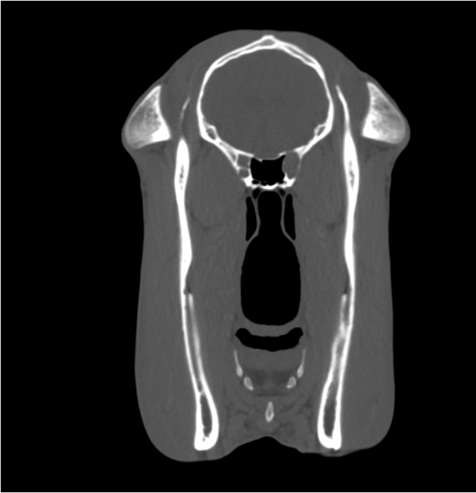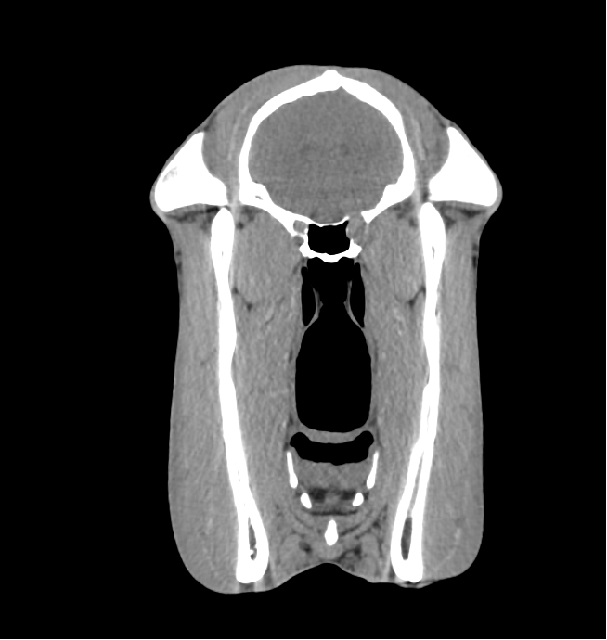
Figure 2. Transverse MPR CT images in a modified bone WL 350 WW 1500 (left image) and soft tissue window WL 35 WW 350, at the level of the emergence of the maxillary nerve from the rostral alar foramen. There is enlargement of the rostral alar foramen, with thinning of the bone margins and loss of definition with the orbital fissure and base of the skull dorsally, likely consistent with enlargement of the neurovascular bundle (highlighted by arrow). The orbital fissure on the right side cannot be identified as a separate structure whereas this is well defined on the left.
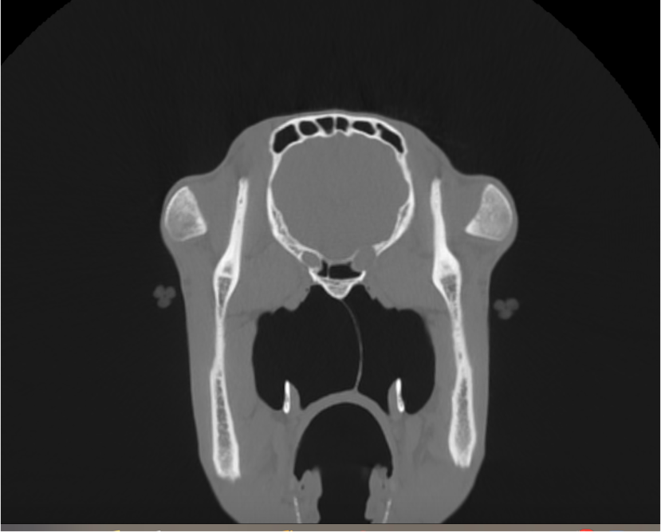
Figure 3. Transverse MPR CT images in a modified bone window WL 350 WW 1500 at the level of the rostral alar canal. There is enlargement of the right rostral alar canal which was suspected to be due to enlargement of the neurovascular bundle at this level creating a mass effect and thinning of the bone of the alar canal (highlighted by arrow). As a result, there is effacement of the soft tissue attenuating nerve root with the soft tissue structures of the base of the skull.
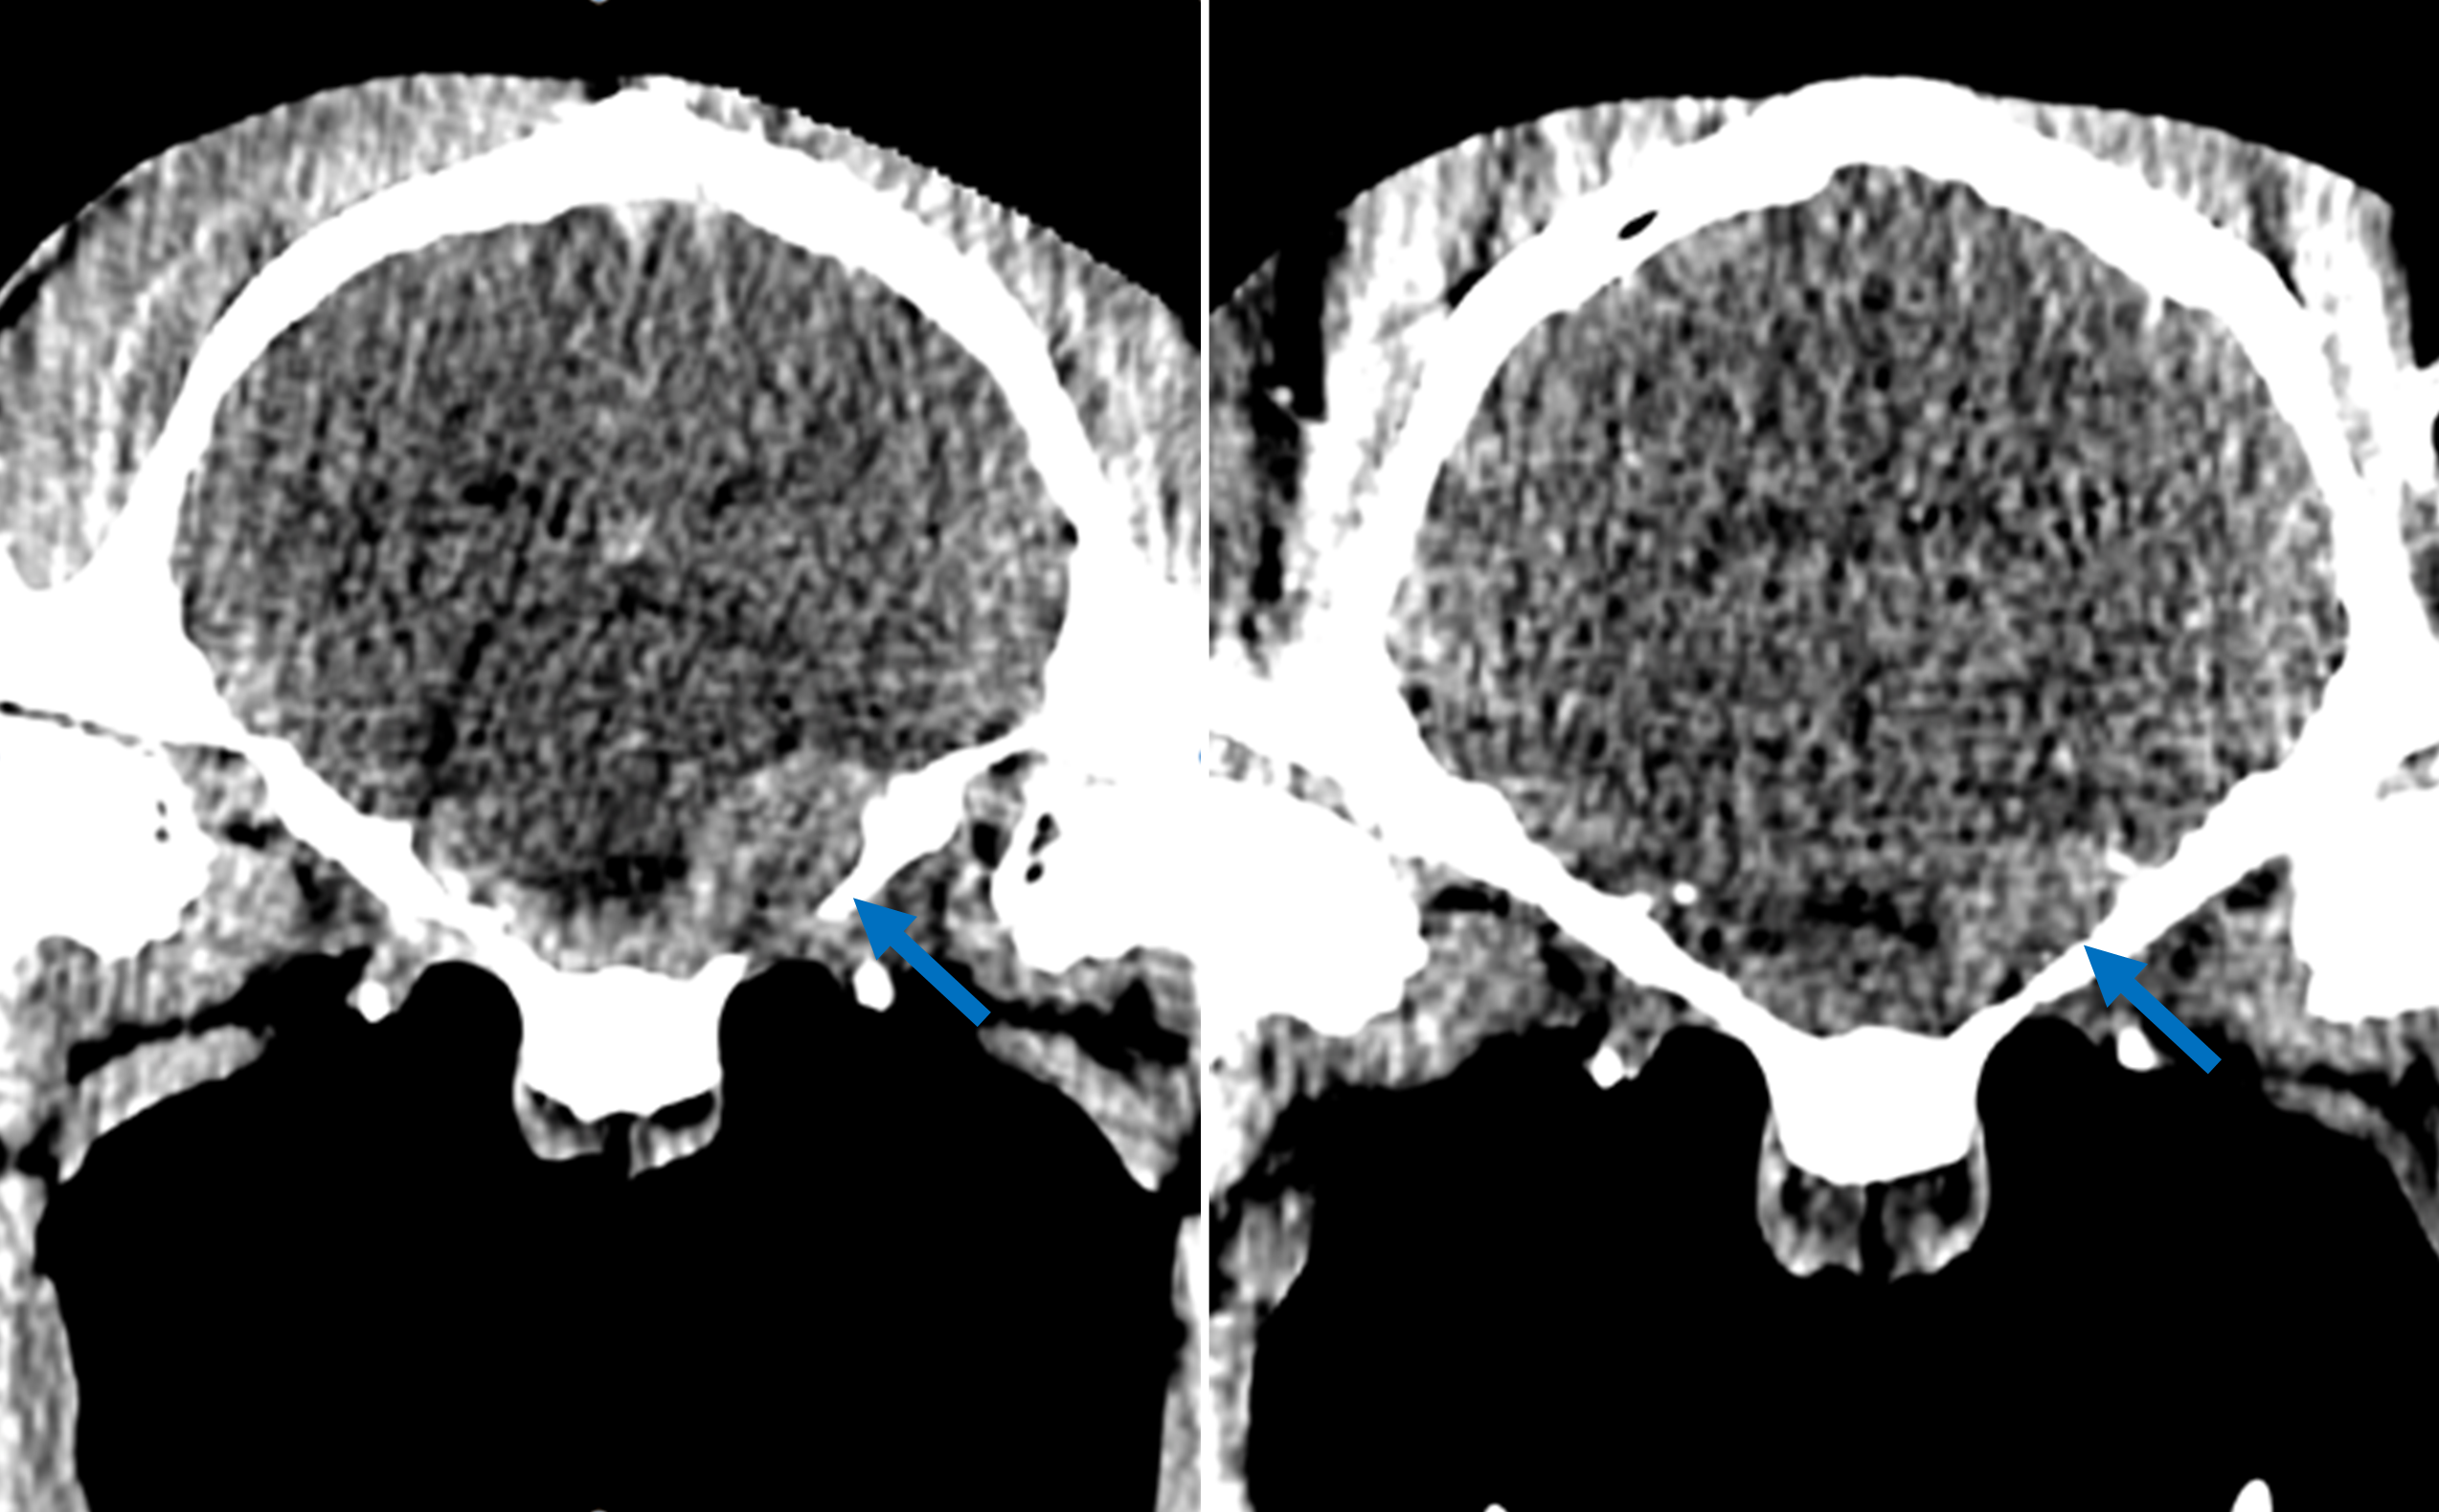
Figure 4: Transverse MPR CT images in brain window WL 50 WW 100 at the level of the temporomandibular joints with contrast enhancement (left) and as a plain study (right). The image provides subjective contrast enhancement of the area of the trigeminal nerve with improved delineation from surrounding soft tissue.
- Outcome
Considering the impact of this condition on the horse’s welfare, and the lack of treatment options, the decision was made to humanely euthanise the horse. Humane euthanasia was performed with intravenous injection of cinchocaine hydrochloride and quinalbarbitone sodium solution (Somulose®, Dechra Veterinary Products, Shropshire, UK.) The gelding then underwent post mortem examination for extraction and examination of the trigeminal nerves and CNS.
- Post Mortem findings
The trigeminal nerve was enlarged at the level of the orbital fissure and rostral alar foramen, causing mild compression atrophy of the homolateral brainstem. A haematoma was also identified in the right caudal maxillary sinus (Fig. 4A). Histopathology confirmed that the vast majority of the nerve was obscured and replaced by the infiltration of a squamous cell carcinoma, with residual ganglional cells and numerous degenerate axons intercalating amongst nests of squamous keratinocytes (Fig. 4B-D).

*
*
*
Figure 5: Post mortem images of the skull following sagittal transection. A) The trigeminal nerve (highlighted by arrow) is notably enlarged with an irregular surface at the level of the rostral alar foramen. B) Cross section through the trigeminal nerve showing near complete infiltration and replacement of normal nerve architecture by infiltrating SCC. C) Ganglional cells (asterisks) with rim of satellite cells are displaced laterally by nests of neoplastic squamous keratinocytes, cross section. D) Axonal degeneration with axonal fragments and myelin sheath oedema, longitudinal section. H&E (B-D), 4x (B) and 200x (C-D) magnification.
- Discussion
This case describes a squamous cell carcinoma which resulted in dysfunction of the oculomotor and trigeminal nerves on the right side. The case demonstrates the use of a thorough neurological assessment to aide neurolocalisation. By identifying the cranial nerves affected in this case, we were able to use this information to focus on the area of pathology on CT. Gonçalves et al. (2015) study demonstrates the anatomical landmarks for the cranial nerves in the horse on both CT and Magnetic Resonance Imaging (MRI). This study shows that the cranial nerves; oculomotor (CN III), trochlear (CN IV), abducens (CN VI), and the ophthalmic branch of the trigeminal nerve (CN V) course together as group through the alar canal, exiting the skull at the level of the orbital fissure. The maxillary branch of the trigeminal nerve enters the round foramen and also travels though the alar canal, exiting the skull through the alar foramen, in close proximity ventrally to the orbital fissure. This study, therefore, may indicate that the level of nerves affected may also suggest involvement of both the trochlear (CN IV) and abducens (CN VI) nerves, though medial or dorsomedial strabismus was not noted in this case.
Typically, MRI is used as the gold standard imaging modality for identification of peripheral nerve sheath tumours in dogs and humans, due to superior soft tissue contrast detail (Abreu et al, 2013, Bagley et al, 2015, Zhai et al, 2019). However high field MRI units which are suitable for use in equine skulls, are not widespread for use in the UK and require a general anaesthetic, which may be less favourable in horses exhibiting neurological signs (especially with intracranial disease).
The main differentials for the mass seen on CT were neoplastic, inflammatory, or infectious. Previous case reports of horses with masses in close proximity with the cranial nerves have described multiple differing diagnoses, firstly peripheral nerve sheath tumour (Kappe et al., 2009; Schneider et al., 2010; Federici et al, 2015; Lemonnier et al., 2022) and granulomatous neuritis (Beltran et al., 2016). In light of this, imaging alone cannot reach a conclusive diagnosis. Sadly, all previous case reports relating to neoplasia affecting the cranial nerves in the horse have resulted in euthanasia due to the grave outcome. To our knowledge, this is the first report of a squamous cell carcinoma (SCC) resulting in trigeminal nerve dysfunction in a horse. Due to its infiltrative nature, it is plausible that the current neoplasm represents the local extension from a primary neoplasm originating from either the oral or respiratory mucosa, whose primary site has not been appreciated during post mortem examination. This tumour exhibited high grade malignancy, with the histologic malignancy score of 23 out of 24 following the grading system described by Strohmayer et al (2020), which is equivalent to grade IV on the human malignancy grading system described by Anneroth et al (1987). This is consistent with the findings of a review of equine squamous cell carcinomas, where most horses (13/14) had categorisation as grade 3 or above with a highly invasive nature (Strohymayer et al, 2020).
Tumours of the trigeminal nerve are well described in dogs. The clinical signs are similar to those seen in this case, with masticatory muscle atrophy, reduced facial and corneal sensation with absent palpebral reflex (Bagley et al, 1998, Swift et al, 2017). Occasionally, neurological signs associated with compression of the brainstem occur with seizure activity, ataxia and/or hemiparesis. In a case series of 27 dogs, the most common trigeminal branch affected was the mandibular (26/27), followed by the maxillary (22/27) and then the ophthalmic (10/27) (Swift et al, 2017). Interestingly, dogs with trigeminal nerve dysfunction affecting the mandibular branch will commonly show tympanic effusion due to loss of innervation of the tensor veli palatini muscle (Kent et al, 2013). The tensor veli palatini muscle normally functions to open the pharyngeal orifice of the auditory tube in humans and dogs, and the pharyngeal orifice of the guttural pouch in horses (Baptiste, 1997). The tensor veli palatini muscle also has a role in palatal stability during intense exercise in the horse (Holcombe et al, 1997). This highlights the importance of thorough image interpretation in cases with suspected trigeminal nerve dysfunction. The case described here had no evidence of tympanic or guttural pouch effusion, again supportive of normal mandibular branch function. There are anatomical variations of the trigeminal nerve routes in different species, as the mandibular branch exits more caudally in horses, at the foramen lacerum, when compared to dogs (Levine et al, 2008, Gonçalves et al, 2015). This anatomical variation may explain why the mandibular branch function remains intact in this case.

Tumours affecting the trigeminal nerves in dogs are treated with stereotactic radiation therapy (Hansen et al, 2016). However, currently there is no evidence of significantly improved survival time in radiated versus unirradiated dogs, though this treatment when combined with corticosteroids may ameliorate neurological signs with intracranial disease, thus improving quality of life. (Swift et al, 2017).
- Summary
This case describes the sudden onset of trigeminal nerve dysfunction. The clinical findings directed the advanced imaging. The latter identified enlargement of the rostral alar foramen and neurovascular bundles, with osseous lysis, which was suggestive of neoplasia. Following euthanasia, post mortem findings demonstrated the mass to be a squamous cell carcinoma that likely originated from the oral or respiratory mucosa. The primary lesion was not identified in either the pre- or post-mortem studies.
This report highlights the need for accurate clinical assessment of cranial nerve function alongside guided cross-sectional imaging to identify the lesion. Histopathology remains essential to confirm the diagnosis.

Supplementary item:
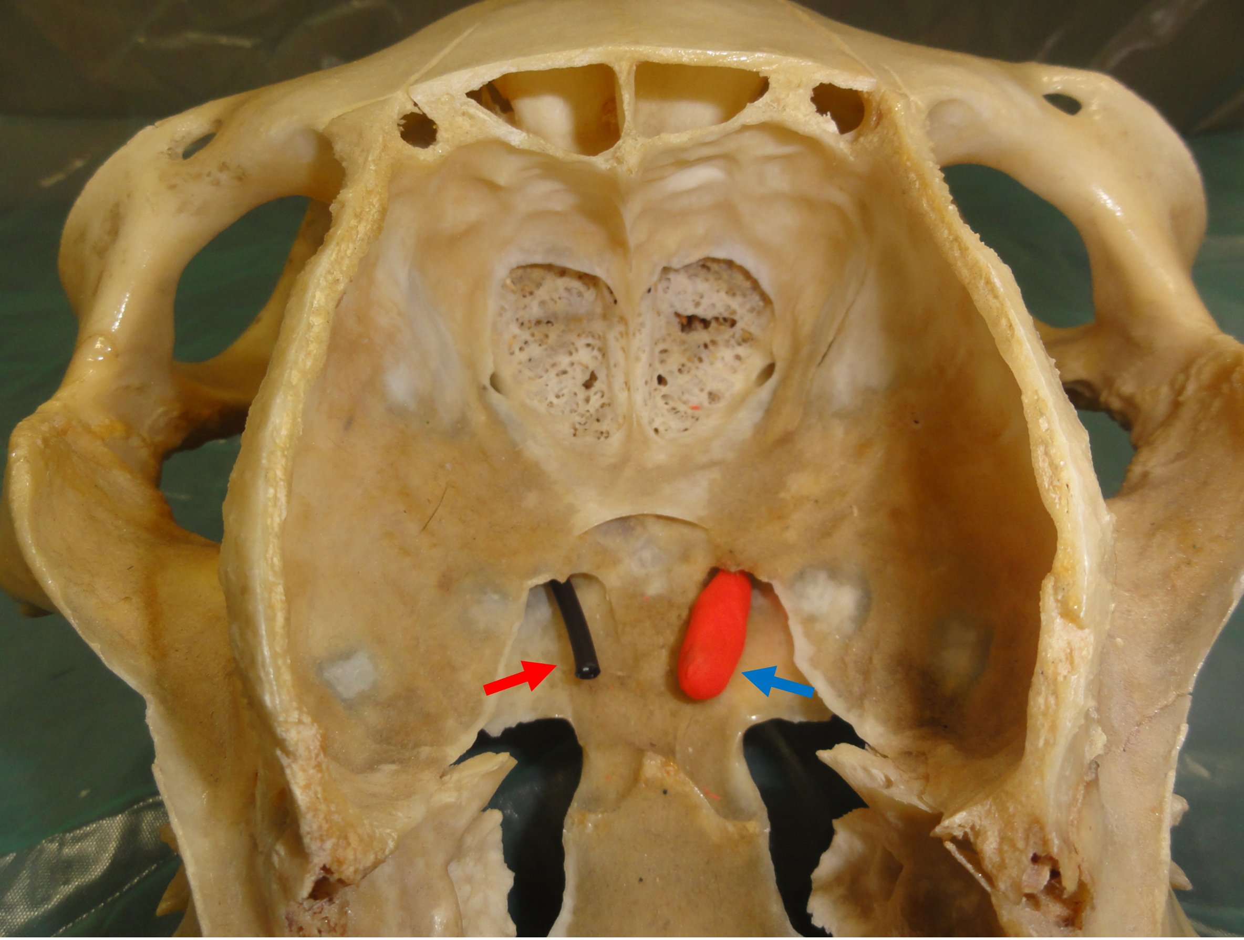
Figure 6: Coronal cross section of an equine skull to demonstrate the lesion location. The blue arrow highlights the abnormal right sided neurovascular bundle at the level of the alar foramen. The red arrow is provided for comparison to the normal contralateral neurovascular bundle.

References:
Abreu E, Aubert S, Wavreille G, Gheno R, Canella C, Cotten A. (2013) Peripheral tumor and tumor-like neurogenic lesions. European Journal of Radiology. , 82, 38-50.
Anneroth G, Batsakis J, Luna M (1987) Review of the literature and a recommended system of malignancy grading in oral squamous cell carcinomas. Scandinavian Journal of Dental Research. 95, 229–49.
Bagley, R. S., Wheeler, S. J., Klopp, L., Sorjonen, D. C., Thomas, W. B., Wilkens B. E., Gavin, P. R., Dennis, R. (1998) Clinical features of trigeminal nerve-sheath tumor in 10 dogs. Journal of the American Animal Hospital Association. 34,19-25.
Baptiste, K. (1997) Functional anatomy observations of the pharyngeal orifice of the equine guttural pouch (auditory tube diverticulum). The Veterinary Journal. 153, 311-9
Beltran, E., Grundon, R., Stewart, J., Biggi, M., Holloway, A., Freeman, C.(2016) Imaging Diagnosis – Unilateral Trigeminal neuritis mimicking peripheral nerve sheath tumor in a horse. Veterinary Radiology & Ultrasound. 57, E1-4
Boorman, S., Scherrer, N. M., Stefanovski, D., Johnson, A. L. (2020) Facial nerve paralysis in 64 equids: Clinical variables, diagnosis, and outcome. Journal of Veterinary Internal Medicine. 34, 1308-1320.
Federici, M., Del Chicca, F., Rütten, M., Fürst, A. and Bischofberger, A.S. (2015), Peripheral nerve sheath tumour of the equine maxillary sinus. Equine Veterinary Education. 27, 585-591.
Furr, M. & Reed, S. (2015) Examination of the nervous system. Equine neurology 2nd edn 6, 67-79
Gonçalves R, Malalana F, McConnell JF, Maddox T (2015) Anatomical study of cranial nerve emergence and skull foramina in the horse using Magnetic Resonance Imaging and Computed Tomography. Veterinary Radiology & Ultrasound. 56, 391-7.
Hansen, K. S., Zwingenberger, A. L., Théon, A. P., Pfeiffer, I., Kent, M. S. (2016) Treatment of MRI-Diagnosed Trigeminal Peripheral Nerve Sheath Tumors by Stereotactic Radiotherapy in Dogs. Journal of Veterinary Internal Medicine 30, 1112-20
Holcombe, S. J., Derksen, F. J., Stick, J.A., Robinson, N. E. (1997) Effect of bilateral tenectomy of the tensor veli palatini muscle on soft palate function in horses. American Journal of Veterinary Research 58, 317-321.
Kappe E. C., Köhler, K., Felbert, I. V., Teifke, J. P., Tóth, J., Reinacher, M. (2009) Pleomorphic corneal sarcoma resembling malignant peripheral nerve sheath tumor in a horse. Veterinary Pathology 46, 444-8.
Kent, M., Glass, E. N., de Lahunta, A., Platt, S. R., Haley, A. (2013). Prevalence of effusion in the tympanic cavity in dogs with dysfunction of the trigeminal nerve: 18 cases (2004-2013). Journal of Veterinary Internal Medicine. 27, 1153-8.
Lemonnier, L.C., Dorso, L., Tricaud, C., Fusellier, M. & Leroux, A.A. (2022) Otopathy secondary to trigeminal schwannoma in a Quarter Horse. Equine Veterinary Education, 00, 1– 7.
Levine, J. M., Levine, G. J., Hoffman, A. G., Bratton G. (2008) Comparative Anatomy of the Horse, Ox, and Dog: The Brain and Associated Vessels. Compendium Equine 2, 153-164
Schneider, A., Tessier, C., Gorgas, D., Kircher, P., Mamani, J. and Miclard, J. (2010), Magnetic resonance imaging features of a benign peripheral nerve sheath tumour with ‘ancient’ changes in the tongue of a horse. Equine Veterinary Education, 22, 346-351.
Strohmayer, C., Klang, A., and Kneissl, S. (2020) Computed Tomographic and Histopathological Characteristics of 13 Equine and 10 Feline Oral and Sinonasal Squamous Cell Carcinomas. Frontiers in Veterinary Science 7, 591437.
Swift KE, McGrath S, Nolan MW, Young M, Reese M, Rao S, Randall E, Leary D, LaRue S.(2017) Clinical and imaging findings, treatments, and outcomes in 27 dogs with imaging diagnosed trigeminal nerve sheath tumors: A multi-center study. Veterinary Radiology & Ultrasound 58, 679-689.
Zhai, H., Lv, Y., Kong, X, Liu, X., Liu, D. (2019) Magnetic resonance neurography appearance and diagnostic evaluation of peripheral nerve sheath tumors. Scientific Reports 9, 6939

