Concise Guidelines - The Diagnosis of Fibromyalgia Syndrome
Dr Richard Berwick¹, Dr Chris Barker² and Dr Andreas Goebel³ on behalf of the guideline development group

¹Richard Berwick, specialist registrar in Pain Medicine and Anaesthetics, Walton Centre NHS Foundation Trust and PhD student at Liverpool University. ¹Chris Barker is a Pain Physician, Mersey Care NHS Foundation Trust, ³Andreas Goebel, consultant and reader in Pain Medicine, Walton Centre NHS Foundation Trust and Liverpool University.
The full guideline is available from the Royal College of Physicians website (www.rcplondon.ac.uk).

Corresponding Author: Dr Richard Berwick, Pain Relief Institute, Clinical Sciences Centre, Lower Lane, Liverpool, L9 7AL. Email: richard.berwick@liverpool.ac.uk Telephone: 0151 5295835

Abstract
Fibromyalgia syndrome (FMS) is a common widespread primary pain condition, with a worldwide prevalence of 2-4%. Recent research has revealed important evidence for changes in central and peripheral nervous system functions and immunological activity. The diagnosis of FMS can be challenging with no known clinical laboratory investigations to confirm or refute its presence. Symptoms are commonly multiple, fluctuant and may not easily align with established medical diagnostic categories. It can be difficult for patients to articulate their array of symptoms, and for both patients and healthcare professionals to fully make sense of the complexities of the condition. As such, patients may be diagnosed inaccurately with alternative conditions, delaying diagnosis by years. The recent publication of the Royal College of Physician’s guidance aims to support clinicians in the diagnosis of FMS. Its purpose is to provide succinct, relevant information for patients and clinicians about FMS and its diagnosis.

Keywords: Fibromyalgia Syndrome, FMS, Diagnosis, Clinical Guidelines, Surgery, Nociplastic Pain, Chronic Pain

Introduction
Fibromyalgia syndrome (FMS) is a common condition characterised by persistent and widespread pain that is associated with intrusive fatigue, sleep disturbance, impaired cognitive and physical function and psychological distress.¹ It is classified in the International Classification of Diseases ICD-11 as Chronic Primary Pain.¹ FMS (MG30.01) has had many names such as fibrositis, or fibromyositis. It is now, however, accepted that these terms are misnomers, inaccurately implying muscle inflammation as the primary cause of pain. Although the aetiology is still abstruse, advances in research have shown that alterations in pain processing within the nervous system are likely causative.^{2,3}
The diagnosis of FMS can be challenging as there are no clinical laboratory investigations to confirm its presence. Symptoms fluctuate and may not easily map with established medical diagnostic categories. There is, therefore, a key need to support diagnosticians in managing this condition.

Scope and Purpose
This Concise Guideline summarises the key recommendations of the recent Royal College of Physician’s (RCP) UK Fibromyalgia Syndrome Guidance document on the diagnosis of adult FMS in both primary and secondary care.⁴ The guidance has been adapted to provide digestible information for clinicians and patients around a diagnostic encounter in both medical and surgical specialties. The purpose is to provide help in guiding clinicians towards improved and timely patient diagnosis and early management.

Recommendations
The FMS Diagnostic Consultation
When reviewing a patient, a number of features may signify the need to formally assess for FMS (Box 1).
- Widespread pain: pain in multiple regions of the body. Patients with FMS may not report widespread pain, instead reporting only focal pain.⁵ It is, therefore, important to directly ask about the presence of pain elsewhere.
- Intrusive fatigue. This may be physical, cognitive, or emotional (motivational) fatigue.
- Hypersensitivities. Increased sensitivity to sound, light or ambient temperature can represent changes in peripheral or central nervous system sensory processing.⁶ Widespread tenderness on clinical examination may indicate abnormal mechanical hypersensitivity.⁷
- Longevity of symptoms. Pain that has been present or recurrent for longer than 3 months is considered ‘chronic’ or ‘persistent’.
- Ineffective treatments so far. Drug treatments are often ineffective⁸ and rehabilitation focusing solely on mobilisation or classical musculoskeletal physiotherapy can also be ineffective and can even increase pain from FMS^{9,10}, both suggesting that abnormal pain processing predominates.
- Feeling overwhelmed (patients). Multiple symptoms¹¹ and their consequences such as disability and distress can be difficult to understand and patients often feel overwhelmed.
- Feeling overwhelmed (clinicians). Healthcare professionals may feel overwhelmed by the expansive symptomatology.

Box 1: FMS alert features
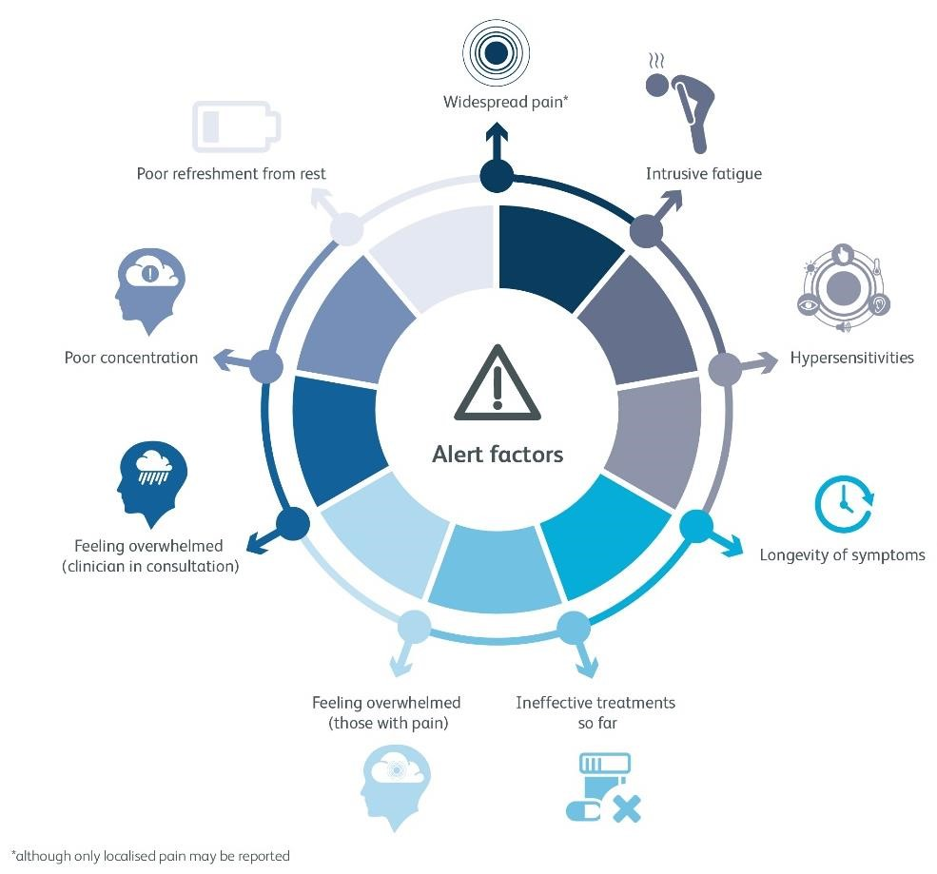

Diagnosing FMS
The diagnosis of FMS has made a departure from the specialist domain and can be initiated by physicians or practitioners who feel equipped to do so.¹² Making a diagnosis of fibromyalgia is likely to represent a significant juncture in the patient’s life, and as such, it is suggested that the clinician sets the scene appropriately (Box 2). The most recent best evidence-based guideline is the American College of Rheumatologists (ACR) 2016 diagnostic criteria¹² A diagnosis is made if the following are met. (A diagnostic sheet can be found in the guidance document). ⁴
1. Widespread pain index (WPI) ≥7 and symptom severity scale (SSS) score ≥5 OR WPI 4–6 and SSS score ≥9.
2. Generalised pain, defined as pain in at least 4 of the 5 body regions, is present
3. Symptoms have been present at a similar level for at least 3 months. Patients with symptoms below this threshold may be diagnosed with FMS if above threshold symptoms were recently documented.

In the case of uncertainty, referral to a specialist with experience in diagnosing fibromyalgia (usually a pain specialist or a rheumatologist) is recommended.

Box 2: Setting the scene when making the FMS diagnosis
Recommendation | Evidence
Acknowledge the patient’s life situation | E2
Allow sufficient time | E1+E2
Arrange additional appointments or refer where needed, and explain the arrangement | E2
Allow for a face-to-face diagnostic consultation if possible | E2
Key for evidence evaluation: E1=user or carer opinion; E2=professional or stakeholder opinion; RA/RB/RC=research grading based on published evidence. For details see Limitations (below).

Consideration of Differentials
FMS is not a diagnosis of exclusion; it may, and often does, exist alongside other conditions (e.g., rheumatoid arthritis, systemic lupus erythematosus, ankylosing spondylitis). There are no specific diagnostic tests for FMS but it is recommended that treatable conditions be examined for (Box 3).

Box 3: Considering differentials
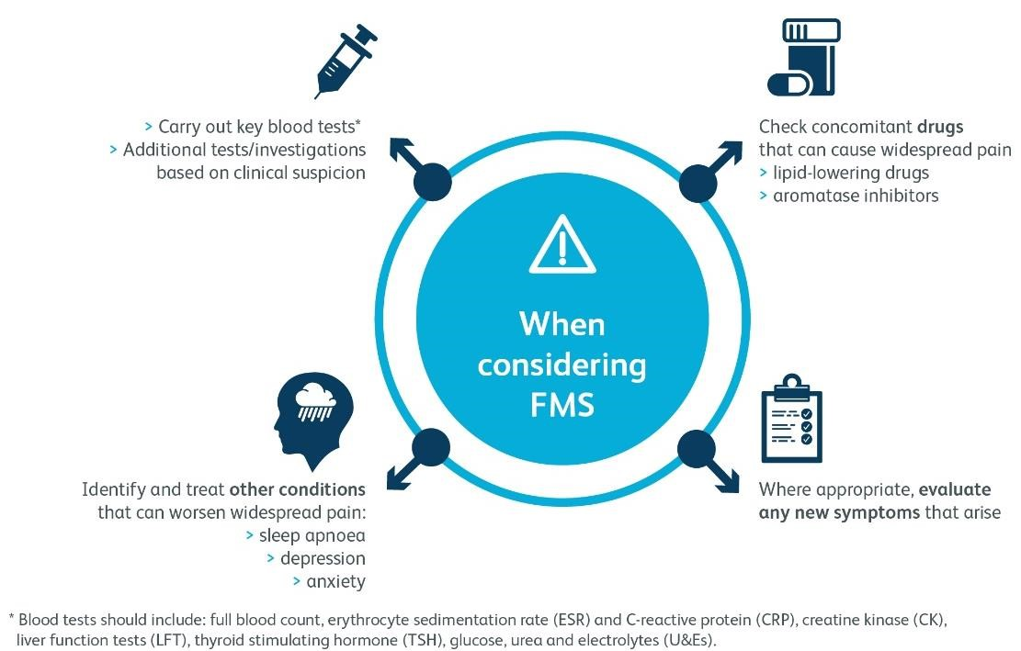

When a Diagnosis is Not Certain
- Reasons for diagnostic uncertainty may include:
  - fluctuant symptoms just below the ACR diagnostic threshold;
  - multiple health conditions (e.g., inflammatory conditions or depression) independently impacting the ACR widespread pain index or symptom severity score.
- Symptoms evolve and it is appropriate to share any diagnostic dilemma with the patient, applying a ‘watchful waiting’ strategy.¹³
- ‘Safety netting’ is often necessary, by sharing important clinical symptoms or signs with the patient that may indicate alternate diagnoses.
- Sensitisation does not have temporal linearity, i.e., there is no evidence that sub-threshold symptoms will always progress to an FMS diagnosis.¹⁴
- Diagnostic uncertainty should not preclude agreeing a shared plan using the best evidence for the management of chronic pain.

Clinical Management
Clinical management is beyond the scope of this diagnostic guideline and is covered elsewhere¹⁵, but some general principals are suggested (Box 4).

Box 4: Clinical management and essential information
Recommendation | Evidence
Management of pain, including management with information, rehabilitative methods, and connect with non-clinical support groups can reduce suffering. This should be done in parallel to investigation. | E1+E2
Established pain medications or normal musculoskeletal physiotherapy are often not effective or can even cause harm and the patient should be advised accordingly. ^{8,15,16,17} | E1+E2, RA
FMS is a long-term condition, sometimes requiring planned reviews in primary or secondary care. Development of a therapeutic relationship is crucial if expertise from both clinician and patient is to be effectively utilised in a shared management plan.^{16,18} | E1+E2,  RB

FMS and Perioperative Care Specific to Surgical Practice
FMS is a common condition, and whilst FMS pain is not itself amenable to surgery, many patients with FMS will undergo surgery. Nociceptive pain (pain due to mechanical or inflammatory stimuli) may be amenable to surgery. Neuropathic pain (pain caused by a lesion to the nervous system) may sometimes be amenable to surgery. However, most chronic pains are neither nociceptive nor neuropathic. Their mechanism is termed nociplastic^{2,19}, whereby abnormal pain processing is primarily responsible.
When practising in surgery, there are some important alert factors to suggest that the pain may be nociplastic (Box 5). If nociplastic pain, or FMS is suspected, the direction of referral following surgical assessment will depend on the local situation, and may include back to the GP or to a pain clinic. In this situation, patient communication is vital and may require finesse in surgery as much as medicine (Box 6).

Box 5: FMS alert factors in practice
Recommendation |  | Evidence
Clinicians should be alert to the possibility of FMS if any of the following factors are evident:
a) Pain
Pain out of proportion to pathology now, or in the patient’s history, either in the currently painful or other body regions |  | E2
Chronic pain in more than one location¹⁴ |  | RC
b) Effectiveness of treatment for pain
 | Pain not improving with prior surgeries for this or other problems. This includes pain recurrence both immediately – or months after surgery | E2
 | History of repeated surgeries for this or other painful problems | E2
 | Medication treatment or physiotherapy not effective or even worsening  pain^{8,17} | E2, RC
c) Other factors
Presence of fatigue, non-refreshing sleep, psychological distress and cognitive decline (such as short-term memory problems or problems with thinking) |  | E2, RC
High perioperative pain, and high analgesia requirements in earlier operations²⁰⁻²² |  | E2, RB

Box 6: Communication with your patient and other healthcare professionals
Recommendation |  | Evidence
a) What to say to your patient
 | State the reason for the referral (why is the patient here) | E1+E2
 | State that you can exclude the surgical cause, and explain why | E1+E2
 | State that this does not mean that there is no reason for their pain | E1+E2
 | If you suspect that this could be nociplastic pain, then explain this to the patient and provide them with a nociplastic pain information leaflet⁴ | E1+E2
b) What to include in the clinic letter
Mention suspected nociplastic pain or FMS within the clinic letter. This will provide important information to other healthcare professionals |  | E2
Clarify that the specific surgical cause for their pain has been excluded |  | E1+E2
c) What not to say to your patient
 | ‘There is no reason for your pain’ | E1+E2
 | ‘There is nothing wrong with you’ or ‘I can’t find anything wrong with you’ | E1+E2
 | ‘It is all in your head’ | E1+E2
 | ‘It is psychological’ | E1+E2
 | ‘There is nothing we can do’, without providing further information | E1+E2
 | ‘There is nothing anyone can do’ | E1+E2

Decision to Operate
Patients with FMS often respond to surgical interventions differently to patients without FMS with a similar lesion and their management may benefit from the involvement of a multidisciplinary team. It should be noted that failure to relieve pain with surgery may often only become apparent many months afterwards, because surgery may evoke a significant placebo response, and some types of anaesthetic may temporarily diminish nociplastic pain by reducing central sensitisation.²³ The true long-term effect of surgery on pain is impossible to gauge outside clinical trials. Pain increase post-surgery may also reflect an independent FMS pain flare.

Patients Without a Formal Diagnosis of FMS
Surgeons should be aware that patients who have some features of FMS – even if these do not trigger a formal diagnosis of FMS – may achieve poorer pain relief from surgery.^{24,25} Patients with mostly regional pain (e.g., painful knee osteoarthritis) may possess symptoms akin to FMS such as fatigue, hypersensitivity to sensory stimuli, poor sleep, poor memory, psychological distress, without meeting FMS criteria.¹¹ The causes for these symptoms are unknown and they are not considered psychological, although psychological distress is often present.
The degree of symptomatology is thought to relate to the degree of nervous system sensitisation. Research indicates that even below the threshold for diagnosis surgical outcomes may be affected: as a group, patients with high scores are likely to be at risk of poor pain improvement following surgery.²⁶ Conversely, the response to surgery among patients with high sensitisation scores is diverse and many patients do have good outcomes. Six months after knee or hip replacement surgery, two thirds of patients with high preoperative sensitisation scores, but not FMS, reported improvement in regional pain but also in generalised symptoms, such as fatigue and poor sleep.²⁷ However, the remaining one-third experienced either no improvement or, worse, an increase in pain following their operation. Sadly, no reliable tool yet exists to predict surgical responders.

Limitations
The guidance was compiled using the standards set out by the AGREE collaboration.²⁸ A methodology table is available online with a comprehensive description of the procedure in the main RCP guidance document.⁴ The recommendations were formulated through panel consensus, considering the existing literature. Randomised control trial (RCT) data was used as a priority. However, due to a paucity of RCT-based evidence specifically informing diagnosis and management, many of the recommendations were based on the expert opinion of service users (E1) and professionals (E2) (as per The National Service Framework for Long Term Conditions).²⁹ Where research exists, this is denoted RA (high quality) and RB (medium quality) or RC (low quality), as detailed in the guidance methodology.⁴ This guidance refers to the adult population.

Implications for implementation
For the Physician, be cognisant of alert features of FMS in consultations. When making a diagnosis of FMS use the ACR 2016 criteria¹². FMS may coexist with other medical conditions and a diagnosis can be made with detailed history and examination in conjunction with standard blood tests to exclude other treatable conditions. For the Surgeon, when considering the appropriateness of a patient for surgery be aware of alert features of FMS and nociplastic pain. If a patient with FMS presents for surgery to treat pain, consider whether their pain is amenable to surgery and communicate this effectively. If surgery is indicated involvement of the MDT may be helpful for optimal outcomes.

Acknowledgements
The input of all GDG members is gratefully acknowledged. A complete list can be found in the RCP guidance document ⁴. RB, CB and AG are all members.

References
1. Nicholas M, Vlaeyen JWS, Rief W, et al. The IASP classification of chronic pain for ICD-11: chronic primary pain. Pain 2019;160:28-37.
2. Fitzcharles MA, Cohen SP, Clauw DJ, Littlejohn G, Usui C, Hauser W. Nociplastic pain: towards an understanding of prevalent pain conditions. Lancet 2021;397:2098-110.
3. Clauw DJ, D'Arcy Y, Gebke K, Semel D, Pauer L, Jones KD. Normalizing fibromyalgia as a chronic illness. Postgrad Med 2018;130:9-18.
4. Royal College of Physicians. The diagnosis of fibromyalgia syndrome. UK clinical guidelines. London: RCP; 2022.
5. Mansfield KE, Sim J, Croft P, Jordan KP. Identifying patients with chronic widespread pain in primary care. Pain 2017;158:110-9.
6. Berwick RJ, Siew S, Andersson DA, Marshall A, Goebel A. A Systematic Review Into the Influence of Temperature on Fibromyalgia Pain: Meteorological Studies and Quantitative Sensory Testing. J Pain 2021;22:473-86.
7. Berwick RJ, Andersson DA, Goebel A, Marshall A. After-Sensations and Lingering Pain following Examination in Patients with Fibromyalgia Syndrome. Pain Med 2022.
8. Macfarlane GJ, Kronisch C, Dean LE, et al. EULAR revised recommendations for the management of fibromyalgia. Ann Rheum Dis 2017;76:318-28.
9. Lima LV, Abner TSS, Sluka KA. Does exercise increase or decrease pain? Central mechanisms underlying these two phenomena. J Physiol 2017;595:4141-50.
10. Chafer S, Hamilton F. Efficacy of Manual Therapy as a Treatment for Fibromyalgia Patients. Journal of Physical Therapy and Health Promotion Sept 2015;3:28-38.
11. Wolfe F, Clauw DJ, Fitzcharles MA, et al. The American College of Rheumatology preliminary diagnostic criteria for fibromyalgia and measurement of symptom severity. Arthritis Care & Research 2010;62:600-10.
12. Wolfe F, Clauw DJ, Fitzcharles MA, et al. 2016 Revisions to the 2010/2011 fibromyalgia diagnostic criteria. Semin Arthritis Rheum 2016;46:319-29.
13. van Bokhoven MA, Koch H, van der Weijden T, et al. The effect of watchful waiting compared to immediate test ordering instructions on general practitioners' blood test ordering behaviour for patients with unexplained complaints; a randomized clinical trial (ISRCTN55755886). Implement Sci 2012;7:29.
14. Bair MJ, Krebs EE. Fibromyalgia. Annals of Internal Medicine 2020;172:ITC33-ITC48.
15. National Institute for Health and Care Excellence. Chronic pain (primary and secondary) in over 16s: assessment of all chronic pain and management of chronic primary pain. London: NICE; 2021
16. Fitzcharles MA, Ste-Marie PA, Goldenberg DL, et al. 2012 Canadian Guidelines for the diagnosis and management of fibromyalgia syndrome: executive summary. Pain Res Manag 2013;18:119-26.
17. Mascarenhas RO, Souza MB, Oliveira MX, et al. Association of Therapies With Reduced Pain and Improved Quality of Life in Patients With Fibromyalgia: A Systematic Review and Meta-analysis. JAMA Intern Med 2021;181:104-12.
18. Bieber C, Müller KG, Blumenstiel K, et al. A shared decision-making communication training program for physicians treating fibromyalgia patients: effects of a randomized controlled trial. J Psychosom Res 2008;64:13-20.
19. Kosek E, Cohen M, Baron R, et al. Do we need a third mechanistic descriptor for chronic pain states? Pain 2016;157:1382-6.
20. Brummett CM, Janda AM, Schueller CM, et al. Survey criteria for fibromyalgia independently predict increased postoperative opioid consumption after lower-extremity joint arthroplasty: a prospective, observational cohort study. Anesthesiology 2013;119:1434-43.
21. Janda AM, As-Sanie S, Rajala B, et al. Fibromyalgia survey criteria are associated with increased postoperative opioid consumption in women undergoing hysterectomy. Anesthesiology 2015;122:1103-11.
22. As-Sanie S, Till SR, Mowers EL, et al. Opioid Prescribing Patterns, Patient Use, and Postoperative Pain After Hysterectomy for Benign Indications. Obstet Gynecol 2017;130:1261-8.
23. Schwartzman RJ, Alexander GM, Grothusen JR, Paylor T, Reichenberger E, Perreault M. Outpatient intravenous ketamine for the treatment of complex regional pain syndrome: a double-blind placebo controlled study. Pain 2009;147:107-15.
24. Brummett CM, Clauw DJ. Fibromyalgia: a primer for the anesthesia community. Curr Opin Anaesthesiol 2011;24:532-9.
25. Wolfe F. Fibromyalgianess. Arthritis Rheum 2009;61:715-6.
26. Brummett CM, Urquhart AG, Hassett AL, et al. Characteristics of fibromyalgia independently predict poorer long-term analgesic outcomes following total knee and hip arthroplasty. Arthritis Rheumatol 2015;67:1386-94.
27. Schrepf A, Moser S, Harte SE, et al. Top down or bottom up? An observational investigation of improvement in fibromyalgia symptoms following hip and knee replacement. Rheumatology (Oxford) 2020;59:594-602.
28. Brouwers MC, Kho ME, Browman GP, et al. AGREE II: advancing guideline development, reporting and evaluation in health care. Cmaj 2010;182:E839-42.
29. Turner-Stokes L, Harding R, Sergeant J, Lupton C, McPherson K. Generating the evidence base for the National Service Framework for Long Term Conditions: a new research typology. Clin Med (Lond) 2006;6:91-7.

