**Improve it or reveal it? Product innovation and demonstration decisions**

**under different supply chain contract modes**

[Citation: Li, Y., Li, B., Song, D., Wu, S. (2021), Improve it or reveal it? Product innovation and demonstration decisions under different supply chain contract modes, Computers & Industrial Engineering, 162, 107757.]

**Abstract**

When consumers are uncertain about their choice of a product, the product innovation effort and the product demonstration level will significantly affect product sales. Under the impact of factors such as contract mode, channel competition, and product competition, the relationship between firms’ decisions on innovation effort and demonstration level will become more complicated. This study comprehensively models and analyzes the interaction between the manufacturer's product innovation effort and the retailer's product demonstration level in a dual-channel supply chain under either the agency contract mode or the wholesale contract mode. In our model, a manufacturer sells his innovative product through a retailer’s physical store under wholesale or agency contract mode, as well as his direct online channel. The results show that under two contract modes, the trend of the demonstration level is almost opposite. Moreover, the correlations between the innovation effort and the demonstration level decisions under the two contract modes are opposite. From the perspective of marketing strategy, when the potential market of the innovative product is not too small, the *penetration strategy* is preferred under the agency contract mode, whereas the *skimming strategy* is preferred under the wholesale contract mode. In certain conditions, two firms can achieve Pareto optimality by choosing the agency contract mode. Besides, we find that the consumer showrooming behavior makes two firms more likely to achieve Pareto optimality, while the manufacturer’s introduction of the online direct sales channel will not hurt the retailer, who can avoid the loss of profit by adjusting the product demonstration level decision.

***Keywords:***dual-channel supply chain management, product innovation, product demonstration, contract mode, Bayes updating

1. Introduction

In this paper, we investigate the interactions between the retailer’s product demonstration level decision and the manufacturer’s product innovation effort in dual-channel supply chain context under either wholesale or agency contract mode.

In practice, a manufacturer with a dual-channel supply chain needs to balance revenue from both channels, while a retailer selling multiple products needs to balance revenue from different products. Examples of such supply chain structure are common. Manufacturers may sign a ***wholesale contract*** or ***agency contract*** with a professional retailer to sell products in the retailer’s physical stores, where their products will be demonstrated. For example, large brick-and-mortar retailers, such as Gome, Suning, and Sephora, operate either wholesale or agency contracts with their upstream manufacturers (Shen et al., 2019). Meanwhile, under the E-commence environment, most manufacturers open an online direct sales channel as a supplement to the retail channels, like Apple, Haier, etc. Retailers may also sell their store brand products as a complement to their product line. According to the Private Label Manufacturers Association, store brands account for one-fifth products sold every day in the US[1]. This phenomenon can be seen in examples such as Sephora, Watson, Wal-Mart, and Tesco (Jin et al., 2017). When a retailer sells a store brand product as alternatives, its relationship with the manufacturer is not only a buying and selling relationship but also a competitive relationship (Dhar & Hoch, 1997; Chai et al., 2020). Thus, competition between store brand product and innovative product, and competition between the physical channel and the online channel complicate the production and marketing decisions of the firms in the supply chain.

With the changing environment and advances in technologies, manufacturers are forced to invest in innovative products to maintain their competitive edge. This paper focuses on ***product innovation***, such as the introduction of new features, which could add value to products and meet consumers’ preferences (Boleslavsky et al., 2017; Jiang et al., 2017). The manufacturers need to determine how much innovation efforts that they should invest in the innovative product under different contract modes. From the consumers’ perspective, they may have higher valuations for innovative products, but they may also think that some innovations are not suitable for their preferences. However, they are often uncertain about the attributes of innovative products before evaluating or consuming them. Thus, on the one hand, the innovation level of the manufacturer’s products can increase consumers’ valuation; on the other hand, the product promotion methods such as product demonstration can reveal the attribute information of the innovative products and influence consumers’ purchase decisions. Lal and Sarvary (1999) divided the product attributes into digital attributes and non-digital attributes. They indicated that digital attributes could be communicated on the online channel easily, while non-digital attributes have to be revealed by physical inspection of the product. Therefore, the manufacturer may *free ride* the retailer by using the demonstration service of the retailer to improve the revenue of the innovative product in the physical channel. In addition, since the manufacturer generates revenue from both online and physical channels, he may boost the innovation effort and thus get a *free ride by* the offline retailer. This leads to the phenomenon of *two-way free-ride effect*. Besides, the contract mode between the manufacturer and the retailer may have a significant impact on two firms’ decisions.

A physical retailer may increase consumers’ understanding of the innovative product through ***in-store product demonstration*** methods such as offering samples, trials, and return policies (Boleslavsky et al., 2017). Many studies have shown that revealing product attribute information to consumers via production demonstration is conducive to increasing selling prices and demands (Johnson & Myatt, 2006; Bernstein et al., 2009). However, other studies argue that revealing product information may be harmful to firms. For example, Heiman and Muller (1996) stated that consumers may find that the new product is unsuitable for them through product demonstration and thus give up the purchase. There also exists an emerging stream of literature that discusses the bidirectional impacts of new product demonstration (Chen & Xie, 2008; Kuksov & Lin, 2010; Boleslavsky et al., 2017). Thus, product demonstration may have a positive effect on the sale of the innovative product by increasing consumers’ valuation of the innovative product; but it may have a negative effect by revealing the mismatch between the innovation and the consumers’ preference that may cause consumers to turn to buy an alternative product. Physical retailers who resell innovative products need to choose the optimal in-store demonstration strategies under different contract modes. This paper considers a physical retailer demonstrates and resells a manufacturer’s innovative product, and also produces and sells her store brand product as an alternative product.

We consider consumers who care about both the valuation and suitability of the innovative product. For example, suppose a consumer wants to buy a facial cleanser. She learns that Lancôme had launched a new facial cleanser and *may be* *suitable* for her (i.e., meets her needs.) If she prefers shopping online, then she may choose to buy from Lancôme’s online store directly. Otherwise, she may want to go to Sephora and experience an in-store demonstration service if she prefers shopping offline. In Sephora, the consumer tries the sample of Lancôme’s new facial cleanser. If she believes the smell and the efficacy are indeed *suitable* for her, she may purchase it. But if she finds that the cleanser is *unsuitable* for her skin, she will give up purchasing and may turn to buy Sephora’s store brand facial cleanser as an alternative. This phenomenon is very common in the fields like clothing, food, and cosmetics. Some studies have used Bayesian updating to model the impact of product demonstration on consumers (Boleslavsky et al., 2017; Gao & Su, 2017). In line with them, this paper uses the same approach to describe consumer utilities under the impact of product demonstration.

This work attempts to comprehensively model and analyze the interactions between the manufacturer’s product innovation effort decision and the retailer’s product demonstration decision under two contract modes. We use game theory methods to build mathematical models. In the field of Economics and Management, game theory has been proven to be a suitable method for solving the optimal decisions of multiple members. Under the framework of game theory, when the behaviors of multiple decision-makers in the system interact, each decision-maker infers the decisions that other decision-makers may make based on the information one has, and makes one’s own optimal decisions accordingly. Specifically, we set up a game between a manufacturer (he) who produces an innovative product and a retailer (she) who owns an established store brand product. The manufacturer distributes his product through the retailer’s physical store under either agency contract mode or wholesale contract mode. He also sells the innovative product through his direct online channel. The manufacturer decides the innovation effort to be committed on his product, and the retailer decides the in-store demonstration level of the innovative product. Besides, we consider two dimensions of consumer heterogeneity: the *channel preferences* and the *true preferences on the innovation product.* As for the *channel preferences*, O-type consumers prefer the online channel, while P-type consumers prefer to visit the physical store. As for the *true preferences on the innovation product*, high- and low-type consumers are regarded as consumers who feel suitable and unsuitable for the innovation product after consuming, respectively.

We aim to examine the following questions:

(1) What are the optimal innovation and demonstration decisions of the innovative product under the agency contract mode or the wholesale contract mode, and how should the firms balance their markets (online and offline markets for the manufacturer, markets of innovative and alternative products for the retailer)?

(2) Under the firms’ optimal strategies, in what situations should the manufacturer and the retailer adopt the agency contract mode or the wholesale contract mode?

(3) Whether and when will the firms achieve Pareto optimality?

(4) What impacts do the costs (both innovation cost and demonstration cost) and the commission rate have on the Pareto optimality if it exists? What impact do the consumer showrooming behavior and channel structure have on the optimal outcomes?

The main contributions of this paper include:

(i) Our study shows that the wholesale price eases the *two-way free-ride effect* when the proportion of the high-type consumers is large. Both firms are more willing to commit higher level of effort on innovation and demonstration. Besides, the trend of the demonstration level is almost opposite under the two contract modes. When the potential market of the innovative product is not too small, two players will choose opposite marketing strategies under different contract modes: *penetration strategy* under the agency contract mode and *skimming strategy* under the wholesale contract mode.

(ii) The retailer is better off under the wholesale contract mode only when the proportion of the high-type consumers is small and the proportion of P-type consumers is medium. The manufacturer is better off under the wholesale contract mode when the proportion of the high-type consumers is not large and the proportion of the P-type consumers is not medium.

(iii) When the proportion of high-type consumers is small, two firms will achieve Pareto optimality by choosing the agency contract mode if the proportion of P-type consumers is medium or extremely small. When the proportion of high-type consumers is large, the two firms will always achieve Pareto optimality. When the proportion of the high-type consumers is large, a higher commission rate or lower unit costs of innovation or demonstration will generally reduce the case of Pareto optimality.

(iv) The showrooming behavior makes the two firms more likely to achieve Pareto optimality by choosing the agency contract mode. As for the impact of the channel structure, intuitively, the manufacturer may infringe the interests of the retailer by opening a direct sales channel. But our results show that because of the product demonstration level decision, neither firm will be worse off in the dual-channel scenario compared with the single-channel scenario.

The rest of this paper is organized as follows. We provide a literature review in Section 2. In Section 3, we describe the problem. In Section 4, we present the models under two contract modes respectively and analyze the equilibrium solutions to the models. In Section 5, we compare the optimal decisions and profits under the two contract modes and examine how the system parameters affect the contract preferences of the firms. Finally, we draw conclusions in Section 6. All proofs of the propositions are given in the Appendix.

2. Literature review

Three streams of research using game theory methods are closely related to this study: the product innovation decision, the effect of product demonstration, and the comparisons of manufacturer-retailer contract modes.

***2.1 Product innovation under supply chain structure***

The first stream explicitly considers firms’ product quality innovation in the context of the marketing channel. Most of the literature in this stream focus on oligopoly or duopoly market structure, considering factors such as innovation uncertainty, imitative innovation, cooperative innovation (Klastorin et al., 2016; Jiang & Shi, 2018; Hao et al., 2019). Some studies address product quality innovative strategies in the supply chains with upstream and downstream firms. Lin et al. (2014) studied the situation in a platform market where two firms make decisions about the innovation rate, and the platform decides two-sided fees for both firms and buyers. The innovation rate determines the probability of successful invention and market entry, as well as the quality of the products. Ge et al. (2014) investigated cooperative innovation behavior between upstream and downstream firms under a wholesale contract, in which the upstream firm invests in the components, and the downstream firm invests in the final products. Yin et al. (2015) considers a monopolistic firm that sells two successive generations of a product over two sale periods, and analyzed the firm's trade-in program on the demand and pricing-decision of two-generation products. Zhang et al. (2019b) investigated a Stackelberg game between a manufacturer and a retailer considering environment-conscious consumers. The manufacturer decides to produce a brown or green product and bears the green innovative cost if the green product is chosen. Gernert et al. (2020) investigated the subcontracting decisions on an innovative product project in a supply chain structure consisting of a manufacturer and two upstream suppliers.

Some researchers have incorporated marketing efforts when considering product innovation. Xiao and Xu (2012) studied the problem of product innovation decisions, including upstream and downstream firms. The marketing effort of the downstream marketer is more focused on directly expanding market volume than demonstrating product information to consumers. Song et al. (2017) integrated firms’ innovation and advertising decisions in a single marketing channel. They did not consider the impact of different contract modes on firms’ decisions, nor the negative effects of the marketing efforts.

***2.2 The effect of product demonstration***

The second relevant research stream explicitly addresses the decision or effect of product demonstration. Firms use various product demonstration methods, such as advertising, return policies, product samples, trials, and product reviews, to increase consumers’ awareness of the product and thus reduce the product uncertainty. Much attention has been attracted on this topic in the recent years.

Some studies have investigated the demonstration decisions under monopolist markets. Bagwell and Riordan (1991) studied how a firm demonstrates the quality information of a new product through pricing. Che (1996) built a model that includes the return policies provided by a monopolist firm, and consumers could choose whether to return after they bought the products. Gardete (2013) considered a firm that allows consumers to acquire product information through advertising. Wang and Özkan-Seely (2018) considered the situation that a monopolist firm offers a free trial period as a means of demonstration to allow consumers to experience the new product before making their purchase decision.

Several studies have focused on product demonstration in supply chains. Chaab and Rasti-Barzoki (2016) considered local advertising and global advertising as means of product demonstration and the manufacturer and the retailer in the supply chain can adopt cooperative advertising. Jena et al. (2017) considered a closed-loop supply chain in which a manufacturer and a retailer adopt joint advertising as a means to demonstrate the product and encourage consumers to return used items for remanufacturing. Hao and Tan (2018) investigated the incentives of a supplier and a retailer to demonstrate the information of the product and allow consumers to learn about their product valuation. Shi et al. (2019) studied the effect of channel structure and advertising authority on advertising content when consumers are uncertain about product match and retail price. Li et al. (2020) studied the effect of in-store product demonstration on consumer showrooming behavior in a dual-channel supply chain consisting of an online retailer and a manufacturer that owns an offline direct sales store. Based on the research of product demonstration decision-making in the dual-channel supply chains, this paper considers the analysis of the impacts of supply chain contract modes and product competition. Moreover, we assume that the product innovation efforts and the product demonstration level are both endogenous decisions.

Other literature studies the effect of product demonstration between competitive firms. Kuksov and Xie (2010) and Kwark et al. (2017) considered product information provided by two competitive firms that allow consumers to publish product reviews online. Boleslavsky et al. (2017) introduced product demonstration into a pricing competition model, in which the demonstration of the innovative product will increase the expected valuation of those consumers who receive favorable impressions of the innovative product. Hong et al. (2018) considered a model of two manufacturers, in which consumers learn the valuation information of the green product according to the greenness degree of the green product and the reference effect between two products. Piccolo and Pignataro (2018) considered the problem in which duopoly firms take product trial policy as a means of product demonstration.

***2.3 Comparisons of contract modes in supply chain***

The third stream concerns the contractual relationship between upstream and downstream firms in supply chains. Many researchers have considered various contract modes, especially wholesale contract mode and agency contract mode. Among them, some studies have focused on the influences of production and distribution factors between firms. Cachon and Lariviere (2005) compared agency contract mode with wholesale contract mode along with other modes. They showed that the agency contract mode can better coordinate a supply chain with retailers competing in quantities. Hagiu and Wright (2015) analyzed the differences between the wholesale and the agency contract modes in the situation when the supplier may have more demand information than the retailer. Abhishek et al. (2016) showed that an e-tailer will choose the agency contract mode if the electronic channel cannibalizes the demand in the traditional channel. Otherwise, it will choose the wholesale contract mode. Tian et al. (2018) investigated the influences of different proportional fees based on the product category on the firms’ preferences for agency contract mode or wholesale contract mode.

Other studies examined the impacts of marketing factors on firms and consumers. Kwark et al. (2017) compared the effects of fitness information disclosure between the agency contract mode and the wholesale contract mode under the influence of third-party information. Hao and Tan (2018) investigated a retailer’s and a supplier’s incentive to facilitate information disclosure to consumers under agency contract mode and wholesale contract mode. Liu et al. (2020) built a model that included a manufacturer and an online platform considering the impact of data-driven marketing and compared the platform’s preferences for agency or wholesale contract mode. Johnson (2020) considered a supply chain structure with a supplier and two retail platforms. The result showed that when one of the retail platforms can lock in consumers, the retail prices and profits of the rival retail platform are higher under the agency contract mode than that under the wholesale contract mode.

***2.4 Research contribution***

To sum up, few of the existing studies on product innovation under supply chain structure have considered the impact of innovation and demonstration efforts on valuation or suitability of consumers, nor have they considered product innovation and demonstration efforts in the context of different contract modes or dual-channel supply chains. However, when incorporating the issue of product innovation between upstream and downstream firms in the dual-channel supply chains, there are not only horizontal competitive relationships (competition between established product and innovative product, and competition between the physical channel and the online channel) but also a buying and selling vertical relationship between firms. The combination of these factors makes the decisions of product innovation and demonstration effort more complicated. The literature on the comparisons of contract modes mainly focused on the impact of inter-firm factors such as order quantity, uncertain or asymmetric demand information, and product category, or factors between firms and consumers such as information disclosure and consumer locking in. Few have investigated the interactions between the contract modes and the production and marketing processes. We extend this stream of research by modeling the interactive effects of innovation effort and demonstration level on the production and marketing processes.

As for the effect of product demonstration, our study is closely related to Boleslavsky et al. (2017). We use the method in Boleslavsky et al. (2017) to update the consumers’ valuation of the innovative product through the demonstration in the physical store, which has also been referenced by the literature such as Gao and Su (2017) and Li et al. (2020). The difference is that Boleslavsky et al. (2017) only discussed the influence of demonstration informativeness, without considering the innovation effort as a strategic decision. To better understand the role of two firms with an innovative product in the production and sale processes, our study combines the influences of the manufacturer’s innovation effort and the retailer’s in-store demonstration level. Besides, Boleslavsky et al. (2017) considered a pricing competition between duopoly and compared two kinds of sequences, while our study examines the impacts of different contract modes on upstream and downstream firms in a dual-channel supply chain. The supply chain structure in our model is similar to that in Chiang et al. (2003). But they did not consider the impact of product demonstration. Their results indicated that the profit of the manufacturer could be improved due to a direct sales channel augmented, while the retailer may be worse off. However, our results show that the retailer can use the product demonstration level decision to improve her profit.

3. Problem statement

***3.1 Supply chain structure and product innovation***

We model a market of two firms with two substitutive products, an established store brand product  provided by a traditional retailer (she) and an innovative product  produced by a manufacturer (he). The manufacturer sells his innovative product *M* through the retailer in her physical store. That is, the retailer sells products  and  in her offline store at prices  and . Meanwhile, the manufacturer opens an online store to sell his innovative product  at price . In this paper, the relationship between the manufacturer and the retailer for distributing product  is represented by either the agency contract mode or the wholesale contract mode. In the agency contract mode, the retailer charges the manufacturer a fraction  of the revenue by selling the innovative product  in the physical store. In the wholesale contract mode, the manufacturer charges the retailer a wholesale price  per unit for the innovative product  to be sold in the retailer’s store. The structures of the supply chains are shown in Figure 1. The main notations used in this paper are summarized in the Appendix.

The market consists of one unit mass of consumers who are familiar with the established product but uncertain about their true preferences on the innovative product . According to the Private Label Manufacturers Association, more than 90% of polled consumers felt familiar with store brands, and 83% of them purchased store brand products on a regular basis[2]. Therefore, the store brand product  is defined as an established product that consumers are generally familiar with. To promote the innovative product , the retailer will offer the in-store product demonstration to introduce the new product to consumers. We assume that the quality of product  is denoted as , which is known to consumers (Boleslavsky et al., 2017). The quality of the new product  is represented by , which is related to the innovation level of the product (Chenavaz, 2012). Here  represents the innovation effort committed by the manufacturer. Without loss of generality, we suppose  is normalized to .

This supply chain structure is common in practice. For instance, manufacturers such as Lancôme, Givenchy, and Loewe sell their items through beauty chain retailer Sephora and their online stores. Besides, Sephora sells more than 450 items under her store brand.[3] A similar phenomenon can be seen in examples such as Watson, Wal-Mart, and Tesco (Jin et al., 2017).

(a) agency contract mode (b) wholesale contract mode

Figure 1. The structures of the supply chain under different contract modes

***3.2 Consumer heterogeneity***

In this paper, we consider two dimensions of consumer heterogeneity in our modeling framework, i.e., the *channel preferences* and the *true preferences on product* .

As for the *channel preferences*, we assume that consumers are divided into two categories: O-type and P-type consumers. O-type consumers prefer purchasing online directly, and P-type consumers prefer going to the offline store to experience the product and then decide whether to buy it. We assume that the percentage of P-type consumers is , and the remaining  are O-type consumers (Cai et al., 2009; Wang et al., 2016; Zhang et al., 2019a). It means that the potential market shares for physical and online channels are  and , respectively.

As for the *true preferences on product* , consumers have two kinds of true preferences on the innovative feature of . Some consumers (referred to as high-type consumers) may feel the innovation suitable after consuming it. Other consumers (referred to as low-type consumers) may find the innovation unsuitable. The probability of a consumer being high-type is , and the probability of a consumer being low-type is . The high-type and low-type consumers are denoted by  and , respectively. Similar to Boleslavsky et al. (2017), we assume that the true valuation of high-type consumers is equal to its quality , and the true valuation of low-type consumers is . Consumers can only confirm their true valuations after fully evaluating or consuming the innovative product. ***Before evaluating or consuming*** the innovative product, all consumers ***do not*** know whether they are high- or low-type, only know that the probabilities are  and , respectively. That is, before going to the physical store, all consumers are supposed to be potential high-type (Boleslavsky et al., 2017; Gao & Su, 2017). This assumption is reasonable because only consumers who consider themselves being high-type can be potential consumers. Thus, both high- and low-type consumers share the same prior expected valuation of the product, i.e., .

To sum up, two dimensions of consumer heterogeneity are shown in Figure 2(a). Consumers know their *channel preferences* before the shopping decision. But they do not know their *true preferences on product M* before they physically evaluate it through the in-store demonstration or consume the product *M*. Figure 2(b) shows the consumer’s shopping decision. The demands and the expected valuations are represented by blue and red formulas, respectively.

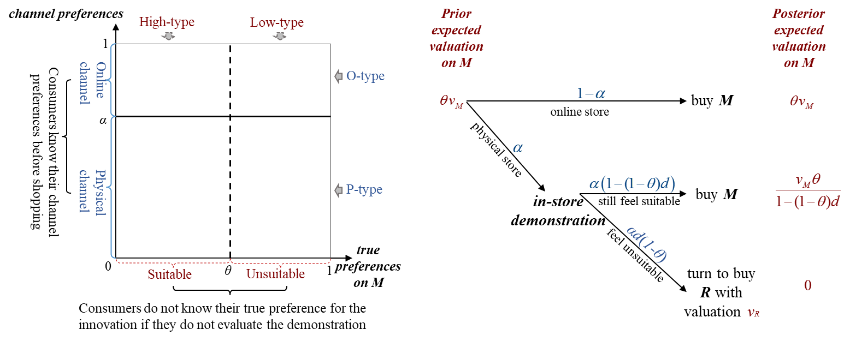

(a) Two dimensions of consumer heterogeneity (b) shopping decisions and valuations on *M*

Figure 2. consumer heterogeneities and shopping decisions

***3.3 Product demonstration***

Next, we elaborate on the effect of product demonstration. The retailer provides product demonstration in her physical store that allows consumers to evaluate the innovative product. The product demonstration can help consumers understand the suitability of product *M* to a certain extent. That is, the in-store demonstration will let some consumers identify the mismatch between their true preference and the innovation, i.e., the demonstration ***screens out*** some of the *low-type* consumers, while others remained to be potential high-type. The low-type consumers who find the innovation product unsuitable will give up purchasing , and other consumers will increase their expected valuation after experiencing the product demonstration and choose to buy . Thus, following Boleslavsky et al. (2017) and Gao and Su (2017), we assume that the impact of in-store product demonstration is modeled as a binary random signal  from which consumers draw either a “suitable” (i.e., ) or “unsuitable” (i.e., ) impression, corresponding to their realized perceptions and valuation about the product. With the product demonstration, a low-type consumer draws an unsuitable impression with conditional probability  and draws a suitable impression with conditional probability . Besides, a high-type consumer will always receive signal of “suitable” (Boleslavsky et al., 2017). This implies that the probabilities that a low-type and a high-type consumer receive a signal  are  and , respectively. Therefore,  can be interpreted as the demonstration level of product (Boleslavsky et al., 2017; Gao & Su, 2017).

According to the Bayes’ rule, the probabilities of consumers who feel suitable and unsuitable after evaluating the product through in-store demonstration become  and , respectively. For P-type consumers, before going to the physical store, their prior expected valuation of the innovative product is . After they go to the physical store, they receive the signal  or , and update their perceptions through the in-store demonstration. Thus, the posterior expected valuation of consumers with suitable impressions become . Other consumers with unsuitable impressions will update their valuation to  as the product  does not meet their preferences.

Thus, as shown in Figure 2(b), P-type consumers who draw suitable impressions will buy  offline at price  with posterior expected valuation , and others who draw unsuitable impressions will turn to buy  offline at price  with expected valuation . Besides, all O-type consumers will buy  online at price  with prior expected valuation . Therefore, the demands of the innovative product  in the online store and the physical store and the alternative product  in the physical store are ,  and , respectively.

Besides, we focus on the impacts of product innovation effort and demonstration level on consumers’ valuation and firms’ profits. Therefore, we explicitly consider the innovation and demonstration costs (Lin et al., 2014; Iyer & Soberman, 2016). Without loss of generality, the production costs of both firms are normalized to zero. The cost of product innovation is , where  represents the unit innovation cost, and the cost of product demonstration is , in which  represents the unit demonstration cost (Lin & Saggi, 2002; Li & Ni, 2018; Li et al., 2019a).

4. Models

In this section, we will establish the game theoretical models and solve the optimal decisions problems under the agency and wholesale contract modes. These two contract modes have been widely used in practice and compared in many relevant studies(Cachon & Lariviere, 2005; Hagiu & Wright, 2015; Kwark et al., 2017; Hao & Tan, 2018; Johnson, 2020). We use superscript  to denote either agency or wholesale contract mode.

***4.1 Agency contract mode***

Under the agency contract mode, the manufacturer determines the innovation effort, the prices of the innovative product  in the physical channel and online channel, i.e., , , and , while the retailer sets the price of the store brand product  and the in-store demonstration level, i.e.,  and . Meanwhile, the retailer charges the manufacturer a fraction  of the revenue by selling the innovative product  in the physical store. Thus,  is referred to the commission rate. Existing studies have pointed out that in practice, the commission rate is usually exogenous, and its range is generally not higher than 25% (Cachon et al., 2017; Tian et al., 2018; Li et al., 2019b).

The profits for the retailer and the manufacturer are as follows:

, (1)

. (2)

The sequence the events is assumed as follows. Firstly, the manufacturer, as the Stackelberg leader, decides the innovation effort and produces the innovative product . Secondly, the retailer, as a follower, observes the innovation effort and sets the in-store demonstration level for the innovative product . Thirdly, both firms set the prices of their own products simultaneously to extract the maximum profit from the consumers. Finally, consumers collect information about product attributes and make purchase decisions based on their valuations and preferences.

***4.2 Wholesale contract mode***

Under the wholesale contract mode, the manufacturer sets a wholesale price  per unit for the innovative product  to be sold in the retailer’s store and also sets the price  for the innovative product on the online channel. The retailer decides the prices for both the in-store product  and the innovative product  in the physical store, i.e.,  and . The profits for the retailer and the manufacturer are as follows:

, (3)

. (4)

The sequence of the events is as follows. In the first stage, the manufacturer, as the Stackelberg leader, decides the innovation effort  and the wholesale price , and then produces the innovative product . In the second stage, the retailer, as the follower, sets the in-store demonstration level  of the innovative product  after observing the innovation effort and the wholesale price. Thirdly, both firms set the prices in their own stores simultaneously. Finally, consumers collect information and make purchase decisions.

***4.3 Equilibrium solutions***

We solve these game models using the backward induction approach. The equilibrium solutions under two contract modes are summarized in the Appendix. The retailer’s optimal demonstration strategies divided by consumer heterogeneities under different contract modes are illustrated in Figure 3. As shown in Figure 3, the horizontal axis is the proportion of the high-type consumers (i.e. ), and the vertical axis is the proportion of the P-type consumers (i.e. ). Recall that  represents the unit demonstration cost and  represents the proportion of the P-type consumers that have access to in-store demonstration services. Thus, we define  as the *demonstration efficiency*. The indifference curves for the regions in Figure 3 are expressed as follows: :  if ; :  if ; :  if .

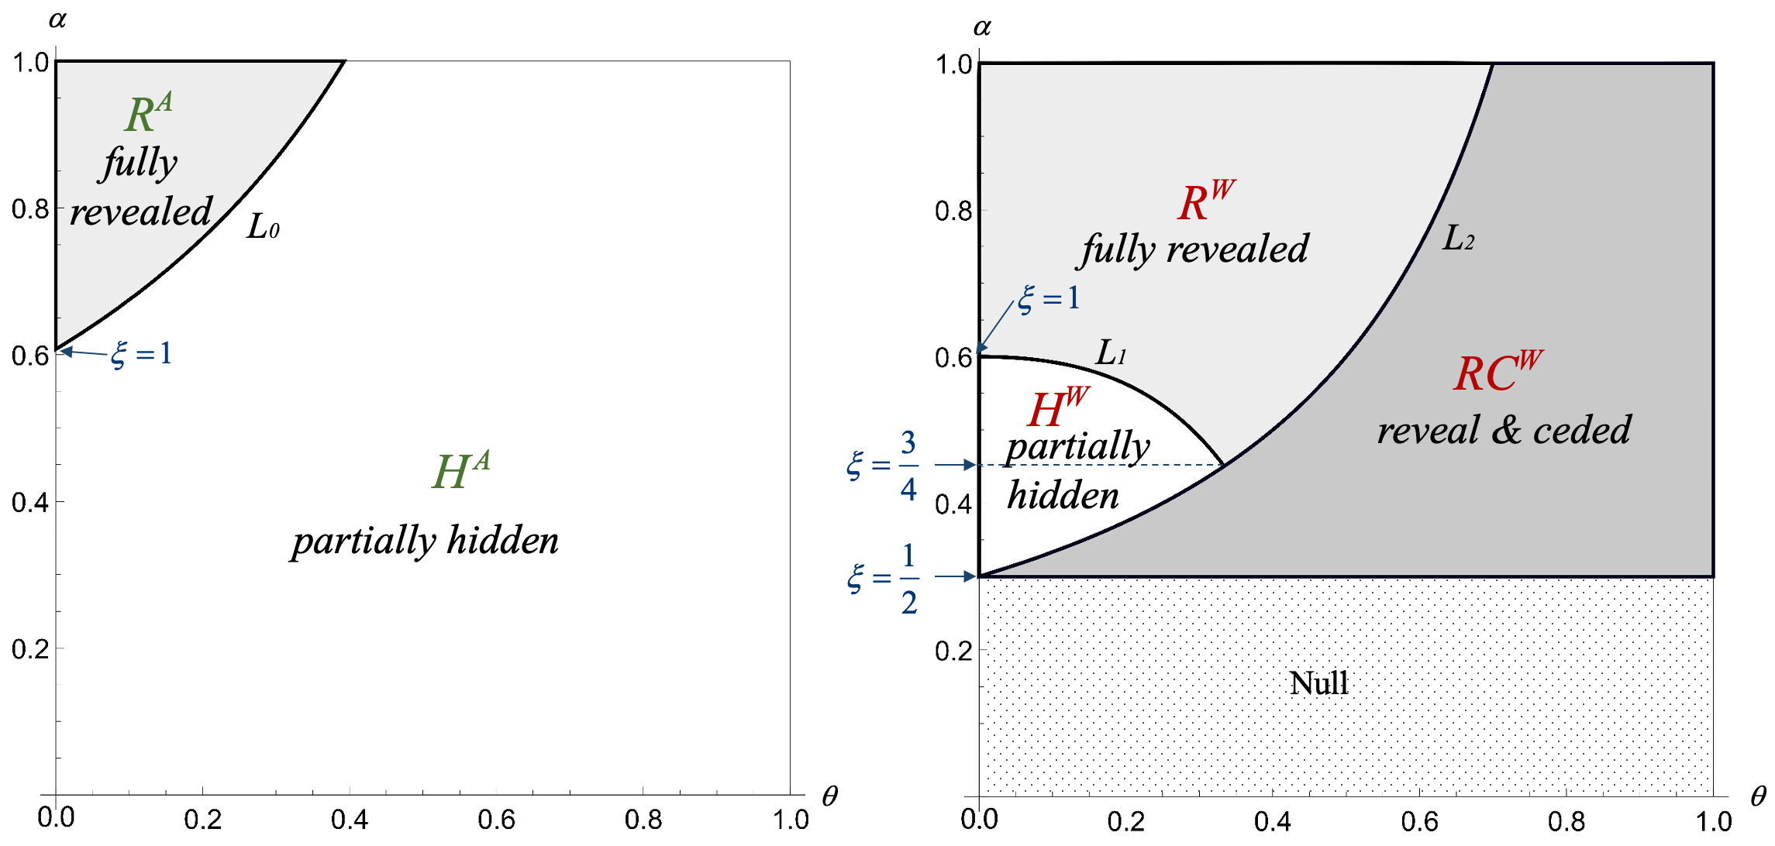

(a) Agency contract mode (b) Wholesale contract mode

Figure 3. the retailer’s optimal demonstration strategies divided by consumer heterogeneities

We have the following results regarding the retailer’s optimal demonstration strategy. The *partially hidden* strategy means the retailer hides part of the product information, making some low-type consumers fail to know their true preferences. The *fully revealed* strategy means the retailer maximizes the demonstration level to 1 so that all consumers know their true preferences. The *reveal & ceded* strategy means the retailer maximizes the demonstration level to 1 and has the manufacturer ceded the profit to her. Hereafter, we refer to strategies in Regions , , and  as *fully revealed*, *partially hidden*, and *reveal & ceded*, respectively.

**Proposition 1.** *The* *optimal demonstration strategies of the innovative product under different contract modes are characterized in Figure 3:*

*(1) Under the agency contract mode, the information of the innovative product is fully revealed in Region*  *and partially hidden in Region* .

*(2) Under the wholesale contract mode, the information of the innovative product is fully revealed in Regions*  *and* *, and partially hidden in Region* *. Besides, the retailer has the manufacturer ceded the profit to her in Region* .

The proof is referred in the Appendix.

According to the equilibrium solutions under the agency contract mode, there are two strategies for the retailer: *fully revealed* in region  and *partially hidden* in region . In region , the percentage of P-type consumers is large, and the percentage of high-type consumers is low. The retailer will choose to reveal the information about the innovative product fully. In region , for the manufacturer, as the proportion of the high-type consumers increases, the higher innovation effort will lead to the higher revenue. For the retailer, there is a trade-off between the positive and negative effects of product demonstration. Because  increases with  and  decreases with , while  increases with  and . Therefore, as the proportion  of high-type consumers increases, the share of the established product is decreasing. Most of the revenue from the demonstration of the innovative product belongs to the manufacturer (i.e., , which is often higher than 75%), which cannot make up for the retailer’s losses caused by the cannibalization effect on the established product . As the proportion of low-type consumers decreases, the retailer will become less and less motivated to demonstrate the innovative product. Besides, the manufacturer has the incentive to increase the innovation effort, so the retailer with a lower demonstration level can sell the innovative product at a higher price without reducing the market share of the established product remarkably.

Under the wholesale contract mode, the retailer chooses one of the following three demonstration strategies: the information of the product is *partially hidden* (region ), the information of the product is *fully revealed* (region ), and the information of the product is *fully revealed* and the retailer has the manufacturer ceded the profit to her (region ). Because of the influence of the wholesale price, when the retailer chooses to reveal the information fully, she may get a cession of profit from the manufacturer by forcing the manufacturer to reduce the wholesale price. In region , because the proportion of the high-type consumers is low, the manufacturer has less incentive to increase innovation effort. Therefore, the expected valuation of the innovative product is not particularly high, so the retailer will choose to *partially hide* the information of the innovative product to control cost. In regions  and , on the one hand, the increase in the share of consumers who feel the innovative product suitable provides the incentive for the manufacturer to innovate. The retailer, on the other hand, will choose to reveal the innovative product fully. Thus, the retailer’s initiative reduces. The manufacturer can adjust the wholesale price to maximize his benefit. If the wholesale price is too high, resulting in the retailer losing the gains, she will choose to withdraw from the market, which may also hurt the manufacturer. Therefore, the retailer may get a cession of profit from the manufacturer by forcing the manufacturer to reduce the wholesale price.

Specifically, an excessive demonstration cost may lead to negative profit for the retailer, and she may exit the market. To keep the retailer in the supply chain and continue demonstrating the product for him, the manufacturer may reduce the wholesale price to a certain extent to ensure that the retailer's profit remains at zero. This kind of cession of profit from the manufacturer is feasible when the demonstration cost is not particularly high. But when the cost of the demonstration level is too high (i.e., when demonstration efficiency ), the manufacturer's loss of providing a lower wholesale price will exceed the benefit brought by the retailer with the demonstration. Then the manufacturer will terminate the supply chain relationship with the retail. We define  as the lower bound for the retailer staying in the supply chain. Based on the above analysis, the feasible regions under the agency and wholesale contract modes are given in Figure 3. Thus, to avoid trivial cases, the following comparisons are limited within the regions, which are feasible under two contracts, i.e., regions above the line .

**Corollary 1.** *Under the wholesale contract mode, in regions*  *and* *, the wholesale price*  *increases with* *. In region* *, there exits*  *such that:*

*(1) When* *,*  *is decreasing in* *.*

*(2) When* *,*  *is decreasing first and then increasing in* *.*

*(3) when* *,*  *is increasing in* *.*

The proof is given in the Appendix.

In regions  and , the demand and price of the innovative product in the offline store increase with . Since  is small, the market of the established product will not be cannibalized excessively. Therefore, it is profitable for the retailer to demonstrate and sell the innovative product, and this part of profits increases with . For the manufacturer, as  increases, he can increase the wholesale price accordingly.

In region , the retailer has the manufacturer ceded the profit to her. The increase in wholesale prices is affected by the proportion of the P-type consumers and the cost of innovation. When the cost of innovation  and the proportion of the P-type consumers  are both relatively large, the wholesale price decreases with the proportion of the high-type consumers . When the cost of innovation  is small () or large (), and the proportion of the P-type consumers  is not large, the wholesale price decreases first and then increases with . When the cost of innovation  is small and the proportion of the P-type consumers  is relatively large, the wholesale price increases with . It is essentially affected by the need for the manufacturer to balance the market size distribution between two channels and the innovation costs. On the one hand, when the potential market of the physical store is relatively large, the manufacturer will pay more attention to the benefit brought to him by the physical channel, so he has a greater incentive to reduce the wholesale price to the retailer. On the other hand, a lower innovation cost allows the manufacturer to have a greater incentive to innovate his product so that it can be sold at a higher retail price, and correspondingly the manufacturer can gain more by setting a higher wholesale price.

**Corollary 2.** *As the unit demonstration cost*  *increases, the regions will change as follows (see Figure 4):*

*(1) Under the agency contract mode, when* the demonstration efficiency,  *region*  *shrinks and region*  *expands; when* *, there exists only one region* .

*(2) Under the wholesale contract mode: when* *, region*  *shrinks and region*  *expands; when* , *region*  *and region*  *expand whereas region*  *shrinks; when* , *region*  *shrinks and region*  *expands.*

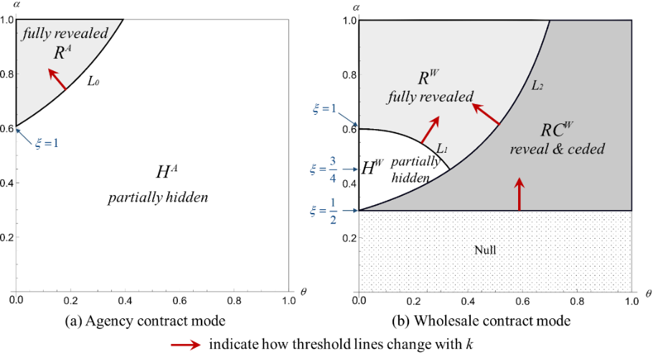

Figure 4. Equilibrium outcomes under the influence of 

The proof is referred to the Appendix.

Under the agency contract mode, since the revenue share is fixed, the two firms use product innovation and demonstration to take each other’s free rides. Hereafter, we refer to this effect as the *two-way free-ride effect*. Intuitively, the higher the cost borne by the firm is, the more unfavorable to the firm himself/herself is. Therefore, the retailer will choose to fully reveal the information only when the demonstration efficiency , and the higher the unit demonstration cost , the less willing the retailer is to demonstrate the innovative product.

Under the wholesale contract mode, when the unit demonstration cost  increases, to reduce the negative impact of demonstration cost on the profit, the retailer may lower the demonstration level and reduce total demonstration cost, or offer a full demonstration and get a cession of profit from the manufacturer. When the proportion of the P-type consumer increases, the demonstration efficiency  increases, and the retailer becomes more willing to demonstrate the innovative product. The full revealing of the innovative product helps divide the market, allowing consumers to understand their true preferences for the innovative product so that some consumers will turn to buy incumbent products. At the same time, the fully revealing product information will also help to increase the valuation of consumers who like innovative products, thereby charging a higher price. Therefore, the retailer will be more inclined to fully demonstrate innovative products when she has a large potential market. Besides, as unit demonstration cost increases, the situation in which the manufacturer needs to provide a wholesale price reduction is more likely to occur. Because the higher demonstration cost the retailer bears, the higher the price passed on to the manufacturer through cession.

5. Contract modes comparison

***5.1 Decisions comparison***

Firstly, Figure 5 is obtained by overlaying the two figures in Figure 3. Under both contract modes, the information of the innovative product is partially hidden in region I and fully revealed in region III. In region II, the demonstration strategy of partially hidden is chosen under the agency contract mode, and fully revealed is chosen under the wholesale contract mode.

Next, we compare the properties of the demonstration level, the innovation effort, and the retail price of the innovative product in the physical store under two contract modes.

**Proposition 2.** *Through comparing the demonstration level  under two contract modes, we have:*

*(1) Under the agency contract mode,* * equals 1 in region*  *and is* ***decreasing*** *with*  *in region* *. Under the wholesale contract mode,  is* ***increasing*** *with*  *in region*  *and equals 1 in regions*  *and* *.*

*(2)  is always higher than or equal to .*

The proofs are given in the Appendix.

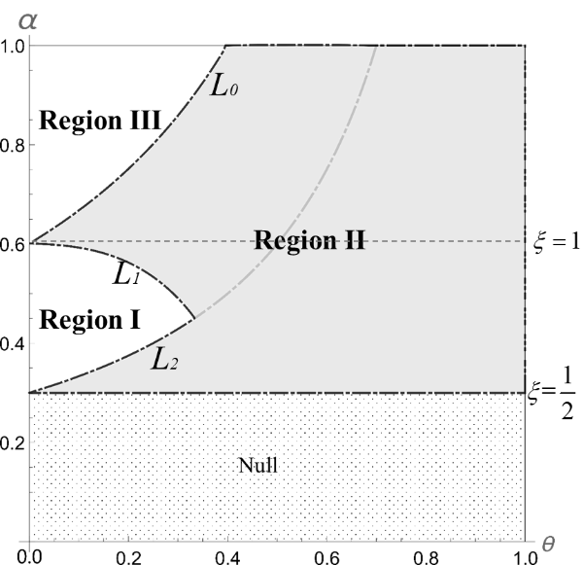

Figure 5. The comparison of the equilibrium solutions under two contract modes

From proposition 2, if the demonstration efficiency is high (), the physical store accounts for a larger market share. Under the wholesale contract mode, as the manufacturer uses the wholesale price to capture the retailer's profit of selling the innovative product, the retailer will always choose to fully reveal the information to screen out consumers who feel unsuitable. Thus, the retailer will make more profit by giving her store brand product a more significant market share. Under the agency contract mode, the increase of the price offsets the reduction of the demand brought about by the demonstration. The benefits brought by the demonstration of the innovative product are reflected in the trade-offs between the increase of the established product market and the cost of the demonstration. Besides, the share of the firms’ profits is fixed, so the retailer has an incentive to adjust the demonstration level according to the innovation level. If the innovation level is low, the retailer will fully reveal the information to increase the price of the innovative product (region III). However, if the innovation level is already high, the retailer will choose to free-ride by reducing the demonstration level even the demonstration efficiency is high (the area above the dashed-line  in region II).

If the demonstration efficiency is medium (), when  is small (region I), the manufacturer does not need to bear the cost of the demonstration, and the negative effect brought by the product demonstration (that is, demand reduction) is not significant. Therefore, he always hopes that the retailer can increase the demonstration level and thus increase the retail price. The manufacturer can set a lower wholesale price to encourage the retailer to demonstrate more information about the innovative product. Then, the retailer can obtain a higher revenue share of selling the innovative product under the wholesale mode than under the agency mode. As a result, she is more motivated and capable of revealing more information. When  is larger (the area below the dashed-line  in region II), under the wholesale contract mode, the manufacturer surrenders part of the profits to the retailer by adjusting the wholesale price. To further segment her market and increase the price of the innovative product, the retailer chooses to fully reveal the information of the innovative product. Under the agency contract mode, the retailer decides the demonstration level only based on the trade-offs between the market growth of the established product and the demonstration cost of the innovative product, which results in the demonstration level decreasing with .

**Proposition 3.** *Through comparing the innovation effort  under two contract modes, we have:*

*(1) The innovation effort  under either contract mode increases with* *.*

*(2)*  *in region I, otherwise .*

The proofs are given in the Appendix.

From Proposition 3, we can conclude that as the proportion of the high-type consumers increases, increasing the innovation effortis conducive to achieving a higher price. The increase of market shares and unit selling price will thereby result in higher profits. Thus, when the proportion of the high-type consumer increases, the manufacturer is always motivated to increase the innovation effort.

When the proportion of the high-type consumers is relatively low, the innovation effort under the agency contract mode is higher; otherwise, when the proportion of the high-type consumers is relatively high, the innovation effort under the wholesale contract mode is higher. Because when  and  are small (region I), the demonstration level under the wholesale contract mode is higher than that under the agency contract mode, and the manufacturer can get higher profits by free-riding without committing a higher innovation effort. When  or  is large (regions II and III), the retailer’s initiative of demonstration under the wholesale contract mode decreases, and the manufacturer can set a higher wholesale price. Therefore, the increase in profits allows the manufacturer to have more capabilities and a higher willingness to increase the innovative effort.

To sum up, compared with the fixed-share method of the agency contract mode, under the wholesale contract mode, the existence of wholesale price eases the *two-side free-ride effect* when the proportion of the high-type consumers is large. Both firms are more willing to put in a higher level of efforts on innovation and demonstration.

**Proposition 4.** *The retail price of the innovative product in the physical store under the wholesale contract mode is always higher than that under the agency contract mode, except in region I when* *, where* .

The proof is given in the Appendix.

In regions II and III in Figure 5, the retail price of the innovative product in the physical store under the wholesale contract mode is higher than that under the agency contract mode. This is because the wholesale contract mode has a higher innovation effort and demonstration level, and the retailer can charge a higher prices to the consumers who feel suitability of the innovative product. Interestingly, in Region I, the contract mode with a higher product price does not necessarily have a higher level of innovation. The following two situations may occur in region I. When , which is illustrated in Figure 6 using Region I-2, the retailer sets a higher retail price of the innovative product under the agency contract mode. Because the innovation effort under the agency contract mode is higher, it compensates the influence of the low demonstration level. However, when , which is illustrated in Figure 6 using Region I-1,  is higher than . Because the innovation effort under the agency contract mode is not high enough to make up for the decrease of the demonstration level.

Figure 6 summarizes the comparison results of Propositions 2, 3, and 4. Especially, region II lays out two kinds of selling strategies that often appear in practice. That is, *penetration strategy* and *skimming strategy* (Spann et al., 2015).

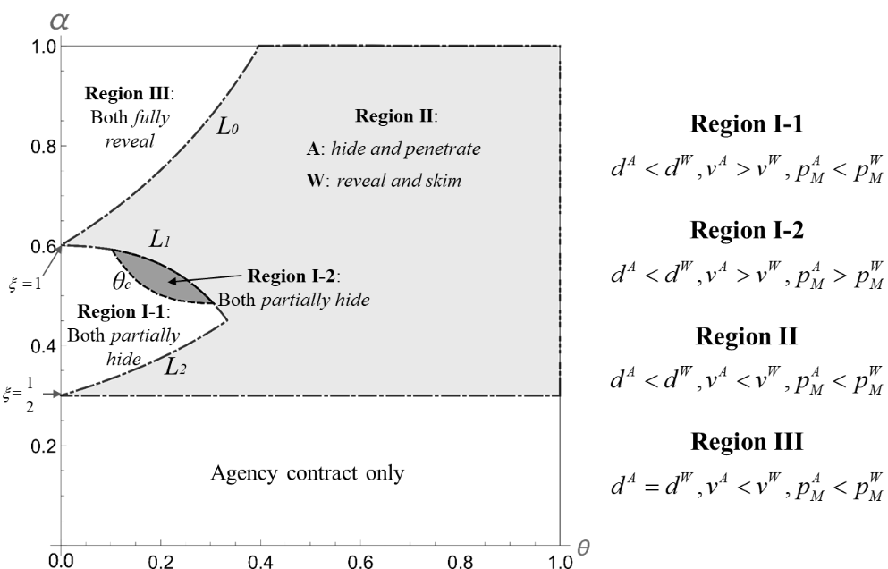

Figure 6. Selling strategies of the innovative product under different contract mode

Under the agency contract mode, the *penetration strategy* is preferred, which involves charging a low price and reach a wide fraction of the market. Thus, while the manufacturer increases his innovation effort, the retailer partially hides the information of the innovative product. Therefore, she expands the demand in the physical store with a lower demonstration level and a lower retail price to achieve lower unit profit and higher sales. Under the wholesale contract mode, the *skimming strategy* is preferred, in which firms skim surplus from consumers by exploiting the low price-sensitivity of innovators. Thus, the retailer maximizes the demonstration level to fully reveal the information of the innovative product. Therefore, all low-type consumers are screened out, while all high-type consumers are targeted. In the meantime, the manufacturer passively innovates, does not care much about the market segment of the direct channel. He will free ride the retailer of making a vigorous demonstration to the market segment of the offline channel and earn a more significant segment profit.

***5.2 Profits comparison***

The profit of the manufacturer is affected by both online and offline channels, while the profit of the retailer is affected by both the innovative product and the established product. It makes the impact of contract modes on profits more complicated under such a problem that considers channel structure and product categories simultaneously. We next compare the profits under the two contract modes. Let  and . The curves  and ,  are the indifference points defined by  and . Recall that curves , , and  are the indifference points of the equilibrium solutions, and line  is the lower bound for the retailer staying in the market.

**Proposition 5.** *Compare the profits under two contract modes (see, Figure 7), we have:*

*(1) the retailer prefers the wholesale contract mode only in region R3; otherwise, she prefers the agency contract mode;*

*(2) the manufacturer prefers the wholesale contract mode in regions R1, R4, R5, and R7; otherwise, he prefers the agency contract mode.*

The proof is given in the Appendix.

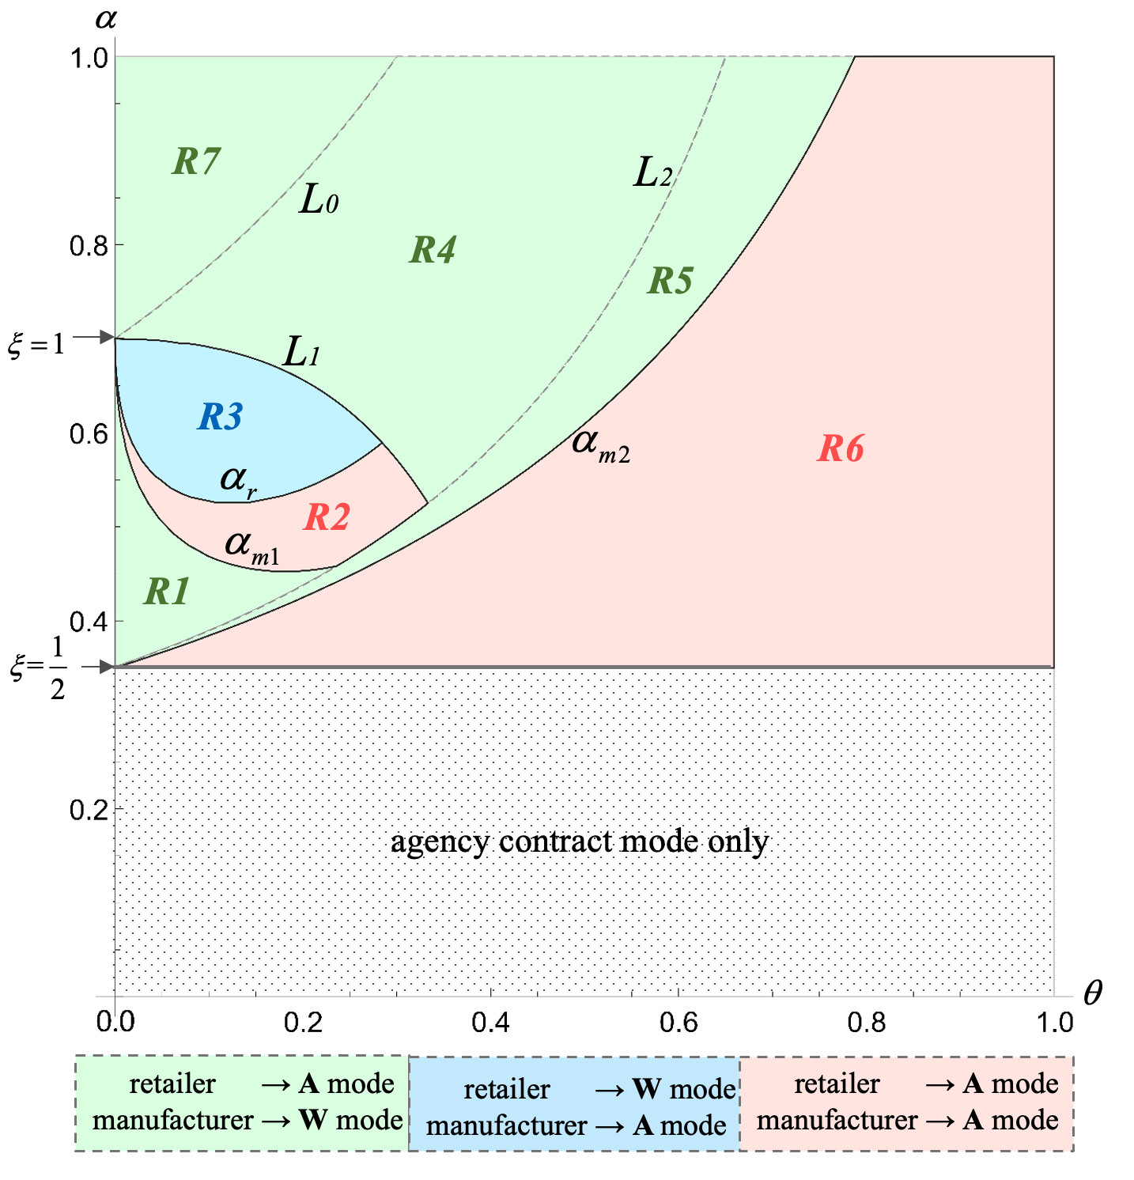

**→W mode** or →**A mode** means a firm prefers wholesale contract mode or agency contract mode, respectively.

Figure 7. Comparison of profits under two contract modes

For the retailer, in regions R1, R2, and R3, she prefers the *partially hidden* strategy under both contract modes. In regions R1 and R2, the potential market of the innovative product in the physical retail channel is relatively small. This means the retailer needs to reduce her investment in demonstrating the innovative product. It is because that the demonstration level under the agency contract mode is lower than that under the wholesale contract mode. Therefore, in this case, the agency contract mode is conducive to reducing the retailer’s demonstration investment in the innovative product. Meanwhile, because is small, the innovation effort is higher under the agency contract mode, and a lower retail price with a lower demonstration level increases the sales of the innovative product in the physical store. Therefore, the agency contract mode is more favorable for the retailer. In region R3, compared with regions R1 and R2, the P-type consumers account for a relatively large proportion (i.e., ), and the potential market of the innovative product in the physical store is large. Besides, the manufacturer reduces the incentive to innovate because he needs to share a broader market with the retailer. Thus, under the wholesale contract mode, the wholesale price decreases with , that is, the manufacturer will reduce the wholesale price to encourage the retailer to put more effort to demonstrate the innovative product. The retailer is also willing to make more demonstration effort for the larger potential market. Therefore, the higher demonstration level under the wholesale price contract leads to a higher retail price of the innovative product, and the lower wholesale price means that the retailer can gain more profit from the sales of the innovative product. Therefore, the wholesale price contract is more favorable to the retailer.

In regions R4, R5, R6, and R7, the retailer always prefers the agency contract mode. It is because that the potential market of the innovative product is large, which makes the innovative product very profitable. Under the agency contract mode, the retailer does not need to pay much demonstration cost to obtain a fixed share. Under the wholesale contract mode, the retailer will not only have to bear a higher cost for fully demonstrating the product but will also be charged with a higher wholesale price by the manufacturer. When  is large, the manufacturer will surrender part of the profit to the retailer under the wholesale contract mode, but it is only enough to maintain her basic operation.

For the manufacturer, when the proportion of the high-type consumers is large, the higher the demonstration level, the greater the profitability. Therefore, the wholesale contract mode, which has a higher demonstration level, should be more beneficial to the manufacturer. Counter-intuitively, this is not always the case. Note that under the wholesale contract mode, the manufacturer needs to reduce the wholesale price to motivate the retailer to demonstrate his product. Thus, if the proportion of the P-type consumers is small (region R6), then the physical channel cannot bring much benefit to him. As a result, the fixed share under the agency contract mode becomes more beneficial to the manufacturer. Only when the P-type consumer accounts for a relatively large proportion (region R5), the physical channel can bring sufficient benefit to him. This makes him willing to lower the wholesale price in exchange for a higher level of product demonstration. In this case, the manufacturer is better off under the wholesale contract mode. Similarly, this explanation also applies to the situation when  is not large and  is large (regions R4 and R7).

When the proportion of the high-type consumers is relatively small, the innovation effort is low if the proportion of the P-type consumers is small (region R1). Then, the wholesale contract mode with a higher demonstration level and a higher retail price is more favorable to the manufacturer. This is because he does not need to put much effort to obtain higher profits from the physical channel. It is worth noting that when the proportion of the P-type consumers is relatively high (regions R2 and R3), the agency contract mode with higher innovation effort and lower demonstration level is more beneficial to the manufacturer. Because in such a case, the potential market for the physical channel is large, and the manufacturer is not able to make a high profit from the online channel. Therefore, he pays more attention to the physical channel and has a higher incentive to adopt more innovation efforts. Correspondingly, the retailer does not need to make too much demonstration effort.

In summary, in regions R2 and R6, both firms are better off under the agency contract mode. In regions R1, R3, R4, R5, and R7, the retailer and the manufacturer will choose the opposite contract modes. In other words, the two firms have the same preference of the contract mode and achieve Pareto optimality only in regions R2 and R6.

6. Extensions

***6.1 The impact of parameters***

Next, we carry out three computational experiments to analyze the impact of the commission rate , the unit innovation cost , and the unit demonstration cost  on the regions of Pareto optimality because these regions are of more interest from the supply chain management perspective.

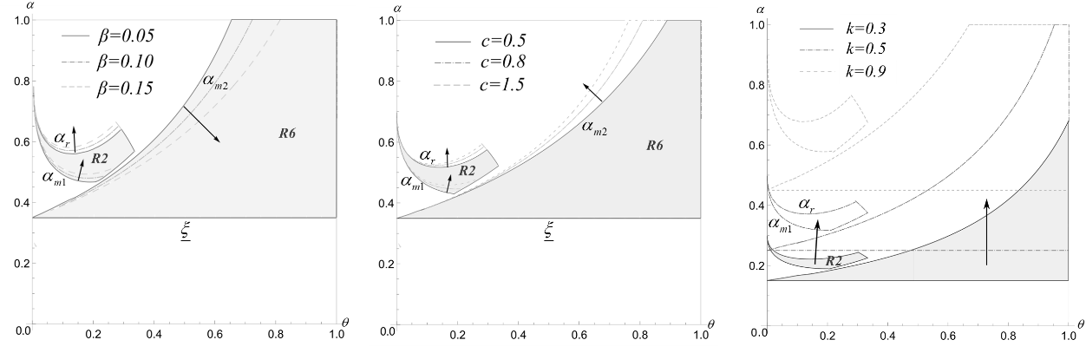

(a) impact of  (b) impact of  (c) impact of 

Figure 8. Impact of parameters on regions of Pareto optimality

As shown in Figure 8(a), when high-type consumers account for a small proportion, with the increase of the commission rate , the two firms need a higher proportion of the P-type consumers to achieve Pareto optimality. (see Region R2). Because the increase in commission rate makes the retailer prefer the agency contract mode, but will reduce the manufacturer’s willingness to choose the agency contract mode. Only when the proportion of the P-type consumers increases, which increases the potential market size of the physical channel, the two firms will agree on choosing the agency contract mode (both curves  and  rise). When the high-type consumers account for a large proportion, as the commission rate  increases, the situation that the two firms achieve Pareto optimality will become less likely (see Region R6). Because when the high-type consumers account for a large proportion, the retailer always prefers the agency contract mode, and the higher the commission rate, the better for her. However, for the manufacturer, the higher proportion of the high-type consumers means that he can obtain more significant profit from the direct online channel; and the larger the potential market for the physical channel, the more commission costs he must pay. Then, as the commission rate increases, he tends to choose the wholesale contract mode (the curves moves downwards).

As shown in Figure 8(b), in general, as the unit innovation cost increases, the two firms need a higher proportion of the P-type consumers to achieve Pareto optimality. Because as the unit innovation cost increase, the manufacturer’s input-output ratio increases. When the proportion of high-type consumers is relatively small (see Region R2), the increase of the innovation cost will mainly reduce the manufacturer’s profit from the direct online channel. However, the retail channel is more complicated. The manufacturer can pass the cost on to the retailer by increasing the wholesale price. Therefore, in this case, the larger the potential market for the retail channel, the more likely the manufacturer will choose the wholesale contract mode (line rises). Accordingly, the retailer needs a larger potential market to adopt the wholesale contract mode (line rises). However, when the proportion of the high-type consumers is relatively large (see Region R6), it is difficult for the manufacturer to pass the cost on to the retailer by increasing the wholesale price. Not only that, but he also needs to keep the retailer in the market for product demonstration by lowering the wholesale price. Therefore, in this case, as the unit innovation cost increases, the manufacturer is more likely to choose the agency contract mode (line rises).

As shown in Figure 8(c), as the unit demonstration cost increases, the two firms are more likely to achieve Pareto optimality when the proportion of the P-type consumers gets larger. In general, the optimal demonstration level under the wholesale contract mode is always higher than that under the agency contract mode. Accordingly, the retailer needs to bear a higher demonstration cost under the wholesale contract mode, and the manufacturer may also pass some costs on to her. Therefore, with the increase of the unit demonstration cost, the two firms are more likely to have a common preference for the agency contract mode. When the proportion of the high-value consumers is relatively small (see Region R2), the retailer’s willingness to demonstrate the innovative product increases with the proportion of the P-type consumer. The optimal demonstration level under the wholesale contract mode is always higher than that under the agency contract mode. Thus, if the unit demonstration cost increases, it is only when facing a larger potential market that the retailer is likely to lean towards the wholesale contract mode (line rises). The demonstration level under the agency contract mode is lower than that under the wholesale contract mode. Therefore, for the manufacturer, if the potential market of the physical channel is relatively large, he will be inclined to the agency contract mode. Otherwise, he would prefer the wholesale contract mode. However, the higher the unit demonstration cost, the lower the retailer’s demonstration level. So, a larger potential market is needed to make the manufacturer choose the agency contract mode. When the high-type consumers account for a relatively large proportion (see Region R6), as the unit demonstration cost increases, the total revenue of the two products sold by the retailer will increase accordingly. Otherwise, she may withdraw from the supply chain because she cannot make ends meet. So, correspondingly, she needs a larger potential market (line rises). As for the manufacturer, in this case, he needs to keep the retailer in the supply chain by reducing the wholesale price under the wholesale price mode. Therefore, the higher the retailer’s demonstration cost, the more compromises he needs to make. Thus, he is unwilling to choose the wholesale contract mode, unless the potential market for the retail channel is sufficiently large (line rises).

***6.2 The impact of showrooming behavior***

In the previous sections, we assumed that after consumers go to the offline store to get the product demonstration, if they still feel that product  is suitable, they will choose to buy  in the offline store directly. However, in practice, some consumers may choose to purchase products online after obtaining product demonstration services in offline stores. This consumer behavior is called showrooming behavior (Mehra et al., 2018; Li et al., 2020). According to ComScore, 36% of American consumers exhibited showrooming behavior[4]. This section will extend our models by considering the consumer showrooming behavior.

We assume that after consumers obtain the product demonstration service in the offline store, among the consumers who still feel the suitability of product , there is a proportion  of consumers who engage in showrooming behavior, that is, switch to purchase product  online. Therefore, the demands of product *M* in the offline and online stores are  and , respectively. The profit functions of the two firms are the same as that in the previous sections.

The new models can be solved in the similar way to that in section 4. However, due to the complexity of the models, it is difficult to analyze analytically. Therefore, we carry out a numerical experiment to analyze the impact of consumers’ showrooming behavior.

Figure 9 shows the changes in the regions of Pareto optimality when  takes different values. According to section 5, when no consumer engages in showrooming behavior, as shown in Figure 9(a), the two firms in Region R2 and R6 have the same preference for the contract mode, i.e., the agency contract mode. When a proportion of consumers engage in showrooming behavior, as shown in Figure 9(b), a new Pareto optimality region RS emerges. That is, when the proportions of high-type consumers and P-type consumers (i.e.,  and ) are both medium, the showrooming behavior makes the two firms achieve Pareto optimality by choosing the agency contract mode. Further, as the proportion of consumers who engage in showrooming behavior continues to increase, Region RS expands, as shown in Figure 9(c). This may be explained by the fact that showrooming is a free-riding behavior for consumers. That is, consumers accept the retailer's product demonstration service in the offline store to obtain product information, but they do not purchase the product from the retailer. Because they purchase the product online at a lower price, the retailer and the manufacturer will suffer the loss of demand and the loss of unit revenue, respectively. Next, we focus on Region RS. Under the wholesale contract mode, when the retailer chooses to fully reveal the information of product , the showrooming behavior weakens the benefit of the product demonstration to the manufacturer. Moreover, the manufacturer has to pass part of the demonstration cost. However, under the agency contract mode, the retailer will choose to partially hide the information of product . Thus the damage to the interests of the firms from the showrooming behavior decreases. Therefore, with the increase of , the two firms will be more inclined to choose the agency contract mode.

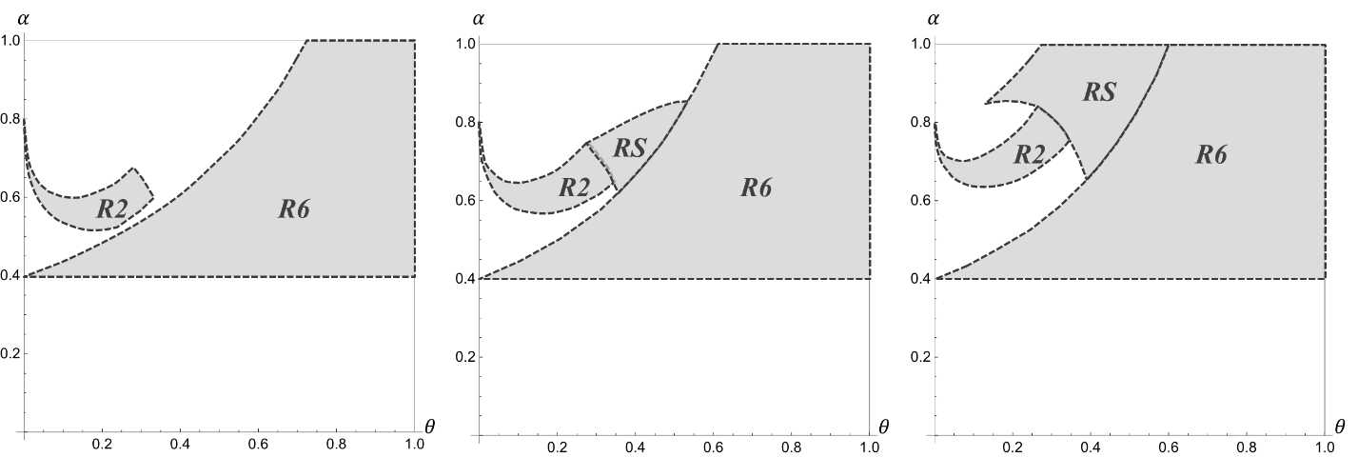

(a) when  (b) when  (c) when 

Figure 9. The impact of consumers’ showrooming behavior on regions of Pareto optimality

***6.3 The impact of the direct sales channel***

To further analyze the impact of product demonstration level, we compare the scenarios of supply chain structures with and without a direct sales channel.

We use a tilde symbol to indicate the scenario where the manufacturer does not open an online direct sales channel. Thus, the profits for the retailer and the manufacturer under the agency and wholesale contract modes are as follows:

, (5)

, (6)

, (7)

. (8)

The model can be solved similarly. Next we compare the profits in the scenarios of supply chain structures with and without an online direct sales channel. Let , where , .We can obtain Proposition 6.

**Proposition 6.** *Compare the profits in the scenarios of supply chain structures with and without a direct sales channel, we have:*

*(1) if the innovative product is partially demonstrated, then , where  and ;*

*(2) if the innovative product is fully demonstrated, then* *,* *, and , where .*

The proof is given in the Appendix.

The results show that under either contract mode, because of the product demonstration level decision, neither firm will be worse off in the dual-channel scenario. Specifically, under the agency contract mode, when the innovative product is partially or fully demonstrated, the profits of the two firms in the dual-channel scenario are both higher. While under the wholesale contract mode, when the innovative product is partially demonstrated, the profits of the two firms in the dual-channel scenario are both higher; when the innovative product is fully demonstrated, the retailer’s profit is the same in two scenarios, and the manufacturer’s profit is higher in the dual-channel scenario. Intuitively, the manufacturer may infringe the interests of the retailer by opening a direct sales channel. But our results show that, by incorporating the decision of the product demonstration level, the retailer can improve her profit to avoid the negative impact of the manufacturer’s introduction of an online direct sales channel. That is, the double marginalization effect is alleviated. Thus, two firms can reach Pareto optimality in the dual-channel situation.

7. Conclusions and managerial insights

We consider a dual-channel supply chain consisting of a manufacturer (who produces an innovative product) and an offline retailer (who owns an established store brand product). The manufacturer sells his innovative product through the retailer’s physical store under either wholesale or agency contract mode. He also sells the product through his direct online channel. By explicitly considering the manufacturer’s innovation effort and the retailer’s demonstration level decisions, this work attempts to comprehensively model and analyze the interaction between the production and the sale processes of the innovative product when facing consumers with uncertain information under two contract modes respectively. As one of the most directly related and concerning phenomena, the impacts of innovation and demonstration costs on the firms’ optimal decisions and profits under two contract modes are analyzed and compared. Besides, our research also identifies how the consumer attributes and segmentations affect two firms’ decisions on product innovation and demonstration efforts.

We provide several managerial insights. First, we obtained and analyzed the equilibrium solutions of innovation and demonstration efforts under two different contract modes, respectively. When analyzing these two decisions, Kuksov and Lin (2010) pointed out that a firm with a high-quality product should always provide information to resolve consumer uncertainty. However, our research offers different conclusions when the contract modes between upstream and downstream firms are considered, and the innovation and demonstration levels are treated as endogenous continuous decision variables. We found that the manufacturer’s innovation effort increases with the proportion of the high-type consumers. Moreover, when the high-type consumers account for a smaller proportion, the innovation effort under the agency contract mode is higher; and when the high-type consumers account for a larger proportion, the innovation effort under the wholesale contract mode is higher. The demonstration level under the wholesale contract mode is always higher than or equal to that under the agency contract mode. Besides, it is interesting to note that, under both contract modes, the trend of the retailer’s product demonstration level with respect to the proportion of the high-type consumers is almost opposite. Under the agency contract mode, the demonstration level decreases with the proportion of the high-type consumers; the *fully reveal* strategy (i.e., the retailer maximizes the demonstration level so that all consumers know their true preferences) will be chosen only when the proportion of the high-type consumers is small, and the proportion of the P-type consumers is large. Under the wholesale contract mode, the *partially hide* strategy (i.e., the retailer hides part of the product information, making some low-type consumers failed to know their true preferences) will be chosen only when the proportions of high-type and P-type consumers are both small, and the demonstration level increases with the proportion of the high-type consumer. Otherwise, the *fully reveal* strategy will be preferred. This finding shows that the retailer’s decision on the level of product demonstration is not only depending on the manufacturer’s innovation effort and the market acceptance of the product, but also significantly influenced by the contract mode. Interestingly, the higher level of product innovation does not necessarily entail the retailer’s more willingness to demonstrate the innovative product. We find that, under the agency contract mode, when the level of innovation is high, the retailer is reluctant to demonstrate information about innovative products. Compared with the fixed-share method of the agency contract mode, under the wholesale contract mode, the wholesale price eases the *two-side free-ride effect* when the proportion of the high-type consumers is large. Both firms are more willing to put in a higher level of efforts on innovation and demonstration.

Comparing the pricing decisions under two contract modes, we have some more findings. Under the influence of the competition between two products and the competition between two channels, the choice of different contract modes may lead the firms to adopt different sales strategies for the innovative product. Especially when the potential market of the innovative product is not small, the *penetration strategy* is preferred under the agency contract mode, whereas the *skimming strategy* is preferred under the wholesale contract mode.

An interesting finding is that two firms may have the same contract mode preference and can achieve Pareto optimality under certain conditions. For example, when the potential market for the innovative product is small, they will have the same contract mode preferences if the proportion of the P-type consumers is medium or extremely small. If the proportion of the P-type consumers is large, the potential market for the innovative product required to make them prefer the same contract mode is relatively large. Besides, increasing the commission rate will generally reduce the case of Pareto optimality, while increasing the unit cost of product innovation or demonstration will increase the case of Pareto optimality. Moreover, when considering the impact of consumer showrooming behavior, we found that showrooming makes two firms more likely to achieve Pareto optimality by choosing the agency contract mode. When examining the channel encroachment, Chiang et al. (2003) indicated that the retailer may be worse off due to a direct sales channel augmented. However, our results show that the retailer can use the product demonstration level decision to improve her profit even when the online direct sales channel is introduced by the manufacturer. Thus, two firms can reach Pareto optimality.

In this paper, we assume the situations where information is symmetric between the manufacturer and the retailer. In practice, retailers may not have complete information about the innovative product, and manufacturers may not have much information about consumer preferences. A possible future research is to consider how the asymmetric information will affect firms’ strategies and profits when the innovation and demonstration levels are controllable under different contract modes.

References

Abhishek, V., Jerath, K., & Zhang, Z. J. (2016). Agency Selling or Reselling? Channel Structures in Electronic Retailing. *Management Science*, *62*(8), 2259-2280. <https://doi.org/10.1287/mnsc.2015.2230>

Bagwell, K., & Riordan, M. H. (1991). High and declining prices signal product quality. *The American Economic Review*, *81*(1), 224-239.

Bernstein, F., Song, J., & Zheng, X. (2009). Free riding in a multi-channel supply chain. *Naval Research Logistics*, *56*(8), 745-765. <https://doi.org/10.1002/nav.20379>

Boleslavsky, R., Cotton, C. S., & Gurnani, H. (2017). Demonstrations and price competition in new product release. *Management Science*, *63*(6), 2016-2026. <https://doi.org/10.1287/mnsc.2016.2449>

Cachon, G. P., Daniels, K. M., & Lobel, R. (2017). The role of surge pricing on a service platform with self-scheduling capacity. *Manufacturing & Service Operations Management*, *19*(3), 368-384. <https://doi.org/10.1287/msom.2017.0618>

Cachon, G. P., & Lariviere, M. A. (2005). Supply chain coordination with revenue-sharing contracts: strengths and limitations. *Management Science*, *51*(1), 30-44. <https://doi.org/10.1287/mnsc.1040.0215>

Cai, G., Zhang, Z. G., & Zhang, M. (2009). Game theoretical perspectives on dual-channel supply chain competition with price discounts and pricing schemes. *International Journal of Production Economics*, *117*(1), 80-96. <https://doi.org/10.1016/j.ijpe.2008.08.053>

Chaab, J., & Rasti-Barzoki, M. (2016). Cooperative advertising and pricing in a manufacturer-retailer supply chain with a general demand function; A game-theoretic approach. *Computers & Industrial Engineering*, *99*, 112-123. <https://doi.org/10.1016/j.cie.2016.07.007>

Chai, L., Wu, D. D., Dolgui, A., & Duan, Y. (2020). Pricing strategy for B&M store in a dual-channel supply chain based on hotelling model. *International Journal of Production Research*, 1-14. <https://doi.org/10.1080/00207543.2020.1787536>

Che, Y. (1996). Customer Return Policies for Experience Goods. *The Journal of Industrial Economics*, *44*(1), 1-17. <https://doi.org/10.2307/2950557>

Chen, Y., & Xie, J. (2008). Online consumer review: word-of-mouth as a new element of marketing communication mix. *Management Science*, *54*(3), 477-491. <https://doi.org/10.1287/mnsc.1070.0810>

Chenavaz, R. (2012). Dynamic pricing, product and process innovation. *European Journal of Operational Research*, *222*(3), 553-557. <https://doi.org/10.1016/j.ejor.2012.05.009>

Chiang, W. K., Chhajed, D., & Hess, J. D. (2003). Direct Marketing, Indirect Profits: A Strategic Analysis of Dual-Channel Supply-Chain Design. *Management Science*, *49*(1), 1-20. <https://doi.org/10.1287/mnsc.49.1.1.12749>

Dhar, S. K., & Hoch, S. J. (1997). Why store brand penetration varies by retailer. *Marketing Science*, *16*(3), 208-227. <https://doi.org/10.1287/mksc.16.3.208>

Gao, F., & Su, X. M. (2017). Online and offline information for omnichannel retailing. *Manufacturing & Service Operations Management*, *19*(1), 84-98. <https://doi.org/10.1287/msom.2016.0593>

Gardete, P. M. (2013). Cheap-Talk Advertising and Misrepresentation in Vertically Differentiated Markets. *Marketing Science*, *32*(4), 609-621. <https://doi.org/10.1287/mksc.2013.0772>

Ge, Z., Hu, Q., & Xia, Y. (2014). Firms' R&D cooperation behavior in a supply chain. *Production and Operations Management*, *23*(4), 599-609. <https://doi.org/10.1111/poms.12037>

Gernert, A., Heese, H. S., & Wuttke, D. A. (2020). Subcontracting new product development projects: the role of competition and commitment. *Decision Sciences*. <https://doi.org/10.1111/deci.12484>

Hagiu, A., & Wright, J. (2015). Marketplace or reseller? *Management Science*, *61*(1), 184-203. <https://doi.org/10.1287/mnsc.2014.2042>

Hao, L., & Tan, Y. (2018). Who wants consumers to be informed? Facilitating information disclosure in a distribution channel. *Information Systems Research*, *30*(1), 34-49. <https://doi.org/10.1287/isre.2017.0770>

Hao, Z., Qi, W., Gong, T., Chen, L., & Shen, Z.-J. M. (2019). Innovation uncertainty, new product press timing and strategic consumers. *Omega*, *89*, 122-135. <https://doi.org/10.1016/j.omega.2018.09.011>

Heiman, A., & Muller, E. (1996). Using Demonstration to Increase New Product Acceptance: Controlling Demonstration Time. *Journal of Marketing Research*, *33*(4), 422-430. <https://doi.org/10.1177/002224379603300404>

Hong, Z., Wang, H., & Yu, Y. (2018). Green product pricing with non-green product reference. *Transportation Research Part E: Logistics and Transportation Review*, *115*, 1-15. <https://doi.org/10.1016/j.tre.2018.03.013>

Iyer, G., & Soberman, D. A. (2016). Social responsibility and product innovation. *Marketing Science*, *35*(5), 727-742. <https://doi.org/10.1287/mksc.2015.0975>

Jena, S. K., Sarmah, S. P., & Sarin, S. C. (2017). Joint-advertising for collection of returned products in a closed-loop supply chain under uncertain environment. *Computers & Industrial Engineering*, *113*, 305-322. <https://doi.org/10.1016/j.cie.2017.09.024>

Jiang, B., & Shi, H. (2018). Intercompetitor licensing and product innovation. *Journal of Marketing Research*, *55*(5), 738-751. <https://doi.org/10.1177/0022243718802846>

Jiang, B. J., Narasimhan, C., & Turut, O. (2017). Anticipated regret and product innovation. *Management Science*, *63*(12), 4308-4323. <https://doi.org/10.1287/mnsc.2016.2555>

Jin, Y., Wu, X., & Hu, Q. (2017). Interaction between channel strategy and store brand decisions. *European Journal of Operational Research*, *256*(3), 911-923. <https://doi.org/10.1016/j.ejor.2016.07.001>

Johnson, J. P. (2020). The agency and wholesale models in electronic content markets. *International Journal of Industrial Organization*, *69*, 102581. <https://doi.org/10.1016/j.ijindorg.2020.102581>

Johnson, J. P., & Myatt, D. P. (2006). On the Simple Economics of Advertising, Marketing, and Product Design. *American Economic Review*, *96*(3), 756-784. <https://doi.org/10.1257/aer.96.3.756>

Klastorin, T., Mamani, H., & Zhou, Y. P. (2016). To preannounce or not: new product development in a competitive duopoly market. *Production and Operations Management*, *25*(12), 2051-2064. <https://doi.org/10.1111/poms.12594>

Kuksov, D., & Lin, Y. F. (2010). Information provision in a vertically differentiated competitive marketplace. *Marketing Science*, *29*(1), 122-138. <https://doi.org/10.1287/mksc.1090.0486>

Kuksov, D., & Xie, Y. (2010). Pricing, Frills, and Customer Ratings. *Marketing Science*, *29*(5), 925-943. <https://doi.org/10.1287/mksc.1100.0571>

Kwark, Y., Chen, J., & Raghunathan, S. (2017). Platform or wholesale? A strategic tool for online retailers to benefit from third-party information. *MIS Quarterly*, *41*(3), 763-785. <https://doi.org/10.25300/misq/2017/41.3.05>

Lal, R., & Sarvary, M. (1999). When and how is the internet likely to decrease price competition? *Marketing Science*, *18*(4), 485-503. <https://doi.org/10.1287/mksc.18.4.485>

Li, G., Li, L., & Sun, J. (2019a). Pricing and service effort strategy in a dual-channel supply chain with showrooming effect. *Transportation Research Part E: Logistics and Transportation Review*, *126*, 32-48. <https://doi.org/10.1016/j.tre.2019.03.019>

Li, M., Zhang, X., & Dan, B. (2019b). Competition and cooperation in a supply chain with an offline showroom under asymmetric information. *International Journal of Production Research*, 1-16. <https://doi.org/10.1080/00207543.2019.1661536>

Li, Y., Li, B., Zheng, W., & Chen, X. (2020). Reveal or hide? Impact of demonstration on pricing decisions considering showrooming behavior. *Omega*, *102*. <https://doi.org/10.1016/j.omega.2020.102329>

Li, Z., & Ni, J. (2018). Dynamic product innovation and production decisions under quality authorization. *Computers & Industrial Engineering*, *116*, 13-21. <https://doi.org/10.1016/j.cie.2017.12.011>

Lin, M., Li, S., & Whinston, A. B. (2014). Innovation and price competition in a two-sided market. *Journal of Management Information Systems*, *28*(2), 171-202. <https://doi.org/10.2753/mis0742-1222280207>

Lin, P., & Saggi, K. (2002). Product differentiation, process R&D, and the nature of market competition. *European Economic Review*, *46*(1), 201-211. <https://doi.org/10.1016/S0014-2921(00)00090-8>

Liu, W., Yan, X., Li, X., & Wei, W. (2020). The impacts of market size and data-driven marketing on the sales mode selection in an Internet platform based supply chain. *Transportation Research Part E: Logistics and Transportation Review*, *136*, 101914. <https://doi.org/10.1016/j.tre.2020.101914>

Mehra, A., Kumar, S., & Raju, J. S. (2018). Competitive Strategies for Brick-and-Mortar Stores to Counter “Showrooming”. *Management Science*, *64*(7), 3076-3090. <https://doi.org/10.1287/mnsc.2017.2764>

Piccolo, S., & Pignataro, A. (2018). Consumer loss aversion, product experimentation and tacit collusion. *International Journal of Industrial Organization*, *56*, 49-77. <https://doi.org/10.1016/j.ijindorg.2017.11.001>

Shen, Y., Yang, X., & Dai, Y. (2019). Manufacturer-retail platform interactions in the presence of a weak retailer. *International Journal of Production Research*, *57*(9), 2732-2754. <https://doi.org/10.1080/00207543.2019.1566657>

Shi, H., Liu, Y., & Petruzzi, N. C. (2019). Informative advertising in a distribution channel. *European Journal of Operational Research*, *274*(2), 773-787. <https://doi.org/10.1016/j.ejor.2018.10.042>

Song, J., Li, F., Wu, D. D., Liang, L., & Dolgui, A. (2017). Supply chain coordination through integration of innovation effort and advertising support. *Applied Mathematical Modelling*, *49*, 108-123. <https://doi.org/10.1016/j.apm.2017.04.041>

Spann, M., Fischer, M., & Tellis, G. J. (2015). Skimming or penetration? Strategic dynamic pricing for new products. *Marketing Science*, *34*(2), 235-249. <https://doi.org/10.1287/mksc.2014.0891>

Tian, L., Vakharia, A. J., Tan, Y. R., & Xu, Y. (2018). Marketplace, reseller, or hybrid: strategic analysis of an emerging e-commerce model. *Production and Operations Management*, *27*(8), 1595-1610. <https://doi.org/10.1111/poms.12885>

Wang, S., & Özkan-Seely, G. F. (2018). Technical note—Signaling product quality through a trial period. *Operations Research*, *66*(2), 301-312. <https://doi.org/10.1287/opre.2017.1675>

Wang, W., Li, G., & Cheng, T. C. E. (2016). Channel selection in a supply chain with a multi-channel retailer: The role of channel operating costs. *International Journal of Production Economics*, *173*, 54-65. <https://doi.org/10.1016/j.ijpe.2015.12.004>

Xiao, W., & Xu, Y. (2012). The impact of royalty contract revision in a multistage strategic R&D alliance. *Management Science*, *58*(12), 2251-2271. <https://doi.org/10.1287/mnsc.1120.1552>

Yin, R., Li, H., & Tang, C. S. (2015). Optimal Pricing of Two Successive-Generation Products with Trade-in Options under Uncertainty. *Decision Sciences*, *46*(3), 565-595. <https://doi.org/10.1111/deci.12139>

Zhang, P., He, Y., & Zhao, X. (2019a). “Preorder-online, pickup-in-store” strategy for a dual-channel retailer. *Transportation Research Part E: Logistics and Transportation Review*, *122*, 27-47. <https://doi.org/10.1016/j.tre.2018.11.001>

Zhang, Q., Zhao, Q., & Zhao, X. (2019b). Manufacturer's product choice in the presence of environment-conscious consumers: brown product or green product. *International Journal of Production Research*, *57*(23), 7423-7438. <https://doi.org/10.1080/00207543.2019.1624853>

1. https://plma.com/storebrands/sbt02.html
2. https://plma.com/storebrands/sbt02.html
3. https://www.sephora.cn/brand/sephoracollection-1/
4. https://www.comscore.com