Assessing the effectiveness of prophylactic treatment strategies for sheep scab

Emily Joanne Nixon^{1,2,} Ellen Brooks-Pollock^{3,4}, Richard Wall¹

¹School of Biological Sciences, University of Bristol, Bristol, BS8 1TQ
²Department of Mathematical Sciences, University of Liverpool, Liverpool, UK
³School of Population Health Sciences, University of Bristol, Bristol, UK
⁴NIHR Health Protection Research Unit in Behavioural Science and Evaluation at University of Bristol, Bristol, UK
Corresponding author: emily.nixon@liverpool.ac.uk

Highlights
- Sheep scab interventions were assessed using a mathematical model
- Treating all sheep prior to movement was the most effective national strategy
- Targeting prophylaxis in hotspots initially reduced scab risk more than random prophylaxis
- The efficacy of focussed treatment waned as infected sheep were introduced
- Control of the movement of infected sheep is shown to be essential

Abstract
Ovine psoroptic mange (sheep scab) is a condition caused by a hypersensitivity response to the ectoparasitic mite, Psoroptes ovis. It is an animal welfare concern and causes extensive economic losses to the sheep industry worldwide. More effective scab management is required to limit increases in infection prevalence, particularly given growing concerns over acaricide resistance. Here, a stochastic metapopulation model is used to explore the effectiveness of a range of prophylactic acaricide treatment strategies in comparison to no intervention. Over a simulated one-year period, movement control, based on the prophylactic treatment of animals being moved in sales, followed by farm biosecurity of bought in animals, was shown to be the most effective at reducing scab risk and more cost-effective than no intervention. Localised targeting of prophylaxis in areas of high scab prevalence was more effective than using prophylaxis at random, however, this localised effect declined post-treatment because of the import of infected animals. The analysis highlights the role of the movement of infected animals in maintaining high levels of scab infection and the importance of reducing this route of transmission to allow localised management to be effective.

Keywords: infection control, mathematical modelling, Psoroptes ovis, livestock disease
Corresponding author: Dr Emily Nixon emily.nixon@bristol.ac.uk

- Introduction
Psoroptes ovis, an obligate ectoparasitic mite (Sanders et al., 2000), is the causal agent of ovine psoroptic mange (sheep scab), an infectious condition that adversely affects sheep farming systems worldwide. The faecal material of P.ovis can lead to a hypersensitivity response causing inflammation followed by dermatitis, pruritus and self-trauma. This leads to weight loss (Kirkwood and Quick, 1980), wool loss and in some cases, death resulting from secondary infections, pneumonia, epileptiform fitting, or severe dehydration (Tarry 1974; Bygrave et al., 1993; Bates, 1997). Not only is sheep scab a welfare concern, but it has significant economic impacts (Nixon et al. 2020) due to the costs of preventing and treating infection (Nixon et al., 2017).
Historically, several approaches have been taken to try to control sheep scab in Great Britain since its reintroduction in 1972, however, none have been successful in re-eradicating the disease. Although there have been several industry-led interventions for scab since deregulation in 1992 (Phillips, 2014), the number of outbreaks in Great Britain is still estimated to be around 7,000 per year (Bisdorff et al., 2006). There are only two classes of acaricide licenced for use prophylactically and therapeutically in the UK. These include the organophosphate, diazinon, and the macrocyclic lactones (moxidectin, doramectin and ivermectin), which are applied by plunge dipping and injection, respectively. Although these products are important for preventing and treating scab, resistance in P. ovis to the macrocyclic lactones, moxidectin (Doherty et al., 2018), ivermectin and doramectin (Sturgess-Osborne et al., 2019) has recently been reported. Hence, future approaches to scab control must consider balancing prophylactic use against the risk of the further spread of resistance. More focussed treatment could be achieved by application in association with use of the recently developed enzyme-linked-immunosorbent assay (ELISA) for sheep scab (Burgess et al., 2012). This has been shown to be a more effective method for diagnosis (sensitivity 98.2% and specificity of 96.5%, Hamer et al., 2019) than the traditional skin scrape method which has been reported to have a success rate as low as 18% (Bates, 2009. In addition, if used as a routine measure, the ELISA could prevent undetected transmission via subclinically infested animals.
Mathematical modelling has been used effectively to identify management strategies for the control of a range of infectious diseases in livestock, such as foot and mouth (Keeling et al., 2002), bovine tuberculosis (Brooks-Pollock et al., 2014) and avian influenza (Hill et al., 2017). A mathematical model for sheep scab has been developed (Nixon et al., 2021a) and has proposed the existence of spatial clusters of contiguous farms between which local transmission of scab occurs by contact between sheep with a shared contaminated environment (Nixon et al., 2021b). At the boundaries of these clusters, where the distances between farms is greater, transmission rates would be lower, and scab would self-limit in the absence of long-distance movements. These areas correspond geographically with areas that have been identified previously as having a higher scab prevalence and risk compared to other areas in Great Britain (Rose et al., 2009). It has been suggested that focusing control within these spatial clusters may be a cost-effective means to control scab (Nixon et al., 2021b). However, the effectiveness and cost of such a management strategy has not been explored on a national scale in relation to alternatives. Hence, the current work explores different management strategies for sheep scab in Great Britain with the aim of identifying approaches that would be able to reduce the unnecessary use of acaracides and financial losses for the sheep industry while improving animal welfare. Where suitable data are available, these treatment scenarios could be investigated in other countries affected by scab using our open access model framework.

- Methods
2.1 Model description
An existing open access stochastic metapopulation model for sheep scab transmission was used for this study (Nixon et al., 2021a). The model was coded in programming language R v.3.6.3 (R core team, 2020) based on the modified R package “SimInf” (Widgren et al. 2019). The model was further adapted to allow the prophylactic treatment to prevent scab (Nixon 2021b). The model includes all georeferenced sheep holdings in Great Britain and allows transmission to occur within and between holdings as shown schematically in Figure 1. Transmission of scab within holdings is modelled using individual epidemic compartmental models, as first described by Ronald Ross (1915) and now widely used in infectious disease modelling (Keeling and Rohani, 2008). Within each holding, sheep are classified into compartments: susceptible (S), infected (I) and carrier (C). Carrier sheep are considered to be less infectious than sheep that are classified as clinically infected. Sheep that no longer harbour mites are moved to the susceptible compartment, since they have the potential to become reinfested. Continuous-time Markov chains using the Gillespie stochastic simulation algorithm (Gillespie 1977) are used to integrate the infection dynamics within each holding, as used in Bauer et al. (2016) and Widgren et al. (2019).
The number of susceptible sheep that become infected is determined by an infectious pressure exerted by a compartment (e) which is contingent on the transmission and shedding of P. ovis mites from infectious sheep either to the environment or directly to in-contact sheep within a holding or contiguous holdings. Holdings with central points which are 2km or less apart are considered to be contiguous, based on an average farm’s radius (Eurostat statistics explained, 2013).
The rate of change of the environmental infectious pressure $φ_{i}(t)$ over time is shown in equation 1 (as first given in Nixon et al., 2021a):
$\frac{dφ_{i}}{dt}= \frac{αI_{i}\left(t\right)+ εαC_{i}(t)}{N_{i}(t)}+ \sum_{k}{\frac{φ_{k}\left(t\right)N_{k}\left(t\right)- φ_{i}(t)N_{i}(t)}{N_{i}(t)}} * \frac{D}{d_{ik}}- β(t)φ_{i}(t)$ (1)
where i is a sheep holding, k is a contiguous sheep holding whereby transmission of scab between i and k can occur. The first term of equation 1 shows the contribution of infectious pressure to i from infected ($αI_{i}\left(t\right)$) and carrier ($εαC_{i}(t)$) sheep within i, while the second term describes the contribution from all contiguous farms k, scaled by their Euclidean distance from i. The third term gives the environmental infectious pressure decay, to capture the death of P. ovis mites in the environment. All model parameters and further detail are given in Nixon et al., 2021a.
Transmission of scab between holdings can also occur via the movement of infected sheep, which are specified as scheduled deterministic events and then are executed when the simulation (in continuous time) reaches the specified timestep for the event. The specified number of sheep to be moved are sampled at random across all disease compartments in the source holding and then transferred to the corresponding disease compartment in the destination holding.
The use of a prophylactic treatment was also modelled as a scheduled event, where a stated proportion of sheep within specified holdings are pre-determined to move from the S, I and C compartments to a “Treated” (T) compartment on a particular timestep in the simulation. All treatments in the simulations were assumed to be with organophosphate dip; treatment efficacy was assumed to be 98% (to allow for misapplication) and treatment uptake was varied between scenarios. Residual activity of the OP dip was considered to be 60 days (Veterinary Medicines Directorate, 2009) at the end of which all sheep from the treatment compartment are moved back to the susceptible compartment. It was assumed that only farms that were permanent sheep residences (i.e. not markets) used prophylactic treatment.

2.2 Sheep movement and holding data
The spatial coordinates and numbers of sheep at each sheep holding in the Great Britain in 2010 were obtained from the Animal and Plant Health Agency (APHA) of the UK government. Contiguous farms were then identified by using the easting and northing data to calculate the Euclidean distance between centres of farms using the distance matrix function from the “SimInf” package (Widgren et al., 2019). Sheep movement data for 2010 were also provided by APHA and were used to specify the deterministic movement events for given numbers of sheep, between specific source and destination holdings on specific dates. It was assumed that all holdings which were temporary residences, such as markets, had no sheep at the start of each simulation.

2.3 Classifying farms
Farms were classified in the model as “upland” or “lowland”. For Scotland, an ESRI shapefile of “Less Favoured Areas” (1997 data) was used (British Government, 2018) to identify farms (using the “Clip Tool” in QGIS 2.18.20) in the “Severely Disadvantaged Less Favoured Areas”, since these are areas of upland farmland in Scotland (Scottish Government, 2017). For England and Wales, it was assumed that all upland farms used common grazing. For England, the database of registered common land (Department for Environment, Food and Rural Affairs, 2015) was used to identify which farms were likely to be using common grazing. The number of farms with ‘rights to pasture’ were summed, to identify the number of farms with rights to graze sheep in each common. The number of farms using each common was estimated by examining the Euclidean distance between each common and surrounding farms and summing the number that were contiguous. For Wales, a shapefile of registered common land (Lle, 2014) was used to identify the common grazing area and survey data (Hybu Cig Cymru, 2007) were used to identify the number of farms that were likely to be using these areas. The Geoprocessing toolkit from QGIS 2.18.20 was used to create a buffer around all common grazing areas and then select farms (using the “Clip Tool”) located within the buffers.

2.4 Model parameters
The parameters α, the daily contribution to environmental pressure per infected individual, β, the decay rate of the environmental infectious pressure and υj, the indirect transmission rate from the environmental compartment (j) to susceptible sheep in farm i, were estimated in a previous study which used sequential Monte Carlo approximate Bayesian Computation (SMC ABC) methods to fit the model to weekly and yearly scab incidence cases from 1973 to 1992 (Nixon et al., 2021a). The prevalence of scab in Great Britain is thought to have increased since 1992 (Bisdorff et al., 2006) and so the upper ranges of the posterior distribution from the SMC ABC for the two transmission rates (α = 1 × 10^{2,} υj = 6 × 10⁴) and the lower range of the posterior distribution for the disease decay rate (β = 4 × 10²) were used in the current study. Other parameters were determined using published data as described in Nixon et al., 2021a. All scenarios described here had 50 stochastic repeats.
The results are presented as relative risks compared to a baseline scenario (number of infections in intervention scenario/ number of infections in baseline scenario), allowing the relative effectiveness of different treatment strategies to be demonstrated. Where the relative risk is zero, this indicates that there are no infections.

  - Scenarios
A scenario with no control measures for scab was used to provide a baseline. Two groups of control scenario were considered; one group where treatment was synchronised across Great Britain and the other group where more localised regional or individual control measures were applied. In the first national control scenario, all moved sheep were treated prior to movement and then biosecurity measures enforced on arrival at a new location, this is described as ‘National movement control’. The second considered the application of a national annual winter dip, ‘National synchronised dip’ in January for lowland farms and February for upland farms. Farms were allocated a random day to treat in the month that corresponded to their upland/lowland status. To reflect imperfect uptake of interventions, for each scenario it was assumed that only 90% of farms in the model that had been chosen to use an intervention, actually implemented it.
Geographical areas in Great Britain which have a relatively high density of contiguous farms and sheep movements, with a high scab risk, had been identified previously (Nixon et al., 2021b) and these areas were used here in the regional control scenario. The use of a synchronised yearly prophylactic winter dip on farms in these high-density regions (90% of farms, n = 12,948), described as a ‘Targeted synchronised dip’ was compared with a scenario where an equivalent number of farms were selected at random from all farms in Great Britain, described as a ‘Random synchronised dip’.

2.6 Initial infection
All simulations were run with an average initial low (3%) or high (9%) national scab prevalence. These prevalence estimates are based on survey results (Bisdorff et al., 2006; Rose et al., 2011) and publicly available surveillance data (Geddes et al., 2021). While keeping the national average at a low (3%) or high (9%) prevalence, the prevalence at a county level was scaled according to data on county prevalence estimated from survey data (Bisdorff et al.,2006, Supplementary materials). We generated fifty combinations of randomly selected initially infected farms according to the conditions for a low initial prevalence and a further fifty combinations with a high initial prevalence, all scaled according to individual county prevalence. Each model scenario was run once for each combination of randomly selected initially infected farms (100 total repeats).

2.7 Scab infection and treatment costs
The costs associated with the impact of scab on animal productivity and treatment were calculated using values for an average farm, assuming 300 ewes (plus lambs) and taking the mean for a lowland or upland farm and whether the outbreak occurs when the lambs were present or not. For each scenario, other than ‘National movement control’, the cost was calculated as follows:

$\left(Ct*Ft\right)+(Cs*Fs)$ ……………………………………….. Eq. 1,

where Ct is the average cost of treating per farm when using a dip (assumed to be £398 per farm), Ft is the number of farms treating per year in that scenario, Cs is the average cost of getting scab per farm (assumed to be £1500) and Fs is the number of farms with scab in a one-year period. The prophylactic costs associated with the ‘National movement control’ scenario were calculated by multiplying the average cost of dipping per ewe (estimated to be £1.33) by the number of sheep moved in the 10-month post-treatment period. The costs of getting scab were calculated in the same way as for the other scenarios.
All costs were calculated for the simulated post-treatment period (March-December).
These costs were estimated using published data (see Supplementary Material) based on the economic element of a game theory model (Nixon et al., 2017). All costs were scaled to be relative to the baseline scenario.

- Results
There was no differences between the qualitative results of a high (9%) or low (3%) initial prevalence for any scenario and so we present the results from the most conservative, low initial incidence (3%) scenario in the main paper and have included the results from the high prevalence simulations in the Supplementary material.
The ‘national movement control’ scenario gave the largest reduction in scab risk with a median weekly risk reduction of 99.8% (IQR = 99-100%) compared to the no-intervention baseline scenario (Fig. 2). With the ‘national movement control’ scenario there was a slight increase in risk between weeks 14 -28, probably associated with the fact that treatment was considered to be only 98% and that this is the period of maximum national animal movement. A ‘national synchronised dip’ gave a median weekly risk reduction of 16.7% (IQR = 9.9-34.3%). The greatest impact of this scenario on risk reduction was seen immediately following treatments in week 10, but then declined from week 16 onwards (Fig. 2). Both national control strategies had a higher reduction in risk than the regional strategies.
Amongst the two regional strategies, the greatest difference in risk was seen between the ‘Targeted synchronised dip’ compared to the ‘Random synchronised dip’ between weeks 4 – 28, with a median relative risk of 11.0% (IQR= 7.4-18.5%) and 9.2% (IQR=5.6-13.1%) respectively. However, after week 28, the reduction in risk is similar for both scenarios, with a median of 2.1% (IQR=1.3-2.6%) for the ‘Targeted synchronised dip’ and 2.3% (IQR = 1.9-2.7%) for the ‘Random synchronised dip’ (Fig. 2).
The ‘National movement control’ strategy was the only intervention that cost less than the baseline scenario (10% less), with most of the costs associated with prophylaxis, rather than with the cost associated with treating scab or production losses (Fig. 3). The ‘National synchronised dip’ scenario was the most expensive and was 1.222 times more costly than the baseline. The least expensive regional control scenario was the ‘Targeted synchronised dip’, costing 1.069 more than the baseline, however, due to the short-lived benefit of targeted control, the cost for the ‘Random synchronised dip’ were similar, at 1.071 more expensive than the baseline.
The weekly case numbers in all scenarios, excluding the national movement control scenario, closely follow the pattern of the number of weekly sheep movements (Fig. 4).

Discussion
This comparison of the effectiveness and cost of interventions for sheep scab, using mathematical modelling, shows that overall, the most effective and cost-effective approach is preventing infected animals being moved. This can be best achieved by a combination of treating animals prior to movement and then enforcing a strict quarantine after arrival on a new premises. Treatment prior to movement would be more effective than treatment on arrival because between departure and arrival at farms, sheep often pass through markets where infected animals may infect multiple other flocks. If the movement of infected animals can be minimised this is likely to allow scab free areas to maintain their biosecurity.
The Welfare of Animals at Markets Order 1990 states that it is an offence for an animal to be sold at a market if the animal is unfit (inform, diseased, ill injured or fatigued) and the Sheep Scab Order (2010) in Scotland specifically requires that sheep visibly affected with scab are not moved or sold. However, not all sheep with scab show clinical symptoms (Bates, 1997) and not all farmers follow the regulations, for example, in an anonymous survey by Cross et al. (2012), some farmers admitted to selling sheep which they had suspected to have scab. To prevent transmission of scab through markets in future, if the treatment of moved sheep is not enforceable, the quarantine of bought-in sheep, testing for scab using an ELISA (Nunn et al., 2011) and treatment using a licensed product are essential (SCOPS, 2022).
The next best approach identified by the model was the use of synchronised treatment in known high farm-density sheep scab transmission hotspots. However, the advantage of this approach was lost quickly after treatment, largely due to the importation of infected animals. Synchronised regional control has many practical advantages, in that it allows the use of treatment to be focussed, minimising the use of insecticide with reduced costs, less environmental residue and lower selection for resistance (because of the maintenance of untreated refugia). However, as the current study suggests, its advantages only persist if infected animals are prevented from re-entering the region.
In terms of cost, the only scenario more cost-effective than the no-treatment baseline was the ‘National movement control’ scenario, which incurred 97% of the baseline cost and was 20% less expensive than the ‘National dip’. Previous work has also suggested that under most circumstances reliance on reactive therapeutic treatment following infection is more cost-effective than prophylactic treatment, except in the highest-risk areas (Nixon et al. 2017). However, since sheep scab is also a welfare issue, taking measures to prevent scab is important, even if it associated with additional financial burdens. The synchronised winter dip, targeted in hotspot regions, was more cost effective than treating a similar number of farms at random, but as discussed above this advantage waned as infected sheep were introduced into the treated area. Targeting transmission hotspots has been found to be efficient for other diseases such as malaria (Bousema et al., 2021) and tuberculosis (Dowdy et al., 2012). However, although the success of this approach may seem intuitive, it has not always found to be the optimum strategy. For example, targeting “coldspots” may be more effective as a late response to epidemics where local epidemics in hotspots have already depleted the susceptible population, as found when using metapopulation models of Cholera- like disease to investigate reactive vaccination strategies (Azman and Lessler, 2015). Alternatively, in the case of a slow spreading disease, targeting interventions at random rather than in areas which have historically had high transmission potential may be equally effective, as found by Rosendal et al., (2020) when investigating surveillance strategies for Mycobacterium avium subsp. Paratuberculosis.
Here, we only considered the use of OP dips as a treatment method, as it is expected that this may become the most commonly used method in future, due to the development of resistance in P. ovis against the macrocyclic lactones (Doherty et al., 2018; Sturgess-Osborne et al., 2019). However, we expect the qualitative rankings of relative cost across the different scenarios would be the same, regardless of which treatment product is used, assuming that the proportion of treatment product used is consistent across the scenarios.
In the scenarios we considered here, we assumed a 90% level of uptake of the strategies considered, as it is unlikely that all farmers can or will always adhere to recommended or even compulsory treatment strategies. Whether or not a farmer will use a disease prevention strategy will depend on their attitudes and responses to multiple factors such as economics, animal welfare and peer pressure, as well as the presence or absence of any practical barriers to the effective implementation of the strategy (Shortall et al., 2016). In addition, their uptake may depend on their perceived or known preventative behaviours of their neighbours, as if their neighbours are not engaging then they may feel that their own contribution may have little impact (Smith et al., 2022) and it could be uneconomical (Nixon et al., 2017). To ensure a high uptake of intervention strategies for sheep scab in future, it will be important to coordinate responses between groups of contiguous farms (Paton et al., 2022).

Conclusion
In conclusion, the modelling presented here suggests that regardless of what strategies are implemented, the movement of infected animals needs to be an important component of any effective strategy in the future.
Acknowledgements
We are grateful to the Animal and Plant Health Agency (APHA) for providing sheep movement and holding data from the Animal Movement and Livestock System (AMLS) via the RADAR data warehouse. We thank the Department of the Environment, Food and Rural affairs for funding this research through the Veterinary Medicines Directorate and the Moredun Research Institute.
Role of the funding source
The funders had no role or involvement in the preparation of the article, study design, collection, analysis and interpretation of data, writing of the report and the decision to submit it for publication.
Author contributions
RW and EN conceptualised the study, EN adapted the model and EBP supported this, EN ran the model simulations, analysed the results and produced the figures, EN wrote the original draft, RW and EBP critically reviewed the manuscript; all authors approved the final version of the manuscript.
Funding
This work was supported financially by the Veterinary Medicines Directorate and the Moredun Research Institute.
Conflict of interest
The authors have no conflicts of interest to declare
Data availability
The data from the simulations are available on request from the corresponding author. The data provided by APHA cannot be provided due to data protection agreements.

References
Animal Health and Welfare Wales, 2018. Working towards the eradication of Psoroptes ovis in Wales [online, viewed 16 March 2022]. Available from: https://www.nationalsheep.org.uk/workspace/news-pdfs/sheep-scab-report-final-sept2018_nn.pdf
Azman, A. S., Lessler J., 2015. Reactive vaccination in the presence of disease hotspots. Proc Biol Sci. 282(1798), 20141341.
Bates, P.G., 1997. The pathogenesis and ageing of sheep scab lesions - Part 1. State Vet. J. 7, 11-15.
Bates, P., 2009. The effective diagnosis of sheep scab: differential diagnosis, sero-diagnosis and pen-side tests. Gov Vet J. 20, 32–7.
Bauer, P., Engblom, S., Widgren, S., 2016. Fast event-based epidemiological simulations on national scales. Int J High Perform Comput Appl. 30, 438–53.
Bisdorff, L., Wall, R., Milnes, AS., 2006. Prevalence and regional distribution of scab, lice and blowfly strike in sheep in Great Britain. Vet. Rec. 158 (22), 749-752.
British Government, 2018. Less Favoured Areas [online, viewed 16 March 2022]. Available from: https://data.gov.uk/dataset/a1ba43dd-569c-47e9-9623-21664aaf49ff/less-favoured-areas
Bousema, T., Griffin, J.T., Sauerwein, R.W., Smith, D.L., Churcher, T.S., Takken, W., Ghani, A., Drakeley, C., Gosling, R., 2012. Hitting hotspots: spatial targeting of malaria for control and elimination. PLoS Med. 9: e1001165.
Brooks-Pollock, E., Roberts, G.O., Keeling, M.J., 2014. A dynamic model of bovine tuberculosis spread and control in Great Britain. Nature. 10;511(7508), 228-31.
Burgess, S.T.G., Innocent, G., Nunn, F., Frew, D., Kenyon, F., Nisbet, A.J., Huntley, J.F., 2012. The use of a Psoroptes ovis serodiagnostic test for the analysis of a natural outbreak of sheep scab. Parasites Vectors. 5(7).
Bygrave, A., Bates, P., Daniel, N., 1993. Epileptiform seizure in ewes associated with sheep scab mite infestation. Vet. Rec. 132, 394-395.
Chivers, C. A., Rose Vineer, H., Wall, R., 2018. The prevalence and distribution of sheep scab in Wales: a farmer questionnaire survey. Med. Vet. Entomol. 32(2), 244-250.
Cross, P., Edwards-Jones, G., Omed, H., Prysor-Williams, A., 2010. Use of a randomised response technique to obtain sensitive information on animal disease prevalence. Prev. Vet. Med. 96, 252-262.
Department for Environment, Food and Rural Affairs, 2015. Managing common land [online, viewed 16 March 2022]. Available from: https://www.gov.uk/guidance/managing-common-land
Doherty, E., Burgess, S., Mitchell, S., Wall, R., 2018. First evidence of resistance to macrocyclic lactones in Psoroptes ovis sheep scab mites in the UK. Vet Rec. 182:106.
Dowdy, D.W., Golub, J.E., Chaisson, R.E., Saraceni, V., 2012. Heterogeneity in tuberculosis transmission and the role of geographic hotspots in propagating epidemics. Proc Natl Acad Sci USA. 109: 9557–9562.
Eurostat statistics explained, 2013. Agricultural census in the United Kingdom [online, viewed 16 March 2022]. Available from: http://ec.europa.eu/eurostat/statistics-explained/index.php/File:Table_Farm_Structure_key_indicators_UK_2000_2010.PNG
French, N.P., Berriatua, E., Wall, R., Smith, K., Morgan, K.L., 1999. Sheep scab outbreaks in Great Britain between 1973 and 1992: spatial and temporal patterns. Vet. Parasitol. 83, 187-200.
Geddes, E., Mohr, S., Mitchel, S., Robertson, S., Brzozowska, A., Burgess, S., Busins, V., 2021. Exploiting scanning surveillance data to inform future strategies for the control of endemic diseases: The example of sheep scab. Front. Vet. Sci. 8.
Gillespie, D.T., 1977. Exact stochastic simulation of coupled chemical reactions. J. Phys. Chem. A. 81:2340.
Hamer, K., Burgess, S., Busin, V., Sargison, N.D. 2019. Performance of the Psoroptes ovis antibody enzyme-linked immunosorbent assay in the face of low-level mite infestation. Vet Rec. 185(4):107
Hill, E.M., House, T., Dhingra, M.S., Kalpravidh, W., Morzaria, S., Osmani, M.G., Brum, E., Yamage, M., Kalam, M.A., Prosser, D.J., Takekawa, J.Y., Xiao, X., Gilbert, M., Tildesley, M., 2018. The impact of surveillance and control on highly pathogenic avian influenza outbreaks in poultry in Dhaka division, Bangladesh. PLoS Comput Biol 14(9), e1006439.
Hybu Cig Cymru, 2007. The influence of ectoparasites on Welsh sheep farms. Welsh Assembly Government through Farming Connect.
Keeling, M., Woolhouse, M., May, R., Davies, G., Grenfell, B.T., 2003. Modelling vaccination strategies against foot-and-mouth disease. Nature 421, 136–142.
Keeling, M.J., Rohani, P. (Eds.), 2008. Modelling infectious diseases in humans and animals. Princeton University Press, Woodstock.
Kirkwood, A.C., Quick, M.P, 1980. Effect of Psoroptes ovis on the weight of sheep
Vet. Rec. 107, 469-470.
Lessler, J., Azman, A. S., McKay, H. S., Moore, S. M., 2017. What is a Hotspot Anyway? Am. J. Trop. Med. Hyg. 96(6), 1270-1273.
Lle, 2014. Open Access- Registered Common Land [online, viewed 16 March 2022]. Available from: http://lle.gov.wales/catalogue/item/OpenAccessRegisteredCommonLand?lang=en
Nixon, E., Rose Vineer, H., Wall, R., 2017. Treatment strategies for sheep scab: An economic model of farmer behaviour. Prev. Vet. Med. 137, 43-51.
Nixon, E., Wall, R., Vineer, H., Stubbings, L., 2020. The high cost of sheep scab. Vet. Rec. 187(8), 325-325.
Nixon, E.J., Brooks-Pollock, E., Wall, R., 2021a. Sheep scab transmission: a spatially explicit dynamic metapopulation model. Vet. Res. 52:54.
Nixon, E.J., Brooks-Pollock, E., Wall, R, 2021b. Sheep scab spatial distribution: the roles of transmission pathways. Parasites Vectors. 14, 344.
Nixon EJ, 2022. ScabModel, “Treatment” branch. Research software available from Github. https://github.com/emjnixon15/ScabModel/tree/Treatment
Nunn, F.G., Burgess, S.T.G., Innocent, G., Nisbet, A.J., Bates, P., Huntley, J.F., 2011. Development of a serodiagnostic test for sheep scab using recombinant protein Pso o 2. Mol Cell Probes. 25:212–8.
O’Brien D.J., 1999. Treatment of psoroptic mange with reference to epidemiology and history. Vet. Parasitol. 177-185.
Paton, N., Burgess, S., Bartley, K., Griffths, J., Jones, E. 2022. Piloting an approach to scab control on Welsh sheep farms. Vet. Rec. Open. 9(1): e30
Phillips, K., Webb, D, Fuller, H. Brown, C., Lovatt, F., 2013. Help needed to stamp out sheep scab. Vet. Rec. 172, 510.
QGIS Association, 2021. QGIS Geographic information system. QGIS Association. http://www.qgis.org.
R Core Team, 2020. R: A language and environment for statistical computing. R foundation for statistical computing, Vienna, Austria. https://www.R-project.org/
Rose, H., Learmount, J., Taylor, M., Wall, R., 2009. Mapping risk foci for endemic sheep scab. Vet. Parasitol. 165, 112-118.
Rosendal, T., Widgren, S., Ståhl, K., Frössling, J., 2020. Modelling spread and surveillance of Mycobacterium avium subsp. paratuberculosis in the Swedish cattle trade network. Prev Vet Med. 183 (105152): 0167-5877.
Ross, R, 1915. Some a priori pathometric equations. Brit Med J. 1(2830):546–7.
Sanders, A., Frogatt, P., Wall, R., Smith, K.E., 2000. Life-cycle stage morphology of Psoroptes mites. Med. Vet. Entomol. 14, 131-141.
Scottish Government, 2017. Agricultural land use in Scotland [online, viewed 16 March 2022]. Available from: https://www.webarchive.org.uk/wayback/archive/20141130171601/http://www.scotland.gov.uk/Publications/2014/06/3709/3
Shortall, O., Ruston, A., Green, M., Brennan, M., Wapenaar, W., Kaler, J. 2016. Broken biosecurity? Veterinarians’ framing of biosecurity on dairy farms in England. Prev. Vet. Med. 132, 20-31.
Smith, A., Ruston, A., Doidge, C., Lovatt, F., Kaler, J. 2022. Putting sheep scab in its place: A more relational approach. Prev. Vet. Med. 206: 105711
Sturgess-Osborne, C., Burgess, S., Mitchell, S., Wall, R., 2019. Multiple resistance to macrocyclic lactones in the sheep scab mite Psoroptes ovis. Vet Parasitol. 272:79–82.
Tarry, D.W., 1974. Sheep scab: its diagnosis and biology. Vet. Rec., 95, 530-532.
Sustainable control of parasites, 2022. Roundworm. Sheep scab. Fluke. Effective quarantine and treatments. [online, viewed 16 March 2022]. Available from: https://www.scops.org.uk/workspace/pdfs/effective-quarantine-and-treatments.pdf
Veterinary Medicines Directorate, 2009. Scientific Discussion: Product Name: Paracide 62, Concentrate for DIP Emulsion. MA Holder: Animax Ltd. [online, viewed 16 March 2022]. Available from https://www.vmd.defra.gov.uk/productinformationdatabase/files/UKPAR_Documents/UKPAR_253319.PDF
Widgren, S., Bauer, P., Eriksson, R., Engblom, S., 2019. SimInf: An R package for data-driven stochastic disease spread simulations. J. Stat. Softw. 91:1–42.

Figure Legends
Fig. 1. Model schematic. The large circle represents a farm in the model and the smaller circles represent two other types of farms in the model that relate to the focal farm. Sheep within the focal farm are classified as “susceptible” (S), “infected” (I), “carrier” (C) or “treated” (T). The e compartment represents the infectious pressure exerted on susceptible sheep within a farm, which is determined by the shedding of P. ovis from infested sheep.
Fig. 2. The post-treatment consequences of interventions for scab compared to a baseline scenario where no interventions are used (all interventions happen prior to week 10). The mean relative risk (indicated by solid lines) and 2 standard deviations above and below the mean (indicated by coloured shading) are calculated using the mean or two SDs of the number of weekly cases from 50 simulations for each intervention scenario divided by the mean or two SDs of the number of weekly cases from 50 simulations of the baseline scenario. The initial incidence at the start of the simulation was 3% nationally, weighted by county according to historical survey data.
Fig. 3. The relative cost of each prophylactic intervention scenario compared to the baseline scenario (indicated by the black line) where no prophylaxis for scab was used. The cost of getting scab includes the extra finishing food costs for infested lambs, mortality costs, treatment costs and loss of wool sales that occur for the 10-month period in a simulated year after the initial two-month intervention period.
Fig.4. The dynamics of sheep movement patterns compared with farm incidence from all model scenarios. Simulations ran for a one-year period and here we present the post-treatment period. To calculate the relative farm incidence, we used the mean week cases +- 2 * standard deviation (for 50 simulations) and scaled this relative to the maximum mean week case + 2 * the maximum standard deviation across all scenarios. The sheep movement data is the weekly mean number of sheep batch movements divided by the maximum weekly number of sheep batch movements.

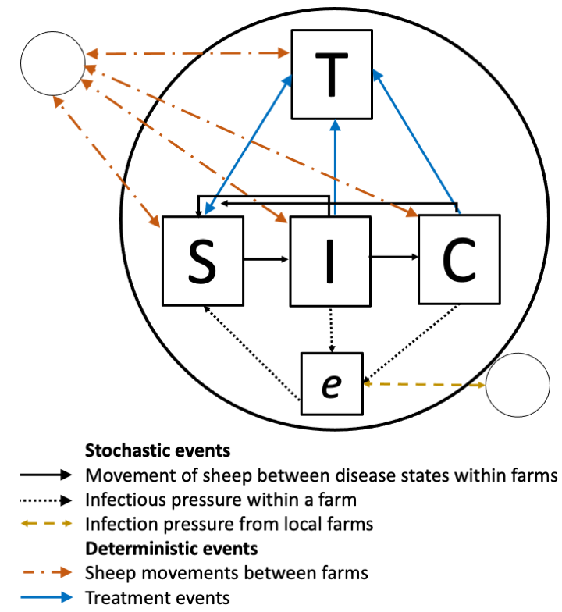

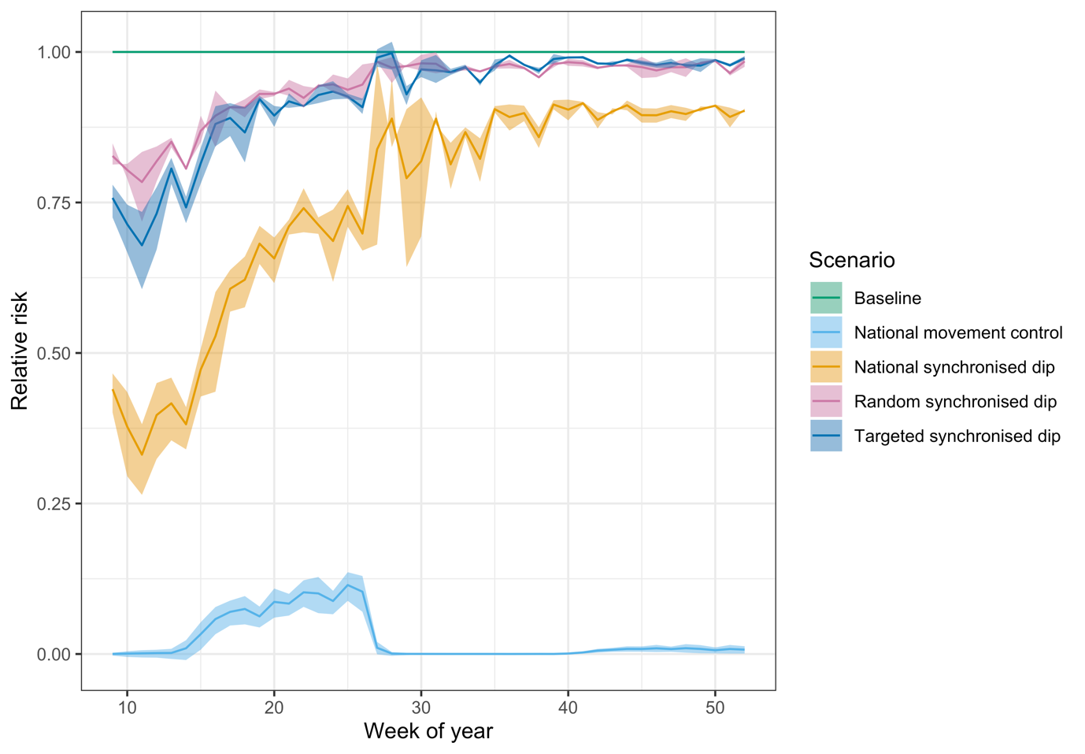
Relative risk compared to no intervention
Week of year

