Effects of different exercise types on quality of life for patients with atrial fibrillation:
A systematic review and meta-analysis

Ahlam AbuElkhair (MSc),^{a,c,h} Maxime Boidin (PhD),^{b,c,d} Benjamin JR Buckley (PhD),^{a,b,c} Deirdre A Lane (PhD),^{a,c,g} Nefyn H Williams (PhD),^{c,e} Dick Thijssen (PhD),^{b} Gregory Y H Lip (MD),^{a,c,g} Dong L. Barraclough (PhD).^{f}
ªDepartment of Cardiovascular and Metabolic Medicine, Institute of Life Course and Medical Sciences, University of Liverpool, Liverpool, United Kingdom
^{b}Research Institute for Sport and Exercise Sciences, Liverpool John Moores University and Liverpool Centre for Cardiovascular Sciences, Liverpool, U.K.
^{c}Liverpool Centre for Cardiovascular Science, University of Liverpool and Liverpool Heart & Chest Hospital, Liverpool, United Kingdom
^{d}Department of Sport and Exercise Sciences, Institute of Sport, Manchester Metropolitan University, Manchester, United Kingdom
^{e}Department of Primary Care and Mental Health, Institute of Population Health, University of Liverpool, U.K.
^{f}Department of Musculoskeletal & Ageing Sciences, Institute of Life Course and Medical Sciences, University of Liverpool, U.K.
^{g}Department of Clinical Medicine, Aalborg University, Aalborg, Denmark
^{h}Department of Physiotherapy, Faculty of Medical Technology, University of Tripoli, Libya

*Corresponding author:
Correspondence to Ahlam AbuElkhair, Department of Cardiovascular and Metabolic Medicine, Institute of Life Course and Medical Sciences, The University of Liverpool, William Henry Duncan Building, 6 West Derby Street, Liverpool L7 8TX, UK. E-mail: Ahlam244@liverpool.ac.uk
Conflicts of interest:
BJRB has received research funding from Bristol-Myers Squibb (BMS)/Pfizer.
DAL has received investigator-initiated educational grants from Bristol-Myers Squibb (BMS), has been a speaker for Bayer, Boehringer Ingeheim, and BMS/Pfizer and has consulted for BMS, and Boehringer Ingelheim.
GYHL Consultant and speaker for BMS/Pfizer, Boehringer Ingelheim and Daiichi-Sankyo. No fees are received personally.
NHW is a general medical practitioner principal in Plas Menai health centre, Lanfairfechan. He is chief investigator of NIHR HTA funded RCTs of enhanced rehabilitation for proximal femoral fracture and cardiac rehabilitation for chronic stable angina. He is a member of the NIHR HTA funding committee (commissioned research).
AAE, DB, MB, and DT have no conflicts of interest to declare.
Word count: 3361
Abstract
Aim: To investigate the effectiveness of exercise and the most effective types of exercise for patients with atrial fibrillation (AF) to improve health-related quality of life (HRQoL) and exercise capacity, and reduce AF burden, AF recurrence and adverse events.
Methods and results: Systematic search in PubMed, Cochrane Central Register of Controlled Trials, MEDLINE, CINAHL Plus, and SPORTDiscus for randomised controlled trials (RCTs) and non-randomised pre-post intervention studies investigating the effect of different types of exercise on AF patients. After exclusion, twelve studies (11 RCTs, 1 pre-post) with a total of 670 participants were included. Exercise interventions consisted of aerobic exercise, aerobic interval training (AIT), Qigong, yoga, and exercise-based cardiac rehabilitation (CR). There were significant positive effects of exercise on general health (mean difference (MD) 6.42 (95% CI: 2.90, 9.93); p= 0.0003; I² = 17%) and vitality (MD 6.18 (95% CI: 1.94, 10.41); p= 0.004; I²= 19%)) sub-scales of the Short Form 36-item questionnaire (SF-36). Qigong resulted in a significant improvement in the 6-minute walk test (MD 105.00m (95% CI: 19.53, 190.47)). Exercise-based CR and AIT were associated with a significant increment in V̇O₂peak, and AIT significantly reduced AF burden. Adverse events were few and one intervention-related serious adverse event was reported for exercise-based CR.
Conclusion: Exercise led to improvements in HRQoL, exercise capacity, and reduced AF burden. The available exercise interventions for AF patients are few and heterogeneous. Future studies are needed for all types of exercise intervention in this patient group to (co-)develop an optimised exercise training intervention for AF patients.

Introduction
One of the most common heart conditions among older people is atrial fibrillation (AF).¹ The prevalence of AF has increased globally over the last 30 years from 3.79 million (95% uncertainty interval [UI]: 2.96 to 4.83) in 1990 to 8.39 million (95% UI: 6.69 to 10.5) in 2019,² with a rise from 2.1% in 2000 to 3.3% in 2016 in the United Kingdom.³AF significantly increases the risk of stroke (five-fold),⁴ with approximately 15% of strokes attributable to AF.⁵ AF is also associated with a 1.5- to 1.9-fold greater mortality risk,^{6,7} and increasing healthcare costs.⁸
Patients with AF may face difficulty maintaining an active lifestyle due to fear of exacerbating AF episodes during increased physical effort.^{9,10} Several studies have shown substantial benefits of exercise for patients with AF including those related to enhanced health-related quality of life (HRQoL),^{11,12} as well as improvements in symptoms of anxiety and depression.¹³ Exercise has been shown to reduce AF incidence and recurrence,¹⁴⁻¹⁶ and AF-related symptom burden.¹⁷
Despite such benefits, the most effective type of exercise for patients with AF in terms of improved HRQoL and other important clinical and patient-reported outcomes are unknown. Therefore, this systematic review was conducted to find out more about the effectiveness of exercise, and which type(s) of exercise are effective for patients with AF, focussing on HRQoL, exercise capacity, adherence, adverse events, and AF burden.
Method
Search strategy
Five bibliographic databases were searched: PubMed, Cochrane Central Register of Controlled Trials (CENTRAL), MEDLINE, CINAHL Plus, and SPORTDiscus, with keywords “Atrial fibrillation”, AND “Exercise” [MeSH], OR “Sports” [MeSH], OR “Rehabilitation” [MeSH], OR “Mind-Body Therapies” [MeSH], OR “Qigong” [MeSH], OR “Tai Ji” [MeSH] AND “Quality of life”, OR “Physical function”, OR “Mortality”, OR “Fitness”, OR “Strength”, OR “Burden”, OR “Recurrence” (Supplemental Digital Content Table S1). Eligible full-text articles published after 2000 up to 11 October 2021 with no restrictions based on language were included to ensure the review was contemporary and incorporated modern management of AF. The reference lists of relevant studies and reviews were also searched.
Inclusion criteria
Randomised controlled trials (RCT), non-randomised controlled trials, pre-post studies, and prospective cohort studies were included; patients diagnosed with AF regardless of age and sex; interventions within the categories of aerobic exercise, resistance training, flexibility, neuromuscular or neuromotor; sessions of any duration or frequency; comparators included non-exercise, alternative physical activity or exercise intervention, or no treatment control.
Selection process and data extraction
All identified papers were imported into Endnote (Version X9). Two reviewers (AAE and MB) independently screened titles and abstracts against the inclusion/exclusion criteria. Full-text articles of potentially eligible studies were screened independently by the same two reviewers. Discrepancies were resolved by discussion with a third reviewer (BB). Risk of bias and quality assessments were undertaken independently by four review authors (AAE, DL, NW and MB), using the Cochrane risk-of-bias tool¹⁸ to assess RCTs, and the Risk of Bias In Non-randomised Studies of Interventions (ROBINS-I) tool¹⁹ for non-randomised studies.
Data were extracted as follows: study characteristics; participants; intervention; comparator; blinding; outcome measures; list of adjusted confounders used in analysis; results.

Outcomes
The primary outcome of interest was HRQoL, measured by generic or condition-specific questionnaires. The secondary outcomes were: (i) death (all-cause, cardiovascular); (ii) adverse events (composite of mortality, hospitalisation, or study withdrawal due to an adverse event); (iii) cardiorespiratory fitness (exercise capacity) measured via maximal/sub-maximal fitness tests, or 6-minute walk test (6MWT); (iv) retention of participants’ in the intervention; (v) intervention adherence; (vi) AF burden measured via duration/frequency of AF by wearable or implanted devices; and (vii) AF recurrence confirmed by 12-lead ECG, remote Holter monitor or similar.
Data synthesis
Where sufficient data were available for the outcomes of interest, meta-analyses were performed. HRQoL and secondary outcome effect measures with 95% confidence intervals were pooled using RevMan software. Random effects’ models were used, which allowed for between-study variability by weighting studies using a combination of their own variance and the between-study variance. Where meta-analyses were not possible, a narrative synthesis of the results is provided and where possible the findings of the studies. Change in scores over time were calculated from mean baseline and mean post-intervention scores. Baseline standard deviations were used, and if unreported were calculated from confidence intervals using the RevMan SD calculator.²⁰ Heterogeneity was assessed using the I² statistic with 25%, 50% and 75% considered moderate, substantial and considerable heterogeneity, respectively.
Results:
The screening process is summarised using the Preferred Reporting Items for Systematic Reviews and Meta-Analyses (PRISMA) flow diagram (Supplemental Digital Content Figure S1). Our initial search identified 1,175 articles, 639 of which remained after removing duplicates. Of these, 600 were excluded because of cardiovascular conditions other than AF, ineligible study type, and non-exercise/PA intervention. Thirty-nine full-text articles were assessed for eligibility; 27 were excluded for reasons including ineligible study designs, insufficient data, outcome measures not of interest to this review, incorrect study population (i.e., either healthy participants or AF-free comparator), or the intervention contained inspiratory muscle training which is not regarded as traditional exercise training. Twelve studies (n=857 participants) were included in the review (Table 1). Only eight studies were included in the meta-analysis because of either: different ways of measurements, insufficient data, or active group comparison; heterogeneity was low (<25%).
Table 1: Characteristics of included studies.
Authors, Year, and Country | Study design | N | Exercise Duration | Exercise Group | Comparator/ control group | Reported Outcomes
Pippa (2007), Italy | RCT | 43 | 16 weeks | Qigong | Wait-list | Exercise capacity, Retention rate, Adverse events
Osbak (2011), Denmark | RCT | 49 | 12 weeks | Aerobic exercises | No training | Quality of life, Exercise capacity, Retention rate, Adverse events
Lakkireddy (2013), United States | Single-centre, pre-post study | 52 | 12 weeks | Iyengar yoga | No training (patient acted as his or her own control) | Quality of life, AF burden, Retention rate, Adherence, Adverse events
Malmo (2016), Norway | RCT | 53 | 12 weeks | Aerobic interval training | Continue exercise habits | Quality of life, Exercise capacity, AF burden, Retention rate, Adherence, Adverse events
Risom (2016, 2020), Denmark* | RCT | 221 | 12 weeks | Cardiac rehabilitation and strength exercises | No training | Quality of life, Exercise capacity, Retention rate, Adherence, Adverse events
Skielboe (2017), Denmark | RCT | 76 | 12 weeks | Low intensity interval exercising | High intensity interval exercising | AF burden and recurrence, Exercise capacity, Retention rate, Adherence, Adverse events
Wahlstrom (2017), Sweden | RCT (pilot) | 80 | 12 weeks | Medi-yoga | No yoga | Quality of life, Retention rate, Adherence
Joensen (2019), Denmark | RCT | 58 | 12 weeks | Cardiac rehabilitation | Standard care | Quality of life, Exercise capacity, Retention rate, Adherence, Adverse events
Melo (2019), Portugal | RCT | 63 | 6 months | High Intensity Interval Training | No specific advice on exercise training and no supervised training. | Quality of life, Exercise capacity
Kato (2019),  Japan | RCT | 68 | 6 months | Cardiac rehabilitation | Usual care | Exercise capacity, AF recurrence, Retention rate, Adherence, Adverse events
Wahlström (2020), Sweden | Prospective randomised study (three arms) | 152 | 12 weeks | Medi-yoga | Relaxation group/ Standard treatment group | Quality of life, Retention rate, Adherence, Adverse events
* Risom (2020) has longer follow-up duration (24 months).
AF, Atrial Fibrillation; N, number; RCT, Randomised controlled trials.

Participant characteristics
The average age of the participants ranged from 56¹⁷ to 71²¹ years and the proportion of women included varied from 9.15%²⁷ to 79%¹⁷. Only two studies^{22,24} reported ethnicity, one²⁴ was exclusively white and in the other study most were white (97.0% and 97.3% in the low and high-intensity groups, respectively).²² The duration of intervention was 12-weeks in nine studies,^{13,17,21,22,25-29} and varied from 16-weeks to 6-months in three studies.^{24,23,30}
The type of exercise intervention included aerobic exercise (n= 1),²¹ aerobic interval training (AIT) (n=3),^{17,22,23} Qigong (n=1),²⁴ yoga (n=3),^{13,25,26} and exercise-based CR (n=4).²⁷⁻³⁰
Primary outcome: Quality of Life
Nine studies (n=670)^{13,17,21,23,25-29} reported HRQoL using a range of questionnaires. Seven studies used the Short Form 36-item questionnaire (SF-36)^{13,17,21,25,26,28,29} in different ways (i.e., different time points, the eight domains, or the Physical Component Summary (PCS) and Mental Component Summary (MCS) scales). Therefore, only the four studies^{17,21,26,28} that assessed the effects of exercise (AIT,¹⁷ aerobic exercises,²¹ yoga²⁶ and exercise-based CR)²⁸ on HRQoL across eight domains of the SF-36 were combined in meta-analyses and presented in the Forest plot (Figure 1).
Physical functioning
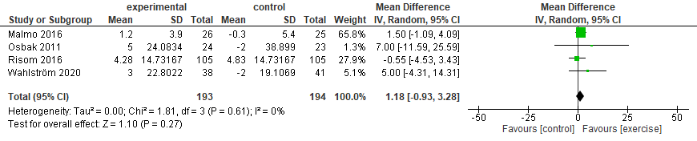
Role Physical 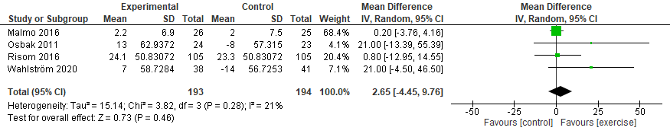
Bodily Pain
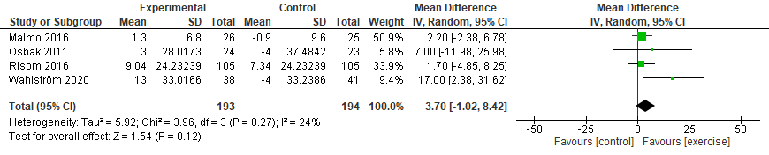
General Health
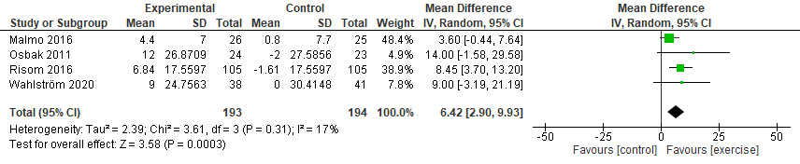
Vitality 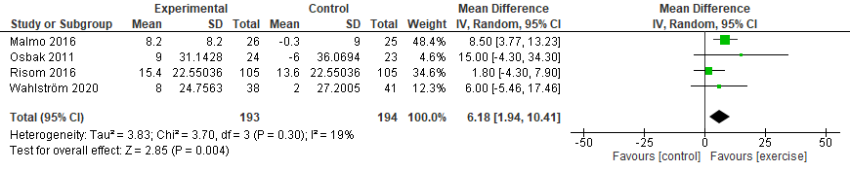
Social Functioning 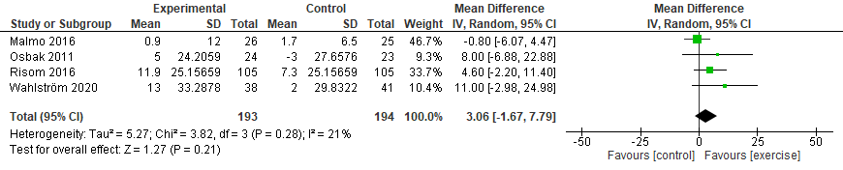

Role Emotional 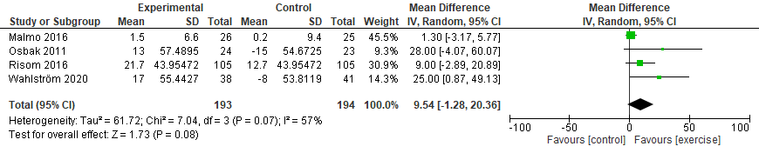
Mental Health
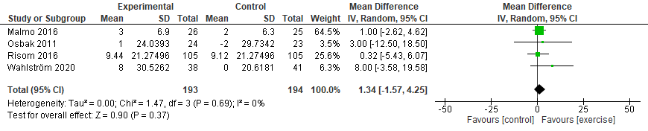
Figure 1: Changes in health-related quality of life in the eight domains of the SF-36 from the baseline to end of the intervention.
SD, Standard deviation; 95% CI, 95% confidence interval.

Exercise resulted in significant improvements in general health (mean difference (MD) 6.42 (95%CI 2.90, 9.93); p= 0.0003; I² = 17%) and vitality (MD 6.18 (95%CI: 1.94, 10.41); p= 0.004; I²= 19%); there was an improvement in the other six domains but the differences were not significant. When considering individual interventions in turn, yoga²⁶ demonstrated a significant improvement in bodily pain (MD 17 (95%CI 2.38, 31.62)) and role emotional domains (MD 25 (95%CI: 0.87, 49.13)). AIT¹⁷ resulted in a significant improvement in vitality (MD 8.50 (95%CI: 3.77, 13.23)). Exercise-based CR²⁸ reported significant improvement in the general health domain (MD 8.45 (95%CI: 3.70, 13.20)). (Supplemental Digital Content Table S2).
Risom et al.^{28,29} used the SF-36 at different time points: baseline and 4, 6, 12, and 24-months follow-up. Four studies^{17,25,26,28} reported the total score of PCS and MCS (Figure 2). Exercise resulted in significant improvements in the PCS score (MD 1.68 (95%CI: 0.06, 3.3); p= 0.04; I² = 0%) and the MCS score (MD = 2.69 (95%CI: 0.45, 4.93); p= 0.02; I² = 0%).
PCS 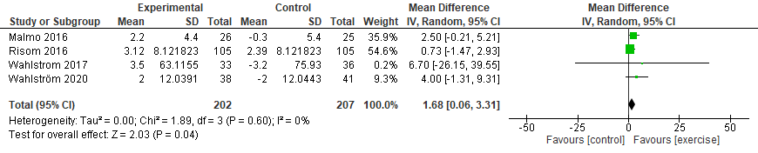
MCS
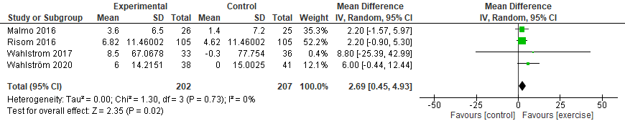
Figure 2: Changes in health-related quality of life in the Physical Component Scale and Mental Component Scale of the SF-36 from the baseline to end of the intervention.
MCS, Mental Component Scale; PCS, Physical Component Scale; SD, Standard deviation; 95% CI, 95% confidence interval.

Other questionnaires used to assess change in HRQoL in response to exercise included the condition-specific questionnaires such as Quality of Life in patients with Atrial Fibrillation-18 items (AF-QoL-18),²⁷ Atrial Fibrillation Effect on Quality-of-life Questionnaire (AFEQT),²⁷ visual analogue scale of the EuroQol questionnaire (EQ-VAS),²⁷ and HeartQoL-14 (HQL-14).²³ No significant improvement in quality of life was reported between groups after 12 weeks of exercise-based CR intervention,²⁷ for the AFEQT (MD 7.00 (95%CI -11.15, 25.15)), AF-QoL-18 (MD 9.70 (95%CI: -7.51, 26.91)), and EQ-VAS (MD 7.20 (95%CI: -4.22, 18.62)). There was no significant difference in HRQoL with high-intensity interval training (HIIT)²³ (MD 0.00 (95%CI: 0.36, -0.36)).
Secondary outcomes
Exercise capacity
Exercise capacity was assessed in nine studies.^{17,21-24,27-30} The 6MWT (distance in metres) was used in six studies,^{21,24,27-30} but only data from four studies^{21,24,27,30} were available to be pooled (Figure 3). There was no statistically significant effect of exercise on the 6MWT. The Qigong intervention²⁴ revealed a significant improvement in 6MWT following a 16-week intervention (MD 105.00m (95%CI: 19.53, 190.47)).
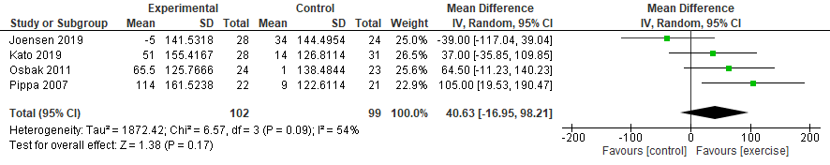Figure 3: Changes in the six-minute walk test distance from the baseline to the follow-up at different time points for intervention and control
SD, Standard deviation; 95% CI, 95% confidence interval.

V̇O₂peak was assessed in six studies;^{17,22,23,29-30} three^{17,22,23} used AIT and AIT in the form of HIIT,^{22,23} or low-intensity interval training (LIIT)²² as interventions for 12 weeks^{17,22} and 6 months.²³ V̇O₂peak significantly improved in the intervention group after 12 weeks in one study (MD 3.50 mL·kg⁻¹·min⁻¹ (95%CI:1.56, 5.44))¹⁷ but this was no longer significant at 6 months (MD -1.10 mL·kg⁻¹·min⁻¹ (95%CI: -3.92, 1.72)).²³ When comparing HIIT with LIIT²², there were no significant differences between groups (0.75 mL·kg⁻¹·min⁻¹ (95%CI: -1.31, 2.81)) after 12 weeks of intervention. For exercise-based CR^{28,29,30} V̇O₂peak significantly increased in the exercise group from 22.1 mL·kg⁻¹·min⁻¹ to 24.3 mL·kg⁻¹·min⁻¹ after 4 months²⁸, 17.8(3.4) mL·kg⁻¹·min⁻¹ to 19.8(4.6) mL·kg⁻¹·min⁻¹ after 6 months³⁰, and from 24 mL·kg⁻¹·min⁻¹ to 25.8 mL·kg⁻¹·min⁻¹ after 12 months (SD/95% CI not reported^{28,29} and the control group data were not available).³⁰
Maximal power (in watts) was assessed in four studies.^{21,27-29} Only two studies^{21,27} (effect of aerobic exercise²¹ and exercise-based CR²⁷) were pooled (Supplemental Digital Content Figure S2), as the others^{28,29} did not report a standard deviation. There was no difference in maximal power between baseline and the end of the intervention with either aerobic exercise or exercise-based CR (MD 17.52W; 95% CI -12.59, 47.63) as shown in Figure S2 (Supplemental Digital Content). The other two studies^{28,29} reported significant differences in maximal power in the intervention group following 4- and 12-months of exercise-based CR (p=0.018 and p=0.01, respectively; SD/95% CI not reported).
AF burden and AF recurrence
AF burden was assessed in two studies,^{17,22} where one study¹⁷ investigated the effects of AIT on AF burden measured using a loop recorder, reporting a significant reduction in AF burden from 8.1% to 4.8% with AIT, compared to an increase in AF burden among the control group from 10.4% to 14.6%. In the other study,²² AF burden was calculated using the ratio of ECGs recording AF with the total number of ECGs. There were no significant differences between HIIT and LIIT on AF burden, which remained after adjusting for predefined confounders.
AF recurrence was reported in two studies,^{22,30} but the method of measurement was not recorded in one study.²² AF recurrence was the most frequent reason for hospital admission during follow-up with no significant difference between intervention groups (89.5% of the HIIT and 68.4% of the LIIT; p=0.465).²² Kato and colleagues³⁰ used the 12-lead ECG to assess AF recurrence, which was not significant between groups (21.4% in the exercise group and 25.8% in usual care group; risk ratio, 0.83 (95%CI: 0.33, 2.10)).
Retention and adherence
Eleven studies^{13,17,21,22,24-30} (n=841) reported retention and adherence. One study investigating AIT,¹⁷ reported 100% retention in both groups. Four studies^{13,21,22,24} reported retention rates of 92-96% and another four 86-89%.^{27,25,26,30} The attrition rate varied over time in the two remaining studies.^{28,29} In one,²⁸ from baseline to 1 month follow-up, 2.9% of participants dropped out. In the other,²⁹ 66% of the participants in both groups completed the exercise capacity assessment at 12-months; at 24 months²⁹ 74.3% of the exercise group and 77.1% of the control completed the MCS with no clear total number reported for retention of participants at the end of the interventions.
Intervention adherence was reported in eight studies.^{13,17,22,25-28,30} Most were supervised interventions in hospital. Adherence to exercise-based CR was ≥75.0%²⁷ and 93.3%,³⁰ while in another exercise-based CR intervention²⁸ it varied by site (home 69.4%, hospital 52.7%, supervised facility 44.4%). The AIT interventions reported adherence rates between 65.0%²² and 80.0%.¹⁷ For yoga interventions,^{13,25,26} the adherence of Iyengar yoga was a mean of three studio sessions per week (range 2-7);¹³ Medi-yoga a mean of 10 hospital-based sessions (range 8–12), and median of two sessions a week (range 1–4) at-home,²⁵ and nine hospital-based sessions (7–11) in another study.²⁶
Adverse events
Ten studies^{13,17,21,22,24,26-30} reported adverse events, and seven^{17,21,24,26-28,30} are presented in the Forest plot (Supplemental Digital Content Figure S3). The reasons for excluding the other three studies^{13,22,29} were: pre-post study,¹³ comparison with another active group (HIIT and LIIT),²² and adverse events not presented by group.²⁹ Three studies^{13,21,26} did not report any adverse events for either intervention or control groups, or they were not serious or were unrelated to the intervention.^{17,22,24,30}
Only three studies²⁷⁻²⁹ reported serious adverse events (SAE). One exercise-based CR study reported two SAEs,²⁸ one death during exercise-based CR but it was unrelated to the intervention and one related SAE that required hospital admission due to AF during exercise. Another study²⁹ reported two deaths (1 in the exercise group and 1 in the control group) at 24-months follow-up. An exercise-based CR study²⁷ reported 20 hospital readmissions among the intervention group and 18 among controls for cardiac reasons (mostly AF-related), although no participants experienced adverse events during exercise training (Supplemental Digital Content Table S2).

Risk of bias
Among the 11 RCTs, random sequence generation and allocation concealment were the major sources of risk of bias, which were mostly unclear. Due to the nature of the interventions, blinding of study participants or research personnel was not possible, therefore this was graded as high risk of bias in all studies. Of 11 RCTs (Supplemental Digital Content Figures S4), five studies adequately described the method of randomisation^{23,24,26,28,30} and the remaining six^{17,21,22,25,27,29} provided an inadequate description of random sequence generation or allocation concealment. Two trials^{24,26} had attrition rates over 25% and did not report intention-to-treat analyses. Four studies^{22,27-29} blinded the outcome assessors to minimise bias. The only non-RCT (pre-post),¹³ reported moderate risk of bias due to missing data using ROBINS-I tool, however the study was considered good quality since all other sources of biases were reported as low risk.

Discussion
This systematic review shows the positive effect of the exercise on HRQoL, exercise capacity and AF burden. Twelve studies with a total of 857 participants were included, mostly RCTs and predominantly from Europe. Yoga had a significant effect on enhancing two HRQoL domains (bodily pain and role emotional). A Qigong intervention reported a significant improvement in the 6MWT. None of the exercise interventions reported a significant improvement in maximal power. Exercise-based CR and AIT were associated with a significant increment in V̇O₂peak and AIT was associated with a significant reduction in AF burden.
One AIT intervention¹⁷ reported a significant reduction in AF burden; this may be due to the association of AIT in remodelling the left ventricle³¹ and its advantages in improving oxygen uptake,³² and the AIT also reported a significant effect on V̇O₂peak. However, future studies on AIT, including the comparison of moderate-intensity continuous training with interval training, in AF patients are needed to confirm this finding.
Serious adverse events occurred rarely in the included studies, with most studies free of any adverse events, such as yoga and aerobic exercise intervention.^{13,21,26} However, the exercise-based CR interventions^{27,28,29} reported deaths unrelated to the intervention and hospital readmissions, mostly because of AF, with just one hospital admission related to the intervention.²⁸
Comparison with previous studies
During our search, similar exercise-related systematic reviews on patients with AF were identified.³³⁻³⁶ The first systematic review³³ investigated the benefits of physical activity in AF patients with 1056 participants from 36 articles. The interventions included stretching, exercise training, resistance, flexibility and aerobic exercise. They demonstrated that moderate-intensity exercise had positive effects on improving HRQoL and exercise capacity among AF patients and that moderate-intensity physical activities and a year of exercise training in preparation for cardiac surgery significantly decreased AF incidence.
The second systematic review³⁴ investigated the effects of exercise training on exercise capacity, cardiac function, BMI, and quality of life in AF patients. However, this review was confined to RCTs, with supervised training and inactive control and only five studies (n=379 participants) were included. Exercise capacity improved in the intervention group (standardized mean difference (SMD): 0.91, 95%CI: 0.70 to 1.12, I²: 0%) compared to controls and there were significant improvements in two domains of quality of life, general health and vitality assessed by the SF-36 (SMD: 0.71, 95%CI: 0.30 to 1.12, I²: 0%; SMD: 0.81, 95%CI: 0.40 to 1.23, I²: 0%, respectively). These findings are similar to the current systematic review, although previous analyses only included two studies (98 participants) compared with four studies (387 participants) in our analyses.
The third systematic review and meta-analysis (9 studies, n=959 participants),³⁵ showed post exercise-based CR significantly improved V̇O₂-peak (MD 1.59 mL·kg⁻¹·min⁻¹ (95%CI: 0.11 to 3.08; p=0.04)); and 6MWT (MD 46.9m (95%CI: 26.4 to 67.4; (p<0.001)) after 12 weeks intervention. These results were similar to ours, however, the V̇O₂-peak differnce was not significant after 6 months in our review. It is noteworthy that exercise-based CR in the review by Smart et al³⁵ also included physical therapies such as functional electrical stimulation and inspiratory muscle training. The present review added three more trials but excluded studies with these physical therapies, which are not strictly exercise training.
The most recent systematic review and meta-analysis (12 studies, n=819 participants),³⁶ also reported a significant improvement in vitality (SMD 0.51 (95%CI: 0.31–0.71)), physical functioning (SMD 0.63 (95%CI: 0.18–1.09)) and general health (SMD 0.64 (95%CI: 0.35–0.93)), although the heterogeneity was high in the last two domains (I²=85.6%, and I²=66.2% respectively). V̇O₂-peak and 6MWT were also significantly improved (SMD 0.37 (95%CI: 0.16–0.57), SMD 0.69 (95%CI: 0.19–1.19) respectively) but heterogeneity was high in the 6MWT (I²=70.6%) owing to the training duration. Our review includes other validated quality of life questionnaires (not only the SF-36) and excluded studies where patients who were AF-free were included in the control group.
When examining the effect of exercises individually on outcomes, the current review showed that yoga significantly improved bodily pain and emotional role functioning. A study by Howie-Esquivel et al³⁷ has also demonstrated the positive effect of yoga on HRQoL and on stabilising the symptoms of heart failure patients. Exercise capacity was significantly increased by Qigong²⁴ (6MWT) and exercise-based CR^{28,29,30} (V̇O₂-peak). A systematic review by Chan et al³⁸ recommends implementation of Qigong for patients with chronic heart disease given its’ positive effect on exercise capacity. A systematic review³⁹ (12 articles, n=4822 participants) examining the effect of CR on patients with AF, found a positive correlation between the improvement in aerobic fitness and a lower risk of mortality and hospital admission.
There is a paucity of different types of exercise/physical activity interventions for AF patients compared with other cardiac conditions. For example, there were no studies examining Tai Chi interventions despite research demonstrating a positive effect on improving HRQoL and physical function in patients with coronary artery disease^{40,41} and myocardial infarction.⁴² Given the heterogeneity in the AF population, a variety of exercise interventions that demonstrate benefits on exercise capacity, improvements in quality of life, without increasing adverse outcomes are needed to enable patient choice based on functional capacity, ability, and interest. Enhancing exercise and physical activity are important considerations for lifestyle factors in the Atrial fibrillation Better Care (ABC) pathway,⁴³ as advocated by guidelines as part of the holistic or integrated care approach to AF management. Adherence to the ABC pathway has been shown to be associated with improved clinical outcomes.⁴⁴⁻⁴⁶
Strengths and limitations
Searching and screening of the evidence were conducted by two independent reviewers (following established PRISMA guidelines) and risk of bias assessment for the included studies was completed independently by four reviewers. Some data from included studies were not available and had to be calculated. There was significant variation in terms of the type of exercise, duration of follow-up, and outcome measures, which prevented meta-analysis of some data.
Conclusions
Most AF patients are older (>65 years) with co-morbidities, including mobility problems, and therefore physical activity interventions need to be tailored to an individual’s functional capacity. This systematic review demonstrated that aerobic exercises, AIT, Qigong, yoga, and exercise-based CR were associated with improvements in HRQoL, exercise capacity, and AF burden, where aerobic exercises, AIT, Qigong, and yoga appear relatively safe. No differences between the effect of high and low intensity exercise on AF burden or AF recurrence were found. To better assess efficacy, safety, and patient acceptability, further well-designed and suitably powered trials are recommended.

Contributorship statement:
DAL, NHW, and DB conceived the idea. AAE, DAL, NHW, DB, MB, BJRB, and DT developed the review questions. AAE and MB conducted the searches. AAE, MB, DAL, NHW, and BJRB assessed the studies for risk of bias. AAE performed the meta-analyses and DAL, NHW, and DB verified the analytical methods. DAL, NHW, and DB supervised the work. AAE drafted the manuscript, and all authors contributed to the critical revision and final draft.

Acknowledgements:
We would like to thank Dr Philip Osbak and Dr Signe S. Risom for providing further clarification regarding their studies.

Funding:
No direct funding for this review. Ms Ahlam Abu Elkhair PhD is funded by the Libyan Cultural Affairs’- Libyan Ministry of Education. Dr Maxime Boidin is financially supported by a grant from the Fonds de Recherche du Québec – Santé (FRQ-S) and the Quebec Network for Research on Aging (RQRV).

Registration and protocol
The protocol has been registered on the PROSPERO database; registration number CRD42021231102.

References
- Furberg CD, Psaty BM, Manolio TA, Gardin JM, Smith VE, Rautaharju PM, et al. Prevalence of atrial fibrillation in elderly subjects (the Cardiovascular Health Study). Am J Cardiol. 1994;74(3):236-241.
- Roth GA, Mensah GA, Johnson CO, Addolorato G, Ammirati E, Baddour LM, et al. Global Burden of Cardiovascular Diseases and Risk Factors, 1990-2019: Update From the GBD 2019 Study. J Am Coll Cardiol. 2020;76(25):2982-3021.
- Adderley NJ, Ryan R, Nirantharakumar K, Marshall T. Prevalence and treatment of atrial fibrillation in UK general practice from 2000 to 2016. Heart. 2019;105(1):27-33.
- Wolf PA, Abbott RD, Kannel WB. Atrial fibrillation as an independent risk factor for stroke: the Framingham Study. Stroke. 1991;22(8):983-988.
- Lip GY, Lane DA. Stroke prevention in atrial fibrillation: a systematic review. Jama. 2015;313(19):1950-1962.
- Benjamin EJ, Wolf PA, D’Agostino RB, Silbershatz H, Kannel WB, Levy D. Impact of atrial fibrillation on the risk of death: the Framingham Heart Study. Circulation. 1998;98(10):946-952.
- Nourmohammadi Z, Khalifehzadeh-Esfahani A, Eftekhari M, Sanei H. The effect of aerobic physical rehabilitation on the quality of life in patients with chronic atrial fibrillation; A randomized controlled clinical trial study. ARYA Atheroscler. 2019;15(1):1-8.
- Burdett P, Lip GY. Atrial Fibrillation in the United Kingdom: Predicting Costs of an Emerging Epidemic Recognising and Forecasting the Cost Drivers of Atrial Fibrillation-related costs. Eur Heart J Qual Care Clin Outcomes. 2022;8(2):187–194.
- Bosomworth NJ. Atrial fibrillation and physical activity: Should we exercise caution? Canadian Family Physician. 2015;61(12):1061-1070.
- McCabe PJ, Barnason SA, Houfek J. Illness beliefs in patients with recurrent symptomatic atrial fibrillation. Pacing Clin Electrophysiol. 2011;34(7):810-820.
- Hegbom F, Stavem K, Sire S, Heldal M, Orning OM, Gjesdal K. Effects of short-term exercise training on symptoms and quality of life in patients with chronic atrial fibrillation. Int J Cardiol. 2007;116(1):86-92.
- Reed JL, Clarke AE, Faraz AM, Birnie DH, Tulloch HE, Reid RD, et al. The impact of cardiac rehabilitation on mental and physical health in patients with atrial fibrillation: a matched case-control study. Can J Cardiol. 2018;34(11):1512-1521.
- Lakkireddy D, Atkins D, Pillarisetti J, Ryschon K, Bommana S, Drisko J, et al. Effect of yoga on arrhythmia burden, anxiety, depression, and quality of life in paroxysmal atrial fibrillation: the YOGA My Heart Study. J Am Coll Cardiol. 2013;61(11):1177-1182.
- Buckley BJR, Lip GYH, Thijssen DHJ. The counterintuitive role of exercise in the prevention and cause of atrial fibrillation. Am J Physiol Heart Circ Physiol. 2020;319(5):H1051-H1058.
- Eijsvogels TM, Fernandez AB, Thompson PD. Are There Deleterious Cardiac Effects of Acute and Chronic Endurance Exercise? Physiol Rev. 2016;96(1):99-125.
- Mozaffarian D, Furberg CD, Psaty BM, Siscovick D. Physical activity and incidence of atrial fibrillation in older adults: the cardiovascular health study. Circulation. 2008;118(8):800-807.
- Malmo V, Nes BM, Amundsen BH, Tjonna AE, Stoylen A, Rossvoll O, et al. Aerobic Interval Training Reduces the Burden of Atrial Fibrillation in the Short Term: A Randomized Trial. Circulation. 2016;133(5):466-473.
- Higgins JP, Altman DG, Gotzsche PC, Juni P, Moher D, Oxman AD, et al. The Cochrane Collaboration's tool for assessing risk of bias in randomised trials. BMJ. 2011;343:d5928.
- Sterne JA, Hernan MA, Reeves BC, Savovic J, Berkman ND, Viswanathan M, et al. ROBINS-I: a tool for assessing risk of bias in non-randomised studies of interventions. BMJ. 2016;355:i4919.
- Drahota A, Beller E. RevMan Calculator [Available from: https://training.cochrane.org/resource/revman-calculator (9 Aug 2021)
- Osbak PS, Mourier M, Kjaer A, Henriksen JH, Kofoed KF, Jensen GB. A randomized study of the effects of exercise training on patients with atrial fibrillation. Am Heart J. 2011;162(6):1080-1087.
- Skielboe AK, Bandholm TQ, Hakmann S, Mourier M, Kallemose T, Dixen U. Cardiovascular exercise and burden of arrhythmia in patients with atrial fibrillation - A randomized controlled trial. PLoS One. 2017;12(2):e0170060.
- Melo X, Abreu A, Santos V, Cunha P, Oliveira M, Pinto R, et al. A Post hoc analysis on rhythm and high intensity interval training in cardiac resynchronization therapy. Scand Cardiovasc J. 2019;53(4):197-205.
- Pippa L, Manzoli L, Corti I, Congedo G, Romanazzi L, Parruti G. Functional capacity after traditional Chinese medicine (qi gong) training in patients with chronic atrial fibrillation: a randomized controlled trial. Preventive cardiology. 2007;10(1):22-25.
- Wahlstrom M, Rydell Karlsson M, Medin J, Frykman V. Effects of yoga in patients with paroxysmal atrial fibrillation - a randomized controlled study. Eur J Cardiovasc Nurs. 2017;16(1):57-63.
- Wahlstrom M, Rosenqvist M, Medin J, Walfridsson U, Rydell-Karlsson M. MediYoga as a part of a self-management programme among patients with paroxysmal atrial fibrillation - a randomised study. Eur J Cardiovasc Nurs. 2020; 19(1):74-82.
- Joensen AM, Dinesen PT, Svendsen LT, Hoejbjerg TK, Fjerbaek A, Andreasen J, et al. Effect of patient education and physical training on quality of life and physical exercise capacity in patients with paroxysmal or persistent atrial fibrillation: A randomized study. J Rehabil Med. 2019;51(6):442-450.
- Risom SS, Zwisler AD, Rasmussen TB, Sibilitz KL, Madsen TL, Svendsen JH, et al. Cardiac rehabilitation versus usual care for patients treated with catheter ablation for atrial fibrillation: Results of the randomized CopenHeart(RFA) trial. Am Heart J. 2016;181:120-129.
- Risom SS, Zwisler A-D, Sibilitz KL, Rasmussen TB, Taylor RS, Thygesen LC, et al. Cardiac Rehabilitation for Patients Treated for Atrial Fibrillation With Ablation Has Long-Term Effects: 12-and 24-Month Follow-up Results From the Randomized CopenHeartRFA Trial. Archives of Physical Medicine and Rehabilitation. 2020;101(11):1877-1886.
- Kato M, Ogano M, Mori Y, Kochi K, Morimoto D, Kito K, et al. Exercise-based cardiac rehabilitation for patients with catheter ablation for persistent atrial fibrillation: A randomized controlled clinical trial. European journal of preventive cardiology. 2019;26(18):1931-1940.
- Wisloff U, Stoylen A, Loennechen JP, Bruvold M, Rognmo O, Haram PM, et al. Superior cardiovascular effect of aerobic interval training versus moderate continuous training in heart failure patients: a randomized study. Circulation. 2007;115(24):3086-3094.
- Fu TC, Wang CH, Lin PS, Hsu CC, Cherng WJ, Huang SC, et al. Aerobic interval training improves oxygen uptake efficiency by enhancing cerebral and muscular hemodynamics in patients with heart failure. Int J Cardiol. 2013;167(1):41-50.
- Giacomantonio NB, Bredin SS, Foulds HJ, Warburton DE. A systematic review of the health benefits of exercise rehabilitation in persons living with atrial fibrillation. Can J Cardiol. 2013;29(4):483-491.
- Kato M, Kubo A, Nihei F, Ogano M, Takagi H. Effects of exercise training on exercise capacity, cardiac function, BMI, and quality of life in patients with atrial fibrillation: a meta-analysis of randomized-controlled trials. International Journal of Rehabilitation Research. 2017;40(3):193-201.
- Smart NA, King N, Lambert JD, Pearson MJ, Campbell JL, Risom SS, et al. Exercise-based cardiac rehabilitation improves exercise capacity and health-related quality of life in people with atrial fibrillation: a systematic review and meta-analysis of randomised and non-randomised trials. Open heart. 2018;5(2):e000880.
- Shi S, Shi J, Jia Q, Shi S, Yuan G, Hu Y. Efficacy of Physical Exercise on the Quality of Life, Exercise Ability, and Cardiopulmonary Fitness of Patients With Atrial Fibrillation: A Systematic Review and Meta-Analysis. Front Physiol. 2020;11:740.
- Howie-Esquivel J, Lee J, Collier G, Mehling W, Fleischmann K. Yoga in heart failure patients: a pilot study. J Card Fail. 2010;16(9):742-749.
- Chan CL-W, Wang C-W, Ho RT-H, Ho AH-Y, Ziea ET-C, Taam Wong VC-W, et al. A systematic review of the effectiveness of qigong exercise in cardiac rehabilitation. The American journal of Chinese medicine. 2012;40(02):255-267.
- Reed JL, Terada T, Chirico D, Prince SA, Pipe AL. The effects of cardiac rehabilitation in patients with atrial fibrillation: a systematic review. Can J Cardiol. 2018;34(10):S284-95.
- Park IS, Song R, Oh KO, So HY, Kim DS, Kim JI, et al. Managing cardiovascular risks with Tai Chi in people with coronary artery disease. J Adv Nurs. 2010;66(2):282-292.
- Sato S, Makita S, Uchida R, Ishihara S, Masuda M. Effect of Tai Chi training on baroreflex sensitivity and heart rate variability in patients with coronary heart disease. International heart journal. 2010;51(4):238-241.
- Nery RM, Zanini M, de Lima JB, Buhler RP, da Silveira AD, Stein R. Tai Chi Chuan improves functional capacity after myocardial infarction: A randomized clinical trial. Am Heart J. 2015;169(6):854-860.
- Lip GY. The ABC pathway: an integrated approach to improve AF management. Nature Reviews Cardiology. 2017;14(11):627-628.
- Yoon M, Yang P-S, Jang E, Yu HT, Kim T-H, Uhm J-S, et al. Improved population-based clinical outcomes of patients with atrial fibrillation by compliance with the simple ABC (Atrial Fibrillation Better Care) pathway for integrated care management: a nationwide cohort study. Thrombosis and haemostasis. 2019;119(10):1695-1703.
- Stevens D, Harrison SL, Kolamunnage-Dona R, Lip GY, Lane DA. The Atrial Fibrillation Better Care pathway for managing atrial fibrillation: a review. EP Europace. 2021; 23(10):1511-1527
- Romiti GF, Pastori D, Rivera-Caravaca JM, Ding WY, Gue YX, Menichelli D, et al. Adherence to the ‘Atrial Fibrillation Better Care’Pathway in Patients with Atrial Fibrillation: Impact on Clinical Outcomes—A Systematic Review and Meta-Analysis of 285,000 Patients. Thrombosis and Haemostasis. 2021; 122(03):406-414.

Figure legends
Figure 1 | Changes in health-related quality of life in the eight domains of the SF-36 from the baseline to the end of the intervention.
Figure 2 | Changes in health-related quality of life in the Physical Component Scale and Mental Component Scale of the SF-36 from the baseline to the end of the intervention.
Figure 3 | Changes in the six-minute walk test distance from the baseline to the follow-up at different time points for intervention and control groups.

Supplementary materials
Supplementary Table 1. Complete search strategy for the MEDLINE database.
Supplementary Table 2. Characteristics and results of the included studies.
Supplementary Figure 1. PRISMA flow diagram summarising the screening process.
Supplementary Figure 2. Changes in the maximal power test from the baseline to the 12-weeks follow-up for intervention and control groups.
Supplementary Figure 3. Differences in the reported adverse events by seven RCTs for intervention and control groups during the intervention period and the follow-up.
Supplementary Figure 4. Risk of bias assessment of the randomised controlled trials using the Cochrane risk-of-bias tool.

