Fate of intravenously administered umbilical cord mesenchymal stromal cells and interactions with the host's immune system
Francesco Amadeo^{1,2,3}, Vivien Hanson¹, Neill J. Liptrott⁴, Bettina Wilm^{2,3}, Patricia Murray^{2,3}, Arthur Taylor^{2,3}

1. Cellular Therapies Laboratory, NHS Blood and Transplant, Liverpool, UK.
2. Department of Molecular Physiology and Cell Signalling, University of Liverpool, Liverpool, UK.
3. Centre for Preclinical Imaging, University of Liverpool, Liverpool, UK.
4. Immunocompatibility Group, Department of Pharmacology & Therapeutics, University of Liverpool, Liverpool, UK.
Corresponding author e-mail address: taylora@liverpool.ac.uk
Orcid IDs: Francesco Amadeo 0000-0002-3868-2348; Neill Liptrott 0000-0002-5980-8966; Bettina Wilm 0000-0002-9245-993X; Patricia Murray 0000-0003-1316-148X; Arthur Taylor 0000-0003-2028-6694

Abstract (maximum length: 250 words)
Mesenchymal stromal cells (MSCs) are multipotent cells showing promise in pre-clinical studies and currently used in many clinical trials. The regenerative potential of MSCs is mediated, at least in part, by direct and indirect immunomodulatory processes. However, the mechanism of action is not fully understood yet, and there are still concerns about possible undesired negative effects associated with the administration of living cells. In this study, we (i) compare the long-term fate and safety of umbilical cord (UC-)MSCs administered to immunocompetent and immunocompromised (severe combined immunodeficient (SCID) and non-obese diabetic (NOD)/SCID) animals, and (ii) investigate the immunological response of the host to the administered cells. Intravenous administration of firefly luciferase expressing UC-MSCs revealed that the cells get trapped in the lungs of both immunocompetent and immunocompromised animals, with >95% of the cells disappearing within 72 hours after administration. In 27% of the SCID and 45% of the NOD/SCID, a small fraction of the cells lived up to day 14 but in most cases they all disappeared earlier. One NOD/SCID mouse showed weak signal up to day 31. Immunocompetent mice displayed elevated percentages of neutrophils in the lungs, the blood, and the spleen 2h after the administration of the cells. The concentration of neutrophil chemoattractants (MCP1, CCL7, Gro-α and IP-10) were also increased in the plasma of the animals 2h after the administration of the MSCs. Our results suggest that although the UC-MSCs are short-lived in mice, they still result in an immunological response that might contribute to a therapeutic effect.
Keywords: mesenchymal stromal cells, cell therapies, bioluminescence imaging, reporter genes, animal models
Declarations:
Funding: This project has received funding from the European Union’s Horizon 2020 research and innovation programme under the Marie Sklodowska-Curie grant agreement No. 813839.
Conflicts of interest/Competing interests: The authors have no conflicts of interest to declare that are relevant to the content of this article.
Availability of data and material: All datasets from this study are publicly available on Zenodo, DOI: 10.5281/zenodo.7377487
Acknowledgements: We acknowledge the support of the Flow Cytometry Facility at the University of Liverpool.
- Introduction
Mesenchymal stromal cells (MSCs) are multipotent cells identified for the first time in the bone marrow in the 1970s [1, 2]. Since then, MSCs have been identified in many other human tissues (e.g. umbilical cord, Warton’s jelly, adipose tissue, synovial membrane, tooth pulp, etc.) and several of those are currently being investigated in clinical trials because of the promising properties that these cells have shown in pre-clinical studies [3-5]. MSCs have been reported to exert several direct and indirect immunomodulatory effects on both the innate and the adaptive immunity [6], including suppression of B and T cells activation [7, 8], together with the induction of T cell differentiation toward a regulatory phenotype (Tregs) [9], inhibition of natural killer (NK) [9, 10] and dendritic cell maturation (DCs) [11], and promotion of macrophages polarisation toward an anti-inflammatory phenotype [12]. MSCs have also been reported to display regenerative potential through the secretion of paracrine factors [13]. However, despite MSCs having been extensively studied, the mechanisms underlying their therapeutic effect have not been fully elucidated.
Furthermore, limited data is available on potential undesired effects associated with the administration of living cells, such as tumour formation [14], embolism [15] and unwanted differentiation [16]. The fact that MSCs are used in several clinical trials involving patients with an impaired immune system (e.g. patients with graft versus host disease/GVHD, or HIV [17]), further reinforces the need to address their safety in hosts with varying immunological profiles.
Preclinical models can be used to assess the safety and the biodistribution of injected MSCs by monitoring their fate following administration. The use of reporter genes, such as bioluminescence reporters, is a standard technique that can be used to investigate cell biodistribution, viability and safety in small animals [18, 19]. Intravenous (IV) injection is one of the most common routes of administration of MSCs [20], despite this often leading to lung entrapment in animal models [21-25]. MSCs have short-term survival in the lungs of immunocompetent animals, as evidenced by most of their bioluminescence signal disappearing within the initial 24h post administration, which is an indication of cell death [19, 22, 25]. The induction of apoptosis of IV administered MSCs by host immune cytotoxic cells (CD8 T and NK cells) has been recently documented in a mouse model of GVHD [26], suggesting a possible direct involvement of the recipient immune system in the death of the administered cells. Longer survival of umbilical cord (UC-)MSCs coming from a single donor was observed by Scarfe et al. in severe combined immunodeficient (SCID) mice [19].
Here, human UC-MSCs from 3 individual donors (including the same cells used by Scarfe et al. [19]) were used to compare their biodistribution between two immunocompromised mouse strains (SCID and non-obese diabetic (NOD)/SCID) and one healthy immunocompetent strain (BALB/c) to clarify: (a) if an altered immunological profile can influence the survival of the administered cells, and (b) the long-term safety of MSCs in immunocompromised hosts. We also explored how the presence of the xenogeneic cells affected the immune system of healthy animals using a combination of flow cytometry, to determine the immune cell populations present in a range of organs and tissues, and a multiplex assay to determine the levels of soluble factors in the plasma of the animals.

- Materials and methods
  - Cell culture
Human UC-MSCs were obtained from the NHS Blood and Transplant (NHSBT, Liverpool, UK) from three individual healthy donors, in accordance with the UK’s Human Tissue Act (HTA) and with the Declaration of Helsinki. The cells were isolated according to NHSBT good manufacturing practice (GMP) procedures. In summary, the tissue was halved horizontally, cut into pieces and cultured undisturbed for 7 days. Then, the pieces were removed and the cells were expanded for two passages under standard tissue culture conditions. The cells were cryopreserved and shipped to the Department of Molecular Physiology and Cell Signalling of the University of Liverpool. There, the cells were cultured following standard tissue culture protocols in MEM-α containing GlutaMAX (Gibco) and supplemented with 10% foetal bovine serum (FBS; Gibco). The cells were kept at 37 °C in a humidified incubator, with 5% CO2.
  - Production of FLuc⁺ UC-MSCs
UC-MSCs were transduced with a pHIV-Luc2-ZsGreen lentiviral vector (LV) carrying the luc2 firefly luciferase (FLuc) reporter and the ZsGreen green fluorescent protein. The pHIV-Luc2-ZsGreen vector was a gift from Bryan Welm and Zena Werb (Addgene plasmid #39,196). Lentiviral particles were produced using a standard protocol [27] by co-transfection of HEK cells with the transfer vector (pHIV-Luc2-ZsGreen), an envelope plasmid (pMD2.G) and a packaging plasmid (psPAX2).
To produce transduced populations, UC-MSCs were infected overnight with a multiplicity of infection of 5 in the presence of 6 μg/mL 40 kDa diethylaminoethyl-dextran (DEAE-dextran) as previously described [28]. The cells were then grown until 60-90% confluence and sorted based on the ZsGreen fluorescence using a FACSaria II (BD Biosciences) to obtain a pure population of cells expressing the transgenes (henceforth referred to as FLuc⁺ UC-MSCs).
  - Animal experiments
7-9 week old severe combined immunodeficient (SCID; CB17/lcr-PrkdcSCID/lcrlcoCrl), non-obese diabetic SCID (NOD/SCID; NOD.CB17-PrkdcSCID/NCrCrl) and BALB/c immune-competent female mice were obtained from Charles River. 8-week old C57 Black 6 (C57BL/6) albino female mice were obtained from a colony managed by the Biomedical Services Unit at the University of Liverpool (UK), which had been established from the C57BL/6J. Tyrc-2J strain originally purchased from JAX. Mice were housed in individually ventilated cages (IVCs) under a 12-hours light/dark cycle and provided with standard food and water ad libitum. All animal procedures were performed under a licence granted by the UK’s Animals (Scientific Procedures) Act 1986 and approved by the University of Liverpool Animal Welfare and Ethics Review Board.
    - Long term biodistribution of FLuc⁺ UC-MSCs in immunocompromised mice
SCID, NOD/SCID and BALB/c mice (n = 45; 15 animals per strain) were used to evaluate the biodistribution, persistence over time and safety of FLuc⁺ UC-MSCs for up to 31 days from administration. SCID and NOD/SCID strains were used as immunocompromised groups, while the BALB/c strain was used as immunocompetent control group.
FLuc⁺ UC-MSCs (n = 3 different donors) were harvested and suspended in ice-cold PBS at a concentration of 2.5x10⁵ cells/100 μL and kept on ice until administered to SCID, NOD/SCID and BALB/c mice. Animals (n = 5 mice per strain per donor) were anaesthetised with isoflurane and intravenously (IV) injected with 100 μL of cell suspension via the tail vein. 1 of the NOD/SCID receiving the cells from donor #735O died right after the administration of the cells and was excluded from the rest of the experiment.
An IVIS Spectrum system (Perkin Elmer) was used to perform the bioluminescence imaging. For that purpose, 200 μL of 47 mM D-Luciferin was administered subcutaneously (SC) 20 minutes before each data acquisition session [25]. Administration of substrate and imaging were performed on the day of cell injection (day 0) and after 1, 3, 5 and 7 days. From the second week until the end of the experiment (day 31), the animals were imaged twice a week. The acquired signal was always normalised to radiance (photons/second/centimeter²/steradian) and the region of interest (ROI) tool of the IVIS software (Living Image v. 4.5.2) was used to obtain the total number of photons emitted from the thoracic area of the mice. All imaging sessions were performed using an open filter, a binning of 8, a f-stop of 1, and 60 seconds exposure time at day 0 and 180-seconds exposure time from day 1 onwards.
    - Flow cytometry analysis of immune cells from different tissues
C57BL/6 albino mice were used to assess whether the administration of UC-MSCs can have an impact on immune cell populations from different organs/tissues.
The animals (n = 18) were divided into 3 groups: (1) control naïve mice that did not receive cells, (2) mice culled 2h after cell administration and (3) mice culled 24h after cell administration. Animals from groups 2 and 3 were anaesthetised and received an IV injection of 2.5x10⁵ untransduced UC-MSCs (from 1 donor) suspended in 100 μL PBS. Animals were culled by cardiac exsanguination and the blood, lungs, spleen and bone marrow were harvested.
      - Whole blood collection and processing
Whole blood was collected via cardiac puncture under terminal anaesthesia. Immediately after collection, 10 mL of Red Blood Cell (RBC) lysis buffer (eBioscience, #00-4333-57) was added to each 1.0 mL of mouse blood and incubated for 10 minutes at room temperature, with occasional shaking. After stopping the reaction with 30 mL of PBS, the cells were centrifuged at 400 g for 1 minute at 4°C. The cell pellet was then suspended in PEB (PBS, 5mM EDTA and 0.5% w/v bovine serum albumin) buffer.
      - Lung harvesting and digestion
Lungs were collected and digested to obtain single-cell suspensions following the protocol described by Jungblut et al. [29]. Briefly, the harvested lung tissue was transferred to a gentleMACS C Tube (Miltenyi Biotec, #130-096-334) containing 4.9 mL of HEPES buffer (10 mM HEPES-NaOH pH 7.4, 150 mM NaCl, 5 mM KCl, 1 mM MgCl2, 1.8 mM CaCl2). Then, 100 μL of Collagenase D (SigmaAldrich, #11088866001; 100 mg/mL stock solution in HEPES buffer) and 20 μL DNase I solution (SigmaAldrich, # 11284932001; 20,000 U/mL stock solution) was added. The C tube was loaded into the gentleMACS dissociator and subsequently run with the gentleMACS standard programs "m_lung_01" and "m_lung_02", with a 30 min incubation at 37°C with automated rotation in between the programs. The dissociated tissue was then passed through a 70 µm cell strainer, centrifuged at 300 g for 10 min and suspended in PEB buffer.
      - Bone Marrow harvesting and processing
Bone marrow was collected from the hind limbs following the protocol described by Amend et al. [30]. The long bones (femurs and tibias) were carefully dissected from the euthanized mice. After the removal of any remaining muscle or connective tissue, the metaphysis of the femurs and the tibias were exposed. An 18 G needle was used to pierce a hole through the bottom of a 0.5 mL microcentrifuge tube and the long bones were placed into it, with the exposed metaphysis facing the bottom of the tube. The 0.5 mL tube was housed inside of a 1.5 mL tube and centrifuged at ≥10,000 g for 15 seconds. After discarding the 0.5 mL tube, the pellet at the bottom of the 1.5 mL tube was transferred into a 50mL tube and incubated for 5 minutes with 5mL RBC lysis buffer to remove red blood cells. After another centrifugation step (400g), the cells were suspended in PEB buffer.
      - Spleen harvesting and digestion
To obtain a single cell suspension of splenocytes, the spleen was mechanically and enzymatically digested. The freshly harvested spleen was transferred to a gentleMACS C Tube (Miltenyi Biotec, #130-096-334) containing 2 mL of digestion solution, made of 1.8 mL of sterile DMEM, 200 μL of Liberase (SigmaAldrich, #5401160001, 3 mg/mL stock solution) and 10 μL DNase I solution (SigmaAldrich, # 11284932001; 20,000 U/mL stock solution). The C tube was loaded into the gentleMACS Dissociator and subsequently run with the gentleMACS standard programs "m_spleen_01" and "m_spleen_02", with a 30 min incubation at 37°C with automated rotation in between the programs. The dissociated tissue was then passed through a 70 µm cell strainer, centrifuged at 300 g for 10 min and suspended in RBC lysis buffer for 5 minutes. At the end of the incubation, the cells were centrifuged again and suspended in PEB buffer.
      - Staining for flow cytometry
Cells isolated from the different organs suspended in PEB buffer were incubated with Fc blocking agent (Miltenyi Biotec, #130-092-575) at room temperature for 15 minutes. Then, the cells were divided into individual tubes for the respective cell type analysis, suspended in 100 µL of PEB buffer and stained. Table 1 summarises the immune cells investigated and the respective markers, while Supplementary Table 1 presents the antibodies used. All stainings were performed according to the manufacturer’s instructions. As FoxP3 and CD68 are intracellular markers the cells were fixed and permeabilised prior to staining for these two markers, as suggested by the manufacturer. Unstained cells were used as controls. The flow cytometry data were acquired with a FACS Canto II cytometer and analysed using the Flowing Software from Perttu Terho [31]. The gating strategy is based on the study performed by Hensel et al. [32], and is summarised below:
- Immature myeloid cells (iMCs): population 1 (P1) = singlets; P2 = CD11b VioBlue and Gr-1 APC-Vio770 double positive gate; P3 = F4/80 APC negative and Ly6b FITC negative, F4/80 APC positive and Ly6b FITC negative, F4/80 positive and Ly6b positive gate.
- Neutrophils: P1 = singlets; P2 = CD11b VioBlue and Gr-1 APC-Vio770 double positive gate; P3 = F4/80 APC negative and Ly6b FITC positive gate.
- Macrophages: P1 = singlets; P2 = CD11b VioBlue and F4/80 double-positive gate; P3 = CD68 PE (intracellular staining) positive gate.
- Natural killer (NK) cells: P1 = singlets; P2 = CD3ε APC-Vio770 negative and NKp46 positive gate.
- Myeloid dendritic cells (mDC): P1 = singlets; P2 = CD11b VioBlue and CD11c PE double positive gate.
- Peripheral dendritic cells (pDC): P1 = singlets; P2 = CD11b VioBlue negative and CD11c PE positive gate; P3 = B220 APC-Vio770 and Siglec H FITC double positive gate.
- CD4 T cells: P1 = singlets; P2 = CD3ε APC-Vio770 and CD4 VioBlue double positive gate.
- CD4 T regulatory (Tregs) cells: P1 = singlets; P2 = CD3ε APC-Vio770 and CD4 VioBlue double positive gate; P3 = CD25 and FoxP3 APC (intracellular staining) double positive gate.
- CD8 T cells: P1 = singlets; P2 = CD3ε APC-Vio770 and CD8 FITC double positive gate.
- B cells: P1 = singlets; P2 = B220 APC-Vio770 and CD19 PE double positive gate.
Table 1: Cell markers used to identify immune cell populations.
Cell type | Markers
iMCs | CD11b VioBlue | Gr-1 APC-Vio770 |  | Ly6B⁻ FITC |  |  | F4/80^{-/+} APC
 |  |  |  | Ly6B⁺ FITC |  |  | F4/80⁺ APC
Neutrophils | CD11b VioBlue | Gr-1 APC-Vio770 |  | Ly6B FITC |  |  | F4/80 APCª
Macrophages | CD11b VioBlue | F4/80 APC |  | CD68 PE
NK cells | CD3ε APC-Vio770ª | NKp46 FITC
mDC | CD11b VioBlue | CD11c PE
pDC | CD11b VioBlue | CD11c PE |  | B220 APC-Vio770 |  |  | Siglec H FITC
CD4 T cells | CD3ε APC-Vio770 | CD4 VioBlue
CD4 Tregs | CD3ε APC-Vio770 | CD4 VioBlue |  | CD25 PE |  |  | FoxP3 APC
CD8 T cells | CD3ε APC-Vio770 | CD8 FITC
B cells | B220 APC-Vio770 | CD19 PE
ª indicates the absence of a marker
    - Measurement of analytes in blood
C57BL/6 albino mice were used for measuring the levels of several analytes (Table 2) in the blood of animals with the use of a Luminex multiplex assay. The animals (n = 24) were divided into the same 3 groups as for flow cytometry and the cells (donor 1) were administered to groups 2 and 3 as above. Blood collection was performed during terminal anaesthesia via cardiac exsanguination 2h (group 2) or 24h (group 3) after the administration of the cells. The blood was collected into tubes containing lithium heparin (BD microtainer tubes, #365966) for plasma separation. Each tube was immediately inverted 10 times and centrifuged at 2,000 g for 5 minutes. The plasma was then collected, snap frozen with dry ice and stored at -80 °C until used for the multiplex assay.
The Immune Monitoring 48-Plex Mouse ProcartaPlex™ Panel (Invitrogen™, EPX480-20834-901) was used to evaluate the presence of 48 different analytes (cytokines, chemokines, soluble receptors, and growth factors) in the plasma. The ProcartaPlex 96-well plate and the plasma samples were prepared according to the manufacturer’s instructions. Each sample was analysed in duplicate as suggested by the manufacturer and a Bio-Plex® Multiplex Immunoassay System (Bio-Rad™) was used for the detection and quantification of the analytes. When the signal was below the limit of detection and displayed as “OOR< =” (out of range below) it was considered non-available (N/A) and excluded from the dataset. Values below the lower limit of the standard curve but automatically extrapolated by the system were included in the analysis.
Table 2: Composition of the analyte panel. The relative bead regions are shown in brackets.
Analytes
BAFF [67] | Betacellulin (BTC) [73] | ENA-78 (CXCL5) [57] | Eotaxin (CCL11) [62]
G-CSF (CSF-3) [12] | GM-CSF [42] | Gro-α (CXCL1) [43] | IFN-α [30]
IFN-γ [38] | IL-1α [56] | IL-1β [19] | IL-2 [20]
IL-2R [63] | IL-3 [14] | IL-4 [26] | IL-5 [27]
IL-6 [28] | IL-7 [74] | IL-7Rα [53] | IL-9 [34]
IL-10 [13] | IL-12p70 [39] | IL-13 [35] | IL-15/IL-15R [54]
IL-17A (CTLA-8) [52] | IL-18 [66] | IL-19 [61] | IL-22 [33]
IL-23 [37] | IL-25 (IL-17E) [29] | IL-27 [36] | IL-28 [64]
IL-31 [76] | IL-33 [75] | IL-33R (ST2) [78] | IP-10 (CXCL10) [22]
Leptin [65] | LIF [18] | M-CSF [21] | MCP-1 (CCL2) [51]
MCP-3 (CCL7) [48] | MIP-1α (CCL3) [47] | MIP-1β (CCL4) [72] | MIP-2 [55]
RANKL [46] | RANTES (CCL5) [44] | TNF α [45] | VEGF-A [25]
Abbreviations: BAFF = B cell activating factor; ENA = epithelial-derived neutrophil-activating peptide; CXCL = chemokine (C-X-C motif) ligand; CCL = chemokine (C-C motif) ligand; G-CSF = granulocyte colony stimulating factor; GM-CSF = granulocyte macrophage CSF; IFN = interferon; IL = interleukin; R = receptor; IP = interferon gamma-induced protein; LIF = leukaemia inhibitory factor; MCP = monocyte chemoattractant protein; MIP = macrophage inflammatory protein; RANKL = Receptor activator of nuclear factor kappa-Β ligand; RANTES = regulated on activation, normal T cell expressed and secreted; TNF = tumour necrosis factor; VEGF = vascular endothelial growth factor.

  - Statistical analysis
All values are presented as mean ± standard deviation. The statistical analysis was performed using the GraphPad Prism 8 software. The type of statistical test and the number of replicates included in the analyses are indicated in the figure legends.

- Results
  - UC-MSCs are short-lived in both healthy and immunocompromised animals
To determine the persistence of FLuc⁺ UC-MSCs following IV administration, we measured the bioluminescence from BALB/c, SCID and NOD-SCID mice on the day of injection (day 0), 24h and 3 days later (Figure 1a). Immediately after administration, the cells reached the lungs and got trapped there, regardless of the immune status of the animals (Figure 1a). 24h after cell administration, the bioluminescence signal decreased noticeably in all 3 mouse strains (Figure 1a). Then, 3 days post administration, the signal reduced further (Figure 1a).
Quantitative analyses of the data confirmed that regardless of the donor, the signal intensity was similar between the 3 groups of animals (Figure 1b). The relative bioluminescence intensity normalised to day 0 revealed that at day 1 the signal decreased to 16.3 ± 2.8%, 14.1 ± 4.6% and 8.9 ± 2.1% for BALB/c, SCID and NOD/SCID, respectively (Figure 1c), indicating that the highest signal reduction occurred in the immunocompromised NOD/SCID group. At day 3 the signal decreased to 1.1 ± 0.4%, 1.3 ± 0.1% and 2.3 ± 1.6% for BALB/c, SCID and NOD/SCID, respectively (Figure 1c).
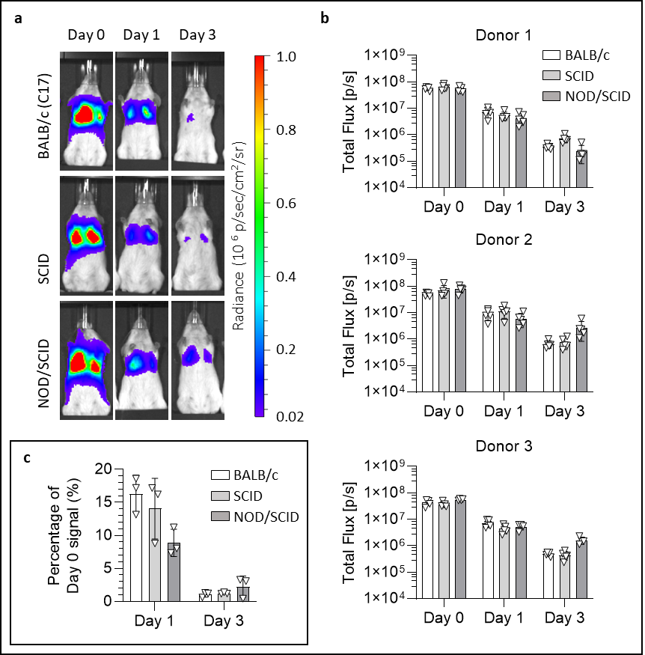
Figure 1| Over 95% of the UC-MSCs disappear within 3 days of administration in both immunocompetent and immunocompromised mice. (a) Representative bioluminescence images of BALB/c, SCID and NOD/SCID mice up to 3 days post administration of FLuc⁺ UC-MSCs (radiance scale from 0.2x10⁵ to 1x10⁶ p/s/cm²/sr). (b) Light output (flux) as a function of time (days) for each of the 3 UC-MSC samples in the 3 animal strains. Data are displayed as mean ± SD from n ≥ 4 for each sample. (c) Day 1 and day 3 flux normalised to the respective day 0 flux. Data are displayed as mean ± SD from n = 3. Day 0 corresponds to the day that the cells were administered.
From day 5 to day 31, no signal originated from the BALB/c group (Figure 2a), while some of the SCID and NOD/SCID animals still displayed a weak signal during this period (Figure 2a). The general behaviour of the UC-MSCs over time appeared comparable irrespective of the donor of origin, with the only exception being the NOD/SCID group where cells from donor 1 disappeared more quickly (Figure 2b). While there was no detectable signal from day 5 for donor 1, the NOD/SCID animals that received UC-MSCs from the two other donors displayed a weak signal for longer (Figure 2b). Information on the number of SCID and NOD/SCID mice displaying a signal from day 5 to day 31 is summarised in Supplementary Table 2 and Supplementary Table 3, respectively. Approximately 27% (4 out of 15) of the SCID animals that received the UC-MSCs still displayed a detectable signal at day 14, before the signal completely disappeared by day 17 (Supplementary Table 2). Furthermore, while the bioluminescence signal from the NOD/SCID animals receiving cells from donor 1 (ID #727R) disappeared by day 5, the 9 remaining animals that received cells from the two other donors displayed a detectable signal until day 10 (Supplementary Table 3). After this time point, 7 mice displayed a signal until day 14 and 3 until day 17 (Supplementary Table 3). Interestingly, one of the NOD/SCID animals administered with UC-MSCs from donor 2 (ID #733S) displayed a weak signal until the end of the experiment (Supplementary Table 3, Supplementary Figure 1). The signal coming from this mouse seemed stronger than the other 4 mice until day 14, then it stabilised around 2x10⁵ until day 31 (Supplementary Figure 1b). At these low signal intensity scales a little background signal appears on the nose of some mice, an observation that has been previously reported [33].
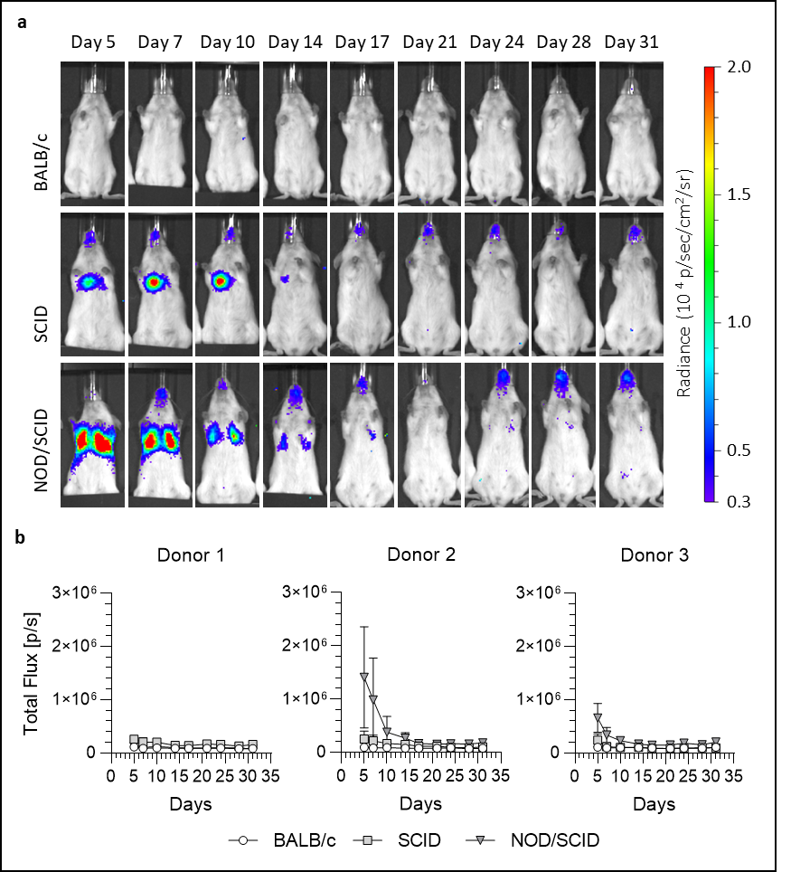
Figure 2| SCID and NOD/SCID mice displayed a weak but detectable signal that persisted beyond that seen with immunocompetent animals. (a) Representative bioluminescence images of BALB/c, SCID and NOD/SCID mice from day 5 to 31 post administration of FLuc⁺ UC-MSCs (radiance scale from 0.3x10⁴ to 2x10⁴ p/s/cm²/sr). (b) Light output (flux) as a function of time (days) for each of the 3 UC-MSC donors in the 3 animal strains. Data are displayed as mean ± SD from n ≥ 4 for each donor.

  - Flow cytometry analysis reveals an increase in circulating neutrophils
Since most of the signal coming from the FLuc⁺ UC-MSCs was cleared in the initial 24h both in both immunocompetent and immunocompromised animals, only immunocompetent mice were used to investigate the impact of UC-MSCs on different immune cells at 2h and 24h post administration. For this, we used in-house immunocompetent C57BL/6 albino mice, where the fate of UC-MSCs is equivalent to that of BALB/c mice [34]. Naïve animals that did not receive the cells were used as controls. The percentage of innate (neutrophils, immature myeloid cells (iMCs), macrophages, natural killer (NK) cells, myeloid dendritic cells (mDC) and plasmacytoid dendritic cells (pDC)) and adaptive (CD4 T cells, CD4 Tregs, CD8 T cells and B cells) immune cells was investigated in the blood, lungs, spleen and bone marrow.
Analysis of the innate immune cells (Figure 3) revealed that the most remarkable results concerned the neutrophils. Two hours after the administration of UC-MSCs, increased levels of neutrophils were detected in the blood (25.5 ± 3.9% compared to 8.5 ± 2.1% in naïve mice), lungs (6.98 ± 2.74% compared to 1.39 ± 0.37% in naïve mice) and spleen (3.9 ± 2.1% compared to 0.72 ± 0.36% in naïve mice) (Figure 3a). Twenty-four hours after the administration of the cells, the number of neutrophils returned to normal levels (7.8 ± 1.2%, 1.15 ± 0.42 and 0.51 ± 0.17% for the blood, lungs and spleen respectively, Figure 3a).
Regarding iMCs, no statistically significant difference was detected 2 hours after the administration of the UC-MSCs in any of the tissues or organs (Figure 3b). Nonetheless, the number of iMCs decreased significantly in the lungs and in the spleen in the next 22 hours, even if the original increase at 2h was not statistically different when compared to that of naïve mice (Figure 3b).
No statistically significant differences were observed between groups for macrophages (Figure 3c), NK cells (Figure 3d) or the pDCs (Figure 3f). The levels of the mDCs in the bone marrow increased from 0.86 ± 0.18% in control mice to 1.50 ± 0.61% 2 hours after the administration of the cells (Figure 3e).
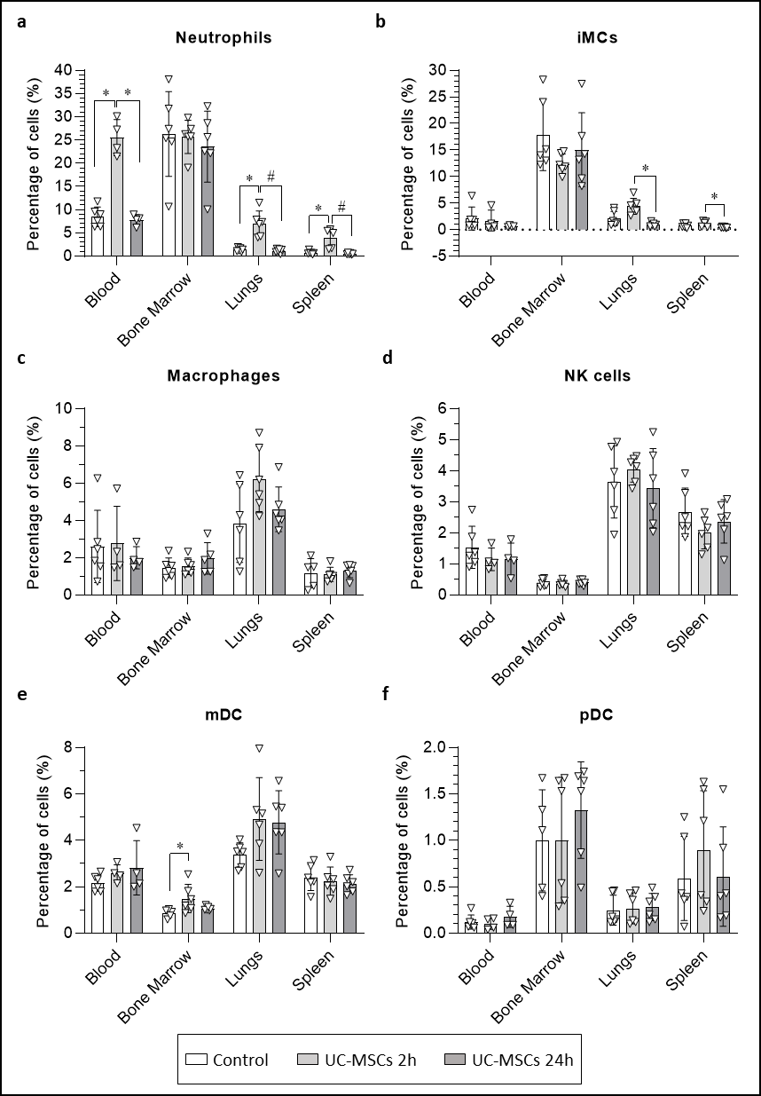
Figure 3| Quantification of innate immune cells in the blood, bone marrow, lungs and spleen of mice, 2h and 24h after the administration of UC-MSCs. Levels of (a) neutrophils, (b) immature myeloid cells, (c) macrophages, (d) natural killer cells, (e) myeloid dendritic cells and (f) plasmacytoid dendritic cells. Data are displayed as mean ± SD from n ≥ 4. Statistical analyses performed using the Kruskal-Wallis test and the Dunn’s multiple comparison post hoc test. * p < 0.05, # p < 0.01.
Analysis of the adaptive immune cells (Figure 4) revealed that the administration of the UC-MSCs did not affect the levels of CD4 T cells in any of the measured sites (Figure 4a), although it contributed to a slight increase in the number of CD4 Tregs in the spleen 24 hours after cell administration from 0.27 ± 0.23% in naïve mice and 0.34 ± 0.19% 2h after cell administration, to 0.73 ± 0.13% 24h post administration (Figure 4b).
Twenty-four hours post cell administration, the levels of CD8 T cells were significantly reduced in the bone marrow, where they decreased from 1.53 ± 0.31% 2h post cell administration to 0.84 ± 0.24% 24h later. In the lungs, the CD8 T cells decreased from 13.8 ± 3.1% in naïve mice to 9.0 ± 2.3% after 24 hours (Figure 4c).
Finally, a reduction in the levels of B cells in the lungs 2 hours after cell administration (from 13.0 ± 2.5% to 8.7 ± 1.9%) was also observed. A return to basal levels (12.9 ± 2.1%) was observed after 24 hours (Figure 4d).
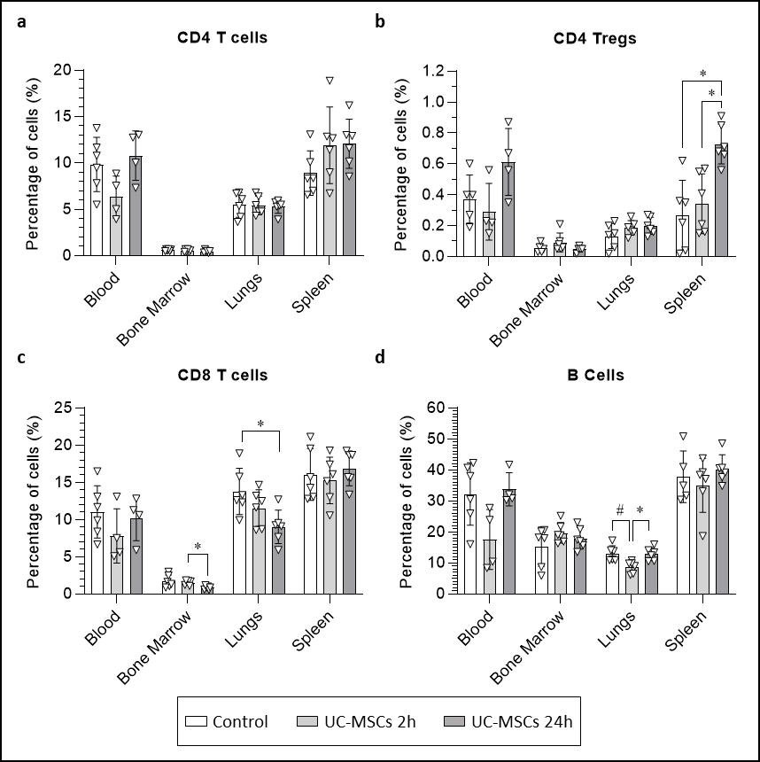
Figure 4 | Quantification of adaptive immune cells in the blood, bone marrow, lungs and spleen of mice, 2h and 24h after the administration of UC-MSCs. Evaluation of the levels of (a) CD4 T cells, (b) CD4 T regulatory cells, (c) CD8 T cells and (d) B cells. Data are displayed as mean ± SD from n ≥ 4. Statistical analysis performed using the Kruskal-Wallis test and the Dunn’s multiple comparison post hoc test. * p < 0.05, # p < 0.01.

  - Multiplex analysis of the plasma of mice receiving UC-MSCs
To further explore the effect of UC-MSCs on the immune system of healthy animals, levels of 48 cytokines, chemokines, soluble receptors, and growth factors were measured in the plasma 2h and 24h after IV administration of the cells. The analytes that were detectable in the samples are summarised in Figure 5a. 2 h after administration, a statistically significant increase in the concentrations of Gro-α (CXCL1) and MCP3 (CCL7) was observed (Figure 5b-c). At the 24h time point, Gro-α returned to basal levels and MCP3 levels dropped to levels below that of controls (Figure 5b-c). MCP1 (CCL2) and IP-10 (CXCL10), which were undetectable in controls, increased to detectable levels at the 2h time point, but were again undetectable after 24 hours (Figure 5d-e). The levels of the soluble receptors IL-2R and IL-7Rα decreased after UC-MSC administration: IL-2R was significantly reduced after 24 hours (Figure 5f), whereas IL-7Rα was only detectable in the control group (Figure 5g). The plasma levels of RANKL were significantly reduced 24 h after the administration of UC-MSCs when compared to controls and the 2h time point (Figure 5h). IL-18 was also significantly reduced after 24 h when compared to controls (Figure 5i). IL-22 levels were significantly reduced after 2h (Figure 5j). After 24h, the IL-22 signal was detectable in only three animals (Figure 5j). No statistically significant changes in plasma concentration of BAFF, ENA-78 (CXCL5), Eotaxin (CCL11), RANTES (CCL5) and IL-1β were observed, although most of them appear to show a trend towards lower levels after administration of UC-MSCs (Figure 5k-o). The signal from BTC, G-CSF (CSF-3), GM-CSF, IFN-α, IFN-γ, IL-1α, IL-2, IL-3, IL-4, IL-5, IL-6, IL-7, IL-9, IL-10, IL-12p70, IL-13, IL-15/IL-15R, IL-17A (CTLA-8), IL-19, IL-23, IL-25 (IL-17E), IL-27, IL-28, IL-31, IL-33, IL-33R (ST2), leptin, LIF, M-CSF, MIP-1α (CCL3), MIP-1β (CCL4), MIP-2, TNFα and VEGF-A was below the limit of detection for either all or almost all the animals (data not shown).

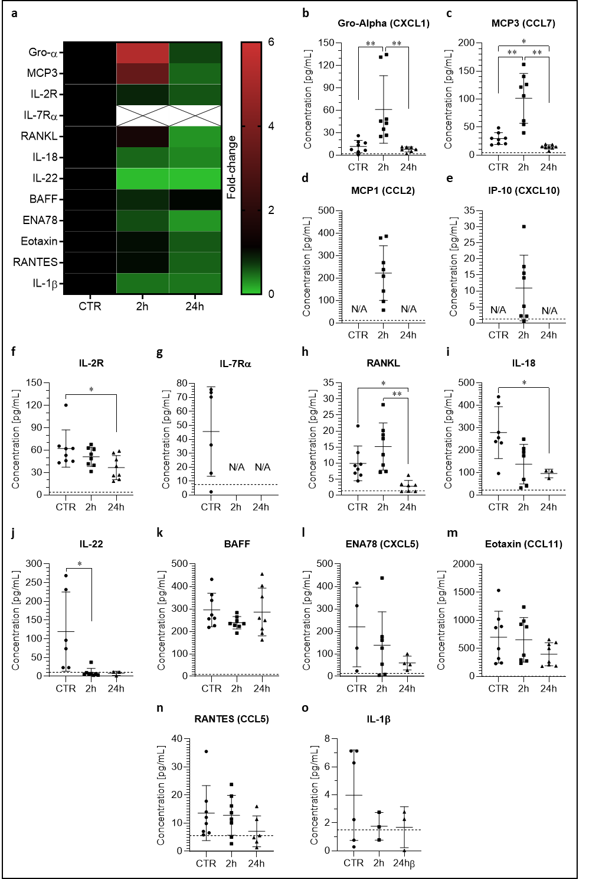
Figure 5| Plasma concentrations of analytes after IV administration of UC-MSCs. Concentrations are expressed as pg/mL. (a) Heatmap representation of the detectable cytokines and chemokines in the plasma of the 3 groups expressed as fold-change (normalised to day 0; MCP1 and IP-10 excluded because day 0 was undetectable). (b) Plasma level of Gro-α (CXCL1). Lower limit of quantification (LLOQ) = 1.9 pg/mL. Data are presented as mean ± SD from n = 8 for each group. Kruskal-Wallis test with Dunn’s multiple comparison post-hoc test. ** p < 0.01. (c) Plasma level of MCP3 (CCL7). LLOQ = 4.1 pg/mL. Data are presented as mean ± SD from n = 8 for each group. Brown-Forsythe and Welch ANOVA with Dunnett multiple comparison post-hoc test. * p < 0.05, ** p < 0.01. (d) Plasma level of MCP1 (CCL2). Data from control and 24h were displayed as out of range below (<=OOR, N/A in the graph). Statistical analysis not possible. LLOQ = 11 pg/mL. (e) Plasma level of IP-10 (CXCL10). Data from control and 24h N/A (<=OOR). Statistical analysis not possible. LLOQ = 1.2 pg/mL. (f) Plasma level of IL-2R. LLOQ = 3.8 pg/mL. Data are presented as mean ± SD from n = 8. Kruskal-Wallis test with Dunn’s multiple comparison post-hoc test. * p < 0.05. (g) Plasma level of IL-7Rα. Data from 2 and 24h N/A (<=OOR). Statistical analysis not possible. LLOQ = 7.6 pg/mL. (h) Plasma level of RANKL. LLOQ = 1.3 pg/mL. Data are presented as mean ± SD from n ≥ 7. Data from one of the 24h not shown (<=OOR). Brown-Forsythe and Welch ANOVA with Dunnett multiple comparison post-hoc test. * p < 0.05, ** p < 0.01. (i) Plasma level of IL-18. LLOQ = 22.2 pg/mL. Data are presented as mean ± SD from n = 7 (CTR and 2h) and n = 3 (24h); missing data points were N/A (<=OOR). Brown-Forsythe and Welch ANOVA with Dunnett multiple comparison post-hoc test. * p < 0.05. (j) Plasma level of IL-22. LLOQ = 10.5 pg/mL. Data are presented as mean ± SD from n = 6 (CTR), n = 7 (2h) and n = 3 (24h); missing data points were N/A (<=OOR). Kruskal-Wallis test with Dunn’s multiple comparison post-hoc test. * p < 0.05. (k) Plasma level of BAFF. LLOQ = 8.6 pg/mL. Data are presented as mean ± SD from n = 8 for each group. (l) Plasma level of ENA78 (CXCL5). LLOQ = 12.9 pg/mL. Data are presented as mean ± SD from n = 4 (CTR), n = 7 (2h) and n = 4 (24h); missing data points were N/A (<=OOR) (m) Plasma level of Eotaxin (CCL11). LLOQ = 0.8 pg/mL. Data are presented as mean ± SD from n = 8 for each group. (n) Plasma level of RANTES. LLOQ = 5.6 pg/mL. Data are presented as mean ± SD from n = 8 (CTR and 2h), and n = 7 (24h); missing data points were N/A (<=OOR). (o) Plasma level of IL-1β. LLOQ = 1.5 pg/mL. Data are presented as mean ± SD from n = 6 (CTR) and n = 3 (2h and 24h); missing data points were N/A (<=OOR). The lower limits of quantification (LLOQ) are represented in each graph by the dashed line.

- Discussion
Lung entrapment followed by a rapid cell death after IV administration of MSCs is well documented [21-25, 34] and the direct contribution of host immune cytotoxic cells has been recently reported [26]. This suggests a possible direct involvement of the recipient immune system in the death of the administered cells. The purpose of this study was to elucidate the role of the host immune system in the survival and clearance of IV injected UC-MSCs and the general immunological response of the host in the first hours post cell administration.
  - UC-MSCs survive longer in some immunocompromised animals
Two different immunocompromised strains, SCID and NOD/SCID, were used here to investigate the involvement of the immune system in the clearance of the IV injected MSCs. SCID animals are characterised by a mutation of the Prkdc gene that prevents the maturation of B and T cells, making this strain ideal for investigating the role of the adaptive immunity. NOD/SCID mice combine the SCID mutations with an impaired natural immunity, which is due to the NOD background, characterised by defective NK-cells, a lack of circulating complement as well as impaired macrophages and antigen presenting cells. Administration of UC-MSCs in SCID and NOD/SCID animals confirmed the lung entrapment and resulted in a reduction of bioluminescence that was comparable to immunocompetent BALB/c and similar to observations from other studies, with most of the signal disappearing in the first 24h post administration [25]]. Because luciferase is expressed only by the exogenous UC-MSCs, a drop in bioluminescence signal is interpreted as cell death. Interestingly, while the BALB/c mice showed complete signal loss by day 7, the two immunocompromised groups revealed variability in UC-MSC survival, indicating that the small fraction of UC-MSCs that survived the first 72h can persist longer in immunocompromised animals. Fourteen days post administration, 27% of the SCID animals still displayed a weak but detectable signal. These results are in line with what we have previously reported [19], confirming the reproducibility and consistency of the data. Similar results were obtained with the NOD/SCID animals, where cells from 2 of the 3 donors survived longer than 10 days. Also, while the signal disappeared after 17 days in most of the animals, one of the NOD/SCID mice still had a weak signal detectable by the end of experiment (31 days post cell administration).
These data suggest that the initial death of the cells is unlikely to be associated with an involvement of either the innate or adaptive immunity. However, the fact that a small percentage of cells can survive longer than 3 days in the two immunocompromised strains suggests that both immunological compartments play a role in the clearance of the surviving fraction of injected MSCs. Nonetheless, by the end of the experiment, only one of the NOD/SCID animals had a detectable signal coming from the lung region and the signal never increased during the study. These data suggest that even in an immunocompromised host, UC-MSCs are likely safe and do not undergo uncontrolled proliferation. These results are in line with a recent study that revealed a lack of tumorigenesis and pro-tumorigenic potential of human UC-MSCs in NOD/SCID mice [35].
  - UC-MSCs influence the host immune system and induce neutrophil migration
Although the death of the majority of MSCs is likely unrelated to a direct effect of the host immune system, it is well recognised that MSCs do interact with the host’s immune system, either directly or indirectly, to yield several immunomodulatory responses [6]. In a recent study, Heng and co-workers revealed that preventing the apoptosis of IV-administered MSCs had a negative impact on their immunomodulatory capacity [36]. Also, efferocytosis, the process by which apoptotic cells are engulfed by local immune cells without triggering a pro-inflammatory response, has been reported to be one of the main immunomodulatory mechanisms exerted by infused MSCs [36-38]. One of the critical aspects of this study was to clarify the connection between the administered MSCs and the host immune system. Because in both healthy and immunocompromised animals the greatest signal reduction was observed in the first 24 hours post cell administration, we investigated whether the administered MSCs triggered an immunological response in that time window.
Two hours after administration of the MSCs, neutrophil mobilisation was observed in the blood, lungs and spleen of the mice. These results are consistent with what observed by Pichardo et al., where they observed a rapid neutrophil infiltration in the lungs 2h after IV administration, followed by decreased neutrophils levels 24 hours later [39]. Neutrophils, as part of the innate immune system, provide the host’s first line of defence. Also, they are phagocytic cells, which have been reported to be actively involved in the phagocytosis of apoptotic cells [40]. Similar results were recently obtained by Pang et al., as they identified monocytes and neutrophils being the major cell types responsible for the efferocytosis of IV administered bone marrow (BM-)MSCs in mice [36]. The higher percentage of neutrophils observed in the 2h group compared to control and 24h groups was consistent with results obtained with multiplex analysis that showed neutrophil chemoattractants in plasma were upregulated (CCL7 and Gro-α) or raised above detectable levels (MCP1 and IP-10) 2 hours after cell administration. The involvement of MCP1 (CCL2) and CCL7 in the recruitment of neutrophils to the lungs has also been reported by Mercer et al. following intranasal administration of recombinant CCL2 and CCL7 into mice [41]. Moreover, Gro-α not only plays an important role in recruiting neutrophils, but also in their activation [42]. These results are in line with a study performed by Hoogduijn et al. [43], who identified an upregulation of the serum levels of MCP1 (CCL2) and Gro-α (CXCL1) 2 hours after the IV administration of mouse adipose-derived (A-)MSCs in 8–10 week old C57BL/6 mice [43]. Additionally, it was reported that the level of these cytokines went back to normal after 20 hours, in close agreement with our 24h measurements [43].
Although macrophages have also been reported to be responsible for MSC efferocytosis [36-38], we did not observe any statistically significant differences in the amount of these cells in the lungs after 2 hours. This could either be because this time point was not optimal for detecting changes in the levels of macrophages, or because we used pan-monocytes markers we failed to identify polarisation towards pro- and anti-inflammatory phenotypes. Piraghaj et al. [37] revealed an increase in the M2 anti-inflammatory and regulatory phenotype following incubation of macrophages with apoptotic A-MSCs [37]. Similarly, Min et al. showed that the efferocytosis of apoptotic cord tissue-derived MSCs by macrophages enhanced their immunosuppressive capacity [44].
We also identified a response to the MSCs from the adaptive immune cells in the lungs. The percentage of B and CD8 T cells were reduced 2 and 24 hours post cell administration, respectively. Even though the levels of B-cell activation factor (BAFF) seemed to be reduced in serum 2h after the administration of the MSCs, the levels were not statistically different from the control group and from 24h after the administration of the cells. However, it is unclear whether the fluctuations in the levels of B and CD8 T cells are directly mediated by the presence of the MSCs, by paracrine mechanisms or by other cells recruited to the lungs.
Among the other analytes investigated, interesting results were observed for IL-18, IL-22, RANKL, sIL-2R and sIL-7Rα. IL-18 is a pro-inflammatory cytokine of the IL-1 family produced by antigen presenting cells that influences both the innate and adaptive immunity as it can enhance T cell and NK cell maturation [45]. Interestingly, MSCs were reported to reduce the IL-18 signalling pathway in NK cells in vitro [46]. Also, in a rat model of sepsis, the intravenous administration of A-MSCs has been shown to reduce the level of IL-18 [47], which is in line with the reduction we observed in this study.
IL-22 is a cytokine belonging to the IL-10 family with both protective and pro-inflammatory functions. Here, we observed a reduction of IL-22 levels 2h and 24h after the administration of the cells. The MSC-mediated downregulation of IL-22 has already been reported in vitro and has been associated with paracrine pathways [48]. Wu et al. observed that CD4+ T cells isolated from patients with immune thrombocytopenia co-cultured with UC-MSCs had reduced IL-22 production [48]. Similar results were obtained by Hyvärinen et al. who showed that both co-culture with MSCs and MSC released EVs downregulated IL-22 production which resulted in increased polarisation of macrophages toward an anti-inflammatory phenotype [49]. These data demonstrate that our in vivo results are well aligned with what has been reported in vitro.

- Conclusions
We have confirmed the pulmonary first pass effect in both immunocompetent and immunocompromised animals following IV administration of human UC-MSCs. Additionally, most of the injected cells disappear in the first 24h, regardless of the immunological status of the host, suggesting no direct involvement of the immune system in their initial death. On the other hand, some UC-MSCs survive longer in immunocompromised animals, although they never display an increase in the detectable signal, suggesting that these cells are likely safe for immunocompromised subjects. Despite most UC-MSCs dying in the first 24 hours, they induce an immediate immunological reaction in the host, with a rapid recruitment of neutrophils. In parallel to the cellular phenotyping, alterations in signalling factors such as CCL7 were observed which supports neutrophil responses to the administered cells. If the neutrophils play any role in inducing the death of the administered cells or are instead attracted by signals emitted by dying MSCs is unclear. We suggest that increased understanding of how MSCs affect the immune system could shed light on their therapeutic mechanisms and lead to more effective therapies in future.

- References
1. Friedenstein, A.J., et al., Heterotopic of bone marrow. Analysis of precursor cells for osteogenic and hematopoietic tissues. Transplantation, 1968. 6(2): p. 230-47.
2. Friedenstein, A.J., R.K. Chailakhjan, and K.S. Lalykina, The development of fibroblast colonies in monolayer cultures of guinea-pig bone marrow and spleen cells. Cell Tissue Kinet, 1970. 3(4): p. 393-403.
3. Perico, L., et al., Human mesenchymal stromal cells transplanted into mice stimulate renal tubular cells and enhance mitochondrial function. Nat Commun, 2017. 8(1): p. 983.
4. Cao, J., et al., Three-dimensional culture of MSCs produces exosomes with improved yield and enhanced therapeutic efficacy for cisplatin-induced acute kidney injury. Stem Cell Res Ther, 2020. 11(1): p. 206.
5. Zou, X., et al., Microvesicles derived from human Wharton's Jelly mesenchymal stromal cells ameliorate renal ischemia-reperfusion injury in rats by suppressing CX3CL1. Stem Cell Res Ther, 2014. 5(2): p. 40.
6. Weiss, A.R.R. and M.H. Dahlke, Immunomodulation by Mesenchymal Stem Cells (MSCs): Mechanisms of Action of Living, Apoptotic, and Dead MSCs. Front Immunol, 2019. 10: p. 1191.
7. Corcione, A., et al., Human mesenchymal stem cells modulate B-cell functions. Blood, 2006. 107(1): p. 367-72.
8. Glennie, S., et al., Bone marrow mesenchymal stem cells induce division arrest anergy of activated T cells. Blood, 2005. 105(7): p. 2821-7.
9. Selmani, Z., et al., Human leukocyte antigen-G5 secretion by human mesenchymal stem cells is required to suppress T lymphocyte and natural killer function and to induce CD4+CD25highFOXP3+ regulatory T cells. Stem Cells, 2008. 26(1): p. 212-22.
10. Spaggiari, G.M., et al., Mesenchymal stem cell-natural killer cell interactions: evidence that activated NK cells are capable of killing MSCs, whereas MSCs can inhibit IL-2-induced NK-cell proliferation. Blood, 2006. 107(4): p. 1484-90.
11. Ramasamy, R., et al., Mesenchymal stem cells inhibit dendritic cell differentiation and function by preventing entry into the cell cycle. Transplantation, 2007. 83(1): p. 71-6.
12. Heo, J.S., Y. Choi, and H.O. Kim, Adipose-Derived Mesenchymal Stem Cells Promote M2 Macrophage Phenotype through Exosomes. Stem Cells Int, 2019. 2019: p. 7921760.
13. Chang, C., et al., Effects of Mesenchymal Stem Cell-Derived Paracrine Signals and Their Delivery Strategies. Adv Healthc Mater, 2021. 10(7): p. e2001689.
14. Barkholt, L., et al., Risk of tumorigenicity in mesenchymal stromal cell-based therapies--bridging scientific observations and regulatory viewpoints. Cytotherapy, 2013. 15(7): p. 753-9.
15. Cui, L.L., et al., The cerebral embolism evoked by intra-arterial delivery of allogeneic bone marrow mesenchymal stem cells in rats is related to cell dose and infusion velocity. Stem Cell Res Ther, 2015. 6(1): p. 11.
16. Yoon, Y.S., et al., Unexpected severe calcification after transplantation of bone marrow cells in acute myocardial infarction. Circulation, 2004. 109(25): p. 3154-7.
17. ; Available from: https://clinicaltrials.gov/.
18. Togel, F., et al., Bioluminescence imaging to monitor the in vivo distribution of administered mesenchymal stem cells in acute kidney injury. Am J Physiol Renal Physiol, 2008. 295(1): p. F315-21.
19. Scarfe, L., et al., Non-invasive imaging reveals conditions that impact distribution and persistence of cells after in vivo administration. Stem Cell Res Ther, 2018. 9(1): p. 332.
20. Buzhor, E., et al., Cell-based therapy approaches: the hope for incurable diseases. Regen Med, 2014. 9(5): p. 649-72.
21. Fischer, U.M., et al., Pulmonary passage is a major obstacle for intravenous stem cell delivery: the pulmonary first-pass effect. Stem Cells Dev, 2009. 18(5): p. 683-92.
22. Eggenhofer, E., et al., Mesenchymal stem cells are short-lived and do not migrate beyond the lungs after intravenous infusion. Front Immunol, 2012. 3: p. 297.
23. Patrick, P.S., et al., Lung delivery of MSCs expressing anti-cancer protein TRAIL visualised with (89)Zr-oxine PET-CT. Stem Cell Res Ther, 2020. 11(1): p. 256.
24. de Witte, S.F.H., et al., Immunomodulation By Therapeutic Mesenchymal Stromal Cells (MSC) Is Triggered Through Phagocytosis of MSC By Monocytic Cells. Stem Cells, 2018. 36(4): p. 602-615.
25. Amadeo, F., et al., Firefly luciferase offers superior performance to AkaLuc for tracking the fate of administered cell therapies. Eur J Nucl Med Mol Imaging, 2022. 49(3): p. 796-808.
26. Galleu, A., et al., Apoptosis in mesenchymal stromal cells induces in vivo recipient-mediated immunomodulation. Sci Transl Med, 2017. 9(416).
27. Kutner, R.H., X.Y. Zhang, and J. Reiser, Production, concentration and titration of pseudotyped HIV-1-based lentiviral vectors. Nat Protoc, 2009. 4(4): p. 495-505.
28. Amadeo, F., et al., DEAE-Dextran Enhances the Lentiviral Transduction of Primary Human Mesenchymal Stromal Cells from All Major Tissue Sources Without Affecting Their Proliferation and Phenotype. Mol Biotechnol, 2022.
29. Jungblut, M., et al., Standardized preparation of single-cell suspensions from mouse lung tissue using the gentleMACS Dissociator. J Vis Exp, 2009(29).
30. Amend, S.R., K.C. Valkenburg, and K.J. Pienta, Murine Hind Limb Long Bone Dissection and Bone Marrow Isolation. J Vis Exp, 2016(110).
31. Terho, P. Flowing Software 2.5.1. Available from: https://bioscience.fi/services/cell-imaging/flowing-software/.
32. Hensel, J.A., et al., Characterization of immune cell subtypes in three commonly used mouse strains reveals gender and strain-specific variations. Lab Invest, 2019. 99(1): p. 93-106.
33. Deroose, C.M., et al., Noninvasive monitoring of long-term lentiviral vector-mediated gene expression in rodent brain with bioluminescence imaging. Mol Ther, 2006. 14(3): p. 423-31.
34. Calcat-i-Cervera, S., et al., Multicentre comparison of biological and functional properties of mesenchymal stromal cells from different sources cultivated using a harmonised manufacturing workflow. bioRxiv, 2022: p. 2022.09.14.507944.
35. He, J., et al., Lack of tumorigenesis and protumorigenic activity of human umbilical cord mesenchymal stem cells in NOD SCID mice. BMC Cancer, 2022. 22(1): p. 307.
36. Pang, S.H.M., et al., Mesenchymal stromal cell apoptosis is required for their therapeutic function. Nat Commun, 2021. 12(1): p. 6495.
37. Ghahremani Piraghaj, M., et al., Effect of efferocytosis of apoptotic mesenchymal stem cells (MSCs) on C57BL/6 peritoneal macrophages function. Life Sci, 2018. 212: p. 203-212.
38. Cheung, T.S., et al., Apoptotic mesenchymal stromal cells induce prostaglandin E2 in monocytes: implications for the monitoring of mesenchymal stromal cell activity. Haematologica, 2019. 104(10): p. e438-e441.
39. Pichardo, A.H., et al., Optical Tissue Clearing to Study the Intra-Pulmonary Biodistribution of Intravenously Delivered Mesenchymal Stromal Cells and Their Interactions with Host Lung Cells. Int J Mol Sci, 2022. 23(22).
40. Esmann, L., et al., Phagocytosis of apoptotic cells by neutrophil granulocytes: diminished proinflammatory neutrophil functions in the presence of apoptotic cells. J Immunol, 2010. 184(1): p. 391-400.
41. Mercer, P.F., et al., Proteinase-activated receptor-1, CCL2, and CCL7 regulate acute neutrophilic lung inflammation. Am J Respir Cell Mol Biol, 2014. 50(1): p. 144-57.
42. Sawant, K.V., et al., Chemokine CXCL1 mediated neutrophil recruitment: Role of glycosaminoglycan interactions. Sci Rep, 2016. 6: p. 33123.
43. Hoogduijn, M.J., et al., Mesenchymal stem cells induce an inflammatory response after intravenous infusion. Stem Cells Dev, 2013. 22(21): p. 2825-35.
44. Min, H., et al., Mesenchymal stromal cells reprogram monocytes and macrophages with processing bodies. Stem Cells, 2021. 39(1): p. 115-128.
45. Biet, F., C. Locht, and L. Kremer, Immunoregulatory functions of interleukin 18 and its role in defense against bacterial pathogens. J Mol Med (Berl), 2002. 80(3): p. 147-62.
46. Chatterjee, D., et al., Human Umbilical Cord-Derived Mesenchymal Stem Cells Utilize Activin-A to Suppress Interferon-gamma Production by Natural Killer Cells. Front Immunol, 2014. 5: p. 662.
47. Wang, H., et al., Adipose‑derived mesenchymal stem cell‑derived HCAR1 regulates immune response in the attenuation of sepsis. Mol Med Rep, 2022. 26(3).
48. Wu, M., et al., Mesenchymal Stem Cells Immunosuppressed IL-22 in Patients with Immune Thrombocytopenia via Soluble Cellular Factors. J Immunol Res, 2015. 2015: p. 316351.
49. Hyvarinen, K., et al., Mesenchymal Stromal Cells and Their Extracellular Vesicles Enhance the Anti-Inflammatory Phenotype of Regulatory Macrophages by Downregulating the Production of Interleukin (IL)-23 and IL-22. Front Immunol, 2018. 9: p. 771.

