**Innovative Development Strategy of a Risk-averse Firm Considering Product Unreliability under Competition**

(Zheng, W., Li, B., Song, D.P. and Li, Y. (2022), Innovative development strategy of a risk-averse firm considering product unreliability under competition, Transportation Research Part E., (accepted on 14/11/2022))

**Abstract:** This paper aims to seek the innovative development strategy for a leading firm in a competitive market when considering product unreliability and risk behavior. A higher innovation level may bring about better product performance. Nevertheless, it may cause some unreliability events which might incur serious negative outcomes (e.g., products recall). Facing uncertain outcomes, the innovative firm may care more about the risk of innovation when making decisions, especially in a competitive market. We build a Stackelberg game model for a competitive market consisting of a leading firm and a competitor. The Conditional Value-at-Risk (CVaR) is used to measure the firm’s risk attitude. The optimal innovation strategy of the leading firm and the response strategy of the competitor is obtained. We find that the optimal innovation strategy takes three different forms depending on the risk attitude and the development cost of innovation. i.e., no innovation, complete innovation and partial innovation. In addition, different from most existing literature on risk-averse players’ pricing decisions, we find that a risk-averse innovative firm may set a higher price to focus on only tech-savvy consumers. Moreover, the effects of innovation are also investigated. We find that the two competing firms can achieve a win-win result by adopting an appropriate innovation strategy.

**Keywords:** Game theory; Innovation strategy; Product unreliability; Risk attitude; Competition

**1. Introduction**

Innovation is seen as one of the key strategies to attract demand in most industries. Nowadays, many firms upgrade their products by applying some new innovative technologies. For example, Samsung released its curved-screen smartphone, Samsung Galaxy S6 Edge. Tesla introduced some innovative technologies, e.g., new pack thermal architecture, new autopilot mode, on its newly launched smart electric cars. Obviously, product innovation can introduce new functions and improve overall product performance (Gao et al., 2021). In this way, innovation can help companies expand their market and attract more demands. In addition to the price competition, innovation competition has become a new tool for companies - to innovate, or be killed in the market (Moreira et al., 2020).

However, a majority of firms in the market still tend to upgrade their products by using mature technologies to achieve regular improvements rather than revolutionary development with innovative technologies, especially the followers in the market (Alexis, 2020). For example, firms in the electronic market more like just to introduce a new phone with a bigger screen, or release a laptop with more memory regularly. The resulting attraction and competitiveness of regular upgrades are obviously lower than the radical innovation (if the product is reliable enough). The conservative behavior of these conventional firms is mainly because that product innovation requires companies not only to commit high R&D investment, but also to face the risk of product unreliability after launching the products. Since innovative technologies are often not fully mature, an innovative product is more likely to cause unreliability events, which may result in highly risks (Gao et al., 2021). Product unreliability often causes huge losses to the companies. On the one hand, companies may face mandatory requirements to recall or repair all unreliable products due to regulatory pressures from institutions such as the government (Bala et al., 2012; Gao et al., 2021). On the other hand, the occurrence of negative events means that the corporate image will fall sharply. One of the world’s largest manufacturers of electronic products, Apple Inc., unveiled its fourth-generation MacBook Pro in October 2016. The new product also introduced a “second-generation” butterfly-mechanism keyboard. Due to the structural characteristics of this type of keyboard, the keys are relatively stable, which can effectively improve the accuracy of typing. In addition, the new keyboard structure helped Apple make its products thinner and lighter. According to MacRumors[1], Apple had received the most online orders for the new MacBook Pro compared to its previous generations. However, a report by AppleInsider[2] showed that the failure rate of the new butterfly-mechanism keyboard was twice of the Apple’s older models. In 2018, Apple filed two class actions for keyboard problems. Later, Apple announced a “free repair of eligible MacBook and MacBook Pro keyboards” service program. In 2019, Apple promised that any MacBook keyboard with butterfly-mechanism keyboard will be repaired or replaced free of charge within four years from the date of sale. This has led to expensive repair cost. The implication is that the innovation strategy implies risk and may incur cost. This is probably one of the main reasons that most companies in the electronics industry prefer to launch new products with evolutionary improvements such as a bigger screen for mobile phones, and more memory and storage for laptops. There is another example about the risks of product innovation in the automobile industry. Tesla introduced Tesla Model 3 in mid-2017, which included some innovative technologies, e.g., new pack thermal architecture, new autopilot mode. However, there is much negative news about Tesla’s Tesla Model 3 due to the risks associated with its autopilot feature. In June 2021, Tesla recalled more than 285,000 electric cars to resolve the problems related to its autopilot mode after an investigation conducted by China’s market regulator. What’s more, in 2021, the State Administration for Market Regulation officially proposed a new guideline about vehicle defect investigation work mechanism for new energy and smart connected vehicles, which are increasingly prominent in recalls, aiming to establish an intelligent vehicle safety self-assessment and accident reporting system, and regulatory sandbox. Actually. There are also many other examples about the recall events of innovative products. On September 2, 2016, Samsung recalled 2.5 million Galaxy Note 7 phones due to the batteries catching fire accidents during charging, just after 2 weeks of release[3]. Boeing 787 Dreamliner, which is seen as one of the most innovative aircraft[4] has been recalled and revised because of its several in-service problems like engine failures associated with the lithium-ion batteries (Gao et al., 2021), which is blamed on the pursuit of inappropriate innovation (Morrison, 2013). It should be noticed that the measure of product reliability will be largely affected by the epistemic uncertainty or other factors (Kang et al., 2016). As these examples show, due to the lack of practical applications and the requirement of faster time-to-market (Fetaji et al., 2019), it is often impossible to make accurate predictions about the actual reliability levels of new products with immature technologies before they are launched to the market (Gao et al., 2021). Researches show that newly-designed products may have significantly higher failure rates than the expectations after they are launched (Ge et al., 2018; Lu et al., 2007). Even though the firm could overcome the development risk and design a seemly “successful” product that has passed the necessary tests and allowed to launch to the market (it means the reliability of the products is considered being acceptable), the product might still cause unpredictable problems in use. This further increases the complexity and uncertainty of the innovation strategy. Thus, it is reasonable that firms may consider the uncertainty and risks of the innovation during their decision-making process (Cucculelli et al., 2013).

The above examples and arguments illustrate the underlying trade-off between the attraction and the reliability of innovative products for companies to adopt appropriate innovation strategies. In most situations that require the firms to launch products timely, it is difficult for the firms to maintain high reliability and high attraction of the products simultaneously. Introducing a product with high innovation technologies and functions can improve the performance of the product and attract more customer demands, which may help the firms expand the market and generate more revenue. On the other hand, the firms also have to face the risk of product unreliability after launching the products, which may incur heavy defective costs. In contrast, introducing a regular product with mature technologies and functions is more reliable. Nevertheless, the regular product may be less attractive to customers; as a result, the firm may lose customers to its competitors. As such, we want to examine the appropriate innovation strategy when a company plans to develop products.

In competitive markets, the impact of the innovation strategy of one company can further trigger more spillover effects. An innovative company’s accident of product unreliability is likely to have an impact on other conventional companies in the same market. Therefore, the impact of innovation strategy and the uncertainty on the company’s competitors are worthy of investigation. However, most of the existing studies involving R&D and product recalls only consider a single firm and neglect the competitors. In addition, to the best of our knowledge, the research about the effect of firms’ risk attitude predominantly focuses on the uncertainties such as supply uncertainty, demand uncertainty and cost uncertainty; none of them consider the uncertainty generated from innovation and recall loss. In this paper, we attempt to fill the research gap by considering the innovation strategy of a leading firm (firm M) and the response strategy of its competitor (firm C), which can be seen as the representative of the conventional firms facing innovation encroachment in the market. To analyze the interactions between factors such as competition, risks, innovation uncertainty and their effects on strategic decisions, a Stackelberg game model is established with the Conditional Value-at-Risk (CVaR) measuring the firms’ attitude to the risk. We attempt to address the following research questions: (1) When there are reliability uncertainties and risks associated with the innovative products, considering the possible recall or repair loss, how do the company determine the innovation strategies and pricing strategies to compete with other conventional companies? In what condition should the firm launch an innovative product? (2) How does the firm’s attitude to the risk affect the optimal strategies and profits in the market? (3) What are the effects of the innovation strategies on the firm’s and its competitor’s profits and decisions? How should a conventional firm respond to the leading firm’s innovation strategy and possible uncertain events?

To the best of our knowledge, we are the first to examine a firm’s innovation strategy considering product unreliability and innovation risk in a competitive market from the game theory perspective. We obtain the optimal innovation strategy of the leading firm and find that the risk attitude is the main factor affecting whether the company would innovate when facing the unreliability of the innovative products. The innovation costs can only affect the level of innovation (e.g., complete innovation or partial innovation). Based on different market positions and market environments, the company has to consider different innovation strategies. The response strategy of the competitor is also introduced. We investigate the impact of risk attitude and market attributes on two companies’ optimal decisions and their profits. Different from most existing literature, we find that the prices of two firms may increase when the leading firm pays more attention to the risk. Finally, we find that the firm’s innovation may bring a spillover effect to its competitor based on three effects, i.e., the risk effect, the snatching effect and the expansion effect. The risk effect is generated from the uncertain product defective events, which is related to the recall loss and the risk attitude of firms. The expansion effect and the snatching effect are generated from the attraction of the innovative product to the consumers outside the potential market and the consumers inside the traditional market from the competitor. The three effects will be defined in detail in section 4.3. The spillover effect may be positive or negative. When the risk effect and the expansion effect are dominating, there exists a Pareto zone in which both firms can get benefits from the innovation activity of the leading company.

The rest of this paper is organized as follows: in section 2, we review the existing relevant studies. In section 3, the assumption and the problem are described. The models with product innovation and without innovation are built, and the equilibrium solutions are obtained. In section 4, we analyze the equilibrium results and elaborate the optimal innovation strategy. The effects of the risk attitude and the innovation strategy are examined. In section 5, we further made some extensions to examine some more general cases. Finally, conclusions and limitations are explained in section 6.

**2. Literature Review**

Our research is related to three research streams. The first research stream is about innovation strategies in competitive markets. The second research stream is about uncertainties, reliability and recall events of innovative products. The third research stream concerns the decision-making with risk attitude generated from uncertainty in supply chain management.

**2.1. Innovation Strategies in Competitive Markets**

The literature about innovation R&D strategies for new products is abundant, like Hua et al. (2011); Gmelin et al. (2014); Dai et al. (2017) and Wu et al. (2016). It should be noted that all of the above studies believe that through the innovation upgrade, the performance and quality of products can be significantly improved, which has a positive impact on the customer’s valuation and demands. Thus, in a competitive market, besides price competition, innovation is another important tool for firms to occupy the market. The following studies emphasized innovation R&D as a major tool to win in the competitive market by game theory. Minniti (2010) analyzed the relationship between product competition and R&D. They found that when market competition is more intense, companies tend to improve product quality development, while the level of innovation has been neglected. Williams et al. (2011) compared the impact of different retail channel structures (single-channel and dual-channel) on manufacturers’ optimal new product development strategies and profits. Their numerical analysis showed that in the case of single-channel, manufacturers prefer low-quality and high-price strategies. When competitive retailers enter the market, manufacturers will improve product quality and get higher profits than the single retailer system. But when there are more retailers, manufacturers will ignore the impact of retailers on their product development. Matsumura et al. (2013) considered the impact of the R&D investment on the profits in a duopoly market. In addition, they conducted in-depth analysis from the perspective of profits and social welfare. They found that when the competition intensity in the duopoly market was high or low enough, the R&D activities were more important. Li et al. (2013) used Hoteling model to analyze the stochastic R&D competition between two companies. They introduced technical risks to their model and investigated the company’s R&D investment and location decisions. Song et al. (2021) constructed a two-stage dynamic R&D competition game model. In the first stage, the firm does not know the difficulty of development and the firm has to choose when to stop its development. They found that competition is not always good for social welfare. In addition to game theory, there are also some researches that use other methodologies such as data-driven or other mathematical methodologies, to evaluate the innovation strategies and their competitiveness. For example, Morgan et al. (2001) examined the quality and time-to-market strategy for the firms by a discrete optimization model. They found that the multiple generation approach is an effective method to compete with other firms. Souza et al. (2004) considered the effect of clockspeed, product development and competition on the decisions about time-to-market and quality for a new product using Markov Decision Process. Correa et al. (2012) studied the relationship between competition and innovation by data analysis. They found that there is a positive relationship between competitiveness and innovation during 1973-1982, whereas the relationship is not obvious during 1983-1994. Bessonova et al. (2019) analyzed company’s motivation to innovate in response to the competition through empirical method. They found a modest level of competition could induce the firms to introduce more innovative products. However, nearly all of the above studies neglect the unreliability and the uncertainties of the innovative products after launching, which is a major factor affecting companies’ innovation strategy.

**2.2. Uncertainties, Reliability and Recall Events of Innovative Products**

Product development could also bring uncertainties sometimes, especially for innovative products, such as R&D success uncertainty (Bhaskaran et al., 2009), development time uncertainty (Song et al., 2021), demand uncertainty (Xie et al., 2021) and investment uncertainty (Bilgiç et al., 2012).

In fact, product innovation development can also influence the reliability of the product (Gao et al., 2021), which is another uncertainty generated from the innovation. In addition, there may be higher event handling costs (e.g., recall loss) with lower reliability products by the regulation of the government (Gao et al., 2021; Iyer et al., 2017). However, there are few studies considering these factors. Öner et al. (2015) introduced a component upgrade model to investigate product reliability issues. They designed two component upgrade strategies: one is preventively upgrading of all components, and the other is to upgrade when components fail. They found that the advantages and disadvantages of these two strategies depend on the entire lifecycle of the product. Shah et al. (2016) analyzed the impact of product recalls on firms’ profits. They found that although most studies believe that product recalls can have a devastating impact on companies, it depends on other factors such as product type, plant characteristics, capacity effectiveness and so on. Bala et al. (2016) considered the impact of product recall events on the competitor’s decisions in the pharmaceutical industry. It is shown that the firms in the market should set the defensive effort to prevent the negative impact of its competitor’s product recall. Kirshner et al. (2017) studied the optimal product upgrades strategy for an innovative firm considering the brand commitment and the risk of product failure. They found the firm could reduce the risk by decreasing the price of products. Most of the above studies are empirical or based on optimization methods.

As far as we know, there are only two published studies that have analyzed the impact of product reliability and handling costs on the firm’s product development and other decisions using game theory, which will be adopted in our model. Iyer et al. (2017) stated that the product reliability is difficult to estimate even the R&D process is completed. Neither the customers have all the reliability information, nor can the manufacturer fully understand the safety level of the product. If there is a safety-related event concerning the product, both the buyer and the seller will suffer losses (recall costs). They built a game model to explore whether the company should request the testing certification and whether the information should be published. Gao et al. (2021) believed that the development of innovative products can improve the performance (quality) of products, but also increase the risk of safety and reliability (development failure). Specifically, a highly innovative product can satisfy more customers, but the safety risk of the product increases. They obtained the enterprise’s optimal R&D decisions and the government’s regulatory strategies in such case. Nevertheless, the above two papers both considered a monopolist firm producing a single product in the market. They didn’t consider those important issues (e.g., uncertainty of innovation and recall loss) in a competitive market. Moreover, the risk attitude generated from the reliability uncertainty is ignored. Further, the product reliability is assumed to follow a two-point distribution. In our model, the product reliability is modeled as a continuous random variable, which is more general.

**2.3. The Effect of Risk attitude in Supply Chain Management**

Due to the uncertainty of the outcomes, innovative R&D may lead to serious events handling risks and incur high losses. Therefore, decision-makers tend to take a risk-averse attitude. Different from rational decision-makers, risk-averse firms not only care about the expected performance, but also concern about the deviation of the performance from the expected one. The risk-averse behavior has been analyzed in many supply chain decisions making situations, especially the risk behavior generated from the demand uncertainty (Ma et al., 2012; Li et al., 2014; Wang et al., 2019; Xie et al., 2021).

However, the risk attitude may also be derived from other sources of uncertainty. Demirag et al. (2013) proposed a mean-variance model to analyze the price and promotion decisions of a risk-averse retailer under weather uncertainty. Liu and He (2013) analyzed the optimal order decision of a risk-averse decision-maker under the consumer returns uncertainty. They used the mean-variance model to examine the effect of risk attitude on the decisions of retailers. Xue et al. (2016) built a mean-variance model to consider the diversification strategy of a risk-averse manufacturer collaborating with unreliable suppliers. In this paper, we consider the firms’ risk-averse attitude generated from the recall risk of the innovative product. Some researchers have studied the effect of risk attitude on firms’ innovation willingness. For example, Baker et al. (2016) examined the effect of risk attitude on the benefits obtained by firms through innovation according to the data about U.S. business managers. Cucculelli et al. (2013) and Zhang (2021) analyzed the relationship between the managers’ risk attitude, product innovation and firm performance. However, it should be pointed out that the above researches analyzed the effect of risk attitude through experimental methods. We adopt analytical methods and our findings could support their results theoretically. As far as we know, there has been no researches that have deeply analyzed the effect of firms’ risk attitude caused by the uncertainty of product reliability theoretically.

Several common methods have been used to measure the risk attitude in the finance field, such as mean-variance (MV), Value at Risk (VaR) and Conditional Value at Risk (CVaR), etc (Li and Song, 2021). These methods have now been extended to many other fields like sustainable management, supply chain management, marketing management. Mean-Variance method estimates the risk according to the variance of the uncertain factor. Thus, it is often used under the normal distribution. In addition, there is a major limitation for the Mean-Variance method, i.e., it is a symmetric method and treats good outcomes and undesirable outcomes equally when considering the risk (Li and Song, 2021). Therefore, MV is not suitable for the decision-makers who are more concerned with bad outcomes generated by the risk. Later, VaR and CVaR are introduced and they are more appropriate to characterize such decision-makers (Zheng et al., 2017). Through the VaR model, we can define a confidence level  as the decision maker’s risk attitude, and VaR is a new threshold ensuring that the profit is below the value with probability  (Artzner et al., 1997). Nevertheless, the VaR method is not always a concave function and may result in multiple extreme values. Thus, it is difficult to work with numerically (Rockafellar and Uryasev 2002). The CVaR method is a more recent measurement evolved from VaR, which reflects the average of all potential profits below VaR. It can overcome most of the above shortcomings. Further, it could also measure the tail end of the distribution of profit well, which is more related to our research question, because risk-averse firms are more concerned with the potential loss rather than the possible excess profit. Among all the above methods, mean-variance and CVaR are the most commonly used tools in the management field and fruitful results have been achieved (Choi et al., 2008, Wei et al., 2010, Shen et al., 2013, Cui et al., 2016, Li et al., 2018, Zheng et al., 2017). Compared to mean-variance, CVaR (extended from VaR) has the advantage of measuring the tail of the distribution of the harmful outcome more appropriately (Ma et al., 2012, Rockafellar and Uryasev, 2002). Thus, this paper adopts the CVaR to measure the risk attitude.

It can be concluded that the existing literature has rarely considered the risk attitude of the decision-makers generated from the reliability uncertainty of the innovative product, especially in a competitive market. To fill the research gap, we will investigate the impact of risk attitude and product unreliability on the firms’ innovation strategy and pricing decisions in a competitive market. The product unreliability is represented by a random variable reflecting the uncertainty of the innovative product after launching. In addition, we will analyze the relationship between the risk attitude, the competition and the innovation as well as their cross impacts on the profits and other economic outcomes.

**3. The Model**

Consider a competitive market consisting of two firms, called firm M (he) and firm C (she). The two firms compete with each other by selling substitute products. We assume firm M is the leading firm that may choose to conduct a revolutionary improvement for his product with innovative technologies. Firm C is his competitor preferring evolutionary improvements, representing the conventional firms with weaker innovation ability in the market. The case that the innovative firm leads the market is not rare in practice. For example, one of the world’s largest and leading manufacturers of electronic products, Apple Inc., unveiled its fourth-generation MacBook Pro with a “second-generation” innovative butterfly-mechanism keyboard. However, most companies in the electronics industry especially the followers prefer to launch new products with evolutionary improvements. In most situations, firms usually design and develop their products first, after the development phase, they will further set the price (Kraft et al., 2017; Zheng et al., 2020). That is, the decision on innovation strategy often proceeds the pricing decisions, which forms a sequential decision-making scenario (Stackelberg game). In our model, the evolutionary firm does not involve innovation strategy decision, and can be regarded as a follower. Nevertheless, the two firms make the pricing decision simultaneously after the innovation development. The full sequence of decisions is divided into three phases: development phase, sales phase, and after-sales phase, as shown in Figure 1.



Figure 1. The sequence of events

At the beginning of the game, firm M decides whether to conduct the innovative improvement process. If he decides to develop innovative products, then he should decide the innovative effort, denoted by .  can be seen as the proportion of innovative technologies in the entire product. For example, when , firm M does not apply any innovative feature or effort to the product; when , the firm introduces a totally innovative product. As the follower, we assume firm C is a conventional firm preferring to routinely launch her new products, i.e., a product with mature technologies and features.

After the development phase, the two firms introduce their products to the market and set their prices simultaneously. Then customers make their purchase decisions by observing the innovative degree and the prices of two products. In the after-sales phase, there may be some problems (e.g., design defects) revealed by the customers when using the products. This phenomenon is defined as product unreliability. A more innovative product may have higher product unreliability (Gao et al., 2021). This reflects the reality that a product with more innovative technologies which are less mature could generate more unexpected problems. When the defective event occurs, firm M has to recall/repair or compensate for all his products. For convenience, this paper assumes that the product with fully mature technologies is absolutely reliable.

To investigate the innovation strategy and pricing decisions of the two firms, the following assumptions are formulated.

**Assumption 1 (Customer Demand):** In the supply chain literature, models with linear price-dependent demand have been widely used, e.g., Xiao et al. (2008), Karaer et al. (2017), Zheng et al. (2017). This paper adopts a similar type of linear demand model. We assume that the total demand in the original market is normalized to 1, and the demand for one firm is price-dependent, i.e., it depends on its price and its competitor’s price; the price sensitivity of the firm is normalized to 1 and the cross-price sensitivity is captured by ,  (Zheng et al., 2020). In order to analyze the effect of innovative products. We assume that the product with higher innovative technologies could exhibit greater performance and more features that original product. As a result, innovative product could attract more demands (Jerath et al., 2017; Dai et al., 2017 and Wu et al., 2016). We assume there are two sources of the attracted demands. The first source related to the competitiveness of innovative products within the original market, which helps the firm with innovative products gain competitive advantage against its competitor. We use ,  to represent this part. Similar settings can be found in Niu et al. (2021); Niu et al. (2022); Liu et al. (2014) and Bala et al. (2017). The second source is related to the attraction of innovative products to consumers outside the potential market, i.e., the newly added innovative features can attract some new customers who are not interested in the original product. This could help the firm with innovative products expand its original market. We use  to represent the fraction of the original market share occupied by firm *i* (), so the new market share (market power) of the innovative product is , where the parameter  could represent the attraction of innovative product to the original market, . Similar settings are widely used in the field of supply chain management, e.g., Guo et al. (2020), Zhu et al. (2017) and Zheng et al. (2021).

We use superscript *I* and *N* to represent the innovation case and no innovation case. Thus, if firm M decides to launch an innovative product, the demands of two firms are shown as:

|  |  |  |
| --- | --- | --- |
|  | , | (1) |
|  | . | (2) |

If the firm M doesn’t adopt the innovative technologies, then the demands are:

|  |  |  |
| --- | --- | --- |
|  | , | (3) |
|  | . | (4) |

To simplify the narrative, we set  and , then .

**Assumption 2 (Product Cost):** We assume that the development cost of an innovative product is a convex, increasing function of . In particular, we set it as a quadratic function. We use  as the scalar for the cost function, thus the development cost for an innovative product with innovative effort  is . The similar form of development cost can be seen in Shin et al. (2016) and Iyer et al. (2016). Since the development cost of a normal product is relatively small, for convenience, we will normalize it to be zero. In addition, we assume that the unit production cost of both products is zero. In section 5.1, we will further consider the cases where the two firms have different production costs.

**Assumption 3 (Firm Profit):** The firm can obtain a revenue of *pi* per product from customers, and have to spend the expected total development costs described above. In addition, the innovative product may incur uncertain events during its usage in the after-sale phase; we assume that the firm suffers a loss ** per product to handle the product recall or other costs. It means the firm with innovative products may suffer from uncertain loss due to product unreliability. Similar forms of handling cost have been used in many studies on product safety, such as Iyer et al. (2017), Gao et al. (2021).

As we discussed before, due to lacking practice experience, the unreliability of innovative products is hard to predict precisely (Ge et al., 2018; Lu et al., 2007). Thus, we assume that the unreliability of innovative products is represented by an uncertain parameter *ξ*, representing the probability that the product incurs a failure in the after-sale phase. *ξ* is a random variable with cumulative distribution function  and probability density function  over the support [0,]. This assumption may be explained as follows: it is convenient for firm M to set a goal of innovative level ; however, the realized unreliability can’t be predicted directly. It is reasonable to assume that if the innovation level is higher, i.e., the product applies more immature technologies, it’s harder to predict the realized reliability, and the degree of product unreliability and uncertainty is higher (Gao et al., 2021). In our model, the upper limit of the random variable  is related to the innovative effort . When  increases, the leading firm commits more innovative effort, the degree of product unreliability is increasing and the uncertainty of product reliability is amplified, too, i.e., when  increases to , we have  (Wang et al., 2010). Specifically, when , firm M adopts mature technologies (denoted as no innovation scenario), and the product is sufficiently reliable (the probability of failure  is equal to zero). When , firm M introduces a completely innovative product and the usability of the product is less evident. As a result, the potential problems in the product may be hard to find (Kang et al., 2016). In this situation, the random variable  will belong to the widest range from 0 to 1, which indicates it’s the most difficult scenario to estimate the reliability.

Thus, under the innovative upgrade strategy, the profits of the two firms are shown as:

|  |  |  |
| --- | --- | --- |
|  | , | (5) |
|  | . | (6) |

If the firm doesn’t adopt the innovative technologies, the profits are:

, .

**Assumption 4 (Utility under risk-averse attitude):** In our setting, the leading firm (firm M) make a decision on conducting the innovative improvement process to its product, which may lead to some problems (e.g., design defects) revealed by the customers in the after-sales phase. When the defective event occurs, the innovative firm has to recall/repair or compensate for all its products. That is, the leading firm has to bear the innovation risk if it chooses to sell an innovative product. It is natural that the leading firm has a risk-averse behavior. On the other hand, the competitor firm (firm C) always adopts the evolutionary improvements and will introduce a product using mature and reliable technologies. This implies that its operation is not under the risk. In that sense, the competitor firm can be interpreted as a risk-averse company. However, its risk attitude (either risk-averse or risk-neutral) has no influence on its objective function. In our paper, to simplify the narrative, we label the leading firm as risk-averse, and the competitor firm as risk-neutral. It should be noticed that in our model, we assume that when the defective event occurs, the firm has to compensate the consumers who have bought the related products, which means the risk borne by the customers is relatively small. Thus, we believe that the consumers are risk-neutral. We use CVaR to measure firm M’s risk attitude, it can be defined as the average profit below the -quantile level, ignores the contribution of profit exceeding the specified quantile, i.e., , where  could be regard as the reserve profits. For the convenience of computation, the CVaR utility can be rewritten as (Rockafellar et al., 2000):

,

When , the firm is risk-neutral；when , the firm is risk-averse, and the firm cares more about the risk as  decreases. Then, under the CVaR measure, the utility of firm M can be written as:

 , (7)

The utility of firm C, and the utility of firm M with no innovation are the same as the profit functions.

All parameters and notations used in our model are defined in Table 1.

Table 1. Parameters and notations

|  |  |
| --- | --- |
| **Notation** | **Definition** |
|  | *i=C, M*, where *i=C* represents firm C and *i=M* represents firm M. |
|  | the innovative effort, which can be seen as the proportion of innovative technologies in the entire product, |
|  | the unreliability of the product, which is a random variable over the interval [0,] with the probability density function and the cumulative distribution function ,  respectively. |
|  | the cross-price sensitivity of the customers, |
|  | the fraction of the forecasted market demand occupied by firm *i, i=M, C,* |
|  | the price per unit product for firm , which is a decision variable, *i=M, C*. |
|  | the competitiveness of the innovative product in the original market, |
|  | the attraction of innovative products to the customers outside the original market, |
|  | the demand for firm , *i=M, C*. |
|  | the profit of firm , *i=M, C*. |
|  | the development cost parameter of innovative product, . |
|  | the handling cost (e.g., recall loss) of unreliable products, |
|  | the risk attitude indicator of firm i, where |

Through the first-order condition, we can obtain the equilibrium solutions under no innovation scenario (denoted Scenario N) and innovation scenario (Scenario I) in Lemma 1. All proofs are given in Appendix.

**Lemma 1.** The equilibrium solutions under no innovation scenario (denoted Scenario N) and innovation scenario (Scenario I) are given as follows:

**Scenario N:** The equilibrium solution and the optimal profits of two firms under no innovation scenario can be obtained as follows:

, ,

, .

**Scenario I:** The equilibrium solution and the optimal profits of two firms under innovation scenario can be obtained as follows:

When  which ensures the existence of equilibrium, where  is given implicitly by the solution to the following equation:

, (8)

and

, ,

where

,

,

For convenience of expression, we define , ,

 .

Then, .

All the proofs are shown in the appendix.

**4. Results Analysis**

According to the equilibrium solutions obtained in section 3, we can compare the results and derive the optimal innovation strategies for firm M. In addition, this section will analyze the effects of product unreliability and innovation effort on the two firms. Finally, by the analysis of the trade-off among the effects of innovation, we find the Pareto zone where the two firms can achieve a win-win result by the innovation strategy. To ease the theoretical analysis, we assume the product unreliability  follows a uniform distribution, i.e. U[0,]. There are several advantages for the uniform distribution in our model. First, it is convenient for analytical discussion, which enables us to analyze the complicated interactions of different important factors and obtain in-depth results and insights. Second, it can reasonably characterize the phenomenon of the accident occurrence, e.g., the greater the proportion of innovative technologies is adopted, the greater the range of unreliability event possibility is. In addition, the uniform distribution can well characterize the unpredictability of the unreliability. In section 5.3, we further examine the robust of our model under the normal distribution.

**4.1 The Optimal Innovation Strategy**

Under the uniform distribution, we can obtain the equilibrium  in Scenario I and the thresholds  more explicitly:

,  ,.

Where **.**

In addition, we find another threshold  and the optimal decisions of the firms can be written as follows:



Where **.**

The above results can be summarized in Proposition 1 and illustrated in Figure 2.

**Proposition 1.** When the product unreliability  follows a uniform distribution U [0,], there are two threshold values, innovation cost  and risk attitude , which categorize the optimal innovation strategies for firm M as follows:

1. when , he prefers to introduce a product with complete innovation;
2. when , he prefers to introduce a product with partial innovation;
3. when , he will introduce a regular product without innovation (i.e., with mature technologies).

From Figure 2, we can see that when firm M cares less about the risk (), he prefers to apply the innovative technologies to his products, otherwise, he will routinely launch mature products. In addition, when the attraction of the innovative product increases ( and  increase),  would decrease, which means firm M would like to launch innovative products more likely. Thus, the innovation strategy of firm M depends on the trade-off between the risk and the attraction of the innovative products. In fact, such trade-off across nearly all our analyses. In section 4.3, we will deeply analyze the trade-off among these effects of innovation. Furthermore, when firm M chooses the innovation strategy, if the innovation cost is low enough and the company can afford it (), then he will launch a completely innovative product. If the innovation cost exceeds a certain level, the company will adopt a partial innovation strategy. This is consistent with our intuition. Firms in the industries with strong risk-averse perceptions, e.g., the pharmaceutical industry (Madadi et al., 2014), are more conservative about innovative products. However, firms in the industries with lower risk-averse attitudes and high competition intensity, e.g., the digital products industry (Thompson et al., 2009), often prefer to introduce innovative products. Firms need to consider appropriate innovation efforts of their products during the development period. Setting a high price to maintain their target customer within a small scope of loyal customers to mitigate the losses caused by the event, or introducing a low innovative product to reduce product unreliability should be considered by the manager carefully.

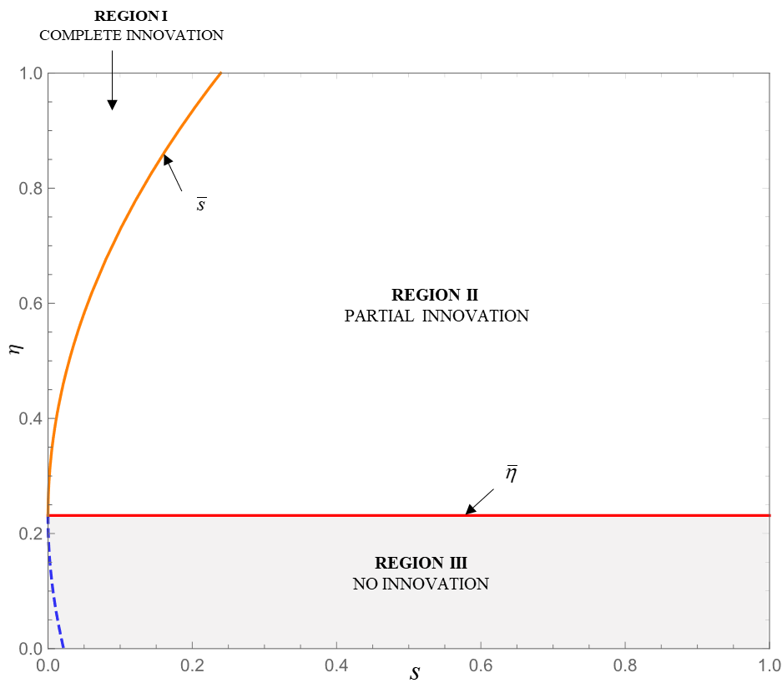

Figure 2. Categorization of the innovation strategy of firm M with different *η* and *s*

Furthermore, it is worth noticing that the threshold  is independent of the innovation cost *s*. This indicates that the risk attitude indicator  is a major factor affecting whether the firm to innovate, but the cost of innovation can only affect the level of innovation (complete innovation or partial innovation). This phenomenon can be explained as follows: the risk-averse attitude will lead firm M to amplify his perception of uncertain losses. Extremely risk-averse firms may not be able to tolerate any loss uncertainty. In this way, the risk-averse attitude becomes the main factor preventing companies from innovating. However, in our model, the whole innovation cost depends on the level of innovation. For firm M, he can find an appropriate level of innovation so that additional profits can offset the cost brought by product innovation.

**Corollary 1.** The threshold  is increasing in  when  and decreasing otherwise.

Interestingly, we find the cross-price sensitivity  and market power  are two important factors affecting firm M’s innovation strategy. If the company is dominant in the market (with strong market power ), when the cross-price sensitivity is increasing, that is, the substitutability and competition between the products of the two companies are increasing, then the threshold  is decreasing. It means as the competition in the market becomes more fierce, firm M more prefers to compete with the rival by innovation and will not care about the risks. However, if the market power of firm M is lower, then the competition between the two products will inhibit the innovation and induce the firm to pay more attention to the risks. For example, the SMEs (small and medium-sized enterprises) in the competitive market will try to avoid competing through innovation and prefer pricing competition instead. This explains the phenomenon that in many competitive markets, the leading company (e.g., Apple and Samsung in the mobile phone market) tend to innovate and produce high-priced products. Large-scale recalls or repairs usually occur in this type of firm. Firms such as Xiaomi in China, which has less market power, are more inclined to compete by trying to lower their selling prices and routinely upgrade their products with mature technologies. On the contrary, in markets with a low degree of substitutability or in markets with severe monopoly, such as the telecom market, large firms are more conservative about innovation. However, small firms or some agents are more inclined to introduce a variety of packages and new services to attract demand. Therefore, firms need to choose an appropriate innovation strategy by carefully considering their market positions and the characteristics of their products.

**4.2 The Effect of Risk Attitude of the Leading Firm**

In section 4.1, we have demonstrated that the risk attitude of firm M is an important factor affecting his innovation strategy. In this section, we will further analyze the effect of risk attitude and the uncertain loss of the innovation product. First, from the reaction function of the two firms, we have the following lemma.

**Lemma 2.** Given the innovative effort  ( is seen as an exogenous parameter), the prices of two firms are increasing as firm M is becoming more risk-averse (i.e.,  decreases), that is, **,** **.**

Lemma 2 shows that given the innovative effort , when firm M cares more about risk ( decreases), his optimal price will increase, which is different from the results in most studies considering risk attitude generated from other types of uncertainties, e.g., demand uncertainty, return uncertainty and so on (Li et al., 2014, Zheng et al., 2017). In their model, risk-averse firms prefer to set a lower price to attract more customers to compensate for the loss from uncertainties, even though they can only obtain lower marginal returns. However, considering the uncertain reliability of innovation, firm M tends to increase the price to reduce his demands and only capture loyal consumers. In this way, if the unreliability event happens, firm M could face a lower recall loss. Due to the price competition in the original market, firm C can also increase her price (to seek a higher profit from the spillover effect of innovation) at the same time.

However, when we treat the innovation effort  as an endogenous variable, the impact of the risk attitude on the optimal decisions is more complex to characterize. For the convenience of analysis, similar to the concept of price elasticity in economics, we introduce a notion, risk elasticity of innovation as follows.

**Definition:** The risk elasticity of innovation represents the innovation sensitivity to the risk attitude，denoted as , which can be simplified as .

More precisely, this concept gives the percentage change in the innovation level  in response to one percent change in risk attitude indicator . Then, we can obtain the effect of risk attitude on the optimal decisions as Proposition 2.

**Proposition 2.** Regarding the effect of risk attitude on the decisions of two firms, we have the following properties.

(i) For the innovation decision of firm 1, we can obtain .

(ii) For the pricing decisions of two firms, there exist two threshold values of the risk elasticity of innovation  and  (which can be found in Appendix 2),

if , then ; otherwise .

If  and , then ; otherwise .

Proposition 2 reveals the sensitivities of two firms’ decisions to firm M’s risk attitude. For the innovation decision of firm M, when he cares less about the risk, he tends to improve the level of innovation. This implies that more risk-averse firms are less willing to innovate. For the pricing decisions, the results are more complicated. On the one hand, risk attitude has a direct impact on the pricing decisions from Lemma 1. On the other hand, risk attitude can influence the pricing decisions indirectly by affecting firm M’s innovation effort decision (which will be elaborated in Section 4.3). The ultimate impact of risk attitude on the pricing decisions depends on the combination of both direct and indirect impacts. When the risk elasticity of innovation is large enough, i.e., , the innovation level is highly sensitive to the risk attitude. At this point, the indirect impact of risk attitude on the pricing decisions is opposite to the direct impact and dominates the direct impact (i.e., the risk attitude will inhibit innovation of firm M and then decrease the prices). Thus, as firm M cares more about risks ( decreases), the two companies tend to decrease their prices. When the risk elasticity of innovation is relatively small, i.e., , the innovation effort is less sensitive to the risk attitude. The indirect impact may be positive or negative, but becomes minor, while the direct impact is dominating. As a result, the impacts of risk attitude on both pricing decisions are negative, i.e., firm M tends to increase his price to reduce the demand, which in turn reduces the risk of recall loss; then firm C will adopt the high price strategy simultaneously.

To explore the effect of risk attitude and the uncertainties on the firms’ profits, we show the results of some numerical experiments in Figure 3. We set the parameters , , ,  in our numerical experiments. The above parameter setting is mainly based on Iyer et al. 2017, Karaer et al. 2017.

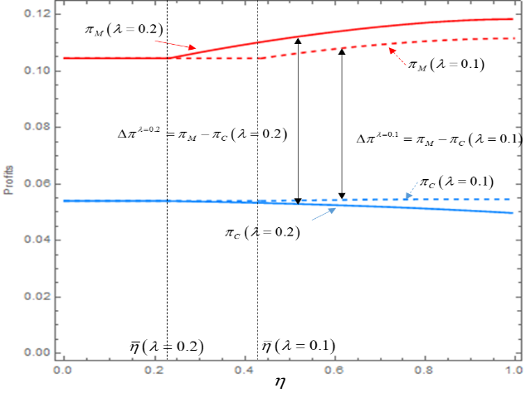 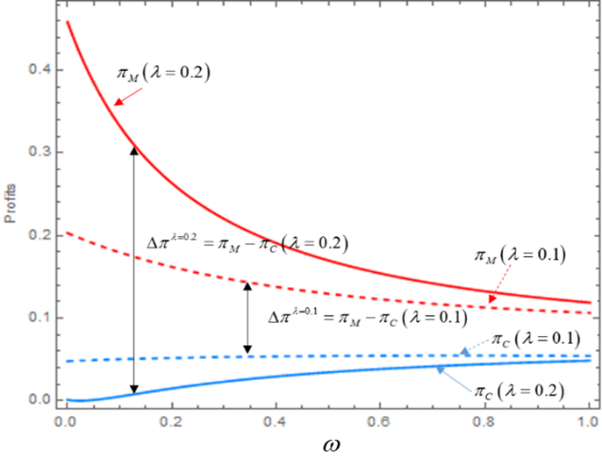

(a) varying risk attitude () (b) varying recall loss ()

Figure 3. the effect of risk attitude and the uncertain event loss

Figure.3(a) shows how the risk attitude influences the profits of two firms. Specifically, in the case that the innovation has a higher impact on the competition (i.e., ), when firm M is extremely risk-averse (), he will introduce a mature product, thus, the risk attitude has no influence on two firms. When firm M is less risk-averse ( increases), he inclines to innovate to compete for the market, and his profit will increase, while firm C’s profits may decrease. At this point, some demands of firm C are snatched by firm M. However, when the innovation has less impact on the competition, i.e.,  is small (), both firms can achieve higher profits through the innovation of firm M. As firm M tends to be risks-neutral, the profits of both firms are gradually increasing. At this time, firm C can enjoy the positive spillover effect of firm M’s innovation, too. That is, the innovation of firm M may bring a win-win result. As for the profits gap between two firms, when firm M cares less about the risk ( increases), the profit gap will gradually expand. The results illustrate that adopting innovative technologies is not always beneficial or harmful to two firms. We will further discuss the Pareto zone for two firms in the next section (Section 4.3), which is probably more interesting from a practical perspective.

The effect of recall losses on two firms’ profits is shown in Figure 3(b). It can be seen that the recall loss will reduce the profit of firm M, but the profit of firm C will increase. The impact of recall losses can be exacerbated by the competitiveness of the innovative product in the original market , that is, when  is small, the impact of recall losses is reduced. Generally speaking, the recall loss has a similar effect pattern to that of the risk attitude (when  increases and  decreases).

**4.3 The Effects of the Innovation Strategy**

In section 4.2, we find that the innovation strategy may benefit both two firms, which is a really interesting result. Thus, in this section, by comparing firm M’s no innovation case with the innovation case, we further explore the effects of innovation strategy on two firms’ profits and try to characterize the Pareto zone according to the trade-off among these effects.

When we compare the two cases, we found there is an important condition across nearly all our analyses, i.e., . We can easily divide this condition into three terms, ,  and . According to our model setting, we try to interpret the meaning of these three terms, which can facilitate the follow-up discussions. The first term,  is proportional to the recall loss of unreliable innovative product *ω*. Namely, when the recall events increase (i.e. the risk of innovation increases), the first term increases whereas the other two terms are not affected. Thus, we call the first part the risk effect of innovation. The second term,  is proportional to the attraction of innovative products to consumers outside the potential market, . Note that the first and third terms are not related to . Thus, we call the second part the expansion effect of innovation. Similarly, the third term,  is proportional to the competitiveness of innovative products in the original market, , whereas the other two terms are not related to *λ*. Thus, we call the third term the snatching effect.

Thus, the three effects of innovation strategy are defined as follows:

*Risk effect:*the effect generated from the product defective events, which is relative to the recall loss ** and the risk attitude  of firm M, i.e., *.*

*Expansion effect:* the effect generated from the attraction of innovative products to consumers outside the potential market, which is relative to the parameter , i.e., *.*

*Snatching effect:*the effect generated from the competitiveness of innovative products in the original market, which is relative to the parameter , i.e., *.*

Then we can obtain Proposition 3:

**Proposition 3.** (i) The price of firm M is increasing as his innovative effort increases, i.e., .

(ii) The influence of innovation effort on the price of firm C depends on the relationships of the risk effect, the expanding effect, and the snatching effect. When the risk effect and the expansion effect are greater than the snatching effect, i.e., , the price of firm C is increasing in the innovative effort, i.e., ; otherwise, .

According to Proposition 3, we can further obtain Corollary 2 as follows:

**Corollary 2** (i) The price of firm M in the innovative scenario is always higher than his price in the no innovation scenario, i.e., .

(ii) When the risk effect and the expansion effect are greater than the snatching effect, i.e., **, the price of firm C in the innovative scenario is higher than her price in the no innovation scenario, i.e., , otherwise, .

Proposition 3 and Corollary 2 show that the more innovative technologies firm M adopts, the higher price he will take, which is understandable because the innovative technologies can improve the product performance with higher development costs. However, the price of his competitor is more complicated. Intuitively, if a company introduces an innovative product, then its competitor tends to cut down the price to maintain her demand. Nevertheless, Proposition 3 and Corollary 2 indicate that firm C’s pricing decision actually depends on the trade-off among the risk effect, the expansion effect and the snatching effect associated with the innovation strategy.

The risk effect can be interpreted as firm M’ perceived loss from product unreliability taking the risk-averse attitude. When the recall loss increases or firm M becomes more risk-averse, the risk effect will increase, which represents that firm M pays more attention to the negative impact of uncertainty. According to Proposition 2 in Section 4.2, given the innovation effort, the more risk-averse firm M will set a higher price. Meanwhile, firm C can also follow the mark-up strategy. This means when the risk effect is dominating, innovation has a positive influence on firm C’s pricing decision. The expansion effect represents the attraction of innovative products to the consumer outside the original market. When the expansion effect increases, which means the innovative product can attract more additional consumers from other markets, firm M can put more attention to the new consumers. This implies that the competition within the original market will decrease. Benefited from this, firm C can set a higher price when firm M introduces a more innovative product. However, when the snatching effect is dominating, the innovative product will attract more consumers from the original market, this forces firm C to cut down her price to maintain her demands. Thus, the snatching effect has a negative impact on firm C’s pricing strategy. Further, consider the profits of the two firms, we can obtain Proposition 4 as follows:

**Proposition 4.** When the sum of the risk effect and the expansion effect is greater than the snatching effect, i.e., **, firm C can enjoy a *free-ride* from firm M’s innovation strategy, i.e., .

Proposition 4 shows that in some situations (i.e., the risk effect and the expansion effect are dominating), the two firms can both get benefits from firm M’s innovation strategy. To further illustrate this phenomenon, we use the numerical experiments (see Figure 4) to display the regions where both two companies can enjoy benefits from innovation, that is Pareto zone.

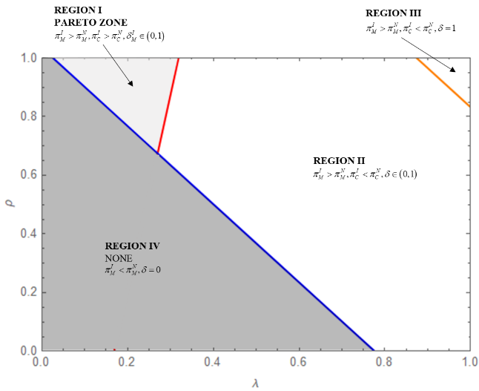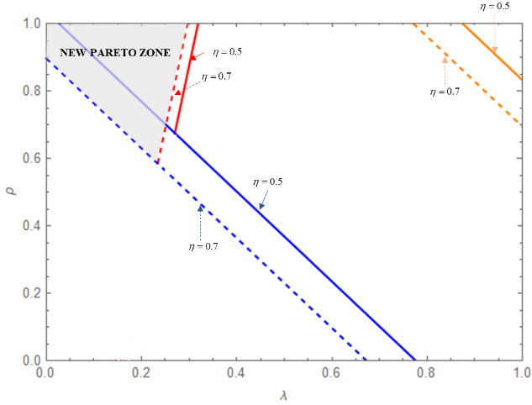

(a)  (b) 

Figure 4. Illustration of the Pareto zone

In Figure 4, the X-axis () and Y-axis () can represent the varying snatching effect and the varying expansion effect respectively. When the expansion effect and snatching effect are dominating (region I, II and III), it is profitable for firm M to apply innovative technologies. In these situations, firm M can more easily win the competition through innovation. When these two effects are sufficiently large, i.e., in region III, firm M will always introduce a fully innovative product. However, it is noticed that in region I, both firms can obtain higher profits from the innovation to achieve a win-win result. At this time, firm C can enjoy the positive spillover effect from firm M’s innovation. In this region, the snatching effect is limited, and the expansion effect is dominating, firm M prefers to attract more additional demand from outside the original market. As for firm C, she can attract considerable customers without the need of cutting-off price. The implication is that an appropriate innovation strategy of firm M will not destroy its competitors; in fact, it could decrease the competition in the original market and bring a positive development for the players. For example, in 2006, Nintendo Inc, a consumer electronics and video game company, introduced a new generation of game consoles called Nintendo Wii. Based on the innovative motion control stick and motion-sensing sports games, Wii attracted many new customers who never played traditional console games before and achieved a big success. In the meanwhile, this innovation strategy also relieved the competition in the market and promoted the development of the industry[5]. The risk effect is another important factor. When the risk effect decreases ( increases), shown in Figure 4(b), the Pareto zone will expand, and the infeasible area (Region IV) will shrink. This reveals that the less risk-averse attitude of firm M can more easily achieve a win-win situation for two firms.

In order to further analyze the impact of three types of effects on two firm’s profits, we conducted more numerical experiments as shown in Figure 5, the data settings are the same as those used in Figure 3. In general, the expansion effect has a positive impact on firm M’s profit since it can expand the demand source in addition to the original market. However, when firm M is less risk-averse and the expansion effect is relatively low ( is small), then it actually has a negative impact on firm M’s profit (e.g., the red-solid lines in Figure 5). This is because when the expansion effect is relatively small, firm M can only compete for demands in original markets, and the competition in the market is intensified. Firm C has to maintain her demands by lowering her prices. Therefore, firm M is hard to set a higher price for his innovative products to increase profits. That is, for firm M, the loss generated from the intense competition is greater than the benefits generated from the expansion effect. However, when the expansion effect becomes sufficiently large, firm M can put more effort on the new customers outside the original market and no longer pay much attention to compete with firm C. As a result, he will obtain a higher profit.

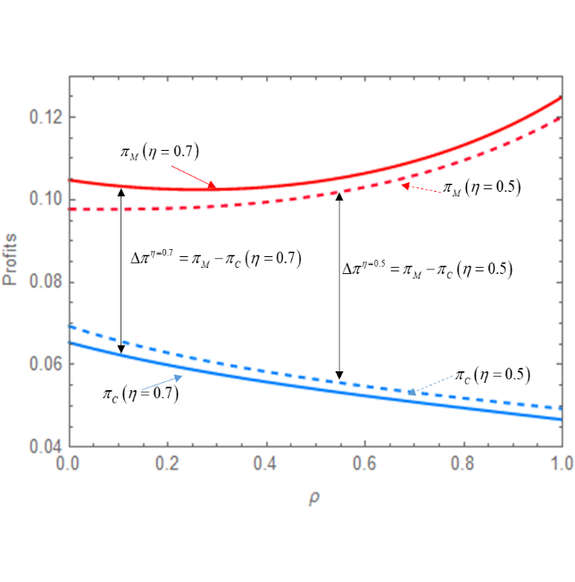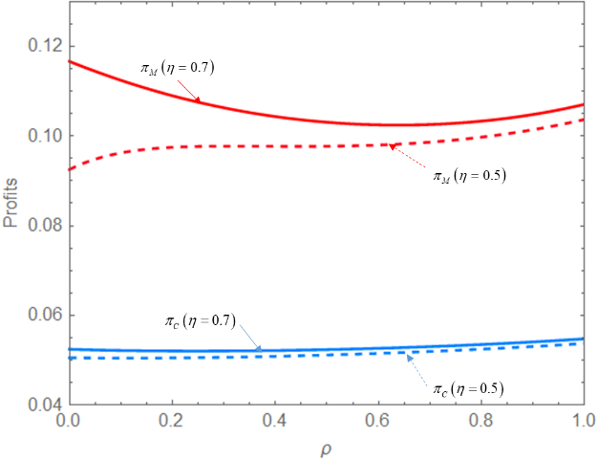

(a) (b)

Figure 5. The impacts of the three effects on firms’ profits

Interestingly, observing the blue lines in Figure 5, we find that the snatching effect is not always harmful to firm C, similarly, the expansion effect is not necessarily beneficial to her, either. This can be explained as follows. Generally, firm C’s profit is decreasing as the snatching effect increases, which is in line with our intuition. However, it should be noticed that when the expansion effect is insignificant (i.e., *ρ* is very small), the impact of the snatching effect on firm C could be positive, e.g., firm C’s profit at *λ*=0.2 is greater than that at *λ*=0.1 when *ρ* is sufficiently small (e.g., the left-side part of the blue lines in Figure 5(a-b)). This is because the competition in the original market is fierce at that time, firm C can compete for demands through price reduction. But firm M may not win the price war because of his expensive cost of innovative development. Then firm C could benefit from the snatching effect. In addition, the expansion effect may be harmful to firm C as shown in Figure 5(a), when the snatching effect is relatively high (), the increase of the expansion effect will encourage firm M to set a higher innovation effort, which will snatch more demands from firm C and result in a lower profit for her.

Finally, the risk effect significantly affects the profit gap between the two firms, Figure 5 shows that when the risk effect increases (*η* = 0.7 to *η* = 0.5), firm M prefers a more conservative innovation strategy (according to Proposition 2), thus, the profit gap between the two firms  is decreasing. Interestingly, from figure 5(b), we can observe that when the risk effect is different, the expansion effect plays different roles on the profit of firm M. When the risk effect is higher (*η* = 0.5), firm M’s profit will always increase when the expansion effect increases. In this situation, firm M will put less effort into innovation and focus on the competition with firm C. Thus, with a lower level of innovation, firm M can easily win the price war based on his advantage of market share. Meanwhile, the increase of expansion effect can help firm M get more demands outside the original market. However, it should be noticed, at this moment, the profit of firm M is lower than the situation where the risk effect is lower (*η* = 0.7).

**5. Extensions**

In this section, we made some extensions to examine some more general cases. Specifically, we try to analyze the following situations: (1) the case with production cost, (2) the case that both firms introduce innovative products, (3) the case that the unreliability of innovative products follows a normal distribution.

**5.1 The effect of production cost**

In the basic model, we have assumed that the production costs of the two firms are zero. This assumption simplifies the mathematical model and enables us to concentrate on the effect of uncertainty and innovation. In this section, we further consider the case that the two production costs cannot be normalized to zero simultaneously. Specifically, we assume the innovative product has a higher production cost than the regular product. Let the production cost of the innovative product with innovation effort  be **. Since the production process of the regular product is mature enough and can enjoy economies of scale, we assume that the production cost of the regular product is . For the convenience of analysis, we assume the product unreliability  follows a uniform distribution , and  in this extension (Chen et al., 2019; Guo et al., 2020). Thus, the profit of the firm with innovative products (firm M) can be rewritten as:



The utility of the firm with the risk-averse behavior is:



The profit and utility of the firm with mature products are the same as those in our basic model because its production cost is normalized to be 0. Then we can obtain the optimal pricing solutions as follows.

**Lemma 3.** Considering the effect of production cost, given the innovation effort of firm M, , the optimal pricing decisions  are given by:

, .

From Lemma 3, it can be seen that when the production cost of the innovative product is higher than the regular product, if the firm M’s innovation effort is treated as an exogenous parameter, then the optimal prices of two firms are higher than those in the basic model. This result is intuitive. Note that the marginal cost of the innovative product will obviously increase the price. Due to the competition in the market, the firm producing the regular product could also increase its selling price. Next, we treat the innovation effort as a decision of firm M. We can obtain proposition 5.

**Proposition 5.** There exists a threshold of firm M’s risk-averse attitude . When , firm M prefers to launch a product with innovative technologies. Otherwise, he prefers to launch a regular product without innovation.

Proposition 5 shows that the results of the extended model are similar to those in our basic model (Proposition 1). That is, when firm M is more risk-averse, he is more likely to launch a regular product. However, we find that the threshold of risk attitude  in the extended model is larger than the threshold in the basic model . Therefore, the production cost of the innovation product reduces firm M’s intention for innovation due to the risk-averse behavior.

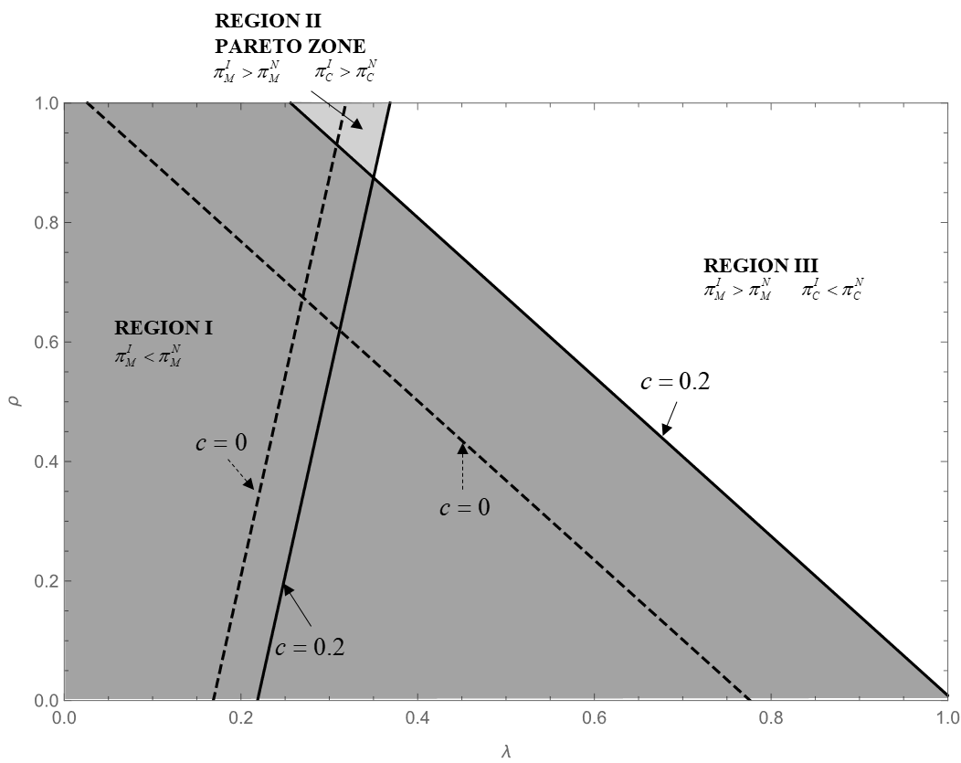

Figure 6. The Pareto zone when considering the nonzero production cost

Figure 6 further illustrates the Pareto zone of two firms when we consider nonzero production cost of innovative products. It could be found that the result is similar to that in Figure 4. However, when the production cost of innovative products increases (from 0 to 0.2), the Pareto zone (region II in figure x) is shrinking. This is because when the production cost of innovative products increases, firm M intends to decrease the innovative effort. As a result, he reduces the opportunities for firm C to enjoy a free ride from firm M. The results demonstrate the robustness of our results numerically.

**5.2 Both firms introduce innovative products**

In this section, we consider the situation that the two firms could both decide to introduce innovative products. The full sequence of decisions is similar to that in our basic model, i.e., at the beginning of the game, the two firms decide how much effort to conduct the innovative improvement process simultaneously, denoted by  and . After the development phase, the two firms introduce their products to the market and set their prices simultaneously. In the after-sales phase, there may be some problems revealed by the customers when using the innovative products. If the event occurs, the firm that introduces the product has to recall/repair or compensate for all its products.

Similar to our basic model, the demands of two firms when they both introduce innovative products are shown as:





The profits of two firms are shown as:

, *i* = *M*, *C*

The utilities of two firms under the CVaR measure can be written as:

, *i* = *M*, *C*

For convenience, we assume the two firms have the same risk attitude, i.e., . The case that one firm introduces innovative products and the case that no firm introduces innovative products are the same as these in our basic model.

**Lemma 4.** Given the innovative efforts of the two firms ,

(i) The optimal pricing decisions are shown as:





(ii) the prices of two firms are increasing as the two firms are becoming more risk-averse (i.e.,  decreases), that is, , .

Where , 

Lemma 4 gives the optimal pricing decisions of two firms when the innovative efforts  are exogenous. The main results are similar to those in our basic model shown in Lemma 2, i.e., risk-averse firms prefer to set a higher price to decrease their potential loss from uncertainties, even though they may lose more customers. The explanations are the same as those in our basic model.

Due to the complicated expressions of the price decisions, it is difficult to obtain the optimal innovation strategies of two firms analytically. Thus, the final results of innovation efforts are numerically illustrated in Figure 7. The values of input parameters are the same as those in our basic model.

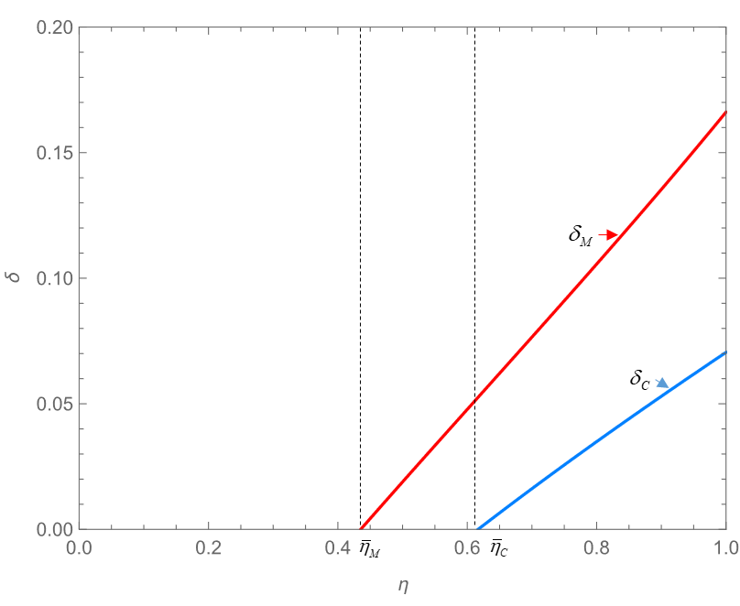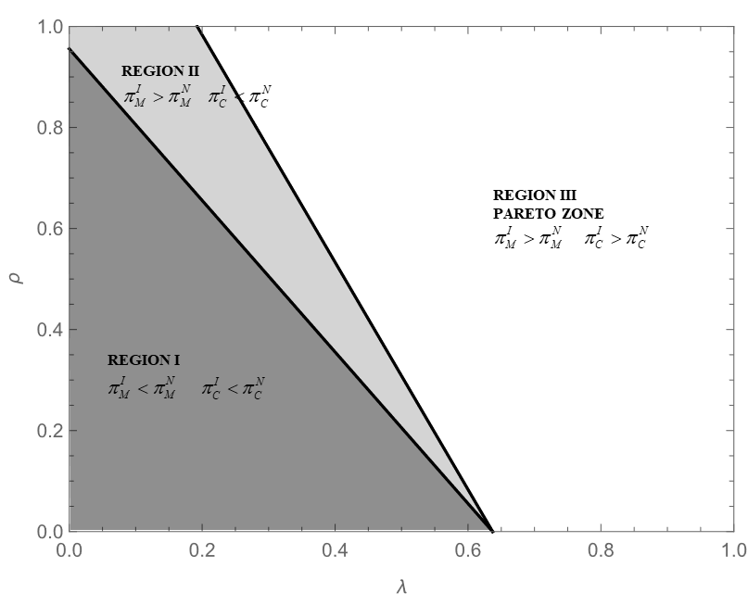

|  |  |
| --- | --- |
| Figure 7. The optimal innovative effort of two firms | Figure 8. Illustration of the Pareto zone |

As shown in Figure 7, when the two firms care less about the risk (), they are more likely to apply innovative technologies to their products. Otherwise, they prefer to introduce mature products. This result is the same as our basic model. However, in figure 8, we find that the Pareto zone (Region III) is different from the result in the basic model (where only the major firm could launch innovative products). When the expansion effect and the snatching effect are lower, i.e., in Region I, the innovative product is not attractive to the customers. Thus, the two firms both could obtain higher profits when they launch mature products. However, when the expansion effect increases (in Region II), the firm with a higher market share (firm M) will launch innovative products whereas firm C prefers to launch mature products. At that time, the firm with a higher market share could attract more customers with its innovative product because it has a larger influence on the market. Finally, when the two effects are both larger enough, the two firms will both obtain higher profits when they introduce innovative products, which achieves a win-win result in Region III.

**5.3 The case that the unreliability of innovative products follows a normal distribution**

Our main results are based on the assumption that the distribution of unreliability follows a uniform distribution. In this section, we try to verify our main results in the case where the unreliability of innovative products  follows a normal distribution . To be consistent with our main model, we assume  and  to ensure that the random variable  with a 99% level of confidence. We set , and the values of other parameters are the same as those in our basic model. The results are shown in figure 9 and figure 10.

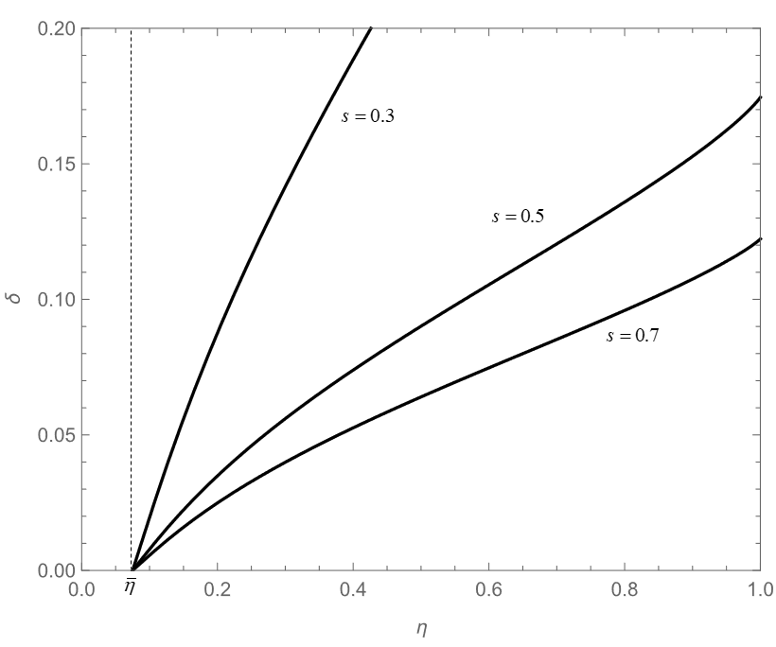 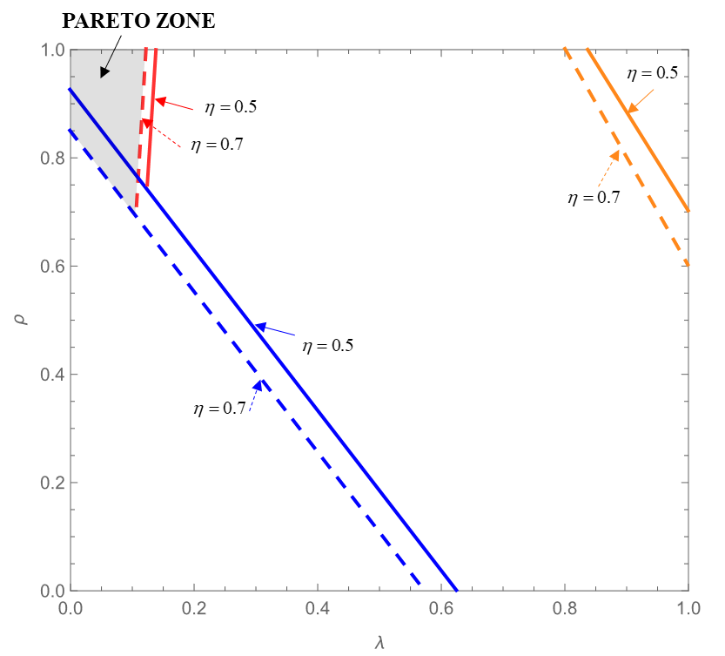

|  |  |
| --- | --- |
| Figure 9. The optimal innovative effort of two firms | Figure 10. Illustration of the Pareto zone |

Figure 9 verifies the results obtained by proposition 1 and proposition 2 for the case where  follows a normal distribution, i.e., when firm M is sufficiently risk-averse (), he prefers to introduce a regular product without innovation. Otherwise (), he prefers to introduce an innovative product. When firm M becomes more risk-neutral ( increases), or the development cost of innovative products *s* decreases, he prefers to introduce products with a higher innovation level. The explanations are similar to those in section 4.1. Figure 10 further shows the Pareto zone of two firms in the case where  follows a normal distribution, which verifies the main results of proposition 4. That is, when the risk effect and the expansion effect are dominating, the two firms can both obtain benefits from firm M’s innovation strategy. The above numerical results illustrate that our findings are robust to the probability distribution of the unreliability of innovation products.

**6. Conclusion**

In this paper, we investigate the impacts of the risk attitude and the product unreliability after launching on the innovation strategy and pricing decisions in a competitive market consisting of a leading firm (firm M) and a competitor (firm C). Due to the uncertain product reliability generated from the innovative development, the leading firm may care about the associated risk when making the innovation decision. We establish a Stackelberg game model using CVaR to measure the risk attitude and obtain the optimal innovation and pricing decisions for two firms. In addition, we analyze the relationships between risk-attitude, competition and innovation and their cross impacts on the profits and other economic outcomes.

The result shows that there exists a threshold of the risk attitude, when the leading firm’s concern on the risk is below the threshold level, he prefers to introduce a more innovative product; otherwise, he will routinely introduce a product with mature technologies. This implies that the risk-averse attitude is a decisive factor for the firm to determine whether or not to innovate the product. On the other hand, the development cost of innovation does not affect whether to innovate, instead, it can only affect the innovation level, i.e., complete innovation or partial innovation. In addition, the competitor will follow the innovator and adopt a similar pricing strategy when the two firms’ risk elasticities of innovation are both higher or lower, but the opposite strategy would be selected otherwise. Interestingly, we find that the risk attitude can encourage two firms to set a higher price, which is a different phenomenon compared to most existing literature. Furthermore, we introduce three types of effects of innovation called risk effect, snatching effect and expansion effect. In some situations (the risk effect and the expansion effect are dominating), the competitor can enjoy positive spillover effects from the innovator’s behavior. As far as we know, we are the first to model the risk attitude of firms, reliability uncertainty of innovative products, and competition marketplace simultaneously, and analyze their cross impacts on the economic outcomes. The obtained results can largely explain the phenomena that happened in many competitive markets, such as the smartphone market, the auto market, and so on. The findings can offer useful managerial insight for firms as well as government policymakers.

It should be pointed out that there are some limitations in our paper. First, the demand function in our model is assumed to be linear, and there are only two firms in the competitive market. In reality, multiple innovators and competitors are likely co-existing. Second, the recall loss is assumed to be a linear cost depending on the demand only. The reputation loss caused by product unreliability is not explicitly included. Further research can be done by relaxing these assumptions.

**References**

Alexis. C. Madrigal. (2020). Silicon valley abandons the culture that made it the envy of the world. *The Atlantic*. Available at <https://www.theatlantic.com/technology/archive/2020/01/why-silicon-valley-and-big-tech-dont-innovate-anymore/604969/>

Artzner, P. (1997). Thinking coherently. *Risk*, 68-71.

Bala, R., Bhardwaj, P., & Chintagunta, P. K. (2017). Pharmaceutical product recalls: Category effects and competitor response. *Marketing Science*, 36(6), 931-943.

Bessonova, E., & Gonchar, K. (2019). How the innovation-competition link is shaped by technology distance in a high-barrier catch-up economy. Technovation, 86, 15-32.

Bhaskaran, S. R., & Krishnan, V. (2009). Effort, revenue, and cost sharing mechanisms for collaborative new product development. *Management Science*, 55(7), 1152-1169.

Bilgiç, T., & Güllü, R. (2016). Innovation race under revenue and technology uncertainty of heterogeneous firms where the winner does not take all. *IIE Transactions*, 48(6), 527-540.

Chen, J. Y., Dimitrov, S., & Pun, H. (2019). The impact of government subsidy on supply Chains’ sustainability innovation. *Omega*, 86, 42-58.

Choi, T. M., Li, D., & Yan, H. (2008). Mean–variance analysis of a single supplier and retailer supply chain under a returns policy. *European Journal of Operational Research*, 184(1), 356-376.

Cucculelli, M., & Ermini, B. (2013). Risk attitude, product innovation, and firm growth. Evidence from Italian manufacturing firms. *Economics Letters*, 118(2), 275-279.

Correa, J. A. (2012). Innovation and competition: An unstable relationship. Journal of Applied Econometrics, 27(1), 160-166.

Cui, Q., Chiu, C. H., Dai, X., & Li, Z. (2016). Store brand introduction in a two-echelon logistics system with a risk-averse retailer. *Transportation Research Part E: Logistics and Transportation Review*, 90, 69-89.

Dai, R., & Zhang, J. (2017). Green process innovation and differentiated pricing strategies with environmental concerns of South-North markets. *Transportation Research Part E: Logistics and Transportation Review*, 98, 132-150.

Davidson W., Worrell D. (1992). Research notes and communications: The effect of product recall announcements on shareholder wealth. *Strategic Management Journal*. 13(6):467–473.

Demirag, O. C. 2013. Performance of weather-conditional rebates under different risk preferences. *Omega*, 41(6), 1053-1067.

Fetaji, B., Ebibi, M., Fetaji, M., Abdullahu, A., Armenski, G., & Antovski, L. (2019). Devising UIF Model in Designing Usable User Interface Impacted from Shorter-Time-To-Market Phenomena. In 2019 ENTRENOVA Conference Proceedings.

Gan, X., Sethi, S., & Yan, H. (2005). Channel coordination with a risk-neutral supplier and a downside-risk-averse retailer. *Production and Operations Management*, 14(1), 80-89.

Gao, F., Cui, S., & Cohen, M. (2021). Performance, Reliability, or Time-to-Market? Innovative Product Development and the Impact of Government Regulation. *Production and Operations Management*, 30(1), 253-275.

Ge, Q., Peng, H., van Houtum, G. J., & Adan, I. (2018). Reliability optimization for series systems under uncertain component failure rates in the design phase. *International Journal of Production Economics*, 196, 163-175.

Gmelin, H., & Seuring, S. (2014). Determinants of a sustainable new product development. *Journal of Cleaner Production*, 69, 1-9.

Guo, S., Choi, T. M., & Shen, B. (2020). Green product development under competition: A study of the fashion apparel industry. *European Journal of Operational Research*, 280(2), 523-538.

Hartman, R. S. (1987). Product quality and market efficiency: The effect of product recalls on resale prices and firm valuation. *The Review of Economics and Statistics*, 367-372.

Hou, P., Zhen, Z., & Pun, H. (2020). Combating copycatting in the luxury market with fighter brands. *Transportation Research Part E: Logistics and Transportation Review*, 140, 102009.

Hua, Z., Zhang, X., & Xu, X. (2011). Product design strategies in a manufacturer–retailer distribution channel. *Omega*, 39(1), 23-32.

Iyer, G., & Soberman, D. A. (2016). Social responsibility and product innovation. *Marketing Science*, 35(5), 727-742.

Iyer, G., & Singh, S. (2017). Voluntary product safety certification. *Management Science*, 64(2), 695-714.

Jerath, K., Kim, S. H., & Swinney, R. (2017). Product quality in a distribution channel with inventory risk. *Marketing Science*, 36(5), 747-761.

Kang, R., Zhang, Q., Zeng, Z., Zio, E., & Li, X. (2016). Measuring reliability under epistemic uncertainty: Review on non-probabilistic reliability metrics. *Chinese Journal of Aeronautics*, 29(3), 571-579.

Karaer, Ö., Kraft, T., & Khawam, J. (2017). Buyer and nonprofit levers to improve supplier environmental performance. *Production and Operations Management*, 26(6), 1163-1190.

Kirshner, S. N., Levin, Y., & Nediak, M. (2017). Product upgrades with stochastic technology advancement, product failure, and brand commitment. Production and Operations Management, 26(4), 742-756.

Kraft, T., & Raz, G. (2017). Collaborate or compete: Examining manufacturers' replacement strategies for a substance of concern. *Production and Operations Management*, 26(9), 1646-1662.

Li, B., An, S. M., & Song, D. P. (2018). Selection of financing strategies with a risk-averse supplier in a capital-constrained supply chain. *Transportation Research Part E: Logistics and Transportation Review*, 118, 163-183.

Li, B., Chen, P., Li, Q., & Wang, W. (2014). Dual-channel supply chain pricing decisions with a risk-averse retailer. *International Journal of Production Research*, 52(23), 7132-7147.

Li, B., & Song, D. P. (2021). Dual-channel Supply Chain Decisions with Risk-averse Behavior. World Scientific.

Li, C., & Zhang, J. (2013). R&D competition in a spatial model with technical risk. *Papers in Regional Science*, 92(3), 667-682.

Liu, B., Cai, G., & Tsay, A. A. (2014). Advertising in asymmetric competing supply chains. *Production and Operations Management*, 23(11), 1845-1858.

Liu, J., & He, Y. (2013). Coordinating a supply chain with risk-averse agents under demand and consumer returns uncertainty. *Mathematical Problems in Engineering*, 289572, 1-10.

Lu, M., Sethi, S., Xie, Y., & Yan, H. (2019). Profit allocation, decision sequence and compliance aspects of coordinating contracts: a retrospect. *Production and Operations Management*, 28(5), 1222-1237.

Lu, Y., den Ouden, E., Brombacher, A., Geudens, W., & Hartmann, H. (2007). Towards a more systematic analysis of uncertain user–product interactions in product development: an enhanced user–product interaction framework. *Quality and Reliability Engineering International*, 23(1), 19-29.

Ma, L., Liu, F., Li, S., & Yan, H. (2012). Channel bargaining with risk-averse retailer. *International Journal of Production Economics*, 139(1), 155-167.

Madadi, A., Kurz, M. E., Taaffe, K. M., Sharp, J. L., & Mason, S. J. (2014). Supply network design: Risk-averse or risk-neutral?. *Computers & Industrial Engineering*, 78, 55-65.

Matsumura, T., Matsushima, N., & Cato, S. (2013). Competitiveness and R&D competition revisited. *Economic Modelling*, 31, 541-547.

Minniti, A. (2010). Product market competition, R&D composition and growth. *Economic Modelling*, 27(1), 417-421.

Moreira, S., Klueter, T. M., & Tasselli, S. (2020). Competition, technology licensing-in, and innovation. Organization Science, 31(4), 1012-1036.

Morgan, L. O., Morgan, R. M., & Moore, W. L. (2001). Quality and time-to-market trade-offs when there are multiple product generations. Manufacturing & Service Operations Management, 3(2), 89-104.

Morrison, M. (2013). How Boeing Can Bounce Back from Dreamliner Problems. Available at https://www.cnn.com/2013/01/18/opinion/dreamliner-murdo-analysis/index.html

Ni, D., Li, K. W., & Tang, X. (2010). Social responsibility allocation in two-echelon supply chains: Insights from wholesale price contracts. *European Journal of Operational Research*, 207(3), 1269-1279.

Niu, B., Dong, J., & Zeng, F. (2022). Green manufacturers’ power strategy in the smart grid era. *Computers & Industrial Engineering*, 163, 107836.

Niu, B., Zeng, F., & Chen, L. (2021). Impact of promised-delivery-time and brand image on imported vaccine provider’s agency marketing strategy. *Computers & Industrial Engineering*, 162, 107748.

Öner, K. B., Kiesmüller, G. P., & van Houtum, G. J. (2015). On the upgrading policy after the redesign of a component for reliability improvement. *European Journal of Operational Research*, 244(3), 867-880.

Rockafellar, R. T., & Uryasev, S. (2000). Optimization of conditional value-at-risk. *Journal of Risk*, 2, 21-42.

Shah, R., Ball, G. P., & Netessine, S. (2017). Plant operations and product recalls in the automotive industry: An empirical investigation. *Management Science*, 63(8), 2439-2459.

Shen, B., Choi, T. M., Wang, Y., & Lo, C. K. (2013). The coordination of fashion supply chains with a risk-averse supplier under the markdown money policy. *IEEE Transactions on Systems, Man, and Cybernetics: Systems*, 43(2), 266-276.

Shin, Y., Van Thai, V., Grewal, D., & Kim, Y. (2017). Do corporate sustainable management activities improve customer satisfaction, word of mouth intention and repurchase intention? Empirical evidence from the shipping industry. *The International Journal of Logistics Management*, 28(2), 555-570.

Song, Y., & Zhao, M. (2021). Dynamic R&D competition under uncertainty and strategic disclosure. *Journal of Economic Behavior & Organization*, 181, 169-210.

Souza, G. C., Bayus, B. L., & Wagner, H. M. (2004). New-product strategy and industry clockspeed. Management Science, 50(4), 537-549.

Thirumalai S., Sinha K. (2011). Product recalls in the medical device industry: An empirical exploration of the sources and financial consequences. *Management Science*. 57(2):376–392.

Thompson, S. (2009). Price competition in the presence of rapid innovation and imitation: The case of digital cameras. *Economic of Innovation and New Technology*, 18(1), 93-106.

Wang, D., Liu, W., Shen, X., & Wei, W. (2019). Service order allocation under uncertain demand: Risk aversion, peer competition, and relationship strength. *Transportation Research Part E: Logistics and Transportation Review*, 130, 293-311.

Wang, Y., Gilland, W., & Tomlin, B. (2010). Mitigating supply risk: Dual sourcing or process improvement?. *Manufacturing & Service Operations Management*, 12(3), 489-510.

Wei, Y., & Choi, T. M. (2010). Mean–variance analysis of supply chains under wholesale pricing and profit sharing schemes. *European Journal of Operational Research*, 204(2), 255-262.

Williams, N., Kannan, P. K., & Azarm, S. (2011). Retail channel structure impact on strategic engineering product design. *Management Science*, 57(5), 897-914.

Wu, S. B., Gu, X., Wu, G. D., & Zhou, Q. (2016). Cooperative R&D contract of supply chain considering the quality of product innovation. *International Journal of Simulation Modelling*, 15(2), 341-351.

Xiao, T., & Qi, X. (2008). Price competition, cost and demand disruptions and coordination of a supply chain with one manufacturer and two competing retailers. *Omega*, 36(5), 741-753.

Xie, X., Dai, B., Du, Y., & Wang, C. (2021). Contract Design in a Supply Chain With Product Recall and Demand Uncertainty. *IEEE Transactions on Engineering Management*.

Xie, L., Hou, P., & Han, H. (2021). Implications of government subsidy on the vaccine product R&D when the buyer is risk-averse. *Transportation Research Part E: Logistics and Transportation Review*, 146, 102220.

Xue, W., Choi, T. M., & Ma, L. (2016). Diversification strategy with random yield suppliers for a mean–variance risk-sensitive manufacturer. *Transportation Research Part E: Logistics and Transportation Review*, 90, 90-107.

Zhao, X., Li, Y., & Flynn, B. B. (2013). The financial impact of product recall announcements in China. *International Journal of Production Economics*, 142(1), 115-123.

Zheng, W., Huang, H. F., Song, D. P., & Li, B. (2020). Optimal CSR and Pricing Decisions With Risk-Averse Providers in a Competitive Shipping System. *IEEE Transactions on Systems, Man, and Cybernetics: Systems*, doi: 10.1109/TSMC.2019.2958376.

Zheng, W., Li, B., & Song, D. P. (2017). Effects of risk-aversion on competing shipping lines’ pricing strategies with uncertain demands. *Transportation Research Part B: Methodological*, 104, 337-356.

Zhu, W., & He, Y. (2017). Green product design in supply chains under competition. *European Journal of Operational Research*, 258(1), 165-180.

1. Available at https://www.macrumors.com/2016/11/02/phil-schiller-new-macbook-pro-interview/
2. Available at https://appleinsider.com/articles/18/04/30/2016-macbook-pro-butterfly-keyboards-failing-twice-as-frequently-as-older-models
3. Available at https://www.businessinsider.com/how-samsung-overcame-its-galaxy-note-7-fiasco-2017-10
4. Available at https://www.cnn.com/travel/article/dreamliner-features/index.html
5. http://businessmodelalchemist.com/blog/2007/01/nintendos-blue-ocean-strategy-wii.html