Supplementary information for “Single crystal growth and properties of the polar ferromagnet Mn1.05Bi with Kagome layers, huge magnetic anisotropy and slow spin dynamics”

Q.D. Gibson1, C.M. Robertson1, M.S. Dyer1, M. Zanella1, T.W Surta1, L.M. Daniels1, J.B. Claridge1, J. Alaria2, M.J. Rosseinsky1

1 University of Liverpool Department of Chemistry, Crown Street, Liverpool, L69 7ZD, United Kingdom

2 University of Liverpool Department of Physics, Oliver Lodge Laboratory, Liverpool, L69 7ZE, United Kingdom

*Crystal structure and solution*

Details of the crystal structure solution are shown in Tables S1-S3 below. Data were refined with an inversion twin, with a BASF of 0.34(2). Due to high absorption, the anisotropic thermal parameters were refined one at a time while the others remained fixed. The large max peaks of 4.1 were found within 1 Å of the bismuth site and are due to absorption; these resulted in alerts in the checkcif program but are expected due to presence of bismuth; the crystal was too small to properly apply absorption corrections from the shape factor. A final R1 of 3.90% and wR2 of 10.08 % were achieved, with a goodness of fit of 1.025 and an I/σ of 16.9 and a dmin of 0.80.

|  |  |
| --- | --- |
| Identification code | bimn_phase_check_0m |
| Empirical formula | Bi1.45Mn1.52 |
| Formula weight | 387.521 |
| Temperature/K | 150.10 |
| Crystal system | orthorhombic |
| Space group | Fdd2 |
| a/Å | 47.577(3) |
| b/Å | 8.6499(6) |
| c/Å | 14.957(1) |
| α/° | 90 |
| β/° | 90 |
| γ/° | 90 |
| Volume/Å3 | 6155.3(7) |
| Z | 88 |
| ρcalcg/cm3 | 9.200 |
| μ/mm‑1 | 97.635 |
| F(000) | 13598.2 |
| Crystal size/mm3 | 0.055 × 0.05 × 0.01 |
| Radiation | Mo Kα (λ = 0.71073) |
| 2Θ range for data collection/° | 5.5 to 52.92 |
| Index ranges | -58 ≤ h ≤ 59, -10 ≤ k ≤ 10, -16 ≤ l ≤ 18 |
| Reflections collected | 6891 |
| Independent reflections | 2835 [Rint = 0.0462, Rsigma = 0.0591] |
| Data/restraints/parameters | 2835/1/83 |
| Goodness-of-fit on F2 | 1.025 |
| Final R indexes [I>=2σ (I)] | R1 = 0.0390, wR2 = 0.0898 |
| Final R indexes [all data] | R1 = 0.0610, wR2 = 0.1008 |
| Largest diff. peak/hole / e Å-3 | 4.29/-4.87 |
| Flack parameter | 0.01(2) |

**Table S1.** Crystal data and structure refinement for bimn_phase_check_0m.

|  | | | | |
| --- | --- | --- | --- | --- |
| **Atom** | ***x*** | ***y*** | ***z*** | **U(eq)/ ×103Å2** |
| Bi01 | 5000 | 0 | 5437.87(10) | 2.9(3) |
| Bi02 | 5000 | 5000 | 5257.01(10) | 6.1(3) |
| Bi03 | 3747.59(14) | -2513(3) | 7930.99(10) | 2.53(19) |
| Bi04 | 4999.90(18) | 7764.6(10) | 8021.87(10) | 4.7(2) |
| Bi05 | 3750.04(14) | 2506(3) | 7937.92(10) | 2.32 |
| Bi06 | 4411.44(17) | 2719.7(14) | 4523.0(1) | 7.15 |
| Bi07 | 4379.90(14) | 10(2) | 2098.94(10) | 2.327 |
| Bi08 | 4415.11(17) | -2732.3(14) | 4527.21(10) | 5.9(3) |
| Bi09 | 4413.09(15) | -3(2) | 7248.9(1) | 7.0(2) |
| Mn0A | 4046.2(5) | -10(8) | 8770.0(10) | 3.69 |
| Mn0B | 4072.7(5) | -33(8) | 3782.1(10) | 4.09 |
| Mn0C | 4077.3(5) | -2506(9) | 1256.6(10) | 5.977 |
| Mn0D | 4690.4(6) | 4(4) | 3759.4(11) | 3.89 |
| Mn0E | 4071.8(5) | -2453(9) | 6247.2(10) | 4.67 |
| Mn0F | 5308.3(6) | 2517(9) | 6268.9(10) | 7.097 |
| Mn0G | 4690.7(5) | 2506(9) | 6266.8(10) | 4.907 |
| Mn0H | 5000 | 5000 | 7101.2(11) | 5.9 |
| Mn0I | 4368.3(7) | -1(5) | 5428.2(11) | 4.437 |

**Table S2.** Fractional Atomic Coordinates (×104) and Equivalent Isotropic Displacement Parameters (Å2×103) for bimn_phase_check_0m. Ueq is defined as 1/3 of the trace of the orthogonalised UIJ tensor.

| **2π2[h2a*2U11+2hka*b*U12+…].** | | | | | | |
| --- | --- | --- | --- | --- | --- | --- |
| **Atom** | **U11** | **U22** | **U33** | **U12** | **U13** | **U23** |
| Bi01 | 3.3(5) | 4.0(6) | 1.4(6) | -0.1(8) | -0 | 0 |
| Bi02 | 4.7(5) | 4.9(7) | 8.7(8) | -0.6(9) | -0 | 0 |
| Bi03 | 3.5(4) | 1.8(4) | 2.3(4) | 0.5(4) | 0.0(3) | -0.4(5) |
| Bi04 | 4.7(4) | 4.2(4) | 5.2(5) | -1.6(5) | -0.1(4) | 1.4(4) |
| Bi05 | 2.32 | 2.32 | 2.32 | 0 | 0 | -0 |
| Bi06 | 6.77 | 8.9 | 5.78 | -0.3 | -1.34 | -3.12 |
| Bi07 | 3.91 | 2.42 | 0.65 | 0.61 | -0.73 | -0.45 |
| Bi08 | 7.2(4) | 4.9(6) | 5.7(5) | -4.8(4) | -1.3(4) | 1.8(4) |
| Bi09 | 5.1(4) | 7.5(6) | 8.6(6) | -0.4(5) | 2.0(4) | -0.8(6) |
| Mn0A | 5.06 | 5.26 | 0.75 | -0.53 | -0.95 | 0.92 |
| Mn0B | 3.84 | 5.72 | 2.71 | 3.57 | 1.2 | 0.66 |
| Mn0C | 5.49 | 6.91 | 5.53 | -2.47 | 0.26 | -4.85 |
| Mn0D | 3.44 | 5.46 | 2.77 | -2.46 | -0.18 | 0.51 |
| Mn0E | 4.46 | 4.81 | 4.74 | -0.89 | 1.93 | -1.97 |
| Mn0F | 8.31 | 8.39 | 4.59 | -1.98 | -1.1 | -2.55 |
| Mn0G | 2.57 | 7.76 | 4.39 | 0.74 | 0.14 | -1.45 |
| Mn0I | 5.05 | 4.49 | 3.77 | 2.25 | -2.88 | -1.64 |

**Table S3.** Anisotropic Displacement Parameters (Å2×103) for bimn_phase_check_0m. The Anisotropic displacement factor exponent takes the form: -2π2[h2a*2U11+2hka*b*U12+…].

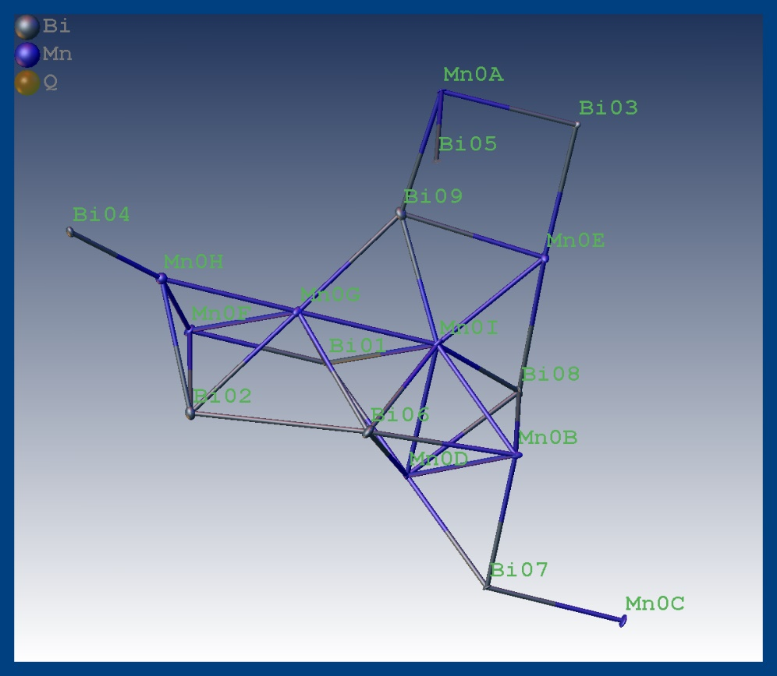

**Figure S1.** Crystal structure of Mn1.05Bias determined by the Olex-2 refinement, showing the different Mn and Bi sites as well as their refined thermal ellipsoid from the anisotropic displacement parameters.

*Magnetic Measurements*

The background signal for the AC measurement was determined by measuring the empty quartz sample holder. Figure S2 shows this data at 900 Hz, demonstrating a peak in the out-of-phase susceptibility around 30 K. This shows that this feature, observed in the measurements of Mn1.05Bi as shown in Figure 7, is an artefact of the background, rather than a feature of the magnetism of Mn1.05Bi.



**Figure S2.** In phase (χ′) and out-of phase (χ′′) contributions to the susceptibility of an empty sample holder as measured in the quantum design magnetic properties measurement system, with an AC field of 1 Oe applied at a frequency of 900 Hz. While the average susceptibility remains close to zero, a negative in-phase and positive out-of-phase component develops at low temperatures leading to a peak around 30 K.

In order to confirm the nature of the features observed in the AC susceptibility, the derivative of the susceptibility was taken, leading two observable peaks in the derivative (Figure S3). This demonstrates that, unambiguously, there is one low temperature and one high temperature transition observed in the AC susceptibility that is consistent with those observed in the DC susceptibility and resistivity measurements.

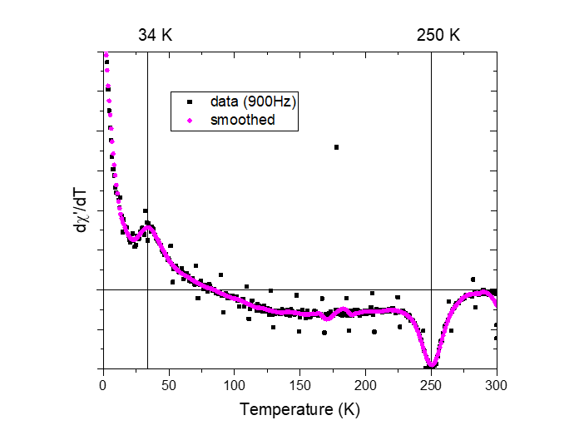

**Figure S3.** The temperature derivative of the in-phase AC susceptibility (900 Hz with an applied field of 1 Oe and no DC bias field) along the a-axis, showing peaks around 34 K and 250 K.

*SEM- EDX*

Secondary electron microscopy (SEM) was performed to image single crystals of Mn1.05Bi and determine their composition through Energy Dispersive X-ray spectroscopy (EDX). The EDX spectra was measured over different regions of the crystal (as shown in Figure S3 below) and averaged for an overall composition of Mn1.08(4)Bi where the error was determined by a propagation of the errors in each individual measurement along with the standard deviation of the average value. Some regions were excluded due to pockets of Bi on the surface, left from the flux reaction. This composition is within error of the refined composition.

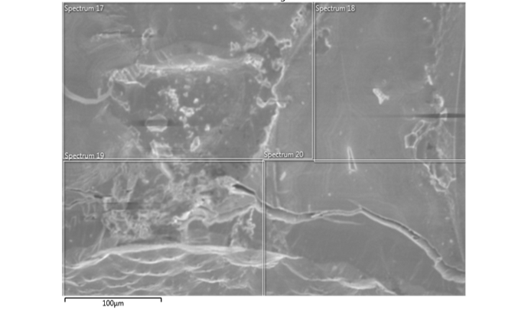

**Figure S4**. Secondary electron microscope image of the surface of a Mn1.05Bi, showing the region sizes over which Energy Dispersive X-ray spectra were collected.

*Differential Scanning Calorimetry*

In order to confirm the metastability of Mn1.05Bi single crystals, a 15.2 mg single crystal was heated to 300 °C under flowing Ar and cooled back to room temperature on differential scanning calorimeter. Clear, broad features are observed on heating, that are not observed on cooling, indicative of an irreversible transition. The melting point of the Bi flux is suppressed by over 50 °C on cooling, indicative of the freezing of a Mn-Bi eutectic composition, due to evolution of elemental Mn during the decomposition process (from the reaction Fdd2 Mn1.05Bi 🡪 Mn + P63/mmc MnBi). The crystal shows severe discoloration after heating to 300 °C.

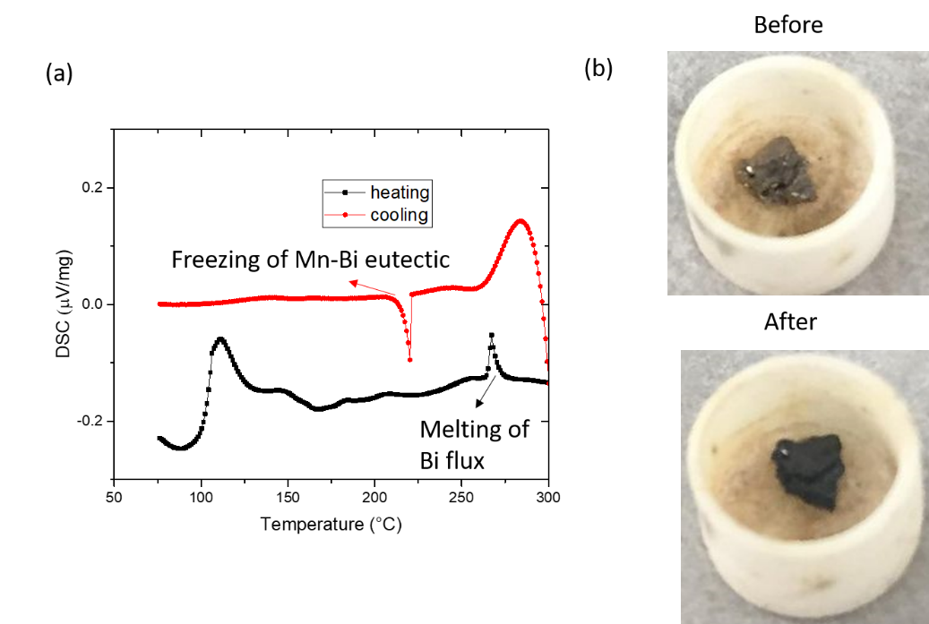

**Figure S5.** (a)Differential scanning calorimetry curves on heating and cooling. The curve on heating shows features in the temperature range 125-250 °C not present in the cooling curve, indicative of an irreversible transition. Melting of the Bi flux and freezing of the resulting Mn-Bi eutectic are also observed. (b) Images of the crystal before and after heating, showing discoloration from decomposition.

*Heat Capacity*

Heat capacity was measured with high temperature H grease in order to elucidate the presence or absence of large-entropy transitions in Mn1.05Bi in the temperature range 230-300 K. As can be seen from Figure S6 below, no features, within the threshold of noise, are observed within this range, suggesting that the transitions observed in other measurements must involve only small amounts of entropy. This confirms that the feature observed with the N-grease is an artefact of the grease, which is a well-known issue in the temperature range 220 K to 300 K.

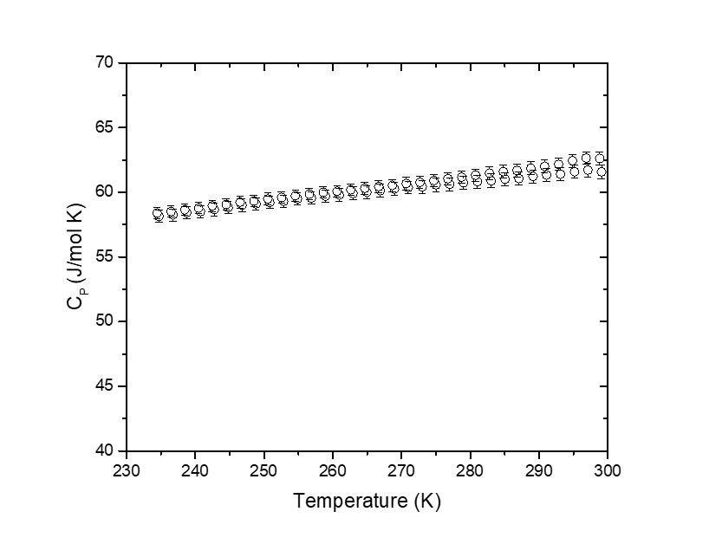

**Figure S**6. Heat capacity of a crystal of Mn1.05Bi as measured using the high temperature H-grease, showing no features, within error, in the range 230 K to 300 K.

*Density Functional Theory Calculations*

The direction and magnitude of the magnetic moment associated with each Mn atom in the unit cell is shown in Table S4 below. The type of site (hcp, Kagome, Int A and Int B) is listed, along with the projection of the magnetisation along the orthorhombic *a*, *b*, and *c* axes. The Int A sites correspond to those between the Kagome and hcp type layers, whereas the Int B sites correspond to interstitials between two Kagome type layers. As can be seen from the table, the Int A sites show a strong reorientation away from the *b* axis, along which most other Mn moments are pointed. Furthermore, the Int A and Int B sites have a lower average moment than the hcp or Kagome sites, due to their trigonal bipyramidal coordination with Bi, as opposed to the octahedral coordination of the hcp and Kagome sites.

**Table S4.** Mn number and site type, along with the projection of its associated magnetisation as projected along the *a*, *b* and *c* crystallographic axes, as determined by density functional theory calculations on a single orthorhombic cell.

|  |  |  |  |  |
| --- | --- | --- | --- | --- |
| **Mn** | **Type of Site** | **M*b* (μB)** | **M*a* (μB)** | **M*c* (μB)** |
| 1 | hcp | 0.15 | 3.55 | 0.25 |
| 2 | Kagome | -0.15 | 3.36 | -0.63 |
| 3 | hcp | 0.16 | 3.55 | 0.23 |
| 4 | Kagome | -0.50 | 3.33 | -0.62 |
| 5 | Kagome | -0.51 | 3.35 | -0.49 |
| 6 | Kagome | -0.12 | 3.39 | -0.51 |
| 7 | Kagome | -0.23 | 3.37 | -0.49 |
| 8 | Int A | 1.28 | -1.86 | 1.96 |
| 9 | Kagome | -0.43 | 3.32 | -0.64 |
| 10 | Kagome | -0.41 | 3.35 | -0.54 |
| 11 | Int B | 0.22 | 2.87 | 0.40 |
| 12 | Int B | 0.24 | 2.86 | 0.42 |
| 13 | Int A | 1.24 | -1.83 | 2.01 |
| 14 | hcp | 0.14 | 3.54 | 0.27 |
| 15 | Kagome | -0.22 | 3.35 | -0.61 |
| 16 | hcp | 0.11 | 3.55 | 0.27 |
| 17 | hcp | 0.37 | 3.42 | 0.67 |
| 18 | Kagome | -0.27 | 3.39 | -0.40 |
| 19 | Int A | 1.06 | -1.90 | 2.05 |
| 20 | hcp | 0.38 | 3.42 | 0.65 |
| 21 | hcp | 0.39 | 3.41 | 0.67 |
| 22 | hcp | 0.38 | 3.41 | 0.67 |
| 23 | hcp | 0.15 | 3.54 | 0.25 |
| 24 | hcp | 0.11 | 3.55 | 0.24 |
| 25 | Kagome | -0.30 | 3.33 | -0.75 |
| 26 | hcp | 0.14 | 3.55 | 0.23 |
| 27 | hcp | 0.11 | 3.52 | 0.19 |
| 28 | hcp | 0.13 | 3.52 | 0.21 |
| 29 | hcp | 0.12 | 3.52 | 0.23 |
| 30 | hcp | 0.11 | 3.52 | 0.21 |
| 31 | Kagome | -0.34 | 3.32 | -0.74 |
| 32 | Kagome | -0.38 | 3.39 | -0.35 |
| 33 | hcp | 0.15 | 3.54 | 0.27 |
| 34 | Int A | 1.04 | -1.86 | 2.10 |