Packing-Induced Selectivity Switching in Molecular Nanoparticle Photocatalysts for Hydrogen and Hydrogen Peroxide Production
Haofan Yang,^{1,2,#} Chao Li,^{3,1,#} Tao Liu,¹ Thomas Fellowes,¹ Samantha Y. Chong,¹ Luca Catalano,^{1,4} Mounib Bahri,⁵ Weiwei Zhang,^{1,6} Yongjie Xu,^{1,2} Lunjie Liu,¹ Wei Zhao,¹ Adrian M. Gardner,³ Rob Clowes,¹ Nigel D. Browning,⁵ Xiaobo Li,^{7,1,*} Alexander J. Cowan^{3,*} and Andrew I. Cooper^{1,2,*}

¹ Materials Innovation Factory & Department of Chemistry, University of Liverpool, 51 Oxford Street, Liverpool L7 3NY, UK.
² Leverhulme Research Centre for Functional Materials Design, University of Liverpool, Liverpool L7 3NY, U.K.
³ Stephenson Institute for Renewable Energy, University of Liverpool, Peach Street, Liverpool L69 7ZF, UK.
⁴ Laboratoire de Chimie des Polymères, Université libre de Bruxelles (ULB), 1050 Bruxelles.
⁵ Albert Crewe Centre for Electron Microscopy, University of Liverpool, Liverpool L69 3GL, UK.
⁶ Key Laboratory for Advanced Materials and Institute of Fine Chemicals, School of Chemistry and Molecular Engineering, East China University of Science and Technology, Shanghai 200237, China.
⁷ Key Laboratory of the Ministry of Education for Advanced Catalysis Materials, Zhejiang Key Laboratory for Reactive Chemistry on Solid Surfaces, Institute of Physical Chemistry, Zhejiang Normal University, Jinhua 321004, China.
# These authors contributed equally: Haofan Yang, Chao Li.
*Corresponding authors. Xiaobo.li@zjnu.edu.cn, acowan@liverpool.ac.uk, and aicooper@liverpool.ac.uk.

Abstract: Molecular packing controls optoelectronic properties in organic molecular nanomaterials, such as charge carrier mobility, excited state dynamics, and light absorption. Hence, controlling molecular packing and understanding structure-activity relationships are both critical in the search for new molecular organic photocatalysts. Here, we report a donor-acceptor organic molecule, 2,6-bis(4-cyanophenyl)-4-(9-phenyl-9H-carbazol-3-yl)pyridine-3,5-dicarbonitrile (CNP), that exhibits two aggregate states in aqueous dispersions: amorphous nanospheres and ordered nanofibres with π-π molecular stacking. The molecular packing has a profound effect on photocatalytic performance: the nanofibre form of CNP promotes sacrificial photocatalytic H₂ production (31.85 mmol g⁻¹ h⁻¹) while the nanospheres produce hydrogen peroxide (H₂O₂) (3.20 mmol g⁻¹ h⁻¹ in the presence of O₂). This is the first example of an organic photocatalyst that can be directed to produce these two different solar fuels simply by changing the molecular packing. The different packings in these two nanoscale aggregates affect energy band levels, the extent of excited state delocalization, the excited state dynamics, charge transfer to O_{2,} and the light absorption profile. We use a combination of structural and photophysical measurements to understand how this influences the photocatalytic selectivity. This study shows that it is possible to achieve multiple photocatalytic functionalities with a single organic molecule by careful engineering the nanomorphology and the solid-state packing.
Main
Organic molecular materials are of growing interest in the area of photocatalysis.^{1–3} For solid-state organic materials, photocatalytic properties are not controlled by chemical structure alone: molecular packing can play an equally important role in controlling electronic and optical properties.^{4–9} For example, charge carrier mobility can vary by up to six orders of magnitude depending on the degree of order in pentacene.¹⁰ Likewise, the control of molecular packing for perylene imides results in different photocatalytic H₂ production performance.^{1,11–13} For molecular solids, there is often a subtle interplay between thermodynamics and kinetics during aggregation processes because of the weak nature of most intermolecular interactions.^{14,15} In principle, this can be exploited to control the structure of aggregate states and, hence, the photocatalytic performance of organic molecular photocatalysts. To do this, it is essential that we understand the structure-photoactivity relationships that govern photocatalytic activity. Knowledge of these relationships should allow the design of molecular photocatalysts for useful chemical transformations, such as transforming solar energy into storable fuels, such as hydrogen (H₂) or hydrogen peroxide (H₂O₂).^{16–21}
Here, we report a donor-acceptor organic molecule, 2,6-bis(4-cyanophenyl)-4-(9-phenyl-9H-carbazol-3-yl)pyridine-3,5-dicarbonitrile (CNP) (Fig. 1a), which exhibits two aggregate states in aqueous solutions: amorphous nanospheres and ordered nanofibres with π-π molecular stacking. Remarkably, these two CNP aggregate states showed totally different and complementary photocatalytic behaviour, with one producing H₂O₂ and the other producing H₂. Structural and spectral analysis showed that this photocatalysis selectivity switching can be attributed to the two different molecular packing modes in the CNP nanoparticles, which result in contrasting photophysical properties for the two aggregates.
Molecular structure of CNP and its photophysical properties in solution
CNP is a donor–acceptor (D–A) molecule bearing a pyridinedicarbonitrile acceptor unit (A) and a substituted carbazole donor unit (D) (Fig. 1a). CNP was synthesised and characterized by ¹H and ¹³C NMR spectroscopy, mass spectrometry, and elemental analysis (Fig. S1,2 in Supporting Information). In the solution UV-Vis absorption spectrum of CNP, the lowest energy absorption band at 368 nm in tetrahydrofuran (THF) was not observed for either the separate donor or acceptor fragments that constitute the CNP molecule (Fig.1a,b and S3). Photoluminescence emission spectra of CNP in various solvents showed broad and featureless emission peaks (Fig.1c and S4, and Table S1), which is a common characteristic of charge transfer (CT) states.²² CNP in acetonitrile showed dual emission, which probably arises from population of excited electronic states with differing degrees of charge-separation; for example, emission from both a local excited state or multiple charge transfer states.^{23,24} The emission spectrum of CNP exhibited a distinct redshift as solvent polarity was increased (Fig. 1c), which is consistent with a CT excited state. Spatially separated highest occupied natural transition orbitals (HONTO) and lowest unoccupied natural transition orbitals (LUNTO) calculated by time-dependent density functional theory again support that the lowest energy excitation of CNP is charge transfer state (Fig. 1d and S5). CNP showed a remarkable Stokes shift of 12,533 cm⁻¹ in acetonitrile, which is one of the largest shifts reported for an organic molecule.²⁴ Analysis of the solvatochromism using the Lippert-Mataga method²³ showed that CNP has a large dipole moment of the excited state of 21.4 ± 2.2 Debye (Fig. 1e and S6). This dipole is a measure of polarity and the large dipole moment of CNP is beneficial for photogenerated charge separation.²⁵
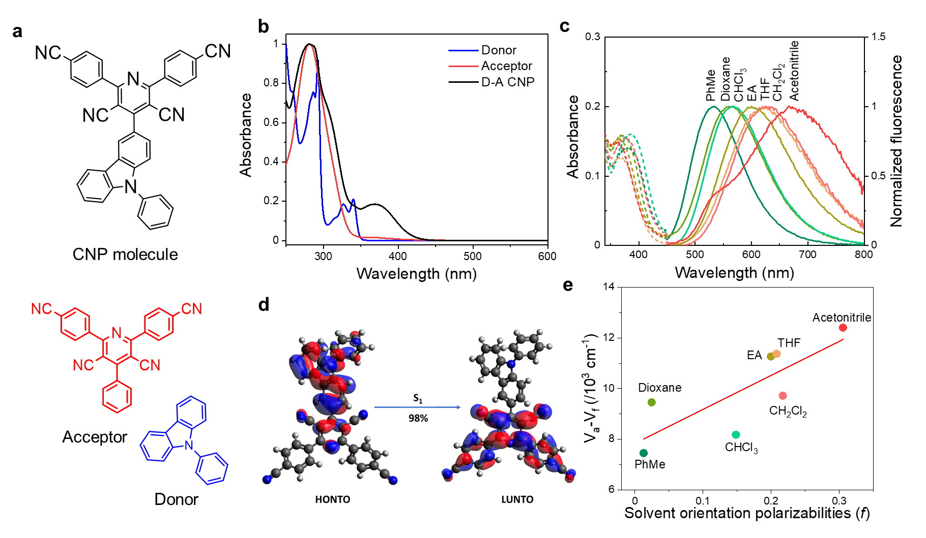
Fig. 1 | Molecular structure of CNP and its photophysical properties in solution. a, Molecular structures of CNP plus analogous acceptor and donor molecules. b, Absorption spectra of CNP, the acceptor molecule, and the donor molecule (10 μM) in THF. c, Absorption and emission spectra (λ_{exc} = 390 nm) of CNP (10 μM for absorption and emission measurement) in different solvents at ambient temperature. d, Electron density distributions of HONTO and LUNTO calculated by time-dependent density functional theory (TD-DFT) in Gaussian 16 at the CAM-B3LYP/6-31G(d) level. Isosurface = 0.03 a.u., rendered using Avogadro. Blue N, gray C, white H. Blue: positive, red: negative isosurfaces of molecular orbitals. e, Lippert-Mataga plot of Stokes shift (v_{a} – v_{f} /10³ cm⁻¹) for CNP versus solvent orientation polarizabilities (f).
Morphology and structure of CNP aggregates
Nanoaggregates of CNP were prepared using a nanoprecipitation method where a THF solution of CNP was injected into water under continuous sonication (Fig. S7).²⁶ A pale yellow suspension was obtained using a THF/H₂O volume ratio of 1/100. By contrast, an orange suspension was formed (Fig. 2a and 2b) when the THF/H₂O volume ratio was increased to 1/10. Scanning electron microscopy (SEM) was used to image the particles from the pale yellow and orange suspensions. This revealed that they had nanosphere and nanofibre morphologies, respectively (Fig. 2a and 2b). The average diameter of the yellow CNP nanospheres (CNP-s) was estimated to be around 100 nm (Fig. S8). The orange CNP nanofibres (CNP-f) had a width of about 40 nm (Fig. 2b). There were no discernible diffraction peaks in the powder X-ray diffraction (PXRD) pattern for CNP-s (Fig. 2c), indicating that the nanospheres were amorphous. By comparison, broad diffraction peaks in the PXRD pattern of CNP-f were observed suggesting that the nanofibres had some degree of structural order. To gain further insight into the molecular packing in these nanofibres, we obtained two single crystals of CNP. We initially sublimed CNP at 683 K under dynamic vacuum and obtained crystal 1 (CNP-C1) which crystallised in the orthorhombic space group P2₁2₁2₁ (Fig. S9 and Table S2). In this structure, the adjoining aromatics of the D and A unit twist by ~71°, preventing CNP molecules from forming aligned stacks. Instead, CNP intertwines along the a-axis, with π-π interactions at a distance of ~4.3 Å between D–A and A–A parts of adjacent CNP molecules. The stacks of twisted, intertwined CNP molecules are then held together by a network of C≡N∙∙∙H-C(aryl) interactions at distances of around 2.7 Å. We also obtained crystal 2 (CNP-C2) as poorly diffracting, X-ray-sensitive yellow needles by diffusion of water into a THF solution of CNP (Fig. 2d, 2e, and Table S2). CNP-C2 crystallised in the triclinic space group P1 with two molecules in the asymmetric unit. In this structure, the torsion angle between the donor and acceptor units was only 42°. CNP-C2 shows strong π-stacking along the a-axis; that is, along the length of the needle. The packing is extended into the b and c directions (transverse to the length of the needles) by weak C≡N∙∙∙H-C(aryl) H-bonding (Fig. 2d and 2e). CNP-C2 is a solvate, and it also contains a significant proportion of poorly-ordered solvent that occupies the linear voids that extend along the length of the needles (Fig. S10). These voids constitute 16% of the unit cell by volume. Unlike the close-packed CNP-C1 structure, there is no stacking between the donor and acceptor units in neighbouring CNP molecules in CNP-C2. For CNP-C2, the D–D distance is 3.52 Å and the A–A distance is 3.69 Å. The PXRD pattern of CNP-f shows a feature that corresponds to a d spacing of 3.7–3.9 Å, which is consistent with a layered structure with a similar interlayer spacing to CNP-C2. However, as evident from PXRD data (Fig. 2i), the degree of long-range order in the CNP-f nanofibres is much lower than in the two single-crystal forms, CNP-C1 and CNP-C2.
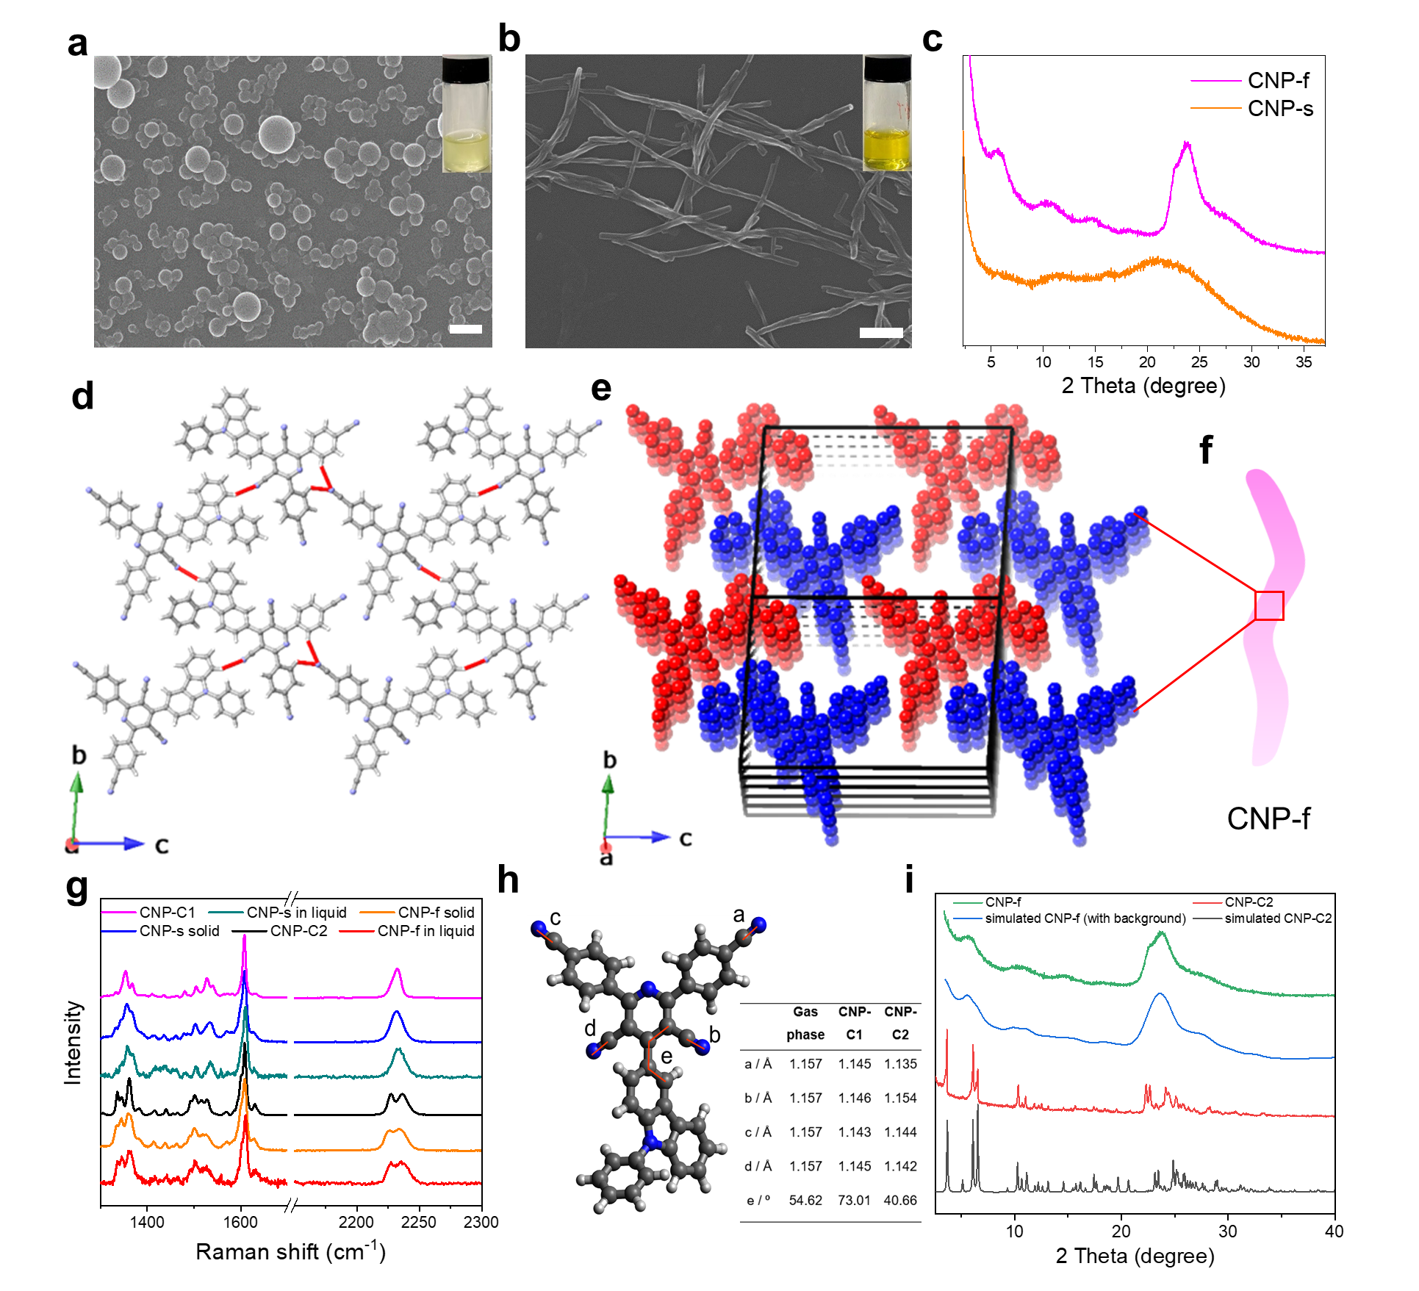
Fig. 2 | Morphology and structure for CNP aggregates. a,b, SEM images of CNP-s and CNP-f Inset pictures showing CNP-s and CNP-f aqueous suspension. (scale bar is 300 and 200 nm for CNP-s and CNP-f, respectively). c, PXRD patterns of CNP-s and CNP-f. d, Single crystal structure of CNP-C2. Adjacent building blocks are held together by intermolecular C≡N∙∙∙H-C(aryl) H-bonding (red). Gray, carbon; blue, nitrogen; white, hydrogen. e, The strong π-stacking along the a-axis. f, Scheme showing proposed molecular packing structure in CNP-f. g, Raman spectra of two single crystals (CNP-C1 and CNP-C2), CNP-s solid, CNP-s in water, CNP-f solid, and CNP-f in water (785 nm laser). For CNP-C2 measurement, the laser was focused on single crystal particle. h, Conformers of CNP in three states. i, Simulated PXRD patterns of CNP-f and CNP-C2, and experimental PXRD patterns of CNP-f and CNP-C2 (detailed simulation method for CNP-f is in the Method Section).
Raman spectroscopy analysis revealed that CNP-f and CNP-C2 had similar Raman spectra, with two stretching frequencies for the cyano groups at around 2230 cm⁻¹. By contrast, only one stretching vibration for the cyano groups was observed in CNP-s and in CNP-C1 (Fig. 2g). For the CNP-C2 and CNP-C1 measurement, the laser was focused on a single crystal particle. The dried, solid CNP-s and CNP-f samples showed similar Raman spectra to CNP-s and CNP-f in suspension, respectively. DFT calculations revealed that the different bond lengths of the cyano groups in the crystals can explain the observed cyano Raman shifts (Fig. S11–13, Fig. 2h). All four cyano (CN) groups of the CNP molecule in CNP-C1 have similar calculated Raman shifts, which merge into a single peak in the calculated spectrum. By contrast, CNP-C2 has two distinct calculated Raman shifts for the CN groups due to the presence of different cyano group bond lengths in CNP-C2. By analogy, this suggests that there are different CN bond lengths in the CNP-f nanofibre packing. CNP-f and CNP-C2 have similar UV-Vis absorption profiles in the liquid, dispersed state, in contrast with CNP-s and CNP-C1 in solid-state (Fig. S14). Also, CNP-f and CNP-C2 were obtained from the same solvent mixture (THF/H₂O). In addition, the simulated XRD pattern of CNP-C2 agrees with the PXRD pattern of CNP-C2, and it shows diffraction peaks at similar 2θ compared to the PXRD pattern of CNP-f. Refining the lattice parameters of CNP-C2 based on the observed PXRD pattern of CNP-f indicates that there is a limited expansion of the lattice dimensions a change and reconfiguration of the cell angles; the change in cell volume is less than 10 %. The simulated profile, incorporating peak broadening and preferred orientation consistent with the nanofibre morphology, is in broad agreement with the observed PXRD pattern of CNP-f (Fig. 2i). Taken together, these data suggest that the aggregate structure in CNP-f is composed of similar molecular conformers and a similar π-stacked packing as found in the single crystal, CNP-C2 (Fig. 2e), albeit with a much lower degree of long-range order.
Aggregation-dependent photophysical properties
Fig. 3a shows the UV-Vis absorption spectra of CNP nanoaggregates in H₂O after removing THF by heating. This heating did not alter the nanoaggregate morphology, as shown by SEM imaging (Fig. S15 and S16). CNP-s in water showed a similar UV-Vis absorption profile to the CNP molecule in THF (Fig. S17). In CNP-f, the lowest energy absorption band red shifts to 412 nm. DFT calculations confirm that HONTO and LUNTO are localised orbitals due to the large π-π stack distance in CNP-C1, but the closer π-π stacking in CNP-C2 results in a delocalised excited state (Fig. 3b and 3c). CNP-f showed a red shift of 70 nm in emission spectrum of fluorescence compared with CNP-s (Fig. 3a). The fluorescence quantum yields of CNP-s and CNP-f in water were determined to be 0.19 and 0.007, respectively, as measured using quinine sulfate (Φ_{f} = 0.577 in 0.1 M H₂SO₄, λ_{exc} = 350 nm) as the standard. The weaker emission intensity of CNP-f compared to CNP-s again supports increased charge separation in the nanofibres. We suggest that this is driven by both (i) reduced h⁺/e⁻ binding energy in the exciton, owing to increased charge delocalization, and (ii) increased ordering, providing a facile route for charge migration.
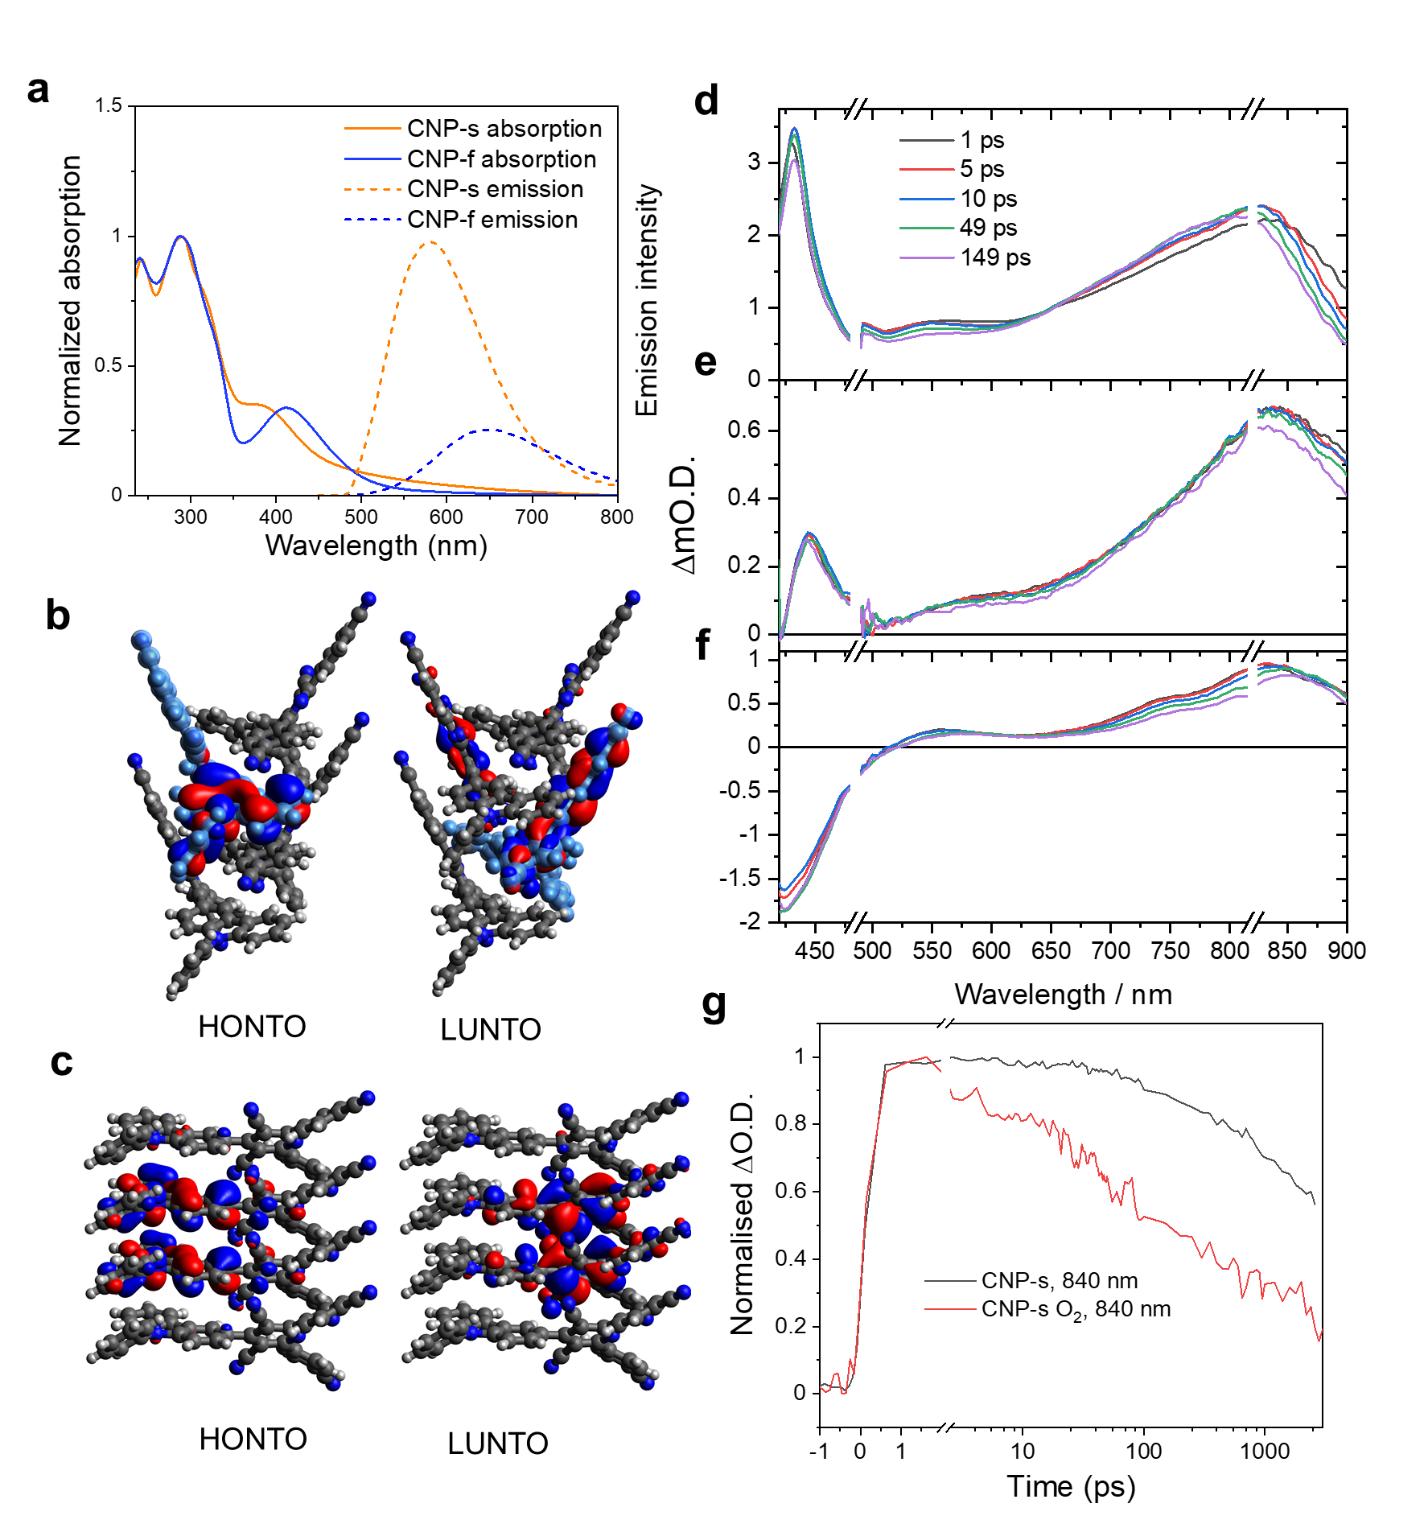
Fig. 3 | Aggregation-dependent photophysical properties. a, Absorption and emission spectra (λ_{exc} = 390 nm) of CNP-s and CNP-f in water after THF removal. b and c, Electron density distributions in the HONTO and LUNTO of 4 molecules layers extracted from CNP-C1 and CNP-C2. Isosurface = 0.03 a.u. Blue N, gray C, white H. Blue: positive, red: negative isosurfaces of molecular orbitals. The light blue colour is used to distinguish overlapped molecules. d, e, f, Transient absorption spectra of CNP in THF (d), CNP-s (e), and CNP-f (f) in water at pump-probe time delays. An excitation wavelength of 380 nm is used for CNP in THF and 410 nm for CNP-s and CNP-f in water (all at 750 µW). The disconnect in the transient absorption spectra axis reflect the removal of the twice pump laser scatter (820 nm) and the break in separate experiments (480–900 nm and < 480 nm). g, Kinetic traces of CNP-s probed at 840 nm in different gas environments (Ar and O₂).
To gain further insight into the character of the excited electronic states, we carried out transient absorption (TA) spectroscopic studies on both CNP dissolved in THF and its CNP-s and CNP-f nanoaggregates in water (Fig. 3d–g). Excitation of CNP in THF solution (380 nm) and in aggregates (410 nm) was achieved using a femtosecond laser (ca. 170 fs duration). The TA spectra of CNP in THF show a photoinduced absorption (PIA) across the visible region with a broad peak between 650–900 nm (Fig. 3d, ca. 825 nm at 10 ps) and a sharp, intense band at 432 nm (Fig. S18c and 19c). To assign the TA spectra of CNP we performed spectroelectrochemical measurements of both CNP and its respective donor and acceptor subunits (Fig. S20–23). These measurements show that the PIA between 650–900 nm is assignable to the reduced pyridinedicarbonitrile acceptor unit of the charge transfer state. Supporting this assignment is the sensitivity to O₂ band for CNP-s on the picosecond timescale (Fig. 3g). The reduced CNP also has a UV-Vis bands at 440 nm and a weaker shoulder at 550 nm, which partially overlaps with the spectroelectrochemical features of the oxidized carbazole (400–550 nm, Fig. S23a).²⁷ Therefore the TA spectra of CNP in THF on the ps timescale is assignable to rapid (< 1 ps) formation of a charge transfer state. Over the first 150 ps, the bands between 650–900 nm in the TA spectra of CNP in THF continue to evolve, all showing a blue shift in peak position (Fig. S24 and 25a); we propose this is due to a combination of intramolecular reorientation, likely twisting around the D–A bond and solvent reorganisation.²⁸ We note that CNP in acetonitrile exhibits dual emission (Fig. 1c), consistent with these relaxation processes.
The TA spectra of CNP-s in water following 410 nm excitation is like that observed for CNP in THF (Fig. 3e); notably, the observance of the oxidised donor feature at 444 nm and reduced accepter band at 835 nm, supports the formation of an exciton with localised oxidised donor/reduced acceptor character (Fig. 3b). Little spectral evolution was observed in the TA spectra during the first 20 ps, after which, only a very small blue shift occurs alongside the decay of the shoulder band at 835 nm (Fig. S25b). The lack of change of the TA spectra of CNP-s indicates no evolution of the initially generated charge transfer state on the ps timescale and is in-line with the limited rotational freedom of CNP within the aggregate.
The TA data of CNP-f in water shows distinct differences to the analogous data for CNP-s and CNP in THF (Fig. 3f). At 1 ps, the TA spectrum for CNP-f has three maxima between 700–900 nm (746, 830, 880 nm), and a negative signal below 500 nm assigned to ground state bleaching. This highlights that the character of the exciton formed in CNP-f differs from that in CNP-s. The similarity in the 1 ps spectra of CNP in THF and CNP-s is consistent with the formation of a delocalised exciton for CNP-f (Fig. 3c). The initial TA spectrum red shifts and the highest wavelength TA band appears to decay rapidly over the first 20 ps. The red shift of the main TA bands of CNP-f contrasts with the TA spectra of CNP-s and CNP in THF, where a blueshift occurs over time (Fig. S25c). This difference lies in the relaxation mechanisms open to each species. CNP-f is expected to have reduced conformational flexibility compared to CNP in THF owing to the close packing of CNP layers in this semi-crystalline aggregate. We propose that the exciton undergoes charge separation with the crystalline structure facilitating charge transport on the picosecond timescale after formation with the red-shift potentially arising from the optical Stark effect. This is consistent with the low fluorescence quantum yield and broad emission spectrum obtained for this nanofibre aggregate.
Morphology transformation
We observed that nanospheres could transform into nanofibres over time, depending on the THF/H₂O ratio (Fig. 4a). Nanospheres were formed first after precipitation; these then transformed to nanofibres over a few days at THF/H₂O ratio of 1/25. A much faster transformation (around 30 min aging) was observed with a THF/H₂O ratio of 1/10 (Fig. S26). THF/H₂O ratios lower than 1/25 resulted in the formation of stable nanosphere suspensions, while THF/H₂O ratios higher than 1/10 lead to the immediate formation of nanofibres (or at least, no nanospheres could be observed on our measurement timescales). Adding THF into a stable aqueous nanosphere suspension can also promote the transformation into nanofibres (Fig. S27). We did not observe the transformation from nanofibres to nanospheres, suggesting that the nanospheres are a kinetic product and the nanofibres are the thermodynamic product in the presence of THF.

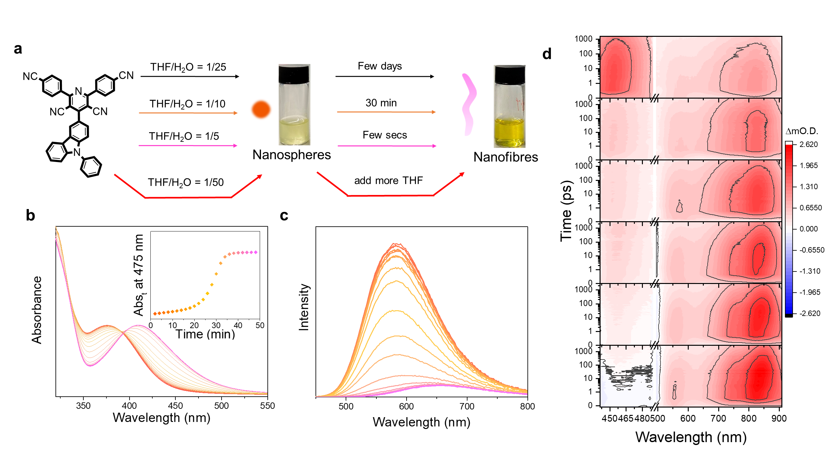
Fig. 4 | Morphology transformation. a, Scheme summarizing the morphology transformation. b, UV-Vis absorption spectra of CNP-f (THF/H₂O = 1/10) growth process (recorded every 2 min), inset Fig. showing the kinetics of CNP-f growth process (absorbance at 475 nm). c, Emission spectrum of CNP-f (THF/H₂O = 1/10) growth process under 390 nm excitation (recorded every 1.5 min). Measurements were carried out at ambient temperature. d, TA spectra of CNP-f (THF/water = 7%) growth process (recorded every 1 hour, top panel = 0 hours) probed at the region of 440-908 nm, 410 nm excitation under an argon gas atmosphere. The break (480 nm) is due to the data being recorded in two separate experiments (480–900 nm and < 480 nm).
In-situ UV-Vis absorption spectra of the CNP nanoaggregate evolution process showed that a CT absorption band of the peak at 377 nm was formed initially, and its peak maximum was close to that of CNP in THF solution (Fig. S28). During aggregate transformation from nanosphere to nanofibre, the absorption band at 408 nm appears gradually at the expense of the CT absorption band because of increased charge delocalization in the nanofibres (Fig. 4b). This suggests that a switch to π-π stacking is driving the morphological change of the nanoaggregates from nanospheres to nanofibres. The observation of an isosbestic point at 392 nm indicates a stoichiometric conversion from nanospheres to nanofibres. The growth of CNP-f occurred after a lag time and exhibited a nonlinear sigmoidal transition (inset, Fig. 4b). This implies that the transformation includes two kinetics: the nucleation of seeded nanospheres and the elongation of nanofibres.¹⁵ In-situ photoluminescence emission spectra of the transformation process showed bathochromic shift of the emission peak maxima and reduced intensity, consistent with the change of aggregate morphology from nanosphere to nanofibre (Fig. 4c). TA spectroscopy was also used to follow the transformation of the aggregates from spheres to fibres over a 5-hour period in a THF/water = 7% mixed solvent (Fig. 4d); ground state UV-Vis spectra recorded over the same time period are shown in Fig. S29. At 0 h, the solution contains CNP-s and the TA spectrum matches that seen for CNP-s in water (Fig. 3e). Over the 5-hour period, an evolution of the TA spectra occurs until, the spectrum matches that of CNP-f in water (Fig. 3f), clearly demonstrating the correlation between aggregation state and photophysics.
Switching photocatalytic selectivity
CNP-f loaded with platinum (Pt) as a hydrogen evolution reaction (HER) catalyst showed much higher activity than CNP-s, both under solar simulator (wavelength interval: 350 nm–1000 nm) irradiation and LED irradiation in the presence of ascorbic acid as an electron donor (Fig. 5a,b and S30). CNP-f had a H₂ production rate (31.85 mmol g⁻¹ h⁻¹) that was more than 72 times higher than CNP-s (0.44 mmol g⁻¹ h⁻¹). By contrast, under an O₂ atmosphere, CNP-s generated H₂O₂ at a high production rate of 3.20 mmol g⁻¹ h⁻¹ from neat water under simulated solar light, while CNP-f produced H₂O₂ at much lower rates at neutral and acidic conditions (Fig. 5a and Fig. S31). We therefore have a unique case of an organic molecular catalyst that can produce either hydrogen or hydrogen peroxide, selectively, depending on its aggregation state.
Kinetic H₂ evolution measurements under visible light irradiation (> 420 nm) showed that CNP-f afforded an average HER of 11.7 mmol g⁻¹ h⁻¹, with no reduction in activity observed during 34 hours of photoreaction (Fig. 5c). The amount of H₂ generated after 22 h irradiation was 644.5 µmol for CNP-f, which is more than 17.5 times higher than CNP-s (36.7 µmol). The apparent quantum yields (AQYs) for CNP-f were determined to be 2.69% at 490 nm, 4.43% at 420 nm, 3.76% at 405 nm, and 3.08% at 395 nm, broadly following the absorption spectrum of CNP-f and suggesting that the hydrogen generation is a photocatalytic process (Fig. S32). Deuterium isotope experiments were carried out using D₂O for photocatalytic sacrificial hydrogen production, and the produced gases were detected by mass spectrometry (Fig. S33). The majority of the produced gas was D₂ indicating that the gas is produced from water. The H₂O₂ production over 6 hours under visible light irradiation (> 420 nm) in pure water showed an average rate of 343.2 µmol g⁻¹ h⁻¹ and 56.8 µmol g⁻¹ h⁻¹ for CNP-s and CNP-f, respectively (Fig. 5d). Table S3 and S4 are the summaries of the reported photocatalytic H₂O₂ and H₂ production performances on selected organic photocatalysts, it was found that the CNP-f and CNP-s are among the most efficient small organic molecule-based photocatalysts, respectively, compared to their literature counterparts.
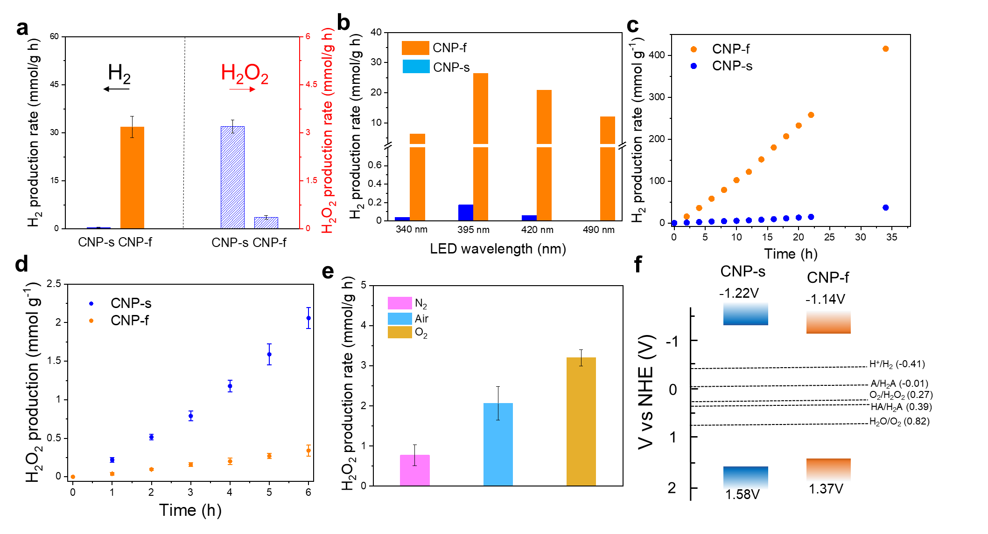
Fig. 5 | Switching photocatalytic selectivity. a, Photocatalytic H₂ (the left side) and H₂O₂ (the right side) production activities of CNP-s and CNP-f (0.5 mg catalyst in 5 mL water; light source = solar simulator, 1 sun; irradiation time = 1 hour). Condition for H₂ production: degassing with N₂; ascorbic acid (0.04 M); Pt loading: 3 wt. %. Condition for H₂O₂ production: degassing with O₂, pure water. b, Photocatalytic H₂ production activities of CNP-s and CNP-f (0.5 mg catalyst in 5 mL water; light source = LED; irradiation time = 1 hour; ascorbic acid = 0.04 M; Pt loading = 3 wt. %. c, Time course of H₂ production for CNP-s and CNP-f, irradiated by 300 W Xe lamp fitted with a λ > 420 nm filter. Testing condition: 2.5 mg catalyst in 25 mL water; ascorbic acid (0.1 M); Pt loading: 3 wt. %. d, Time course of H₂O₂ production for CNP-s and CNP-f, irradiated by 300 W Xe lamp fitted with a λ > 420 nm filter using 5 mg of the catalyst in O₂ environment. e, Photocatalytic H₂O₂ production activities of CNP-s in the different gas environments (0.5 mg catalyst in 5 mL water; light source = solar simulator, 1 sun; irradiation time = 1 hour). f, Schematic diagram of the energy levels for CNP-s and CNP-f (pH = 7).²⁹
Increasing the concentration of O₂ in the reactor gave an increase in the H₂O₂ production rate (Fig. 5e). Isotopic labelling experiments using ¹⁸O₂ detected the percentage of ¹⁸O₂ in the decomposed product of the formed H₂O₂ (increased from 1.2% to 71% over 70 h) (Fig. S34). Combined with observations on the effect of different scavengers on the photocatalytic activity (Fig. S35), we conclude that H₂O₂ is produced via an oxygen reduction pathway. The electronic energy levels of CNP-s and CNP-f were estimated by combining Mott-Schottky analysis (Fig. S36) and Tauc plots (Fig. S37). Both CNP-s and CNP-f are thermodynamically suitable for water reduction, oxygen reduction, and water oxidation reactions (Fig. 5f). CNP-f has reduced driving forces because of intermolecular interactions leading to delocalization of electrons across adjacent aligned CNP molecules. The proposed reduction of O₂ by CNP-s but not CNP-f is supported by TA spectroscopy, which shows that the PIA around 800–840 nm, which we propose is a signature of the reduced acceptor decays at an accelerated rate in the presence of O₂ with CNP-s, but not CNP-f (Fig. 3g and S38,39).
After 32 hours photocatalytic H₂ evolution, no decomposition of structure or morphology in CNP-f was observed, as revealed by ¹H NMR (Fig. S40) and HRTEM (Fig. S41). Lattice spacing and EDX analysis confirmed the presence of Pt on CNP-f and CNP-s with well-defined similarly sized Pt nanoparticles after photocatalysis (Fig. S42,43). CNP-s showed continuous H₂O₂ production over 125 hours of irradiation (Fig. S44). However, ¹H NMR spectra of CNP-s after long-term photoreaction showed partially decomposition of CNP (Fig. S45). No decomposition of CNP-s was observed for the photocatalytic H₂ evolution reaction (Fig. S40). Scanning electron microscopy characterisation of CNP-s and CNP-f before and after photocatalytic H₂ and H₂O₂ production were conducted and no significant changes in morphology was observed, except for CNP-s after H₂O₂ production where a small number of irregular sphere aggregates were found (Fig. S46), most likely due to partial decomposition during photocatalysis. In the photocatalytic water oxidation reaction to produce H₂O₂, the formation of N₂ was observed as a self-oxidation product of the nitrogen-containing CNP photocatalyst (Fig. S47). We therefore inferred that the decomposition of CNP-s is mainly due to the self-oxidation by photogenerated holes, which is a known cause of instability for organic polymer photocatalysts.³⁰ The long-term photostability of organic materials in photocatalytic H₂O₂ production requires further attention, as raised in a recent study.³¹
Discussion
When prepared at a low ratio of THF/H₂O, CNP-s has an amorphous structure and shows charge transfer character with localised excitons in the excited state. At high ratio of THF/H₂O, the morphology transforms from amorphous nanospheres to ordered CNP-f nanofibres. At the same time, the conformer structure of CNP changes; specifically, its D–A unit twist angle and bond length adapt to the molecular π-π stacking arrangement in the nanofibres. As a result of this structural transformation, CNP-f shows improved H₂ production efficiency of CNP-f compared to CNP-s. By contrast, CNP-f is significantly less active for photocatalytic H₂O₂ production from water in the presence of O₂, while CNP-s shows a high H₂O₂ production rate. This clearly indicates that the change in catalytic activity is due to a change in the aggregation state of CNP (see Supporting Information for a discussion of the effect of molecular conformations on the charge transfer state of CNP, Fig. S48 and Table S5).
There are several factors that may be important for efficient photocatalytic hydrogen evolution performance. One is the effective photodeposition of the Pt cocatalyst and subsequent transfer of electrons to the Pt nanoparticles. TA spectroscopy shows that following photodeposition, the lifetime of the 850 nm band assigned to the reduced acceptor in the charge transfer state is decreased (Fig. S49,50) for CNP-f, indicating that a portion of the photogenerated charge can transfer to the hydrogen evolution co-catalyst on the ps timescale. By contrast, sensitivity of the 850 nm band CNP-s to the presence of Pt on any of the timescales studied was minimal. This demonstrates that electron transfer to Pt cocatalysts is less efficient from this localised CT state in CNP-s compared to CNP-f. Also, π-π stacking in CNP-f is beneficial for photocatalytic H₂ production because of intermolecular charge transfer, resulting in improved charge transfer and longer charge transfer distances compared to CNP-s. The quantum yield for emission is much lower for CNP-f than for CNP-s showing that fast radiative decay still occurs at high levels with CNP-s. Slow transient absorption spectroscopy (Fig. S51–53) reinforces this point, showing that the charge transfer state of CNP-f persists for microseconds, while for CNP-s it decays on the nanosecond timescale. Taken together, these observations explain the much higher photocatalytic hydrogen evolution rate observed for CNP-f.
Electron transfer to O₂ is critical in the photocatalytic H₂O₂ production reaction. TAS analysis revealed that in the presence of O₂, the PIA (800–840 nm) of the reduced acceptor species in CNP-s decays at an accelerated rate compared to CNP-f, supporting the improved charge transfer to O₂ from excited CNP-s. Also, it was found that CNP-f can produce ¹O₂ at a much higher rate than CNP-s (estimated quantum yields of ¹O₂ formation of ca. 5 x10⁻⁴ and 1 x10⁻¹ for CNP-s and CNP-f, respectively, see Fig. S54,55). The formation of ¹O₂ is a hence a competitive reaction to the production of H₂O₂ for CNP-f. In addition, CNP-f has reduced redox potentials for oxygen reduction and water oxidation compared to CNP-s due to the delocalization of electrons across aligned CNP molecules. Together, this explains the lower photoactivity for H₂O₂ production observed for CNP-f.

Conclusion
In conclusion, CNP is a donor-acceptor molecule that has two different nanoaggregates with strongly contrasting photocatalytic activity for solar fuels production. While this selectivity switch is the unique feature of the study, the magnitude of the photocatalytic activities for photocatalytic H₂O₂ production (CNP-s) and H₂ production (CNP-f), respectively, are also among the highest observed for organic molecular systems (Table S3, S4). The distinctly different photophysical behaviours of the two aggregates are a result of the energy band levels, the extent of excited state delocalization, the excited state dynamics, the rate of charge transfer to O_{2,} and the light absorption profiles. These differences can be ascribed to the differences in molecular packing in CNP-s and CNP-f. This study highlights the major impact of molecular packing in aggregate states on the behaviour of organic molecule-based photocatalysts. Such understanding should allow us in the future to design multiple photocatalytic functionalities for a given molecule by engineering molecular packing. For example, beyond H₂ and H₂O₂ production, one might expect that the reaction selectivity in photoorganocatalysis using organic molecular catalysts could be polymorph dependent.
Methods
Materials and characterizations
All the reagents and solvents used for the synthesis were commercially available from Alfa Aesar, Sigma-Aldrich, Fluorochem, TCI Europe, Carbosynths, and used as received without further purification. Tetrahydrofuran (anhydrous, inhibitor-free) was obtained from Sigma-Aldrich. The deionized water was obtained from a Milli-Q System (ρ = 15 MΩ). ¹H and ¹³C NMR spectra were carried out on Bruker Avance 400 NMR spectrometer at 400 MHz and 100 MHz, respectively. The scanning electron microscope (SEM) measurements were performed on Hitachi S-4800 cold field emission scanning electron microscope (FE-SEM) at a working voltage of 10 kV and a working distance of around 8.4 mm. The transmission electron microscope (TEM) measurements were operated on a JEOL 2100 Plus microscopy at an accelerating voltage of 200 kV. Scanning transmission electron microscopy (STEM) images were performed using a Cs-Corrected JEOL 2100FCs Microscope operating at 200KV. Powder X-ray diffraction (PXRD) measurements were performed under high throughput transmission mode, using a Panalytical Empyrean diffractometer, X-ray focusing mirror, and PIXcel detector with Cu Kα radiation. Raman spectroscopy was performed on inVia reflex Qontor confocal Raman microscope using 785 nm laser (For CNP-C2 measurement, the laser was focused on single crystal particle). UV-Vis absorption spectra were recorded on a Cary 5000 UV-visible-NIR spectrophotometer at room temperature. For in-situ measurement, 0.5 mL of THF containing 0.1 mg of CNP was added into 5 mL of deionized water, and then half of this solution is added into a quartz cuvette quickly before recording the adsorption spectrum every 1.5 min. Steady-state photoluminescence spectra were performed on an Edinburgh Instruments LS980-D2S2-STM spectrometer. For in-situ emission, 0.5 mL THF containing 0.5 mg of CNP was added into 5 mL deionized water, and then this solution is added into a quartz cuvette quickly before recording emission. Single crystal X-ray diffraction intensity data for CNP-C1 were measured on a Rigaku MicroMax-007 HF rotating anode diffractometer (Mo-Kα radiation, λ = 0.71073 Å, Kappa 4-circle goniometer, Rigaku Saturn724+ detector) with the temperature during data collection maintained at 100.0(1) K using an Oxford Cryosystems cooling device. Data were integrated and reduced using CrysalisPro,³² and the structure solved by dual-space methods using SHELXT³³ integrated within the Olex2 suite.³⁴ Least-squares refinement was conducted using SHELXL³⁵ against F². Intensity data for CNP-C2 were measured using synchrotron radiation (λ = 0.6889 Å, fixed-χ goniometer, Pilatus 300 K detector) at the Diamond Light Source (beamline I19, EH1).^{36,37} Data were integrated and reduced using the in-house processing pipeline, and solved and refined as above.
Synthesis of CNP
Synthesis of 2,6-bis(4-cyanophenyl)-4-(9-phenyl-9H-carbazol-3-yl)pyridine-3,5-dicarbonitrile (CNP): 4-(2-cyanoacetyl)benzonitrile (5 mmol, 0.850 g), 9-Phenyl-9H-carbazole-3-carboxaldehyde (3 mmol, 0.813 g), and ammonium acetate (15 mmol, 1.15 g) were discharged into the reaction flask, then 15 ml acetic acid was added. The reaction mixture was heated to 110 ºC for overnight. The resultant precipitates were filtered and washed with methanol. Then, the solids were oxidised with 2,3-dichloro-5,6-dicyano-p-benzoquinone (DDQ, around 5 mmol, 1.13 g) in acetic acid solution (30 mL) under 110 ºC for 1 hour, followed by filtration and methanol washing. The solids were purified by column chromatography, giving the final product as an orange powder (around 1.18 g, yield: 83%). ¹H NMR (400 MHz, DMSO) δ 8.80 (1H), 8.33 (1H), 8.31-8.25 (4H), 8.18-8.10 (4H), 7.92 (1H), 7.78-7.70 (4H), 7.67-7.59 (2H), 7.55 (1H), 7.48-7.37 (2H). ¹³C NMR (101 MHz, DMSO) δ 161.57, 160.23, 141.80, 141.44, 140.99, 136.66, 133.12, 130.94, 130.83, 128.80, 127.88, 127.78, 127.49, 125.55, 123.25, 122.91, 122.78, 121.44, 121.17, 118.75, 116.48, 114.10, 110.71, 110.52, 108.55. Chemical Formula: C₃₉H₂₀N₆, Elemental Analysis: calcd., C, 81.80; H, 3.52; N, 14.68; found C, 81.31; H, 3.47; N,14.57. HRMS (ESI, m/z): [MH]⁺ calcd. 573.1822; found 573.1816.
Synthesis of nanostructures
The CNP molecule was dissolved in anhydrous THF with concentrations of 10, 5, 2.5, 1, 0.5, and 0.25 mg mL⁻¹, respectively, serving as stock solutions. A specific volume of stock solution was added rapidly into a vial containing 5 mL of deionized water under continuous sonication for around 5 seconds, resulting in the formation of CNP-s-_{X} and CNP-f-_{X}, where X is the THF to water ratio. To prepare nanospheres, 50 µL of 10 mg mL⁻¹, 100 µL of 5 mg mL⁻¹, and 200 µL of 2.5 mg mL⁻¹ stock solution were used to produce CNP-s-_{1/100}, CNP-s-_{1/50}, and CNP-s-_{1/25}, respectively. To prepare nanofibres, 500 µL of 1 mg mL⁻¹, 1 mL of 0.5 mg mL⁻¹, and 2 mL of 0.25 mg mL⁻¹ stock solution were used to produce CNP-f-_{1/10}, CNP-f-_{1/5}, and CNP-f-_{2/5}, respectively. For photocatalytic measurements, THF is removed by placing all samples in a cover-free sample holder on a hot plate at 130 °C for 5 hours.
Simulation of PXRD profile of CNP-f
The unit cell of CNP-C2 was refined against the experimental PXRD profile of CNP-f using a Pawley refinement performed in TOPAS-Academic version 7³⁸ (R_{wp} = 1.64 %, R_{p} = 1.47 %, χ² = 1.09) to obtain the approximate lattice parameters a = 3.981(1) Å, b = 18.29(3) Å, c = 26.36(4) Å, α = 94.3(1)°, β = 68.3(1)°, γ = 80.9(1)°, V = 1741(4) Å³. It was not possible to perform a full structural refinement of the framework due to the broadened diffraction profile of CNP-f. Modifying the unit cell of CNP-C2 to the lattice parameters obtained from the Pawley refinement preserved the connectivity of the framework, with some non-physical bond angles. A Lorentzian size broadening term was included, which was manually set to 40 nm; the approximate width of the nanofibers observed by SEM. The March-Dollase model³⁹ was used to simulate the non-random distribution of diffracting planes, indicated by strong (h00) and weak (0k0) and (0kl) reflections. The axis was set to account for this pattern of intensities and the preferred orientation parameter was manually set to r = 0.6 based on the comparison between the simulation and the experimental PXRD pattern (Fig. 2i).
Photocatalysis experiments
The high throughput measurements: The catalysts (0.5 mg) were dispersed into 0.04 M ascorbic acid water solution (5 mL) with diluted hexachloroplatinic acid solution as a platinum precursor (3%) in small vials (volume = 12 mL). After purging with nitrogen in a Sweigher Chemspeed Technologies robot for 3 hours, these vials were sealed with pierceable caps. Then, all sample vials were irradiated under a solar simulator (AM1.5G, Class AAA, IEC/JIS/ASTM, 1440 W xenon, 12 × 12 in., MODEL:94123A) equipped with a roller device. Gaseous products were analyzed on a Shimadzu GC-2010 equipped with Shimadzu HS-20 through injecting a sample from the headspace sampler via a transfer line (temperature 150 °C) onto a Rt-Msieve 5 Å column with He as the carrier gas (30 mL min⁻¹). Hydrogen was detected with a barrier discharge ionization detector referencing against standard gas with a known concentration of hydrogen. Control experiments showed that no hydrogen production occurred in the absence of a photocatalyst, illumination, or a hole scavenger. For H₂O₂ measurement, the catalyst solutions (0.5 mg in 5 mL water) with or without sacrificial agents (10 mM) or adjusting pH with 0.1M H₂SO₄ were sealed in small vials (volume = 12 mL). After purging with oxygen for 2 min, all sample vials were irradiated under a solar simulator (AM1.5G, Class AAA, IEC/JIS/ASTM, 1440 W xenon, 12 × 12 in., MODEL:94123A) equipped with a roller device. 1 mL of solution was filtered with a 0.22 μm filter to remove the photocatalyst, and the amount of H₂O₂ generated was quantified using UV-Vis spectroscopy.
The Kinetic measurements: Kinetic H₂ production measurements were conducted in a 75 mL quartz flask using a 300 W Newport Xe light-source (Model: 6258, Ozone free) equipped with a λ > 420 nm cut-off filter. 25 mL of CNP-s or CNP-f aqueous solution (0.1 mg mL⁻¹), 440 mg of ascorbic acid, and a certain amount of hexachloroplatinic acid solution were added into the flask. This solution was then purged with N₂ for at least 30 min to remove O₂. Gas products were taken with a gas-tight syringe and then run through a Molecular Sieve 13X 60-80 mesh 1.5 m × ⅛” × 2 mm ss column at 50 °C with an argon flow of 40.0 mL min⁻¹ by using Bruker 450-GC gas chromatograph equipped with a thermal conductivity detector referencing against standard gas with a known concentration of hydrogen. Hydrogen dissolved in the reaction mixture was not measured. Kinetic H₂O₂ production measurements were conducted in a 75 mL quartz flask using a 300 W Newport Xe light-source (Model: 6258, Ozone free) equipped with a λ > 420 nm cut-off filter. Around 30 mL of CNP-s or CNP-f (5 mg) aqueous solution was bubbled with oxygen for 15 min. At certain time intervals, 1 mL solution was sampled and filtered with a 0.22 μm filter to remove the photocatalyst. Then the amount of H₂O₂ generated was quantified using UV-Vis spectroscopy. Kinetic O₂ production measurements were carried out on the Perfect Light system at 12 °C using a 300 W xenon lamp with λ > 420 nm cut-off filter. 50 mg of CNP-s were dispersed in 100 mL of 10 mM AgNO₃ (aq) solution with 0.2 g La₂O₃ in the reaction cell with a magnetic stirrer.
Hydrogen peroxide analysis: The amount of H₂O₂ was analyzed by iodometry.⁴⁰ 0.5 mL of filtrated solution, 1 mL of 0.1 mol L⁻¹ potassium hydrogen phthalate (C₈H₅KO₄) aqueous solution, and 1 mL of 0.4 mol L⁻¹ potassium iodide (KI) aqueous solution were mixed, which was then kept in dark for 30 min. The H₂O₂ molecules reacted with iodide anions (I⁻) under acidic conditions to produce triiodide anions (I₃⁻) possessing a strong absorption at around 350 nm.³⁸ The amount of I₃⁻ was determined by means of UV-Vis spectroscopy on the basis of the absorbance at 350 nm, from which the amount of H₂O₂ produced during each reaction was estimated.
Transient absorption spectroscopy
fs-ns timescale transient absorption spectroscopy: TA spectra were collected on a Harpia-TA spectrometer (Light Conversion). The pump light was generated using a Pharos-SP-10W (Light conversion, FWHM ~ 140 fs, 10 kHz, 1030 nm) coupled to an OPA (Orpheus), an internal chopper lowers the pump frequency to 5 kHz. The white light probe beam was achieved by focusing a portion of the Pharos-SP-1030 nm output onto a sapphire crystal within the Harpia spectrometer. Due to minimal white light generation at short wavelengths (< 480 nm) using 1030 nm excitation of sapphire, two separate experiments (480–900 nm and < 480 nm) were carried out. For probe wavelengths < 480 nm the second harmonic of the 1030 nm beam (515 nm) is is focused onto the sapphire crystal. Samples were excited with a 325, 380 or 410 nm pump light with a power of 750 µW. The pump beam (ca. 0.6 mm diameter) and the probe beam (ca. 0.4 mm diameter) were overlapped on the sample position. Data was initially collected using the Harpia-TA spectrometer and analysed using Carpetview software (Light Conversion). Individual molecules were dissolved in THF (100 µM) and then transferred into a quartz cuvette with a 1 mm path length, sealed with a rubber septa cap, and degassed by Ar bubbling for 10 minutes. For the in-situ experiment, 350 µL of CNP in THF (1 mg mL⁻¹) was added to 5 mL H₂O and then transferred into 2 mm quartz cuvette degassed by Ar bubbling for 10 minutes. CNP aggregates (0.1 mg mL⁻¹) were prepared in water and transferred into a 2 mm quartz cuvette degassed by Ar or O₂ bubbling for 20 minutes.
µs-s timescale transient absorption spectroscopy: Measurements were carried out using the third harmonic output of a Nd:YAG laser (Continuum, Surelite I-10, 355 nm, 6 ns pulse width) for 355 nm excitation. The laser output was transmitted to the sample via a liquid light guide. Samples were excited at an excitation fluence of 0.40 mJ cm⁻² at 0.66 Hz. A 100 W tungsten lamp coupled to a monochromator (OBB Corp., typically set to 4 nm resolution) was used as the probe light and the change in optical density of the sample was calculated by measuring the transmitted light using a Si Photodiode and a homemade amplification system coupled to both an oscilloscope (Textronix TDS 220) and data acquisition card (National Instruments NI-6221). The oscilloscope data were used to study the microseconds time scale while the DAQ card covered milliseconds to seconds. The data is averaged over 200 laser shots per wavelength. Samples were prepared by the same method as that in ultrafast TA experiment.
Apparent quantum yield measurements
The apparent quantum yield for the photocatalytic H₂ evolution was measured using a λ = 395 nm LED, λ = 405 nm LED, λ = 420 nm LED, and λ = 490 nm LED controlled by an IsoTech IPS303DD power supply. For the measurement, 8 vials of CNP-f sample (each vial containing 0.1 g NaBr), prepared by nano-precipitation strategy, were mixed together and then diluted to 25 mL with deionized water. Then, 440 mg of ascorbic acid (0.1 M) and diluted hexachloroplatinic acid (3% loading) were added before illuminating with LED. The light intensity was measured with a ThorLabs S120VC photodiode power sensor controlled by a ThorLabs PM100D Power and Energy Meter Console and the apparent quantum yield was estimated using the equation below:
$$AQY=2×\frac{moles of hygrogen evolved}{moles of incidentphotons}×100\%$$
DFT calculations
The structure of CNP was optimized by CAM-B3LYP density functional,⁴¹ together with the 6-31G* basis set, using the Gaussian 16 software. A frequency calculation was carried out to ensure there is no imaginary frequency. The effect of solvation by DMF was accounted for by using the PCM/SMD solvation model. The lowest-lying excited states were studied by the TD-DFT method based on the optimised geometry with the same level of theory. Properties of excited states were calculated by Multiwfn.^{42,43} The overlap between the hole distribution and the electron distribution index S_{r} is 0.37 a.u., electron-hole separation distance index D is 5.2 Angstrom, charge separation index t is 2.92 Angstrom, these three parameters all indicate that electron and hole are largely separated. The dipole moment of ground state 7.6 Debye and that of excited state 17.5 Debye, which is consistent with experimental measured value 21.4 Debye, also confirm the charge separation for the first excited states.
Electron density distributions of HONTO and LUNTO calculated by time-dependent density functional theory (TD-DFT) in Gaussian 16⁴⁴ at the CAM-B3LYP/6-31G(d) level.⁴⁵ Isosurface = 0.03 a.u., rendered using Avogadro.⁴⁶
Mott–Schottky measurements
Mott–Schottky measurements were performed using a three-electrode setup containing working electrode (samples on FTO), counter electrode (Pt plate), and reference electrode (Ag/AgCl) on Bio-logic SP200 workstation. The electrolyte (0.5 M Na₂SO₄) was degassed for 30 min by bubbling with N₂ before the measurement. For sample preparation, 0.5 mg of samples were mixed with 50 µL of water and 5 µL of Nafion (5 wt. %). After sonication for 10 min, 20 µL of this mixed solution was dropped onto FTO glass for measurements (1 cm²).
Isotopic exchange experiments (¹⁸O₂)
A vial was charged with 50 mg CNP-s and 35 mL H₂¹⁶O and sealed with a rubber septum, then bubbled with Helium (He) for 10 min, ¹⁸O₂ gas (purity : 99%, ca. 10 mL) was subsequently injected by a syringe. The vial was illuminated by a Xe lamp with a filter (λ > 420 nm) for 70 h, then He gas was bubbled again to remove the ¹⁸O₂ gas. After that, the reaction solution was injected into a vial containing MnO₂ and He gas, and the gas produced from the decomposition phase was detected by an Agilent 7890B GC-MS system. The same procedures were applied for the 0h experiment, except for the lack of irradiation. This shows that ¹⁸O isotopically labelled H₂O₂ is produced in the irradiated case. The ¹⁶O₂ was from the air as the gas samples were injected into the GC with a syringe.
Isotope labelling experiments (D₂O)
CNP-f (2.5 mg) was dispersed in a D₂O (20 mL) containing 352 mg of ascorbic acid, and a certain amount of hexachloroplatinic acid solution (3% Pt loading) by ultrasonication before degassing thoroughly by Argon bubbling for 30 minutes. The mixture was placed in a quartz vessel and sealed in a reactor under Argon. The sample was illuminated with a 300 W Newport Xe light source with a filter (λ > 420 nm) (Model: 6258, Ozone free) for the time specified at a fixed distance under atmospheric pressure. The Xe light source was cooled by water circulating through a metal jacket. Gas samples were analyzed at the time periods specified by a customized HPR-70 batch sampling system from Hiden Analytical using a HAL3F/301 triple filter mass spectrometer with a faraday detector for analysis.
Fluorescence quantum yields
The fluorescence quantum yields ($Φ$ _{f}) were determined with quinine sulfate as standard ($Φ$_{ST} = 0.577 in 0.1 M H₂SO₄, λ_{exc} = 350 nm). The values were calculated with Equation below
$Φ_{f}=Φ_{ST}\left(\frac{{Grad}_{f}}{{Grad}_{ST}}\right)\left(\frac{η_{f}^{2}}{η_{ST}^{2}}\right)$, where $Φ$, $η$ represent the fluorescence quantum yield and refractive index of the solvent, $Grad$ represents the gradient from the plot of integrated fluorescence intensity vs absorbance. Symbols with f and ST stand the corresponding parameter for the sample and standard respectively.
Data availability
All data generated and analysed relevant to the study are included in the article and the Supplementary Information files.
Supplemental Information includes
Fig.s S1−S56 and Tables S1−S6.
Author information
These authors contributed equally: Haofan Yang, Chao Li.
Corresponding Authors
Xiaobo.li@zjnu.edu.cn
acowan@liverpool.ac.uk
aicooper@liverpool.ac.uk
Author Contributions
H.Y. synthesised and characterised CNP nanoparticles, grew the crystals, performed photocatalysis experiments and analysis. C.L. carried out TA, Raman experiments, spectroelectrochemistry, singlet oxygen measurements and spectra analysis with help from A.M.G. and A.J.C. T.L. performed DFT calculations. T.F. and L.C. measured the single crystal. S.Y.C. performed simulation on nanoparticle structures. L.L. help with electrochemical characterisation. Weiwei Zhang and Y.X. involved on analysis of CNP photoactivity. Wei Zhao helped with isotopic exchange experiments. B.M. and B.D.N. carried out the HRTEM measurements. R.C. helped with instrument build-up. X.L. synthesised the CNP molecule and performed initial study. X.L., A.J.C., and A.I.C. supervised this work. All authors discussed the results and commented on the manuscript.
Acknowledgments
We thank the Engineering and Physical Sciences Research Council (EPSRC) for financial support under Grants EP/N004884/1 and EP/P034497/1. TA measurements were performed at the University of Liverpool Early Career Researcher Laser Laboratory supported by UKRI-EPSRC grant EP/S017623/1 and the University of Liverpool, maintained and operated as a shared research facility by the Faculty of Science and Engineering. We are grateful to Benjamin Greeves (University of Liverpool) for assistance with performing the spectroelectrochemical measurements and Martin Volk for discussion on ¹O₂. H.Y. thanks the Leverhulme Trust via the Leverhulme Research Centre for Functional Materials Design for funding. H.Y. thanks Marc little for the input on the crystal measurements and discussion. C.L. thanks the China Scholarship Council for a PhD studentship. The TEM experiments in this paper were performed in the Albert Crewe Centre for Electron Microscopy at the University of Liverpool, maintained and operated as a shared research facility by the Faculty of Science and Engineering. Computing support from HPC in the University of Liverpool is gratefully acknowledged.

References
1. Weingarten, A.S., Kazantsev, R.V., Palmer, L.C., McClendon, M., Koltonow, A.R., Samuel, A.P., Kiebala, D.J., Wasielewski, M.R. & Stupp, S.I. Self-assembling hydrogel scaffolds for photocatalytic hydrogen production. Nat. Chem. 6, 964–970 (2014).
2. Wagner, A., Sahm, C. D. & Reisner, E. Towards molecular understanding of local chemical environment effects in electro- and photocatalytic CO2 reduction. Nat. Catal. 3, 775–786 (2020).
3. Liu, D., Wang, J., Bai, X., Zong, R. & Zhu, Y. Self-Assembled PDINH Supramolecular System for Photocatalysis under Visible Light. Adv. Mater. 28, 7284–7290 (2016).
4. Giri, G., Verploegen, E., Mannsfeld, S.C., Atahan-Evrenk, S., Kim, D.H., Lee, S.Y., Becerril, H.A., Aspuru-Guzik, A., Toney, M.F. & Bao, Z. Tuning charge transport in solution-sheared organic semiconductors using lattice strain. Nature. 480, 504–508 (2011).
5. Aida, T., Meijer, E. W. & Stupp, S. I. Functional supramolecular polymers. Science. 335, 813–817 (2012).
6. Tantakitti, F., Boekhoven, J., Wang, X., Kazantsev, R.V., Yu, T., Li, J., Zhuang, E., Zandi, R., Ortony, J.H., Newcomb, C.J., Palmer, L.C., Shekhawat, G.S., Cruz, M., Schatz, G.C. & Stupp, S.I. Energy landscapes and functions of supramolecular systems. Nat. Mater. 15, 469–476 (2016).
7. Li, Q. & Li, Z. Molecular Packing: Another Key Point for the Performance of Organic and Polymeric Optoelectronic Materials. Acc. Chem. Res. 53, 962–973 (2020).
8. Rivnay, J., Jimison, L.H., Northrup, J.E., Toney, M.F., Noriega, R., Lu, S., Marks, T.J., Facchetti, A. & Salleo, A. Large modulation of carrier transport by grain-boundary molecular packing and microstructure in organic thin films. Nat. Mater. 8, 952–958 (2009).
9. Mutai, T., Satou, H. & Araki, K. Reproducible on-off switching of solid-state luminescence by controlling molecular packing through heat-mode interconversion. Nat. Mater. 4, 685–687 (2005).
10. Coropceanu, V., Cornil, J., da Silva Filho, D.A., Olivier, Y., Silbey, R. & Brédas, J.L. Charge transport in organic semiconductors. Chem. Rev. 107, 926–952 (2007).
11. Kazantsev, R.V., Dannenhoffer, A.J., Weingarten, A.S., Phelan, B.T., Harutyunyan, B., Aytun, T., Narayanan, A., Fairfield, D.J., Boekhoven, J., Sai, H., Senesi, O’Dogherty, P.I., Palmer, L.C., Bedzyk, M.J., Wasielewski, M.R. & Stupp, S.I. A. Crystal-Phase Transitions and Photocatalysis in Supramolecular Scaffolds. J. Am. Chem. Soc. 139, 6120–6127 (2017).
12. McDowall, D., Greeves, B.J., Clowes, R., McAulay, K., Fuentes-Caparrós, A.M., Thomson, L., Khunti, N., Cowieson, N., Nolan, M.C., Wallace, M., Cooper, A.I., Draper, E.R., Cowan, A.J. & Adams, D.J. Controlling Photocatalytic Activity by Self-Assembly – Tuning Perylene Bisimide Photocatalysts for the Hydrogen Evolution Reaction. Adv. Energy Mater. 10, (2020).
13. Weingarten, A.S., Kazantsev, R.V., Palmer, L.C., Fairfield, D.J., Koltonow, A.R. & Stupp, S.I. Supramolecular Packing Controls H2 Photocatalysis in Chromophore Amphiphile Hydrogels. J. Am. Chem. Soc. 137, 15241–15246 (2015).
14. Korevaar, P.A., George, S.J., Markvoort, A.J., Smulders, M.M., Hilbers, P.A., Schenning, A.P., De Greef, T.F. & Meijer, E.W. Pathway complexity in supramolecular polymerization. Nature. 481, 492–496 (2012).
15. Ogi, S., Sugiyasu, K., Manna, S., Samitsu, S. & Takeuchi, M. Living supramolecular polymerization realized through a biomimetic approach. Nat. Chem. 6, 188–195 (2014).
16. Kudo, A. & Miseki, Y. Heterogeneous photocatalyst materials for water splitting. Chem. Soc. Rev. 38, 253–278 (2009).
17. Zhang, G., Lan, Z. A. & Wang, X. Conjugated Polymers: Catalysts for Photocatalytic Hydrogen Evolution. Angew. Chemie. Int. Ed. 55, 15712–15727 (2016).
18. Hou, H., Zeng, X. & Zhang, X. Production of Hydrogen Peroxide by Photocatalytic Processes. Angew. Chemie. Int. Ed. 59, 17356–17376 (2020).
19. Kosco, J., Bidwell, M., Cha, H., Martin, T., Howells, C.T., Sachs, M., Anjum, D.H., Gonzalez Lopez, S., Zou, L., Wadsworth, A., Zhang, W., Zhang, L., Tellam, J., Sougrat, R., Laquai, F., DeLongchamp, D.M., Durrant, J.R. & McCulloch. I. Enhanced photocatalytic hydrogen evolution from organic semiconductor heterojunction nanoparticles. Nat. Mater. 19, 559–565 (2020).
20. Shiraishi, Y., Takii, T., Hagi, T., Mori, S., Kofuji, Y., Kitagawa, Y., Tanaka, S., Ichikawa, S. & Hirai, T. Resorcinol–formaldehyde resins as metal-free semiconductor photocatalysts for solar-to-hydrogen peroxide energy conversion. Nat. Mater. 18, 985–993 (2019).
21. Lin, L., Lin, Z., Zhang, J., Cai, X., Lin, W., Yu, Z. & Wang, X. Molecular-level insights on the reactive facet of carbon nitride single crystals photocatalysing overall water splitting. Nat. Catal. 3, 649–655 (2020).
22. Benniston, A. C., Harriman, A., Lawrie, D. J. & Mayeux, A. The photophysical properties of a pyrene-thiophene-terpyridine conjugate and of its zinc(II) and ruthenium(II) complexes. Phys. Chem. Chem. Phys. 6, 51–57 (2004).
23. Zhou, C., Cong, D., Gao, Y., Liu, H., Li, J., Zhang, S., Su, Q., Wu, Q. & Yang, B. Enhancing the Electroluminescent Efficiency of Acridine-Based Donor-Acceptor Materials: Quasi-Equivalent Hybridized Local and Charge-Transfer State. J. Phys. Chem. C. 122, 18376–18382 (2018).
24. Dhara, A., Sadhukhan, T., Sheetz, E.G., Olsson, A.H., Raghavachari, K. & Flood, A.H. Zero-Overlap Fluorophores for Fluorescent Studies at Any Concentration. J. Am. Chem. Soc. 142, 12167–12180 (2020).
25. Guo, Y., Shi, W. & Zhu, Y. Internal electric field engineering for steering photogenerated charge separation and enhancing photoactivity. EcoMat. 1, 1–20 (2019).
26. Schubert, S., Delaney, J. T. & Schubert, U. S. Nanoprecipitation and nanoformulation of polymers: From history to powerful possibilities beyond poly(lactic acid). Soft Matter. 7, 1581–1588 (2011).
27. Ramírez, C. L., Mangione, M. I., Bertolotti, S. G., Arbeloa, E. M. & Parise, A. R. A photophysical and spectroelectrochemical study on N-phenyl-carbazoles and their oxidized species. J. Photochem. Photobiol. A. Chem. 365, 199–207 (2018).
28. Neelambra, A. U., Govind, C., Devassia, T. T., Somashekharappa, G. M., & Karunakaran, V. Direct evidence of solvent polarity governing the intramolecular charge and energy transfer: ultrafast relaxation dynamics of push–pull fluorene derivatives. Phys. Chem. Chem. Phys. 21, 11087-11102 (2019).
29. Wang, X., Chen, L., Chong, S.Y., Little, M.A., Wu, Y., Zhu, W.H., Clowes, R., Yan, Y., Zwijnenburg, M.A., Sprick, R.S. and Cooper, A.I. Sulfone-containing covalent organic frameworks for photocatalytic hydrogen evolution from water. Nat. Chem. 10, 1180–1189 (2018).
30. Maeda, K., Wang, X., Nishihara, Y., Lu, D., Antonietti, M. & Domen, K. Photocatalytic activities of graphitic carbon nitride powder for water reduction and oxidation under visible light. J. Phys. Chem. C. 113, 4940–4947 (2009).
31. Liu, L., Gao, M.Y., Yang, H., Wang, X., Li, X. & Cooper, A.I. Linear Conjugated Polymers for Solar-Driven Hydrogen Peroxide Production: The Importance of Catalyst Stability. J. Am. Chem. Soc. 143, 19287–19293 (2021).
32. CrysAlisPRO, Oxford Diffraction/Agilent Technologies UK Ltd, Yarnton, England.
33. Sheldrick, G. M. A short history of SHELX. Acta Cryst. A64, 112–122 (2008).
34. Dolomanov, O. V., Bourhis, L. J., Gildea, R. J., Howard, J. A. K. & Puschmann, H. OLEX2: A complete structure solution, refinement and analysis program. J. Appl. Cryst. 42, 339–341 (2009).
35. Sheldrick, G. M. Crystal structure refinement with SHELXL. Acta Cryst. C71, 3–8 (2015).
36. Nowell, H., Barnett, S. A., Christensen, K. E., Teat, S. J. & Allan, D. R. I19, the small-molecule single-crystal diffraction beamline at Diamond Light Source. J. Synchrotron Radiat. 19, 435–441 (2012).
37. Allan, D., Nowell, H., Barnett, S.A., Warren, M.R., Wilcox, A., Christensen, J., Saunders, L.K., Peach, A., Hooper, M.T., Zaja, L., Patel, S., Cahill, L., Marshall, R., Trimnell, S., Foster, A.J., Bates, T., Lay, S., Williams, M.A., Hathaway, P.V., Winter, G., Gerstel, M. & Wooley, R.W. A Novel Dual Air-Bearing Fixed-χ Diffractometer for Small-Molecule Single-Crystal X-ray Diffraction on Beamline I19 at Diamond Light Source. Crystals. 7, 336 (2017).
38. Coelho, A. A. TOPAS and TOPAS-Academic: an optimization program integrating computer algebra and crystallographic objects written in C++. J. Appl. Cryst. 51, 210–218 (2018).
39. Dollase, W. A. Correction of intensities for preferred orientation in powder diffractometry: application of the March model. J. Appl. Cryst. 19, 267–272 (1986).
40. Wei, Z., Liu, M., Zhang, Z., Yao, W., Tan, H. & Zhu, Y. Efficient visible-light-driven selective oxygen reduction to hydrogen peroxide by oxygen-enriched graphitic carbon nitride polymers. Energy Environ. Sci. 11, 2581–2589 (2018).
41. Yanai, T., Tew, D. P. & Handy, N. C. A new hybrid exchange-correlation functional using the Coulomb-attenuating method (CAM-B3LYP). Chem. Phys. Lett. 393, 51–57 (2004).
42. Lu, T. & Chen, F. Multiwfn: A multifunctional wavefunction analyzer. J. Comput. Chem. 33, 580–592 (2012).
43. Liu, Z., Lu, T. & Chen, Q. An sp-hybridized all-carboatomic ring, cyclo[18]carbon: Electronic structure, electronic spectrum, and optical nonlinearity. Carbon. 165, 461–467 (2020).
44. Gaussian 16, Revision C.01, Frisch, M. J., Trucks, G. W., Schlegel, H. B., Scuseria, G. E., Robb, M. A., Cheeseman, J. R., Scalmani, G., Barone, V., Petersson, G. A., Nakatsuji, H., Li, X., Caricato, M., Marenich, A. V., Bloino, J., Janesko, B. G., Gomperts, R., Mennucci, B., Hratchian, H. P., Ortiz, J. V., Izmaylov, A. F., Sonnenberg, J. L., Williams-Young, D.,; Ding, F., Lipparini, F., Egidi, F., Goings, J., Peng, B., Petrone, A., Henderson, T., Ranasinghe, D., Zakrzewski, V. G., Gao, J., Rega, N., Zheng, G., Liang, W., Hada, M., Ehara, M., Toyota, K., Fukuda, R., Hasegawa, J., Ishida, M., Nakajima, T., Honda, Y., Kitao, O., Nakai, H., Vreven, T., Throssell, K., Montgomery, J. A., Jr., Peralta, J. E., Ogliaro, F., Bearpark, M. J., Heyd, J. J., Brothers, E. N., Kudin, K. N., Staroverov, V. N., Keith, T. A., Kobayashi, R., Normand, J., Raghavachari, K., Rendell, A. P., Burant, J. C., Iyengar, S. S., Tomasi, J., Cossi, M., Millam, J. M., Klene, M., Adamo, C., Cammi, R., Ochterski, J. W., Martin, R. L., Morokuma, K., Farkas, O., Foresman, J. B. & Fox, D. J. Gaussian, Inc., Wallingford CT, 2016.
45. Bannwarth, C. & Grimme, S. A simplified time-dependent density functional theory approach for electronic ultraviolet and circular dichroism spectra of very large molecules. Comput. Theor. Chem. 1040, 45–53 (2014).
46. Hanwell, M. D., Curtis, D. E., Lonie, D. C., Vandermeersch, T., Zurek, E., & Hutchison, G. R. Avogadro: an advanced semantic chemical editor, visualization, and analysis platform. J. Cheminform. 4, 1–17 (2012).

