Developing and assessing Health Information Technologies: Opportunities and challenges

##### Matthew Neame MD1, Kathrin Cresswell PhD2, Ian Sinha PhD1, Daniel B Hawcutt MD1,3*

1: Department of Women’s and Children’s Health, Institute of Translational Medicine, University of Liverpool, Alder Hey Children’s Hospital, L12 2AP, UK

2: Usher Institute, University of Edinburgh, Old Medical School, Teviot Place, Edinburgh, EH8 9AG

3: NIHR Alder Hey Clinical Research Facility, Liverpool, UK

*Corresponding Author

Department of Women’s and Children’s Health, Institute of Translational Medicine, University of Liverpool, Alder Hey Children’s Hospital, L12 2AP, UK

[Dhawcutt@liverpool.ac.uk](mailto:Dhawcutt@liverpool.ac.uk)

+44 (0)151 228 4811

Word count: 1095

## Abstract

Health Information Technologies (HITs) may help to improve the effectiveness and safety of clinical care but achieving these aims can be costly, and the benefits and risks of using HIT systems may not always be clear cut. HIT implementation research aims to identify the best methods for developing and assessing new technologies so that the most effective interventions can be selected for use in clinical practice. This overview highlights these methods by describing how HIT development frameworks can be used to improve the quality and safety of newly developed technologies and outlining the approaches that can be used to conduct assessments of HIT implementations. Key factors include collaboration between HIT developers and user-groups; appropriate consideration of HIT complexity as a factor in designing assessments; and the importance of carefully considering HIT-related Participant, Intervention/Comparison and Outcome (PICO) characteristics that are described in HIT assessment reports. As paediatric health professionals are increasingly called upon to reach judgements about the selection of health technologies, using these approaches may help to ensure that the most effective HITs are developed and implemented in clinical practice.

## Introduction

Internationally, billions of dollars have been invested in Health Information Technologies (HITs)1. In the UK, digitally-enabled care forms a key pillar of the NHS long term plan, and responses to COVID have been underpinned by data sharing and the use of new technologies.

However, HITs represent a wide range of interventions used for storing, analysing or sharing electronic clinical data. They can be highly complex with wide-ranging impacts on health systems (e.g., hospital-wide patient records (EPRs), or more focussed interventions that are designed to solve specific clinical problems (e.g., a dose checking algorithm). These variations mean that developing and assessing HITs can be challenging. There may also be disagreement about the main objectives for using/implementing digital interventions; their impacts can evolve unpredictably over time; and there is a lack of agreement about how to define and measure whether HITs have been successful. These factors can be particularly relevant in paediatric settings where HITs may need to be re-configured for children’s health and care needs, and where there may be specific legal and regulatory frameworks that need additional consideration2.

This article aims to provide an overview of howHIT development, implementation and assessment approaches can be used to overcome these challenges so that the most effective HITs can be selected for use in clinical practice. We include a real-world case study in Figure 1. to illustrate how the principles described in the overview can be applied in practice.

Figure 1. Case study describing the implementation and evaluation of Dose Range Checking Software in a children’s hospital in the United Kingdom (UK)3

**Background**

Dosing errors can cause significant harm in paediatric healthcare settings. Dose Range Checking (DRC) software may help to prevent dosing errors by using automated analyses of formulary databases to provide alerts to prescribers when electronic prescriptions are issued. In 2018, a project to implement and assess DRC software in a specialist children’s hospital in the UK was undertaken.

**Implementation**

Key considerations for the project team included the selection and appropriate configuration of the software, oversight and governance of the project, and a post-implementation assessment of its impacts on over-dosing prescription error rates.

The project team successfully integrated the DRC software with an electronic prescribing system that was already in use within the hospital. The software was configured to reflect national and selected local dosing recommendations and was deployed in September 2018.



**Schematic illustrating Dose Range Checking Alert and options for manually overriding the notification**

**Assessment**

An evaluation of the impacts of the DRC software was undertaken using mixed quantitative and qualitative methods. The evaluation identified that the use of paediatric DRC software did not prevent or significantly reduce the incidence of over-dosing errors, but it may have reduced the severity of harm associated with over-dosing errors in the hospital. Prescribers reported that the DRC software was acceptable and provided useful insights into modifiable factors that may have limited the effectiveness of the intervention including concerns about the clarity of the over-dosing alerts and issues with ensuring that prescriptions were only completed once children’s weights had been entered into the hospital’s electronic patient record.

## Defining development, implementation and assessment objectives

HITs should be developed with the aim of improving the quality of health systems; however, these objectives can be difficult to achieve if new technologies are not designed in collaboration with the groups who understand the health contexts in which they will be implemented. This is because the impacts of HITs are influenced by a wide range of human, social and organisational factors, and these can all have significant impacts beyond the “on-paper” functionality of new technologies4. Furthermore, these wider contextual issues can also be key to identifying the most relevant development objectives (or value propositions) that are required in order to establish whether HIT implementations have achieved their aims.

HIT development and implementation frameworks can be a useful resource for enabling these factors to be systematically addressed; furthermore, they can provide guidance on the relevant regulatory standards for HIT developers and implementers. Table 1 highlights how these frameworks can be used during the development, implementation, or configuration of HITs and applies these to the Dose Range Checking case study (Figure 1).

Table . Examples of available frameworks for supporting the development and implementation of HITs applied to the Dose Range Checking case study

|  |  |  |
| --- | --- | --- |
| **Suggested framework** | **Proposed Benefits** | **Examples of application to Dose Range Checking case study** |
| **Step 1. Identify key contextual factors relevant to the proposed development/ implementation/ configuration** | | |
| The Technology, People, Organizations, and Macroenvironmental factors (TPOM) framework5 | This framework provides guidance on a range of technological, social, and organisational factors that can be considered during the development, implementation and assessment of HITs. | Selected DRC related implementation factors that are highlighted in the TPOM framework:  Technological: the need to select configurable software enabling the dosing alerts to be adjusted in keeping with the specialist formularies used in the hospital.  People: consideration of the impacts of users’ previous experiences with alerts used in the electronic prescribing system and the risk of “alert fatigue”  Organisational: the project needed to be aligned with the work of existing governance groups e.g., the Medication Safety Team |
| Non-adoption, abandonment, and challenges to scale-up, spread, and sustainability (NASSS) framework and Complexity Assessment Tools (NASSS-CAT)6 | The NASSS and NASSS-CAT frameworks support assessments of factors that contribute to the complexity of HITs and HIT implementation programmes. These assessments can help to support judgements about the likelihood of success or failure of planned programmes and can help teams to clarify development and implementation objectives. | Selected items from the NASSS framework and relationship to the DRC intervention selected for implementation (framework items in italics):  *“The Technology - the technology is likely to require major changes to organisational tasks and routines”*  **No**: the selected technology and DRC alerts can be embedded within the hospital’s existing electronic prescribing system  *“The external context for innovation - Opportunities for learning from other (similar) organisations are limited”*  **Yes:** evidence regarding the impact of DRC software on over-dosing rates in similar organisations was not clear |
| **Step 2. Identifying and formalising key development/ implementation objectives** | | |
| Health Information Technology Evaluation Toolkit7 | Provides a structured approach for articulating the goals of HIT implementation programmes, including identifying and consulting with relevant stakeholder groups, and outlining benefits measurement strategies. | Examples of items from the toolkit that relate to the evaluation and benefits measurement strategies for the DRC project include the recommendation to consider both quantitative and qualitative measures during the evaluation of HITs (Item V) and the importance of identifying objectives and outcome measures that are of importance to key stakeholders (Item IX). |
| **Step 3. Identify any relevant regulatory / security / safety requirements** | | |
| Digital Technology Assessment Criteria (DTAC) for Health and Social Care2 | The DTAC highlights clinical safety, data protection and cyber security standards that HIT interventions are expected to adhere to in the United Kingdom. The DTAC can be used by developers to ensure that their products have been designed in accordance with standards and by healthcare organisations to assess HIT systems at the point of procurement. | An example of the standards outlined in the DTAC (unpublished at the time of the DRC implementation) would include a requirement for the providers of the DRC software to demonstrate that they have appropriate clinical safety procedures in place. These would include the development of a clinical safety plan and the development of a Hazard Log with evidence of risk mitigation procedures to reduce any identified risks. |

## Designing assessments of HITs

Once HITs have been developed, assessments and evaluation can enable their impacts to be better understood. However, the most appropriate method for assessing a HIT will be influenced by the complexity of the technology as well as any relevant development or implementation objectives.

Whereas less complex technologies, or *discrete innovations* (e.g., computerised clinical decision support systems, health condition specific mobile applications), are likely to have been developed to address a specific health need; more complex HITs (e.g., Electronic Patient/Health Records (EPRs/EHRs)) may cause wide-ranging, *infrastructural changes* to health systems with impacts that evolve over time.

Therefore, whilst discrete innovations may feasibly be assessed using experimental or quantitative methods, qualitative and case study designs may be more helpful for investigating and explaining the factors that lead to the adoption or failure of more complex HIT implementations. These types of evaluations have previously had significant impacts in terms of influencing HIT-related policy decisions.1,8

For these reasons, designing and appraising HIT assessments against a hierarchy of methods – where randomised controlled trials (RCTs) are ranked the most highly, and qualitative, observational studies are presumed to provide less helpful evidence – may not always be helpful. Figure 29 provides a summary of these factors and highlights their impacts on the design of the assessment that was used to evaluate the DRC system.

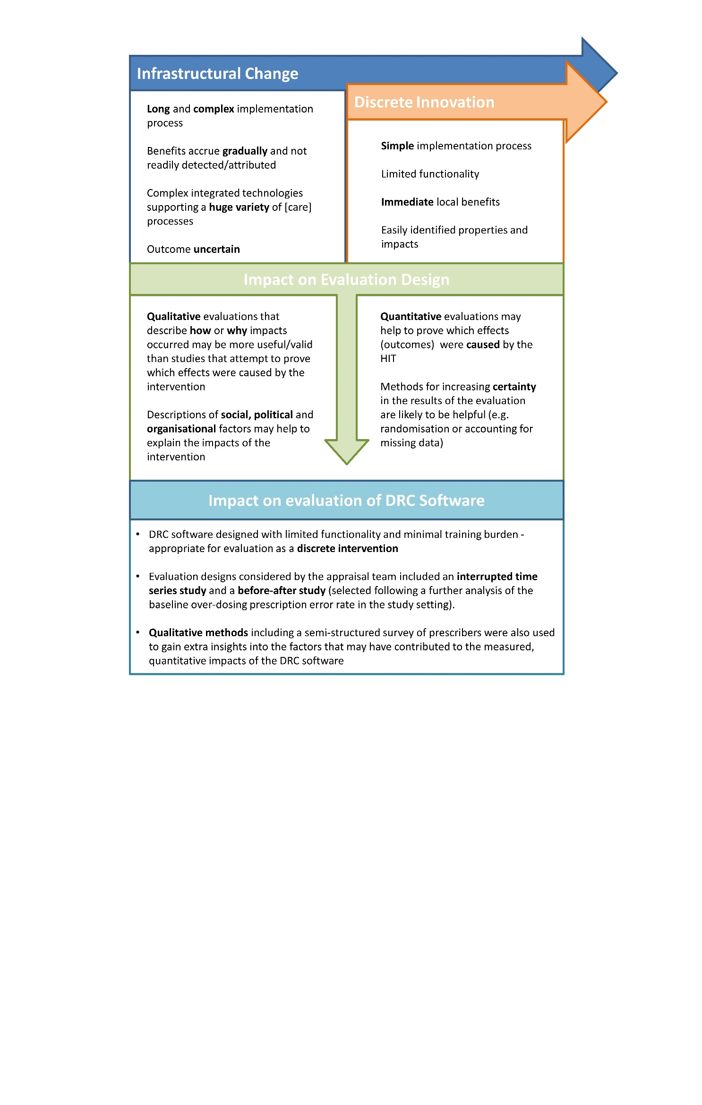

## Participant, Intervention, Comparison and Outcome Characteristics

HIT implementation research also highlights that HIT-related Participant, Intervention, Comparison and Outcome (PICO) factors need to be carefully considered during the assessment of HITs.10 This is because PICO factors can influence judgements about whether the findings from assessment settings are likely to be generalisable to other health contexts; key issues may include whether user groups are familiar with and accepting of new technologies; whether technologies can be equally well integrated into alternative HIT infrastructures; and consideration of whether the effects that are measured and reported during HIT assessments are relevant and important to HIT implementers and user groups.

If these PICO factors (summarised in 3) are not carefully considered when HIT assessments are conducted and reported, then these studies will be much less helpful when they are appraised by groups who are tasked with using research evidence to inform their decision-making.

For example, to reach judgements about whether the impacts of the DRC software described in this overview would be generalisable to other settings, decision-makers would need to develop a detailed understanding of a range of technical and socio-organisational factors including the methods used to integrate the software into existing prescribing systems, the resources required to update and maintain the software and the approaches taken to ensure that the DRC system had been used in the intended way during the course of the evaluation.

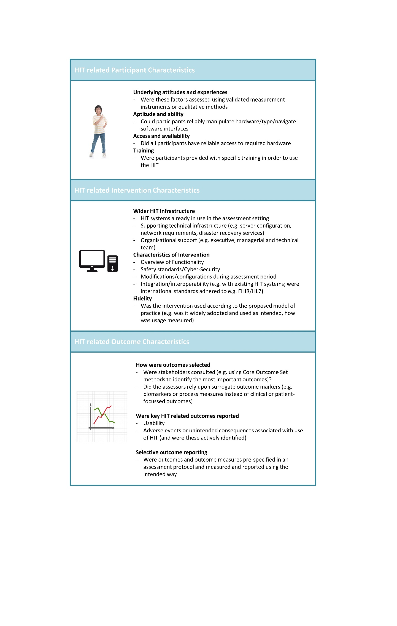

## HIT related conflict-of-interest factors and new technology bias

HIT implementations and assessments may also be prone to a range of conflict-of-interest factors. These may occur when technology providers become involved in assessment processes, but they can also occur when public bodies make the provision of funds for ongoing HIT investments contingent on the demonstration of “benefits realisation” or other externally imposed targets.

New technology bias can result from the excitement and promise of new technologies. This may lead assessors and commissioning groups to an implicit bias in favour of HITs, even when they are unlikely to cause significant improvements in care.11 These issues may have less of an impact when assessments are conducted using the most rigorous experimental methods, however factors such as publication bias, or the post-hoc (after the event) emphasis of results from secondary outcomes or sub-group analyses may also indicate the need for assessment reports to be interpreted with extra caution.

## Summary

As HITs proliferate across health systems it becomes increasingly important for health professionals to understand the methods that can be used to assess their impacts. This article highlights some of the approaches that may help with these processes, including the use of implementation frameworks, an awareness of the benefits of mixed-methods of assessment, and the need for caution when reaching judgements about the generalisability of findings described in HIT evaluation reports (particularly when considering their application in children’s healthcare settings). Using these approaches may help to ensure that the most effective HITs are developed and implemented in clinical practice.

## COMPETING INTEREST STATEMENT

The authors have no competing interests to declare.

## References

1. Wachter R. Making IT work: harnessing the power of health information technology to improve care in England. 2016.

2. NHSx. The Digital Technology Assessment Criteria

for Health and Social Care (DTAC) London, UK: NHSx, 2021.

3. Neame M, Moss J, Saez Dominguez J, et al. The impact of paediatric dose range checking software. *European Journal of Hospital Pharmacy* 2020: ejhpharm-2020-002244.

4. Cresswell K, Williams R, Sheikh A. Developing and Applying a Formative Evaluation Framework for Health Information Technology Implementations: Qualitative Investigation. *J Med Internet Res* 2020; **22**(6): e15068.

5. Cresswell K, Williams R, Sheikh A. Developing and applying a formative evaluation framework for health information technology implementations: qualitative investigation. *Journal of medical Internet research* 2020; **22**(6): e15068.

6. Greenhalgh T, Maylor H, Shaw S, et al. The NASSS-CAT Tools for Understanding, Guiding, Monitoring, and Researching Technology Implementation Projects in Health and Social Care: Protocol for an Evaluation Study in Real-World Settings. *JMIR Res Protoc* 2020; **9**(5): e16861.

7. Cusack CM, Poon EG. Health information technology evaluation toolkit. *Rockville, MD: Agency for Healthcare Research and Quality* 2007.

8. Colicchio TK, Cimino JJ, Del Fiol G. Unintended Consequences of Nationwide Electronic Health Record Adoption: Challenges and Opportunities in the Post-Meaningful Use Era. *J Med Internet Res* 2019; **21**(6): e13313.

9. Williams R, Cresswell, K. Diagram illustrating evaluation factors relating to HIT intervention complexity Edinburgh, UK; 2021.

10. Neame MT, Sefton G, Roberts M, Harkness D, Sinha IP, Hawcutt DB. Evaluating Health Information Technologies: A systematic review of framework recommendations. *International Journal of Medical Informatics* 2020: 104247.

11. Elsbach KD, Stigliani I. New information technology and implicit bias. *Academy of Management Perspectives* 2019; **33**(2): 185-206.