Stages of palaeoenvironmental evolution, climate, and sea level change of the Niger Delta - East Equatorial Atlantic: Novelty from elemental tracers, sedimentary facies, and pollen records: A refocus from sediment supply and applied microfossils

Onema C. Adojoh^{ac}, Fabienne Marret^{b}, Robert Duller^{b}, Peter L. Osterloff^{d}, Francisca E. Oboh-Ikuenobe^{c}, and Beverly Z. Saylorª

ªDepartment of Earth, Environmental and Planetary Sciences, Case Western Reserve University, Cleveland, OH 44106, USA
^{b}School of Environmental Sciences, University of Liverpool, Liverpool, L69 7ZT, UK
^{c}Department of Geosciences and Geological and Petroleum Engineering, Missouri University of Science and Technology, Rolla, MO 65409, USA
^{d}Exploration and Production, Shell International, London, E14 5NR, UK
Corresponding author: oxa105@case.edu

Abstract
This study used the comparative analysis of 3 gravity cores (GCs) obtained from the shallow offshore at ~40 m water depth to reconstruct the morphological evolution of the delta. The focus of this study is on the interpretation of elemental tracers and their justification between these tracers and microfossil data to understand the impact of climate-sea level controls on the evolution of the Niger Delta during the Late Quaternary. Key elemental tracers comprising Ti, Zr, Fe, and S were explored to strengthen this concept. High Ti/Zr ratio values down-hole indicate fluvial transport of terrestrial components to the marine setting (20-11.7 ka), whereas high values of Fe/S ratio up-hole provide an extent of inherent marine shale of the Niger Delta (11.7-6.5 ka). In addition, the integrated multiple proxy (mangrove and hinterland pollen, planktonic foraminifera, and sedimentary facies) with elemental tracer ratios provided robust and coherent information for delineating the late glacial (MIS2) prograding and interglacial (MIS1) retrograding deltaic transition, respectively. The overall trends of the two elemental tracer ratios (Lower and Mid-upper depths of the GCs) provide a new distinction on the depositional patterns (prograding and retrograding delta) to determine the proximal/upper (clay, silt, and very fine sand) and distal offshore/lower shorefaces (coarse-medium sand), and gross paleoenvironments based on planktonic foraminifera records.
These sequential records provide a new clue as evidence of the morphological evolutionary stages (delta plain, delta front, and prodelta) of the Niger Delta landscape, gross paleoenvironments, and vegetation dynamics (pollen data) during two distinct time-bound intervals (20-6.5 ka), which potentially delineate the climate and sea level regime of the coastal offshore.

Keywords: Sedimentary facies, elemental tracers, pollen, planktonic foraminifera, Niger Delta evolution, sea level- climate change, Late Quaternary

- Introduction
The reconstruction of the deltaic morphological evolution of the Niger Delta during the late to post-glacial period (Marine Isotope Stages - MIS1 and MIS2) over the last 20 ka has been the subject of debate (Armentrout et al., 1999; Kim et al., 2010; Adeonipekun et al., 2019). This study presents a model that explains the interplay between the driving mechanisms and palaeoenvironmental settings in the basin based on biotic and abiotic evidence (Zong et al., 2009; Riboulot et al., 2012; Adojoh et al., 2017). Previous studies of the Late Quaternary-sea level in the shallow offshore of the Niger Delta and other West African regions indicate post-glacial early Holocene sea level rise (SLR) and a middle Holocene SLR, followed by a subsequent fall to the present time (e.g., Oomkens, 1974; Lézine, 1997; Lézine et al., 2005; Scourse et al., 2005; Miller and Gosling, 2013; Bouimetarhan et al., 2015; Joo-Chang et al., 2015; Chadwick et al., 2020; Bouimetarhan et al., 2021). Climate-driven sea level change and local fluvial sediment discharge are among the factors controlling evolution of the Niger Delta during the Quaternary (Lézine, 1997; Adojoh et al., 2017; Adeonipekun and Sowunmi, 2019). Several shallow offshore palaeoenvironments exist in this setting, such as including the littoral realm (mangrove swamps, barrier islands, lagoons, estuary, deltas), and inner neritic realm. These palaeoenvironments may be composed of an integrated depositional system, and thus cannot be examined in sequestration (Woodroffe, 2002, Cohen et al. 2014). The major depositional systems under rising sea level on a gently sloping sandy coast are barrier islands or littoral systems, while strand plains (sand belts) with beach ridges are essentially absent (Cohen et al., 2014, Chadwick et al., 2020).
The response of the shallow offshore paleoenvironments of the Niger Delta to sea level changes is influenced by tidal impact, and climate driven-nearshore wave and fluvial discharge relative to the nature of the sedimentary budget (Lézine et al., 2005; Adojoh et al., 2017). All littoral settings assumed their present structure during the onset of sea level transgression that occurred during the Last Glacial Maximum (LGM), about 20-25 ka early Holocene (Poumot 1989; Lézine, 1997; Riboulot et al., 2012; Cohen et al., 2014 Adojoh et al., 2017; Chadwick et al., 2020). Nevertheless, a sea level fall promotes extremely adverse conditions for the origination and preservation of the littoral and neritic realms, especially in wave-controlled settings. Thus, if rapid fluvial/sediment supply occurs during shoreline progradation, it may generate a delta (Cohen et al., 2014, Chadwick et al., 2020). Under this circumstance and depositional complexities, lagoons, shoreface, and the neritic realm evolve, and wave-dominated deposits may rapidly prograde, causing regressive sand strands (Martin and Suguio, 1992; Chadwick et al., 2020).
Some major questions associated However, those depositional complexities remain unanswered unclear with vegetation succession. For instance, in relation to the link between the nature of the vegetation dynamics and timing of sediment supply to the onshore and shallow offshore Niger Delta areas, as well as the impact role of the Niger and Benue Rivers and their tributaries (Figure 1). The significance of the key sedimentary facies and vegetation distribution over the post-glacial evolution of the Niger Delta is still not well known, in particular how the sedimentary facies and delta depositional patterns have responded to sea level changes and the impact of Holocene warm and wet conditions on the coastal successions. This study attempts to answer some of these questions through the correlation and evaluation of key elemental tracer, planktonic foraminifera, pollen data, and sedimentary facies using three gravity cores (GCs) (Figure 1). When present, key elemental tracers, and mangrove pollen in marine sediments along the littoral realm can be used as markers of coastal and delta morphological dynamics, since their locations within the intertidal zone are strongly influenced by SLR (Woodroffe,1989, 1995, 2002; Lézine, 1997; Scourse et al., 2005; Adeonipekun and Sowunmi, 2019). The mangroves and littoral fringe of most tropical settings have kept up with sedimentation and can accommodate eustatic SLR rates of ~ 3.8 mm/year. However, when eustatic rates surpass 5.2 mm/year, then the mangroves would not be preserved (Mckee et al., 2007; Cohen et al., 2014; Chadwick et al., 2020).
The main aim of this study is to establish understand the evolution of the Niger Delta landscape and delta response due to climate-driven sea level change during the Late Quaternary. In addition, it explores the significance of detailed and integrated multiproxy data (key elemental tracer, planktonic foraminifera, pollen indicators, and sedimentary facies) to identify the main controls on the distinct stages of the Niger Delta evolution and its reorganisation during the Late Quaternary (MIS1 and MIS2). The methodological approaches will contribute to the body of knowledge on the factors affecting the depositional patterns (stages of evolution) of the West African region through the impact of climate-driven sea level fluctuations on the coastal/littoral delta shifts
2. Materials and methods
The three gravity cores (GCs) utilized for this study were collected from the Niger Delta by Fugro Geotechnical Company for Shell Petroleum Development Company of Nigeria in 2002 (Figure 1). The cores were acquired from the seabed within the nearshore (shallow marine) realm at approximately 40 m water depth. They were well positioned in the eastern (GC1 = Latitude - 4°49″43 N, Longitude - 5°20′20″ E), central (GC2 = Latitude - 4°05′08″ N, Longitude - 6°33′30″ E), and western (GC3 = Latitude - 4°11′59″ N, Longitude - 7°21′29″ E) parts of the delta. A detailed lithological description on the scale of 1:10 cm was undertaken to select the intervals for detailed microfossil and geochemical analyses. Each gravity core was sampled at every 2 cm for detailed analyses to further infer the imprints of sea level/climate cycles and delta morphological dynamics over time.
Preparations for palynomorph data (at the University of Liverpool, UK) followed the standard procedures described in Adojoh et al. (2017). In that method, preparation of palynomorphs followed the non-acetolysis and required sieving procedures. A small amount (~10 to 15ml) of cold 10% hydrochloric acid (HCl) was added to the sieved material to dissolve the carbonate component. The residue was decanted and neutralised ready for the HF. Cold 40% hydrofluoric acid (HF) was added to the test tube vial and left for 24 hours to dissolve the silicate component. The final residue was treated with heavy liquid (Sodium Polytungstate; density of 2.4g/cm3) to separate palynomorphs and non-palynomorphs from the residue. Palynomorphs and Non-palynomorphs slides were mounted on the microscope stage and where possible, a minimum of 300 palynomorphs and 120-200 mangrove taxa were counted on 400X magnification for the quantitative interpretation.
In addition, the geochemical components of the three GC samples were analysed at 2 cm intervals for physical, and chemical properties using a Bruker S2 Ranger XRF Spectrophotometer Autosampler at the University of Liverpool, UK. In this study, 28 samples were selected as required for the maximum batch of 28 clean and dry pots. Nylon film was used to separate the individual pots while the bases of the pots were kept flat and level with no protrusions. The samples were compacted gently by using the brass plunger. All recorded measurements were obtained from the saved drive of th138e XRF analyser database and used for graphical plots. The samples for Ti/Zr and Fe/S ratios were selected in their ranges of elemental analyses for the XRF Spectrophotometer. This is because high Ti/Zr ratios provide information on the extent of fluvial materials supplied from terrestrial environments, whereas high Fe/S ratios provide the extent of inherent marine shale deposited on the continental shelf (Marius and Lucas, 1991; Zabel et al., 2001; Adegbie et al., 2003; Doktorgrades, 2004; Mendoza, 2007). Note: All data used for this study can found here - https://issues.pangaea.de/browse/PDI-33758
3. Chronology
Adojoh et al. (2017, 2020) based the age model for each gravity core on biostratigraphy defined by the first occurrences (FO) of calcareous nannoplankton (NN19 to NN21) and planktonic foraminifera (Glorobotalia tumida and Glorobotalia truncatulinoides), and extrapolated radiometric dating (Peltier, 1994; Scourse et al., 2005). In this study, radiometric dating was not successful because impact of freshwater dilution and siliciclastic flux (peculiar with long and large volume river dominated deltas) on the near-shelf margin affected the preservation and quantitative counts of relevant fossil materials, such as foraminiferal tests, macrofossil shells (gastropod, bivalves), and wood particles, that could have been used for dating. To note here, is another similar study in Congo River delta (Core KZai 02) (Dalibard et al., 2014) that encountered the same chronological situation. In that study, the pollen and other data listed below were correlated with the nannofossil (NN) stratigraphy of KZai 02 as well as MIS 1-2 and radiometric dating records from a nearby core. The age model is also supported by similar chronological records (MIS 1-2) that are regionally linked to wiggles of Total Organic Carbon (Schneider et al., 1997), Vostock ice core CO₂ (Petit et al., 1999), Guinean Gulf Sea Surface Temperatures (Schneider et al., 1997), Congo Basin Mean Temperature (Weijers et at., 2007), West African Monsoon (Weldeab et al., 2007), summer insulation curve (Berger and Loutre, 1992), and Latitudinal Insolation Gradients (Davis and Brewer, 2009) as discussed by Dalibard et al., 2014.
Furthermore, given that similar sedimentary archives of marine cores are recognised based on sea level and climate fluctuations, this paper has compared the dated multiple proxy records from the GCs with published data on relative sea level change for the Niger Delta region over the last 20 ka. In Figures 2-4, we have extrapolated the relative sea level curve for the Gulf of Guinea region plotted against the radiocarbon date from a global isostatic model database (Peltier, 1994) and a representative location (5830V S, 11830V E, T89-16 core) on the Congo shelf margin (Scourse et al., 2005) which instill confidence in our age model.

4. Results
Here we provide a novelty based on selected elemental tracers (Ti/Zr; Fe/S ratios), microfossils - key pollen/vegetation (Mangrove, Savanna), and foraminifera (Globorotalia spp.) proxies to establish the landscape and morphological evolution of the Niger Delta. The three GCs record remarkably similar changes in the different proxies and two main stages of delta sedimentation were distinguished (Figures 2-5).

4.1 Microfossils proxy
4.1.1 Lower depths (GC1: 272-202 cm, GC2: 266-202 cm, GC3: 260-202 cm)
The lower depths record lower sedimentation of intercalated coarse to medium sand (GC1 = 9.8cm/kyr; GC2 = 13.9cm/kyr; GC3 = 13.1 cm/kyr), high abundances of hinterland (terrestrial) components (e.g., ~40-41% Savannah grass pollen – Poaceae, 30% Cyperaceae, 19-21% charred grass _ cuticles, ~43% Afromontane taxon – Podocarpus), ~18-19% freshwater algae – Pediastrum (Table 1). In addition, low abundances of planktonic foraminifera Globorotalia spp. (~18-20%) and mangrove pollen (Rhizophora 21%, Avicenniaceae ~13 are also recorded at these depths (Figures 2-5). Thus, terrestrial indicators increased relative to mangrove/littoral proxies.

4.1.2 Mid-upper depths (GC1: 0-202 cm, GC2: 0-202 cm, and GC3: 0-202 cm)
These depths cover the middle to the upper parts of the three GCs and are characterised by a slower sedimentation rate of mudstone ((Table 1) due to expansion of mangrove vegetation (~60-80% Rhizophora sp. and 25-30% Avicenniaceae) and increase in planktonic foraminifera (~60-79 % Globorotalia spp.). These depths also record fewer hinterland pollen (e.g., ~10-20% Poaceae, 0-5% Podocarpus, ~7% Cyperaceae, 0-4% cuticles _ charred grass), 2-5% Pediastrum, and higher sedimentation rate of very fine-silty sand (GC1 = 78.2 cm/kyr; GC2 = 57.3 cm/kyr; GC3 = 57.3 cm/kyr) (Table 1). During this interval of rapid expansion of mangrove-dominated pollen, hinterland pollen, and other components (e.g., cuticles) dramatically decline when compared to the lower depths (Figures 2-5).

4.2 Elemental tracers proxy
In this study, Ti/Zr vs. Fe/S ratios were selected from the range of elemental analysis carried out through the XRF Spectrophotometer. Two elemental tracer ratios data plots and lithological logs presented demonstrate various changes in elemental concentration and sediment chemistry observed throughout the three GCs (Figure 5).
The value of Ti/Zr ratio is significant with an abrupt shift in baseline down-hole (140-80 mg-1/PPM) at the lower depth intervals (GC1: 272-180 cm, GC2: 266-185 cm, GC3: 260-187 cm), especially at the bottom of the GCs (Figure 5). The value of Fe/S is low (between 0-6 mg-1/PPM) throughout the same intervals at the bottom of the GCs due to the low presence of organic matter and relative formation of pyrite.
However, from the middle to uppermost intervals of the three GCs (GC1: 180-0 cm, GC2: 185-0 cm, GC3: 187-0 cm), the value of the Ti/Zr decreases (5-65 mg-1/PPM) but the value of Fe/S increases (4-45 mg-1/PPM) across the same relative intervals in the three GCs (Figures 2-5).

5. Interpretation
5.1 Lower depths - GC1: 272-180 cm, GC2: 262-185 cm, GC3: 260-187 cm
These depths correlate to the later part of the last glacial period (MIS2) which is characterised by fluvial run-off of weathered Ti/Zr components from open landscape vegetation (Dupont and Agwu, 1991; Morley, 1995; Morley et al., 2011, 2017; Miller and Gosling, 2013; Cohen et al., 2014; Adojoh et al., 2017; Adeonikpekun and Sowunmi, 2019) (Figure 6-7). It provides evidence of dry conditions and fluvial sediment supply to the Niger Delta based on abundant records of the catchment (Ti/Zr ratio) and hinterland (Poaceae, cuticle) indicators interpreted from the lower part of the GCs (Zabel et al., 2001; Adegbie et al., 2003; Pastouret et al., 1978; Morley and Richards, 1993; Skonieczny et al., 2015; Adojoh et al., 2017; Adeonipekun and Sowunmi, 2019) (Figures 2-5). In addition, the observed fluvial sediment supply could be linked to the seasonal latitudinal migration of the Intertropical Convergent Zone (ITCZ) with a mean annual position assumed to be around 15ºN positioned further south (15ºS) (Leroux, 1993; Marret et al., 2001; Kim et al., 2010; Shannahan et al., 2015; Höpker et al., 2019).
Assuming the sedimentation pattern remained uneroded, this phase could be the main conduit through which terrestrial and riverine materials (e.g., pollen, cuticle, trace elements, etc.) were transported to the Niger Delta during the sea level fall and dry climate. It was is possible that sediment transport was local (period of intense tectonism), regional (climate sea and level change), or experienced both conditions, which contributed to the volume of sediment discharge through the Niger and Benue Rivers to the Niger Delta (Adegbie et al., 2003; Skonieczny et al., 2015; George et al., 2019) (Figures 1; 6-7).

5.2 Mid-upper depths - GC1: 180-0 cm, GC2: 185-0 cm, GC3: 187-0 cm
Fe/S ratio can be linked to stages of sea-level and climate change over the last 20 ka (Marius and Lucas, 1991), as also inferred in this study (Figures 2-5). During the Early to mid-Holocene (11-6.5 ka), these depths (up-hole GCs) experienced sea level transgression and warm climate based on the higher sedimentation rate, expansion of mangrove assemblages (e.g., Rhizophora sp.), and marine indicators (Fe/S ratio) in the GC depths of ~202-0 cm (Figures 2-5). This was a set of both rapid spread of the coastal/littoral vegetation zone and marine organically related iron- sulphur preservation associated with sea level rise and linked to the gently sloping shelf where transgressive sedimentation took place, leading to delta plain retreat (; Lézine, 1997; Scourse et al., 2005; Rull, 2002; Torricelli et al., 2006; Amorosi et al., 2014; Adojoh et al., 2015; Adeonikpekun and Sowunmi, 2019; Höpker et al., 2019). These depths also experienced increased marine (tidal) influence when compared to lower depths (GC depths of ~272-202) (Figures 2-5), implying that marine organically rich iron-sulphur (Fe/S) and mangrove pollen preservation in intertidal- tidal settings would be much higher (Rull 2002; Punwong et al., 2013; Joo-Chang et al., 2015) (Figures 6-7). Consequently, high values of Fe/S ratio correlated with abundance of mangrove pollen type (Rhizophora) and planktonic foraminifera is acknowledged as an indicator of sea level transgression when matched with the regional sea level curve (e.g., Peltier, 1994; Scourse et al., 2005; Joo-Chang et al., 2015; Chadwick et al., 2020) (Figures 2-5).

6. Discussion
Given the array of multiple proxy (sedimentary facies, microfossils, and elemental tracers) components of the GCs interpreted here are independent of the visual characteristics. In context, the cores logged and investigated show a general observation of the sedimentary facies (lithofacies types) indicating the dominance of mudstone lamination intercalation with pulses of coarse-medium grained sand at the lower depths of the GCs (Figure 5). In addition, the Ti and Zr components obtained are from the weathering of basaltic granites during the wetting and drying of the rock, whereas Fe and S elements are disseminated from post-weathering and transportation of weathered felsic rocks into adjourning stream channels linked to the coastal Niger Delta (Marius and Lucas, 1991; Doktrogrades, 2004; Olayiwola et al., 2017; Ghandour et al., 2021). These descriptions correlated with other multiple proxy (especially sedimentary facies and planktonic foraminifera) and provide a new information on the depositional patterns and palaeoenvironmental conditions of the delta (Figures 5; 8.). Based on the information observed from the multiple proxy, the sequential records on the depositional patterns and morphological stages (Progradation and Retrogradation) of the Niger Delta evidenced by elemental tracers, sedimentary facies, and planktonic foraminifera are discussed below.

6.1 Delta progradation – Stage 1
The record shows high values of Ti/Zr and low values of Fe/S ratios in these intervals (272 - 185 cm) across the GCs during the late Pleistocene (MIS 2). High Ti/Zr ratio points to a granitic/arkosic rock composition identifying nearby highland weathering (Cameroun highland fringe) and siliciclastic input (Olayiwola et al., 2017; Ghandour et al., 2021) (Figure 5). Originally, deposition of sediments took place under continental or terrestrial conditions but was subsequently remobilized and redeposited as siliciclastic input within the marine realm basin (Zabel et al., 2001; Adegbie et al., 2003; Doktorgrades, 2004; Bulian et al., 2019; Ghandour et al., 2021). This suggests a prograding delta and fluvial transport of terrestrial sediment from the continental setting into the middle neritic/pro-delta realm of the Niger Delta (source-to-sink). The depositional environment identified is due to the occurrence of Globorotalia spp. microfauna (Adegoke, 1975; Murray, 1991; Hayward et al., 2004; Hart et al., 2015; 2017; Ghandour et al., 2021) (Figure 8).
6.2 Delta retrogradation – Stage 2
An intermediate value of Ti/Zr and Fe/S ratios is recorded in this interval (185 - 120 cm) across the GCs at the onset of early Holocene (MIS 1). Overlying the intervals (120 - 60 cm) below is a decrease in the values of Ti/Zr ratio, whereas the Fe/S ratio increases that probably provides a hint of the mixture of transported sediments (clay, silt) within the marine setting (Zabel et al., 2001) (Figure 5). The lower part of this interval indicates a sequential short-lived, highly organic rooted swamp environment, characterized by temporarily inundated conditions, and preservation of the microfauna (Globorotalia spp. and sporadic appearance of Globigerinoides ruber), transported or washed is identified as well. The phase lines of evidence from the elemental tracer values (Fe/S), sedimentary facies (clay, silt), and microfauna suggest an inner-middle neritic or delta front (Allen, 1965; Adegbie et al., 2003) depositional environment (Figure 8) (Adegbie et al., 2003; Bulian et al., 2019; and Cattaneo et al., 2004; Ghandour et al., 2021).
Retrograding towards the shoreline are the intervals between 45 - 0 cm that cut across the GCs during the mid-Holocene (MIS 1). These intervals also show a low value of Ti/Zr ratio, while the value of Fe/S ratio increases continuously (Figure X). These variations suggest marine-dominated sediment (clay, very fine sand) and a complete shift to a marine-based depositional setting (Allen, 1965; Doust and Omatsola, 1990; Adegbie et al., 2003, Doktorgrades, 2004; Reijer, 2011; Riboulot et al., 2012; Omuije et al., 2015; George et al., 2019). This condition relates to a period of anoxia due to the increase in the concentration of Fe and S contents (pyrite) in the sediment (Doktorgrades, 2004; Karoodi et al., 2012). Thus, the sedimentary facies (clay, silt, very fine sand) interpreted and the occurrence of the microfauna (Globorotalia spp. and Globigerinoides ruber) suggest a retrograding and lagoonal barrier system to coastal plain depositional environment (delta plain) (Figure 5) (Allen, 1964; Murray, 1991; Kakroodi et al., 2012; Hart et al., 2015; 2017 Ghandour et al., 2021).

6.3 Climate and sea level change controls as an expression of palaeoenvironmental and morphological evolution of the Niger Delta
The three GCs record a coherent signal of significant changes in elemental tracer ratios and abundances of palynomorphs and planktonic foraminifera that correlate with the effects of the transition from low sea level to sea level rise (two succinct time-bound stages) on the coastal margin of the Niger Delta. This change in sea level has been reported elsewhere, especially along the East Equatorial African margin (Lézine, 1997; Scourse et al., 2005). In addition, these source-to-sink relationships record transitions between glacial-interglacial variations in sediment chemistry, vegetation dynamics, sediment gradation, catchment preferences, and climate change in the Niger Delta. The integrated multiple proxy obtained presented in this study provide a link to two evolutionary time-bound stages of the Niger Delta during the last 20 ka. These two succinct time-bound stages provide a resonating clue on the prevailing past environment, climate, and sea level change as follows: prograding/ advancing and retrograding/ retreating delta (Figures 5-8).
During delta progradation (stage 1), the GC data confirm the emergence of the continental shelf in response to a lower than present-day sea level (Figures 7-8). The littoral environment (mangrove and coastal swamp) is subaerially exposed, and sedimentation and fluvial transport are affected by mass movement triggered by the weak West African Monsoon (WAM) (Morley, 1995; Reijers, 2011; Zong et al., 2009; Shannahan et al., 2015; Skonieczny et al., 2015; Adojoh et al., 2017; Höpker et al., 2019; Chadwick et al., 2020). The morphological evolution of the Late Quaternary Niger Delta was identified based on terrestrial components transported beyond the littoral realm/coastal zone, representing a strong signal of the prevalent arid-dry conditions (Figures 6-8). Under this setting, GCs record indicate high values of Ti/Zr ratio, coarse-medium sand, the predominance of hinterland pollen, cuticle, freshwater algae (Pediastrum), and rapid sedimentation rate. In addition, the dominance of multiple proxy correlated with low abundance of planktonic foraminifera (Globlorotalia spp.) suggests a distal offshore/lower shoreface prodelta paleoenvironment (Adegoke, 1975; Murray, 1991; Omuije et al., 2015) (Figures 6-8). On a regional scale, this stage was a period of enhanced sediment transport, as observed in the settings of the Amazon, Senegal (Ogolian regression), and Congo Rivers (Figures 3-5; 7) (Barusseau, 1988; Barusseau et al., 1995; Marret et al., 2001; Giosan et al., 2005; Bonne, 2014; Adeonipkekun and Sowunmi, 2019).
Following delta retrogradation (stage 1) was a period of rapid sediment retreat in the Niger Delta attributed to sea level rise (Figures 6-8). This period of onset of Early to mid-Holocene sea level rise and warm climate coincides with an episode of shoreline transgression and fine-grain (clay, silt, very fine sand) sediment suspension reflecting the proximity of turbidity currents (Peltier, 1994; Goodbred, 2003; Scourse et al., 2005; Joo-Chang et al; 2015; Höpker et al., 2019). Increases in the values of Fe/S elemental tracer as opposed Ti/Zr ratio suggests a reducing environment with the potential of rapid post-dissolution of pyrite (FeS) minerals and organic-rich sulphur content (Fletcher, 2005; Mendoza, 2007). Sedimentary facies and pollen deposition during this stage were principally driven by the interaction between the creation of accommodation space and density of mangrove vegetation spread across the nearshore realm (Bonne, 2014) (Figures 6-7). On a regional extent, delta retrogradation correlates to the period of sea level rise (Nouakchottian transgression) as observed from the coastal margins of Congo, Senegal, and Mauritania (Barusseau, 1988; Barusseau et al., 1995; Lézine 1997; Lézine and Denefle, 1997; Dalibard et al., 2014; Scourse et al., 2005; Höpker et al., 2019). In addition, this setting suggests a proximal-upper shoreface (delta plain/delta front) palaeoenvironment based on the dominance of the planktonic foraminiferal (Globorotalia spp., Globigerinoides ruber) (Figure 8).

7. Conclusions
The variations in the elemental tracer ratios during the two stages of sedimentation provided the first clarification and supportive evidence on the timing between glacial-interglacial feedback on vegetation, sedimentary facies, and morphological evolution in the Niger Delta. The overall trends (Lower and Mid-upper depths of the GCs) of the two ratios (Ti/Zi and Fe/S) provide a transition and distinction between the climate-driven sea level regime, depositional environments (lower / upper shoreface), and morphological patterns (prograding and retrograding delta) of the Niger Delta.
Integration of the multiple datasets in the GCs (three gravity cores) permitted the identification of the direct link between delta landscape and sediment transport (source-to-sink) in the eastern (GC1), central (GC2), and western (GC3) locations of the Late Quaternary Niger Delta. Given the sequence of changes observed, this study clearly identified two time-bound stages (prograding) and (retrograding) of delta evolution as inputs for interpreting seasonal (glacial and interglacial) variations in climate and sea level change. The stages of prograding and retrograding delta were identified at 20-11.75 ka (Lower depth) and 11.7-6.5 (Upper depth), respectively. These stages outlined in this context confirm a direct link between the elemental tracers, pollen data, and sediment supply as evidence of landscape evolution of the Niger Delta. The major findings are as follows:
- The integrated and correlated datasets – elemental tracer ratios, mangrove and hinterland pollen, cuticle, planktonic foraminifera, and sedimentary facies provided robust and coherent information for delineating the late glacial (MIS2) prograding delta and interglacial (MIS1) retrograding delta boundary. In addition, planktonic foraminifera species aided to distinguish between the proximal/upper and distal offshore/lower shoreface paleoenvironments (delta plain, delta front and prodelta).
- Prograding delta stage linked the period from 20-11.7 ka to higher influx of hinterland pollen, higher values of Ti/Zr ratio and coarse-medium sedimentation on the prodelta, sea level fall, and drier climate in the Niger Delta.
- Retrograding delta stage (11.7-6.5 ka) indicated a stage of slow-moderate clay-very fine sand sedimentation on the delta front, sea level rise, and warm climate. In addition, sedgeland/sedge swamp (Cyperaceae) dominance in prograding delta area was replaced by mangrove and higher values of Fe/S ratio in retrograding stage due to greater salinity and organic matter-rich water depths associated with sea-level inundation.
- Multiple datasets used in this study demonstrate the significance of key driving mechanisms of deltaic morphological evolution. Sea level change has been the main driving factor influencing ancient deltaic growth and landscape, and paleoenvironments due to variations of seasonal monsoon runoff. This implies that the morphological evolution of Niger Delta was developed and accelerated due to a large amount of sediment trapped and encircled by the dense littoral vegetation as the shoreline fluctuates between the proximal and distal axis of the delta.

8. Study limitations and recommendations
The Late Quaternary marine sediments from the Niger Delta lack an age model using conventional radiocarbon dating due to the rarity of calcareous macrofossils and poorly filtered wood materials. Niger Delta (mixed delta) similar to other long and large river-dominated deltas such as Congo and Amazon tend to pose this difficulty, especially shallow water depth. In addition, the proprietary nature of material drilled by companies prospecting for hydrocarbons in the Niger Delta basin, and in the rare cases when samples are available for study added to this dearth of knowledge. Numerous studies have also, noted that the preservation and abundance of marine microfossils shells and wood materials for radiocarbon dating in shallow parts of marine deltas are mostly impacted by freshwater dilution and siliciclastic flux from continental runoff. These conditions affected our initial attempts (radiometric dates) by providing errors and noise, and different age connotations across the GCs depths investigated. Although the age control used for this study is reliable based on the precise matched GCs results received from different organisations (industry and institution), we recommend that other dating methods (e.g., tree ring, OSL, etc.) should be employed and compared with our method.

Acknowledgements
We sincerely appreciate the Petroleum Technology Development Fund of Nigeria (PTDF Grant ID: PTDF/E/OSS/PHDAOC/385/11), and the University of Liverpool, UK, and Missouri University of Science and Technology, USA for funding the first author's doctoral studies and post-doctoral research fellowship, respectively. Professor Malcolm Hart (Plymouth University, UK), Dr. Claudia Cetean (CGG Robertson, UK), and Shell Petroleum Development Company are thanked for their help in terms of logical suggestions and the provision of the Gravity Cores samples, respectively.

References
Abbink, O.A., 1998. Palynological investigations in the Jurassic of the North Sea region. LPP Contribution Series 8: 192.
Abbink, O.A., Van Konijnenburg-Van Cittert, J. H. A., and Visscher, H., 2004. A Sporomorph Ecogroup Model for the Northwest European Jurassic - Lower Cretaeous I - Concepts and framework. Netherlands Journal of Geociences / Geologie en Mijnbouw 83, 1: 389–404
Adegbie, A.T., Schneider, R., Röhl, U. and Wefer, G., 2003. Glacial millennial-scale fluctuation in central African precipitation recorded in terrigenous sediment supply and freshwater signals offshore Cameroon. Palaeogeography, Palaeoclimatology, Palaeoecology, 197, 323-333.
Adegoke, O.S., 1975. Foraminifera fauna of the polyhaline lagoons of the Gulf of Guinea. Journal Mining and Geology, 12, 1-8.
Adeonipekun, P.A., and Sowunmi, M.A., 2019. Palaeoclimatology and biostratigraphic significance of late Neogene/Quaternary vegetational changes recorded in the offshore western Niger Delta. Acta Palaeobotanica, 59, 373-390.
Adojoh, O., Dada, S., 2015. Geomorphic resources and tourism potentials of the Niger-Benue confluence area, Central Nigeria. Journal of Geosciences and Geomatics, 3, 44-49.
Adojoh, O., Adebayo, L.F. and Dada, S., 2015. Palynocycles, palaeoecology and systems tracts concepts: A Case Study from the Miocene Okan-1 Well, Niger Delta Basin, Nigeria. Applied Ecology and Environmental Sciences, 3, 66-74.
Adojoh O., Marret, F., Duller, R. and Osterloff, P., 2017. Tropical palaeovegetation dynamics, environmental and climate change impact from the low latitude Coastal Offshore Margin, Niger Delta, Gulf of Guinea. Palaeoecology of Africa, 34, 107-144.
Adojoh, O., Fabienne, M., Duller, R., Osterloff. P., 2019. Taxonomy and phytoecology of palynomorphs and non-pollen palynomorphs: a refined compendium from the West Africa Margin. International Journal of Biodiversity, 3,188-200.
Adojoh O., Marret, F., Duller, R., Osterloff, P., Ikuenobe, F., Hart, M. Smart, C., 2020. The biostratigraphy of the offshore Niger delta during the Late Quaternary: Complexities and progress of dating techniques. Quaternary Science Advances, 1, 100003.
Amorosi, A., Rossi, V., Scarponi, D., Vaiani, S.C. and Ghosh, A., 2014. Biosedimentary record of postglacial coastal dynamics: high-resolution sequence stratigraphy from the northern Tuscan coast, Italy. Boreas, 43, 939-954.
Armentrout, J.M., Fearn, L.B., Rodgers, K., Root, S., Lyle, W.D., Herrick, D.C., Bloch, R.B., Snedden, J.W. and Nwankwo, B., 1999. High-resolution sequence biostratigraphy of a lowstand prograding deltaic wedge: Oso field (Late Miocene), Nigeria. In: Jones, R.W. and Simmons, M.D. (eds.) Biostratigraphy in production and development geology. Geological Society, London, Special Publications, 152, 259-290.
Bankole, I., Schrank, E. and Osterloff, P., 2014. Palynostratigraphy, palaeoclimates and palaeodepositional environments of the Miocene aged Agbada Formation in the Niger Delta, Nigeria. Journal of African Earth Sciences, 95, 41-62.
Barusseau, J.P., Bâ-diar, A.M., deScamps, C., Diop, H. S., Giresse, P. and Saos J.l., 1995. Coastal evolution in Senegal and Mauritania at 103, 102 and 101-year scales: natural and human records. Quaternary International, 29, 61-73.
Barusseau, J.P., Giresse, P., Faure, H., Lézine, A.M. and Masse, J.P., 1988. Marine sedimentary environments on some parts of the tropical and equatorial margins of Africa during the Late Quaternary. Continental Shelf Research, 8, 1-21.
Berger, A. and Loutre, M. F., 1991. Insolation values for the climate of the last 10million years. Quaternary Science Reviews, 10, 297-319.
Bonne, P.M., 2014. Cenozoic Atlantic margin of Africa during the Cretaceous and the implications for sediment supply to the Equatorial Reconstruction of the evolution of the Niger River. Geological Society, London, Special Publications, 386.
Bouimetarhan, I., Dupont, L., Kuhlmann, H., Pätzold, J., Prange, M., Schefuß, E. and Zonneveld, K., 2015. Northern Hemisphere control of deglacial vegetation changes in the Rufiji uplands, Tanzania. Climate of the Past, 11, 751-764.
Bouimetarhan, I., Dupont, L., Reddad, H., Baqloul, A. and Lezine, A., 2021. Vegetation response-and-orbital-scale climate change in Africa: A review from the Ocean: In Quaternary vegetation dynamics. Palaeoecology of Africa, 35, 349-372.

Chadwick, J.A., Lamb, P.M., Ganti V., 2020. Accelerated river avulsion frequency on lowland deltas due to sea-level rise. Proceedings of National Academy of Sciences in the USA, 3017584-17590.
Cohen, L.C.M., França, M.C., Rossetti, F.D., Pessenda, R.C.L., Giannini, F.C.P., Lorente, F.L., Buso-Junior, A.A., Castro, D., and Macario, K., 2014. Landscape evolution during the Late Quaternary at the Doce River mouth, Espírito Santo State, Southeastern Brazil. Palaeogeography, Palaeoclimatology, Palaeoecology, 415, 48-58.
Corredor, F., Shaw, J.H., Bilotti, F., 2005. Structural styles in the deep-water fold and
thrust belts of the Niger Delta. AAPG Bulletin 89, 753-780.
Davis, B. S., and Brewer, S., 2009. Orbital forcing and role of the latitudinalinsolation/temperature gradient. Climate Dynamics, 32, 143-165.
Dalibard, M., Popescua, S., Maley, J., François Baudin, F., Melinte-Dobrinescue, M., Pittetf, B., Marsset, T., Dennieloug, B., Droz, L. and Succ, J., 2014. High-resolution vegetation history of West Africa during the last 145 ka Geobios, 46, 183-198.
Doktorgrades, E., 2004. Reconstruction of the sedimentary environment and climate conditions by multi-geochemical investigations of Late Palaeozoic glacial to postglacial sedimentary sequences from SW-Gondwana. Dissertation submitted to Universität Bonn, Germany, 96 - 117.
Doust, H.E. and Omatsola, E.M., 1990. Niger Delta. In: Edwards J.D., and Santagrossi, P.A (eds.). Divergent/Passive Basins. American Association of Petroleum Geologists Memoir, 48, 201-238.
Dupont, L.M. and Agwu, C.O., 1991. Environmental control of pollen grain distribution patterns in the Gulf of Guinea and offshore NW-Africa. International Journal of Earth Sciences, 80, 567-589.
Fletcher, W.J., 2005. Holocene Landscape History of Southern Portugal. Doctoral thesis, University of Cambridge; https://doi.org/10.17863/CAM.20470.
Fredoux, A. and Tastet, J.P., 1976. Analyse pollinique d'une carotte marine au large de la Côte d'Ivoire. Variations de la végétation et du climat depuis 225 000 ans BP. Palynosciences, 2, 173-188.
Galloway, W.E., 1975. Process framework for describing the morphologic and stratigraphic evolution of deltaic depositional systems. In: Broussard, M.L. (Ed.), Houston Geological Society, Deltas, 87-98.
George, D.C., Franklin, I.M., and Spagnolo, M.M., 2019. Deltaic sedimentary environments in the Niger Delta, Nigeria. Journal of African Earth Sciences 160, 103592.
Giosan, L., Donnelly, J.P., Vespremeanu, E. and Buonaiuto, F.S., 2005. River delta morphodynamics: Examples from the Danube delta, In: Giosan, L., and Bhattacharya, J. (eds.), River Deltas: Concepts, Models, Examples, SEPM Special Publication 83, 393-411.
Goodbred, S.L., 2003. The response of the Ganges dispersal system to climate change: a source-to-sink view since the last interstade. Sedimentary Geology, 162, 83-104.
Höpker, S.N., Wu, H.C., Müller, P., Barusseau, J.P., Vernet, R., Lucassen, F., Kasemann. S.A., and Westphal, H., 2019. Pronounced Northwest African monsoon discharge during the Mid-to Late Holocene. Frontiers in Earth Science, 7, 314.
Joo-Chang, J.C., Islebe, G.A., and Torrescano-Valle, N., 2015. Mangrove history during middle- and late-Holocene in Pacific south-eastern Mexico. Holocene 25, 651-662.
Kim, S.Y., Scourse, J.D., Marret, F. and Lim, D.I., 2010. A 26,000-year integrated record of marine and terrestrial environmental change off Gabon, west equatorial Africa. Palaeogeography, Palaeoclimatology, Palaeoecology, 297, 428-438.
Knox, G.J. and Omatsola, E.M., 1990. Development of the Cenozoic Niger Delta in terms of the escalator regression model and impact on hydrocarbon distribution. In: van der Linden, W.J.M., Cloetingh, S.A.P.L., Kaasschieter, J.P.K., van der Graff, W.J.E., Vandenberghe, J., and van der Gun, J.A.M. (eds.), KNGMG Symposium on coastal lowland geology and geotechnology, proceedings. The Netherlands, Kluwer Academic Publishers, 181-202.
Knox, G.J. and Omatsola, M.E., 1987. Development of the Cenozoic Niger Delta in terms of the escalator regression model. Kluwer Academic Publishers, 181-202.
Leroux, M., 1993. The mobile polar high: A new concept explaining present mechanisms of meridional airmass and energy exchanges and global propagation of palaeoclimatic changes. Global and Planetary Change, 7, 69-93.
Lézine, A.M., Cazet, J.P. and Duplessy, J.C., 2005. West African monsoon variability during the last deglaciation and the Holocene: Evidence from freshwater algae, pollen and isotope data from core KW31, Gulf of Guinea. Palaeogeography Palaeoclimatology, Palaeoecology, 219, 225-237.
Lézine, A.M, 1997. Evolution of the West African mangrove during the Late Quaternary. Geographie Physique et and Quaternaire, 51, 405-414.
Lézine, A.M. and Denèfle, M., 1997. Enhanced anticyclonic circulation in the eastern North Atlantic during cold intervals of the last deglaciation inferred from deep-sea pollen records. Geology, 25, 119-122.
Martin, L., Suguio, K., 1992. Variation of coastal dynamics during the last 7000 years recorded in beach-ridge plains associated with river mouths: example from the central
Brazilian coast. Palaeogeography, Palaeoclimatology, Palaeoecology, 99, 119-140.
Marius, C. and Lucas, J., 1991. Holocene mangrove swamps of West Africa sedimentology and soils. Journal of African Earth Sciences, 12, 41-54.
Marret, F., Scourse, J., Versteegh, G., Jansen, J., Fred, S., and Ralph, R., 2001. Integrated marine and terrestrial evidence for abrupt Congo River palaeodischarge fluctuations during the last deglaciation. Journal of Quaternary Science, 16, 761-766.
Mendoza, U.M., 2007. Dynamics of phosphorus and sulphur in a mangrove forest in Bragança, North Brazil. PhD thesis, University of Bremen 1-16.
Miller, C.S., and Gosling, W.D., 2013. Quaternary forest associations in lowland tropical West Africa. Quaternary Science Reviews, 84, 7-25.
McKee, K.L., Cahoon, D.R., and Feller, I.C., 2007. Caribbean mangroves adjust to rising sea level through biotic controls on change in soil elevation. Global Ecological Biogeography, 16, 545–556.
Morley, R.J., 1995. Biostratigraphic characterisation of systems tracts in Tertiary sedimentary basins. Proceedings of International Symposium on Sequence Stratigraphic in SE Asia, 50-71.
Morley, R.J., 2014. Rifting and mountain building across Sundaland, a palynological and sequence biostratigraphy perspective. Proceedings, Indonesian Petroleum Association Thirty-Eighth Annual Convention and Exhibition, IPA 14-G-011M.
Morley, R.J., 2017. The complex history of mountain building and the establishment of mountain floras in Southeast Asia and Eastern Indonesia. In: Hoorn, C., and Antonelli, A. (eds.), Mountain, climate and diversity. Wiley, 475-494.
Morley, R.J. and Richards, K., 1993. Gramineae cuticles: A key indicator of Late Cenozoic climatic change in the Niger Delta. Review of Palaeobotany and Palynology, 77, 119-127.
Morley, R.J., Swiecicki, T. and Thi-Pham, D., 2011. A sequence stratigraphic framework for the Sunda region, based on integration of biostratigraphic, lithological and seismic data from Nam Con Son Basin, Vietnam. Proceedings, Indonesian Petroleum Association 35th Annual Convention and Exhibition, IPA11-G-002.
Murray J.W., 1991. Ecology and palaeoecology of benthic foraminifera. Amsterdam, Elsevier. 397.
Omuije, J. Ozumba, B. Adojoh, O. 2015. Depositional Controls on Niger Delta Onshore Reservoirs. Conference Proceedings on the Sedimentology of Paralic Reservoirs: Recent Advances and their Applications. Geological Society, London.
Oomkens, E., 1974. Lithofacies relations in Late Quaternary Niger delta complex. Sedimentology, 21,195-222.
Okpoli, C.C., and Arogunyo, D.I., 2020. Integration of Well logs and seismic attribute analysis in reservoir identification on PGS field onshore Niger Delta, Nigeria. Pakistan Journal of Geology, 4, 12-22.
Pastouret, L., Chamley, H., Delibrias, G., Duplessy, J.C., Thiede, J., 1978. Late Quaternary climatic changes in Western Tropical Africa deduced from deep-sea sedimentation off the Niger delta. Oceanologica Acta 1, 217-232.
Petit, J. R., Jouzel, J., Raynaud, D., Barkov, N. I., Barnola, J. M., Basile, I., Bender,M., Chappellaz, J., Davisk, M., Delaygue, G., Delmotte, M., Kotlyakov, V.M.,Legrand, M., Lipenkov, V. Y., Lorius, C., Pepin, L., Ritz, C., Saltzmank, E. andStievenard, M., 1992. Climate and atmospheric history of the past 420,000 yearsfrom the Vostok ice core, Antartica. Nature, 399, 429-436.
Poumot, C., 1989. Palynological evidence for eustatic events in the tropical Neogene. Centres for Research Exploration Production Elf Aquitaine, 13, 437-453.
Punwong, P., Marchant, R., and Selby, K.A., 2013. Holocene mangrove dynamics from Unguja Ukuu, Zanzibar. Quaternary International, 298, 4-19.
Reijers, T.J.A., 2011. Stratigraphy and sedimentology of the Niger Delta. Geologos, 17, 133-162.
Riboulot, V., Cattaneo, A., Berné, S., Schneider, R., Voisset, M., Imbert, P., and Grimaud, P., 2012. Geometry and chronology of Late Quaternary depositional sequences in the Eastern Niger Submarine Delta. Marine Geology, 319-322, 1-20.
Rull, V., 2002. High impact palynology in petroleum geology. Applications from Venezuela (northern South America). American Association of Petroleum Geologists Bulletin, 86, 279-300.
Scourse, J., Marret, F., Versteegh, G.J.M., Jansen, J.H.F., Schefuss, E., and van der Plicht, J., 2005. High resolution last deglaciation record from the Congo fan reveals significance of mangrove pollen and biomarkers as indicators of shelf transgression. Quaternary Research, 64, 57-69.
Schneider, R. R., Price, B., Muller, P. J., Kroon, D. and Alexander, I., 1997. Monsoonrelated variations in Zaire (Congo). Sediment load and influence of fluvial silicatesupply on marine productivity in the east equatorial Atlantic during the last 200,000years. Paleoceanography, 12, 463-481.
Shannahan, T.M., Overpeck, J.T., Sharp, W.E., Scholz, C.A. and Arko, J.A., 2007. Simulating the response of a closed-basin lake to recent climate changes in tropical West Africa (Lake Bosumtwi, Ghana). Hydrological Processes, 21, 1678-1691.
Street-Perrott, F.A. and Roberts N., 1983. Fluctuations in closed-basin lakes as an indicator of past atmospheric circulation patterns. In: Perrott F.A. et al. (eds), Variations in the Global Water Budget. Street- Reidel, Dordrecht, 331-345.
Skonieczny, C., Paillou, P., Bory, A., Bayon, G., Biscara, L., Crosta, X., Eynaud, F., Malaizé, B., Revel, M., Aleman, N., Barusseau, J., Vernet, R., Lopez, S. and Grousset, F., 2015. African humid periods triggered the reactivation of a large river system in Western Sahara. Nature Communications, 6, 8751.
Stacher, P., 1995. Present understanding of the Niger Delta hydrocarbon habitat. In: Oti, M.N., and Postma, G. (eds.), Geology of Deltas. Rotterdam, A.A. Balkema, 257-267.
Torricelli, S., Knezaurek, G. and Biffi, U., 2006. Sequence biostratigraphy and palaeoenvironmental reconstruction in the Early Eocene Figols Group of the Tremp–Graus Basin (south-central Pyrenees, Spain). Palaeogeography, Palaeoclimatology, Palaeoecology, 232, 1-35.
Weldeab, S., Lea, D.W., Schneider, R.R. and Andersen, N., 2007. 155,000 years of West African Monsoon and ocean thermal evolution. Science, 316, 1303-1307.
Weijers, W. J., Schefub, E., Schouten, S. and Sinninghe Damste ́, J. S., 2007.Coupled thermal and hydrological evolution of tropical Africa over the lastdeglaciation. Science, 315, 1701–1704.
Woodroffe, C.D., 1995. Response of tide-dominated mangrove shorelines in northern Australia to anticipated sea-level rise. Earth Surface Processes and Landforms, 20, 65–85.
Woodroffe, C.D., 2002. Coasts: Form, Process and Evolution. Cambridge University Press, Cambridge, 623.
Woodroffe, C.D., Chappell, J.M.A., Thomas, B.G., Wallensky, E., 1989. Depositional model of a macrotidal estuary and flood plain, South Alligator River, Northern Australia. Sedimentology, 36, 737-756.
Zabel, M., Schneider, R.R., Wagner, T., Adegbie, A.T., de Vries, U. and Kolonic, S., 2001. Late Quaternary climate changes in Central Africa as inferred from terrigenous input to the Niger Fan. Quaternary Research, 56, 207-217.
Zong, Y., Huang, G., Switzer, A., Yu, F. and Yim, W., 2009. An evolutionary model for the Holocene formation of the Pearl River delta, China. The Holocene, 19, 129-142.

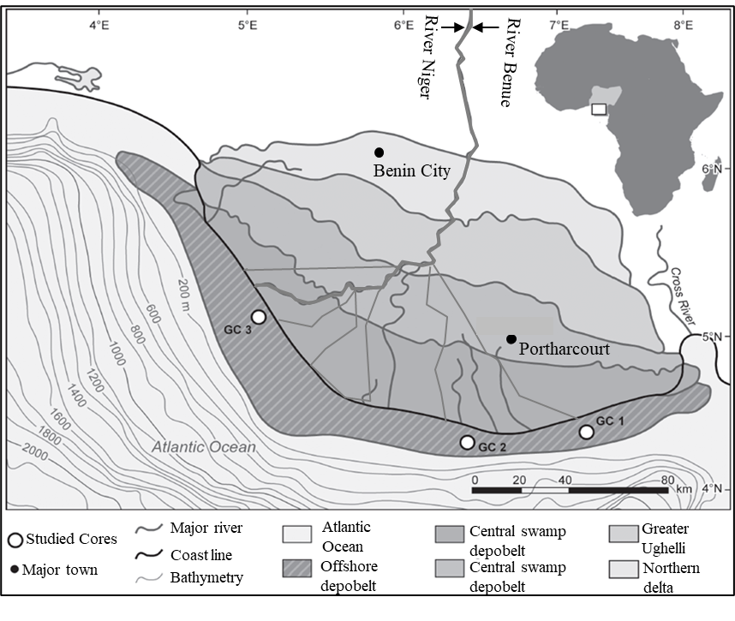
Figure 1. Map of the Niger Delta showing its location in southern Nigeria (inset) and the locations of the gravity cores (GCs). Note - The major river was formed from the confluence of Niger (North-West Nigeria) and Benue (South-West Nigeria) Rivers (modified after Adojoh et al., 2017).

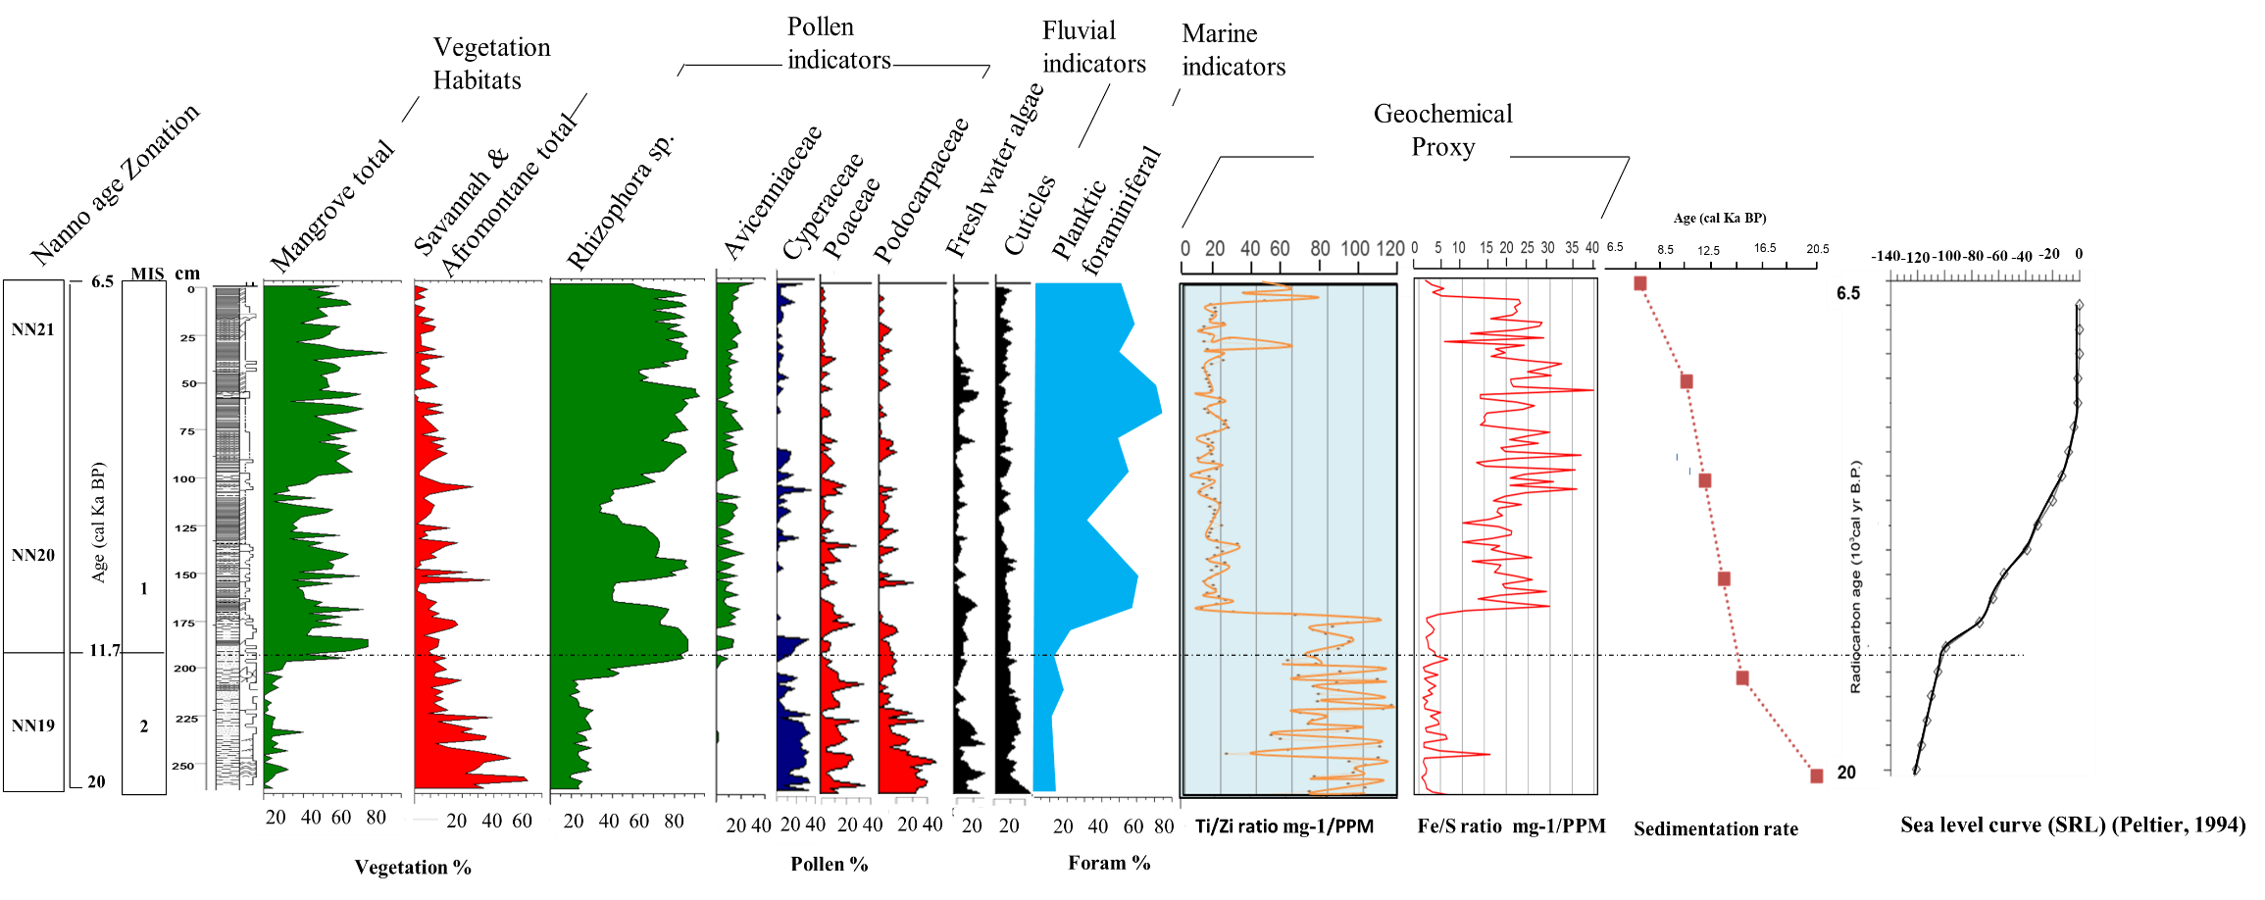
Figure 2. Vegetation, pollen, geochemical, lithological log, and sedimentation rate records in GC 1.

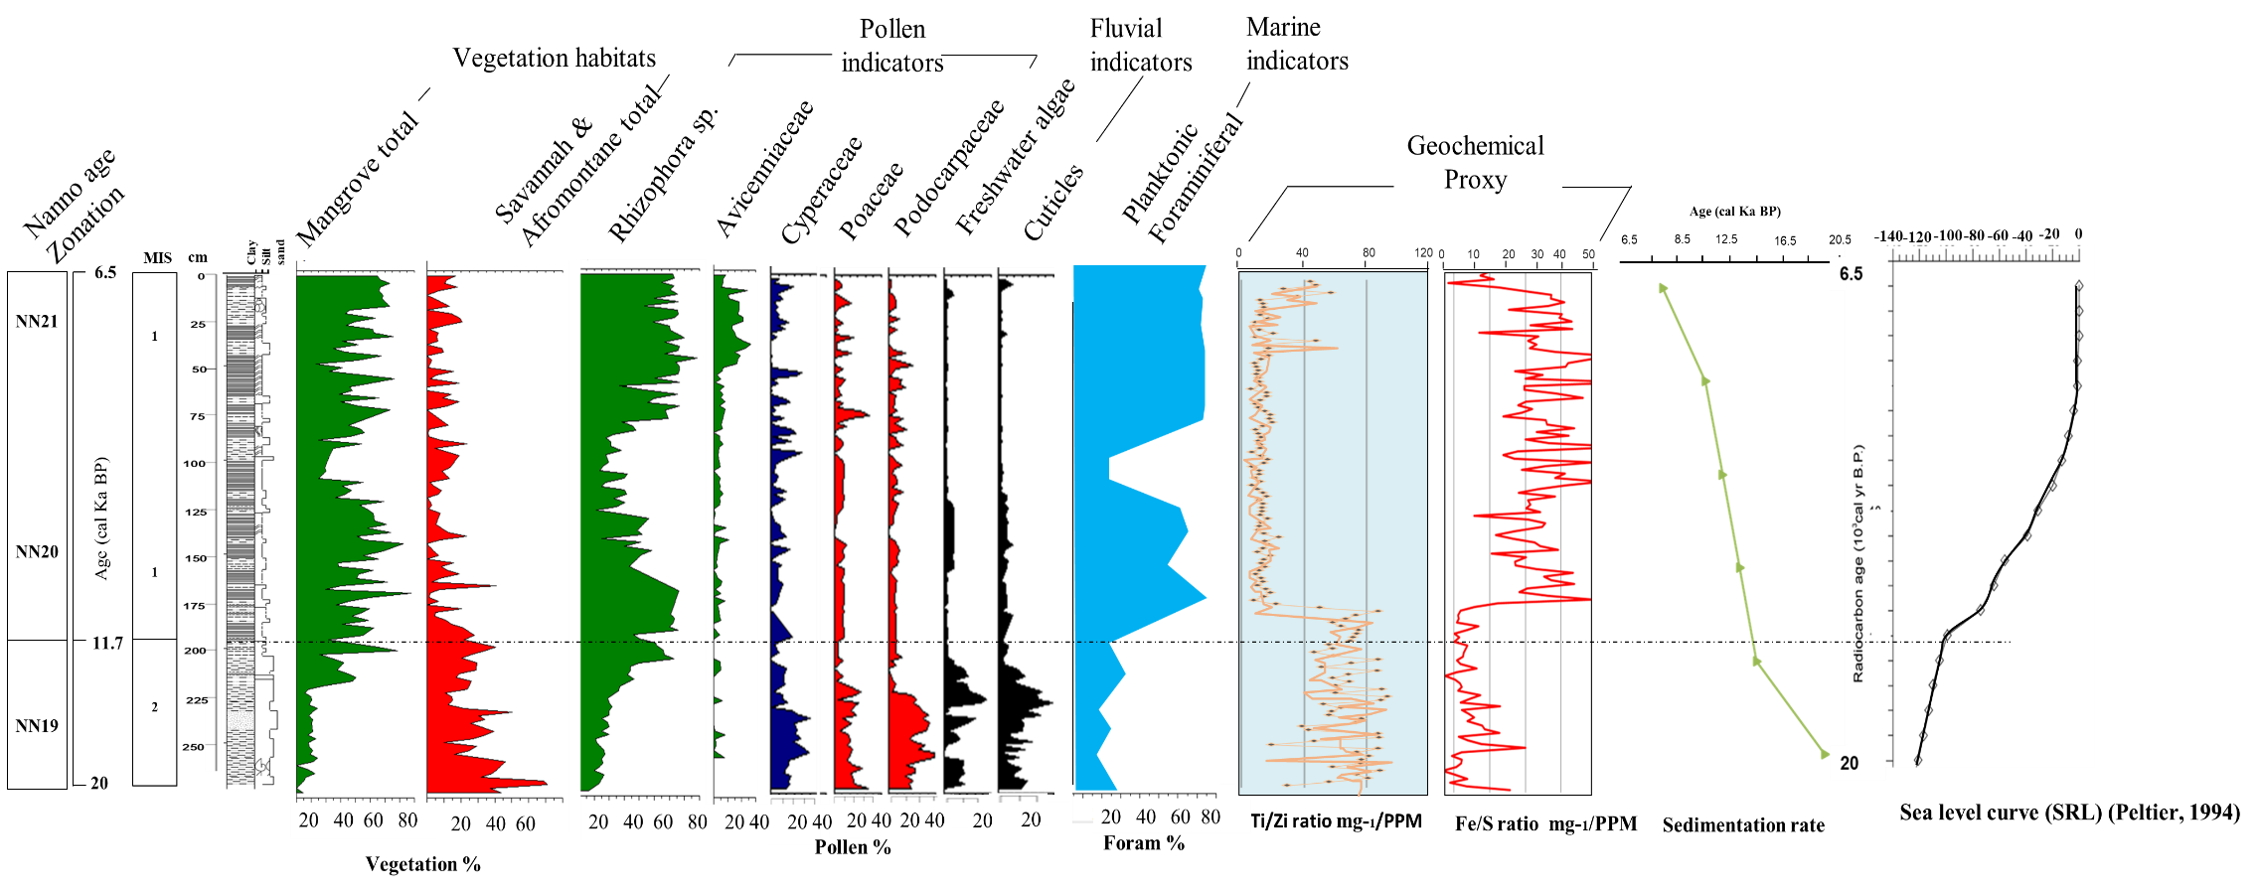
Figure 3. Vegetation, pollen, geochemical, lithological log, and sedimentation rate records in GC 1.

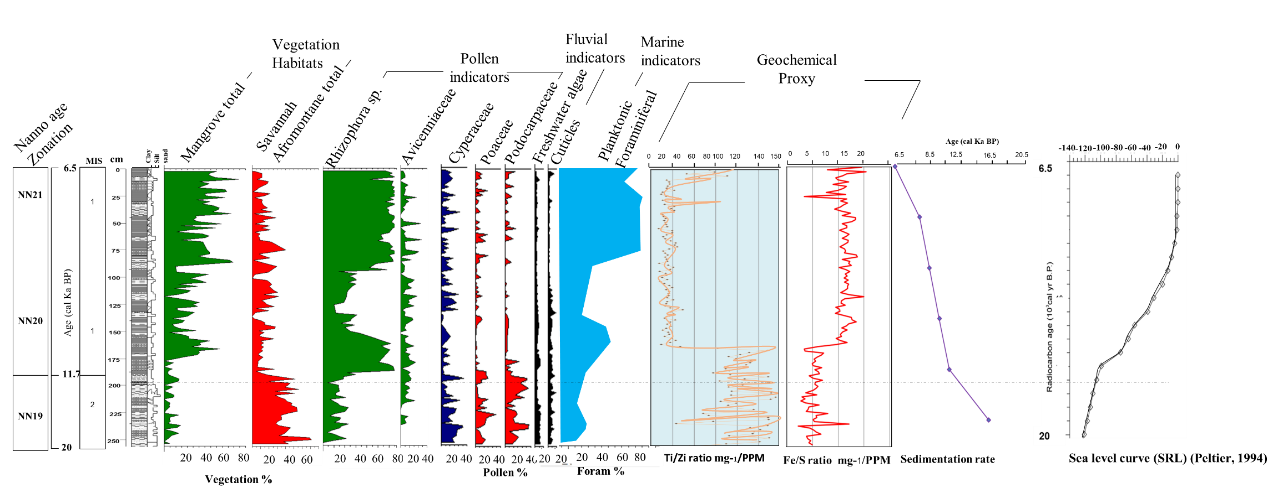
Figure 4. Vegetation, pollen, geochemical, lithological log, and sedimentation rate records in GC 1.

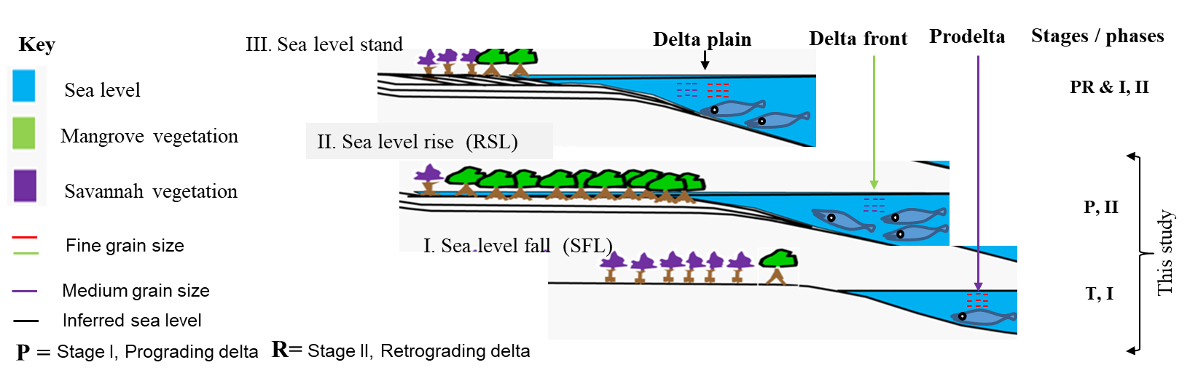

Figure 6. A model of sea level change in relation to vegetation dynamics, deltaic evolution, and sediment supply (grain size variation).

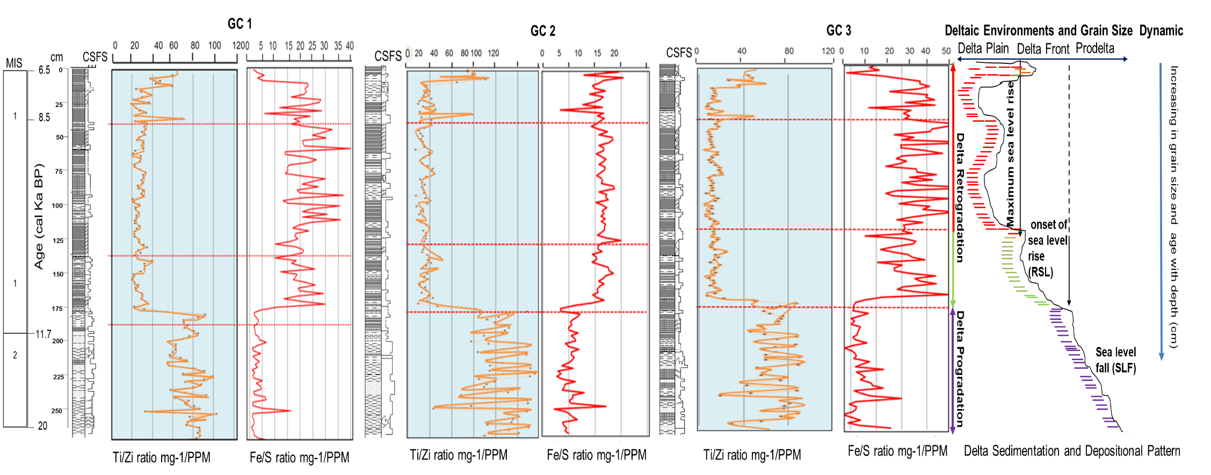
Figure 5. Sedimentary facies / lithological logs, elemental tracer ratios, grain size change, and depositional morphology / patterns record in GCs based on sea level control. (Note: Colors indicator can be referred to key-legend in figure 6). C=Clay, S= Silt, FS = Fine Sand

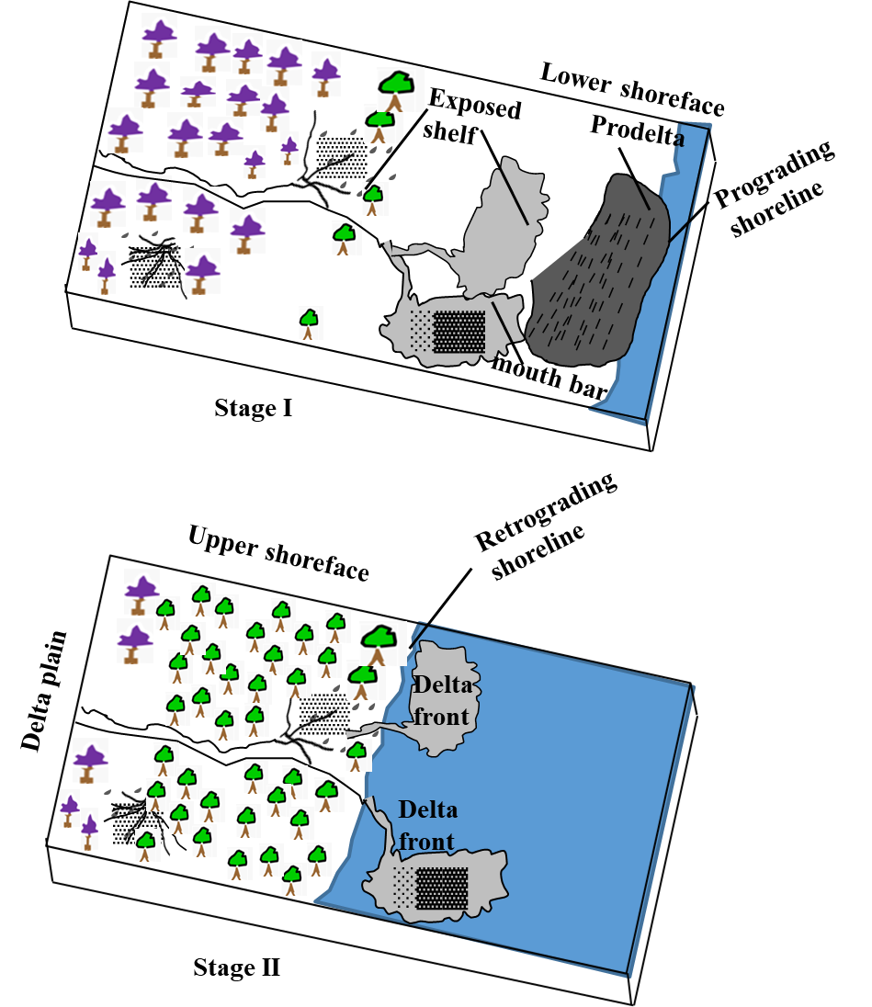

Figure 7. Two stages of vegetation dynamics, sea level change, and depositional patterns observed in Figures 3-5 modified into the landscape evolution of the Niger Delta during the Late Quaternary (last 20 ka).

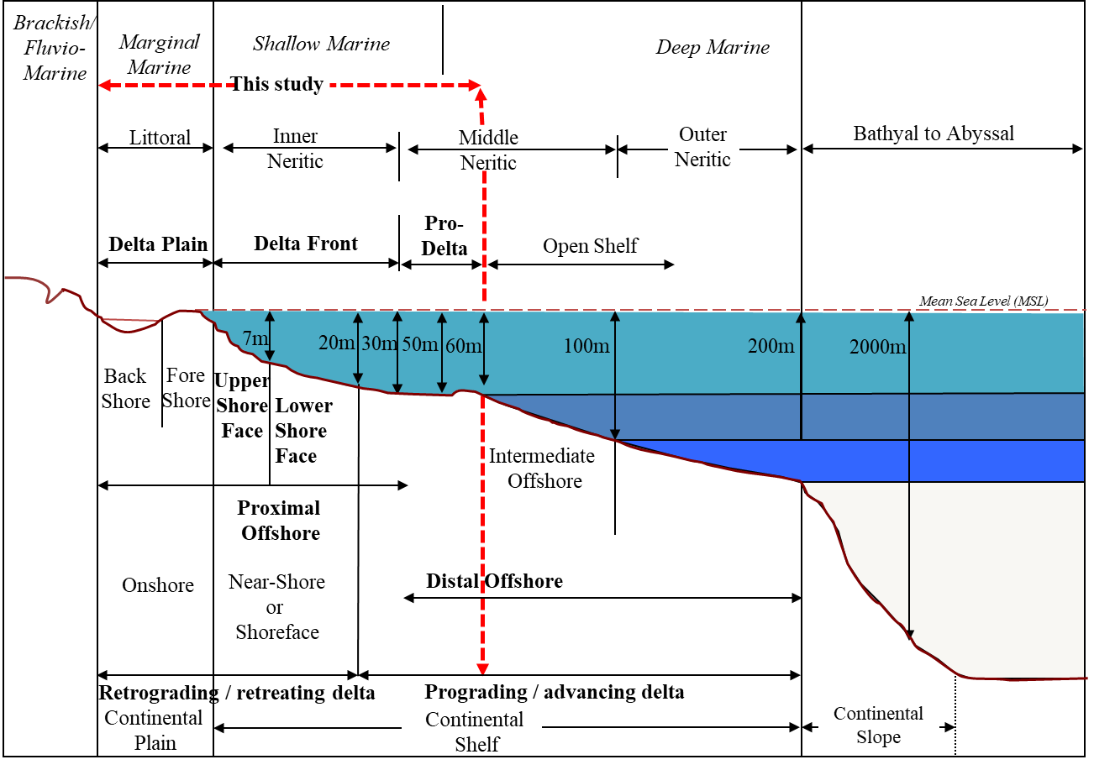
Figure 8. Gross palaeoenvironmental and stages of evolution of the Niger Delta linked to the offshore paleobathymetry as observed from microfauna ecology (planktonic foraminifera), sedimentary facies succession, and depositional patterns record in GCs. (Note: Red color delineation indicate the types of deltaic facies and environments examined in this study)

Table 1: Sedimentation rate records of the GCs. Sedimentation rate (SR, cm/kyr) is the thickness of sediment (Z, cm) that accumulates over a specified time interval (age difference) (T, kyr). Therefore, SR = Z/T where = Intervals between samples (cm); T= Age difference between samples (kyr). The first two intervals (i.e, from 11.7-8.5 + 6.5) ka were added to compute the SR result for the phase II.

Gravity Core (GC) | Age (ka) | GC1 | SR (cm/ kyr) | GC 2 | SR SR (cm/kyr) | GC3 | SR (cm/ kyr)
Depth (cm) | 6.5 | 0-40 | 6.2 | 0-40 | 6.2 | 0-40 | 6.2
Depth (cm) | 11.7 | 40-184 | 72.0 | 40-142 | 52.6 | 40-142 | 52.6
Depth (cm) | 20 | 184-272 | 9.8 | 142-266 | 13.8 | 142-260 | 13.1

