Fusobacterium necrophorum and Actinomyces spp.
MASSETER MUSCLE ABSCESSATION IN AN ADULT ALPACA:
(Marta Nieto Poza, Cajsa Isgren, Niall Connolly, Alison Talbot)
Abstract:
Background: There are few documented cases of facial abscesses linked to masseter abscess formation in South American Camelids (SAC) (Münch et al., 2020). Facial swellings in SAC have been reported and are frequently due to apical tooth root infections (Kumar et al., 2013). Herein we report a case where computed tomography was utilised in an alpaca with a facial swelling to diagnose a masseter abscess due to Fusobacterium necrophorum and Actinomyces spp.
Case presentation: An adult male alpaca was presented to the Leahurst Equine Hospital with a history of being purchased three weeks prior to referral. The new owners had detected a swelling under the right eye which was discharging purulent material. The discharge ceased after amoxicillin treatment (Betamox LA: Norbrook), however the swelling did not decrease in size. A computed tomographic examination revealed a heterogeneous soft tissue opacity (8 x 5 x 7.5 cm) below the right orbit with gas attenuation in the centre of the soft tissue swelling tracking towards the skin surface.
The mass was removed under general anaesthesia and the cavity debrided and lavaged. The histopathology of the mass revealed severe focally extensive suppurative inflammation which infiltrated and effaced the skeletal muscle (Figure 5, Figure 6, and Figure 7). These findings were consistent with an abscess of the masseter muscle. Bacterial culture of the mass identified moderate mixed growths including Fusobacterium necrophorum and Actinomyces spp. from extended cultures.
Conclusions: This case report describes the clinical signs, diagnostic procedures, and pathological findings in an adult male alpaca suffering from a masseter abscess due to Fusobacterium necrophorum and Actinomyces spp. which due to the lack of trauma history and dental disease we hypothesized was caused by either an oral mucosa penetration or dissemination of oropharyngeal infection.
Keywords: Alpaca, abscess, masseter, computer tomography examination, pathology.
Background:
Masseter abscess have been described in humans (Palonta et al., n.d.) and in horses with periapical infection of the 411 and 311 teeth (J.M.Gayle,1999) however this lesion has not previously been described in South American camelids (SACs). This case report describes the clinical signs, diagnostic procedures, and pathological findings in adult male alpaca suffering from a masseter abscess.
Case presentation
An adult alpaca was referred to the University of Liverpool Farm and Equine departments for investigation of a persistent facial swelling. The alpaca was purchased 3 weeks prior to referral and that time a mass on the right cheek just below the zygomatic arch (6 x 8 cm) was observed. The main clinical sign was discharge from the mass. The referring veterinarian treated the alpaca with amoxicillin (Betamox LA: Norbrook). The purulent discharge from the mass resolved after the course of antimicrobials however the mass did not reduce in size. A tooth root abscess was suspected; therefore, the alpaca was referred for further imaging diagnostics and treatment.
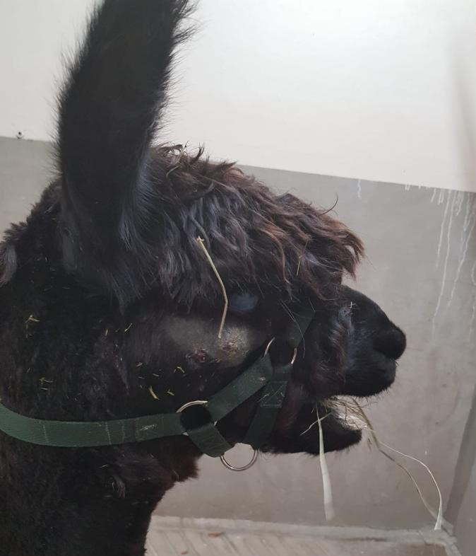
On initial physical examination, the male alpaca appeared quiet and body score condition was 7/10. Heart rate, respiratory rate and temperature were within reference ranges (Elitok & Cagdas Cirak, n.d.). Auscultation of lungs and heart were unremarkable. No abnormalities were detected at abdominal palpation and auscultation. Examination of the mass under the right eye was performed under sedation with xylazine (0.5 mg/kg). It revealed two adjacent tracts approximately 2 cm apart with evidence of purulent material at each opening.
In the right eye a corneal scar was noticed, therefore an ophthalmological examination was conducted. It revealed a ventral iris adhesion with mild neovascularisation ventrally. The alpaca had vision bilaterally, however, was too fractious to assess pupillary light response.
An indwelling intravenous jugular catheter was placed. Th
Fig.1 Adult male alpaca on initial physical examination. A large mass at the level of the right cheek below the right orbit can be appreciated.
e alpaca underwent general anaesthesia (xylazine (0.5mg/kg), thiopental (5mg/kg)) and computed tomography examination was performed in sternal recumbency. Oral examination was not conducted as it is very difficult in conscious camelids and no obvious dental, buccal, or lingual abnormalities were detected during intubation. Computed tomography examination was conducted instead of radiographs because a tooth root abscess was suspected and computed tomography would offered a superior imaging diagnostic procedure to multiple radiographs of the skull, by avoiding the superposition of teeth and tooth roots.

The computed tomographic examination revealed a large, soft tissue attenuating swelling of the right cheek which was well encapsulated and involving most of the masseter muscle. The soft tissue opacity was heterogeneous with gas attenuation in the centre of the soft tissue swelling extending towards the surface. The mass had an ovoid shape and measured 8cm (length) by 5 cm (width) and 7.5 cm (depth). There was no evidence of bone involvement such as fracture, sequestrum formation, orbital or intracranial extension, sinusitis, cortical destruction, or inflammatory odontogenic focal areas. No radiopaque foreign bodies were visible.
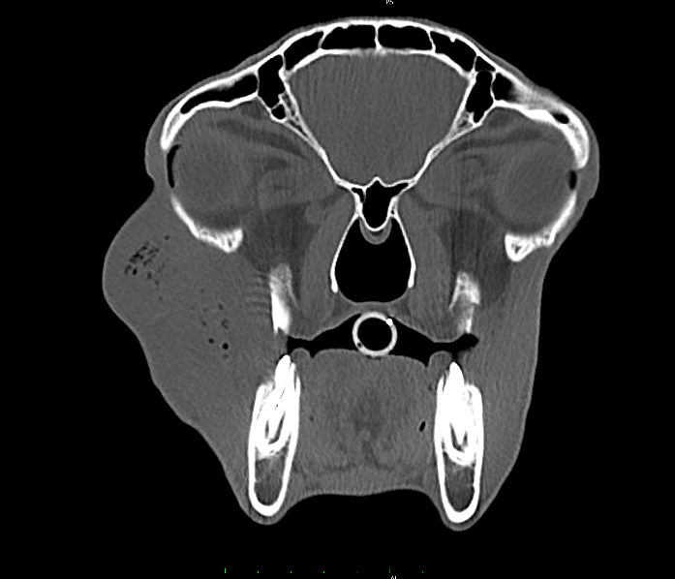
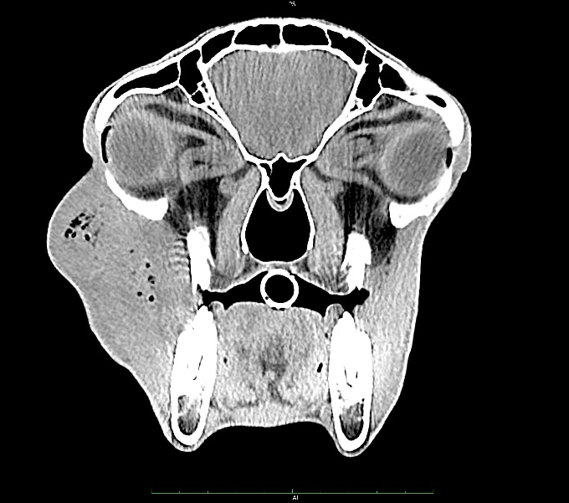

Fig.3 CT image of the head of the alpaca (bone window).
Fig.2 CT image of the head of the alpaca (soft tissue window)
After assessment of the CT images,
the alpaca was placed in left lateral recumbency and the mass was explored surgically whilst alpaca remained under general anaesthesia. The two draining tracts were joined by surgical incision. The content of the abscess did not appear adhered to surrounding tissue and upon manipulation the soft tissue masseter mass was removed in its entirety as a single solid structure (see Fig 4). Following removal, the cavity was debrided and lavaged with sterile saline. A swab soaked in manuka honey (Activion) was place in the cavity and removed 24 hours later. After surgery, the alpaca received five-day treatment of amoxicillin (Synulox: Zoetis) while culture and susceptibility results were pending. Post-operative analgesia was provided by meloxicam (Metacam: Boehringer Ingelheim at a dose of 0.5 mg/kg subcutaneously) and the cavity was flushed with sterile saline for 48 hours after the surgery. Four days after surgery a dramatic reduction of the facial swelling could be appreciated.

Histopathological examination of the mass revealed tissue composed of varying proportions of necrotic cell debris, fibrin, large numbers of degenerate neutrophils and some fibrovascular connective tissue. The inflammation infiltrated pre-existing skeletal muscle which exhibited hypereosinophilia and karyorrhexis. (Figure 4).
Bacteriology examination of the tissue resected revealed no aerobic or anaerobic bacterial growth after 24 hours; however, mixed growths of Fusobacterium necrophorum and Actinomyces spp. were obtained when cultures were extended. The antibiogram for the Actinomyces spp. is shown in table 1.
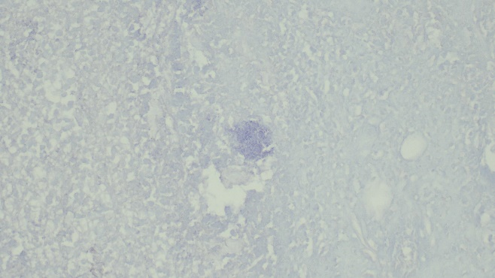

B
A

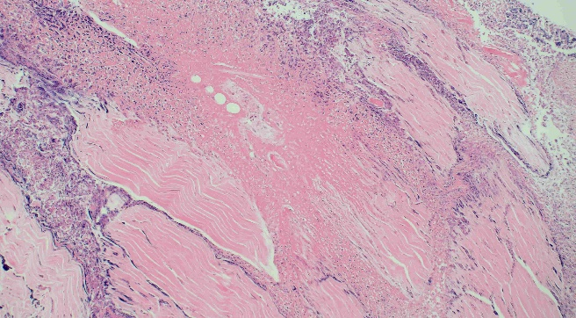
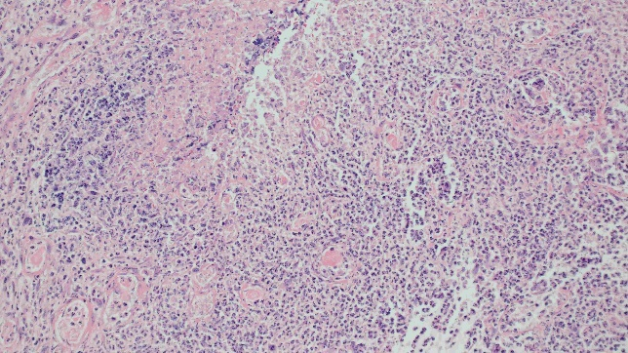

D
C

Figure 4- A) Masseter abscess removed under general anesthesia. Figures 4- B, 4-C and 4-D The histological features represented severe focally extensive suppurative inflammation which infiltrates and effaces the skeletal muscle. These findings were consistent with an abscess, however there was no clear evidence of a capsule on the sections examined.

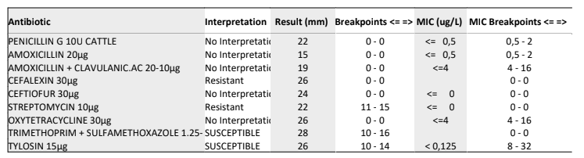

Table 1- Antibiogram Results for Fusobacterium Necrophorum

Discussion:
Dental disease has been reported as a frequent pathology among new world camelids, with tooth root abscess the most common etiology for facial swelling in South American camelids (Niehaus, 2009; Proost et al., 2020).
Masseter abscessation is an uncommon disease and has been previously reported in humans (Palonta et al., n.d.) mice (Clarke et al., 1978) and in horses with concomitant periapical infection of the 411 and 311 teeth (J.M Gayle et al, 1999).
Different diagnostic procedures are frequently used in equine medicine to detect foreign bodies such as computed tomography (CT) or ultrasound (Ogden et al., 2021).
However, a potential limitation of the CT examination is that if attenuation of the foreign body is the same as the abscess mass it will not be seen in the CT examination.
In the present case report, Fusobacterium necrophorum and Actinomyces spp., were identified from the abscess. Fusobacterium necrophorum is a Gram-negative anaerobe that can be the primary pathogen in local or systemic infectious disease.
In camelids, this bacteria can spread from different locations such as lips, pharynx, interdigital spaces, foot, larynx, mandible or maxillary bones (Carvallo et al., 2020). Oral lesions commonly affect the tongue, oral mucosa at the angle of the mandible and its adjacent soft tissue.(Roeder et al., 1989). In humans oropharyngeal infection complication can develop into Lemierre syndrome characterized of septic embolization of Fusobacterium necrophorum. This disease is characterized by metastatic foci of infection, internal jugular thrombophlebitis, and septicaemia. (Lee et al., 2020).Even though the alpaca in the present study did not have signs of septicaemia neither of internal jugular thrombophlebitis, Fusobacterium necrophorum was isolated in the masseter muscle abscess, causing a soft tissue manifestation of the disease which has been previously described in humans (Joshua D. Harris et al, 2010)

It has been reported in human medicine that despite providing appropriate antimicrobial treatment, the observed clinical response might be slow due to the endovascular infection and the antibiotics having difficulties to penetrate the fibrin clot (Riordan, 2007), however the alpaca in the current case report respond successfully to antimicrobial therapy.

It is notable that the Fusobacterium necrophorum growth reported in this study was accompanied by Actinomyces spp. These findings are like a previous study in which Actinomyces spp. and Fusobacterium necrophorum were isolated from a neck and jaw abscess in an adult alpaca (Münch et al., 2020). Despite bone lesions has been previously described in fusobacterium necrophorum soft tissue and mandible abscesses (Roeder et al., 1989), no signs of osteomyelitis were appreciated in the current alpaca. Actinomyces spp. is a Gram-positive bacillus, mainly belonging commensal flora of the oropharynx, gastrointestinal tract, and urogenital tract. Intra-masseteric abscess caused by Actinomyces spp. has been previously reported in humans (Palonta et al., n.d.) In cattle the incidence of disease is higher due to the rough forage material or ensilage that is fed. These types of feeds may injure the buccal mucosa, and predisposes the animal to ‘Lumpy jaw’, commonly manifesting as chronic osteomyelitis and rarefaction of the bones particularly mandible and maxilla (Ab Ahad et al., 2020). Based on culture and susceptibility results, amoxicillin was continued after surgical intervention as the alpaca was responsive to treatment.
The dosage regimens used for many therapeutic drugs have been extrapolated from other ruminants; however, the pharmacokinetics, in camelids, may differ from those of other species. (Kreuder et al., 2012) Several differences have already been discovered, for example antibiotics, as a rule, appear to have a longer time of action in camelids compared to domestic ruminants. There also seems to be a difference in dosing between llamas and alpacas (Pamela G. Walker, 2008).
Conclusion: This case report has acknowledged that facial swellings in SAC are not always associated with dental disease and that other diseases such as oral mucosa penetration or trauma should be taken in consideration.
Bibliography:

Ab Ahad, W., Kumar, S., Lone, H. A., Beghum, R., & Assistant Surgeon, V. (2020). Clinical Management of Bovine Actinomycosis (Lumpy Jaw) in Cattle: A Case Report. In IJESC.
Brook, I. (2003). Microbiology and management of deep facial infections and Lemierre syndrome. In ORL (Vol. 65, Issue 2, pp. 117–120).
Carvallo, F. R., Uzal, F. A., Flores, C., Diab, S. S., Giannitti, F., Crossley, B., & Wünschmann, A. (2020). Alimentary necrobacillosis in alpacas. Journal of Veterinary Diagnostic Investigation, 32(2), 339–343.
Clarke, M. C., Taylor, R. J., Hall, G. A., & Jones, P. W. (1978). The occurrence in mice of facial and mandibular abscesses associated with Staphylococcus aureus. In Laboratory Animals (Vol. 12).
Elitok, B., & Cagdas Cirak, A. (n.d.). Clinical, Hematological and Blood Biochemical Features of Camels.
Kreuder, A. J., Coetzee, J. F., Wulf, L. W., Schleining, J. A., KuKanich, B., Layman, L. L., & Plummer, P. J. (2012). Bioavailability and pharmacokinetics of oral meloxicam in llamas. BMC Veterinary Research, 8.
Kumar, A., Anderson, D., Amachawadi, R. G., Nagaraja, T. G., & Narayanan, S. K. (2013). Characterization of Fusobacterium necrophorum isolated from llama and alpaca. Journal of Veterinary Diagnostic Investigation, 25(4), 502–507.
Lee, W. sen, Jean, S. S., Chen, F. L., Hsieh, S. M., & Hsueh, P. R. (2020). Lemierre’s syndrome: A forgotten and re-emerging infection. In Journal of Microbiology, Immunology and Infection (Vol. 53, Issue 4, pp. 513–517). Elsevier Ltd.
Münch, B., Wochenschr, T., Sting, R., Schwalm, A. K., Contzen, M., Roller, M., & Rau, J. (2020). Open Access Actinomycetes associated with abscess for-mation in a goat, a llama and two alpacas.
Niehaus, A. (2009). Dental Disease in Llamas and Alpacas. In Veterinary Clinics of North America - Food Animal Practice (Vol. 25, Issue 2, pp. 281–293).
Palonta, F., Preti, G., & Vione, N. (n.d.). Actinomycosis of the Masseter Muscle: Report of a Case and Review of the Literature.
Proost, K., Pardon, B., Pollaris, E., Flahou, T., & Vlaminck, L. (2020). Dental disease in alpacas. Part 1: Prevalence of dental disorders and their mutual relationships. Journal of Veterinary Internal Medicine, 34(2), 1028–1038.
Riordan, T. (2007). Human infection with Fusobacterium necrophorum (Necrobacillosis), with a focus on Lemierre’s syndrome. In Clinical Microbiology Reviews (Vol. 20, Issue 4, pp. 622–659).
Roeder, B. L., Chengappa, M. M., Lechtenberg, K. F., Nagaraja, T. G., & Varga4, G. A. (1989). FUSOBACTERIUM NECROPHORUM AND ACTINOMYCES PYOGENES ASSOCIATED FACIAL AND MANDIBULAR ABSCESSES IN BLUE DUIKER. In Journal of Wildlife DIseases (Vol. 25, Issue 3).

