Depression and the Gender Gap in Political Interest

Christopher Ojeda (University of California, Merced)
Luca Bernardi (University of Liverpool)
Claudia Landwehr (Johannes-Gutenberg-University Mainz)

Abstract
It is well-documented that women report less interest in politics than men on average. We argue that depression—and the differential strategies used to cope with its symptoms—contribute to this persistent gender gap in political interest. While women tend to rely on rumination when experiencing depression, there is less agreement on men’s coping strategies. Depressive symptoms should thus more greatly reduce political interest among women than among men. We analyze data from the European Social Survey and the German GESIS Panel Study. We find some evidence that depressive symptoms, even those that are sub-clinical and short-lived, reduce political interest among women, but have little or no effect on the political interest of men. These findings have implications for political and gender equality, especially with the rising prevalence of depression around the world, and contribute to our understanding of the impact of depression on political engagement.

Keywords: political interest, gender, depression, mental health, political inequality

Version accepted for publication in Electoral Studies on 8th February 2023.
It is well-documented that women report less interest in politics (Burns et al. 2001; Verba et al. 1997; Welch 1997). This worldwide gender disparity is troubling because it reflects and reinforces a political sphere that lacks female role models, portrays politics as a man’s game, and ultimately diminishes the voices of women (Schneider and Bos 2019). As the political scientists Fraile and Gomez note, “If women systematically have lower levels of political interest than men, this may result in a clear disadvantage in women’s capacity to voice their political wants and needs, and thus to influence the political decision-making process.” (2017, p. 601). Some studies indicate the gap is narrower than once thought—finding that women report similar levels of interest about local politics (Coffé 2013; Stolle and Gidengil 2010) and are interested in different areas of politics (Ferrín et al. 2020).
We contribute to the study of the gender gap in political interest by highlighting depressive symptoms as one important explanation. Depression—a debilitating mental health condition that is growing worldwide (Hidaka 2012)—is highly stratified by gender. The psychologist Hammen has even referred to the “female sex as a major risk factor for depression” (2018, p. 16). Estimates from the United States put the lifetime incidence of depression at 21.3% for women but only 12.7% for men (Kessler et al. 1993), while a study of Europe finds a similar gap (Van de Velde et al. 2010). These statistics, coupled with the fact that many more people suffer from symptoms that do not reach a clinical threshold, highlight the potency of depressive symptoms as an explanatory variable. By bringing depression into greater focus, we add to a budding literature on how psychological resources may shape gender differences in political behavior (Wolak 2020).
We argue in this research note that depression dampens political interest, such that gender disparities in depression can account for some of the gap in political interest. This would be especially troubling if, as we hypothesize, the effect of depression on political interest is stronger for women than men. We test our arguments using the European Social Survey and the German GESIS Panel Study. Our results indicate that depressive symptoms moderately reduce the political interest of women but have mixed effects on the political interest of men on average and across studies. We also find that even short-lived episodes are consequential to the political interest of women. Overall, the small or inconsistent effects observed here are not entirely discouraging and contribute to our wider understanding of the impact of depression on core political attitudes (Bernardi and Gotlib 2022; Bernardi et al. 2022).

Hypotheses
Depressive symptoms entail feelings of apathy, hopelessness, helplessness, anhedonia, negative self-evaluations, internalization of personal failures, and pessimism about the future (Beck 1976; Seligman et al. 1979). Apathy may be especially consequential to political interest, creating the belief that politics is irrelevant or beyond one’s control. There are thus good reasons to suspect that feeling depressed reduces interest in politics, irrespective of gender. We call this the general depression hypothesis. If depressive symptoms reduce political interest for everyone then this alone would mean more women are affected, given that more women experience depression. Indeed, as we previously noted, one of the most robust findings in psychopathology is that women, irrespective of nationality, culture, or ethnicity, are twice as likely to experience major depressive disorder at some point in their lifetime compared to men (Piccinelli and Wilkinson 2000). Although the precise ratio varies across countries (Van de Velde et al. 2010), the gender gap in depression is commonly called the “2:1 ratio” and is also observed in less severe disorders, such as chronic minor depression and dysthymia, and in subclinical depressive symptoms (Kessler 2003; Salk, Hyde, and Abramson 2017).
We next turn to the possibility that depressive symptoms matter more if they are persistent, that is, if there is some accumulation of symptoms over time. If depression creates a negative thought spiral in which the mind is gradually captured by negativity (Beck 1976) and lack of reactivity to pleasurable stimuli (Pizzagalli 2014), then interest in politics may continually diminish while symptoms persist. We call this the persistent symptoms hypothesis. If the persistence of symptoms magnifies their negative effect on political interest, this could contribute to the gender gap in interest to the extent women experience more chronic or recurring depression. There is mixed evidence on whether women experience recurring or chronic depression more than men, with some studies finding no difference (Kessler et al. 1993) and others finding women more affected (Stefansson et al. 1994); no studies suggest that men have more persistent symptoms.
Moreover, depression has been found to affect women differently than men. Turning to the question of how sufferers cope with depressive symptoms, gender differences in coping strategies are well-documented (Piccinelli and Wilkinson 2000) and have origins in the gender intensification process of early adolescence (Wichstrøm 1999). Rumination is a coping strategy that consumes cognitive resources by fixating attention on depressed feelings. As the psychologist Susan Nolen-Hoeksema explains, rumination “can include sitting alone and thinking how tired and unmotivated you feel, worrying that your depression will interfere with your job, and passively reviewing all the things wrong in your life” (1990, p. 82). A recent meta-analysis confirms that this strategy is common among women but less so among men (Johnson and Whisman 2013), possibly to the detriment of women’s political interest. Rumination thus seems especially likely to dampen political interest given how it monopolizes information processing.
There is less agreement on the typical coping strategies of men. Some studies highlight externalizing symptoms (e.g., Real 1998; Lynch and Kilmartin 1999; Cochrane and Rabinowitz 2000), arguing that “rather than appearing sad, men experiencing emotional pain are more likely to react with anger, self-destructive behavior, self-distraction, or numbing of pain with substance use, gambling, womanizing, and workaholism” (Martin et al. 2013: 1101). Other studies identify avoidant behavior as a coping strategy (Addis 2008), stating that “gender socialization can direct some men to withhold or restrict emotional expression” (Martin et al. 2013: 1101). However, there is mixed evidence that men employ these strategies more (e.g., Ottenbreit and Dobson 2004) and more clinical research is needed to establish gender differences in coping strategies other than rumination.
The pervasive role of rumination among women compared to men leads us to think that the deleterious consequences of depression for political interest may be amplified among women. Although we cannot test it directly with our data, we call this argument the gender disparity hypothesis. Importantly, this argument does not imply that the political interest of men is unaffected by depression; rather it merely states that depressed women would be more affected because of a greater reliance on a coping strategy that draws their attention away from the sociopolitical world and to depressed feelings.

Methodology
We use data from the European Social Survey (ESS) and the German GESIS Panel Study (GESIS). The ESS is a nationally representative survey of individuals living in Europe and Israel. We use the waves from 2006 and 2012 because they include measures of depressive symptoms and political interest. These data test the general depression and gender disparity hypotheses. The GESIS Panel Study (GESIS) is an online and mail panel study of German-speaking adults residing in Germany (Bosnjak et al. 2017). Conducted annually since 2013, we focus on three waves from 2014-2016 which include measures of depressive symptoms and political interest. The GESIS data tests all three hypotheses. We briefly describe the variables below. Appendix A provides a detailed description of all variables. Appendix B reports the descriptive statistics for all variables.
Depressive symptoms are measured using abridged versions of the Center for Epidemiological Studies Depression (CES-D) instrument (Radloff 1977; Siddaway et al. 2017), asking respondents about eight symptoms. We generate a measure of contemporaneous symptoms—symptoms measured at the same time as political interest—by taking the mean of the responses to each item for each respondent. In the GESIS, we generate a measure of persistent symptoms as the mean across all preceding waves. We leave both scales in their continuous forms because we are interested in the effect of depressive symptoms, whether clinical or subclinical.
Appendix C reports the validity of the abridged scales, inter-item correlations, a factor analysis of the scale’s dimensionality, a discussion of diagnoses versus self-reported symptoms, and a discussion of potential response bias across genders. Although speculation that men underreport depressive symptoms is commonplace (e.g., Addis 2008), experimental research finds minimal evidence of underreporting when questions are asked covertly (Hunt, Auriemma, and Cashew 2003) and without the possibility of a clinical check-up (Sigmon et al. 2005). Given that our questions are neither overt nor refer to psychiatry, we believe they minimize the risk of underreporting. In the surveys, respondents self-identify as either male or female.
We test the general depression hypothesis using contemporaneous depressive symptoms as the key predictor and the persistent symptoms hypothesis using persistent depressive symptoms as the key predictor. If the hypotheses are supported, then the coefficients for depressive symptoms should be negative and statistically significant, with the one on persistent symptoms larger than the one on contemporaneous symptoms. We expand these models to test the gender disparity hypothesis by adding an interaction term between gender and depressive symptoms; if the hypothesis is supported, then the coefficient for the interaction term should be negative and statistically significant. We conclude our analysis by presenting the results of mediation models that estimate how much of the gender gap in political interest can be explained by symptoms of depression.
The ESS models are ordinal logistic regressions that include probability weights, country-level fixed effects, and a year variable. The GESIS models are ordinary least squares regressions that include individual-level fixed effects. All models include control variables that account for alternative explanations. We account for socialization theories using age and the presence of traditional values. Traditional values are measured as the importance of religious and familial customs in the ESS and as belief in traditional gender roles in the GESIS. We account for situational theories by controlling for socioeconomic status (education, income, employment status), potential caretaking responsibilities (marital status, child in the household), and social capital (social activity, religious attendance, union membership). We account for context in the ESS through country-level variables, including gender inequality, the disproportionality of representation, income inequality, GDP per capita, and the unemployment rate.

Results
Figure 1 reveals that women have less interest and more depressive symptoms than men in the ESS. Interest for women is 2.24 (vs. 2.50 for men) while symptoms are 1.94 (vs. 1.81 for men). The GESIS is similar: interest is 2.86 for women (vs 3.38 for men), contemporaneous symptoms are 2.74 for women (vs. 2.65 for men), and persistent symptoms are 2.74 for women (vs. 2.65 for men). T-tests confirm that these differences are statistically significant.
Figure 1: Gender Differences in Political Interest and Depressive Symptoms in the ESS

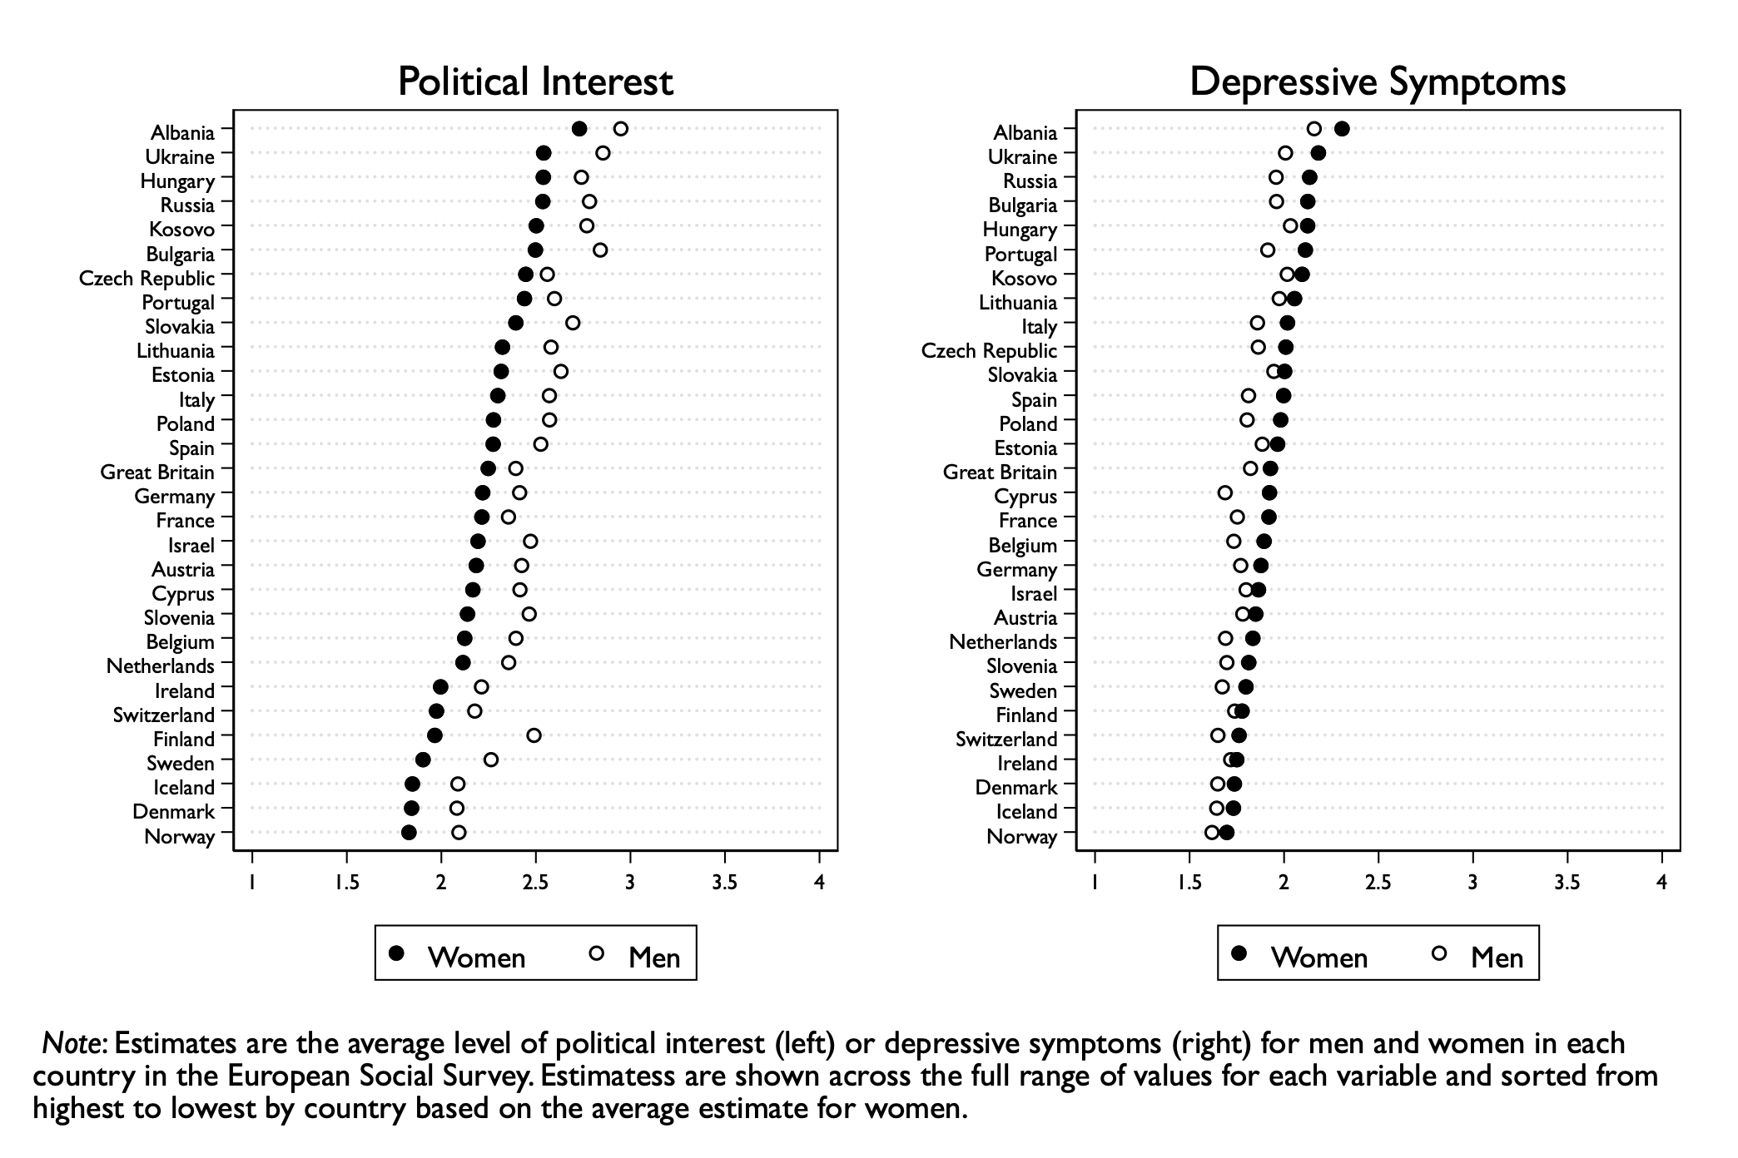
The results for the key variables in our regression models are reported in Table 1. Appendix D reports the full results. The negative and statistically significant coefficients for contemporaneous symptoms in Model 1 (ESS) and Model 2 (GESIS) provide support for the general depression hypothesis. As depressive symptoms increase, political interest decreases. Model 3 (GESIS) replaces contemporaneous symptoms with persistent symptoms and reveals a negative and statistically significant effect on political interest. Although the coefficient for persistent symptoms is twice as large as the coefficient for contemporaneous symptoms in Model 2, the difference in coefficient sizes is not statically significant. We report the results of this test in Appendix E. In short, we can’t be sure that persistent symptoms have a stronger effect on political interest than contemporaneous symptoms. Overall, this result does not support the persistent symptoms hypothesis.
The final three models in Table 1 test the gender disparity hypothesis. In Model 4 (ESS), the coefficient for the depressive symptoms term represents the effect for men (i.e., when the “woman” variable is equal to 0); it is negative but not statistically significant. The interaction term indicates the difference in the effect of depressive symptoms between men and women; the coefficient is negative and statistically significant. Altogether, these results suggest that depressive symptoms reduce the political interest of women but not men. In contrast, the GESIS results in Model 5 (contemporaneous symptoms) and Model 6 (persistent symptoms) indicate that there is not a statistically significant difference in how depressive symptoms affect men and women; depressive symptoms reduce political interest equally. However, in Appendix F, we re-estimate the GESIS models using random-effects and find a negative and statistically significant coefficient for the corresponding interaction terms; these results suggest the negative effects of depressive symptoms are greater for women. Overall, these results provide mixed support for the gender disparity hypothesis.

Table 1: Multivariate Regression Models of Political Interest on Depressive Symptoms
Tested Hypothesis: | General  Depression |  |  | Persistent  Symptoms |  | Gender  Disparity
 | (1)  ESS | (2)  GESIS |  | (3)  GESIS |  | (4)  ESS | (5)  GESIS | (6)  GESIS
Contemporaneous Symptoms | -0.098*  (.020) | -0.040*  (.014) |  |  |  | -0.050  (.030) | -0.043*  (.021)
Persistent Symptoms |  |  |  | -0.080*  (.030) |  |  |  | -0.091*  (.043)
Woman | -0.512*  (.017) |  |  |  |  | -0.364*  (.073)
Symptoms X Woman |  |  |  |  |  | -0.082*  (.039) | 0.005  (.028) | 0.022  (.059)
Observations | 48,572 | 7,440 |  | 7,523 |  | 48,572 | 7,440 | 7,523
Note: * p < 0.05. The dependent variable in all models is political interest. Results are estimated coefficients from ordinal logistic regressions with standard errors in parentheses; control variables are suppressed for presentation purposes. Full results are reported in Appendix D. Coefficients for gender are not reported in the GESIS fixed-effects models since it is time-invariant.

How do these results translate into actual levels of political interests? Figure 2 plots the predicted probability of each response to the political interest question across values of depressive symptoms using ESS results from Model 1. The results show how political interest changes substantively as depression increases—going from no symptoms to full-blown symptoms corresponds to a 3.5-point for not at all interested, a 3.5-point increase for hardly interested, a 5-point decrease for quite interested, and a 3-point decrease for very interested. Using the GESIS results from Model 3, the expected value of political interest changes from 3.30 (out of 6) to 2.91 (out of 6) going from no to full-blown persistent symptoms.
Figure 2: Predicted Probability of Political Interest for Everyone
across Contemporaneous Symptoms in the ESS
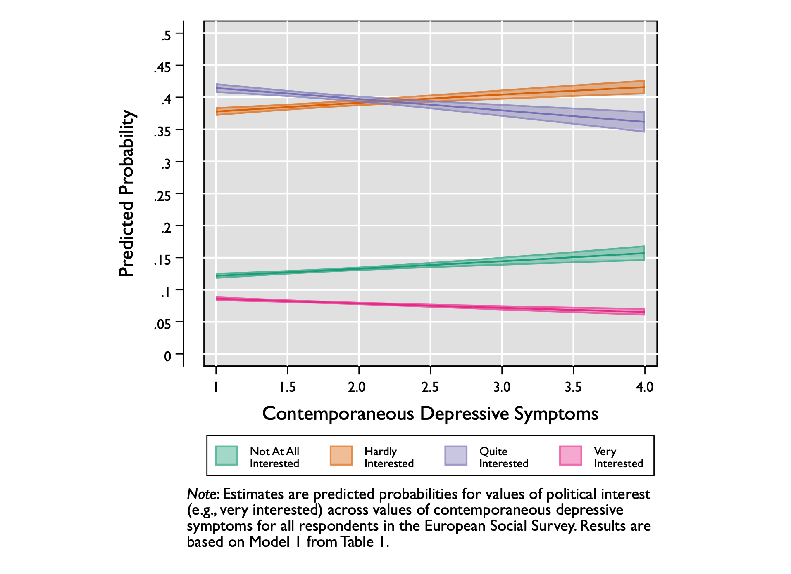
Figure 3 plots the predicted probabilities of political interest across depressive symptoms for men and women using the ESS results of Model 5. The panels going from left to right show the predicted probability of reporting each response option. The probability of being interested “none of the time” changes across symptoms from 0.09 to 0.11 for men and from 0.14 to 0.21 for women. The probability of reporting “most of the time” has an inverse pattern with shifts from 0.46 to 0.43 for men and from 0.38 to 0.30 for women. The changes for women and men are parallel for the other two categories; the greater shift in the political interest of women (relative to men) is in the categories of “none of the time” and “most of the time.” The confidence interval increases at higher levels of symptoms because fewer respondents cluster at this end of the scale.

Figure 3: Predicted Probability of Political Interest for Women and Men
across Contemporaneous Symptoms in the ESS
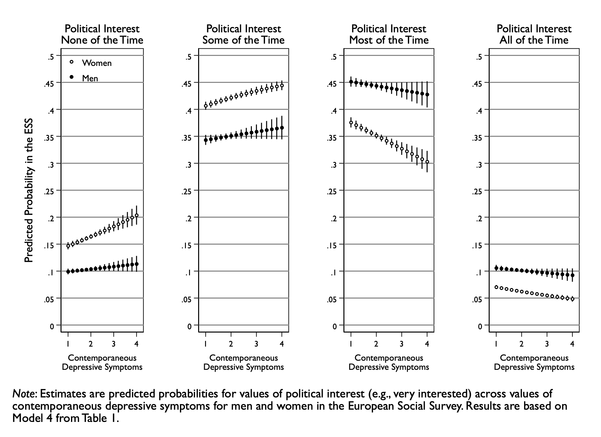
We conduct a series of robustness checks to ensure our findings are not an artifact of the analytic strategy or model specification. Appendix G reveals that these associations hold in the absence of control variables. Appendix H shows the results are unaffected by using an ordinary least squares estimator. Appendix I shows our results are unaffected when estimating the models separately by gender. Appendix J shows our results are unaffected by using a binary depressed/not depressed variable. Appendix K shows gender differences in how depressive symptoms shape political interest are consistent across countries and cultural regions of Europe, with women largely being more negatively affected than men. Appendix L reports analyses of individual symptoms and reveals consistent results across gender.
Finally, we turn to the mediation models to estimate how much of the gender gap in political interest can be explained by depression, both because of its greater prevalence and stronger impact on political interest among women. The results from the ESS analysis indicate that depressive symptoms account for about 3% of the gap on average. The results of the GESIS analysis indicate a much smaller mediated effect—less than 1% when using either contemporaneous or persistent symptoms. In contrast, if we reanalyze the ESS data using only German respondents to make it comparable to the GESIS, the results show that nearly 5% of the gender gap in political interest is accounted for by depressive symptoms. Appendix M reports the full results from these mediation analyses. Altogether, the findings indicate that depressive symptoms mediate a small but non-trivial portion of the gap.

Conclusion
This paper highlighted depressive symptoms as an explanation for the persistent gender gap in political interest. Even though the biographies and living conditions of women and men have become far more similar in developed democracies over the last 50 years, differences in political attitudes and behavior, and most notably, political interest, persist. Given the crucial role of political interest in motivating participation and the fact that depression inhibits participation (Landwehr and Ojeda 2021), we set off to explore whether depression undermines political interest in women.
Drawing on data from the ESS, a large study of European countries, as well as longitudinal data from the German GESIS panel, we tested three hypotheses: first that depressive symptoms reduce political interest, secondly that symptoms are more potent when persistent, and thirdly that symptoms affect the interest of women more strongly. Our analysis provides support for the general depression hypothesis, mixed support for the gender disparity hypothesis, and no support for the persistent symptoms hypothesis. We thus conclude that even subclinical and short-lived depressive symptoms can dampen political interest, perhaps more so for women than men. The finding against the persistent symptoms hypothesis may actually lend greater support to our argument that differences in coping strategies account for the gender differences we observe. If coping strategies are applied as symptoms are experienced, then we would expect rumination to dampen political interest irrespective of whether symptoms have persisted over time. What is more, our estimation may be rather conservative, because sufferers of clinical depression are less likely to participate in surveys and we may thus assume that the negative effects of depression on political interest are even stronger in this group. Despite our robustness checks, we cannot however fully rule out the possibility that men under-report depressive symptoms and over-report their political interest because of social desirability bias.
Overall, although we could not test here for the effect of rumination directly, our results have a great potential to help explain the lower political interest of women, which may considerably reduce the extent to which women make use of their political voice options. We thus need to reflect on the ways in which millennia of gender oppression continue to further the development of depressive mood disorders in women. Social norms still tend to require women to be gentle and caring rather than demanding and angry. If women’s learned strategies in coping with negative emotions therefore prevent them from externalizing these, this means that in societies still in many respects stacked against them, women will on average be less likely have their voices heard and interests considered in politics.
Researchers studying political behavior and/or gender equality should thus take depressive symptoms seriously as a determinant of political attitudes and participation and as a potential explanatory factor for the gender differences found here. Although the effects observed in our study are not huge, future analyses can and should further explore the mediating role of coping/emotion regulation strategies (see Bernardi et al. 2022). The significance of cultural differences regarding gender stereotypes and the social acceptance of depression should also be further studied to fully understand the political consequences of men’s and women’s mental health.
References

Addis, Michael E. 2008. “Gender and depression in men.” Clinical Psychology: Science and Practice 15(3): 153–168.
Beck, Aaron T. 1976. Cognitive Therapy and the Emotional Disorders. New York: International Universities Press.
Bernardi, Luca, Mikko Mattila, Achillefs Papageorgiou, and Lauri Rapeli. 2022. “Down But Not Yet Out: Depression, Political Efficacy, and Voting.” Political Psychology. EarlyView.
Bernardi, Luca, and Ian H. Gotlib. 2022. “COVID-19 stressors, mental/emotional distress and political support.” West European Politics EarlyView.
Bosnjak, Michael, Tanja Dannwolf, Tobias Enderle, Ines Schaurer, Bella Struminskaya, Angela Tanner, and Kai W. Weyandt. 2018. “Establishing an Open Probability-Based Mixed-Mode Panel of the General Population in Germany: The GESIS Panel.” Social Science Computer Review 36 (1): 103–15.
Burns, Nancy, Kay Lehman Schlozman, and Sidney Verba. 2001. The Private Roots of Public Action. Cambridge: Harvard University Press.
Cochran, Sam V., and Fredric E. Rabinowitz. 2000. Men and depression: Clinical and empirical perspectives. San Diego, CA: Academic Press.
Coffé, Hilde. 2013. “Women Stay Local, Men Go National and Global? Gender Differences in Political Interest.” Sex Roles 69 (5): 323–38.
Ferrín, Monica, Marta Fraile, Gema M. Garía-Albacete, Raul Gómez. 2020. “The Gender Gap in Political Interest Revisited.” International Political Science Review 41(4): 473-489.
Fraile, Marta, and Raul Gomez. 2017. “Bridging the Enduring Gender Gap in Political Interest in Europe: The Relevance of Promoting Gender Equality.” European Journal of Political Research 56 (3): 601–18.
Hammen, Constance. 2018. “Risk Factors for Depression: An Autobiographical Review.” Annual Review of Clinical Psychology 14 (1): 1–28.
Hidaka, Brandon H. 2012. “Depression as a Disease of Modernity: Explanations for Increasing Prevalence.” Journal of Affective Disorders 140 (3): 205–14.
Hunt, Melissa G., Joseph Auriemma, and Ashara C. A. Cashaw. 2003. “Self-Report Bias and Underreporting of Depression on the BDI-II.” Journal of Personality Assessment 80 (1): 26–30.
Johnson, Daniel P., and Mark A. Whisman. 2013. “Gender differences in rumination: A meta-analysis.” Personality and Individual Differences 55 (4): 367-374.
Kessler, Ronald C. 2003. “Epidemiology of women and depression.” Journal of Affective Disorders 74: 5–13.
Kessler, Ronald C., Katherine A McGonagle, Marvin Swartz, Dan G. Blazer, and Christopher B. Nelson. 1993. “Sex and Depression in the National Comorbidity Survey I: Lifetime Prevalence, Chronicity and Recurrence.” Journal of Affective Disorders 29 (2): 85–96.
Landwehr, Claudia, and Christopher Ojeda. 2021. “Democracy and Depression: A Cross-National Study of Depressive Symptoms and Nonparticipation.” American Political Science Review 115 (1): 323-330.
Lynch, John, and Christopher Kilmartin. 1999. The Pain Behind the Mask: Overcoming Masculine Depression. New York, NY: Haworth Press.
Martin, Lisa A., Harold W. Neighbors, and Derek M. Griffith. 2013. “The experience of symptoms of depression in men vs women: Analysis of the national comorbidity survey replication.” JAMA Psychiatry 70(10): 1100–1106.
Nolen-Hoeksema, Susan. 1990. Sex Differences in Depression. Stanford: Stanford University Press.
Ottenbreit, Nicole, and Keith Dobson. 2004. “Avoidance and Depression: The Construction of the Cognitive-Behavioral Avoidance Scale.” Behaviour Research and Therapy 42 (3): 293–313.
Piccinelli, Marco, and Greg Wilkinson. 2001. “Gender Differences in Depression: Critical Review.” The British Journal of Psychiatry 177 (6): 486–92.
Pizzagalli, Diego. 2014. “Depression, Stress, and Anhedonia: Toward a Synthesis and Integrated Model.” Annual Review of Clinical Psychology 10 (1): 329–423.
Radloff, Lenore Sawyer. 1977. “The CES-D Scale: A Self-Report Depression Scale for Research in the General Population.” Applied Psychological Measurement 1 (3): 385–401.
Real, Terrance. 1998. I Don’t Want to Talk About It: Overcoming the Secret Legacy of Male Depression. New York: Scribner.
Salk, Rachel H., Janet S. Hyde, and Lyn Y. Abramson. 2017. “Gender Differences in Depression in Representative National Samples: Meta-Analyses of Diagnoses and Symptoms.” Psychological Bulletin 143 (8): 783–822.
Schneider, Monica C., and Angela L. Bos. 2019. “The Application of Social Role Theory to the Study of Gender in Politics.” Advances in Political Psychology 40 (Suppl. 1): 173–213.
Seligman, Martin E., Lyn Y. Abramson, Amy Semmel, and Carl von Baeyer. 1979. “Depressive Attributional Style.” Journal of Abnormal Psychology 88 (3): 242–47.
Siddaway, Andy P., Alex M. Wood, and Peter J. Taylor. 2017. “The Center for Epidemiologic Studies-Depression (CES-D) Scale Measures a Continuum from Well-Being to Depression: Testing Two Key Predictions of Positive Clinical Psychology.” Journal of Affective Disorders 213 (15): 180–86.
Sigmon, Sandra T., Jennifer J. Pells, Nina E. Boulard, Stacy Whitcomb-Smith, Teresa M.
Edenfield, Barbara A. Hermann, Stephanie M. LaMattina, Janell G. Schartel, and
Elizabeth Kubik. 2005. “Gender Differences in Self-Reports of Depression: The Response Bias Hypothesis Revisited.” Sex Roles 53: 401-411.
Stefànsson, J. G., E. Lindal, J.K. Bjornsson, and A. Guomundsdottir. 1994. “Period prevalence
rates of specific mental disorders in an Icelandic cohort.” Social Psychiatry and Psychiatric Epidemiology 29: 119–125.
Stolle, Dietlind, and Elisabeth Gidengil. 2010. “What Do Women Really Know? A Gendered Analysis of Varieties of Political Knowledge.” Perspectives on Politics 8 (1): 93–109.
Velde, Sarah Van de, Piet Bracke, and Katia Levecque. 2010. “Gender Differences in Depression in 23 European Countries. Cross-National Variation in the Gender Gap in Depression.” Social Science & Medicine 71 (2): 305–13.
Verba, Sidney, Nancy Burns, and Kay Lehman Schlozman. 1997. “Knowing and Caring about Politics: Gender and Political Engagement.” The Journal of Politics 59 (4): 1051–72.
Welch, Susan. 1977. “Women as Political Animals? A Test of Some Explanations for Male-Female Political Participation Differences.” American Journal of Political Science 21 (4): 711–30.
Wichstrøm, Lars. 1999. “The Emergence of Gender Difference in Depressed Mood during Adolescence: The Role of Intensified Gender Socialization.” Developmental Psychology.
Wolak, Jennifer. 2020. “Self-Confidence and Gender Gaps in Political Interest, Attention, and Efficacy.” Journal of Politics 82(4): 1490-1501.

