Page Number | Contents
2 | Supplementary Methods
5 | Table S1a: Demographics at baseline for those recovering from COVID-19 (whole cohort) vs the controls used to derive reference ranges (median [IQR] or count [%]).
6 | Table S1b: Reference ranges for MRI metrics.
8 | Table S2: Differences in organ impairment and symptoms by COVID-19 diagnosis method for the whole cohort at baseline
10 | Table S3: Baseline characteristics of individuals with organ impairment identified at baseline, eligible for follow-up (the follow-up group) vs those without impairment, who were only invited for the baseline visit
11 | Table S4: Characteristics for individuals with long COVID (whole cohort) at baseline, comparing those with common symptoms (systemic, cardiopulmonary, severe breathlessness, cognitive dysfunction, poor health related quality of life) and those with less common symptoms.
13 | Table S5: Blood investigations in the whole cohort and the follow-up group of individuals with long Covid.
15 | Table S6. Comparison of MRI metrics between healthy controls and whole long COVID cohort at baseline.
16 | Table S7: Associations between biomarkers and symptom groups in individuals with long COVID.
18 | Figure S1: Example MRI data segmentations used in organ morphology measurements.
19 | Figure S2: Symptoms at baseline in long COVID individuals with organ impairment identified at baseline, eligible for follow-up (the follow-up group) vs those without impairment, who were only invited for the baseline visit
20 | Figure S3: Self-reported health related quality of life as reported from the EQ-5D-5L instrument showing the UK specific index scores (left) and the visual analogue score (right), in the follow-up group
21 | Figure S4: Dimensions of health from the EQ-5D-5L questionnaire in the follow-up group.
22 | Figure S5: Proportion of long COVID cases with liver steatosis by symptom group (systemic, cardiopulmonary, severe breathlessness, brain fog, poor HRQoL).
23 | Figure S6: Heat maps showing the proportion of those with impairment in individual organs that reported specific symptoms at baseline (left) and follow-up (right) in the follow-up group
24 | Supplementary references

Supplementary Methods

Inclusion and exclusion criteria
Inclusion criteria were recent confirmed diagnosis of SARS-CoV-2 RNA via a polymerase chain reaction (PCR) assay (having been discharged 7 or more days from hospital, where hospital admission was required), a positive SARS-CoV-2 antibody test or clinically suspected COVID-19 by at least two qualified clinicians. Exclusion criteria were contraindications to MRI (e.g. pacemakers, defibrillators, metallic implanted devices, claustrophobia) and any of: active respiratory infection symptoms (temperature >37.8°C or ≥3 coughing episodes in 24 hours); hospital discharge in last 7 days; asymptomatic for ≥4 months prior to enrolment, or hospital discharge ≥4 months prior to enrolment (to harmonise time post-infection across the study).

SARS-CoV-2 Diagnosis
Prior SARS-CoV-2 infection was defined based on a laboratory-confirmed tests (positive oro-/nasopharyngeal SARS-CoV-2 swab test by reverse-transcriptase-polymerase-chain reaction, n=151, or antibody test, n=145). Furthermore, strong clinical suspicion of infection (typical symptoms and COVID-19 diagnosis by two independent clinicians) was included as criterion (n=240), as testing was not widely available to non-hospitalized patients at the time of study recruitment. In n=18 patients, clinical diagnosis was performed only by one clinician (clinical equipoise).

Study recruitment
Participants were informed about the study via promotional material, disseminated via health authority centers, patient online forums and websites. The study website (coverscan.com) was advertised by Perspectum or by iWGC (an independent platform and service provider for patient experience data collection and analysis) via online posting (social media, website banners) to the general public and by global invitation emails to existing networks of patients consented to hear of new research.
Participants interested in the study registered their interest by responding to a link located on the study’s webpage. The majority of participants heard of the study from social media (350/536) or by word of mouth (122/536), while few responded to advertising (42/536) or came from hospital referrals (16/536). All self-referred participants underwent systematic screening for eligibility before enrolment into the study, conducted by trained clinical research personnel using a standardized questionnaire. Participation was voluntary (no remuneration other than small contribution to travel costs).

Symptom collection and classification
Self-reported symptoms for recruited participants in the study were collected through several means: 1) through responses to validated questionnaires (EQ-5D-5L/Dyspnoea-12) and 2) as part of medical history collection. From medical history 15 common, self-reported symptoms were identified: history of fever, cough, sore throat, runny nose, wheezing, chest pain, myalgia, joint pain, fatigue or malaise, shortness of breath, inability to walk, headaches, seizures, abdominal pain, diarrhoea. HRQoL was assessed by validated EQ-5D-5L (EuroQOL), comprising: (1) five health dimensions (mobility, self-care, usual activities, pain and discomfort, and anxiety and depression) each at five severity levels (none, slight, moderate, severe, and extreme); (2) self-rated health using visual analogue scale (VAS) from 0 (worst imaginable) to 100 (best imaginable); (3) derived EQ-5D ‘utility’ or index score from 0 (‘dead’) to 1 (‘full health’).
The most common symptoms were classified according to published subgroups⁹: systemic (fever, myalgia, joint pain, fatigue/malaise, headaches), cardiopulmonary (wheezing, chest pain, shortness of breath), cognitive dysfunction (poor memory, cognition and concentration), poor HRQoL (EQ-5D utility score<0.7) and a subset of the cardiopulmonary subgroup for severe breathlessness (dyspnoea-12 total score≥10). Participants who only reported more unusual, less common, symptoms (such as sensitivity to light, hallucinations, rib pain), which did not clearly fit into these categories, were defined as having “less common symptoms only”).

Imaging Acquisitions
• Cardiac MR imaging involved complete coverage of the heart with a short-axis stack (from the apex to the valve plane) of cine images acquired using cardiac gating, each acquired within a short breath-hold. This acquisition mirrors the one used at the UK Biobank and is a standardized approach [1]. Three short-axis and two long axis cine (HLA and VLA) cardiac T1 maps were also acquired using the MOLLI-T1 approach at the basal, mid, and apical levels of the left ventricle. Three short-axis and two long axis cine (HLA and VLA) at the basal, mid, and apical levels. For cardiac T2 maps, acquired using the fast low angle shot (FLASH) in 3T, at 1.5T scanner, TrueFISP was used (a Siemens version of balanced SSFP).
• Liver and pancreas imaging used the LiverMultiScan acquisition protocol (Perspectum, Oxford, UK), which involves 3 single 2D axial slice breath-held acquisitions that separately are sensitive to the fat content (proton density fat fraction [PDFF]), to T2* (which can yield liver iron content) and a MOLLI-T1 measurement (providing a measurement of tissue water).Additionally, a volumetric scan was used that covers the entire liver [2].
• Lungs: Two single slice dynamic cine MR acquisitions were acquired in the coronal plane with a 307ms temporal resolution: one 40 s acquisition with the patient instructed to breathe normally and a second 30 s acquisition with the patient instructed to breathe deeply.
• Kidney: a single coronal view was used to image both kidneys. Imaging contrasts were MOLLI-T1, and a spoiled gradient recalled acquisition (spGR).
• Spleen: Volumetric spGR MRI images

Image Analysis
• Cardiac: Experienced cardiac MRI analysts used CVI42v5.11 (Cardiovascular Imaging Inc, Canada) to trace manually the myocardium in the end-diastolic and end-systolic phases in each of the short-axis views, following the standard UK Biobank evaluation approach as previously described [3]. We reported ventricular function; end systolic and diastolic volume; stroke volume and ejection fraction in both ventricles; left ventricular muscle mass and ventricular max wall thickness and global longitudinal and circumferential 3D strain metrics. Cardiac T1 and T2 measurements were determined as the mean of each of the 16 cardiac segments (of the AHA 17 segment model excluding the apex) [4]. When artefacts were present those measurements were not included in the results.
• Liver Images were analysed by data analysts experienced at using the LiverMultiScan (Perspectum, Oxford, UK) software. This yielded global metrics in each liver of PDFF (proton density fat fraction), T2*, and cT1 (cT1 is a measurement of T1 that has been corrected for the confounding effects of iron and standardised to 3 Tesla; it is elevated with disease).
• Pancreas images were analysed in an equivalent manner to the above except the software used was not FDA-cleared and iron correction was not performed [5]. The T1 was standardized to 3 Tesla.
• Lung: Patient respiration was assessed by imaging a single 2D coronal slice of the lungs using a 30 second dynamic cine MRI acquisition (with a time resolution of 307ms), during which the patient was instructed to breathe deeply. In-house developed automated segmentation methods were used to segment the lungs and measure their areas in each time frame. Segmentations were reviewed and corrected by trained analysts. From these area vs time measurements, the lung area at maximum inspiration and expiration was measured, as well as a fractional area change (max area - min area)/max area.
• Kidney: assessed using in-house tools to fit parametric maps and to allow trained analysts to make measurements. The kidney cortex was manually segmented using the MOLLI-T1 map to guide the boundary. Multiple regions-of-interests were manually placed within the cortex to extract a median value of cortical T1 in each kidney. Volumetric delineations of the kidneys were derived from SPGR MRI images. Automated delineations were produced using a 3D convolutional neural network, trained on expert annotations. Delineations were manually checked, and corrected, if necessary, for each subject.
• Spleen: Volumetric delineations were derived from SPGR MRI images. Automated delineations were produced using a 3D convolutional neural network, trained on expert annotations. Delineations were manually checked, and corrected, if necessary, for each subject.

Technical failures were considered to be those acquisitions which did not produce images of sufficient quality as to derive metrics reported herein. For cardiac T1 and T2, this was based on derivation of global values for 3 segments.

Reference Ranges
All MRI metric reference ranges, but organ volumes, were calculated with n=92 Healthy Controls (HC) scanned at 1.5T and 3T based on the 2.5% (lower threshold) and 97.5% percentiles (upper threshold), using bootstrapping (100,000 permutations). Organ volumes were calculated from a combined cohort of 92 healthy controls and 1744 BMI-matched participants from the UK Biobank[6], representing all sex and height subgroups, as these are known confounders of organ size [7].

Analysis
Organ Impairment
Organ impairment was calculated for each organ based on evidence of any of the measurement appearing out of reference range (Liver: elevated cT1 or Fat; Kidney: elevated T1; Pancreas: elevated srT1 or Fat; Heart: elevated T1 in 3 or more segments, decreased RV or LV EF or increased LV or RV EDV or increased LV global longitudinal strain; Spleen: elevated volume; Lung: reduced fractional area volume). Thus, depending on the metric the upper or lower threshold was considered. For cardiac T1, elevation in at least 3 AHA segments defined elevated T1. Single organ impairment was based on at least 1 organ impaired and multi-organ impairment was based on 2 organ impairments. Elevations in liver or kidney volume were excluded from definitions of organ impairment, as these were considered anatomical findings subject to diurnal variation²⁰ but not necessarily hallmarks of impairment and specific histological features of disease¹¹. Since pre-COVID data were unavailable, organ impairment may pre-date COVID-19. A sensitivity analysis was conducted, excluding those with metabolic syndrome risk factors on study entry, in whom organ impairment is more likely to have pre-existed before first symptoms of COVID-19 (including BMI ≥30 kg/m2, hypertension and diabetes).

Associations of Symptoms and Biomarkers
For multivariable regression, the outcomes of interest included separately the most common symptom groups systemic (reporting: fever, myalgia, joint pain, fatigue/malaise, headaches), cardiopulmonary (wheezing, chest pain, shortness of breath), severe breathlessness (dyspnoea-12 total score >=10), cognitive dysfunction (reporting any problems with memory, cognition and concentration), and poor HRQoL (EQ-5D utility score <0.7).

The regressors included i) demographic characteristics (age, sex, and BMI); ii) elevation in T1 metrics, steatosis or organ volume defined as a binary variable (liver cT1, PDFF and volume; pancreas srT1 and PDFF; kidney cortex T1 and volume, spleen volume, lung FAC, heart injury); iii) blood investigations outside of normal range in 15% of participants or significantly different between visits (cholesterol, HDL cholesterol, lactate dehydrogenase [LDH], mean corpuscular haemoglobin concentration [MCHC], potassium, low transferrin saturation, creatine kinase, basophils, low total iron binding capacity [TIBC], C-peptide) defined as binary variables. All continuous variables (BMI and age) were z-scored before entering the statistical models. Only observations with no missing data were included in the models.

For each outcome, first the effect of organ impairment was assessed in a multi-variable stepwise regression model, including regressors for demographics and all MRI organ metrics. Second, the effect of blood markers was assessed in a separate multi-variable stepwise regression model including demographic factors. Third, we performed a final multi-variable stepwise regression including regressors for demographic characteristics and both the MRI and blood metrics combined. Standardized odd ratios (OR) with 95% confidence intervals from this regression were presented in forest plots.
Table S1a: Demographics at baseline for those recovering from COVID-19 (whole cohort) vs the controls used to derive reference ranges (median [IQR] or count [%]).

 | Long COVID  n=536 | control group 1,  n=92 | p-value* | control group 2,  n=1835 | p-value**
Sex (n female) | 389 (73%) | 61 (66%) | 0.3 | 1024 (56%) | <0.001
Age | 44 (38, 52) | 44 (32, 53) | 0.5 | 56 (49, 61) | <0.001
BMI | 26 (23, 29) | 23 (21, 25) | <0.001 | 25 (23, 28)  (missing: n=3) | 0.2
Ethnicity |  |  | 0.093 |  | <0.001
White | 477 (89%) | 85 (92%) |  | 1794 (98%)
Black | 13 (2%) | 0 (0%) |  | 5 (0%)
Chinese | 2 (0%) | 2 (2%) |  | 7 (0%)
South Asian | 22 (4%) | 16 (1%) |  | 13 (1%)
Other | 22 (4%) | 1 (1%) |  | 16 (1%)
Smoking status |  |  |  | (missing: n=3) | 0.021
Current smoker | 14 (3%) | 3 (3%) | 0.7 | 101 (6%)
Past smoker | 172 (32%) | 17 (18%) | 0.012 | 591 (32%)
Hypertension | 44 (8%) | 0 (0%) | 0.009 | 0 (0%) | <0.001
Diabetic | 10 (2%) | 0 (0%) | 0.4 | 0 (0%) | <0.001
Heart disease | 9 (2%) | 0 (0%) | 0.21 | 65 (4%)  (missing: n=346) | 0.014
Asthma | 101 (19%) | 0 (0%) | <0.001 | 318 (23%)  (missing: n=435) | <0.001

*p-value of comparisons between long COVID patients and controls for reference ranges for all metrics but organ volumes (control group 1, n=92). **p-value of comparisons between long COVID participants and a larger pool of healthy controls for organ volumes (control group 2, n=1836).

Table S1b: Reference ranges for MRI metrics.

 | Sex | Field Strength | Height (cm) | Lower threshold | Upper threshold (*)
CARDIAC METRICS
Field strength independent metrics (body-surface area [BSA] corrected)
Left end diastolic volume (ml) | F | - | - | - | 108
Left end diastolic volume (ml) | M | - | - | - | 132
Right end diastolic volume (ml) | F | - | - | - | 110
Right end diastolic volume (ml) | M | - | - | - | 139
Field strength independent metrics (not BSA corrected)
Global longitudinal strain 3D (%) | F | - | - | - | -11.45
Global longitudinal strain 3D (%) | M | - | - | - | -7.75
Left ventricle ejection fraction (%) | F | - | - | 52 | -
Left ventricle ejection fraction (%) | M | - | - | 51 | -
Right ventricle ejection fraction (%) | F | - | - | 50 | -
Right ventricle ejection fraction (%) | M | - | - | 50 | -
Field strength dependent metrics
Global T1 ref range (ms) (#) | F | 1.5T | - | - | 1042
Global T1 ref range (ms) (#) | M | 1.5T | - | - | 997
Global T2 ref range (ms) (#) | - | 1.5T | - | - | 51
Global T1 ref range (ms) (#) | F | 3T | - | - | 1255
Global T1 ref range (ms) (#) | M | 3T | - | - | 1214
Global T2 ref range (ms) (#) | - | 3T | - | - | 46
LIVER METRICS
Field strength independent metrics
cT1 (ms) | - | - | - | - | 800 (*)
PDFF (%) | - | - | - | - | 5 (*)
Volume (ml) | F | - | < 164 | - | 1778
Volume (ml) | M | - | < 164 | - | 2003
Volume (ml) | F | - | ≥ 164  < 250 | - | 2048
Volume (ml) | M | - | ≥ 164  < 250 | - | 2284
KIDNEY METRICS
Field strength independent metrics
Left volume (ml) | F | - | < 164 | - | 177
Left volume (ml) | M | - | < 164 | - | 221
Left volume (ml) | F | - | ≥ 164  < 250 | - | 192
Left volume (ml) | M | - | ≥ 164  < 250 | - | 255
Right volume (ml) | F | - | < 164 | - | 176
Right volume (ml) | M | - | < 164 | - | 207
Right volume (ml) | F | - | ≥ 164  < 250 | - | 186
Right volume (ml) | M | - | ≥ 164  < 250 | - | 229
Field strength dependent metrics
Left or Right Cortical T1 (ms) (§) | - | 1.5T | - | - | 1154
Left or Right Cortical T1 (ms) (§) | - | 3T | - | - | 1512
PANCREAS METRICS
Field strength independent metrics
srT1 (ms) | - | - | - | - | 821
PDFF (%) | - | - | - | - | 6.6 (*)
SPLEEN METRICS
Field strength independent metrics
Volume (ml) | F | - | < 164 | - | 255
Volume (ml) | M | - | < 164 | - | 392
Volume (ml) | F | - | ≥ 164  < 250 | - | 293
Volume (ml) | M | - | ≥ 164  < 250 | - | 411
LUNG METRICS
Field strength independent metrics
Total deep fractional area change (%) | - | - | - | 22.0 | -

(*) Reference ranges for the liver cT1 and liver PDFF were established from literature [8]. For pancreas PDFF, which has a positive skew in the distribution, reference ranges were extracted with the 95% percentile. (§) Right and left kidney cortex T1 limits were averaged for threshold setting. (#) Cardiac T1 and cardiac T2 were measured for each of 16 AHA segments but thresholds are reported for the global average.

Table S2: Differences in organ impairment and symptoms by COVID-19 diagnosis method for the whole cohort at baseline. P-values represent results from an independent two-sample t-test (or non-parametric equivalent), Fisher’s exact test for dichotomous variables and for categories.

 | Whole cohort
Characteristic | Clinically diagnosed COVID-19  (n=240) | COVID-19 positive test result  (n=296) | P Value
Age (years) | 44 (9) | 45 (11) | 0.074
Sex (n females) | 184 (77%) | 205 (69%) | 0.064
BMI (kg/m²) | 25 (22, 28) | 26 (23, 30) | 0.003
Ethnicity |  |  | 0.085
White | 221 (92%) | 256 (86%)
Mixed | 10 (4%) | 11 (4%)
South Asian | 6 (2%) | 18 (6%)
Black | 3 (1%) | 10 (3%)
Healthcare worker | 46 (19%) | 126 (43%) | <0.001
At least one COVID-19 vaccination | 3 (1%) | 7 (2%) | 0.524
Comorbidities and risks
Smoking |  |  | 0.441
Never | 149 (62%) | 200 (68%)
Current | 7 (3%) | 7 (2%)
Ex-smoker | 83 (35%) | 89 (30%)
BMI
≥25 kg/m² | 109 (45%) | 184 (62%) | <0.001
≥30 kg/m² | 44 (18%) | 76 (26%) | 0.048
Hypertension | 19 (8%) | 25 (8%) | 0.875
Diabetes | 4 (2%) | 6 (2%) | >0.999
Heart disease | 5 (2%) | 4 (1%) | 0.523
Asthma | 49 (20%) | 52 (18%) | 0.437
Hospitalised during acute COVID-19 | 25 (10%) | 47 (16%) | 0.075
Time off work (days) | 180 (150, 300) | 30 (12, 120) | <0.001
15 common symptoms
Number reported [median (IQR)] | 10 (9, 12) | 9 (8, 11) | <0.001
None reported in history | 0 (0%) | 0 (0%) | No Change
None reported in history/ questionnaires | 0 (0%) | 0 (0%) | No Change
Symptom groups
Systemic | 120 (50%) | 125 (42%) | 0.081
Cardiopulmonary | 130 (54%) | 108 (36%) | <0.001
Severe breathlessness (Dyspnoea 12 ≥10) | 104 (45%) | 83 (29%) | <0.001
Cognitive dysfunction | 135 (56%) | 133 (45%) | 0.012
Poor HRQoL | 156 (67%) | 125 (44%) | <0.001
Less common symptoms only | 15 (6%) | 51 (18%) | <0.001
Duration (days: median, [IQR])
Initial symptoms-to-assessment | 195 (162, 227) | 160 (106, 215) | <0.001
COVID-19 positive-to-assessment | 134 (60, 187) | 97 (53, 153) | 0.002
Organ Impairment
Liver | 53 (23%) | 98 (34%) | 0.007
Heart | 43 (18%) | 59 (20%) | 0.580
Kidney | 38 (16%) | 41 (14%) | 0.624
Pancreas | 41 (18%) | 59 (21%) | 0.432
Lungs | 6 (3%) | 6 (2%) | 0.776
Spleen | 21 (9%) | 22 (7%) | 0.633
≥1 organ | 132 (55%) | 182 (61%) | 0.135
≥2 organs | 48 (20%) | 74 (25%) | 0.179

Table S3: Baseline characteristics of individuals with organ impairment identified at baseline, eligible for follow-up vs those without impairment, who were only invited for the baseline visit. P-values represent results from an independent two-sample t-test (or non-parametric equivalent), Fisher’s exact test for dichotomous variables and for categories.
 | Baseline
Characteristic | Whole cohort  (n=536) | Eligible for baseline visit only (n=205) | Eligible for and completed both visits (n=331) | P Value  (baseline only vs completed both visits)
Age (years) | 45 (11) | 42 (10) | 46 (11) | <0.001
Sex (n females) | 389 (73%) | 148 (72%) | 241 (73%) | 0.92
BMI (kg/m²) | 25 (23, 29) | 24 (22, 27) | 26 (23, 31) | <0.001
Ethnicity |  |  |  | 0.57
White | 477 (89%) | 182 (89%) | 295 (89%)
Mixed | 21 (4%) | 9 (4%) | 12 (4%)
South Asian | 24 (4%) | 7 (3%) | 17 (5%)
Black | 13 (2%) | 7 (3%) | 6 (2%)
Healthcare worker | 172 (32%) | 60 (29%) | 112 (34%) | 0.30
At least one COVID-19 vaccination | 10 (2%) | 5 (2%) | 5 (2%) | 0.52
Comorbidities and risks
Smoking |  |  |  | 0.63
Never | 349 (65%) | 131 (64%) | 218 (66%)
Current | 14 (3%) | 7 (3%) | 7 (2%)
Ex-smoker | 172 (32%) | 66 (32%) | 106 (32%)
BMI
≥25 kg/m² | 293 (55%) | 93 (45%) | 200 (60%) | <0.001
≥30 kg/m² | 120 (22%) | 29 (14%) | 91 (27%) | <0.001
Hypertension | 44 (8%) | 11 (5%) | 33 (10%) | 0.07
Diabetes | 10 (2%) | 3 (1%) | 7 (2%) | 0.75
Heart disease | 9 (2%) | 5 (2%) | 4 (1%) | 0.31
Asthma | 101 (19%) | 39 (19%) | 62 (19%) | >0.999
Hospitalised during acute COVID-19 | 72 (13%) | 15 (7%) | 57 (17%) | 0.001
Time off work (days) | 56 (14, 180) | 41 (13, 192) | 58 (14, 150) | 0.79
15 common symptoms
Number reported [median (IQR)] | 10 (8, 11) | 10 (8, 12) | 10 (8, 11) | 0.50
None reported in history | 0 (0%) | 0 (0%) | 0 (0%)
None reported in history/ questionnaires | 0 (0%) | 0 (0%) | 0 (0%)
Symptom groups
Systemic | 245 (46%) | 86 (42%) | 159 (48%) | 0.18
Cardiopulmonary | 238 (44%) | 95 (46%) | 143 (43%) | 0.53
Severe breathlessness (Dyspnoea 12 ≥10) | 187 (36%) | 67 (34%) | 120 (38%) | 0.40
Cognitive dysfunction | 268 (50%) | 108 (53%) | 160 (48%) | 0.37
Poor HRQoL | 281 (55%) | 100 (51%) | 181 (57%) | 0.20
None of five symptom groups | 66 (13%) | 29 (15%) | 37 (12%) | 0.34
Duration (days: median, [IQR])
Initial symptoms-to-assessment | 182 (132, 222) | 191 (141, 230) | 170 (126, 208) | 0.004
COVID-19 positive-to-assessment | 110 (53, 175) | 115 (54, 178) | 110 (56, 172) | 0.422

Table S4: Characteristics for individuals with long COVID (whole cohort) at baseline, comparing those with common symptoms (systemic, cardiopulmonary, severe breathlessness, cognitive dysfunction, poor health related quality of life) and those with less common symptoms. P-value was for comparison between participants in a symptom group vs those with only less common symptoms. P-values represent results from an independent two-sample t-test (or non-parametric equivalent), Fisher’s exact test for dichotomous variables and for categories.
 | Less common symptoms only | Systemic Symptoms |  | Cardiopulmonary Symptoms |  | Severe Breathlessness |  | Cognitive Dysfunction |  | Poor HRQoL
 | n=66 | n=245 | p-value | n=238 | p-value | n=187 | p-value | n=268 | p-value | n=281 | p-value
Demographic characteristics
Age | 45 (38, 51) | 44 (37, 52) | 0.948 | 43 (38, 51) | 0.557 | 43 (37, 50) | 0.285 | 44 (38, 52) | 0.792 | 43 (38, 51) | 0.613
Female sex | 37/66 (56%) | 192/245 (78%) | <0.001 | 178/238 (75%) | 0.006 | 143/187 (76%) | 0.003 | 201/268 (75%) | 0.004 | 224/281 (80%) | <0.001
BMI (kg/m²) | 25 (22, 27) | 26 (23, 31) | 0.007 | 26 (23, 30) | 0.015 | 26 (23, 30) | 0.017 | 25 (23, 30) | 0.072 | 25 (23, 30) | 0.082
Ethnicity
White | 53/66 (80%) | 218/245 (89%) | 0.095 | 215/238 (90%) | 0.032 | 169/187 (90%) | 0.047 | 242/268 (90%) | 0.032 | 254/281 (90%) | 0.031
Mixed | 0/66 (0%) | 3/245 (1.2%) | >0.999 | 3/238 (1.3%) | >0.999 | 4/187 (2.1%) | 0.575 | 3/268 (1.1%) | >0.999 | 5/281 (1.8%) | 0.588
South Asian | 7/66 (11%) | 10/245 (4.1%) | 0.061 | 6/238 (2.5%) | 0.01 | 2/187 (1.1%) | 0.001 | 9/268 (3.4%) | 0.022 | 4/281 (1.4%) | 0.001
Black | 3/66 (4.5%) | 3/245 (1.2%) | 0.112 | 3/238 (1.3%) | 0.119 | 3/187 (1.6%) | 0.185 | 4/268 (1.5%) | 0.142 | 5/281 (1.8%) | 0.18
Health care worker | 17/66 (26%) | 87/245 (36%) | 0.145 | 71/238 (30%) | 0.544 | 56/187 (30%) | 0.636 | 87/268 (32%) | 0.373 | 87/281 (31%) | 0.457
Comorbidities and risks
No smoker | 46/66 (70%) | 152/244 (62%) | 0.313 | 143/237 (60%) | 0.196 | 104/187 (56%) | 0.058 | 172/268 (64%) | 0.471 | 175/280 (62%) | 0.32
Current smoker | 1/66 (1.5%) | 7/244 (2.9%) | >0.999 | 7/237 (3.0%) | >0.999 | 7/187 (3.7%) | 0.684 | 8/268 (3.0%) | >0.999 | 8/280 (2.9%) | >0.999
Past smoker | 19/66 (29%) | 85/244 (35%) | 0.382 | 87/237 (37%) | 0.247 | 76/187 (41%) | 0.104 | 88/268 (33%) | 0.559 | 97/280 (35%) | 0.389
BMI >25 kg/m² | 34/66 (52%) | 141/245 (58%) | 0.404 | 136/238 (57%) | 0.484 | 104/187 (56%) | 0.569 | 141/268 (53%) | 0.891 | 148/281 (53%) | 0.892
BMI >30 kg/m² | 7/66 (11%) | 70/245 (29%) | 0.002 | 59/238 (25%) | 0.012 | 53/187 (28%) | 0.004 | 66/268 (25%) | 0.013 | 76/281 (27%) | 0.004
Hypertension | 4/66 (6.1%) | 21/245 (8.6%) | 0.617 | 21/238 (8.8%) | 0.616 | 19/187 (10%) | 0.456 | 24/268 (9.0%) | 0.621 | 27/281 (9.6%) | 0.475
Diabetes | 1/66 (1.5%) | 8/245 (3.3%) | 0.69 | 5/238 (2.1%) | >0.999 | 2/187 (1.1%) | >0.999 | 2/268 (0.7%) | 0.485 | 3/281 (1.1%) | 0.572
Heart disease | 1/66 (1.5%) | 6/245 (2.4%) | >0.999 | 2/238 (0.8%) | 0.521 | 5/187 (2.7%) | >0.999 | 3/268 (1.1%) | 0.587 | 6/281 (2.1%) | >0.999
Asthma | 8/66 (12%) | 45/245 (18%) | 0.272 | 59/238 (25%) | 0.029 | 45/187 (24%) | 0.052 | 52/268 (19%) | 0.211 | 57/281 (20%) | 0.16
Hospitalized during acute COVID-19 | 11/66 (17%) | 41/245 (17%) | >0.999 | 37/238 (16%) | 0.849 | 20/187 (11%) | 0.274 | 31/268 (12%) | 0.299 | 37/281 (13%) | 0.434
Common symptoms
Fever | 33/63 (52%) | 245/245 (100%) | <0.001 | 179/238 (75%) | <0.001 | 142/187 (76%) | <0.001 | 189/268 (71%) | 0.007 | 210/281 (75%) | <0.001
Cough | 43/63 (68%) | 199/245 (81%) | 0.038 | 194/238 (82%) | 0.036 | 143/187 (76%) | 0.242 | 212/268 (79%) | 0.069 | 217/281 (77%) | 0.146
Sore Throat | 37/63 (59%) | 191/245 (78%) | 0.003 | 190/238 (80%) | <0.001 | 144/187 (77%) | 0.009 | 201/268 (75%) | 0.013 | 220/281 (78%) | 0.002
Runny Nose | 21/63 (33%) | 84/245 (34%) | >0.999 | 97/238 (41%) | 0.312 | 74/187 (40%) | 0.453 | 102/268 (38%) | 0.563 | 101/281 (36%) | 0.771
Wheezing | 10/63 (16%) | 137/245 (56%) | <0.001 | 238/238 (100%) | <0.001 | 126/187 (67%) | <0.001 | 150/268 (56%) | <0.001 | 156/281 (56%) | <0.001
Chest Pain | 34/63 (54%) | 214/245 (87%) | <0.001 | 238/238 (100%) | <0.001 | 172/187 (92%) | <0.001 | 239/268 (89%) | <0.001 | 251/281 (89%) | <0.001
Myalgia | 49/63 (78%) | 245/245 (100%) | <0.001 | 216/238 (91%) | 0.008 | 171/187 (91%) | 0.007 | 242/268 (90%) | 0.01 | 256/281 (91%) | 0.007
Joint Pain | 30/63 (48%) | 245/245 (100%) | <0.001 | 189/238 (79%) | <0.001 | 146/187 (78%) | <0.001 | 207/268 (77%) | <0.001 | 221/281 (79%) | <0.001
Fatigue | 59/63 (94%) | 245/245 (100%) | 0.002 | 237/238 (100%) | 0.007 | 184/187 (98%) | 0.07 | 267/268 (100%) | 0.005 | 276/281 (98%) | 0.062
Shortness of Breath | 39/63 (62%) | 232/245 (95%) | <0.001 | 238/238 (100%) | <0.001 | 185/187 (99%) | <0.001 | 250/268 (93%) | <0.001 | 265/281 (94%) | <0.001
Inability to walk | 9/63 (14%) | 102/245 (42%) | <0.001 | 95/238 (40%) | <0.001 | 79/187 (42%) | <0.001 | 90/268 (34%) | 0.002 | 110/281 (39%) | <0.001
Headaches | 37/63 (59%) | 245/245 (100%) | <0.001 | 211/238 (89%) | <0.001 | 160/187 (86%) | <0.001 | 239/268 (89%) | <0.001 | 252/281 (90%) | <0.001
Seizures | 0/63 (0%) | 4/245 (1.6%) | 0.585 | 1/238 (0.4%) | >0.999 | 2/187 (1.1%) | >0.999 | 3/268 (1.1%) | >0.999 | 4/281 (1.4%) | >0.999
Abdominal pain | 21/63 (33%) | 157/245 (64%) | <0.001 | 154/238 (65%) | <0.001 | 121/187 (65%) | <0.001 | 157/268 (59%) | <0.001 | 180/281 (64%) | <0.001
Diarrhoea | 29/63 (46%) | 152/245 (62%) | 0.031 | 148/238 (62%) | 0.022 | 112/187 (60%) | 0.058 | 156/268 (58%) | 0.091 | 179/281 (64%) | 0.011
Number of common symptoms | 7 (6, 9) | 11 (10, 12) | <0.001 | 11 (10, 12) | <0.001 | 11 (9, 12) | <0.001 | 10 (9, 12) | <0.001 | 11 (9, 12) | <0.001
MRI abnormality
Liver (cT1 or fat high) | 13/65 (20%) | 80/240 (33%) | 0.048 | 69/237 (29%) | 0.159 | 64/186 (34%) | 0.042 | 77/264 (29%) | 0.163 | 85/278 (31%) | 0.096
Liver cT1 (high) | 8/64 (12%) | 30/238 (13%) | >0.999 | 25/236 (11%) | 0.655 | 21/185 (11%) | 0.822 | 30/263 (11%) | 0.828 | 36/277 (13%) | >0.999
Liver fat (high) | 10/66 (15%) | 70/245 (29%) | 0.027 | 60/238 (25%) | 0.099 | 58/187 (31%) | 0.015 | 67/267 (25%) | 0.103 | 72/281 (26%) | 0.078
Liver volume (high) | 5/66 (7.6%) | 19/244 (7.8%) | >0.999 | 16/237 (6.8%) | 0.787 | 19/187 (10%) | 0.632 | 18/267 (6.7%) | 0.788 | 24/280 (8.6%) | >0.999
Pancreas (srT1 or fat high) | 12/63 (19%) | 51/230 (22%) | 0.729 | 43/224 (19%) | >0.999 | 41/177 (23%) | 0.597 | 47/252 (19%) | >0.999 | 53/264 (20%) | >0.999
Pancreas cT1 (high) | 6/63 (9.5%) | 25/229 (11%) | >0.999 | 19/223 (8.5%) | 0.802 | 18/175 (10%) | >0.999 | 19/251 (7.6%) | 0.605 | 24/263 (9.1%) | >0.999
Pancreatic fat (high) | 8/66 (12%) | 37/235 (16%) | 0.56 | 34/230 (15%) | 0.691 | 33/182 (18%) | 0.334 | 36/259 (14%) | 0.841 | 44/270 (16%) | 0.454
Kidney (cortex T1 high) | 7/65 (11%) | 39/241 (16%) | 0.332 | 37/237 (16%) | 0.428 | 34/185 (18%) | 0.177 | 38/263 (14%) | 0.548 | 46/278 (17%) | 0.34
Kidney volume (high) | 6/66 (9.1%) | 26/243 (11%) | 0.822 | 21/236 (8.9%) | >0.999 | 22/187 (12%) | 0.653 | 23/266 (8.6%) | >0.999 | 29/279 (10%) | >0.999
Splenomegaly | 3/65 (4.6%) | 27/243 (11%) | 0.157 | 23/236 (9.7%) | 0.316 | 18/187 (9.6%) | 0.298 | 26/267 (9.7%) | 0.229 | 23/279 (8.2%) | 0.438
Lung FAC (low) | 1/56 (1.8%) | 7/233 (3.0%) | >0.999 | 6/231 (2.6%) | >0.999 | 5/180 (2.8%) | >0.999 | 5/262 (1.9%) | >0.999 | 7/271 (2.6%) | >0.999
Heart injury | 15/66 (23%) | 42/240 (18%) | 0.372 | 44/234 (19%) | 0.486 | 34/183 (19%) | 0.474 | 48/261 (18%) | 0.485 | 56/276 (20%) | 0.736
Cardiac global T1 (elevated in >=3 segments) | 8/66 (12%) | 17/245 (6.9%) | 0.2 | 21/238 (8.8%) | 0.477 | 15/187 (8.0%) | 0.325 | 20/268 (7.5%) | 0.221 | 22/281 (7.8%) | 0.328
LF EF (low) | 3/66 (4.5%) | 9/243 (3.7%) | 0.724 | 8/237 (3.4%) | 0.71 | 7/186 (3.8%) | 0.725 | 10/266 (3.8%) | 0.727 | 9/280 (3.2%) | 0.706
RF EF (low) | 2/66 (3.0%) | 8/243 (3.3%) | >0.999 | 11/237 (4.6%) | 0.741 | 2/186 (1.1%) | 0.281 | 11/266 (4.1%) | >0.999 | 9/280 (3.2%) | >0.999
LV EDV (high) | 1/66 (1.5%) | 1/243 (0.4%) | 0.382 | 2/237 (0.8%) | 0.523 | 1/186 (0.5%) | 0.456 | 2/266 (0.8%) | 0.487 | 1/280 (0.4%) | 0.346
RV EDV (high) | 0/66 (0%) | 3/243 (1.2%) | >0.999 | 4/237 (1.7%) | 0.58 | 2/186 (1.1%) | >0.999 | 5/266 (1.9%) | 0.587 | 3/280 (1.1%) | >0.999
Global longitudinal strain (high) | 3/66 (4.5%) | 10/240 (4.2%) | >0.999 | 7/233 (3.0%) | 0.464 | 8/183 (4.4%) | >0.999 | 9/258 (3.5%) | 0.715 | 17/273 (6.2%) | 0.775
Multi-organ
no organ impaired | 29/66 (44%) | 95/245 (39%) | 0.48 | 94/238 (39%) | 0.571 | 66/187 (35%) | 0.238 | 114/268 (43%) | 0.89 | 113/281 (40%) | 0.581
>= 1 organ impaired | 37/66 (56%) | 150/245 (61%) | 0.48 | 144/238 (61%) | 0.571 | 121/187 (65%) | 0.238 | 154/268 (57%) | 0.89 | 168/281 (60%) | 0.581
>=2 organs impaired | 12/66 (18%) | 66/245 (27%) | 0.154 | 49/238 (21%) | 0.731 | 49/187 (26%) | 0.242 | 56/268 (21%) | 0.734 | 68/281 (24%) | 0.333
>=3 organs impaired | 2/66 (3.0%) | 23/245 (9.4%) | 0.125 | 21/238 (8.8%) | 0.185 | 19/187 (10%) | 0.116 | 23/268 (8.6%) | 0.189 | 25/281 (8.9%) | 0.13

.
Table S5: Blood investigations in the whole cohort and the follow-up group of individuals with long COVID. Baseline and follow-up in the follow-up group were compared using McNemar’s test. Note that ‘No Change’ indicates that there was no change in blood value for all individuals with paired data.
 | Whole cohort | Follow-up group
Biomarker | Baseline  n=536 | Baseline  n = 331 | Follow-up  n=331 | p-value (baseline vs follow-up visits) | Unit | Reference range
Alanine transferase (high)  (low) | 74/508 (15%)  7/508 (1%) | 49/313 (16%)  4/313 (1%) | 46/326 (14%)  4/326 (1%) | 0.391  >0.999 | IU/L | F: 10-35,  M: 10-50
Albumin (high)  (low) | 27/508 (5%)  0/508 (0%) | 18/313 (1%)  0/313 (0%) | 11/326 (3%)  0/326 (0%) | 0.099  No Change | g/L | 34-50
Alkaline Phosphatase (high)  (low) | 13/508 (3%)  13/508 (3%) | 8/313 (3%)  7/313 (2%) | 11/326 (3%)  5/326 (2%) | 0.450  0.617 | IU/L | F: 35-104,  M: 40-129
Amylase (high)  (low) | 34/463 (7%)  10/463 (2%) | 22/284 (8%)  6/284 (2%) | 22/279 (8%)  10/279 (4%) | >0.999  0.221 | IU/L | 28 - 100
Aspartate transferase (high)  (low) | 43/488 (9%)  0/488 (0%) | 26/296 (9%)  0/296 (0%) | 37/312 (12%)  0/312 (0%) | 0.458  No Change | IU/L | F: 0-31,  M:0-37
Basophils (high)  (low) | 2/508 (0%)  0/508 (0%) | 2/313 (1%)  0/313 (0%) | 7/324 (2%)  0/324 (0%) | 0.131  No Change | 10^9/L | 0.0-0.1
Bicarbonate (high)  (low) | 25/508 (5%)  49/508 (10%) | 17/313 (5%)  34/313 (11%) | 21/326 (6%)  33/326 (10%) | >0.999  0.896 | mmol/L | 22-29
Bilirubin (high)  (low) | 17/508 (3%)  0/508 (0%) | 8/313 (3%)  0/313 (0%) | 12/326 (4%)  0/326 (0%) | 0.724  No Change | μmol/L | 0-20
C-peptide (high)  (low) | 19/463 (4%)  0/463 (0%) | 19/283 (7%)  0/283 (0%) | 24/279 (9%)  1/279 (0%) | 0.823  No Change | μg/L | 1.1 - 4.4
Calcium (high)  (low) | 7/508 (1%)  8/508 (2%) | 5/313 (2%)  4/313 (1%) | 1/326 (0%)  5/326 (2%) | No Change  >0.999 | mmol/L | 2.20-2.60
Chloride (high)  (low) | 10/508 (2%)  11/508 (2%) | 9/313 (3%)  7/313 (2%) | 1/326 (0%)  6/326 (2%) | No Change  0.752 | mmol/L | 98-107
Cholesterol (high) | 236/508 (46%) | 152/313 (49%) | 157/326 (48%) | 0.791 | mmol/L | <5
Creatine kinase (high)  (low) | 40/508 (8%)  2/508 (0%) | 26/313 (8%)  1/313 (0%) | 41/323 (13%)  2/323 (1%) | 0.059  >0.999 | IU/L | F: 26-104,  M: 38-204
Creatinine (high)  (low) | 6/508 (1%)  25/508 (5%) | 5/313 (2%)  14/313 (4%) | 6/326 (2%)  16/326 (5%) | >0.999  0.628 | μmol/L | F: 49-92,  M: 66-112
CRP - high sensitivity (high) | 37/507 (7%) | 29/312 (2%) | 30/326 (9%) | >0.999 | mg/L | <5
eGFR (low) | 5/508 (1%) | 4/313 (1%) | 6/325 (2%) | >0.999 | mL/min/1.73m2 | > 60
Eosinophils (high)  (low) | 14/508 (3%)  0/508 (0%) | 7/313 (2%)  0/313 (0%) | 11/324 (3%)  0/324 (0%) | 0.546  No Change | 10^9/L | 0-0.4
ESR (high)  (low) | 40/510 (8%)  0/510 (0%) | 33/313 (11%)  0/313 (0%) | 28/323 (9%)  0/323 (0%) | 0.286  No Change | mm/hr | M: 1-20,  F or >40 years: 1-23
Gamma GT (high)  (low) | 32/508 (6%)  12/508 (2%) | 21/313 (7%)  5/313 (2%) | 18/326 (6%)  4/326 (1%) | 0.267  >0.999 | IU/L | F: 6-42,  M: 10-71
Globulin (high)  (low) | 2/508 (0%)  14/508 (3%) | 1/313 (0%)  9/313 (3%) | 0/326 (0%)  11/326 (3%) | No Change  0.814 | g/L | 19-35
Haemoglobin (high)  (low) | 6/508 (1%)  13/508 (3%) | 5/313 (2%)  7/313 (2%) | 7/324 (2%)  6/324 (2%) | >0.999  >0.999 | g/L | F: 115-115,  M: 130-170
HCT (high)  (low) | 10/508 (2%)  8/508 (2%) | 9/313 (3%)  4/313 (1%) | 12/324 (4%)  1/324 (0%) | 0.752  0.248 |  | F: 0.33-0.45,  M: 0.37-0.5
HDL Cholesterol (high)  (low) | 176/508 (35%)  40/508 (8%) | 104/313 (33%)  31/313 (10%) | 101/326 (31%)  31/326 (10%) | 0.371  >0.999 | mmol/L | F: 1.2-1.7,  M: 0.9-1.5
Insulin (high)  (low) | 41/460 (9%)  10/460 (2%) | 30/281 (11%)  2/281 (1%) | 27/276 (10%)  7/276 (3%) | 0.646  0.041 | mIU/L | 2.6-24.9
Iron (high)  (low) | 24/508 (5%)  10/508 (2%) | 16/313 (5%)  5/313 (2%) | 11/326 (3%)  11/326 (3%) | 0.404  0.267 | μmol/L | F: 6.6-26,  M: 10.6-28.3
LDH (high)  (low) | 80/500 (16%)  19/500 (4%) | 59/306 (19%)  9/306 (3%) | 70/319 (22%)  10/319 (3%) | 0.688  >0.999 | IU/L | F: 135-214,  M: 38-204
LDL Cholesterol (high) | 167/500 (33%) | 108/306 (35%) | 116/325 (36%) | >0.999 | mmol/L | <3
Lymphocytes (high)  (low) | 2/508 (0%)  38/508 (7%) | 2/313 (1%)  25/313 (8%) | 6/324 (2%)  28/324 (9%) | 0.371  0.689 | 10^9/L | 1.2-3.65
Magnesium (high)  (low) | 2/508 (0%)  1/508 (0%) | 2/313 (1%)  1/313 (0%) | 4/326 (1%)  1/326 (0%) | >0.999  No Change | mmol/L | 0.6-1.0
MCH (high)  (low) | 4/508 (1%)  8/508 (2%) | 3/313 (1%)  6/313 (2%) | 5/324 (2%)  8/324 (2%) | >0.999  >0.999 | pg | 26-33.5
MCHC (high)  (low) | 106/508 (21%)  0/508 (0%) | 62/313 (20%)  0/313 (0%) | 49/324 (15%)  1/324 (0%) | 0.050  No Change | g/L | 300-350
MCV (high)  (low) | 1/508 (0%)  10/508 (2%) | 1/313 (0%)  8/313 (3%) | 3/324 (1%)  6/324 (2%) | 0.480  0.683 | fL | 80-99
Monocytes (high)  (low) | 4/508 (1%)  2/508 (0%) | 3/313 (1%)  0/313 (0%) | 2/324 (1%)  0/324 (0%) | >0.999  No Change | 10^9/L | 0.2-1
MPV (high)  (low) | 8/506 (2%)  0/506 (0%) | 6/313 (2%)  0/313 (0%) | 7/324 (2%)  0/324 (0%) | 0.617  No Change | fL | 7-13
Neutrophils (high)  (low) | 8/508 (2%)  30/508 (6%) | 7/313 (2%)  13/313 (4%) | 7/324 (2%)  17/324 (5%) | >0.999  0.814 | 10^9/L | 2-7.5
Phosphate (high)  (low) | 13/508 (3%)  53/508 (10%) | 6/313 (2%)  38/313 (12%) | 6/326 (2%)  34/326 (10%) | >0.999  0.542 | mmol/L | 0.87-1.45
Platelet count (high)  (low) | 22/505 (4%)  2/505 (0%) | 16/311 (5%)  1/311 (0%) | 15/324 (5%)  2/324 (1%) | >0.999  >0.999 | 10^9/L | 150-400
Potassium (high)  (low) | 231/476 (49%)  0/476 (0%) | 140/289 (48%)  0/289 (0%) | 91/248 (37%)  0/248 (0%) | 0.016  No Change | mmol/L | 3.5-5.1
RDW (high)  (low) | 12/507 (2%)  26/507 (5%) | 10/312 (3%)  17/312 (5%) | 5/324 (2%)  8/324 (2%) | 0.041  0.027 |  | 11.5-15.0
Red cell count (high)  (low) | 14/508 (3%)  17/508 (3%) | 9/313 (3%)  8/313 (3%) | 6/324 (2%)  12/324 (4%) | 0.450  0.546 | 10^12/L | F: 3.95-5.15,  M: 4.4-5.8
Sodium (high)  (low) | 1/508 (0%)  17/508 (3%) | 1/313 (0%)  10/313 (3%) | 2/326 (1%)  8/326 (2%) | >0.999  0.579 | mmol/L | 135-145
Testosterone (high)  (low) | 19/463 (4%)  9/463 (2%) | 10/284 (4%)  5/284 (2%) | 7/279 (3%)  7/279 (3%) | 0.579  0.724 | nmol/L | F: 0-1.8,  M: 7.6 - 31.4
Thyroid stimulating hormone (high)  (low) | 3/468 (1%)  0/468 (0%) | 3/288 (1%)  0/288 (0%) | 4/279 (1%)  1/279 (0%) | >0.999  No Change | mIU/L | 0.27-4.2
TIBC (high)  (low) | 19/501 (4%)  1/501 (0%) | 8/307 (3%)  1/307 (0%) | 5/319 (2%)  5/319 (2%) | 0.221  0.134 | μmol/L | 41-77
Total protein (high)  (low) | 2/508 (0%)  7/508 (1%) | 1/313 (0%)  6/313 (2%) | 0/326 (0%)  9/326 (3%) | No Change  0.773 | g/L | 63-83
Transferrin saturation (high)  (low) | 9/501 (2%)  79/501 (16%) | 6/307 (2%)  55/307 (18%) | 6/319 (2%)  65/319 (20%) | >0.999  0.222 | % | 20-55
Triglycerides (high) | 71/508 (14%) | 49/313 (16%) | 44/326 (13%) | 0.349 | mmol/L | <2.3
Troponin I (high) | 4/463 (1%) | 3/184 (1%) | 2/279 (1%) | >0.999 | ng/L | < 15.6
Urea (high)  (low) | 1/508 (0%)  1/508 (0%) | 0/313 (0%)  0/313 (0%) | 3/326 (1%)  1/326 (0%) | No Change  No Change | mmol/L | 1.7-8.3
Uric acid (high)  (low) | 29/508 (6%)  59/508 (12%) | 22/313 (7%)  31/313 (10%) | 19/326 (6%)  27/326 (8%) | 0.453  0.571 | μmol/L | F: 175-363,  M: 266-474
White cell count (high)  (low) | 19/508 (4%)  1/508 (0%) | 14/313 (4%)  0/313 (0%) | 16/324 (5%)  0/324 (0%) | 0.814  No Change | 10^9/L | 3-10

Table S6: Comparison of MRI metrics between healthy controls and whole long COVID cohort at baseline. Comparisons are statistically assessed using the two-sample t-test for normal data and the two-sample Wilcox test for non-normal data. Normality is assessed using the Shapiro-Wilk test.

Metric | N  total | Healthy controls  (n=92) | Long COVID  (n=536) | P-value
CARDIAC
(Field strength independent metrics)
Global longitudinal strain 3D (%) | 601 | -14.68 (2.4) | -14.50 (2.3) | 0.336
Missing |  | 13 | 14
RV EF (%) | 621 | 57.6 (4.5) | 59.1 (4.9) | 0.004
Missing |  | 5 | 2
LV EF (%) | 625 | 59.5 (56.6, 62.7) | 59.7 (56.8, 62.4) | 0.747
Missing |  | 1 | 2
RV EDV (ml)  (BSA corrected) | 621 | 87 (78 101) | 77 (68 87) | <0.001
Missing |  | 5 | 2
LV EDV (ml)  (BSA corrected) | 593 | 86 (78, 99) | 80 (70, 90) | <0.001
Missing |  | 5 | 2
(Field strength dependent: 1.5T)
Global T1 (ms) | 387 | 968 (962, 988) | 976 (956, 991) | 0.592
Missing |  | 1 | 9
(Field strength dependent: 3T)
Global T1 (ms) | 224 | 1,179 (1,152, 1,199) | 1,182 (1,159, 1,199) | 0.972
Missing |  | 0 | 7
LIVER
(Field strength independent metrics)
cT1 (ms) | 613 | 709 (667, 748) | 714 (669, 759) | 0.304
Missing |  | 3 | 12
PDFF (%) | 578 | 1.8 (1.3, 2.6) | 2.6 (1.6, 5.0) | <0.001
Missing |  | 3 | 1
Liver volume (ml) | 626 | 1,344 (1,238, 1,550) | 1,420 (1,269, 1,636) | 0.126
Missing |  | 1 | 1
KIDNEY
(Field strength independent metrics)
Left volume (ml) | 624 | 141 (125, 170) | 149 (129, 169) | 0.430
Missing |  | 2 | 2
Right volume (ml) | 622 | 151 (131, 178) | 149 (132, 168) | 0.392
Missing |  | 2 | 4
(Field strength dependent: 1.5T)
Left cortex T1 (ms) | 394 | 1,065 (54) | 1,080 (71) | 0.070
Missing |  | 1 | 2
Right cortex T1 (ms) | 395 | 1,050 (58) | 1,070 (68) | 0.020
Missing |  | 1 | 1
(Field strength dependent: 3T)
Left cortex T1 (ms) | 227 | 1,397 (61) | 1,412 (75) | 0.213
Missing |  | 0 | 4
Right cortex T1 (ms) | 225 | 1,389 (69) | 1,389 (79) | 0.969
Missing |  | 0 | 6
PANCREAS
(Field strength independent metrics)
srT1 (ms) | 590 | 714 (686, 743) | 717 (683, 761) | 0.390
Missing |  | 6 | 32
PDFF (%) | 607 | 2.11 (1.62, 2.91) | 2.80 (2.10, 4.75) | <0.001
Missing |  | 4 | 17
SPLEEN
(Field strength independent metrics)
Volume (ml) | 624 | 182 (121, 239) | 182 (146, 240) | 0.248
Missing |  | 1 | 3
LUNG
(Field strength independent metrics)
Deep fractional area change (%) | 582 | 47 (39, 53) | 45 (38, 51) | 0.120
Missing |  | 17 | 29

Table S7: Associations between biomarkers and symptom groups in individuals with long COVID. Odds ratios (95% CI) and p-values from stepwise-selected model (using AIC) are reported. The timepoint ‘prediction’ refers to an association of biomarker at baseline and symptom at follow-up. Sample sizes for presenting the outcome (yes/no) refer to observations with no missing data. In bold are significant biomarkers identified in the combined regression model.

Symptom group | Timepoint | MRI metrics (stepwise model) | Blood metrics (stepwise model) | Combined (stepwise model)
Severe breathlessness | Baseline  (whole cohort) | Liver fat: OR 1.4 (1.13, 1.73), p=0.002  Pancreatic fat: OR 1.22 (0.98, 1.51), p=0.07  Kidney cortex T1: OR 1.17 (0.95, 1.44), p=0.128  Liver cT1: OR 0.82 (0.65, 1.03), p=0.095  Age: OR: 0.69 (0.56, 0.86), p=0.001  Sex (male): OR 0.59 (0.36, 0.94), p=0.029  Sample size: yes n=161, no, n=278 | Transferrin sat (low): OR 1.32 (1.08, 1.62), p=0.007  Cholesterol (high): OR 1.25 (1, 1.56), p=0.046  MCHC (high): OR 1.2 (0.98, 1.47), p=0.082  Age: OR 0.79 (0.63, 0.98), p=0.037  Sample size: yes n=150, no, n=248 | Liver fat: OR 1.40 (1.12, 1.75), p=0.003  Transferrin sat (low): OR 1.24 (0.99, 1.55), p=0.057  MCHC (high): OR 1.2 (0.95, 1.51) p=0.132  Age: OR 0.8 (0.63, 1) p=0.055  Sex (male): OR 0.64 (0.36, 1.12) p=0.127  Sample size: yes n=133, no, n=214
 | follow-up (follow-up group) | Liver volume: OR 1.42 (1.02, 2.00), p=0.036  Age: OR 0.69 (0.49, 0.95), p=0.025  Kidney volume: OR 0.68 (0.40, 1.00), p=0.083  Sample size: yes n=59, no, n=129 | BMI: OR 1.39 (1.03, 1.91) p=0.036  Potassium (high): OR 1.3 (0.95, 1.78) p=0.099  Age: OR 0.78 (0.57, 1.07) p=0.128  Transferrin sat (low): OR 0.72 (0.51, 1) p=0.061  Sex (male): OR 0.45 (0.2, 0.96) p=0.044  Sample size: yes n=64, no, n=128 | BMI: OR 1.73 (1.11, 2.77) p=0.018  Age: OR 0.69 (0.46, 1.02) p=0.067  Transferrin sat (low): OR 0.60 (0.37, 0.92) p=0.027  Sex (male): OR 0.46 (0.18, 1.14) p=0.101  Kidney Volume: OR 0.45 (0.18, 0.79) p=0.019  Sample size: yes n=44, no, n=85
 | prediction (follow-up group) | Liver fat: OR 1.40 (1.06, 1.85), p=0.016  Lungs FAC: OR 1.23 (0.95, 1.67), p=0.124  Age: OR 0.72 (0.53, 0.96), p=0.026  Sex (male): OR 0.48 (0.24, 0.92), p=0.033  Sample size: yes n=79, no, n=178 | Cholesterol (high): OR 1.51 (1.02, 2.25), p=0.042  BMI: OR 1.3 (0.96, 1.76), p=0.087  Age: OR 0.77 (0.56, 1.05), p=0.108  LDH (high): OR 0.76 (0.53, 1.04), p=0.106  LDL Cholesterol (high): OR 0.75 (0.5, 1.1), p=0.142  Sample size: yes n=71, no, n=156 | Liver Fat: OR 1.55 (1.1, 2.2) p=0.013  Cholesterol (high): OR 1.33 (0.93, 1.92), p=0.124  MCHC (high): OR 1.3 (0.92, 1.84) p=0.128  Age: OR 0.64 (0.43, 0.93) p=0.021  Liver volume: OR 0.62 (0.39, 0.9) p=0.021  Sex (male): OR 0.26 (0.09, 0.66) p=0.007  Sample size: yes n=60, no, n=134
Cognitive dysfunction | Baseline  (whole cohort) | BMI: OR 1.15 (0.95, 1.39) p=0.148  Pancreas srT1: OR 0.84 (0.69, 1.01) p=0.066  Sample size: yes n=236, no, n=222 | Potassium (high): OR 1.36 (1.12, 1.66), p=0.002  Sample size: yes n=218, no, n=195 | Potassium (high): OR 1.44 (1.16, 1.78) p=0.001  Spleen Volume: OR 1.23 (0.98, 1.55) p=0.078  Pancreas srT1: OR 0.85 (0.68, 1.05) p=0.127  Sample size: yes n=192, no, n=167
 | follow-up (follow-up group) | Liver cT1: OR 1.48 (1.09, 2.05) p=0.015  Kidney cortex T1: OR 0.75 (0.53, 1.02) p=0.078  Pancreatic fat: OR 0.62 (0.42, 0.87), p=0.009  Sex (male): OR 0.37 (0.17, 0.76) p=0.009  Sample size: yes n=79, no n=123 | CK (high): OR 0.79 (0.57, 1.07) p=0.14  Sex (male): OR 0.51 (0.26, 0.99) p=0.05  Sample size: yes n=83, no, n=123 | MCHC (high): OR 1.38 (0.94, 2.08) p=0.103  Liver cT1: OR 1.37 (0.92, 2.07) p=0.122  Cardiac T1: OR 0.75 (0.5, 1.1) p=0.15  Pancreas Fat: OR 0.67 (0.41, 1.01) p=0.073  CK (high): OR 0.66 (0.4, 1) p=0.067  Kidney cortex T1: OR 0.66 (0.43, 0.96) p=0.037  Sex (male): OR 0.29 (0.1, 0.72) p=0.011  Sample size: yes n=56, no, n=82
 | Prediction  (follow-up group) | BMI: OR 0.8 (0.62, 1.02) p=0.084  Sex (male): OR 0.41 (0.22, 0.74) p=0.004  Sample size: yes n=104, no n=175 | BMI: 0.75 (0.56, 0.97) p=0.036  Sex (male): OR 0.39 (0.19, 0.73) p=0.005  Sample size: yes n=101, no n=146 | MCHC (high): OR 1.43 (1.04, 2) p=0.032  Age: OR 1.35 (0.98, 1.88) p=0.07  Cardiac T1: OR 1.29 (0.95, 1.78) p=0.107  Cholesterol (high): OR 0.79 (0.58, 1.09) p=0.152  Pancreas srT1: OR 0.79 (0.56, 1.08) p=0.155  BMI: OR 0.68 (0.49, 0.93) p=0.019  Sex (male): OR 0.21 (0.08, 0.48) p<0.001  Sample size: yes n=56, no, n=82
Poor HRQoL | Baseline  (whole cohort) | BMI: OR 1.21 (0.99, 1.49) p=0.073  Cardiac T1: OR 1.16 (0.95, 1.42) p=0.143  Age: OR 0.84 (0.69, 1.02) p=0.074  Sex (male): OR 0.43 (0.28, 0.67) p<0.001  Sample size: yes n=241, no n=202 | Sex (male): OR 0.44 (0.27, 0.7) p=0.001  Sample size: yes n=231, no n=167 | Liver Fat: OR 1.21 (0.97, 1.52) p=0.103  Sex (male): OR 0.42 (0.25, 0.7) p=0.001  Sample size: yes n=200, no, n=147
 | follow-up (follow-up group) | Liver Volume: OR 1.74 (1.25, 2.59) p=0.002  Age: OR 0.75 (0.55, 1.02) p=0.069  Cardiac T1: OR 0.71 (0.5, 0.98) p=0.043  Sample size: yes n=84, no n=104 | MCHC (high): OR 1.28 (0.94, 1.78) p=0.122  Transferrin sat (low): OR 0.73 (0.53, 0.99) p=0.048  Cholesterol (high): OR 0.7 (0.51, 0.95) p=0.023  Age: OR 0.67 (0.49, 0.92) p=0.014  Sex (male): OR 0.35 (0.16, 0.92) p=0.014  Sample size: yes n=93, no n=99 | Liver volume: OR 1.77 (1.15, 2.93) p=0.015  MCHC (high): OR 1.66 (1.09, 2.66) p=0.024  Potassium (high): OR 1.59 (1.07, 2.41) p=0.023  Age: OR 0.73 (0.49, 1.08) p=0.119  Cardiac T1: OR 0.68 (0.42, 1.04) p=0.087  Transferrin sat (low): OR 0.55 (0.34, 0.84) p=0.009  Sex (male): OR 0.32 (0.12, 0.83) p=0.023  Sample size: yes n=60, no n=69
 | Prediction (follow-up group) | Kidney cortex T1: OR 1.28 (0.98, 1.67) p=0.067  Liver cT1: OR 1.22 (0.94, 1.59) p=0.142  Age: OR 0.74 (0.57, 0.96) p=0.025  Sex (male): OR 0.53 (0.29, 0.96) p=0.039  Sample size: yes n=115, no n=142 | C-Peptide (high): OR 1.27 (0.97, 1.72) p=0.099  Sex (male): OR 0.53 (0.28, 1.01) p=0.056  Sample size: yes n=111, no n=116 | Kidney cortex T1: OR 1.28 (0.96, 1.74) p=0.1  Sex (male): 0.43 (0.2, 0.88) p=0.024  Sample size: yes n=92, no n=102

Figure S1: Example MRI data segmentations used in organ morphology measurements.

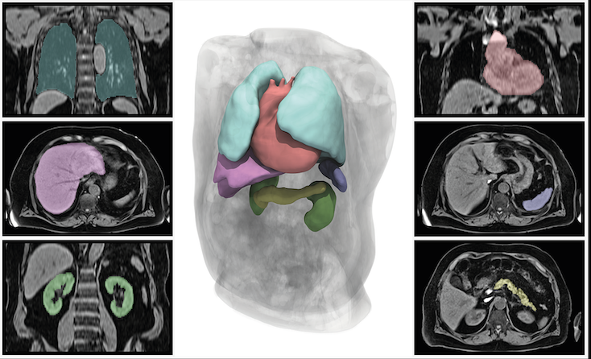

Figure S2: Symptoms at baseline in long COVID individuals with organ impairment identified at baseline, eligible for follow-up (the follow-up group) vs those without impairment, who were only invited for the baseline visit.

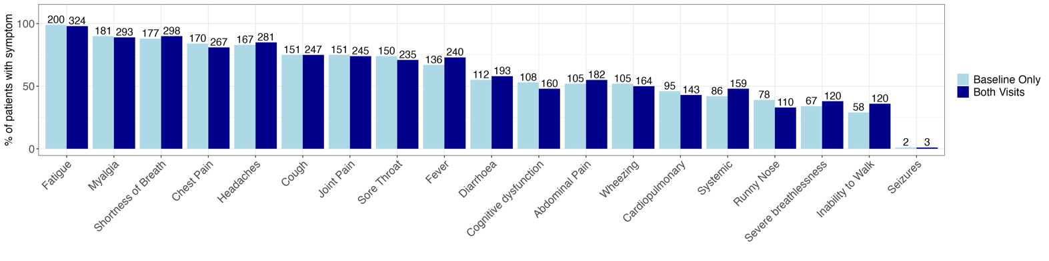

Figure S3: Self-reported health related quality of life as reported from the EQ-5D-5L instrument showing the UK specific index scores (left) and the visual analogue score (right), in the follow-up group. Comparisons were performed using the paired Wilcoxon test.
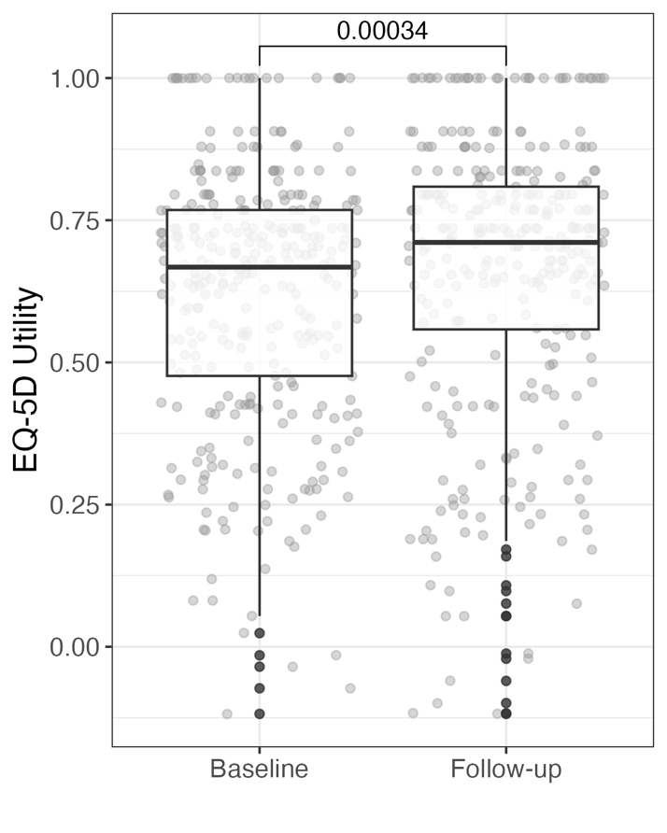
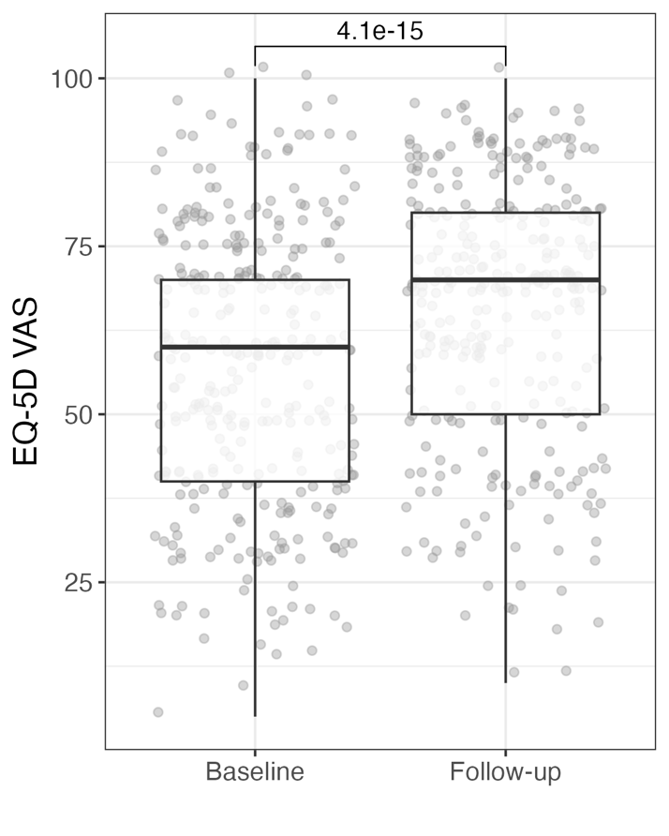
A
B

Figure S4: Dimensions of health from the EQ-5D-5L questionnaire in the follow-up group. Comparisons between baseline and follow-up were performed using McNemar’s test.
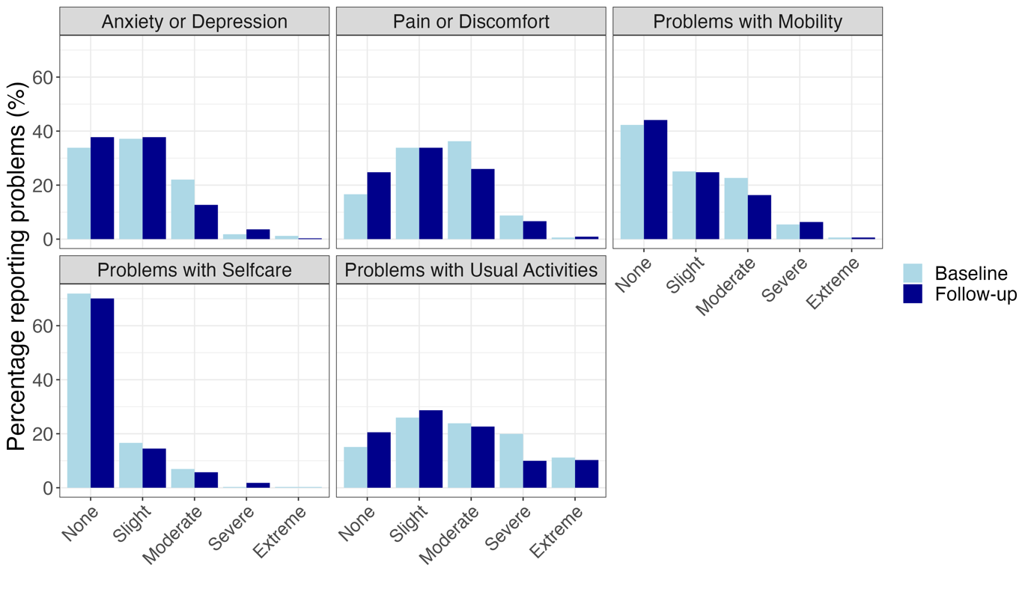
*
*
*
*
*

Lighter bars represent baseline scores and darker bars the scores at follow-up.

Figure S5: Proportion of long COVID cases with liver steatosis by symptom group (systemic, cardiopulmonary, severe breathlessness, brain fog, poor HRQoL. A: Whole cohort at baseline (n=536) B: A subgroup of cases from the whole cohort at baseline without metabolic syndrome (BMI>=30 or diabetes or hypertension) (n=144).
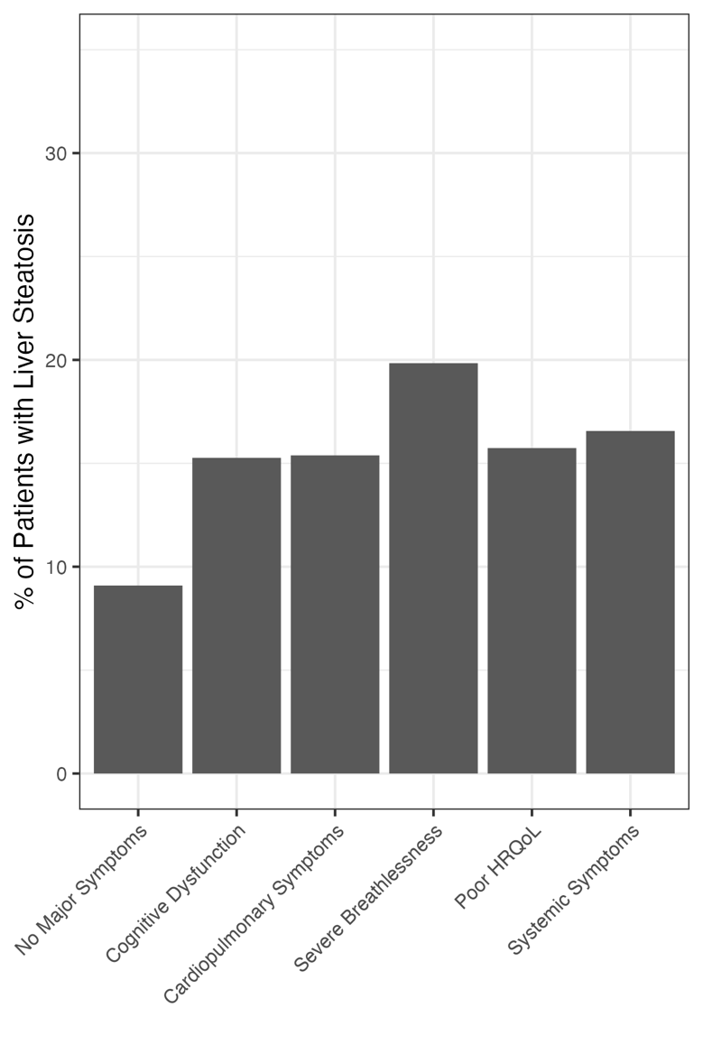
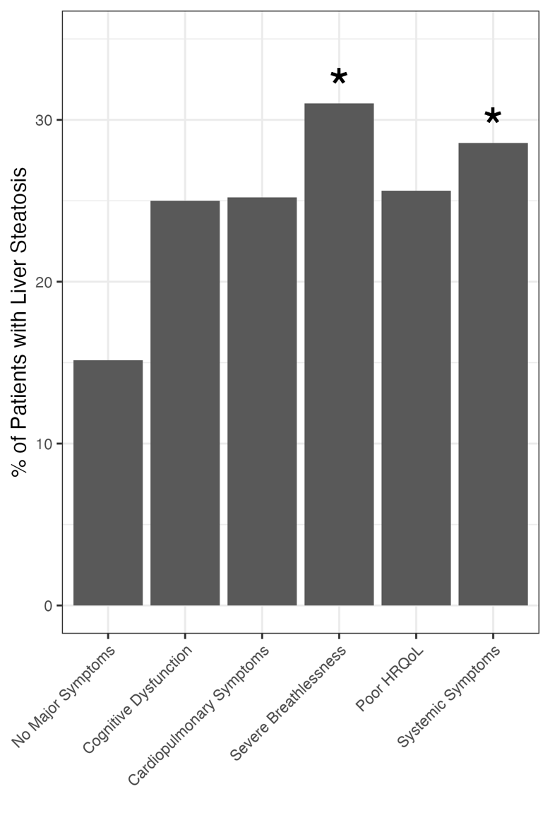
A
B

Figure S6: Heat maps showing the proportion of those with impairment in individual organs that reported specific symptoms at baseline (left) and follow-up (right) in the follow-up group. Rows and columns are sorted by mean prevalence of the symptom at baseline. Labels of the x-axis indicate the number of patients presenting with organ impairment at each time point. Shortness of breath is self-reported, and breathlessness is based on Dyspnoea-12. Greener colours indicate a higher proportion as defined by the scale on the right.

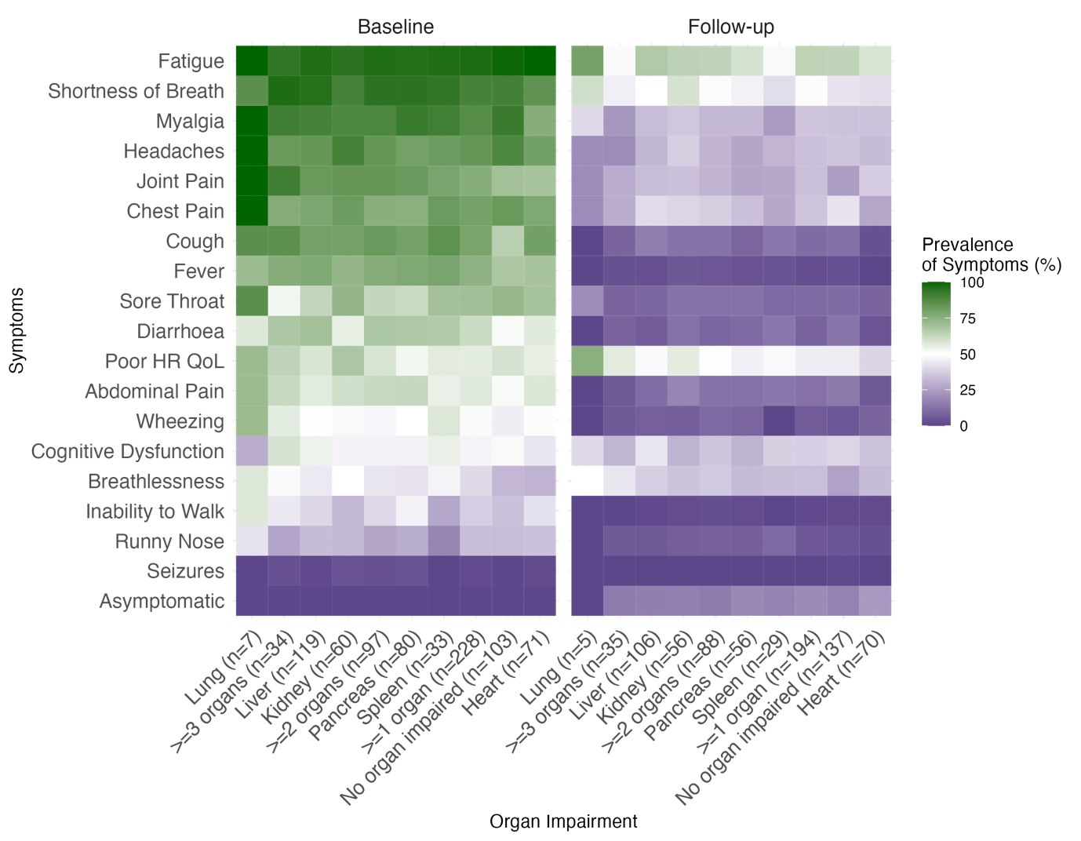

Supplementary References

1 Petersen SE, Matthews PM, Francis JM, et al. UK Biobank’s cardiovascular magnetic resonance protocol. J Cardiovasc Magn Reson 2016;18:8. doi:10.1186/s12968-016-0227-4
2 Pavlides M, Banerjee R, Tunnicliffe EM, et al. Multiparametric magnetic resonance imaging for the assessment of non-alcoholic fatty liver disease severity. Liver Int 2017;37:1065–73. doi:10.1111/liv.13284
3 Petersen SE, Aung N, Sanghvi MM, et al. Reference ranges for cardiac structure and function using cardiovascular magnetic resonance (CMR) in Caucasians from the UK Biobank population cohort. J Cardiovasc Magn Reson 2017;19:18. doi:10.1186/s12968-017-0327-9
4 Cerqueira MD, Weissman NJ, Dilsizian V, et al. Standardized myocardial segmentation and nomenclature for tomographic imaging of the heart. A statement for healthcare professionals from the Cardiac Imaging Committee of the Council on Clinical Cardiology of the American Heart Association. Circulation 2002;105:539–42. doi:10.1161/hc0402.102975
5 Triay Bagur A, Aljabar P, Ridgway GR, et al. Pancreas MRI Segmentation Into Head, Body, and Tail Enables Regional Quantitative Analysis of Heterogeneous Disease. Journal of Magnetic Resonance Imaging;n/a. doi:10.1002/jmri.28098
6 Sudlow C, Gallacher J, Allen N, et al. UK biobank: an open access resource for identifying the causes of a wide range of complex diseases of middle and old age. PLoS medicine 2015;12:e1001779–e1001779. doi:10.1371/journal.pmed.1001779
7 Glodny B, Unterholzner V, Taferner B, et al. Normal kidney size and its influencing factors - a 64-slice MDCT study of 1.040 asymptomatic patients. BMC Urology 2009;9:19–19. doi:10.1186/1471-2490-9-19
8 Andersson A, Kelly M, Imajo K, et al. Clinical utility of MRI biomarkers for identifying NASH patients’ high risk of progression: A multi-center pooled data and meta-analysis. Clin Gastroenterol Hepatol 2021;:S1542-3565(21)01056-9. doi:10.1016/j.cgh.2021.09.041
9 Bachtiar V, Kelly MD, Wilman HR, et al. Repeatability and reproducibility of multiparametric magnetic resonance imaging of the liver. PLoS One 2019;14. doi:10.1371/journal.pone.0214921

