Journal of Medical Microbiology

Pathogen Profile template
Word count: ~1500 words main text (not including references, funding, acknowledgements or conflicts of interest)

TITLE: JMM Profile: Usutu Virus
Author name/s: Megan Golding¹, Nicola Seechurn², Matthew Baylis² and Nicholas Johnson^{1,}*

Affiliation:
- Vector-Borne Diseases, Virology Department, Animal and Plant Health Agency, Woodham Lane, Addlestone, Surrey, KT15 3NB, United Kingdom;
- Department of Livestock and One Health, Institute of Infection, Veterinary and Ecological Sciences, University of Liverpool, Leahurst Campus, Chester High Road, Neston, Cheshire, CH64, 7TE, United Kingdom

*Corresponding author: Nicholas Johnson, Nick.Johnson@apha.gov.uk

Keywords: Mosquito, Flavivirus, meningoencephalitis, blackbird [between three and six keywords that are not found in your title or abstract that will make your article easily searchable.]

Abbreviations: Advisory Committee for Dangerous Pathogens (ACDP), interferons (IFNs), Usutu virus (USUV), West Nile virus (WNV)

SECONDARY TITLE/TAGLINE DESCRIBING THE MEDICALLY IMPORTANT MICROBE: [Informal, eye-catching, descriptive title about this Pathogen]
Usutu virus: an emerging arbovirus and potential zoonotic pathogen

GRAPHICAL ABSTRACT [Please provide a figure and figure legend]
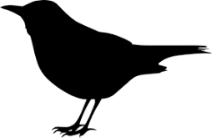
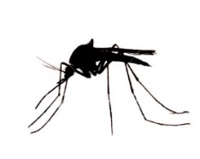
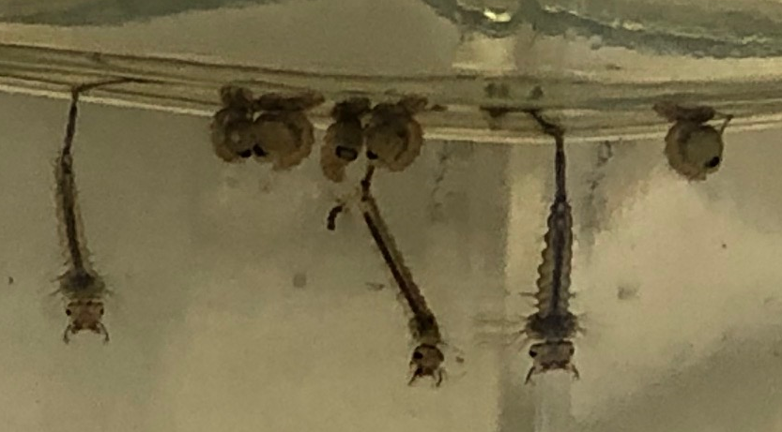
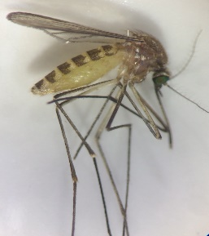
Passerine birds such as the Eurasian blackbird (Turdus merula)
Culex pipiens mosquitoes
Usutu virus
Spillover to other mammalian hosts including humans
ENZOOTIC CYCLE
Usutu virus

Legend: Schematic showing the natural reservoir cycle of Usutu virus involving Culex spp. mosquitoes and passerine birds. The images inset show Culex pipiens larvae and pupae (upper panel) and an adult female of the species (lower panel).

ABSTRACT [Up to ~100 words]
Usutu virus (USUV) is an emerging arbovirus belonging to the Flaviviridae family, genus Flavivirus. It is maintained in an enzootic cycle, with mosquitoes as the vector and birds as the main amplifying host. Humans, and other mammals such as horses, are dead-end hosts. The virus was originally detected in sub-Saharan Africa but in the past two decades has spread across Europe. In certain bird species, such as the Eurasian blackbird (Turdus merula), USUV is extremely virulent and can be fatal. Human infection is rare and often asymptomatic but multiple short-term neuroinvasive diseases have been reported, highlighting its public health risk.

HISTORICAL PERSPECTIVE [Up to ~50 words]
Usutu virus was first isolated in 1959 from Culex neavei mosquitoes in South Africa, and subsequently detected in a range of mosquito and bird species across sub-Saharan Africa. In 1996, USUV was first detected outside of Africa when it caused the death of Eurasian blackbirds in Tuscany, Italy. Subsequently, USUV has been detected in countries across Europe [1].

CLINICAL PRESENTATION [Up to ~75 words]
In humans, USUV infections are often asymptomatic but can present with mild clinical symptoms such as fever, rash, headache, nuchal rigidity, hand tremor and hyperreflexia, with headache, fever, and nuchal rigidity being the most commonly reported. Infection is usually only detected retrospectively by serology, and often through blood donations. However, blood donors are not routinely screened for USUV. Cases of severe disease predominantly occur in immunocompromised individuals and often present as severe meningoencephalitis [1]. Reports of infections in birds describe clinical signs such as prostration, disorientation, ataxia and weight loss.

MICROBIAL CHARACTERISTICS: PHENOTYPIC AND GENOTYPIC FEATURES [Up to ~125 words]
Similar to other flaviviruses, the USUV genome is a positive sense, single-stranded RNA approximately 11,000 nucleotides in length. It encodes a single polyprotein comprised of three structural genes (capsid, pre-membrane and envelope) and seven non-structural genes (NS1, NS2A, NS2B, NS3, NS4A, NS4B and NS5). The mature virion particle is enveloped with a host-derived membrane. Phylogenetic analysis indicates there have been at least four introductions of distinct strains of USUV into Europe over the past 50 years [2].

CLINICAL DIAGNOSIS, LABORATORY CONFIRMATION AND SAFETY [Up to ~350 words]

Clinical diagnosis
In humans, USUV infection can be asymptomatic or present with a range of clinical signs and symptoms, similar to related viruses such as West Nile virus (WNV). It is not possible to make a diagnosis based on clinical presentation alone. Likewise, detection of infection in birds and other mammals requires confirmation with a diagnostic test [3].

Laboratory confirmation
Diagnosing USUV infections in humans can be achieved by detection of viral RNA in blood and cerebrospinal fluid (CSF) by RT-PCR, detection of virus antigen using immunohistochemistry [4] or isolation of virus in cell culture, for example in Vero cells. A commercial diagnostic test is available for USUV serology produced by Euroimmun (https://euroimmun.de/en/). Serological detection of USUV infection requires serum neutralisation assays due to cross-reactivity among flaviviruses.

Laboratory safety
In the United Kingdom, USUV has not been classified within a hazard group by the Advisory Committee on Dangerous Pathogens (ACDP). However, it should be worked with at biosafety level 2 based on its ability to cause infection in humans. USUV has been detected in human blood donations in a number of European countries [1].

TREATMENT AND RESISTANCE [Up to ~200 words]

Treatment
There is currently no treatment for USUV infection other than supportive care. A better understanding of the structure of viral enzymes such as helicase and polymerase of flaviviruses will enable design of future antiviral therapies.

Resistance
Experimental infection demonstrated that chicken embryos and chicken embryo fibroblast monolayers were resistant to USUV infection, suggesting domestic chickens may be resistant to infection [5] and this may extend to other Galliformes and Anseriformes.

PATHOGENIC STRATEGIES: HOST RANGE, TRANSMISSION, INFECTION AND VIRULENCE FACTORS [Up to ~250 words]

Host range
Passerine (songbirds) and Strigiforme (owls) bird species are the primary amplifying hosts and USUV has been shown to infect at least 58 species, including migratory and resident species in Europe. There is serological evidence of numerous mammals acting as incidental hosts of USUV, including humans, bats, equines, dogs and ruminants. Symptomatic and asymptomatic human cases can occur. At least 123 asymptomatic and 44 symptomatic cases have been reported across North and Central Europe. These are the known cases identified so far, and it is possible that there are more cases that have not been detected. Seroconversion has been detected in humans in multiple European countries [1].

Transmission
USUV transmission is facilitated by various mosquito species, mainly ornithophilic species within the genus Culex. Within this genus, Cx. pipiens is considered the main vector in Europe. The invasive mosquito species, Aedes albopictus, has also been found carrying USUV [6]. Vector competency of this species is considered low [7] but may still enable transmission of the virus.

Infection
The mechanism through which USUV interacts with host cells and triggers innate immune responses, is still largely unknown. In an in vitro study in mammalian cells, USUV infection upregulated the cellular autophagic pathway, which is consistent with infection by other flaviviruses [8]. In human or non-human monkey cell lines, the virus replicates efficiently, completing its replication cycle within 48 hours in Hep-2 and Vero cells [9]. Infection induced a weak antiviral response by type I and III interferons (IFNs). In cells treated with IFNs after virus exposure, USUV sensitivity to antiviral effects was greatly reduced, suggesting established infection could inhibit IFN action.
Some studies suggest USUV infection may be neurotropic [1], demonstrating USUV to be efficient at establishing infection and inducing apoptosis in a range of neuronal cell types.

Virulence factors
USUV can be highly pathogenic in wild and captive birds due to its wide tropism and high levels of virus replication in a variety of tissues and organs [4]. The reasons for variable virulence between avian species, and reduced virulence in mammalian hosts is not known.

EPIDEMIOLOGY, PREVENTION AND RISK GROUPS [Up to ~300 words]

Epidemiology
USUV has been classified into at least eight distinct lineages that are further split into African or European groups based on the location where the first isolate was detected [10]. In Europe, USUV Europe 2 lineage is the most prevalent genetic lineage detected in birds, mosquitoes and humans. Other Europe lineages and Africa 2 and 3 lineages have been detected in birds and mosquitoes [10]. The diversity in European lineages is likely a result of enzootic maintenance. The diversity of African lineages is thought to be driven by bird migration events and repeated re-introduction of virus variants from other geographic locations.
There have been several reported outbreaks of USUV over the past two decades, primarily in blackbird populations across Europe. Blackbirds are generally more susceptible to USUV infections than other bird species, comprising over 60 % of all birds tested positive for USUV in Europe. In the 2003-2005 outbreak in Vienna/Austria and surrounding areas, blackbird population decline is estimated to be 90 %, and in the German outbreak in 2011-2012, decline is estimated to be >50 % [11]. More recent outbreaks in wild birds have been detected in The Netherlands [12] and the United Kingdom [13].

The reason for the dominance of this species is unclear but contributing factors may be the wide distribution and abundance of blackbirds, its close association with humans that increases the likelihood of recovering blackbird bodies for testing and a higher virus susceptibility compared to other species. The impact of USUV infections on blackbird population dynamics, such as the ability of the population to recover after an outbreak, is also unknown but is important for understanding long-term impacts on the ecosystem and ecosystem services such as seed dispersal. Above average temperatures may also drive mosquito reproduction and consequently lead to faster virus replication within the vector and disease spread.

Prevention
Surveillance programmes are present across Europe for the early detection of outbreaks of USUV in wild bird populations and were responsible for the detection of the virus in the United Kingdom in 2020 [13]. Infection in humans can be avoided by preventing mosquito biting.
Migratory bird flyways and timing of species movements may be useful in predicting continental and inter-continental USUV dispersal [2] and potentially identify higher-risk areas for implementing bird and human surveillance programmes.

Risk groups
Detection of USUV in blood donors could present concern for blood transfusions and organ transplants, especially for immunocompromised patients. Whilst there is no report of a recipient developing USUV disease following blood or organ donation. There have been reports of USUV positive tissue being provided to some hospitalised individuals [14].

Individuals who spend more time outside in USUV endemic regions such as forestry workers are more at risk than the general population [1].

OPEN QUESTIONS [Please list up to 5 questions]
- Can the clinical presentation of USUV infection in humans be refined to improve identification of suspected cases?
- How does Usutu virus infect and spread in the vertebrate host?
- What is the lasting impact of USUV-associated mortality on avian species populations and their dynamics?
- What is the correlation between mortality (host/vector) and speed of virus turnover in natural reservoirs (e.g. blackbirds)?
- How would co-circulation of USUV and WNV impact virus dynamics and co-infections in humans?

CONFLICTS OF INTEREST
The authors report no conflict of interest.

FUNDING INFORMATION
This profile was funded by the UK Department for Environment, Food and Rural Affairs (Defra) and the Scottish and Welsh Governments through project SE0560.

ACKNOWLEDGEMENTS

REFERENCES [Harvard Style]
- Roesch F, Fajardo A, Moratorio G, Vignuzzi M. Usutu virus: An arbovirus on the rise. Viruses 2019:11;640.
- Engel D, Jöst H, Wink M, Börstler J, Bosch S, et al. Reconstruction of the evolutionary history and dispersal of Usutu virus, a neglected emerging arbovirus in Europe and Africa. MBio 2016;7;e01938-15.
- Michel F, Fischer D, Eiden M, Fast C, Reuschel M, et al. West Nile virus and Usutu virus monitoring of wild birds in Germany. Int J Environ Res Public Health 2018:15;171.
- Giglia G, Agliani G, Oude Munnink BB, Sikkema R, Mandara MT, et al. Pathology and Pathogenesis of Eurasian Blackbirds (Turdus merula) Naturally Infected with Usutu Virus. Viruses 2021:13;1481.
- Chvala S, Bakonyi T, Hackl R, Hess M, Nowotny N, et al. Limited pathogenicity of Usutu virus for the domestic chicken (Gallus domesticus). Avian pathol 2005:34;392-395.
- Mancini G, Montarsi F, Calzolari M, Capelli G, Dottori M, et al. Mosquito species involved in the circulation of West Nile and Usutu viruses in Italy. Vet. Ital. 2017:53;97-110.
- Puggioli A, Bonilauri P, Calzolari M, Lelli D, Carrieri M, et al. Does Aedes albopictus (Diptera: Culicidae) play any role in Usutu virus transmission in Northern Italy? Experimental oral infection and field evidences. Acta Trop. 2017:172;192-196.
- Blázquez AB, Escribano-Romero E, Merino-Ramos T, Saiz JC, Martín-Acebes MA. Infection with Usutu virus induces an autophagic response in mammalian cells. PLoS Negl Trop Dis 2013:7;e2509.
- Scagnolari C, Caputo B, Trombetti S, Cacciotti G, Solda A, et al. Usutu virus growth in human cell lines: induction of and sensitivity to type I and III interferons. J Gen Virol 2013:94;789-795.
- Vilibic-Cavlek T, Petrovic T, Savic V, Barbic L, Tabain I, et al. Epidemiology of Usutu Virus: The European Scenario. Pathogens 2020:9;699.
- Lühken R, Jöst H, Cadar D, Thomas SM, Bosch S, et al. 2017. Distribution of Usutu virus in Germany and its effect on breeding bird populations. Emerg Infect Dis 2017:23;1994.
- Oude Munnink BB, Münger E, Nieuwenhuijse DF, Kohl R, van der Linden A, et al. Genomic monitoring to understand the emergence and spread of Usutu virus in the Netherlands, 2016-2018. Sci. Rep. 2020:10;2798.
- Folly AJ, Lawson B, Lean FZ, McCracken F, Spiro S, et al. 2020. Detection of Usutu virus infection in wild birds in the United Kingdom, 2020. Eurosurveill 2020:25;2001732.
- Zaaijer HL, Slot E, Molier M, Reusken CBEM, Koppelman MHGM. Usutu virus infection in Dutch blood donors. Transfusion 2019:59;2931-2937.

