H∞ control-based optimization design for active and passive dynamic vibration absorber
Bin Liª, Huajiang Ouyang^{b}, Jia-Fan Zhang^{*, a}, Ya-Jun Jiangª, Zhi-Gang Huª
ªSchool of Mechanical Engineering, Wuhan Polytechnic University, Wuhan 430023, China
^{b}School of Engineering, University of Liverpool, The Quadrangle, Liverpool L693GH, UK

Abstract: This paper is concerned with the H∞ optimization design of passive and active dynamic vibration absorbers (DVAs) attached to an undamped or damped primary system. The proposed optimization method is an efficient non-smooth H∞-synthesis algorithm that is utilized to solve structured H∞-synthesis in control engineering. This method can conveniently achieve the optimal design for the amplitude magnification factors of both the absolute and the relative displacements of a DVA using the proposed dual H∞ design, and implement co-design of H∞-optimal proportional-integral-differential controllers and passive parameters of an active DVA. Two active DVAs and two variant passive DVAs reported in the literature are taken as examples for design improvement. The optimization results indicate that the proposed method has significant advantages over the conventional fixed-points-theory-based methods and many numerical global optimization methods.
Keywords: dynamic vibration absorber, H∞ optimization, inerter, negative stiffness, structured H∞-synthesis, H∞-optimal PID controller

- Introduction
Dynamic vibration absorbers (DVAs) are one kind of mechanical devices connected to a vibrating system, called a primary system, to mitigate excessive vibration of the system. Generally speaking, a DVA is usually represented as a secondary mass-spring-damper system and also referred to as a tuned mass damper (TMD) and a tuned vibration absorber (TVA), depending on the application. As simple and effective vibration control devices, DVAs have been widely used in mechanical and civil engineering.
For a primary system subject to harmonic excitation loads, it is desirable to increase the suppression frequency bandwidth of a DVA in order to cope with variations of the exciting frequency and the system parameters, and reduce the steady-state response of the primary system as far as possible. Thus, many methods have been proposed to tune design parameters and optimize the performances of a DVA attached to a single-degree-of-freedom (SDOF) undamped or damped primary system. One optimization criterion used in these methods aims to minimize the frequency response peak value of the primary system, called the H∞ optimization. An original and well-known design method is “equal peak design” or the so called fixed-points theory for the undamped primary system ^{[1-3]}. Although the obtained optimal design parameters in closed-form expressions are not exact but approximate solutions for the H∞ optimization of a DVA, the difference between them is very small when the mass ratio of a DVA is small (e.g., ＜0.2) ^{[4,5]}.
However, for a damped primary system the fixed-points theory does not hold and no exact closed-form formula of the optimal design parameters exists. Only an approximate analytic solution in the form of an infinite series can be derived for the optimal parameters ^{[5]}. Additionally, there have been efforts to derive closed-form solutions of optimal design parameters based on the empirical observation that the “fixed-points” could still hold approximately for a primary system with low-to-moderate damping ratios ^{[6,7]}. In general, most past studies in this situation have been directed towards developing efficient numerical approaches. The relevant literature for instance includes using nonlinear programming techniques ^{[8]}, the min-max Chebyshev’s criterion ^{[9]}, minimax optimization ^{[10]}, and globally optimal methods ^{[11-13]}.
It should be noted that variant DVAs for the undamped or damped primary system have been continuously proposed based on the classic model of the DVA shown in Fig. 1. These variants are constructed via reconfiguring and/or adding elastic and/or damping elements. Their optimal tuning frequencies and damping ratios were derived analytically by the extended fixed-points technique ^{[14-19]}, or numerically calculated ^{[12,20]}, for minimizing the resonant vibration of a SDOF primary system. In recent years, several novel inerter-based DVAs without/with negative stiffness have been researched ^{[21-25]}. All were shown to have resulted in a greater reduction of the resonant vibration amplitude of the primary mass compared with the classic DVA. However, for these novel DVAs, the derivation procedure of approximately analytical optimal solutions and the optimized objective function is complicated and lengthy, and it is easy to make mistakes.
Research works mentioned involved passive DVAs (PDVAs). Due to practical limits on the implementable and tunable range of design parameters such as the mass ratio and the damping ratio, to improve the performance of DVAs even better is naturally resorted to active DVAs (ADVAs). Through an actuator installed between the absorber mass and the primary system and incorporating control techniques, the ADVA enables more flexibility to provide cancellation forces. Various control algorithms and strategies have been proposed for ADVAs. Among these methods some are very complicated and require sophisticated analysis and design procedures, for example, those using neural networks ^{[26]}, fuzzy logic controllers ^{[27]}, positive position feedback‑based predictive control ^{[28]} and delayed resonators ^{[29]}. However, most practitioners in control engineering prefer controllers of simple strategies like PID (proportional-integral-differential) for various reasons. Both analytical and experimental results demonstrated that a delayed resonator and PD control in an AVDA can be equally effective in suppressing undesired oscillations ^{[30]}. So, an AVDA with a PID controller (PID-AVDA) is a preferred choice. In [31,32], the authors employed PD control and P control with the displacement and velocity feedback taken from the primary mass and the absorber mass, respectively, and presented analytical optimum results for the controller gains and design parameters of the DVA attached to a SDOF undamped primary system. Their derivations were still based on the fixed-points theory.
In this article, a well-established H∞ optimization method is introduced to conveniently and efficiently solve the optimization design of PDVAs and PID-AVDAs. This optimization method is originally used to solve structured H∞-synthesis using tailored non-smooth algorithms and directly deals with H∞-norm of transfer functions. The main contribution of this article includes: (1) No explicit formulations of transfer functions (i.e., optimized objective functions in this article ) are required to be derived from equations of motion of DVAs in the MATLAB circumstance; (2) The co-design of PID-AVDA for the controller gains and design parameters is conducted; (3) The dual H∞ optimal design for the amplitude magnification factors of both the absolute and the relative displacements of a DVA is proposed. The concerned primary system in this article is assumed to be a SDOF undamped or damped system. Two PID-AVDAs (see Fig. 1) studied in [31,32] and two variant PDVAs (see Fig. 2) in [12,24] are chosen to be examples and optimized by using the H∞ optimization method in this article. The advantages of this method over existing optimum design methods are also demonstrated.
The organization of this article is as follows. The normalized equations of motion and relevant frequency response functions of DVAs involved are established in section 2. Section 3 briefly introduces structured H∞-synthesis and the H∞ optimization method, then describes formulations of optimum designs of the DVAs. And section 4 provides the optimum design results of the DVAs and a comparison with those in the relevant literature, and sums up advantages of this method. Finally, the conclusions are drawn in section 5.
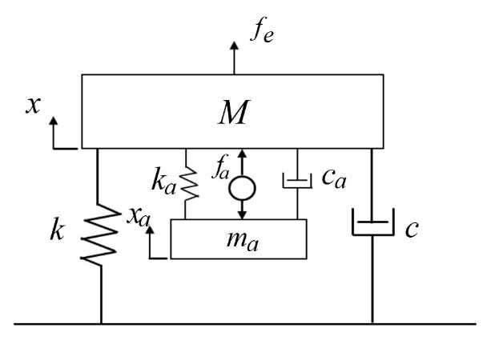
Fig.1. The classic model of an active DVA.
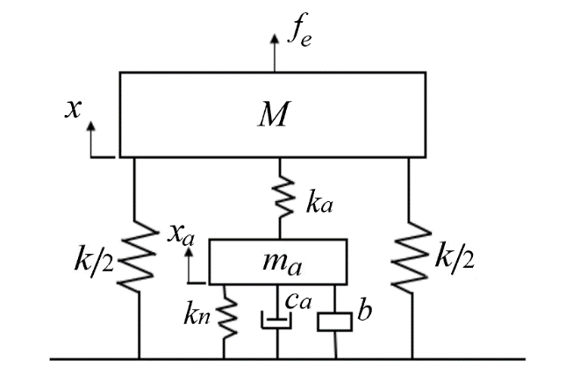
Fig.2. The model of a variant passive DVA ^{[24]}.

- Theory of Vibration absorbers
2.1 The classic model of ADVA
The classic model of an ADVA attached to damped primary system is considered here as shown in Fig. 1. The equations of motion of the primary mass subject to a sinusoidal excitation and the absorber mass are given as follows:
$M\ddot{x}+c\dot{x}+kx+c_{a}\left(\dot{x}-{\dot{x}}_{a}\right)+k_{a}\left(x-x_{a}\right)=f_{e}-f_{a}$ (1)
$m_{a}{\ddot{x}}_{a}-c_{a}\left(\dot{x}-{\dot{x}}_{a}\right)-k_{a}\left(x-x_{a}\right)=f_{a}$ (2)
where M, c, and k are the mass, damping, and stiffness, respectively, of the primary system; m_{a}, c_{a}, and k_{a} are the mass, damping, and stiffness of the absorber; x and x_{a} are the displacements of the primary mass and the absorber mass; the overhead dot denotes differentiation with respect to the actual time t; $f_{e}=Fsinωt$ and F and ω are the amplitude and frequency of the excitation force; and $f_{a}=ρx$ is the active force applied by the actuator with the displacement of the primary mass as the feedback signal. This control strategy is referred to as proportional control on x (i.e., P control). (Noting that another strategy involved in this paper is proportional plus derivative control on x (i.e., PD control) if $f_{a}=ρ_{1}x+ρ_{2}\dot{x}$).
The frequency response amplitude (also called the amplitude magnification factor) of the primary mass M, $\left|H\left(\right)\right|$, may be written in the dimensionless forms ^{[5]}
$\left|H\left(\right)\right|=\left|\frac{x}{x_{st}}\right|=\left|\frac{x}{F/k}\right|=\sqrt{\frac{A^{2}+B^{2}}{C^{2}+D^{2}}}$ (3)
Additionally, the frequency response amplitude of the maximum relative displacement $x_{r}=x-x_{a}$ between the absorber and the primary masses is
$\left|H_{r}\left(\right)\right|=\left|\frac{x_{r}}{F/k}\right|=\frac{{}^{2}+2/}{\sqrt{C^{2}+D^{2}}}$ (4)
where
$$A={}^{2}-{}^{2}$$
$$B=2{}_{a}$$
$C={}^{2}-\left[1+4{}_{p}{}_{a}+2+\left(1+\right){}^{2}\right]{}^{2}+{}^{4}$ (5)
$$D=2\left\{\left({}^{2}-{}^{2}\right){}_{p}+\left[1-\left(1+\right){}^{2}\right]{}_{a}\right\}$$
and the dimensionless parameters in (5) are defined as follows:
$={m_{a}}/M$ : mass ratio
$={{}_{a}}/{{}_{p}}$ : natural frequency ratio
${}_{p}=c/{2M{}_{p}}$ : primary damping ratio (6)
${}_{a}={c_{a}}/{2m_{a}{}_{a}}$ : absorber damping ratio
$=ω/{{}_{p}}$ : forced frequency ratio
and ${}_{p}=\sqrt{k/M}$ and ${}_{a}=\sqrt{{k_{a}}/{m_{a}}}$ are the natural frequencies of the primary system and the absorber, respectively; $=ρ/{2k}$. Noted that the explicit formulations of $\left|H\left(\right)\right|$and $\left|H_{r}\left(\right)\right|$ are derived here for comparison, which are not required by the optimization method proposed in this article.
Rescaling the time by $t=τ/{{}_{p}}$, one has
$\frac{d}{dt}={}_{p}\frac{d}{dτ}$, $\frac{d^{2}}{dt^{2}}={}_{p}^{2}\frac{d^{2}}{dτ^{2}}$ (7)
By substituting Eqs. (6)−(7) into Eqs. (1)−(2) and normalizing them with respect to ${}_{p}^{2}M$, one has normalized forms of Eqs. (1)−(2) as follows:
$x^{''}+2{}_{p}x^{'}+x+2{}_{a}\left(x^{'}-x_{a}^{'}\right)+{}^{2}\left(x-x_{a}\right)=u_{e}-u_{a}$ (8)
$x_{a}^{''}+2{}_{a}x_{a}^{'}+{}^{2}x_{a}-2{}_{a}x^{'}-{}^{2}x=u_{a}$ (9)
where the prime in the superscript represents differentiation with respect to the rescaled time $τ$; and $u_{e}={f_{e}}/k$ and $u_{a}={{{f_{a}}/{{}_{p}^{2}M}=f}_{a}}/k=\left(ρ/k\right)x$. (Noting that for PD control on x, $u_{a}={{{f_{a}}/{{}_{p}^{2}M}=f}_{a}}/k=\left({ρ_{1}}/k\right)x+\left({ρ_{2}}/{{}_{p}M}\right)x^{'}$).
Setting $f_{a}=0$ in Eqs. (1)−(2) (or $u_{a}=0$ in Eqs. (8)−(9)) yields the classic model of an PDVA, and the corresponding frequency response amplitude of the primary mass M can be obtained by letting $=0$ in Eq. (3). Additionally, setting $c=0$ in Eqs. (1)−(2) (or ${}_{p}=0$ in Eqs. (8)−(9)) yields the classic model of an ADVA attached to the undamped primary system which was studied by Cheung et al. ^{[32]}.

2.2 Two variant models of PDVA
A novel model of PDVA attached to undamped primary system is considered here, as shown in Fig. 2 ^{[24]}, which is denoted by PDVA-Ⅰ. The dynamics of the primary mass subject to a sinusoidal excitation and the absorber mass are given as follows:
$M\ddot{x}+kx+k_{a}\left(x-x_{a}\right)=f_{e}$ (10)
$\left(m_{a}+b\right){\ddot{x}}_{a}+c_{a}{\dot{x}}_{a}-k_{a}\left(x-x_{a}\right)+k_{n}x_{a}=0$ (11)
where b is the inertance and k_{n} is the coefficient of negative stiffness spring, which are directly connected between the absorber mass and the ground; other parameters have the same definitions as those in Eqs. (1)−(2). Following the same derivation and some dimensionless parameters of Eqs. (8)−(9), one has the normalized forms of Eqs. (10)−(11) as follows:
$x^{''}+x+{}^{2}\left(x-x_{a}\right)=u_{e}$ (12)
$\left(1+ \right)x_{a}^{''}+2{}_{a}x_{a}^{'}-{}^{2}\left(x-x_{a}\right)+{}_{2}{}^{2}x_{a}=0$ (13)
with the additional dimensionless parameters involving the inertance and the coefficient of negative stiffness as follows:
$δ=b/{m_{a}}$ , $α_{2}={k_{n}}/{k_{a}}$ (14)
For this PDVA model, its frequency response amplitude of the primary mass M, $\left|H\left(\right)\right|$, has the same form as Eq. (3), where the specific parameters are given below ^{[24]}:
$$A=\left(1+{}_{2}\right){}^{2}-{\left(1+ \right)}^{2}$$
$$B=2{}_{a}$$
$C={}^{2}\left[1++\left(1+{}_{2}++ \right){}^{2}\right]-\left(1+ \right){}^{4}-{}^{2}\left(1+{}_{2}+{}_{2}{}^{2}\right)$ (15)
$$D=2{}_{a}\left[{}^{2}-\left(1+{}^{2}\right)\right]$$
The explicit formulation of $\left|H\left(\right)\right|$ is quoted here for comparison, which is not required by the optimization method proposed in this article. The optimum parameters of this PDVA are derived by using fixed-points theory as follows ^{[24]}:
${}_{opt}=\sqrt{\frac{1+}{\sqrt{2\left(1+\right)}-\left(1+\right)}}$ (16a)
${}_{aopt}=\sqrt{\frac{1}{2}\sqrt{\frac{{\left(1+\right)}^{3}}{2}}}$ (16b)
${}_{2opt}=\sqrt{2\left(1+\right)}-1$ (16c)
In addition, to guarantee ${}_{2opt}$ to be negative, the range of is obtained as follows:
$0<<\frac{1}{2}-1$ (17)
By deleting the inertance and the negative stiffness and adding the linear viscous damping to the primary mass in Fig. 2, another variant PDVA (denoted by PDVA-Ⅱ) is presented with the equation of motion as follows:
$x^{''}+2{}_{p}x^{'}+x+{}^{2}\left(x-x_{a}\right)=u_{e}$ (18)
$x_{a}^{''}+2{}_{a}x_{a}^{'}-{}^{2}\left(x-x_{a}\right)=0$ (19)
whose optimal design problem was studied in Reference [12].
- H∞ control-based parameters optimization
To widen the effective operating frequency range of the DVA and suppress the ${\left|H\left(\right)\right|}_{max}$ of the primary system near its resonance frequency, minimizing H∞ norm of the $H\left(\right)$ is a major approach. H∞ norm measures the peak input/output gain of a given transfer function:
${\left\|H\left(s\right)\right\|}_{∞}∶=\max_{}{\overline{}}\left(H\left(j\right)\right)$ (20)
where $\overline{}\left(·\right)$ is the peak gain over frequency in the single-input-single-output case; In the multi-input-multi-output case, it is the maximum singular value of the frequency response matrix $H\left(j\right)$ over frequency.
Naturally, the well-known H∞-control design (or synthesis) would be expected to assist the H∞ optimization design of DVAs regardless of ADVAs or PDVAs. This is made possible by the use of an efficient non-smooth H∞-synthesis algorithm based on generalized gradients and bundling techniques suited for the H∞ norm, which was used to solve structured H∞-synthesis and detailed in [33]. The structured H∞-synthesis facilitates the engineers to design H∞-optimal PID controllers or other practically useful controller structures or architectures with the rationale of H∞-control, and incorporates tuning techniques into H∞-control framework. A mathematically sound solution to structured H∞-synthesis has been developed and is already implemented in the Robust Control Toolbox by The MathWorks ^{[34, 35]}. This synthesis problem therefore can be solved via the MATLAB functions hinfstruct and systune.
In what follows, the H∞ optimization design of DVAs under structured H∞-synthesis framework is introduced. Choosing the state vector $q\left(t\right)={\left\{x x^{'} x_{a} x_{a}^{'}\right\}}^{T}$, the state-space equation and the output equation of DVAs, corresponding to Eqs. (8)-(9), Eqs. (12)-(13) or Eqs. (18)-(19), are presented as
$q^{'}\left(t\right)=Aq\left(t\right)+Bu\left(t\right)$ (21)
$y\left(t\right)=Cq\left(t\right)+Du\left(t\right)$ (22)
where the specific elements of system matrix $A$ are straightforward to derive and thus are not given here; The feedthrough matrix $D$ in the output equation is normally set to be zero if the transfer function from $u_{e}$ to $u_{a}$, as in Eqs. (8)-(9), is not concerned with for an ADVA design. The input matrix $B$ is
$B=\left[\begin{matrix}0 & 0 \\ 1 & -1 \\ \begin{matrix}0 \\ 0\end{matrix} & \begin{matrix}0 \\ 1/\end{matrix}\end{matrix}\right]$ for the ADVA or $B=\left[\begin{matrix}0 \\ 1 \\ \begin{matrix}0 \\ 0\end{matrix}\end{matrix}\right]$ for the PDVA (23a, b)
and the corresponding input vector $u\left(t\right)$ is $u\left(t\right)={\left\{u_{e} u_{a}\right\}}^{T}$or $u\left(t\right)=\left\{u_{e}\right\}$, respectively. The output matrix $C$ would have a different form depending on the design considerations. If, for instance, $x$ is both the output-controlled signal and the output-feedback signal, and $x-x_{a}$ is an additional output-controlled signal for the PDVA, then $C$ is
$C=\left[\begin{matrix}1 0 0 0 \\ 1 0 -1 0\end{matrix}\right]$ (24)
The generalized model for the ADVA and the PDVA is shown in Fig. 3(a)-(b) where G represents the DVA (including the primary system) and PID represents the conventional PID controller. Significantly, both G and PID may contain tunable elements, which allows for co-design of the DVA and the controller parameters. In the MATLAB circumstance, one can set up bounds of the DVA design parameters in Eqs. (21)-(22), construct generalized model of the DVA and derive the transfer functions, for instance, from $u_{e}$ to $x$ and $x-x_{a}$, respectively. It should be noted that the resulting transfer functions here are exactly the $H\left(\right)$ and $H_{r}\left(\right)$ described in section 2.
Thus, the H∞ optimization design of DVAs, called the single H∞ design in this article, is conducted as follows:
minimize ${\left\|H\left(j\right)\right\|}_{∞}$ ( 25)
subject to bounds of the DVA design parameters and the closed-loop stability (the latter is required only for the design of an ADVA).
In the design of an ADVA, the single H∞ design would result in a large magnitude of the relative displacement $x-x_{a}$ in the operating frequency range, which is usually limited by the stroke of the actuator. Hence the following dual H∞ design is introduced
minimize Blockdiag$\left\{{\left\|H\left(j\right)\right\|}_{∞} , {\left\|H_{r}\left(j\right)\right\|}_{∞} \right\}$ (26)
in order to suppress the ${\left|H_{r}\left(\right)\right|}_{max}$. is the weighting factor and $0<≤1$. In addition, a somewhat complex approach is the loop-shaping of $H\left(j\right)$ and $H_{r}\left(j\right)$, for which there is no need for a further discussion.

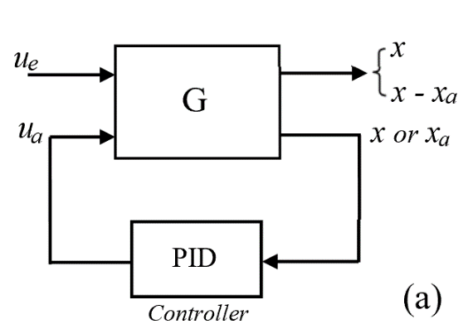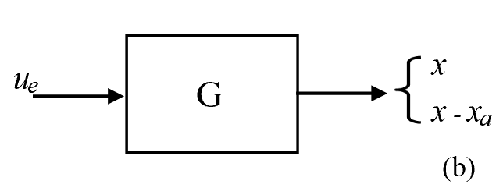
Fig. 3. Block diagram of the generalized model for (a) the ADVA and (b) the PDVA.

4. Numerical evaluation and comparison
Numerical evaluations for finding the optimal design variables and the vibration suppression performance in terms of $\left|H\left(\right)\right|$ and $\left|H_{r}\left(\right)\right|$ are conducted in three cases: (a) the ADVA with the undamped primary system; (b) the ADVA with the damped primary system and (c) two variant PDVAs with the undamped and damped primary system. The DVA models under discussions mainly refer to Figs. 1 and 2. The comparison between the results obtained here and in the relevant literature is presented.
There are practical constraints that should be considered on the range of the design variables in the design of DVAs. For example, the mass ratio μ is normally chosen not to be larger than 0.2 in applications, which is usually predetermined in the existing design method for DVAs. But, if necessary, μ can be a design variable with a proper range for the H∞ control-based co-design in this paper. In the following numerical calculations, the upper and lower bounds of the design variables are given as 0＜μ ≤ 0.2, 0＜ ≤ 1.0, 0＜${}_{a}$ ≤ 1.0, 0＜${}_{p}$ ≤ 0.2, −1＜$α_{2}$ ≤ − 0.01 and 0＜$δ$ ≤ 3.0, respectively, unless otherwise stated.
4.1 ADVA with the undamped primary system
In the following, the design of ADVA based on P control, for the ADVA shown in Fig.1 with the damping c of the primary system omitted, is discussed. The feedback signal is the displacement $x$ of the primary mass. To compare the single H∞ control-based optimization design with the one by Cheung et al. ^{[32]}, firstly the feedback gain α and the mass ratio μ are predetermined, and only tuning parameters and ${}_{a}$ of the ADVA are design parameters to be determined by using both H∞ optimization methods. For μ = 0.05 with α = 0.2 and 0.5, and μ = 0.2 with α = 0.2 and 0.4, respectively, the frequency response amplitudes of the primary mass M, $\left|H\left(\right)\right|$, are calculated according to Eq. (3) with their calculated optimal values of and ${}_{a}$. They are plotted in Figs. 4(a)-(b) and Figs. 5(a)-(b) for illustration, respectively. The calculated optimal values of and ${}_{a}$ are given in Table 1. It is apparent from these figures that both amplitude response curves almost coincide for each comparison group and have slightly different amplitude values around the resonance frequency for larger values of α (see Figs. 4(b) and 5(b)). Hence, in the situations where α and μ are properly prescribed, while only other two tuning parameters, and ${}_{a}$, remain to be design variables, both H∞ optimization methods yield nearly the same vibration suppression result from the point view of $\left|H\left(\right)\right|$ for the ADVA.

Table 1. Optimal values of and ${}_{a}$ with μ and α at some selected values
Y.L. Cheung et al. ^{[32]} This investigation
Tuning
Parameter μ = 0.05 μ = 0.2 μ = 0.05 μ = 0.2
α = 0.2 α = 0.5 α = 0.2 α = 0.4 α = 0.2 α = 0.5 α = 0.2 α = 0.4
0.847 0.656 0.727 0.601 0.846 0.650 0.726 0.598
${}_{a}$ 0.463 0.913 0.535 0.846 0.456 0.873 0.528 0.817

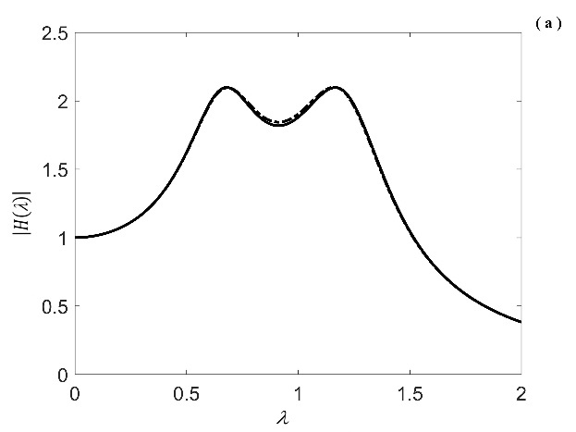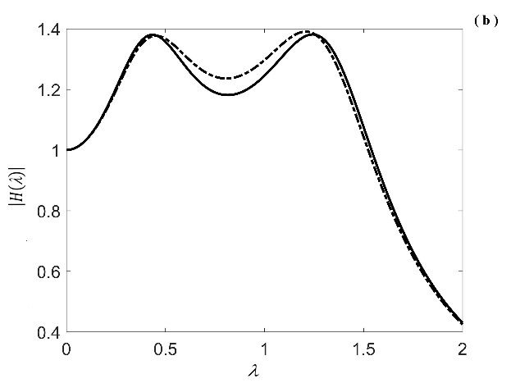
Fig. 4. Optimal $\left|H\left(\right)\right|$ curves of this investigation (–––) and Cheung et al. (·-·-·-) with prescribed values (a) μ = 0.05, α = 0.2 and (b) μ = 0.05, α = 0.5.
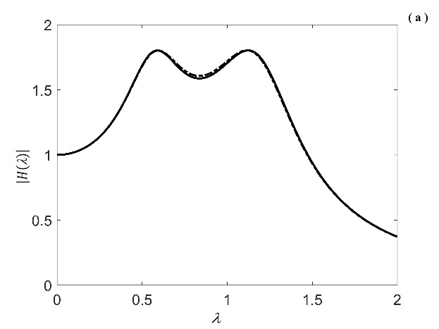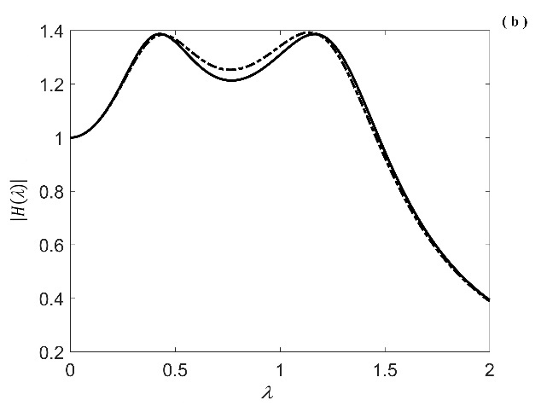
Fig. 5. Optimal $\left|H\left(\right)\right|$ curves of this investigation (–––) and Cheung et al. (·-·-·-) with prescribed values (a) μ = 0.2, α = 0.2 and (b) μ = 0.2, α = 0.4.

Now, the co-design of the tuning parameters, and ${}_{a}$, of DVA and the feedback gain α of P control is conducted at μ = 0.05 and 0.2, respectively, using the single H∞ optimization of the $\left|H\left(\right)\right|$, which yields calculated optimal values: = 0.430, ${}_{a}$ = 1.0, α = 0.765, ${\left|H\left(\right)\right|}_{max}=1.24$ and = 0.386, ${}_{a}$ = 1.0, α = 0.670, ${\left|H\left(\right)\right|}_{max}=1.22$, respectively. Each $\left|H\left(\right)\right|$ of the primary mass M is plotted in Fig. 6(a)-(b) with the solid lines according to Eq. (3). On the other hand, in order to be comparable with that of Cheung et al. ^{[32]}, setting μ = 0.05, ${\left|H\left(\right)\right|}_{max}=1.24$, and μ = 0.2, ${\left|H\left(\right)\right|}_{max}=1.22$, respectively, as two sets of prescribed values of the ADVA, one can obtain the corresponding two groups of optimal values of , ${}_{a}$ and α according to the formulations given by Cheung et al., i.e., firstly, the specified values, μ and ${\left|H\left(\right)\right|}_{max}$, used to determine the required value of α (see Eq.(19) in [32]), then μ and α used to calculate the corresponding optimal values of , ${}_{a}$ (see Eqs. (10) and (18) in [32]). Their results are α = 0.611, = 0.570, ${}_{a}$ = 1.157 and α = 0.533, = 0.5, ${}_{a}$ = 1.147, thereby plotting their $\left|H\left(\right)\right|$ curves, respectively, as shown in Fig. 6(a)-(b) with the dotted-dashed lines for comparison. In fact, as predicted, they all have two peaks of identical values for each comparison group. However (and surprisingly) the proposed single H∞ optimization co-design yields much better vibration suppression result than that of Cheung et al. in the frequency range of = 0.26−1.39 and = 0.24−1.32, respectively, whose range of , including the resonant frequency of the primary mass, is most commonly operating frequency range in practice. Besides, the absorber damping ratio ${}_{a}$ >1 obtained in the above results from Cheung et al. is rarely used in the ADVA. Thus, it may be observed from the above results that the H∞ optimization design based on the fixed-points theory for the P control based ADVA attached to the undamped primary system cannot be guaranteed to provide the best vibration suppression performance and the optimal design parameters such as , ${}_{a}$ and α from the viewpoint of the $\left|H\left(\right)\right|$ configuration, although it could achieve the same ${\left|H\left(\right)\right|}_{max}$ as that of the single H∞ optimization co-design at the same μ value.

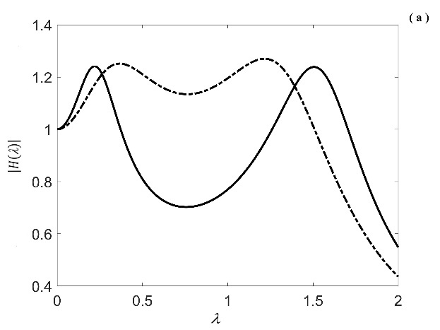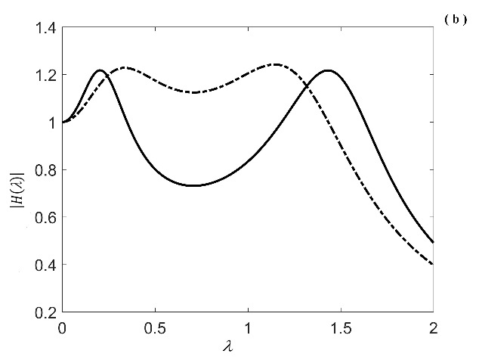
Fig. 6. Comparisons of optimal $\left|H\left(\right)\right|$ curves with the same ${\left|H\left(\right)\right|}_{max}$ between this investigation (–––) and Cheung et al. (·-·-·-) (a) μ = 0.05, ${\left|H\left(\right)\right|}_{max}=1.24$ and (b) μ = 0.2, ${\left|H\left(\right)\right|}_{max}=1.22$.

On the other hand, the $\left|H_{r}\left(\right)\right|$ curves for the design parameters corresponding to those of Fig. 6(b) at μ = 0.2 are plotted in Fig. 7(a). It is apparent that at the low frequency range of ($≈0.1-0.4$), i.e., the forcing frequencies being significantly smaller than the natural frequency of the primary system, the $\left|H_{r}\left(\right)\right|$ from the proposed single H∞ design is significantly larger than that from Cheung et al. But in the operating range of , i.e., $≈0.5-1.5$, for the DVA, their $\left|H_{r}\left(\right)\right|$ values are nearly the same. To reduce and restrict the magnitudes of $\left|H_{r}\left(\right)\right|$, the dual H∞ design mentioned in section 3 can be used through choosing a suitable weighting factor β in Eq. (26). For the case under discussion, the dual H∞ design with β = 0.05 gives an improvement in $\left|H_{r}\left(\right)\right|$ (see Figs. 7(a)-(b)) and a slight change on $\left|H\left(\right)\right|$ (see Figs. 6(b) and 7(c)), as shown in Figs. 7(a)-(c). The resulting design parameters for β = 0.05 at μ = 0.2 are = 0.473, ${}_{a}$= 1.0, α = 0.540. When choosing β = 0.07 the dual H∞ design results are shown in Figs. 8(a)-(b). The $\left|H\left(\right)\right|$ of this design is poorer than its counterpart with β = 0.05, as shown in Fig. 7(c), while the $\left|H_{r}\left(\right)\right|$ becomes better than the corresponding one from Cheung at the low frequency range of . The yielded design parameters for β = 0.07 at μ = 0.2 are = 0.527, ${}_{a}$ = 1.0, α = 0.494.
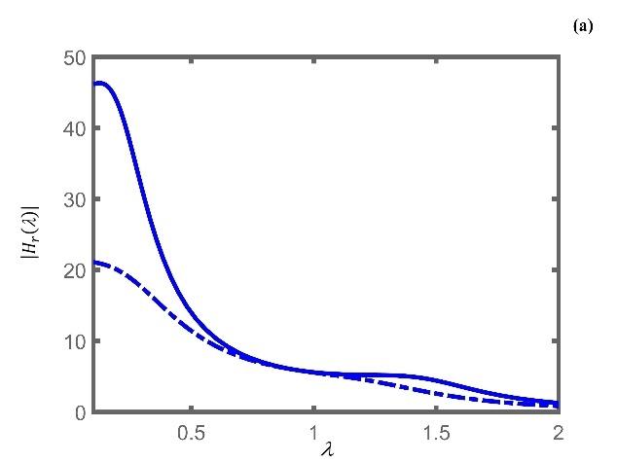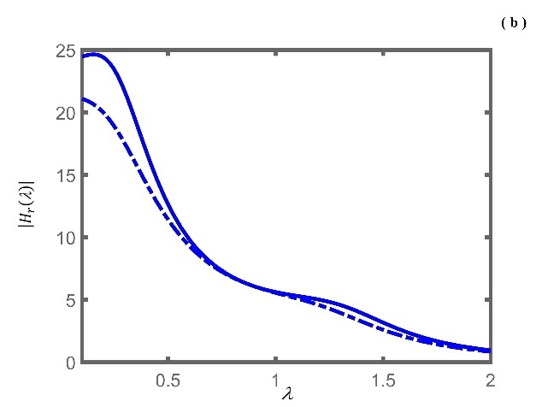
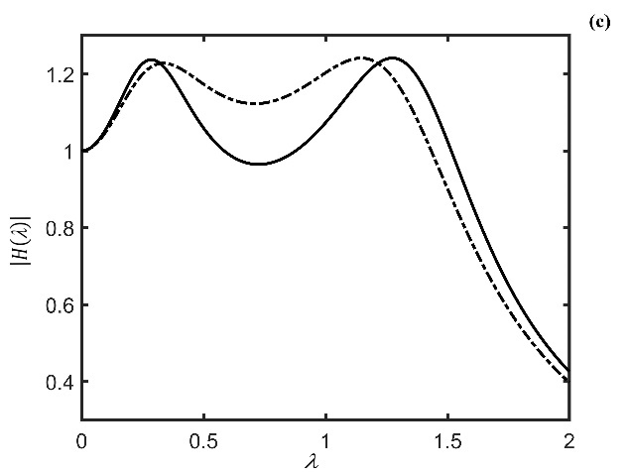
Fig. 7. (a) $\left|H_{r}\left(\right)\right|$ curves of this single H∞ design (–––) and Cheung et al. (·-·-·-) with the same design parameters as that shown in Fig. 6(b) at μ = 0.2; (b) $\left|H_{r}\left(\right)\right|$ curves of this dual H∞ design (–––) with β = 0.05 at μ = 0.2 and Cheung et al. (·-·-·-) with no change as in Fig.7(a); (c) $\left|H\left(\right)\right|$ curves of this dual H∞ design (–––) with β = 0.05 at μ = 0.2 and Cheung et al. (·-·-·-) with no change as in Fig.6(b).
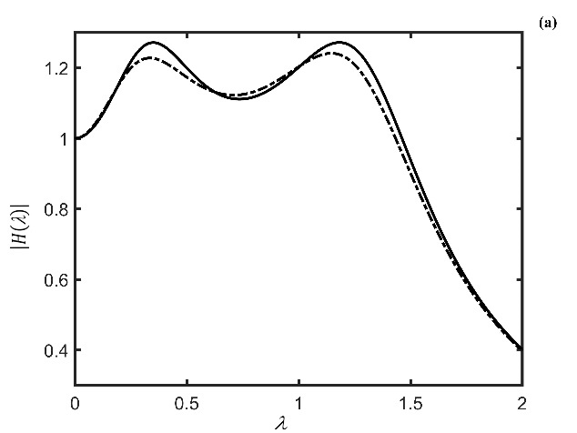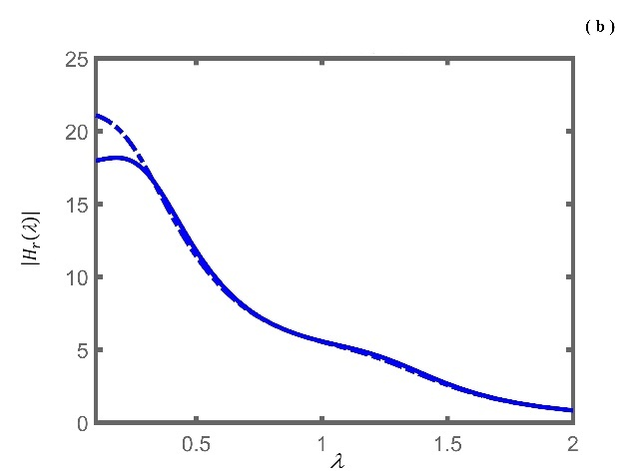
Fig. 8. (a) $\left|H\left(\right)\right|$ curves of this dual H∞ design (–––) with β = 0.07 at μ = 0.2 and Y.L. Cheung et al. (·-·-·-) with no change as in Fig.6(b); (b) $\left|H_{r}\left(\right)\right|$ curves of this dual H∞ design (–––) with β = 0.05 at μ = 0.2 and Cheung et al. (·-·-·-) with no change as in Fig.7(a).

In what follows, the ADVA based on PD control is presented with respect to two different feedback signals, i.e., displacements $x$ and $x_{a}$ of the primary mass and the absorber, respectively. Figs. 9(a)-(b) illustrate the $\left|H\left(\right)\right|$ and $\left|H_{r}\left(\right)\right|$, respectively, obtained from the single H∞ optimization for the $\left|H\left(\right)\right|$ only, at μ = 0.2, therein the solid lines representing $x$ feedback and the dotted-dashed lines $x_{a}$ feedback. Figs. 10(a)-(b) present the $\left|H\left(\right)\right|$ and $\left|H_{r}\left(\right)\right|$, respectively, after using the dual H∞ approach with β = 0.1 for each feedback signal. In addition, optimal results given by Chatterjee ^{[31]} were derived via employing the fixed-points theory and PD control on $x_{a}$ for the ADVA without including any passive damping in the primary system and the absorber. Fig. 11 shows the corresponding results of the $\left|H\left(\right)\right|$ and $\left|H_{r}\left(\right)\right|$ obtained by using the single H∞ co-design with the same design constraints as those of [31]. Table 2 lists the main results obtained from the above calculations and from Chatterjee. It also indicates that the single H∞ co-design can give the best ${\left|H\left(\right)\right|}_{max}$ result among those listed and the dual H∞ co-design can achieve a better balance between the results of ${\left|H\left(\right)\right|}_{max}$ and ${\left|H_{r}\left(\right)\right|}_{max}$ for the ADVA. Moreover, how to balance the magnitudes of $\left|H\left(\right)\right|$ and $\left|H_{r}\left(\right)\right|$, and determine an appropriate weighting factor β is dependent on specific requirements. One numerical method for determining an appropriate β value is to depict the curves of ${\left|H\left(\right)\right|}_{max}$ and ${\left|H_{r}\left(\right)\right|}_{max}$ with respect to different β values and then an β could be chosen so as to make the corresponding ${\left|H\left(\right)\right|}_{max}$ and ${\left|H_{r}\left(\right)\right|}_{max}$ satisfying specific requirements.

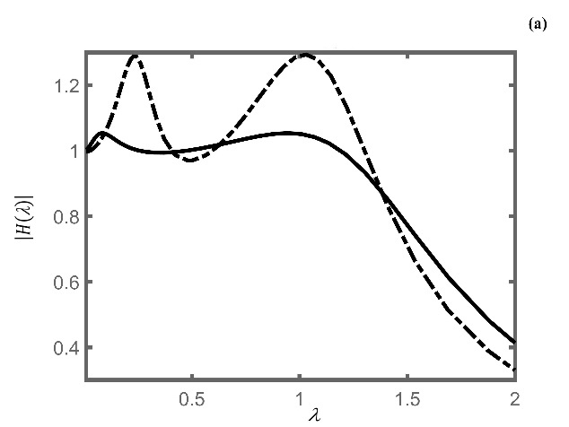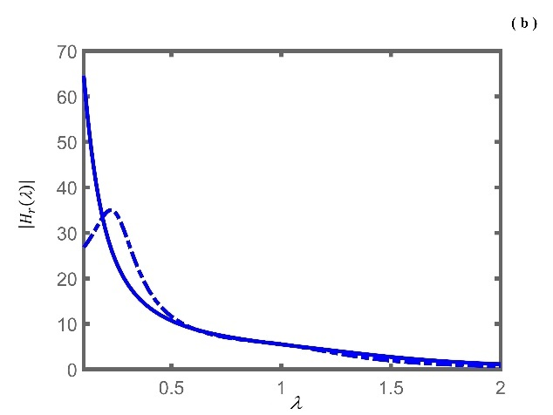
Fig. 9. Optimal $\left|H\left(\right)\right|$ and $\left|H_{r}\left(\right)\right|$ curves of this single H∞ co-design for PD control-based ADVA at μ = 0.2; (–––) and (–––) denoting $x$ feedback, (·-·-·-) and (·-·-·-) denoting $x_{a}$ feedback; (a) $\left|H\left(\right)\right|$ curves and (b) $\left|H_{r}\left(\right)\right|$ curves.

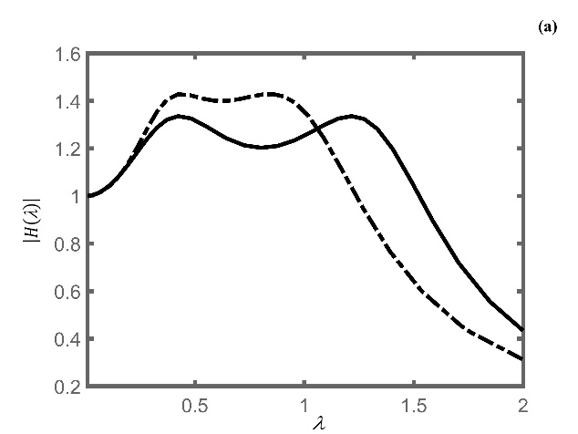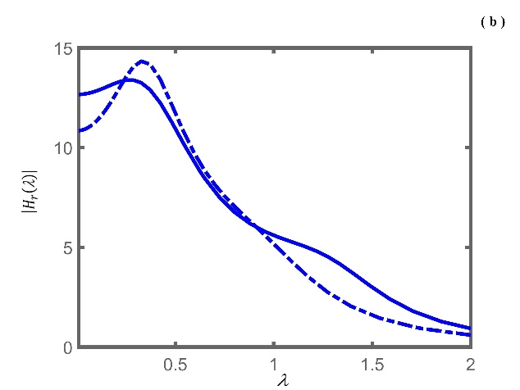
Fig. 10. Optimal $\left|H\left(\right)\right|$ and $\left|H_{r}\left(\right)\right|$ curves of this dual H∞ co-design for PD control-based ADVA with β = 0.1 at μ = 0.2; (–––) and (–––) denoting $x$ feedback, (·-·-·-) and (·-·-·-) denoting $x_{a}$ feedback; (a) $\left|H\left(\right)\right|$ curves and (b) $\left|H_{r}\left(\right)\right|$ curves.

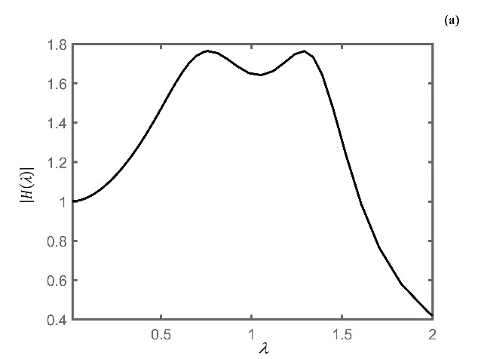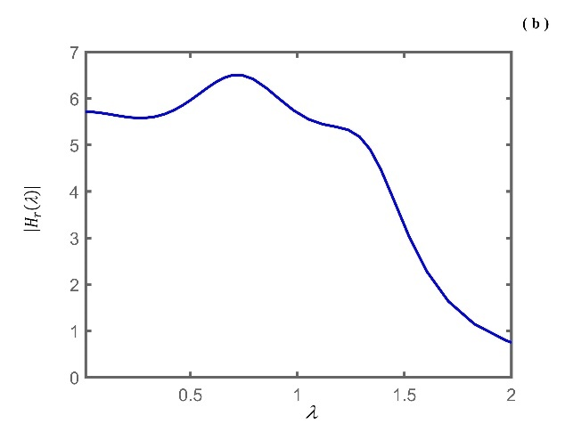
Fig.11. Optimal $\left|H\left(\right)\right|$ (–––) and $\left|H_{r}\left(\right)\right|$ (–––) curves of this single H∞ co-design for PD control-based ADVA using $x_{a}$ feedback with = 1.5 and ${}_{a}$ = 0.0 at μ = 0.2; (a) $\left|H\left(\right)\right|$ curve and (b) $\left|H_{r}\left(\right)\right|$ curve.

Table 2. Some optimal results for PD control-based ADVA at μ = 0.2
Parameters ${}_{a}$ ${\left|H\left(\right)\right|}_{max}$ ${\left|H_{r}\left(\right)\right|}_{max}$ β
single H∞ (x feedback) 0.1 1.0 1.054 64.6 −
dual H∞ (x feedback) 0.64 1.0 1.336 13.4 0.1
single H∞ (x_{a} feedback)& 1.5 1.0 1.292 26.8 −
dual H∞ (x_{a} feedback)& 1.5 1.0 1.428 14.3 0.1
single H∞ (x_{a} feedback)* 1.5 0.0 1.764 6.5 −
Chatterjee (x_{a} feedback)# 1.5 0.0 2.108 ≈ 6.8 −
# See the Equation (25) and Figures 3 and 4 of reference [31].
* The corresponding results from this investigation for a comparison with those of Chatterjee ^{[31]}.
&Although the resulting parameters and ${}_{a}$ are the same, two calculating approaches yield two groups of different PD control gains, respectively, which are not listed in this Table.

4.2 ADVA with the damped primary system
In the following calculations the upper bound of is extended to 1.5 in the co-design. Fig.12 and Fig.13 show the $\left|H\left(\right)\right|$ and $\left|H_{r}\left(\right)\right|$ of the ADVA based on P control and PD control for x and x_{a} feedback, respectively, using the single H∞ co-design at μ = 0.2. In the case of P control, it is observed from multiple calculation settings that (1) the ADVA using x feedback can achieve a better vibration suppression performance than that using x_{a} feedback in terms of the $\left|H\left(\right)\right|$, but the ADVA using x feedback may appear much larger $\left|H_{r}\left(\right)\right|$ in the low frequency range of , as shown in Fig.12; (2) the ${\left|H\left(\right)\right|}_{max}$ decreases with the increasing value of ${}_{p}$ for both x and x_{a} feedback, respectively, as shown in Fig.13 (μ = 0.1).
In the case of PD control, they show a reserved feature, as shown in Fig.14, compared to the feature (1) mentioned above in the case of P control, at a larger allowable value, e.g., ${}_{max}$ = 1.5. While ${}_{max}$ = 1.0 is set up, ${\left|H\left(\right)\right|}_{max}=1.036$ for x feedback is still better than ${\left|H\left(\right)\right|}_{max}=1.196$ for x_{a} feedback. But other than that, they manifest the same trends as the feature (2) above in the case of P control.
Using the dual H∞ co-design with the weighting factor β = 0.05 and 0.1, respectively, Fig.15 and Fig.16 show the results of $\left|H\left(\right)\right|$ and $\left|H_{r}\left(\right)\right|$ of the ADVA corresponding to the design shown in Fig. 14. It is also verified that the dual H∞ co-design can significantly decrease the ${\left|H_{r}\left(\right)\right|}_{max}$ under suitable choices of β at the expense of slightly increased ${\left|H\left(\right)\right|}_{max}$ for both feedback situations.

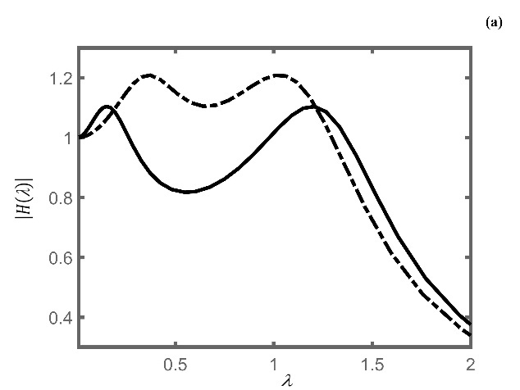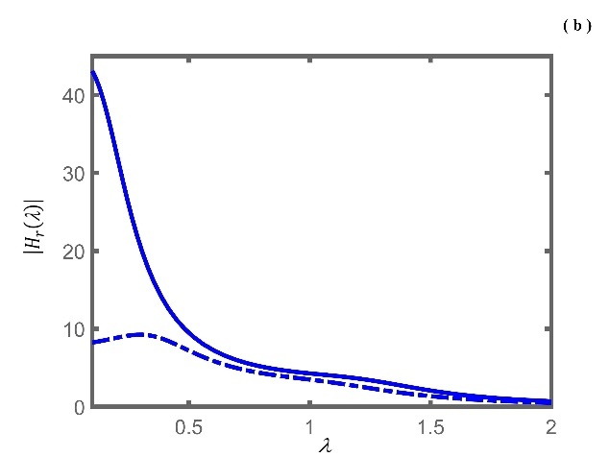
Fig.12. Optimal $\left|H\left(\right)\right|$ and $\left|H_{r}\left(\right)\right|$ curves of this single H∞ co-design for P control-based ADVA at μ = 0.2; (–––) and (–––) denoting $x$ feedback, (·-·-·-) and (·-·-·-) denoting $x_{a}$ feedback; (a) $\left|H\left(\right)\right|$ curves and (b) $\left|H_{r}\left(\right)\right|$ curves.

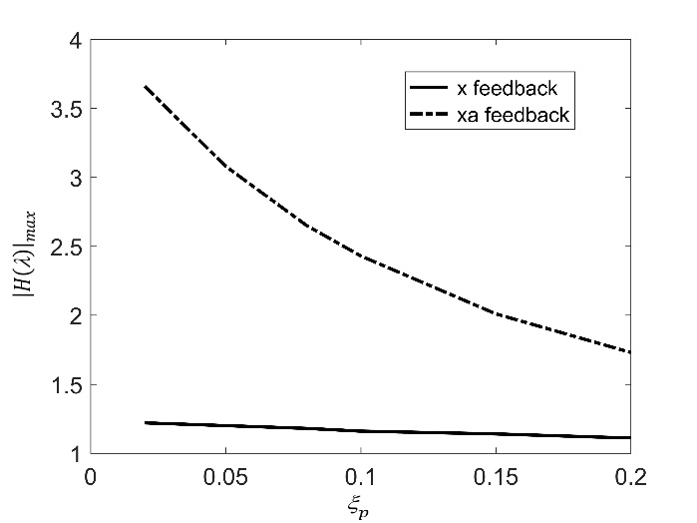
Fig.13. ${\left|H\left(\right)\right|}_{max}$ curves with respect to different ${}_{p}$ values by using this single H∞ co-design for P control-based ADVA at μ = 0.1, (–––) denoting $x$ feedback, and (·-·-·-) denoting $x_{a}$ feedback.
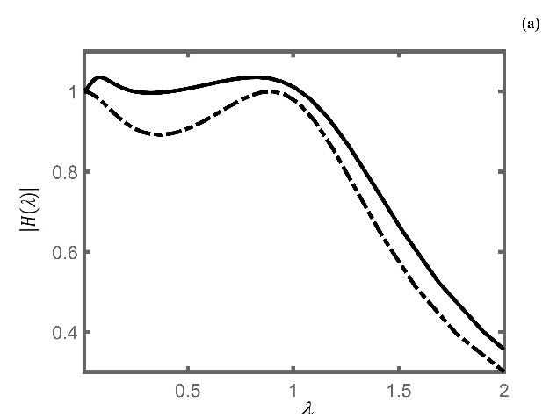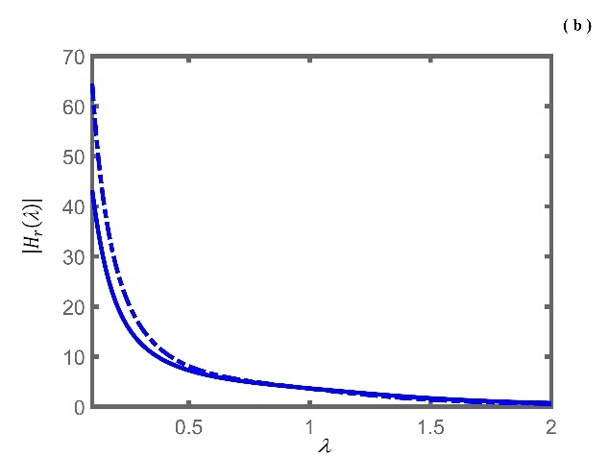
Fig.14. Optimal $\left|H\left(\right)\right|$ and $\left|H_{r}\left(\right)\right|$ curves of this single H∞ co-design for PD control-based ADVA at μ = 0.2; (–––) and (–––) denoting $x$ feedback, (·-·-·-) and (·-·-·-) denoting $x_{a}$ feedback; (a) $\left|H\left(\right)\right|$ curves and (b) $\left|H_{r}\left(\right)\right|$ curves.

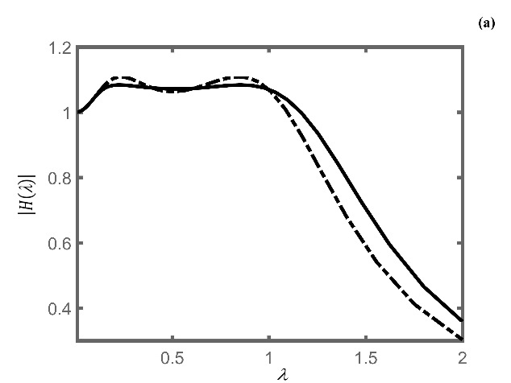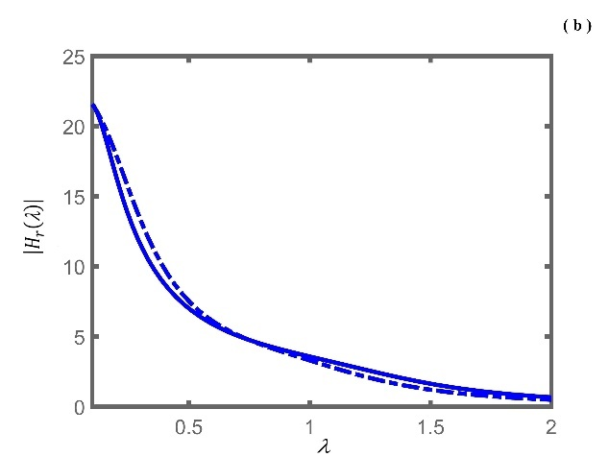
Fig.15. Optimal $\left|H\left(\right)\right|$ and $\left|H_{r}\left(\right)\right|$ curves of this dual H∞ co-design for PD control-based ADVA with β = 0.05 at μ = 0.2; (–––) and (–––) denoting $x$ feedback, (·-·-·-) and (·-·-·-) denoting $x_{a}$ feedback; (a) $\left|H\left(\right)\right|$ curves and (b) $\left|H_{r}\left(\right)\right|$ curves.
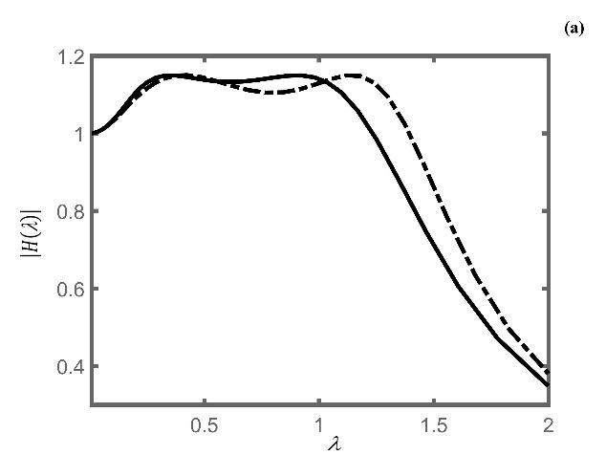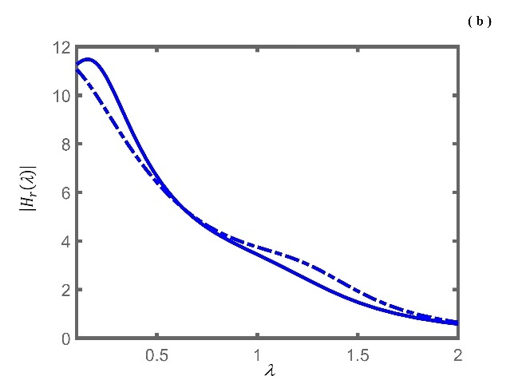
Fig.16. Optimal $\left|H\left(\right)\right|$ and $\left|H_{r}\left(\right)\right|$ curves of this dual H∞ co-design for PD control-based ADVA with β = 0.1 at μ = 0.2; (–––) and (–––) denoting $x$ feedback, (·-·-·-) and (·-·-·-) denoting $x_{a}$ feedback; (a) $\left|H\left(\right)\right|$ curves and (b) $\left|H_{r}\left(\right)\right|$ curves.

4.3 Two variant PDVAs
PDVA-Ⅰ has an additional inerter and an additional negative-stiffness spring, as shown in Fig. 2, which was considered to broaden the effective frequency range of vibration mitigation and performed the best under harmonic and random excitations among four kinds of novel inerter-based DVAs with the negative stiffness element ^{[24]}.
For selected values of $=1$ and $=2$ at μ = 0.1, one can calculate the corresponding optimum parameters of the PDVA according to Eqs. (16a)-(16c), respectively, which were given by Wang et al^{[24]}. Meanwhile, the proposed single H∞ optimization method also yields the corresponding optimum parameters of PDVA-Ⅰ, respectively, at the same prescribed values of and μ. Those results are tabulated in Table 3. The resulting $\left|H\left(\right)\right|$ and $\left|H_{r}\left(\right)\right|$ curves are plotted in Fig. 17(a)-(b), therein red dotted-dashed lines and solid lines representing results from Wang et al. and black dotted-dashed lines and solid lines the present single H∞ optimization method, respectively. It is evident that for this variant PDVA the design variables obtained from the method of H∞ optimization based on the fixed-points theory may not yield the minimum ${\left|H\left(\right)\right|}_{max}$ in the reasonable range of the design variables, let alone find the minimum ${\left|H_{r}\left(\right)\right|}_{max}$ desirable. Again, the proposed H∞ optimization design performs quite a lot.

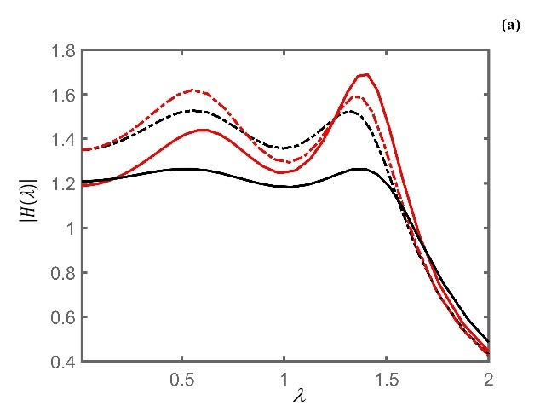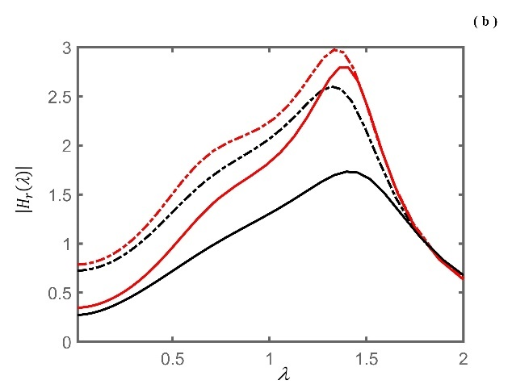
Fig. 17. Optimal $\left|H\left(\right)\right|$ and $\left|H_{r}\left(\right)\right|$ curves of the PDVA-Ⅰ from this single H∞ optimization (–––) and Wang, et al (–––) at μ = 0.1, $=2$ ; (·-·-·-) and (·-·-·-) at μ = 0.1, $=1$; (a) $\left|H\left(\right)\right|$ curves and (b) $\left|H_{r}\left(\right)\right|$ curves.

Table 3. Comparison of some optimal results for variant PDVA-Ⅰ at μ = 0.1
Parameters ${}_{a}$ $α_{2}$ ${\left|H\left(\right)\right|}_{max}$ ${\left|H_{r}\left(\right)\right|}_{max}$
single H∞* 2.2 0.64 −0.349 1.527 2.60 1
X. Wang, et al 2.12 0.56 −0.368 1.619 2.97 1
single H∞# 2.77 1.0 −0.184 1.266 2.29 2
X. Wang, et al 2.34 0.76 −0.225 1.695 2.79 2
* The upper bound of is extended to 2.2 for a comparison with that of X. Wang, et al.
# The upper bound of is extended to 3.0 for a comparison with that of X. Wang,
et al.

Now another variant PDVA (PDVA-Ⅱ) mentioned in Section 2 is obtained with the proposed single H∞ optimization method. Chun et al. ^{[12]} employed a globally optimal method to handle the H∞ optimization design for the variant PDVA and presented the optimal design parameters of and ${}_{a}$ under three given design conditions ^{[12]}, i.e., (c1) μ = 0.1, ${}_{p}$= 0.08 and $0<≤1.5$; (c2) μ = 0.1, ${}_{p}$= 0.08 and $0<≤3.1623$; (c3) μ = 0.25, ${}_{p}$= 0.3 and $0<≤1.3$. Interestingly, optimal results here calculated by the single H∞ optimization method are identical to them under the same design conditions and tabulated in Table 4. Moreover, additional information on values of ${\left|H_{r}\left(\right)\right|}_{max}$ is also listed in Table 4. The resulting $\left|H\left(\right)\right|$ and $\left|H_{r}\left(\right)\right|$ curves are plotted in Fig. 18(a)-(b) and shown by red lines (noting that interested readers refer to Tables 1-3 and Figs. (7)-(8) in [12]). Subsequently, all design parameters are adopted as design variables in the single H∞ optimization with the following implementable design condition, labelled by (c4), $0<≤0.25$, $0<≤3.0$, $0<{}_{p}≤0.3$ and $0<{}_{a}≤0.8$. The optimal results obtained are excellent with $=0.2473$, $=1.5069$, ${}_{p}=0.2997$, ${}_{a}=0.7582$, ${\left|H\left(\right)\right|}_{max}=1.0$ and ${\left|H_{r}\left(\right)\right|}_{max}=0.9441$. Its $\left|H\left(\right)\right|$ and $\left|H_{r}\left(\right)\right|$ curves are plotted in Fig. 18(a)-(b) and shown by black solid lines.
It is illustrated from the above numerical examples that the design results of the proposed single H∞ optimization method for variant PDVAs can broaden the effective operating frequency range of the PDVAs, and yield a better steady-state vibration performance in terms of ${\left|H\left(\right)\right|}_{max}$ and ${\left|H_{r}\left(\right)\right|}_{max}$, compared with those of the existing methods based on the fixed-points theory, despite their design results being in the form of the analytical or closed-form solutions for H∞ optimization. The introduced numerical approach of H∞ optimization can be configured to automatically run multiple optimizations from randomly generated starting points. This helps increase the likelihood of finding optimal DVA parameters values under reasonable design conditions.
At this point, the peculiarities and advantages of the design method based on the structured H∞-synthesis for DVAs H∞ optimization design are worth emphasizing: (1) It solves the optimization design of DVAs based on the state-space form of their equations of motion, which can contain the tunable design variables, and various transfer functions of DVAs such as $\left|H\left(\right)\right|$ and $\left|H_{r}\left(\right)\right|$ which can be easily established by setting up relevant input and output matrices in their state equations, and no explicit expressions of them are required beforehand. (2) The preparation process and the formulation for running H∞ the optimization algorithm is simple, and no user parameters are needed to be set up and tuned. These advantages are not available to many numerical global optimization methods, and the proposed method considers DVA structure in a straightforward manner in the overall system design. (3) In ADVAs design, the DVA and the controller can be optimized simultaneously. Specifically, the constraint on the closed-loop stability of ADVAs has been built into the structured H∞-synthesis algorithm, which is also unavailable to other existing numerical optimization methods reported in the literature for ADVAs design; Besides, the ${\left|H_{r}\left(\right)\right|}_{max}$ of an ADVA can be mitigated by using the dual H∞ co-design, which can be also used to the parameters design of PDVAs when the constraint on ${\left|H_{r}\left(\right)\right|}_{max}$ is required.

Table 4. Optimal results from this investigation for variant PDVA-Ⅱ
Parameters ${}_{a}$ ${\left|H\left(\right)\right|}_{max}$ ${\left|H_{r}\left(\right)\right|}_{max}$
(c1) * 1.0366 0.2305 2.6221 6.3267
(c2) 3.123 0.8 1.5365 0.7927
(c3) 1.3 0.7298 1.0244 1.1431
* Results given by Chun et al. [12] under the condition (c1) had negligible differences with this investigation. They were $=1.0364$, ${}_{a}=0.2302$ and ${\left|H\left(\right)\right|}_{max}=2.6224$.

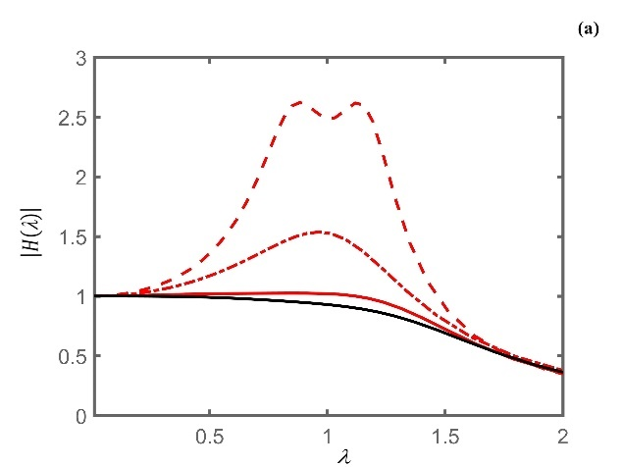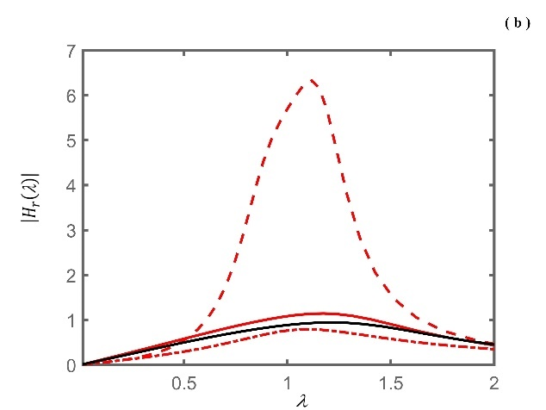
Fig. 18. Optimal $\left|H\left(\right)\right|$ and $\left|H_{r}\left(\right)\right|$ curves of the PDVA-Ⅱ from this single H∞ optimization; (c1) (---) , (c2) (·-·-·-) and (c3) (–––); (c4) (–––); (a) $\left|H\left(\right)\right|$ curves and (b) $\left|H_{r}\left(\right)\right|$ curves.

5. Conclusions
The proposed H∞ optimization method has significant advantages over the existing numerical methods in the H∞ optimization design of variant passive dynamic vibration absorbers (PDVAs) with complicated structures and active dynamic vibration absorbers (ADVAs). It is directly based on their equations of motion in state-space forms, and explicit formulations of various amplitude magnification factors, such as those on the absolute and the relative displacements and active force, need not be derived in the MATLAB environment. A true co-design of design parameters of dynamic vibration absorbers and controller gains yields an H∞-optimal proportional-integral-differential control based ADVAs (PID-ADVAs) or ADVAs with other practically useful controller structures, which also have robust stability. A possible situation of occurrence of large amplitude of the relative displacement in ADVAs rarely considered in the literature can be handled by using the proposed dual H∞ design. Therefore, there is a very strong reason to believe that this method provides a promising alternative approach to the optimal design of DVAs.

References
[1] E. Hahnkamm (1932) Die Dämpfung von Fundamentschwingungen bei veränderlicher Erregergrequenz. Ingenieur Archive 4:192–201. (In German).
[2] Brock JE (1946) A note on the damped vibration absorber. ASME Trans J App Mech 68(34): 280-284.
[3] J. P. Den Hartog (1956) Mechanical Vibrations. 4th ed. McGraw-Hill, New York.
[4] Nishihara O, Asami T (2002) Closed-form solutions to the exact optimizations of dynamic vibration absorber (minimizations of the maximum amplitude magnification factors). ASME Trans J Vib Acoust 124: 576–582.
[5] Asami O, Nishihara A, Baz M (2002) Analytical solution to H∞ and H₂ optimization of dynamic vibration absorbers attached to damped linear systems. Trans ASME J Vib Acoust 124(2): 284–295.
[6] Ghosh A, Basu B (2007) A closed-form optimal tuning criterion for TMD in damped structures. Struct Control Hlth 14 (4): 681–692.
[7] Argenziano M, Faiella D, Carotenuto AR (2022) Generalization of the Den Hartog model and rule-of-thumb formulas for optimal tuned mass dampers. J Sound Vib 538:117213.
[8] Liu K, Coppola G (2010) Optimal design of damped dynamic vibration absorber for damped primary systems. Can Trans Soc Mech Eng 34 (1): 119–135.
[9] Pennestri E (1998) An application of Chebyshev’s min-max criterion to the optimum design of a damped dynamic vibration absorber. J Sound Vib 217: 757–765.
[10] Brown B, Singh T (2011) Minimax design of vibration absorbers for linear damper systems. J Sound Vib 330: 2437–2448.
[11] Viana FAC, Kotinda GI, Rade DA (2008) Tuning dynamic vibration absorbers by using ant colony optimization. Comput Struct 86:1539–1549.
[12] Chun S, Lee Y, Kim TH (2015) H∞ optimization of dynamic vibration absorber variant for vibration control of damped linear systems. J Sound Vib 335: 55–65.
[13] Kaveh A, Javadi SM, Moghanni RM (2020) Optimal structural control of tall buildings using tuned mass dampers via chaotic optimization algorithm. Struct 28: 2704–2713.
[14] Asami T, Nishihara O (1999) Analytical and experimental evaluation of an air damped dynamic vibration absorber: design optimizations of the three-element type model. ASME Trans J Vib Acoust 121(3): 334–342.
[15] Ren MZ (2001) A variant design of the dynamic vibration absorber. J Sound Vib 245: 762–770.
[16] Liu K, Liu J (2005) The damped dynamic vibration absorbers: revisited and new result. J Sound Vib 284: 1181–1189.
[17] Wong WO, Cheung YL (2008) Optimal design of a damped dynamic vibration absorber for vibration control of structure excited by ground motion. Eng Struct 30: 282–286.
[18] Cheung YL, Wong WO (2011) H-infinity optimization of a variant design of the dynamic vibration absorber–revisited and new results. J Sound Vib 330(16): 3901–3912.
[19] Batou A, Adhikari S (2019) Optimal parameters of viscoelastic tuned-mass dampers. J Sound Vib 445: 17–28.
[20] Najafi M, Ashory MR, Jamshidi E (2009) Optimum configuration for vibration absorbers of a SDOF system using genetic algorithm. In: Proceedings of the IMAC-XXVII.
[21] Barredo E, Larios JGM, Colín J (2020) A novel high-performance passive non-traditional inerter-based dynamic vibration absorber. J Sound Vib 485: 115583.
[22] Marcial B, Aurelien KJ (2022) Parameters optimization and performance evaluation for the novel tuned inertial damper. Eng Struct 250:113396.
[23] Chang W, Jin X, Huang Z, Cai G (2021) Random response of nonlinear system with inerter‑based dynamic vibration absorber. J Vib Eng Technol 9:1903–1909.
[24] Wang X, He T, Shen Y (2019) Parameters optimization and performance evaluation for the novel inerter-based dynamic vibration absorbers with negative stiffness. J Sound Vib 463: 114941.
[25] Chowdhury S, Banerjee A, Adhikari S (2022) Optimal negative stiffness inertial-amplifier-base-isolators: exact closed-form expressions. Int J Mech Sci 218:107044.
[26] Bani-Hani KA (2007) Vibration control of wind-induced response of tall buildings with an active tuned mass damper using neural networks. Struct Control Hlth 14(1): 83–108.
[27] Samali B, Al-Dawod M (2003) Performance of a five-story benchmark model using an active tuned mass damper and a fuzzy controller. Eng Struct 25:1597–1610.
[28] Aguilar‑Álvarez P, Valencia‑Palomo G, Enríquez‑Zárate J, Morales‑Valdez J, Hernández‑González O (2022) Vibration control using a positive position feedback‑based predictive controller applied to a one‑bay three‑story scaled shear frame. J Vib Eng Technol Published online: 14 July https://doi.org/10.1007/s42417-022-00613-w.
[29] Olgac N, Holm-Hansen B (1994) A novel active vibration absorption technique: delayed resonator. J Sound Vib 176: 93–104.
[30] Elmali H, Renzulli M, Olgac N (2000) Experimental comparison of delayed resonator and PD controlled vibration absorbers using electromagnetic actuators. ASME Trans J Dyn Syst 122: 514–520.
[31] Chatterjee S (2010) Optimal active absorber with internal state feedback for controlling resonant and transient vibration. J Sound Vib 329: 5397–5414.
[32] Cheung YL, Wongn WO, Cheng L (2012) Design optimization of a damped hybrid vibration absorber. J Sound Vib 331: 750–766.
[33] Apkarian P, Noll D (2006) Nonsmooth H∞ synthesis. IEEE Trans Automat Contr 1: 71–86.
[34] Gahinet P, Apkarian P (2011) Structured H∞ synthesis in MATLAB IFAC Proc Vol 44 (1): 1435–1440.
[35] Apkarian P, Noll D (2017) The H∞ control problem is solved. Aerospace Lab J 13:1–11.

Acknowledgements
This research work was supported by Key R&D Plan of Hubei Province (Grant No: 2021ABA085) and Hubei Natural Science Foundation Youth Program (Grant No: ZRMS2021002387).

