The impact of the COVID-19 lockdowns on wildlife-vehicle collisions in the UK
Sarah Raymond¹*, Matthew Spencer², Elizabeth A. Chadwick¹, Joah R. Madden³, Sarah E. Perkins¹
¹The Sir Martin Evans Building, School of Biosciences, Cardiff University, CF10 3AX
²School of Environmental Sciences, University of Liverpool, L69 3GP
³Washington Singer Laboratories, University of Exeter, EX4 4QG
*Corresponding author: raymondsc@cardiff.ac.uk

Abstract
- Wildlife-vehicle collisions (WVC) cause millions of vertebrate mortalities globally, threatening population viability and influencing wildlife behaviour and survival. Traffic volume and speed can influence wildlife mortality on roads, but roadkill risk is species-specific and depends on ecological traits.
- The COVID-19 pandemic, and associated UK-wide lockdowns, offered a unique opportunity to investigate how reducing traffic volume alters WVC. These periods of reduced human mobility have been coined the 'anthropause'.
- We used the anthropause to identify which ecological traits may render species vulnerable to WVC. We did this by comparing the relative change in WVC of species with differing traits before and during the anthropause.
- We used Generalised Additive Model (GAM) predictions to assess which of the 19 species most frequently observed as WVC in the UK exhibited changes in road mortality during two lockdown periods, March-May 2020 and December 2020-March 2021, relative to the same time periods in previous years (2014-2019). Compositional data analysis was used to identify ecological traits associated with changes in the relative number of observations during lockdown periods compared to previous years.
- WVC were, across all species, 80% lower during the anthropause than predicted. Compositional data analysis revealed proportionally fewer reports of nocturnal mammals, urban visitors, mammals with greater brain mass and birds with a longer flight initiation distance (FID). Species that have several of these traits, and correspondingly significantly lower than predicted WVC during lockdowns, included badgers, Meles meles, foxes Vulpes vulpes, and pheasants, Phasianus colchicus; we posit they stand to benefit most from reduced traffic, and, of the species studied here, have highest mortality under ‘normal’ traffic levels.
- This study identifies traits and species that may have experienced a temporary reprieve during the anthropause, and highlights the impacts of traffic-induced mortality on species numbers and ultimately on trait frequency in a road-dominated landscape. By taking advantage of reductions in traffic offered by the anthropause, we can understand how vehicles influence wildlife survival and behaviour and may be exerting a selective force for certain species and traits.

Keywords: anthropause, roadkill, wildlife-vehicle collisions, compositional data analysis, citizen science

- Introduction
Many millions of vertebrates are estimated to be killed by vehicles each year in any given country, and globally, the toll could be an order of magnitude higher (Grilo et al. 2020; Schwartz et al. 2020). Typically, the greater the traffic volume, the higher the mortality; a review of 645 studies revealed that traffic volume and speed are predominantly positively correlated with the number of wildlife-vehicle collisions (WVC) (Pagany 2020). The risk to all species is not equal, however (Sadleir and Linklater 2016; Raymond et al. 2021), suggesting ecological traits may underlie species-specific patterns of mortality risk. Removing or reducing traffic on roads could therefore not only offer wildlife a reprieve from WVC, but also provide an opportunity to empirically test which traits and/or species are most and least susceptible to road-associated mortality. During the COVID-19 pandemic in 2020-2021, human movement was significantly reduced during a series of ‘lockdowns’, involving ‘stay at home’ orders (Lillie et al. 2020; Brooks-Pollock et al. 2021; Hale et al. 2021). Indeed, at the height of restrictions, an estimated 4.4 billion people globally were impacted (Bates et al. 2021). The reduction in human activity, especially with respect to transport (Du et al. 2021; Havaei-Ahary 2021; Yasin et al. 2021), was so profound that a global ‘quietening’ was detected (Lecocq et al. 2020); a time period referred to as the ‘anthropause’ (Rutz et al. 2020). Such a reduction in traffic offers the equivalent of a unique perturbation experiment to allow us to assess road mortality risk according to species traits (Perkins et al. 2022).

1.1 What determines WVC risk?
Some mortality patterns are ultimately driven by abiotic factors; for example, levels of anthropogenic development and activity, including urbanisation, can influence roadkill risk, with some species (e.g. rabbits and birds) experiencing greater mortality in urban environments than rural areas (Rendall et al. 2021). Considerable previous work has evaluated both species-specific and trait-based risk in WVC (see for example, Cook and Blumstein (2013) and González-Suárez et al. (2018)), albeit in observational studies rather than via perturbation. WVC risk has been found to depend on both morphological characteristics and behavioural traits, ranging from taxonomic order and brain mass to diel activity (i.e. nocturnal, crepuscular and diurnal) (Steiner et al. 2014; Møller and Erritzøe 2017), and feeding behaviours (i.e. predators, prey and scavengers) (Cook and Blumstein 2013; Silva et al. 2019). There is a degree of collinearity in these traits, such that species with larger body mass generally also have larger home ranges, and both traits result in a greater risk of WVC than their smaller counterparts (Green-Barber and Old 2019; Grilo et al. 2020). Similarly, escape responses such as flight initiation distance (FID) are influenced by morphological attributes such as animal speed, mobility and cognition, and are linked to anthropogenic activity and infrastructure, with, for instance, individual birds adapting their FID to local traffic speeds (Legagneux and Ducatez 2013; DeVault et al. 2014).

1.2 Effects of the anthropause on WVC
Anthropause-mediated reductions in WVC reports have previously been observed (Bates et al. 2021), but have focused on numerical changes in species. A reduction of between 21-44% in large mammal WVC was recorded in four US states with a 58% reduction for some species (Nguyen et al. 2020; Shilling et al. 2021), and a 19% and 48% reduction in roadkill was reported in South Korea and Australia, respectively (Bates et al. 2021; Driessen 2021). Similarly, Bíl et al. (2021) found that seven out of 11 European countries studied had significantly lower WVC than predicted, exhibiting a reduction of up to 40%. Road mortality was halved for some species, for example, the white-breasted hedgehog Erinaceus roumanicus (Łopucki et al. 2021). Despite a drop in WVC coinciding with the greatest COVID-19 mobility restrictions, one study found a gradual increase in WVC reports after lockdowns had ceased, eventually exceeding WVC in the previous year (Abraham and Mumma 2021). Importantly, absolute numbers of WVC reports should be interpreted with caution if data are dependent on reporter effort, a likely outcome in the anthropause due to the reduced ability of many reporters to travel (August et al. 2020). Indeed, reduced reporter effort has been cited as one reason for decreases in WVC (Dörler and Heigl 2021).

Here, we used the dramatic reductions in traffic volume associated with the anthropause in the UK to assess species-level predictions of WVCs, according to their traits. We analysed WVC of 19 species reported across the UK to a citizen science project from 2014-2021 (Shilling et al. 2020), and compared the relative proportion of WVC during two periods of COVID-19 movement restrictions (anthropause) to previous years where no such restrictions occurred. Our objectives were to determine which species traits are most vulnerable to WVC by quantifying trait-specific changes in WVC probability during the anthropause. We hypothesised that the anthropause would result in lower WVC due to reduced traffic and that the relative prevalence of species with traits previously identified as important WVC risk factors (taxonomic, morphological and behavioural traits, discussed above in ‘1.1 What determines WVC risk?’) would be reduced in COVID-19 lockdown periods.

- Methods
2.1 Data collection
Wildlife-vehicle collision (WVC) data were collated from an ongoing nationwide citizen science project based in the UK running from 2013 (https://www.theroadlab.co.uk/ with data available open access at National Biodiversity Network: https://registry.nbnatlas.org/public/show/dp205). The data consist of reports submitted ad hoc by members of the public via an app or social media and include the date, location, and species. Any species can be reported at any time of year and at any location across the UK. Data submitted without a location, and duplicate reports (same species, location and date) are excluded. Due to a lack of data available for Northern Ireland, only WVC reports for England, Scotland and Wales were included in this study, totalling an initial dataset of 41,844 individual WVC reports.
All species with an average of 50 or more annual reports since 2014 were included in the analyses. This included 19 species, of which 11 were mammals (European badger Meles meles, roe deer Capreolus capreolus, Reeves’ muntjac deer Muntiacus reevesi, red fox Vulpes vulpes, European hare Lepus europaeus, European hedgehog Erinaceus europaeus, Eurasian otter Lutra lutra, European polecat Mustela putorius, European rabbit Oryctolagus cuniculus, brown rat Rattus norvegicus and grey squirrel Sciurus carolinensis) and eight were birds (European blackbird Turdus merula, common buzzard Buteo buteo, herring gull Larus argentatus, Eurasian magpie Pica pica, barn owl Tyto alba, ring-necked pheasant Phasianus colchicus, feral pigeon Columba livia domestica and the common woodpigeon Columba palumbus).
We collected trait-based data for each species, focusing on ecological traits previously identified as important in determining WVC risk (e.g. González-Suárez et al. (2018); Grilo et al. (2020)), and used existing literature to obtain values or classifications for each species (Supplementary Information A - Table 1). Traits included taxonomic order, time of activity, predator-prey distinction, scavenging behaviour, and quantitative traits such as FID, body and brain mass, and home range size (see Supplementary Information A for a full list of traits, classification and sources of the data used). We also classified species into ‘urban dweller’ or ‘urban visitor’, defined as species that have been recorded residing either permanently (urban dwellers) or occasionally (urban visitors) in urban ecosystems (Santini et al. 2019).
This study did not require ethical approval.
2.2 Impact of the anthropause on WVC
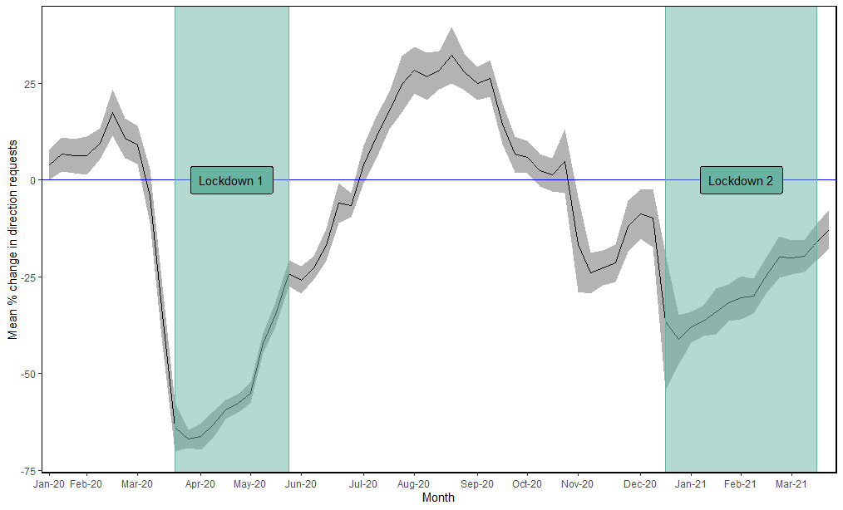
To mitigate disease spread at the start of the COVID-19 pandemic, there were two major UK-wide lockdowns, during which movement restrictions were coincident across England, Wales and Scotland: 23rd March-31st May 2020 (hereafter ‘lockdown 1’) and 20th December-20th March 2021 (hereafter ‘lockdown 2’) (Cameron-Blake et al. 2021; Hale et al. 2021; IfG 2021). These lockdowns corresponded to periods of reduced human movement, as evidenced by fewer driving direction requests via Apple COVID-19 Mobility data, which represent daily counts of the number of requests to Apple Maps for directions (Fig. 1, https://covid19.apple.com/mobility). The data reflect a change in the volume of people driving from one day or week to the next, and, in this instance, enable a comparison to pre-lockdown levels and represent a proxy for traffic volume in the UK during the COVID-19 pandemic (Jing et al. 2021; Kurita et al. 2021; Nouvellet et al. 2021). During lockdowns 1 and 2, there were 53.3% and 29.1% fewer requests for driving directions per week, compared to the baseline pre-pandemic week (Fig. 1). Similarly, according to the Department for Transport (Havaei-Ahary and Heyworth 2022), there was on average a 44% reduction in motor vehicle traffic on UK roads between March-May 2020 (overlapping with Lockdown 1) compared to the same months in 2019, and an average of 28% decline in traffic from December 2020-March 2021 (overlapping with Lockdown 2) compared to 2019. We refer to these two lockdown periods collectively as the anthropause.
Figure 1: Percentage change in the number of direction requests during the United Kingdom’s anthropause: The mean percentage change (with 95% confidence intervals) in the number of driving direction requests per week compared to a baseline week pre-COVID-19 emergence (the week commencing 13th January 2020) when mobility was less restricted. Both UK-wide lockdowns are demarcated and together represent what we refer to here as the UK’s anthropause. Data taken from Apple Maps COVID-19 Mobility Trends Reports https://covid19.apple.com/mobility.
2.3 Statistical analysis
All statistical analyses were carried out in R version 4.1.1 (R Core Team 2021).
- Observed versus expected WVC
Generalised additive models (GAMs) were used to identify temporal patterns in the WVC data for each species, and to then predict the expected ‘typical’ weekly reports of WVC during the anthropause. Weekly total WVC were collated for each of the 19 species from 2014-2019 and were analysed with a separate GAM, with the weekly counts of WVC as the dependent variable. A Poisson error family was used with the most suitable link function (log, identity or square-root), based on which produced the lowest Akaike Information Criterion (AIC) value (Marra and Wood 2011). Where high dispersion resulted in poor model fit, identified by an overdispersion statistic value >2, a negative binomial family with log-link function was used. Week (1 to 52) and year (2014 to 2019) were treated as numerical independent variables, modelled using a cyclic cubic smoothing spline, using the “mgcv” package (Wood 2011). K-values of -1 and 6 were assigned to week and year, respectively, with ‘fx’ set to false to allow for penalization of the smooth terms. The predict function was then used (with type=”link”) to predict future values based on the average seasonality experienced during 2014-2019, and asymmetric 95% confidence intervals were computed for these predictions.
To statistically test for a difference between the predicted and observed WVC during the two lockdowns, a rate ratio (RR) was calculated (the observed number of WVC divided by the predicted number) and the rate ratio test employed from the package “rateratio.test” (Fay 2022). The rate ratio test determines whether there are equal rates (RR=1), more (RR>1.0) or less (RR<1.0) WVC observed than predicted, with the associated p-value indicating whether this relationship is significant or not. For model details and outputs for each species, see Supplementary Information B.

- Spatial reporter bias during lockdowns
Reduced human mobility during lockdowns might cause spatial bias in WVC, for example, if reports were confined to certain areas, so favouring the recording of species whose distribution might coincide with that spatial shift. To ensure equivalent spatial coverage in and out of lockdowns, we spatially subsampled the pre-lockdown points to reflect the spatial extent of WVC during the anthropause. We used a kernel density estimation (KDE) approach and the getverticeshr function in package “adehabitatHR” (Calenge 2006), to extract the 80% and 95% bivariate normal kernels around WVC reports from during lockdown 1 and 2 separately (Fig. 1, Supplementary Information C). The pre-lockdown WVC reports (from 2014-2019) were overlayed on the lockdown WVC reports and only data that fell within the respective KDEs were used in compositional data analysis (Fig. 2, Supplementary Information C). We took the more conservative approach and used the 80% KDE (results reported in the main text). After extracting the WVC data that fell within the dates of interest (i.e. periods coinciding with lockdowns or their respective dates in previous years), and within the 80% KDE, the final dataset for our data analysis comprised of 15,421 data points, submitted by 1302 individual reporters. For comparison the 95% KDE selection and compositional data analysis are presented in Fig. 3 in Supplementary Information C.

- Compositional data analysis
With fewer drivers present on the roads during the anthropause, it was inevitable that fewer WVC reports would be received (Dörler and Heigl, 2021), and bias is also inherent in citizen science data. For these reasons we use compositional data analysis because it uses the relative proportion of species reported, as opposed to raw count data, and allows us to model the effects of these biases on our estimations (Supplementary Information D). The WVC data are collated from a citizen science project, where individual data points are reported ad hoc so observer bias (preferential reporting of certain species) and identification bias (misidentification of species) may occur. We find that observer bias and multiple reports do not affect estimation, i.e. our compositional model is robust to these biases, but identification bias does effect estimation (Supplementary Information D), and we address this in discussing our results.
For the purposes of comparing the relative abundance of WVC of different species during the two lockdown periods in 2020-2021 to equivalent times of year in previous years, we estimated the relative abundance of each species in WVC in each combination of lockdown status and time period. We then represented the effects of lockdown status, time period and their interaction on these relative abundances in coordinates associated with meaningful ecological traits of the organisms involved. In summary, we used a latent compositional data analysis approach with a multinomial observation model. This allowed us to determine the relative change in the frequency of WVC in and out of the anthropause. Relative abundances are an example of compositional data, which have special properties that invalidate most standard statistical approaches (Aitchison 1982). Pairwise correlations are difficult to interpret because their values depend on which other variables are included. At least one pair of variables must be negatively correlated, and compositional data cannot follow a multivariate normal distribution because the values are bounded between 0 and 1 (van den Boogaart and Tolosana-Delgado 2013). Although appropriate statistical methods for compositional data have existed for several decades (Aitchison 1982), and are widely used in studies of habitat use (Aebischer et al. 1993) and microbiota (Grantham et al. 2017), these methods have been underused in community ecology despite their obvious applicability to relative abundance data (Billheimer et al. 2001).
We treat the true relative abundances in WVC data as compositions and assume that the numbers reported for each species in a given combination of time of year and lockdown status are drawn from multinomial distributions parametrized by these compositions, conditional on the total number of individuals reported. As in Chong and Spencer (2018), some species in our study had zero counts recorded in some combinations of lockdown and time of year. The maximum likelihood estimate of the relative abundance would be zero for such species, but this is an unrealistic treatment of sampling zeros and makes compositional data analysis difficult. Bayesian estimation can solve this problem (Billheimer et al. 2001; Chong and Spencer 2018), but we used the simplest possible Laplace pseudocount approach (also known as additive smoothing), in which we added 1 to each count (Aitchison 1982; Manning and Schütze 1999, pp. 197-205; Silverman et al. 2017).
We used loglinear models (Agresti 2012) to determine whether differences in the relative rate of WVC occurred due to the anthropause ‘lockdown’, the ‘time of year’ and lastly whether interaction effects (differences in relative rate of WVC between lockdowns) occurred. The effect of ‘lockdown’ refers to comparing the relative rate of WVC in versus out of lockdown (i.e. during or before the anthropause), while controlling for the time of year. The ‘time of year’ is effectively seasonality and refers to dates that coincided with lockdowns (March-May or December-March), while controlling for all years, i.e. in and out of lockdown combined. The interaction combines these two variables and looks at whether there was a difference in the relative rate of WVC between lockdown 1 and lockdown 2. We initially fitted the most complicated model, with a separate vector of relative abundances for each combination of time of year and lockdown status (equivalent to a three-way interaction between species, time of year and lockdown status in the loglinear model formulation), and the next simplest model (with all two-way interactions but no three-way interaction). A three-way interaction in a log-linear model is really a two-way interaction in a model that distinguishes one variable as a response (Agresti 2012, Section 8.5.3), so that we are determining whether the effect of lockdown status on relative abundances depends on time of year. We compared these models using a likelihood ratio test. We decomposed the estimated differences in relative abundances into time of year, lockdown status and interaction effects, using a compositional approach analogous to two-way ANOVA with interaction. Each of these effects is itself a composition. We then explored the ecological traits associated with these effects. We outline our approach below and give full details in Supplementary Information D.
Following log-linear modelling, a compositional approach was adopted to examine which ecological traits may play a role in any changes in relative abundance in either of the lockdown periods. A central principle of compositional data analysis is that compositions can be mapped to log ratio coordinate systems, in which each coordinate represents a log contrast (a weighted sum of log relative abundances, for which the weights sum to zero) (Egozcue et al. 2003). We chose each coordinate to represent either a binary contrast (e.g. between two taxonomic groups) or a quantitative contrast (e.g. the effect of body mass) (Supplementary Information A). We plotted the projections of the time of year, lockdown status and interaction effects onto these coordinates, and graphically explored whether the projections were associated with differences in ecological traits known to alter WVC risk. For the purposes of analysis, we used the orthogonal version of these ecological traits. The number of ecological traits we investigated was smaller than the dimension of the relative abundances, so there may be effects on the relative rate of WVC that are not captured in our analysis.

- Results
  - Observed vs. expected WVC
Significantly lower than predicted WVC were observed for all weeks of both lockdown periods for all species combined (Fig. 2). During lockdown 1, an average of 72% fewer WVC were observed than expected for the time of year and 87% lower for lockdown 2; Table 1). At a species-specific level, all species (except polecat in lockdown 1, herring gull in lockdown 2, and barn owl in both lockdowns) were lower than predicted, with 13 species significantly so in lockdown 1, and 16 during lockdown 2 (Fig. 3).
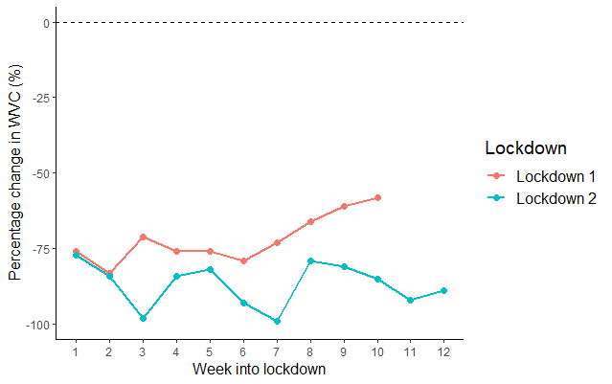
Figure 2: Deviation from forecasted WVC during COVID-19 lockdown period. The observed versus predicted WVC for each week during the two COVID-19 lockdown periods, represented as a percentage change. Both lockdowns saw significantly lower than expected weekly WVC. Note: week number represents the number of weeks into the lockdown, rather than into the calendar year.
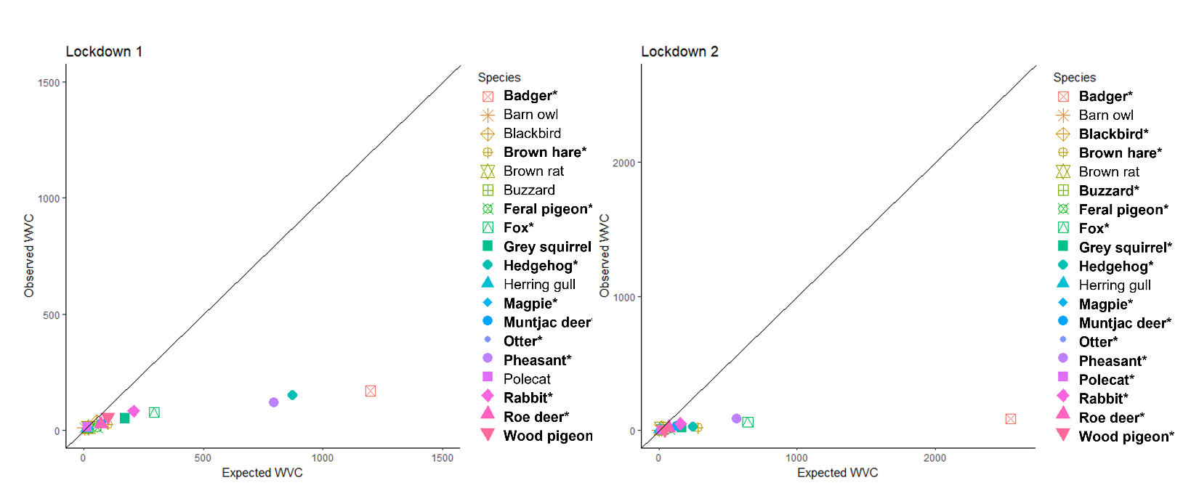
Figure 3: A comparison of observed versus predicted WVC during lockdowns: The observed number of WVC for each species reported during the two COVID-19 lockdowns are shown in comparison to the predicted number produced from GAM models. Points lying on the 1:1 line show little to no difference between observed and predicted WVC. Species with significantly lower observed WVC than forecasted are listed in bold and denoted by an asterisk.
3.2 Compositional data analysis – lockdown and traits
There was strong evidence that lockdown 1 and lockdown 2 had different overall effects on WVC (model with three-way interaction vs. model without, likelihood ratio test: deviance = 49.16, df = 18, p<0.0001). We therefore included time of year, lockdown status and interaction effects in all further analysis.
During lockdowns, four traits showed distinctive relative changes in WVC risk (Fig. 4a): relatively fewer nocturnal mammals, urban visitors, mammals with larger brain mass, and birds with a longer flight initiation distance were reported as WVC. Nocturnal birds and animals with larger home range also saw relatively fewer WVC during lockdowns; however, the 95% confidence intervals overlapped marginally with the 0 line. In line with our previous observations (Raymond et al. 2021), seasonality was evident in the WVC reports. Relatively fewer birds, nocturnal mammals, urban dwellers, animals with smaller body and brain mass, and birds with longer FID were reported as WVC during March-May than December-March, across all years (Fig. 4b). There were no differences between the two lockdowns in the relative frequency of WVC reported, for any of the given ecological traits in this study (solid error bars all overlap zero, Fig. 4c).
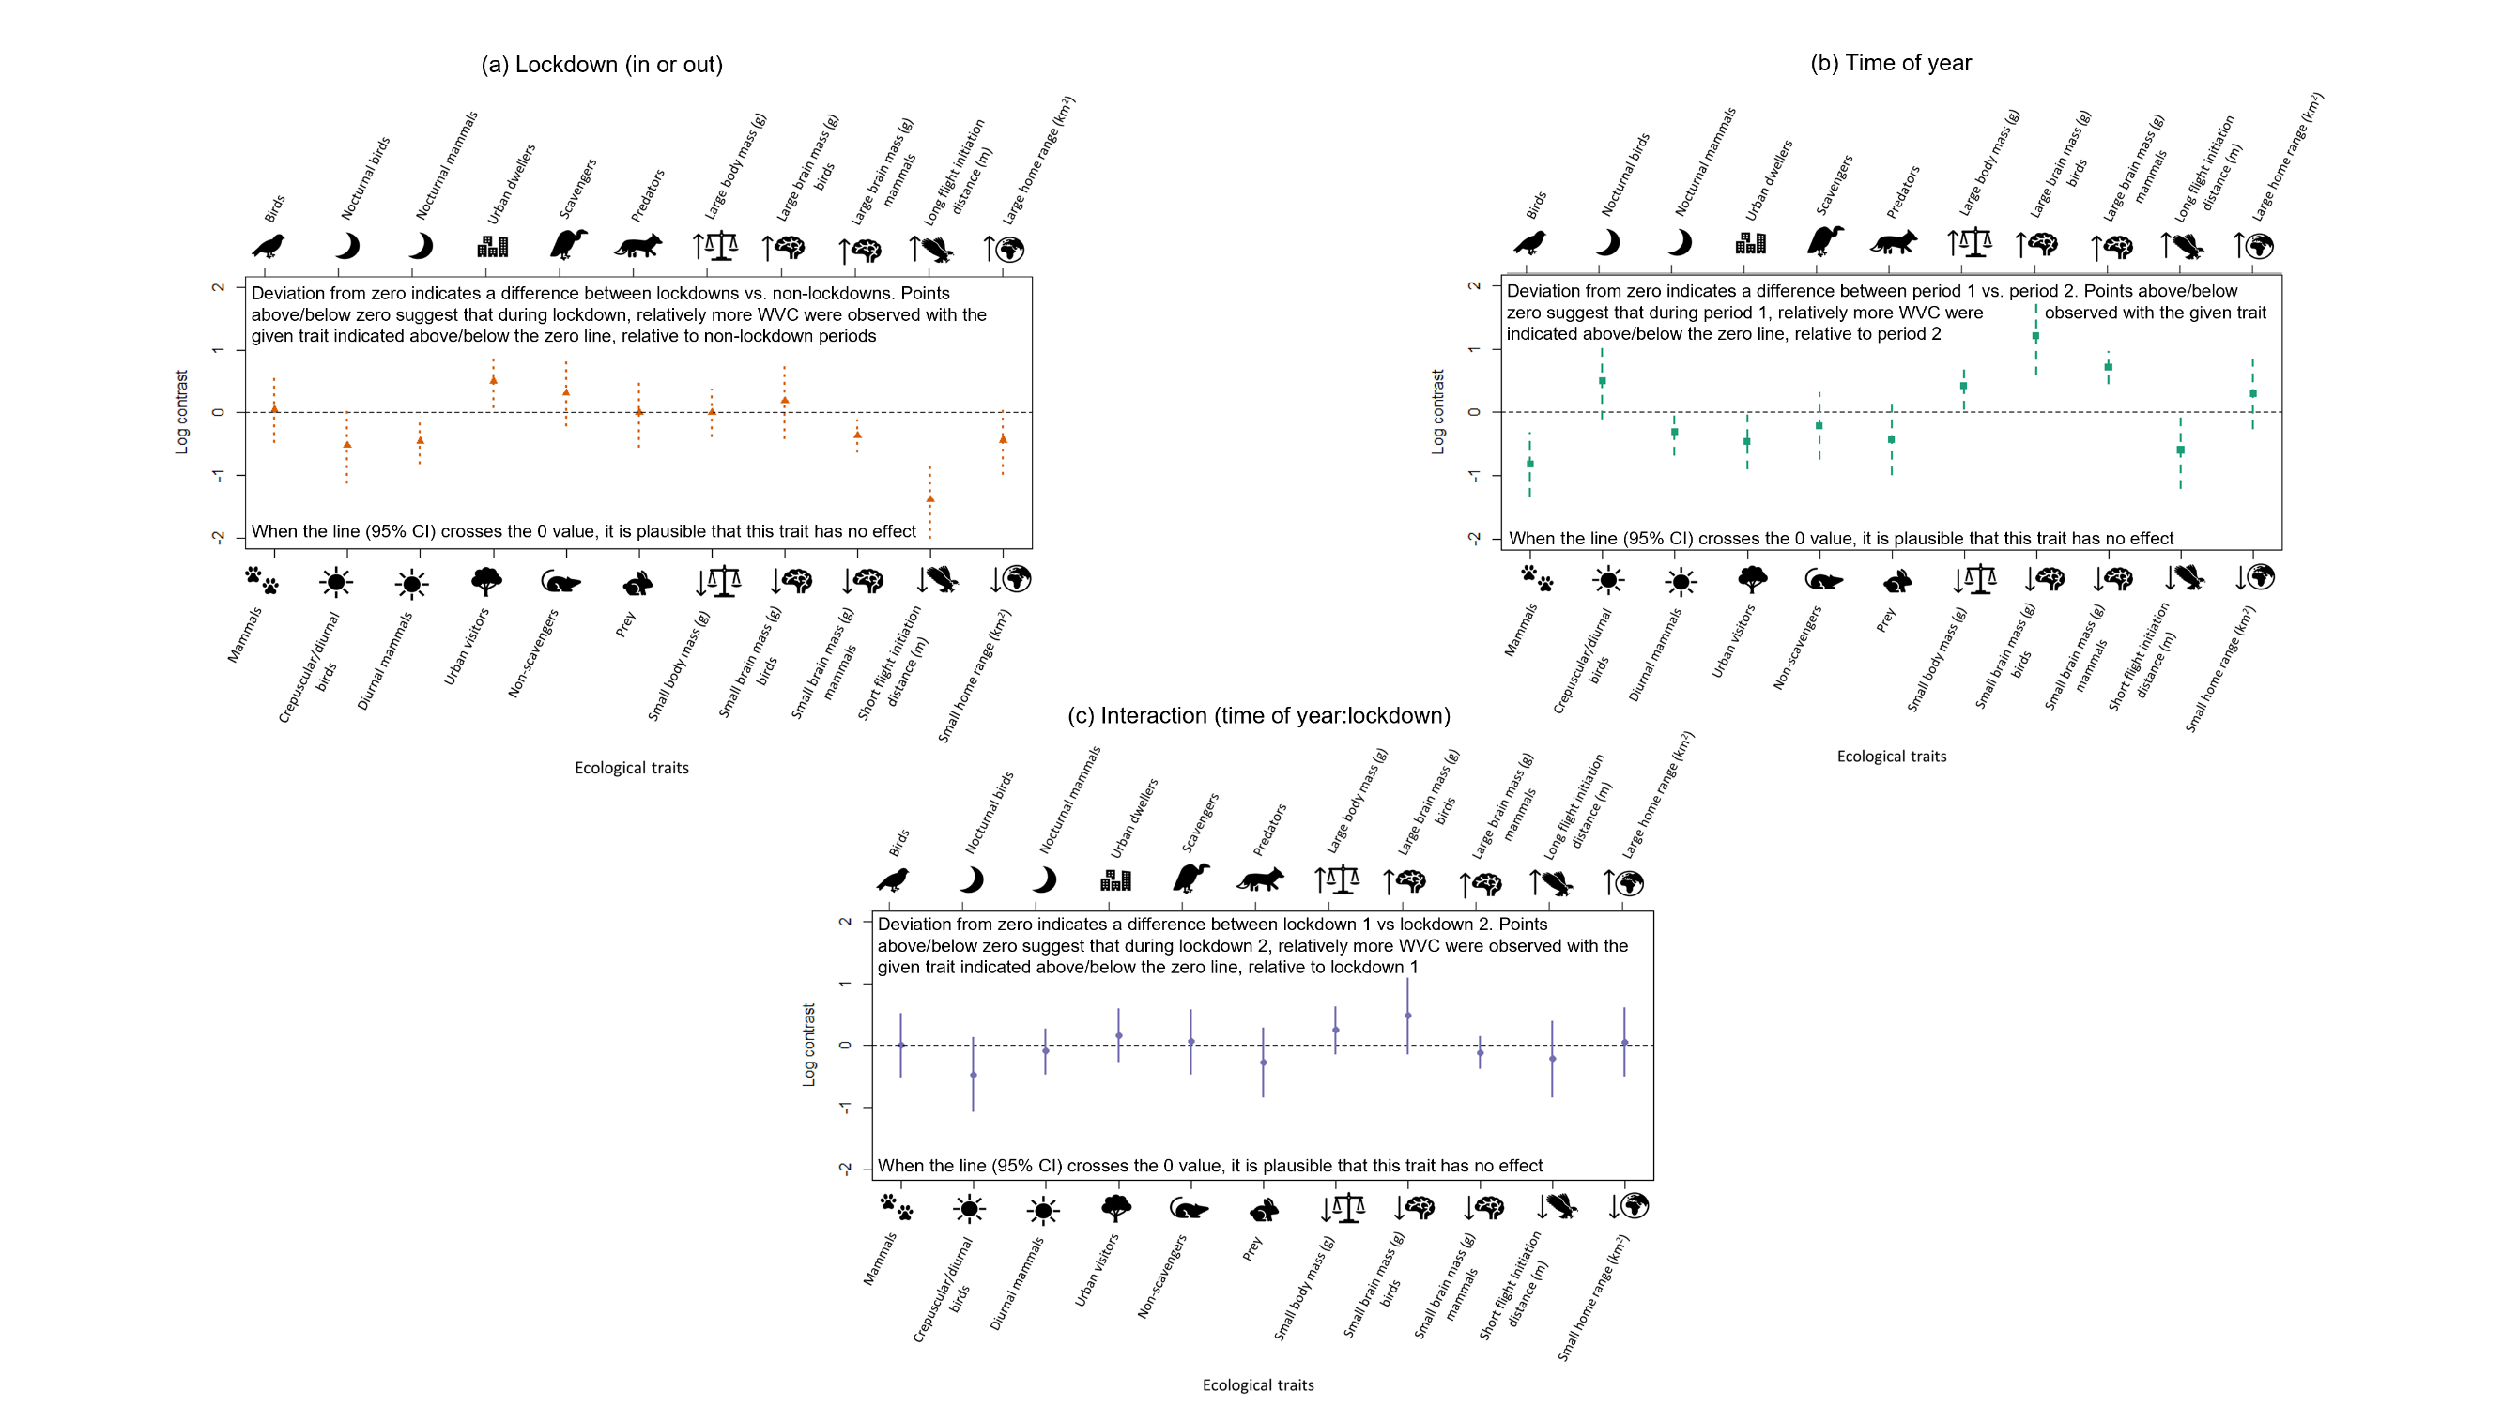
Figure 4: Log contrasts for WVC: Log contrasts of ecological traits associated with WVC reported during (a) lockdown, (b) time of year (i.e. taking account of possible seasonality), and (c) the interaction effects between lockdown and time of year. For each ecological trait (x-axis label), the log-contrast (y-axis) indicates whether relatively more or fewer animals with a given trait were associated with the effect. If the point falls above the line, it indicates that relatively more animals with the trait above the graph were reported as roadkill, and if the point falls below the line, it indicates that relatively more animals with the trait below the graph were reported as roadkill. (a) The “lockdown” points (orange triangles) represent the relative change in WVC during lockdowns compared to pre-lockdown years, averaged over the two times of year. (b) “Time of year” (green squares) represents seasonality in WVC, by the relative change in WVC reports between the two times of year that coincide with the two lockdowns (23rd March-31st May) and (20th December-20th March), averaged over all years (2014-2021). (c) The “time of year:lockdown” interaction (purple circles) represents the relative difference between the two lockdowns. Error bars represent 95% confidence intervals – when the error bar crosses the zero line, it is plausible that the trait has no effect on WVC risk.

- Discussion
The COVID-19 pandemic resulted in widespread reductions in vehicle-use during national lockdowns; the anthropause offered a unique opportunity to determine species’ traits, and ultimately species, susceptible to mortality on roads (Du et al. 2021; Havaei-Ahary 2021; Yasin et al. 2021). The current study reveals lower than predicted WVC in the UK during the anthropause, in line with our expectations and previous studies in other countries (Nguyen et al. 2020; Bates et al. 2021; Bíl et al. 2021; Driessen 2021; Łopucki et al. 2021). Six species experienced notably lower WVC during the anthropause than predicted under typical driving mobility (pheasant, badger, hedgehog, fox, squirrel and rabbit; Fig. 3). The most parsimonious hypothesis for a decrease in WVC is the reduction in vehicles on roads (Fig. 1), as previous work has shown that high traffic volume is associated with high WVC risk (Jaeger et al. 2005; Colino-Rabanal et al. 2011; Pagany 2020). Importantly, our work also suggests that differences between species in the anthropause-mediated reduction in WVC (corrected for reporting effort through compositional data analysis) were associated with ecological traits. Nocturnal mammals, urban visitors, mammals with larger brain mass, and birds with longer flight initiation distance (FID) appeared to experience a greater mortality reprieve during the anthropause, relative to their contrasting traits (Fig. 4a). This study highlights ecological traits that are influenced by road mortality: we infer from this that species with these traits are likely to be more vulnerable to WVC under non-lockdown conditions.

Although previous observational studies present evidence that all of the ecological traits in the current study are related to WVC risk (Cook and Blumstein 2013; González-Suárez et al. 2018), we found evidence supporting only four of these (as described above). For two additional traits, evidence was marginal (diel activity in birds and home range size; Fig 3a), and for the remaining five traits, our study did not support their influence on WVC risk as a result of traffic reduction. It is important to note, however, that our observations occurred over a relatively short time-period in two distinct times of year and it could be that only traits or species that are quick to respond to the reduction in human mobility and/or were seasonally sensitive to WVC-risk (Raymond et al. 2021), were apparent in the present study. Additionally, there will be other traits and variables not included in this study that influence the vulnerability of different species to WVC; population density, differences in distribution between species, and spatial variation in traffic are examples (Grilo et al. 2020). Indeed, the relative abundance of each species differed significantly between the two lockdowns, as evidenced by the likelihood ratio test (see 3.2 Compositional data analysis – lockdown and traits in Results). However, there was no difference in WVC risk for the ecological traits investigated in this study between the two lockdown periods (Fig. 4c), suggesting that differences in WVC risk between lockdowns may have been caused by other traits or variables not included in this study.

The results of this study suggest that nocturnal species were relatively less likely to be involved in WVC during the anthropause (Fig. 4a), and reports of species with this trait, badgers and foxes, were on average 91% and 82% lower during lockdowns, respectively (Fig. 3). This observation fits our hypothesis that the relative prevalence of species which have traits associated with vulnerability to WVC would decline with reduced traffic. Nocturnal species have previously been shown to have a higher mortality risk on roads, due to reduction in driver visibility at night, and animals being startled by car headlights (González-Suárez et al. 2018; Lala et al. 2021), and due to mammalian crepuscular activity coinciding with traffic rush hours (e.g. badger, otter, hedgehog) (Rosalino et al. 2005; Garcia de Leaniz et al. 2006; Finch et al. 2020). This trait may have been particularly prominent in our findings as, alongside the overall reduction in driving, there was a particularly notable decline in traffic between the hours of 8-11pm (Havaei-Ahary 2021; TomTom 2021), which might have contributed to an even greater shift in relative prevalence of nocturnal species.

Urban visitor species in this study, which include badger, roe deer and pheasant experienced a relative reduction in WVC occurrences during the anthropause, suggesting high WVC risk normally. We hypothesise that urban visitor risk may highlight an interplay between human activity and WVC risk. Lockdowns certainly reduced traffic (Fig. 1), but coincidentally reduced human presence in rural open spaces (Gilby et al. 2021; Hockenhull et al. 2021). We hypothesise that the reduction in human disturbance in more rural areas may have led to a reduction in displacement movements from those areas. High movement typically translates into high WVC risk (Barthelmess and Brooks 2010; Costa et al. 2022). Therefore, a reduction in both people and vehicles may present a dual ‘benefit’ that is likely to be especially applicable to pheasants, a rural and particularly ‘flighty’ species with a long FID (62.2m) (Livezey et al. 2016; Madden 2021), a trait that is also be associated with WVC risk in the current study (Fig. 4a; Supplementary Information A). Indeed, pheasants saw on average 85% lower than predicted WVC across the two lockdowns. WVC involving pheasants during lockdown 2 will also have been influenced by an estimated 20-30% reduction in pheasant releases by game bird managers in late summer 2020 (Browne 2020; Keepers Choice 2020). However, it is striking that the decrease in reported pheasant WVC is almost four times what we might have expected as a simple result of reduced numbers of released birds, suggesting that these reductions in WVC were more a product of changes in traffic behaviour or pheasant responses to it.

The results of the present study also suggest that mammals with greater brain mass and birds with longer FID are more vulnerable to WVC, as taxa with these traits saw an overall relative reduction in WVC risk during the anthropause (Fig. 3a). Previous studies have found that animals with smaller brain mass tend to be less adept at escaping oncoming threats, although most of these previous studies focused on birds, whereas we saw little evidence of a change in brain mass-associated WVC risk in birds (Samia et al. 2015; Møller and Erritzøe 2016; Møller and Erritzøe 2017) (Fig. 4a). Similarly, Møller and Erritzøe (2014) found that brain size and FID are linked, with FID decreasing with brain size (relative to body size), highlighting that species with a smaller relative brain size take longer to flee oncoming threats than those with larger brains. A 236% increase in excessive speeding offences in lockdown may have resulted in bias towards WVC involving birds with shorter FID (Masri 2020; Yasin et al. 2021). Birds have previously been shown to be adapted to the speed limit of a road rather than the speed of individual cars (Legagneux and Ducatez 2013) – therefore speeding is likely to contribute to high mortality risk.

Inherent in ad hoc citizen science data is bias (Arazy and Malkinson 2021). In the current study, this could include bias in reporter location shifting during lockdowns, observer bias (preferential reports of species) and misidentification. In our data generation, we used KDE and random subsampling (Supplementary Information C) to limit potential bias in the spatial location of WVC reports during lockdowns compared to previous years. In our data analysis, we assessed the effect of observer bias on our estimations. Observer bias may favour reporting of certain species, based on their ease of detection (e.g. size and distinctiveness). As outlined in Supplementary Information D, observer bias does not impact the model outputs when using compositional data analysis. Finally, species could be misidentified by inexperienced observers (Kelling et al. 2015), and there is no formal species verification in the present WVC data due to safety issues surrounding asking reporters to take photos of wildlife on roads for expert verification. Our analyses showed that model estimation is sensitive to misidentification (Supplementary Information D). The species in the current study, however, are all common in the UK and the majority are morphologically distinctive from one another. Exceptions to this include the two deer species (roe and muntjac) and two pigeon species (feral and wood). Our compositional data analysis, however, utilised traits, not species, and the traits for these potentially misidentified species are similar (7 out of 8 traits for the deer species, and 6 out of 9 traits for the pigeons; Supplementary Information A). Additionally, it is reasonable to assume that the prevalence of misidentification of species in the database was not altered by the presence of lockdowns. It is also possible that the relationship between actual and reported WVC events is nonlinear, and this would not be captured by our analyses, but we do not have data from which such nonlinearities could be identified. Although we have attempted to account for and discuss known biases and limitations associated with ad hoc citizen science data, it remains possible that unknown biases, or those that we cannot control, may have influenced the outcomes of our models.

Conclusion
Travel restrictions during the pandemic hindered scientific research and fieldwork opportunities (Saraswat and Saraswat 2020), but also provided opportunities (Bates et al. 2021; Perkins et al. 2022). By utilising an extensive database of citizen science roadkill records over an eight-year time series, and using compositional data analysis, a previously under-utilised method for relative abundance data, this study has revealed the impact that vehicles may have on wildlife, and that the risk is trait-based. This work highlights the far-reaching impacts that roads and vehicles may have on wildlife survival under “normal” circumstances, in a country where roads cover 398,359km in length (DfT 2021) and car ownership numbers 39.2 million (Reynolds and Parry 2021). The effects of decreased human mobility on wildlife provides an insight into the extent to which modern anthropogenic infrastructure is embedded in the ecological response of organisms, and could also be an evolutionary driver.

Acknowledgements
We would like to thank the volunteers and members of the public who have contributed to The Road Lab database since 2013, enabling us to gain insights into the impact of roads on UK wildlife. We would like to acknowledge the project and database management work of Anya Griffiths, Rhodri Phillips and Amy Laird. We would also like to thank Dr Rob Thomas for his continued support and guidance and two anonymous referees for their feedback that greatly improved the manuscript. Sarah Raymond was supported by the Natural Environment Research Council through the GW4+ Doctoral Training Partnership [NE/S007504/1]. We also thank Animex Fencing for co-funding this GW4+ studentship and for their continued support and enthusiasm throughout.

Conflict of Interest
The authors have no conflicts of interest to declare.

Author Contributions
Sarah Raymond, Sarah Perkins, Joah Madden and Elizabeth Chadwick conceived the ideas; Sarah Raymond, Matthew Spencer and Sarah Perkins designed methodology; Sarah Raymond and Matthew Spencer analysed the data. Sarah Raymond and Sarah Perkins led the writing of the manuscript. All authors contributed critically to the drafts and gave final approval for publication.

Data availability statement
Data available from the National Biodiversity Network: https://registry.nbnatlas.org/public/show/dp205 (Raymond et al. 2023).

References
Abraham, J. O. and Mumma, M. A. 2021. Elevated wildlife-vehicle collision rates during the COVID-19 pandemic. Scientific Reports 11(1), p. 20391. doi: 10.1038/s41598-021-99233-9

Aebischer, N. J., Robertson, P. A. and Kenward, R. E. 1993. Compositional Analysis of Habitat Use From Animal Radio-Tracking Data. Ecology 74(5), pp. 1313-1325. doi: 10.2307/1940062

Agresti, A. 2012. Categorical Data Analysis. Somerset, UNITED STATES: John Wiley & Sons, Incorporated.

Aitchison, J. 1982. The Statistical Analysis of Compositional Data. Journal of the Royal Statistical Society. Series B (Methodological) 44(2), pp. 139-177.

Arazy, O. and Malkinson, D. 2021. A Framework of Observer-Based Biases in Citizen Science Biodiversity Monitoring: Semi-Structuring Unstructured Biodiversity Monitoring Protocols. Frontiers in Ecology and Evolution 9, doi: 10.3389/fevo.2021.693602

August, T., Fox, R., Roy, D. B. and Pocock, M. 2020. Data-derived metrics describing the behaviour of field-based citizen scientists provide insights for project design and modelling bias. Scientific Reports 10, p. 11009. doi: 10.1038/s41598-020-67658-3

Barthelmess, E. and Brooks, M. 2010. The influence of body-size and diet on road-kill trends in mammals. Biodiversity and Conservation 19, pp. 1611-1629. doi: 10.1007/s10531-010-9791-3

Bates, A. E. et al. 2021. Global COVID-19 lockdown highlights humans as both threats and custodians of the environment. Biol Conserv 263, p. 109175. doi: 10.1016/j.biocon.2021.109175

Bíl, M. et al. 2021. COVID-19 related travel restrictions prevented numerous wildlife deaths on roads: A comparative analysis of results from 11 countries. Biological Conservation 256, p. 109076. doi: https://doi.org/10.1016/j.biocon.2021.109076

Billheimer, D., Guttorp, P. and Fagan, W. F. 2001. Statistical Interpretation of Species Composition. Journal of the American Statistical Association 96(456), pp. 1205-1214. doi: 10.1198/016214501753381850

Brooks-Pollock, E., Danon, L., Jombart, T. and Pellis, L. 2021. Modelling that shaped the early COVID-19 pandemic response in the UK. Philosophical Transactions of the Royal Society B: Biological Sciences 376(1829), p. 20210001. doi: doi:10.1098/rstb.2021.0001

Browne, G. 2020. How much shooting will there actually be this season? https://www.gunsonpegs.com/articles/shooting-talk/s/game-shooting-census/how-much-shooting-will-there-actually-be-this-season: GunsOnPegs. Available at: https://www.gunsonpegs.com/articles/shooting-talk/s/game-shooting-census/how-much-shooting-will-there-actually-be-this-season [Accessed: 03/02/2022].

Calenge, C. 2006. The package adehabitat for the R software: tool for the analysis of space and habitat use by animals. Ecological Modelling 197(1035),

Cameron-Blake, E., Tatlow, H., Hale, T., Phillips, T., Grewal, S. and Wood, A. 2021. Variation in the response to COVID-19 across the four nations of the United Kingdom. https://www.bsg.ox.ac.uk/research/publications/variation-response-covid-19-across-four-nations-united-kingdom:

Chong, F. and Spencer, M. 2018. Analysis of relative abundances with zeros on environmental gradients: a multinomial regression model. PeerJ 6, pp. e5643-e5643. doi: 10.7717/peerj.5643

Colino-Rabanal, V. J., Lizana, M. and Peris, S. J. 2011. Factors influencing wolf Canis lupus roadkills in Northwest Spain. European Journal of Wildlife Research 57(3), pp. 399-409. doi: 10.1007/s10344-010-0446-1

Cook, T. C. and Blumstein, D. T. 2013. The omnivore’s dilemma: Diet explains variation in vulnerability to vehicle collision mortality. Biological Conservation 167, pp. 310-315. doi: https://doi.org/10.1016/j.biocon.2013.08.016

Costa, I. M. d. C., Ferreira, M. S., Mourão, C. L. B. and Bueno, C. 2022. Spatial patterns of carnivore roadkill in a high-traffic-volume highway in the endangered Brazilian Atlantic Forest. Mammalian Biology 102(2), pp. 477-487. doi: 10.1007/s42991-022-00247-1

DeVault, T. L., Blackwell, B. F., Seamans, T. W., Lima, S. L. and Fernández-Juricic, E. 2014. Effects of Vehicle Speed on Flight Initiation by Turkey Vultures: Implications for Bird-Vehicle Collisions. PLOS ONE 9(2), p. e87944. doi: 10.1371/journal.pone.0087944

DfT, D. f. T. 2021. Road lengths in Great Britain: 2020. In: Transport, D.f. ed. https://www.gov.uk/government/collections/road-network-size-and-condition.

Dörler, D. and Heigl, F. 2021. A decrease in reports on road-killed animals based on citizen science during COVID-19 lockdown. PeerJ 9, p. e12464. doi: 10.7717/peerj.12464

Driessen, M. M. 2021. COVID-19 restrictions provide a brief respite from the wildlife roadkill toll. Biological Conservation 256, p. 109012. doi: https://doi.org/10.1016/j.biocon.2021.109012

Du, J., Rakha, H. A., Filali, F. and Eldardiry, H. 2021. COVID-19 pandemic impacts on traffic system delay, fuel consumption and emissions. International Journal of Transportation Science and Technology 10(2), pp. 184-196. doi: https://doi.org/10.1016/j.ijtst.2020.11.003

Egozcue, J. J., Pawlowsky-Glahn, V., Mateu-Figueras, G. and Barceló-Vidal, C. 2003. Isometric Logratio Transformations for Compositional Data Analysis. Mathematical Geology 35(3), pp. 279-300. doi: 10.1023/A:1023818214614

Fay, M. 2022. rateratio.test: Exact rate ratio test.

Finch, D., Schofield, H. and Mathews, F. 2020. Traffic noise playback reduces the activity and feeding behaviour of free-living bats. Environmental Pollution 263, p. 114405. doi: https://doi.org/10.1016/j.envpol.2020.114405

Garcia de Leaniz, C., Forman, D. W., Davies, S. and Thomson, A. 2006. Non-intrusive monitoring of otters (Lutra lutra) using infrared technology. Journal of Zoology 270(4), pp. 577-584. doi: https://doi.org/10.1111/j.1469-7998.2006.00124.x

Gilby, B. L. et al. 2021. Potentially negative ecological consequences of animal redistribution on beaches during COVID-19 lockdown. Biological Conservation 253, p. 108926. doi: https://doi.org/10.1016/j.biocon.2020.108926

González-Suárez, M., Zanchetta Ferreira, F. and Grilo, C. 2018. Spatial and species-level predictions of road mortality risk using trait data. Global Ecology and Biogeography 27(9), pp. 1093-1105. doi: https://doi.org/10.1111/geb.12769

Grantham, N., Reich, B., Borer, E. and Gross, K. 2017. MIMIX: a Bayesian Mixed-Effects Model for Microbiome Data from Designed Experiments. Journal of the American Statistical Association 115, doi: 10.1080/01621459.2019.1626242

Green-Barber, J. M. and Old, J. M. 2019. What influences road mortality rates of eastern grey kangaroos in a semi-rural area? BMC Zoology 4(1), p. 11. doi: 10.1186/s40850-019-0047-8

Grilo, C., Koroleva, E., Andrášik, R., Bíl, M. and González-Suárez, M. 2020. Roadkill risk and population vulnerability in European birds and mammals. Frontiers in Ecology and the Environment 18(6), pp. 323-328. doi: https://doi.org/10.1002/fee.2216

Hale, T. et al. 2021. A global panel database of pandemic policies (Oxford COVID-19 Government Response Tracker). Nature Human Behaviour 5(4), pp. 529-538. doi: 10.1038/s41562-021-01079-8

Havaei-Ahary, B. 2021. Road Traffic Estimates: Great Britain 2020. In: Transport, D.f. ed.

Havaei-Ahary, B. and Heyworth, A. 2022. Road Traffic Estimates: Great Britain 2021. In: Transport, D.f. ed. https://www.gov.uk/government/statistics/road-traffic-estimates-in-great-britain-2021.

Hockenhull, J., Squibb, K. and Cameron, A. 2021. How Has the COVID-19 Pandemic Affected the Way We Access and Interact with the Countryside and the Animals within It? Animals 11(8), p. 2281.

IfG. 2021. Institute for Government: Timeline of UK government coronavirus lockdowns, March 2020 to June 2021.

Jaeger, J. A. G. et al. 2005. Predicting when animal populations are at risk from roads: an interactive model of road avoidance behavior. Ecological Modelling 185(2), pp. 329-348. doi: https://doi.org/10.1016/j.ecolmodel.2004.12.015

Jing, M. et al. 2021. COVID-19 modelling by time-varying transmission rate associated with mobility trend of driving via Apple Maps. Journal of Biomedical Informatics 122, p. 103905. doi: https://doi.org/10.1016/j.jbi.2021.103905

Keepers Choice, G. F. 2020. Reducing bird numbers as a result of covid may help shooting in the long term. https://keeperschoice.co.uk/2020/12/16/reducing/.

Kelling, S., Fink, D., La Sorte, F. A., Johnston, A., Bruns, N. E. and Hochachka, W. M. 2015. Taking a ‘Big Data’ approach to data quality in a citizen science project. Ambio 44(4), pp. 601-611. doi: 10.1007/s13280-015-0710-4

Kurita, J., Sugishita, Y., Sugawara, T. and Ohkusa, Y. 2021. Evaluating Apple Inc Mobility Trend Data Related to the COVID-19 Outbreak in Japan: Statistical Analysis. JMIR Public Health Surveill 7(2), p. e20335. doi: 10.2196/20335

Lala, F. et al. 2021. Wildlife roadkill in the Tsavo Ecosystem, Kenya: identifying hotspots, potential drivers, and affected species. Heliyon 7(3), p. e06364. doi: https://doi.org/10.1016/j.heliyon.2021.e06364

Lecocq, T. et al. 2020. Global quieting of high-frequency seismic noise due to COVID-19 pandemic lockdown measures. Science 369(6509), pp. 1338-1343. doi: 10.1126/science.abd2438

Legagneux, P. and Ducatez, S. 2013. European birds adjust their flight initiation distance to road speed limits. Biology Letters 9(5), p. 20130417. doi: doi:10.1098/rsbl.2013.0417

Lillie, P. J. et al. 2020. Novel coronavirus disease (Covid-19): The first two patients in the UK with person to person transmission. Journal of Infection 80(5), pp. 578-606. doi: https://doi.org/10.1016/j.jinf.2020.02.020

Livezey, K. B., Fernández-Juricic, E. and Blumstein, D. T. 2016. Database of Bird Flight Initiation Distances to Assist in Estimating Effects from Human Disturbance and Delineating Buffer Areas. Journal of Fish and Wildlife Management 7(1), pp. 181-191. doi: 10.3996/082015-jfwm-078

Łopucki, R., Kitowski, I., Perlińska-Teresiak, M. and Klich, D. 2021. How Is Wildlife Affected by the COVID-19 Pandemic? Lockdown Effect on the Road Mortality of Hedgehogs. Animals 11(3), p. 868.

Madden, J. R. 2021. How many gamebirds are released in the UK each year? European Journal of Wildlife Research 67(4), p. 72. doi: 10.1007/s10344-021-01508-z

Manning, C. D. and Schütze, H. 1999. Foundations of statistical natural language processing. MIT Press.

Marra, G. and Wood, S. N. 2011. Practical variable selection for generalized additive models. Computational Statistics & Data Analysis 55(7), pp. 2372-2387. doi: https://doi.org/10.1016/j.csda.2011.02.004

Masri, L. 2020. Car crashes deadlier as drivers speed during lockdowns. Reuters 26/06/2020. [Accessed: 23/03/2022].

Møller, A. and Erritzøe, J. 2017. Brain size in birds is related to traffic accidents. Royal Society Open Science 4, p. 16104. doi: 10.1098/rsos.161040

Møller, A. P. and Erritzøe, J. 2014. Predator–prey interactions, flight initiation distance and brain size. Journal of Evolutionary Biology 27(1), pp. 34-42. doi: https://doi.org/10.1111/jeb.12272

Møller, A. P. and Erritzøe, J. 2016. Brain size and the risk of getting shot. Biology Letters 12(11), p. 20160647. doi: doi:10.1098/rsbl.2016.0647

Nguyen, T., Saleh, M., Kyaw, M. K., Trujillo, G., Bejarano, M. and Tapia, K. 2020. Special Report 4: Impact of COVID-19 Mitigation on Wildlife-Vehicle Conflict. Davis, CA: Road Ecology Center, University of California-Davis:

Nouvellet, P. et al. 2021. Reduction in mobility and COVID-19 transmission. Nature Communications 12(1), p. 1090. doi: 10.1038/s41467-021-21358-2

Pagany, R. 2020. Wildlife-vehicle collisions - Influencing factors, data collection and research methods. Biological Conservation 251, p. 108758. doi: https://doi.org/10.1016/j.biocon.2020.108758

Perkins, S. E., Shilling, F. and Collinson, W. 2022. Anthropause Opportunities: Experimental Perturbation of Road Traffic and the Potential Effects on Wildlife. Frontiers in Ecology and Evolution 10, doi: 10.3389/fevo.2022.833129

R Core Team. 2021. R: A language and environment for statistical computing. R Foundation for Statistical Computing, Vienna, Austria.

Raymond, S., Schwartz, A. L. W., Thomas, R. J., Chadwick, E. and Perkins, S. E. 2021. Temporal patterns of wildlife roadkill in the UK. PLOS ONE 16(10), p. e0258083. doi: 10.1371/journal.pone.0258083

Raymond, S., Spencer, M., Chadwick, E. A., Madden, J. R. and Perkins, S. E. 2023. Data from: The impact of the COVID-19 lockdowns on wildlife-vehicle collisions in the UK. National Biodiversity Network, doi: https://registry.nbnatlas.org/public/show/dp205

Rendall, A. R., Webb, V., Sutherland, D. R., White, J. G., Renwick, L. and Cooke, R. 2021. Where wildlife and traffic collide: Roadkill rates change through time in a wildlife-tourism hotspot. Global Ecology and Conservation 27, p. e01530. doi: https://doi.org/10.1016/j.gecco.2021.e01530

Reynolds, S. and Parry, T. 2021. Vehicle Licensing Statistics: 2021 Quarter 3 (Jul to Sep). In: Transport, D.f. ed. https://www.gov.uk/government/statistics/vehicle-licensing-statistics-july-to-september-2021.

Rosalino, L. M., Macdonald, D. W. and Santos-Reis, M. 2005. Activity rhythms, movements and patterns of sett use by badgers, Meles meles, in a Mediterranean woodland. 69(3-4), pp. 395-408. doi: doi:10.1515/mamm.2005.031

Rutz, C. et al. 2020. COVID-19 lockdown allows researchers to quantify the effects of human activity on wildlife. Nature Ecology & Evolution 4(9), pp. 1156-1159. doi: 10.1038/s41559-020-1237-z

Sadleir, R. M. F. S. and Linklater, W. L. 2016. Annual and seasonal patterns in wildlife road-kill and their relationship with traffic density. New Zealand Journal of Zoology 43(3), pp. 275-291. doi: 10.1080/03014223.2016.1155465

Samia, D. S. M., Pape Møller, A. and Blumstein, D. T. 2015. Brain size as a driver of avian escape strategy. Scientific Reports 5(1), p. 11913. doi: 10.1038/srep11913

Santini, L., González-Suárez, M., Russo, D., Gonzalez-Voyer, A., von Hardenberg, A. and Ancillotto, L. 2019. One strategy does not fit all: determinants of urban adaptation in mammals. Ecology Letters 22(2), pp. 365-376. doi: https://doi.org/10.1111/ele.13199

Saraswat, R. and Saraswat, D. A. 2020. Research opportunities in pandemic lockdown. Science 368(6491), pp. 594-595. doi: 10.1126/science.abc3372

Schwartz, A. L. W., Shilling, F. M. and Perkins, S. E. 2020. The value of monitoring wildlife roadkill. European Journal of Wildlife Research 66(18),

Shilling, F., Collinson, W., Bil, M., Vercayie, D., Heigl, F., Perkins, S. E. and MacDougall, S. 2020. Designing wildlife-vehicle conflict observation systems to inform ecology and transportation studies. Biological Conservation 251, p. 108797. doi: https://doi.org/10.1016/j.biocon.2020.108797

Shilling, F. et al. 2021. A Reprieve from US wildlife mortality on roads during the COVID-19 pandemic. Biological Conservation 256, p. 109013. doi: https://doi.org/10.1016/j.biocon.2021.109013

Silva, C., Simões, M., Mira, A. and Santos, S. 2019. Factors influencing predator roadkills: The availability of prey in road verges. Journal of Environmental Management 247, pp. 644-650. doi: 10.1016/j.jenvman.2019.06.083

Silverman, J. D., Washburne, A. D., Mukherjee, S. and David, L. A. 2017. A phylogenetic transform enhances analysis of compositional microbiota data. eLife 6, p. e21887. doi: 10.7554/eLife.21887

Steiner, W., Leisch, F. and Hackländer, K. 2014. A review on the temporal pattern of deer–vehicle accidents: Impact of seasonal, diurnal and lunar effects in cervids. Accident Analysis & Prevention 66, pp. 168-181. doi: https://doi.org/10.1016/j.aap.2014.01.020

TomTom. 2021. TomTom Traffic Index: As our world changes, traffic tells the story. https://www.tomtom.com/en_gb/traffic-index/: Available at: [Accessed: 07/03/2022].

van den Boogaart, K. G. and Tolosana-Delgado, R. 2013. Introduction.Analyzing Compositional Data with R. Berlin, Heidelberg: Springer Berlin Heidelberg, pp. 1-12.

Wood, S. N. 2011. Fast stable restricted maximum likelihood and marginal likelihood estimation of semiparametric generalized linear models. Journal of the Royal Statistical Society: Series B (Statistical Methodology) 73(1), pp. 3-36. doi: https://doi.org/10.1111/j.1467-9868.2010.00749.x

Yasin, Y. J., Grivna, M. and Abu-Zidan, F. M. 2021. Global impact of COVID-19 pandemic on road traffic collisions. World Journal of Emergency Surgery 16(1), p. 51. doi: 10.1186/s13017-021-00395-8

Figure legends
Figure 3: A comparison of observed versus predicted WVC during lockdowns: The observed number of WVC for each species reported during the two COVID-19 lockdowns are shown in comparison to the predicted number produced from GAM models. Points lying on the 1:1 line show little to no difference between observed and predicted WVC. Species with significantly lower observed WVC than forecasted are listed in bold and denoted by an asterisk.
Figure 1: Percentage change in the number of direction requests during the United Kingdom’s anthropause: The mean percentage change (with 95% confidence intervals) in the number of driving direction requests per week compared to a baseline week pre-COVID-19 emergence (the week commencing 13th January 2020) when mobility was less restricted. Both UK-wide lockdowns are demarcated and together represent what we refer to here as the UK’s anthropause. Data taken from Apple Maps COVID-19 Mobility Trends Reports https://covid19.apple.com/mobility.
Figure 2: Deviation from forecasted WVC during COVID-19 lockdown period. The observed versus predicted WVC for each week during the two COVID-19 lockdown periods, represented as a percentage change. Both lockdowns saw significantly lower than expected weekly WVC. Note: week number represents the number of weeks into the lockdown, rather than into the calendar year.

Figure 4: Log contrasts for WVC: Log contrasts of ecological traits associated with WVC reported during (a) lockdown, (b) time of year (i.e. taking account of possible seasonality), and (c) the interaction effects between lockdown and time of year. For each ecological trait (x-axis label), the log-contrast (y-axis) indicates whether relatively more or fewer animals with a given trait were associated with the effect. If the point falls above the line, it indicates that relatively more animals with the trait above the graph were reported as roadkill, and if the point falls below the line, it indicates that relatively more animals with the trait below the graph were reported as roadkill. (a) The “lockdown” points (orange triangles) represent the relative change in WVC during lockdowns compared to pre-lockdown years, averaged over the two times of year. (b) “Time of year” (green squares) represents seasonality in WVC, by the relative change in WVC reports between the two times of year that coincide with the two lockdowns (23rd March-31st May) and (20th December-20th March), averaged over all years (2014-2021). (c) The “time of year:lockdown” interaction (purple circles) represents the relative difference between the two lockdowns. Error bars represent 95% confidence intervals – when the error bar crosses the zero line, it is plausible that the trait has no effect on WVC risk.

