Current Concepts

Comprehensive ‘Cardiovascular Health’ Rehabilitation: An integrated approach to improve secondary prevention and rehabilitation of cardiovascular diseases

Benjamin J. R. Buckley¹, Gregory Y. H. Lip^{1,2,3}

¹Liverpool Centre for Cardiovascular Science, University of Liverpool and Liverpool John Moores University, Liverpool, UK
²Liverpool Heart and Chest Hospital, Liverpool, UK
³Department of Clinical Medicine, Aalborg University, Aalborg, Denmark

Date June 17th, 2022
Manuscript wordcount 687 (excluding title page, table, figure, and references)

Corresponding author
Prof GYH Lip
gregory.lip@liverpool.ac.uk

Definitions
Physical activity - any bodily movement produced by skeletal muscles that increases energy expenditure.
Moderate-vigorous intensity exercise - activities purposely undertaken to improve a component of fitness with an energy expenditure of ≥3 metabolic equivalents (METs) eg brisk walking to running.
Exercise-based cardiac rehabilitation (ExCR) - exercise training alone (typically two sessions/wk) or in combination with psychological or educational interventions.
Physical activity and moderate-vigorous intensity exercise provides primary¹ and secondary² ‘cardio-protection’. Further, the benefits of regular exercise training go beyond improvement in traditional cardiovascular disease risk factors (ie blood pressure, cholesterol, glycaemia), and most notably, elicit an improvement in vascular endothelial function.³

As such, exercise-based cardiac rehabilitation (ExCR), often with general risk factor and some lifestyle advice, is an essential component of routine care for patients after presentation with an acute coronary syndrome, those undergoing revascularisation (coronary artery bypass graft or percutaneous coronary intervention), and those with heart failure.⁴ Indeed, a substantive evidence base supports ExCR as a clinically effective and cost-effective intervention for patients with acute coronary syndrome or heart failure with reduced ejection fraction and after coronary revascularization.² The evidence base for use of ExCR in other indications, including heart failure with preserved ejection fraction,⁵ atrial fibrillation,⁶ ⁷ congenital heart disease,⁸ and stroke⁹, requires further research.

Although some evidence suggests ExCR leads to improved outcomes for patients with AF,¹⁰ traditional ExCR infrastructure is already struggling to cope with existing demand. For example, our previous work suggested that only 1.6% of eligible patients with heart failure were referred or initiated an ExCR programme.⁵ Therefore, alternative models of rehabilitation support are needed for other cardiovascular conditions not yet eligible for ExCR referral (ie atrial fibrillation, stroke, and chronic coronary syndrome). This may provide an opportunity to go beyond exercise rehabilitation and focus on a more holistic comprehensive cardiovascular health rehabilitation programme.

Herein, we propose comprehensive ‘cardiovascular health’ rehabilitation as a potential ‘concept’ approach to help cope with the growing demand for more holistic and integrated cardiovascular disease management. Such an integrated care approach is increasingly evident in various chronic long-term conditions.¹¹⁻¹⁴

Comprehensive ‘cardiovascular health’ rehabilitation could therefore go beyond exercise-based rehabilitation and incorporate three key pillars (Central Figure): 1. disease-specific management (medication optimisation and symptom burden), 2. lifestyle behaviour change support (exercise, physical activity, diet, smoking, alcohol, sleep, mental health, and social wellbeing), and 3. Cardiovascular comorbidity and risk management (individual patient comorbidities and cardiovascular event risk). This is highly relevant given the typical clustering of cardiovascular disease and risk factors (for example, multimorbidity can be seen in 2/3 older adults),¹⁵ and the clustering of healthy/maladaptive lifestyle behaviours such as exercise, physical activity, smoking, alcohol consumption, and diet in people with cardiovascular disease¹⁶.

There are some existing examples of promising efforts towards a more comprehensive lifestyle/cardiovascular health lens such as the American Heart Associations’ ‘Life’s simple 7’.¹⁷ This concept identified 7 key risk factors for cardiovascular disease (smoking, body mass index, physical activity, diet, total cholesterol, blood pressure, and fasting serum glucose) and demonstrated that maintaining ideal cardiovascular health in all 7 variables was related to lower lifetime risk of coronary heart disease.¹⁸ Further, the American Heart Association have recently highlighted a primary care agenda,¹⁹ highlighting modifiable risk factors for cognitive decline including depression, hypertension, physical inactivity, diabetes, obesity, hyperlipidaemia, poor diet, smoking, social isolation, excessive alcohol use, sleep disorders, and hearing loss.

This focus on both heart and brain health is topical, since new-onset cardiovascular complications diagnosed following an ischaemic stroke (termed ‘stroke-heart syndrome’) are very common and associated with significantly worse 5-year prognosis, compared to stroke survivors without cardiovascular complications.²⁰ This further reinforces the need for a holistic and personalised cardiovascular health rehabilitation pathway, especially for those with multimorbidity’s such as brain-heart conditions.¹² ²⁰

Another example of integrated cardiovascular disease management includes the ABC (Atrial fibrillation Better Care) pathway, including three guiding concepts: “A”—avoid stroke (with anticoagulants); “B”—better symptom management (with rate or rhythm control); and “C”—cardiovascular and comorbidity risk optimisation.¹¹ This guideline-recommended approach²¹ incorporates both disease-specific treatment (for atrial fibrillation and stroke prevention) and management of individual cardiovascular comorbidities (and lifestyle changes) which associated with lower major adverse cardiovascular events.²² Indeed, clustering of healthy lifestyle behaviours is not only associated with less incident AF¹⁶, and a reduction of AF-related adversecomplications, such as stroke, heart failure and mortality²³.

Conclusions
Comprehensive ‘cardiovascular health rehabilitation’ provides a simple integrated care pathway guide for primary and secondary prevention and holistic ‘vascular health’ rehabilitation of patients with cardiovascular disease. Promotion and evaluation of such an approach may provide an opportunity to improve patient-centred and integrated care pathways for patients with cardiovascular disease, especially those with multimorbidity.

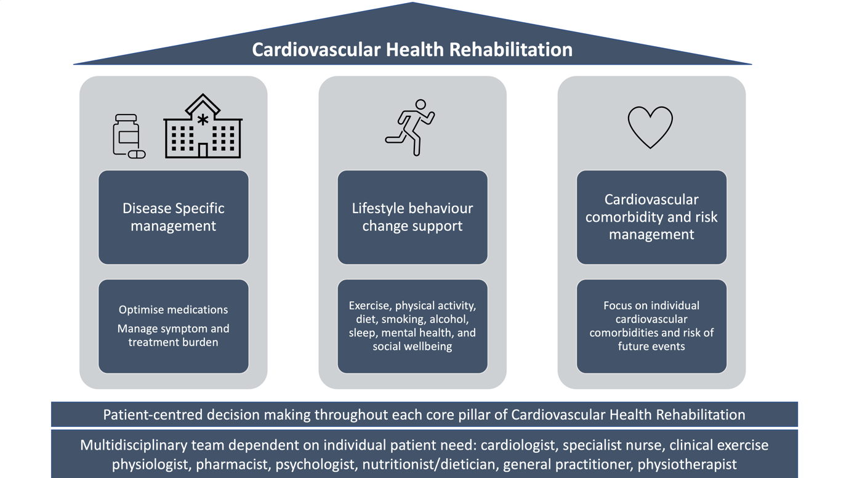

Central Figure. Three key pillars of ‘Cardiovascular Health Rehabilitation’ to be incorporated within an integrated care pathway for patients with cardiovascular disease.
1 Disease-specific management: First, the focus should be on optimising the clinical management of the patient and their disease-specific symptoms. This includes optimising any medication and discussion of potential treatment options. It is important to also consider treatment burden on an individual patient basis.
2 Lifestyle behaviour change support: This should be patient-driven and allow choose and tailoring of the cardiovascular health rehabilitation programme. For some, an exercise-based programme may be highly suitable whereas others may not yet be able to exercise and may want to focus on physical activity levels and diet, or in fact, others may first want to focus on their metal wellbeing and are not yet able to exercise. The type and intensity of rehabilitation should be malleable and able to progress with evolving patient goals. Some patients will need more support than others, whether that is face-to-face, virtual, or hybrid should be discussed with the patient and consideration given to available resources.
3 Cardiovascular comorbidity and risk management: Patients with cardiovascular disease often have comorbidities and are at an elevated risk of future cardiovascular events. Therefore, as part of an integrated rehabilitation approach, management of other risk factors and conditions such as obesity, hypertension, diabetes mellitus, sleep apnoea, and other secondary cardiovascular conditions should be managed to help reduce the risk of future adverse events and the underlying cardiovascular burden. This should also facilitate a patient with cardiovascular disease to better manage their multimorbidity and improve their overall quality of life. Education and counselling can improve a patient’s understanding, adherence and compliance to rehabilitation.

References

1. Morris JN, Heady JA, Raffle PA, et al. Coronary heart-disease and physical activity of work. Lancet 1953;262(6796):1111-20; concl. doi: 10.1016/s0140-6736(53)91495-0 [published Online First: 1953/11/28]
2. Taylor RS, Dalal HM, McDonagh STJ. The role of cardiac rehabilitation in improving cardiovascular outcomes. Nat Rev Cardiol 2022;19(3):180-94. doi: 10.1038/s41569-021-00611-7 [published Online First: 2021/09/18]
3. Fiuza-Luces C, Santos-Lozano A, Joyner M, et al. Exercise benefits in cardiovascular disease: beyond attenuation of traditional risk factors. Nat Rev Cardiol 2018;15(12):731-43. doi: 10.1038/s41569-018-0065-1 [published Online First: 2018/08/18]
4. Ambrosetti M, Abreu A, Corrà U, et al. Secondary prevention through comprehensive cardiovascular rehabilitation: From knowledge to implementation. 2020 update. A position paper from the Secondary Prevention and Rehabilitation Section of the European Association of Preventive Cardiology. Eur J Prev Cardiol 2020;28(5):460-95. doi: 10.1177/2047487320913379
5. Buckley BJR, Harrison SL, Fazio-Eynullayeva E, et al. Cardiac rehabilitation and all-cause mortality in patients with heart failure: a retrospective cohort study. Eur J Prev Cardiol 2021;28(Supplement_1) doi: 10.1093/eurjpc/zwab035 [published Online First: 2021/08/02]
6. Buckley BJR, Harrison SL, Fazio-Eynullayeva E, et al. Association of Exercise-Based Cardiac Rehabilitation with Progression of Paroxysmal to Sustained Atrial Fibrillation. J Clin Med 2021;10(3) doi: 10.3390/jcm10030435 [published Online First: 2021/01/28]
7. Buckley BJR, Harrison SL, Fazio-Eynullayeva E, et al. Exercise-Based Cardiac Rehabilitation and All-Cause Mortality Among Patients With Atrial Fibrillation. J Am Heart Assoc 2021;10(12):e020804. doi: 10.1161/JAHA.121.020804 [published Online First: 2021/06/08]
8. Tikkanen AU, Oyaga AR, Riaño OA, et al. Paediatric cardiac rehabilitation in congenital heart disease: a systematic review. Cardiol Young 2012;22(3):241-50. doi: 10.1017/s1047951111002010 [published Online First: 2012/01/19]
9. Buckley BJR, Harrison SL, Fazio-Eynullayeva E, et al. Exercise-based cardiac rehabilitation and major adverse cardiovascular events in patients with cerebrovascular disease Cerebrovasc Dis In Press
10. Buckley BJR, Risom SS, Boidin M, et al. Atrial Fibrillation Specific Exercise Rehabilitation: Are We There Yet? J Pers Med 2022;12(4) doi: 10.3390/jpm12040610 [published Online First: 2022/04/24]
11. Lip GYH. The ABC pathway: an integrated approach to improve AF management. Nat Rev Cardiol 2017;14(11):627-28. doi: 10.1038/nrcardio.2017.153 [published Online First: 2017/09/30]
12. Lip GYH, Lane DA, Lenarczyk R, et al. Integrated care for optimizing the management of stroke and associated heart disease: a position paper of the European Society of Cardiology Council on Stroke. European Heart Journal 2022:ehac245. doi: 10.1093/eurheartj/ehac245
13. Lip GYH, Ntaios G. "Novel Clinical Concepts in Thrombosis": Integrated Care for Stroke Management-Easy as ABC. Thromb Haemostasis 2022;122(3):316-19. doi: 10.1055/a-1632-1777 [published Online First: 2021/09/03]
14. Field M, Kuduvalli M, Torella F, et al. Integrated Care Systems and the Aortovascular Hub. Thrombosis and haemostasis 2022;122(2):177-80. doi: 10.1055/a-1591-8033 [published Online First: 2021/08/19]
15. Jadad AR, To MJ, Emara M, et al. Consideration of multiple chronic diseases in randomized controlled trials. Jama 2011;306(24):2670-2. doi: 10.1001/jama.2011.1886 [published Online First: 2011/12/29]
16. Lee SR, Choi EK, Ahn HJ, et al. Association between clustering of unhealthy lifestyle factors and risk of new-onset atrial fibrillation: a nationwide population-based study. Scientific reports 2020;10(1):19224. doi: 10.1038/s41598-020-75822-y [published Online First: 2020/11/07]
17. Folsom AR, Yatsuya H, Nettleton JA, et al. Community Prevalence of Ideal Cardiovascular Health, by the American Heart Association Definition, and Relationship With Cardiovascular Disease Incidence. Journal of the American College of Cardiology 2011;57(16):1690-96. doi: https://doi.org/10.1016/j.jacc.2010.11.041
18. Hasbani NR, Ligthart S, Brown MR, et al. American Heart Association’s Life’s Simple 7: Lifestyle Recommendations, Polygenic Risk, and Lifetime Risk of Coronary Heart Disease. Circulation 2022;145(11):808-18. doi: 10.1161/CIRCULATIONAHA.121.053730
19. Lazar RM, Howard VJ, Kernan WN, et al. A Primary Care Agenda for Brain Health: A Scientific Statement From the American Heart Association. Stroke 2021;52(6):e295-e308. doi: 10.1161/STR.0000000000000367
20. Buckley BJR, Harrison SL, Hill A, et al. Stroke-Heart Syndrome: Incidence and Clinical Outcomes of Cardiac Complications Following Stroke. Stroke 2022;53(5):1759-63. doi: 10.1161/strokeaha.121.037316 [published Online First: 2022/04/01]
21. Chao TF, Joung B, Takahashi Y, et al. 2021 Focused Update Consensus Guidelines of the Asia Pacific Heart Rhythm Society on Stroke Prevention in Atrial Fibrillation: Executive Summary. Thrombosis and haemostasis 2022;122(1):20-47. doi: 10.1055/s-0041-1739411 [published Online First: 2021/11/14]
22. Romiti GF, Pastori D, Rivera-Caravaca JM, et al. Adherence to the 'Atrial Fibrillation Better Care' Pathway in Patients with Atrial Fibrillation: Impact on Clinical Outcomes-A Systematic Review and Meta-Analysis of 285,000 Patients. Thromb Haemostasis 2021 doi: 10.1055/a-1515-9630 [published Online First: 2021/05/22]
23. Lee S-R, Choi E-K, Park S-H, et al. Clustering of Unhealthy Lifestyle and the Risk of Adverse Events in Patients With Atrial Fibrillation. Frontiers in cardiovascular medicine 2022;9 doi: 10.3389/fcvm.2022.885016

