A critical evaluation of an MR guided radiotherapy system; do the manufacturer’s claims stand up to scientific scrutiny?
Caroline Maguire PGDip and Mike Kirby PhD, Department of Medical Imaging and Radiotherapy, School of Health Sciences, University of Liverpool, UK
(Approx 2800 words excluding fig/table captions, in-text referencing and reference list)

Introduction
Magnetic Resonance guided Radiotherapy Systems (MRg-RTSs) are beginning to be commercialised, installed and used clinically in radiotherapy departments around the world. The manufacturers of such systems often post bold statements about their systems on their websites. One such statement was recently posted (below), stating that their system….
“…... gives clinicians a fresh approach to observing, assessing, and personalizing a patient’s treatment…. When clinicians can clearly see the target and watch where the radiation dose is actually being delivered, they are better able to adapt to changes in the patient’s anatomy.” (1)
But do such bold statements stand up to critical evaluation and scientific scrutiny? This paper attempts to examine, critically, scientifically and concisely, whether such claims are truly evidenced based.
This statement claims to bring innovative changes to present radiotherapy techniques particularly current image guided radiotherapy (IGRT) methods. IGRT was introduced into daily clinical practice concurrently with treatment techniques such as intensity modulated radiotherapy (IMRT), volumetric modulated arc therapy (VMAT), stereotactic body radiotherapy (SBRT) and high dose hypofractionation regimens (2). These treatment advances have made it possible to conform the dose tightly around targets, even concave targets encompassing organs at risk thus increasing the risk of significant errors with small deviations in treatment delivery (2,3). Current IGRT methods use ionizing radiation and most commonly include 3D cone-beam computed tomography (CBCT), 2D kilovoltage (kV) and 2D megavoltage (MV) images (4). However, despite its success, the daily practice of IGRT revealed limitations inherent to this technology (2). Magnetic resonance imaging (MRI) is often utilised in pre-treatment and with this MR-guided system, a different approach to IGRT is presented (5). This paper will evaluate this statement in two parts; firstly by discussing the initial claim including the limitations of current IGRT methods and what MR guided radiotherapy can offer; and secondly by examining how the techniques the MR system offers, to visualise the actual target during treatment delivery, can enable adaptation to changes in the patients’ anatomy. For both parts, an evidence based approach will be adopted, reviewing the current literature.

The MR guided radiotherapy system (MRg-RTS)
For the MRg-RTS in question (1), there are two major subsystems which are different to standard linacs; that is the use of cobalt-60 for treatment delivery and MR as a means of image guidance. This particular MRg-RTS (1) consists of a split 0.35 Tesla MR scanner spanning 3 cobalt-60 (Co-60) heads mounted on a ring gantry that are 120° apart (6) (Figure 1). Each head is equipped with independent doubly focussed Multileaf Collimators (MLCs) and provides a dose rate of 550cGy/min, comparable to linacs (7). The doubly-focussed MLCs allow IMRT and the low magnetic fields reduce numerous dose perturbation effects including the electron return effect, lateral dose shifting, cavity under and overdosing; multiple beam angles also reduce the impact of skin dose (5). Early reports comparing treatment plan quality have suggested that this system produces treatment plans of similar quality to standard linacs (7). Online MR-guided external-beam radiation delivery is achieved through the coordinated movement of the treatment delivery system (in this case, the Cobalt heads) and a modified treatment couch (8).
The MRg-RTS also includes an integrated treatment planning system (TPS) designed to perform IMRT and software capable of auto contouring and on-couch adaptive RT (ART) calculations using mathematical dose computing algorithms (9). The speed of the TPS enables ART treatments based on the image taken on the day of treatment (10).

On-treatment image guidance

The MRg-RTS differs dramatically from current IGRT methods in assessing patients’ anatomy without the use of additional ionising radiation (11). With current IGRT methods such as CBCT and kV imaging, x-rays are used thus giving patients an unreported concomitant dose of radiation to the target and also healthy tissues (12). Although the doses from IGRT appear insignificant, the risk of secondary cancer is present and only long term follow-up will define any potential risk from low dose exposure. Thus, there is an ongoing debate on the necessary frequency of verification imaging on-treatment when using ionizing radiation (2,13). Currently, it is recommended to image for the first three days and weekly thereafter if a systematic set-up error has not been recorded (14).
With MR-IGRT no radiation dose is delivered to the patient therefore giving the option of daily, volumetric imaging for treatment verification (16). Additionally, the most severe limitation of current IGRT methods is its poor soft-tissue contrast, making it impossible to discriminate between tumour targets and adjacent healthy tissues for some treatment sites, thus requiring imaging surrogates such as fiducial markers or bony anatomy (4). MRI provides excellent anatomical information regarding normal and pathological soft tissues. This would provide visualisation of actual tumours such as the prostate without the need for fiducial markers (11). Noel et al. (17) researched whether on-board MR guidance with this system improves visualization of the target and organs at risk (OARs) compared to standard on-board computed tomography and found that low-field MR provides better anatomic visualization of many radiotherapy targets and most OARs as compared to OB-CT (17) (Figure 2). This evidence helps support the above statement made by the manufacturer for an MR-guided radiotherapy system.

Intra-fractional Imaging
Another factor which would support this statement is the ability of the MR-system to view the tumour and surrounding healthy tissues intra-fractionally (18). Intra-fractional motion consists of the movement occurring during the delivery of the fraction post-patient set-up (19). The MR and RT systems share a common isocentre, enabling simultaneous and continuous MRI during RT delivery (20). This enables constant visualisation of the target during treatment (21).
Currently, daily intra-fractional motion based on the actual target volume, and not surrogates, is extremely difficult to assess; it can only be measured, and any required set-up corrections made, before the delivery of the fraction of treatment (3). Fluoroscopic 2D projection imaging only allows for a direct assessment of relevant translational coordinates of target motion one at a time using, for example, gantry mounted or in-room 2D kV imaging. Even then, surrogates are needed for the evaluation – e.g. using bony anatomy or implanted fiduciary markers. The acquisition of 3D images during the treatment fraction is impossible due to the acquisition time that is required (e.g. between fields) and because it is linked to the treatment delivery system. For the MRg-RTS in question, the 3D imaging system is static and does not rotate with the gantry. Also, continuous X-ray imaging only enables visualisation of high-contrast objects and is generally associated with an unacceptable accumulation of concomitant dose to healthy tissues (3).
Typically for IGRT, inter/intra-fractional motion, random and systematic errors are accounted for by using geometric margins defined around the tumour: gross tumour volume (GTV), clinical target volume (CTV) and planning target volume (PTV) (22). This motion is accounted for by larger PTV margins to ensure the CTV is constantly covered, but with the consequence of irradiating greater volumes of healthy tissues, with the increased risk of side effects. Some intra-fractional compensation strategies utilise tracked radiation delivery or gating based on surrogates (14,15). For example, electromagnetic transponder seeds can be implanted into the prostate gland for prostate patients which can monitor intra-fractional motion during treatment delivery (4). The disadvantage of current intra-fractional motion compensation guidance modalities is that they are marker based; by tracking one or a couple of markers they still look at surrogates for the actual target motion. OARs are not visualised and may display uncorrelated motion. Furthermore, uses of surrogates is poor for intra-fractional adaptations for target deformations, they are invasive and not suitable for all sites (23).
The MRg-RTS could be described as an ideal intra-fractional motion image guidance modality as it acquires 3D images of the internal patient anatomy, with sufficiently high soft-tissue contrast to distinguish the tumour from its surroundings and visualising, besides translations and rotations, deformations as well (24). It also has acceptable spatial resolution and gives information to compensate in all three dimensions. With real-time MRguided imaging, continual monitoring of the target is possible, as is compensation for the target motion based upon feedback from the volumetric MR images. This will allow for a reduction in the PTV and the opportunity of adapting radiation treatments to the actual tumour position (4). During treatment imaging, MR images are acquired at four frames per second while a target is auto-contoured at the same time (25). This auto-contouring enables a gating approach and the beam can stop if the actual target moves outside a pre-specified tolerance (25).
So a critical evaluation of the evidence thus far, broadly supports the statement that the MRg-RTS gives a novel way to viewing patients’ anatomy. The second part of this paper now examines whether the benefits from this system help view the target during treatment delivery using intra-fractional imaging, soft tissue visualisation and functional information and help to better adapt the treatment to changes in the patients anatomy.

Anatomical changes on-treatment
Changes in patients’ anatomy during the treatment course (inter and intrafractionally) are well documented for a variety of tumours, particularly treatments with relatively long beam delivery times such as those seen with IMRT (13). Anatomical changes include internal motion such as respiratory motion, musculature motion, organ motion such as bowel and bladder, possible patient movement during treatment delivery and tumour change such as shrinkage. Certain treatment sites such as pelvis, lung, pancreas, liver, for example, are more prone to motion than others and may, or may not, be easily visualised on CBCT. Some of these sites are also not easily accessible for surrogates. This hinders dose optimisation and also makes them prone to geometrical uncertainties (21).
External surrogates also may not correlate with tumour motion such as lung motion (26). Breathing cycle variations in respiratory motion can cause significant geometric and dosimetric errors in lung radiotherapy (27). A common limitation of the current strategies for motion management is that they assume a constant, reproducible respiratory cycle (27). Figure 3 highlights the possible change in position, size and shape of the tumour over the treatment course and further supports the statement that visualising the tumour allows for adaptation to the change in patients’ anatomy. With an MRg-RTS there is the opportunity of more accurate and continuous monitoring of breathing-induced organ motion. This will allow for a reduction in PTV margin and facilitate dynamic tumour tracking and the possibility of optimisation of adaptive therapy strategies due to its superior soft tissue contrast (3).
For tumours of the prostate gland, intra-fractional motion appears to be a limiting factor when delineating margins. Kron et al. (28) showed that a uniform set of margins for all patients may not be satisfactory when high target doses are to be delivered, thus highlighting the need for more adaptive and personalised treatment that MRI-IGRT has the potential to supply. It is also shown that the prostate can change location in a relatively small time-frame and is largely influenced by rectal and bladder filling as seen in figure 4 (19,28,29). This again supports the statement that accurately seeing the target during treatment allows for adaptation to anatomical changes.
Similarly, cervical cancer motion during treatment has been reported to be considerable, as much as 1.8cm from baseline (30), and larger PTV margins are needed to account for this (31). Figure 5 shows the displacement of cervical seeds due to rectal gas (30). However, with an MRg-RTS, soft tissue registration viewing the actual target during treatment can compensate for this motion. (32,33) (Figure 6).
Head and neck tumours have a real potential benefit from viewing the actual target during radiation delivery. Although they do not suffer significantly from internal motion (14,15), it has been recognized that patients receiving radiotherapy to the head and neck often undergo anatomical changes including tumour shrinkage, weight loss, post-operative changes or oedema (34) (Figure 7). Being able to visualise the target and adapt the treatment to these anatomical changes allows for dose optimisation and avoids unintentional dose to nearby critical structures (11).
Changes in the patients’ anatomy doesn’t just include motion but also changes in the target and OAR anatomy deformations that occur as seen in figure 7 (18,34). Evidence supports the above statement that by seeing what to treat, at the time of treatment, gives a wide possibility of therapeutic advances that are not present with current IGRT methods (3). Adapting the treatment in real-time, enables a safe escalation of dose to the tumour, facilitating hypofractionation and improving dose sparing of radio-sensitive organs for a number of treatment sites (3,4). The ability to view functional information with MRguided IGRT, as well as being able to target dominant tumour lesions during radiation delivery specifically for dose-escalation, enables the development of safer and more accurate dose-painting strategies (3). There is also the prospect that it will be capable of assessing and predicting the treatment response of the individual patient to radiation therapy at an early time point during the course of treatment (3,16) . This would make it possible to develop more adaptive and personalised treatment – for example, by identifying patients with highly hypoxic tumours that might benefit from hypoxic cell sensitizers or the most pre-metastatic or radioresistant regions of the tumour can be targeted with extra radiation dose and the more sensitive normal tissues can be optimally spared (3,35).

Limitations
However, even if the scientific evidence is largely in support of this statement, it is also important to note the MRg-RTS is not free from limitations either. It isn’t suitable for patients containing ferromagnetic material such as some pacemakers. Additionally, as table 1 shows, MRI has been associated with having inferior geometric accuracy than CBCT which will have to be improved for radiotherapy purposes. (4, 24).
Furthermore, x-ray output calibration, overall cost, the effects of motion artefacts, dose computation in the presence of MR fields, electron density information, MR image distortion and magnetic interference are all aspects which have an impact on the quality of treatment and must be carefully considered (24,36).

Conclusions
From this short, critical evaluation, it would appear the evidence is broadly supportive of this particular manufacturer’s statement. The capability of the MRg-RTS for soft tissue visualisation, intra-fractional motion assessment, functional information and the ability to perform adaptive radiotherapy based on real-time image feedback gives a fresh approach to observing, assessing and personalizing patients’ treatment. These are all techniques that current IGRT methods are lacking, showing there is a place for the MRg-RTS in radiotherapy practice. Also, the evidence would support the claim that visualising the actual tumour during delivery makes it possible to better adapt to changes in the patients’ anatomy. Anatomical changes can vary from internal motion to tumour regression and being able to see the target is clearly better than using surrogates with some studies showing that surrogates are not always a true representation of the target position, size or shape, nor those of the nearby organs at risk. However, since it is only recently coming into clinical use, more research needs to be done on which patients will benefit most from the MRg-RTS and similar technologies. Finally, no single technology is ideal for every scenario and with the advent of a variety of imaging verification techniques, it will give more options as to what will be best suited for an individual patient. The MRg-RTS is unlikely to entirely replace current treatment technologies using x-ray based IGRT; but as more is learned of its capabilities and its application, there may be an increase in its use, bringing new possibilities for treating patients.

Figures and Tables incl Captions

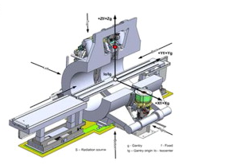
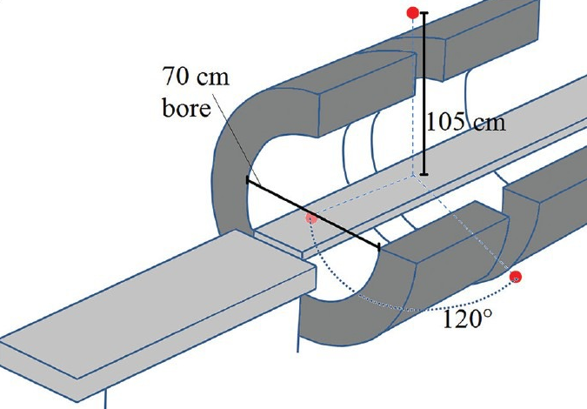
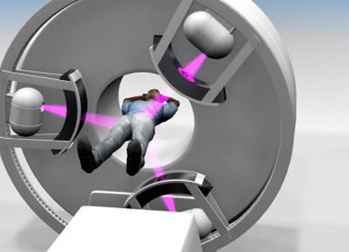
Figure 1 showing the schematic of the split magnet surrounding the gantry and the radiotherapy isocentre at the centre of the field of view (6,10,25).

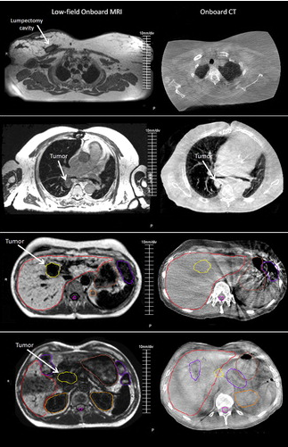
Figure 2 Example of MRI (left)/CT (right) verification images for lumpectomy cavity, lung tumour, liver tumour, and pancreas tumour (from top to bottom). The superior soft tissue contrast is seen with MRI-IGRT and the contours as drawn by a clinician on the image sets are shown for the liver and pancreas cases (17).

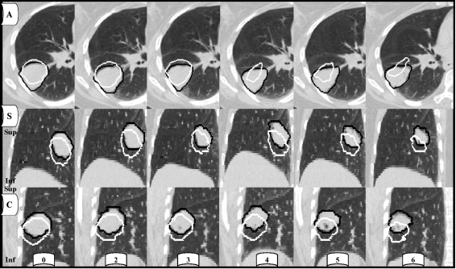
Figure 3 shows transverse (A), sagittal (S) and coronal (C) sections through the GTV of a patient from initial simulation CT scan to last treatment week. PTV at end of inspiration (white) and expiration (black) throughout treatment shows inter- and intra-fractional size changes. Total volume loss at week 6 of treatment was 41.3% of the initial volume (37).

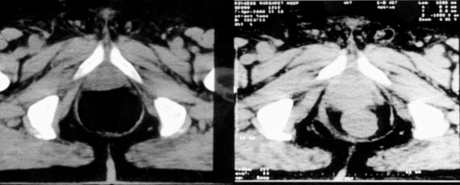
Figure 4 with two images of the prostate taken a day apart illustrating prostate movement and deformation due to rectal distension highlighting the need to accurately see the target and surrounding organs (29).

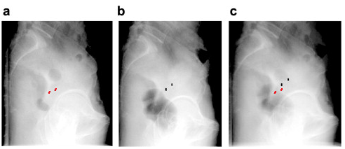
Figure 5: Displacement of cervical seeds due to gas in the rectum (a) shows seeds before treatment (red), (b) shows the seeds after the treatment fraction (black) and (c) is an overlay of the two showing seed displacement (30).

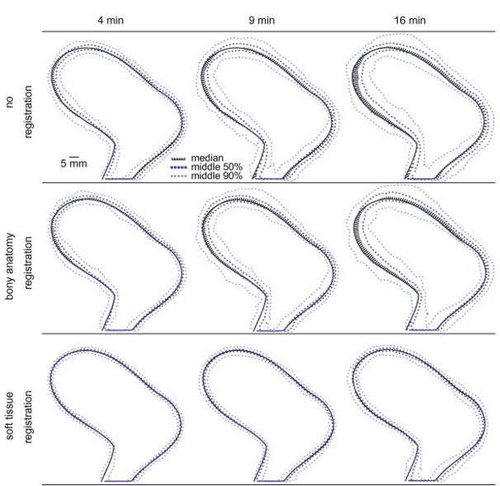
Figure 6: CTV motion results with no registration, bony anatomy registration and soft tissue registration over 4, 9 and 16 minutes. Highlighting that soft-tissue registration corrects for motion in cervical cancer patients (33).

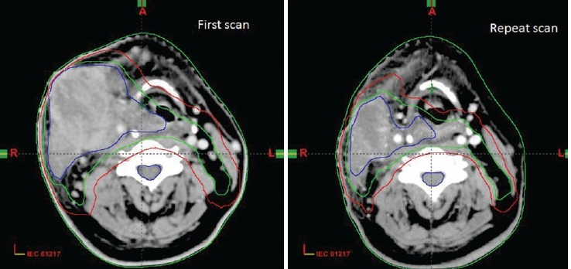
Figure 7: Evidence of volume changes between first scan and a repeat scan three weeks into radiotherapy treatment (34)

Table 1: Indicating the geometric accuracy, and dose delivered for the most common IGRT methods (4).
IGRT Method | Image Acquisition | Average dose per image | Geometric Accuracy
Electronic Portal Image Detector (EPID) kV or MV planar | 2D | 1-3mGy | 1-2mm
Cone-beam CT | 3D | 30-50mGy | ≤1mm
MVCT | 3D | 10-30mGy | ≤1mm
MRI | 3D | 0 | 1-2mm

References
(1) Viewray.com: The MRIdian System - true image guided radiation therapy [internet]; Available from http://www.viewray.com/product
(2) Goyal S, Kataria T. Image Guidance in Radiation Therapy: Techniques and Applications. Radiology Research and Practice 2014; vol 2014, Article ID 705604. doi:10.1155/2014/705604.
(3) Oelfke U. Magnetic Resonance Imaging-guided Radiation Therapy: Technological Innovation Provides a New Vision of Radiation Oncology Practice. Clinical Oncology 2015.
(4) De Los Santos J, Popple R, Agazaryan N, Bayouth JE, Bissonnette J, Bucci MK, et al. Image guided radiation therapy (IGRT) technologies for radiation therapy localization and delivery. International Journal of Radiation Oncology Biology Physics 2013;87(1):33-45.
(5) Metcalfe P, Liney GP, Holloway L, Walker A, Barton M, Delaney GP, et al. The potential for an enhanced role for MRI in radiation-therapy treatment planning. Technology in Cancer Research and Treatment 2013 Oct;12(5):429-446.
(6) Green OP, Goddu S, Mutic S. SU‐E‐T‐352: Commissioning and Quality Assurance of the First Commercial Hybrid MRI‐IMRT System. Medical Physics 2012;39(6):3785-3785.
(7) Wooten HO, Rodriguez V, Green O, Kashani R, Santanam L, Tanderup K, et al. Benchmark IMRT evaluation of a Co-60 MRI-guided radiation therapy system. Radiotherapy and Oncology 2015;114(3):402-405.
(8) Jaffray DA, Carlone MC, Milosevic MF, Breen SL et al. A Facility for Magnetic Resonance–Guided Radiation Therapy. Seminars in Radiation Oncology 2014;24(3):193-195.
(9) Mutic S. WE‐A‐BRA‐02: First Commercial Hybrid MRI‐IMRT System. Medical Physics 2012;39(6):3934-3934.
(10) Mutic S, Dempsey JF. The ViewRay System: Magnetic Resonance–Guided and Controlled Radiotherapy. Seminars in Radiation Oncology 2014;24(3):196-199.
(11) Lagendijk JJ, Raaymakers BW, Van den Berg, Cornelis AT, Moerland MA, Philippens ME, van Vulpen M. MR guidance in radiotherapy. Physics in Medicine and Biology 2014;59:349.
(12) Wooten HO, Green O, Yang M, DeWees T, Kashani R, Olsen J, et al. Quality of Intensity Modulated Radiation Therapy Treatment Plans Using a (6)(0)Co Magnetic Resonance Image Guidance Radiation Therapy System. International Journal of Radiation Oncology Biology Physics 2015 Jul 15;92(4):771-778.
(13) Kim DW, Chung WK, Yoon M. Imaging doses and secondary cancer risk from kilovoltage cone-beam CT in radiation therapy. Health Physics 2013 May;104(5):499-503.
(14) Hoskin PJ, Gaze M, Greener T, Kirby M et al.. On target: ensuring geometric accuracy in radiotherapy. London: Royal College of Radiologists; 2008.
(15) National Radiotherapy Implementation Group Report. Image Guided Radiotherapy (IGRT): guidance for implementation and use. London: NHS, National Cancer Action Team, 2012
(16) Bostel T, Nicolay NH, Grossmann JG, Mohr A, Delorme S, Echner G, et al. MR-guidance--a clinical study to evaluate a shuttle- based MR-linac connection to provide MR-guided radiotherapy. Radiation Oncology 2014 Jan 9;9:12-717X-9-12.
(17) Noel CE, Parikh PJ, Spencer CR, Green OL, Hu Y, Mutic S, et al. Comparison of onboard low-field magnetic resonance imaging versus onboard computed tomography for anatomy visualization in radiotherapy. Acta Oncologica 2015;54(9):1474-1482.
(18) Kontaxis C, Bol G, Lagendijk J, Raaymakers B. A new methodology for inter-and intrafraction plan adaptation for the MR-linac. Physics in Medicine and Biology 2015;60(19):7485.
(19) Budiharto T, Slagmolen P, Haustermans K, Maes F, Junius S, Verstraete J, et al. Intrafractional prostate motion during online image guided intensity-modulated radiotherapy for prostate cancer. Radiotherapy and Oncology 2011;98(2):181-186.
(20) Dempsey J, Dionne B, Fitzsimmons J, Haghigat A, Li J, Low D, et al. WE‐E‐ValA‐06: A Real‐Time MRI Guided External Beam Radiotherapy Delivery System. Medical Physics 2006;33(6):2254-2254.
(21) Lagendijk JJ, Raaymakers BW, Raaijmakers AJ, Overweg J, Brown KJ, Kerkhof EM, et al. MRI/linac integration. Radiotherapy and Oncology 2008;86(1):25-29.
(22) International Commission on Radiation Units. Definition of Volumes (Chapter 4). Journal of the ICRU 2010 10(1): Report 83
(23) Yun J, Yip E, Wachowicz K, Rathee S, Mackenzie M, Robinson D, et al. Evaluation of a lung tumor autocontouring algorithm for intrafractional tumor tracking using low-field MRI: A phantom study. Medical Physics 2012;39(3):1481-1494.
(24) Crijns S. On-line MRI guidance for Radiotherapy. Dissertation - University of Utrecht Repository 2013.
(25) Saenz DL, Paliwal BR, Bayouth JE. A dose homogeneity and conformity evaluation between ViewRay and pinnacle-based linear accelerator IMRT treatment plans. Journal of Medical Physics 2014;39(2):64.
(26) Koch N, Liu HH, Starkschall G, Jacobson M, Forster K, Liao Z, et al. Evaluation of internal lung motion for respiratory-gated radiotherapy using MRI: Part I—correlating internal lung motion with skin fiducial motion. International Journal of Radiation Oncology Biology Physics 2004;60(5):1459-1472.
(27) Sawant A, Keall P, Pauly KB, Alley M, Vasanawala S, Loo Jr BW, et al. Investigating the feasibility of rapid MRI for image-guided motion management in lung cancer radiotherapy. BioMed Research International 2014; 2014.
(28) Kron T, Thomas J, Fox C, Thompson A, Owen R, Herschtal A, et al. Intra-fraction prostate displacement in radiotherapy estimated from pre-and post-treatment imaging of patients with implanted fiducial markers. Radiotherapy and Oncology 2010;95(2):191-197.
(29) Wu J, Haycocks T, Alasti H, Ottewell G, Middlemiss N, Abdolell M, et al. Positioning errors and prostate motion during conformal prostate radiotherapy using on-line isocentre set-up verification and implanted prostate markers. Radiotherapy and Oncology 2001;61(2):127-133.
(30) Haripotepornkul NH, Nath SK, Scanderbeg D, Saenz C, Yashar CM. Evaluation of intra-and inter-fraction movement of the cervix during intensity modulated radiation therapy. Radiotherapy and Oncology 2011;98(3):347-351.
(31) Heijkoop ST, Langerak TR, Quint S, Mens JWM, Zolnay AG, Heijmen BJ, et al. Quantification of intra-fraction changes during radiotherapy of cervical cancer assessed with pre-and post-fraction Cone Beam CT scans. Radiotherapy and Oncology 2015; 117(3):536-41
(32) Chan P, Dinniwell R, Haider MA, Cho Y, Jaffray D, Lockwood G, et al. Inter-and intrafractional tumor and organ movement in patients with cervical cancer undergoing radiotherapy: a cinematic-MRI point-of-interest study. International Journal of Radiation Oncology Biology Physics 2008;70(5):1507-1515.
(33) Kerkhof EM, van der Put, Richard W, Raaymakers BW, van der Heide, Uulke A, Jürgenliemk-Schulz IM, Lagendijk JJ. Intrafraction motion in patients with cervical cancer: The benefit of soft tissue registration using MRI. Radiotherapy and Oncology 2009;93(1):115-121.
(34) Bhandari V, Patel P, Gurjar OP, Gupta KL. Impact of repeat computerized tomography replans in the radiation therapy of head and neck cancers. Journal of Medical Physics 2014;39(3):164-8.
(35) Keall PJ, Barton M, Crozier S. The Australian Magnetic Resonance Imaging–Linac Program. Seminars in Radiation Oncology; 2014:24(3):203-206.
(36) Crijns S, Bakker C, Seevinck P, De Leeuw H, Lagendijk J, Raaymakers B. Towards inherently distortion-free MR images for image-guided radiotherapy on an MRI accelerator. Physics in Medicine and Biology 2012;57(5):1349.
(37) Britton KR, Starkschall G, Tucker SL, Pan T, Nelson C, Chang JY, et al. Assessment of gross tumor volume regression and motion changes during radiotherapy for non–small-cell lung cancer as measured by four-dimensional computed tomography. International Journal of Radiation Oncology Biology Physics 2007;68(4):1036-1046.

