A literature review: which endodontic access cavity is best?
Abstract:
The preparation of an access cavity is the first part of endodontic treatment and is a key stage in the healing of both periapical and pulpal infections. It should allow endodontists to remove obstructions in the pulp chamber, to locate all canal orifices and to clean the entire root canal system with minimum coronal tooth structure removed. This has been done traditionally through establishing straight line access. The development of minimally invasive endodontics aimed to preserve as much of the natural tooth structure as possible, particularly dentine, while undertaking root canal treatment resulting in the development of other access cavity preparations. This includes conservative, ultra conservative (ninja), Truss, guided access, caries orientated and restorative access cavities. These access cavity preparations also gained popularity due to increased magnification and enhanced lighting, allowing practitioners to visualise the pulpal space in greater detail throughout treatment.
Our current recommendation is to conduct access cavities traditionally rather than conservatively. Ideally conservative access cavities need magnification, which might not be available for all clinicians. With traditional access cavity the procedure takes less time and, it is more predictable to locate the canal orifices, deliver irrigation effectively, avoid iatrogenic damage with biomechanical preparation and achieve better obturation.

Key points:
- Endodontic access cavities can be conducted traditionally or conservatively, which is more in line with minimally invasive dentistry.
- Endodontic access cavities include traditional, conservative, ultra conservative (ninja), Truss, guided access, caries orientated and restorative access cavities.
- Our current recommendation is to conduct access cavities traditionally rather than conservatively, as their benefits outweigh the risks presented by it.

Introduction:
Endodontics is concerned with prevention, diagnosis and treatment of the periradicular tissue and dental pulp ^{[1,2]}. Endodontic disease, the infection of the pulp and surrounding periapical tissues, is treated globally on a daily basis. Endodontic treatment involves pulpotomy, pulp capping, pulp extirpation and the treatment of root canals and surrounding periapical tissue both surgically and non-surgically [1].

There are various steps in endodontic treatment which include chemical and mechanical procedures. Mechanical procedures include endodontics access cavity, instrumentation as well as obturation of the root canal system. Chemical procedures are those including the use of irrigants such as sodium hypochlorite (NaOCl) and sealers, it also includes intra-canal medicaments such as calcium hydroxide (CaOH) ^{[3-6]}
Access cavity preparation is the first clinical step in endodontic therapy and is key towards healing of pulpal and periapical infections ^{[7-8]}. It can be one of the most challenging aspects of endodontic treatment, but it is the key to successful treatment ^{[9]}. It should allow endodontists to remove obstructions in the pulp chamber, to locate canal orifices and to clean the root canal system with minimum coronal tooth structure removed. Improper access preparation can lead to subsequent treatment errors and ultimately case failure ^{[9-11]}. Good access cavity design and preparation is therefore imperative for quality endodontic treatment, prevention of iatrogenic problems and endodontic failure ^{[9]}. Magnification and lighting developments aided practitioners to perform more minimally invasive endodontics and could result in conservation of greater amounts of natural tooth structure ^{[1]}.
Increased magnification and enhanced lighting have also allowed practitioners to visualise pulpal space in greater detail. The learning curve associated with using magnification and the cost has resulted in less than 10% of dentists using magnification even though it has been used in endodontics since the 1980’s ^{[12-15]}. Magnification is achieved in multiple ways including dental loupes as well as the operating microscope ^{[12]}. As well as aiding with visualisation, it allows for increased diagnostic accuracy and allows for treatment to be completed more precisely. This is due to the ability to visualise the presence of fractures more clearly ^{[16]}. One study concluded that magnification improves clinicians ability to locate canals and impacted the quality of access cavities positively ^{[17]}. Some clinicians do report, that the limitation of the field of view results in a greater difficulty in the insertion of instruments however this can be combatted with increased practice and close fourhanded dentistry ^{[18]}.
The increased use of magnification means endodontic techniques, such as conservative endodontic cavity (CEC) preparations are also being considered. These techniques could aid in enhancing the prognosis of teeth by retaining more natural tooth structure and could result in minimally restored teeth ^{[19]}. However, despite advances in techniques and equipment, there is currently no protocols for minimally invasive endodontics and CECs ^{[19]}. This is because the current traditional endodontic cavity (TEC) technique emphasises the need for straight line access to aid disinfection and debridement. Straight line access has also been shown to reduce the chances of iatrogenic issues such as zipping and ledging created by more inflexible stainless steel filing systems ^{[9]}. This straight line access is not achieved through a CEC ^{[9,20-21]}. TECs are prepared with their widest dimensions being occlusally and the smallest dimensions being at the orifices and this is one of the main reasons it is being questioned. Some believe this technique is over invasive considering the advances in imaging, lighting and magnification ^{[19]}. This approach was challenged by a radical access cavity design that was proposed in recent years ^{[22-23]}. The new design emphasized the preservation of pericervical dentine. The pericervical dentin is the dentin that is present 4mm above and below the crestal bone and the reason it is crucial is because it helps distribute any forces placed on the tooth throughout it which can increase the strength of the tooth ^{[22]}.

What is minimally invasive dentistry:
In the last few decades there have been scientific and technological advances. This includes advances in diagnostic and imaging systems, dental materials and cariology including the management of dental caries. This has resulted in a shift in the management of caries from ‘’extension for prevention’’ described by G.V. Black to a biological approach commonly called minimally invasive dentistry ^{[24]}. This approach to dental treatment aims to treat caries in a similar way to which infectious diseases are treated. It aims to delay invasive operative procedures and focuses on processes and treatment modalities that encourage remineralisation and prevention of cavitation ^{[25]}. There is also a greater understanding of cariology which has meant it is now recognised that early carious lesions can be arrested prior to cavitation resulting in a lack of need for restorations ^{[25]}. There has equally been advances in dental materials and a shift to adhesive materials. This has resulted in the ability to conserve more tooth structure as there is less reliance on mechanical material retention ^{[25]}. More than half of a practitioner’s time is spent replacing existing restorations due to secondary caries or failures due to overpreparing teeth to gain mechanical retention ^{[26]}. Considering the impact both on the patient who requires the replacement restoration and the dentist who is spending time carrying this out, the ability to detect caries early and risk assess more effectively because of technological advances will be beneficial to those involved. This is also considered to be an aspect of minimally invasive dentistry as in most cases, when a restoration is replaced, there is loss of tooth structure, therefore, where possible delay or avoidance of replacing restorations is beneficial for the retention of teeth ^{[26]}.

What is minimally invasive Endodontic and its benefits
Similar in concept to minimally invasive dentistry, minimally invasive endodontics aims to preserve as much of the natural tooth structure as possible, particularly dentine, while undertaking root canal treatment ^{[27]}. This has the aim of strengthening endodontically treated teeth to allow them to be preserved ^{[19]}. This concept was made possible, due to technological advances from materials to microscopes becoming more readily available. The development of CBCT and dental microscopes has meant that endodontists can better plan the access cavity. This is because they can pinpoint with greater accuracy the location of canal orifices ^{[27]}. This in turn means that a less destructive access cavity can be considered, falling in line with the concept of preservation of tooth structure described in minimally invasive endodontics. The development on endodontic ultrasonics has also allowed for effective agitation of irrigants within the root canal system meaning a more conservative approach can be considered ^{[27]}.
As minimally invasive endodontics is only just emerging, there is no clear evidence that it impacts the success rate of endodontic treatment. Similarly, to minimally invasive dentistry, minimally invasive endodontics also requires practitioners to handle new materials and develop skills to allow them to work in different and often, more limited environments. This can be challenging and is often one of the reasons for the lack of uptake of new endodontic procedures and the lack of use of equipment^{[19]}.
Materials and Methods
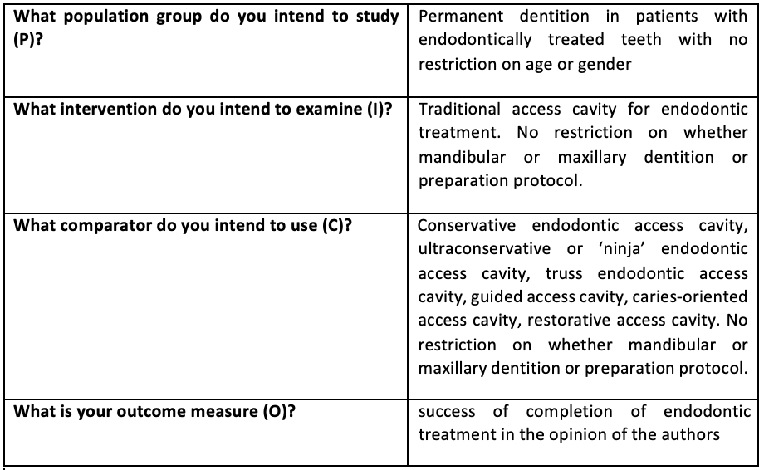
Table 1- PICO Parameters
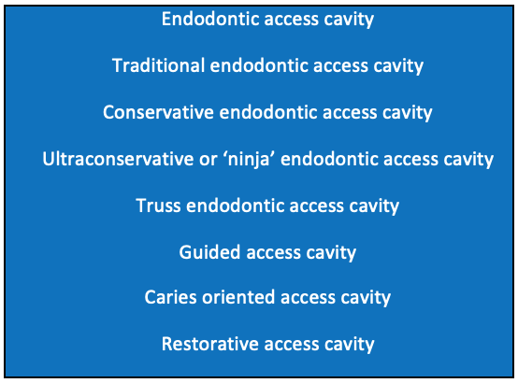
Table 2- key terms included in electronic search
Review method
To derive a search that was meaningful, a PICO strategy (population, intervention, comparison and outcome) was used. This included the exclusion and intrusion criteria and the search term (Table 2).
An initial literature search was done to identify studies relevant to the research question and their quality was assessed. There were no specific exclusion criteria in this scoping search and therefore a large variety of measures were present within studies. Therefore, this literature review has a primary outcome measure of success of completion of endodontic treatment for a particular access cavity design in the opinion of the authors.

Eligibility Criteria
Using the PICO criteria in table 1, the eligibility criteria were outlined:
Inclusion criteria
- No limitation on follow up period
- In vivo, ex vivo and studies carried out on human permanent dentition.
- Peer-reviewed journal articles and studies
- Journal articles discussing endodontic access designs

Exclusion criteria
- Only research published in the English language
- Studies carried out in non-human permanent teeth
- Where authors do not discuss the success of completion of endodontic treatment with a particular access cavity design.

What are the types of Endodontic access cavity:
TAC- Traditional endodontic access cavity
CAC- Conservative endodontic access cavity
NA-Ultraconservative or ‘ninja’ endodontic access cavity
Truss endodontic access cavity
Guided access cavity
Caries oriented access cavity
Restorative access cavity
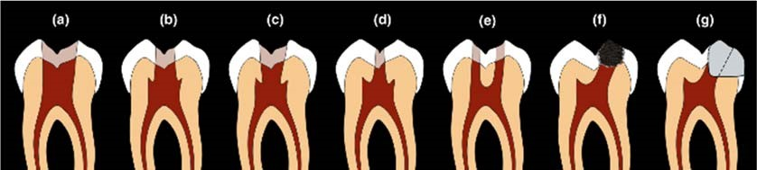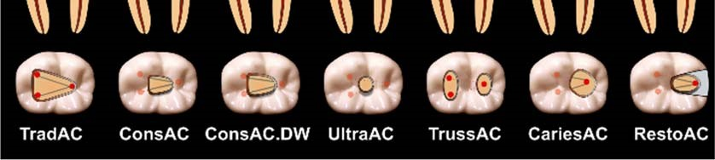
Figure 1- Types of access cavities. TradAC- traditional ConsAC- Conservative UltraAC- ultraconservative TrussAC- Truss CariesAC- caries orientated RestoAC- Restorative ^{[28]}

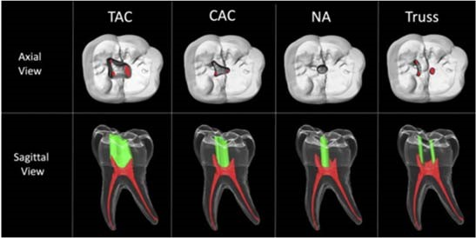
Figure 2- Axial and saggital view of access cavities ^{[29]}

A - Traditional
TECs aim to perform complete unroofing of the pulp chamber, exposing all pulp horns and creating straight line access to the root canal allowing visualisation of the pulpal floor and orifices, without the need to alter visual angulation ^{[30]}. It also aims to produce an access design which reduces the likelihood of procedural complications such as perforation, instrument separation and ledge formation ^{[31-32]}. This is achieved through straight line access which allows and enhances effective instrumentation. TECs are cut so that the pulpal roof and any overlying dentin are removed. The main influence on the size of the access cavity is the anatomical location of the orifices and the axial walls are extended as required to achieve straight line access ^{[33]}. The access cavity is completed when visualisation of all the orifices can be achieved without tilting the mirror ^{[33]}. This access design allows for effective delivery of irrigant into the root canal system and good instrumentation. This is important as a successful endodontic procedure is difficult to achieve if the cleaning and shaping is compromised ^{[32]}.
However, TECs and their design means they require the removal of a substantive amount of tooth structure including the pericervical dentin. This may result in reduced resistance to fracture as there is increased strain on the root and coronal surfaces, especially in teeth with an increased occlusal load ^{[8,31]}. Tooth surface lost in TECs cannot be replaced completely by restorative materials and consequently preservation of dentine is important to maintain the strength and integrity of the tooth ^{[8,31]}.
With advances within dentistry, CECs are being considered more frequently within endodontics in hopes that preservation of tooth structure, particularly the pericervical dentine, will allow for increased strength of teeth post endodontic treatment without compromising the need for effective instrumentation and irrigation ^{[32]}.
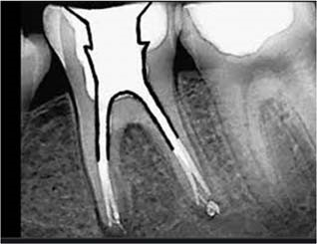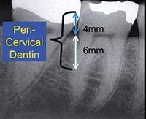
Figure 3 - Pericervical dentine ^{[22]}

B - Conservative
CECs aim to perform partial deroofing of the pulp chamber with preservation of pulp horns. The access cavity is slightly convergent, and the walls bevelled occlusally ^{[30]}. This results in the visualisation of the pulp chamber floor and one root canal orifice at one time with other orifices being visualised at a different visual angulation ^{[30]}.
CECs depart from the practice of deroofing the pulp chamber and providing straight line access. Instead, they use CBCTs to plan a trajectory towards the orifices ^{[31]}. With regards to the increased resistance to fracture this has been particularly evident in mandibular premolars and molars and especially observed when considering cuspal chipping that was shown to be less catastrophic in nature in CECs ^{[31]}. Although many agree CECs may increase the strength of endodontically treated teeth it has been questioned whether effective shaping, cleaning, and filling can be achieved. There is also the increased risk of procedural error due to reduced direct vision. Some reports suggest the use of higher fatigue resistant rotary instrumentation may reduce this risk ^{[31]}. Another issue raised is the increased likelihood of missing root canal anatomy, notably the second mesiobuccal canal in maxillary molars as this can sometimes be difficult to visualise on diagnostic imaging even in CBCTs ^{[32]}.

C - Ultraconservative (Ninja)
Ultraconservative endodontic access cavity (UEC), which has popularly also become known as the ‘ninja’ access are created by cutting a cavity in the central fossa of the occlusal surface with no further expansion ^{[28]}. With a severely worn anterior tooth, the access cavity may be cut on the incisal edge in line with the long axis of the tooth. The aim of this access cavity is to the orifices, with an extremely conservative deroofing of the pulp chamber and preservation of all pulp horns. The walls are convergent with the aim to preserve occlusal enamel ^{[29]}. This precise and minimal access cavity relies on detailed pre-treatment planning including appropriate imaging such as a CBCT.
It also needs enhanced lighting and magnification to prevent procedural errors as much as possible ^{[29]}. UECs also make canal locating, cleaning, shaping and filling more challenging. The aim of this design, similarly to other CECs, is the preservation of tooth structure to reduce the risk of post procedural fracture of endodontically treated teeth ^{[29]}. Other benefits stated include increased mechanical stability and increased function and long-term survival ^{[33]}. Even though this is the aim, a systematic review of UECs and other CECs and the outcomes when considering fracture resistance and tooth preparation and filling outcomes showed that the results were limited and contentious ^{[29]}. There is also an increased risk of missed canals, compromise to irrigant penetration and increased treatment time ^{[29,32,36]}. Many of these studies were also conducted in laboratory settings. This makes it more difficult to extrapolate the results and use them to justify the use of CECs as standard practice in clinical settings.

D - Truss access
A truss access cavity is where separate access cavities are formed on the occlusal surface to expose the mesial and distal canal orifices while leaving the intervening dentin intact ^{[37]}. With mandibular molars this results in two separate access cavities, one mesial and one distal. Whereas with maxillary molar both the mesiobuccal and distobuccal orifices are accessed through one opening and the palatal canal through a separate opening ^{[37]}. This is also sometimes called an orifice-dictated design. This access aims to preserve dentin between the access cavities, with the aim to improve fracture resistance. There is also the aim that these teeth may require less complex, destructive and less expensive post endodontic restorations ^{[37]}. However, there is no extensive research to report the effects of this design on whether they increase the risk of procedural errors such as instrument separation. There is also the issue of effective cleaning, which is considered not possible without the use of ultrasonics in CECs ^{[38]}.

E - Guided access
Guided access cavities or commonly known as guided endodontics uses imaging software and CBCTs to produce a three-dimensional impression of the tooth requiring treatment. This allows clinicians to virtually plan their access cavity prior to commencement of treatment ^{[39]}. Clinicians can also adjust the position of the access cavity and modify the template if there are other influencing factors. This is particularly the case with maxillary central incisors where an access cavity on the incisal edge tends to be recommended by the software to allow for straight line access ^{[39]}. Clinicians can adjust this so the access cavity is on the palatal surface. Following this a template is produced, which can be placed in the patients mouth prior to beginning the access and allows for guided dentin removal. Guided endodontics are being used more commonly in pulp canal obliteration with the presence of apical periodontitis where the risk of canal deviation and perforation is greater and could help reduce the risk of these complications ^{[40]}. In 2019, the European Society of Endodontics concluded that a CBCT and guided endodontics may be indicated in cases of root canal calcification to allow greater probability of tooth retention ^{[41]}.

F - Caries directed/ Caries leveraged access
Caries directed or caries leveraged access cavities aim is tooth structure preservation ^{[42]}. This is achieved by accessing a tooth through the area of caries and allowing this to dictate the access design ^{[42]}. This design also favours the removal of existing restorations rather than sound tooth structure ^{[22]}. Like other CECs the aim of preservation is to reduce the risk of post procedural fracture. However, one of the main disadvantages highlighted is that due to its minimalistic nature, there is increased stress and strain on instruments, resulting in increased risk of instrument separation ^{[42]}. There is also the argument of whether the access design allows for appropriate debridement, irrigation and cleaning. Obturation processes are also often compromised with caries leveraged designs due to limited access ^{[42]}. For the general practitioner, caries directed access is often also unachievable as specialised instruments including ultrasonics and specific burs are required that may not be readily available.

G - Restorative access cavity
Where patients present with teeth that are caries free, total, or partial removal of an existing restoration is done to gain access to the pulp chamber ^{[28]}. This helps in the preservation of as much of the remaining tooth structure ^{[28]}.

Conclusion
From a clinical perspective, looking at the available research, our current recommendation is to conduct access cavities traditionally rather than conservatively as the benefits of TECs outweigh the risks presented by it. The CECs fall in line with the concept of minimally invasive dentistry however it is not standard and mainstream practice within endodontics globally due to the claims of reduced fracture risk and other benefits not yet being supported by substantial research data. Most of the research data available is also research that has been conducted in vitro rather that in vivo therefore for CECs to become standard practice more research needs to be conducted in clinical settings. Although huge advances have also been made with imaging and diagnostics in the dental setting such as greater availability of CBCT imaging, these are less available in general dental settings and therefore it may still be recommended that TECs are used for many years by most clinicians.
Conservative endodontic cavities are however increasing in popularity and are beginning to be used more widely and once more research data becomes available allowing clinicians to better understand its benefits and risks, they may begin to become part of standard practice in endodontics.

REFERENECES
- Levine M. Root-canal therapy: a means of treating oral pain and infection. Canadian Family Physician 1988; 34: 1357.
- American Association of Endodontics. Access opening and Canal location. 2010. Online information available at https://f3f142zs0k2w1kg84k5p9i1owpengine.netdna-ssl.com/specialty/wpcontent/uploads/sites/2/2017/07/ecfespring2010_final.pdf (Accessed January 2021)
- Stoward P J. A histochemical study of the apparent deamination of proteins by sodium hypochlorite. Histochemistry 1975; 45(3): 213-226.
- Davies J M, Horwitz D A, Davies K J. Potential roles of hypochlorous acid and Nchloroamines in collagen breakdown by phagocytic cells in synovitis. Free Radical Biology and Medicine 1993; 15(6): 637-643.
- Hülsmann M, Heckendorff M, Lennon A. Chelating agents in root canal treatment: mode of action and indications for their use. International endodontic journal 2003; 36(12): 810-830.
- Marending M, Luder H U, Brunner T J, Knecht S, Stark W J, Zehnder M. Effect of sodium hypochlorite on human root dentine–mechanical, chemical and structural evaluation. International endodontic journal 2007; 40(10): 786-793.
- Siqueira Jr J F, Rôças I N. Clinical implications and microbiology of bacterial persistence after treatment procedures. Journal of endodontics 2008; 34(11): 12911301.
- Moore B, Verdelis K, Kishen A, Dao T, Friedman S. Impacts of contracted endodontic cavities on instrumentation efficacy and biomechanical responses in maxillary molars. Journal of endodontics 2016; 42(12): 1779-1783.
- Patel S, Rhodes J. A practical guide to endodontic access cavity preparation in molar teeth. British dental journal 2007; 203(3): 133-140.
- Ingle J I. Endodontic cavity preparation. In Ingle J, Tamber J (ed) Endodontics. 3rd ed.
Pp 102-222. Philadelphia: Lea & Febiger, 1985.
- Christie W H, Thompson G K. The importance of endodontic access in locating maxillary and mandibular molar canals. Journal (Canadian Dental Association) 1994; 60(6): 527-532.
- Forgie A H, Pine C M, Longbottom C, Pitts N B. The use of magnification in general dental practice in Scotland - a survey report. Journal of dentistry 1999; 27(7): 497502.
- Friedman M, Mora A F, Schmidt R. Microscope-assisted precision dentistry. Compendium of Continuing Education in Dentistry 1999; 20(8): 723-728.
- Moura Jr J R. Operating microscopes in restorative dentistry: the pursuit of excellence. J Minim Interv Dent 2009; 2: 241-247.
- Das U, Das S. Dental operating microscope in endodontics-a review. Journal of Dental and Medical Science 2013; 5(6): 1-8.
- Del Fabbro M, Taschieri S, Lodi G, Banfi G, Weinstein R L. Magnification devices for endodontic therapy. Cochrane Database of Systematic Reviews 2009; 12: CD005969.
- Rampado M E, Tjäderhane L, Friedman S, Hamstra S J. The benefit of the operating microscope for access cavity preparation by undergraduate students. Journal of endodontics 2004; 30(12): 863-867.
- Low J F, Dom T N, Baharin S A. Magnification in endodontics: A review of its application and acceptance among dental practitioners. European journal of dentistry 2018; 12(04): 610-616.
- Gluskin A H, Peters C I, Peters O A. Minimally invasive endodontics: challenging prevailing paradigms. British dental journal 2014; 216(6): 347-353.
- Mannan G, Smallwood E R, Gulabivala K. Effect of access cavity location and design on degree and distribution of instrumented root canal surface in maxillary anterior teeth. International endodontic journal 2001; 34(3): 176-183.
- Johnson B R. Endodontic access. Gen Dent 2009; 57(6): 570-577.
- Clark D, Khademi J. Modern molar endodontic access and directed dentin conservation. Dental Clinics 2010; 54(2): 249-273.
- Clark D, Khademi J A. Case studies in modern molar endodontic access and directed dentin conservation. Dental Clinics 2010; 54(2): 275-289.
- Osborne J W, Summitt J B. Extension for prevention: is it relevant today? American journal of dentistry 1998; 11(4): 189-196.
- Murdoch-Kinch C A, McLean M E. Minimally invasive dentistry. J Am Dent Assoc 2003; 134(1): 87-95.
- Ericson D, Kidd E, McComb D, Mjör I, Noack M J. Minimally invasive dentistry— concepts and techniques in cariology. Oral Health Prev Dent 2003; 1(1): 59-72.
- Bürklein S, Schäfer E. Minimally invasive endodontics. Quintessence Int 2015; 46(2): 119-124.
- Silva E J, Pinto K P, Ferreira C M, Belladonna F G, De-Deus G, Dummer P M, Versiani M A. Current status on minimal access cavity preparations: a critical analysis and a proposal for a universal nomenclature. International endodontic journal 2020; 53(12): 1618-1635.
- Silva A A, Belladonna F G, Rover G, et al. Does ultraconservative access affect the efficacy of root canal treatment and the fracture resistance of two-rooted maxillary premolars? International endodontic journal 2020; 53(2): 265-275.
- Shabbir J, Zehra T, Najmi N, et al. Access cavity preparations: classification and literature review of traditional and minimally invasive endodontic access cavity designs. Journal of Endodontics 2021; 47(8): 1229-1244.
- Plotino G, Grande N M, Isufi A, et al. Fracture strength of endodontically treated teeth with different access cavity designs. Journal of endodontics 2017; 43(6): 9951000.
- Krishan R, Paqué F, Ossareh A, Kishen A, Dao T, Friedman S. Impacts of conservative endodontic cavity on root canal instrumentation efficacy and resistance to fracture assessed in incisors, premolars, and molars. Journal of endodontics 2014; 40(8): 1160-1166.
- Neelakantan P, Khan K, Ng G P, Yip C Y, Zhang C, Cheung G S. Does the orificedirected dentin conservation access design debride pulp chamber and mesial root canal systems of mandibular molars similar to a traditional access design? Journal of endodontics 2018; 44(2): 274-279.
- Elghany M H A A E, Aljuieed H A. Conservative Access Cavity Preparations. EC Dental Science 2020; 19(2): 1-6.
- Ruddle C J. Access preparation endodontic: an opening for success. Dentistry today 2007; 26(2): 114-119.
- Bóveda C, Kishen A. Contracted endodontic cavities: the foundation for less invasive alternatives in the management of apical periodontitis. Endodontic Topics 2015; 33(1): 169-186.
- Mooktiar H, Hedge V, Srilatha S, Chopra M. Conservative endodontics: a truss access case series. Int J Appl Dent Sci 2019; 5(4): 213-218.
- Auswin M K, Ramesh S. Truss access new conservative approach on access opening of a lower molar: a case report. Journal of Advanced Pharmacy Education & Research 2017; 7(3): 344-347.
- Tavares W L, Viana A C, de Carvalho Machado V, Henriques L C, Sobrinho A P. Guided endodontic access of calcified anterior teeth. Journal of endodontics 2018; 44(7): 1195-1199.
- Zehnder M S, Connert T, Weiger R, Krastl G, Kühl S. Guided endodontics: accuracy of a novel method for guided access cavity preparation and root canal location. International endodontic journal 2016; 49(10): 966-972.
- European Society of Endodontology. European Society of Endodontology position statement: Use of cone beam computed tomography in Endodontics. International Endodontic Journal 2019; 52(12): 1675-1678.
- Bair J. Endodontics Access and Glide Path. 2019. Online information available at https://www.dentallearning.net/sites/default/files/ENDODONTICS_Access_and_Glid epath.pdf (Accessed March 2021)

Ethical declaration:
The authors declare no conflicts of interest.

Authors and affiliations:
Noor Al-Helou
Corresponding Author
BDS (Hons) MFDS RCS Ed
Noor.malhelou@gmail.com

Ammar Ahmed Zaki BDS MSci MFDS RCS Ed
ammarahmedzaki@hotmail.com

Dr Mustafa Al Agha
BDS MBA M Endo RCS(Ed.) DDSc Endodontics
M.Alagha@liverpool.ac.uk

Dr Emad Moawad
BDS, M Endo RCS(Ed.) DDSc Endodontics FHEA
Emad.moawad@liverpool.ac.uk

Professor Fadi Jarad
BDS, PhD, MFDS RCS(Eng) MRD Endodontics RCS (Edin), FHEA, FDS Restorative Dentistry RCS (Edin), ITI Fellow
F.jarad@liverpool.ac.uk

Contribution statement:
All authors discussed, planned, and contributed to the final manuscript. Noor led the analysis and manuscript writing.

