Surgical treatment of wrist joint dysfunction in rheumatoid arthritis: two case reports

Running title: Surgical management of wrist joint dysfunction in RA
Kosuke Kumagai¹, Yoshinori Takemura¹, Noriaki Okumura^{1, 2}, Yasutaka Amano¹, Takafumi Yayama¹, Tomohiro Mimura¹, Kanji Mori¹, Richard Barrett-Jolley³ & Shinji Imai¹
¹ Department of Orthopaedic Surgery, Shiga University of Medical Science, Otsu, Japan.
² Department of Orthopaedics, Kyoto Okamoto Memorial Hospital, Co Japan.
³ Institute of Ageing and Chronic Disease, Musculoskeletal Biology II, University of Liverpool, Liverpool, UK.
Corresponding author: Kosuke Kumagai
ZIP: 520-2192 / Seta Tsukinowa-cho, Otsu, Shiga, JAPAN.
Tel: +81-77-548-2252. Fax: +81-77-548-2254
kumamp@belle.shiga-med.ac.jp
Kosuke Kumagai http://orcid.org/0000-0003-4392-9795
Word count: 1413 words (7733 letters)
Surgical treatment of wrist joint dysfunction in rheumatoid arthritis: two case reports
Abstract
In rheumatoid arthritis (RA) it is important to actively treat wrist dysfunction to improve patient outcomes. Here, we report two cases of wrist dysfunction in RA patients who required partial wrist fusion soon after drug initiation.
[Case 1] A 38-year-old woman was referred to our hospital because of left wrist joint pain. At the time of examination, swelling and tenderness of the left wrist joint were observed. After 6 months of medication, no improvement in symptoms was noted; therefore, partial wrist fusion was performed.
[Case 2] A 38-year-old woman was referred to our hospital because of right wrist joint pain. A plain X-ray image showed fusion of the carpal bones. Due to previous failure of drug treatment, the patient chose arthrodesis.
The postoperative course was good in both cases, and the pain improved.
In these cases of monoarthritic RA, synovitis and bony destruction were observed, but blood tests showed no features of active disease, and drug treatment was ineffective. In such cases, early surgical treatment should be considered, rather than continuing conservative treatment, to ensure the best outcomes.
Keywords: rheumatoid arthritis, arthrodesis, wrist joint, carpal bones, synovitis.

Introduction
In recent years, significant progress has been made in the drug treatment of rheumatoid arthritis (RA), and the choice of drugs, including biological disease-modifying anti-rheumatic drugs (bioDMARDs), has become diverse. The control of disease activity has dramatically improved with these drugs; furthermore, furthermore, these drugs can supress joint destruction [1, 2]. In turn, it is thought that the need for RA orthopaedic surgery may decrease; indeed, artificial joint replacement of large joints in RA patients is decreasing [3, 4]. Although advances in drug treatment have made it easier to achieve tight control of RA, residual arthritis in one or two areas is still commonly seen. Frequently surgery is indicated in this scenario, and we report two cases in which monoarthritis of the wrist joint remained despite the administration of drug therapy, and surgical treatment was performed soon after therapeutic intervention.

Case presentations
[Case 1] A 38-year-old woman consulted her general practitioner doctor for left ulnar wrist pain. She was suspected of having a triangular fibrocartilage complex injury and underwent conservative treatment, but her symptoms did not improve, and she was referred to our hospital. She had swelling and tenderness in her left wrist joint at the time of examination. She also experienced resting pain, which was exacerbated by drooping. She tested positive for fovea sign, handshake, and synergy tests.
Plain X-ray imaging showed displacement of the carpal bone to the ulnar side, centring on the lunate (Figure 1a). Magnetic resonance imaging (MRI) revealed diffuse synovitis of the wrist joint and extensive oedema of the carpal bones (Figure 1b). Although the inflammatory response was low, based on blood test results, the patient was diagnosed with RA as she tested positive for anti-cyclic citrullinated peptide antibody and rheumatoid factor (Table 1).
We immediately administered methotrexate (MTX) 6 mg/week orally, but her symptoms had not improved at 3 months. Therefore, we increased her MTX to 8 mg/week and introduced the bioDMARD, certolizumab pegol (CZP) 200mg every 2 week by subcutaneous injection. However, 6 months later, she still had not shown any symptom improvement, and she chose surgical treatment.
At operation, synovectomy of the wrist joint was performed under arthroscopy; however, pain on motion remained postoperatively. Therefore, partial wrist fusion was additionally performed. Her radial lunate joint surface was freshened, iliac bone was grafted onto the joint, and the joint was fixed with a distal radial locking plate (Synthes Locking. DRP; Synthes, West Chester, PA, USA) (Figure 2). Postoperatively, any resting pain in the left wrist joint disappeared, and pain on movement was slightly improved by passive exercise. However, due to partial joint fixation, supination restriction was reduced to approximately -10° in passive movement. The CZP was withdrawn, and her MTX was reduced to 4 mg/weekly until she is next reviewed.
[Case 2] A 38-year-old woman first presented with right wrist joint pain. She had been diagnosed at another rheumatology hospital with seronegative RA for 13 years (Table 1) and was treated with salazosulfapyridine and MTX, but her symptoms did not improve. She had temporarily discontinued her treatment due to pregnancy, but her pain had persisted despite being on this medication pre-pregnancy, and she was referred to our hospital for surgical treatment.
At her first visit, the range of motion (ROM) of the right wrist joint was restricted. The ROM was 0° dorsiflexion and 20° palmar flexion (80°/80° on the unaffected side). Diffuse swelling was observed from the right wrist joint to the carpal region. Plain X-ray imaging showed destruction of the right carpal joint, and confirmed partial fusion (Figure 3a). Computed tomography revealed carpal bone ankylosis in all carpal bones, except the lunate and triquetrum (Figure 3b). T2-weighted MRI showed enhanced brightness centred on the mid-carpal joint. However, no obvious bone destruction was observed in the carpometacarpal joint (Figure 3c). Since she had interrupted her treatment, we first discussed enhancement of drug treatment. However, she preferred wrist arthrodesis because her previous treatments did not improve her symptoms, and she was currently breastfeeding.
The surgical findings showed marked synovial hyperplasia between the carpal bones and fusion of some carpal bones. However, cartilage damage was not observed in the wrist joints. Therefore, we chose to fuse the carpal bones only. The lunate and scaphoid bones were transfixed, and the triquetrum and hamate bones were fixed using Acutrak mini screws (Acumed, Hillsboro, OR, USA), and the scaphoid head diaphysis was fixed using the Acutrak standard screw (Acumed, Hillsboro, OR, USA) (Figure 4). The wrist joint fixed with a splint postoperatively and then at four weeks this was changed to a wrist joint brace. The brace was removed 3 months postoperatively. At the time of examination 6 months postoperatively, the right wrist joint pain had disappeared, and the ROM of the right wrist joint was 10°dorsiflexion/10° palmar flexion. She is still being reviewed without medication.

Discussion
In the past, non-steroidal anti-inflammatory drugs, steroids, and conventional DMARDs were used in combination to treat RA, depending on the individual patient and disease condition. However, the advent of MTX and bioDMARDs have made clinical remission of RA a viable therapeutic goal. In Europe and the United States, MTX and bioDMARDs were approved in 1989 and 1998, respectively, but in Japan, approval was slightly delayed happening in 1999 and 2003, respectively. For the past 20 years, these drugs have revolutionized RA treatment due to their enhanced disease activity and joint destruction suppression effects. Over this period the following have been developed: new RA classification criteria in 2010 [5], new RA remission criteria in 2011 [6], European League Against Rheumatism treatment recommendations in 2013/2016/2019 [7-9], Japanese College of Rheumatology RA practice guidelines in 2014, and American College of Rheumatology treatment recommendations in 2015 [10]. Both MTX and bioDMARDs are at the forefront of RA treatment and are recommended for early use. Coinciding with their increased use, in Europe and the United States, it has been reported that the number of operations for RA has decreased since the year 2000. Recently, Jamsen et al. [11] reported that in Finland artificial joint surgery for RA, between 1995 and 2010, showed downward trends in total hip, knee, shoulder, and elbow arthroplasties. Furthermore, this downward trend is closely correlated with a corresponding upward trend in the increased use of MTX for RA. Kievit et al. [12] noted similar findings in a Dutch cohort from 1989 to 2008. In the Japanese IORRA cohort of RA patients, between 2001 and 2012, Momohara et al. [13] noted that the total number of joint surgeries for RA declined from 2003 and reached a plateau in 2007; indeed, the number of operations on fingers, wrists, toes, and ankles has been increasing since 2009.
Due to the advances in drug treatments, the treatment of RA has shifted from the responsibility of an orthopaedist (surgeon) to a rheumatologist (physician). If a patient has destruction of a large joint in the lower limbs, it will be easy for a physician to recognise that the patient is in pain when walking and to refer to a surgeon, if appropriate. However, in the case of upper limb small joints, such as fingers and wrists, there is a greater chance that these can be overlooked by the physician and patient, especially if disease control appears good as assessed by blood tests. Thus, it should be explained to patients that surgery may improve hand and wrist joint pain and dysfunction. The treat-to-target (T2T) strategy aims for remission, or at least low disease activity, and to prevent future joint destruction. If joint destruction can be prevented, even if surgical treatment is required, this too is in keeping with the aims of T2T. In addition, since there is a possibility that joints may be repaired by drug treatment, it is necessary to consider a surgical method that preserves joints [14,15]. First performing systemic disease control and then surgery for local residual symptoms may result in a better prognosis.
In some cases of monoarthritic RA, in which synovitis and bony destruction are observed clinically but no inflammatory response is seen biochemically, drug treatments using MTX may have no effect. For these cases, early surgical treatment should be considered rather than indiscriminately continuing conservative treatment.

Patient Consent
Written informed consent for the publication of their clinical details and images was obtained from the patients by the corresponding author.

Ethical Statement
The present study adhered to the principles of the Declaration of Helsinki. And also, it was approved by the Shiga University of Medical Science Hospital Ethical Committee.

Funding details
None.

Conflicts of interest
None.

References
- Lipsky PE, van der Heijde DM, St. Claris EW, et al. Infliximab and methotrexate in the treatment of rheumatoid arthritis. Anti-Tumor Necrosis Factor Trial in Rheumatoid Arthritis with Concomitant Therapy Study Group. N Engl J Med. 2000;343:1594-1602.
- Klareskog L, van der Heijde D, de Jager JP, et al. Therapeutic effect of the combination of etanercept and methotrexate compared with each treatment alone in patients with rheumatoid arthritis: double-blind randomised controlled trial. Lancet. 2004;363:675-681.
- da Silva E, Doran MF, Crowson CS, et al. Declining use of orthopedic surgery in patients with rheumatoid arthritis? Results of a long-term, population-based assessment. Arthritis Rheum. 2003;49(2):216-220.
- Weiss RJ, Stark A, Wick MC, et al. Orthopaedic surgery of the lower limbs in 49,802 rheumatoid arthritis patients: results from the Swedish National Inpatient Registry during 1987 to 2001. Ann Rheum Dis. 2006;65(3):335-341.
- Aletaha D, Neogi T, Silman AJ, et al. 2010 rheumatoid arthritis classification criteria: an American College of Rheumatology/European League Against Rheumatism collaborative initiative. Ann Rheum Dis. 2010;69(9):1580-1588.
- Felson DT, Smolen JS, Wells G, et al. American College of Rheumatology/European League against Rheumatism provisional definition of remission in rheumatoid arthritis for clinical trials. Ann Rheum Dis. 2011;70(3):404-413.
- Kerschbaumer A, Sepriano A, Smolen JS, et al. Efficacy of pharmacological treatment in rheumatoid arthritis: a systematic literature research informing the 2019 update of the EULAR recommendations for management of rheumatoid arthritis. Ann Rheum Dis. 2020;79(6):744-759.
- Smolen JS, Landewe R, Bijlsma J, et al. EULAR recommendations for the management of rheumatoid arthritis with synthetic and biological disease-modifying antirheumatic drugs: 2016 update. Ann Rheum Dis. 2017;76(6):960-977.
- Smolen JS, Landewe R, Breedveld FC, et al. EULAR recommendations for the management of rheumatoid arthritis with synthetic and biological disease-modifying antirheumatic drugs: 2013 update. Ann Rheum Dis. 2014;73(3):492-509.
- Singh JA, Saag KG, Bridges SL Jr, et al. 2015 American College of Rheumatology Guideline for the Treatment of Rheumatoid Arthritis. Arthritis Rheumatol. 2016;68(1):1-26.
- Jamsen E, Virta LJ, Hakala M, et al. The decline in joint replacement surgery in rheumatoid arthritis is associated with a concomitant increase in the intensity of anti-rheumatic therapy. A nationwide register-based study from 1995 through 2010. Acta Orthop. 2013;84(4):331-337.
- Kievit W, Fransen J, de Waal Malefijt MC, et al. Treatment changes and improved outcomes in RA: an overview of a large inception cohort from 1989 to 2009. Rheumatology (Oxford). 2013; 52(8): 1500-1508.
- Momohara S, Inoue E, Ikari K, et al. Recent trends in orthopedic surgery aiming to improve quality of life for those with rheumatoid arthritis: data from a large observational cohort. J Rheumatol. 2014; 41(5): 862-866.
- Nampei A. Orthopedic surgery in patients with rheumatoid arthritis in the biologic era. Clin Rheumatol. 2016; 28(3): 179-185.
- Nakagawa N. New trend of hand surgery in RA patients. Clin Rheumatol. 2016; 28: 232-239.
Table 1. Biochemical blood examination results at the first visit to our hospital.

 | Case 1 | Case 2
CRP (mg/dl; 0–0.3) | 0.16 | 0.06
ESR (mm/h; 3–15) | 11.0 | 12.0
MMP-3 (ng/ml; 17.3–59.7) | 82.2 | 43.0
RF (IU/ml; 0–15) | 181 | 2
ACPA (U/ml; 0–4.5) | 171 | 0.6

One patient was seropositive for RA, and the other was seronegative. However, both patients showed negative inflammatory responses on the blood test results.
CRP, C-reactive protein; ESR, erythrocyte sedimentation rate; MMP-3, matrix metalloproteinase-3; RF, rheumatoid factor; ACPA, anti-cyclic citrullinated peptide antibody

Figure 1. Preoperative plain X-ray and MRI of left wrist.
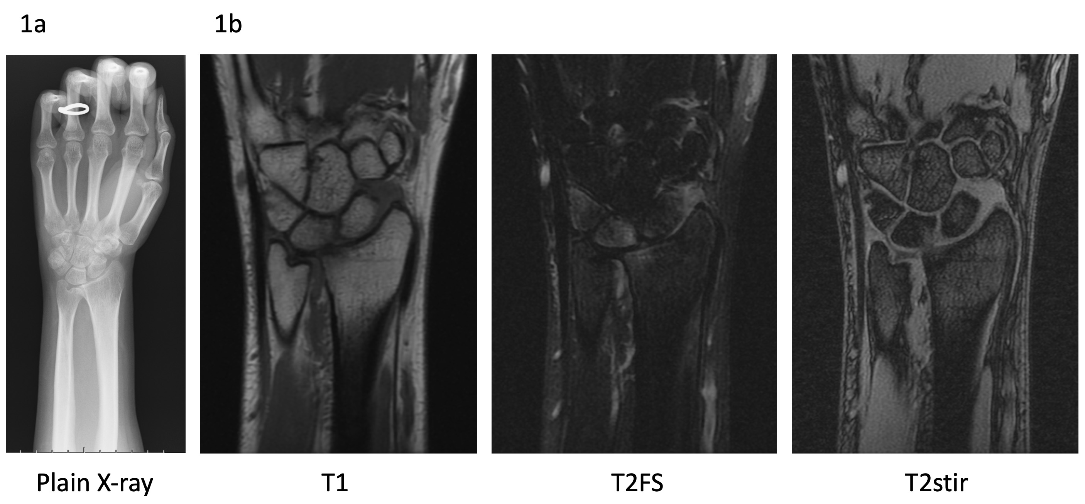
1a) Plain X-ray shows negative ulnar variance and displacement of the carpal bones to the ulnar side centring on the lunate.
1b) MRI showing proliferative synovial changes in the left wrist joint. Bone marrow oedema is found in the distal radius, scaphoid, triquetral, and pisiform bones. No abnormalities were found in the TFCC.
MRI, magnetic resonance imaging; FS, fat suppression, stir, short TI inversion recovery; TFCC, Triangular Fibrocartilage Complex.

Figure 2. Postoperative plain X-ray of left wrist.
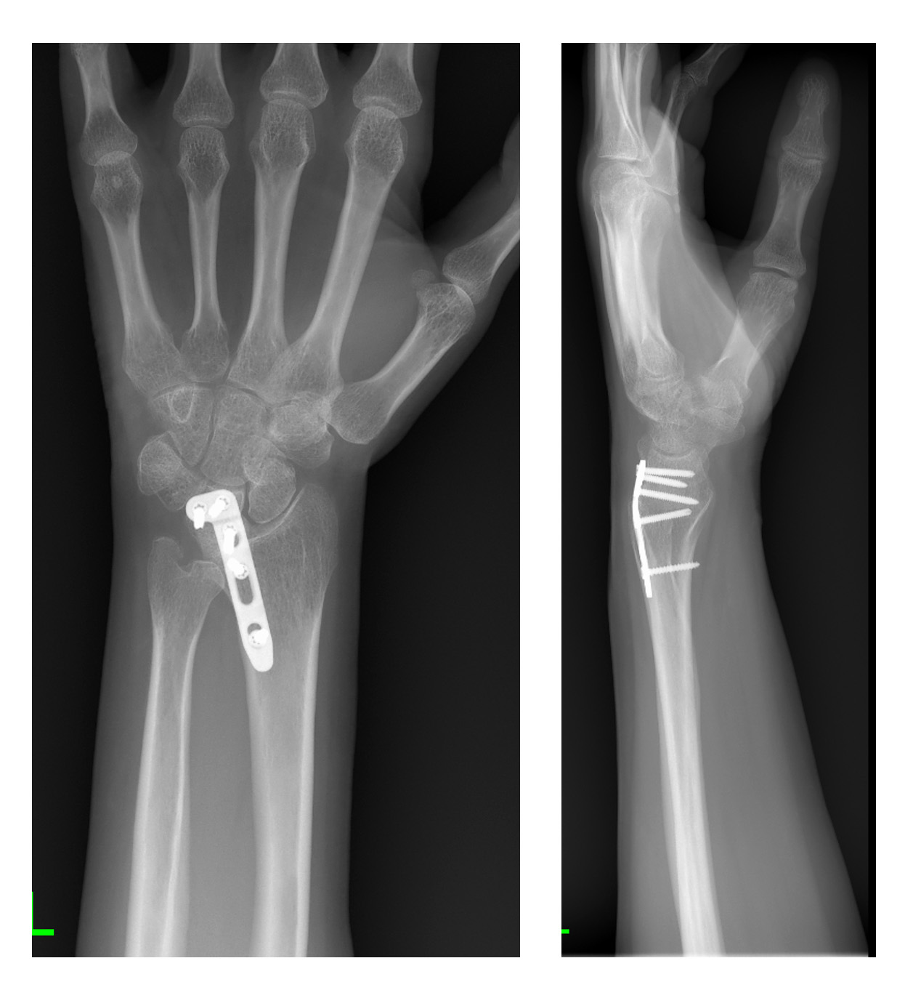
The radial lunate joint is fused with a distal radial locking plate.
Left panel; anteroposterior view. Right panel; lateral view.

Figure 3. Preoperative plain X-ray, CT, and MRI of right wrist.
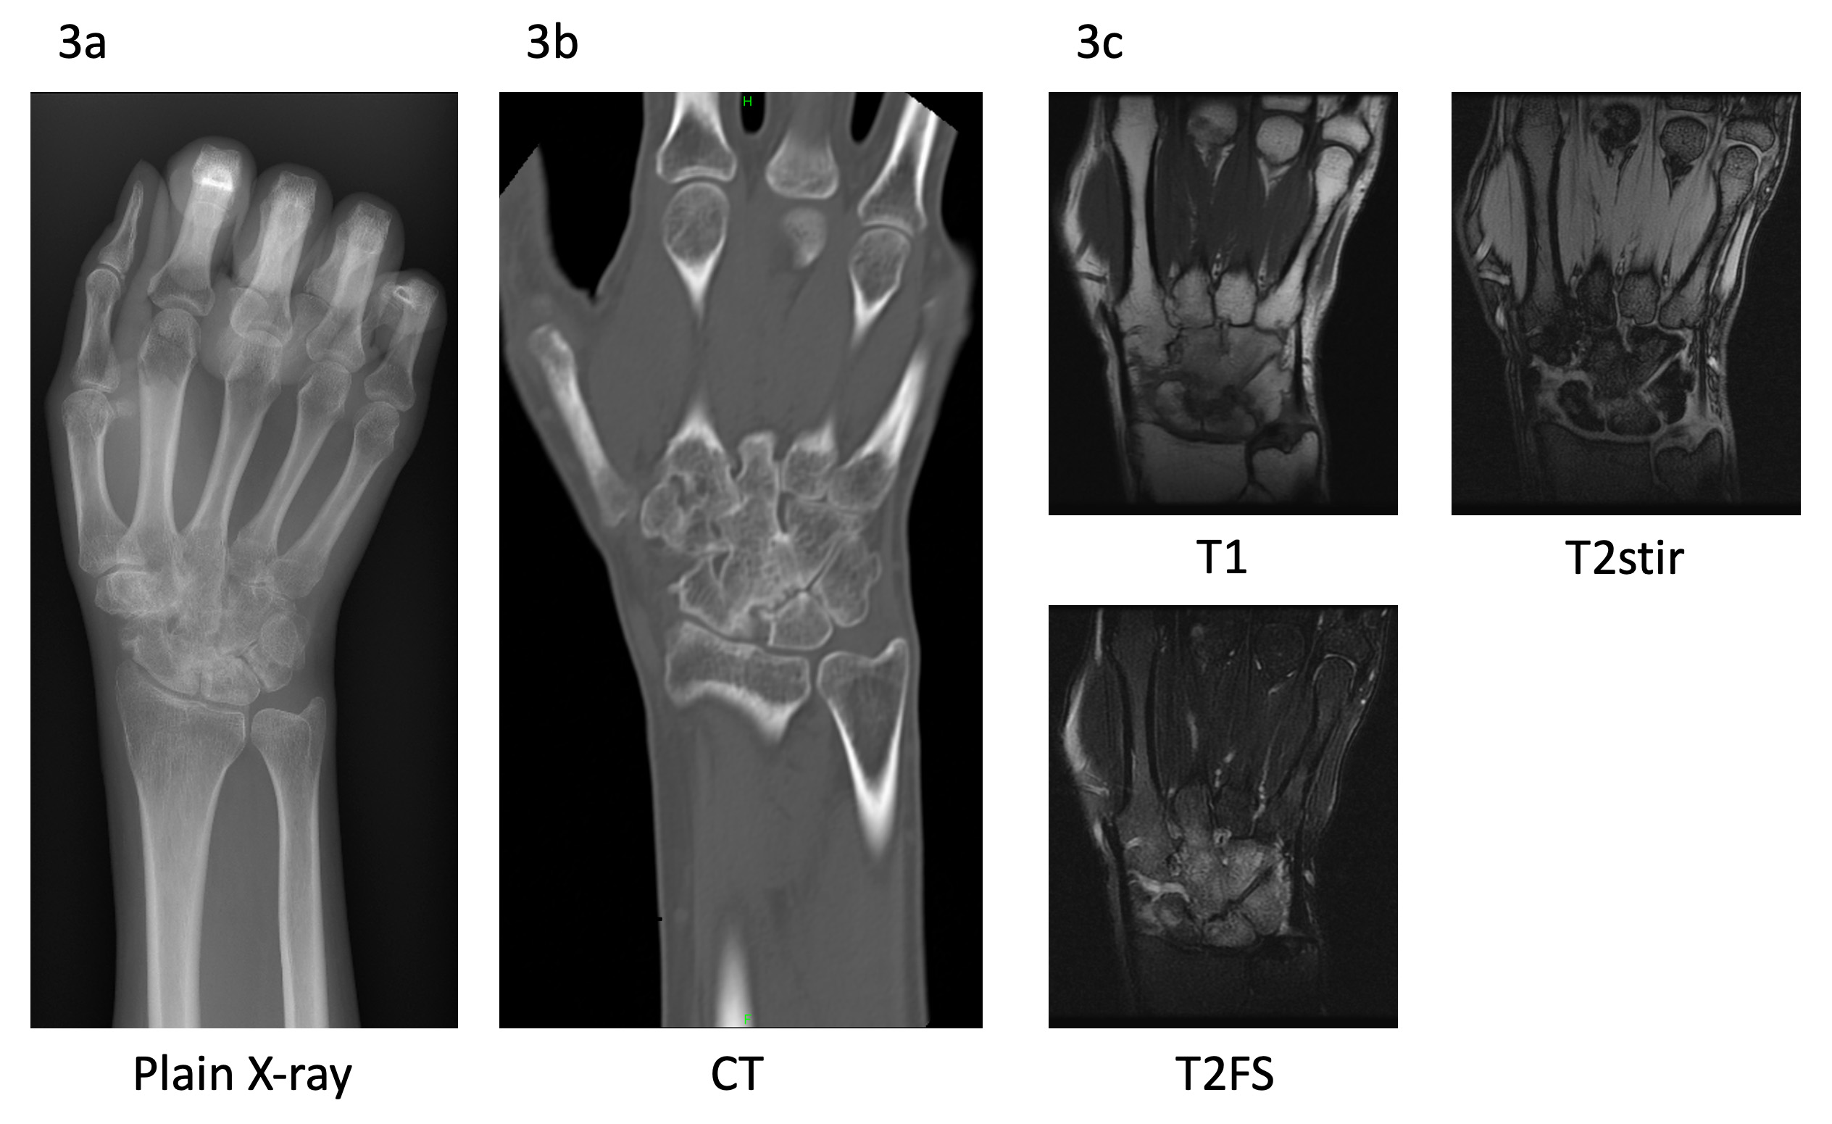
3a) Plain X-ray imaging showing destruction and partial fusion of the right carpal joint.
3b) CT showing bony ankylosis in trapezoid, capitate and hamate bones.
3c) T1-weighted MRI showed low intensity and T2-weighted MRI showing increased brightness centring on the mid-carpal joint but no obvious bony destruction in the carpometacarpal joint.
CT, computed tomography; MRI, magnetic resonance imaging

Figure 4. Postoperative plain X-ray of light wrist.
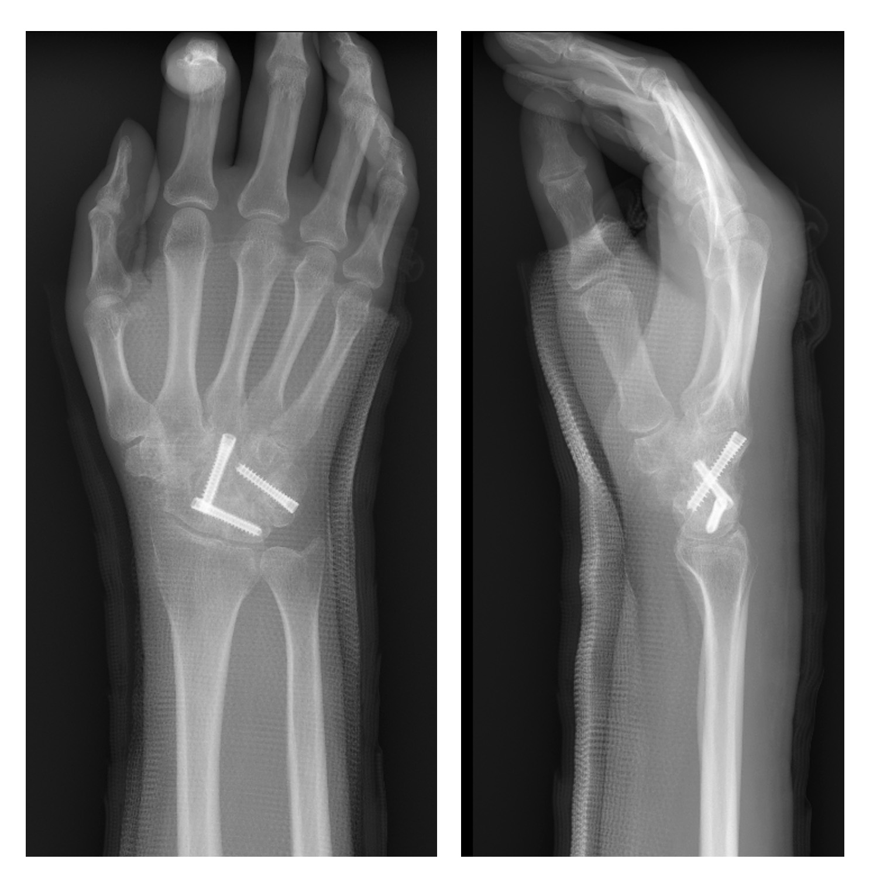
The lunate and scaphoid bones, triquetral and hamate bones, were fixed with Acutrak mini screws, and the scaphoid and capitate bones were fixed using the Acutrak standard screw. (Acumed, Hillsboro, OR, USA)
Left panel; anteroposterior view. Right panel; lateral view.

