The Biology of Symptom-Based Disorders – Time to Act

Andreas Goebel^{1*}, David Andersson², and Yehuda Shoenfeld³

¹ Pain Research Institute, Institute of Life Course and Medical Sciences, University of Liverpool, and Walton Centre NHS Foundation Trust, Liverpool, UK

² King’s College London, Wolfson CARD, Institute of Psychiatry, Psychology & Neuroscience, Guy’s Campus, London, United Kingdom

³ Zabludowicz Center for Autoimmune Diseases, Sheba Medical Center, Tel-Hashomer, Israel

*Corresponding author; Pain Research Institute, Aintree University Hospital, Liverpool L9 7AL; e-mail: andreasgoebel@rocketmail.com; phone: +44 1515295826; fax:+44 1515295821

Keywords: chronic pain, fibromyalgia, autoimmune, autoantibody, symptom-based disorder

Abstract: Symptom-based disorders are conditions that are characterised mostly by somatic symptoms rather than objectively identifiable signs. They are very common, including pain and fatigue disorders, functional gastrointestinal and respiratory disorders, and others, and they cause far greater disability than diseases where signs are prominent. Such conditions may sometimes be triggered by infection, as in Post Covid Syndrome ^{1,2} or physical or psychological trauma. By employing passive immunoglobulin transfer experimental approaches, recent research in several ‘unexplained’ chronic pain conditions has demonstrated that pathogenic IgG autoantibodies can explain several of these conditions’ core symptoms and are ubiquitous in patients with severe phenotypes. The promise from placing positive resources into exploring the role of ‘invisible’, functional, non-inflammatory autoantibodies in symptom-based disorders across additional areas of Medicine includes patient empowerment and the development of new diagnostic tests and therapies.

Main Manuscript Text: Symptoms are experiences that patients report to their health care professionals. ‘Symptom-based disorders’ can be defined as conditions characterised mostly by somatic symptoms, rather than objectively identifiable signs³. Such conditions are very common and cause far greater disability than diseases where signs are prominent⁴. Unfortunately, the underlying causes of symptom-based disorders are typically not understood, and there are few effective treatments.

Should one classify symptom-based disorders the list would be long. It would include, in addition to pain and fatigue disorders, postural tachycardia syndrome (POTS)⁵, idiopathic tinnitus, ‘functional’ dyspnoea, functional sleep disorders, functional gastrointestinal disorders⁶, and others. Subtle signs such as small nerve fibre pathology⁷⁻¹⁰ or autonomic dysregulation^{11,12} may occur, but their importance is dwarfed by the impact of the symptoms ^{13,14}.

The recent COVID epidemic has brought symptom-based disorders into sharp focus. Following resolution of acute COVID infection, many people report debilitating somatic symptoms such as fatigue, ‘brain fog’, pain, and dyspnoea, with few accompanying signs. These symptoms are labelled Post Covid Syndrome (PCS)^{15,16} and, as is common in symptom-based conditions, PCS is often also associated with mental symptoms such as anxiety.

AG, DA and others have recently identified potential aetiological factors for unexplained painful symptoms. We have demonstrated a change in neuronal communication produced by functional, non-inflammatory autoantibodies. In Fibromyalgia syndrome (FMS), Complex Regional Pain Syndrome (CRPS), and other chronic pain conditions, autoantibodies enhance the impulse activity of peripheral sensory afferent fibres, without evidence of tissue destruction or inflammation^{17,18}. In each of these disorders, proof of functional consequences of the respective autoantibodies was achieved by injecting purified patient antibodies into mice, a method termed ‘passive immunoglobulin transfer’. In some instances, a ‘double hit’ was required; for example, in CRPS, an uncommon post-traumatic limb pain condition, paw trauma was an obligatory component, and the transferred symptoms remained restricted to the injured paw¹⁹⁻²². No additional insult or trauma was required to transfer FMS symptoms, where IgG transfer elicited widespread symptoms. The discrepancy between CRPS and FMS also confirms that the nature of functional autoantibodies differs between these conditions. Following administration of patient IgG these rodents developed typical disease features such as hypersensitivity to mechanical pressure or cold and reduced grip strength that were specific to the respective patient donor’s disease phenotype. We only assessed severely affected patients, and we unexpectedly found for each examined condition that functional antibodies were ubiquitous, meaning that these results satisfy Witkeby’s criteria for autoimmune aetiology for (at least) the severe manifestations²³. Preliminary results suggest that abnormal autoantibody production typically accompanies PCS, but confirmation of a causative link is outstanding^{1,2,24}.

Such symptom-based disorders often follow a recognised trigger, such as an infection^{25,26} or trauma - which can be physical or psychological²⁷. One putative explanation for psychological trauma has been that the brain expresses present or past distress as abnormal symptoms, i.e. a form of hysteria, or that such distress may establish a state of central sensitisation, which amplifies normal sensory experiences into pain.²⁸ The addition of the autoantibody findings, however, suggest that distress can trigger symptomatic immune activation (Figure 1).

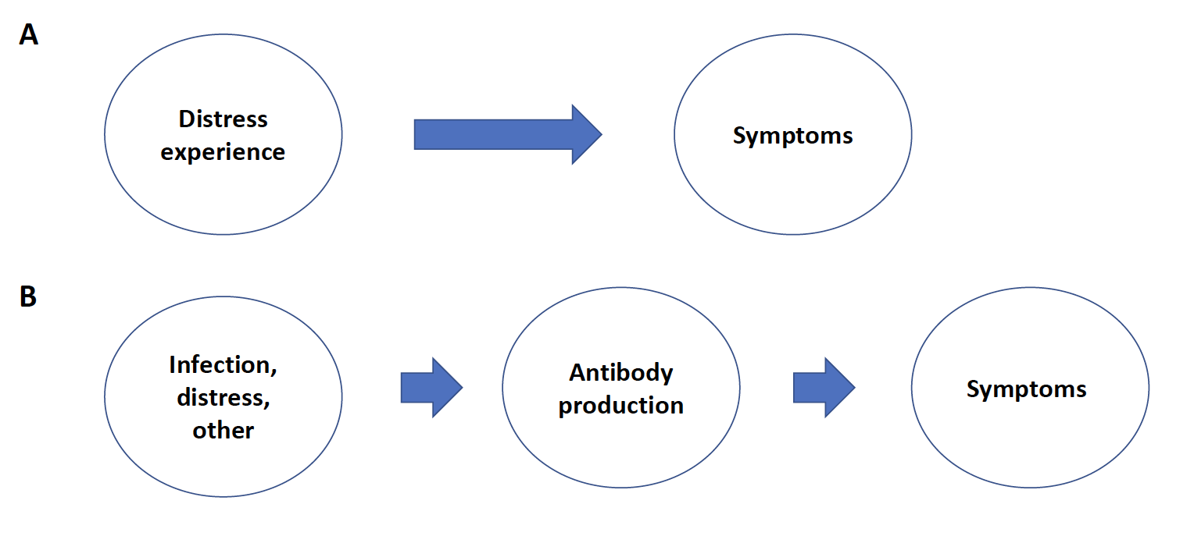

Figure 1. Paradigms for the translation of distress into symptoms. A) triggered by distress the brain generates abnormal symptoms (hysteria, somatisation); B) either experience of distress, or alternative triggers initiate the production of functional autoantibodies causing symptoms.

For established autoimmune disorders, integrating his and others’ findings YS has proposed the conceptual framework ‘hyperstimulation by environmental factors in genetically susceptible individuals’, outlining how various triggers may converge (Figure 2²⁹). External stimuli include hormones, infections (including COVID-19³⁰), adjuvants such as silicone breast implants^{13,27}, and novel cancer therapies with check points inhibitors. He espoused the view that genetic predisposition³¹ largely determines whether an individual will develop classical autoimmune disease; in particular the HLA-DRB1 gene, which may be “notorious” for its links to autoimmunity^{29,31}.

Such classical autoimmune diseases are often also associated with chronic widespread pain, and fatigue. However, whether trigger- and genetic factors for autoantibody-mediated symptom-based disorders i.e., disorders without destructive phenotypes are unique from those in classical autoimmune disorders, and how infection or distress translate into autoantibody production in these disorders must require explorative work.

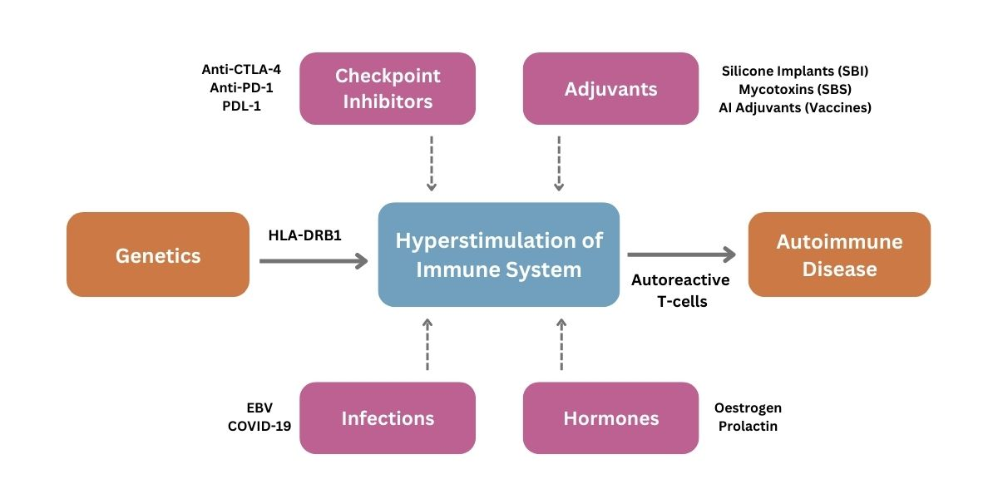

Fig.2. Hypothesis about the development of classical, established autoimmunity through hyperstimulation from environmental factors in genetically vulnerable people

Results from recent chronic pain research suggest that hitherto invisible immune mechanisms may manifest in debilitating symptom-based disorders. Functional, non-inflammatory autoantibodies are not detected by modern proteomics, metabolomics, or transcriptomics studies and might represent a yet-unexplored regulatory system of the body. It would seem prudent across additional areas of medicine to place effort and positive resources into exploring the role of functional autoantibodies, their trigger factors, and their potential evolutional purpose. The promise from such research initiatives includes patient empowerment, and development of new therapeutic or preventative interventions which may yield needed cost reductions for our social and healthcare systems. Now is an apt time to act!

Acknowledgement: The authors wish to thank Dr. Ann Lyons, Bristol, and Dr. John Wiles, Liverpool for important suggestions to the manuscript.

Reference List

1. Cabral-Marques O, Halpert G, Schimke LF, et al. Autoantibodies targeting GPCRs and RAS-related molecules associate with COVID-19 severity. Nature communications 2022;13:1220.
2. Baiocchi GC, Rosenberg AZ, Voydani E, Halbert G, al. e. Autoantibodies linked to autoimmune diseases associate with COVID-19 outcomes. medrxiv (pre-print) 2022.
3. Hyams KC. Developing case definitions for symptom-based conditions: the problem of specificity. Epidemiol Rev 1998;20:148-56.
4. Global, regional, and national incidence, prevalence, and years lived with disability for 301 acute and chronic diseases and injuries in 188 countries, 1990-2013: a systematic analysis for the Global Burden of Disease Study 2013. Lancet 2015;386:743-800.
5. Fedorowski A. Postural orthostatic tachycardia syndrome: clinical presentation, aetiology and management. Journal of internal medicine 2019;285:352-66.
6. Black CJ, Drossman DA, Talley NJ, Ruddy J, Ford AC. Functional gastrointestinal disorders: advances in understanding and management. Lancet 2020;396:1664-74.
7. Grayston R, Czanner G, Elhadd K, et al. A systematic review and meta-analysis of the prevalence of small fiber pathology in fibromyalgia: Implications for a new paradigm in fibromyalgia etiopathogenesis. Seminars in arthritis and rheumatism 2019;48:933-40.
8. Oaklander AL, Herzog ZD, Downs HM, Klein MM. Objective evidence that small-fiber polyneuropathy underlies some illnesses currently labeled as fibromyalgia. Pain 2013;154:2310-6.
9. Uceyler N, Zeller D, Kahn AK, et al. Small fibre pathology in patients with fibromyalgia syndrome. Brain 2013;136:1857-67.
10. Drossman DA, Leserman J, Nachman G, et al. Sexual and physical abuse in women with functional or organic gastrointestinal disorders. Annals of internal medicine 1990;113:828-33.
11. Tocut M, Halpert G, Tsur AM, et al. Cognitive Impairment, Sleep Disturbance, and Depression in Women with Silicone Breast Implants: Association with Autoantibodies against Autonomic Nervous System Receptors. Biomolecules 2022;12.
12. Halpert G, Amital H, Shoenfeld Y. Dysregulation of G protein-coupled receptors of the autonomic nervous system, adrenergic and muscarinic acetylcholine receptors, in patients with autoimmune dysautonomic-related disorders. Brain Behav Immun Health 2020;4:100056.
13. Halpert G, Amital H, Shoenfeld Y. Silicone Breast Illness as a Classical Example of Autoimmune/Inflammatory Syndrome Induced by Adjuvant (ASIA). Isr Med Assoc J 2022;24:357-9.
14. Shoenfeld Y, Ryabkova VA, Scheibenbogen C, et al. Complex syndromes of chronic pain, fatigue and cognitive impairment linked to autoimmune dysautonomia and small fiber neuropathy. Clin Immunol 2020;214:108384.
15. Hope AA, Evering TH. Postacute Sequelae of Severe Acute Respiratory Syndrome Coronavirus 2 Infection. Infect Dis Clin North Am 2022;36:379-95.
16. Dotan A, Shoenfeld Y. Post-COVID syndrome: the aftershock of SARS-CoV-2. Int J Infect Dis 2022;114:233-5.
17. Goebel A, Krock E, Gentry C, et al. Passive transfer of fibromyalgia symptoms from patients to mice. J Clin Invest 2021;131.
18. Goebel A, Andersson D, Helyes Z, Clark JD, Dulake D, Svensson C. The autoimmune aetiology of unexplained chronic pain. Autoimmun Rev 2022;21:103015.
19. Goebel A, Stock M, Deacon R, Sprotte G, Vincent A. Intravenous immunoglobulin response and evidence for pathogenic antibodies in a case of complex regional pain syndrome 1. AnnNeurol 2005/3;57:463-4.
20. Tekus V, Hajna Z, Borbely E, et al. A CRPS-IgG-transfer-trauma model reproducing inflammatory and positive sensory signs associated with complex regional pain syndrome. Pain 2014;155:299-308.
21. Cuhadar U, Gentry C, Vastani N, et al. Autoantibodies produce pain in complex regional pain syndrome by sensitizing nociceptors. Pain 2019;160:2855-65.
22. Helyes Z, Tekus V, Szentes N, et al. Transfer of complex regional pain syndrome to mice via human autoantibodies is mediated by interleukin-1-induced mechanisms. Proceedings of the National Academy of Sciences of the United States of America 2019;116:13067-76.
23. Rose NR, Bona C. Defining criteria for autoimmune diseases (Witebsky's postulates revisited). ImmunolToday 1993/9;14:426-30.
24. Bornstein SR, Voit-Bak K, Donate T, et al. Chronic post-COVID-19 syndrome and chronic fatigue syndrome: Is there a role for extracorporeal apheresis? Molecular psychiatry 2022;27:34-7.
25. Kanduc D, Shoenfeld Y. Human Papillomavirus Epitope Mimicry and Autoimmunity: The Molecular Truth of Peptide Sharing. Pathobiology 2019;86:285-95.
26. Kanduc D, Shoenfeld Y. Molecular mimicry between SARS-CoV-2 spike glycoprotein and mammalian proteomes: implications for the vaccine. Immunol Res 2020;68:310-3.
27. Yavne Y, Amital D, Watad A, Tiosano S, Amital H. A systematic review of precipitating physical and psychological traumatic events in the development of fibromyalgia. Seminars in arthritis and rheumatism 2018;48:121-33.
28. Mai FM, Merskey H. Briquet's concept of hysteria: an historical perspective. Can J Psychiatry 1981;26:57-63.
29. Watad A, Bragazzi NL, Amital H, Shoenfeld Y. Hyperstimulation of Adaptive Immunity as the Common Pathway for Silicone Breast Implants, Autoimmunity, and Lymphoma of the Breast. Isr Med Assoc J 2019;21:517-9.
30. Dotan A, Mahroum N, Bogdanos DP, Shoenfeld Y. COVID-19 as an infectome paradigm of autoimmunity. The Journal of allergy and clinical immunology 2022;149:63-4.
31. Arango MT, Perricone C, Kivity S, et al. HLA-DRB1 the notorious gene in the mosaic of autoimmunity. Immunol Res 2017;65:82-98.

