Title: General Framework to Quantitatively Predict Pharmacokinetic Induction Drug-Drug Interactions Using In vitro Data
Running heading: General Framework to Quantitatively Predict Induction Drug-Drug Interactions Using In vitro Data
Authors: Sandra Grañana-Castillo¹, Angharad Williams¹, Thao Pham¹, Saye Khoo¹, Daryl Hodge¹, Asangaedem Akpan^{2,3}, Rachel Bearon⁴, Marco Siccardi¹
Affiliations:
¹Pharmacology and Therapeutics, University of Liverpool, Liverpool, UK
²Institute of Life Course & Medical Sciences, University of Liverpool and Liverpool University Hospitals NHS FT, Liverpool, United Kingdom
³NIHR Clinical Research Network, Northwest Coast, Liverpool, UK
⁴Mathematical Sciences, University of Liverpool, Liverpool, UK

Correspondent author: siccardi@liverpool.ac.uk
Department of Pharmacology and Therapeutics
Institute of Systems, Molecular and Integrative Biology
University of Liverpool
3rd Floor, William Henry Duncan Building
6 West Derby Street
Liverpool, L7 8TX
Abstract
Introduction
Metabolic inducers can expose people with polypharmacy to adverse health outcomes. A limited fraction of potential drug-drug interactions (DDIs) have been or can ethically be studied in clinical trials, leaving the vast majority unexplored. In the present study, an algorithm has been developed to predict the induction DDI magnitude, integrating data related to drug metabolising enzymes.
Methods
The area under the curve ratio (AUC_{ratio}) resulting from the DDI with a victim drug in the presence and absence of an inducer (rifampicin, rifabutin, efavirenz, or carbamazepine) was predicted from various in vitro parameters and then correlated with the clinical AUC_{ratio} (N=319). In vitro data including fraction unbound in plasma, substrate specificity and induction potential for cytochrome P450s, phase II enzymes and uptake, and efflux transporters were integrated. To represent the interaction potential, the in vitro metabolic metric (IVMM) was generated by combining the fraction of substrate metabolised by each hepatic enzyme of interest with the corresponding in vitro fold increase in enzyme activity (E) value for the inducer.
Results
Two independent variables were deemed significant and included in the algorithm: IVMM and fraction unbound in plasma. The observed and predicted magnitudes of the DDIs were categorised accordingly: no induction, mild, moderate, and strong induction. DDIs were assumed to be well classified if the predictions were in the same category as the observations, or if the ratio between these two was less than 1.5-fold. This algorithm correctly classified 70.5% of the DDIs.
Conclusion
This research presents a rapid screening tool to identify the magnitude of potential DDIs utilising in vitro data which can be highly advantageous in early drug development.

Key messages
- A multiple linear regression analysis was developed to predict drug-drug interactions using accessible in vitro data that can be beneficial for a rapid screening of potential DDIs.
- The integration of the fractions metabolised (Fm) by each hepatic enzyme multiplied by the inducer effect (E) for the corresponding enzyme isoform is a strong predictor of potential DDIs.

Statements and Declarations
This project is funded by Engineering and Physical Sciences Research Council (EPSRC).
Conflict of interest
Marco Siccardi has received research grant funding from Janssen and ViiV unrelated to this work. M.S. is currently employed by Labcorp. Saye Khoo has received grant support for the Liverpool drug interaction website (www.covid-druginteractions.org) from AbbVie, Gilead, MSD, Novartis, and Sobi. S.K. has also received speakers’ honoraria from ViiV Healthcare, Gilead Sciences, and AbbVie; consultancy fees from ViiV Healthcare and Merck; and research funding from Gilead Sciences and ViiV Healthcare unrelated to this work. Sandra Grañana-Castillo, Angharad Williams, Thao Pham, Daryl Hodge, Asangaedem Akpan, and Rachel Bearon declare that they have no potential conflicts of interest that might be relevant to the contents of this manuscript.

- Introduction
The efficacy and toxicity of pharmacological strategies can be complicated by the concomitant use of multiple drugs. Individuals receiving a high number of drugs simultaneously have a higher risk of drug-related events such as drug-drug interactions (DDIs) and consequently, adverse drug reactions (ADRs) although multiple factors can influence ADRs[1]. DDIs can be defined as the modulation of the pharmacologic activity of one drug (victim) by the prior or concomitant administration of another drug (perpetrator). DDIs can occur on a pharmacokinetic or pharmacodynamic level. Pharmacokinetic DDIs affect the absorption, distribution, metabolism, or excretion of the victim drug, and pharmacodynamic DDIs cause direct changes to the pharmacological activity. DDIs can increase the victim’s concentration leading to toxicity or decrease it and reduce the drug effect, in both situations potentially jeopardising the clinical management of multiple therapies [2]. Adverse drug reactions caused by DDIs are prevalent in 22.2% of hospital admissions and of 8.9% of hospital visits (outpatient and emergency room) [3], and an incidence of 6% in older adult outpatients [4]. The extent of the pharmacokinetic interaction can be quantified by the ratio of the victim drug exposure measured as area under the curve ratio (AUC_{ratio}), defined as (AUC_{i}/AUC), where AUC_{i} is with, and AUC is without the DDI perpetrator.
Compared to the high number of possible drug combinations, only a limited number of DDI studies are conducted, leading to a high percentage of potential DDIs remaining unexplored. In most cases, the evaluation of DDIs is supported only by individual judgment of the prescriber or expert opinion. Multiple approaches to identify and quantify the potential of two drugs to interact have been established, from in vivo in vitro extrapolation (IVIVE) methods to physiologically based pharmacokinetic modelling (PBPK), and these have been extensively reviewed [5-10]. PBPK models can estimate the magnitude and clinical relevance of a particular drug combination and are consequently increasingly used to inform regulatory agencies. To note, in 2015 22% of new drug applications approved to the FDA contained PBPK-supported data and this increased up to 45% in 2019 [11]. DDI PBPK models benefit from in vitro experiments, whose can also be used in simpler IVIVE methods, which benefit from a broader and systematic application. Although PBPK models are becoming a robust tool to evaluate DDIs other than clinical trials, IVIVE static methods are still used for an early rapid screening of potential DDIs. In this paper we describe a mathematical algorithm to predict the induction DDI magnitude between a victim and a perpetrator, integrating data regarding drug metabolising enzymes. Induction DDIs often occur through the binding to transcription factors that alter the enzyme expression. The induction capability differs across enzymes, for example, it is suggested that the inducibility potential of the CYP family is greater than the UGT family. Within the same family, some enzymes are also more inducible than others. For example, CYP3A4 is a very inducible compared to CYP1A2 [12]. Additionally, the CYP family is the major contributor of xenobiotics corresponding to 2/3 of the most commonly prescribed drugs, whereas UGTs are 1/10 [13].
Four paradigm metabolic inducers were considered to build this algorithm: rifampicin, carbamazepine, efavirenz, and rifabutin. These drugs induce multiple enzymes by promoting the gene expression of pregnane X receptor (PXR) [14]. Additionally, carbamazepine and efavirenz increase the activation of the constitutive androstane receptor (CAR) [14, 15]. Rifampicin is a strong inducer of CYP3A and CYP2C19, and acts as a moderate inducer of CYP1A2, CYP2B6, CYP2C8, and CYP2C9 [16]. Carbamazepine is a known strong inducer of CYP3A and CYP2B6, a moderate inducer of CYP2C8 and CYP2C9, and a weak inducer of CYP1A2 and CYP2C19 [16]. Efavirenz is considered a moderate inducer of CYP3A and CYP2B6 [16]. Rifabutin is a moderate CYP3A and a weak CYP2C9 inducer [16]. However, there is no clear consensus of the magnitude of potential induction and inhibition of different isozymes and reported results differ across sources and studies. Similarly, there is conflicting information on the effect of these perpetrators on several transporters. In this article, two transporters were considered, as they play an important role in the absorption and distribution of many commonly prescribed drugs: P-glycoprotein (P-gp) and organic anion transporting polypeptide (OATP)1B1. Rifampicin is a strong inducer of P-gp, and strong inhibitor of OATP1B1 on single dose, although acts as an OATP inducer after multiple dosing due to PXR promotion [17-19]. Carbamazepine is also an inducer of P-gp and OATP1B1 [14], while efavirenz and rifabutin do not significantly induce either of these two transporters [14, 20].
The overall aim of this study is to generate a mechanistic algorithm for the prediction of induction DDI through the integration of in vitro data.
- Materials and methods
Literature in vivo data: substrate drugs were selected considering the availability of DDI clinical data with rifampicin, carbamazepine, efavirenz, or rifabutin, which acted as perpetrators of the interaction. Clinical interaction studies were collated from the University of Washington Drug Interactions Database (UW DIDB, https://didb.druginteractionsolutions.org/) and all drug combinations reported in the platform were downloaded and selected according to the following inclusion and exclusion criteria.
Studies were considered only if the substrate was orally administered, and the perpetrator was administered with multiple dosing regimen (a minimum of three days and at least once daily). If multiple studies were reported for the same drug combination, number of participants (studies with more than 10 participants were preferred) and posology strategy (perpetrator given at a therapeutic dose and steady state) were first considered for the selection of the AUC measurement. If more than one paper had similar designs, the selection was based on the latest year of publication. Where possible, studies in healthy volunteers and non-smokers were preferred. When the AUC measurement was reported across several enzyme genotypes, the preferred AUC measurement was from the study with patients with the more frequent genotype and not variant alleles. Studies that reported extensive and poor metabolisers separately were pooled together by calculating the weighted mean. Case reports, PBPK simulations, studies involving investigational drugs, and clinical studies in paediatric populations were excluded.
The preferred clinical interaction measurement was the AUC_{ratio}(the substrate’s AUC administered with the inducer divided by the substrate’s AUC administered alone at comparable dosing). When unavailable, the clearance ratio (CL_{ratio}) defined as (CL_{i}/CL), where CL_{i} is with, and CL is without the DDI perpetrator, was used and transformed to AUC_{ratio} following equations 1 and 2 assuming a) a well-stirred hepatic model, and b) the intestinal absorption and fraction unbound are unaffected by the perpetrator [21].
$AUC= \frac{dose · F_{a}}{CL·f_{u}}$ (1)
${AUC}_{ratio}= \frac{{AUC}_{i}}{AUC}= \frac{dose·F_{a,i}·CL· f_{u}}{{CL}_{i}·f_{u,i}·dose·F_{a}} =\frac{CL}{{CL}_{i}}=\frac{1}{{CL}_{ratio}}$ (2)
Where dose is the amount of drug, F_{a} is the fraction absorbed, CL is the volume of plasma from which a drug is removed per unit of time, f_{u} is fraction unbound in plasma. Parameters with the i subscript represent the substrate value with the perpetrator and without represent the substrate alone.
A total of 319 clinical studies met these criteria.
Literature in vitro data: for substrate drugs, data were collected regarding plasma protein binding, fraction metabolised and specificity for P-gp and OATP1B1 transporters. For the inducers, data were collected regarding the in vitro fold increase in enzyme activity (E) (table 1).
For the substrates, the fraction of drug metabolised (f_{m}) was obtained by calculating the intrinsic clearance (CL_{int}) contribution of each metabolic enzyme (equation 3) from in vitro studies as the preferred method.
$f_{m,i}=\frac{{CL}_{int,i}}{\sum_{j ∈ S}{{(CL}_{int,j })}}$ where i ϵ S (3)
f_{m,i} is the fraction of drug metabolised for a specific enzyme (i) which equals to the intrinsic clearance (CL_{int,i}) for the same enzyme i divided by the sum of all reported CL_{int,j} for all enzymes (j) that the drug undergoes metabolism by. For a given drug A, S = S_{A,} and i belongs to the set of S_{A}. For example, imatinib is metabolised by CYP2C8 and CY3A4, so i can take the value of CYP3C8 and CYP3A4, and S is the conjunction of these two enzymes. CL_{int,CYP2C8} is 21.8 pmol/min/mg and CL_{int,CYP3A4} is 85.56 pmol/min/mg. Thus, CL_{int,CYP2C8} is 0.2, as is the resulting value of 21.8/(21.8+85.56).
Where there were limited in vitro data to calculate the fractions metabolised, literature descriptions of the substrate metabolism were used as an alternative, primarily found in the FDA label, Drugbank, or published articles in Pubmed. In these cases, fraction metabolised for an isozyme was assumed to be 0.8 when words such as “major”, “mainly”, “primarily” or “main” pathway were used to describe their metabolism and a fraction metabolised of 0.2 when words such as “minor”, “in a lesser extent” and "minimally” or analogous were used. For both approaches, if mass balance studies with 14-C drug were available, f_{m} was refined by subtracting the proportion of drug excreted unchanged (f_{excr}), either through urine, faeces, or both, and multiplied by the f_{m,i}, corresponding to each enzyme(equation 4). The corrected f_{m} was renamed to f_{m,i,corr}.
$f_{m,i,corr}=(1-f_{excr})· f_{m,i}$ (4)
The selection of in vitro results for the intrinsic clearance was based on the following criteria: recombinant microsomes as preferred system, followed by pooled human liver microsomes. Within the same system, the preference was to use data from a publication containing as many isozymes as possible and containing at least the main metabolic enzyme. If more than one article was eligible, the newest was considered for the calculation of f_{m,i}. If an article reported the intrinsic clearance for several metabolites, the main metabolite was selected, and if unknown, the metabolite that yielded the highest intrinsic clearance was selected. Genetic variants in enzymes were not considered.
We chose recombinant microsomes as the preferred system due to the overexpression of a single isozyme. Intrinsic clearance rates using recombinant microsomes allow normalisation of enzyme expression across experiments, whereas the enzyme expression in human liver microsomes can vary greatly across samples. Thus, the use of recombinant microsomes is characterised by lower variability compared to human liver microsomes.
The weighted mean enzyme abundance of several CYP P450 enzymes (CYP 1A2, 2A6, 2B6, 2C8, 2C9, 2C18, 2C19, 2D6, 2E1, 2J2, 3A4, 3A5, and 3A7) in the liver were used in equation 3 [22]. Intrinsic clearance rates were calculated primarily for CYP P450 and phase II enzymes.
Calculated f_{m,i,corr} values for the substrates were then coupled with the in vitro fold increase in enzyme activity (E_{i}) by the inducer (table 1) and the integration of these two factors generated a new potential parameter for the algorithm named in vitro metabolic metric parameter (IVMM) (equation 5):
$IVMM= \sum_{i ∈ S}{ (f_{m,i,corr}}·E_{i})$ (5)
Similarly, substrates were identified if they were sensitive substrates or not of P-gp or OATP1B1 transporters. For P-gp, the in vitro efflux ratio reported in articles, preferably using Caco-2 cells, was used, while for OATP1B1 a yes/no (1/0) approach was used based on the information in the literature. This information was combined with the overall effect of the perpetrator on this transporter, either if it was acting as an inducer or inhibitor and a categorical classification of no effect, mild, moderate, or strong effect (positive or negative and 0, 1, 2, or 3, respectively). This led to two new parameters named P-gp interaction and OATP1B1 interaction.
Dataset development: The database included a vast amount of quantitative drug information for the following parameters: molecular weight, maximum concentration, bioavailability, plasma protein binding, systemic clearance, volume of distribution, and half-life. Additionally, IVMM, P-gp interaction, OATP1B1 interaction, and fraction unbound in plasma (f_{u}) were calculated and included in the dataset. Missing f_{u} values were searched in the FDA label, Drugbank, or scientific papers and included in the dataset. Finally, the clinical AUC_{ratio} measurement for each substrate-perpetrator interaction was added.
Statistical analysis: the dataset included 244 substrates and 4 inducers, composing of 319 substrate-perpetrator combinations with clinical data available, 205 with rifampicin, 43 with carbamazepine, 45 with efavirenz, and 26 with rifabutin. The dataset was randomly split in a training dataset (70% of the DDIs, N=224) and a validation dataset (30% of the DDIs, N=95) using Matlab (R2021a version). The training dataset was analysed using a multiple linear regression approach with the stepwise method in IBM SPSS Statistics software (version 26). Post-processing was done with SPSS and Microsoft Excel (version 2102) software.
Acceptance criteria: the DDI magnitude for both the predicted and the observed AUC_{ratio}, was classified in 4 categories, no induction (AUC_{ratio} > 0.8), mild [AUC_{ratio} 0.8-0.5), moderate [AUC_{ratio} 0.5-0.2), and strong induction [AUC_{ratio} ≤0.2). If the predicted AUC_{ratio} was in the same category as the observed AUC_{ratio}, it was assumed that the predictions agreed with the observations. However, if the ratio between the predicted and the observed values were within ±1.5-fold, the DDI was considered well classified as the inaccuracy in the classification was considered due to the hard limits of the categorical classification. When the fold was outside the ±1.5-fold and the observed and predicted AUC_{ratio} were in different categories, the DDI was considered misclassified.

- Results
We trained the model in a dataset (N=224) containing data regarding the f_{u}, IVMM, P-gp and OATP1B1 interaction effect. Two independent variables, IVMM and f_{u}, were the only statistically significant variables, and these accounted for 46.6% of the variability in the model. The P-gp and OATP1B1 interaction effect did not significantly improve the data fit. The training dataset provided equation 6 which describes the predicted AUC_{ratio}:
$predicted {AUC}_{ratio}=0.598+(-0.027·IVMM)+(0.002·f_{u} )$ (6)
The performance of the algorithm was evaluated by applying the equation derived from the training dataset to the validation dataset (N=95). This resulted with 70.5% of the DDIs falling within the acceptance criteria. In comparison, the training dataset also yielded 70.5% of the DDIs within the acceptance criteria.
This algorithm appeared to have greater precision for mild interactions followed by moderate interactions which yielded predictions with 90.4% (N=94) and 76.6% (N=111) within the acceptance criteria. On the other hand, non-interactions and strong interactions had a 56.8% (N=44) and 42.9% (N=70). DDIs with only rifampicin as an inducer, returned 68.8% and 67.2% of the DDIs within the acceptance criteria in the training (N=144) and validation (N=61) datasets, respectively. For carbamazepine, efavirenz, and rifabutin, 71.9, 75.9, and 73.7% of the DDIs were within the acceptance criteria in the training dataset (N=32, 29, 19), and 90.9, 68.8, and 71.4% in the validation dataset (N=11, 16, 7), respectively. The observed versus predicted AUC measurement for both the validation and training DDIs are shown in Fig. 1 and the observed versus predicted AUC measurement highlighting the different inducers are shown in Fig. 2. Additionally, the combined performance represented as the % of DDIs within the 1.25, 1.5, 2 or more-fold between the training and validation dataset and the overall percentage of drugs within the acceptance criteria by each inducer is shown in Fig. 3.
We evaluated subsets of drugs based on their anatomical, therapeutic, pharmacologic, and chemical similarity. The grouping was based on the Anatomical Therapeutic Chemical (ATC) classification system (https://www.whocc.no/atc_ddd_index/). As the overall performance between the training and validation dataset had the same ratio of drugs within the acceptance criteria, the following results are expressed as total of drugs within the acceptance criteria without distinguishing between training and validation dataset. These results are displayed in Fig 4. and a comparison of some of these subgroups can be found in the discussion.

- Discussion
In this work, we presented a new approach to tackle the prediction of the magnitude of DDIs. In the final model, IVMM and f_{u} were significant parameters for the prediction of the observed AUC_{ratio}.
Our algorithm performs similarly to the IVIVE approach of Shou et al. (R² 0.625 vs 0.466) [23]. Using six paradigm inducers and 103 DDIs, Shou et al. utilized a mechanistic equation integrating EC₅₀, E_{max}, f_{m,CYP3A4}, f_{u} in plasma, and the experimental in vitro f_{u} in hepatocytes to predict the clinical AUC_{ratio}. E_{max} is the maximum fold effect and EC₅₀ is the inducer’s concentration that elicits half of the maximum effect. Our approach is novel, as the algorithm can not only predict the DDI with CYP3A4 substrates, but also that of many other metabolising enzymes. The calculation of f_{m} also differed between approaches. Shou et al. used an estimation from the AUC_{ratio} resulting from the AUC with or without a strong CYP3A4 inhibitor from clinical reports, while our approach is based entirely on in vitro data. Ohno et al. used an equation considering f_{m}, also derived from the AUC_{ratio} with a strong CYP3A4 inhibitor, and the apparent increase in clearance of a substrate produced by the induction of CYP3A4. The latter accounts for EC₅₀ and E_{max} parameters [24]. Fahmi et al. developed a method to account for the net DDI contribution of mixed induction and inhibition (competitive and time-dependant) of CYP3A4 in the liver. The authors have predicted the AUC_{ratio} for 32 drugs, 21 of which exhibited induction potential, for a total of 59 DDI predictions using available clinical data [25]. This resulted in 66% of the predictions falling within the 2-fold margin. In comparison, with our algorithm, while it did not account for inhibition DDIs, 83.2% of the predictions in the validation dataset were within the 2-fold margins.
Subgroups of interest from the previous classification which were well classified included 87.5% of the benzodiazepines (N=8), 80% of beta-blockers (N=5), and 80% of Nucleotide Reverse Transcriptase Inhibitors (NRTIs) (N=4) such as tenofovir and zidovudine. Benzodiazepines are well-known extensive CYP3A4 substrates and are not sensitive substrates of transporters such as P-gp or OATP1B1. Benzodiazepines do not elicit induction or inhibition of transporters or metabolic enzymes. Tenofovir and zidovudine are minimally or not metabolised by CYP3A4 [26-29]. Beta-blockers are mainly metabolised to certain extent by CYP3A4 and/or CYP2D6. However, similar to benzodiazepines, beta-blockers are usually not CYP or P-gp inhibitors. Propranolol is a CYP2D6 inhibitor and was the only drug of this subgroup that was misclassified [30]. This suggests this algorithm yields a good performance for DDIs where only one or two dominant pathways of substrate metabolism or distribution are affected.
Two out of the three DDIs involving macrolides, 56.3% of protease inhibitors (N=16), and 42.9% of hepatitis C virus (HCV) drugs (N=14) were misclassified. Three DDIs involving macrolides were evaluated, clarithromycin-rifabutin, erythromycin-rifampicin and telithromycin-rifampicin. Of these, only the clarithromycin-rifabutin DDI was well classified. Erythromycin-rifampicin was overpredicted (we predicted a stronger interaction than the clinical study shows), but telithromycin-rifampicin was underpredicted. In general, macrolides are substrates and strong inhibitors of CYP3A4 by mechanism-based inhibition and are substrates for P-gp efflux transporter [31]. Similarly, protease inhibitors are also notable strong CYP3A4 inhibitors and substrates of this isozyme [32]. These drugs are substrates of CYP3A4 to some extent and inhibit their own metabolism. In combination with inducers of CYP3A4, the overall effect is challenging to predict. Drugs to treat HCV such as the discontinued telaprevir and boceprevir are also protease inhibitors [33], and other direct-acting antiviral agents such as paritaprevir are combined with ritonavir to increase its concentration [34] along with ombitasvir and with or without dasabuvir and ribavirin. Additionally, some of the HCV drugs are substrates and/or inhibitors of several transporters and CYPs. For example, simeprevir is both substrate and inhibitor of Breast Cancer Resistance Protein (BCRP), OATP1B1, and P-gp and substrate and weak inducer of CYP3A4. Velpatasvir is a substrate of CYP3A4 as well as a substrate and inhibitor of BCRP, OATP1B1, and P-gp[35], which could justify the difficulty in accurately predicting these DDIs. This suggests the accuracy of the prediction is far less reliable if the victim of the DDI is both a substrate and an inhibitor of the affected enzymes and/or transporters. The prediction may either under or over predict the clinical magnitude of the DDI in these cases. Figure B from the Supplementary data shows the differences in the predicted DDIs between strong CYP3A4 inhibitors and drugs only metabolised by CYP3A4. Additional sub-groups percentages of DDIs within the 1.25, 1.5, and 2-fold or more are shown in Fig. 4.
Neither the P-gp nor the OATP1B1 interaction effect had a significant impact on the prediction of the AUC_{ratio}. Rifampicin inhibits OATP1B1 (an uptake transporter mainly in the liver) in vitro by 84.7%, [18]. A single dose of rifampicin has been established as a clinical index inhibitor of OATP1B1 [36]. Multi-dosing of rifampicin induces several enzymes and transporters such as CYP3A, P-gp, and OATP1B1, greatly countering the initial rapid onset of OATP1B1 inhibition [37]. This could explain why grazoprevir predictions with efavirenz and rifampicin were not in agreement with the clinical data. Grazoprevir is partially eliminated by CYP3A4, it is also a mild inhibitor of CYP3A4, is substrate of P-gp and OATP transporters, and 80% of the drug is excreted unchanged. However, the contribution of CYP3A4 to the metabolism of grazoprevir has not been determined [38]. The clinical data for grazoprevir with daily efavirenz showed a strong interaction (AUC_{ratio} 0.17), the prediction was moderate-mild (AUC_{ratio} 0.57) and no significant interaction was found with daily rifampicin (AUC_{ratio} 0.93) when the predictions were also moderate-mild (AUC_{ratio} 0.47) [39]. One hypothesis is that the contribution of CYP3A4 in DDI interactions is significant, but in the case of rifampicin, the DDI appears to be much milder, as it is counteracting the increase of the AUC due to the inhibition of OATP1B1 transporter. This theory could be supported by the increase of grazoprevir levels up to 8.35-fold when administered with a single oral dose of rifampicin 600 mg [39].
Rifampicin also induces the expression and activity of P-gp, an efflux transporter found in the liver, intestine, and kidney [40]. Rifampicin has a strong induction effect on P-gp substrates, as demonstrated with digoxin and dabigatran in clinical studies [19, 41-46]. Digoxin is not metabolised by CYPs, however, it has a high affinity for the P-gp, thus is used as a probe drug for in vitro P-gp inhibition or induction assays [47]. When digoxin is given simultaneously with rifampicin, several studies have shown an AUC drop of 15.6-30.4% [41-45]. Similarly, dabigatran is a sensitive P-gp substrate which is not metabolised by CYPs, and only 20% is metabolised via glucuronidation [48]. The effect of rifampicin on dabigatran is more marked, with a decrease in AUC ranging from 67-71.6% [19, 46]. However, P-gp interaction was not included in the final model, as it was deemed to be non-significant. We hypothesised that P-gp was not significant as P-gp induction is highly correlated to CYP3A4 induction, and the extent of the induction of P-gp can greatly vary across different drugs. However, for drugs that are not metabolised by CYP3A4 but are highly sensitive P-gp substrates, the algorithm did not predict accurately the strong-moderate interactions.
This algorithm relies on the quality of the in vitro data. For this reason, estimation of f_{m,i,corr} was crucial to adequately characterise the potential interaction with the perpetrator. To calculate f_{m,i,corr}, CL_{int,i} were selected from different papers. For most drugs, only one paper was used for each drug, however, sometimes a pool of data from two or more papers was necessary to characterise the drug’s metabolism. In some cases, the order of magnitude between reported CL_{int,i} values across different papers was above 100-fold. Thus, data were not pooled. In this particular case, either the contribution of the minor enzyme was not considered for the calculation of f_{m,i,corr}, or the percentages were estimated based on literature (major/minor). The rationale behind this approach was to mitigate the already existent sources of variability such as the use of different in vitro systems (e.g., recombinant microsomes versus human liver microsomes). While some efforts have been made to extrapolate results from recombinant microsomes to human liver microsomes with a scaling factor (ISEF), it still shows a large variability [49]. Thus, no scaling factors were implemented in our standardisation of units for CL_{int,i}.
Pharmacogenetics can play an important role in the metabolism of drugs and increase the variability between subjects. Efavirenz, voriconazole, codeine, warfarin, and tramadol are substrates defined in the algorithm that are susceptible to enzymatic polymorphisms [50]. For example, CYP2B6 is a highly polymorphic enzyme and it is responsible for the metabolism of 8% of the commercialised drugs such as efavirenz, methadone, bupropion and artemisinin. Drug clearance can drop up to 25% and 50% in certain polymorphisms carriers compared to the wild-type [51] Similarly, it is well-described that CYP2C19 polymorphisms are responsible for the large interindividual variability in voriconazole exposure [52-54]. Polymorphisms were not considered in the model due to the limited and sparse reported data both in vitro and clinical on polymorphisms and the limitations within IVIVE methods. This type of challenges should be further explored using more sophisticated methods such as population pharmacokinetics and PBPK modelling.
Drug metabolism pathways can be very challenging to describe, as enzymes can produce different reactions and metabolites, and metabolites can be further metabolised by the same or other enzymes. The end goal of these enzymes is to create a more polar metabolite to facilitate renal or biliary excretion. CYP enzymes play a major role in phase I metabolism (oxidation, reduction, and hydrolysis) while UGT enzymes play a major role in phase II metabolism (conjugation) [55]. In this algorithm, f_{m,i,corr} was calculated using CYP and UGT fractions combined for simplicity, although in vivo, CYP and UGT enzymes have an overlapping role in drug metabolism, where they can metabolise both the parent drug and metabolites interchangeably. Additionally, in vitro data for some enzymes were not available in the literature, for example, the moderate induction of CYP2C8 by carbamazepine or the weak induction of CYP2C9 by rifabutin. However, the E fold value was covered for most of the major enzymes and inducers (table 1) so the algorithm has the potential to capture most of the major enzyme-based DDIs. In this paper we developed an algorithm to predict potential DDIs and due to the complex nature of DDIs, it is unlikely that a universal static equation can predict all DDIs. The DDI magnitude can be dependant of many factors and not limited to phase I and II enzymes, such as transporters induction or inhibition, pH alteration, protein binding displacement, pharmacogenetics and further complicated with a pharmacodynamic component. Specially in these cases, PBPK or population pharmacokinetic models can outperform static approaches and they should be prioritised. Therefore, this algorithm should be used cautiously and limited to drugs with a good DMPK description of their metabolic pathways that are described within this model.
- Conclusions
This algorithm yields an accuracy of 70.5% by using only in vitro data to predict the clinical classification of DDIs. Adequate identification of the potential DDI magnitude can be highly advantageous in early drug development, where clinical trials have not yet been performed. IVIVE approaches are challenging due to scalability and uncertainty around some parameters such as fraction metabolised, but as more in vitro studies on a wide range of drug metabolising enzymes and transporters are conducted, IVIVE approaches can be improved and refined. This model provides a fit-for-purpose tool to identify which drug combinations should be prioritised for DDI studies in the primary stages of drug development, and thus avoid the late recognition of important DDIs which may harm people and compromise public health programmes.

Figures and tables
Table 1. Representative values of the in vitro fold increase in enzyme activity (E) for rifampicin, carbamazepine, efavirenz, and rifabutin to calculate the in vitro metabolic metric (IVMM) in the liver.
Enzyme | E (fold) | System | Substrate reaction | Reference | Pubmed ID
Rifampicin
CYP3A4/5/7 | 18.5 | HepaRG | Midazolam 1'-hydroxylation | [56] | 24191259
CYP2B6 | 7.27 | Hepatocytes (cryopreserved) | Bupropion hydroxylation | [57] | 25395831
CYP2C8 | 3 | Hepatocytes (primary culture) | Amodiaquine N-deethylation | [58] | 22498895
CYP2C9 | 2 | Hepatocytes (cryopreserved) | Diclofenac 4'-hydroxylation | [59] | 23153057
CYP2C19 | 3.6 | Hepatocytes (cryopreserved) | (S)-mephenytoin 4'-hydroxylation | [60] | 20460162
CYP2E1 | 2.2 | Hepatocytes (primary culture) | Chlorzoxazone 6-hydroxilation | [61] | 12642468
CYP1A2 | 1.65 | Hepatocytes (primary culture) | 7-ethoxyresorufin O-deethylation | [62] | 20119716
CYP2A6 | 2.4 | Hepatocytes (chimeric mice) | Coumarin 7-dydroxylation | [63] | 15769886
UGT1A3 | 1.4 | Hepatocytes (cryopreserved) | Norursodeoxycholic acid 23-glucuronide | [64] | 19889628
UGT1A4 | 2.2 | Hepatocytes (primary culture) | Lamotrigine glucuronidation | [65] | 19845433
UGT1A9 | 1.75 | Hepatocytes (primary culture) | Propofol glucuronidation | [66] | 14709631
UGT2B7 | 3.8 | Hepatocytes (primary culture) | Morphine-3-glucoronidation | [66] | 14709631
SULT1A2 | 2 | Hepatocytes (primary culture) | Dehydroepiandrosterone sulfation | [67] | 17687072
Carbamazepine
CYP3A4/5/7 | 5.6 | Hepatocytes (cryopreserved) | Testosterone 6-beta-hydroxylation | [68] | 31564409
CYP2C9 | 4 | Hepatocytes (cryopreserved) | Tolbutamide methylhydroxylation | [68] | 31564409
UGT2B7 | 4.3 | Hepatocytes (primary culture) | Morphine-3-glucuronidation | [66] | 14709631
CYP1A2 | 2 | HepaRG | Phenacetin O-deethylation | [69] | 31158489
CYP2B6 | 5 | Hepatocytes (primary culture) | Bupropion hydroxylation | [70] | 14977870
Efavirenz
CYP3A4/5/7 | 6 | Hepatocytes (primary culture) | Alfentanil hydroxylation | [71] | 22398970
CYP2B6 | 3 | Hepatocytes (primary culture) | Bupropion hydroxylation | [71] | 22398970
Rifabutin
CYP3A4/5/7 | 2.4 | Hepatocytes (chimeric mice) | Testosterone 6-beta-hydroxylation | [72] | 16308281

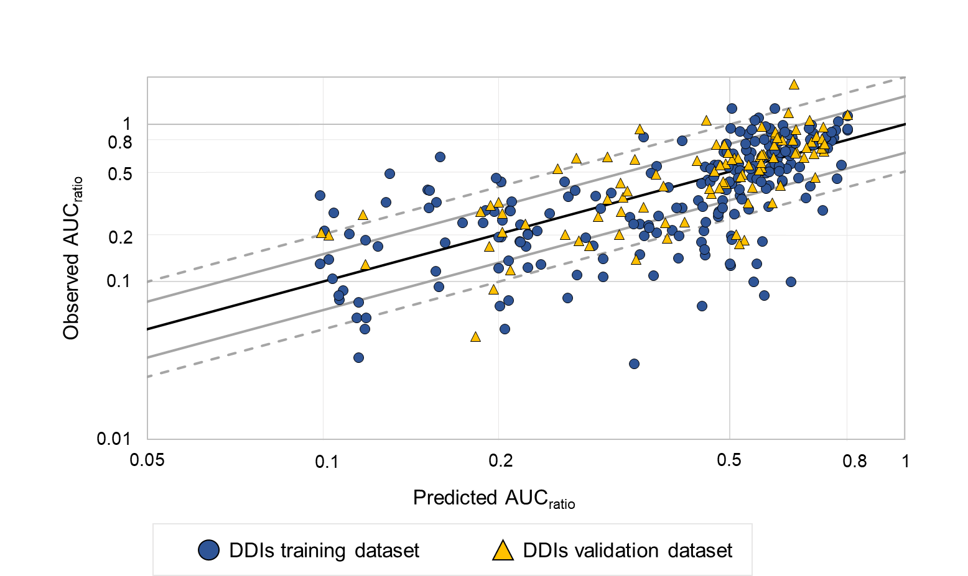
Fig. 1 Predicted versus observed Area Under the Curve ratio (AUC_{ratio}) of orally administered drugs (with vs without perpetrator) separated by training and validation dataset. The predicted AUC_{ratio} is represented by the X axis and the observed AUC_{ratio} in clinical trials by the Y axis. An AUC_{ratio} value of >0.8-fold represents non-induction DDIs, between [0.8-0.5-fold) represents a mild induction, [0.5-0.2-fold) a moderate induction, and ≤0.2 a strong induction. The black solid line represents the identity line, the grey solid line represents the 1.5-fold margins, and the grey dashed lines represent the 2-fold margins. DDIs that are within the same interval classification (no, mild, moderate, strong interaction) or the ratio between the observed and predicted AUC falls within the ±1.5-fold, is considered well-classified. Light blue markers represent all DDIs in the training dataset and yellow markers represent all DDIs in the validation dataset.

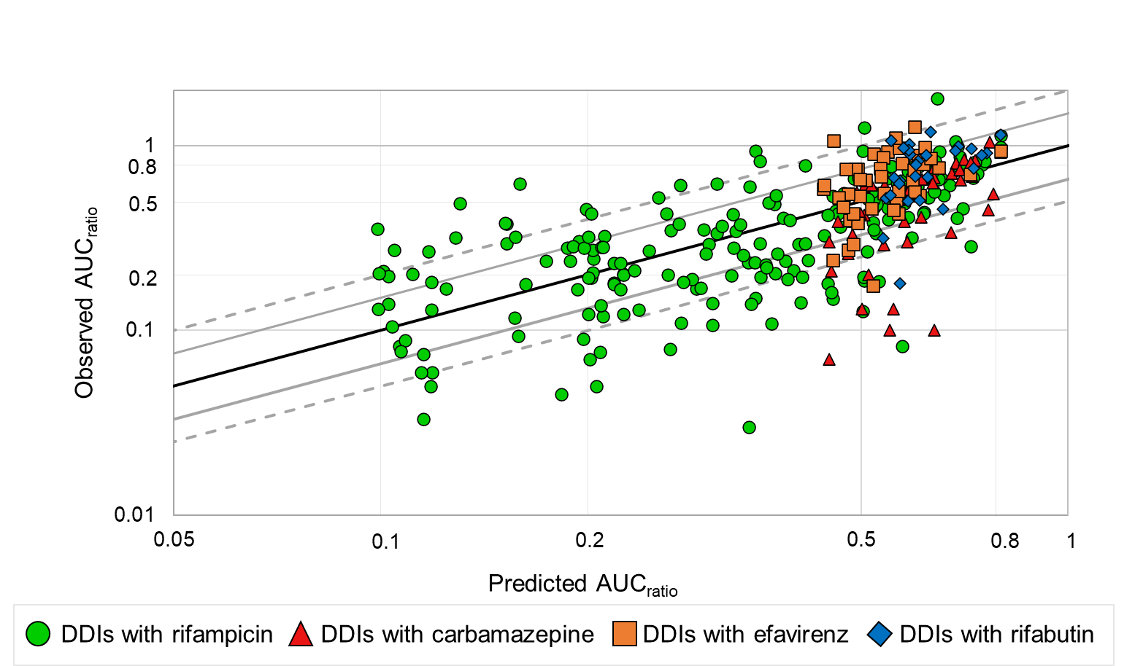
Fig. 2 Predicted versus observed Area Under the Curve ratio (AUC_{ratio}) of orally administered drugs (with vs without perpetrator) separated by inducer. The predicted AUC_{ratio} is represented by the X axis while the observed AUC_{ratio} in clinical trials by the Y axis. An AUC_{ratio} value of >0.8-fold represents non induction DDIs, between [0.8-0.5-fold) represents a mild induction, [0.5-0.2-fold) a moderate induction, and ≤0.2 a strong induction. The black solid line represents the identity line, the grey solid lines represent the 1.5-foldmarginss, and the grey dashed lines represent the 2-fold margins. DDIs that are within the same interval classification (no, mild, moderate, strong interaction) or where the ratio between the observed and predicted AUC falls within the ±1.5-fold, are considered well-classified. Grey dashed lines represent the 2-fold margins. Green markers represent DDIs with rifampicin, red markers represent DDIs with carbamazepine, orange markers represent DDIs with efavirenz and dark blue markers represents DDIs with rifabutin.
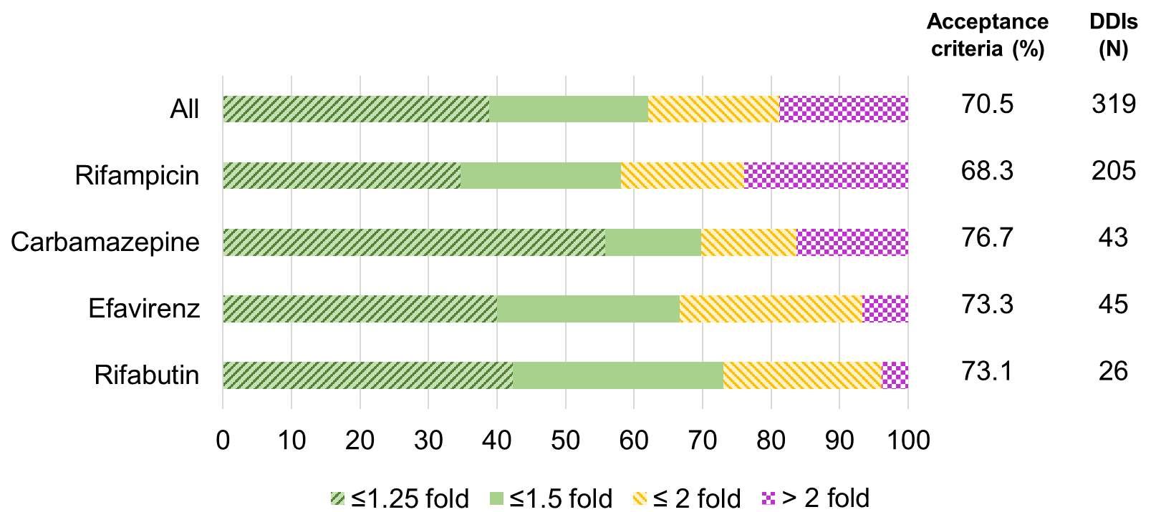
Fig. 3 Percentage of drugs within the 1.25-fold margins between the observed and predicted AUC_{ratio} in light green, 1.5-fold in dark green, 2-fold in amber and above 2-fold in fuchsia. The results are shown divided by the inducer. The percentage of acceptance criteria reflects all DDIs within each category that are within the 1.5-fold AUC_{ratio} or are within the same classification category of no/mild/moderate and strong interaction, followed by the number of DDIs.
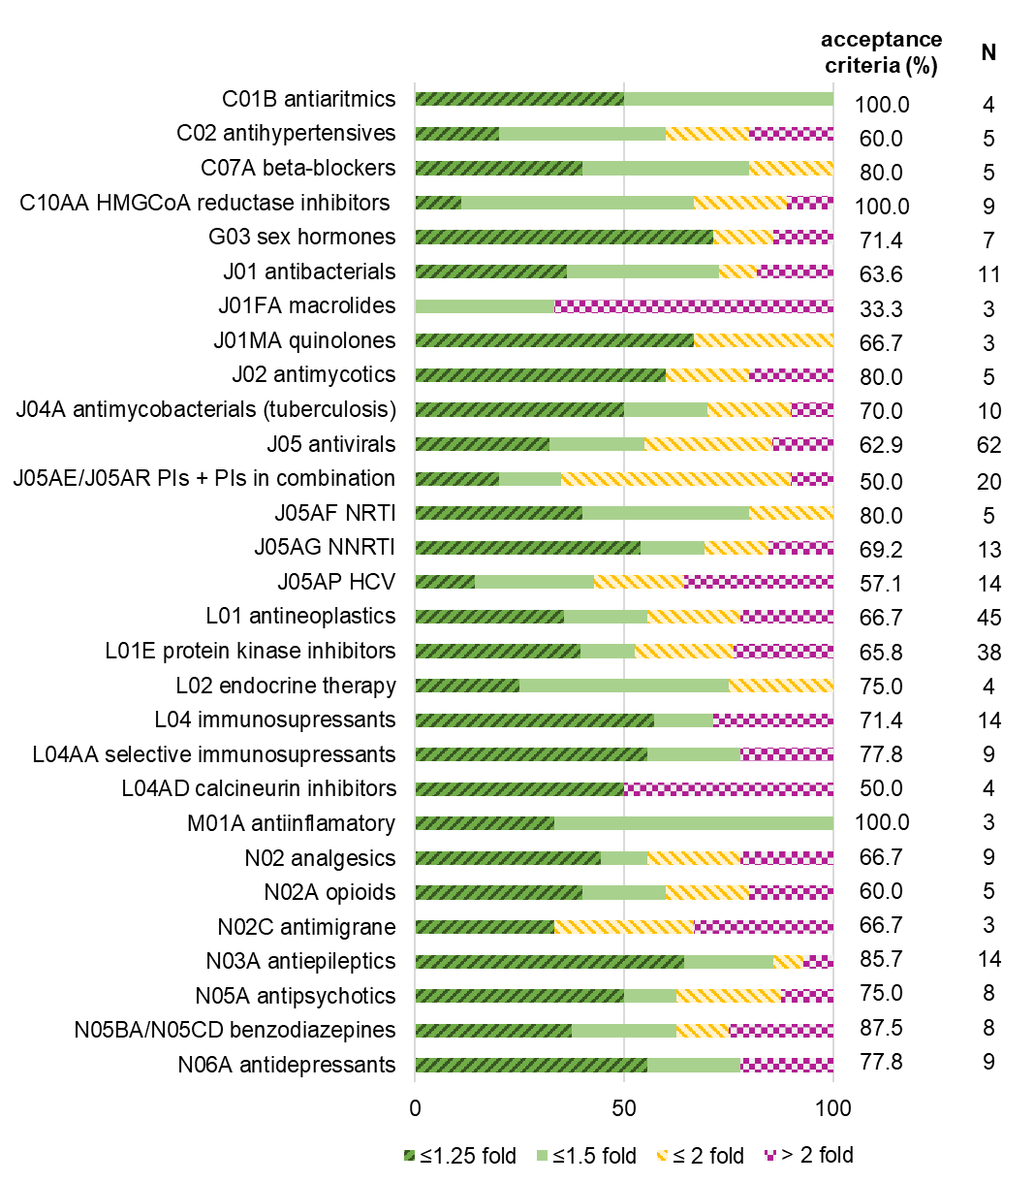
Fig. 4 Percentage of drugs within the 1.25-fold margins between the observed and predicted A AUC_{ratio} in dark green, 1.5-fold in light green, 2-fold in yellow and above 2-fold in fuchsia. The results are shown separated based on the therapeutic, pharmacological, or chemical subgroup of the ATC classification system of the victim drug. The percentage of acceptance criteria reflects all DDIs within each category that are within the 1.5-fold AUC_{ratio} or are within the same classification category of no/mild/moderate and strong interaction, followed by the number of DDIs. PIs (protease inhibitors), NRTI (nucleoside and nucleotide reverse transcriptase inhibitors), NNRTI (non-nucleoside reverse transcriptase inhibitors), HCV (antivirals for treatment of HCV infections).

Authors and contributions
All authors contributed to the study conception and design. Data collection was performed by SGC and analysis were performed by SGC with additional contribution of AW. The first draft of the manuscript was written by SGC, and all authors commented on previous versions of the manuscript. All authors read and approved the final manuscript.

Data availability
The datasets generated during and/or analysed during the current study are available from the corresponding author on reasonable request.
ETHICS APPROVAL: Not applicable.
CONSENT TO PARTICIPATE: Not applicable.
CONSENT FOR PUBLICATION: Not applicable.
CODE AVAILABILITY: Not applicable.

References
1. Viktil KK, Blix HS, Moger TA, Reikvam A. Polypharmacy as commonly defined is an indicator of limited value in the assessment of drug-related problems. Br J Clin Pharmacol. 2007 Feb;63(2):187-95.
2. Tornio A, Filppula AM, Niemi M, Backman JT. Clinical Studies on Drug-Drug Interactions Involving Metabolism and Transport: Methodology, Pitfalls, and Interpretation. Clin Pharmacol Ther. 2019 Jun;105(6):1345-61.
3. Dechanont S, Maphanta S, Butthum B, Kongkaew C. Hospital admissions/visits associated with drug-drug interactions: a systematic review and meta-analysis. Pharmacoepidemiol Drug Saf. 2014 May;23(5):489-97.
4. Obreli-Neto PR, Nobili A, de Oliveira Baldoni A, Guidoni CM, de Lyra Júnior DP, Pilger D, et al. Adverse drug reactions caused by drug-drug interactions in elderly outpatients: a prospective cohort study. Eur J Clin Pharmacol. 2012 Dec;68(12):1667-76.
5. Lu C, Di L. In vitro and in vivo methods to assess pharmacokinetic drug- drug interactions in drug discovery and development. Biopharm Drug Dispos. 2020 Feb;41(1-2):3-31.
6. Ito K, Sugiyama Y. Use of clearance concepts and modeling techniques in the prediction of metabolic drug-drug interactions. Trends Pharmacol Sci. 2010 Aug;31(8):351-5.
7. Peng Y, Cheng Z, Xie F. Evaluation of Pharmacokinetic Drug-Drug Interactions: A Review of the Mechanisms, In Vitro and In Silico Approaches. Metabolites. 2021 Jan 27;11(2).
8. Boulenc X, Barberan O. Metabolic-based drug-drug interactions prediction, recent approaches for risk assessment along drug development. Drug Metabol Drug Interact. 2011;26(4):147-68.
9. Min JS, Bae SK. Prediction of drug-drug interaction potential using physiologically based pharmacokinetic modeling. Arch Pharm Res. 2017 Dec;40(12):1356-79.
10. Marsousi N, Desmeules JA, Rudaz S, Daali Y. Usefulness of PBPK Modeling in Incorporation of Clinical Conditions in Personalized Medicine. Journal of pharmaceutical sciences. 2017 Sep;106(9):2380-91.
11. Zhang X, Yang Y, Grimstein M, Fan J, Grillo JA, Huang SM, et al. Application of PBPK Modeling and Simulation for Regulatory Decision Making and Its Impact on US Prescribing Information: An Update on the 2018-2019 Submissions to the US FDA's Office of Clinical Pharmacology. J Clin Pharmacol. 2020 Oct;60 Suppl 1:S160-s78.
12. Zhou D, Sunzel M, Ribadeneira MD, Smith MA, Desai D, Lin J, et al. A clinical study to assess CYP1A2 and CYP3A4 induction by AZD7325, a selective GABA(A) receptor modulator - an in vitro and in vivo comparison. Br J Clin Pharmacol. 2012 Jul;74(1):98-108.
13. Williams JA, Hyland R, Jones BC, Smith DA, Hurst S, Goosen TC, et al. DRUG-DRUG INTERACTIONS FOR UDP-GLUCURONOSYLTRANSFERASE SUBSTRATES: A PHARMACOKINETIC EXPLANATION FOR TYPICALLY OBSERVED LOW EXPOSURE (AUC<sub>I</sub>/AUC) RATIOS. 2004;32(11):1201-8.
14. Lutz JD, Kirby BJ, Wang L, Song Q, Ling J, Massetto B, et al. Cytochrome P450 3A Induction Predicts P-glycoprotein Induction; Part 2: Prediction of Decreased Substrate Exposure After Rifabutin or Carbamazepine. Clin Pharmacol Ther. 2018 Dec;104(6):1191-8.
15. Meyer zu Schwabedissen HE, Oswald S, Bresser C, Nassif A, Modess C, Desta Z, et al. Compartment-specific gene regulation of the CAR inducer efavirenz in vivo. Clin Pharmacol Ther. 2012 Jul;92(1):103-11.
16. Solutions UDI. DIDB - The Drug Interaction Database. 2022.
17. Elmeliegy M, Vourvahis M, Guo C, Wang DD. Effect of P-glycoprotein (P-gp) Inducers on Exposure of P-gp Substrates: Review of Clinical Drug-Drug Interaction Studies. Clin Pharmacokinet. 2020 Jun;59(6):699-714.
18. van de Steeg E, Venhorst J, Jansen HT, Nooijen IH, DeGroot J, Wortelboer HM, et al. Generation of Bayesian prediction models for OATP-mediated drug-drug interactions based on inhibition screen of OATP1B1, OATP1B1∗15 and OATP1B3. Eur J Pharm Sci. 2015 Apr 5;70:29-36.
19. Lutz JD, Kirby BJ, Wang L, Song Q, Ling J, Massetto B, et al. Cytochrome P450 3A Induction Predicts P-glycoprotein Induction; Part 1: Establishing Induction Relationships Using Ascending Dose Rifampin. Clin Pharmacol Ther. 2018 Dec;104(6):1182-90.
20. Burhenne J, Matthée AK, Pasáková I, Röder C, Heinrich T, Haefeli WE, et al. No evidence for induction of ABC transporters in peripheral blood mononuclear cells in humans after 14 days of efavirenz treatment. Antimicrob Agents Chemother. 2010 Oct;54(10):4185-91.
21. Ito K, Brown HS, Houston JB. Database analyses for the prediction of in vivo drug-drug interactions from in vitro data. Br J Clin Pharmacol. 2004 Apr;57(4):473-86.
22. Achour B, Barber J, Rostami-Hodjegan A. Expression of hepatic drug-metabolizing cytochrome p450 enzymes and their intercorrelations: a meta-analysis. Drug Metab Dispos. 2014 Aug;42(8):1349-56.
23. Shou M, Hayashi M, Pan Y, Xu Y, Morrissey K, Xu L, et al. Modeling, prediction, and in vitro in vivo correlation of CYP3A4 induction. Drug Metab Dispos. 2008 Nov;36(11):2355-70.
24. Ohno Y, Hisaka A, Ueno M, Suzuki H. General framework for the prediction of oral drug interactions caused by CYP3A4 induction from in vivo information. Clin Pharmacokinet. 2008;47(10):669-80.
25. Fahmi OA, Maurer TS, Kish M, Cardenas E, Boldt S, Nettleton D. A combined model for predicting CYP3A4 clinical net drug-drug interaction based on CYP3A4 inhibition, inactivation, and induction determined in vitro. Drug Metab Dispos. 2008 Aug;36(8):1698-708.
26. DrugBank. Tenofovir. 03/07/2021 [cited 2022 08/03/2022]; Available from: https://go.drugbank.com/drugs/DB14126
27. Veal GJ, Back DJ. Metabolism of Zidovudine. Gen Pharmacol. 1995 Nov;26(7):1469-75.
28. Hellinger E, Veszelka S, Tóth AE, Walter F, Kittel A, Bakk ML, et al. Comparison of brain capillary endothelial cell-based and epithelial (MDCK-MDR1, Caco-2, and VB-Caco-2) cell-based surrogate blood-brain barrier penetration models. Eur J Pharm Biopharm. 2012 Oct;82(2):340-51.
29. Gertz M, Harrison A, Houston JB, Galetin A. Prediction of human intestinal first-pass metabolism of 25 CYP3A substrates from in vitro clearance and permeability data. Drug Metab Dispos. 2010 Jul;38(7):1147-58.
30. Tolledo EC, Miksys S, Gonzalez FJ, Tyndale RF. Propranolol is a mechanism-based inhibitor of CYP2D and CYP2D6 in humanized CYP2D6-transgenic mice: Effects on activity and drug responses. Br J Pharmacol. 2020 Feb;177(3):701-12.
31. Eberl S, Renner B, Neubert A, Reisig M, Bachmakov I, König J, et al. Role of p-glycoprotein inhibition for drug interactions: evidence from in vitro and pharmacoepidemiological studies. Clin Pharmacokinet. 2007;46(12):1039-49.
32. Malaty LI, Kuper JJ. Drug interactions of HIV protease inhibitors. Drug Saf. 1999 Feb;20(2):147-69.
33. Back D. New drug interactions in HIV and HCV. Retrovirology. 2012;9(Suppl 1):I8-I.
34. FDA. VIEKIRA PAK (ombitasvir, paritaprevir, and ritonavir tablets; dasabuvir tablets) label. 2018 07/2018 [cited 09/03/2022]; Available from: https://www.accessdata.fda.gov/drugsatfda_docs/label/2018/206619s018lbl.pdf
35. Garrison KL, German P, Mogalian E, Mathias A. The Drug-Drug Interaction Potential of Antiviral Agents for the Treatment of Chronic Hepatitis C Infection. Drug Metab Dispos. 2018 Aug;46(8):1212-25.
36. McFeely SJ, Ritchie TK, Yu J, Nordmark A, Berglund EG, Levy RH, et al. Inhibitors of Organic Anion-Transporting Polypeptides 1B1 and 1B3: Clinical Relevance and Regulatory Perspective. J Clin Pharmacol. 2020 Aug;60(8):1087-98.
37. Shitara Y. Clinical importance of OATP1B1 and OATP1B3 in drug-drug interactions. Drug metabolism and pharmacokinetics. 2011 Jun;26(3):220-7.
38. Kiang TKL. Clinical Pharmacokinetics and Drug-Drug Interactions of Elbasvir/Grazoprevir. Eur J Drug Metab Pharmacokinet. 2018 Oct;43(5):509-31.
39. FDA. Zepatier (elbasvir and grazoprevir) tables, for oral use label. 2016.
40. Thiebaut F, Tsuruo T, Hamada H, Gottesman MM, Pastan I, Willingham MC. Cellular localization of the multidrug-resistance gene product P-glycoprotein in normal human tissues. Proceedings of the National Academy of Sciences of the United States of America. 1987 Nov;84(21):7735-8.
41. Kirby BJ, Collier AC, Kharasch ED, Whittington D, Thummel KE, Unadkat JD. Complex drug interactions of the HIV protease inhibitors 3: effect of simultaneous or staggered dosing of digoxin and ritonavir, nelfinavir, rifampin, or bupropion. Drug Metab Dispos. 2012 Mar;40(3):610-6.
42. Gurley BJ, Swain A, Williams DK, Barone G, Battu SK. Gauging the clinical significance of P-glycoprotein-mediated herb-drug interactions: comparative effects of St. John's wort, Echinacea, clarithromycin, and rifampin on digoxin pharmacokinetics. Mol Nutr Food Res. 2008 Jul;52(7):772-9.
43. Greiner B, Eichelbaum M, Fritz P, Kreichgauer HP, von Richter O, Zundler J, et al. The role of intestinal P-glycoprotein in the interaction of digoxin and rifampin. J Clin Invest. 1999 Jul;104(2):147-53.
44. Gurley BJ, Swain A, Barone GW, Williams DK, Breen P, Yates CR, et al. Effect of goldenseal (Hydrastis canadensis) and kava kava (Piper methysticum) supplementation on digoxin pharmacokinetics in humans. Drug Metab Dispos. 2007 Feb;35(2):240-5.
45. Gurley BJ, Barone GW, Williams DK, Carrier J, Breen P, Yates CR, et al. Effect of milk thistle (Silybum marianum) and black cohosh (Cimicifuga racemosa) supplementation on digoxin pharmacokinetics in humans. Drug Metab Dispos. 2006 Jan;34(1):69-74.
46. Härtter S, Koenen-Bergmann M, Sharma A, Nehmiz G, Lemke U, Timmer W, et al. Decrease in the oral bioavailability of dabigatran etexilate after co-medication with rifampicin. Br J Clin Pharmacol. 2012 Sep;74(3):490-500.
47. Administration FaD. Drug Development and Drug Interactions: Table of Substrates, Inhibitors and Inducers. 2020 03/10/2020 [cited 06/04/2021]; Available from: https://www.fda.gov/drugs/drug-interactions-labeling/drug-development-and-drug-interactions-table-substrates-inhibitors-and-inducers#table4-1
48. Stangier J. Clinical pharmacokinetics and pharmacodynamics of the oral direct thrombin inhibitor dabigatran etexilate. Clin Pharmacokinet. 2008;47(5):285-95.
49. Proctor NJ, Tucker GT, Rostami-Hodjegan A. Predicting drug clearance from recombinantly expressed CYPs: intersystem extrapolation factors. Xenobiotica. 2004 Feb;34(2):151-78.
50. Johansson I, Ingelman-Sundberg M. Genetic Polymorphism and Toxicology—With Emphasis on Cytochrome P450. Toxicological Sciences. 2010;120(1):1-13.
51. Wang PF, Neiner A, Kharasch ED. Efavirenz Metabolism: Influence of Polymorphic CYP2B6 Variants and Stereochemistry. Drug Metab Dispos. 2019 Oct;47(10):1195-205.
52. Dean L. Voriconazole Therapy and CYP2C19 Genotype. In: Pratt VM, Scott SA, Pirmohamed M, Esquivel B, Kattman BL, Malheiro AJ, editors. Medical Genetics Summaries. Bethesda (MD): National Center for Biotechnology Information (US); 2012.
53. Moriyama B, Obeng AO, Barbarino J, Penzak SR, Henning SA, Scott SA, et al. Clinical Pharmacogenetics Implementation Consortium (CPIC) Guidelines for CYP2C19 and Voriconazole Therapy. Clin Pharmacol Ther. 2017 Jul;102(1):45-51.
54. Zhang Y, Hou K, Liu F, Luo X, He S, Hu L, et al. The influence of CYP2C19 polymorphisms on voriconazole trough concentrations: Systematic review and meta-analysis. Mycoses. 2021 Aug;64(8):860-73.
55. Bachman K. Chapter 8 - Drug Metabolism: Academic Press; 2009.
56. Hardy KD, Wahlin MD, Papageorgiou I, Unadkat JD, Rettie AE, Nelson SD. Studies on the role of metabolic activation in tyrosine kinase inhibitor-dependent hepatotoxicity: induction of CYP3A4 enhances the cytotoxicity of lapatinib in HepaRG cells. Drug Metab Dispos. 2014 Jan;42(1):162-71.
57. Cho YY, Jeong HU, Kim JH, Lee HS. Effect of honokiol on the induction of drug-metabolizing enzymes in human hepatocytes. Drug Des Devel Ther. 2014;8:2137-45.
58. Liu L, Mugundu GM, Kirby BJ, Samineni D, Desai PB, Unadkat JD. Quantification of human hepatocyte cytochrome P450 enzymes and transporters induced by HIV protease inhibitors using newly validated LC-MS/MS cocktail assays and RT-PCR. Biopharm Drug Dispos. 2012 May;33(4):207-17.
59. Gerin B, Dell'Aiera S, Richert L, Smith S, Chanteux H. Assessment of cytochrome P450 (1A2, 2B6, 2C9 and 3A4) induction in cryopreserved human hepatocytes cultured in 48-well plates using the cocktail strategy. Xenobiotica. 2013 Apr;43(4):320-35.
60. Lübberstedt M, Müller-Vieira U, Mayer M, Biemel KM, Knöspel F, Knobeloch D, et al. HepaRG human hepatic cell line utility as a surrogate for primary human hepatocytes in drug metabolism assessment in vitro. J Pharmacol Toxicol Methods. 2011 Jan-Feb;63(1):59-68.
61. Madan A, Graham RA, Carroll KM, Mudra DR, Burton LA, Krueger LA, et al. Effects of prototypical microsomal enzyme inducers on cytochrome P450 expression in cultured human hepatocytes. Drug Metab Dispos. 2003 Apr;31(4):421-31.
62. Chen Y, Liu L, Laille E, Kumar G, Surapaneni S. In vitro assessment of cytochrome P450 inhibition and induction potential of azacitidine. Cancer Chemother Pharmacol. 2010 Apr;65(5):995-1000.
63. Katoh M, Matsui T, Nakajima M, Tateno C, Soeno Y, Horie T, et al. In vivo induction of human cytochrome P450 enzymes expressed in chimeric mice with humanized liver. Drug Metab Dispos. 2005 Jun;33(6):754-63.
64. Trottier J, El Husseini D, Perreault M, Pâquet S, Caron P, Bourassa S, et al. The human UGT1A3 enzyme conjugates norursodeoxycholic acid into a C23-ester glucuronide in the liver. J Biol Chem. 2010 Jan 8;285(2):1113-21.
65. Argikar UA, Senekeo-Effenberger K, Larson EE, Tukey RH, Remmel RP. Studies on induction of lamotrigine metabolism in transgenic UGT1 mice. Xenobiotica. 2009 Nov;39(11):826-35.
66. Soars MG, Petullo DM, Eckstein JA, Kasper SC, Wrighton SA. An assessment of udp-glucuronosyltransferase induction using primary human hepatocytes. Drug Metab Dispos. 2004 Jan;32(1):140-8.
67. Fang HL, Strom SC, Ellis E, Duanmu Z, Fu J, Duniec-Dmuchowski Z, et al. Positive and negative regulation of human hepatic hydroxysteroid sulfotransferase (SULT2A1) gene transcription by rifampicin: roles of hepatocyte nuclear factor 4alpha and pregnane X receptor. J Pharmacol Exp Ther. 2007 Nov;323(2):586-98.
68. Endo-Tsukude C, Kato M, Kaneko A, Iida S, Kuramoto S, Ishigai M, et al. Risk of CYP2C9 induction analyzed by a relative factor approach with human hepatocytes. Drug Metab Pharmacokinet. 2019 Oct;34(5):325-33.
69. Bernasconi C, Pelkonen O, Andersson TB, Strickland J, Wilk-Zasadna I, Asturiol D, et al. Validation of in vitro methods for human cytochrome P450 enzyme induction: Outcome of a multi-laboratory study. Toxicology in vitro : an international journal published in association with BIBRA. 2019 Oct;60:212-28.
70. Faucette SR, Wang H, Hamilton GA, Jolley SL, Gilbert D, Lindley C, et al. Regulation of CYP2B6 in primary human hepatocytes by prototypical inducers. Drug Metab Dispos. 2004 Mar;32(3):348-58.
71. Kharasch ED, Whittington D, Ensign D, Hoffer C, Bedynek PS, Campbell S, et al. Mechanism of efavirenz influence on methadone pharmacokinetics and pharmacodynamics. Clin Pharmacol Ther. 2012 Apr;91(4):673-84.
72. Katoh M, Watanabe M, Tabata T, Sato Y, Nakajima M, Nishimura M, et al. In vivo induction of human cytochrome P450 3A4 by rifabutin in chimeric mice with humanized liver. Xenobiotica; the fate of foreign compounds in biological systems. 2005 Sep;35(9):863-75.

Supplementary material

Fig. A. Predicted versus observed Area Under the Curve ratio (AUC_{ratio}) of orally administered drugs (with vs without perpetrator). The predicted AUC_{ratio} is represented by the X axis and the observed AUC_{ratio} in clinical trials by the Y axis. The black solid line represents the identity line, the grey solid lines represent the 1.5-fold margins, and the grey dashed lines represent the 2-fold margins. DDIs that are within the same interval classification (no, mild, moderate, strong interaction) or where the ratio between the observed and predicted AUC falls within the ±1.5 fold, are considered well-classified. Grey dashed lines represent the 2-fold margins. Green markers represent DDIs with rifampicin, red markers represent DDIs with carbamazepine, orange markers represent DDIs with efavirenz, and dark blue markers represents DDIs with rifabutin.

Acceptance criteria (%) | DDIs (N)
55.2 | 29
69.0 | 84

Fig. B. Percentage of drugs within the 1.25-fold margins between the observed and predicted A AUC_{ratio} in dark green, 1.5-fold in light green, 2-fold in yellow and above 2-fold in fuchsia. First bar represents DDIs where the substrate drug is a strong CYP3A4 strong inhibitor regardless of its metabolic pathway, second bar represents DDIs were the substrate drug is metabolised only by CYP3A4 and at least the contribution is 50% and it is not a kown CYP3A4 strong inhibitor. The percentage of acceptance criteria reflects all DDIs within each category that are within the 1.5-fold AUC_{ratio} or are within the same classification category of no/mild/moderate and strong interaction, followed by the number of DDIs.

