A 4-Transistor Monolithic Solution to Highly Linear On-chip Temperature Sensing in GaN Power Integrated Circuits
Ang Li, Student Member, IEEE, Yi Shen, Ziqian Li, Fan Li, Ruize Sun, Member, IEEE, Mitrovic Ivona, Senior Member, IEEE, Huiqing Wen, Senior Member, IEEE, Sang Lam, Member, IEEE, Wen Liu, Member, IEEE
Abstract—We report the monolithic realization of on-chip temperature sensing design using four transistors (4T) in gallium nitride (GaN) technology. The temperature sensor consists of a voltage reference and a logic inverter, both of which are built from an enhancement-mode (E-mode) and depletion-mode (D-mode) MIS-HEMTs. The temperature-insensitive voltage reference outputs a very stable voltage as the input of the logic inverter, which exhibits good temperature dependence in its voltage transfer characteristics. As the temperature varies from 25 to 250 °C, the output voltage of the logic inverter changes linearly. By configuring the active-load D-mode transistor as a 2DEG resistor in the logic inverter, the temperature sensing solution is improved further, showing stable sensing output, higher sensitivity (31.28 mV/°C), better linearity (R² = 0.995) and smaller error (±2.74 °C). This demonstrates a compact monolithic sensor for monitoring the on-chip temperature of GaN power integrated circuits (ICs) for protection and control.
Index Terms—GaN, MIS-HEMT, monolithic integration, temperature sensor.

Introduction
Gallium nitride (GaN) power semiconductor devices feature high voltage, high-temperature operation and fast switching, contributing to the application in high-density power conversion systems [1], [2]. The monolithic integration of drive, control, sensing and protection in a high-integration module allows the potential of GaN power high electron mobility transistors (HEMTs) to be further exploited [3]–[6]. While the high-temperature operation of GaN devices and circuits mitigates the demand for complex cooling sections [7], temperature sensing of the IC chips is still required for safe operation and reliable thermal control of the systems.
In previous work on GaN temperature sensing, the Schottky barrier diode (SBD) was shown to have good temperature characteristics with a sensitivity of 2.58 mV/℃. However, the SBD solution to on-chip temperature sensing required additional processing steps in the IC fabrication [8]. 2DEG resistors in GaN were used as simple temperature sensors that give high linearity but only with limited sensitivity [9]. Good linearity in temperature sensing could be achieved in GaN ICs by using sophisticated feedback topology which then requires a complex design [10]. So, it is desirable to have a solution to GaN temperature sensing that has simplicity in monolithic integration and topology. For GaN ICs, the direct-coupled field effect transistor logic (DCFL) and resistor-transistor logic (RTL) inverters have been reported to present their temperature dependence [11], [12]. Whereas this characteristic of GaN inverters is rarely implemented to realize temperature sensing.
In this work, the temperature dependence of GaN logic inverters is exploited to achieve on-chip temperature sensing by integrating with a simple voltage reference. In particular, the DCFL and RTL inverters are circuit building blocks commonly used in GaN ICs; they require no overhead in changing the normal fabrication. A few simple GaN MIS-HEMTs are enough for constructing the temperature sensor. The experimental investigation is reported in the following sections about such an attractive solution to on-chip temperature sensing for real-time safety detection, especially in high-temperature operating conditions such as electric vehicles [13].

Device Structure and Characteristics
The schematic cross-section of the Al_{0.25}Ga_{0.75}N/GaN MIS-HEMT structure used for the temperature sensor is illustrated in Fig. 1(a). The normally-off operation is achieved by digital etching of the AlGaN recess. The normally-on device also has the threshold voltage adjusted through the etching process. The transfer characteristics of transistors with the size of L_{GS}/L_{G}/L_{GD} = 3/2/3 µm, W_{G} = 100 µm were measured using an Agilent B1500A semiconductor device analyzer as shown in Fig. 1(b). At 25 ℃, the threshold voltage, V_{th}, is −2.83 V for the D-mode MIS-HEMT and 2.63 V for the E-mode MIS-HEMT obtained by the extended line. The maximum output current, I_{ds,max}, is 532.7 mA/mm for the D-HEMT and 328 mA/mm for the E-HEMT. At 250 ℃, the D-mode (E-mode) device exhibits a V_{th} of −2.61 V (+2.87 V) and I_{ds,max} of 291.4 mA/mm (193 mA/mm). Fig. 1(c) shows the curves of the 2DEG resistance with temperature dependence for a width of 2 μm and a length of 10/20/50/100/200 μm. The 2DEG resistance is 42 kΩ at 25 ℃ and 63 kΩ at 250 ℃ (for a length of 200 μm). The results show that the 2DEG resistance increases linearly with the chip temperature, similar to that of a complicated structure in [9].

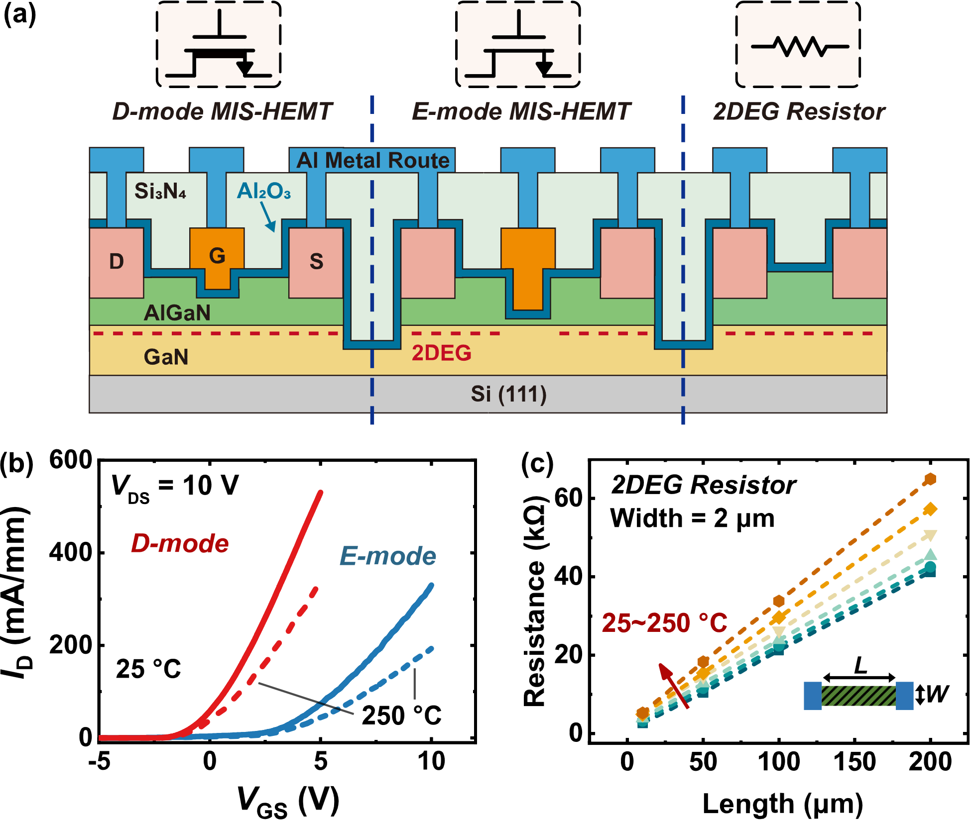
Fig. 1. Schematic cross-section of monolithically integrated D/E-mode GaN MIS-HEMTs and 2DEG resistor (a) Transfer characteristics of GaN MIS-HEMTs at different temperatures, and (b) 2DEG resistance versus the length resistor at the temperature varying from 25 to 250 °C.

On-Chip Temperature Sensor
The temperature sensing structure consists of a voltage reference and the sensor section. A 2-transistor (2-T) configuration is adopted for the simple but robust voltage reference as reported in our previous work [14]. The design can withstand variations in ambient temperature and in the supply voltage to output a stable reference voltage. In its monolithic integration for building the GaN temperature sensor, a D-mode MIS-HEMT (W/L = 50/2 μm) and an E-mode MIS-HEMT (W/L = 50/2 μm) are used. At a supply voltage V_{DD} = 10 V (or above), the 2-T voltage reference output is 3.02 V at 25 °C and 3.044 V at 250 ℃, with a temperature drift of 0.11 mV/℃, with more details explained in [14].

GaN PTAT Voltage Source
With the almost temperature-independent reference voltage, a compact temperature sensor can be formed by adding a proportional-to-absolute-temperature (PTAT) block driven by this stable bias voltage. Considering the simplicity of temperature sensing, the logic inverter can be adopted as a PTAT building block. As shown in Fig. 2(a), the temperature sensor, consists of a voltage reference (built by M1 and M2) cascaded by a DCFL inverter (built by M3 and M4). When using the RTL inverter, the load usages as a 2DEG resistor (R_{2DEG}) with the device structure and geometry shown in Fig. 2(b). The device sizes in the monolithic realization are W/L=100/2 μm for M3, 10/2 μm for M4, length = 200 μm for R_{2DEG}.
In the DCFL temperature sensor, the voltage reference produces a stable V_{REF} as the input to the logic inverter. V_{REF} is set slightly larger than V_{th,E}, the threshold voltage of the E-mode MIS-HEMT. This is to make the gate overdrive voltage (V_{GS,E} – V_{th,E}) of the E-mode M3 small. As a result, M3 operates in the saturation region but passes only a small I_{D}. The small I_{D} cannot support the D-mode active load (M4) working in its saturation, forcing M4 to operate in the linear region. This relationship is shown as
$$\begin{aligned}k_{E}{\left(V_{REF}-V_{th,E}\right)}^{2}=k_{D}\left[-2V_{th,D}\left(V_{DD}-V_{out}\right)-{\left(V_{DD}-V_{out}\right)}^{2}\right] \#(1)\end{aligned}$$
where μ_{eff} is the effective mobility, C_{eff} is the effective capacitance, ${k_{E}}/{k_{D}}={μ_{eff,E}C_{eff,E}}/{μ_{eff,D}C_{eff,D}}$ and V_{th,E}/V_{th,D} which are temperature dependent [11], resulting in the temperature-dependent output V_{out}. However, once the temperature dependence makes I_{D} become larger, the subsequent operation mode of this active load (M4 in Fig. 2(a)) could be in saturation mode [15]. The relationship can be expressed as
$$\begin{aligned}k_{E}{\left(V_{REF}-V_{th,E}\right)}^{2}=k_{D}{\left(V_{out}-V_{th,D}\right)}^{2}, \#(2)\end{aligned}$$
which output exhibits a different variation with temperature when compared to Equation (1). The operation mode ambiguity of the former and latter half of the transition stage can lead to the challenge of choosing a suitable bias voltage, especially with process-voltage-temperature (PVT) variations [16].
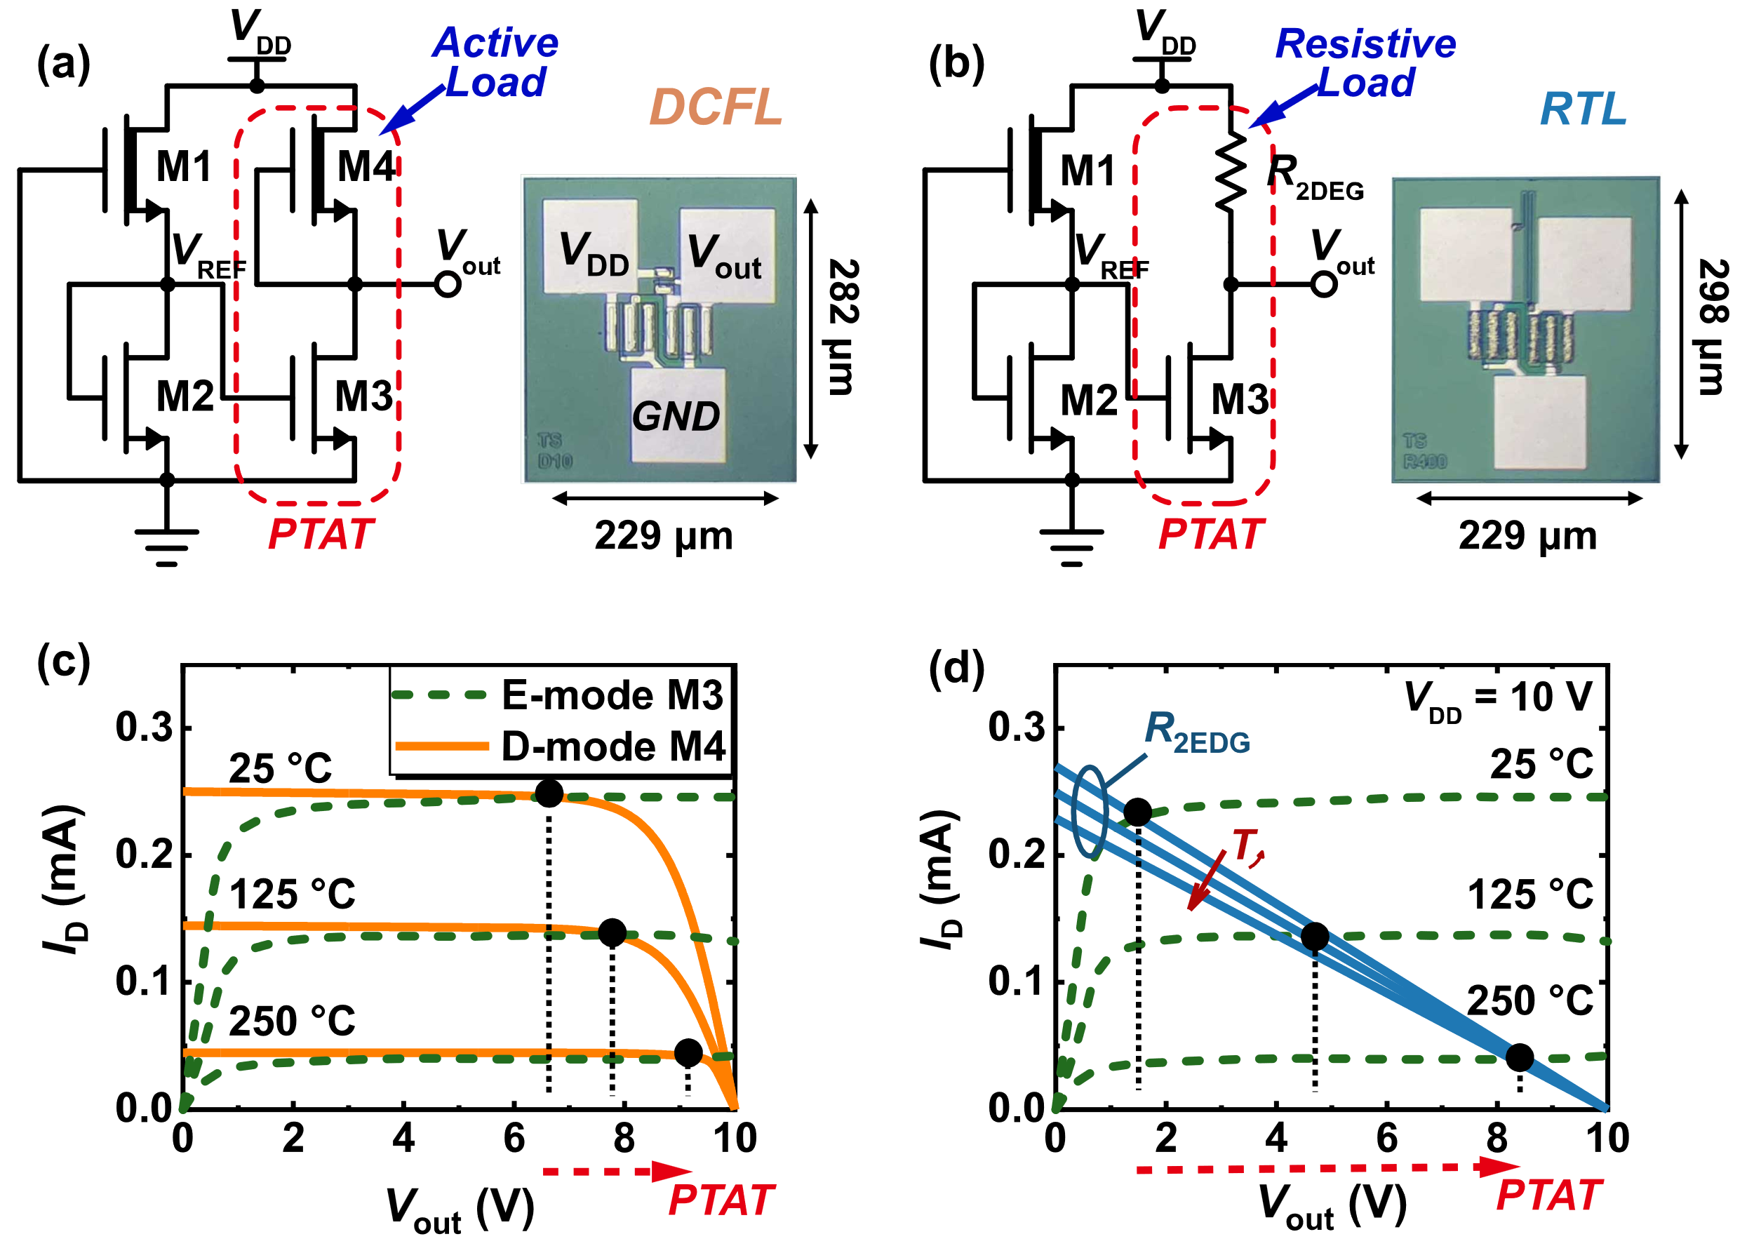
Fig. 2. Schematics and photograph of proposed temperature sensor:(a) DCFL and (b) RTL structure. Measured load-line characteristics of the (c) DCFL and (d) RTL inverter from 25 to 250 °C, V_{gs,3}=V_{REF}, V_{gs,4} = 0 V.
As for the sensor with the RTL inverter, it has a resistive load of the 2DEG resistor. Then the transition of the inverter output voltage has a constant slope since [17]
$$\begin{aligned}k_{E}{\left(V_{REF}-V_{th,E}\right)}^{2}={(V}_{DD}-V_{out})/R_{2DEG} \\ V_{out}=V_{DD}-β(V_{REF}-V_{th,E})\#(3)\end{aligned}$$
where β = qn_{s}μ_{R}/k_{E} and V_{th,E} and they also show temperature dependence. The temperature sensing of the RTL inverter can work well as long as its input (the gate terminal of M3) is biased within the transition region of the voltage transfer characteristics (VTC). Compared to the DCFL implementation, it is more convenient to bias the RTL-based sensor at a proper operation point and then it is more robust to provide the margin for PVT variations. Thus, the RTL implementation can be used to improve the sensor performance and stability over the DCFL counterpart. As illustrated in the load-line diagram in Figs. 2(c) and 2(d), there is a clear temperature-dependent trend in the intersections of the output characteristics of the devices in the DCFL- and RTL- based inverters.

Characterization of the Temperature Sensor
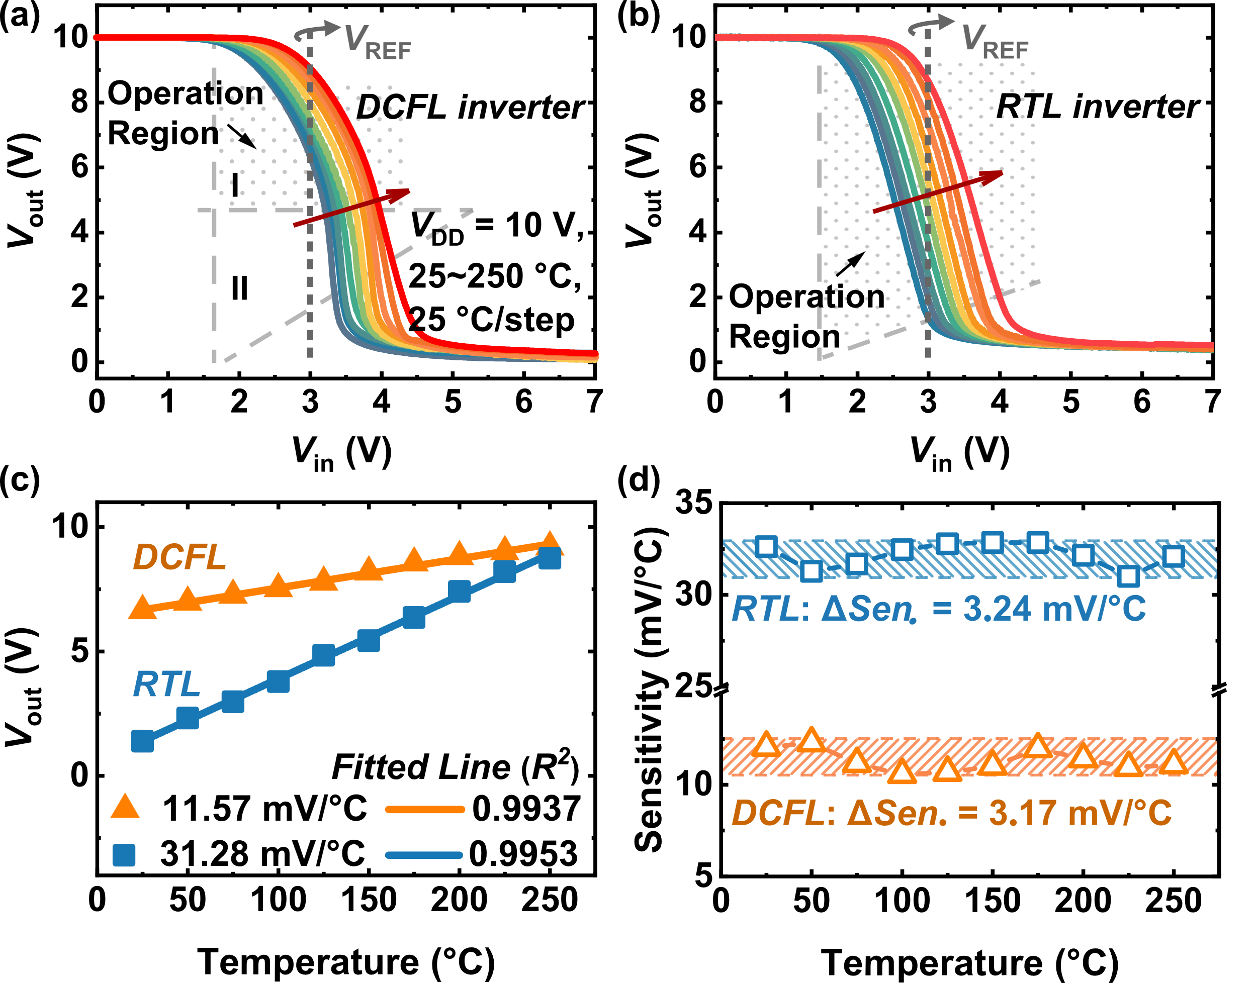
Fig. 3 The VTC of the inverter inside the temperature sensor with (a) (Region I, M3: saturation, M4: linear; Region II, M3/M4: saturation) and (b) RTL inverter. (c) The sensor output performances versus temperature, (d) the extracted sensitivity of each temperature.

The DCFL and RTL inverters’ VTC curves were obtained for temperature ranging from 25 to 250 ℃ (25 ℃/step), as shown in Figs. 3(a) and (b). The grey dashed lines of the set input V_{in} = V_{REF} = 3.02 V are shown as the reference to indicate the sensing ranges of the DCFL- and RTL-based implementation as 6.2~9.1 V and 1.2~9.3 V, respectively. The results show that the range of the RTL inverter output is larger than that of the DCFL inverter. This is because the DCFL implementation is designed to work in a single mode for good linearity, while its output range and sensitivity must be sacrificed.

Table 1. Comparison of Temperature Sensors
Reference | Technology | Temp.  Range (℃) | Sensitivity  (mV/℃) | Linearity  (R²)
[10] (2014) | GaN HEMT | 25~250 | 0.35 | 0.993
[18] (2015) | SiC SBD | 30~300 | 5.11 | 0.985~0.999
[9] (2016) | GaN 2DEG | 25~175 | 10 Ω/℃
[8] (2020) | GaN SBD | 25~200 | 2.58
[19] (2020) | GaN SBD | 25~200 | 1.60 | 0.995~0.998
This work | GaN HEMT | 25~250 | 31.28 | 0.995

Fig. 3(c) shows the sensor output voltage measurement results versus temperature. The sensitivity (ΔV_{out}/ΔT) is 31.28 mV/℃ using the RTL inverter while 11.57 mV/℃ for the DCFL inverter. The variance between the linear fit and actual data can be examined by the linearity (R²), which is over 0.99 in both configurations. Therefore, it verifies that the output has high relevance to the straight line. As a temperature sensor, the RTL structure shows better sensitivity than the DCFL. The DCFL temperature sensor is constrained in the first operation mode (region I, as Equation (1)) to maintain linearity, which will sacrifice its sensitivity. It also indicates a smaller V_{out} range by biased VREF (Fig. 3(a)). In comparison, the RTL structure is benefited from its single-mode operation and avoids this issue. Therefore, it can be biased to obtain a higher sensitivity, which is a competitive level compared to previous GaN temperature sensors [8], [10].
Meanwhile, the sensitivity variations for different temperatures, are 3.24 mV/℃ (DCFL) and 3.17 mV/℃ (RTL), as shown in Fig. 3(d). These results show that both structures can produce a stable output voltage with high sensitivity and linearity at 25~250 ℃. Table I compares several implementations of temperature sensing in GaN and SiC processes. The proposed design for RTL implementation shows better performance in sensitivity. It also performs competitively in terms of temperature range and linearity.
Fig. 4(a) shows the measured temperature error of 10 samples from one processing batch. The sensors were placed along with a thermocouple calibrated to 50 mK. The 3σ errors in the temperature range of 25 to 250 °C for the DCFL- and RTL-based sensor implementations are ±2.82°C and ±2.74 °C, respectively. To characterize the power supply variation immunity of the temperature sensor, the power supply rejection ratio (PSRR) was measured and the results are shown in Fig. 4(b). At various frequencies and temperatures in measurements, the corresponding PSRR achieved is always above 40 dB. All these results of the temperature sensing solution demonstrate good accuracy and robustness.
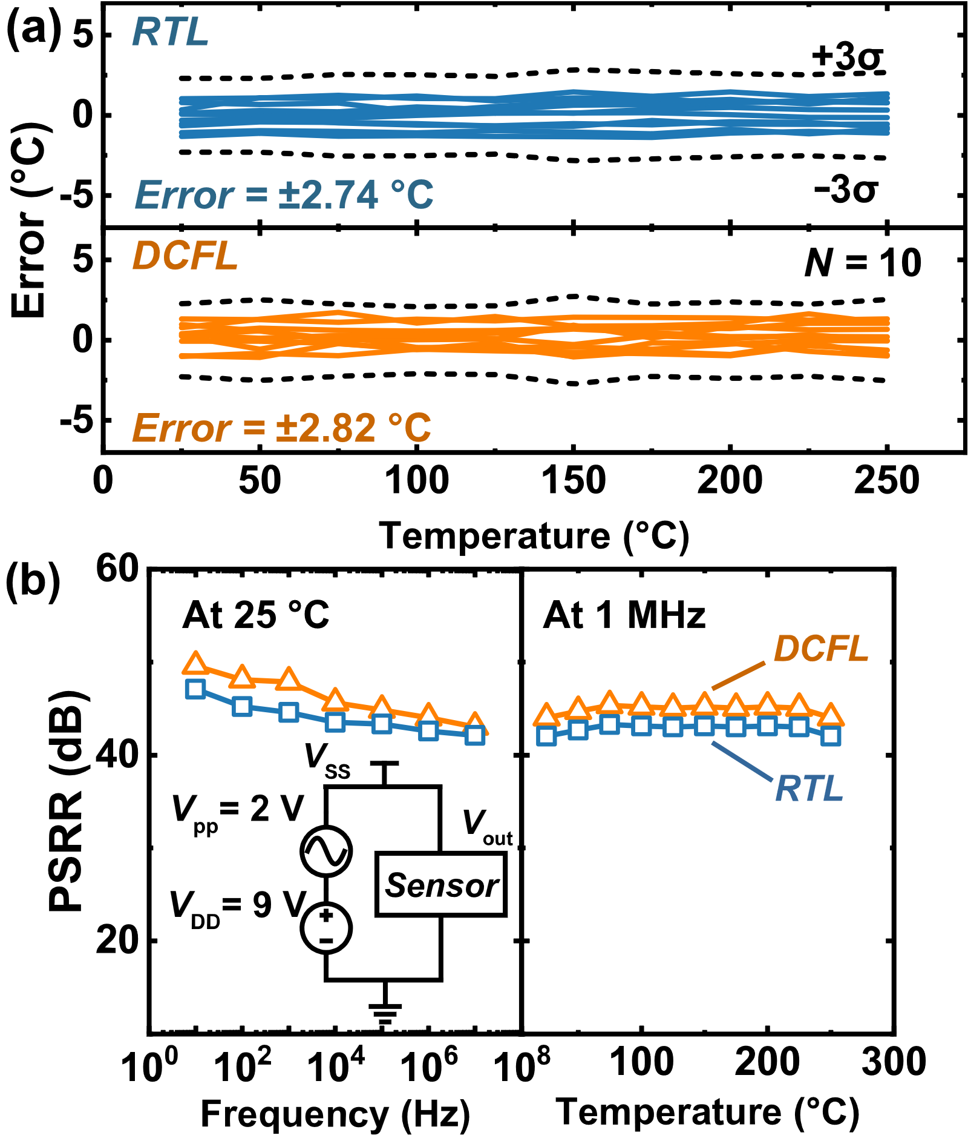
Fig. 4 Measured (a) temperature errors of 10 samples with ±3σ without calibration (25°C/step), (b) PSRR from 10 Hz to 10MHz and 25 to 250 °C, with the inset schematic circuit showing the test setup conceptually.

Conclusion
Detailed experimental results have been presented about the GaN temperature sensor with the monolithic realization using four MIS-HEMTs. Both DCFL- and RTL-based designs work well with excellent temperature sensitivity and linearity. In particular, the RTL approach using a 2DEG resistor have more superior sensor performance over a wider temperature sensing range. With its simplicity in IC design and fabrication, the on-chip temperature sensing devices provide valuable solutions for integrating high-performance sensing and protection modules in all-GaN smart power systems.

References
[1] K. J. Chen et al., “GaN-on-Si Power Technology: Devices and Applications,” IEEE Transactions on Electron Devices, vol. 64, no. 3, pp. 779–795, 2017, doi: 10.1109/TED.2017.2657579.
[2] O. Trescases, S. K. Murray, W. L. Jiang, and M. S. Zaman, “GaN Power ICs: Reviewing Strengths, Gaps, and Future Directions,” Dec. 2020, p. 27.4.1-27.4.4. doi: 10.1109/IEDM13553.2020.9371918.
[3] X. Li et al., “Demonstration of GaN Integrated Half-Bridge With On-Chip Drivers on 200-mm Engineered Substrates,” IEEE Electron Device Letters, vol. 40, no. 9, pp. 1499–1502, 2019, doi: 10.1109/led.2019.2929417.
[4] H. Wang, A. M. H. Kwan, Q. Jiang, and K. J. Chen, “A GaN Pulse Width Modulation Integrated Circuit for GaN Power Converters,” IEEE Transactions on Electron Devices, vol. 62, no. 4, pp. 1143–1149, Apr. 2015, doi: 10.1109/ted.2015.2396649.
[5] S. Moench, R. Reiner, P. Waltereit, R. Quay, O. Ambacher, and I. Kallfass, “Integrated Current Sensing in GaN Power ICs,” May 2019, pp. 111–114. doi: 10.1109/ISPSD.2019.8757678.
[6] H. Xu, G. Tang, J. Wei, Z. Zheng, and K. J. Chen, “Monolithic Integration of Gate Driver and Protection Modules With P-GaN Gate Power HEMTs,” IEEE Transactions on Industrial Electronics, vol. 69, no. 7, pp. 6784–6793, 2022, doi: 10.1109/TIE.2021.3102387.
[7] W. J. Zhang et al., “Compact GaN Power Modules with Direct Bonded Liquid-Cooled Heat Exchanger Suitable for EV Applications,” in 2021 IEEE 8th Workshop on Wide Bandgap Power Devices and Applications (WiPDA), 2021, pp. 123–128. doi: 10.1109/WiPDA49284.2021.9645122.
[8] X. Li, T. Pu, L. Li, and J.-P. Ao, “Enhanced Sensitivity of GaN-Based Temperature Sensor by Using the Series Schottky Barrier Diode Structure,” IEEE Electron Device Letters, vol. 41, no. 4, pp. 601–604, 2020, doi: 10.1109/LED.2020.2971263.
[9] R. Reiner et al., “Linear temperature sensors in high-voltage GaN-HEMT power devices,” in 2016 IEEE Applied Power Electronics Conference and Exposition (APEC), Long Beach, CA, USA, Mar. 2016, pp. 2083–2086. doi: 10.1109/APEC.2016.7468154.
[10] A. M. H. Kwan, G. Yue, L. Xiaosen, and K. J. Chen, “A Highly Linear Integrated Temperature Sensor on a GaN Smart Power IC Platform,” IEEE Transactions on Electron Devices, vol. 61, no. 8, pp. 2970–2976, 2014, doi: 10.1109/ted.2014.2327386.
[11] Z. Xu et al., “High Temperature Characteristics of GaN-Based Inverter Integrated With Enhancement-Mode (E-Mode) MOSFET and Depletion-Mode (D-Mode) HEMT,” IEEE Electron Device Letters, vol. 35, no. 1, pp. 33–35, 2014, doi: 10.1109/LED.2013.2291854.
[12] T. Cosnier et al., “200 V GaN-on-SOI Smart Power Platform for Monolithic GaN Power ICs,” in 2021 IEEE International Electron Devices Meeting (IEDM), 2021, p. 5.1.1-5.1.4. doi: 10.1109/IEDM19574.2021.9720591.
[13] L. Spaziani and L. Lu, “Silicon, GaN and SiC: There’s room for all: An application space overview of device considerations,” in 2018 IEEE 30th International Symposium on Power Semiconductor Devices and ICs (ISPSD), 2018, pp. 8–11. doi: 10.1109/ISPSD.2018.8393590.
[14] A. Li et al., “A Monolithically Integrated 2-Transistor Voltage Reference With a Wide Temperature Range Based on AlGaN/GaN Technology,” IEEE Electron Device Letters, vol. 43, no. 3, pp. 362–365, 2022, doi: 10.1109/LED.2022.3146263.
[15] G. Tang et al., “Digital Integrated Circuits on an E-Mode GaN Power HEMT Platform,” IEEE Electron Device Letters, vol. 38, no. 9, pp. 1282–1285, 2017, doi: 10.1109/led.2017.2725908.
[16] S.-W. Chen, M.-H. Chang, W.-C. Hsieh, and W. Hwang, “Fully on-chip temperature, process, and voltage sensors,” in Proceedings of 2010 IEEE International Symposium on Circuits and Systems, 2010, pp. 897–900. doi: 10.1109/ISCAS.2010.5537410.
[17] A. H. Zahmani, A. Nishijima, Y. Morimoto, H. Wang, J.-F. Li, and A. Sandhu, “Temperature Dependence of the Resistance of AlGaN/GaN Heterostructures and Their Applications as Temperature Sensors,” Japanese Journal of Applied Physics, vol. 49, no. 4, p. 04DF14, Apr. 2010, doi: 10.1143/jjap.49.04df14.
[18] S. Rao, G. Pangallo, F. Pezzimenti, and F. G. Della Corte, “High-Performance Temperature Sensor Based on 4H-SiC Schottky Diodes,” IEEE Electron Device Letters, vol. 36, no. 7, pp. 720–722, 2015, doi: 10.1109/LED.2015.2436213.
[19] X. Li, T. Pu, X. Li, L. Li, and J.-P. Ao, “Correlation Between Anode Area and Sensitivity for the TiN/GaN Schottky Barrier Diode Temperature Sensor,” IEEE Trans. Electron Devices, vol. 67, no. 3, pp. 1171–1175, Mar. 2020, doi: 10.1109/TED.2020.2968358.

This work was supported in part by the Suzhou Industrial Park Initiative Platform Development for Municipal Key Laboratory for New Energy Technology under RR0140. (Corresponding authors: Wen Liu). A. Li, Y. Shen, Z. Li, F. Li, S. Lam, H. Wen, and W. Liu are with the Department of Electrical and Electronic Engineering, Xi’an Jiaotong-Liverpool University, Suzhou 215123, China. (e-mail: wen.liu@xjtlu.edu.cn). R. Sun is with the State Key Laboratory of Electronic Thin Films and Integrated Devices, University of Electronic Science and Technology of China, Chengdu 610054, China. I. Mitrovic is with the Department of Electrical Engineering and Electronics, University of Liverpool, Liverpool L69 3GJ, U.K.

