The Dual‐Challenge of Teaching Online in a Foreign Land: Understanding Western Foreign Teachers’ Professional Identity and Confidence Development via a Transformative Learning Lens
Biying Wen1,4 · Qian Wang2 · Amy Gooden3 · Floriana Grasso4 · Qing Chen5 · Juming Shen2
1 Academy of Future Education, Xi’an Jiaotong-Liverpool University, Suzhou, China
2 Academy of Future Education, Xi’an Jiaotong-Liverpool University, Suzhou, China
3 College of Liberal Arts and Sciences, Lesley University, Cambridge, USA
4 Department of Computer Science, University of Liverpool, Liverpool, UK
5 Center for Innovation for Education, University of Liverpool, Liverpool, UK
Abstract
This study takes a transformative learning lens to gain insights into Western foreign teachers’ identity as educators and professional confidence in online teaching at a Sino-British university. The biographical narrative interpretive method was used for data collection and analysis. The researcher gathered critical incidents during the pandemic through in-depth interviews with six Western foreign teachers. Western foreign teachers encountered dual-dimensional challenges: one related to cultural differences in teaching and the other caused by a shift to online teaching. Western foreign teachers’ belief in their professional identity as educators anchored by their pedagogical and curricular rationales helped them overcome workplace challenges. Through action-taking and critically reflecting on their experiences, Western foreign teachers gained skills and competencies that promoted their confidence in transnational education. This study developed a framework to explain teacher identity as educators and professional confidence development in teaching as an iterative process led by transformative learning. The reflective practice serves as a medium to help Western foreign teachers construct experiences in unfamiliar situations. The study makes a practical contribution to understanding Western foreign teachers’ professional development, which can be used for recruitment and retention.
Keywords Cross-cultural teaching · Online teaching · Professional confidence · Transformative learning · Transnational education · Western foreign teacher identity

Introduction
Globalization has brought forward the bourgeoning of transnational education in China and has created spaces for the bloom of cultural pluralities (Lai et al., 2016). Many Western foreign teachers leave their home countries to work as full-time international staff in this cross-cultural environment (Poole & Bunnell, 2021). Universities may provide foreign teachers with extra inducements that are not usually available to local staff, such as: faculty housing, travel reimbursement, and international school’s tuition discount for children’s education (Shahjahan & Edwards, 2022). While they enjoy those benefits (Poole & Bunnell, 2021), Western foreign teachers must overcome the cultural dissonance embedded in their workplaces (Savva, 2017). For example, although in more recent studies, scholars (e.g., Brook & Abbott, 2020; Li et al., 2022; Marquardt, 2015) have noticed a mindset shift in the Confucian culture, to a greater extent, people of such a cultural orientation generally believe that teachers possess greater knowledge than students and that students should accept information from teachers without questions (Kim, 2009). This commonly expected power relation is a cause of silent classroom behavior in a typical Confucian culture classroom (Kim, 2009; Rao, 2010). On the contrary, in a Western culture classroom, teachers tend to encourage students to debate and voice their disagreements (Brook &Abbott, 2020). Sometimes, when a Western foreign teacher encounters students from the Confucian culture, their different cultural preferences in teaching and learning styles can create perceptual conflicts on what constitutes desirable classroom behaviors (Rao, 2010; Woolf, 2002).
While cross-cultural issues are an ongoing challenge for Western foreign teachers in transnational higher education contexts, a new set of challenges has emerged in the past three years due to the global pandemic. The outbreak of COVID-19 led to several fundamental changes in Chinese education institutions such as reducing physical contact by moving teaching activities online. Even though the content and audience remain unchanged, shifting to a virtual learning environment entails many pedagogical and curricular adaptations and demands a new set of competencies from teachers. For example, effective online student–teacher interactions have become more complicated yet essential with online teaching (Mahmood, 2021). Learning to teach online has resulted in increased stress for teachers, including Western foreign teachers. Those foreign teachers’ pre- pandemic teaching experiences acquired in their home countries and internationally (including within China) may be outdated in the post-COVID context. Devlin and Samarawickrema (2022) propose that the global pandemic has added to the complex changes and ambiguous challenges in higher education teaching; therefore, there needs to be rethinking about the effectiveness of university teaching that aligns with the current context and remains globally relevant.
Western foreign teachers remain an under-researched group in Chinese transnational education. Furthermore, the trend toward advocating for online teaching has presented a new opportunity to reconstruct teachers’ online identity as educators (Nazari & Seyri, 2021). In contrast to local teachers, Western foreign teachers encounter dual-dimensional challenges post-pandemic: one is cross-cultural teaching, and the other is online teaching. It is necessary to re-examine Western foreign teachers’ professional identity as educators and its impact on professional confidence in online teaching. The literature on Western foreign teachers’ professional identity as educators in the online environment is scarce. Some scholars suggest that there should be more studies exploring Western foreign teachers’ professional experiences and the factors that affect their identities as educators (e.g., Bodycott & Walker, 2000; Chen & Cheng, 2010; Leigh, 2019). Our study targets the exploration of Western foreign teachers’ dual-dimensional challenges and the associated interconnection between their teacher identity construction and professional confidence development in online teaching. Specifically, the study applies a transformative learning (TL) perspective in the investigation. The study intends to examine “How does TL of exploring Western foreign teachers’ lived online teaching experiences contribute to renewing their teacher identity as educators and confidence development in online teaching?”.

A Review of Literature and Conceptual Framework
Jack Mezirow—the founder of transformative learning (TL) theory, claims TL facilitates adult learners’ learning through generating individual stories and evaluating their past beliefs and experiences (Mezirow, 1997a). Mezirow and many scholars believe that reflective practice is the core of TL (Anand et al., 2020a, 2020b; Cho & Johnson, 2020; Daniëls et al., 2020; Eschenbacher, 2020; Eschenbacher & Fleming, 2020). Through reflection, one can acquire insights about oneself (Anand et al., 2020a; Welch et al., 2020). The process leads to the recognition of one’s identity(s) as one gains a better understanding through sense-making of the issues grounded in one’s life. The TL process presents an opportunity to learn, understand, and appreciate one’s identity and meaning (Illeris, 2014; Yoshihara et al., 2020). According to identity process theory, reflection acts as a powerful tool to highlight the different angles of being and allows for the examinations of alternative frameworks to an individual’s identity; the process facilitates individuals’ discovery and evaluation of predominant perspectives (Harrison & Leitch, 2019; Thorsen & DeVore, 2013). Anand et al. (2020b) regard critical reflection as a developmental approach that enables individuals to improve pre-existing viewpoints socially constructed through lived communities and cultural settings; such an approach supports individuals in stepping into newly formed perspectives. Continual reflection can increase self-awareness and help individuals better understand their identities (Mau & Harkness, 2020).
According to Mezirow (1996), TL occurs after a person experiences a critical incident (i.e., an out-of-the-ordinary situation) because such an incident causes direct or indirect distress in the person’s experience (i.e., a disorienting dilemma). During the TL process, the person questions his/her existing frames of reference (e.g., beliefs and values). Musanti’s (2005) study identifies critical incidents with the following features: (1) each event holds some degree of conflict (e.g., cross-cultural challenge); (2) the incident is unplanned and stimulates reflection on action (e.g., local students’ response to Western foreign teacher’s pedagogical practice); (3) it is a metaphorical source for knowledge (e.g., pedagogical belief) or skills (e.g., strategies to overcome a cross-cultural challenge in teaching). Analyzing critical incidents usually involves describing the events, explaining their contributions, and evaluating their transformative potential (Richards et al., 2005). Critical incidents in education are often framed as challenges and inconsistencies to generate reflections on teachers’ teaching practices and identity development (e.g., Beau- champ & Thomas, 2009; Mansour, 2009; Kissock & Richardson, 2010). Interacting with different cultural norms can be challenging when teaching in a cross-cultural set- ting. These experiences offer opportunities for teachers to respect cultural differences (Paris & Alim, 2017), integrate asset-based (Lin, 2020), differentiated (Tomlinson, 2001), and culturally responsive teaching (Gay, 2018; Robinson & West, 2012). Teachers’ TL practices stimulate the identification, critical reflection, and questioning of their assumptions and beliefs about teaching and learning (Montgomery, 2014; Smith, 2009). In overcoming cultural differences and developing strategies to manage challenges, Western foreign teachers may negotiate multiple identities to overcome difficulties and realize their career potential (Leigh, 2019). Analyzing critical incidents creates opportunities to view the interconnectedness of several events and facts (Halquist & Musanti, 2010); therefore, it facilitates understanding of Western foreign teachers’ perceptions of their teacher identity.
Reflection begins with exploring individual experiences and then moves to reflective dialogues about the disorienting dilemma. In reflective conversations, individuals explore uncertain parts of the situation and gradually gain insights as they make sense of the lived experience (Anand et al., 2020a). As people contemplate the unfamiliar aspects of their experiences, they identify potential actions to cope with challenges (Wendel et al., 2018), which helps them become more skilled at problem-solving. A series of reflective practices lead to the alignment of actions that can further refine people’s mental habits and points of view (Mezirow, 1996, 1997b, 2003). Reflective discourse allows participants to make space for new understandings of themselves and others, which helps them to identify skills and strengths in an appreciative environment (Eschenbacher, 2020). Mezirow (1998) agrees with Taylor (1994) that reflective discourses enable participants to gain a critical awareness of assumptions and transform them to become more open, integrative, and inclusive.
Identity is essential in confidence development. Identity recognition and acceptance support understanding one’s role and expected behavior (Cofta, 2007). Confidence refers to how one believes in one’s ability to complete specific tasks and the effectiveness of undertaking those behaviors (Yang et al., 2017). Professional confidence connects the perception of the self to one’s capacity to competently fulfill work expectations (Holland et al., 2012; Iredale et al., 2013). It fosters the ability to cope with anxiety and stress caused by workplace challenges; it enables professionals to apply coping mechanisms and develop intellectual insights and cognitive functioning (Cofta, 2007; Holland et al., 2012). It requires understanding one’s identity concerning one’s working role and the scope of its relevant practices. When teachers feel confident that they hold a solid knowledge base and can effectively make decisions regarding their teaching practices, they feel more assured about their teacher identity. Furthermore, a teacher’s professional confidence warrants better performance in teaching (Berry, 2004). Confidence can therefore be defined as an essential element of teacher professionalism, and it is fostered through affirming teacher identity (Nolan & Molla, 2018). Professionals’ acting to strengthen their confidence is an iterative and recursive process; at its core, it is about personal growth to affirm teacher identity (Poekert et al., 2016). There is a strong synergy between identity renewal and confidence development.
The literature suggests that TL can help teachers to recognize their identities. Therefore, the study applies the pedagogical practices of TL to investigate Western foreign teachers’ dual-dimensional challenges (as critical incidents) and learn how they transform their perspectives (and actions) to cope with challenges. Figure 1 illustrates that TL helps teachers reach new perspectives and perceptions of teacher identity. With renewed identities, teachers apply reflection and problem-solving orientations to overcome challenges in a cross-cultural setting. As teachers become more skilled at modifying their perspectives and choosing suitable problem- solving approaches, their actions and outcomes strengthen their professional confidence. Based on the literature review, this study proposes a relationship between identity renewal and professional confidence via the TL lens.
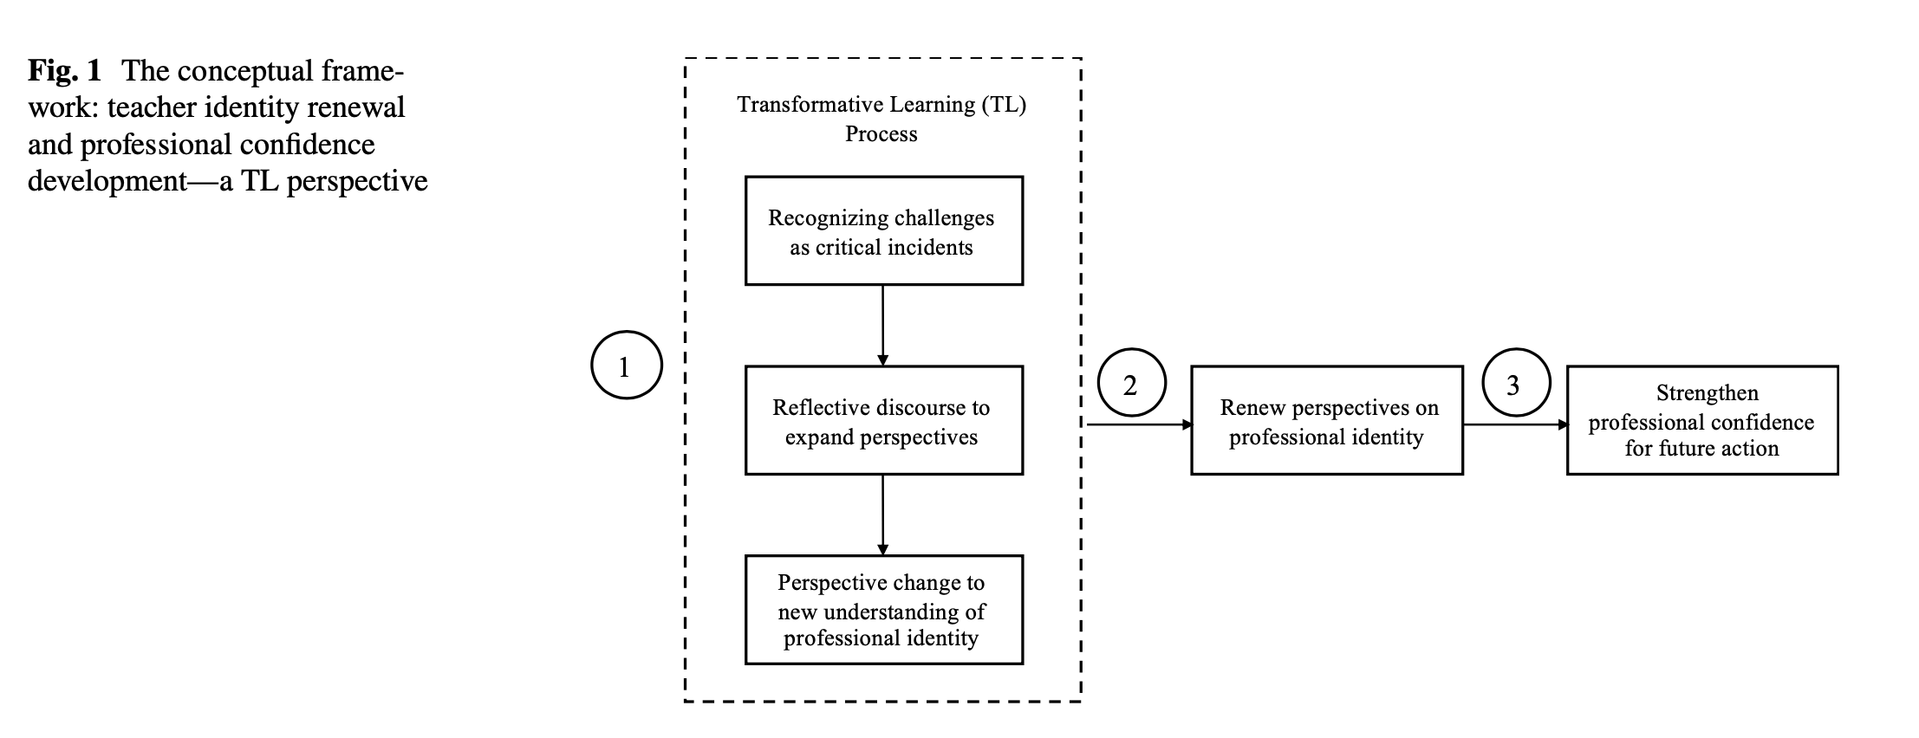
Methodology
Western Foreign Teachers’ Working Context: The CASE University
This study was conducted at a Sino-British university (i.e., the case University) in China. As an EMI (English Medium of Instruction) context, the case University’s teaching instruction must all be delivered in English. The curriculum and teaching practices must follow British higher education standards. After the onset of the pandemic, this University requested faculty to deliver lessons online. When the pandemic was under control (from time to time) and some local students were allowed to return to campus, the University continued to make online teaching available to accommodate international students and the local student groups still in lockdown. Between 2020 and 2022, the campus was closed several times due to the local pandemic prevention policy. Presently, although most students have returned to campus, with its mission toward future-oriented learning, the University decided to keep its online teaching model and encourages teachers to explore blended learning.

Sample Selection Rationale, Interview Process, and Interviewees’ Profile
There were several reasons for selecting the case University. First, the case University reflected an example of Western foreign teachers’ working environment. Second, interviewing Western foreign teachers within one University allowed participants to have a shared working environment and enabled the interviewer who knew the case University to apply the implied contextual knowledge in interpreting and appreciating teachers’ experiences (Poole, 2019; Starman, 2013). Third, the case University had been rapidly developing its online education platform and driving online teaching and learning as one of its organization’s strategic focuses (Li et al., 2022; Wang et al., 2021). Therefore, the case University provided a rich ground for research on Western foreign teacher identity in the online environment.
The choice of Western foreign teachers reflected the study’s mindfulness of cultural differences and cultural impact on teaching. The study purposefully avoided choosing English-speaking non-western foreign teachers, such as academic staff with Japanese, Korean, or southeastern Asian cultural backgrounds, because those countries’ cultural values and practices often share values of Confucian culture. The group of Western foreign teachers in this study held western-centric assumptions and knowledge, which distinguished their behaviors from the traditional Chinese ways of teaching. Their pedagogical practices were rationalized and operated within the comfort zone of their cultural frames of reference (Poole, 2019). Scholars suggested that foreign teachers from North America and Europe found themselves as a minority when teaching local students in China (Poole & Bunnell, 2022). Hence this study targeted the exploration of Western foreign teachers’ identities in the Chinese cultural context.
A purposive sampling strategy (Bloomberg & Volpe, 2018) was used to locate suitable participants who were Western foreign teacher at the case University with the following requirements: (1) have taught in Western countries, (2) have taught at the case University’s campus before the pandemic, and (3) have continued to teach online during the pandemic in 2020 and 2021. Unfortunately, the pandemic heightened a sense of insecurity and precarity among foreign teachers; consequently, many left their employments in China in year 2020 (Bailey, 2021; Beauchamp & Thomas, 2009). The number of foreign teachers who maintained their employment contracts with the case University in 2020 and 2021 were significantly reduced, which had created some challenge in securing interviewees for data collection. After sending out invitations to 15 English-speaking Western foreign teachers at the case University in November 2021, four people agreed to be interviewed.
Previous studies had used the biographical narrative interpretive method (BNIM) to collect data from a small sample size (e.g., five interviewees in Smith’s (2014) study and three interviewees in Flynn’s (2019) study). The researcher decided to deploy the BNIM method to work with the four Western foreign teachers. Each person independently underwent three interview sessions and each session lasted 60 min. Interviews were conducted in participants’ offices in the case University. Previous studies suggested that a familiar and relaxed atmosphere can help interviewees to be more open (Bunnell & Poole, 2021; Malterud et al., 2016). The four Western foreign teachers were from the business, language, computer science, and mathematics departments. After analyzing four participants’ data, the researcher proposed a tentative framework with the transformative learning lens, to gain insights into the concept of teacher identity. Subsequently, the study started a second round of interviews to validate the initial findings. Two additional Western foreign teachers were invited for interview. Those two teachers were from the business and chemistry departments. The additional interviews ensured that the study reached data saturation and the later interviews confirmed the previously proposed framework (Francis et al., 2010). Table 1 provides the interviewees’ general background and their prior relevant work experiences.
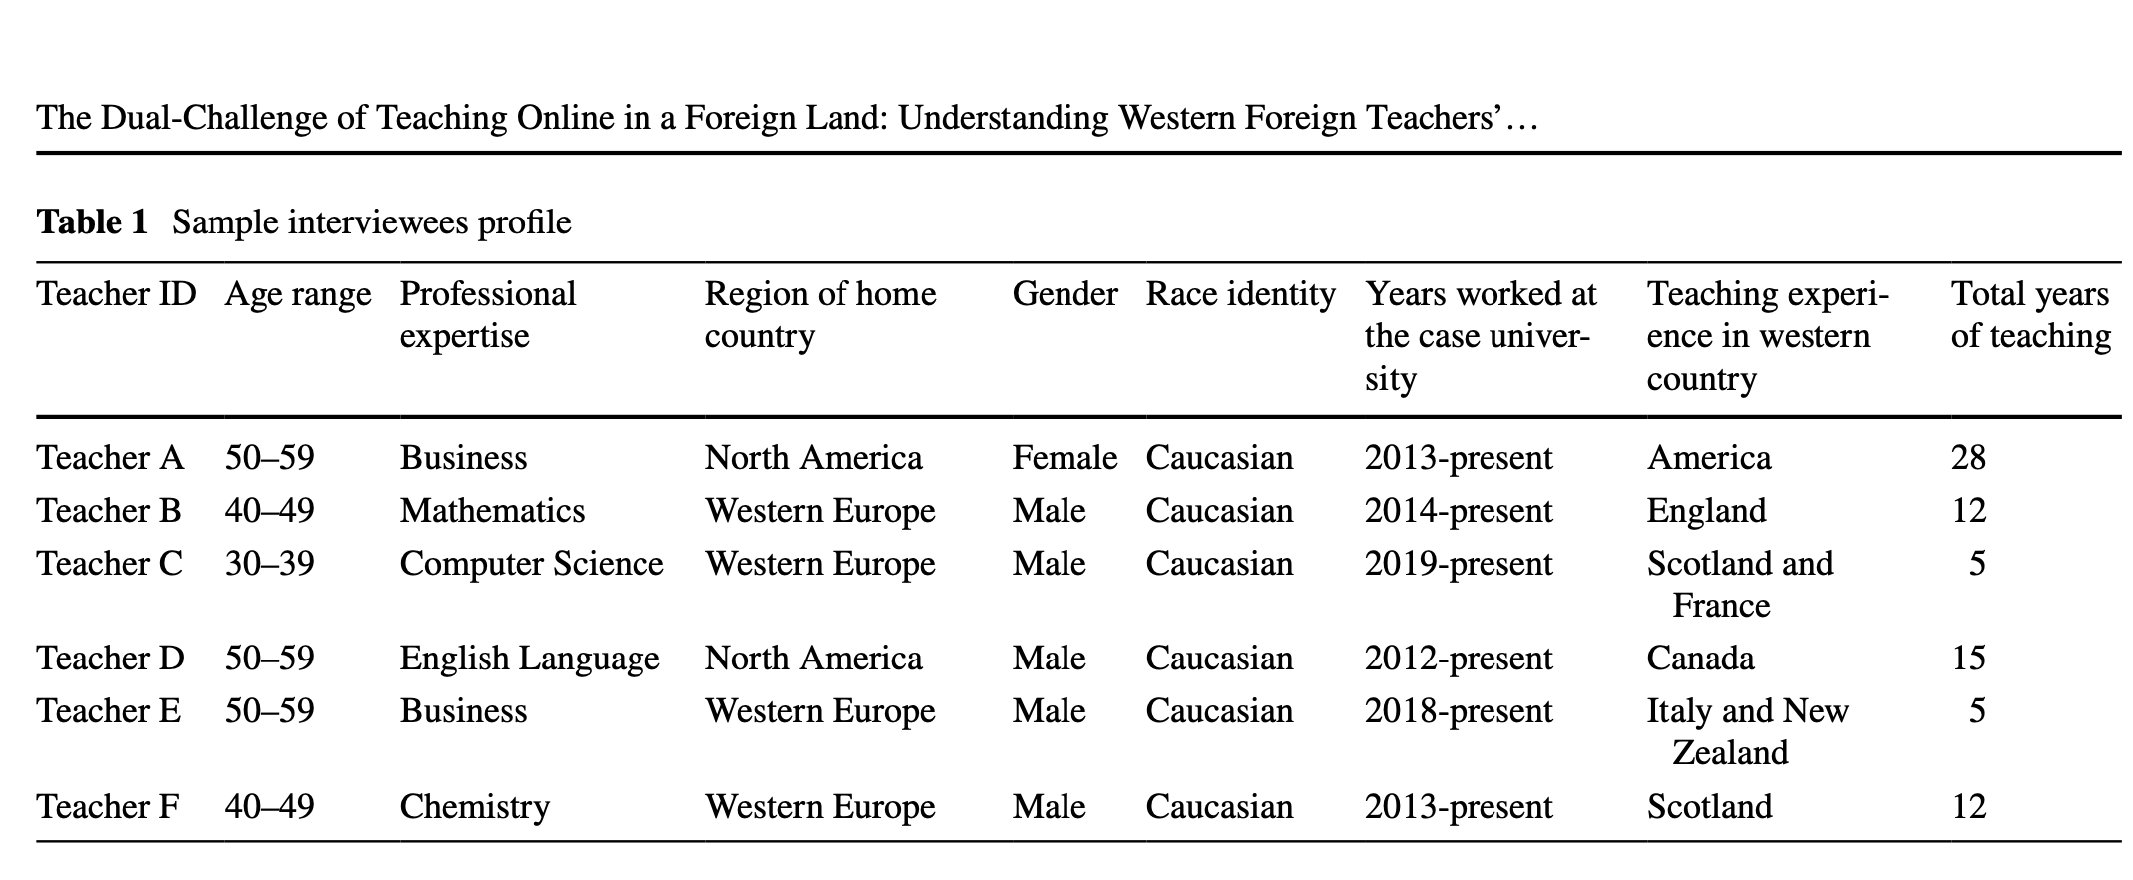
Data Collection
The BNIM—one approach in the narrative inquiry method (Wengraf, 2001)—allowed the researcher to investigate critical incidents experienced by Western foreign teachers in online teaching. This first interview aimed to gather participants’ online teaching experiences in a cross-cultural setting. Open-ended questions included, “Can you please tell me your online teaching experience so far?” “Can you please share some memorable stories (positive and negative) of your online teaching at the (case) university?” The interviewer tried not to interrupt the narrative, which ensured the interviewee’s gestalt and created a space for them to fill with a textual structure of told stories (Wengraf, 2001). The interviewer analyzed the first interview’s transcript and highlighted interesting stories for subsequent follow-up. In the second interview, the researcher carried out reflective practices by guiding each interviewee to recall and narrate their teaching challenges (i.e., critical incidents). The researcher explored Western foreign teachers’ perspectives on teacher identities. The researcher aimed to collect more details on the experiences identified in the first interview. The second interview lasted 60–90 min. Sample interview questions included, “About the challenge you mentioned in the first interview, how has this experience affected your assessment of your teacher identity?” “Has your perception of teacher identity changed due to reflecting on online teaching experiences?” In the first and second sessions, the interviewee’s narrative followed their own “systems of relevancy” (Wengraf, 2001). The data collected presented a parallel picture between “past origins” (e.g., the teaching history mentioned in the first interview) and “present experiences” (e.g., teaching stories that occurred at the case University) (Wengraf, 2001). Finally, the researcher conducted a third semi-structured interview to better understand and contextualize the narratives provided in the previous two sessions. The final session lasted 45–60 min.
Data Analysis
The researcher performed data analysis in three stages (Fig. 2). The first stage was divided into two parallel tracks: data categorization and analysis. For track I, the researcher categorized the interview transcriptions according to the biographical data chronology (i.e., “lived-life”). The biographical data showed essential milestones in the interviewees’ lives relevant to teaching. This part of the data was prepared for the subsequent biographical data analysis (BDA), which aimed to present interviewees’ online teaching experiences according to historical timelines. For track II, the researcher organized data according to interviewees’ stories (i.e., “told- story”), aiming to explore how the interviewees presented their online teaching experiences in the interviews. These data were organized into narratives based on the key themes (i.e., “test structure sequinization”). Then, the researcher applied thematic field analysis (TFA) to interpret the data (Wengraf, 2001; Wrigley, 2002). After the researcher completed this part of the work, two external experts validated the data analysis procedure and outcome. Later, the three of them conducted meetings to address concerns or questions. After an agreement was reached, modifications were incorporated into the final output of the first stage of data analysis.
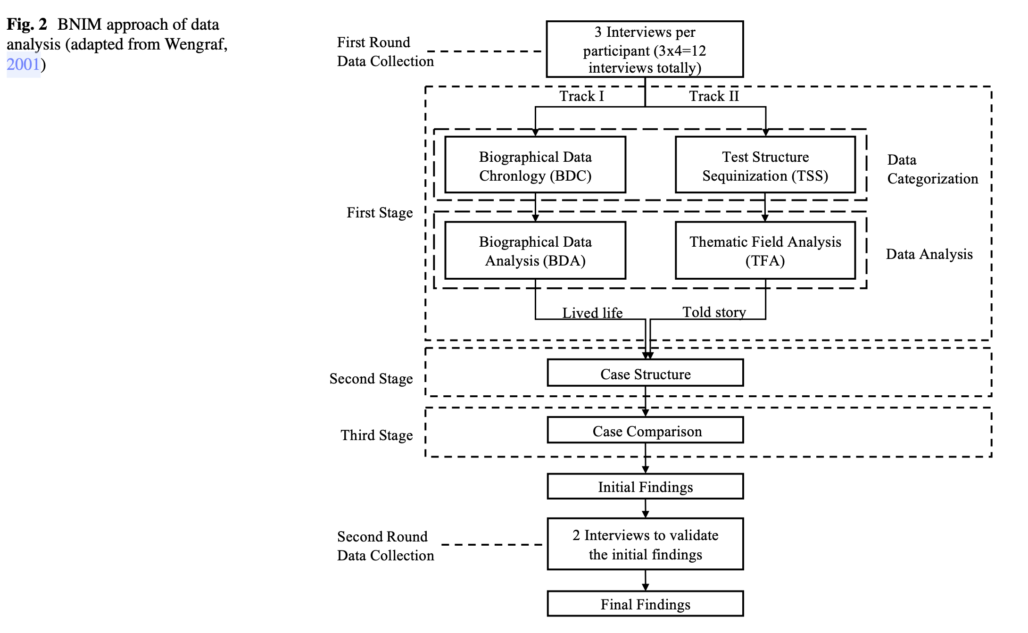
The second stage of data analysis was regenerating a case for each interviewee based on the data filtered from the first stage. This process was called creating a case structure. In this study, six case structures were created (Wengraf, 2001). The researcher validated how the “lived life” informed the “told story.” The second stage helped with identifying the critical incidents of each interviewee. The study extracted 12 critical incidents which were reviewed chronologically to highlight the dual-dimensional characteristics (i.e., online teaching challenges in the cross-cultural context). The second stage supported the sense-making of each interviewee’s whole experience. The study generated steps of a process informed by TL theory to reveal how teachers shifted their perspectives on teacher identity as a result of reflecting on their critical online teaching experiences (Fig. 3).
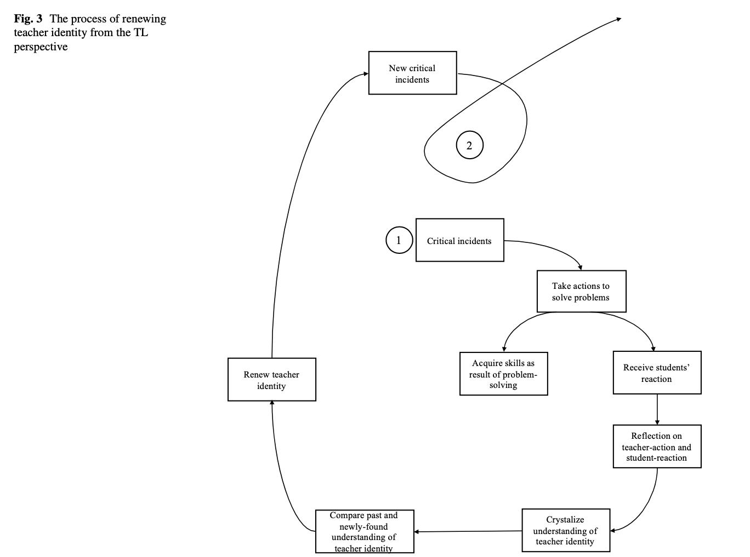
The third stage was a Case Comparison across the six interviewees. The researcher classified major themes shared by the six Western foreign teachers on their renewed perceptions of teacher identities and impact on their confidence development. The findings indicated teachers’ perceptions influence their interpretations of student learning behaviors, shaping teachers’ assumptions about what actions they could take. Despite this difference, six Western foreign teachers arrived at a shared understanding of teacher identity in this study. Hence, this study proposed a framework that leverages transformative learning to explore teacher identity and professional confidence (see later Fig. 4).
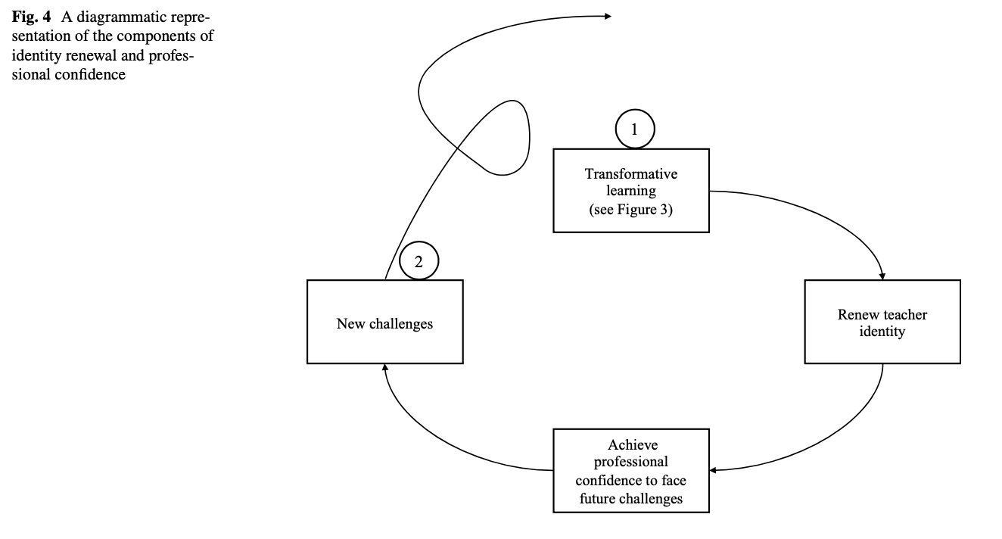
Findings
Rationales for Students’ Lack of Interaction in Online Learning
A common challenge described by all six Western foreign teachers in their online teaching critical incidents is lack of student interaction. However, each teacher interpreted this phenomenon differently. Teachers’ perception differences led to varied problem-solving actions. Western foreign teachers’ reflections on their actions were supported by their rationales which fell into two types: cultural-related or language-associated issues. In the cross-cultural teaching context, the local students implicitly revealed their traditional values through showing their feelings and attitudes in response to western foreigners’ teaching.
Western foreign teachers sensibly attended to the effect of value differences in their teaching.
Students are dealing with a foreigner, and maybe (it is) the first time. They also hoped that they could speak (English) better. So, (students) are trying their best in a difficult situation. (Teacher D)
Students just say yes (in the class), even though they don’t understand. The reason is, students don’t want to look stupid, so they want to move on, and sometimes they are used to answer yes. Chinese students are reluctant to give personal opinions in class to avoid the risk of public embarrassment. (Teacher B)
The online teaching context magnified cultural-related barriers at the interpersonal level. Before the pandemic, Western foreign teachers could see students in class in a shared space, teachers and students from varied cultural backgrounds could create their shared experiences in class. Post-pandemic, online teaching took away the face-to-face access and socio-cultural exchange was limited. This phenomenon led to less trust among Western foreign teachers and the Chinese students, who had never met each other in person. Without shared socio-cultural connections, students started to care less about Western teachers’ words. As a result, they became less active in online engagement.
With the pandemic and the fast speed of change in China....(students) started to not believe in teachers’ words as much as they used to, making online classes more challenging. (Teacher A)
Language-associated communication barriers further divided into issues of language proficiency or missing necessary background-knowledge. For example, Teacher B mentioned that the local students did not know many technical mathematical terms in English. Therefore, he used a translation tool from time to time. Teacher C was alert of his English-speaking speed and asked students to let him know when it impacted listening comprehension. More importantly, Western teachers reflected beyond students’ language proficiency. They sought after reasons underpinning the issue of communication barriers in English. One teacher discovered that students sometimes could not appreciate meanings behind the message, although they might know all the vocabulary, some noted that they lacked shared background knowledge to support comprehension.
One thing I have tried to do is, at the start of the semester, I’ll tell a joke. No one will laugh. By the end of the semester, I’ll do it again, and they laugh. I will then say: “Congratulations! You picked up the visual clues.” I feel good because when I’m telling the joke, it turns out that students can understand. (Teacher F)
Regardless of the different perceptions held by the six Western foreign teachers, the local reality significantly influenced their’ online teaching in the cross-culture context. Western foreign teachers took proactive measures. Upon reflecting on their problem-solving, they all arrived at two shared recognitions of teacher identity: a learning partner and the student helper).

Reflecting on Critical Cross‐Cultural Incidents: Renewed Teacher Identity as a Learning Partner
Reflecting on teaching experiences was a critical thought process that changed the Western foreign teachers’ recognition of teacher identity which transformed their pedagogical content knowledge and curricular knowledge (Shulman, 2013). As they experienced dilemmas in their cross-cultural online teaching situations, they reflected on their handling of critical incidents. This internalized meaning-making process offered a new perspective on their teaching. They began to shift their identity recognition from being a class teacher to becoming a learning partner.
I supposed in which way the students would be able to understand (my teaching). I asked some questions to myself: did I go too fast? Could I explain it better? Did I use the wrong analogies to explain it? Can I improve? All of that goes into the reflection.... I teach based on the students’ reactions because our teaching is (centered on) students learning. We don’t teach for ourselves. When (I am) speaking too fast, and they’re not following, then it’s not worth continuing the lesson. (Teacher C)
I don’t only spend my free time with foreign people. I’m doing my best to integrate with the local community, to understand their social point of view and culture point of view. I must match the expectation of my clients. If there are some expectations that I can match, I would be very happy to match with them. (Teacher E)
I think that making the students feel like they are the center is really important. Teachers needed to give students time to think, challenge their thinking. (Teacher D)
This new identity recognition prompted Western foreign teachers to approach the online teaching challenge differently in both pedagogical and curricular approaches. The role of a learning partner was identified as a way to help students learn and give them a chance to recognize their autonomy over learning. The recognition of the new teacher identity prompted Western foreign teachers to consider the underlining rationale of a learning design. They began to explicitly reflect on and evaluate their teaching approaches and what they value in teaching and lesson design. For example, Teacher A changed their teaching style to improve students’ online engagement.
I have learned why people don’t participate (because) they don’t know what to do. So, I need to give better instructions. I also need to divide a larger task into smaller, more manageable tasks. I think that’s what I have done here, and it’s been more successful. (Teacher A)
A learning partner centers students in teaching. The traditional perception of the teacher’s role was centered on content and content delivery, while the learning partner focused on the learning relationship and quality. Although the Western foreign teachers experienced language and cultural barriers to communicate with the local students effectively, their renewed teacher identity enabled them to alter their teaching practices for better student engagement.
In previous years, I always spent five to ten minutes reviewing (the content of) the last lecture. Now I changed a little bit. I just made a very short summary; I pay more attention to the teaching way and the teaching quality.... I try to make (the online class) a bit interesting, surprising, and relevant to daily life.... (Teacher B)
Their new teacher identities favored cooperative learning, included guided questions for scaffolded comprehension, and promoted connections between new and previous knowledge from student experience. They created a comfortable atmosphere to cultivate student expression and ongoing feedback.
I can just show students that there is one or more options in front of them. Each option leads to an experience. But I cannot force the students to choose which option. I encourage students by letting them know, if they choose an option, they will have some opportunities. (Teacher E)
In this study, the six Western foreign teachers invest effort in student-centered learning. They focused on learner engagement, asset-based instruction (Lin, 2020), and relationship building over traditional emphasis on classroom management and student learning deficits.

Reflecting on Online Teaching Critical Incidents: Renewed Teacher Identity as the Student Helper
Before the pandemic, being a teacher was about honing one’s teaching skills. However, Western foreign teachers’ perspectives shifted when they had to teach online. They broadened their pedagogical content knowledge and curricular knowledge, upon reflection, and began to integrate inclusive teaching strategies (Salazar, et al., 2009; Waitoller & Thoirus, 2016). When the Chinese students performed below expectations online due to health and wellness issues, they showed compassion to the local students’ personal challenges instead of merely focusing on honing their teaching designs and activities.
One student’s mom got COVID in China, but I was (teaching online) in the United States, and he was super stressed. We had private conversations about it, but I can’t force him to work hard in class when he’s worried about his mom.... I remind myself that I’m here to help students. (Teacher A)
In the Western foreign teachers’ minds in this study, helping students learn was their foremost responsibility. These teachers demonstrated a high-level of differentiation and inclusive practice and they varied instruction to attend to learner needs. In addition, they demonstrated teacher agency (Biesta, et al., 2015). Instead of complaining about why those challenges had occurred, they focused on supporting students. Online teaching required an intensive workload, demanded extra effort to create electronic resources, and required teachers to be more accessible virtually. The teachers were willing to transform their teaching approaches to better serve the local students.
My colleagues and I created a lot of online content for the labs. It doesn’t replace the value and benefit of physical space, but we created videos with a virtual reality lab together. Students can see and go online to watch videos. We were trying to add on extra parts (in teaching). We’ve done a lot to try and help students. (Teacher F).
Before the epidemic, I never had to record my own lectures. But now I recorded all lectures because some students are online and their internet is bad.... I thought (recording lectures) was better for the students to learn. (Teacher B)
The first semester was fully online. I was finding a way to connect with the students. (Teacher C)
The Western foreign teachers in this study realized it was more critical to identify and respond to students’ varied needs and differentiate instruction to align with their diverse readiness levels. Teachers M and Teacher D came to terms with their teaching practices and concluded that it was critical to helping students build up good learning habits and engagement rather than giving them a rich reservoir of knowledge.
I do not just want students to pass the exam. I want them to be motivated and engaged. Students learn to build good habits and then embed them in their future work. (Teacher C)
I made recommendations about how students could change their English learning style.... I helped (students) to become more mature. Through my interaction with them, I tried to help (students) realize their potential in their life. (Teacher D)

Achieving Professional Confidence: A Developmental Process
In the second and/or third-round of interview, the participants stated that they felt more confident after experiencing online teaching because they knew how challenges could affect their work. They felt better at handling changes because of their recent experiences with the pandemic. As the six Western foreign teachers acted as problem-solvers, they transformed their professional dilemmas (i.e., challenges) into professional expertise (e.g., teaching online in a cross-cultural setting). Teacher B changed by adapting to uncertainty and persevering through the agonizing online teaching process.
At least I learned from some change, which is good. Some disruptive changes keep you awake in life.... You have to suffer a little bit of pain, but it makes you stronger.... Everybody solved (online teaching) in their way. I’m confident that I worked it out. (Teacher B)
The Western foreign teachers’ reflective practice renewed their understanding of teacher identity, and subsequent actions strengthened their professional confidence. Taking matters into their own hands was grounded in their belief that a teacher should be a student helper. As they implemented their beliefs, they effectively transformed themselves into a new teacher identity, and their confidence accelerated. For example, Teacher C reached a new and self-assured anticipation to deal with the uncertainty of students’ online performance.
I had no idea how good the students were going to be,. I just had no idea really what to expect.... I have confidence (based on) experience, knowing that I’ll be able to deal with (any challenge) if it happens. I can accept that things are going to happen (in ways that) I have not anticipated. (Teacher C)
Western teachers achieved the capacity to execute suitable teaching methods at their disposal and apply them to varied learning contexts. They began to gain confidence as result of overcoming challenges the cross-culture employment.
I would give other hours of my time to students to deliver private online classes rather than ignoring their problems. There’s no mess which is made by me last semester, and I’m very proud of this. I got a different solution. So, I had good relationship with students because there were small group tutorials (online). We provided videos and data, so students were able to write lab reports. We created online lab content, as an additional tool, and this part we can use further. (Teacher F)
After successfully dealing with various cross-cultural and online teaching problems, Teacher A marveled at her problem-solving capability. Teacher E felt more confident to integrate with local community to deal with changes.
I had so many difficulties. It’s good to remind me that I worked it out. It’s amazing what human beings are capable of. We’re not super people, but our problem- solving abilities are incredible. (Teacher A)
I decided that it was the right time to start with a new project of life, to start with something completely new.So I got rid of my comfort zone and start from scratch in a completely new environment. To be honest, it was not easy at all, but I never regret if I will do the same what I did. I have to adapt but that is okay. (Teacher E)

Conclusion, Contribution, and Limitation for Further Research
Previous studies have indicated that teachers’ professional confidence could be built through transformative learning (Nolan & Molla, 2021). This study crystallized that idea by proposing a framework that leverages TL to render the connection between teacher identity as educators and professional practice and confidence in teaching (Fig. 4). The researcher investigated six Western foreign teachers’ perceptions of their teacher identity as educators and their professional confidence in teaching by gathering critical incidents in teaching before and after the pandemic. Based on the data analysis, the study proposed that developing teacher identity as educators and professional practice and confidence in teaching is an iterative process. Transformative learning is a vehicle to facilitate the reflection-after-action process (previous Fig. 3) and serves as an essential component in strengthening teachers’ pedagogical content knowledge, curricular knowledge, and professional competence for facing future challenges.
Reflective interviews between the six Western foreign teachers and the researcher explored teaching experiences, teacher beliefs, and perspectives contributing to identity renewal (i.e., reflection). The teachers took the initiative (i.e., action) in dealing with critical challenges in teaching and reshaped their perspectives on teaching and student learning during the pandemic. The reflective practice served as a medium for recognizing transformation, and action- taking affirmed their professional confidence in teaching. They continuously renewed their understanding of teacher identity as educators to strengthen their pedagogical practice and confidence in teaching. This understanding exerted further influence, enabling them to take new actions in future problem-solving in teaching.
The pandemic caused many Western foreign teachers to re-evaluate their employment choices in unfamiliar cultural settings. Some could not handle the increased stress from the pandemic and decided to return home. Some chose to stay but struggled with teaching stresses in a foreign land. This study operationalized TL to illustrate how Western foreign teachers convert challenging teaching experiences into meaningful learning moments to promote professional development. The integration of this approach may positively impact teacher retention and success. Further research is needed to explore the long-term impact and efficacy of the TL approach for Western teachers. This study offered insights into Western foreign teachers’ teaching experiences in China, filling an important gap in the field of transnational education. Besides exploring teacher identity as educators and professional confidence in teaching via the theoretical lens of transformative learning, the study made a practical contribution to Western foreign teachers’ employment recruitment and retention in transnational education settings.
In this single casestudy research, the six Western foreign teachers identified themselves as Caucasians. Studies with more diversified sample pools from multiple higher education institutions could further strengthen the credibility and creation of a context-independent identity development framework (Starman, 2013). Additional studies could also examine the potential of organizational influence on Western foreign teachers’ identity development. The current study focused on Western foreign teachers’ professional identity as educators. Further research could focus on other aspects of Western foreign teachers’ professional identity in higher education, including identity as researcher or identity as academic leader. Exploration of other dimensions of professional identity would provide a holistic picture of Western foreign teachers’ career development. Finally, the ability of Western foreign teachers to reflect on experience seemed to be a prerequisite for renewed teacher identity and professional confidence development. More practice-based research would be desirable to explore how to better support Western foreign teachers mastering such a skill in a cross-cultural context to effectively enrich their professional development.

Acknowledgements
The study received financial support from Xi’an Jiaotong-Liverpool University’s Research Development Fund (Ref No.: RDF-19-01-23). The authors would like to thank this study’s six anonymous Western foreign teachers.

Funding
The authors received financial support from Xi’an Jiaotong-Liverpool University’s Research Development Fund (Ref No.: RDF-19-01-23).
Data Availability
Data in this study are not publicly available to protect participants’ privacy. Data can be made available upon reasonable written request to the corresponding author.
Declarations
Competing Interests
Authors do not have any financial or nonfinancial interests that are directly or indirectly related to the work
submitted for publication.
Ethical Approval The study was approved by the corresponding author’s institute (ethics approval number: 21–02-05). The study’s participants signed consent forms were in line with ethical standards.
References
Anand, T. S., Anand, S. V., Welch, M., Marsick, V. J., & Langer, A. (2020a). Overview of transformative learning I: Theory and its evolution. Reflective Practice, 21(6), 732–743. https://doi.org/10.
1080/14623943.2020.1821942
Anand, T. S., Anand, S. V., Welch, M., Marsick, V. J., & Langer, A. (2020b). Overview of transformative learning II: Real-world applications. Reflective Practice, 21(6), 744–758. https://doi.org/ 10.1080/14623943.2020.1821945
Bailey, L. (2021). International school teachers: precarity during the COVID-19 pandemic. Journal of Global Mobility: The Home of Expatriate Management Research, 9(1), 31–43. https://doi.org/10. 1108/JGM-06-2020-0039Beauchamp
Beauchamp, C., & Thomas, L. (2009). Understanding teacher identity: An overview of issue in the literature and implications for teacher education. Cambridge Journal of Education, 39(2), 175–189. https://doi.org/10.1080/03057640902902252
Berry, A. (2004). Confidence and uncertainty in teaching about teaching. Australian Journal of Education, 48(2), 149–165. https://doi. org/10.1177/000494410404800205
Biesta, G., Priestley, M., & Robinson, S. (2015). The role of beliefs in teacher agency. Teachers and Teaching: Theory and Practice, 21(6), 624–640. https://doi.org/10.1080/13540602.2015.1044325
Bloomberg, L. D., & Volpe, M. (2018). Completing your qualitative dissertation: A road map from beginning to end. SAGE Publications, Inc.
Bodycott, P., & Walker, A. (2000). Teaching abroad: Lessons learned about inter-cultural understanding for teachers in higher education. Teaching in Higher Education, 5(1), 79–94. https://doi.org/ 10.1080/135625100114975
Brook, C., & Abbott, C. (2020). Facilitating the facilitators of action learning in China: Practices and prospects. Action Learning: Research and Practice, 17(2), 200–214. https://doi.org/10.1080/ 14767333.2019.1646208
Bunnell, T., & Poole, A. (2021). International Schools in China and teacher turnover: The need for a more nuanced approach towards precarity reflecting agency. Asia Pacific Journal of Education. https://doi.org/10.1080/02188791.2021.1940840
Chen, C.W.-Y., & Cheng, Y.-S. (2010). A case study on foreign English teachers’ challenges in Taiwanese elementary schools. System, 38(1), 41–49. https://doi.org/10.1016/j.system.2009.12.004
Cho, H., & Johnson, P. (2020). Preservice teachers’ transformative learning through field experience with emergent bilinguals in a dual language school. Reflective Practice, 21(6), 819–833. https:// doi.org/10.1080/14623943.2020.1821625
Cofta, P. (2007). Confidence, trust and identity. BT Technology Jour- nal, 25(2), 173–178. https://doi.org/10.1007/s10550-007-0042-4 Daniëls, E., Hondeghem, A., & Heystek, J. (2020). Exploring the out- comes of group reflective learning for school leaders. Reflective Practice, 21(5), 604–618. https://doi.org/10.1080/14623943.2020.
1784865
Devlin, M., & Samarawickrema, G. (2022). A commentary on the crite- ria of effective teaching in post-COVID higher education. Higher Education Research & Development, 41(1), 21–32. https://doi.org/ 10.1080/07294360.2021.2002828
Eschenbacher, S. (2020). Transformative learning and the hidden dynamics of transformation. Reflective Practice, 21(6), 759–772. https://doi.org/10.1080/14623943.2020.1821631
Eschenbacher, S., & Fleming, T. (2020). Transformative dimensions of lifelong learning: Mezirow, Rorty and COVID-19. International Review of Education. Internationale Zeitschrift Fur Erziehun- gswissenschaft. Revue Internationale de Pedagogie, 66(5–6), 657–672. https://doi.org/10.1007/s11159-020-09859-6
Flynn, S. (2019). Life stories of the economic recession: Biographical Narrative Interpretative Method (BNIM) and the lived experience of disability in times of austerity. Scandinavian Journal of Dis- ability Research. https://doi.org/10.16993/sjdr.594
Francis, J. J., Johnston, M., Robertson, C., Glidewell, L., Entwistle, V., Eccles, M. P., & Grimshaw, J. M. (2010). What is an adequate sample size? Operationalising data saturation for theory-based interview studies. Psychology & Health, 25(10), 1229–1245. https://doi.org/10.1080/08870440903194015
Gay, G. (2018). Culturally responsive teaching: Theory, research, and practice (Multicultural Education Serise) (3rd ed.). Teachers College Press.
Halquist, D., & Musanti, S. I. (2010). Critical incidents and reflection: Turning points that challenge the researcher and create opportunities for knowing. International Journal of Qualitative Studies in Education, 23(4), 449–461. https://doi.org/10.1080/09518398. 2010.492811
Harrison, R. T., & Leitch, C. M. (2019). The dynamics of identity, identity work and identity formation in the family business: Insights from identity process theory and transformative learn- ing. Springer International Publishing
Holland, K., Middleton, L., & Uys, L. (2012). Professional confidence: A concept analysis. Scandinavian Journal of Occupational Therapy, 19(2), 214–224. https://doi.org/10.3109/11038128.2011. 583939
Illeris, K. (2014). Transformative learning re-defined: As changes in elements of the identity. International Journal of Lifelong Edu- cation, 33(5), 573–586. https://doi.org/10.1080/02601370.2014. 917128
Iredale, A., Orr, K., Bailey, W., & Wormald, J. (2013). Confidence, risk, and the journey into praxis: Work-based learning and teacher development. Journal of Education for Teaching, 39(2), 197–208. https://doi.org/10.1080/02607476.2013.765192
Kim, K. H. (2009). Cultural influence on creativity: The relationship between Asian culture (Confucianism) and creativity among Korean educators. The Journal of Creative Behavior, 43(2), 73–93. https://doi.org/10.1002/j.2162-6057.2009.tb01307.x
Kissock, C., & Richardson, P. (2010). Calling for action within the teaching profession: It is time to internationalize teacher education. Teaching Education, 21(1), 89–101. https://doi.org/10.1080/ 10476210903467008
Lai, C., Li, Z., & Gong, Y. (2016). Teacher agency and professional learning in cross-cultural teaching contexts: Accounts of Chinese teachers from international schools in Hong Kong. Teaching and Teacher Education, 54, 12–21. https://doi.org/10.1016/j.tate.2015. 11.007
Leigh, L. (2019). “Of course I have changed!”: A narrative inquiry of foreign teachers’ professional identities in Shenzhen, China. Teaching and Teacher Education, 86, 102905. https://doi.org/10. 1016/j.tate.2019.102905
Li, N., Wang, Q., Liu, J., & Marsick, V. J. (2022). Improving interdisciplinary online course design through action learning: A Chinese case study. Action Learning: Research and Practice, 19(1), 49–64. https://doi.org/10.1080/14767333.2021.2002681
Lin, A. M. (2020). From deficit-based teaching to asset-based teaching in higher education in BANA countries: Cutting through ‘either- or’binaries with a heteroglossic plurilingual lens. Language, Culture and Curriculum, 33(2), 203–212. https://doi.org/10.1080/ 07908318.2020.1723927
Mahmood, S. (2021). Instructional strategies for online teaching in COVID-19 pandemic. Human Behavior & Emerging Technologies, 3(1), 199–203. https://doi.org/10.1002/hbe2.218
Malterud, K., Siersma, V. D., & Guassora, A. D. (2016). Sample size in qualitative interview studies: Guided by information power. Qualitative Health Research, 26(13), 1753–1760. https://doi.org/ 10.1177/1049732315617444
Mansour, N. (2009). Science teachers’ beliefs and practices: Issues, implications and research agenda. International Journal of Environmental and Science Education, 4(1), 25–48.
Marquardt, M. J. (2015). Action learning in China. Action Learning: Research and Practice, 12(3), 325–333. https://doi.org/10.1080/ 14767333.2015.1094619
Mau, S. T., & Harkness, S. S. (2020). The role of teacher educators and university supervisors to help student teachers reflect: From monological reflection toward dialogical conversation. Reflec- tive Practice, 21(2), 171–182. https://doi.org/10.1080/14623 943.2020.1716710
Mezirow, J. (1996). Toward a learning theory of adult literacy. Adult Basic Education, 6(3), 115.
Mezirow, J. (1997a). Transformation theory out of context. Adult Education Quarterly, 48(1), 60–62. https://doi.org/10.1177/ 074171369704800105
Mezirow, J. (1997b). Transformative learning: Theory to practice. New Directions for Adult & Continuing Education, 1997(74), 5–12. https://doi.org/10.1002/ace.7401
Mezirow, J. (1998). On critical reflection. Adult Education Quar- terly, 48(3), 185–198. https://doi.org/10.1177/0741713698 04800305
Mezirow, J. (2003). Transformative learning as discourse. Journal of Transformative Education, 1(1), 58–63. https://doi.org/10.1177/ 1541344603252172
Montgomery, C. (2014). Transnational and transcultural positionality in globalised higher education. Journal of Education for Teach- ing., 40, 198–203. https://doi.org/10.1080/02607476.2014.903021
Musanti, S. I. (2005). Collaboration and inservice teachers’ professional development: A qualitative study on knowledge, identity and practice. The University of New Mexico.
Nazari, M., & Seyri, H. (2021). Covidentity: Examining transitions in teacher identity construction from personal to online classes. European Journal of Teacher Education. https://doi.org/10.1080/ 02619768.2021.1920921
Nolan, A., & Molla, T. (2018). Teacher professional learning through pedagogy of discomfort. Reflective Practice, 19(6), 721–735. https://doi.org/10.1080/14623943.2018.1538961
Nolan, A., & Molla, T. (2021). Building teacher professional capabilities through transformative learning. Asia-Pacific Journal of Teacher Education, 49(4), 450–465. https://doi.org/10.1080/ 1359866X.2020.1828823
Paris, D., & Alim, H. S. (Eds.). (2017). Culturally sustaining pedagogies: Teaching and learning for justice in a changing world. Teachers College Press.
Poekert, P., Alexandrou, A., & Shannon, D. (2016). How teachers become leaders: An internationally validated theoretical model of teacher leadership development. Research in Post-Compulsory Education, 21(4), 307–329. https://doi.org/10.1080/13596748. 2016.1226559
Poole, A. (2019). Negotiating Intercultural Spaces and Teacher Identity in an Internationalised School in Shanghai. Intercultural Communication Education, 2(2), 59–70. https://doi.org/10.29140/ice. v2n2.128
Poole, A., & Bunnell, T. (2021). Developing the notion of teaching in ‘International Schools’ as precarious: Towards a more nuanced approach based upon ‘transition capital.’ Globalisation, Socie- ties and Education, 19(3), 287–297. https://doi.org/10.1080/14767 724.2020.1816924
Poole, A., & Bunnell, T. (2022). Precarious privilege in the time of pandemic: A hybrid (auto)ethnographic perspective on COVID- 19 and international schooling in China. British Educational Research Journal, 48, 915–931. https://doi.org/10.1002/berj.3801
Rao, Z. (2010). Chinese students’ perceptions of native English- speaking teachers in EFL teaching. Journal of Multilingual and Multicultural Development, 31(1), 55–68. https://doi.org/10.1080/ 01434630903301941
Richards, J. C., Richards, J. C., & Farrell, T. S. (2005). Professional development for language teachers: Strategies for teacher learn- ing. Cambridge University Press.
Robinson, S. P., & West, J. E. (2012). Preparing inclusive educators: A call to action. Journal of Teacher Education, 63(4), 291–293.
Salazar, M. D., Norton, A. S., & Tuitt, F. A. (2009). Weaving promising practices for inclusive excellence into the higher education classroom. In L. B. Nilson & J. E. Miller (Eds.), To Improve the Academy (pp. 208–226). Jossey-Bass.
Savva, M. (2017). The personal struggles of ‘national’educators working in ‘international’schools: An intercultural perspective. Globalisation, Societies and Education, 15(5), 576–589. https://doi. org/10.1080/14767724.2016.1195728
Shahjahan, R. A., & Edwards, K. (2022). Mobilizing Whiteness: Race, futurity, and globalization of higher education. Oxford University Press.
Shulman, L. (2013). Those who Understand: Knowledge Growth in Teaching. Journal of Education., 193, 1–11. https://doi.org/10. 1177/002205741319300302
Smith, K. (2009). Transnational teaching experiences: An under- explored territory for transformative professional development. International Journal for Academic Development, 14(2), 111– 122. https://doi.org/10.1080/13601440902969975
Smith, K. (2014). Exploring flying faculty teaching experiences: Motivations, challenges and opportunities. Studies in Higher Education, 39(1), 117–134. https://doi.org/10.1080/03075079.2011. 646259
Starman, A. B. (2013). The case study as a type of qualitative research.
Journal of Contemporary Educational Studies/Sodobna Pedagogika, 64(1).
Taylor, E. W. (1994). Intercultural competency: A transformative learning process. Adult Education Quarterly, 44(3), 154–174. https:// doi.org/10.1177/074171369404400303
Thorsen, C. A., & DeVore, S. (2013). Analyzing reflection on/for action: A new approach. Reflective Practice, 14(1), 88–103. https://doi.org/10.1080/14623943.2012.732948
Tomlinson, C. A. (2001). How to differentiate instruction in mixed- ability classrooms. Association for Supervision and Curriculum Development
Waitoller, F. R., & King Thorius, K. A. (2016). Cross-pollinating culturally sustaining pedagogy and universal design for learning: Toward an inclusive pedagogy that accounts for dis/ability. Harvard Educational Review, 86(3), 366–389. https://doi.org/10. 17763/1943-5045-86.3.366
Wang, Q., Xiong, C., & Liu, J. (2021). Does culture or self-directed learning drive online performance? International Journal of Educational Management, 35(6), 1077–1098. https://doi.org/10.
1108/IJEM-06-2020-0327
Welch, M. A., Saunders, A. A. P., Buergelt, P. T., Gilpin-Jackson, Y., Ferguson, J., & Marsick, V. J. (2020). Your story, our story: The transformative power of life narratives. Reflective Practice, 21(6), 861–876. https://doi.org/10.1080/14623943.2020.1821633
Wendel, M. L., Garney, W. R., Castle, B. F., & Ingram, C. M. (2018). Critical reflexivity of communities on their experience to improve population health. American Journal of Public Health, 108(7), 896–901. https://doi.org/10.2105/AJPH.2018.304404
Wengraf, T. (2001). Qualitative research interviewing. SAGE Publications, Ltd.
Woolf, M. (2002). Harmony and dissonance in international education: The limits of globalisation. Journal of Studies in International Education, 6(1), 5–15. https://doi.org/10.1177/102831530200600 1002
Wrigley, M. (2002). Review: Tom Wengraf (2001) qualitative research interviewing: Biographic narrative and semi-structured method. Forum Qualitative Sozialforschung / Forum: Qualitative Social Research. https://doi.org/10.17169/fqs-3.4.801
Yang, X., Wang, X., Zhang, L., & Weidman, J. C. (2017). Gender role conflict, professional role confidence, and intentional persistence in engineering students in China. Studies in Higher Education, 42(2), 248–263. https://doi.org/10.1080/03075079.2015.1045476
Yoshihara, R., Kurata, A., & Yamauchi, A. (2020). Reflective journals to explore struggles and difficulties of novice Japanese EFL university instructors. Reflective Practice, 21(1), 81–93. https://doi. org/10.1080/14623943.2019.1708714
Publisher’s Note Springer Nature remains neutral with regard to jurisdictional claims in published maps and institutional affiliations.

