TITLE:
PROXIMITY TO HUMAN SETTLEMENTS CAN REDUCE VIGILANCE, BUT INCREASE ALARM CALL RESPONSES IN AFRICAN ANTELOPES

SHORT TITLE: HUMAN IMPACT ON ANTELOPE ANTIPREDATOR BEHAVIOUR

AUTHORS
Giacomo D’Ammando ^{a*} and Jakob Bro-Jørgensen ^{b}
ORCID ID: Giacomo D’Ammando 0000-0003-0860-8064; Jakob Bro-Jørgensen 0000-0003-2899-8477
ª Mammalian Behaviour and Evolution, Department of Evolution, Ecology and Behaviour, University of Liverpool, Liverpool, L69 7ZB, UK.
*Corresponding author: Giacomo D’Ammando
Telephone number (mobile): (+254) (0)748 916 718. Email address:giacomo@savetheelephants.org
Present address: Save the Elephants, Nairobi, Kenya.
ACKNOWLEDGEMENTS
We are grateful for permission to conduct the fieldwork from the Kenyan National Commission for Science, Technology, and Innovation (NACOSTI/P/16/78559/12753), the Narok County Government and the Chief Park Warden of the Maasai Mara National Reserve (NCG/MMN/R/R/VOL. VII/30), and the Kenya Wildlife Service (KWS/BRM/5001). We thank Mada Hotels (Tinu Mhajan) for logistic support, and Simone Ciuti and two anonymous referees for insightful comments on the manuscript. This research was funded by a Natural Environment Research Council studentship to G.D. All experiments and behavioural observations adhere to guidelines of the Kenya Wildlife Service.

DECLARATION OF INTERESTS
The authors declare no conflicts of interests.

AUTHOR CONTRIBUTION
JBJ and GD conceived and designed the study. GD collected and analysed the data, and GD and JBJ wrote the manuscript.

ABSTRACT
Human activities can have complex effects on the antipredator behaviour of wildlife, and an understanding of the intricacies can provide important information for conservation management. In some cases, ‘human shields’ that attract wild ungulates may form around human settlements due to a lower density of large predators. However, human presence may also be associated with increased exposure to a range of anthropogenic threats, such as poaching, predation by dogs, and costly interactions with livestock and their herders. Here we compare the antipredator behaviour of two savannah antelopes, topi (Damaliscus lunatus) and Thomson’s gazelle (Eudorcas thomsonii), between the relatively undisturbed areas in the interior of the Maasai Mara National Reserve (Kenya) and the peripheral areas next to human settlements by the reserve boundary. We found that both antelope species were less vigilant in the more human-impacted peripheral areas, suggesting a reduction in the overall predation risk. However, both species also responded more strongly to conspecific (but not heterospecific) alarm calls in the human-impacted areas. We suggest that alarm calls in the human-impacted areas may be elicited by a more variable and unpredictable set of threats, many of which are anthropogenic, and that these require more careful assessment by the antelopes. Human presence can thus have opposite effects on different aspects of antipredator behaviour, emphasising the need to better understand how animals perceive threats in their environment and the consequences for population performance.
KEYWORDS: Antipredator Behaviour – Behavioural Plasticity - Human Disturbance – Human Shields – Playback Experiments - Ungulates – Vigilance
INTRODUCTION
Wildlife is increasingly coming into contact with human activities due to global population growth and encroachment into natural habitats (Ceballos & Ehrlich 2002; Nyhus 2016; Margulies & Karanth 2018). Human activities may not only cause direct mortality of wildlife, but also induce severe disturbance that can lead to costly behavioural changes in affected species (Stabach et al. 2016; Greenberg & Holekamp 2017; Paton et al. 2017; Benitez-Lopez 2018; Gaynor et al. 2018). Antipredator behaviours of wildlife, such as vigilance and alarm communication, are selected to be adaptive in natural environments (Caro 2005), however, anthropogenic disturbance can create novel conditions where animal responses are inadequate, either due to lack of behavioural flexibility or due to changes in the trade-offs with other crucial behaviours relating to survival and reproduction. This has the potential to compromise population performance (Bro-Jørgensen et al. 2019), and we therefore need a better understanding of the context-dependence of antipredator behaviours.
In large mammals, hunting and other forms of persecution by humans can instil strong fear, which is known to increase the time spent in antipredator behaviours (e.g. vigilance: Ciuti et al. 2012a, 2012b; Crosmary et al. 2012; Schuttler et al. 2017). As a consequence, time spent in restorative behaviours, such as foraging and resting, may be reduced with negative fitness consequences. By contrast, urbanization and nature-based tourism are often associated with a relaxation of antipredator behaviours (Lowry et al. 2013; Hansen & Aanes 2015; Uchida et al. 2019; Wevers et al. 2020; Berger et al. 2020). This can frequently be explained by the eradication or deterrence of large carnivores from human-dominated landscapes, a phenomenon described as the ‘shielding effect’ (Berger 2007; Atickem et al. 2014; Sarmento et al. 2016; Berger et al. 2020). Conservationists have, however, voiced concerns over the possibility that such ‘human shields’ might interfere with the ability of prey species to correctly discriminate and assess cues to predation risk (Geffroy et al. 2015; Carthey & Blumstein 2018). Overall, because human expansion into natural habitats thus can lead to multiple types of human-wildlife interactions (e.g. both hunting and tourism), complex behavioural changes may be induced. In this study, we investigate how expanding human presence in an East African savannah system affects the antipredator behaviour of African ungulates, focusing on vigilance behaviour and alarm call communication.
Ungulate populations in agricultural or urban contexts have been found to be significantly less vigilant than those inhabiting more pristine wilderness (e.g. Shannon et al. 2014; Saltz et al. 2019). This can be explained by wild ungulates perceiving settlements and other anthropogenic infrastructures as safe refuges because their natural predators avoid areas associated with humans due to a long history of persecution (Wilmers et al. 2013; Gehr et al. 2017). Whereas reduced vigilance may be adaptive due to lower predation risk, some evidence exists that ‘shielding’ effects can also diminish ungulate sensitivity to predator cues: mountain goats (Oreamnos americanus), for example, are less prone to flee from grizzly bear (Ursus arctos) models at tourist sites, from which the bears have been actively deterred (Sarmento & Berger 2017). However, other studies have found the opposite pattern: Gunther's dik-diks (Madoqua guentheri) reacted more strongly (by nose-twitching) to playback of side-striped jackal (Canis adustus) calls in proximity to human settlements, the explanation for which remains unclear (Coleman et al. 2008). The results of research into the human impact on ungulate responses to direct predator cues are thus equivocal.
Likewise, we know little about the impact of human proximity on ungulate antipredator communication using alarm calls. Ungulates emit alarm calls primarily to signal detection to stalking predators (Caro 2005). Thereby they prevent the predator from attacking because these predators need to remain undetected to enter within the critical striking radius (Caro 1994; Bro-Jørgensen & Pangle 2010). In social species, alarm calls have the additional effect of alerting group members to potential danger. Such information transfer also occurs in mixed-species herds, where individuals often rely on the alarm calls from heterospecifics to locate approaching predators (Schmitt et al. 2016; Palmer & Gross 2018; Meise et al. 2018, 2020; Makin et al. 2019). Playback experiments have revealed that the strength of responses to con- and heterospecific alarm calls generally reflects the severity of the associated threat from the perspective of the receiver (Meise et al. 2018). To what extent the responses to alarm calls are adjusted to local variation in predation is however less clear.
The Maasai Mara National Reserve in Kenya (henceforth MMNR) presents a well-suited setting for testing the effect of human shields on ungulate antipredator behaviour. The last decades have witnessed sprawling growth around urban centres situated along the north-eastern and eastern boundaries of the MMNR, and livestock herding by the local Maasai tribe is prevalent inside the reserve (Butt 2014; Green et al. 2019a). The Maasai pastoralists do not usually hunt wild ungulates (Ceppi & Nielsen 2014; Kiffner et al. 2015), but they regularly persecute large carnivores (Mukeka et al. 2019; Broekhuis et al. 2020). This has led to reduced densities of some predator species in peripheral areas of the reserve next to village land (Ogutu et al. 2005; Green et al. 2018). By contrast, the reserve interior is more or less inaccessible to herders and thus relatively unaffected by human-predator conflict (https://www.marapredatorconservation.org; Farr et al. 2019).
Here we test a set of alternative hypotheses on ungulate antipredator responses by comparing vigilance and alarm call responses of two open plains antelopes, the topi (Damaliscus lunatus) and the Thomson’s gazelle (Eudorcas thomsonii) between human-impacted and more undisturbed areas of the MMNR. We predicted that, if the antelopes benefitted from lower predation risk from their natural predators within human shields, vigilance levels would be lower in the human-impacted areas than in the undisturbed areas. By contrast, if human-impacted areas were associated with increased predation risk due to humans, we predicted the opposite pattern. Moreover, if a shielding effect meant that alarm calls required less attention because they were less likely to indicate natural predators, we predicted weaker responses in human-impacted areas compared to undisturbed areas. Conversely, if anthropogenic threats were perceived as more ambiguous or more severe than threats from natural predators, we predicted that they would require more thorough assessment and that responses therefore would by stronger in human-impacted areas than in undisturbed areas. We tested predictions separately for con- and heterospecific alarms.

METHODS
Study system
The Masai Mara National Reserve is an unfenced protected area covering 1,510 km² of grassland, interspersed with patches of thickets and riparian forests in south-western Kenya (Fig. 1). The area is characterized by bimodal rainfall patterns, peaking in November-December and March-May. The unprotected Talek Enclave is a major hub for pastoralist settlements and has in recent decades witnessed a significant increase in the populations of humans (406% from 1991 to 2012), which has led to a drastic increase in the number of livestock grazing inside the MMNR (from 0 in 1988 to 2219 in 2013; Green et al. 2019a). The present study was conducted between November 2017 and May 2018.

Study design
Study sites: We selected our undisturbed and human-impacted study sites based on (i) similarity in ecological conditions except for the impact of human activities, (ii) contrast in the impact of humans on the presence of livestock and predators, and (iii) accessibility even during wet conditions. Maasai herders and their livestock are known to regularly move up to 6km into the MMNR from the Talek enclave (Pangle & Holekamp 2010; Butt 2014), and therefore our two ‘human-impacted plains’ were located within 2.5km of the reserve’s boundary with the Talek enclave whereas the ‘undisturbed plains’ were ≥10km from the reserve boundary (Fig. 1). Otherwise, the plains were similar open expanses of grassland practically void of trees, bordered by rivers with woody vegetation. High exposure to livestock herding on the human-impacted plains was confirmed by direct observation during our study as well as road transect surveys by the Mara Predator Conservation Programme (Annual reports 2014 to 2018; www.marapredatorconservation.org), with a numerical indication of the scale of the impact given by the daily grazing of approx. 4,000 cattle on average within a largely overlapping 143km²-study area in 2013 (Green et al 2019a). Moreover, long-term monitoring has shown that the numbers of lion (Panthera leo) and cheetah (Acinonyx jubatus), the two large stalking predators of the open plains, are now distinctly lower on the human-impacted plains than on the undisturbed plains (lion: Elliot & Gopalaswamy 2017, Green et al. 2018; cheetah: Klaassen & Broekhuis 2018; Broekhuis et al. 2019).
Study species: To assess the generality of our findings, we chose as study species two savannah antelopes that contrasted in their vulnerability to the stalking predators whose densities are known to have been negatively affected on the human-impacted plains, i.e. the Thomson’s gazelle (21kg) and the topi (119kg) (Estes 1991). Because of their size difference, Thomson gazelles are preferred by cheetahs and leopards (Panthera pardus) whereas lions have a stronger preference for topi (Hayward & Kerley 2005; Hayward et al. 2006a,b). Otherwise, the two species are both gregarious grazers and abundant year-round throughout the reserve (Green et al. 2019a). They are usually found on open plains, frequently aggregating in mixed-species herds (Meise et al. 2019), and both species regularly emit alarm calls in response to lion, cheetah, and leopard (Meise et al. 2018). Both the topi and Thomson’s gazelle have resident populations in our study area (Green et al. 2019a); even if a proportion of the Thomson’s gazelles migrate in the wider Serengeti-Mara system (Durant et al. 1988), the migratory ungulates usually occupy the MMNR from June to October, i.e. outside our study period. We therefore assumed that significant movements of both study species between the undisturbed and human-impacted plains during the study were unlikely, given estimated home range diameters of 3km for resident Thomson’s gazelles (Walther 1972) and 8km for the resident topi in the study area (Bro-Jørgensen 2003). Individual antelopes in the two areas were thus assumed to have experienced distinctly different levels of human impact over a prolonged period.
Sampling: Based on previous playback experiments and vigilance recordings on the two study species in the same study system (Meise et al 2018, 2020), we estimated that 10-12 repeat measurements of vigilance and playback responses were likely to reveal any clear differences in behavioural responses between contexts. To control for the potential effect of sex on responses, we balanced the focal animals for vigilance recordings as well as both producers and receivers of alarm calls between males and females throughout; however, as stated in the Results, no effect of sex was found in any of the analyses.

Vigilance recording
Using a digital video camera (Sony HDR-PJ810E), vigilance was recorded during otherwise uninterrupted grazing bouts from a 4WD Toyota Landcruiser at a distance of 50m (as measured using a laser rangefinder, Bushnell Scout DX 1000 ARC). From the videos, we later scored vigilance of the most visible animal as the number of head-lifts above shoulder level over a five-minute period, using the BORIS (Behavioural Observation Interface) Software (Friard & Gamba 2016). Vigilance was recorded for both topi and Thomson’s gazelles on ten separate occasions in both undisturbed and human-impacted areas, i.e. a total of 40 measurements. Five males and five females were sampled in each context. Because vigilance is known to be affected by group size (Underwood 1982) and sward characteristics (Brown & Kotler 2007, Pays et al. 2012, Stears & Shrader 2015), we further standardized socioecological conditions by limiting all observations to individuals in small herds (≤4 individuals) at sites with short grass (≤20 cm); that this standardization had been successful was supported by a lack of association in the total dataset between vigilance and either group size (Kendall’s rank correlation test, topi: Z = 0.258, N₁ = N₂ = 10, P = 0.796; Thomson’s gazelle: Z = 0.326, N₁ = N₂ = 10, P = 0.745) or grass height (Kendall’s rank correlation test, topi: Z = 0.717, N₁ = N₂ = 10, P = 0.474; Thomson’s gazelle: Z = 1.231, N₁ = N₂ = 10, P = 0.218).

Playback experiments
Topi and Thomson’s gazelles each have a highly stereotypic alarm call, without obvious difference in the acoustic structure of calls elicited by different predator species (Estes 1991; Meise et al. 2018; Fig. 2). In the playback experiments, we used as exemplars recordings of six alarm calls from each species, collected during a previous study (Meise et al. 2018). Although there was no conspicuous difference in alarm calls of the two sexes, we selected three calls from each sex for both species to balance the experiments. Recordings of non-alarm calls from the ring-necked dove (Streptopelia capicola), also collected in the study of Meise et al. (2018) and comparable in volume to the alarm calls, were used as the control sound (Fig. 2). All playback stimuli were played back at natural volume, using a sound-level meter (UNI-T, model UT352) for calibration.
Within both the undisturbed and the human-impacted areas, each stimulus type (topi, Thomson’s gazelle, and control) was presented to 11-13 adult individuals of each species (5-7 of each sex), resulting in a total of 144 playback trials. For the experiments, grazing herds of topi and Thomson’s gazelles were located while driving along the existing network of tracks, and the animal closest to the vehicle was chosen as the focal individual, which hence was invariably in the periphery of the group, thereby limiting any confounding effect of within-group position on the magnitude of alarm call responses. The stimulus was played back after a 20s period of uninterrupted grazing (Meise et al. 2018) using a digital audio recorder (Tascam H2-P2) connected to a loudspeaker (Mipro MA707) positioned at ground level and hidden behind the field vehicle (ungulates in MMNR are habituated to vehicles). All trials were recorded using the digital video camera. Playbacks were conducted at distances of 45-80m (measured with the laser rangefinder) and at a wind speed of ≤3m/s (measured with an anemometer, Proster Digital LCD) in order to ensure stimulus detection (Meise et al. 2018). We also estimated grass height and distance from nearest cover, and recorded group size at each playback site.
Although the large population sizes of the two study species in MMNR (approx. 8,000 Thomson’s gazelles and 5,000 topi; Ogutu et al. 2011) reduced the likelihood of playing back stimuli to the same individual twice, the risk of pseudo-replication was further minimized by individual recognition based on horn morphology, coloration, and scars (Walther et al. 1983; Bro-Jørgensen & Durant 2003). To avoid habituation of individuals prior to playback trials, we moreover only visited the same plains after a minimum interval of five days, and playback trials on the same day were located >500m apart, i.e. beyond the active space of the playbacks (Meise et al. 2018). Individual exemplars were presented in a randomized order and not played back more than three times to the same species in the same area.
Videos from playback trials were processed in the BORIS Software using frame-by-frame analysis (temporal window length = 0.04s). Focal individuals were scored as responding if they lifted their head at shoulder level within 10s of the onset of the stimulus. Response intensity was measured as: (i) response latency (time to head-lifting); and (ii) response duration (interval between head-lifting and resumption of grazing; Meise et al. 2018).

Statistical analyses
All statistical analyses were conducted in R v. 3.5.2 (R Development Core Team, 2019). Vigilance rates and the durations of alarm call responses were both compared between undisturbed and human-impacted areas using unpaired Wilcoxon rank-signed sum tests (α=0.05). Latency to alarm call responses was compared between areas using the log-rank statistic of time-to-event Kaplan-Meyer survival analysis in the packages survival and survminer (Therneau & Lumley 2014; Kassambara et al. 2017). In case of no response, data were right-censored and entered in the model with a value of 10,000 ms (the cut-off point for a response to occur). Due to non-normal distribution of the data, Wilcoxon rank-signed sum tests was also used to test whether playback locations in undisturbed and human-impacted areas differed in conditions, i.e. distance to focal individual, group size, grass height, distance to vegetation cover, and wind speed.
We tested whether responses to alarm call playbacks were an artefact of the playback methodology by comparing the likelihood of a response (i.e. head-lifting) after playback of alarm calls and control sounds (dove calls). We moreover tested whether the control sound was appropriate by comparing the likelihood of head-lifting (i) after playback of the dove call and (ii) during randomly-selected 10s intervals of undisturbed grazing bouts. In both cases, we used Pearson’s chi-squared tests (α=0.05).

RESULTS
Vigilance
Both topi and Thomson’s gazelles living closer to human settlements were less vigilant during grazing bouts than those in relatively undisturbed areas (topi, human-impacted areas: mean ± S.E. = 1.9 ± 0.5 head-lifts/5min.; undisturbed areas: 5.6 ± 0.6 head-lifts/5min.; Wilcoxon rank-signed test: W = 7, N₁ = N₂ = 10, P =0.001; Thomson’s gazelle, human-impacted areas: 7.8 ± 0.8 head-lifts/5min.; undisturbed areas: 15 ± 1.4 head-lifts/5min.; Wilcoxon rank-signed test: W = 3.5, N₁ = N₂ = 10; P < 0.001). No effect of sex on vigilance level was found (results not shown). This supports the hypothesis that human settlements next to the reserve create human shields, within which overall predation risk is reduced.

Alarm call responses
Both topi and Thomson’s gazelles exhibited stronger responses to conspecific alarm calls in the human-impacted areas than in the undisturbed areas. In the vicinity of human settlements, both species reacted faster to alarm call playbacks, although the difference was not significant for Thomson’s gazelles (log-rank, topi: χ² = 12.1, P < 0.001; Fig. 3A; Thomson’s gazelle: χ² = 3.30, P = 0.071; Fig. 3B). Responses to conspecific alarm calls also lasted longer in human-impacted areas for both topi (human-impacted areas, 39.9 ± 9.6 s; undisturbed areas = 13.2 ± 2.4 s; Wilcoxon rank-signed test: W = 124, N₁ = 12, N₂ = 13, P = 0.011; Fig. 4A) and Thomson’s gazelles (human-impacted areas = 30.501 ± 6.49 s; undisturbed areas = 15.382 ± 4.737 s; Wilcoxon rank-signed test: W = 114, N₁ = 13, N₂ = 11, P = 0.013; Fig. 4B). Human presence had no obvious effect on the reactions to heterospecific alarm calls, with no significant difference between human-impacted and undisturbed areas in either response latency (topi to Thomson’s gazelle: χ² = 0.400, N₁ = 11, N₂ = 13, P = 0.530, Fig. 3C; Thomson’s gazelle to topi: χ² < 0.001, P = 0.860, Fig. 3D) or duration (topi to Thomson’s gazelle, Wilcoxon rank-signed test: W = 14, N₁ = 11, N₂ = 13, P = 0.145, Fig. 4A; Thomson’s gazelle to topi, Wilcoxon rank-signed test: W = 76, N₁ = N₂ = 12, P = 0.149; Fig. 4B). No effect of the sex of either the caller or the receiver was found in any of the analyses (results not shown). The stronger reaction to conspecific alarm calls in human-impacted areas is contrary to the hypothesis that alarm calls in this situation require less attention because the likelihood that they indicate natural predators is reduced.
Except for grass height, no difference was found in the playback conditions between undisturbed and human-impacted areas (Wilcoxon rank-signed test, group size: W = 1135.5, P = 0.771, distance to cover: W = 968.5, P = 0.135, wind speed: W = 1300.5, P = 0.368). Grass height was significantly shorter for the playback locations in proximity to human settlements (Wilcoxon rank-signed test: W = 588, P < 0.001), likely due to livestock grazing pressure (Green et al. 2019a). Because a stronger response to predator cues in tall grass (which facilitates stalking) is well-established in ungulates (Caro 1994; Meise et al. 2018), it is worth noting that the stronger responses to conspecific alarm calls in the human-impacted areas occurred in spite of their shorter grass.

Responses to control stimuli
Topi and Thomson’s gazelles were found to lift their heads significantly more often after playback of alarm calls than after playback of the control sound (Pearson chi-square test, topi: χ² = 32.24, P < 0.001; gazelle: χ² = 27.04, P < 0.001), and both species were not more likely to lift their heads in the 10s after playback of the control sound than during 10s intervals randomly-selected from grazing bouts (Pearson chi-square test, topi in human-impacted areas: χ² = 0.002, P = 0.961; topi in undisturbed areas: χ² < 0.001, P = 1.00; gazelle in human-impacted areas: χ² = 0.552, P = 0.458; gazelle in undisturbed areas: χ² < 0.001, P = 1.00). These results show that responses were not an artefact due to the playback itself.

DISCUSSION
Our results suggest that proximity to human settlements can at the same time reduce vigilance behaviour and intensify responses to conspecific alarm calls in wild ungulates. The lower vigilance rates observed during grazing bouts imply that both our study species, the topi and the Thomson’s gazelle, perceived areas around humans as safer from predation than those further away. In contrast to its effects on vigilance, proximity to humans appeared to increase the strength of the responses to conspecific alarm calls. This could be because alarm calls in human-impacted areas were associated with anthropogenic threats which required heightened attention from receivers because they were either more severe or more ambiguous than the threats eliciting alarm calls in undisturbed areas.
Our finding of lowered vigilance levels in proximity to human settlements can be explained by a decrease in the probability of encountering lions and cheetahs as head-lifting in grazing ungulates is assumed to be primarily aimed at detecting stalking predators approaching (Ciuti et al. 2012a; Crosmary et al. 2012; Periquet et al. 2012). In contrast to the stalking predators, the spotted hyena (Crocuta crocuta), also a major predator of especially topi (Hayward 2006), has increased numerically in the human-impacted parts of our study area and is more abundant there than in the more undisturbed areas (Green et al 2019b); however, as a coursing rather than a stalking predator, the spotted hyena is expected to have less of an effect on vigilance levels (Dröge et al. 2019). Humans are also encountered more often in human-impacted areas, but the reduced vigilance here is consistent with most encounters being non-threatening, leading to a degree of habituation to what is potentially also a stalking predator.
If reduced vigilance in proximity to settlements suggests a human shield effect, why would the two antelopes then respond more strongly to conspecific alarm calls in the human-impacted areas? We propose that, although infrequent, anthropogenic threats eliciting alarm calls could be perceived as either more severe or indeed more ambiguous than threats deriving from natural predators; where there is ambiguity, uncertainty about the information content in alarm calls may call for more intense scrutiny (Bradbury & Vehrencamp 2011; Favreau-Peigne et al. 2016). For antelopes adapted to natural environments, humans are likely to behave more unpredictably than large carnivores, engaging in a wide range of activities: some activities incur a relatively low cost to wild ungulates (various harassment and nuisances), but other activities, even if infrequent, can be associated with extremely high mortality (notably shooting by firearms or bow-and-arrow; Proffitt et al. 2009; Zbyryt et al. 2018). Livestock herders are also often accompanied by guarding dogs which are known to chase, injure, and sometimes kill wild ungulates (Pelletier 2006; Young et al. 2011; Ekernas et al. 2017; authors pers. obs.). It may therefore be adaptive for topi and Thomson’s gazelles co-existing with humans to react more quickly and for longer to alarm calls in order to assess if the danger is imminent, and subsequently – if ambiguity remains - invest the time required to correctly identify the stimulus eliciting the alarm and its associated danger. This interpretation also agrees with the higher variability in response duration to conspecific calls in the human-impacted areas.
The positive effect of human presence on alarm call responses appeared less pronounced in Thomson’s gazelles than in topi. Even if the study took place outside the migration season, an explanation for this pattern may be the possibility that some of the Thomson’s gazelles were still migratory, covering both human-impacted and undisturbed areas. Such migratory individuals would be less likely to develop responses specific to local conditions and more likely to express behaviours that are adaptive on average. Alternatively, topi could be more affected by the anthropogenic threats or they could display a higher degree of behavioural flexibility than Thomson’s gazelle; however, these explanations remain speculative.
Why were responses found to be stronger only to conspecific – and not to heterospecific – alarm calls in human-impacted areas? It is possible that the conspecific calls more accurately reflect species-specific anthropogenic threats in the human-impacted areas, whereas heterospecific calls primarily convey information about the presence of natural predators. Alternatively, ungulates may be less capable of detecting subtle changes in the information content of alarm calls from another species, which they are likely to hear less frequently than their own (cf. Magrath et al 2015). Here it is noteworthy that vervet monkeys (Chlorocebus aethiops) have been shown no longer to react fearfully to their own alarm calls when these calls are repeatedly associated with non-threatening stimuli, but they fail to adjust in the same way to the alarm calls of familiar birds and antelopes (Cheney & Seyfarth 1992). However, mule deer (Odocoileus hemionus ) have been found to react more strongly to heterospecific alarm calls from yellow-bellied marmots (Marmota flaviventris) in proximity to human settlements (Carrasco & Blumstein 2012). We therefore believe that a larger sample size on the present study species would be desirable for a firmer conclusion as to whether responses to heterospecific alarms may also differ between undisturbed and human-impacted areas.
In conclusion, this study provides novel evidence that even where human shields against predators reduce vigilance levels, responsiveness to alarm calls is not necessarily also reduced and may even be increased. An explanation for the increased attention paid by antelopes to alarm calls in human-impacted landscapes may be that alarm calls in this context are also elicited by anthropogenic threats, which are more unpredictable than threats from natural predators. This explanation suggests that antelopes are capable of nuanced adaptive responses in human-modified environments. However, whether lack of detectable change in response to heterospecific alarms reflects adaptive behaviour or rather constraints on behavioural flexibility is not yet clear. The overall effect of human presence on antelope fitness will depend on how benefits from reduced vigilance balance out with costs of increased responsiveness to alarm calls (which again depend on how frequently alarms are heard), as well as of course the changes in direct mortality. We would welcome future comprehensive studies integrating these effects, which would allow us to establish consequences of human activities for population performance.

REFERENCES
Atickem, A., Loe, L. E., & Stenseth, N. C. (2014). Individual heterogeneity in use of human shields by mountain nyala. Ethology, 120, 715-725. https://doi.org/10.1111/eth.12242
Benítez-López, A. (2018). Animals feel safer from humans in the dark. Science, 360, 1185-1186. https://doi.org/10.1126/science.aau1311
Berger, J. (2007). Fear, human shields and the redistribution of prey and predators in protected areas. Biology Letters, 3, 620-623. https://doi.org/10.1098/rsbl.2007.0415
Berger, J., Wangchuk, T., Briceno, C., Vila, A., & Lambert, J. E. (2020). Disassembled food webs and messy projections: modern ungulate communities in the face of unabating human population growth. Frontiers in Ecology and Evolution, 8, 128. https://doi.org/10.3389/fevo.2020.00128
Bradbury, J. W., & Vehrencamp, S. L. (2011). Principles of Animal Communication. Sunderland (USA): Sinauer.
Broekhuis, F., Madsen, E. K., & Klaassen, B. (2019). Predators and pastoralists: how anthropogenic pressures inside wildlife areas influence carnivore space use and movement behaviour. Animal Conservation, 22, 404-416. https://doi.org/10.1111/acv.12483
Broekhuis, F., Kaelo, M., Sakat, D. K., & Elliot, N. B. (2020). Human–wildlife coexistence: Attitudes and behavioural intentions towards predators in the Maasai Mara, Kenya. Oryx, 54, 366-374. https://doi.org/10.1017/s0030605318000091
Bro-Jørgensen, J. (2003). The significance of hotspots to lekking topi antelopes (Damaliscus lunatus). Behavioural Ecology and Sociobiology, 53, 324-331. https://doi.org/10.1007/s00265-002-0573-0
Bro-Jørgensen, J., & Durant, S. M. (2003). Mating strategies of topi bulls: getting in the centre of attention. Animal Behaviour, 65, 585-594. https://doi.org/10.1006/anbe.2003.2077
Bro-Jørgensen, J., & Pangle, W. M. (2010). Male topi antelopes alarm snort deceptively to retain females for mating. The American Naturalist, 176, 33-39. https://doi.org/10.1086/653078
Bro-Jørgensen, J., Meise, K., & Franks, D. F. (2019) Linking behaviour to dynamics of populations and communities: application of novel approaches in behavioural ecology to conservation. Philosophical Transactions of the Royal Society of London B: Biological Sciences, 374, 20190008. https://doi.org/10.1098/rstb.2019.0008
Brown, J. S., & Kotler, B. P. (2007) Foraging and the ecology of fear. Pp. 437-480 in: Foraging: Behavior and Ecology. Chicago (USA): The University of Chicago Press.
Butt, B. (2014). The political ecology of 'incursions': Livestock, protected areas and socio-ecological dynamics in the Mara region of Kenya. Africa, 84, 614-637. https://doi.org/10.1017/s0001972014000515
Caro, T. M. (1994). Ungulate antipredator behaviour: preliminary and comparative data from African bovids. Behaviour, 128, 189-228. https://doi.org/10.1163/156853994x00262
Caro, T. M. (2005). Antipredator Defenses in Birds and Mammals. University of Chicago Press.
Carrasco, M. F., & Blumstein, D. T. (2012). Mule deer (Odocoileus hemionus) respond to yellow‐bellied marmot (Marmota flaviventris) alarm calls. Ethology, 118, 243-250. https://doi.org/10.1111/j.1439-0310.2011.02002.x
Carthey, A. J., & Blumstein, D. T. (2018). Predicting predator recognition in a changing world. Trends in Ecology and Evolution, 33, 106-115. https://doi.org/10.1016/j.tree.2017.10.009
Ceballos, G., & Ehrlich, P. R. (2002). Mammal population losses and the extinction crisis. Science, 296, 904-907. https://doi.org/10.1126/science.1069349
Ceppi, S. L., & Nielsen, M. R. (2014). A comparative study on bushmeat consumption patterns in ten tribes in Tanzania. Tropical Conservation Science, 7, 272-287. https://doi.org/10.1177/194008291400700208
Cheney, D. L., & Seyfarth, R. M. (1992). How Monkeys see the World: Inside the Mind of Another Species. Chicago (USA): University of Chicago Press.
Ciuti, S., Muhly, T. B., Paton, D. G., McDevitt, A. D., Musiani, M., & Boyce, M. S. (2012a). Human selection of elk behavioural traits in a landscape of fear. Proceeding of the Royal Society B: Biological Sciences, 279, 4407-4416. https://doi.org/10.1098/rspb.2012.1483
Ciuti, S., Northrup, J. M., Muhly, T. B., Simi, S., Musiani, M., Pitt, J. A., & Boyce, M. S. (2012b). Effects of humans on behaviour of wildlife exceed those of natural predators in a landscape of fear. PloS One, 7, e50611. https://doi.org/10.1371/journal.pone.0050611
Coleman, A., Richardson, D., Schechter, R., & Blumstein, D. T. (2008). Does habituation to humans influence predator discrimination in Gunther's dik-diks (Madoqua guentheri)? Biology Letters, 4, 250-252. https://doi.org/10.1098/rsbl.2008.0078
Crosmary, W. G., Makumbe, P., Côté, S. D., & Fritz, H. (2012). Vulnerability to predation and water constraints limit behavioural adjustments of ungulates in response to hunting risk. Animal Behaviour, 83, 1367-1376. https://doi.org/10.1016/j.anbehav.2012.03.004
Dröge, E., Creel, S., Becker, M., Christianson, D., M'Soka, J., & Watson, F. (2019). Response of wildebeest (Connochaetes taurinus) movements to spatial variation in long term risks from a complete predator guild. Biological Conservation, 233, 139-151. https://doi.org/10.1016/j.biocon.2019.02.031
Durant, S. M., Caro, T. M., Collins, D. A., Alawi, R. M., & FitzGibbon, C. D. (1988). Migration patterns of Thomson's gazelles and cheetahs on the Serengeti Plains. African Journal of Ecology, 26, 257-268. https://doi.org/10.1111/j.1365-2028.1988.tb00978.x
Ekernas, L. S., Sarmento, W. M., Davie, H. S., Reading, R. P., Murdoch, J., Wingard, G. J., & Berger, J. (2017). Desert pastoralists’ negative and positive effects on rare wildlife in the Gobi. Conservation Biology, 31, 269-277. https://doi.org/10.1111/cobi.12881
Elliot, N. B., & Gopalaswamy, A. M. (2017). Toward accurate and precise estimates of lion density. Conservation Biology, 31, 934-943.
Estes, R. D. (1991). The Behaviour Guide to African Mammals. Berkeley (USA): University of California Press.
Farr, M. T., Green, D. S., Holekamp, K. E., Roloff, G. J., & Zipkin, E. F. (2019). Multispecies hierarchical modeling reveals variable responses of African carnivores to management alternatives. Ecological Applications, 29, e01845. https://doi.org/10.1002/eap.1845
Favreau-Peigné, A., Calandreau, L., Constantin, P., Bertin, A., Arnould, C., Laurence, A., & Leterrier, C. (2016). Unpredictable and repeated negative stimuli increased emotional reactivity in male quail. Applied Animal Behaviour Science, 183, 86-94. https://doi.org/10.1016/j.applanim.2016.07.010
Friard, O., & Gamba, M. (2016). BORIS: a free, versatile open‐source event‐logging software for video/audio coding and live observations. Methods in Ecology and Evolution, 7, 1325-1330. https://doi.org/10.1111/2041-210x.12584
Gaynor, K. M., Hojnowski, C. E., Carter, N. H., & Brashares, J. S. (2018). The influence of human disturbance on wildlife nocturnality. Science, 360, 1232-1235. https://doi.org/10.1126/science.aar7121
Geffroy, B., Samia, D. S., Bessa, E., & Blumstein, D. T. (2015). How nature-based tourism might increase prey vulnerability to predators. Trends in Ecology and Evolution, 30, 755-765. https://doi.org/10.1016/j.tree.2015.09.010
Gehr, B., Hofer, E. J., Muff, S., Ryser, A., Vimercati, E., Vogt, K., & Keller, L. F. (2017). A landscape of coexistence for a large predator in a human dominated landscape. Oikos, 126, 1389-1399. https://doi.org/10.1111/oik.04182
Green, D. S., Johnson-Ulrich, L., Couraud, H. E., & Holekamp, K. E. (2018). Anthropogenic disturbance induces opposing population trends in spotted hyenas and African lions. Biodiversity Conservation, 27, 871-889. https://doi.org/10.1007/s10531-017-1469-7
Green, D. S., Zipkin, E. F., Incorvaia, D. C., & Holekamp, K. E. (2019a). Long-term ecological changes influence herbivore diversity and abundance inside a protected area in the Mara-Serengeti ecosystem. Global Ecology and Conservation, 20, e00697. https://doi.org/10.1016/j.gecco.2019.e00697
reen, D. S., Farr, M. T., Holekamp, K. E.., Strauss, E. D., & Zipkin, E. F. (2019b). Can hyena behaviour provide information on population trends of sympatric carnivores? Philosophical Transactions of the Royal Society of London B: Biological Sciences, 374, 20180052. https://doi.org/10.1098/rstb.2018.0052
Greenberg, J. R., & Holekamp, K. E. (2017). Human disturbance affects personality development in a wild carnivore. Animal Behaviour, 132, 303-312. https://doi.org/10.1016/j.anbehav.2017.08.023
Hansen, B. B., & Aanes, R. (2015). Habituation to humans in a predator-free wild ungulate. Polar Biology, 38, 145-151. https://doi.org/10.1007/s00300-014-1572-0
Hayward, M. W. (2006). Prey preferences of the spotted hyaena (Crocuta crocuta) and degree of dietary overlap with the lion (Panthera leo). Journal of Zoology, 270:606-614.
Hayward, M. W., & Kerley, G. I. H. (2005). Prey preferences of the lion (Panthera leo). Journal of Zoology, 267, 309-322.
Hayward, M. W., Henschel, P., O'Brien, J., Balme, G., & Kerley, G. I. H. (2006a). Prey preferences of the leopard (Panthera pardus). Journal of Zoology, 270:298-313.
ayward, M. W., Hofmeyr, M., O'Brien, J., & Kerley, G. I. H. (2006b). Prey preferences of the cheetah (Acinonyx jubatus) (Felidae: Carnivora): morphological limitations or the need to capture rapidly consumable prey before kleptoparasites arrive? Journal of Zoology, 270, 615-627.
Kassambara, A., Kosinski, M., Biecek, P., & Fabian, S. (2017). Package survminer: Drawing Survival Curves using 'ggplot2'. https://CRAN.R-project.org/package=survimner.
Kiffner, C., Peters, L., Stroming, A., & Kioko, J. (2015). Bushmeat consumption in the Tarangire-Manyara ecosystem, Tanzania. Tropical Conservation Science, 8, 318-332. https://doi.org/10.1177/194008291500800204
Klaassen, B., & Broekhuis, F. (2018). Living on the edge: Multiscale habitat selection by cheetahs in a human‐wildlife landscape. Ecology and Evolution, 8, 7611-7623.
Lowry, H., Lill, A., & Wong, B. B. (2013). Behavioural responses of wildlife to urban environments. Biological Reviews, 88, 537-549. https://doi.org/10.1111/brv.12012
Magrath, R. D., Haff, T. M., Fallow, P. M., & Radford, A. N. (2015). Eavesdropping on heterospecific alarm calls: from mechanisms to consequences. Biological Reviews, 90, 560-586. https://doi.org/10.1111/brv.12122
Makin, D. F., Chamaille-Jammes, S., & Shrader, A. M. (2019). Alarm calls or predator calls: which elicit stronger responses in ungulate communities living with and without lions? Oecologia, 190, 25-35.
Margulies, J. D., & Karanth, K. K. (2018). The production of human-wildlife conflict: A political animal geography of encounter. Geoforum, 95, 153-164. https://doi.org/10.1016/j.geoforum.2018.06.011
Meise, K., Franks, D. W., & Bro-Jørgensen, J. (2018). Multiple adaptive and non-adaptive processes determine responsiveness to heterospecific alarm calls in African savannah herbivores. Proceedings of the Royal Society B: Biological Sciences, 285, 20172676. https://doi.org/10.1098/rspb.2017.2676
Meise, K., Franks, D. W., & Bro-Jørgensen, J. (2019). Using social network analysis of mixed-species groups in African savannah herbivores to assess how community structure responds to environmental change. Philosophical Transactions of the Royal Society of London B: Biological Sciences, 374(1781), 20190009. https://doi.org/10.1098/rstb.2019.0009
Meise, K., Franks, D. W., & Bro‐Jørgensen, J. (2020). Alarm communication networks as a driver of community structure in African savannah herbivores. Ecology Letters, 23, 293-304. https://doi.org/10.1111/ele.13432
Mukeka, J. M., Ogutu, J. O., Kanga, E., & Røskaft, E. (2019). Human-wildlife conflicts and their correlates in Narok County, Kenya. Global Ecology and Conservation, 18, e00620. https://doi.org/10.1016/j.gecco.2019.e00620
Nyhus, P. J. (2016). Human–wildlife conflict and coexistence. Annual Review of Environment and Resources, 41, 143-171. https://doi.org/10.1146/annurev-environ-110615-085634
Ogutu, J. O., Bhola, N., & Reid, R. (2005). The effects of pastoralism and protection on the density and distribution of carnivores and their prey in the Mara ecosystem of Kenya. Journal of Zoology, 265, 281-293. https://doi.org/10.1017/s0952836904006302
Ogutu, J. O., Owen-Smith, N., Piepho, H.P., & Said, M.Y. (2011) Continuing wildlife population declines and range contraction in the Mara region of Kenya during 1977-2009. Journal of Zoology, 285, 99-109. https://doi.org/10.1111/j.1469-7998.2011.00818.x
Palmer, M. S., & Gross, A. (2018). Eavesdropping in an African large mammal community: antipredator responses vary according to signaller reliability. Animal Behaviour, 137, 1-9. https://doi.org/10.1016/j.anbehav.2017.12.018
Pangle, W. M., & Holekamp, K. E. (2010). Lethal and nonlethal anthropogenic effects on spotted hyenas in the Masai Mara National Reserve. Journal of Mammalogy, 91, 154-164. https://doi.org/10.1644/08-mamm-a-359r.1.
Paton, D. G., Ciuti, S., Quinn, M., & Boyce, M. S. (2017). Hunting exacerbates the response to human disturbance in large herbivores while migrating through a road network. Ecosphere, 8, e01841. https://doi.org/10.1002/ecs2.1841
Pays, O., Blanchard, P., Valeix, M., Chamaillé-Jammes, S., Duncan, P., Périquet, S., Lombard, M., Ncube, G., Tarakini, T., Makuwe, E., & Fritz, H. (2012) Detecting predators and locating competitors while foraging: an experimental study of a medium-sized herbivore in an African savanna. Oecologia, 169, 419-430.
Pelletier, F. (2006). Effects of tourist activities on ungulate behaviour in a mountain protected area. Journal of Mountain Ecology, 8, 15-19. https://doi.org/10.1201/9781420002874.ch22
Périquet, S., Todd-Jones, L., Valeix, M., Stapelkamp, B., Elliot, N., Wijers, M., & Macdonald, D. W. (2012). Influence of immediate predation risk by lions on the vigilance of prey of different body size. Behavioral Ecology, 23, 970-976. https://doi.org/10.1093/beheco/ars060
Proffitt, K. M., Grigg, J. L., Hamlin, K. L., & Garrott, R. A. (2009). Contrasting effects of wolves and human hunters on elk behavioral responses to predation risk. Journal of Wildlife Management, 73, 345-356. https://doi.org/10.2193/2008-210
R Development Core Team (2019). A language environment for statistical computing. R Foundation for Statistical Computing, Vienna, Austria. URL https://www.R-project.org/.
Sarmento, W., Biel, M., & Berger, J. B. J. (2016). Redistribution, human shields and loss of migratory behavior in the crown of the continent. Intermountain Journal of Sciences, 22, 118-118. https://doi.org/10.1098/rsbl.2007.0415
Sarmento, W. M., & Berger, J. (2017). Human visitation limits the utility of protected areas as ecological baselines. Biological Conservation, 212, 316-326. https://doi.org/10.1016/j.biocon.2017.06.032
Saltz, D., Berger‐Tal, O., Motro, U., Shkedy, Y., & Raanan, N. (2019). Conservation implications of habituation in Nubian ibex in response to ecotourism. Animal Conservation, 22, 220-227. https://doi.org/10.1111/acv.12456
Schmitt, M. H., Stears, K., & Shrader, A. M. (2016). Zebra reduce predation risk in mixed-species herds by eavesdropping on cues from giraffe. Behavioral Ecology, 27, 1073-1077.
Schuttler, S. G., Parsons, A. W., Forrester, T. D., Baker, M. C., McShea, W. J., Costello, R., & Kays, R. (2017). Deer on the lookout: how hunting, hiking and coyotes affect white‐tailed deer vigilance. Journal of Zoology, 301, 320-327. https://doi.org/10.1111/jzo.12416
Shannon, G., Cordes, L. S., Hardy, A. R., Angeloni, L. M., & Crooks, K. R. (2014). Behavioral responses associated with a human-mediated predator shelter. PLoS One, 9, e94630. https://doi.org/10.1371/journal.pone.0094630
Stabach, J. A., Wittemyer, G., Boone, R. B., Reid, R. S., & Worden, J. S. (2016). Variation in habitat selection by white‐bearded wildebeest across different degrees of human disturbance. Ecosphere, 7, e01428. https://doi.org/10.1002/ecs2.1428
Stears, K., & Shrader, A. M. (2015) Increases in food availability can tempt oribi antelope into taking greater risks at both large and small spatial scales. Animal Behaviour, 108, 155-164.
Therneau, T. M., & Lumley, T. (2014). Package ‘survival’. https://CRAN.R-project.org/package=survival.
Uchida, K., Suzuki, K. K., Shimamoto, T., Yanagawa, H., & Koizumi, I. (2019). Decreased vigilance or habituation to humans? Mechanisms on increased boldness in urban animals. Behavioral Ecology, 30, 1583-1590. https://doi.org/10.1093/beheco/arz117
Underwood, R. (1982). Vigilance behaviour in grazing African antelopes. Behaviour, 79, 81–107.
Walther, F. R. (1972). Territorial behaviour in certain horned ungulates, with special reference to the examples of Thomson's and Grant's gazelles. African Zoology, 7, 303-307. https://doi.org/10.1080/00445096.1972.11447446
Walther, F. R., Mungall, C. E., & Grau, G.A. (1983). Gazelles and their relatives: a study in territorial behaviour. Park Ridge (USA), Noyes Publications. https://doi.org/10.2307/1381228
Wevers, J., Fattebert, J., Casaer, J., Artois, T., & Beenaerts, N. (2020). Trading fear for food in the Anthropocene: How ungulates cope with human disturbance in a multi-use, suburban ecosystem. Science of the Total Environment, 741, 140369. https://doi.org/10.1016/j.scitotenv.2020.140369
Wilmers, C. C., Wang, Y., Nickel, B., Houghtaling, P., Shakeri, Y., Allen, M. L., & Williams, T. (2013). Scale dependent behavioral responses to human development by a large predator, the puma. PloS One, 8, e60590. https://doi.org/10.1371/journal.pone.0060590
Young, J. K., Olson, K. A., Reading, R. P., Amgalanbaatar, S., & Berger, J. (2011). Is wildlife going to the dogs? Impacts of feral and free-roaming dogs on wildlife populations. BioScience, 61, 125-132. https://doi.org/10.1525/bio.2011.61.2.7
Zbyryt, A., Bubnicki, J. W., Kuijper, D. P., Dehnhard, M., Churski, M., & Schmidt, K. (2018). Do wild ungulates experience higher stress with humans than with large carnivores? Behavioral Ecology, 29, 19-30. https://doi.org/10.1093/beheco/arx142

FIGURE LEGDENDS

Figure 1: Maasai Mara National Reserve and its location in Africa (inset). The location of the human-impacted plains and the undisturbed plains are shown.

Figure 2: Spectrograms of alarm calls used for the playback experiment: (a) topi alarm call; (b) Thomson’s gazelle alarm call; (c) ring-necked dove call (control sound). Spectrograms were generated in Praat version 6.1 (window length = 0.01 s; dynamic range = 50 dB).

igure 3: Cumulative incidence curves from Kaplan-Meyer survival analysis. Shown are response latencies of topi and Thomson’s gazelles to playbacks of conspecific (a: topi to conspecific, b: gazelle to conspecific) and heterospecific alarm calls (c: topi to heterospecific, d: gazelle to heterospecific) in human-impacted and undisturbed areas.

Figure 4: Boxplots of the duration of responses to playbacks of conspecific and heterospecific alarm calls in topi (a) and Thomson’s gazelle (b) in human-impacted and undisturbed areas. Boxes depict the inter-quartile ranges of response durations, while the whiskers indicate variability outside the lower and upper quartiles. Black dots represent outliers.
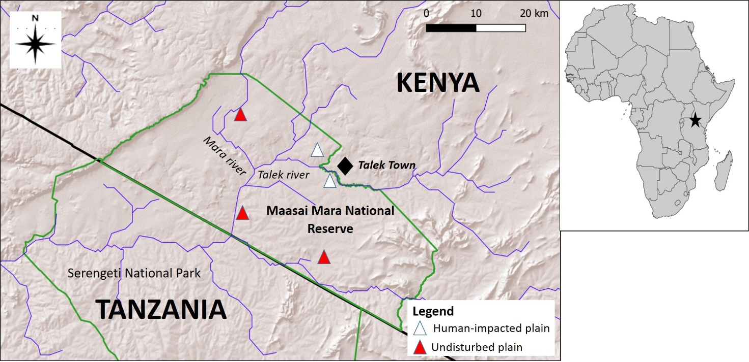
Figure 1

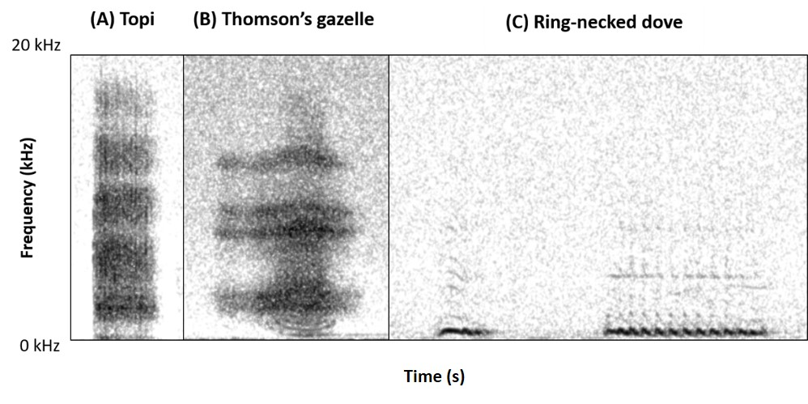
Figure 2

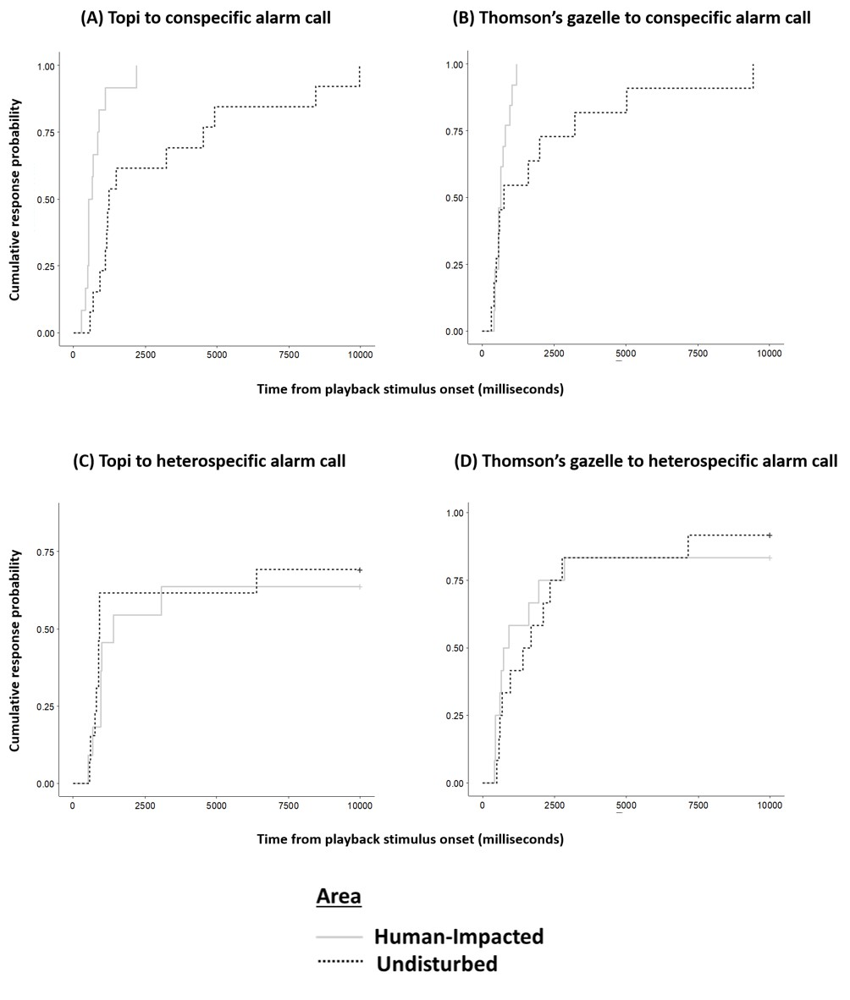
Figure 3

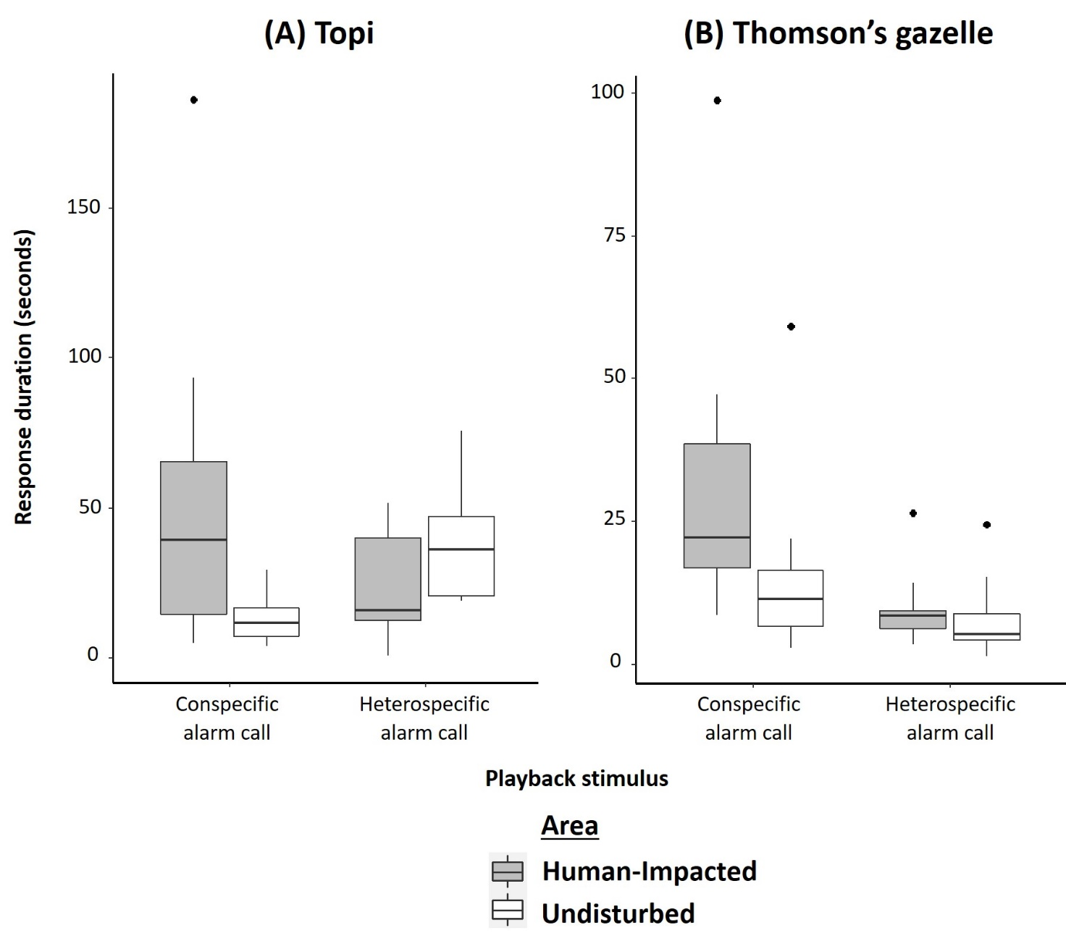
Figure 4

