Received 00th January 20xx,

1. Stephenson Institute for Renewable Energy, University of Liverpool, L69 7ZF, UK.
2. Department of Chemistry, Aarhus University, 8000 Aarhus C, Denmark.
3. Enapter S.R.L, via di Lavoria 56/g, 56040 Pisa.
4. Department of Mathematics, Physics and Electrical Engineering, Northumbria University, NE1 8ST, UK
5. Yusuf Hamied Department of Chemistry, University of Cambridge, CB2 1EW, UK

Electronic Supplementary Information (ESI) available: [details of any supplementary information available should be included here]. See DOI: 10.1039/x0xx00000x

Accepted 00th January 20xx

DOI: 10.1039/x0xx00000x

Hybrid photocathode based on Ni molecular catalyst and Sb2Se3 for solar H2 production

D. Alicia Garcia-Osorio,a Thomas P. Shalvey,a Liam Banerji,a Khezar Saeed,a,b Gaia Neri,a,c Laurie J. Phillips,a Oliver S. Hutter,a,d Carla Casadevall,e Daniel Antón-García,e Erwin Reisner,e Jonathan D Major,a* Alexander J Cowana*

We report the first H2 hybrid photocathode based on Sb2Se3 and a precious metal free catalyst, NiP. Through the use of a high surface area TiO2 scaffold, we successfully increased the NiP molecular catalyst loading from 7.08 ± 0.43 to 45.76 ± 0.81 nmol cm-2, achiving photocurrents of 1.3 mA cm2 at 0 V *vs* RHE, which is 81-fold higher than the device without the TiO2 mesoporous layer.

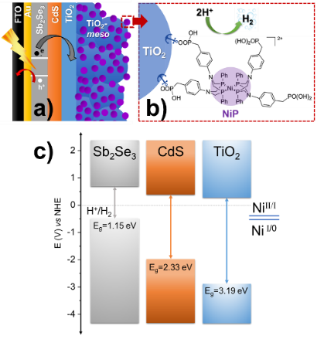Photoelectrodes for the production of solar fuels, for example by splitting water to generate H2 and O2,1 have the potential to play a key role in future energy systems. However, advances in both photoanodes for water oxidation2 and photocathodes for hydrogen evolution (HER) are neededto improve the stability and to lower the cost for industrial scaling, since most long-lasting devices rely on precious metals.3,4 Sb2Se3 has recently gained interest from the photovoltaic (PV) community due to its near-direct band gap of 1.18 eV, a high absorption coefficient across the visible region,5 and an unusual 1D nanoribbon structure that enables effective charge transport.6 These properties, combined with improvements in material processability and the use of earth-abundant elements, have led to the suggestion that Sb2Se3 could be a viable thin film PV material for use on a global scale.7 Sb2Se3 has also been studied as a photocathode for HER, the conduction band minimum at 0.5 V *vs* RHE provides enough driving force for producing H2,8 and its band gap (Eg) is very close to the optimal calculated for the bottom electrode in dual absorber standalone device for water splitting.9 Reported solar to hydrogen efficiencies, using state-of-the-art Sb2Se3 photocathodes, have now exceeded 10%.10,11 With these photocathodes a Sb2Se3/CdS buried junction is coated in a protective TiO2 capping layer. The planar TiO2 is then modified with a HER catalyst like Pt,12,13 RuO2,11,14 and MoSx.15 Notably, even with state-of-the-art devices, reductive dissolution of TiO2 caused by photoelectron accumulation can occur.10,12 C60 between TiO2 and the H2 catalyst can alleviate charge accumulation promoting the photoelectron transfer at the TiO2/Pt interface, but device stabilities are still low.10,12 Therefore, a need still exists to identify new active photoelectrode/catalysts systems that are able to keep up with the rate of photoelectron generation and to explore how the catalyst/TiO2 interface can be modified to prevent the generation of high-electron densities. Earth abundant molecular electrocatalysts have not previously been explored on Sb2Se3 photocathodes, even though they are an alternative to precious metal electrocatalysts and could potentially offer improved rates of charge transfer at the semiconductor/molecular catalyst interface.16,17 Here, **NiP** with a [Ni(P2R′N2R″)2]2+ core (P2R′N2R″ = bis(1,5-R′-diphospha-3,7-R″-diazacyclooctane), shown in Fig 1b) was chosen as model molecular catalyst.18 The **NiP** bio-inspired catalyst mimics the hydrogenase intramolecular proton transfer to the Ni centre through the pendant amine groups in the second coordination sphere.19 Furthermore, it can be covalently anchored to TiO2 by the phosphonic acid groups in the outer coordination sphere, Fig 1a.20

**Fig 1** (a) Schematic diagram of Sb2Se3/CdS/TiO2-*meso*/**NiP** hybrid photocathode (b) chemical structure of **NiP** catalyst molecular catalyst, panel a and b are not drawn to scale. (c) Equilibrium band alignment diagram of Sb2Se3/CdS/TiO2 heterojunction based on VBM10 and Eg measured separately for each layer (Fig. S2.1), note that **NiP** redox couple is pH independent.20

**Fig 2:** Chopped light LSV of the hybrid photocathodes Sb2Se3/CdS/TiO2/NiP (blue trace) and Sb2Se3/CdS/TiO2-*meso*/NiP (purple trace) at 10 mV s1. The TiO2-*meso* enables a higher loading of the NiP catalysts and increased photocurrents. All experiments are carried out in 0.1M Na2SO4 pH 3 at 100 mW cm2 and  > 340nm.



The complete device FTO/Au/Sb2Se3/CdS/TiO2/TiO2-meso/**NiP** is shown in Fig 1a. Sb2Se3 (1.5 m) was deposited on Au (70 nm) coated fluorine doped SnO2-glass (FTO) by a two-step fast-cooling close space sublimation process, which generates a compact preferentially orientated nanoribbon crystal structure that facilitates rapid hole transfer to the Au contact.6,10,11 Then, a thin sputtered CdS buffer layer (20nm) was added which forms a Sb2Se3 heterojunction with a negligible conduction band offset, thereby allowing efficient charge separation and electron transfer towards the TiO2 (Fig 1c).5 In this way, the onset potential and fill factor of the Sb2Se3 photocathodes are improved despite the parasitic absorption of photons below  < 500 nm in the CdS causing a decrease in the photocurrent.10,11 After, TiO2 (100 nm) was sputtered to provide a physical barrier preventing contact between the light absorber and the electrolyte.21 Full details of the synthetic procedures, the device characterisation and SEM images are provided in the supporting information, Figs S2.1-3.

The molecular catalyst was first immobilized overnight onto the sputtered TiO2 (without the TiO2-*meso*) by soaking the photoelectrode in dry methanolic solution (0.5 mM **NiP**), 18,22,23 and from now on labelled as Sb2Se3/CdS/TiO2/**NiP**. It was removed from the soaking solution, thoroughly washed in methanol to remove the non-chemisorbed catalyst and dried under vacuum. **NiP** loadings were determined by stripping the catalyst off using NaOH and then quantified by UV-vis spectroscopy, as shown in Table S1. When **NiP** was attached to the sputtered TiO2 layer, a loading of 7.08 ± 0.43 nmol cm2 was achieved. All the photoelectrochemical tests were done under 100 mW cm2 illumination (unless otherwise stated) and with  > 340 nm in 0.1 M Na2SO4 at pH 3. The pH electrolyte was chosen considering **NiP** the highest activity towards H2 production.22,24 Figure 2 shows a photocurrent of only 16 A cm2 at 0 V *vs* RHE, which exceeds only slightly the current in the absence of any catalyst (3 A cm2 for Sb2Se3/CdS/TiO2, Fig S2.4). The spikes in the light chopped Linear Sweep Voltammetry (LSV) of Sb2Se3/CdS/TiO2/**NiP** demonstrated that the photoelectrons are not being utilised at a fast-enough rate by the catalyst, instead recombination is dominating.25

The low photocurrent of the Sb2Se3/CdS/TiO2/**NiP** electrode is due to the low loading of **NiP** compared with previous devices.22,23 A common approach to achieve higher catalyst loadings on a photoelectrode is to increase the available surface area for catalyst binding by using a mesoporous TiO2 layer (TiO2-*meso*). Typically, following deposition of a TiO2 nanoparticle-organic binder paste, thermal annealing is carried out in air (~450 oC) to remove the binder and sinter the TiO2 nanoparticles forming conductive pathways.25 Sb2Se3 is unstable at these temperatures in air,7 therefore we modified a UV curing approach successfully developed by the Grätzel group for CuO2/AZO/TiO2 photocathodes.26 Following doctor blading of an anatase TiO2 paste (*av*. particle size 20 nm diameter) the sample was UV cured for 68 h using a 365 nm LED, Fig S2.5. Note that the Sb2Se3/CdS/TiO2*-meso* also included the sputtered 100 nm TiO2 layer since it was found to be essential during the UV curing to protect the Sb2Se3/CdS. The photocathode was then annealed at lower temperature (350 °C) under N2 to improve the electrochemical properties of the TiO2-*meso* layer (Fig S2.6-7) without hindering the light absorber capabilities (Fig S2.9). The TiO2*-meso* was *ca.* 4-6 m thick determined by profilometry, the cross-sectional image and Energy-dispersive X-ray spectroscopy (EDX) maps are shown Fig 3a and S2.10, respectively. Neither the UV curing nor the N2 annealing alone resulted in a TiO2-*meso* layer with electrical and mechanical features suitable for a molecular catalyst scaffold (Fig S2.5, S2.8). The NiP immobilization on the TiO2-*meso* device was carried out using the same experimental protocol than the planar structure. The resultant Sb2Se3/CdS/TiO2*-meso*/**NiP** photocathode achieved an increased **NiP** loading (45.76 ± 0.81 nmol cm2), in line with the literature.23 Top view EDX mapping shows the catalyst is evenly distributed on the photocathode surface (Fig S2.11). X-ray photoelectron spectroscopy (XPS) analysis of the **NiP** on the Sb2Se3/CdS/TiO2*-meso*/**NiP** electrode is shown in Fig 3b-d. The energies of the Ni 2p (Fig 3b, ½ at 872.1 eV and ¾ at 854.6 ), P 2p (Fig 3c, 132.6 eV) and N 1s (Fig 3d, 399.6 eV) peaks are in good agreement with the **NiP** catalyst prior to immobilisation (all the XPS peak positions are shown in Table S2).22–24 The complete Sb2Se3/CdS/TiO2*-meso*/**NiP** photocathode achieves a photocurrent of 1.3 mA cm2 at 0 V *vs* RHE with an onset potential of *ca.* +0.37 V *vs* RHE (Fig 2). The photocurrent for this electrode structure is amongst the highest reported for a **NiP** decorated photocathodes, Table S3 provides the state-of-the-art hybrid photocathodes for H2 production. **NiP** has been previously used with a Si/TiO2-*meso* photocathode to achieve a photocurrent of 0.3 mA cm2 at 0 V *vs* RHE23 and 0.6 mA cm2 at 0 V *vs* RHE for a 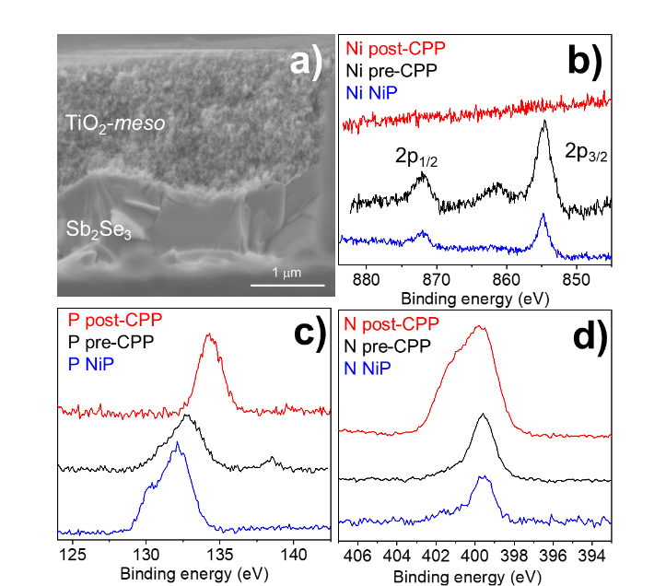La5Ti2Cu0.9Ag0.1S5O7/TiO2 photocathode.22 A control experiment without the catalyst (Sb2Se3/CdS/TiO2*-meso*, Fig S2.4) demonstrates the importance of the **NiP** catalyst, it showed a photocurrent of only 0.12 mA cm2 at 0 V *vs* RHE. Incident photon to current efficiency (IPCE, Fig S2.12) demonstrates the device is active at wavelengths up to 900 nm (at 0 V *vs* RHE), in-line with the Eg of Sb2Se3.5, 6

**Fig 3** (a) Cross-sectional SEM image of Sb2Se3/CdS/TiO2*-meso*/**NiP**. XPS spectra of **NiP** molecular catalyst (blue trace) after it is immobilized on TiO2 (pre-CPP,black trace), and after 5 h of CPP test at 0 V *vs* NHE (post-CPP, red trace) with light intensity of 100 mW cm-2 and  > 340nm in 0.1M Na2SO4 at pH 3. (b, c, d) XPS spectra showing Ni 2p, P 2p and N 1s regions respectively.

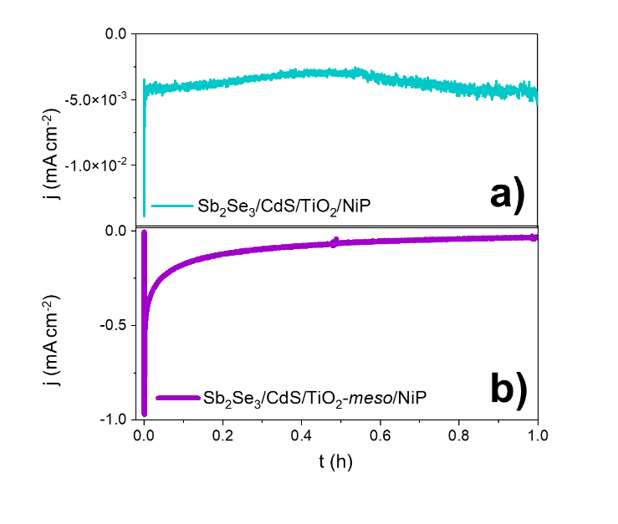Controlled potential photoelectrolysis (CPP) carried out at 0 V *vs* RHE assessed the stability of the Sb2Se3/CdS/TiO2*-meso*/**NiP** electrode, results shown in Fig 4. The H2 Faradaic efficiency after 1 h was 77.5 ± 9.1%, giving a TON**NiP** of 12.8 ± 2.8. However, the photocurrent decreased significantly in the first hour reaching 40 A cm2 and by 5 hours, it decreased to only 15 A cm2 (Fig S2.13). The loss of photoactivity of **NiP** photoelectrodes has previously been attributed to the hydrolysis of the phosphonic anchoring group from the TiO2.22,23 XPS analysis of the hybrid photocathode post CPP shows the loss of the Ni2+ bands (red trace, Fig 3b). However, it is clear that both the N 1s and P 2p signals are still present, although significantly shifted. A broadening of the N 1s band has previously been assigned to protonation of the amine in the acidic electrolyte22 and the shifting of the P band is due to the loss of the metal centre.27 The XPS results suggest the phosphonate linkage has been retained but the Ni is no longer coordinated to the ligand, in-line with the stability of the phosphonate linkage at pH < 7.28 Past studies have shown that **NiP** degradation occurs on photocathodes but with a slower decay rate.22,23

To explore the mechanism of the hybrid photocathode decay here, we examined the TiO2-*meso*/**NiP** interface (without Sb2Se3/CdS).  CPE at 0.24 V vs RHE (Fig S2.7b), shows that following an initial drop in the current in the first 600 s, the electrode maintains a stable current of 0.24 mA cm2 for 1h suggesting that the TiO2*-meso*/**NiP** interface is stable at this potential and capable of dealing with low current density. However, the current spikes observed with Sb2Se3/CdS/TiO2*-meso*/**NiP** when the light is turned off in Fig 2 are typical features of electron accumulation in the TiO2, suggesting that the **NiP** catalyst was unable to turnover at the rate of photoelectron generation under 100 mW cm-2 illumination. Based on the concentration of immobilised **NiP** (45.76 ± 0.81 nmol cm2), and the highest reported turnover frequency of **NiP** (460  5 h1),20 we calculate that the **NiP** on the surface could support a photocurrent of 1.15 mA cm2. This magnitude of photocurrent is achieved briefly in the LSV, but CPP shows the photocurrent decreases rapidly as the **NiP** catalyst degrades. To assess the photoelectron generation of Sb2Se3/CdS/TiO2*-meso*, we used Pt as co-catalyst (see ESI for synthetic details, Fig S2.14). The Sb2Se3/CdS/TiO2*-meso*/Pt electrode achieved a stable photocurrent of 3 mA cm2 at 0 V *vs* RHE for 5 hours. It is clear that the rate of photoelectron generation at the Sb2Se3/CdS interface greatly exceeds the maximum current density that **NiP** can sustain. The catalytic mechanism of **NiP** is shown in figure S2.15,19  where H2 production occurs following the NiII/I reduction. Further reduction from NiI to Ni0 can also potentially occur deactivating the catalyst if the rate of photoelectron generation is too high.29 To explore if limiting the photoelectron generation on the Sb2Se3 would be beneficial, experiments at 20 mW cm-2 (Fig S2.16, 17) were carried out. Notably, only a small decrease in photocurrent was observed from 1.30 to 0.81 mA cm-2 at 0 V *vs* RHE, and 20% of photocurrent was retained after 1800 s compared with the 11% at 100 mW cm-2.

Past studies using precious metal HER catalysts like Pt on planar TiO2 coated Sb2Se3 photocathodes have noted that dissolution of TiO2 can also occur due to photoelectron accumulation.10,12 The SEM images post-CPP Sb2Se3/CdS/TiO2*-meso*/**NiP** electrodes (tested at 100 mW cm-2) did not show significant change in the morphology of the device (Fig S2.18) despite the demonstration of electron accumulation in the device. XRD analysis of a post-CPP sample also only showed the typical peaks of Sb2Se3 and TiO2 (Fig S2.19) and no indication of Sb2O3 formation, which has been associated with the deactivation of the Sb2Se3 photoelectrodes (Fig S2.20).11,12 However experiments where (i) Sb2Se3/CdS/TiO2*-meso*/**NiP** underwent LSV and CPP measurements at 0 V *vs* RHE for 1h, (ii) removal of any remaining **NiP** by NaOH stripping, and (iii) Pt addition and photoelectrochemical testing showed evidence of partial failure of the sputtered TiO2 layer due to photoelectron accumulation. Significantly higher dark currents (< 5 mA cm2, Fig S2.21) and decreased photocurrents were measured compared to a pristine platinized photoelectrode, reinforcing the importance of preventing photoelectron accumulation in the Sb2Se3/CdS/TiO2*-meso*/**NiP** photocathode.

**Fig 4:** CPP at 0 V *vs* RHE of the hybrid photocathodes Sb2Se3/CdS/TiO2/**NiP** (a) and Sb2Se3/CdS/TiO2*-meso*/**NiP** (b) in 0.1M Na2SO4 pH 3 at 100 mW cm2 and  > 340 nm.

Conclusions

Emergent chalcogenides semiconductors such as Sb2Se3 are promising photocathodes due to their ability to achieve a high rate of photoelectron generation but they suffer from thermal instability limiting processing opportunities. Furthermore, Sb2Se3 interfaces need to be protected by metal oxide capping layers where corrosion could occur due to photoelectron accumulation. To prevent electron accumulation research has focused on the use of these absorbers with precious metal HER catalysts. Here we present an alternative approach using a Sb2Se3/CdS/TiO2*-meso* photocathode. The high surface area TiO2 support, prepared by a UV and low temperature N2 annealing process that is compatible with Sb2Se3, enables a high loading of an earth abundant molecular HER catalyst, **NiP**. An 81-fold increase in the photocurrent was achieved when compared to a similar device without the mesoporous TiO2. Despite the high catalyst loading, stability and activity under 100 mW cm-2 is still limited by the turnover frequency of the HER catalyst. However, initial experiments under low light intensities indicate that improved stability are achievable with further advances in the catalytic turnover frequency.

Conflicts of interest

There are no conflicts to declare

**Acknowledgments**

We thank the studentship financial support from CONACYT-SENER (556479, DAGO), EPSRC (DTA, DAG), the UKRI Cambridge Creative Circular Plastics Centre (EP/S025308, ER, CC), and the European Commission for Horizon 2020 Marie Skłodowska‐Curie Individual Fellowships (890745‐SmArtC, CC). EPSRC is acknowledged for funding though EP/P034497/1, EP/N014057/1 and EP/V011863/1. Prof L. Hardwick and Facility for XPS (“HarwellXPS”) are thanked for the Raman spectroscopy access and the XPS data collection (Contract No. PR16195).

**Notes and references**

1 S. Ye, C. Ding, R. Chen, F. Fan, P. Fu, H. Yin, X. Wang, Z. Wang, P. Du and C. Li, J. Am. Chem. Soc, 2018, 140, 32.

2 S. Ye, C. Ding, M. Liu, A. Wang, Q. Huang and C. Li, Advanced Materials, 2019, 31, 1902069.

3 H. Song, S. Luo, H. Huang, B. Deng and J. Ye, ACS Energy Lett, 2022, 7, 1043–1065.

4 R. M. Irfan, D. Jiang, Z. Sun, L. Zhang, S. Cui and P. Du, J Catal, 2017, 353, 274–285.

5 H. Shiel, O. S. Hutter, L. J. Phillips, J. E. N. Swallow, L. A. H. Jones, T. J. Featherstone, M. J. Smiles, P. K. Thakur, T. L. Lee, V. R. Dhanak, J. D. Major and T. D. Veal, ACS Appl Energy Mater, 2020, 3, 11617–11626.

6 O. S. Hutter, L. J. Phillips, K. Durose and J. D. Major, Solar Energy Materials and Solar Cells, 2018, 188, 177–181.

7 A. Mavlonov, T. Razykov, F. Raziq, J. Gan, J. Chantana, Y. Kawano, T. Nishimura, H. Wei, A. Zakutayev, T. Minemoto, X. Zu, S. Li and L. Qiao, Solar Energy, 2020, 201, 227–246.

8 S. Chen, T. Liu, Z. Zheng, M. Ishaq, G. Liang, P. Fan, T. Chen and J. Tang, Journal of Energy Chemistry, 2022, 67, 508–523.

9 B. A. Pinaud, J. D. Benck, L. C. Seitz, A. J. Forman, Z. Chen, T. G. Deutsch, B. D. James, K. N. Baum, G. N. Baum, S. Ardo, H. Wang, E. Miller and T. F. Jaramillo, Energy Environ Sci, 2013, 6, 1983.

10 W. Yang, J. Park, H.-C. C. Kwon, O. S. Hutter, L. J. Phillips, J. Tan, H. Lee, J. Lee, S. D. Tilley, J. D. Major and J. Moon, Energy Environ Sci, 2020, 13, 4362–4370.

11 W. Yang, J. H. Kim, O. S. Hutter, L. J. Phillips, J. Tan, J. Park, H. Lee, J. D. Major, J. S. Lee and J. Moon, Nat Commun, 2020, 11, 1–10.

12 J. Tan, W. Yang, Y. Oh, H. Lee, J. Park, R. Boppella, J. Kim and J. Moon, Adv Energy Mater, 2019, 1900179, 1–12.

13 J. Park, W. Yang, J. Tan, H. Lee, J. W. Yun, S. G. Shim, Y. S. Park and J. Moon, ACS Energy Lett, 2020, 5, 136–145.

14 W. Yang, S. Lee, H.-C. Kwon, J. Tan, H. Lee, J. Park, Y. Oh, H. Choi and J. Moon, ACS Nano, 2018, 12, acsnano.8b05446.

15 R. R. Prabhakar, W. Septina, S. Siol, T. Moehl, R. Wick-Joliat and S. D. Tilley, J Mater Chem A Mater, 2017, 5, 23139–23145.

16 F. Niu, D. Wang, F. Li, Y. Liu, S. Shen and T. J. Meyer, Adv Energy Mater, 2019, 1900399, 1–24.

17 W. Jiang, X. Yang, F. Li, Q. Zhang, S. Li, H. Tong, Y. Jiang and L. Xia, 1414 | Chem. Commun, 2019, 55, 1414.

18 M. L. Helm, M. P. Stewart, R. M. Bullock, M. R. DuBois and D. L. DuBois, Science (1979), 2011, 333, 863–866.

19 W. J. Shaw, M. L. Helm and D. L. du Bois, Biochim Biophys Acta Bioenerg, 2013, 1827, 1123–1139.

20 M. A. Gross, A. Reynal, J. R. Durrant and E. Reisner, J Am Chem Soc, 2014, 136, 356–366.

21 A. Paracchino, V. Laporte, K. Sivula, M. Grätzel and E. Thimsen, Nat Mater, 2011, 10, 456–461.

22 T. E. Rosser, T. Hisatomi, S. Sun, D. Antón-García, T. Minegishi, E. Reisner and K. Domen, Chemistry - A European Journal, 2018, 24, 18393–18397.

23 J. J. Leung, J. Warnan, D. H. Nam, J. Z. Zhang, J. Willkomm and E. Reisner, Chem Sci, 2017, 8, 5172–5180.

24 T. E. Rosser, M. A. Gross, Y. H. Lai, E. Reisner, B. C. M. Martindale, G. A. M. Hutton, C. A. Caputo, E. Reisner, M. A. Gross, A. Reynal, J. R. Durrant, E. Reisner, J. J. Leung, J. Warnan, D. H. Nam, J. Z. Zhang, J. Willkomm and E. Reisner, Chem Sci, 2016, 7, 4024–4035.

25 T. Berger, D. Monllor-Satoca, M. Jankulovska, T. Lana-Villarreal and R. Gomez, ChemPhysChem, 2012, 13, 2824–2875.

26 M. Schreier, J. Luo, P. Gao, T. Moehl, M. T. Mayer and M. Grätzel, J Am Chem Soc, 2016, 138, 1938–1946.

27 NIST X-ray Photoelectron Spectroscopy (XPS) Database, Version 3.5, https://srdata.nist.gov/xps/, (accessed 26 July 2022).

28 K. L. Materna, R. H. Crabtree and G. W. Brudvig, Chem Soc Rev, 2017, 46, 6099–6110.

29 A. Ruff, S. Janke, J. Szczesny, S. Alsaoub, I. Ruff, W. Lubitz and W. Schuhmann, ACS Appl Energy Mater, 2019, 2, 2921–2929.