Interface Engineered Ni-coated CdTe Heterojunction Photocathode for Enhanced Photoelectrochemical Hydrogen Evolution

Jing-Xin Jian,^{1,2} Ming-Ming Yao,² Asim Mumtaz,³ Tom Baines,⁴ Jonathan D Major⁴ Qing-Xiao Tong² and Jianwu Sun^{1,*}

¹ Department of Physics, Chemistry and Biology (IFM), Linköping University, SE-58183, Linköping, Sweden.
² Department of Chemistry, Key Laboratory for Preparation and Application of Ordered Structural Materials of Guangdong Province, Shantou University, Shantou, Guangdong 515063, P. R. China
³ School of Physics, Electronics & Technology, University of York, Heslington, York, YO10 5DD, United Kingdom
⁴ Stephenson Institute for Renewable Energy, University of Liverpool, L69 7ZF, UK.
* Corresponding author: Jianwu Sun, Department of Physics, Chemistry and Biology (IFM), Linköping University, SE-58183, Linköping, Sweden, E-mail: jianwu.sun@liu.se

Abstract
Photoelectrochemical (PEC) water splitting for hydrogen production using CdTe photocathode has attracted much interest due to its excellent sunlight absorption property and energy band structure. This work presents a study of engineered interfacial energetics of CdTe photocathode by deposition of CdS, TiO₂ and Ni layers. A heterostructure CdTe/CdS/TiO₂/Ni photocathode was fabricated by depositing 100-nm n-type CdS layer on p-type CdTe surface, with a 50-nm TiO₂ as a protective layer and a 10-nm Ni layer as a co-catalyst. The CdTe/CdS/TiO₂/Ni photocathode exhibits a high photocurrent density (J_{ph}) of 8.16 mA/cm² at 0 V versus reversible hydrogen electrode (V_{RHE}) and a positive-shifted onset potential (E_{onset}) of 0.70 V_{RHE} for PEC hydrogen evolution under 100 mW/cm² AM1.5G illumination. We further demonstrate that the CdTe/CdS p-n junction promotes the separation of photogenerated carriers, the TiO₂ layer protects the electrode from corrosion, and the Ni catalyst improves the charge transfer across the electrode/electrolyte interface. This work provides new insights for designing noble-metal free photocathodes towards solar hydrogen development.

1. Introduction
Due to the high energy density of 142 MJ/kg and a clean output (water), solar-driven photoelectrochemical (PEC) for hydrogen (H₂) production from water splitting has vast potential. Solar driven PEC water splitting provides a sustainable and storable energy source assisting in reducing society’s dependence on fossil fuels, consequently reducing CO₂ emissions, and improving the ecological environment.¹⁻⁹ Although much research effort has been dedicated to the PEC water splitting systems for solar-to-hydrogen (STH) conversion during past decades,¹⁰⁻¹⁹ it is still very challenging to develop a low-cost solar-driven PEC water splitting cell with a high STH conversion efficiency and long-term stability.^{20, 21}
Cadmium telluride (CdTe) is an attractive candidate for hydrogen production via PEC water splitting due to its excellent optical absorption characteristics, band structure and stability, .²²⁻²⁷ As a direct semiconductor with a bandgap of 1.5 eV, CdTe exhibits a wide range absorption from ultraviolet to infrared sunlight (until 830 nm) and a high absorption coefficient of >10⁴ cm⁻¹ at the wavelengths smaller than 800 nm.²⁸ It has been extensively demonstrated that CdTe is an excellent absorbing material in the application of photovoltaic devices. Since the pioneering work of K. Ohashi et al. in 1977,^{29, 30} the p-type CdTe as a photocathode for the PEC water splitting has also attracted much interest. Recently, it has denmonstrated the CdTe/CdS heterojunction photocathodes with the deposited the noble metal platnium (Pt) as the hydrogen evolution reaction (HER) co-catalyst exhibit an increased photocurrent and a significant shift of the onset potential.^{28, 31-33} Moreover, the Au/Cu/CdTe (CdCl₂)/CdS/Pt photocathode has shown a remarkably high incident photon-to-current conversion efficiency (IPCE) of >95% at 560–660 nm with an applied potential of 0 V versus reversible hydrogen electrode (V_{RHE}).³² However, the CdS layer generally suffers from corrosive degradationand CdS/Pt overlayers can be removed during the PEC tests, resulting in the decrease of the photocurrent and overall instability of the PEC device. Moreover, the reported CdTe-based photocathodes employed the noble-metal Pt as the HER catalyst, which increases the cost of the PEC cells and hinders the future practical applications for low-cost hydrogen production.
In this work, we introduce a new strategy to protect a CdTe/CdS heterojunction photocathode and to enhance its PEC water splitting performance by depositing the earth-abundant and low-cost materials. Briefly, CdTe-based photocathodes were fabricated by depositing an n-type CdS layer on the p-type CdTe forming a p-n heterojunction. The n-type TiO₂ layer was deposited on either CdTe or CdS as a protective layer for comparison. Following, this nickel (Ni), as the HER co-catalyst, was deposited on the CdTe-based photocathodes by the vacuum evaporation. The benefit of using Ni is that it is earth-abundant and low-cost as compared to Pt. The optimal CdTe/CdS/TiO₂/Ni photocathode exhibits a high photocurrent density (J_{ph}) of 8.16 mA/cm² at 0 V_{RHE} under 100 mW/cm² AM1.5G illumination. Mechanism investigation revealed that the p-n junction of CdTe/CdS promotes the separation of photogenerated carriers, the TiO₂ layer protects the photocathodes from corrosion, and the Ni co-catalyst improves the charge transfer across the electrode/electrolyte interface.

2. Experimental Section
2.1. The preparation of CdTe-based photocathodes
A number of different devices configurations were fabricated for this comparative study, including CdTe, CdTe/Ni, CdTe/CdS/Ni, CdTe/TiO₂/Ni and CdTe/CdS/TiO₂/Ni,. All devices were deposited on NSG Ltd soda lime TEC™ 15 glass (Florine doped SnO₂ (FTO) coated glass). The CdTe layer was grown using Close space sublimation (CSS), using a source and substrate temperature of 610°C and 510°C respectively. The growth was performed with an initial higher-pressure of 30 torr N₂ for 14 minutes, followed by a lower pressure growth at 1 torr for 30 seconds. The purpose for this two-step process was to have larger grain sizes under higher pressure conditions and minimize pin holes in the film using the lower pressure. The CdTe films were subsequently chlorine treated to passivate the grain boundaries and has the effect of slight recrystallization of the CdTe grains, both of which improve its optoelectronic properties (Major, 2016). For the chlorine treatment MgCl₂ was spray deposited and subsequently annealed in an air ambient at 430 °C for 20 min (Major et al., 2014). An etch step is then necessary to remove any surface contaminants. A wet etch using a nitric - phosphoric acid (NP) solution is applied for 15 s.
The CdS layers were deposited via radio frequency (RF) magnetron sputtering with an approximate thickness of 80nm. Sputtering took place at room temperature with a chamber pressure of 5 mTorr (0.66 Pa) using sputtering gas of Ar and a target power density of 1.32 W cm⁻². A chamber base pressure of 1.9 × 10⁻⁵ Torr (2.53 mPa) was reached. The CdS layers were approximately 80nm in thickness. The TiO2 layers were deposited. The TiO₂ layers were deposited using a spin coating technique over two stages. A solution of titanium isopropoxide in ethanol was used. The first step used a a 0.15 M solution deposited using spin-coating at 3000 rpm⁻¹ for 30 s and then annealed at 110 °C for 10 min. The next step was a deposition of a 0.3 M solution again using the same spin coating conditions also followed by the same anneal step as before. The resultants layer is heated in air at 550 °C for a duration of 30 min. These steps follow similiar steps as completed in previous studies such as (Baines et al., 2018). The target thickness for the TiO₂ was 50nm.
The Ni nanoparticles were deposited on the surface of CdTe, CdTe/CdS, CdTe/TiO₂ and CdTe/CdS/TiO₂ photocathodes by the vacuum evaporation. The thickness of Ni layer was adjusted to optimize the PEC performance of Ni-coated CdTe/CdS/TiO₂ photocathodes. The results show that the 10-nm thick Ni layer exhibits the best PEC performance, as illustrated in Figure S1.
2.2 PEC characterizations
PEC measurements were carried out in a typical three-electrode configuration in 0.1 M NaH₂PO₄ solution (NaPi, pH = 5) using a potentiostat (Princeton Applied Research, VersaSTAT 3). The electrolyte solution was purged with the high purity (99.999%) Ar gas for over 30 min before the PEC measurements. A standard simulated sunlight (AM1.5G 100 mW/cm²) is generated from a AAA solar simulator (LOT-Quantum Design GmbH). A Pt plate (1 × 1 cm²) and an Ag/AgCl (saturated KCl) electrode were used as the counter electrode and the reference electrode, respectively. Current density-potential (j–V) measurements were carried out at a scan rate of 30 mV/s with the chopped illumination. The measured potential with respect to Ag/AgCl (V_{Ag/AgCl}) was converted to the potential versus reversible hydrogen electrode (V_{RHE}) using the following equation: V_{RHE} = V_{Ag/AgCl} + 0.197 + 0.059 × pH, where V_{Ag/AgCl} is the measured potential with respect to the Ag/AgCl reference electrode. The evolved H₂ gas was measured using a micro gas chromatograph (Agilent Technologies 490 Micro GC) at 0 V_{RHE} under steady-state AM1.5G 100 mW/cm² illumination in 0.1 M NaPi solution. The Faradaic efficiency of H₂ gas evolution was determined by a comparison of the detected volume of H₂ gas and the calculated volumes of H₂ gas with a theoretical 100% faradaic efficiency. SEM images were collected using a LEO 1550 Gemini instrument with an X-Max silicon drift detector (Oxford instruments).

3. Results and Discussion
3.1 PEC performance of the pristine CdTe photocathode
Figure 1 exhibits the PEC performance of the pristine CdTe photocathode in an Ar-purged 0.1 M NaH₂PO₄ (NaPi) electrolyte (pH = 5.0). Current density-potential (J-V) and current density-time (J-t) curves were measured under the chopped 100 mW/cm² AM1.5G illumination so that the dark and photo- current could be monitored simultaneously (Figure 1). The pristine CdTe photocathode exhibits a significant transient photocurrent under chopped illumination, indicating a strong charge recombination and the sluggish HER catalytic performance at the surface of the CdTe.^{17, 21} In the J-t curve measured at 0 V_{RHE} (Figure 1B), the transient photocurrent decays from -1.0 mA cm⁻² to around -0.5 mA cm⁻². Due to the surface corrosion, the pristine CdTe photocathode exhibited a large dark current of ~ -0.25 mA/cm², which results in a rather small the photocurrent (J_{ph}) of -0.25 mA/cm² at 0 V_{RHE}.
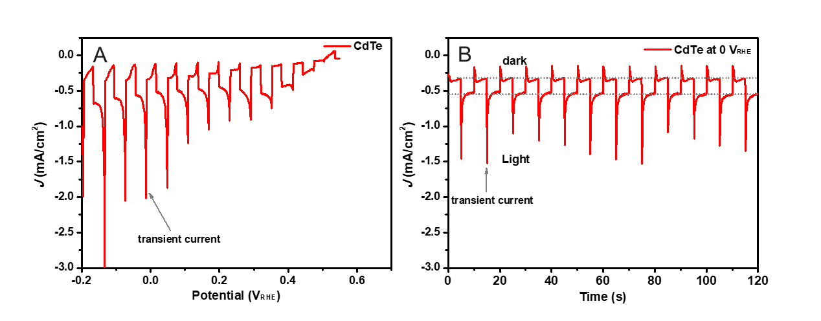
Figure 1. The current density-potential (J-V) curve (A) and current density-time (J-t) curve (B) of the pristine CdTe photocathode in 0.1 M NaPi electrolyte solution (pH = 5) under chopped AM1.5G 100 mW/cm² illumination.

3.2 Ni-coated CdTe heterojunction photocathode
To enhance the photocurrent of the CdTe photocathode, most reported works used the noble metal Pt as the HER co-catalyst to improve H₂ evolution efficiency.^{28, 32-34} In this work, we employed TiO₂ as a protective layer and the earth-abundant and low costmetal Ni as the HER co-catalyst to boost overall PEC performance of the CdTe/CdS heterojunction photocathode. To optimize the thickness of Ni layer, we deposited 2, 5, 10, and 50 nm Ni layer on the CdTe/CdS/TiO₂ photocathodes, respectively. The chopped J-V curves shown in Figure S1 demonstrated that 10-nm thick Ni layer exhibits the best PEC performance (the highest photocurrent density and the largest on-set potential). To elucidate the role of each layer on the improvement of PEC performance, we deposited 10-nm Ni layer on the surface of CdTe, CdTe/CdS, and CdTe/CdS/TiO₂, respectively for a comparative study. Figure 2A-C shows the surface morphologies of the 10-nm Ni coated CdTe, CdTe/CdS, and CdTe/CdS/TiO₂, indicating the identical Ni nanoparticles deposited on their surfaces. The thickness of each layer of the CdTe(2µm)/CdS(100nm)/TiO₂(50nm)/Ni(~10nm) photocathode is shown in the cross-sectional SEM image (Figure 2D).

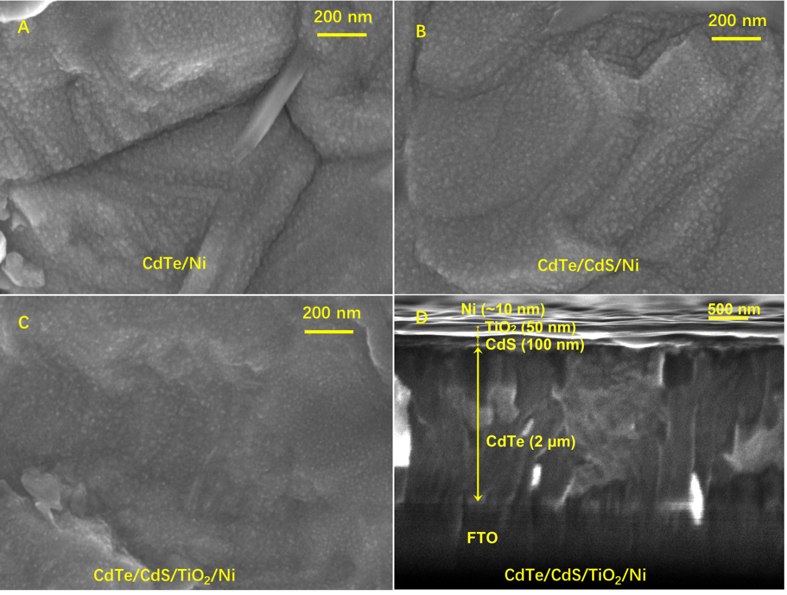

Figure 2. Top-view SEM images of the 10-nm Ni coated CdTe (A), CdTe/CdS (B), and CdTe/CdS/TiO₂ (C). (D) Cross-sectional view SEM image of the 10-nm Ni coated CdTe/CdS/TiO₂.

Figure 3 compares the J-V curves of CdTe, CdTe/CdS, and CdTe/CdS/TiO₂ photocathodes with and without 10-nm Ni co-catalyst. As shown in Figure 3A, the CdTe/Ni photocathode exhibits a slightly positive-shifted onset potentials (E_{onset}) of 0.55 V_{RHE} and a high J_{ph} of -1.25 mA/cm², which is five times higher than that of the pristine CdTe photocathode. The result indicates that the Ni co-catalyst promotes the H₂ evolution activities of CdTe photocathode. However, CdTe/Ni photocathode still shows a significant transient current and same J_{dark} with respect to the pristine CdTe photocathode. This suggests that charge recombination and surface corrosion issues still exist, which limits the improvement of photocurrent.
To suppress the charge recombination and corrosion during PEC water reduction, the interfaces of CdTe photocathodes were engineered by introducing an n-type TiO₂ layer with/without an n-type CdS layer on top of the CdTe.^{23, 32, 33, 35-37} The photocurrent behaviors of heterojunction photocathodes were measured at the same conditions as the CdTe photocathode. As seen in Figure 3B, the TiO₂-coated CdTe (CdTe/TiO₂) photocathode exhibits an extraordinarily low J_{dark} of -0.00 mA cm⁻² at 0 V_{RHE}, a very low J_{ph} of -0.13 mA cm⁻² at 0 V_{RHE} and E_{onset} of 0.38 V_{RHE}. In contrast, the CdS-coated CdTe (CdTe/CdS) photocathode exhibits a low J_{dark} of -0.06 mA cm⁻² at 0 V_{RHE}, a high J_{ph} of -0.53 mA cm⁻² at 0 V_{RHE} and E_{onset} of 0.45 V_{RHE} (Figure 3C). The transient current behaviors of CdTe/TiO₂ and CdTe/CdS photocathodes are significantly suppressed under chopped illumination, due to the enhancement of the charge separation in the formed p-n heterojunction. This result indicates that CdTe/CdS distinctly outperforms CdTe/TiO₂ to achieve a higher photocurrent, while TiO₂ could form a protective layer that significantly reduces the dark current from corrosion.
The 10-nm thick of Ni catalyst layers were deposited on the CdTe/TiO₂ and CdTe/CdS photocathodes to improve their HER activities. In the J-V curves under chopped illumination, the CdTe/CdS/Ni photocathode shows a J_{dark} of -0.43 mA cm⁻² at 0 V_{RHE}, an enhanced J_{ph} of -1.56 mA cm⁻² at 0 V_{RHE} and E_{onset} of 0.50 V_{RHE} (Figure 3C), while the CdTe/TiO₂/Ni photocathode shows a low J_{dark} of -0.02 mA cm⁻² at 0 V_{RHE}, J_{ph} of -0.22 mA cm⁻² at 0 V_{RHE} and E_{onset} of 0.44 V_{RHE} (Figure 3B), respectively. The Ni-coated photocathodes exhibit enhanced photocurrent than its counterpart without Ni catalyst, indicating that the Ni catalyst is a promising HER catalyst to boost H₂ evolution. The increased dark current of CdTe/CdS/Ni photocathode was caused by the surface corrosion.

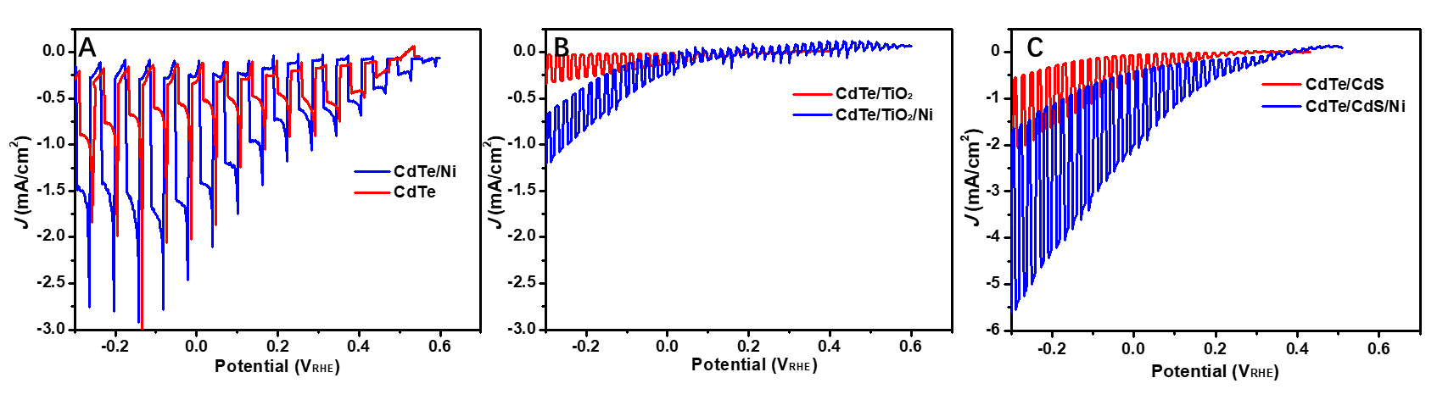
Figure 3. The J-V curves of CdTe (A), CdTe/TiO₂ (B), CdTe/CdS (C) photocathodes with (blue lines) and without (red lines) 10-nm Ni co-catalyst, in 0.1 M NaPi electrolyte solution (pH = 5) and under chopped illumination of AM1.5G 100 mW/cm².

3.3 CdTe/CdS/TiO₂/Ni photocathode
Although the CdTe/CdS p-n heterojunction improves the photoelectrochemical water splitting performance, it still suffers from the poor stability. To address this issue, a CdTe/CdS/TiO₂ photocathode was fabricated to synergistically enhance both the photocurrent and stability. As shown in Figure S1, the CdTe/CdS/TiO₂ photocathode exhibits a significantly enhanced J_{ph} of -3.68 mA cm⁻² at 0 V_{RHE} and a negligibly low dark current. As shown in Figure 4 and S1, the 10-nm Ni coated CdTe/CdS/TiO₂ photocathode exhibits the largest E_{onset} of 0.70 V_{RHE} and the highest J_{ph} of -8.16 mA/cm² at 0 V_{RHE} under 100 mW/cm² AM1.5G illumination (Table 1). This photocurrent is 2.22-folds of CdTe/CdS/TiO₂ photocathode and 32.6-folds of the CdTe photocathode, and is comparable with the reported results with noble metal Pt coated CdTe photocathode.³² This result indicates that the deposition of CdS on CdTe is essential to form a p-n heterojunction which significantly promotes the separation of photogenerated carriers while the TiO₂ layer protects the photocathodes against surface corrosion.
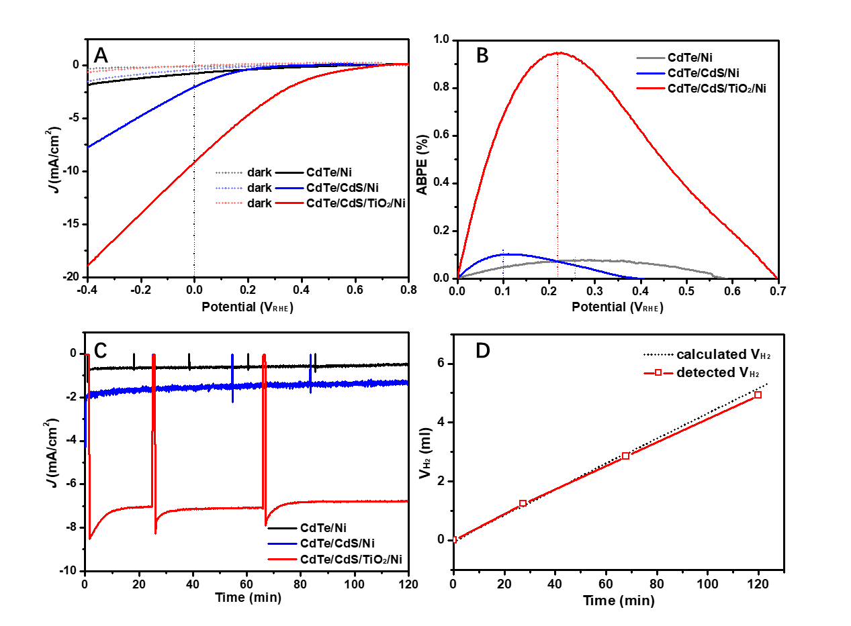
Figure 4. The J-V curves (A) and applied bias photo-to-current efficiency (ABPE) curves (B) of CdTe/Ni, CdTe/CdS/Ni and CdTe/CdSe/TiO₂/Ni photocathodes in 0.1 M NaPi electrolyte solution (pH = 5) under chopped AM1.5G 100 mW/cm² illumination. (C) The J-t curve of CdTe/Ni, CdTe/CdS/Ni and CdTe/CdSe/TiO₂/Ni photocathodes in 0.1 M NaPi electrolyte solution (pH = 5) under stated AM1.5G 100 mW/cm² illumination. (D) Measured H₂ volume of CdTe/CdSe/TiO₂/Ni photocathode under the condition of (C). The black dotted line shows the theoretical volume of H₂ with 100% faradaic efficiencies.

Table 1. PEC performance of the CdTe-based photocathodes.
Photocathodes | A  (cm²) | j_{dark, 0V}  (mA/cm²) | j_{ph, 0V}  (mA/cm²) | E_{onset} (V_{RHE}) | ABPE (%) | V_{ABPEmax} (V_{RHE})
CdTe | 0.5 | -0.05 | -0.25 | 0.45 | 0.01 | 0.23
CdTe/Ni | 0.5 | -0.06 | -1.25 | 0.45 | 0.08 | 0.26
CdTe/CdS | 0.8 | -0.06 | -0.53 | 0.43 | 0.03 | 0.12
CdTe/CdS/Ni | 1.0 | -0.43 | -1.56 | 0.50 | 0.10 | 0.10
CdTe/TiO₂ | 0.9 | -0.00 | -0.13 | 0.38 | 0.01 | 0.12
CdTe/TiO₂/Ni | 0.5 | -0.02 | -0.22 | 0.44 | 0.02 | 0.15
CdTe/CdS/TiO₂ | 0.9 | -0.04 | -3.68 | 0.45 | 0.18 | 0.11
CdTe/CdS/TiO₂/Ni | 0.9 | -0.08 | -8.16 | 0.70 | 0.95 | 0.22

Figure 4B shows the applied bias photo-to-current efficiency (ABPE) curves of CdTe/Ni, CdTe/CdS/Ni and CdTe/CdS/TiO₂/Ni photocathodes. ABPE is given by the following equation: ABPE = │J_{ph}│× E / P_{AM1.5G}, where P_{AM1.5G} is the light density of simulated sunlight (AM1.5G 100 mW/cm²), E is applied potential.²¹ The Ni-coated photocathodes demonstrated significant higher ABPE than their counterparts without Ni catalyst (Table 1). The optimal CdTe/CdS/TiO₂/Ni photocathode exhibited a maximum ABPE of 0.95% at an applied potential of 0.22 V_{RHE}, which is 5.28-folds of CdTe/CdS/TiO₂ photocathode and 95-folds of CdTe photocathode, respectively.
The evolved H₂ gas for the CdTe/CdS/TiO₂/Ni photocathode was measured in a two-compartment cell. Under steady-state AM1.5G 100 mW/cm² illumination, the chronoamperometry (J-t) curve of the CdTe/CdS/TiO₂/Ni photocathode exhibits a reproducible current of around -8.16 mA/cm² at 0 V_{RHE} (Figure 4C). The J-t curve confirms that the CdTe/CdS/TiO₂/Ni photocathode was stable after over 120 minutes of illumination. Meanwhile, the amount of H₂ gases were measured by gas chromatography to evaluate the faradaic efficiency of H₂. As shown in Figure 4D, the CdTe/CdS/TiO₂/Ni photocathode exhibits a ~100% faradaic efficiency for H₂ evolution.

3.4 Understanding of the improvements in Ni-coated heterojunction photocathode
To understand the enhanced PEC performance of the CdTe-based photoelectrodes, we performed photovoltage measurements under open-circuit potential (OCP) conditions (Figure 5 and S3). Under illumination, the photogenerated electron-hole pairs are separated by the built-in electric field in the space charge region. The electric field drives the majority carriers (holes) into the bulk of the semiconductor and the minority carriers (electrons) toward the photocathode/electrolyte interface, resulting in a photovoltage. As shown in Figure 5A and S2, all the CdTe-based photocathodes exhibit positive-shifted OCPs under illuminations, which is a characteristic of the p-type CdTe photocathodes. The OCPs measured in the dark and under illumination represents a photovoltage (V_{ph}) generated in the photocathode. As summarized in Table 2, the p-n heterojunction CdTe/CdS and CdTe/TiO₂ show higher V_{ph} than the pristine CdTe, indicating that the p-n junction improves the separation of the photogenerated carriers. Moreover, the optimal CdTe/CdS/TiO₂/Ni photocathode exhibits the highest V_{ph} of 0.45 V among the CdTe-based photocathodes, which is consistent with its enhanced photocurrent and positive-shifted onset potential. With a synergetic effect of the p-n heterojunction and the Ni co-catalyst, the CdTe/CdS/TiO₂/Ni photocathode promotes the charge separation, and thus more electrons can be swept to the photocathode/electrolyte interface to contribute to the photoelectrochemical H₂ evolution.
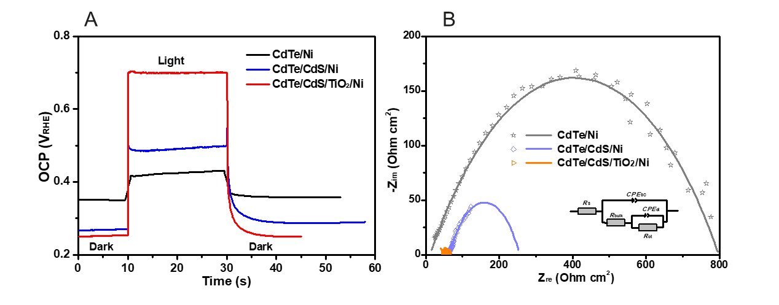
Figure 5. OCP (A) and Nyquist plots (B) of CdTe-based photocathodes with Ni catalyst at 0 V_{RHE} under AM1.5G illumination.

Table 2. OCP and EIS results of the CdTe-based photocathodes.
Photocathodes | j_{ph} (mA/cm²) | V_{ph} (V) | R_{tot} (Ω*cm²)
CdTe | -0.25 | 0.06 | 3990.9
CdTe/Ni | -1.25 | 0.07 | 846.6
CdTe/CdS | -0.53 | 0.11 | 848.2
CdTe/CdS/Ni | -1.56 | 0.08 | 256.1
CdTe/TiO₂ | -0.13 | 0.17 | 3721.6
CdTe/TiO₂/Ni | -0.22 | 0.15 | 2031.4
CdTe/CdS/TiO₂ | -3.68 | 0.18 | 134.0
CdTe/CdS/TiO₂/Ni | -8.16 | 0.45 | 44.9

Electrochemical impedance spectroscopy (EIS) measurements were employed to study the charge-transfer properties at the photocathode/electrolyte interface. Figure 5B and S3 show the Nyquist plots of CdTe-based photocathodes at 0 V_{RHE} in the frequency range of 1–10⁵ Hz under AM1.5G 100 mW/cm² illumination. The EIS data are fitted using the equivalent circuits shown in the inset of Figure 5B. The constant phase elements (CPE) are used instead of the standard capacitance (C) in equivalent circuits, due to their non-ideal capacitive behavior in Bode phase plots with phase angles below 90º. To interpret the EIS data, the series resistance (R_{s}), the charge-transfer resistance (R_{bulk}) from the semiconductor bulk to its surface, the constant phase element of the space-charge capacitance (CPE_{SC}), the charge-transfer resistance from the photocathode to the electrolyte (R_{ct}) and its corresponding capacitance (CPE_{ct}) are included in the equivalent circuit. A total resistance (R_{tot}) is a sum of R_{s}, R_{bulk} and R_{ct}. As depicted in Figure 5B, Table S1, and Table 2, the CdTe/CdS photocathodes exhibit smaller semicircles (lower R_{tot}) than the CdTe/TiO₂ photocathodes, indicating that the CdTe/CdS heterostructure is beneficial for charge separation.¹⁶ Moreover, the Ni-coated photocathodes exhibit smaller semicircles (lower R_{tot}) than their counterparts. Notably, the CdTe/CdS/TiO₂/Ni exhibits the smallest R_{tot} (44.9 Ω*cm²) among all photocathodes, owing to the efficient charge separation by the p-n junction and the boosted electron transfer across electrode/electrolyte interface through the Ni catalyst. This clearly demonstrates that the heterojunction structure and Ni catalyst have a synergetic enhancement of the PEC water splitting performance of the CdTe photocathode.
To illustrate the effect of the p-n heterojunction on the improvement of PEC performance, the schematic energy band structures of the Ni-coated CdTe photocathodes are compared in Figure 6. According to the absorption measurement (Figure S4), the bandgaps of CdTe, CdS and TiO₂ layers are determined to be 1.43, 2.13, and 3.02 eV, respectively. As shown in Figure 6A, the band bending at the interface of CdTe photocathode/electrolyte forms a Schottky junction, which is the driving force for the PEC water splitting. The buried p-n heterojunctions further enhance the built-in electric field for charge separation while the Ni co-catalyst boosts the electron transfer towards the electrolyte for hydrogen generation (Figure 6B-D).
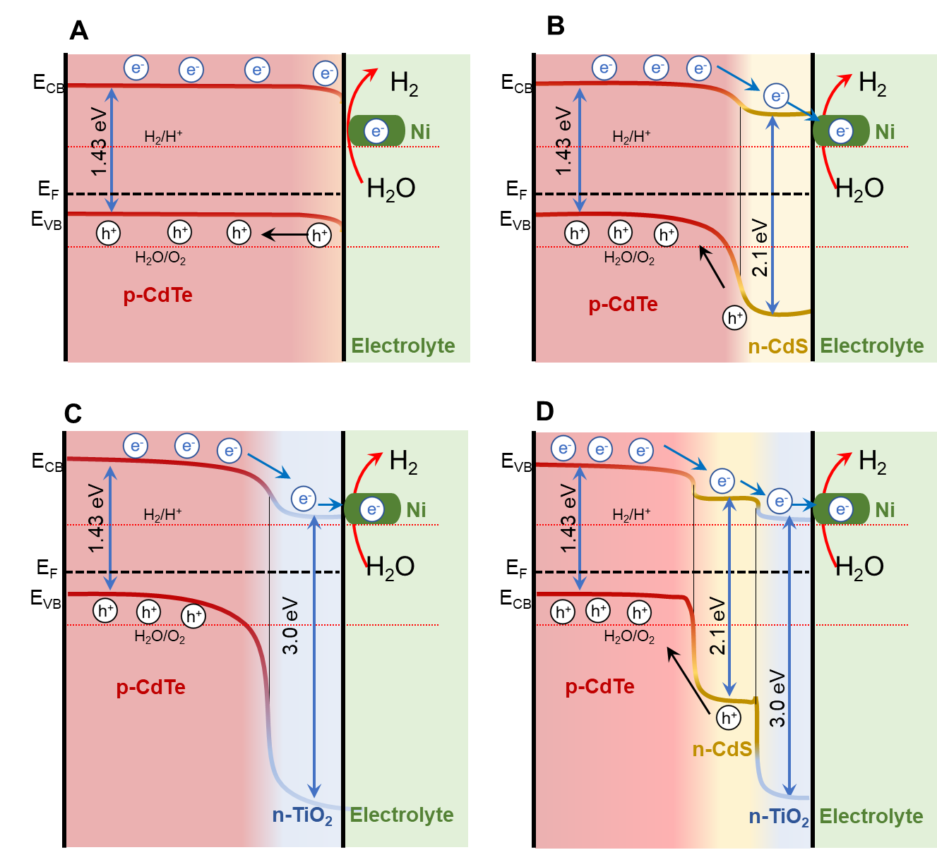
Figure 6. Band structure illustrations of the CdTe/Ni (A), CdTe/CdS/Ni (B), CdTe/TiO₂/Ni (C) and CdTe/CdS/TiO₂/Ni (D) photocathodes. E_{F}: Fermi level (EF), CB: conduction band, VB: valence band.

3.5 Stability of the Ni-coated heterojunction photocathode
To invesitigate the stability of Ni-coated CdTe photocathode, the surface mophology and the surface composition and chemical states of the CdTe/CdS/TiO₂/Ni photocathode were measured by SEM and X-ray photoelectron spectroscopy (XPS) before and after PEC measurements. The top view SEM image of CdTe/CdS/TiO₂/Ni photocathode after PEC measurements shows unchanged surface morphology (Figure S5A). As shown in the XPS survey spectra (Figure S5B), the CdTe/CdS/TiO₂/Ni photocathode exbibits identical peaks before and after PEC measurements, which are assigned to the Cd, Ti, Ni, Te, S elements.³⁶ The Cd 3d spectra shown in Figure 7A show two peaks at 405.2 and 411.9 eV, which have been attributed to the spin-orbit doublets of 3d_{5/2} and 3d_{3/2}, respectively. The Ti 2p spectra in Figure 7B displays two spin-orbit doublets of Ti 2p_{3/2} (458.7 eV) and Ni 2p_{1/2} (464.4 eV). As shown in Figure 7C, the Ni 2p spectra display several fitting peaks, which are the typical characteristics of the presence of Ni⁰ (852.2 eV) and Ni^{II} with peaks of 2p_{3/2} (856.5 eV), Ni^{II} 2p_{1/2} (874.3 eV) and their satellites peaks (861.7 and 880.7 eV). The XPS spectra of the CdTe/CdS/TiO₂/Ni photocathode clealy demonstrated that the Cd, Ti and Ni elements exhibit identical peaks before and after PEC measurements. These results confirms a high stability of the Ni-coated CdTe photocathode for PEC water splitting.
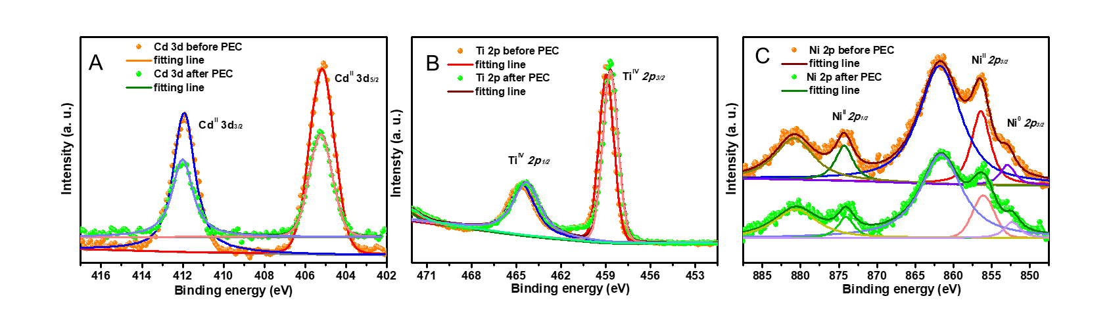
Figure 7. XPS spectra of Cd 3d (A), Ti 2p (B) and Ni 2p (C) of the CdTe/CdS/TiO₂/Ni photocathode before and after PEC measurements.

4. Conclusion
In conclusion, a Ni-coated heterostructure photocathode of CdTe/CdS/TiO₂/Ni was fabricated by depositing of 100-nm n-type CdS layer on p-type CdTe surface as p-n junction structure, 50-nm TiO₂ as the protective layer, and 10-nm Ni as hydrogen-evolution co-catalyst. The prepared CdTe/CdS/TiO₂/Ni photocathode exhibits a high J_{ph} of -8.16 mA/cm² at 0 V_{RHE} and a positive-shifted E_{onset} of 0.70 V_{RHE} for photoelectrochemical hydrogen evolution under one simulated sunlight. OCP and EIS studies indicated that the p-n junction of CdTe/CdS promotes the separation of photogenerated carriers, the TiO₂ layer protects the electrode from corrosion, and the Ni catalyst improves the charge transfer across the electrode/electrolyte interface. Notably, the achieved efficient photoelectrochemical water splitting provides new insights for designing noble-metal free photocathodes towards solar hydrogen development.

Acknowledgements
This work was supported by The Swedish Research Council (Vetenskapsrådet, Grant No. 2018-04670 and Grant No. 2020-04400), The Swedish Foundation for International Cooperation in Research and Higher Education (STINT, Grant No. CH2016-6722), and The Olle Engkvists Stiftelse (Grant No. 220-0222 and Grant No. 221-0259). JXJ and QXT acknowledge the support from The STU Scientific Research Foundation for Talents (NTF20033), the National Natural Science Foundation of China (No. 51973107 and 51673113), the Key Project of the Department of Education of Guangdong Province (No. 2018KZDXM032) and Guangdong Province Universities and Colleges Pearl River Scholar Funded Scheme 2019 (GDUPS 2019).

References
(1) Jian, J. X. and Sun, J. W., A Review of Recent Progress on Silicon Carbide for Photoelectrochemical Water Splitting, Solar RRL, 2020, 4, 2000111.
(2) Manassen, J., Cahen, D., Hodes, G. and Sofer, A., Electrochemical, solid state, photochemical and technological aspects of photoelectrochemical energy converters, Nature, 1976, 263, 97-100.
(3) Gratzel, M., Photoelectrochemical cells, Nature, 2001, 414, 338-344.
(4) Montoya, J. H., Seitz, L. C., Chakthranont, P., Vojvodic, A., Jaramillo, T. F. and Norskov, J. K., Materials for solar fuels and chemicals, Nat. Mater., 2016, 16, 70-81.
(5) Jian, J. X., Liu, Q., Li, Z. J., Wang, F., Li, X. B., Li, C. B., Liu, B., Meng, Q. Y., Chen, B., Feng, K., Tung, C. H. and Wu, L. Z., Chitosan confinement enhances hydrogen photogeneration from a mimic of the diiron subsite of [FeFe]-hydrogenase, Nat. Commun., 2013, 4, 2695.
(6) Jian, J. X., Ye, C., Wang, X. Z., Wen, M., Li, Z. J., Li, X. B., Chen, B., Tung, C. H. and Wu, L. Z., Comparison of H₂ Photogeneration by [FeFe]-Hydrogenase Mimics with CdSe QDs and Ru(bpy)₃Cl₂ in Aqueous Solution, Energy Environ. Sci., 2016, 9, 2083-2089.
(7) Wu, H. L., Li, X. B., Tung, C. H. and Wu, L. Z., Recent Advances in Sensitized Photocathodes: From Molecular Dyes to Semiconducting Quantum Dots, Adv. Sci., 2018, 5, 1700684.
(8) Wu, H. L., Li, X. B., Tung, C. H. and Wu, L. Z., Bioinspired metal complexes for energy-related photocatalytic small molecule transformation, Chem. Commun., 2020, 56, 15496-15512.
(9) Armaroli, N. and Balzani, V., Solar Electricity and Solar Fuels: Status and Perspectives in the Context of the Energy Transition, Chem. Eur. J., 2016, 22, 32-57.
(10) Jian, J., Kumar, R. and Sun, J., Cu2O/ZnO p–n Junction Decorated with NiOx as a Protective Layer and Cocatalyst for Enhanced Photoelectrochemical Water Splitting, ACS Appl. Energy Mater., 2020, 3, 10408-10414.
(11) Zhang, Y., Xie, M., Adamaki, V., Khanbareh, H. and Bowen, C. R., Control of electro-chemical processes using energy harvesting materials and devices, Chem Soc Rev, 2017, 46, 7757-7786.
(12) Mu, R., Zhao, Z. J., Dohnalek, Z. and Gong, J., Structural motifs of water on metal oxide surfaces, Chem Soc Rev, 2017, 46, 1785-1806.
(13) Walter, M. G., Warren, E. L., McKone, J. R., Boettcher, S. W., Mi, Q., Santori, E. A. and Lewis, N. S., Solar water splitting cells, Chem. Rev., 2010, 110, 6446-6473.
(14) Chen, X., Shen, S., Guo, L. and Mao, S. S., Semiconductor-based photocatalytic hydrogen generation, Chem. Rev., 2010, 110, 6503-6570.
(15) Liu, B., Li, X. B., Gao, Y. J., Li, Z. J., Meng, Q. Y., Tung, C. H. and Wu, L. Z., A solution-processed, mercaptoacetic acid-engineered CdSe quantum dot photocathode for efficient hydrogen production under visible light irradiation, Energ Environ Sci, 2015, 8, 1443-1449.
(16) Jian, J. X., Shi, Y. C., Ekeroth, S., Keraudy, J., Syvajarvi, M., Yakimova, R., Helmersson, U. and Sun, J. W., A nanostructured NiO/cubic SiC p-n heterojunction photoanode for enhanced solar water splitting, J. Mater. Chem. A, 2019, 7, 4721-4728.
(17) Jian, J. X., Shi, Y. C., Syvajarvi, M., Yakimova, R. and Sun, J. W., Cubic SiC Photoanode Coupling with Ni:FeOOH Oxygen-Evolution Cocatalyst for Sustainable Photoelectrochemical Water Oxidation, Solar RRL, 2020, 4, 1900364.
(18) Li, B., Jian, J., Chen, J., Yu, X. and Sun, J., Nanoporous 6H-SiC Photoanodes with a Conformal Coating of Ni-FeOOH Nanorods for Zero-Onset-Potential Water Splitting, ACS Appl. Mater. Interfaces, 2020, 12, 7038-7046.
(19) Jian, J. X., Jokubavicius, V., Syvajarvi, M., Yakimova, R. and Sun, J., Nanoporous Cubic Silicon Carbide Photoanodes for Enhanced Solar Water Splitting, Acs Nano, 2021, 15, 5502-5512.
(20) Qi, J., Zhang, W. and Cao, R., Solar-to-Hydrogen Energy Conversion Based on Water Splitting, Adv. Energy Mater., 2018, 8, 1701620.
(21) Chen, Z. B., Dinh, H. N. and Miller, E., Photoelectrochemical Water Splitting: Standards, Experimental Methods, and Protocols, Springer, New York, 2013.
(22) Ager, J. W., Shaner, M. R., Walczak, K. A., Sharp, I. D. and Ardo, S., Experimental demonstrations of spontaneous, solar-driven photoelectrochemical water splitting, Energy Environ. Sci., 2015, 8, 2811-2824.
(23) Yao, T. T., An, X. R., Han, H. X., Chen, J. Q. and Li, C., Photoelectrocatalytic Materials for Solar Water Splitting, Adv. Energy Mater., 2018, 8.
(24) Woods-Robinson, R., Han, Y., Zhang, H., Ablekim, T., Khan, I., Persson, K. A. and Zakutayev, A., Wide Band Gap Chalcogenide Semiconductors, Chem. Rev., 2020, 120, 4007-4055.
(25) Yang, H. H., Fan, W. G., Vaneski, A., Susha, A. S., Teoh, W. Y. and Rogach, A. L., Heterojunction Engineering of CdTe and CdSe Quantum Dots on TiO2 Nanotube Arrays: Intricate Effects of Size-Dependency and Interfacial Contact on Photoconversion Efficiencies, Adv. Funct. Mater., 2012, 22, 2821-2829.
(26) Chen, C. K., Chen, H. M., Chen, C. J. and Liu, R. S., Plasmon-enhanced near-infrared-active materials in photoelectrochemical water splitting, Chem. Commun., 2013, 49, 7917-7919.
(27) Wu, H. L., Li, X. B., Wang, Y., Zhou, S., Chen, Y. J., He, X. J., Tung, C. H. and Wu, L. Z., Hand-in-hand quantum dot assembly sensitized photocathodes for enhanced photoelectrochemical hydrogen evolution, J. Mater. Chem. A, 2019, 7, 26098-26104.
(28) Su, J., Minegishi, T. and Domen, K., Efficient hydrogen evolution from water using CdTe photocathodes under simulated sunlight, J. Mater. Chem. A, 2017, 5, 13154-13160.
(29) Ohashi, K., McCann, J. and Bockris, J. O. M., Hydrogen and electricity from water and light, Int. J. Energy Res., 1977, 1, 259-277.
(30) Ohashi, K., Uosaki, K. and Bockris, J. O. M., Cathodes For Photodriven Hydrogen Generators: Znte and Cdte, Int. J. Energy Res., 1977, 1, 25-30.
(31) Su, J., Minegishi, T., Kageshima, Y., Kobayashi, H., Hisatomi, T., Higashi, T., Katayama, M. and Domen, K., CdTe-Based Photoanode for Oxygen Evolution from Water under Simulated Sunlight, J. Phys. Chem. Lett., 2017, 8, 5712-5717.
(32) Su, J., Minegishi, T., Katayama, M. and Domen, K., Photoelectrochemical hydrogen evolution from water on a surface modified CdTe thin film electrode under simulated sunlight, J. Mater. Chem. A, 2017, 5, 4486-4492.
(33) Su, J., Hisatomi, T., Minegishi, T. and Domen, K., Enhanced Photoelectrochemical Water Oxidation from CdTe Photoanodes Annealed with CdCl2, Angew. Chem. Int. Ed., 2020, 59, 13800-13806.
(34) Li, X., Yu, J. G., Low, J. X., Fang, Y. P., Xiao, J. and Chen, X. B., Engineering heterogeneous semiconductors for solar water splitting, J. Mater. Chem. A, 2015, 3, 2485-2534.
(35) Ojo, A. A. and Dharmadasa, I. M., Electroplating of Semiconductor Materials for Applications in Large Area Electronics: A Review, Coatings, 2018, 8.
(36) Sheng, P. T., Li, W. L., Cai, J., Wang, X., Tong, X., Cai, Q. Y. and Grimes, C. A., A novel method for the preparation of a photocorrosion stable core/shell CdTe/CdS quantum dot TiO2 nanotube array photoelectrode demonstrating an AM 1.5G photoconversion efficiency of 6.12%, J. Mater. Chem. A, 2013, 1, 7806-7815.
(37) Liyanage, W. P. R. and Nath, M., CdS-CdTe heterojunction nanotube arrays for efficient solar energy conversion, J. Mater. Chem. A, 2016, 4, 14637-14648.

Baines, T., Zoppi, G., Bowen, L., Shalvey, T. P., Mariotti, S., Durose, K., & Major, J. D. (2018). Incorporation of CdSe layers into CdTe thin film solar cells. Solar Energy Materials and Solar Cells, 180, 196–204. https://doi.org/10.1016/j.solmat.2018.03.010
Major, J. D. (2016). Grain boundaries in CdTe thin film solar cells: A review. In Semiconductor Science and Technology (Vol. 31, Issue 9). Institute of Physics Publishing. https://doi.org/10.1088/0268-1242/31/9/093001
Major, J. D., Treharne, R. E., Phillips, L. J., & Durose, K. (2014). A low-cost non-toxic post-growth activation step for CdTe solar cells. Nature, 511(7509), 334–337. https://doi.org/10.1038/nature13435

TOC:
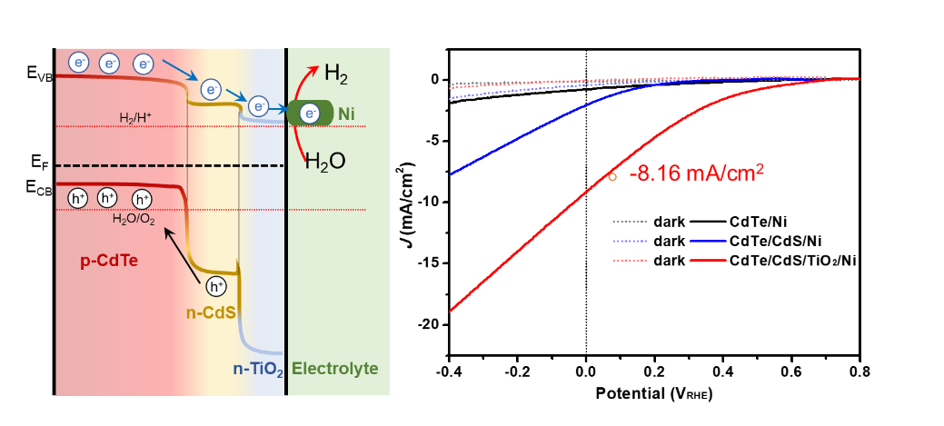
Enhanced photoelectrochemical hydrogen evolution from the noble-metal free, interface engineered heterojunction CdTe/CdS/TiO₂/Ni photocathode.

