Benthic foraminiferal turnover and trait changes across the Paleocene -Eocene Thermal Maximum (PETM) at ODP site 1265A, Walvis Ridge, SE Atlantic Ocean.
Celestine Nwojiji^{1,3*}, Fabienne Marret¹ Bryony Caswell² Athony U okoro³ and Ezekiel O igwe³
- School of Environmental Sciences, University of Liverpool, L69 7ZT, UK.
- School of Environmental Science, University of Hull, HU6 7RX, UK
3. Ebonyi State University, P.M.B 053, Abakaliki, Nigeria
Correspondence: Celestine Nwojiji (Celestine.nwojiji@ebsu.edu.ng)

Abstract
Benthic foraminiferal turnover during the Paleocene -Eocene Thermal Maximum (PETM) has been extensively studied but numerous questions remained unresolved. Question such as why some foraminiferal species went into extinction at a particular location but survive in another or why some species survive in extremely low oxygen environment. Because foraminiferal community interaction with the environment is driven by biological traits instead of taxonomic composition, this study has adopted trait based approach to provide insight into the life strategies of foraminifera that enables them to survive in extreme environmental conditions.
The result from this study show that traits such as test composition, perforation, ornamentation and living habits play important role in the ecological functioning and adaptability of foraminifera in the environment. The faunal assemblage in the studied site is dominantly cosmopolitan taxa suggesting the environment was perturbed during the PETM. Foraminiferal composition is characterised by faunal turnover indicated in extensive mortalities and extinction of both planktonic and benthic fauna. The ordination [non-Metric Dimensional Scaling (nMDS)] of faunal composition also indicated ecological disturbance. The planktonic community was relatively stable before and after PETM but experienced a high level of ecological perturbation during the carbon isotopic excursion (CIE). The benthic community showed higher evidence of perturbation as the fauna assemblage ordination indicated that ecological stress started before the PETM with the disarray of samples in the ordination diagram. Only the recovery interval experienced some level of ecological stability. The environmental disturbance noticed in the fauna composition reflected on the trait. Benthic foraminiferal traits indicated instability throughout the studied section. The evidence of environmental disturbance in the benthic community suggests that the source of the light carbon that caused the PETM may have originated beneath sea floor in the Atlantic Ocean.
Key words: Foraminifera, PETM, ecological functions, biological traits, palaeoecology, marine environment, climate change, Atlantic Ocean

1 Introduction
Due to the rapid changing of global marine ecosystem as a result of anthropogenic (e.g excessive input of greenhouse gases; destruction of natural habitat; environmental pollution) and natural (orbital forcing, volcanism) pressures, climate scientist have forecasted extreme climatic condition for the next few millennia (Zachos et al., 2008; Caswell et al., 2017). This extreme climate could lead to enormous mass extinction and permanently alter the current climate system. To understand how this extreme climate will affect the ocean in the future as well one of the most important organism (foraminifera) in the marine trophic level, this study has investigated a well-known hyperthermal event known as [the Palaeocene – Eocene Thermal Maximum (PETM)] in the geologic record that is similar in magnitude and rate of greenhouse emission as present value. The PETM is a global climatic event that occurred 55 – 56 million years ago. It is believed that the PETM was caused by massive injection of light carbon into the earth system (Lyons et al., 2019) which coincided with eccentricity maxima (Deconto et al. 2012). The event is characterised by 2- 3%₀ carbon isotopic excursion (CIE), extensive acidification of the deep sea that led to the burn down of existing calcite deposit in the ocean and a significant rise in the lysocline and carbon compensation depth (CCD) (Babila et al., 2018). The PETM also have a significant effect on marine ecosystem faunal turnover such as the massive extinction of benthic foraminifera, diversification and migration of planktonic foraminifera (Williams et al., 2007).
Foraminifera are unicellular marine protozoans with calcareous shells usually subdivided into chambers. Foraminifera are the most important calcifying zooplankton group in the marine ecosystem (Grigoratou et al., 2019) and provide crucial ecological functions in the oceans such as primary production, nutrient cycling, and carbon sequestration and as a food source to the numerous organisms in the higher trophic level of the marine ecosystem. In the deep sea, benthic foraminifera represent the most important contributors to the micro-faunal biomass, and their distribution is intricately linked to the flux of particulate organic matter from the upper ocean to the sea floor (Jorissen et al., 2007).
Because the shells of most foraminifera are composed of calcium carbonate, they are the highest contributor of biogenic calcite in the open ocean across the globe (Petrizzo et al., 2008). Foraminifera is known to be very sensitive to the physio-chemical variability in the oceans and tends to incorporate the physical and chemical composition of the sea water they calcified into their shell and thereby recording the prevailing environmental conditions. The chemical composition of foraminiferal shell (hereafter referred as test) is used as proxy for the interpretation of palaeoecological and palaeoclimatic conditions such as temperature, carbon saturation, salinity, palaeocirculation, oxygen concentration and hydrodynamics during their life time (e.g. Thomas, 2007; Boscolo Galazzo et al., 2014; Littler et al., 2014; Nwojiji et al., 2014; Palike et al., 2014; and Arreguín-Rodríguez et al., 2016). The physiological makeup of foraminifera plays a huge role in the surviving strategies they adopt while alive and has been demonstrated in the fossil and modern species records to have a close relationship with environmental parameters (Keating-Bitonti and Payne, 2017).
Several palaeoecological studies have linked vertical separations in the ocean to the morphological stratification of foraminiferal ecosystem both at the pelagic and benthic zones (Luciani et al., 2007; Arreguin-Rodriguez et al., 2016; Schiebel and Hemleben, 2017). In the benthic zone, the epifauna species are composed of smooth trochospirally coiled and coarsely perforated forms while the infaunal species are significantly rough, bi-triserially chambered and elongate forms (Corliss and Chen, 1998; Jorrisen et al., 2007).
Traits referred to as well defined and measurable attribute of an organism is believed to control organism's interaction within their ecological community than taxonomic composition. Foraminiferal traits are intrinsically linked to the ecological functions they perform in the ocean. For instance, test composition function as a protective tool and is known to reduce biological, physical and chemical stress of foraminifera in their environment (Armstrong and Brasier 2005). The test shape could also indicate ecological adaptation and preference by foraminifera. The arrangement of the test chambers and their shape chamber could also indicate ecological stress, for instance, change from sinistral to dextral or evolute to involute coiling in trochospiral test has been related to change in water temperature and bathymetry (Boltovskoy et al., 1991). Elements of test microstructure such as the macro-ornamentation (e.g. spines or muricae) could also reflect the mode of living and adaptation to surrounding water condition. Ornamentation in foraminifera also play a huge role in feeding, adaptation to extreme environmental condition, movement as well as prey -predation relationship (Dubicka et al. 2015). Pores in foraminifera are used for gas exchange, osmoregulation, intake and release of nutrient and ecosymbiosis
Because foraminifera plays a significant role in the global carbon sequestration and food supply, it is very important to use as many technique as possible understand to their feedback to past climatic extreme. The reaction of foraminifera to past climatic changes will provide clues to the current climate and future climate change. To contribute in understanding the past climate in other to forcast the future, this study have selected a suitable location at the southeastern the Atlantic Ocean cored during the ocean drilling program (ODP) campaign of Leg 208 site 1265 (Figure 1) to study the benthic foraminiofera turn over during the PETM. Site 1265 is located in the South African margin on latitude 27°11.160´S and longitude 1°34.620´E in a broad channel at the base of the westward trending slope of the Walvis Ridge (Zachos et al., 2004) at an upper bathyal water depth of 3083m (see Figure 2).

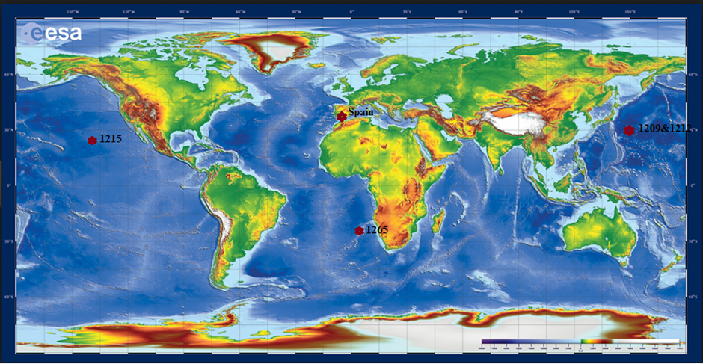
Figure 1: Site location of the study areas
The channel contains a thick sequence of Palaeogene to Neogene sedimentary deposit and the section analysed is composed of foraminifer-bearing nannofossil ooze with red clay layer recording the main CIE interval. ODP Leg 208 was the first site to recover an intact and undisturbed continuous sequence of Palaeocene – Eocene (P/E) boundary in the deep sea drilling because of the drilling strategy that adopted advanced piston corer (APC) techniques. However, there was a poor recovery of the lower part of the PETM at site 1265A (Zachos et al., 2004).
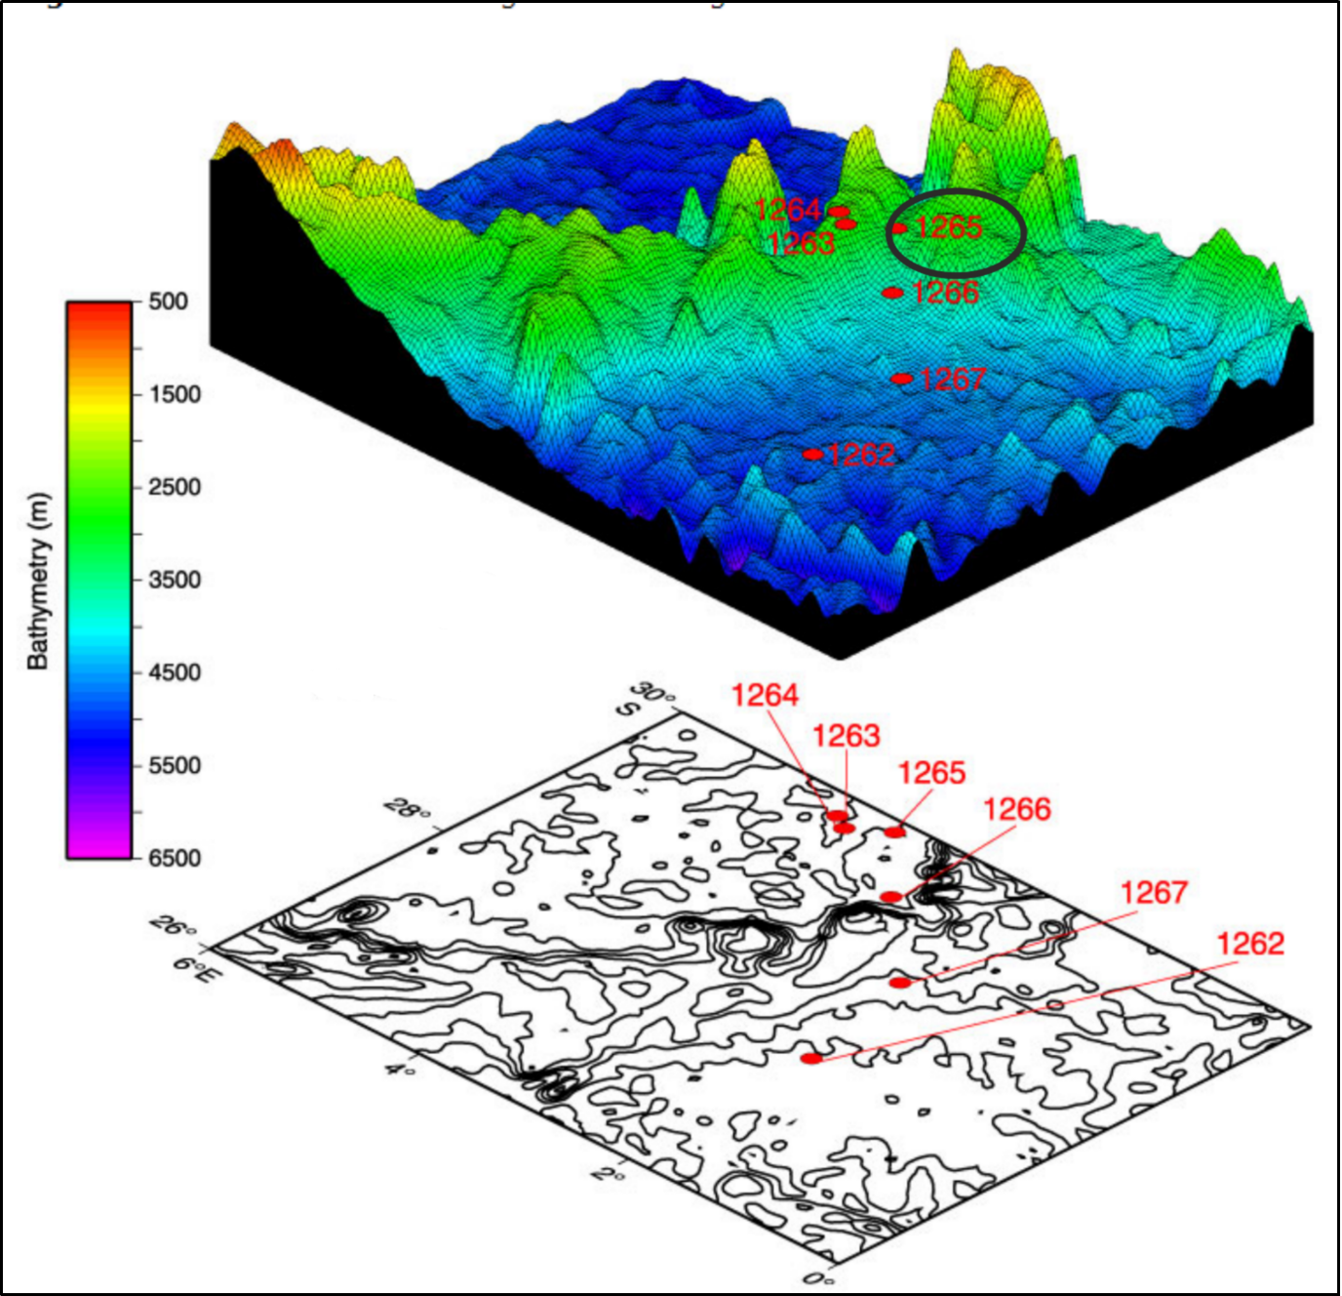
Figure 2: Three-dimensional diagram of the Leg 208 drill sites showing the location of site 1265 and other drilling sites cored during the same mission with corresponding bathymetry (adapted from Zachos et al., 2004).
Thirty-five sediment samples from core depth 266.31 mbsf – 276.66 mbsf have been analysed for foraminiferal abundance and distribution across the PETM section. The recovered foraminifera was further analysed for trait composition and subjected to multivariate statistical modeling known as biological traits analysis (BTA). BTA was used to understand the dominant traits that sustained the ecological functioning of the ocean during the hyperthermal as well as the characteristic attribute possessed by the benthic foraminifera that went into extinction during the event. Biological trait analysis is applied widely in studying anthropogenic influence in modern and ancient ocean macrobenthic communities and has successfully discriminated environmental disturbance. This study is pioneering the application of this technique in fossilised microbenthic (foraminifera).
The aim of this research include:
1. Examine in details, benthic foraminiferal assemblage and composition of the late Palaeocene-early Eocene section in the site 1265 which has not been previously studied except for shipboard report.
2. Integrate the faunal and trait composition to interpret the ecological functioning of foraminifera across the pelagic-benthic ecosystem of the SE Atlantic Ocean during the PETM
3. Understand the sensitivity of foraminifera trait to the ecological changes associated with the PETM

2. Methodology

2.1. Foraminiferal Preparation Protocols
Foraminifera sample preparation followed a conventional protocols. Weighed sediment samples were transferred into the 250ml glass beaker and soaked with water and 2-3 drops of Sodium hypochlorite solution overnight in a fume cupboard. This allows enough time for the sediment to disaggregate and the clays to be dissolved. The disaggregated sediment samples were washed with Endecotts stainless steel 63µ sieve under a running tap water. The recovered residues were transferred to a labeled filter paper placed in a funnel and dried in the laboratory oven. The dried residue was stored in vials for identification and counting.

2.1.1: Counting and identification
Before the counting, the recovered microfauna was sieved into three fractions, >63µm (fine), >125µm (medium) and >250 µm (coarse). Each size fraction was counted separately to avoid the larger microfossil from obstructing the smaller ones. Counting was done by sparingly spraying the microfossil on the observation tray. The observation tray is divided into forty –two equal sized squares and 1-2 microfossil filled trays were counted for each sample by following systematically along a particular transect. We counted more than two tray for the benthic group which was less abundant in order to get a statistically significant data. Counting the fine fraction (>63-125µ) was useful because many species of Abyssamina, and Pleurostomellids which were scarce in the larger fraction were actually abundant in the fine fraction. Most of the taxa were identified to the species level using the systematic description and micrographs from Cushman (1951), Tjalsma and Lohmann (1983), Loeblich and Tappan (1987), Nomura (1991), Speijer (1994), Widmark (1997), Holbourn et al. 2013 and other peer reviewed-publications sited herein.

2.2 Trait classification and analytical procedures
Foraminiferal composition, morphology and life strategy were classified into thirteen biological characteristics based on ecophenotypic responses, their relationship to function of marine ecosystem and availability of data on the traits. The traits were further classified into categories referred as modalities (Table 1). Fussy coding (Chevenet, et al., 1994) techniques was used in expressing the affinity of various species to the traits modalities using a scale of 0.0 – 1.0. The absence or no affinity of a particular trait in a species is denoted with 0 while 1 is used for a species that exhibited dominant/ high affinity to a trait (see supplementary data). This coding techniques allows each species that exhibited more than one modalities to be categorised according to their affinity to trait under consideration, however, all the categories shall sum up to unity (Caswell and Frid, 2013; 2017 and Frid and Caswell 2015;2016 ). The information on the biological traits were sourced from the biological database such as WORMS – World Register of Marine Species: http://www.marinespecies.org, The Palaeobiology http://palaeodb.org; Fossilworks http:// http://fossilworks.org/ and published literatures. The extensive review of these data sources as well as personal communications with experts in a range of taxa informed the choice of traits selected for this analysis.

Table 1. Example of traits and associated modalities used in biological traits classification of foraminiferal communities.
Traits | Modalities
A. Test Shape | A1. Spiral, A2. Elongate, A3. Globose, A4. Subquadrate, A5. Others
B. Test Composition | B1. Hyaline calcite, B2. Hyaline aragonite, B3. Porcellanous, B3. Agglutinated
C. Chamber arrangement | C1. Uniserial, C2. Bi/Tri-serial, C3. Planispiral, C4. Trochospiral, C5. Other
D. Chamber shape | D1. Spherical/Oval, D2. Tubular, D3. Triangular or trapezoidal, D4. Semi-circular, D5. Others
E.Macro ornamentation | E1. Depressed sutures, E2. Raised sutures, E3. Keeled sutures, E4. Others
F. Test micro-ornamentation | F1. No ornament, F2. Reticulate, F3. Hispid, F4. Spinose F5. Striate,
G. Aperture form | G 1. Oval/reniform, G2. Arcuate, G3. Cribate/Radiate, G4. Slit-like, E5. Others
H. Aperture accessory structures | H1. Lips, H2. Bifid teeth, H3. Umbilical teeth, H4. Neck, H5. None
I. primary aperture position | I1. Terminal, I2. Basal interiomarginal, I3. Umbilical, I4 Extra-umbilical, I5. Areal
J. Test perforation | J1. Microperforation, J2. Fine perforation, J3. Macro-perforation, J4. No perforation
K. Life habit | K1. Surface dweller, K2. Intermediate dwellers, K3. Deep water dwellers  K4. Others
L. Feeding habit | L1. Grazer, L2. suspesnsion feeder, L3. Symbiosis, L4. Others
M. Mobility | M1. Sessile, M2. Clinging, M3. Free-living, M4. Others

The frequency of each trait modality in the dataset was calculated by multiplying the category scores with the relative abundance of each species exhibiting those modalities. This was achieved by simple matrix multiplication method (Frid and Caswell, 2016; Charvet et al 1998). The result of this data treatment (see supplementary data) is a trait table that showed the relative abundance of all the biological traits recorded in all the species across the whole samples.
Statistical analysis of both the species composition and biological trait datasets were performed with the software PRIMER ver.6. (Clarke et al., 2006). All the counted foraminifera were grouped into three PETM communities (Pre-CIE, CIE and Recovery) according to their position in the sample relative to the hyperthermal based on carbon isotopes from Zachos et al. (2005).
The foraminiferal relative abundance and traits similarities across the PETM were calculated using the Bray-Curtis index resemblance matrix. The resemblance data were transformed with either a Log (x+1) or square root method depending on the treatment that shows the best similarity. A Log (x+1) modifies the species relative abundance/traits to reduce the influence of the dominant species on the data. Square root transformation also does about the same thing by inflating smaller numbers and stabilises bigger ones. The taxa abundance data were standardized prior to any transformation however, trait data were not subjected to this procedure because it had been standardized during the fussy coding process. The transformed data were plotted with non-metric multidimensional scaling ordination (nmMDS) based on the Bray – Curtis similarity matrices. nmMDS is based on the rank similarities of samples and produces an ordination plot showing relative differences/ resemblance in biological trait composition according to the PETM three biotic communities.
To test for significant differences between various traits and samples across the three PETM sections, analysis of similarity (ANOSIM) tests were performed on the data set. The similarity of percentages (SIMPER) analysis was also applied to the species abundance and biological traits to determine which species/traits accounted for the significant dissimilarities identified by ANOSIM test. Other analyses include faunal assemblage grouping, planktonic/benthic ratio, the percentage of planktonic, epifauna, and infaunal composition in the samples.

3.0 Results

3.1 Benthic Foraminifera

3.1.1 Taxa composition and changes through time
A total of 6128 specimens of benthic foraminifera were counted in 33 samples analysed from Site 1265A. The assemblage was composed of one hundred and thirty-four (134) species comprising of 38 epifauna and 96 infauna morphological groups. The overall fauna composition were dominated by cosmopolitan/ opportunistic taxa and other late Palaeocene – early Eocene foraminiferal assemblage. Faunal abundance and diversity were fairly high before the CIE and during the recovery period but slightly decreased at the CIE interval.
The ANOSIM test on the benthic foraminifera taxa composition indicated that the three groups: pre-CIE, CIE and recovery differed significantly at R= 0.659 and p<0.01. The pairwise test for the three groups also showed that the recovery and the CIE significantly differed by R=0.585, recovery and pre-CIE at 0.896 while the CIE and pre-CIE at 0.516 and p>0.05.
The nmMDS ordination of benthic foraminifera composition showed tight grouping during the recovery while those of the CIE and pre-CIE were more spread (Figure 3). The compact grouping of the recovery samples could be interpreted as environmental stability after the extremely warm conditions and ocean acidification. The CIE samples loosely grouped in the NW axis of the plot but samples from 275.08 mbsf and 275.13 mbsf classified as CIE lay far from the rest of the axis. More so, samples from 274.98 mbsf and 275.04 mbsf also classified as CIE grouped together with the recovery. We may not have an elucidating explanation for the scattered nature of the CIE interval, but it may not unrelated to the benthic ecological disorganisation associated with the CIE. The first two samples (274.98 mbsf and 275.04mbsf) outcropping as outliers may indicate the initial fauna turnover at the beginning when the methane oxidation reached the seafloor and after that period the microbenthos tried to readjust by enhancing their reproduction and that created the two samples (274.98 mbsf and 275.04mbsf) with high abundance similar to the recovery.
In addition, the nmMDS also showed that all the samples during the pre-CIE including the first four samples from the CIE interval were scattered across the whole NE – SE axis of the plot. The scattered nature of these pre-CIE samples could be related to the inception of the release of exogenous greenhouse gases that caused the hyperthermal during the CIE.
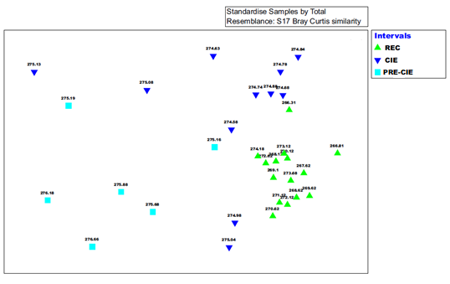
Figure 3: nmMDS ordination of Benthic foraminifera abundance in Site 1265A. Pre-CIE samples were clustered around the eastern axis, CIE at the NE and recovery on the SW axis of the plot.
The result from SIMPER analysis for pre-CIE and recovery indicated that the two intervals were 71.55% dissimilar. The result also highlighted taxa that existed at the pre-CIE but went into extinction during the recovery. The extinct taxa include Gavelinella beccarriformis, Aragonina valescoensis, Praebulimina sp., Coryphostoma midwayensis, Osangularia sp. (Table 3a). The result also showed that taxa like Cibicidoides spp., Nonion havanense, Marsonella oxycona, and Bolivina Spp. were more than five times higher at the pre-CIE than during the CIE. The reduction in the mean abundance of Gavelinella beccarriformis, Osangularia spp., Cibicidoides spp., Nonion havanense and Lenticulina spp. could be related to the susceptibility of heavily calcified taxa like them to the ocean acidification during the PETM (Kennett and Stott, 1991; Pak and Miller, 1992; Luciani et al., 2007; Thomas 2007). Other taxa that decreased in abundance during the CIE include; Marsonella oxycona, Aragonina valescoensis, Coryphostoma midwayensis and Bolivina spp.
SIMPER also indicated a significant increase in the mean abundance of all the Buliminaceae and opportunistic taxa such as Abyssamina quadrata, Quadrimorphina profunda, Nuttallides truempyi, Oridorsalis Paleopleurostomella pleurostomelloides umbonatus, Stillostomella plumaerae and Anomalinoides praeacuta during the recovery, rather than in the CIE (Table 3a). This supported the hypothesis that opportunistic (aka disaster) taxa began to increase during the CIE to take over the niche vacated by dissolution susceptible taxa during the PETM (Takeda and Kaiho, 2007; Alegret et al., 2009; D'haenens et al., 2012 and this study). These disaster taxa were believed to have supported and sustained the ecological functioning in the benthic zone during the PETM.
The dissimilarity between the CIE and the pre-CIE was 71.46%, and the results indicated that Gyroidinoides subglobosa, Spiroplectammina spp. and Aragonina aragonensis disappeared after the pre-CIE and no indication of their precence during the CIE (Table 3b). There were also more Tappanina selmensis, Bulimina tuxpamensis, Praebulimina reuss, Oridorsalis umbonatus, Bulimina midwayensis, Bulimina trihedral, Paleopleurostomella pleurostomelloides, Abyssamina quadrata and Gyroidinoides subangulatus during the CIE than the pre CIE. In the same vein, Abyssamina quadrata, Quadrimorphina profunda and Pleurostomella paleoceanica increased more than 5 fold higher during the CIE than the pre-CIE (Table 3b). The pre-CIE was characterised by an increase in the mean abundance of heavily calcified taxa such as Gavelinella beccarriformis, Cibicidoides spp, Nonion havanense, Osangularia sp., Gyroidinoides globose, Gavelinella spp., Anomalinoides praeacuta, Oridorsalis plumaerae and Lenticulina spp. The mean abundance of most of these taxa dropped drastically during the CIE or became extinct (see the suplimentaey data) due to the effect of dissolution resulting from the ocean acidification and probably decrease in oxygen concentration.
The SIMPER result comparing the CIE and recovery indicated that the two intervals were 63.35% different. It highlighted the origination of Stillostomella plumaerae, Nuttallides sp.1, Quadratobuliminella pyramidalis after the CIE as well the extinction of Praebulimina reuss before the recovery (Figure 4; Table 2). The most remarkable event highlighted by SIMPER result for CIE and recovery was the replacement of the heavily calcified taxa that dominated the pre-CIE by the more opportunistic ones during the recovery ( Figures 4-6; supplimentary data). The heavily calcified taxa were hugely affected by carbonate dissolution during the ocean acidification, and the niche they vacated was recolonised by the opportunistic taxa. In addition, P. pleurostomelloides, Bulimina sp., A. praeacuta, A. aragonensis, B. trihedral, T. selmensis, B. tuxpamensis, Nodosaria spp., Q. profunda, Lenticulina sp., N. truempyi, O.umbonatus were more during recovery than the CIE (Table 2c). Nevertheless, A. quadrata, P. paleoceanica, P.reuss maintained a high relative abundance during the CIE.

Table 2a: Site 1265A SIMPER results of the average abundance of benthic foraminiferal taxa and their respective percentage contribution within the recovery and pre-CIE intervals. (Data cut off 50%)
Species | Mean abundance |  | Contribution to dissimilarity (%)
 | REC | pre-CIE
Stillostomella plumaerae | 2.70 | 0.34 | 3.44
Gavelinella beccarriformis | 0.00 | 2.41 | 3.40
Aragonina aragonensis | 2.35 | 0.30 | 3.02
Cibicidoides spp. | 0.51 | 2.49 | 2.67
P.pleurostomelloides | 2.50 | 0.85 | 2.65
Bulimina sp | 1.92 | 0.68 | 2.14
Anomalinoides praeacuta | 2.09 | 0.90 | 2.11
Nuttallides sp.1 | 1.81 | 0.73 | 2.05
Tappanina selmensis | 2.46 | 1.26 | 1.97
Bulimina tuxpamensis | 2.58 | 1.66 | 1.97
Q.pyramidalis | 1.43 | 0.10 | 1.86
Nonion havenense | 0.43 | 1.62 | 1.86
Abyssammina quadrata | 1.72 | 1.53 | 1.79
Bulimina trihedra | 1.21 | 1.02 | 1.78
Bulimina midwayensis | 1.77 | 0.73 | 1.76
Praebulimina sp. | 0.00 | 1.36 | 1.74
Aragonina valescoensis | 0.00 | 1.28 | 1.72
Marsonella oxycona | 0.24 | 1.37 | 1.71
Quadrimorphina profunda | 1.64 | 0.63 | 1.71
Bolivina sp. | 0.11 | 1.44 | 1.70
Coryphostoma midwayensis | 0.00 | 1.13 | 1.53
Lenticulina sp | 1.06 | 1.38 | 1.52
Oridorsalis umbonatus | 1.45 | 0.81 | 1.49
Nuttallides truempyi | 3.07 | 2.03 | 1.44
Osangularia sp | 0.00 | 1.02 | 1.40

Table 2b: Site 1265A SIMPER results of the average abundance of benthic foraminiferal taxa and their respective percentage contribution within the CIE and pre CIE intervals. (Data cut off 50%)
Species | Mean abundance |  | Contribution to dissimilarity (%)
 | CIE | pre-CIE
Gavelinella beccarriformis | 0.45 | 2.41 | 3.22
Cibicidoides spp. | 0.73 | 2.49 | 2.69
Nonion havenense | 0.23 | 1.62 | 2.10
Aragonina aragonensis | 1.28 | 0.30 | 2.03
Tappanina selmensis | 1.69 | 1.26 | 1.93
Marsonella oxycona | 0.27 | 1.37 | 1.90
Bulimina tuxpamensis | 2.23 | 1.66 | 1.90
Nuttallides truempyi | 2.87 | 2.03 | 1.89
Aragonina valescoensis | 0.00 | 1.28 | 1.89
Bolivina sp. | 0.50 | 1.44 | 1.85
Quadrimorphina profunda | 1.36 | 0.63 | 1.83
Praebulimina sp. | 0.19 | 1.36 | 1.81
Lenticulina sp | 0.23 | 1.38 | 1.78
P. pleurostomelloides | 1.02 | 0.85 | 1.77
Praebulimina reuss | 0.95 | 0.71 | 1.71
Abyssammina quadrata | 1.85 | 1.53 | 1.69
Oridorsalis umbonatus | 1.27 | 0.81 | 1.63
Coryphostoma midwayensis | 0.55 | 1.13 | 1.63
Bulimina trihedra | 1.19 | 1.02 | 1.62
Bulimina midwayensis | 1.30 | 0.73 | 1.57
Osangularia sp | 0.35 | 1.02 | 1.54
Pleurostomella paleoceanica | 1.08 | 0.20 | 1.51
Gyroidinoides globosa | 0.00 | 1.03 | 1.49
Oridorsalis plummerae | 0.16 | 1.06 | 1.49
Spiroplectammina spp | 0.00 | 1.06 | 1.47
Anomalinoides praeacuta | 0.33 | 0.90 | 1.46
Gavelinella sp | 0.20 | 1.06 | 1.44
Gyroidinoides subangulatus | 0.64 | 0.45 | 1.33

Table 2c: Site 1265A SIMPER results of the average abundance of benthic foraminiferal taxa and their respective percentage contribution within the recovery and CIE intervals. (Data cut off 50%)
Species | Mean abundance |  | Contribution to dissimilarity (%)
 | REC | CIE
Stillostomella plumaerae | 2.70 | 0.00 | 5.38
Paleopleurostomella pleurostomelloides | 2.50 | 1.02 | 4.11
Bulimina sp | 1.92 | 0.16 | 3.59
Nuttallides sp.1 | 1.81 | 0.00 | 3.59
Anomalinoides praeacuta | 2.09 | 0.33 | 3.58
Aragonina aragonensis | 2.35 | 1.28 | 3.32
Abyssammina quadrata | 1.72 | 1.85 | 2.81
Quadratobuliminella pyramidalis | 1.43 | 0.00 | 2.69
Bulimina trihedra | 1.21 | 1.19 | 2.62
Tappanina selmensis | 2.46 | 1.69 | 2.49
Bulimina tuxpamensis | 2.58 | 2.23 | 2.27
Nodosaria spp. | 1.10 | 0.43 | 2.09
Quadrimorphina profunda | 1.64 | 1.36 | 2.06
Lenticulina sp | 1.06 | 0.23 | 2.01
Pleurostomella paleoceanica | 0.05 | 1.08 | 1.92
Nuttallides truempyi | 3.07 | 2.87 | 1.87
Praebulimina reuss | 0.00 | 0.95 | 1.86
Oridorsalis umbonatus | 1.45 | 1.27 | 1.85

In the raw data, the foraminiferal assemblage during the pre-CIE at Walvis Ridge was characterised by high abundance and diversity, with a combination of calcareous and agglutinated taxa. The pre-CIE foraminiferal assemblage was dominated by late Palaeocene taxa comprising of 38 infauna and 10 epifauna taxa (Figures 4-6). The exact depth of BEE was difficult to pin point due to the incomplete recovery of the PETM section in the site and low sampling resolution, however, G. beccariiformis, C. midwayensis, A. valescoensis, Praebulimina sp., Globorotalites mecheliniani, Gavellinella sp., G. conicus, Osangulina sp., Anomalinoides sp., Ellisoidella attenuate, Glandulina sp., Gyroidinoides globosa, Nodosaria limbeta and Gauddryina pyramidata (Figure 4) went extinct at the beginning of CIE.
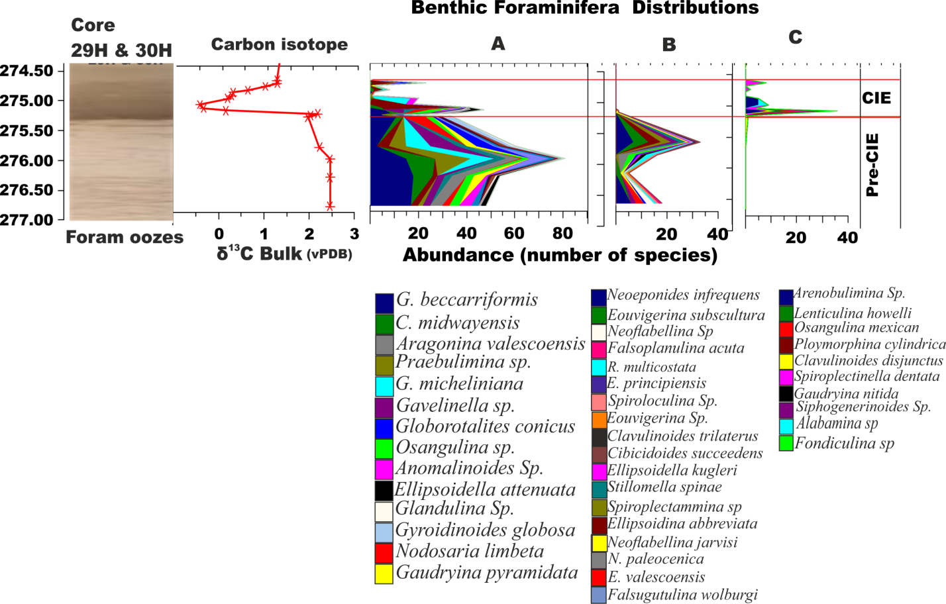
Figure 4: Benthic foraminiferal taxa present before and during the CIE at ODP Site 1265A. A -species that disappeared within the CIE interval. B – species whose occurrence were restricted to the Pre-CIE. C- species restricted to the main CIE interval. The bulk carbon isotope record and lithology were plotted with supplementary data from Zachos et al. (2005). The revenant nature of these species suggest that their reproduction during the PETM was extremely affected and only a few survived to continue their existence after the event. The benthic foraminiferal extinction (BEE) event in this study was placed at 275.08 mbsf with the last occurrence Gavellinella becarriformis.

The CIE (274.5-275.19 mbsf) was characterised by the extinction of many foraminiferal taxa that existed at the latest Palaeocene. Over 30 species (Figures 4 &5) became locally extinct within the CIE interval. The occurrence of Arenobulimina sp., Lenticulina howelli, Osangulina mexicana, Polymorphina cylindrical, Spiroplectinella dentata, Gaudryina nitida and Siphogerinoides sp. (see Suplimentary data) that were mainly infaunal morphogroups locally originated and went into extinction within the CIE interval. Some taxa like Cibicidoides dayi, Lenticulina sp., Fursekoina sp., Gyroidinoides beisseli, Laevidentallina gracilis, Linaresia semicribrata, Marsonella oxycona, Nonion havenense and Pullenia coryelli disappeared within the CIE interval and reappeared again during the recovery (Suplimentary data).
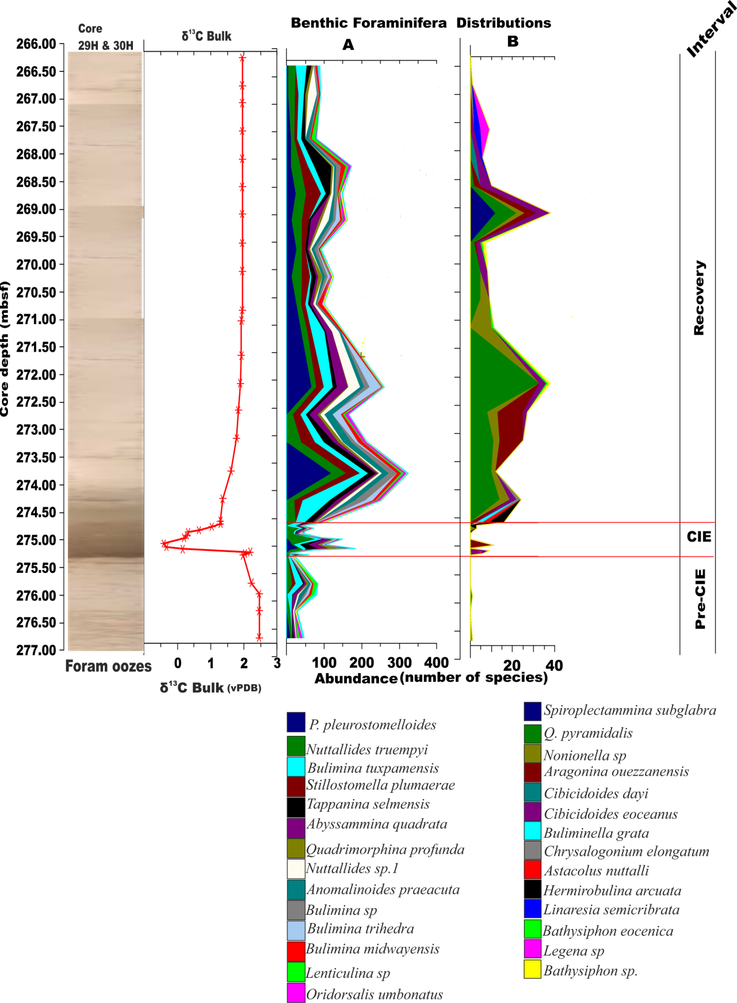
Figure 5: Faunal distribution of benthic foraminifera taxa that remarkably increased and/ or originated after the PETM at ODP Site 1265A. A - species that existed throughout the studied section but significantly increased after the CIE. B - species that originated after the CIE and increased in abundance during the recovery. The bulk carbon isotope record and lithology were plotted with supplementary data from Zachos et al. (2005)
The recovery interval recorded the highest abundance and diversity of benthic foraminifera. It was characterised by increased abundance of Anomalinoides praeacuta, A. quadrata, B. midwayensis, A. aragonensis, Bulimina sp., B. triletra, B tuxpamensis, Lenticulina sp., Nodosaria sp., P. pleurostomelloides, Quadratobuliminella pyramidalis, T. selmensis, S. plumerae and C. subcarinatus (Suplimentary data). Most of the taxa were elongate – cylindrical infauna of Buliminidae and Stilostomellidae. There are couple of epifauna taxa but their abundance was not as rich as the infaunal taxa. Nonion spp., Bulimina elaganstissima, Spiroplectammina subglabra and Valvalabamina depressa only occurred within the recovery section. The increase in the abundance of the Buliminacae actually started at the CIE interval but attained their highest abundance during the recovery.
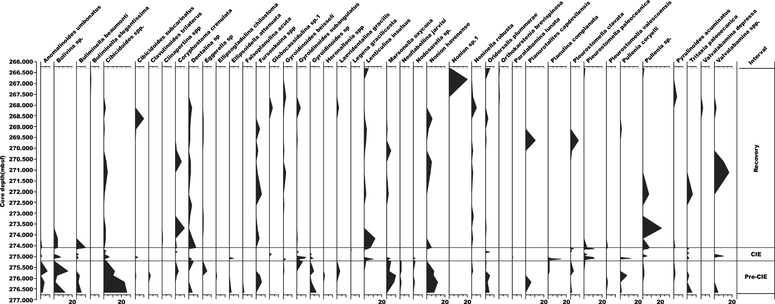
Figure 6: Other cosmopolitan benthic foraminifera recovered from ODP Site 1265A, most of which were present before the CIE but disappeared during the CIE and reappeared at the recovery interval

3.1.2 Trait composition and changes through time
More than 50 trait modalities were recorded in benthic foraminiferal trait composition from Site 1265A (Figure 7). The changes in trait composition across the PETM intervals as determined by ANOSIM test showed that the three intervals were different at global R = 0.117 but at a low level of p>0.05.
The nmMDS for trait composition was similar to the fauna ordination. Most of the samples from the recovery interval ordinated together, however with four other samples from the CIE and one sample from the pre-CIE (Figure 8). Only five samples at the core of the CIE with one sample from (266.81 mbsf) the lower most interval of the pre-CIE ordinated together. Two samples (275.08mbsf & 275.13mbsf) clustered closer to the pre-CIE while the other four samples (275.04mbsf, 274.98mbsf, 274.63mbsf & 274.58mbsf) from the earliest part of the CIE samples grouped with the recovery. From the whole ordination, we could observe that the trait re-organisation started at the pre-CIE and continued throughout the CIE. The spread in the ordination of the pre-CIE and the CIE samples suggested ecological disturbance with the input of the excessive greenhouse prior and coeval to the PETM.
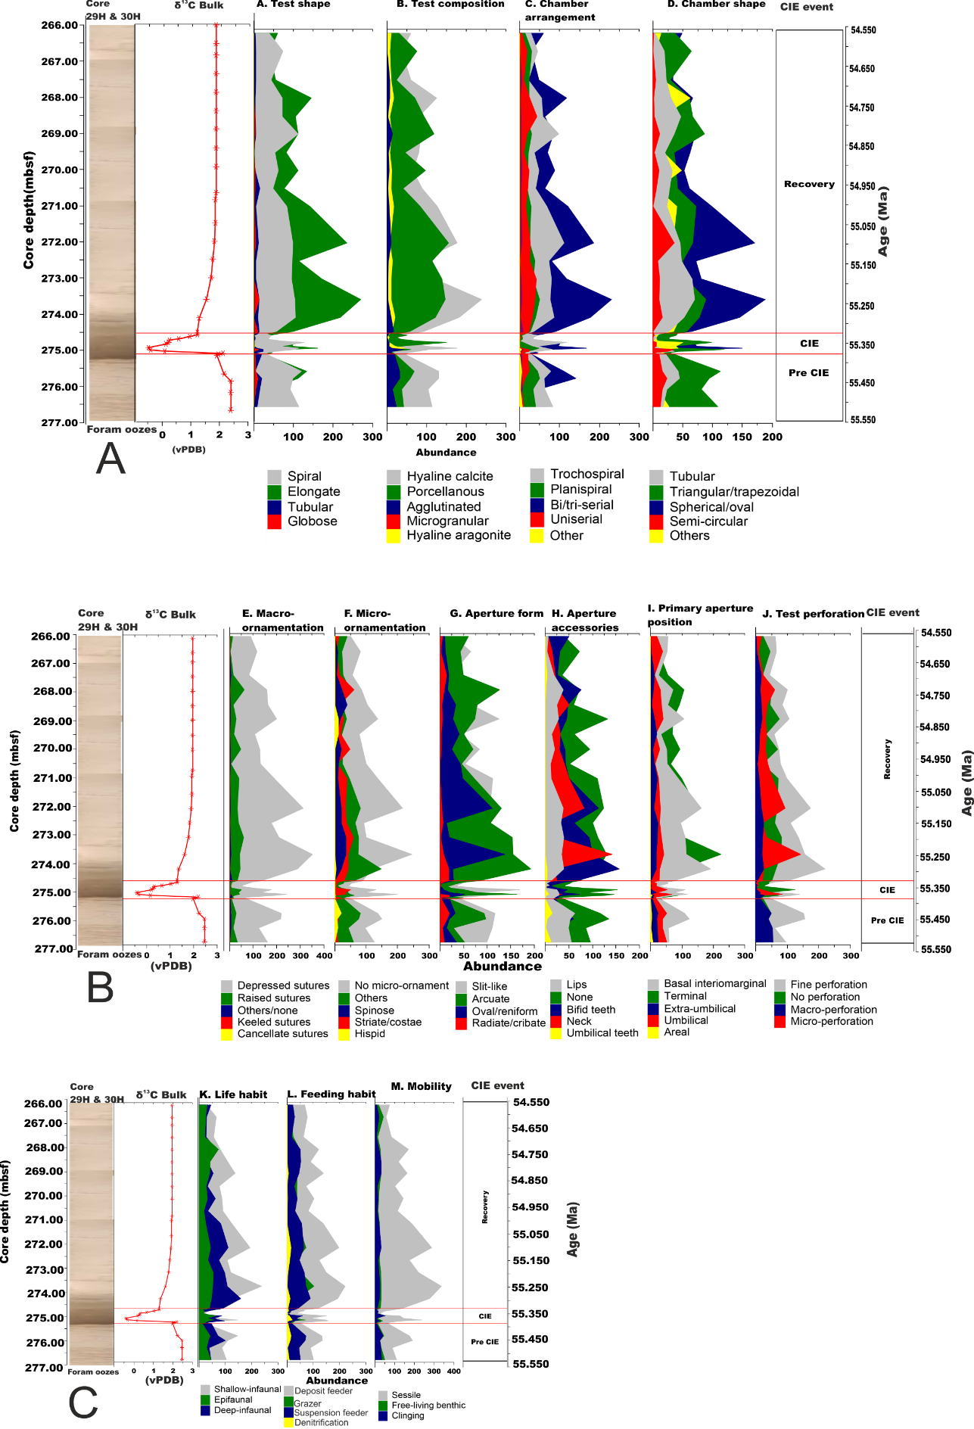
Figure 7: Changes in the traits of benthic foraminifera across the PETM at ODP Site 1265A shown with core depths (mbsf) on the left, δ¹³C record (extracted from Zachos et al., 2005) and age (Ma) on the far right. A. Shows traits for test composition and morphology. B. Test ornamentation and aperture traits. C. Traits associated with life habit.
The similarities analysis between the CIE and pre-CIE the showed that there were more porcellanous tests, arcuate and spherical/oval apertures, apertures with teeth, taxa with no apertural accessories as well as taxa without any recognisable apertures, elongate, tubular, spiral, trochospiral and bi/triserial test, deposit feeders and deep benthic infauna, basal interiomarginal and no ornamentation during the CIE than at the pre-CIE (Figure 7). However, more hyaline calcite tests, macro perforation, slit-like apertures, apertures with lips, triangular/trapezoidal chambers, fine test perforation, shallow benthic infauna and sessile habit occurred during the pre-CIE than during the CIE. This result, show that porcellanous test composition, elongate test, deposit feeders, deep benthic infauna, an aperture with teeth, terminal apertures and that bi/triserial began to increase in abundance from the CIE and continued through the recovery (Figures 7). Basal interiomarginal aperture, non-perforated test, unornamented, no apertural accessories were highest in abundance during the CIE while slit-like aperture, sessile lifestyle and apertures with lip decreased from the pre-CIE to the recovery. This shows that perforation, apertural complexity, ornamentation on the test decreased but sessile lifestyle increased. The mean abundance of hyaline calcite was highest during the pre-CIE and lowest during the CIE.
SIMPER comparism of the CIE and recovery interval indicated that basal interior marginal apertures, slit-like apertures, taxa with no apertural accessories, trochospiral, spiral and bi/triserial tests, triangular/trapezoidal chambers, non-perforated tests, taxa without any ornamentation, deposit feeders and deep benthic infaunal traits were more during the CIE than the recovery. This result shows that apertural complexities and perforation, as well as ornamentation became reduced during the CIE similar to what was observed in the planktonic trait and taxa composition (Nwojiji et al., 2023 in press), living mode also shifted to deeper habitat and deposit feeding mode of life (Figure 9). Basal interiomarginal apertures must have been boasted by the opportunistic taxa that increased in abundance during the warming (Figure 9). However, porcellanous and elongate test, terminal, arcuate and spherical/oval apertures, hyaline calcite and micro perforation, as well as sessile traits, were more abundant during the recovery than the CIE. The increase in hyaline test indicated improved carbonate deposition during the recovery, nevertheless, elongate taxa such as Buliminacae also increased and this could be linked to increase in the food supply to the benthic zone.
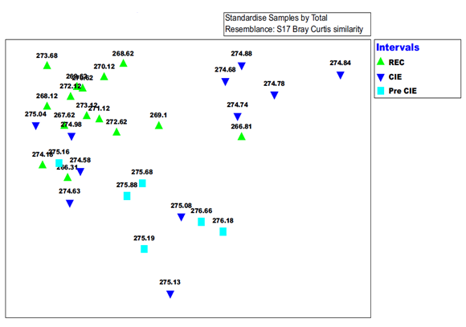
Figure 8: nmMDS ordination of benthic foraminiferal traits composition (transformed with log x+1) of Bray-Curtis similarity from ODP Site 1265A. CIE samples clustered at the SE axis, recovery around the SW axis while the pre-CIE samples clustered mostly on the top most part of the plot.
The dissimilarity between the recovery and the pre-CIE also showed that all traits listed have increased during the recovery interval (Figure 9) as well as bifid teeth and shallow benthic infauna were also more when compared with the pre-CIE interval but triangular/trapezoidal chambers, slit-like apertures, aperture with lips, macro perforation, no ornamentation and no apertural accessory traits were more at the pre-CIE than during the recovery. This shows that test perforation decreased from the pre-CIE towards the recovery and could be linked to the disappearance of macro perforated taxa such as Gavelinellids (supplementary data). There was also a shift from epifaunal lifestyle to infaunal from pre-CIE to recovery as well as from spiral to bi/triserial chamber arrangement which are related to taxa with terminal apertures.

Figure 9: SIMPER result of the most significant trait (at 50% cut off) that contributed to the differences in benthic foraminiferal trait composition across the CIE events at Site 1265A. Grey bars = pre-CIE; sky blue bars = CIE core; deep blue bars= Recovery; green bars = % contribution of each trait.

4. 0. Discussion

4.3.2 Benthic foraminiferal markers indicating ecological changes in the seafloor during the PETM at Walvis Ridge.
The benthic foraminiferal composition at Walvis Ridge indicate high heterogeneity in species richness, abundance and morphotypes. Calcareous taxa dominated the overall foraminiferal assemblage. The predominance of calcareous taxa in the identified fauna suggest that Site 1265A was deposited above the CCD but close to the lysocline during the PETM (Zachos et al., 2005). The preservation of foraminifera was moderately good for the larger tests, however, there was also evidence of frosty calcite overgrowth, etching of test walls, thinning of test walls for some large specimens and high foraminifera population from the fine (>63µm) fraction. SEM imaging further showed that even the specimens that appeared to be well preserved have been affected by dissolution and encrustation with secondary calcite and calcareous nannofossil (Nwojiji et al., 2019). Dissolution seems to have occurred from highly corrosive carbonate under-saturated sea water rather than non-deposition within or below the CCD because dissolution was incomplete and some smooth, thin-walled Praebulimina spp and Nonion spp with glassy tests occurred.
The faunal assemblage was composed of 67% infauna and 33% epifauna, the dominance of infaunal Buliminids and uniserial taxa are associated with high organic flux and decrease in oxygen concentration (Guisberti et al., 2016). Similar benthic foraminifera have been used as an index for trophic conditions at the seafloor (Jorissen et al., 2007) and in this model infaunal Buliminids and other biserial/cylindrical taxa such as Pleurostomella, Stillostomella and Siphonodosaria occurred in high abundance in eutrophic regions with sustained or highly seasonal phytoplankton productivity. These taxa are believed to have tolerated warm, locally oxygen-depleted and carbonate-corrosive bottom waters. Similarly, high abundances of these taxa have been reported from other PETM section as well as the black shale facies of Cretaceous ocean anoxic event II (Alegret and Thomas, 2009) and the middle Eocene climatic optimum (MECO; Boscolo Galazzo et al., 2015). They are reported to be adapted to low-oxygen conditions or can rapidly recolonise the seafloor during brief intervals of reoxygenation. In this study, the Buliminids had the most consistent species richness and abundance across the PETM. During the CIE all the species of Buliminidacea were abundant except for Bulimina bradburyi and high abundance of this species was recorded throughout the recovery. The statistical results from SIMPER also confirm higher abundance of Bulimina species at the CIE and recovery intervals than at the pre-CIE section (Tables 3a – c). Bulimina taxa are tolerant to low oxygen and high organic flux meaning they may occupy niches vacated by vulnerable taxa, and may dominate the foraminiferal assemblage. The prevalent occurrence of Bulimina in this study suggests that the taxa occurrence is more closely linked with nutrient and organic matter influx rather than oxygen depletion (Murray 1991; Gooday 1994; Schmiedl et al., 2000).
Nevertheless, interpreting palaeo-oxygen concentrations based on foraminiferal composition should be done with caution, because foraminifera can utilise alternative metabolic pathways during low oxygen conditions. For example species of Globubulimina and Bolivina are believed to store intracellular nitrate which they use in denitrification in the absence of oxygen (Keating-Bontonti and Payne, 2017). Oxygen minimum zones have been reported to be dominated by small thin-walled specimen of Bulimina (Boltovskoy et al., 1991; Kaiho 1994). The faunal assemblage from Site 1265A indicated high diversity of Bulimininidacea that were well-preserved as well as the co-occurrence of taxa that usually inhabit oxygenated environments. Irrespective of the high abundances of Bulimina, oxygen concentration is interpreted to be moderate. There was also a moderate abundance of oxic indicators such as Oridorsalis umbonatus. O. umbonatus was described as cosmopolitan and an indicator of well-oxygenated pore water but the sustained low flux of highly degraded organic matter (D’haenens et al., 2012) and persistent strong bottom water current. The relatively moderate occurrence of this species across the studied interval suggests the oxygen concentration was moderate during the PETM.
The significant increase of the opportunistic taxa (Nuttallides truempyi) at the main CIE interval in this study could be linked to water circulation. This taxa has been previously associated with sluggish water circulation (Boscolo Galazzo et al., 2015). N. truempyi was consistently high in abundance during the CIE and throughout the recovery interval. This suggests that the thermohaline circulation may have slowed down in the South Atlantic Ocean during the PETM. In the present day ocean, the abundance of the extant relative - N. umbonifera usually coincides with blooms of phytoplankton linked with the formation of deep water mixing and upwelling that redistribute nutrients (Boscolo Galazzo et al., 2015). Therefore, the high abundance of N. truempyi at the CIE interval may be related to a relative increase in productivity during the PETM.
The high abundances of epifaunal foraminifera such as Osangularia mexicana during the CIE indicate that there was a period of seasonal increase in oxygen during the PETM. Osangularia spp. typically live opportunistically and repopulated the seafloor during short-term re-oxygenation phases of Cretaceous ocean anoxic events (Alegret and Thomas, 2009). They also have a high tolerance for organic enrichment and intermittent deoxygenation. Increase in the abundance of Osangularia spp. are reported across the PETM section in Alamedilla (Alegret et al. 2009; Friedrich, 2005;2009) and have made the species a PETM benthic foraminiferal marker.
Tappanina selmensis, Siphogenerinoides Spp., Aragonina spp. are opportunistic species and indicators of high-productivity, continually stressed and lowered oxygen concentration in the sea floor. (Thomas 2003, 2007; Giusberti et al., 2009; Alegret et al., 2009; D’haenens et al., 2012). They are characteristic of hyperthermal sections in the open ocean sites and are capable of colonizing the sediment when productivity increases during environmental instability. In this study, these species relatively increased at the main CIE section suggesting low oxygen condition, nevertheless the taxa showed rich abundance during the recovery.
The parameters used in the above interpretation must be applied with caution as many taxa described are already extinct and the relation between the morphology and the microhabitat is still under investigation. Buzas et al. (1993) estimated the current interpretation to be 75% correct and this work has also shown that there is no straightforward interpretation based on faunal assemblages with the mixture of divergent ecological conditions markers. According to Jorissen et al. (2007), paleoceanographic reconstructions in geologic records are not always uniform but time averaged. Fauna accumulation in sediment will contain a mixture of all different fauna that lived in the location over several decennia assuming there was no addition or loss of test due to basinal processes and lateral transport when these sediments are sampled sediment cores may contain fauna from the period of seasonal blooms and period of severe ecological stress. A similar scenario occurs in terms of oxygen concentration, if ecological conditions were stable during the period under consideration, the composition of the fauna might accurately record the concentration of oxygen in the bottom water. Nevertheless, bottom water oxygen concentration (and oxygen penetration depth into the sediment) may in real situation experience significant seasonal variability, for instance when strong water column stratification, or pulsed phytodetritus deposits, cause seasonal hypoxia/anoxia (Jorissen et al., 2007). Such events may be annual, but can also be highly episodic, occurring once every 10 years, or even less often. In such cases, it will be extremely difficult (if not impossible) to extract the precise oxygenation history from the time-averaged faunas. More so, in cases when anoxic conditions persisted with low fauna occurrence if this was to be interrupted by short periods with oxic bottom waters characterised by rich and high oxygen content faunas.
Using benthic foraminifera as oxygen index may mix up the average long-term oxygen concentration in the environment. In other settings the duration and severity of the periodical hypoxia/anoxia may easily be overestimated, for instance during oligotrophic, well-oxygenated ecosystems are affected by short-term anoxia leading to the explosive development of a few low-oxygen tolerant taxa. The minor events recorded in our fauna distribution could be linked to the seasonal variation in phytodetrital input and oxygen concentration.

4.3.3 Trait indices in ecological function and community interaction in the Seafloor
Functional diversity (i.e. a representation of a range of biological traits and so functions) is a crucial attribute of a community as it measures the role that each organism contributes to ecosystem functioning. On this note we link the biological traits of foraminifera to the ecological changes during the PETM and believe that the higher abundance of hyaline calcite tests in benthic foraminiferal trait during the pre-CIE when compared to the CIE and recovery (Figure 9) suggest that the carbonate ion concentration in seawater and carbonate deposition in ocean floor did not recover after the PETM at the Walvis Ridge. A similar circumstance has been documented in other PETM section such as the Shatsky Rise, Alamedilla and Bass River (Alegret et al., 2009; Petrizzo, 2007; Aze et al., 2014b; Takeda and Kaiho, 2007; Stassen et al., 2015). The increase in a porcelaneous trait in the benthic ecosystem during the CIE and the recovery raises the question of the solubility high magnesium calcite tests during ocean acidification. Previous studies argued that it goes into solution before the low Mg-Ca hyaline calcite but the increase in Lenticulina spp and Praebuilima spp (presumed to be porcelaneous) during the CIE suggest that foraminiferal calcification during ocean acidification may be different from what is currently known.
Also, in benthic foraminiferal traits, there was increase in spiral and trochospiral test during the CIE. These traits are linked to cosmopolitan taxa such A. quadrata, N. trumpyi, and Q. profunda, O. umbonatus and Cibicidoides spp. They occur in wide range of environments and may be floaters, epifaunal to deep infaunal. The relative increases in these traits during the CIE could be interpreted as the increase in opportunist taxa during the PETM (See Supplementary data). In the modern ocean, there have been wide reports of an increase in opportunistic taxa during environmental disturbances (Culver and Lipps, 2003; Bremner et al., 2006; Frid and Caswell, 2016). Trochospiral coiling is also argued to be advantageous for floating and attachment at the sediment-water interface during the times of disturbance in the bottom water (Boltovskoy et al., 1991; D’haenens et al., 2012).
Significant reduction in the benthic foraminiferal wall structure was noticed during the CIE with increase in taxa with no ornament, no perforation and no apertural accessory. Reduction in ornamentation in foraminifera have been reported previously in modern ocean experiencing extreme ecological condition (Dubicka et al., 2015) and we believe that either it is the adaptive strategy adopted by benthic foraminifera or that taxa with complex wall structure are more vulnerable during extreme environmental events than those with no ornamentation in the test. No perforation recorded the highest occurrence during the CIE suggesting that ocean acidification and ecological disturbance may lead to loss of perforation in foraminifera. More so, benthic foraminifera tends to reduce perforation during the period of decrease oxygen concentration to conserve gas exchange during metabolism and reduce the amount of oxygen required by the cells.
Our data also show that the infauna habitat, sessile and omnivorous feeding were the preferred way of living among the benthic foraminifera during the PETM (Figure 9). Shallow epifauna recorded the lowest occurrence during the CIE while the abundance of deep infauna increased after the warming. The decrease in the occurrence of the shallow infaunal trait could be linked to the ecological stress created by the corrosive water in the upper sediment layer. While the increase in the abundance of the deep infauna during the recovery could be interpreted as a reflection of more oxygen reaching the deeper layer of the bottom sediment.
The relatively low abundance of taxa with terminal aperture is interpreted as evidence of nutrient scarcity in the mesopelagic zone during the PETM. The increased temperature during the period must have encouraged thorough consumption of all the nutrients in the upper water column allowing very poor nutrient supply to the intermediate zone where most taxa with terminal apertures reside. As the temperature dropped and surface productivity increased resulting in a more efficient biological pump and increase of nutrient supply to the mesopelagic zone. Terminal aperture trait occurrence in the benthic assemblage indicates relatively low abundance before and during the CIE but significant increase during the recovery. In the benthic community, taxa with terminal appertures is an indication of productivity changes. The moderate abundance of the trait during the pre-CIE and CIE period suggest that not much change occurs in seafloor productivity during those periods. But the increase in the abundance of terminal apertures at the recovery suggests an increase in export production and remineralisation after the PETM. This is because benthic species such as Bulimina, Stilostomellids and Siphonodosaria are characterised by terminal apertures and the increase in their abundance reflect an increase in the rain of particulate organic matter to the ocean (Thomas et al., 2018).
There is an increased in relative abundance of umbilical – extra umbilical apertures during the CIE. Linking traits with ecological change is not a straightforward task and more work is recommended. Nevertheless, because extra umbilical aperture cut across both sides of the trochospiral test it may be a good adaptation for increased metabolism as a result enhanced food consumption and excretion. Taxa with these apertures are mostly opportunistic group such as Acarinina, Abyssamina, Oridosalis and their abundance was reduced during the recovery (Figure 9; Supplementary data).
The results from our biological trait analysis have shown some evidence of ecological stability through the way each sample ordinates within and across the CIE interval. The closeness or disparity between each sample in the nmMDS plot demonstrates how each trait could work together to provide ecological functioning. The tightly clustered samples indicate trait working in harmony to provide the need and stability required for the optimal function of the ecosystem while sparsely diverse sample point to the magnitude of perturbation and hostility experienced by the fauna. Benthic trait nmMDS showed that seafloor experienced ecological disturbance even before onset carbon isotopic excursion and that the ecological turbulence persisted till the early part of the CaCO₃ recovery. Only the uppermost part of the recovery interval showed some level of coherence. We think that the release of methane clathrate which triggered the PETM started in the late Palaeocene and initiated benthic ecological disturbance which did not recover till the mid-early Eocene. The release of methane hydrate was hypothesised to have originated from the Atlantic Ocean before spreading to the other regions (Zachos et al., 2005) and the disorderliness in benthic trait composition seems to support the idea.

4.4 Conclusions
During the PETM at the Walvis Ridge, considerable faunal turnover of the foraminiferal assemblage occurred that resulted in the mortality and extinction of benthic foraminifera. In general, cosmopolitan taxa dominated during the CIE indicating extreme ecological perturbation. Multivariate analyses of the assemblage composition demonstrated that the taxonomic composition of the benthic assemblage was highly perturbed prior to the start of the CIE suggesting that there were environmental changes that impacted the benthos before the PETM sensu stricto. The greater disturbance of assemblages inhabiting the bottom waters suggests that the source of the isotopically light carbon may have originated beneath sea floor causing benthic ecological disturbance and progressively reaching the surface of the ocean. Thus, supporting the methane hydrate dissociation and or subsea volcanism as the main cause of the PETM.
The high prevalence of heavily calcified benthic foraminifera during the late Palaeocene (e.g. Gavelinella beccarriformis, Cibicidoides spp., Nonion havenense, Praebulimina Spp., Marsonella oxycona, Bolivina sp., Coryphostoma midwayensis, Lenticulina Spp, Pleurostomella paleoceanica, Gyroidinoides globosa, Oridorsalis plummerae and Anomalinoides praeacuta) indicated conditions were eutrophic before the PETM. However, the presence of crisis taxa such as Aragonina valescoensis, Osangularia spp. and Spiroplectammina spp. indicates environmental instability at the seafloor even before the PETM. There was a proliferation of opportunistic and ecological stressed fauna during the main CIE; these include Aragonina aragonensis, Tappanina selmensis, Bulimina tuxpamensis, Nuttallides truempyi, Quadrimorphina profunda, Praebulimina reuss, Abyssamina quadrata, Oridorsalis umbonatus, Bulimina trihedral, Bulimina midwayensis, Abyssamina quadrata, and Praebulimina reuss.
During the recovery, the assemblage was comprised of high proportions of heavily calcified epifauna and infaunal taxa (Table 3a – c). This suggests that near the seafloor was not entirely devoid of oxygen but was relatively stable with sufficient nutrient supply for epifaunal taxa with high oxygen and food requirements to thrive. The biotic and trait records from our study suggest massive carbonate dissolution and relatively moderate oceanic productivity at the Walvis Ridge during the PETM. However, it is hard to interpret the amount of oxygen concentration probably because of the ridge topography with enhanced current activities including eddies and circular currents that prevail around the seamount and transport nutrient and oxygen from the surface to the seafloor (Arreguín-Rodríguez et al., 2016 ). This is also made more complicated by the behaviour of some foraminifera in the low oxygen environment as it believed that they have an alternative method of respiring nitrate in the absence of oxygen.
In general, the BTA produced a quantitative and integrated picture of palaeoecological change at the Walvis Ridge during the PETM when compared to the conventional foraminiferal assemblage analysis and have clearly detected environmental disturbance from sample ordinations. The critical foraminiferal traits that controled the ecological function in this site include test composition, chamber arrangement/ shape ornamentation, primary aperture position, perforations and living/feeding habit (Figures 7&9).

Acknowledgement: This research used core samples provided by the International Ocean Discovery Program (IODP). Ebonyi State Government, Nigeria and School of Environmental Sciences, UOL provided parts of the funding for this study.

Conflict of Interests: The authors declare no conflict of interest.

References
Alegret, L. and Thomas, E. (2009). Food supply to the seafloor in the Pacific Ocean after the Cretaceous/Paleogene boundary event. Marine Micropaleontology, 73(1-2), 105-116
Alegret, L., Ortiz, S and Molina, E. (2009). Extinction and recovery of benthic foraminifera across the Paleocene- Eocene Thermal Maximum at the Alamedilla section (Southern Spain). Palaeogeogr. Palaeoclimatol. Palaeoecol. 279:186–200
Armstrong, H. A., Brasier, M. D. (2005). Microfossils. Second Edition. Blackwell Publishing. 304p
Arreguín-Rodríguez, G. J., Alegret, L. and Thomas E. (2016). Late Paleocene-middle Eocene benthic foraminifera on a Pacific seamount (Allison Guyot, ODP Site 865): Greenhouse climate and superimposed hyperthermal events, Paleoceanography, 31, 346–364.
Aze T., Pearson, P. N., Dickson, A. J., Badger, M. P. S., Bown, P. R., Pancost, R. D., Gibbs, S. J., Huber, B. T., Leng ,M. J., Coe, A. L., Cohen, A. S., Foster, G. L. (2014). Extreme warming of tropical waters during the Paleocene–Eocene Thermal Maximum. Geology 42, 739–742.
Babila, T.L., Penman, D.E., Hönisch, B., Kelly, D.C., Bralower, T.J., Rosenthal, Y. and Zachos, J. C. (2018). Capturing the global signature of surface ocean acidification during the Palaeocene–Eocene Thermal Maximum. Phil. Trans. R. Soc. A 376: 20170072. 1- 19. http://dx.doi.org/10.1098/rsta.2017.0072
Berggren, W.A., Kent, D.V., Swisher III, C.C., Aubry, M.P. (1995). A revised Cenozoic geochronology and chronostratigraphy. In: Berggren, W.A., Kent, D.V., Aubry, M.P., Hardenbol, J. (Eds.), Geochronology, Time Scales and Global Stratigraphic Correlation: A Unified Temporal Framework for an Historical Geology: SEPM Special Publ., 54: 129–212.
Bolli, H., Beckmann, J., and Saunders, J. (1994): Benthic foraminiferal biostratigraphy of the South Caribbean region. Cambridge University press , 408p
Boltovskoy, E., Scott, D.B. and Medioli, F.S (1991) Morphological variations of benthic foraminiferal tests in response to changes in ecological parameters: A review Journal of Paleontology, 65, 175-185
Boscolo Galazzo, F., Thomas, E., Pagani, M., Warren, C., Luciani, V., and Giusberti, L. (2014). The middle Eocene climatic optimum (MECO): A multiproxy record of paleoceanographic changes in the southeast Atlantic (ODP Site 1263, Walvis Ridge), Paleoceanography, 29, 1143–1161.
Boscolo Galazzo, F., Thomas, E., and Giusberti, L. (2015) Benthic foraminiferal response to the Middle Eocene Climatic Optimum (MECO) in the Southeastern Atlantic (ODP Site 1263). Palaeogeogr. Palaeocl. Palaeoecol., 417, 432–444.
Bremner, J., Rogers, S.I., Frid, C.L.J. (2006). Methods for describing ecological functioning
of marine benthic assemblages using biological traits analysis (BTA). Ecological Indicators
6(3): 609-622.
Buzas, M. A., Culver, S. J., and Jorissen, F. J. (1993). A statistical evaluation of the microhabitats of living (stained) infaunal benthic foraminifera, Mar. Micropaleont., 29, 73–76
Caswell, B. A. and Frid, C. L. J. (2013). Learning from the past: functional ecology of marine benthos during eight million years of aperiodic hypoxia, lessons from the Late Jurassic. Oikos 122(12): 1687-1699.
Caswell, B. A., & Frid, C. L. (2017). Marine ecosystem resilience during extreme deoxygenation: the Early Jurassic oceanic anoxic event. Oecologia, 183(1), 275-290. https://doi.org/10.1007/s00442-016-3747-6
Charvet, S., Kosmala, A. and Statzner, B. (1998). Biomonitoring through biological traits of benthic macroinvertebrates: perspectives for a general tool in stream management. Arch. Hydrobiol. 142, 415–432.
Chevenet, F, Dolédec, S. and Chessel, D. (1994). A fuzzy coding approach for the analysis of long-term ecological data. Freshwater Biology 31:295–309.
Clarke, K.R. and Gorley R.N. (2006). Primer v6 Plymouth Marine Laboratory, Roborough, Plymouth, UK (2006) <www.primer-e.com>
Corliss, B.H. and Chen, C. (1988). Morphotype patterns of Norwegian Sea deep-sea benthic foraminifera and ecological implications: Geology, 16: 716–719.
Culver, S.J. and Lipps, J.H. (2003). Predation on and by Foraminifera P. Kelley, M. Kowalewski, T. Hansen (Eds.), Predation in the Fossil Record, Kluwer Academic/Plenum Publishers, New York (2003), 7-32
Cushman, J.A. (1951). Palaeocene foraminifera of the Gulf Coastal region of the United States and adjacent areas. U.S. Geological Survey. Professional. Paper, 232:1–75.
D’haenens S. Bornemann A. Stassen P. and Speijer R. (2012). Multiple early Eocene benthic foraminiferal assemblage and δ13C fluctuations at DSDP Site 401 (Bay of Biscay - NE Atlantic): Marine Micropaleontology, 88/89: 15–35.
DeConto, R.M., Galeotti, S., Pagani, M., Tracy, D., Schaefer, K., Zhang, T., Pollard, D., Beerling, D.J. (2012). Past extreme warming events linked to massive carbon release from thawing permafrost. Nature, 484 (7392): 87–91.
Dubicka, Z., Złotnik, M. and Borszcz, T. (2015). Test morphology as a function of behavioural strategies — Inferences from benthic foraminifera. Marine Micropaleontology 116: 38–49
Frid, C. L. J and Caswell B. A. (2015). Is long-term ecological functioning stable: The case of the marine benthos? Journal of Sea Research 98: 15-23.
Frid, C. L. J and Caswell, B. A. (2016). Does ecological redundancy maintain functioning of marine benthos on centennial to millennial time scales? Marine Ecology, 37(2): 392–410.
Friedrich, O., Erbacher, J., Wilson, P. A, Moriya, K., and Mutterlose, J. (2009). Paleoenvironmental changes across the Mid Cenomanian Event in the tropical Atlantic Ocean (Demerara Rise, ODP Leg 207) inferred from benthic foraminiferal assemblages. Marine Micropaleontology, 71(1-2): 28-40
Giusberti L. Coccioni R. Sprovieri M. Tateo F. (2009). Perturbation at the sea floor during the Paleocene–Eocene Thermal Maximum: Evidence from benthic foraminifera at Contessa Road, Italy: Marine Micropaleontology, 70: 102–119.
Giusberti, L. Boscolo Galazzo, F. and Thomas, E. (2016). Variability in climate and productivity during the Paleocene–Eocene Thermal Maximum in the western Tethys (Forada section). Climate of the Past 12(2): 213-240.
Gooday, A.J. (1994). The biology of deep-sea foraminifera: A review of some advances and their applications in paleoceanography, Palaios, 9 (1994), pp. 14-31
Grigoratou, M., Monteiro, F. M., Schmidt, D. N., Jamie, D. W., Ben, A. and Ridgwell, A. (2019). A trait-based modelling approach to planktonic foraminifera ecology. Biogeosciences, 16, 1469–1492.
Holbourn A., Henderson, A.S., and Macleod N. (2013). Atlas of Benthic Foraminifera. Wiley-Blackwell. UK. 642p
Jorissen, F. J., Fontanier, C., and Thomas, E. (2007). Paleoceanographical proxies based on deep-sea benthic foraminiferal assemblage characteristics, in: Proxies in Late Cenozoic Paleoceanography: Pt. 2: Biological tracers and biomarkers, edited by: Hillaire- Marcel, C. and A. de Vernal, A., 1, Elsevier, Amsterdam, The Netherlands, 264–325
Kaiho, K. (1994). Benthic foraminiferal dissolved-oxygen index and dissolved-oxygen levels in the modern ocean. Geology, 22(8): 719–722.
Keating-Bitonti, C. R and Payne, J. L. (2017). Ecophenotypic responses of benthic foraminifera to oxygen availability along an oxygen gradient in the California Borderland. Marine Ecology.;38:e12430
Littler, K., Röhl, U., Westerhold, T., and Zachos, J. C. (2014) A highresolution benthic stable-isotope record for the South Atlantic: Implications for orbital-scale changes in Late Paleocene–Early Eocene climate and carbon cycling. Palaeogeogr. Palaeocl., 401, 18–30
Loeblich, A. R. Jr, and Tappan, H. (Eds.). (1988). Foraminiferal genera and their classification. New York. Van Nostrand Reinhold Company, 970p.
Luciani, V., Giusberti, L., Agnini, C., Backman, J., Fornaciari, E., and Rio, D. (2007) The Paleocene–Eocene Thermal Maximum as recorded by Tethyan planktonic foraminifera in the Forada section (northern Italy): Marine Micropaleontology, 64:189–214.
Lyons, S. L., Baczynski, A. A., Babila, T. L., Bralower, T. J., Hajek, E. A., Kump, L. R., Polites, E. G., Self-Trail, J. M., Trampush, S. M., Vornlocher, J.R., Zachos, J. C. and Freeman, K. H. (2019) Palaeocene–Eocene Thermal Maximum prolonged by fossil carbon oxidation. Nature Geoscience, 12; 54–60
Mancin, N., Hayward, B. W., Trattenero, I., Cobianchi, M., and Lupi, C. (2013). Can the morphology of deep-sea benthic foraminifera reveal what caused their extinction during the mid-Pleistocene Climate Transition? Mar. Micropaleont., 104, 53–70.
Murray, J.W., (1991). Ecology and palaeoecology of benthic foraminifera. Longman, Harlow, 397p
Nomura, R. (1991). Paleoceanography of upper Maestrichtian to Eocene benthic foraminiferal assemblages at Sites 752, 753, and 754, Eastern Indian Ocean. In Weissel, J., Peirce, J., Taylor, E., Alt, J., et al., Proc. ODP, Science party. Results, 121: College Station, TX (Ocean Drilling Program), 121:3–30.
Nwojiji, C. N., Osterloff, P., Okoro, A. U. & Ndulue, G. (2014). Foraminiferal Stratigraphy and Paleoecological Interpretation of Sediments Penetrated by Kolmani River -1 Well, Gongola Basin, Nigeria. Journal of Geosciences and Geomatics, 2(3): 85-93.
Nwojiji, C.N., and Marret Fabienne (2019). The PETM extreme climate impact on the benthic foraminiferal traits and ecological functioning in the tropical Pacific and Tethys Oceans. Journal of Ocean Research, 4(1): 6 -19
Nwojiji, C.N., Marret, F. and Caswell, B.A. 2023. Planktonic foraminiferal turnover and trait changes across the Palaeocene-Eocene Thermal Maximum (PETM) at ODP site 1265A, Walvis Ridge, SE Atlantic Ocean (in press)
Olsson, R.K., Berggren, W.A, Hemleben, CH., and Hubber, B.T.(eds) (1999). Atlas of Palaeocene Foraminifera: Smithsonian Contributions to Palaeobiology, 85:1-252.
Pak, D. K., and K. G. Miller. (1992). Palaeocene to Eocene benthic foraminiferal isotopes and assemblages: Implications for deep water circulation, Paleoceanography, 7, 405-422,.
Pälike, C., Delaney, M. L. and Zachos, J. C. (2014). Deep-sea redox across the Paleocene-Eocene thermal maximum, Geochem. Geophys. Geosyst., 15(4):1038-1053 doi:10.1002/2013GC005074
Petrizzo M. R. (2007). The onset of the Palaeocene–Eocene Thermal Maximum (PETM) at Sites 1209 and 1210 (Shatsky Rise, Pacific Ocean) as recorded by planktonic foraminifera. Marine Micropaleontology, 63 (3–4): 187–200
Petrizzo, M. R. (2006). The Palaeocene-Eocene transition in the subtropical Pacific Ocean Shatsky Rise, Leg 198): Inference from planktonic foraminifera. International Conference Climate & Biota of the Early Paleogene
Petrizzo, M. R., Leoni, G., Speijer, R. P., Bernardi, B. D. and Felletti, F. (2008) Dissolution susceptibility of some Paleogene planktonic foraminifera from ODP site 1209 (Shatsky Rise, Pacific Ocean). Journal of Foraminiferal Research, 38(4):357–371
Rabinowitz, P.D., and Simpson, E.S.W. (1984). Geophysical site survey results on the Walvis Ridge. In Moore, T.C., Jr., Rabinowitz, P.D., et al., Init. Reports. DSDP, 74: Washington (U.S. Government Printing Office), 795–825
Schiebel, R. and Hemleben, C. (2017). Planktic Foraminifers in the Modern Ocean. Springer-Verlag Berlin Heidelberg. 358p
Schmiedl, G., de Bovee, F., Buscail, R. Charrie`re, B., Hemleben, C. and Medernach, L. (2000). Trophic control of benthic foraminiferal abundance and microhabitat in the bathyal Gulf of Lions, western Mediterranean Sea. Marine Micropaleontology, 40(3), 167-188
Speijer, R.P. (1994). Extinction and recovery patterns in benthic foraminiferal paleocommunities across the Cretaceous/Paleogene and Paleocene/Eocene boundaries. Geol. Ultraiectina,124:1–91.
Speijer, R. P., C. Scheibner, P. Stassen, and A.-M. M. Morsi (2012), Response of marine ecosystems to deep-time global warming: A synthesis of biotic patterns across the Paleocene-Eocene thermal maximum (PETM), Aust. J. Earth Sci., 150(1), 6–12.
Stassen, P., E. Thomas, and R. P. Speijer (2015), Paleocene–Eocene Thermal Maximum environmental change in the New Jersey Coastal Plain: Benthic foraminiferal biotic events, Mar. Micropaleontol., 115, 1–23.
Takeda, K., Kaiho, K. (2007). Faunal turnovers in central Pacific benthic foraminifera during the Paleocene–Eocene Thermal Maximum. Palaeogeography, Palaeoclimatology, Palaeoecology 251, 175–197.
Thomas, E. (2003). Extinction and food at the seafloor: A high-resolution benthic foraminiferal record across the Initial Eocene Thermal Maximum, Southern Ocean Site 690, in: Causes and Consequences of Globally Warm Climates in the Early Paleogene, edited by: Wing, S. L., Gingerich, P. D., Schmitz, B., and Thomas, E., Geol. S. Am. S., Boulder, Colorado, The Geological Society of America, 369: 319–332.
Thomas, E. (2007). Cenozoic mass extinctions in the deep sea: What perturbs the largest habitat on Earth?, in: Large Ecosystem Perturbations: Causes and Consequences, edited by: Monechi, S., Coccioni, R., and Rampino, M., Geol. S. Am. S., Boulder, Colorado, The Geological Society of America, 424: 1–23.
Thomas, E., Boscolo-Galazzo, F., Balestra, B., Monechi, S., Donner, B., and Röhl, U. (2018) Early Eocene Thermal Maximum 3: biotic response at Walvis Ridge (SE Atlantic Ocean), Paleoceanography and Paleoclimatology, 33: 862-883
Tjalsma, R.C., and Lohmann, G.P. (1983). Paleocene–Eocene Bathyal and Abyssal Benthic Foraminifera from the Atlantic Ocean. Micropaleontology, Spec. Publ., 4:1–90.
Widmark, J.G.V. (1997). Deep-sea benthic foraminifera from Cretaceous-Tertiary boundary in the South Atlantic Ocean: taxonomy and paleoecology. Fossils Strata, 43:1–94.
Williams, M.; Haywood, A.M.; Gregory, F.J.; Schmidt, D.N. (eds.). (2007). Deep-time perspectives on climate change: marrying the signal from computer models and biological proxies. London, Geological Society. 592p
Zachos, J. C., Röhl, U., Schellenberg, S. A., Sluijs, A., Hodell, D. A., Kelly, D. C., Thomas, E., Nicolo, M., Raffi, I., Lourens, L. J., Mccarren, H., and Kroon, D. (2005). Rapid acidification of the ocean during the Paleocene-Eocene Thermal Maximum, Science, 308: 1611–1615
Zachos, J.C., Kroon, D. and Blum, P. (2004). Leg 208 Shipboard Scientific Party Proceeding ODP, Initial Reports, 208. College Station TX (Ocean Drilling Program), 1–112. http://www-odp.tamu.edu/publications/208_IR/208ir.htm
Zachos, J.C., Dickens, G.R., and Zeebe, R.E. (2008). An early Cenozoic perspective on greenhouse warming and carbon-cycle dynamics. Nature. 451(17): 279–283

Biological trait analysis (BTA) is a procedure that allows the traits of organisms to be quantified was used to examine the foraminiferal trait changes/variability across the analysed section.

