Application of KU812 cells for assessing complement activation related effects by nano(bio)materials
Christopher A. W. Davidª, Liset J. J. de la Fonteyne-Blankestijn^{b}, Jolanda
P. Vermeulen^{b}, Alexander J. Plant-Hatelyª, Rob J. Vandebriel^{b}, Neill J.
Liptrott^{a,∗}
ªImmunocompatibility Group, Department of Pharmacology and Therapeutics, Institute of Systems, Molecular and Integrative Biology, University of Liverpool, Liverpool, UK ^{b}National Institute for Public Health & the Environment, Bilthoven, The Netherlands

Abstract
Immunocompatibility issues related to nano(bio)materials, particularly lipo- somal formulations, involving activation of the complement system have been relatively well described however, they highlight the importance of preclinical evaluation of such interactions. These complement-mediated hypersensitiv- ity reactions, in which basophils are implicated, are associated with com- plement activation-related pseudoallergy (CARPA). Ex vivo investigation of such events using primary basophils is technically challenging due to the rel- atively limited number of circulating basophils in peripheral blood. In the current work, the KU812 cell line has been applied as an in vitro model for ba- sophil activation to investigate CARPA-related responses following exposure to test materials obtained from the REFINE consortium. To that end, we developed a standard operating procedure measuring a panel of cell-surface markers indicative of basophilic activation. Two laboratories performed the assays, demonstrating a clear difference in responses between liposomal and polymeric nano(bio)materials, while interlaboratory comparison of the stan- dard operating procedure demonstrated reproducibility in results, between the two facilities. These results suggest the potential to use this protocol as a screening method for such responses however, validation using primary basophils is now warranted.
Keywords: basophil, flow cytometry, complement activation-related

∗Corresponding author
Email address: Neill.Liptrott@liverpool.ac.uk (Neill J. Liptrott)

Preprint submitted to Biomedicine & Pharmacotherapy April 25, 2023

pseudoallergy

Introduction
Intravenous administration of nanomedicines and biologicals can result in hypersensitivity reactions (HSR) related to the activation of the complement system [1, 2]. Several reviews have summarised the details of many HSR to various therapeutic compounds [3, 4]. Complement plays a role in innate and adaptive immune responses [5], and has been shown to be activated by nanomaterials through its three activation pathways; classical by negatively- charged liposomes [6, 7], lectin by those functionalised with certain surface polymer configurations [8], and alternative by liposomes featuring a positive surface-charge [7].
Complement-mediated HSR are associated with complement activation- related pseudoallergy (CARPA), which can lead to life-threatening condi- tions such as disseminated intravascular coagulopathy (DIC) [9]. CARPA is a particular subtype of pseudoallergy, specifically a type-1 hypersensitiv- ity reaction. Pseudoallergy is characterised by immediate systemic reactions demonstrating similarity to anaphylaxis symptoms; however, the mechanisms involved are mediated by Immunoglobulin E (IgE)-independent release of me- diators from basophils and mast cells [10]. Anaphylatoxins are the causative factors that trigger CARPA [11]. Most notably, complement components C3a and C5a are known to recruit basophils, subsequently releasing sec- ondary mediators [11]. The release of histamine is known to augment the anaphylactic potential of a given tissue site [12], leading to the symptomatic presentation of CARPA.
The mechanism by which CARPA may be induced involves nanomaterial activation of complement proteins C3a, and C5a [13]. C3a and C5a both induce anaphylatoxic effects; in the case of CARPA induction, C3a and C5a initiate white blood cell and platelet activation and activate allergomedin secretory cells such as mast cells and basophils [13]. Subsequently, this leads to increased secretion of vasoactive inflammatory mediators, includ- ing histamine and eicosanoids [13]. The increased prevalence of vasoactive inflammatory mediators leads to the stimulation of autonomic sensory cells, which stimulate the activation of a variety of allergy-based responses such as vasodilation, vasoconstriction, and bronchodilation [13].
The incidence of CARPA has been found in reaction to intravenously (IV) administered agents, including liposomal drugs (e.g. Doxil, Ambisome and

DaunoXome), micelle-solubilised drugs containing amphiphilic lipids (e.g. Cremophor EL), antibodies, PEGylated proteins, radiocontrast media, and others [14, 15]. CARPA occurs primarily during the first infusion but may also present on subsequent administrations [16].
A recent review has highlighted methodological needs in the nanotechnology- based health product space, specifically to fulfil the assessment of immuno- logical endpoints required by regulatory authorities [17]. Among those listed were CARPA and complement activation, emphasising the involvement of cellular mediators such as basophils or mast cells. Due to the relatively lim- ited amounts of circulating basophils in peripheral blood (<1% [18]) it can be challenging to obtain sufficient cells to conduct exposure-response investiga- tions. It may be possible to use, human, immortalised cell lines for screening purposes to refine subsequent investigations in primary basophils, following suitable characterisation.
As part of the REFINE project (EU H2020, grant agreement #761104), we sought to define a standardised approach to observe the potential for complement activation by nano(bio)materials using a basophil cell line. The KU812 cell line has been demonstrated as a useful surrogate for primary basophils for such evaluations [19, 20, 21]. We have previously [22] shown that, KU812 can respond to liposomal materials with phenotypes that are linked to hypersensitivity reactions, that could support their use as an in vitro model for basophil activation to investigate, potential, CARPA in response to exposure to test materials obtained from the REFINE consortium.
Three cell-surface markers were chosen for assessment via flow cytometry; CD63, CD203c (expressed by activated basophils in anaphylactic pathways, following degranulation), and CD164 (involved in cell adhesion and mediates apoptosis and proliferation) [23, 24].
The assays, which included an assessment of potential cytotoxicity and the expression of cell-surface markers, were performed at two laboratories; the University of Liverpool and RIVM. Two nanomedicines were tested: the nanostructured lipid carrier LipImage™ 815 and a nanocarrier composed of poly (alkyl cyanoacrylate) polymer. The latter was tested both empty and loaded with Cabazitaxel.

Methods
  - Materials
KU812 cell line was purchased from ECACC (Wiltshire, UK). MACS BSA stock solution, autoMACS rinsing solution, MACSQuant running buffer, CD63-VioBlue, CD203c-PE (human, clone REA826), CD164-APC, mouse IgG1-VioBlue (clone IS5-21F5), REA control (S)-PE (clone REA293), and mouse IgG1-APC (clone IS5-21F5) were purchased from Miltenyi Biotec GmbH (Bergisch Gladbach, Germany). RPMI-1640 and fetal bovine serum (heat inactivated) were purchased from Thermo Fisher (Cheshire, UK). Phorbol- 12-myristate-13-acetate (PMA) was purchased from Invivogen (Toulouse, France). Calcium ionophore A23187 and WST-1 were purchased from Sigma- Aldrich (Dorset, UK).

  - Nanomedicines
LipImage™ 815 [25] was tested as a model liposomal nanomaterial. Two variants of a polymeric nanocarrier composed of the poly (alkyl cyanoacry- late) (PACA) polymer poly (2-ethylbutyl cyanoacrylate) (PEBCA) were tested; one empty and one loaded with cabazitaxel [26], designated PACA and PACA-CBZ, respectively.

    - LipImage™ 815 synthesis and characterisation
Batches of LipImage™ 815 were prepared by high pressure homogenisa- tion (HPH). The lipid phase comprised 19.125 g of soybean oil, 6.375 g of Suppocire™ NB, 4.875 g of lecithin, and 150 mg of IR-870 oleyl (molar mass: 986.29 g/mol), which was synthetised as previously described [25]. The aque- ous phase comprised 25.875 g of Myrj™ S40 and 110 mL NaCl 154 mM. Mixture of lipid and aqueous phases were pre-emulsified using a mechanical disperser (Ultra-T25 Digital Turrax, IKA) operated at 15,000 rpm for 5 min- utes. The emulsion was then processed with a High Pressure Homogenizer (Panda Plus 2000, GEA Niro Soavi, Italy) operated for 16 cycles with a to- tal pressure of 1250 bars, the pressure of the second stage chamber and the cooling system being set at 50 bars and 30°C, respectively. 200 g batches of particles were then purified by 5 µm filtration followed by tangential flow filtration (Labscale TFF system, Millipore) against NaCl 154 mM through a Pellicon XL Biomax™ cassette (Merck) operated at a trans-membrane pres- sure of 14 psi at a flow rate of 2 mL/min. The nanoparticle dispersion was

adjusted to a concentration of 100 mg/mL and filtered through a 0.22 µm Millipore membrane for sterilisation before storage and use.
Dynamic light scattering (DLS) was used to determine the particle hy- drodynamic diameter and zeta potential (Zeta Sizer Nano ZS, Malvern In- strument, Orsay, France). Particle dispersions were diluted to 2 mg/mL of lipids in 0.22 µm filtered 0.1 × PBS and transferred in Zeta Sizer Nano cells (Malvern Instrument) before each measurement, performed in tripli- cate. Results (Z-average diameter, dispersity index, zeta potential) were expressed as the mean and standard deviation of three independent mea- surements performed at 25°C. The encapsulation efficiency and payload of IR780-oleyl dye in the LipImage™ 815 were determined by high-performance liquid chromatography (HPLC WATERS Alliance 2695 / Fluorescence 2475 detector) and compared with a calibration curve established from the refer- ence fluorophore IR780-Oleyl alone, as previously described [27]. The the- oretical amount of IR780-Oleyl encapsulated in a batch of LipImage™ 815 at 100 mg/mL lipid nanoparticles is 266 µM. The size, polydispersity index, ζ-potential and dye loading of LipImage™ 815 is displayed in Table 1.
    - PACA synthesis
PACA nanoparticles were synthesised under aseptic conditions at SIN- TEF by mini-emulsion polymerisation. Prior to synthesis, all solutions were sterile filtered, and all equipment was autoclaved. An oil phase consist- ing of poly(ethylbutyl cyanoacrylate) (PEBCA) (Cuantum Medical Cosmet- ics) containing 2 wt.% Miglyol 812 (Cremer) and 10 wt.% vanillin was pre- pared. For drug-loaded particles, to the oil phase was added 12 wt.% CBZ (BioChemPartner) and 2 wt.% vanillin was used [28]).
An aqueous phase consisting of 0.1 M HCl containing the two PEG sta- bilisers (Brij®L23 and Kolliphor®HS15, both Sigma-Aldrich, 5 wt.% of each) was added to the oil phase. The water and oil phases were mixed and im- mediately sonicated for 3 min on ice (6 × 30 s intervals, 60% amplitude, Branson Ultrasonics digital sonifier). The solution was rotated (15 rpm) at room temperature overnight. The pH was then adjusted to 5.0 to allow further polymerisation for 5 hours at room temperature. The dispersions were dialysed (Spectra/Por dialysis membrane MWCO 100.000 Da) against 1 mM HCl to remove unreacted PEG. The size (z-average), polydispersity index (PDI) and zeta potential of the NPs in phosphate buffer (10 mM, pH 7.0) were measured by dynamic light scattering (DLS) and laser Doppler Micro-electrophoresis using a Zetasizer Nano ZS (Malvern Instruments).

To calculate the amount of encapsulated drug, the drug was extracted from the particles by dissolving them in acetone (1:10), and quantified by liquid chromatography coupled to mass spectrometry (LC-MS/MS) using an Agilent 1290 HPLC system coupled to an Agilent 6490 triple quadrupole mass spectrometer. The size, polydispersity index, ζ-potential and drug loading of PACA and PACA-CBZ is displayed in Table 1.

Table 1: Size, polydispersity index, ζ-potential, dye and drug loading of the nano(bio)materials tested. Characteristics as measured by the producers CEA and SIN- TEF.
 | Size | PDI | ζ-potential | Drug loading | Dye loading
 | (nm) |  | (mV) | (wt %) | (wt %)
LipImage™ 815 | 53±1 | 0.15 | -1.5±1 | - | 0.35%
PACA | 136.2 | 0.11 | -4.8 | - | -
PACA-CBZ | 121.8 | 0.14 | -5.5 | 10.8% | -

  - Routine cell culture
KU812 were maintained in RPMI-1640 media supplemented 10% v/v with FBS within the density range of 2-9 × 10⁵ viable cells/mL, incubated at 37°C, 5% CO₂, humidified. Cultures were maintained by the addition of fresh medium. All assessments were performed at passage <15.

  - Assessment of nano(bio)material cytotoxicity using WST-1
KU812 were seeded to a 96-well microplate at a density of 1 × 10⁵ cells/well and challenged with a 10-point 1:5 serial dilution of test nano(bio)materials beginning at 1:10 of stock concentration (90 mg/mL LipImage™ 815, 79 mg/mL PACA, and 107 mg/mL PACA-CBZ).
Additionally, negative control (untreated cells), background (culture me- dia), and cell-free (nano(bio)materials at the same dilutions in cell culture media) conditions were prepared.
After 24 hours of incubation, WST-1 was added at 1:10 culture volume to each well and incubated (University of Liverpool - 120 minutes; RIVM - 45 minutes). The absorbance of each well was measured with a spectrometer at 440 nm versus a 620 nm reference (University of Liverpool - CLARIOstar, BMG Labtech; RIVM - SpectraMax M2, Molecular Devices).

  - Flow cytometer-based quantification CD203c, CD63, and CD164
KU812 cells (1 × 10⁶ cells/mL) were challenged with combined positive controls designated low (L: 10 nM PMA and 0.25 µM calcium ionophore), medium (M: 20 nM PMA and 0.5 µM calcium ionophore), high (H: 40 nM PMA and 1 µM calcium ionophore) or nano(bio)materials PACA, PACA- CBZ, and LipImage™ 815, at concentrations of 0.4, 2, 10 and 1000 µg/mL for 24 hours (37°C, 5% CO2, humidified). Untreated, negative control, cells were also prepared and handled identically.
Cultures were mixed, equally divided, and centrifuged at 300 × g for 10 minutes, and the supernatant was aspirated completely. Cells were stained with either antibodies (CD63-VioBlue, CD203c-PE, and CD164-APC) or isotype controls (Mouse IgG1-VioBlue, REA Control (S)-PE, and Mouse IgG1-APC), following the manufacturer’s protocol, for 10 minutes in the dark in the refrigerator (2-8°C). Cells were washed by adding 1 mL of assay buffer and again centrifuged at 300 × g for 10 minutes, and the supernatant was aspirated completely.
The resulting cell pellets were resuspended in 500 µL running buffer. Quantification was performed by flow cytometry (University of Liverpool - MACSQuant, Miltenyi Biotec; RIVM - FACS Canto II, BD).

  - Statistics
Graphing and statistical analyses were performed with GraphPad Prism 7 and/or Microsoft Excel 2016. All data is displayed as an average ± standard deviation. Differences between controls and treatments were evaluated by t-test. Statistical significance was considered at P < 0.05.
To evaluate the interlaboratory variance in all tested KU812 parameters we first normalised data from each experiment to their respective negative (untreated) control. Subsequently, for each of the treatments, the interlab- oratory variance was calculated and expressed in heat maps, in a similar manner to Eder et al. [29] and Vandebriel et al. [30].

Results
  - Assessment of nano(bio)material cytotoxicity using WST-1
PACA and PACA-CBZ generated a significant degree of optical interfer- ence with the assay at the highest tested concentrations. This is shown by the high absorbance values in cell-containing and cell-free conditions (Fig- ure 1A and C). Subtraction of the cell-free absorbance values from the cell- containing at each respective concentration proved insufficient to control for the interference evidenced by the resulting negative absorbance values for some concentrations.
A similar effect was present at the highest tested concentrations of Lip- Image™ 815 (Figure 1E).
Data generated by RIVM also display absorbance at the highest tested concentrations under cell-free conditions, most notably Lipimage™ 815 (Fig- ure 1F).
Although CC₅₀ concentrations were calculated for some conditions (Table
2), a sigmoidal response to increasing concentrations is required for valid- ity which was not observed here for any of the cell-containing preparations. Furthermore, software was able to fit a curve and generate these values for cell-free conditions; this is inherently invalid as a true response in this assay is reliant on the presence of live cells.

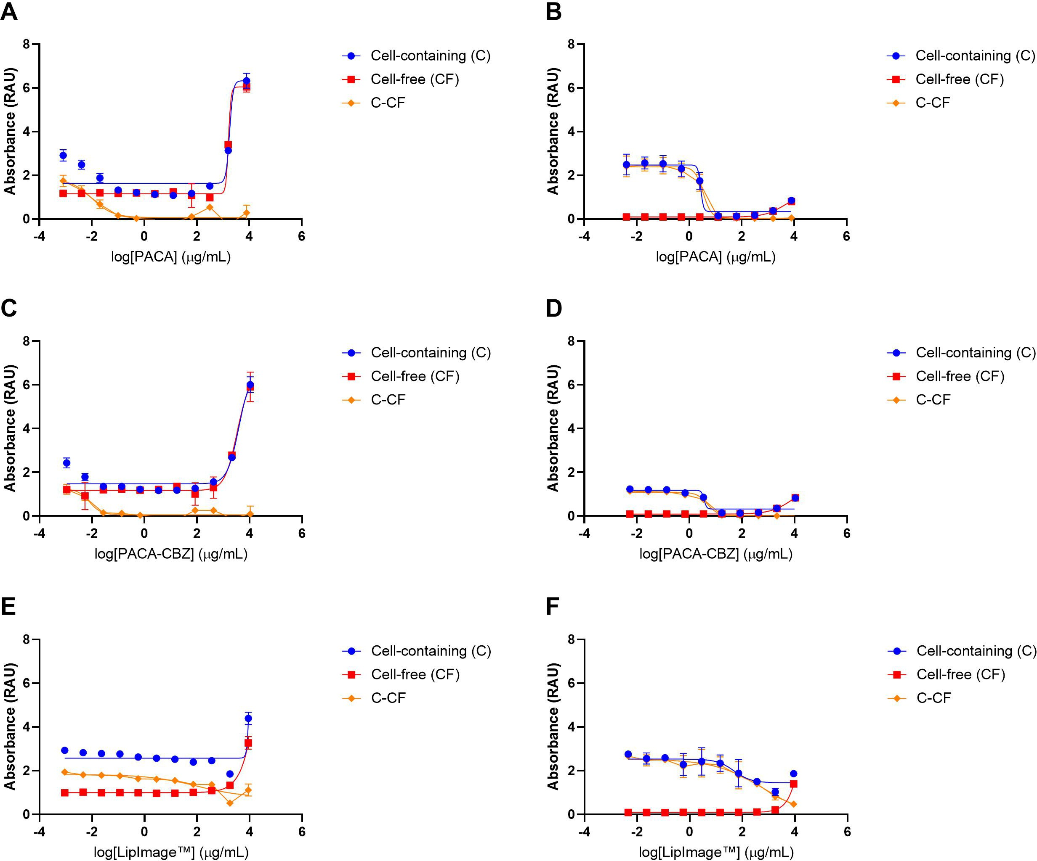

Figure 1: Assessment of cytotoxicity of nanomaterials PACA, PACA-CBZ, and LipImage™ 815 at stated concentrations in KU812 cell line using WST-1 generated by University of Liverpool (A, C, E) and RIVM (B, D, F). Data displayed as an average of 4 technical replicates ± standard deviation.

Table 2: CC₅₀ concentrations (displayed in µg/mL) calculated from the concentration- response curves, displayed in Figure 1, generated by Liverpool and RIVM labs. Recorded
concentrations represent the total mass of nano(bio)materials. - denotes conditions where EC₅₀ concentration could not be calculated. (C) cell-containing, (CF) cell-free, and (C- CF) cell-free subtracted.

PACA

PACA-CBZ

LipImage™
CC₅₀ (µg/mL)
Liverpool RIVM
C - -

CF - 3636
C-CF 0.01006 3.374
C 3937 -

CF 3371 7794
C-CF 0.008054 4.904
C - 48.99
CF - -
C-CF 99.96 705.6

  - Flow cytometer-based quantification CD63, CD203c, and CD164 University of Liverpool
All three concentrations of positive controls resulted in CD63 expression
less than that of the untreated control (Figure 2A). PACA and PACA-CBZ generated a highly similar response at 10 and 1000 µg/mL concentrations where expressions were 47.5%, 45.5%, and 70.7%, 78.7% less than that of the untreated control, respectively. LipImage™ 815, at the highest tested concentration (1000 µg/mL), was the only treatment to result in CD63 ex- pression higher than that of the untreated control (17.2%, p <0.0001).
The positive control designated low (10 nM PMA and 0.25 µM calcium ionophore) resulted in the greatest positive change in expression of CD203c compared to the untreated control (84.3%, p <0.0001, Figure 2B). Again, treatment with PACA and PACA-CBZ produced a similar trend; however, the influence of PACA-CBZ was more profound. The only LipImage™ 815 treatment to produce significant change was 1000 µg/mL resulting in 18.8% greater expression of CD203c (p <0.0001).
The only treatment to result in an expression of CD164 more than that of the untreated control was LipImage™ 815 at 1000 µg/mL (11.2%, p <0.0001). All other treatments significantly reduced the expression of this marker (Fig- ure 2E). The treatments generating the greatest reduction were PACA-CBZ (81% less) and PACA (77.5% less), both at a concentration of 1000 µg/mL.
RIVM
The observed responses of KU812 to both PACA and PACA-CBZ demon- strate a high degree of similarity at each tested concentration, also observed in the Liverpool lab dataset.
Significant reduction in the expression of CD63 was observed following treatment with 10 and 1000 µg/mL PACA and PACA-CBZ (Figure 2B).
Positive control treatment of KU812 resulted in CD203c expression 2.93- and 2.65-times more than the untreated control for L and M, respectively. The lack of significance observed in CD203c in nano(bio)material-treated conditions is the result of variability in the untreated control, having a stan- dard deviation of 33%.
Significantly less CD164 was expressed following treatment with 1000 µg/mL PACA and both 10 and 1000 µg/mL PACA-CBZ (Figure 2F). 75% (p = 0.0007) more CD164 was expressed in response to treatment with 1000 µg/mL LipImage™ 815.

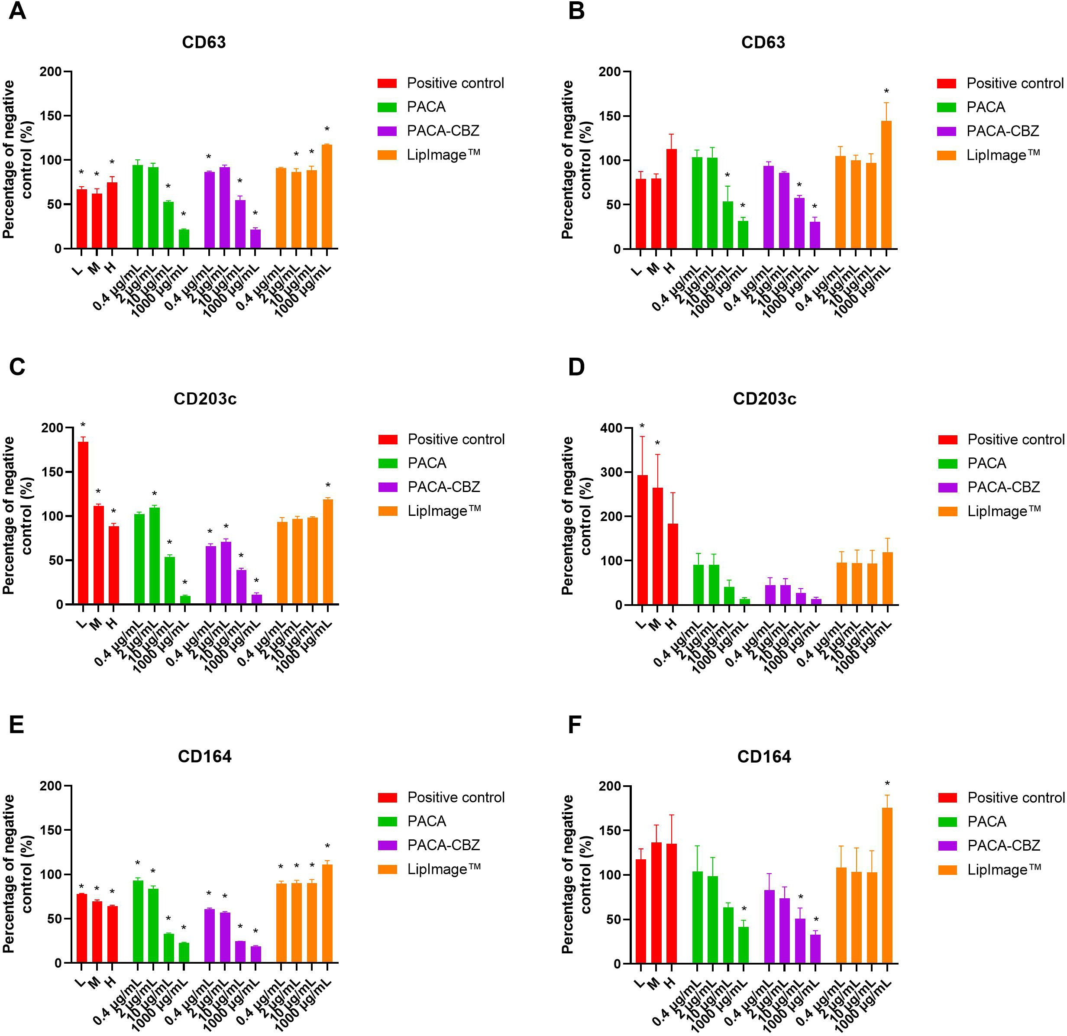

Figure 2: Flow cytometer-based quantification of KU812 cell-surface markers CD203c, CD63, CD164, following exposure to low (L, 10 nM PMA and 0.25 µM calcium ionophore), medium (M, 20 nM PMA and 0.5 µM calcium ionophore), high (H, 40 nM PMA and 1 µM calcium ionophore) positive controls, or nanomaterials PACA, PACA-CBZ, and LipImage™ 815 at stated concentrations generated by University of Liverpool (A, C, E) and RIVM (B, D, F). Data displayed as an average of 3 technical replicates ± standard deviation. * denotes p-value < 0.05.

  - Interlaboratory variance in KU812 parameters
Empty PACA particle exposure resulted in the greatest degree of interlab- oratory variance from the three nano(bio)materials assessed, across the most tested concentrations in the WST-1 assay (Figure 3A). All three materials displayed the greatest respective variance at the highest tested concentration. The greatest variance observed in the assessment of cell-surface marker expression was CD203c following treatment with the controls (PMA and calcium ionophore, Figure 3B). All other treatments demonstrated a high-
degree of similarity in data generated by flow cytometry between sites.

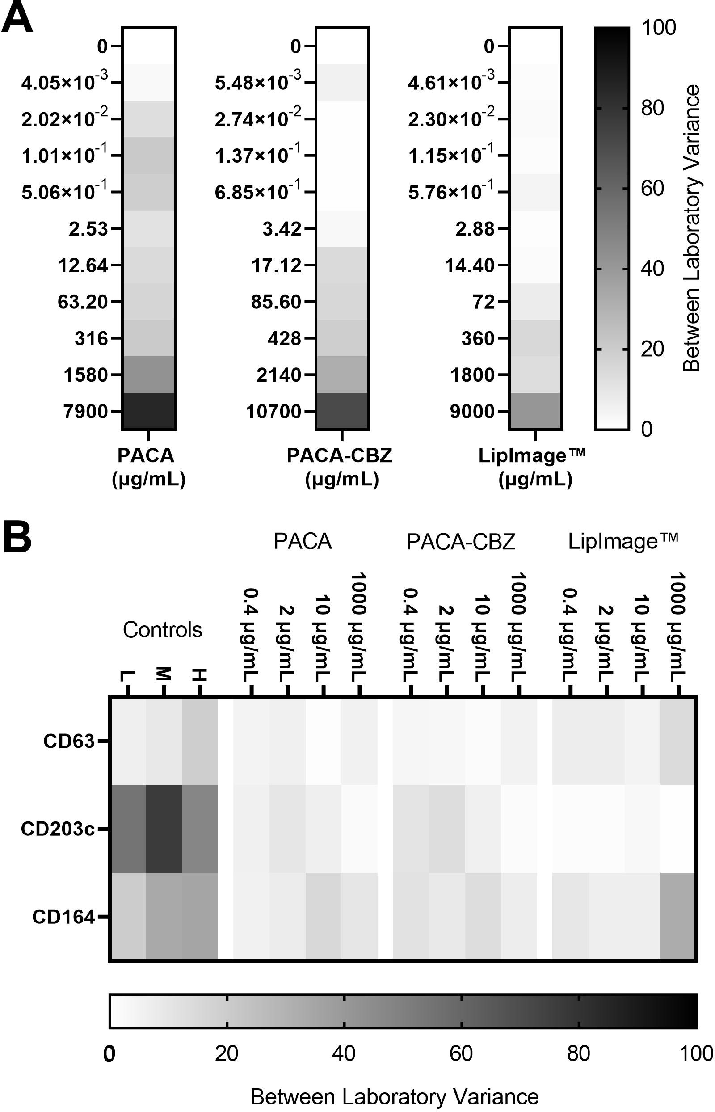

Figure 3: Heat maps of the interlaboratory variance for (A) assessment of nano(bio)material cytotoxicity using WST-1 (B) flow cytometer-based quantification of CD63, CD203c, and CD164. For each set of independent experiments, the untreated con- trol was set at 100%, and the mean and standard deviation was calculated. This was completed for each laboratory, after which the variance between the two laboratories was calculated and expressed in a heat map.

Discussion
We have demonstrated the application of a standardised methodology for the investigation of nano(bio)material impact on activation markers of a basophil-like cell line. The nano(bio)materials investigated represent two distinct nanoparticle subtypes, lipidic and polymeric nanocarriers, known to have previously been implicated with complement activation and CARPA [6]. The protocol was developed to meet the methodological need to generate the information required by regulatory bodies for nanotechnology-based health products [17, 31].
Nano(bio)materials, depending on their composition and payload, have the potential to interact with biological assays in a manner which may lead to confounding results, if those interactions are not taken into consideration [32]. It is for this reason that carefully considered controls be incorporated into any assessment protocols. One of the simplest, yet most effective, means to do so is to include a cell-free preparation of the nanomaterial subject to the same subsequent analysis. Insight is provided on whether any chemi- cal or optical, depending on the assay type, interference results from the presence of the nano(bio)material [32, 33, 34]. This strategy was applied in the assessment of cytotoxicity, which demonstrated that both PACA and LipImage™ possessed significant spectral overlap with the detection wave- length at the highest tested concentrations. If not considered, this could have been interpreted as having a proliferative response, or if the values were subtracted without observation could have been interpreted as com- plete toxicity. The magnitude of interference observed differed between sites. While a unified protocol was followed, instrumentation for the measurement of absorbance differed where the University of Liverpool used a CLARIOstar (BMG Labtech) and RIVM a SpectraMax M2 (Molecular Devices). Dif- fering sensitivity and dynamic range between the plate readers may be the differentiator but this fact affirms the need for scrutiny over results. This is an important consideration as the method described here for evaluating cell-surface marker expression relies on a non-cytotoxic dose to be tested. If cytotoxic concentrations of test materials are used, results may be affected by the loss of viable cells and altered expression of key markers. The interference with the WST-1 assay observed by both laboratories meant that a cytotoxic concentration (CC) profile could not be defined for the nano(bio)materials. Concentrations were chosen from existing data showing that LipImage™ was well-tolerated in vitro in NIH/3T3 fibroblasts up to a concentration of 1000

µg/mL [25].
The highlighted methodological need exists despite the basophil activa- tion test (BAT), which, in its most broadly adopted form, is an ex vivo assay which quantifies the expression of CD63 on basophils, virtually sepa- rated from other cellular populations in whole blood, using flow cytometry [35]. Gaining multi-parametric information from individual samples by us- ing multiplexed marker panels, commonly including CD203c [35] has become more commonplace in recent years. Distinct marker-expression profiles have the capacity to indicate route of activation [20, 24, 23, 36, 37, 35].
The value of characterising, interpreting, and drawing conclusions from increasingly numerous parameters from a highly complex system, namely patient/donor whole blood, is compromised by the lack of harmonised ap- proaches, in the field of nano(bio)materials. A lack of harmonisation in the assay protocol makes interpretation and comparison of results between sites and studies very difficult. Basic technical considerations such as the anti- coagulant employed are known to result in widely varying functional effects [38, 35]. Beyond standardising factors influencing the quality of blood sam- ples, unavoidable confounders include pre-existing medical conditions and medications, variability in cellular response between donors, and numerous others which may modulate the manner and magnitude of any potential im- mune responses toward challenge by nano(bio)materials [39, 40].
Considering an individualised medicine/bench-to-bedside approach, a stan- dardised BAT shows significant promise to assess the suitability of formula- tions in the context of a patient’s most up-to-date immune status [41, 35]. However, this platform does not prove suitable for preclinical screening. A model providing a homogeneous and reproducible response would allow an initial screening for potential adverse outcomes, which, if present, could be further investigated using primary samples [42]. This is supported by stan- dards including ASTM WK60553 “New Guide for Evaluating Impact of Par- ticles and Other Materials on Phagocytic Function In Vitro” utilising the HL-60 cell line, or more broadly ISO/TR 10,993–22:2017 “Biological evalu- ation of medical devices—Part 22: Guidance on nanomaterials” which pro- vides guidance on nanomaterial testing in medical devices for the evaluation of biological effects. Using the KU-812 cell line provides the added benefit of observing the effects of nano(bio)materials on the basophil-like cells in isolation of other cellular subsets.
The high degree of similarity of responses generated between sites for the KU812 expression of CD63, CD203c, and CD164 represents a very promising

outcome for this study. The similarity in the expression of all three tested cell-surface markers between empty and CBZ-loaded PACA would indicate that the observed response is primarily the result of the polymer nanocarrier and not the presence of the drug. Provided sufficient time to allow nanopar- ticle degradation and payload release, the observed profile may expose differ- ences between these materials. However, this is beyond the scope of the de- scribed work, which sought to observe the acute effects of nano(bio)material challenge. The ease of adoption of the SOP, for the described assays by a capable laboratory which does not have prior experience working with either the KU812 cell line or the specific experimental design, would support the further progression toward standardisation.

Conclusion
A standardised protocol was developed to investigate potential basophil activation by nano(bio)materials. KU812 have been demonstrated as capable of responding to anaphylatoxins and nanomaterials via the modulation of the expression of basophilic cell-surface markers. Two laboratories completed the assessment using the nanostructured lipid carrier LipImage™ 815 and the polymer PACA, either loaded or not with CBZ. These complex materials have exemplified some challenges that can arise when subject to biological assessment. The two material types resulted in distinctly different effects on the assessed cell-surface markers, while the differences between PACA and PACA-CBZ were negligible at each tested concentration. The work presented here demonstrates the utility of this model and protocol for the preclinical evaluation of basophil responses to developed nano(bio)materials, and the profile of activation may give some evidence as to how the materials are interacting with the cells.

Acknowledgements
Dr. Yrr Mørch (SINTEF) and Anne Rein Hatletveit (SINTEF) are ac- knowledged for synthesis and characterisation of PACA and PACA-CBZ, Dr. Emilie Rustique (CEA) and Dr. Isabelle Texier (CEA) for synthesis and characterisation of LipImage™ 815, as part of the EU H2020 REFINE project (grant agreement number #761104).

Author contribution
Christopher A. W. David: conceptualisation, data curation, formal analysis, investigation, methodology, validation, writing—original draft, writ- ing—review and editing; Liset J. J. de la Fonteyne-Blankestijn: data curation, investigation, validation, writing—review and editing; Jolanda P. Vermeulen: data curation, investigation, validation, writing—review and editing; Alexander Plant-Hately: methodology, validation, writing—review and editing; Rob J. Vandebriel: conceptualisation, funding acquisition, project administration, supervision, writing—review and editing; Neill J. Liptrott: conceptualisation, funding acquisition, project administration, su- pervision, writing—review and editing.

Funding
Funding The present work has been developed within the REFINE project: Regulatory Science Framework for Nano(bio)material-based Medical Prod- ucts and Devices, funded by European Union’s Horizon 2020 Research and Innovation Programme under Grant Agreement no 761104.

References
- T. Mocan, C. T. Matea, C. Iancu, L. Agoston-Coldea, L. Mo- can, R. Orasan, Hypersensitivity and nanoparticles: Update and research trends, Clujul Medical (1957) 89 (2) (2016) 216–219. doi:10.15386/cjmed-574.
- P. P. Wibroe, S. M. Moghimi, Complement Sensing of Nanoparti- cles and Nanomedicines, in: Functional Nanoparticles for Bioanalysis, Nanomedicine, and Bioelectronic Devices Volume 2, Vol. 1113 of ACS Symposium Series, American Chemical Society, 2012, Ch. 14, pp. 365–
382. doi:10.1021/bk-2012-1113.ch014.
- M. Chaponda, M. Pirmohamed, Hypersensitivity reactions to HIV ther- apy, British Journal of Clinical Pharmacology 71 (5) (2011) 659–671. doi:10.1111/j.1365-2125.2010.03784.x.
- G. M. Shepherd, Hypersensitivity reactions to chemotherapeutic drugs, Clinical Reviews in Allergy & Immunology 24 (3) (2003) 253–262. doi:10.1385/CRIAI:24:3:253.

- J. R. Dunkelberger, W.-C. Song, Complement and its role in innate and adaptive immune responses, Cell Research 20 (1) (2010) 34–50. doi:10.1038/cr.2009.139.
- N. M. La-Beck, M. R. Islam, M. M. Markiewski, Nanoparticle-Induced Complement Activation: Implications for Cancer Nanomedicine, Fron- tiers in Immunology 11 (2021).
- Z. Wang, J. S. Brenner, The Nano-War Against Complement Proteins, The AAPS Journal 23 (5) (2021) 105. doi:10.1208/s12248-021-00630-9.
- S. M. Moghimi, P. P. Wibroe, L. Wu, Z. S. Farhangrazi, Insidious pathogen-mimicking properties of nanoparticles in triggering the lectin pathway of the complement system, European Journal of Nanomedicine 7 (3) (2015) 263–268. doi:10.1515/ejnm-2015-0014.
- S. Kurosawa, D. J. Stearns-Kurosawa, Complement, thrombotic mi- croangiopathy and disseminated intravascular coagulation, Journal of Intensive Care 2 (1) (2014) 61. doi:10.1186/s40560-014-0061-4.
- Joint Task Force on Practice Parameters, American Academy of Al- lergy, Asthma and Immunology, American College of Allergy, Asthma and Immunology, Joint Council of Allergy, Asthma and Immunol- ogy, Drug allergy: An updated practice parameter, Annals of Al- lergy, Asthma & Immunology: Official Publication of the American College of Allergy, Asthma, & Immunology 105 (4) (2010) 259–273. doi:10.1016/j.anai.2010.08.002.
- B. Zhang, Q. Li, C. Shi, X. Zhang, Drug-Induced Pseudoallergy: A Review of the Causes and Mechanisms, Pharmacology 101 (1-2) (2018) 104–110. doi:10.1159/000479878.
- P. W. Askenase, Basophil arrival and function in tissue hypersensitivity reactions, Journal of Allergy and Clinical Immunology 64 (2) (1979) 79–89. doi:10.1016/0091-6749(79)90041-1.
- J. Szebeni, Complement activation-related pseudoallergy: A stress re- action in blood triggered by nanomedicines and biologicals, Molecular Immunology 61 (2) (2014) 163–173. doi:10.1016/j.molimm.2014.06.038.

- R. Bawa, J. Szebeni, T. Webster, G. F. Audette (Eds.), Immune Aspects of Biopharmaceuticals and Nanomedicines, Jenny Stanford Publishing, New York, 2019. doi:10.1201/b22372.
- J. Szebeni, Complement activation-related pseudoallergy: A new class of drug-induced acute immune toxicity, Toxicology 216 (2) (2005) 106–121. doi:10.1016/j.tox.2005.07.023.
- J. Szebeni, P. Bed˝ocs, Z. Rozsnyay, Z. Weiszh´ar, R. Urbanics, L. Ro- sivall, R. Cohen, O. Garbuzenko, G. B´athori, M. T´oth, R. Bu¨nger,
Y. Barenholz, Liposome-induced complement activation and related car- diopulmonary distress in pigs: Factors promoting reactogenicity of Doxil and AmBisome, Nanomedicine: Nanotechnology, Biology and Medicine 8 (2) (2012) 176–184. doi:10.1016/j.nano.2011.06.003.
- B. Halamoda-Kenzaoui, R. J. Vandebriel, A. Howarth, M. Siccardi,
C. A. W. David, N. J. Liptrott, M. Santin, S. E. Borgos, S. Bremer- Hoffmann, F. Caputo, Methodological needs in the quality and safety characterisation of nanotechnology-based health products: Priorities for method development and standardisation, Journal of Controlled Release 336 (2021) 192–206. doi:10.1016/j.jconrel.2021.06.016.
- E. C. McGowan, S. Saini, Update on the Performance and Application of Basophil Activation Tests, Current allergy and asthma reports 13 (1) (2013) 101–109. doi:10.1007/s11882-012-0324-x.
- T. Blom, R. Huang, M. Aveskogh, K. Nilsson, L. Hellman, Phenotypic characterization of KU812, a cell line identified as an immature human basophilic leukocyte, European Journal of Immunology 22 (8) (1992)
2025–2032. doi:10.1002/eji.1830220811.
- M. Hosoda, M. Yamaya, T. Suzuki, N. Yamada, M. Kamanaka, K. Sek- izawa, J. H. Butterfield, T. Watanabe, H. Nishimura, H. Sasaki, Effects of Rhinovirus Infection on Histamine and Cytokine Production by Cell Lines from Human Mast Cells and Basophils, The Journal of Immunol- ogy 169 (3) (2002) 1482–1491. doi:10.4049/jimmunol.169.3.1482.
- C. L. Sokol, R. Medzhitov, Emerging functions of basophils in protective and allergic immune responses, Mucosal Immunology 3 (2) (2010) 129–
137. doi:10.1038/mi.2009.137.

- A. J. Plant-Hately, B. Eryilmaz, C. A. W. David, D. E. Brain,
B. J. Heaton, Y. Perrie, N. J. Liptrott, Exposure of the Ba- sophilic Cell Line KU812 to Liposomes Reveals Activation Pro- files Associated with Potential Anaphylactic Responses Linked to Physico-Chemical Characteristics, Pharmaceutics 14 (11) (2022) 2470. doi:10.3390/pharmaceutics14112470.
- F. Hennersdorf, S. Florian, A. Jakob, K. Baumg¨artner, K. Son- neck, A. Nordheim, T. Biedermann, P. Valent, H.-J. Bu¨hring, Iden- tification of CD13, CD107a, and CD164 as novel basophil-activation markers and dissection of two response patterns in time kinetics of IgE-dependent upregulation, Cell Research 15 (5) (2005) 325–335. doi:10.1038/sj.cr.7290301.
- A. Wolanczyk-Medrala, W. Barg, W. Medrala, CD164 as a Basophil Activation Marker, Current Pharmaceutical Design 17 (34) (2011) 3786–
3796. doi:10.2174/138161211798357890.
- A. Jacquart, M. Keramidas, J. Vollaire, R. Boisgard, G. Pottier, E. Rus- tique, F. Mittler, F. Navarro, J. Boutet, J.-L. Coll, I. Texier, LipImage™ 815: Novel dye-loaded lipid nanoparticles for long-term and sensitive in vivo near-infrared fluorescence imaging, Journal of Biomedical Optics 18 (10) (2013) 101311. doi:10.1117/1.JBO.18.10.101311.
- A. Øverbye, M. L. Torgersen, T. Sønstevold, T. G. Iversen, Y´. Mørch,
T. Skotland, K. Sandvig, Cabazitaxel-loaded poly(alkyl cyanoacry- late) nanoparticles: Toxicity and changes in the proteome of breast, colon and prostate cancer cells, Nanotoxicology 15 (7) (2021) 865–884. doi:10.1080/17435390.2021.1924888.
- M. Varache, M. Escud´e, C. Laffont, E. Rustique, A.-C. Couf- fin, Development and validation of an HPLC-fluorescence method for the quantification of IR780-oleyl dye in lipid nanoparticles, International Journal of Pharmaceutics 532 (2) (2017) 779–789. doi:10.1016/j.ijpharm.2017.06.019.
- A. S. Klymchenko, E. Roger, N. Anton, H. Anton, I. Shulov, J. Vermot,
Y. Mely, T. F. Vandamme, Highly lipophilic fluorescent dyes in nano- emulsions: Towards bright non-leaking nano-droplets, RSC advances 2 (31) (2012) 11876–11886. doi:10.1039/C2RA21544F.

- K. M. Eder, A. Marzi, A. M. W˚agbø, J. P. Vermeulen, L. J. J. de la Fonteyne-Blankestijn, M. R¨osslein, R. Ossig, G. Klinkenberg, R. J. Van- debriel, J. Schnekenburger, Standardization of an in vitro assay matrix to assess cytotoxicity of organic nanocarriers: A pilot interlaboratory comparison, Drug Delivery and Translational Research 12 (9) (2022)
2187–2206. doi:10.1007/s13346-022-01203-9.
- R. J. Vandebriel, C. A. W. David, J. P. Vermeulen, N. J. Liptrott, An inter-laboratory comparison of an NLRP3 inflammasome activation assay and dendritic cell maturation assay using a nanostructured lipid carrier and a polymeric nanomedicine, as exemplars, Drug Delivery and Translational Research 12 (9) (2022) 2225–2242. doi:10.1007/s13346-
022-01206-6.

- J. R. C. E. Commission), H. Box, S. Bremer-Hoffmann, S. Gaitan,
A. Del Pozo, M. van Elk, R. E. Geertsma, E. Gainza Lafuente,
M. Roesslein, A. Owen, B. Halamoda-Kenzaoui, Anticipation of Regula- tory Needs for Nanotechnology-Enabled Health Products: The REFINE White Paper, Publications Office of the European Union, LU, 2019.
- C. A. David, A. Owen, N. J. Liptrott, Determining the relation- ship between nanoparticle characteristics and immunotoxicity: Key challenges and approaches, Nanomedicine 11 (11) (2016) 1447–1464. doi:10.2217/nnm-2016-0017.
- A. Kroll, M. H. Pillukat, D. Hahn, J. Schnekenburger, Interference of engineered nanoparticles with in vitro toxicity assays, Archives of Toxi- cology 86 (7) (2012) 1123–1136. doi:10.1007/s00204-012-0837-z.
- T. J. Maccormack, R. J. Clark, M. K. M. Dang, G. Ma, J. A. Kelly, J. G. C. Veinot, G. G. Goss, Inhibition of enzyme ac- tivity by nanomaterials: Potential mechanisms and implications for nanotoxicity testing, Nanotoxicology 6 (5) (2012) 514–525. doi:10.3109/17435390.2011.587904.
- A. F. Santos, O. Alpan, H.-J. Hoffmann, Basophil activation test: Mech- anisms and considerations for use in clinical trials and clinical practice, Allergy 76 (8) (2021) 2420–2432. doi:10.1111/all.14747.

- G. Monneret, R. Boumiza, S. Gravel, C. Cossette, J. Bienvenu,
J. Rokach, W. S. Powell, Effects of prostaglandin D(2) and 5- lipoxygenase products on the expression of CD203c and CD11b by ba- sophils, The Journal of Pharmacology and Experimental Therapeutics 312 (2) (2005) 627–634. doi:10.1124/jpet.104.074823.
- D. MacGlashan, Marked differences in the signaling requirements for ex- pression of CD203c and CD11b versus CD63 expression and histamine release in human basophils, International Archives of Allergy and Im- munology 159 (3) (2012) 243–252. doi:10.1159/000332150.
- E. Cedrone, B. W. Neun, J. Rodriguez, A. Vermilya, J. D. Clogston,
S. E. McNeil, Y. Barenholz, J. Szebeni, M. A. Dobrovolskaia, Anti- coagulants Influence the Performance of In Vitro Assays Intended for Characterization of Nanotechnology-Based Formulations, Molecules : A Journal of Synthetic Chemistry and Natural Product Chemistry 23 (1) (2017) 12. doi:10.3390/molecules23010012.
- A. F. Santos, G. Lack, Basophil activation test: Food challenge in a test tube or specialist research tool?, Clinical and Translational Allergy 6 (2016) 10. doi:10.1186/s13601-016-0098-7.
- C. A. W. David, M. Barrow, P. Murray, M. J. Rosseinsky, A. Owen,
N. J. Liptrott, In Vitro Determination of the Immunogenic Impact of Nanomaterials on Primary Peripheral Blood Mononuclear Cells, International Journal of Molecular Sciences 21 (16) (2020) 5610. doi:10.3390/ijms21165610.
- A. Akarsu, O. Soyer, B. E. Sekerel, Hypersensitivity Reactions to Bio- logicals: From Bench to Bedside, Current Treatment Options in Allergy 7 (1) (2020) 71–83. doi:10.1007/s40521-020-00242-2.
- B. Drasler, P. Sayre, K. G. Steinh¨auser, A. Petri-Fink, B. Rothen- Rutishauser, In vitro approaches to assess the hazard of nanomaterials, NanoImpact 8 (2017) 99–116. doi:10.1016/j.impact.2017.08.002.

