The transformative power of linguistic mobility – evidence from Italian borderscapes

1. Introduction
This chapter is a comparative examination of linguistic and semiotic constructions of border identities in deeply territorialised spaces as they are enacted in two border areas of Italy, namely Trentino-Alto Adige/South Tyrol and Friuli-Venezia Giulia in the north east of the country (nos. 4 and 6 respectively in Figure 1). In these regions language practices are particularly complex and include sets of varieties pertaining to German, Slovenian and Italian repertoires.

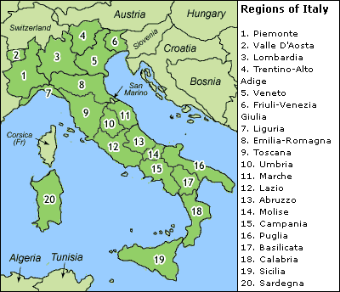
Figure 1 - Regions of Italy (http://www.big-italy-map.co.uk/)

The analysis is based on fieldwork carried out in the areas of Trieste/Trst and Sesto/Sexten, which are integrated in socio-historical contexts where the minoritised languages (i.e. Slovenian and German respectively) have enjoyed both national and regional protection via targeted legislation introduced in the post-war period (Orioles 2003).
The main theoretical framework that the discussion draws upon is the concept of motility, or potential for mobility, as proposed in Kaufmann (2002; 2011) and applied to the sociolinguistic production of space. This perspective, which represents a novel approach to linguistic landscape (LL) studies, will allow us to investigate to what extent local LL dynamics articulate the construction and consolidation of divergent asymmetrical relations (Fairclough 2015) between language agents and their material and symbolic audiences. The analysis will therefore focus on discursively constructed degrees of motility as they are played out in LL, and tease out similarities and differences in spatialisation (Lefebvre 1991) practices in the two localities, where multilingual practices are central to the negotiation of different versions of living. It will become apparent that the symbolic and material weight of the local LL is grounded in complex webs of past and present sociolinguistic dynamics as they have sedimented in these highly contested territories. As a result, LL does not just contribute to the construction and display of spatial multilingualism and multiple identities, but is also instrumental in creating the potential for change and therefore it represents a structuring dimension of social life in the observed sites. This is evident both at the macro level, in that institutionalised space impacts on LL mobility or immobility, and at the micro level, in so far as LL writing acts interact with institutionalised language to manipulate spaces of belonging. The potential for change also translates into different degrees of social empowerment, in that it is directly related to language actors’ agency.
In terms of the organisation of the Chapter, Section 2 provides background information about the two areas from a comparative perspective. This includes an outline of linguistic repertoires, relevant historical information and aspects of language policy. Section 3 examines the theoretical frameworks that have informed the discussion, which is integrated into the presentation of the data (Section 4). Conclusive remarks are provided in Section 5.

2. The context - similarities and differences between the two areas
The data under consideration for the purposes of this chapter relate specifically to the area outside Trieste/Trst in Venezia Giulia (VG) and to the town of Sesto/Sexten in Alto Adige/South Tyrol (ST). Both sub-areas lie on the Italian side of the north-eastern border and, similarly to other regions of Italy, legislation includes specific language provision in terms of support for German and Slovenian. This is framed within special statutes which grant a higher degree of autonomy for internal administration than in other regions of Italy, and within both national and regional legislation supporting linguistic specificity and provision (Piergigli 2017).
As regards linguistic practices (Figures 2 and 3 below), in VG repertoires include Italo-Romance regional varieties and varieties of Slovenian and Italian, whilst in ST Germanic or Ladin varieties are employed alongside Italian, depending on locality.

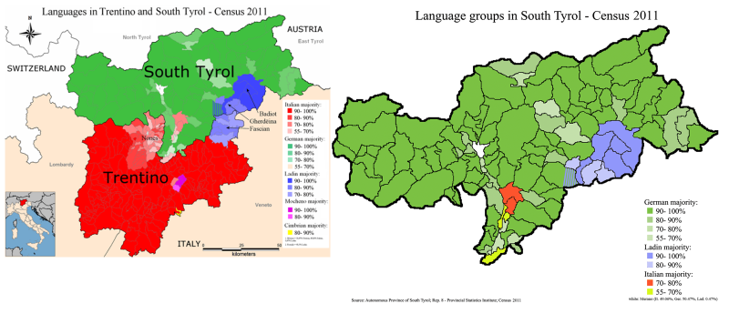
Figure 2 – Language distribution in Trentino-Alto Adige/South Tyrol (https://it.wikipedia.org)

Figure 3 – Language distribution in Friuli-Venezia Giulia (adapted from Marcato 2001: 26)

Urban Trieste is predominantly Italophone in contrast to the surrounding rural area, where Slovenian is more audible and visible. This situation is replicated in Bolzano (the main city in ST), where Italian dominates language repertoires (ASTAT 2018), whereas in the rest of the region Germanic varieties are prevalent (Figure 2). In Sesto, in particular, a near totality of inhabitants self-identify as German speakers (95.37% according to the 2011 Census), a situation that is common in the ST region.The sociolinguistics of the two areas therefore presents similarities and differences. The peculiarities of each region are due to the complex linguistic ecologies that characterise the localities, ecologies where the legacy of the past is a major factor.
Over the course of the 20th century the Italian north-eastern border was highly significant for both the national and the international geopolitical order (Cattaruzza 2007). The events of World War I caused the dissolution of the Habsburg Empire, and Italian control of the two areas under investigation was sanctioned by the 1919 treaties. Within a consolidated context of nation-states which had increasingly articulated ethnic identities via national languages, Italian fascism (1922-1943) implemented harsh assimilationist policies which aimed to Italianise heteroglossic groups. These policies caused comparable mass migrations from the two regions, even though the modalities differed. Whilst between 50,000 and 100,000 Italian Slavs moved to (what was then) Yugoslavia to escape the fascist regime (Corni 2011), due to the alliance between Germany and Italy in ST people were given the opportunity ‘to opt out’ of Italy and move to Austria (about 75,000 Optanten left between 1939 and 1943, of which about 50,000 returned to Italy after the war) (Grote 2012). Although people returning to Italy from Austria often met with distrust and resentment on the part of both those who had stayed and ethnic Italians, the situation relating to Italian Slavs was further exacerbated by a migration counter-flow of ethnic Italians living in Istria and Fiume (in present-day Croatia) between 1943 and 1956, which included anti-Tito Croatians and Slovenians wanting to leave Yugoslavia (Premik 2004; Pupo 2005). The prolonged period which witnessed the bidirectional transfer of people from the two sides of the border, and the traumatic experiences that characterised it, did not facilitate a process of reconciliation between the two groups. These events have contributed to the consolidation of memorial narratives where language is an essentialised part of the self.
Both outward movement and the return of residents over time would have a lasting effect on collective and individual memory in both areas, and contribute to the crystallisation of difference in identity-making processes. For example, in VG Italians are identified with urban dwellers and Slovenians with rural communities, a perception which has become rooted over time and underplays those hybrid identities that have formed as a result of long-term place-sharing on the part of the two groups (Sbisà and Vascotto 2007). In this context, the observed LL in the province of Trieste (by which we refer to an area outside the urban centre which is delimited in administrative terms) is a dynamic agent in the construction of the bounded self, whereas in urban Trieste Slovenian is conspicuous by its absence and visually silenced (Tufi 2013). Geopolitical and historical aspects have also resulted in a sort of tacit acceptance of the low status of Slovenian, both nationally and internationally:

‘The Slovene minority in Italy has been a predominantly closed, exclusive community, both due to historical events that took place in the first half of the 20th century and due to policies of minority protection. As a consequence, no high perceived status of the Slovene minority among Italian speakers has been established.’ (Brezigar 2009: 213).

On the contrary, in ST physical and cultural contiguity with other German-speaking territories, a tradition of discourses around South Tyrol as a ‘German land’ since the late 19th century (Grote 2012), an awareness that the Dachsprache (i.e. the umbrella language - standard German) is one of the main languages of culture globally, and the privileged socio-economic status that ST enjoys as the wealthiest region of Italy (ISTAT, 2018) and one of the richest in Europe , have – amongst other elements – enhanced the type of self-perception and linguistic confidence that LL sanctions, as will become apparent below.
With respect to minority language provision, after World War II, and in a much-changed climate where the new international order was keen to consolidate human rights and safeguard individual freedoms, the protection of ethnolinguistic minorities on Italian territory was enshrined in the Italian Constitution (1948). In the decades following the enacting of the Constitution, and together with other minorities, the people of VG and ST have benefitted from both national and regional legislation granting degrees of autonomy in the administration of local matters, and supporting ethnolinguistic specificity (Toso 2008; Piergigli 2017). Legislation includes provision for education and envisages both the study of the minority language as a subject and its use as a medium of instruction. The outcomes in the two regions, however, have been different: whilst in VG Slovenian-Italian bilingualism is the norm on the part of ethnic Slovenians but not of ethnic Italians (Sussi 2003), a segregationist model of bilingualism in ST has been a decisive factor in the slow normalisation of bilingual practices (German/Italian) on the part of South Tyroleans (Carli 2003). Recent studies (Wand 2016) about bilingual education in ST show that, similarly to Slovenian in VG, German in ST is deployed as an identity defence mechanism but, unlike Slovenian in VG, it is also a marker of superiority for speakers and an indicator of deficiency in othering processes. Again, these attributions are deep-rooted and date back to times when victimising discourses were being constructed by the Germanophone group on the occasion, for example, of World War I and of the following geo-political settlement. However, as Wand (2016) explains, the current prestige of German is reinforced locally by aspects such as the Italophone parents’ choice to send their children to German-medium nurseries as a way to enable German-language acquisition outside the family. In terms of the developments of sociolinguistic aspects, Eichinger (2002) explains that both language attitudes and language practices on the ground have been changing. A growing awareness of the advantages of multilingualism, together with regular contact between German and Italian, have opened up spaces of encounter that feed into forms of regional identity. This is one of the aspects that will account for the peculiar configuration of LL in ST, and is in direct opposition to local language politics as promoted by local political groups. In the attempt to curb the perceived threat to German identity, these groups advocate, for instance, the testing of language proficiency in the first few weeks of entering German-medium schools, therefore undermining the principle of free choice introduced in 1972 as part of the second autonomy statute (Provincia Autonoma di Bolzano Alto Adige 2009). Although this stance does not necessarily reflect common thinking or actual language practices, it shows that there is no general consensus about how to solve the issue of segregated education.
Finally, even though both VG and ST participated in the swift socio-economic development that characterised post-war Italy, ST has experienced a very successful transition from a rural to a service (mainly tourist) economy and enjoys a very high standard of living (Lechner and Moroder 2012). This cannot be claimed in VG.
All the above aspects contribute to the construction of difference as it is played out in LL, as will emerge from the illustration of the data. Before the discussion of the data, however, some space will be devoted to the sketching of the main theoretical frameworks underpinning the present interpretation of LL.

3. Theoretical background
The differences in the perception (and self-perception) of the two groups can be usefully framed in terms of what Blommaert (2005) calls ascribed (externally attributed) and inhabited (internally endorsed) identity. In the extra-urban context of VG under examination, ascribed and inhabited identity do not coincide. Internal perceptions of the group (and the semiotic practices that actualise them) are characterised by internal prestige norms, and the visibility of Slovenian is pervasive (Tufi 2016). On the contrary, ascribed and inhabited identity in ST coincide, in that internal perceptions are reinforced by external perceptions, and LL practices actively contribute to the performance of the different self within the dialectical relationship of unity in diversity of the Germanophone world, a cultural legacy of regional and local autonomy which is rooted in the historical composition of German federalism (Gunlicks 2003).
These aspects complement Berruto’s (2016) reflections on sociolinguistic vitality, whereby internal linguistic vitality would characterise forms of inhabited identity, and external linguistic vitality would characterise forms of ascribed identity. It should be borne in mind, however, that in taking these frameworks into consideration, we are not advocating the application of binary interpretive tools. On the contrary, we continue viewing identity in its performative aspects, where different components of identity are deployed differently in daily interactions and where the self is a matter of actualised degrees of embodied existence. We are aware of the limitations of carrying out comparative studies and of the binary categories that they might inadvertently encourage. We therefore wish to remind the reader that the interpretive tools that we propose in this chapter are employed to help us identify critical features relating to linguistic behaviour that, we believe, endows language agents with transformative potential.
In this respect it is interesting to note that the hyphenated names of these regions have contributed to the fossilisation of hyphenated identities such as Italo-Slovenians and Italo-Germans in reference to the Slovenophone and Germanophone groups who share the respective regions with Italian groups. Due to the inescapable territorial dimension that is inherent in current geopolitics, this lexical compromise was intended to include the different ethnic identities that share lived space, rather than reflecting the original use of hyphenated terms expressing divided loyalty (as in Higham 1955). In any case, this points to the verbal difficulties of articulating the intersections of history, geopolitics and culture, and the limited descriptive power of naming practices. Hyphenated ethnic terms emphasise, once again, binary conceptions of belonging, and banalise identities which are complex and not simply the sum of two parts. In particular, the Italo- side of the terms foregrounds the nation-state (Italy) as the political entity regulating and dictating institutional forms of belonging. The second part of the ethnonyms, on the contrary, engenders the possibility of different, long-standing ethnicities on Italian soil, therefore characterising a form of defective identity if viewed within a traditional understanding of the indissoluble bond between language, culture and the nation-state. Such naming practices, therefore, hinder the normalisation of hybridisation processes and foreground a separation that ignores de facto mixed identities, as illustrated above (§ 2). They also militate against social cohesion, in that they encourage a perception of identity which is bounded, immobile and exclusionary, and therefore incapable of evolving over time – the very opposite of human experience. Finally, they inhibit processes of both group and individual empowerment, a form of emancipation from crystallised identities that requires a suitable descriptive terminology that the logic of the nation-state is not able to engender.
In the attempt to problematise dualistic categories, the main analytical perspective that we wish to take into consideration for the purposes of this chapter is rooted in urban sociology, and draws on Kaufmann’s (2002; 2011) conceptualisation of mobility, both spatial and social. This framework marks a departure from a tradition of studies which have focused on communities or neighbourhoods as concrete and static territories, and which provide an areolar view of space, i.e. one where groups are geographically delineated and physically bounded. This tradition in turn has influenced concepts of spatial mobility, where the focus has been on movement in space-time rather than on the interaction between actors, structures and context.
The potential for movement with respect to mobile actors is central to Kaufmann’s (2002; 2011) theorisation of motility. Motility, borrowed from biology, is understood as the capacity of entities (e.g. goods, information or people) to be mobile in social and geographic space, and as the way in which entities access and appropriate the capacity for socio-spatial mobility according to their circumstances. Within a ‘field of possibilities’ (Kaufmann 2011: 57), i.e. potential choices that are available in a given context, motility is the way an individual or group exploits opportunities that are available to them to fulfil their aspirations and pursue their objectives.
In particular, Kaufmann (2011: 57) posits that mobility is based on three analytical dimensions. The first dimension, as mentioned above, is the field of possibilities – this is based on existing infrastructure in a given locality, the use of space, the job market, the institutions and the laws that govern human activity. The field of possibilities encompasses both given models of achievement and the challenges faced by its members. The second dimension is aptitude for movement – within a given physical, economic, and social context, these aptitudes provide a degree of motility, i.e. an individual’s capacity for movement within certain conditions. Motility is the way individuals or groups exploit the field of possibilities with regard to movement in relation to their aspirations and projects. The third dimension is movement, which refers to actual moving in physical space, and can include ideas, objects and information in addition to people.
When put together, these three dimensions are likely to produce motility. However, the field of possibilities, engendered by existing infrastructure, is not necessarily conducive to the actual selection of real options on the part of individuals or groups. Conversely, highly developed motility can have the result of anchoring a population to an environment, rather than empowering it to change. Similarly, just because an individual or a group moves a great deal, this does not mean that their field of possibilities is favourable or predisposed to mobility.
By uncoupling movement and mobility, Kaufmann (2011: 57) identifies three main outcomes:
(1) Moving and being mobile, where spatial mobility and social mobility go hand in hand. Mobile social actors are empowered to move spatially, too – a prerogative which is afforded by their socio-economic status. In LL terms, this would reflect typical situations in national settings where the status and/or the legislation supporting the majority/standard language warrants its dominant visibility and therefore both its spatial and its social employability.
(2) Moving without being mobile, where physical movement does not impact on the actor in terms of role, identity or social position, and where micro-movements ultimately reinforce (social) immobility. An example could be that of actors who travel regularly for work, but whose social status remains immobile. In LL terms, and taking the role of Slovenian in VG into consideration, status elevation via institutional protection in this particular instance can be seen as a micro-movement which does not change real (both ascribed and inhabited) status. The positive impact on linguistic mobility, i.e. its employability to enhance its cultural capital and gain centrality in the local linguistic market, is limited.
(3) Not moving and being mobile, where (social) change takes place with no spatial component. Virtual movement engendered by connectivity can, for instance, increase the chances of social mobility considerably. In LL terms, this outcome can be exemplified through the role of German in ST in so far as geolinguistic non-movement does not contradict a high degree of sociolinguistic (and LL) mobility. This translates into a maximum usability of all available linguistic resources.
Focusing the analysis on the potential of movement allows us to foreground new aspects of the mobility of LL actors with regards to possibilities and constraints of their manoeuvres. This in turn will enable an appreciation of wider societal consequences of social and spatial mobility, and on the potential of multilingualism in the given settings.
Motility encompasses interdependent elements relating to a) access to different forms and degrees of mobility, b) competence to recognise and make use of access, and c) appropriation of a particular choice. If viewed as a form of capital (in a Bourdieusian sense), motility can be mobilised and transformed into other types of capital (i.e. economic, human and social capital). Depending on (local and geopolitical) context, individual actors, groups and institutions differ in access, competence and appropriation, and have therefore at their disposal different motility options. This framework will inform the analysis of data in the next section.
Kaufmann’s theory has been recently employed in the context of language maintenance and shift in relation to migrant groups. Houtkamp (2018) focuses in particular on language transmission and survival in transnational contexts, such as Turkish groups living in the Netherlands, and analyses the conditions which endow the heritage language with mobility capital, such as the nurturing of transnational ties. The closeness of transnational ties between the two sides of the border is in fact another aspect that VG and ST share in terms of the close cross-border relationships with neighbouring countries where Slovenian and German are the majority (and national) languages. In terms of LL motility, however, this common aspect does not seem to have a high degree of significance, due to the different historical conditions that characterise the long-standing minoritised groups in Italy compared to migrant groups of recent standing, such as the Turkish one living in the Netherlands.
The main purpose of this chapter is to propose and assess the suitability of the theory of motility (Kaufmann (2002; 2011) in LL Studies. The presentation of the data will allow us to illustrate the applicability of this notion and its explanatory power in terms of LL motility as observed in borderscapes, and beyond. The discussion will uncover the links between motility and empowerment in the different outcomes engendered by the local realisation of the potential for change.

4. The data
Prior to the discussion of the data, a methodological note is necessary to explain the differences in the extent and nature of the LL surveys in the two areas. The data presented for VG in this chapter were collected in 2010 and partly discussed in Tufi (2013; 2016) and in Blackwood and Tufi (2015), albeit within different theoretical frameworks. The data relating to ST, on the contrary, were collected in 2016 and have not been published before. As a result, the two data sets are comparable only to a certain extent, in that the corpus for VG includes a wider area (the entire province of Trieste encompassing five towns and a total population of about 30,000) than the corpus for ST, which focuses on one town, Sesto (pop. 2,000) (ISTAT 2012). This imbalance, however, will add solidity to the analysis as presented below – the LL in VG foregrounded adherence to the standard form of the minoritised language consistently even though a wider area was examined, whereas the LL in ST indexed a significantly diverse linguistic repertoire within the limited space of a small centre. In terms of the number of tokens featuring the minority language, the two data sets are broadly comparable (220 in VG and 126 in ST). In addition, an initial comparison as outlined in this research is useful a) as a preliminary application of motility in minoritised LL settings, and b) to share the concept with a wider audience of scholars in view of further analysis and theorisation. For these reasons, we will engage primarily with qualitative aspects of the LL, with the intention of providing a more fine-grained investigation supported by additional data in future research.
As highlighted in Tufi (2013; 2016), data collected in the province of Trieste indicate a pervasive presence of written Slovenian, which is displayed on a wide range of signs pointing to the use of the minority language in all spheres of life. These include both public signs initiated by institutional actors and private ones, such as shop signs and other commercial displays. Signs on recycling bins (Figure 4), for example, and on other items pertaining to the local infrastructure, such as public libraries (Figure 5) and security (Figure 6), are bilingual. Commercial signs range from shop signs (the hairdresser’s in Figure 7) through to signs indicating establishments such as the cafè in Figure 8, or adverts. We also identified items with longer texts such as party-political communications, and they usually appeared as two monolingual signs, one in Slovenian and one in Italian, displayed in parallel or vertically (one above the other).

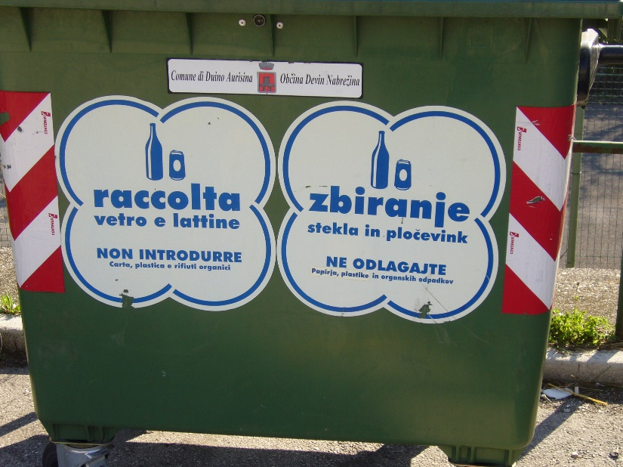
Figure 4 – Recycling bins for glass and cans - Italian (left) and Slovenian (right)
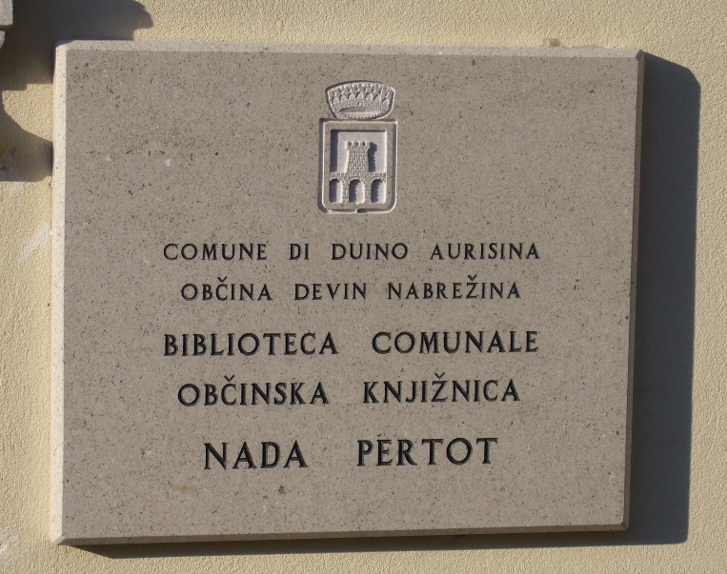
Figure 5 – Municipal library in Duino Aurisina (Italian-Slovenian)

Figure 6 – Finance police (Italian-Slovenian)

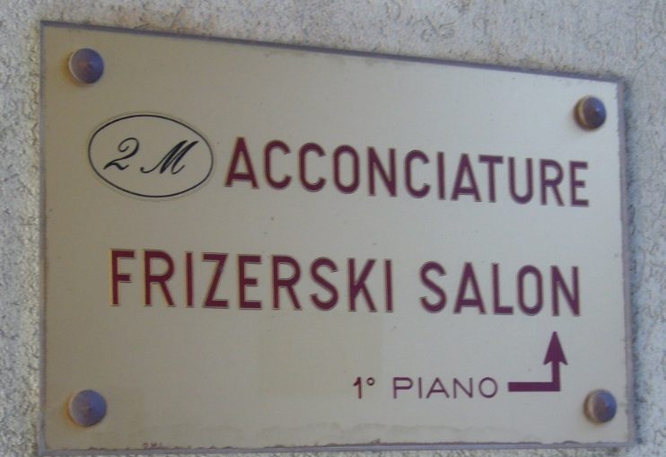
Figure 7 – Hairdresser’s sign (Italian-Slovenian)

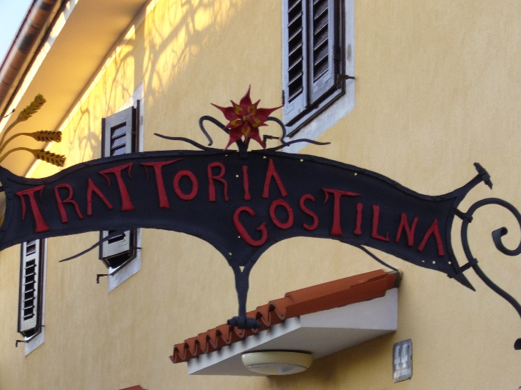
Figure 8 – Cafè (Italian/Slovenian)

Existing sources in fact highlight the high degree of ethno-linguistic awareness of Slovenians in VG and of their dynamism in all social, economic and cultural matters where communication takes place in the minority language (Sussi 2003; Ožbot 2009). Slovenian is therefore the language of business, a significant element in the maintenance of cross-border activities with nearby Slovenia, and of leisure, local politics, religion, and media. The language is widely represented in institutional spaces, too (Figures 4 – 6). What was noticeable during the surveys was that signs featuring Slovenian and generated by institutional actors (such as municipal, directional, tourist, and church signs) were not outnumbered by commercial signs significantly (100 institutional items vs. 120 commercial ones, with a proportion of 5:6). This is a peculiar characteristic when compared to other urban or peri-urban contexts in Italy, where commercial signs usually constitute the largest portion of signs (Blackwood and Tufi 2015). The data therefore suggest that the visibility of Slovenian is highest where Slovenian speakers outnumber non-Slovenian speakers and that the strong visual presence of (standard) written Slovenian both indexes and constructs given spaces as spaces of identity and belonging. In addition, by appearing almost as frequently as commercial signs, institutional signs over-represent institutionally-controlled public space and therefore point to an imbalance between achieved equality in the legal status of Slovenian and perceived power relations between different ethnic groups. The over-representation of Slovenian in the management of public space reproduces the hegemonic ideology of a majority language situation via discursive processes that are mainly representational – they represent national institutional practices as well as incorporating and re-contextualising them into local, self-reflexive practices to construct ways of being (Fairclough 2003). As a result, LL discourses contribute to a semiotic construction of social difference (Fairclough 2015). In other words, ‘too much’ Slovenian inscribed in institutional LL is a meta-semiotic, compensatory device for the perception of low status. This phenomenon underscores a doubly minoritising effect that might ultimately be detrimental to language maintenance and effectively disempower the minoritised group. In this scenario the safeguarding of the minority language is an institutional operation that immobilises language actors in a static linguistic mode (standard Slovenian) that does not release local linguistic energy and dynamism, as will be elaborated below.
Moving to ST, in Sesto German is dominant in the local LL. Similarly to VG, institutional bilingualism has had the effect of producing primarily bilingual inscriptions of the public space where signs generated by bodies endowed with authority and/or organisational power (e.g. local associations) appear regularly. Even though Sesto is only a small centre, the LL survey highlighted that the proportion of institutional vs. commercial signs featuring German is not so strikingly in favour of institutional signs – 48 institutional signs were identified as opposed to 78 commercial ones, with an approximate proportion of 5:8. In addition to numerical considerations, however, it is the characteristics of the signs that matter. For instance, and unlike the situation in VG, the minority language was dominant in the LL of Sesto with respect to both the horizontality and the verticality of the signs, i.e. the hierarchical order of languages on signs. In addition, signs on the village noticeboard, which is positioned in the very centre of the town and therefore a material as well as a symbolic core structure of local culture, were entirely in German. The local LL therefore contributes to the construction of a monolingual ideology (see also Carli 2003). Local spatialisation practices (e.g. the internal organisation of languages on signs and the physical positioning of the village noticeboard displaying monolingual German signs) on the one hand construct German as a community language and a core value, and on the other hand exploit and consolidate the transactional, commodity value of (written) German as a major world language.
The considerations presented so far stem from an initial analysis of LL in the given settings by taking into account notions such as language ideology, spatialisation dynamics, and discursive constructions of identity in minoritised contexts with complex historical legacies. However, the role of LL in the observed settings can be such that it exceeds its explanatory potential as exemplified above. Explanatory power can be enhanced by a consideration of the element of movement (and its implications), in that movement is constitutive of borderscapes and of their materialisation in given settings. In particular, and as mentioned earlier, uncoupling movement and mobility will afford novel insights – the capacity of mobility does not necessarily lead to movement (i.e. social change), nor is social change necessarily engendered by mobility. By dissecting the different components of mobility and employing them within an LL framework, we shall be able to identify features that add transformative potential to minoritised settings.
From this perspective, Sesto LL displays a high degree of motility. Different components of motility are mobilised in the public space and LL is significantly involved in the enactment of access, competence and appropriation. LL agents have access to a given linguistic repertoire and choose to prioritise German, as both the semiotics of verticality/horizontality and monolingual German signs testify. In terms of competence, i.e. the skills employed by agents to recognise and make use of access, in the LL of Sesto linguistic polycentrism is exhibited through displayed orientation to different norms – Swiss, German, Austrian and South-Tyrolean. The display of different varieties of German is supported by language behaviour that permeates every aspect of local life. As shown in Ciccolone (2009), in ST speakers consider the entire Germanophone world a linguistic reservoir that they can freely tap into depending on need, and both regional and dialectal uses are employed not just in informal contexts, but also in public communication. In addition, a high degree of LL agency is detectable via the numerical superiority of private (commercial) signs relative to institutional signs. As for appropriation (of a particular choice), LL actors exploit a range of available options (i.e. linguistic variety) within the ecology of German.
Figures 9 – 13 provide examples of different varieties of German featuring on different signs. In Figure 9 in the phrase DU BISCH MIR WICHTIG (Engl. ‘I care about you / You are important to me’) ‘bisch’ (you ‘are’) is an example of Austrian German (German German – bist), whereas ‘Unberechtigt’ (Eng. ‘unauthorised’) in Figure 10 draws from German German (‘Unauthorised vehicles will be removed’). Figure 11 is an example of local German with the calque ‘Ratsaal’, an adaptation from Italian sala consiliare, the room where the Town Council meet. ‘Dolomitenstrasse’ in Figure 12 reproduces Swiss German orthography (cf. German German Straβe), whilst in Figure 13 we have a possible example of grammaticalisation – mozzarella (feminine in Italian) should be ‘Frischer’ because cheese is masculine in German.
Figure 9 – Village noticeboard in Sesto (German) - use of BISCH (Austrian German)

Figure 10 – Monolingual regulatory signs displayed in vertical order (German/Italian) – use of German German ‘Unberechtigt’ (unauthorised)

Figure 11 – Town Hall intercom (German) - ‘Ratsaal’ indicating the Council Room (Local German)

Figure 12 – Street name sign (German/Italian) - Swiss German orthography (German German β)

Figure 13 – Sign outside dairy farm ‘fresh mozzarella’ (German/Italian)

With respect to VG, we observe a similarity in the ability to access a bilingual linguistic repertoire, but this choice is restricted by language attitudes whereby standard Slovenian is employed consistently in modalities which, in terms of competence, suggest an exhibited monocentrism and compliance with one standard norm. Within our data we can identify occasional instances of local Slovenian such as that represented in Figure 6 above. In Italy the Guardia di Finanza is a special police division responsible for the prosecution of financial crime, and arguably Finančna Straža is a Slovenian adaptation of an Italian institution. These types of adaptations, however, are again in relation to local institutions and as such require the application of official bilingualism in the local naming practices – a form of compliance more than of linguistic autonomy.
This is supported by research undertaken by Fusco (n.d.), who states that the Slovenian community in VG does not agree on the type of linguistic model that should be protected and promoted. Views in fact vary and range from the adoption of standard Slovenian to the use of local varieties as the true expression of linguistic identity and a genuine part of the local heritage. This significant debate, however, does not seem to be part of the LL narrative and is not articulated through LL discourses, thereby contributing to immobility in linguistic terms. As regards appropriation, in VG the materialisation of this component of motility points to limited non-institutional LL agency due to the high proportion of institutional signs relative to the incidence of private (commercial) signs.

5. Conclusion
Drawing some preliminary conclusions, similarities between the two settings would support an expectation that motility (as endangered by local multilingualism) is similarly deployed in the LL of VG and ST., and that local actors display similar degrees of empowerment in the linguistic management of the public space. These similarities include the peri-urban or rural character of the settings, historical memory and identity formation, the existence of complex linguistic repertoires, legal protection of ethnolinguistic rights and the maintenance of a material and cultural borderscape. LL, however, constructs important differences in the manipulation of the public space in the two geolinguistic settings.
In VG, LL agents adhere to a standard language ideology which crystallises the minority status, a status which is doubly marginalised in so far as it is underpinned by the perception of Slovenian as a rural language. Spatialisation practices and the dominance of Italian in the bilingual LL construct Slovenian as a community language that aims to preserve and defend the local identity, but LL practices foreground standard Slovenian in order to assign legitimacy to the inscribed (and inhabited) borderscape.
Internalised perceptions of peripherality and isolation have been alleviated by the softening of the border with nearby Slovenia since 2004, following the inclusion of the country in the EU. Whilst this process may have assigned to Slovenian a higher degree of currency and relevance due to intensified, direct contacts with Slovenia, compliance with norms emanating from the nearby country have resulted in the exclusion of local repertoires from LL displays. In addition, it is debatable whether progressive-looking legislation (however slow and ineffective in its implementation) is sufficient in ensuring the maintenance of dynamic language practices which are able to energise progressively anaemic domains of use (Košuta n.d.). The non-availability of contextual information about actual uses of Slovenian (e.g. the public demonstration of numerical superiority that South Tyroleans thrive in) seems to militate against the type of linguistic confidence that would assign a stronger voice to the minoritised group (and add to the field of possibilities), therefore contributing to elevating the status of the language and to maximising the aptitude for movement for its speakers.
Conversely, in ST German is dominant in the bilingual LL and its high visibility in peri-urban or rural environments is an element of strength – the LL narrative reinforces a monolingual ideology and validates German as a majority language. In ST, too, spatialisation practices construct German as a community language carrying identity functions, but they also exploit and consolidate German as a major world language – German polycentrism is embraced, and both the peculiarities of the local repertoire and those in use elsewhere in the Germanophone world are exhibited in LL.
It follows that it is possible to discern a low level of linguistic (and cultural) motility in the VG LL, and a high level of motility in the ST LL. As an asset, motility is engendered by different mobility options available to given individuals and groups (i.e. the local multilingual repertoires), and it enhances the cultural capital of any social reality, but even more so in minoritised settings which, as part of larger national entities, struggle to assert their visibility and voice. The fact that highly developed linguistic motility has in effect firmly anchored South Tyroleans to their environment is an additional element of strength and falls under the category of not moving and being mobile envisaged by Kaufmann, where (social) change takes place with no spatial component. Linguistic empowerment of local actors is a fact and is supported by language practices that ensure both the internal and the external vitality of German varieties. VG, on the contrary, reflects an outcome similar to moving without being mobile, where physical movement (multiple cross-border activities and contacts) does not impact on the local actors in terms of role, identity or social position, or on their ethnolinguistic status. The physical movement reinforces (linguistic) immobility, instead, and in the long term it might continue inhibiting processes of linguistic emancipation through a weakening of both internal and external vitality.
Motility as an analytical category allows a deeper understanding of the multiple factors affecting language practices, especially in areas where the local and geopolitical context is of fundamental importance, and we have identified LL as a significant factor in enhancing social motility. In particular, LL dynamics and linguistic motility are in a symbiotic relationship whereby divergent asymmetrical relations (Fairclough 2015) between language agents and their material and symbolic audiences can be reversed, and where linguistic inequality can be exposed and contested, therefore endowing writing acts with transformative potential. Similarly to linguistic vitality (Berruto 2016), linguistic motility is not decided once and for all. On the contrary, it is susceptible to change and can therefore be manipulated via linguistic citizenship, e.g. by initiating change that is not triggered by institutional actors (Tufi forthcoming). As we have seen for ST, exhibited linguistic polycentrism and local prestige norms empower language agents via the construction of new spaces of ethnolinguistic inhabiting. This can in turn affect externally ascribed identity, and upset both vertical and horizontal dimensions of crystallised linguistic positionings due to the inextricable links between social and territorial structures. LL can therefore be instrumental in shifting discourses of subalternity, and extremely influential in empowering individuals and groups.

References

ASTAT (2018) South Tyrol in Figures. http://astat.provincia.bz.it/downloads/Siz_2018-eng(1).pdf (26/11/2018)

Berruto, G. (2016) Sulla vitalità delle linguae minores. Indicatori e parametri. In Aline Pons (ed.) Vitalità, morte e miracoli dell’occitano. Pomaretto: Associazione Amici della Scuola Latina. 11-26.

Blackwood, R. J. and Tufi, S. (2015) The Linguistic Landscape of the Mediterranean: French and Italian Coastal Cities. Basingstoke: Palgrave Macmillan.

Blommaert, J. (2005) Discourse. A Critical Introduction. Cambridge: Cambridge University Press.

Brezigar, S. (2009) The Slovene language in Italy: paths to a value-added position. In Susanna Pertot, Tom M. S. Priestly and Colin H. Williams (eds) Rights, Promotion and Integration Issues for Minority Languages in Europe. Basingstoke: Palgrave. 207-215.

Carli, A. (2003) Cinquant’anni di tutela linguistica in Alto Adige/Sudtirolo. Plurilinguismo 9, 217-226.

Cattaruzza, M. (2007) L’Italia e il confine orientale. Bologna: Il Mulino.

Ciccolone, S. (2009) Regionalismi nel tedesco standard in Austria e Alto Adige: valutazioni dei tedescofoni altoatesini. Quaderni della Sezione di Glottologia e Linguistica. Università degli Studi G. D’Annunzio, Chieti 19-20, 1-13.

Corni, G. (2011) The Exodus of Italians from Istria and Dalmatia, 1945–56. In Jessica Reinisch and Elizabeth White (eds) The Disentanglement of Populations. Migration, Expulsion and Displacement in Post-War Europe. Basingstoke: Palgrave Macmillan.

Cortelazzo, M. A. (2010) L’idea del doppio nome per la regione venne avanzata da Graziadio Isaia Ascoli su ‘L’Alleanza’ nel 1863. Il Piccolo, 26 November 2010. http://ricerca.gelocal.it/ilpiccolo/archivio/ilpiccolo/2010/11/26/NZ_26_APRE.html?refresh_ce (12/11/18)

Eichinger, L. (2002) South Tyrol: German and Italian in a changing world. In Jeanine Treffers-Daller and Roland Willemyns (eds) Language Contact at the Romance-Germanic Language Border. Clevedon: Multilingual Matters.

Fairclough, N. (2003) Analysing Discourse – Textual Research for Social Research. New York: Routledge.

Fairclough, N. (2015) Language and Power. (3rd ed.). London: Routledge.

Fusco, F. (n.d.) Il Friuli-Venezia Giulia: mosaico di lingue, lingue di minoranza e dialetti.
http://www.treccani.it/magazine/lingua_italiana/speciali/minoranze/Fusco.html
(10/8/18)

Grote, G. (2012) The South Tyrol Question, 1866-2010: from National Rage to Regional State. Oxford: Peter Lang.

Gunlicks, A. (2003) The Länder and German Federalism. Manchester: Manchester University Press.

Highham, J. (1955) Strangers in the Land: Patterns of American Nativism, 1860-1925. New Brunswick and London: Rutdgers University Press.

Houtkamp, C. (2018) The relevance of motility in language shift research. Language Problems and Language Planning, 42(1): 1-15.

kaufmann (2012) 15º censimento della popolazione e delle abitazioni 2011. https://www.istat.it/it/censimenti-permanenti/censimenti-precedenti/popolazione-e-abitazioni/popolazione-2011 (7/8/18)

ISTAT (2018) https://www.istat.it/it/ (7/8/18)

Kaufmann, V. (2002) Re-thinking Mobility. Burlington: Ashgate.

Kaufmann, V. (2011) Rethinking the City. Urban Dynamics and Motility. Lausanne: EPFL Press.

Košuta, M. (n.d.) Del mare tra il dire e il fare. Stato e tutela della lingua slovena in Italia. https://www.filologiasarda.eu/files/documenti/pubblicazioni_pdf/bss9/01-kosuta.pdf (5/11/18)

Lechner, O. and Moroder, B. (2012) Ritratto economico dell’Alto Adige. https://www.camcom.bz.it/sites/default/files/uploaded_files/Scuola_economia/16873_economia2012_it.pdf (10/8/18)

Lefebvre, H. (1991) The Production of Space. Oxford: Blackwell.

Marcato, C. (2001) Friuli Venezia Giulia. Roma-Bari: Laterza.

Orioles, V. (2003) Le minoranze linguistiche. Profili sociolinguistici e quadro dei documenti di tutela. Roma: Il Calamo.

Ožbot, M. (2009) Sloveno e italiano in contatto: qualche osservazione sugli scambi linguistici in una zona bilingue. In Carlo Consani (ed.) Alloglossie e comunità alloglotte nell’Italia contemporanea. Teorie, applicazioni e descrizioni, prospettive. Atti del XLI Congresso internazionale di studi della Società di Linguistica Italiana (SLI), Pescara, 27-29 settembre 2007. Roma: Bulzoni. 39-52.

Piergigli, V. (2017) La Costituzione italiana delle minoranze linguistiche tra principi consolidati, riforme mancate e prossime sfide. Revista d’estudis autonomics i federals 26, 165-206. https://www.raco.cat/index.php/REAF/article/view/329192/419779 (26/11/2018)

Premik, K. (2004) Relazioni italo-slovene 1880-1956. Trieste: Novi Revija. http://www.kozina.com/premik/indexita_porocilo.htm accessed 13 February 2012

Pupo, R. (2005) Il lungo esodo. Istria: le persecuzioni, le foibe, l’esilio. Milano: Rizzoli.

Provincia Autonoma di Bolzano Alto Adige (2009) Il nuovo statuto di autonomia. http://www.provincia.bz.it/news/it/pubblicazioni.asp (14/12/2018)

Sbisà, M. and Vascotto, P. (2007) How to conceive of the other’s point of view. Considerations from a Case Study in Trieste. In Sharon Millar and John Wilson (eds) The Discourse of Europe: Talk and Text in Everyday Life. Amsterdam: John Benjamins. 153-171.

Sussi, E. (2003) Gli Sloveni in Italia: la situazione attuale e le prospettive. In Vincenzo Orioles (ed.) La legislazione nazionale sulle minoranze linguistiche. Problemi, applicazioni, prospettive. Atti del Convegno di Studi. Udine, 30 novembre – 1 dicembre 2001. Plurilinguismo 9, 203-216.

Toso, F. (2008) Le minoranze linguistiche in Italia. Bologna: Il Mulino.

Tufi, S. (2013) Shared places, unshared identities: Vernacular discourses and spatialised constructions of identity in the linguistic landscape of Trieste. Modern Italy, 18 (4), 391-408.

Tufi, S. (2016) Constructing the self in contested spaces: The case of Slovenian-speaking minorities in the area of Trieste. In Robert J. Blackwood, Elizabeth Lanza and Hirut Woldemariam (eds) Negotiating and Contesting Identities in Linguistic Landscapes. London: Bloomsbury. 101-116.

Tufi (forthcoming) Linguistic landscapes of urban Italy: perspectives on transnational identities. To appear in Transnational Modern Languages series.

Wand, A. (2016) ‘Separate but equal’, segregated or stymied? Second language learning issues in South Tyrol. Journal of the Anthropological Society of Oxford 8(3), 330-347. https://www.anthro.ox.ac.uk/sites/default/files/anthro/documents/media/jaso8_3_2016_330_347.pdf (15/10/2018)

I wish to express my gratitude to all those who contributed to the discussions about signs displaying different varieties of German and Slovenian, and in particular Anke Bohm, Federica Buso, Katia Peruzzo, Francesca Raffi and Giulia Sandrin.
For ease of exposition Trieste and Sesto will henceforth be used, as well as Venezia Giulia and South Tyrol – the latter being the term employed in English-language texts.
Estimates of the Slovenian population in Italy vary between 47,000 and 125,000 (the community refuses to participate in a census). Estimates are therefore controversial in themselves. See Sussi (2003) for an explanation of the nature of the different sources that provide figures.
See Cortelazzo (2010) for an explanation of the hyphenated toponym ‘Friuli-Venezia Giulia’.
Our labelling reflects general agreement among speakers of different varieties of German who were consulted prior to the drafting of this paper. Unsurprisingly, there was also a degree of disagreement about the variety of German identified on each sign. Local orientation to different norms is, however, confirmed and supports our point about the relaxed attitude towards (written) normativity in ST.
The <ss> spelling in e.g. 'Strasse' has also been adopted in recent spelling reforms in Germany, even though not in all phonetic environments.
For the Slovenian data, too, we consulted speakers who confirmed the generalised use of standard Slovenian in our corpus, with the exception of signs indexing the presence of police divisions.

