Recovery of upland acid grasslands after successful Pteridium aquilinum control: long-term effectiveness of cutting, repeated herbicide treatment and bruising

^{a,b.c}Alday, J.G., ªCox, E.S., ^{a,d}Santana, V.M., ^{a,e}Lee, H., ^{a,f}Ghorbani, J., ªMilligan, G., ªMcAllister, H.A., ^{g}Pakeman, R.J., ^{a**}Le Duc M.G., ªMarrs, R.H.

ªSchool of Environmental Sciences, University of Liverpool, Liverpool L69 3GP, UK,

^{b}Joint Research Unit CTFC – AGROTECNIO - CERCA, Av. Alcalde Rovira Roure 191 E25198 Lleida, Spain,
^{c}Department of Crop and Forest Sciences, University of Lleida, Av. Alcalde Rovira Roure 191 E25198 Lleida, Spain,
^{d}Center for Environmental Studies in the Mediterranean (CEAM), University of Alicante, Alicante, Spain,
^{e}National Institute of Ecology, Seocheon-gun, Republic of Korea.
^{f}Sari Agricultural Sciences and Natural Resources University, Sari, Iran
^{g}The James Hutton Institute, Craigiebuckler Aberdeen AB15 8QH Scotland.
** Deceased

27/1/2023

Abstract
There is a clear need for the development of management strategies to control dominant, perennial weeds and restore semi-natural communities and an important part of this is to know how long control treatments take to be effective and how long they last after treatments stop. Here, we report the results from a 17-year long experiment where we compared the effects of five control treatments on dense Pteridium aquilinum (L. Kuhn) relative to an untreated experimental-control in Derbyshire, UK. The experiment was run in two phases. In Phase 1 (2005-2012) we controlled the P. aquilinum by cutting and bruising, both twice and thrice annually, and an herbicide treatment (asulam in year 1, followed by annual spot-re-treatment of all emergent fronds). In Phase 2 (2012-2021) all treatments were stopped, and the vegetation was allowed to develop naturally. Between 2005 and 2021 we monitored P. aquilinum performance annually and full plant species composition at intervals. Here, we concentrate on analysing the Phase 2 data where we used regression approaches to model individual species responses through time and unconstrained ordination to compare treatment effects on the entire species composition over both Phases. Remote sensing was also used to assess edge invasion in 2018.

At the end of Phase 1, a good reduction of P. aquilinum and restoration of acid-grassland was achieved for the asulam and cutting treatments, but not for bruising. In Phase 2, P. aquilinum increased through time in all treated plots but the asulam and cutting ones maintained a much lower P. aquilinum performance for nine years on all measures assessed. There was a reduction in species richness and richness fluctuations, especially in graminoid species. However, multivariate analysis showed that the asulam and cutting treatments were stationed some distance from the untreated and bruising treatments with no apparent sign of reversions suggesting an Alternative Stable State had been created, at least over this nine-year period. P. aquilinum reinvasion was mainly from plot edges.

The use of repeated P. aquilinum control treatments, either through an initial asulam spray with annual follow-up spot-spraying or cutting twice or thrice annually for eight years gave good P. aquilinum control and helped restore an acid-grassland community. Edge reinvasion was detected, and it is recommended that either whole-patch control be implemented or treatments should be continued around patch edges.

Key words:
Bracken,
Ecological restoration
Invasive species control,
Long-term experiments,
Herbicide treatment,
Mechanical treatment

Highlights

- The effect of five Pteridium aquilinum-control treatments was tested for 19 years
- In Phase 1 we tested the effectiveness of control and vegetation restoration
- In Phase 2 we stopped the control treatments and measured recovery
- Cutting 2x or 3x per year or asulam (spray + annual spot sprays) were effective
- Edge invasion was detected and should be tackled where P. aquilinum is controlled
- Introduction
Control of invasive, perennial, plant species is becoming an important issue in ecological restoration worldwide (Weidlich et al., 2020), because they can suppress and displace native plant species, affecting both plant community structure and function, as well as resulting in biodiversity loss (Vitousek et al., 1997, Weidlich et al., 2020). Control of perennial invasives has had varying degrees of success around the world from negligible to complete control (Hoffmann et al., 2019). However, perennial weeds, and especially those that have large, underground storage organs such as rhizomes, have been acknowledged as being particularly difficult to control (Carter, 1990; Anderson, 1999).
The reason rhizomatous plants are difficult to control is that the resources held in their underground storage organs can be quite large and these resources allow the plant to persist through severe disturbance. Even when control techniques reduce the rhizome resources considerably (Le Duc et al., 2003), they are sufficient to fuel plant recovery after the control treatments stop (Marrs and Watt, 2006). Thus, long-term approaches are needed (Akpinar et al., 2023). Therefore, when controlling invasive perennials, two questions must be answered: (1) how long do we need to apply control measures to reduce the invasive species effectively considering the rhizomes reserves and, (2) is it possible to restore a more acceptable plant community from a conservation and ecosystem services perspective? If this is possible, then a key question is how long will the newly-established community remain free of the invasive plants? Hopefully, the goal of all invasive species control treatments should be to overcome the resilience of the initial community containing the invasive species and create a new alternative stable state (ASS), which has sufficient resistance to prevent a return of the newly-restored plant community to the original invaded condition (Alday et al., 2013).
A good example of such a problem caused by invasive species is the fern, Pteridium aquilinum (L.) Kuhn (here, sub-species aquilinum, Marrs and Watt, 2006). This species is notoriously difficult to control (Robinson, 2000; Marrs and Watt, 2006) and, although a native species in the British Isles has been described as a “thug” or “over-dominant species” in British woodlands (Marrs et al., 2011, 2013) and in the open can produce near mono-dominant stands in many parts of the northern hemisphere. P. aquilinum usually displaces plant communities of much greater conservation value (Pakeman and Marrs, 1992).
There are some places where P. aquilinum has a positive value in terms of landscape colour and butterfly conservation (Marrs and Pakeman, 1992), and it can contribute to some ecosystem services such as carbon and nutrient accumulation (Marrs et al., 2007). However, as its presence can cause problems for livestock health, extensive agriculture, recreation, game management, water quality via the production of the potentially-harmful chemical Ptaquiloside, and possibly human health (Varvarigos and Lawton, 1991; Pakeman and Marrs, 1992; O’Driscoll et al., 2016). There is an over-arching management requirement to control P. aquilinum in the United Kingdom and in many other places that experience an oceanic climate (Marrs and Watt, 2006). Management is needed to improve the vegetation for livestock grazing, to prevent ingress into grasslands and heathlands with a higher value and to restore vegetation with a greater conservation value. It is difficult to control because of its large underground rhizome system, which is dormant during the winter under temperate climates, but produces a large above-ground, frond biomass during the summer (Marrs and Watt, 2006).
There are essentially two main ways of controlling P. aquilinum; using either mechanical or herbicidal techniques (Milligan et al., 2016). Mechanical control needs to be applied annually for a considerable number of years (>5, Alday et al., 2013). Here, the aim is to disrupt carbohydrate flow from the fronds to replenish the rhizomes, thus eventually depleting the rhizome reserves (Marrs et al., 1998; Måren et al., 2004). The simplest way to do this is by cutting, but recently there has been a resurgence in the use of bruising (variously termed breaking, crushing and rolling, Milligan et al., 2016). Bruising is an old technique, used in Britain up to the Second World War, before the advent of suitable cutting machines and effective herbicides (Braid, 1959). Bruising involves running over the fronds producing breaks/nicks along the frond rachis, damaging them, but not severing them (Braid, 1959). The advantage of bruising over cutting is that it can be applied much faster than cutting especially on rocky, steep or uneven ground (Lewis et al., 1997).
For chemical control, asulam and glyphosate are the most commonly-used herbicides. Both are applied to the fronds, and thereafter, they are translocated down to the rhizomes where they attack the frond-forming buds (Veerasekaran et al., 1977a,b). For conservation purposes, asulam is preferred because it is relatively selective, whereas glyphosate is non-selective. Whilst it may appear counter-intuitive to recommend herbicide application for use in managing semi-natural vegetation for conservation purposes, herbicides are a very useful tool especially where mechanical treatment is difficult or impossible, i.e. on steep-slopes or rocky ground. Asulam is effective on P. aquilinum and other ferns as well as a few other species (Marrs, 1985) with damage to Rumex spp., bryophytes some fine-leaved grasses and algae reported (Byrne, 2003; Rowntree et al., 2003; Måren et al., 2004). When asulam is used, there are no visible effects in the year of application but in the post-spray year there is a large reduction in frond numbers, followed by recovery in subsequent years (Robinson, 2000; Lowday and Marrs, 1992; Milligan et al., 2016). Asulam is generally considered to pose little environmental risk and has also been approved for use on nature reserves in the UK (Marrs and Griffith, 1985; Byrne, 2003) It has been licensed for aerial application in the UK (Pakeman et al., 2005). It poses a low threat to mammals, birds, fish and bees, although moderately toxic to water fleas (Byrne, 2003). Asulam degrades very quickly in both water and soil through the effects of sunlight and in soils through microbial action, although microbial degradation is slower under anaerobic conditions (Byrne, 2003) It is also very water soluble and there is some risk of leaching into water courses, especially if there is heavy rainfall immediately after application. This risk is deemed to be low and to reduce rapidly with time after application due to fast degradation in soil (Byrne, 2003). However, in 2011 asulam was withdrawn from use within the European Union (EU) (Anon, 2011) due to “a lack of information with respect to metabolites resulting from residues in crop plants”. However, as asulam is the only selective herbicide available to control P. aquilinum, its use has continued in the UK and some other EU-Member States under “derogated powers”. This permission for use has been renewed each year between 2012 and 2022 (Bracken Control Group, 2023). Asulam is currently going through the EU re-registration/approval process. Here asulam use pre-dated these issues.
Irrespective of the control method used in any invasive species control plan, the management goals should be to achieve cost-effective long-term control of P. aquilinum and to restore an alternative plant community. Therefore, the two pre-requisites any ecological restoration strategy for invasive species are: (1) a long-term elimination in the invasive species, here P. aquilinum, and (2) an improvement in both the agricultural/functional and/or conservation value of the restored land/ecosystem (Le Duc et al., 2000; Alday et al., 2013). To investigate this, we report the results of a long-term experiment in Peak District National Park (England) where we tested the effectiveness of three P. aquilinum-control treatments for reducing P. aquilinum and restoring acid-grassland, i.e. (1) asulam applied as an overspray followed by annual spot-treatment of all emergent fronds (Robinson, 2000), (2) bruising and (3) cutting, with both bruising and cutting being applied twice or thrice annually. These treatments were applied for eight years from 2005 to 2012 inclusive (Phase 1). Thereafter, all treatments were discontinued and the P. aquilinum allowed to recover freely until 2021 (Phase 2). Results from phase 1, (see Milligan et al. (2016) for further details) showed that P. aquilinum control and acid-grassland restoration was excellent in the asulam treatment and both cutting treatments but bruising had a marginal effect compared to untreated controls. Indeed, almost no fronds remained within the asulam and cutting treatments in the central part of the treated plots but some were detected around the plot margins (Milligan et al., 2016). In this paper we concentrate on Phase 2, which extends from the last year of treatment (2012) to 2021. We test two hypotheses:
- P. aquilinum will re-invade the plots where control treatment has been successful (spray and cutting treatments) and reduce the conservation value of the underlying acid-grassland plant community.
- Such P. aquilinum re-invasion will mainly originate from plot edges.
To test these hypotheses we used a combination of Generalized Linear (GLM) and Generalized Additive Mixed Models (GAMM) (Crawley, 2013; Wood, 2011) to compare treatment responses through time (2012-2021) for a range of variables important to land managers. We then used a multivariate approach to analyse the entire plant community data over both phases of the experiment and compared treatment trends over time. Finally, we evaluate the role of edge invasion using satellite imagery. Knowing how long the effects of treatments, designed to control invasive species and restore an improved plant community, will last is fundamental for developing long-term management plans for perennial-invasive species (Hoffmann et al., 2019; Alday et al., 2022; Akpinar et al., 2023).
2. Methods
2.1. Study Site
The experiment was conducted at Bamford Edge (1º 41’ W 53º 41’ N; National Grid Reference SK213 841) in the North Peak Environmentally Sensitive Area (ESA) in Derbyshire, United Kingdom. The site is a steep escarpment, most of which was covered with P. aquilinum and is grazed by sheep at a low stocking density (ca. 0.5 ha⁻¹; Pakeman et al., 2000) The site was sprayed with asulam in 1990 (Marrs et al., 1992) but by 2005 there had been substantial frond recovery.

2.2. Bamford Edge Experimental Design
In November 2004, three blocks (replicates) were established, each with six 400 m² (20 m x 20 m) plots separated by untreated 2 m buffer strips. Plots were pre-selected randomly for application of one of six treatments for bracken control (i) cut-twice yearly (Cutx2); (ii) cut-thrice yearly (Cutx3); (iii) bruised-twice yearly (Bruisex2); (iv) bruised-thrice yearly (Bruisex3); (v) herbicide treatment with asulam (Spray); and (vi) an untreated control (Untr). The experimental layout is illustrated in Supplementary Fig. S1.
Cutting and bruising were both applied at the end of June and end of July (x2 treatments) and end of August (x3 treatment only) from 2005 to 2012 inclusive. Cutting treatments involved cutting the fronds with a petrol-powered strimmer and bruising with a Bracken-Bruiser (Peter Gotham, Bracken Bruisers Ltd) pulled by a 4WD ATV. Between 2005 and 2012, 16 treatments were applied to the x2 plots and 24 to the x3 plots. Herbicide treatment (spray) began with an initial application of asulam (commercial product, Asulox, manufactured by BayerCropScience and United Phosphorus Ltd) with a standard knapsack sprayer at a rate of 4.4 kg asulam ha⁻¹ (11 litres Asulox ha⁻¹) in 400 ml water in early September 2005. Thereafter, every emergent frond was spot-sprayed annually from 2006 to 2012 (7 spot-treatments) using a knapsack sprayer at a dose of approximately 2 ml per squirt at a ratio of 1:6 Asulox to water (~0.05 g asulam per frond) (after Robinson, 2000).
All treatment applications were discontinued in 2012 after the initial withdrawal of asulam for sale in the UK under European Union Regulation (EC) No. 1045/2011 (Anon, 2012). Approval for limited continued use was granted thereafter, but its permitted use would have required a change in treatment protocols. The plots were, therefore, left untreated so that recovery from these treatments could be monitored.
2.3 Monitoring
Monitoring of bracken response is outlined graphically in Supplementary Fig. S2. Each plot was divided into a grid of 1 m x 1 m squares. In each sampling year, five of these squares were selected at random for assessment. In late-June between 2005 and 2021 [except 2020, COVID-19 lockdown-year], a 1 m x 1 m quadrat was placed at the selected position and a 0.5 m x 0.5 m quadrat placed concentrically within the larger quadrat. Within the smaller quadrat, all P. aquilinum fronds were cut at ground level, counted to obtain an estimate of density (corrected to number m²) and the length of all fronds measured (cm) to obtain a measure of productivity (mean frond length per quadrat). Between 2005 and 2013, and in 2016 and 2021 plant community data, i.e. the cover of all vascular plants and bryophytes were estimated visually along with the cover of P. aquilinum litter and animal excrement (index of sheep grazing activity, Alday et al., 2013). Species nomenclature follows Stace (2019) for vascular plants and Atherton et al. (2020) for bryophytes. The experiment ended in 2021.

2.4 Data Analysis
All data analyses were performed using R v.4.04 (R Core Team, 2021). The product of frond density and mean frond length was also calculated to provide an index of frond volume (FVI) (Akpinar et al. 2023). Species richness and Simpson’s diversity index were calculated using the ‘specnumber’ and ‘diversity’ functions in the ‘vegan’ package for plant community data (Oksanen et al., 2021). Simpson’s Index was chosen as it gives less weight to rare species (Krebs, 2009).

2.4.1. Assessment of the baseline conditions
To obtain an assessment of the conditions at the start of phase 2 the data for 2012, the last year treatments were implemented, was analyzed. Twenty-one variables (those that occurred in >5% of quadrats, Table S1) were analyzed using the ‘glm’ function with a randomized block design. In all cases the Minimum Adequate Model (MAM, Crawley, 2013) did not include the Block effect.

2.4.2. Evaluation of changes during the recovery phase (2012-2012)
Two approaches were used. For the three variables that here measured annually (FVI, frond density and mean frond length), Generalized Additive Mixed Models (GAMM) were used. GAMM is a semi-parametric and flexible regression procedure that is not restricted to linear relationships and statistical data distributions making it ideal for modelling the different temporal responses to treatment found here (Wood, 2011). It has the advantage of not using predefined shapes to describe the functional relationships. We fitted GAMMs using the ‘gam’ function in the “mgcv” package (GAMM; Wood 2011) and plotted the relationships (±95% confidence limits) using the “mgcViz” package (Fasiolo et al., 2018). Each variable was modelled as a function of elapsed time (vector) by treatment (factor) considering plot and block as random factors. Elapsed time by treatment was modelled with cubic regression smoothing functions and four knots in order to avoid overfitting but allowing for slightly more complex model fits (Wood, 2011). Smoothing parameters for all covariates and models were selected using the Restricted Maximum Likelihood method (Wood, 2011).
For variables measured on four occasions, GLM was used (as described above) with models including blocks and the interaction between treatments and elapsed time (Year 0 = 2012). MAMs were derived using model deletion (Crawley, 2013). Analysis of individual species was limited to those that occurred in half of the combinations of plot and year (≥36 of 72).
Details of all GLM/GAMM models are presented in Supplementary Tables S2-S4.

2.4.3 Treatment effects on the plant community throughout the entire experiment (2005-2021)
Species composition under each treatment through time was analyzed using Detrended Correspondence Analysis (DCA, Hill and Gauch, 1980) using the “decorana” function in the “vegan” package with default conditions (Oksanen et al., 2021). The dataset contained 43 species and species with <5 occurrences were removed, leaving 28 species. Five variables (elapsed time, mean frond length, frond density, and cover of both P. aquilinum litter and animal excrement) were correlated with the model using the “envfit” function and 2-D Standard Deviational ellipses (95% CL) were overlain on the model using the “ordiellipse” function (Oksanen et al., 2021).

    - Assessment of edge invasion
High resolution (25cm) vertical aerial imagery was obtained for the experimental site (SK2184. 1:500, flown 27 June 2018; Supplementary Fig. S1) from GetMapping (Edina, 2021). QGIS v.3.20.2 (QGIS Development Team, 2021) was used to digitize and quantify the areas where P. aquilinum had invaded into the plots given cutting and asulam treatments. Data were expressed as a percentage of the total plot area (400 m²). The untreated and bruised plots were not digitized as all replicates had ca. 100% P. aquilinum cover (Supplementary Fig. S1). Data were analyzed using analysis of variance (‘aov’ function) with the cover data (%) arcsin transformed.

3. Results
3.1. Assessment of the starting conditions
Sixteen of the 21 variables showed significant treatment effects at the end of Phase 1 (Table S1) The treatments applied between 2005 and 2012 have produced a gradient of responses. For variables assessing P. aquilinum performance the Cutx2, Cutx3 and Spray all showed a significant decrease relative to the untreated control, with no P. aquilinum being detected in Cutx2 and Spray treatments and a very small amount in Cutx3. Some P. aquilinum litter was detected in all three treatments (<10%). The bruising treatments showed different responses between the measured variables. For example, both bruising treatments had significantly greater frond densities than the untreated control and fronds were approximately half the height (Untreated = 73 cm vs 30-32 cm in bruising treatments). In terms of FVI, there was no difference between the untreated and bruising treatments and P. aquilinum litter cover was about one-third that of the untreated controls
In terms of species richness and diversity index, the untreated plots were the lowest, and all control treatments resulted in a significant increase, the cutting and spray treatments having the greatest impact. This general result was also evident in the cover of life-forms with both cutting treatments and the spray treatment leading to increases in dicotyledons and graminoids, but only the cutting treatments leading to a significant increase in bryophytes. This general pattern was also observed for Galium saxatile and Avenella flexuosa, increasing cover in both cutting and spray treatments. Interestingly, three species were increased in only one treatment, namely: Rumex acetosella (Spray), Pleurozium schreberi (Cutx2) and Rhytidiadelphus squarrosus (Cutx3). Animal excrement, an indicator of the presence of sheep grazing, was greater in the cutting and spray treatments, while negligible amounts were found in the bruising treatments, and none in the untreated control.

3.2. Assessment of change in the recovery period (Phase 2, 2012-2021)
The P. aquilinum variables showed more or less the same responses over time, with the same gradient of responses throughout. There were no significant differences in responses through time in the FVI of the untreated control and the two bruising treatments with a nearly-flat line response across the period with an index of ca. 2000 (Fig. 1). The two cutting treatments and the spray treatment were significantly lower throughout, starting with an index value of <2 but increasing to an index of between 10 and 500 in 2021 (Fig. 1). The Cutx3 provided the best reduction at the end of the experiment, followed by asulam and then Cutx2 (Fig. 1). Frond densities varied between 20-30 fronds m⁻² in the untreated and bruising treatments, whereas in the cutting and spray treatments while it increased from < 1 frond m⁻² at the start to ca 5.5 fronds m⁻² in 2021 (Supplementary Fig. S3). Frond lengths were always between 50-100 cm in the untreated plots, and whilst the bruising treatments started with slightly smaller fronds they increased over the time period to the same values as the untreated ones (Supplementary Fig. S3). Fronds in the cutting and spray plots were much smaller, but increased in length over the time period to between 1-10 cm in the Cutx3 and between 10-20 cm in the Cutx2 and Spray (Supplementary Fig. S4). The additive model was selected as the MAM for both P. aquilinum frond and litter cover, i.e. slopes through time were similar (Fig. 2). Frond cover was reduced in all treatments compared to the untreated control but only Bruisex3 was not significant (Fig. 2). The two bruising treatments reduced frond cover, but it was always > 60% throughout and increased to >75% by 2021, i.e., similar values to the untreated controls; the cutting and spray treatments started at around zero and increased to ca. 10% by 2021 (Fig. 2). Litter was stable through time but there were increasing effects relative to the untreated control: Untreated (ca. 50%) > Bruisex3 (30%), > Bruisex2 (18%) > cutting and spray treatments (all <5%) (Fig. 2). The grazing index showed significant changes in sheep grazing with pressure peaking in year 4 (2016), but the cutting and spray treatments had a significantly greater increase relative to untreated controls (Fig. 2).
Both species richness and Simpson’s index showed additive responses with a significant increase in richness for both variables in all treatments relative to the control (Fig. 3); the two cutting treatments had the greatest effect, the spray treatment had the third best response, and the bruising treatments had least effect, but Bruisex2 was better than Bruisex3 (Fig. 3). There were contrasting responses among the three taxonomic life-forms. Dicotyledon cover was low in the untreated plot (<5%) and decreased slightly through time. The bruising treatments started with a greater cover (ca. 15%) but decreased through time to <5% (these temporal changes were not significant, Fig. 4). The cutting and spray treatments began at between 20-30% cover with the Cutx2 treatment showing a non-significant increase through time, but the Spray, and especially the Cutx3 treatment, showing a significant increase through time (Fig. 4). Graminoids showed a peak in all treatments in year 4 and a gradation of increasing graminoid cover from untreated < Bruisex3 < Bruisex2 < {Cutx2, Cutx3, Spray} treatment (Fig. 4). For bryophytes the most important result was the large decline between year 0 and year 4, followed by a slight recovery; there were no temporal effects for the untreated, bruising or Spray treatments (Fig. 4).
Seven species showed at least one significant positive treatment or temporal effect for a few treatments through time. The two bruising treatments showed no significant effect on the cover of G. saxatile and V. myrtillus compared to the untreated control, but different temporal responses, no significant differences for the former and a significant temporal increase in the latter (Fig. 5a,b). Both cutting and Spray treatments started at a greater cover; G. saxatile increased over time in the Cutx3 and Spray treatments and V. myrtillus increased in both cutting and Spray treatments (Fig. 5a,b). The two grasses (Agrostis capillaris and Festuca ovina) showed almost complementary quadratic responses; A. capillaris peaked in year 4 (2016) and F. ovina was at its lowest level in year 4 followed by an increase to year 8 (2021) (Fig. 5c,d). For both species only the cutting and Spray treatments showed an increase compared to the untreated controls (Fig. 5c,d). Three mosses showed significant temporal effects in a few treatments. Dicranum scoparium increased significantly in the Cutx3 treatment and both Pleurozium schreberi and Rhytidiadelphus squarrosus had a significantly greater starting cover in the two cutting treatments, but both decreased through time (Fig. 5e-g).

3.3. Assessment of treatment effects on the plant community throughout the entire experiment (2005-2021)

DCA analysis produced eigenvectors of 0.456, 0.298, 0.247 and 0.216 and gradient lengths of 3.03, 3.06, 2.9 and 2.76 for the first four axes respectively. The ordination plots illustrate a gradient along axis 1 from P. aquilinum on the extreme left-hand, negative side through to a grass/grass-heath community on the right-hand positive side (Fig. 6a). Axis 1 scores were correlated negatively with the three P. aquilinum productivity variables, and positively with elapsed time and the grazing index (Fig. 6b). Axis 2 reflected a gradient of communities with Agrostis capillaris, Anthoxanthum odoratum, Avenella flexuosa and Rumex acetosella in a central position, and with Calluna vulgaris, Festuca rubra, Holcus lanatus, Pseudoscleropodium purum, Pleurozium schreberi and Rhytidiadelphus squarrosus at the positive end, and Carex caryophyllea, Dicranum scoparium, Hypnum jutlandicum, Luzula spp. and Vaccinium myrtillus at the negative end (Fig. 6a). A large number of grass/grass-heath species occupied a central position (Fig. 6a).
The treatments showed a clear gradient along axis 1 with much overlap (Fig. 6c). The untreated plot is located mainly in the negative half of axis 1 (Fig. 6c). Both the cutting and Spray treatments extended well into the positive half of axis 1 (most positive, Axis 1, Fig. 6c). The two bruising treatments were placed in intermediate positions in that they extended marginally further into the positive half than the untreated plots (Fig. 6c). Treatments were not well separated on axis 2, but the ellipses increased in size along this axis; untreated and bruising treatments were smaller than the cutting and Spray treatments (Fig. 6c). This is reflected in the area occupied by the ellipses which gives some indication of the species pool in each treatment, i.e., untreated = 1.51, Bruisex2 = 1.47, Bruisex3 = 1.58, Cutx2 = 4.64, Cutx3 = 5.11, Spray = 4.91.
The trajectories of the treatments through time show a shift to the negative end of axis 1 for the untreated and both bruising treatments (Fig. 7a-c); indeed, they were more or less confined to the negative part of axis 1, and all moved in a negative direction. The two cutting and spray treatments moved into the positive end of axis 1, Cutx2 took longer to start and moved the least, Spray was intermediate and Cutx3 moved the furthest (Fig. 7d-f). Of particular interest, the cutting and Spray treatments have remained stationed at the positive end and did not move back toward their starting positions (Fig. 7d-f).

3.4. Assessing edge invasion
Inspection of the aerial image reveals some edge invasion of the cut and sprayed plots (Supplmentary Fig. S1). Analysis of variance of the data showed significant block effects (F_{2,4} = 22.6, P<0.010) but no treatment effects (F_{2,4}= 0.004, P>0.400) suggesting that edge invasion was most influenced by spatial position. Block A had the greatest invasion at 44.8±2.8% of the original plot areas, B was intermediate at 30.9±1.2% and C had the least at 23.4±2.4%.

- Discussion
In this paper, we chart the progress of ecological restoration treatments aimed at shifting a community dominated by P. aquilinum to a new acid-grassland community. We did so in two phases, Phase 1 involved controlling the invasive P. aquilinum through annual applications of different weed control treatments and in Phase 2 describing the changes in the community after the control treatments were stopped. Interestingly, only the two cutting treatments and the asulam were effective in controlling P. aquilinum and restoring a species-poor acid-grassland.
Taking an ecological restoration approach to restore land dominated by an invasive species suggests that the goal should be to create a new ecosystem functionality that maintains it as an ASS (SERI, 2004; Suding et al., 2004). ASS theory predicts that ecosystems can exist in multiple states under the same external environmental conditions, but some form of perturbation is necessary to move an ecosystem from one stable state to another (Beisner et al., 2003). In terms of ecological processes in our case, P. aquilinum species control requires that the resistance of the community dominated by P. aquilinum needs to be overcome (Lepš et al., 1982; Mitchell et al. 2000; Alday et al., 2013), and this can be done clearly using either of the two cutting treatments or the spray treatment. Afterwards, it is desirable to create a new plant community, an acid-grassland in our case, i.e., a new ASS. The new ASS has to have sufficient resistance to prevent recovery by the invasive species not returning to its original invaded condition (Webster et al., 1975; Lepš et al., 1982;; Mitchell et al. 2000; Alday et al., 2013). In our case, although from a community perspective there are some indications that a new acid-grassland community can be maintained (i.e. as an ASS) for 9 years, the low number of species present and the reduction of richness suggests that the recovered acid-grassland community could be improved by increasing the plant species richness to reduce the re-invasion possibility of the newly-created ecosystem (Hulme, 2005).

4.1. The starting conditions and success of control treatments
The main finding of Phase 1 of the study was that excellent success reducing P. aquilinum presence was achieved with the two cutting and asulam treatments. After five years of application these three treatments more or less eradicated P. aquilinum and produced a reasonable-quality, acid-grassland (Milligan et al., 2016). However, the bruising treatments had little effect reducing P. aquilinum presence compared to the untreated control. It is true that frond height was reduced by the two bruising treatments, but this was compensated for by an increased frond density, a common response after mechanical treatment (Lowday and Marrs, 1992). These differential responses can be seen in photographs of the plots in Block C in 2013 (Supplementary Fig. S5), just one year after the end of treatment application, suggesting that bruising treatment is not effective in controlling P. aquilinum and restoring acid-grasslands communities. In contrast, the cutting and spray treatments produced an improved acid-grassland with plant richness and diversity increases, especially from dicotyledons and graminoids, and also resulted in greater sheep use as determined the through the grazing-use index. It seems that the acid-grassland community is recovering after the P. aquilinum control in these plots (Alday et al., 2013). However, one important ecosystem component, the bryophytes, only recovered in cutting treatments. Maybe spraying the remnant fronds had a negative effect on bryophyte recovery (Rowntree, et al., 2003; Alday et al., 2022).
Considering these results the two cutting and asulam treatments appeared to be successful in reducing P. aquilinum and creating a more desirable community from an agricultural and conservation viewpoint. However, recent research has shown that P. aquilinum-control treatments, if effective, can have quite long-lasting effects relative to untreated controls with overall effects lasting 10-20 years (Akpinar et al., 2023), while in ineffective cases there is a relatively rapid recovery by the P. aquilinum, often within 5 to 10 years after treatments stopped (Marrs et al., 1998). Akpinar et al. (2023) also demonstrated the existence of considerable variability in recovery responses between sites that were geographically-close.

4.2. Success of control treatments in Phase 2 - recovery
Recovery of P. aquilinum cover after control treatments are stopped can be quite fast with some examples of recovery taking less than 5 years (Robinson, 2000; Marrs and Watt, 2006). Here, our results are in agreement with these trends since P. aquilinum did slightly recover in the three successful treatments (asulam, Cutx2 and Cutx3) after the treatments were stopped. A positive point is that in all plots where asulam, Cutx2 and Cutx3 were applied the P. aquilinum performance remained much lower than the untreated controls and the unsuccessful bruising treatments. Similar results were obtained for each of the measures of P. aquilinum performance (volume, density, length of fronds and P. aquilinum litter). Interestingly, the bruising treatments reduced both P. aquilinum cover (slightly) and litter, which presumably is brought about by damage to the fronds and litter, allowing faster decomposition (Swift et al., 1979).
Interestingly, the recovery from the edges was expected in our blocks since P. aquilinum presence was very close to areas subjected to eradication treatments, although it is interesting to mention that the edge invasion was independent of the control treatment applied. This result validates the effectiveness of applied treatments in controlling P. aquilinum, and suggests that for effective programs it is better to act over the complete area invaded by P. aquilinum to reduce edge reinvasion.
From a conservation viewpoint, the resulting acid-grassland is species-poor compared with similar recovered acid-grasslands (Alday et al., 2013), possibly by a lack of species pools in the surroundings or distance to propagule sources. Simultaneously, in all plots there has been a reduction in plant species richness after treatments stopped. These results suggest that the new acid-grasslands restored are not as stable as expected, since richness reduction is indicative of a less functional community that can be invaded more easily (Stohlgen et al. 1999). At the same time, in this phase there were important differences between the dicotyledons and graminoids, the former increasing in the successful treatments and decreasing in the unsuccessful ones, whereas the graminoids showed treatment differences, but a maximum in year 4 followed by a decline. Such fluctuations are common in grassland ecosystems and are often driven by changes in annual weather conditions, especially rainfall and interactions with disturbance by grazing animals (Watt, 1981; Mitchell et al., 2018). During Phase 2, there were three years of lower than average April-June rainfall within the region (2017 = 158mm, 2018 – 157 mm and 2020 = 109 mm compared to 2012-21 average of 193mm), and 2018 was the hottest April-June on record (2018 = 18.03ºC, mean ±95%CL between 1883 and 2021 = 15.33±2.02 ºC) (Meteorological Office, 2021). In 2018, the grassland vegetation in this experiment had dried to a crust and recording was abandoned as species identification was difficult. The high temperatures and more variable rainfall predicted by climate models (Lowe et al., 2018) could then have important negative implications for the control of perennial rhizomatous species, since the drying up of these acid-grasslands vegetation such as in 2018 open a windows of opportunity for P. aquilinum to recolonize these debilitated ecosystems (Amouzgar et al., 2022).
With regard to the most successful species that are developed after P. aquilinum-control we can identify that in the three successful treatments (Spray, Cutx2 and Cutx3) there was an increase in Galium saxatile and Vaccinium myrtillus, the latter also increasing in the untreated and bruising treatment but at much lower amounts. Of the grasses, A. capillaris peaked in mid-Phase and was replaced by Festuca ovina in the successful treatments; this may have been instituted by the very hot summer of 2018 coupled with disturbance from sheep. Bryophytes showed treatment-specific responses with most declining or staying at low cover; exceptions were Dicranum scoparium in the Cutx3 and to a lesser extent in the Cutx2. Taken together, these results showed that the changes in individual species within these treatments plots are rather idiosyncratic and probably caused through combinations of starting composition (i.e., that created after Phase 1), space and seeds availability, climate and both direct and indirect effects of grazing animals (Hulme, 2005). Where species are unable to recover and the seed bank is depleted (Lee et al. 2013), restoration practices need to focus on adding seed of acid-grassland species.
When the entire plant community composition in the multivariate analysis was considered there was substantive evidence that the three successful treatments (asulam, Cutx2 and Cutx3) were moving towards a position opposite to the untreated controls and the two unsuccessful bruising treatments, increasing the distance between effective P. aquilinum control treatments and ineffective ones (Fig. 7). This suggests that an ASS (sensu Alday et al., 2013) was created in 2012 and maintained for at least 9 years until 2021. For how long this ASS will be maintained remains to be seen.

  - Practical considerations
Although the asulam and cutting treatments were the most effective eliminating P. aquilinum, their implementation requires different amounts of resource to achieve a good effect. Asulam was applied as a complete overspray, followed by spot-spraying of all emergent fronds over a 7-year period, i.e., eight separate treatments, whereas cutting twice or thrice per year for 8 years requires 16 and 24 separate treatments respectively. On this basis, asulam would be the preferred choice on a cost-effective basis, and leaving only cutting twice yearly where herbicide use is not permitted, i.e. in organic farming schemes (Milligan et al. 2016).
Based on the evidence presented here, and in Milligan et al. (2016), bruising cannot be recommended for general use because it is not effective in eliminating P. aquilinum. However, other authors have reported that bruising can produce better results than those reported here (Braid, 1959; Lewis et al., 1997), but Braid (1959) also reported that bruising produced very variable results in different locations. As there is increasing interest in the use of bruising for conservation purposes more extensive research comparing its effectiveness in a range of different locations is needed. Another aspect that could affect choice of control methodology is the presence of archaeological interests (Pakeman et al., 2005), where cutting and especially bruising can damage surface features, the latter damaging and uprooting stones (R.H. Marrs pers. comm). In these situations, herbicidal methods are the only option.
It is always difficult to scale up from relatively small-scale experiments up to the landscape scale. However, here we suggest that the asulam and cutting treatments applied over eight years to an entire P. aquilinum patch should provide good results. This approach provides two approaches to minimizing P. aquilinum recovery: (1) if the entire patch is treated then invasion from the edge should be negated, and (2) if the entire patch is not treated then continued treatment along invading edges will probably be needed to prevent re-invasion (Pakeman et al. 2002). Nevertheless, the recovery of the acid-grassland plant community after the application of effective P. aquilinum control treatments is not as good as expected (species-poor community), thus, more active plant restoration programs should be implemented to increase the grassland diversity and reduce the re-invasion facility (Hulme, 2005). In any case, an adaptive management approach is recommended with annual monitoring and swift effective control or restoration actions if P. aquilinum re-invasion is noted (Baker and Bode 2021, Serrouya et al., 2019). This could be done using remote sensing via drones and GIS analysis (Aota et al., 2021).
Whilst it is always unwise to extrapolate from single experiments, our results are in keeping with long-term studies done elsewhere in the United Kingdom (Akpinar et al., 2023). However, the response of P. aquilinum in other countries and its related Southern hemisphere P. esculentum (Marrs & Watt 2006) to long-term control treatments remain unclear, but results from short-term studies in Brazil (Xavier et al., 2023) for cutting and both New Zealand (Wasmoth, 1973; Balneaves and Perry, 1982) and North America (Stewart et al., 1979; Jackson, 1981) are in keeping with the results presented here.

Credit authors statement
RHM, RJP and MGLD supervised this study, ESC set up the experiment, RHM, ESC, JGA,HL, HMcA and VMS, collected the field data and RHM, GM and JGA performed data analyses and interpreted the results. All authors approved the final manuscript.

Declaration of competing interests
The authors declare that they have no conflict of interest. RHM is the President of the Heather Trust (2007-2022, ambassadorial role) and sits on the Game & Wildlife Conservancy Trust’s uplands scientific committee and NatureScot’s Scientific Advisory Committee Expert Panel, both in an advisory capacity. None of these organizations has had sight of the results in this paper.

Data Availability
All data generated or analyzed during this study are available from RHM.

Acknowledgements
This experiment was initially funded by DEFRA (BD1226), and continued supported by the Leverhulme Trust(EM-2018-073\2 to RHM), a Ramon y Cajal fellowship (RYC-2016-20528 to JGA), the Heather Trust and the Ecological Continuity Trust. We thank the landowners of the Moscar Estate, previously Mr Jeremy Archdale and more recently the Duke and Duchess of Rutland for permission to access to their land and their gamekeepers (Stephen Lloyd, Jason Clamp and Harry Dovey) and grazing tenant (Neill Taylor) for much help. M. O’Connor, and T. Tollitt provided technical support and we benefitted from the University of Liverpool’s institutional support. Peter Gotham provided the bracken bruiser, and asulam was provided by Bayer CropScience Ltd and United Phosphorus Ltd.

Appendix A. Supplementary data
Supplementary data to this article can be found online at web address to be added??.

References
Akpinar, I., Alday, J.G., Cox, E., Le Duc, M.G., Pakeman, R.J., Marrs, R.H., 2023. How long do bracken (Pteridium aquilinum (L.) Kuhn) control treatments maintain effectiveness? Ecological Engineering, Ecological Engineering, 186, 106842. https://doi.org/10.1016/j.ecoleng.2022.106842.
Alday, J.G., Cox, E.S., Pakeman, R.J., Harris, M.P.K., Le Duc, M.G., Marrs. R.H., 2013. Overcoming resistance and resilience of an invaded community is necessary for effective restoration: a multi-site bracken-control study. J. Appl. Ecol. 50, 156-167. http://DOI:10.1111/1365-2664.12015.
Alday, J.G., O’Reilly, J., Rose, R.J., Marrs, R.H., 2022. Long-term effects of sheep-grazing and its removal on vegetation dynamics of British upland grassland and moorlands; local management cannot overcome large-scale trends. Ecol. Ind. 139.108878. https://doi.org/10.1016/j.ecolind.2022.108878.
Amouzgar, L., Ghorbani, J., Shokri, M., Marrs R.H, Alday J.G., 2022. A regional assessment of the Pteridium aquilinum growth and phenology: a case-study in Southwestern Asia. Lands Ecol. Eng. https://doi.org/10.1007/s11355-022-00528-4.
Anderson, W.P., 1999. Perennial Weeds: Characteristics and Identification of Selected Herbaceous Species. Blackwells, Oxford, UK.
Anon, 2011. Commission Implementing Regulation (EU) No 1045/2011. http://www.legislation.gov.uk/eur/2011/1045/2011-10-19. [accessed 7/7/2020].
Aota, T., Koh,, A., Hideaki M., Mitsuhiko ,T., Satoshi C., 2021. Detection of Anolis carolinensis using drone images and a deep neural network: an effective tool for controlling invasive species. Biol. Inv. 23, 1321-1327. https://doi.org/10.1007/s10530-020-02434-y.
Atherton, I., Bosanquet, S., Lawley, M., 2010. Mosses and liverworts of Brian and Ireland: a field guide. British Bryological Society, Plymouth, UK.
Baker, C.M., Bode, M., 2021. Recent advances of quantitative modeling to support invasive species eradication on islands. Cons. Sci. Pract. 3, e246. https://doi.org/10.1111/csp2.246.
Balneaves, J.M., Perry, C., 1982. Long-term control of gorse/bracken mixtures for forest establishment in Nelson. New Zealand Forest Service, Rotorua.CFE612D8-D291-4CE7-8660-B2F6E1FDC81B.pdf (nzjf.org.nz) CFE612D8-D291-4CE7-8660-B2F6E1FDC81B.pdf
Beisner, B., Haydon, D., Cuddington, K., 2003 Alternative states in ecology. Front Ecol. 1, 376–382.
Bracken Control Group, 2023. https://www.brackencontrol.co.uk/news. [accessed 16/1/2023].
Braid, K.W., 1959. Bracken: A Review of the Literature. CAB, Hurley, UK.
Byrne, A., ed., 2003. The Herbicide Handbook: Guidance on the use of herbicides on nature conservation sites. English Nature, Wetherby, UK.
Carter, E.S., 1990. Weed control in amenity areas and other non-agricultural land, in: Hance R.J., Holly, K. (eds), Weed Control Handbook: Principles. Blackwells, Oxford, UK. pp. 431-456.
Crawley M.J., 2013. The R book, 2nd ed. Wiley, Chichester, UK.
EDINA, 2021. EDINA Aerial Digimap Service, https://digimap.edina.ac.uk. [downloaded 13th September 2021).
Fasiolo M., Nedellec R., Goude Y., Wood S.N., 2018. Scalable visualisation methods for modern Generalized Additive Models. ArXiv preprint arXiv:1809.10632.
Hill M.O., Gauch H.G., 1980. Detrended Correspondence Analysis: An Improved Ordination Technique, in: van der Maarel E. (ed.), Classification and Ordination. Advances in vegetation science, vol 2., Springer, Dordrecht, NL, pp. 47-58. https://doi.org/10.1007/978-94-009-9197-2_7.
Hoffmann, J.H., Moran, V.C., Hill, M.P., 2019. Conceptualizing, categorizing and recording the outcomes of biological control of invasive plant species, at a population level. J. Biocont. 133, 134-137.
Hulme, P. E. (2005). Adapting to climate change: is there scope for ecological management in the face of a global threat? J. Appl. Ecol. 42, 784-794. https://doi.org/10.1111/j.1365-2664.2005.01082.x.
Jackson, L.P., 1981. Asulam for control of eastern bracken fern in Lowbush Blueberry Fields. Can. J. Plant Sci. 61,475-477. https://doi.org/10.4141/cjps81-067.
Krebs, C.J., 2009. Ecology: The experimental analysis of distribution and abundance, 6th edition. Benjamin Cummings, San Francisco.
Lee, H., Alday, J.G., Rosenburgh, A., Harris M., McAllister, H., Marrs R.H., 2013. Change in propagule banks during prescribed burning: a tale of two contrasting moorlands. Biol. Conserv. 165, 187-197.DOI: http://dx.doi.org/10.1016/j.biocon.2013.05.023.
Le Duc, M.G., Pakeman, R.J., Putwain, P.D., Marrs, R.H., 2000. The variable responses of bracken fronds to control treatments in Great Britain. Ann. Bot. 85 17–29. DOI:10.1006/anbo.1999.1052.
Le Duc, M.G., Pakeman, R.J., Marrs, R.H., 2003. Changes in the rhizome system of bracken when subjected to long-term experimental treatment. J. Appl. Ecol. 40, 508-522.
Lepš, J., Osbornová-Kosinová, J. & Rejmánek, M., 1982. Community stability, complexity and species life history strategies. Vegetatio 540, 53-63.
Lewis, N., Gotham, P., Otterburn, B., Overbury, T., Shepherd P., Bacon J., 1997. Bracken breaking – a bruising battle. Enact 5, 19–22.
Lowday, J.E., ,Marrs, R.H. 1992. Control of bracken and the restoration of heathland. I. Control of bracken. J. appl. Ecol., 29, 195-203. http://www.jstor.org/stable/2404361.
Lowe, J.A., Bernie, D., Bett, P., Bricheno, L., Brown, S., Calvert, D., Clark, R., Eagle, K., Edwards, T., Fosser, G. and Fung, F., Gohar, L., Good, P., Gregory, J., Harris, G., Howard, T., Kaye, N., Kendon, E., Krijnen, J., Maisey, P., McDonald, R., McInnes, R., McSweeney, C., Mitchell, J.F.B., Murphy, J., Palmer, M., Roberts, C., Rostron, J., Sexton, D., Thornton, H., Tinker, J., Tucker, S., Yamazaki, K., Belcher, S., 2018. UKCP18 science overview report. Met Office Hadley Centre: Exeter, UK.
Måren, I.E., Vandvik, V., Ekelund, K., 2008. Restoration of bracken-invaded Calluna vulgaris heathlands: Effects on vegetation dynamics and non-target species. Biol. Conserv. 14, 1032 –1042. doi:10.1016/j.biocon.2008.01.012.
Marrs, R.H., 1985. The effects of potential bracken and scrub control herbicides on lowland Calluna and grass heath communities in East Anglia, UK. Biol. Conserv. 32, 13-32. https://doi.org/10.1016/0006-3207(85)90062-X.
Marrs, R.H. & Griffith, F.M. ,1986. Terrestrial herbicides, In: A.S. Cooke (ed.), The use of pesticides on nature reserves. (Focus on Nature Conservation). Nature Conservancy Council, Peterborough, UK, pp. 13-64.
Marrs, R.H., Watt, A.S., 2006. Biological flora of Pteridium aquilinum. J. Ecol. 94, 1272-1321. https://doi.org/10.1111/j.1365-2745.2006.01177.x.
Marrs, R.H., Frost, A.J., Plant, R.A., Lunnis, P., 1992. Aerial applications of asulam: a bioassay technique for assessing buffer zones to protect sensitive sites in upland Britain. Biol. Conserv. 59, 19-23. https://doi.org/10.1016/0006-3207(92)90709-V.
Marrs, R.H., Johnson. S.W., Le Duc, M.G., 1998. Control of bracken and restoration of heathland. VI. The response of bracken fronds to 18 years of continued bracken control or six years of control followed by recovery. J. Appl. Ecol. 35, 479-490. https://www.jstor.org/stable/2405163.
Marrs, R.H, Galtress, K., Tong, C., Blackbird, S. J., Heyes, T.J. Pakeman, R.J., Le Duc, M.G., 2007. Conflicts between competing conservation goals, biodiversity or ecosystem services: quantification of element losses and species recruitment using a moorland-bracken model system. J. Env. Manage 85, 1034-1047, doi:10.1016/jenvman.11.011.
Marrs, R.H. Le Duc, M.G., Smart, S.M., Kirby, K.J, Bunce, R.G.H., Corney, P.M,. 2011. Aliens or Natives: who are the ‘Thugs’ in British woods? Kew Bull. 65, 583-594. https://doi.org/10.1007/s12225-010-9237-9.
Marrs, R.H., Kirby, K.J., Le Duc, M.G., McAllister, H., Smart, S.M., Oksanen, J., Bunce, R.G.H., Corney. P.M., 2013. Native dominants in British woodland– a potential cause of reduced species-richness? New J. Bot. 3, 156-168. DOI: 10.1179/2042349713Y.0000000028.
Meteorological Office, 2021. Meterorological data for Sheffield (Lat 53.381;Lon -1.490).
https://www.metoffice.gov.uk/pub/data/weather/uk/climate/stationdata/sheffielddata.txt. [accessed 6/12/2021].
Milligan, G., Cox, E.S., Alday, J.G., Santana, V.M., McAllister, H.A., Pakeman, R.J., Le Duc M.G., Marrs, R.H. 2016. The effectiveness of old and new strategies for the long-term control of Pteridium aquilinum, an 8-year test. Weed Res. 56, 247–257. DOI:10.1111/wre.12203.
Mitchell, R.J., Auld, M.H.D., Le Duc, M.G., Marrs, R.H., 2000. Ecosystem stability and resilience: a review of their relevance for the conservation management of lowland heaths. Persp. Plant Ecol. Evol. & Systs 3, 142-160.
Mitchell, R.J., Hewison, R.L., Fielding, D.A., Fisher, J.M., Gilbert, D.J., Hurskainen, S., Pakeman, R.J., Potts, J.M., Riach, D., 2018. Decline in atmospheric sulphur deposition and changes in climate are the major drivers of long-term change in grassland plant communities in Scotland. Env. Poll. 235, 956-964. DOI: 10.1016/j.envpol.2017.12.086.
O’Driscoll, C., Ramwell, C., Harhen, B., Morrison, L., Clauson-Kaas, F., Hansen, H.C.B., Campbell, G., Sheahan, J., Misstear, B., Xiao L., 2016, Ptaquiloside in Irish Bracken Ferns and Receiving Waters, with Implications for Land Managers Molecules,21, 543, https://doi.org/10.3390/molecules21050543
Oksanen, J., Blanchet, F.G., Friendly, M., Kindt, R., Legendre, P., McGlinn, D., Minchin, P.R. O'Hara, R.B., Simpson, G.L., Solymos, P., Stevens, M.H.H., Szoecs, E., Wagne H., 2019. Package ‘vegan’ Community Ecology Package Version 2.5-5, 2019-05-08. (accessed 1/8/2019).
Pakeman, R.J., Marrs, R.H. 1992. The conservation value of bracken, Pteridium aquilinum (L.) Kuhn) - dominated communities in the UK, and an assessment of the ecological impact of bracken expansion or its removal. Biol. Conserv. 62, 101-114. https://doi.org/10.1016/0006-3207(92)90931-C.
Pakeman, R.J., Thwaites, R.H., Le Duc, M.G., Marrs, R.H., 2000. Vegetation re-establishment on land previously subject to control of Pteridium aquilinum by herbicide. Appld Veg. Sci., 3, 95-104. https://doi.org/10.2307/1478923.
Pakeman, R.J., Thwaites, R.H., Le Due, M.G., Marrs, R.H., 2002. The effects of cutting and herbicide treatment on Pteridium aquilinum encroachment. Appld Veg. Sci. 5, 203-212. https://www.jstor.org/stable/1479068.
Pakeman, R.J., Le Duc, M.G. Marrs, R.H., Condliffe, I. Enright, D., Smallshire, D., 2005. Bracken control, vegetation restoration and land management. Rural Development Services Technical Advice Note No. 23. Defra, London, UK.
QGIS Development Team, 2021. QGIS Geographic Information System. Open Source Geospatial Foundation Project. http://qgis.osgeo.org. [downloaded 1st September 2021).
R Core Team, 2021. R: A language and environment for statistical computing. R Foundation for Statistical Computing, Vienna, Austria. URLhttps://www.R-project.org [accessed 1/6/2021].
Robinson, R.C., 2000. The means to large-scale, effective bracken clearance, in: Taylor J.A., Smith R.T (Eds), Bracken fern: Toxicity, Biology and Control. International Bracken Group, Aberystwyth, pp. 156-162.
Rowntree, J.K., Lawton, K.F., Rumsey, F.J., Sheffield, E., 2003. Exposure to Asulox inhibits the growth of mosses. Ann. Bot. 92, 547-556. https://doi.org/10.1093/aob/mcg166.
SERI, 2004. The SER International Primer on Ecological Restoration. Tucson Society for Ecological Restoration International, Tucson, USA. SERPrimer.pdf (ser-rrc.org).
Serrouya, R., Seip, D.R., Hervieux, D., McLellan, B.N., McNay, R.S., Steenweg, R.,. Heard, D.C., Hebblewhite, M., Gillingham M., Boutin, S., (2019).Saving endangered species using adaptive management. PNAS 116, 6181–6186. https://doi.org/10.1073/pnas.1816923116.
Stace, C.A., 2019. New flora of the British Isles, 4th edn. C & M Floristics, Middlewood Green, Suffolk.
Stewart, R.E. Cooley, A.W., Guardigli A., 1979. Asulam Controls Western Bracken (Pteridium aquilinum) on Forest Land in Western Oregon. Weed Science , 27 , 589-594.DOI: https://doi.org/10.1017/S0043174500045938.
Stohlgren, T., Binkley, D., Chong, G.W., Kalkhan, M.A., Schell, L.D., Bull, K.A., Otsuki, Y., Newman, G., Bashkin, M., Son, Y., 1999. Exotic plant species invade hot spots of native plant diversity. Ecol. Monog. 69, 25-46. https://doi.org/10.1890/0012-9615(1999)069[0025:EPSIHS]2.0.CO;2
Suding, K., Gross, K. & Houseman, G., 2004. Alternative states and positive feedbacks in restoration ecology. Trends Ecol. Evol. 19, 46–53.
Swift, M.J., Heal, O.W., Anderson, J.M., 1979 Decomposition in terrestrial ecosystems. Blackwells, Oxford.
Varvarigos, P., Lawton, J.H., 1991. Farmers' perceptions of the scale of the bracken problem on farms in less favoured areas in England and Wales. J. Appl. Ecol. 28, 988-1003. DOI:10.2307/2404221.
Veerasekaran, P., Kirkwood, R.C., Fletcher, W.W., 1977a. Studies on the mode of action of asulam in bracken (Pteridium aquilinum (L.) Kuhn). 2. Biochemical activity in the rhizome buds. Weed Res. 17, 85-92. https://doi.org/10.1111/j.1365-3180.1978.tb01166.x.
Veerasekaran, P., Kirkwood, R.C., Fletcher, W.W., 1977b. Studies on the mode of action of asulam in bracken (Pteridium aquilinum (L.) Kuhn). 1. Absorption and translocation of [¹⁴C ] asulam. Weed Res.17, 33-39. https://doi.org/10.1111/j.1365-3180.1977.tb00442.x.
Vitousek, P.M., D’Antonio, C.M., Loope, L.L., Rejmanek, M., Westbrooks, R., 1997. Introduced species: a significant component of human-caused global change. New Zeal. J. Ecol. 21, 1-16. https://www.jstor.org/stable/24054520.
Wasmuth, A.C., 1973. The control of bracken with asulam. Authors Proceedings of the New Zealand Weed and Pest Control Conference: Vol. 26, pp. 7-12. https://doi.org/10.30843/nzpp.1973.26.8948
Watt, A.S., 1981. Further Observations On The Effects Of Excluding Rabbits From Grassland A In East Anglian Breckland - The Pattern Of Change And Factors Affecting It (1936-73). J. Ecol. 69, 509-536. Doi:10.2307/2259681.
Webster, J.R., Waide, J.B., Pattern, B.C., 1975. Nutrient recycling and the stability of ecosystems. Mineral cycling in southeastern ecosystems CONF 740513 National Technical Information Service, Springfield, US.
Weidlich, E.W., Flórido, F.G., Sorrini, T.B., Brancalion, P.H,. 2020. Controlling invasive plant species in ecological restoration: A global review. J. Appl. Ecol. 57, 1806-1817. https://doi.org/10.1111/1365-2664.13656
Wood S.N., 2011. Fast stable restricted maximum likelihood and marginal likelihood estimation of semiparametric generalized linear models. J. Roy. Stat. Soc. 73, 3–36. https://doi.org/10.1111/j.1467-9868.2010.00749.x.
Xavier R., Marques U., Pivello V., Marrs R., Abilleira De Catstro P., Nascimento J.L., Silva-Matos D., 2023. Combining mechanical removal and tree planting to restore montane Atlantic forests dominated by the Neotropical bracken (Pteridium arachnoideum) For. Ecol. Man. 529, 120657. https://doi.org/10.1016/j.foreco.2022.120657.

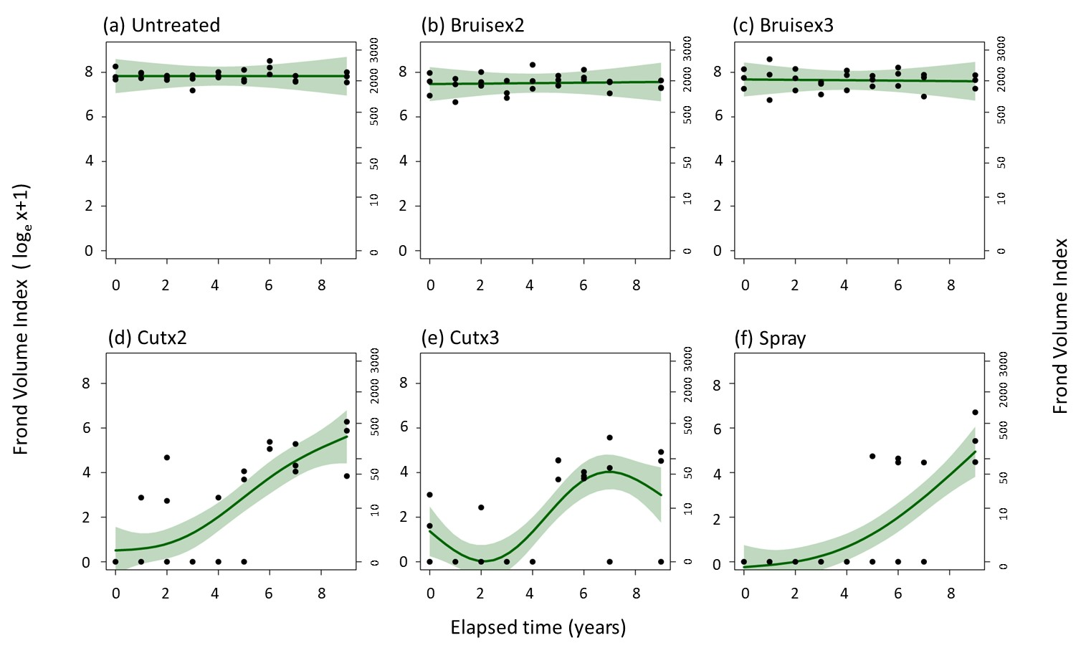

Fig. 1. Modelled (GAMM) relationship of the changes in frond volume index (FVI) through time in response to five P. aquilinum-control treatments and an untreated control after treatments were stopped in 2012 (2012 = Elapsed time = 0). Key to treatments: Bruising= bruised and Cutting= Cut, both either twice(x2) or thrice (x3) each year between 2005 and 2012 inclusive, Spray = sprayed with asulam in 2005 followed by annual spot-spraying of emergent fronts between 2006 and 2012 inclusive. Statistical information is provided in Supplementary Materials: Table S2.

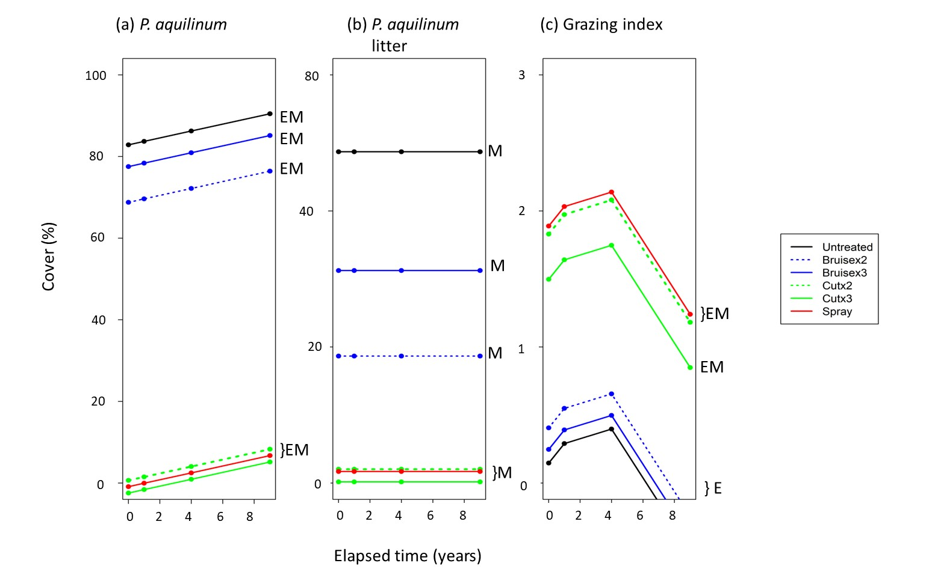

Fig. 2. Modelled (GLM) relationship of the changes in cover of (a) P. aquilinum fronds, (b) P. aquilinum litter and (c) animal excrement (grazing index) through time in response to five P. aquilinum-control treatments and an untreated control after treatments were stopped in 2012 (2012 = Elapsed time = 0). Key to treatments: Bruising= bruised and Cutting= Cut, both either twice(x2) or thrice (x3) each year between 2005 and 2012 inclusive, Spray = sprayed with asulam in 2005 followed by annual spot-spraying of emergent fronts between 2006 and 2012 inclusive. Statistical information is provided in Supplementary Materials: Table S3 and S4; E and M denotes a significant temporal and management effect respectively.

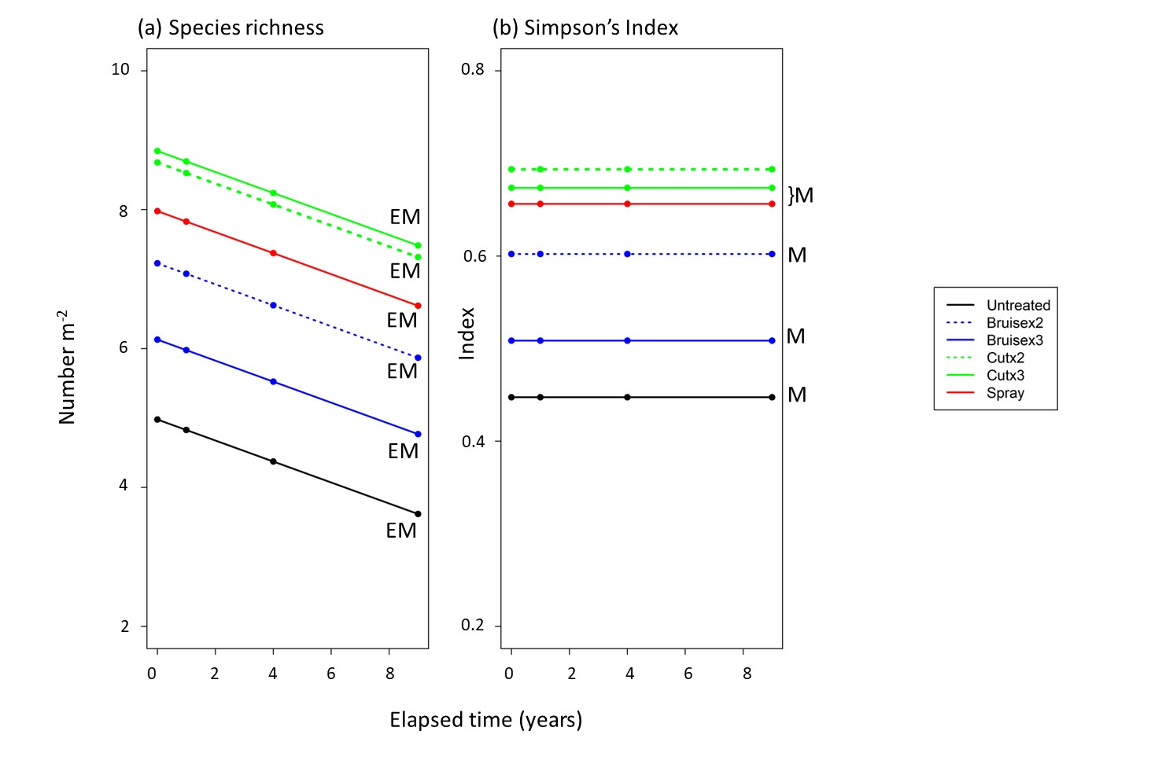
Fig. 3. Modelled (GLM) relationship of the changes in cover of (a) species richness, and (b) Simpson’s Index through time in response to five P. aquilinum-control treatments and an untreated control after treatments were stopped in 2012 (2012 = Elapsed time = 0). Key to treatments: Bruising= bruised and Cutting= Cut, both either twice(x2) or thrice (x3) each year between 2005 and 2012 inclusive, Spray = sprayed with asulam in 2005 followed by annual spot-spraying of emergent fronts between 2006 and 2012 inclusive. Statistical information is provided in Supplementary Materials: Table S4; E and M denotes a significant temporal and management effect respectively.

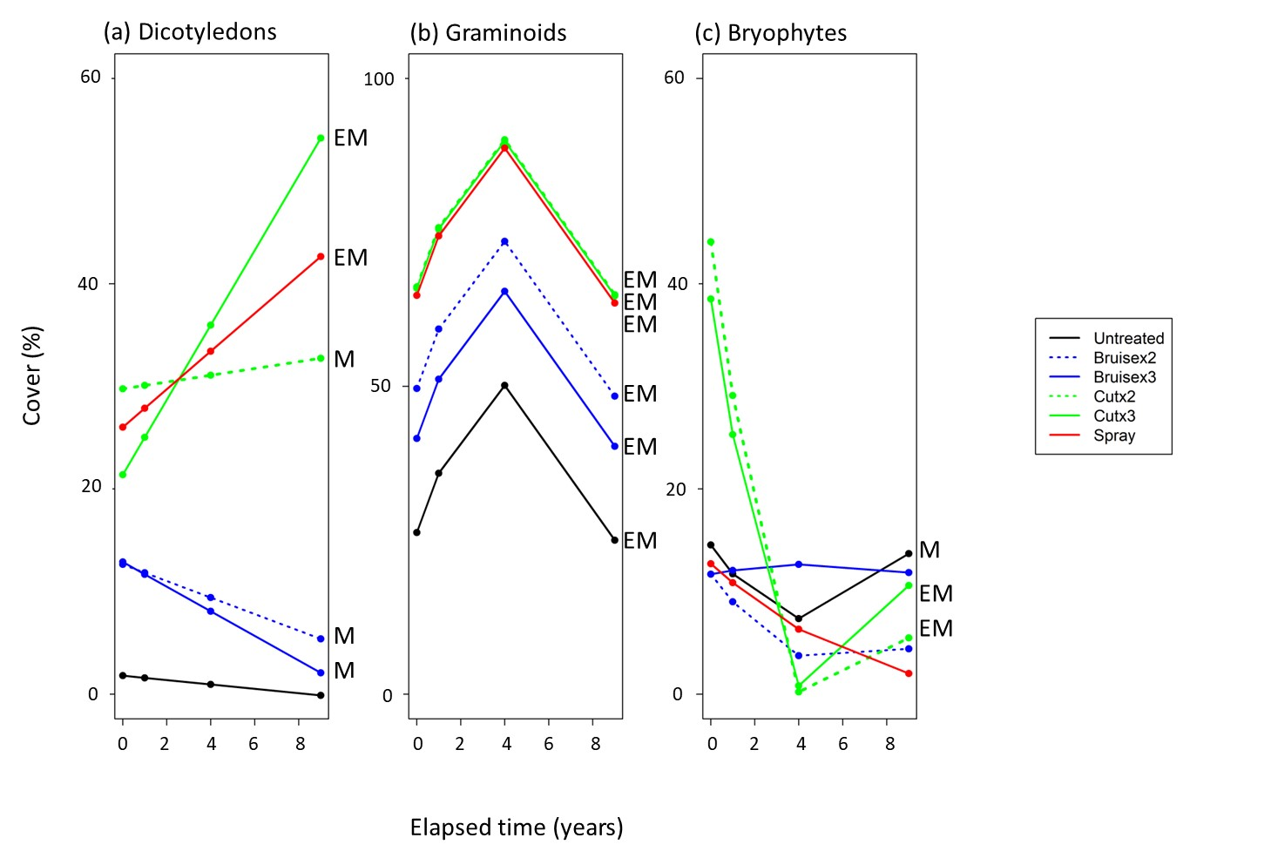

Fig. 4. Modelled (GLM) relationship of the changes in cover of life forms (a) Dicotyledons, (b) Graminoids and (c) Bryophytes through time in response to five P. aquilinum-control treatments and an untreated control after treatments were stopped in 2012 (2012 = Elapsed time = 0). Key to treatments: Bruising= bruised and Cutting= Cut, both either twice(x2) or thrice (x3) each year between 2005 and 2012 inclusive, Spray = sprayed with asulam in 2005 followed by annual spot-spraying of emergent fronts between 2006 and 2012 inclusive. Statistical information is provided in Supplementary Materials: Table S4; E and M denotes a significant temporal and management effect respectively.

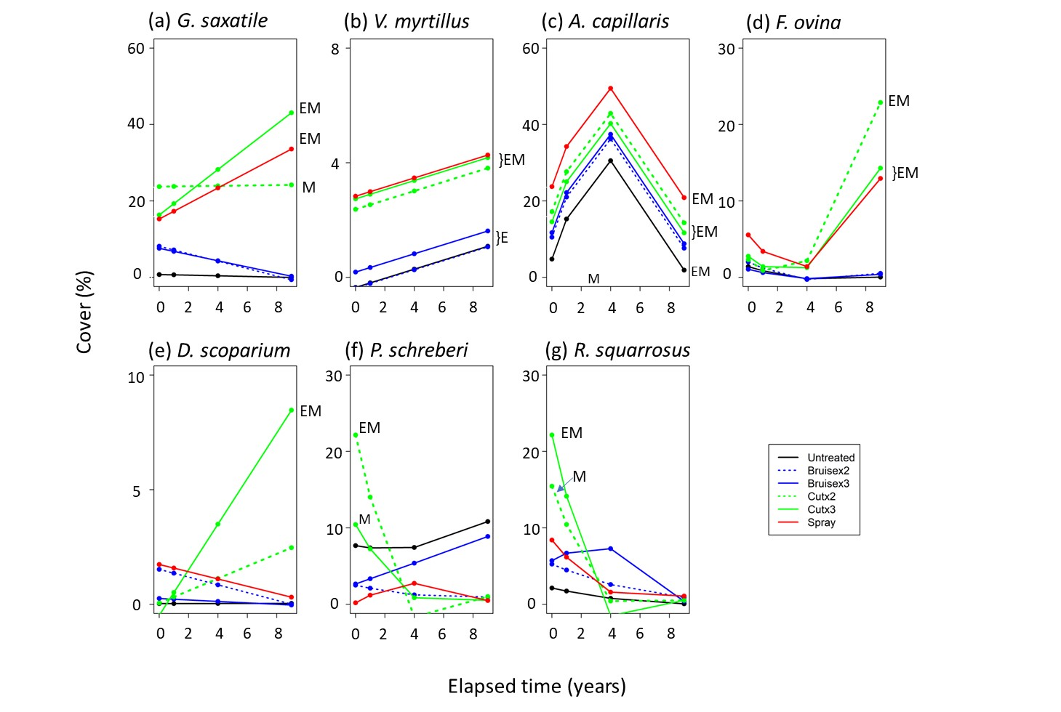

Fig. 5. Modelled (GLM) relationship of the changes in cover of seven species through time in response to five P. aquilinum-control treatments and an untreated control after treatments were stopped in 2012 (2012 = Elapsed time = 0). Key to treatments: Bruising= bruised and Cutting= Cut, both either twice(x2) or thrice (x3) each year between 2005 and 2012 inclusive, Spray = sprayed with asulam in 2005 followed by annual spot-spraying of emergent fronts between 2006 and 2012 inclusive. Statistical information is provided in Supplementary Materials: Table S4; E and M denotes a significant temporal and management effect respectively.

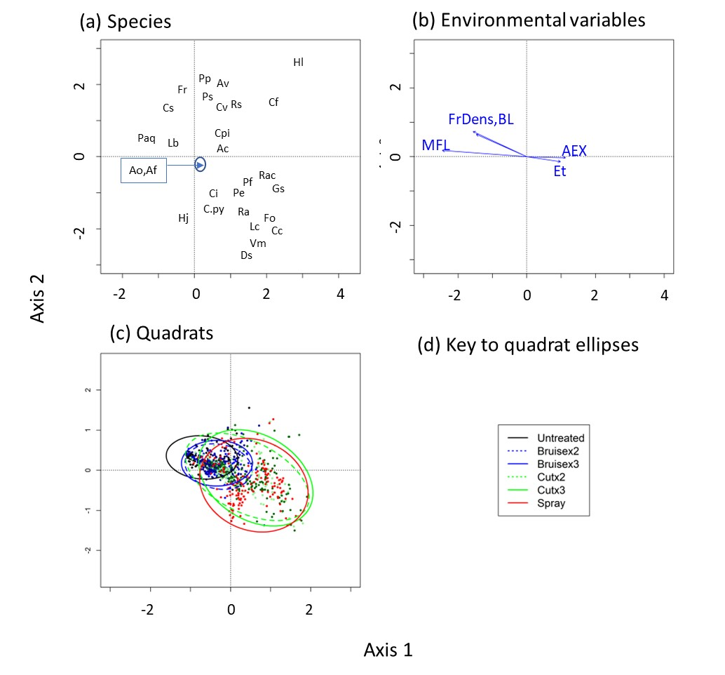
Fig. 6. Decorana plots of the community composition of the through time in response to five P. aquilinum-control treatments and an untreated control over the course of the entire experiments (2005-2021). Key to treatments: Bruising= bruised and Cutting= Cut, both either twice(x2) or thrice (x3) each year between 2005 and 2021 inclusive, Spray = sprayed with asulam in 2005 followed by annual spot-spraying of emergent fronts between 2006 and 2012 inclusive. All treatments stopped in 2012. (a) Species plot, (b) environmental variables, (c) Quadrat plot with 2-d standard deviational ellipses (95% CL). Species Key: Ac =Agrostis capillaris, Ao =Anthoxanthum odoratum, Av =Avenella flexuosa, Cc =Carex caryophyllea, Cf =Cerastium fontanum, Ci =Campylopus introflexus, Cpi =Carex pilulifera, Cpy =Campylopus pyriformis, Cs =Carex spp , Cv =Calluna vulgaris, Ds =Dicranum scoparium, Fo =Festuca ovina, Fr =Festuca rubra, Gs =Galium saxatile, Hj =Hypnum jutlandicum, Hl =Holcus lanatus, Lb =Lophocolea bidentata, Lsp =Luzula spp., Paq =Pteridium aquilinum, Pe =Potentilla erecta, Pf =Polytrichum formosum, Pp =Pseudoscleropodium purum, Ps =Pleurozium schreberi, Ra =Rumex acetosella, Rac =Rumex acetosa, Rs Rhytidiadelphus squarrosus, Vm =Vaccinium myrtillus. Key to Environmental variables: Et = elapsed time, FrDens = frond density, MFL = mean frond length, BL = bracken litter cover, AEX = animal excrement cover (grazing index).
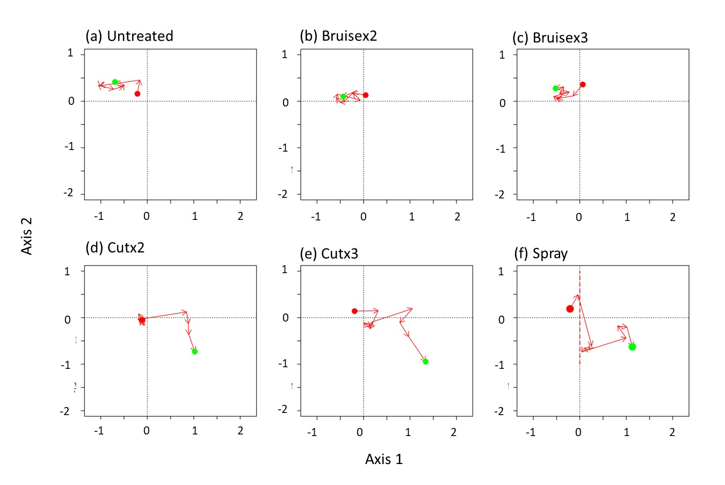

Fig. 7. Decorana plot of the trajectories of the five P. aquilinum-control treatments plus untreated control through time over the course of the entire experiment (2005-2021). Key to treatments: Bruising = bruised and Cutting = Cut, both either twice (x2) or thrice (x3) each year between 2005 and 2012 inclusive, Spray = sprayed with asulam in 2005 followed by annual spot-spraying of emergent fronts between 2006 and 2012 inclusive. The start and end points of the trajectories are denoted with red and green filled circles respectively.

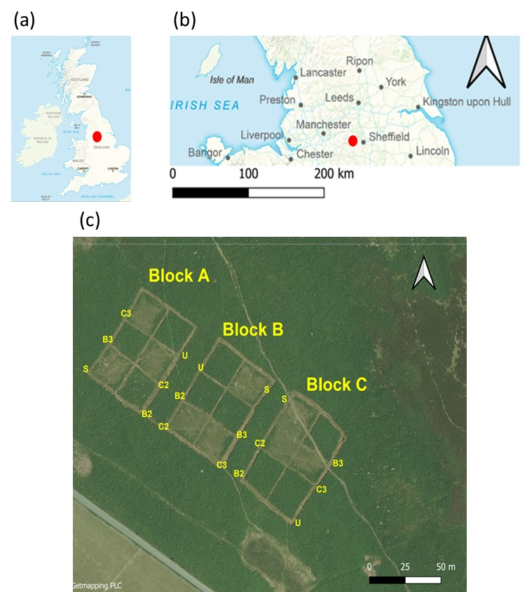

Fig. S1. Location of the Bamford Edge experiment within the UK (a,b; from Ordnance Survey GBOverviewPlus) and a view of the Bamford Edge experiment from the air in June 2018 ilustrating the three blocks and treatments: U = untreated, S = sprayed with asulam, B = Bruising and C= cutting; for bruising and cutting the 2 and 3 refer to the number of treatments applied per year; Image from EDINA (2021). Treatments were applied across the entire plot. The bracken is in dark green and the restored plots are lighter green. Each plot is 20m x 20m; this plot size exceeded that needed to exclude violations of independence due to inter-plot interference from underground rhizomes (Le Duc et al., 2003).

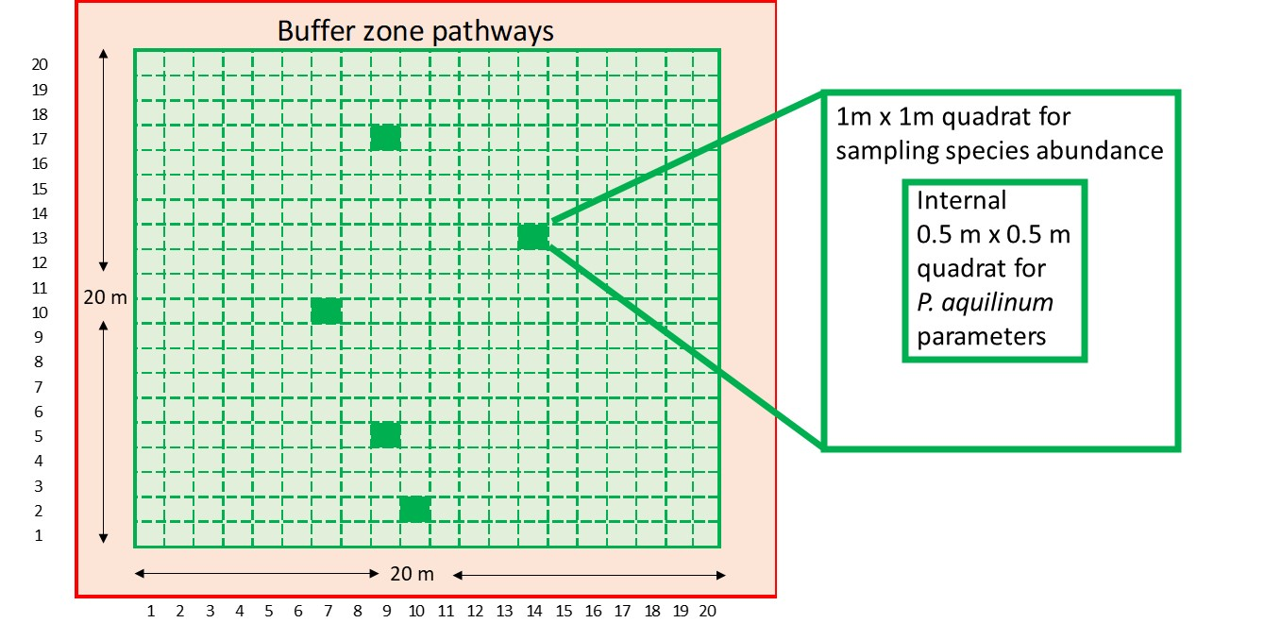
Fig. S2. Illustration of the sampling procedure. Each of the 18 plots, each 20m x 20 m and surrounded by 2 m buffer zone pathways were gridded into 400 1m x 1m squares as shown above.
In each sampling year, five of these 400 squares were selected at random (solid green) and at each, a 1m x 1 m quadrat was positioned to sample species composition and environmental variables. The internal 0.5 m x 0.5 m central quadrat used to assess P. aquilinum paramters. Different positions were selected at random on each sampling occasion. Once both quadrats were positioned the inner quadrat was sampled first.

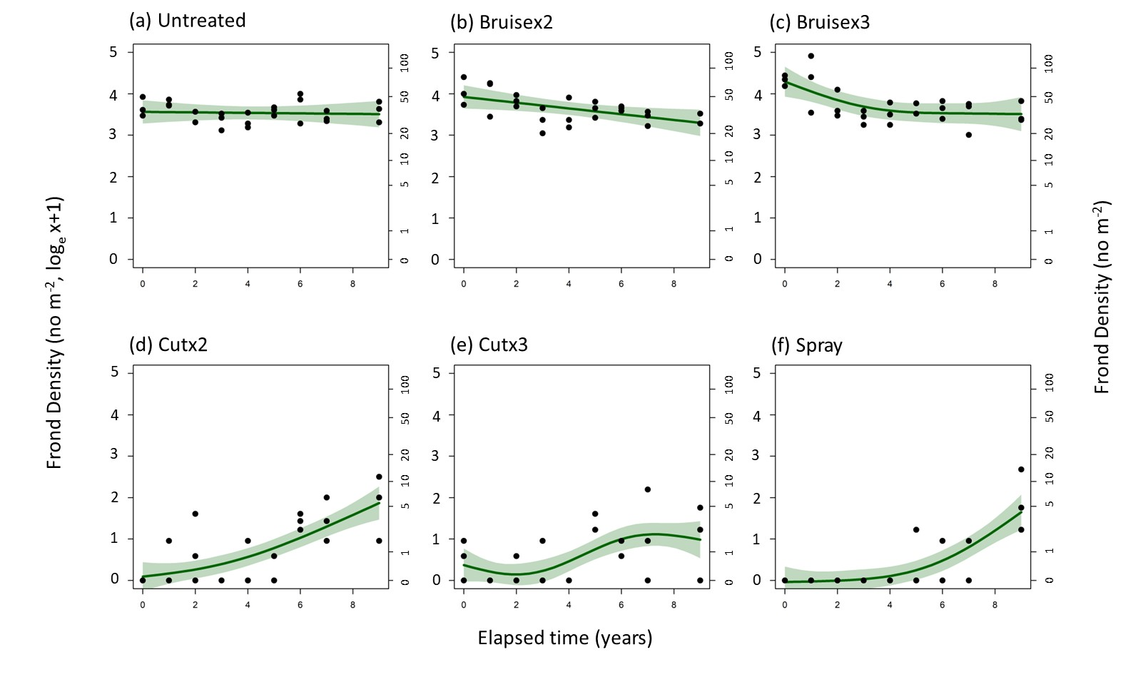

Fig. S3. Modelled (GAMM) relationship of the changes in frond density (fronds m⁻²) through time in response to five P. aquilinum-control treatments and an untreated control after treatments were stopped in 2012 (2012 = Elapsed time = 0),Key to treatments: Bruise = bruised and Cut = Cut, both either twice(x2) or thrice (x3) each year between 2005 and 2012 inclusive, Spray = sprayed with asulam in 2005 followed by annual spot-spraying of emergent fronts between 2006 and 2012 inclusive. Statistical information is provided in Supplementary Materials: Table S2.

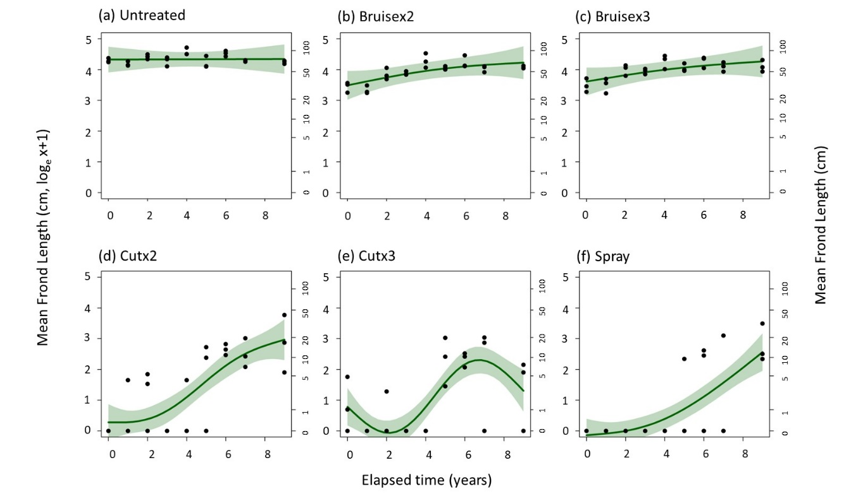

Fig. S4. Modelled (GAMM) relationship of the changes in frond length (cm)through time in response to five P. aquilinum-control treatments and an untreated control after treatments were stopped in 2012 (2012 = Elapsed time = 0),Key to treatments: Bruise = bruised and Cut = Cut, both either twice(x2) or thrice (x3) each year between 2005 and 2012 inclusive, Spray = sprayed with asulam in 2005 followed by annual spot-spraying of emergent fronts between 2006 and 2012 inclusive. Statistical information is provided in Supplementary Materials: Table S2.

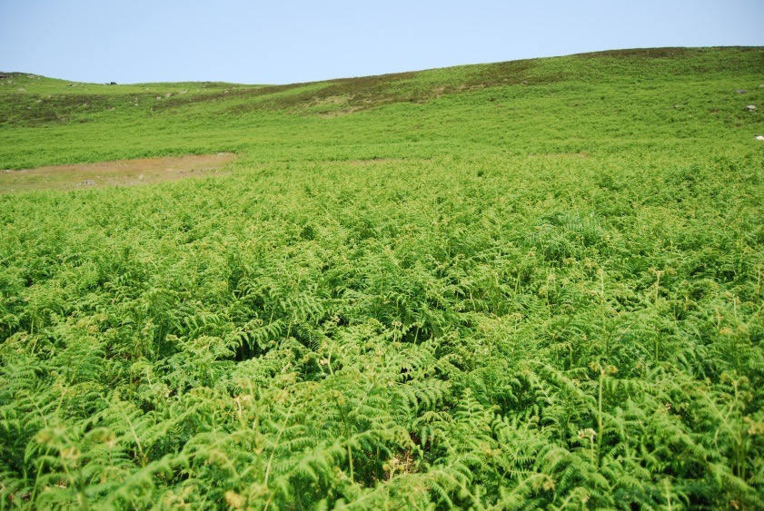
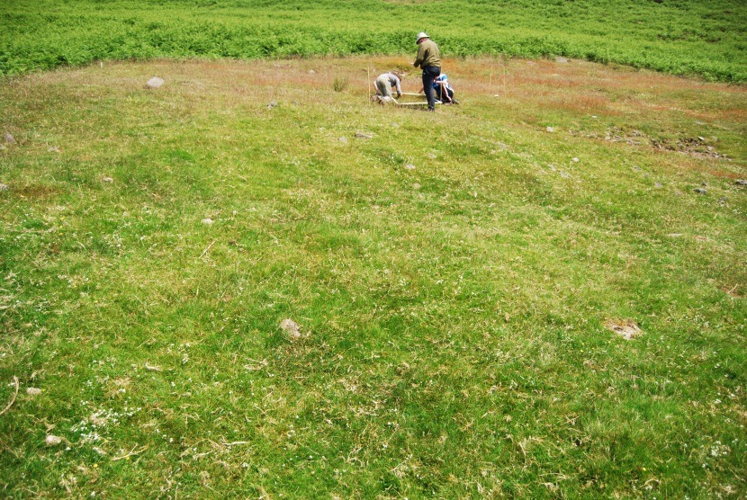
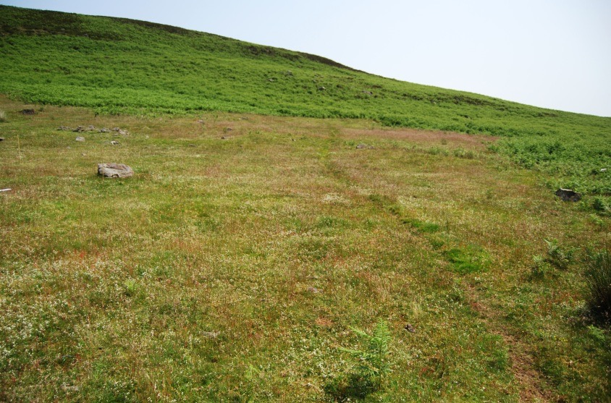
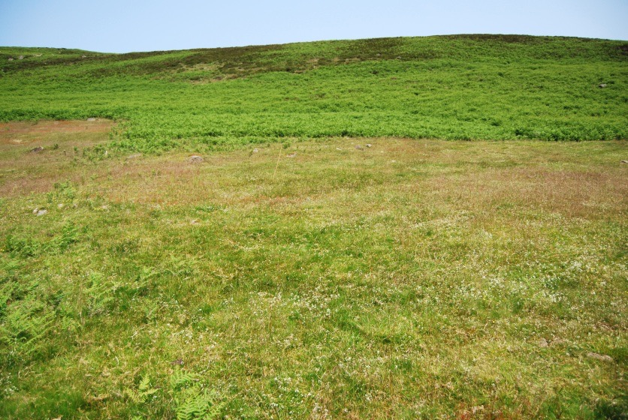
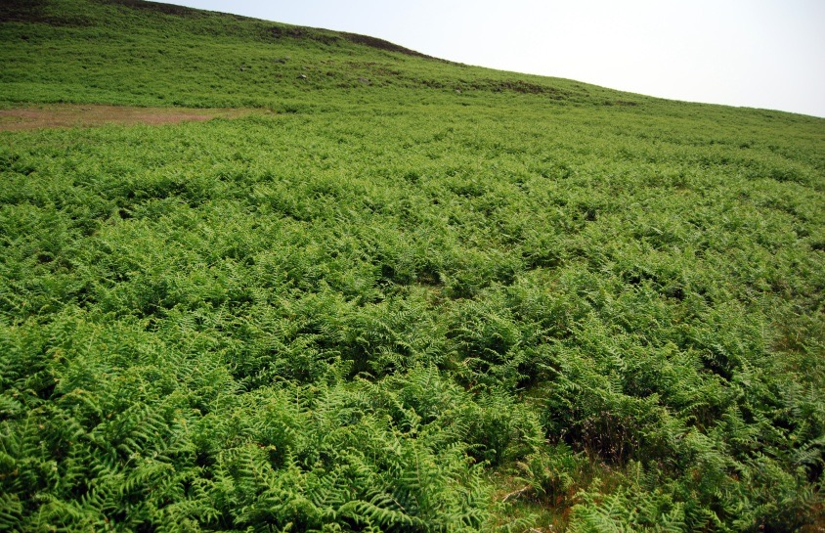
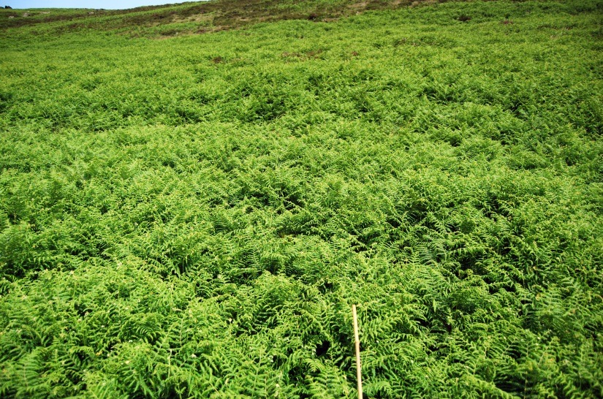
(a) Untreated control
(b) Asulam spray/spot-spray
(c) Cut twice/year
(d) Cut thrice/year
(e) Bruised twice/year
(f) Bruised thrice/year

Fig. S5. Photographs of the six P.aquilinum-control treatments applied to Block C of the Bamford Edge experiment in 2013, the year after treatments were finished (Photos by W. Chiba).
Table S1. Effects of five P. aquilinum control treatments on a range of measured variables relative to an untreated control in 2012,the last year that treatments were applied; mean values (SE) of are presented along with significance of effect size relative to the untreated control (Untr = Intercept) derived from a Generalized Linear Model (statistical results in Supplementary Materials: Table S2). Key to treatments: Bruising= bruised and Cutting= Cut, both either twice(x2) or thrice (x3) each year between 2005 and 2012 inclusive, Spray = sprayed with asulam in 2005 followed by annual spot-spraying of emergent fronts between 2006 and 2012 inclusive. Significance of effects relative to Untreated: ns = no significance (P>0.10), + = P<0.10, * = P<0.05, ** = P<0.001, *** = P < 0.001.
Category | Variable | Treatments
 |  | Untreated | Bruisex2 | Bruisex3 | Cutx2 | Cutx3 | Spray
P. aquilinum | Frond density (no m⁻²) | 38.9±5.5*** | 58.4±11.8* | 74.9±5.6*** | 0*** | 0.8±0.5*** | 0***
 | Mean frond length (cm) | 72.6±2.9*** | 30.5±2.9*** | 32.1±4.3*** | 0*** | 1.9±1.5*** | 0***
 | Frond Volume Index | 2810±534*** | 1975±534 | 2392±578ns | 0*** | 8±6*** | 0***
 | P. aquilinum cover (%) | 92.3±1.7*** | 64.0±7.9*** | 78.0±4.2* | 0*** | 0.2±0.1*** | 0***
 | P aquilinum litter cover (%) | 60.0±6.9*** | 19.2±7.7** | 20.8±10.3** | 6.9±6.7*** | 0.3±0.1*** | 4.1±3.9***
Diversity | Species richness (no m⁻²) | 4.9±0.9*** | 7.7±0.5** | 7.0±0.2* | 8.1±0.4*** | 8.8±0.3*** | 7.9±0.2***
 | Simpson’s Index | 0.40±0.05*** | 0.63±0.03* | 0.59±0.5* | 0.75±0.0** | 0.75±0.01** | 0.71±0.02**
Life-forms  (Σ cover, %) | Dicotyledons | 2.0±0.7ns | 20.0±6.5+ | 18.0±3.1+ | 31.6±6.9** | 27.8±0.8** | 35.0±9.8**
 | Graminoids | 20.5±8.5* | 41.9±6.7+ | 42.4±12.8+ | 61.7±7.1** | 78.4±3.7*** | 70.3±2.1**
 | Bryophytes | 14.9±3.8* | 11.9±1.2ns | 15.6±1.8ns | 52.6±8.5*** | 46.8±5.2*** | 12.3±5.5
Dicotyledon species  cover (%) | Galium saxatile | 0.3±0.2ns | 12.6±4.8+ | 9.2±2.2ns | 26.2±4.8** | 21.9±1.1** | 19.9±7.6**
 | Rumex acetosella | 0ns | 0.5±0.3ns | 0.7±0.7ns | 0.5±0.3ns | 2.7±1.4ns | 5.3±2.7*
Grass species cover (%) | Avenella flexuosa | 16.1±7.7ns | 24.3±4.7ns | 23.1±6.6ns | 36.3±3.7* | 35.3±5.8* | 38.3±7.1*
Moss species  cover (%) | Pleurozium schreberi | 6.1±3.4ns | 3.3±2.0ns | 3.5±2.8 | 27.7±14.6* | 13.0±7.6 | 0.4±0.4
 | Rhytidiadelphus squarrosus | 2.4±2.4ns | 3.9±1.5ns | 8.8±0.9ns | 15.5±8.9ns | 26.2±11.6* | 6.9±5.1
Grazing Index | Animal excrement cover (%) | 0ns | 0.4ns | 0.1±0.1ns | 2.7±0.4*** | 1.7±0.3** | 2.3±0.6***
Five species showed no significant treatment effects, these were [presented with overall means (cover% ± SE, n=18)]: Agrostis capillaris (15.0± 3.1), Festuca ovina (3.1±0.9), Hypnum jutlandicum(5.0±1.6), Potentilla erecta (5.2 ±0.3) and Rumex acetosa (2.1±0.8).
Table S2. Results from the Generalized Linear Modelling of the effects of six P. aquilinum control treatments on vegetation characteristics at Bamford Edge in the last year of treatment (2012). Control treatment codes = Untr= Untreated, Bruise = bruised, Cut = Cut, either twice a year (x2) or thrice a year (x3), Spray = Initial spray with asulam followed by repeat annual spot spraying until 2011. Significance denoted: ns = no significance (P>0.10), + = P <0.01, * = P<0.05, ** = P < 0.001. The % reduction in deviance (ΔDev%) and the reduction in AIC (ΔAIC) are also presented. Species selected occurred in> 20% of the quadrats. Only variables that were available for >20% of quadrats (n=18) are shown. The adjusted reduction in deviance relative to the null model (%) and the reduction in AIC are also presented.
Category | Variable (ΔDev%/ ΔAIC) | Coefficients | Estimate | SE | t-value | P | Sign
P. aquilinum | Frond density  (no m⁻²)  ΔDev%=93.3  ΔAIC=38.5 | Intercept (Untr) | 38.933 | 5.783 | 6.73 | <0.001 | ***
 |  | Bruisex2 | 19.467 | 8.179 | 2.38 | 0.0348 | *
 |  | Bruisex3 | 36.000 | 8.179 | 4.40 | 0.0009 | ***
 |  | Cutx2 | -38.933 | 8.179 | -4.76 | 0.0005 | ***
 |  | Cutx3 | -38.133 | 8.179 | -4.66 | 0.0005 | ***
 |  | Spray | -38.933 | 8.179 | -4.76 | 0.0005 | ***
 | Mean frond length (cm)  ΔDev%=98.2  ΔAIC=62.4 | Intercept (Untr) | 72.558 | 2.497 | 29.06 | <0.0001 | ***
 |  | Bruisex2 | -42.025 | 3.531 | -11.90 | <0.0001 | ***
 |  | Bruisex3 | -40.498 | 3.531 | -11.47 | <0.0001 | ***
 |  | Cutx2 | -72.558 | 3.531 | -20.55 | <0.0001 | ***
 |  | Cutx3 | -70.625 | 3.531 | -20.00 | <0.0001 | ***
 |  | Spray | -72.558 | 3.531 | -20.55 | <0.0001 | ***
 | P. aquilinum Frond Volume Index  ΔDev%=83.1  ΔAIC=22.1 | Intercept (Untr) | 2810.400 | 388.100 | 7.24 | <0.0001 | ***
 |  | Bruisex2 | -835.200 | 548.900 | -1.52 | 0.1540 | ns
 |  | Bruisex3 | -417.900 | 548.900 | -0.76 | 0.4612 | ns
 |  | Cutx2 | -2810.400 | 548.900 | -5.12 | 0.0003 | ***
 |  | Cutx3 | -2802.700 | 548.900 | -5.11 | 0.0003 | ***
 |  | Spray | -2810.400 | 548.900 | -5.12 | 0.0003 | ***
 | P. aquilinum cover  (%)  ΔDev%=98.3  ΔAIC=63.2 | Intercept (Untr) | 92.333 | 3.722 | 24.81 | <0.0001 | ***
 |  | Bruisex2 | -28.333 | 5.264 | -5.38 | 0.0002 | ***
 |  | Bruisex3 | -14.333 | 5.264 | -2.72 | 0.0185 | *
 |  | Cutx2 | -92.267 | 5.264 | -17.53 | <0.0001 | ***
 |  | Cutx3 | -92.133 | 5.264 | -17.50 | <0.0001 | ***
 |  | Spray | -92.267 | 5.264 | -17.53 | <0.0001 | ***
 | P. aquilinum litter cover (%)  ΔDev%=81.5  ΔAIC=20.4 | Intercept (Untr) | 60.000 | 6.746 | 8.89 | <0.0001 | ***
 |  | Bruisex2 | -40.800 | 9.540 | -4.28 | 0.0011 | **
 |  | Bruisex3 | -39.200 | 9.540 | -4.11 | 0.0014 | **
 |  | Cutx2 | -53.133 | 9.540 | -5.57 | 0.0001 | ***
 |  | Cutx3 | -59.733 | 9.540 | -6.26 | <0.0001 | ***
 |  | Spray | -55.867 | 9.540 | -5.86 | 0.0001 | ***
Table S2 (continued)
Category | Variable (ΔDev%/ ΔAIC) | Coefficients | Estimate | SE | t-value | P | Sign
Biodiversity | Species richness | Intercept (Untr) | 4.8667 | 0.4974 | 9.784 | <0.0001 | ***
 | ΔDev%=75.9 | Bruisex2 | 2.800 | 0.703 | 3.98 | 0.0018 | **
 | ΔAIC=15.6 | Bruisex3 | 2.133 | 0.703 | 3.03 | 0.0104 | *
 |  | Cutx2 | 3.200 | 0.703 | 4.55 | 0.0007 | ***
 |  | Cutx3 | 3.933 | 0.703 | 5.59 | 0.0001 | ***
 |  | Spray | 3.067 | 0.703 | 4.36 | 0.0009 | ***
 | Simpson’s Index | Intercept (Untr) | 0.408 | 0.059 | 6.90 | <0.0001 | ***
 | ΔDev%=67.2 | Bruisex2 | 0.220 | 0.084 | 2.64 | 0.0216 | *
 | ΔAIC=8.7 | Bruisex3 | 0.184 | 0.084 | 2.20 | 0.0482 | *
 |  | Cutx2 | 0.337 | 0.084 | 4.04 | 0.0016 | **
 |  | Cutx3 | 0.346 | 0.084 | 4.15 | 0.0014 | **
 |  | Spray | 0.304 | 0.084 | 3.64 | 0.0034 | **
Life-forms  (Σ cover, %) | Dicotyledons  ΔDev%=64.6  ΔAIC=8.7 | Intercept (Untr) | 2.067 | 5.717 | 0.36 | 0.7240 | ns
 |  | Bruisex2 | 16.867 | 8.085 | 2.09 | 0.0590 | +
 |  | Bruisex3 | 15.933 | 8.085 | 1.97 | 0.0723 | +
 |  | Cutx2 | 29.533 | 8.085 | 3.65 | 0.0033 | **
 |  | Cutx3 | 25.733 | 8.085 | 3.18 | 0.0079 | **
 |  | Spray | 32.933 | 8.085 | 4.07 | 0.0015 | **
 | Graminoids  ΔDev%=76.8  ΔAIC= 16.3 | Intercept (Untr) | 20.467 | 7.634 | 2.68 | 0.0200 | *
 |  | Bruisex2 | 21.400 | 10.796 | 1.98 | 0.0708 | +
 |  | Bruisex3 | 21.933 | 10.796 | 2.03 | 0.0649 | +
 |  | Cutx2 | 41.267 | 10.796 | 3.82 | 0.0024 | **
 |  | Cutx3 | 57.933 | 10.796 | 5.37 | 0.0002 | ***
 |  | Spray | 49.867 | 10.796 | 4.62 | 0.0006 | ***
 | Bryophytes | Intercept (Untr) | 14.933 | 4.985 | 3.00 | 0.0112 | *
 | ΔDev%=85.5 | Bruisex2 | -3.067 | 7.050 | -0.44 | 0.6713 | ns
 | ΔAIC=24.8 | Bruisex3 | 0.667 | 7.050 | 0.10 | 0.9262 | ns
 |  | Cutx2 | 37.667 | 7.050 | 5.34 | 0.0002 | ***
 |  | Cutx3 | 31.867 | 7.050 | 4.52 | 0.0007 | ***
 |  | Spray | -2.667 | 7.050 | -0.38 | 0.7118 | ns
Dicotyledon  species (%) | Galium saxatile  ΔDev%=67.3  ΔAIC=10.1 | Intercept (Untr) | 0.267 | 4.284 | 0.06 | 0.9514 | ns
 |  | Bruisex2 | 12.333 | 6.059 | 2.04 | 0.0645 | +
 |  | Bruisex3 | 8.933 | 6.059 | 1.47 | 0.1661 | ns
 |  | Cutx2 | 25.933 | 6.059 | 4.28 | 0.0011 | **
 |  | Cutx3 | 21.600 | 6.059 | 3.57 | 0.0039 | **
 |  | Spray | 19.667 | 6.059 | 3.25 | 0.0070 | **
 | Potentilla erecta  ΔDev%=34.7  ΔAIC=2.3 | Intercept (Untr) | 1.267 | 0.756 | 1.68 | 0.1200 | ns
 |  | Bruisex2 | 1.000 | 1.069 | 0.94 | 0.3680 | ns
 |  | Bruisex3 | -1.200 | 1.069 | -1.12 | 0.2840 | ns
 |  | Cutx2 | -0.067 | 1.069 | -0.06 | 0.9510 | ns
 |  | Cutx3 | -0.600 | 1.069 | -0.56 | 0.5850 | ns
 |  | Spray | -1.267 | 1.069 | -1.18 | 0.2590 | ns
 | Rumex acetosa  ΔDev%=18.1  ΔAIC=6.4 | Intercept (Untr) | <0.000 | 2.031 | 0 | 1 | ns
 |  | Bruisex2 | 3.200 | 2.872 | 1.11 | 0.2870 | ns
 |  | Bruisex3 | 3.333 | 2.872 | 1.16 | 0.2680 | ns
 |  | Cutx2 | 3.267 | 2.872 | 1.14 | 0.2770 | ns
 |  | Cutx3 | 0.533 | 2.872 | 0.19 | 0.8560 | ns
 |  | Spray | 2.133 | 2.872 | 0.74 | 0.4720 | ns
 | Rumex acetosella  ΔDev%=50.8  ΔAIC=2.7 | Intercept (Untr) | 0.000 | 1.286 | 0 | 1 | ns
 |  | Bruisex2 | 0.467 | 1.818 | 0.26 | 0.8018 | ns
 |  | Bruisex3 | 0.667 | 1.818 | 0.37 | 0.7202 | ns
 |  | Cutx2 | 0.533 | 1.818 | 0.29 | 0.7743 | ns
 |  | Cutx3 | 2.667 | 1.818 | 1.47 | 0.1681 | ns
 |  | Spray | 5.267 | 1.818 | 2.90 | 0.0134 | *
Table S2 (continued)
Category | Variable (ΔDev%/ ΔAIC) | Coefficients | Estimate | SE | t-value | P | Sign.
Graminoid species (%) | Agrostis capillaris | Intercept (Untr) | 2.467 | 7.230 | 0.34 | 0.7389 | ns
 | ΔDev%=33.4 | Bruisex2 | 6.933 | 10.224 | 0.68 | 0.5106 | ns
 | ΔAIC=2.7 | Bruisex3 | 14.400 | 10.224 | 1.41 | 0.1844 | ns
 |  | Cutx2 | 13.867 | 10.224 | 1.36 | 0.2000 | ns
 |  | Cutx3 | 22.000 | 10.224 | 2.15 | 0.0525 | +
 |  | Spray | 18.133 | 10.224 | 1.77 | 0.1015 | ns
 | Avenella flexuosa | Intercept (Untr) | 16.067 | 6.098 | 2.64 | 0.0218 | *
 | ΔDev%=47.6 | Bruisex2 | 8.200 | 8.623 | 0.95 | 0.3604 | ns
 | ΔAIC=1.6 | Bruisex3 | 7.067 | 8.623 | 0.82 | 0.4285 | ns
 |  | Cutx2 | 20.267 | 8.623 | 2.35 | 0.0367 | *
 |  | Cutx3 | 19.267 | 8.623 | 2.23 | 0.0453 | *
 |  | Spray | 22.267 | 8.623 | 2.58 | 0.0240 | *
 | Festuca ovina | Intercept (Untr) | 1.800 | 2.041 | 0.88 | 0.3952 | ns
 | ΔDev%=36.1  ΔAIC=2.0 | Bruisex2 | 0.800 | 2.887 | 0.28 | 0.7864 | ns
 |  | Bruisex3 | -0.467 | 2.887 | -0.16 | 0.8743 | ns
 |  | Cutx2 | 0.000 | 2.887 | 0 | 1 | ns
 |  | Cutx3 | 1.267 | 2.887 | 0.44 | 0.6686 | ns
 |  | Spray | 5.933 | 2.887 | 2.06 | 0.0623 | +
Bryophyte species (%) | Hypnum jutlandicum  ΔDev% 16.3  ΔAIC=6.8 | Intercept (Untr) | 6.467 | 4.306 | 1.50 | 0.1590 | ns
 |  | Bruisex2 | -4.600 | 6.089 | -0.76 | 0.4650 | ns
 |  | Bruisex3 | -3.533 | 6.089 | -0.58 | 0.5720 | ns
 |  | Cutx2 | 2.733 | 6.089 | 0.45 | 0.6620 | ns
 |  | Cutx3 | 0.533 | 6.089 | 0.09 | 0.9320 | ns
 |  | Spray | -3.800 | 6.089 | -0.62 | 0.5440 | ns
 | Pleurozium schreberi  ΔDev%=46.4  ΔAIC=1.2 | Intercept (Untr) | 6.067 | 7.015 | 0.87 | 0.4041 | ns
 |  | Bruisex2 | -2.733 | 9.921 | -0.28 | 0.7876 | ns
 |  | Bruisex3 | -2.600 | 9.921 | -0.26 | 0.7977 | ns
 |  | Cutx2 | 21.667 | 9.921 | 2.18 | 0.0496 | *
 |  | Cutx3 | 6.933 | 9.921 | 0.70 | 0.4980 | ns
 |  | Spray | -5.667 | 9.921 | -0.57 | 0.5784 | ns
 | Rhytidiadelphus squarrosus  ΔDev%= 4.3  ΔAIC=0.5 | Intercept (Untr) | 2.400 | 6.441 | 0.37 | 0.7159 | ns
 |  | Bruisex2 | 1.533 | 9.109 | 0.17 | 0.8691 | ns
 |  | Bruisex3 | 6.400 | 9.109 | 0.70 | 0.4957 | ns
 |  | Cutx2 | 13.133 | 9.109 | 1.44 | 0.1749 | ns
 |  | Cutx3 | 23.800 | 9.109 | 2.61 | 0.0227 | *
 |  | Spray | 4.467 | 9.109 | 0.49 | 0.6327 | ns
Grazing Index | Animal Excrement Cover (%)  ΔDev%=86.9  ΔAIC=26.5 | Intercept (Untr) | <0.001 | 0.296 | 0 | 1 | ns
 |  | Bruisex2 | 0.400 | 0.418 | 0.96 | 0.3576 | ns
 |  | Bruisex3 | 0.133 | 0.418 | 0.32 | 0.7553 | ns
 |  | Cutx2 | 2.667 | 0.418 | 6.38 | <0.0001 | ***
 |  | Cutx3 | 1.733 | 0.418 | 4.15 | 0.0014 | **
 |  | Spray | 2.333 | 0.418 | 5.58 | 0.0001 | ***

Table S3. Results from the Generalized Additive Mixed Modelling of the effects of six P. aquilinum control treatments on three P. aquilinum performance variables (Frond volume index - FVI; Frond density and Mean frond length) through elapsed time (Et, zero=2012) at Bamford Edge between 2012 and 2021. Control treatment codes = Untr= Untreated, Bruise = bruised, Cut = Cut, either twice a year (x2) or thrice a year (x3), Spray = Initial spray with asulam followed by repeat annual spot spraying until 2011. Significance denoted: ns = no significance (P>0.10), + = P <0.01, * = P<0.05, ** = P < 0.001. The adjusted R2 and % reduction in deviance (ΔDev%) are also presented.
 | Treatment | Estimate | SE | t-value | p-value | Sign.
Frond Volume Index  log_{e}(FVI+1) | Untr (Intercept) | 7.831 | 0.218 | 35.90 | <0.0001 | ***
 | Bruisex2 | -0.314 | 0.309 | -1.02 | 0.3110 | ns
 | Bruisex3 | -0.186 | 0.309 | -0.60 | 0.5480 | ns
R²_{adj} =0.88 | Cutx2 | -5.385 | 0.309 | -17.45 | <0.0001 | ***
ΔDev% =89.5 | Cutx3 | -5.954 | 0.309 | -19.30 | <0.0001 | ***
 | Spray | -6.540 | 0.309 | -21.20 | <0.0001 | ***
 |  | edf | Ref.df | F | p-value | Sign.
 | s(Et):Untr | 1 | 1 | 0 | 0.9960 | ns
 | s(Et):Bruisex2 | 1 | 1 | 0.018 | 0.8940 | ns
 | s(Et):Bruisex3 | 1 | 1 | 0.013 | 0.9100 | ns
 | s(Et):Cutx2 | 2.538 | 2.847 | 23.23 | <0.0001 | ***
 | s(Et):Cutx3 | 2.926 | 2.996 | 14.41 | <0.0001 | ***
 | s(Et):Spray | 2.082 | 2.474 | 23.26 | <0.0001 | ***
Frond Density  log_{e}(no+1)  R²_{adj} =0.94  ΔDev% =94.3 | Treatment | Estimate | SE | t-value | p-value | Sign.
 | Untr (Intercept) | 3.538 | 0.080 | 44.31 | <0.0001 | ***
 | Bruisex2 | 0.100 | 0.113 | 0.89 | 0.3759 | ns
 | Bruisex3 | 0.194 | 0.113 | 1.72 | 0.0874 | +
 | Cutx2 | -2.820 | 0.113 | -24.97 | <0.0001 | ***
 | Cutx3 | -2.954 | 0.113 | -26.16 | <0.0001 | ***
 | Spray | -3.177 | 0.113 | -28.13 | <0.0001 | ***
 |  | edf | Ref.df | F | p-value | Sign.
 | s(Et):Untr | 1 | 1 | 0.04 | 0.8355
 | s(Et):Bruisex2 | 1 | 1 | 5.81 | 0.0172 | *
 | s(Et):Bruisex3 | 2.09 | 2.482 | 5.03 | 0.0076 | **
 | s(Et):Cutx2 | 1.903 | 2.295 | 21.85 | <0.0001 | ***
 | s(Et):Cutx3 | 2.8 | 2.97 | 7.12 | 0.0002 | ***
 | s(Et):Spray | 2.282 | 2.656 | 16.47 | <0.0001 | ***
Mean frond length  log_{e}(cm+1)  R²_{adj} =0.88  ΔDev% =89.1 | Treatment | Estimate | SE | t-value | p-value | Sign.
 | Untr (Intercept) | 4.335 | 0.119 | 36.36 | <0.0001 | ***
 | Bruisex2 | -0.425 | 0.169 | -2.52 | 0.0128 | *
 | Bruisex3 | -0.368 | 0.169 | -2.18 | 0.0309 | *
 | Cutx2 | -3.011 | 0.169 | -17.86 | <0.0001 | ***
 | Cutx3 | -3.314 | 0.169 | -19.65 | <0.0001 | ***
 | Spray | -3.637 | 0.169 | -21.57 | <0.0001 | ***
 |  | edf | Ref.df | F | p-value | Sign.
 | s(Et):Untr | 1 | 1 | 0.00 | 0.9640 | ns
 | s(Et):Bruisex2 | 1.384 | 1.660 | 1.90 | 0.1040 | ns
 | s(Et):Bruisex3 | 1.273 | 1.490 | 1.59 | 0.1460
 | s(Et):Cutx2 | 2.664 | 2.916 | 22.93 | <0.0001 | ***
 | s(Et):Cutx3 | 2.948 | 2.998 | 16.04 | <0.0001 | ***
 | s(Et):Spray | 2.045 | 2.438 | 22.00 | <0.0001 | ***

Table S4. Effects of five P. aquilinum control treatments on a range of measured variables relative to an untreated control though elapsed time (Et, zero=2012), i.e. during the recovery phase (2012-2021) derived from a Generalized Linear Model; three types of Minimum Adequate Model were derived, i.e., full interaction (treatment x ET), additive, and treatment, only; some included a quadratic effect with Et and a spatial effect (Block). Key to treatments: Bruise = bruised and Cut = Cut, both either twice (x2) or thrice (x3) each year between 2005 and 2012 inclusive, Spray = sprayed with asulam in 2005 followed by annual spot-spraying of emergent fronts between 2006 and 2012 inclusive. Significance of effects relative to Untreated: ns = no significance (P>0.10), + = P<0.10, * = P<0.05, ** = P<0.001, *** = P < 0.001. The adjusted R² and reduction in deviance relative to the null model (ΔDev%) are also presented.
Model | Spatial effect | Variable (ΔDev%/ ΔAIC) |  | Coefficients |  |  | Estimate |  |  |  | SE | t-value |  |  |  |  | P |  |  | Sign
Treatment only | No | Simpson’s Index |  | Untr.BlockA(Intercept) |  |  | 0.489 |  |  |  | 0.034 | 14.23 |  |  |  |  | <0.001 |  |  | ***
 |  | R²_{adj} =47.2 |  | Bruisex2 |  |  | 0.448 |  |  |  | 0.029 | 15.53 |  |  |  |  | 0.0000 |  |  | ***
 |  | ΔDev%grazing  =7.8 |  | Bruisex3 |  |  | 0.155 |  |  |  | 0.041 | 3.80 |  |  |  |  | 0.0003 |  |  | ***
 |  |  |  | Cutx2 |  |  | 0.061 |  |  |  | 0.041 | 1.50 |  |  |  |  | 0.1386 |  |  | ns
 |  |  |  | Cutx3 |  |  | 0.246 |  |  |  | 0.041 | 6.04 |  |  |  |  | <0.0001 |  |  | ***
 |  |  |  | Spray |  |  | 0.226 |  |  |  | 0.041 | 5.55 |  |  |  |  | <0.0001 |  |  | ***
 | Yes | Bracken litter cover |  | Untr.BlockA(Intercept) |  |  | 42.806 |  |  |  | 4.791 | 8.94 |  |  |  |  | <0.001 |  |  | ***
 |  | R²_{adj} =66.0 |  | BlockB |  |  | 4.183 |  |  |  | 4.149 | 1.01 |  |  |  |  | 0.3171 |  |  | ns
 |  | ΔDev% =63.8 |  | BlockC |  |  | 13.500 |  |  |  | 4.149 | 3.25 |  |  |  |  | 0.0018 |  |  | **
 |  |  |  | Bruisex2 |  |  | -30.033 |  |  |  | 5.867 | -5.12 |  |  |  |  | <0.0001 |  |  | ***
 |  |  |  | Bruisex3 |  |  | -17.458 |  |  |  | 5.867 | -2.98 |  |  |  |  | 0.0041 |  |  | **
 |  |  |  | Cutx2 |  |  | -46.658 |  |  |  | 5.867 | -7.95 |  |  |  |  | <0.001 |  |  | ***
 |  |  |  | Cutx3 |  |  | -48.533 |  |  |  | 5.867 | -8.27 |  |  |  |  | <0.001 |  |  | ***
 |  |  |  | Spray |  |  | -47.000 |  |  |  | 5.867 | -8.01 |  |  |  |  | <0.001 |  |  | ***
Additive | No | Vaccinium myrtillus |  | Untr(Intercept) |  |  | -0.351 |  |  |  | 0.865 | -0.41 |  |  |  |  | 0.6867 |  |  | ns
 |  | cover |  | Bruisex2 |  |  | -0.025 |  |  |  | 1.133 | -0.02 |  |  |  |  | 0.9825 |  |  | ns
 |  | R²_{adj} =25.4 |  | Bruisex3 |  |  | 0.533 |  |  |  | 1.133 | 0.47 |  |  |  |  | 0.6394 |  |  | ns
 |  | ΔDev% =9.1 |  | Cutx2 |  |  | 2.725 |  |  |  | 1.133 | 2.41 |  |  |  |  | 0.0190 |  |  | *
 |  |  |  | Cutx3 |  |  | 3.092 |  |  |  | 1.133 | 2.73 |  |  |  |  | 0.0082 |  |  | **
 |  |  |  | Spray |  |  | 3.183 |  |  |  | 1.133 | 2.81 |  |  |  |  | 0.0065 |  |  | **
 |  |  |  | ET |  |  | 0.160 |  |  |  | 0.093 | 1.71 |  |  |  |  | 0.0922 |  |  | +
 | Yes | Pteridium aquilinum cover |  | Untr.BlockA(Intercept) |  |  | 78.583 |  |  |  | 2.912 | 26.98 |  |  |  |  | <0.0001 |  |  | ***
 |  |  |  | BlockB |  |  | 6.296 |  |  |  | 2.378 | 2.65 |  |  |  |  | 0.0102 |  |  | *
 |  | R²_{adj} =96. |  | BlockC |  |  | 6.567 |  |  |  | 2.378 | 2.76 |  |  |  |  | 0.0075 |  |  | **
 |  | ΔDev% =220.6 |  | Bruisex2 |  |  | -14.083 |  |  |  | 3.363 | -4.19 |  |  |  |  | 0.0001 |  |  | ***
 |  |  |  | Bruisex3 |  |  | -5.333 |  |  |  | 3.363 | -1.59 |  |  |  |  | 0.1178 |  |  | ns
 |  |  |  | Cutx2 |  |  | -82.200 |  |  |  | 3.363 | -24.44 |  |  |  |  | <0.0001 |  |  | ***
 |  |  |  | Cutx3 |  |  | -85.325 |  |  |  | 3.363 | -25.37 |  |  |  |  | <0.0001 |  |  | ***
 |  |  |  | Spray |  |  | -83.758 |  |  |  | 3.363 | -24.91 |  |  |  |  | <0.0001 |  |  | ***
 |  |  |  | ET |  |  | 0.847 |  |  |  | 0.277 | 3.05 |  |  |  |  | 0.0033 |  |  | **
 | No | Dicotyledon cover |  | Untr(Intercept) |  |  | 1.810 |  |  |  | 3.645 | 0.50 |  |  |  |  | 0.6214 |  |  | ns
 |  | R²_{adj} =76.5 |  | Bruisex2 |  |  | 10.833 |  |  |  | 5.154 | 2.10 |  |  |  |  | 0.0398 |  |  | *
 |  | ΔDev% =82.2 |  | Bruisex3 |  |  | 11.076 |  |  |  | 5.154 | 2.15 |  |  |  |  | 0.0357 |  |  | *
 |  |  |  | Cutx2 |  |  | 27.948 |  |  |  | 5.154 | 5.42 |  |  |  |  | 0.0000 |  |  | ***
 |  |  |  | Cutx3 |  |  | 19.571 |  |  |  | 5.154 | 3.80 |  |  |  |  | 0.0003 |  |  | ***
 |  |  |  | Spray |  |  | 24.214 |  |  |  | 5.154 | 4.70 |  |  |  |  | 0.0000 |  |  | ***
 |  |  |  | ET |  |  | -0.215 |  |  |  | 0.736 | -0.29 |  |  |  |  | 0.7717 |  |  | ns
 |  |  |  | Bruisex2:ET |  |  | -0.591 |  |  |  | 1.041 | -0.57 |  |  |  |  | 0.5728 |  |  | ns
 |  |  |  | Bruisex3:ET |  |  | -0.986 |  |  |  | 1.041 | -0.95 |  |  |  |  | 0.3475 |  |  | ns
 |  |  |  | Cutx2:ET |  |  | 0.546 |  |  |  | 1.041 | 0.52 |  |  |  |  | 0.6020 |  |  | ns
 |  |  |  | Cutx3:ET |  |  | 3.861 |  |  |  | 1.041 | 3.71 |  |  |  |  | 0.0005 |  |  | ***
 |  |  |  | Spray:ET |  |  | 2.063 |  |  |  | 1.041 | 1.98 |  |  |  |  | 0.0522 |  |  | +
 |  | Species richness |  | Untr.BlockA(Intercept) |  |  | 5.235 |  |  |  | 0.350 | 14.97 |  |  |  |  | < 2e-16 |  |  | ***
 |  | R²_{adj} =72.7 |  | BlockB |  |  | -0.117 |  |  |  | 0.286 | -0.41 |  |  |  |  | 0.6842 |  |  | ns
 |  | ΔDev% =77.5 |  | BlockC |  |  | -0.650 |  |  |  | 0.286 | -2.28 |  |  |  |  | 0.0262 |  |  | *
 |  |  |  | Bruisex2 |  |  | 2.250 |  |  |  | 0.404 | 5.57 |  |  |  |  | <0.0001 |  |  | ***
 |  |  |  | Bruisex3 |  |  | 1.150 |  |  |  | 0.404 | 2.85 |  |  |  |  | 0.0059 |  |  | **
 |  |  |  | Cutx2 |  |  | 3.700 |  |  |  | 0.404 | 9.17 |  |  |  |  | 0.0000 |  |  | ***
 |  |  |  | Cutx3 |  |  | 3.867 |  |  |  | 0.404 | 9.58 |  |  |  |  | 0.0000 |  |  | ***
 |  |  |  | Spray |  |  | 3.000 |  |  |  | 0.404 | 7.43 |  |  |  |  | 0.0000 |  |  | ***
 |  |  |  | ET |  |  | -0.151 |  |  |  | 0.033 | -4.54 |  |  |  |  | 0.0000 |  |  | ***
Table S4 (continued)
Model | Spatial effect | Variable (ΔDev%/ ΔAIC) |  | Coefficients |  |  | Estimate |  |  |  | SE | t-value |  |  |  |  | P |  |  | Sign
Interaction | No | Dicranum scoparium cover |  | Untr(Intercept) |  |  | 0.029 |  |  |  | 0.766 | 0.04 |  |  |  |  | 0.9700 |  |  | ns
 |  |  |  | Bruisex2 |  |  | 1.495 |  |  |  | 1.084 | 1.38 |  |  |  |  | 0.1730 |  |  | ns
 |  | R²_{adj} =52.4 |  | Bruisex3 |  |  | 0.224 |  |  |  | 1.084 | 0.21 |  |  |  |  | 0.8370 |  |  | ns
 |  | ΔDev% =31.4 |  | Cutx2 |  |  | 0.024 |  |  |  | 1.084 | 0.02 |  |  |  |  | 0.9830 |  |  | ns
 |  |  |  | Cutx3 |  |  | -0.510 |  |  |  | 1.084 | -0.47 |  |  |  |  | 0.6400 |  |  | ns
 |  |  |  | Spray |  |  | 1.710 |  |  |  | 1.084 | 1.58 |  |  |  |  | 0.1200 |  |  | ns
 |  |  |  | ET |  |  | 0.001 |  |  |  | 0.155 | 0.01 |  |  |  |  | 0.9930 |  |  | ns
 |  |  |  | Bruisex2:ET |  |  | -0.170 |  |  |  | 0.219 | -0.78 |  |  |  |  | 0.4400 |  |  | ns
 |  |  |  | Bruisex3:ET |  |  | -0.033 |  |  |  | 0.219 | -0.15 |  |  |  |  | 0.8810 |  |  | ns
 |  |  |  | Cutx2:ET |  |  | 0.267 |  |  |  | 0.219 | 1.22 |  |  |  |  | 0.2270 |  |  | ns
 |  |  |  | Cutx3:ET |  |  | 0.993 |  |  |  | 0.219 | 4.54 |  |  |  |  | <0.0001 |  |  | ***
 |  |  |  | Spray:ET |  |  | -0.160 |  |  |  | 0.219 | -0.73 |  |  |  |  | 0.4680 |  |  | ns
 | No | Galium saxatile cover |  | Untr(Intercept) |  |  | 0.738 |  |  |  | 3.235 | 0.23 |  |  |  |  | 0.8203 |  |  | ns
 |  |  |  | Bruisex2 |  |  | 7.410 |  |  |  | 4.575 | 1.62 |  |  |  |  | 0.1106 |  |  | ns
 |  | R²_{adj} =73.4 |  | Bruisex3 |  |  | 6.867 |  |  |  | 4.575 | 1.50 |  |  |  |  | 0.1387 |  |  | ns
 |  | ΔDev% =73.2 |  | Cutx2 |  |  | 23.019 |  |  |  | 4.575 | 5.03 |  |  |  |  | <0.0001 |  |  | ***
 |  |  |  | Cutx3 |  |  | 15.590 |  |  |  | 4.575 | 3.41 |  |  |  |  | 0.0012 |  |  | **
 |  |  |  | Spray |  |  | 14.543 |  |  |  | 4.575 | 3.18 |  |  |  |  | 0.0023 |  |  | **
 |  |  |  | ET |  |  | -0.082 |  |  |  | 0.654 | -0.13 |  |  |  |  | 0.9002 |  |  | ns
 |  |  |  | Bruisex2:ET |  |  | -0.891 |  |  |  | 0.924 | -0.96 |  |  |  |  | 0.3391 |  |  | ns
 |  |  |  | Bruisex3:ET |  |  | -0.729 |  |  |  | 0.924 | -0.79 |  |  |  |  | 0.4337 |  |  | ns
 |  |  |  | Cutx2:ET |  |  | 0.133 |  |  |  | 0.924 | 0.14 |  |  |  |  | 0.8864 |  |  | ns
 |  |  |  | Cutx3:ET |  |  | 3.055 |  |  |  | 0.924 | 3.31 |  |  |  | 0.0016 |  |  | **
 |  |  |  | Spray:ET |  |  | 2.116 |  |  |  | 0.924 | 2.29 |  |  |  | 0.0256 |  |  | *
Additive | No |  | Agrostis capillaris cover | Untr(Intercept) |  |  |  | 13.117 |  | 3.645 |  |  | 3.60 |  | 0.0006 |  |  |  | ***
 |  |  |  | Bruisex2 |  |  |  | 5.733 |  | 5.155 |  |  | 1.11 |  | 0.2702 |  |  |  | ns
 |  |  | R²_{adj} =53.1 | Bruisex3 |  |  |  | 6.917 |  | 5.155 |  |  | 1.34 |  | 0.1844 |  |  |  | ns
 |  |  | ΔDev% =48.6 | Cutx2 |  |  |  | 12.400 |  | 5.155 |  |  | 2.41 |  | 0.0190 |  |  |  | *
 |  |  |  | Cutx3 |  |  |  | 9.750 |  | 5.155 |  |  | 1.89 |  | 0.0631 |  |  |  | +
 |  |  |  | Spray |  |  |  | 18.967 |  | 5.155 |  |  | 3.68 |  | 0.0005 |  |  |  | ***
 |  |  |  | ET |  |  |  | -17.732 |  | 12.626 |  |  | -1.40 |  | 0.1651 |  |  |  | ns
 |  |  |  | ET^2 |  |  |  | -93.512 |  | 12.626 |  |  | -7.41 |  | <0.0001 |  |  |  | ***
 |  |  |  | ET |  |  |  | -0.687 |  | 20.722 |  |  | -0.03 |  | 0.9737 |  |  |  | ns
 |  |  |  | ET^2 |  |  |  | 23.543 |  | 20.722 |  |  | 1.14 |  | 0.2611 |  |  |  | ns
Additive | No |  | Animal Excrement Cover (Grazing Index) | Untr(Intercept) |  |  |  | 0.083 |  | 0.194 |  |  | 0.43 |  | 0.6695 |  |  |  | ns
 |  |  |  | Bruisex2 |  |  |  | 0.258 |  | 0.275 |  |  | 0.94 |  | 0.3508 |  |  |  | ns
 |  |  |  | Bruisex3 |  |  |  | 0.100 |  | 0.275 |  |  | 0.36 |  | 0.7172 |  |  |  | ns
 |  |  | R²_{adj} =62.9 | Cutx2 |  |  |  | 1.683 |  | 0.275 |  |  | 6.13 |  | <0.0001 |  |  |  | ***
 |  |  | ΔDev% =57.5 | Cutx3 |  |  |  | 1.350 |  | 0.275 |  |  | 4.91 |  | <0.0001 |  |  |  | ***
 |  |  |  | Spray |  |  |  | 1.742 |  | 0.275 |  |  | 6.34 |  | <0.0001 |  |  |  | ***
 |  |  |  | ET |  |  |  | -2.303 |  | 0.673 |  |  | -3.42 |  | 0.0011 |  |  |  | **
 |  |  |  | ET^2 |  |  |  | -1.862 |  | 0.673 |  |  | -2.77 |  | 0.0074 |  |  |  | **
Additive | Yes |  | Graminoid cover | Untr(Intercept) |  |  |  | 39.456 |  | 4.742 |  |  | 8.32 |  | <0.0001 |  |  |  | ***
 |  |  | R²_{adj} =66.4 | BlockB |  |  |  | -4.329 |  | 4.106 |  |  | -1.05 |  | 0.2959 |  |  |  | ns
 |  |  | ΔDev% =4.4 | BlockC |  |  |  | -11.063 |  | 4.106 |  |  | -2.69 |  | 0.0091 |  |  |  | **
 |  |  |  | Bruisex2 |  |  |  | 23.408 |  | 5.807 |  |  | 4.03 |  | 0.0002 |  |  |  | ***
 |  |  |  | Bruisex3 |  |  |  | 15.275 |  | 5.807 |  |  | 2.63 |  | 0.0107 |  |  |  | *
 |  |  |  | Cutx2 |  |  |  | 39.892 |  | 5.807 |  |  | 6.87 |  | <0.0001 |  |  |  | ***
 |  |  |  | Cutx3 |  |  |  | 39.683 |  | 5.807 |  |  | 6.83 |  | <0.0001 |  |  |  | ***
 |  |  |  | Spray |  |  |  | 38.533 |  | 5.807 |  |  | 6.64 |  | <0.0001 |  |  |  | ***
 |  |  |  | ET |  |  |  | -11.538 |  | 14.225 |  |  | -0.81 |  | 0.4204 |  |  |  | ns
 |  |  |  | ET^2 |  |  |  | -84.622 |  | 14.225 |  |  | -5.95 |  | <0.0001 |  |  |  | ***
Table S4 (continued)
Model | Spatial effect |  | Variable (ΔDev%/ ΔAIC) |  | Coefficients | Estimate |  |  | SE |  |  |  |  | t-value |  |  |  | P |  |  |  | Sign
Interaction | No |  | Festuca ovina cover |  | Untr(Intercept) | 0.533 |  |  | 1.430 |  |  |  |  | 0.37 |  |  |  | 0.7107 |  |  |  | ns
 |  |  | R²_{adj} =61.8 |  | Bruisex2 | 0.333 |  |  | 2.023 |  |  |  |  | 0.17 |  |  |  | 0.8697 |  |  |  | ns
 |  |  | ΔDev% =35.2 |  | Bruisex3 | -0.058 |  |  | 2.023 |  |  |  |  | -0.03 |  |  |  | 0.9771 |  |  |  | ns
 |  |  |  |  | Cutx2 | 6.533 |  |  | 2.023 |  |  |  |  | 3.23 |  |  |  | 0.0021 |  |  |  | **
 |  |  |  |  | Cutx3 | 4.400 |  |  | 2.023 |  |  |  |  | 2.18 |  |  |  | 0.0340 |  |  |  | *
 |  |  |  |  | Spray | 5.300 |  |  | 2.023 |  |  |  |  | 2.62 |  |  |  | 0.0114 |  |  |  | *
 |  |  |  |  | ET | -4.202 |  |  | 12.136 |  |  |  |  | -0.35 |  |  |  | 0.7305 |  |  |  | ns
 |  |  |  |  | ET | 3.351 |  |  | 12.136 |  |  |  |  | 0.28 |  |  |  | 0.7835 |  |  |  | ns
 |  |  |  |  | Bruisex2:ET | -0.242 |  |  | 17.163 |  |  |  |  | -0.01 |  |  |  | 0.9888 |  |  |  | ns
 |  |  |  |  | Bruisex3:ET | 2.293 |  |  | 17.163 |  |  |  |  | 0.13 |  |  |  | 0.8942 |  |  |  | ns
 |  |  |  |  | Cutx2:ET | 74.873 |  |  | 17.163 |  |  |  |  | 4.36 |  |  |  | 0.0001 |  |  |  | ***
 |  |  |  |  | Cutx3:ET | 44.285 |  |  | 17.163 |  |  |  |  | 2.58 |  |  |  | 0.0126 |  |  |  | *
 |  |  |  |  | Spray:ET | 30.870 |  |  | 17.163 |  |  |  |  | 1.80 |  |  |  | 0.0777 |  |  |  | +
 |  |  |  |  | Bruisex2:ET | 2.311 |  |  | 17.163 |  |  |  |  | 0.14 |  |  |  | 0.8934 |  |  |  | ns
 |  |  |  |  | Bruisex3:ET | -0.140 |  |  | 17.163 |  |  |  |  | -0.01 |  |  |  | 0.9935 |  |  |  | ns
 |  |  |  |  | Cutx2:ET | 28.753 |  |  | 17.163 |  |  |  |  | 1.68 |  |  |  | 0.0997 |  |  |  | +
 |  |  |  |  | Cutx3:ET | 19.500 |  |  | 17.163 |  |  |  |  | 1.14 |  |  |  | 0.2609 |  |  |  | ns
 |  |  |  |  | Spray:ET | 22.305 |  |  | 17.163 |  |  |  |  | 1.30 |  |  |  | 0.1993 |  |  |  | ns
Interaction | No |  | Rhytidiadelphus squarrosus cover |  | Untr(Intercept) | 1.175 |  |  | 1.859 |  |  |  |  | 0.63 |  |  |  | 0.5300 |  |  |  | ns
 |  |  |  |  | Bruisex2 | 2.133 |  |  | 2.629 |  |  |  |  | 0.81 |  |  |  | 0.4207 |  |  |  | ns
 |  |  | R²_{adj} =50.9 |  | Bruisex3 | 3.842 |  |  | 2.629 |  |  |  |  | 1.46 |  |  |  | 0.1498 |  |  |  | ns
 |  |  | ΔDev% =17.2 |  | Cutx2 | 5.533 |  |  | 2.629 |  |  |  |  | 2.11 |  |  |  | 0.0400 |  |  |  | *
 |  |  |  |  | Cutx3 | 7.658 |  |  | 2.629 |  |  |  |  | 2.91 |  |  |  | 0.0052 |  |  |  | **
 |  |  |  |  | Spray | 3.133 |  |  | 2.629 |  |  |  |  | 1.19 |  |  |  | 0.2386 |  |  |  | ns
 |  |  |  |  | ET | -6.718 |  |  | 15.775 |  |  |  |  | -0.43 |  |  |  | 0.6719 |  |  |  | ns
 |  |  |  |  | ET | 1.516 |  |  | 15.775 |  |  |  |  | 0.10 |  |  |  | 0.9238 |  |  |  | ns
 |  |  |  |  | Bruisex2:ET | -7.435 |  |  | 22.309 |  |  |  |  | -0.33 |  |  |  | 0.7402 |  |  |  | ns
 |  |  |  |  | Bruisex3:ET | -12.092 |  |  | 22.309 |  |  |  |  | -0.54 |  |  |  | 0.5901 |  |  |  | ns
 |  |  |  |  | Cutx2:ET | -40.083 |  |  | 22.309 |  |  |  |  | -1.80 |  |  |  | 0.0780 |  |  |  | +
 |  |  |  |  | Cutx3:ET | -60.357 |  |  | 22.309 |  |  |  |  | -2.71 |  |  |  | 0.0091 |  |  |  | **
 |  |  |  |  | Spray:ET | -16.365 |  |  | 22.309 |  |  |  |  | -0.73 |  |  |  | 0.4664 |  |  |  | ns
 |  |  |  |  | Bruisex2:ET | 0.998 |  |  | 22.309 |  |  |  |  | 0.05 |  |  |  | 0.9645 |  |  |  | ns
 |  |  |  |  | Bruisex3:ET | -15.148 |  |  | 22.309 |  |  |  |  | -0.68 |  |  |  | 0.5000 |  |  |  | ns
 |  |  |  |  | Cutx2:ET | 27.515 |  |  | 22.309 |  |  |  |  | 1.23 |  |  |  | 0.2228 |  |  |  | ns
 |  |  |  |  | Cutx3:ET | 47.059 |  |  | 22.309 |  |  |  |  | 2.11 |  |  |  | 0.0396 |  |  |  | *
 |  |  |  |  | Spray:ET | 10.799 |  |  | 22.309 |  |  |  |  | 0.48 |  |  |  | 0.6303 |  |  |  | ns
Interaction | No |  | Bryophyte cover |  | Untr(Intercept) | 11.833 |  |  | 2.406 |  |  |  |  | 4.92 |  |  |  | 0.0000 |  |  |  | ***
 |  |  | R²_{adj} =69.0 |  | Bruisex2 | -4.617 |  |  | 3.403 |  |  |  |  | -1.36 |  |  |  | 0.1805 |  |  |  | ns
 |  |  | ΔDev% =50.4 |  | Bruisex3 | 0.233 |  |  | 3.403 |  |  |  |  | 0.07 |  |  |  | 0.9456 |  |  |  | ns
 |  |  |  |  | Cutx2 | 7.892 |  |  | 3.403 |  |  |  |  | 2.32 |  |  |  | 0.0242 |  |  |  | *
 |  |  |  |  | Cutx3 | 6.975 |  |  | 3.403 |  |  |  |  | 2.05 |  |  |  | 0.0452 |  |  |  | *
 |  |  |  |  | Spray | -3.850 |  |  | 3.403 |  |  |  |  | -1.13 |  |  |  | 0.2629 |  |  |  | ns
 |  |  |  |  | ET | -0.687 |  |  | 20.416 |  |  |  |  | -0.03 |  |  |  | 0.9733 |  |  |  | ns
 |  |  |  |  | ET^2 | 23.543 |  |  | 20.416 |  |  |  |  | 1.15 |  |  |  | 0.2539 |  |  |  | ns
 |  |  |  |  | Bruisex2:ET | -21.880 |  |  | 28.873 |  |  |  |  | -0.76 |  |  |  | 0.4519 |  |  |  | ns
 |  |  |  |  | Bruisex3:ET | 0.970 |  |  | 28.873 |  |  |  |  | 0.03 |  |  |  | 0.9733 |  |  |  | ns
 |  |  |  |  | Cutx2:ET | -118.582 |  |  | 28.873 |  |  |  |  | -4.11 |  |  |  | 0.0001 |  |  |  | ***
 |  |  |  |  | Cutx3:ET | -83.772 |  |  | 28.873 |  |  |  |  | -2.90 |  |  |  | 0.0054 |  |  |  | **
 |  |  |  |  | Spray:ET | -34.083 |  |  | 28.873 |  |  |  |  | -1.18 |  |  |  | 0.2430 |  |  |  | ns
 |  |  |  |  | Bruisex2:ET^2 | -7.293 |  |  | 28.873 |  |  |  |  | -0.25 |  |  |  | 0.8015 |  |  |  | ns
 |  |  |  |  | Bruisex3:ET^2 | -26.621 |  |  | 28.873 |  |  |  |  | -0.92 |  |  |  | 0.3606 |  |  |  | ns
 |  |  |  |  | Cutx2:ET^2 | 68.844 |  |  | 28.873 |  |  |  |  | 2.38 |  |  |  | 0.0206 |  |  |  | *
 |  |  |  |  | Cutx3:ET^2 | 63.904 |  |  | 28.873 |  |  |  |  | 2.21 |  |  |  | 0.0311 |  |  |  | *
 |  |  |  |  | Spray:ET^2 | -17.913 |  |  | 28.873 |  |  |  |  | -0.62 |  |  |  | 0.5376 |  |  |  | ns
Table S4 (continued)
Model | Spatial effect |  | Variable (ΔDev%/ ΔAIC) |  | Coefficients | Estimate |  |  | SE |  |  |  |  | t-value |  |  |  | P |  |  |  | Sign
Interaction | Yes |  | Pleurozium schreberi cover |  | Untr(Intercept) | 10.008 |  |  | 2.315 |  |  |  |  | 4.32 |  |  |  | 0.0001 |  |  |  | ***
 |  |  |  |  | BlockB | -0.842 |  |  | 2.005 |  |  |  |  | -0.42 |  |  |  | 0.6763 |  |  |  | ns
 |  |  | R²_{adj} =48.0 |  | BlockC | -4.183 |  |  | 2.005 |  |  |  |  | -2.09 |  |  |  | 0.0418 |  |  |  | *
 |  |  | ΔDev% =9.1 |  | Bruisex2 | -6.633 |  |  | 2.835 |  |  |  |  | -2.34 |  |  |  | 0.0232 |  |  |  | *
 |  |  |  |  | Bruisex3 | -3.267 |  |  | 2.835 |  |  |  |  | -1.15 |  |  |  | 0.2545 |  |  |  | ns
 |  |  |  |  | Cutx2 | 0.550 |  |  | 2.835 |  |  |  |  | 0.19 |  |  |  | 0.8469 |  |  |  | ns
 |  |  |  |  | Cutx3 | -3.567 |  |  | 2.835 |  |  |  |  | -1.26 |  |  |  | 0.2140 |  |  |  | ns
 |  |  |  |  | Spray | -7.183 |  |  | 2.835 |  |  |  |  | -2.53 |  |  |  | 0.0143 |  |  |  | *
 |  |  |  |  | ET | 10.910 |  |  | 17.009 |  |  |  |  | 0.64 |  |  |  | 0.5241 |  |  |  | ns
 |  |  |  |  | ET^2 | 5.704 |  |  | 17.009 |  |  |  |  | 0.34 |  |  |  | 0.7387 |  |  |  | ns
 |  |  |  |  | Bruisex2:ET | -15.880 |  |  | 24.054 |  |  |  |  | -0.66 |  |  |  | 0.5121 |  |  |  | ns
 |  |  |  |  | Bruisex3:ET | 9.617 |  |  | 24.054 |  |  |  |  | 0.40 |  |  |  | 0.6910 |  |  |  | ns
 |  |  |  |  | Cutx2:ET | -76.267 |  |  | 24.054 |  |  |  |  | -3.17 |  |  |  | 0.0026 |  |  |  | **
 |  |  |  |  | Cutx3:ET | -42.022 |  |  | 24.054 |  |  |  |  | -1.75 |  |  |  | 0.0865 |  |  |  | +
 |  |  |  |  | Spray:ET | -10.647 |  |  | 24.054 |  |  |  |  | -0.44 |  |  |  | 0.6599 |  |  |  | ns
 |  |  |  |  | Bruisex2:ET^2 | -3.708 |  |  | 24.054 |  |  |  |  | -0.15 |  |  |  | 0.8781 |  |  |  | ns
 |  |  |  |  | Bruisex3:ET^2 | -5.560 |  |  | 24.054 |  |  |  |  | -0.23 |  |  |  | 0.8181 |  |  |  | ns
 |  |  |  |  | Cutx2:ET^2 | 44.264 |  |  | 24.054 |  |  |  |  | 1.84 |  |  |  | 0.0715 |  |  |  | +
 |  |  |  |  | Cutx3:ET^2 | 12.179 |  |  | 24.054 |  |  |  |  | 0.51 |  |  |  | 0.6148 |  |  |  | ns
 |  |  |  |  | Spray:ET^2 | -14.070 |  |  | 24.054 |  |  |  |  | -0.59 |  |  |  | 0.5611 |  |  |  | ns

