Platelet TLR7 is Essential for the Formation of Platelet-Neutrophil Complexes and Low-Density Neutrophils in Lupus Nephritis
Running Head: TLR7-dependent platelet-neutrophil complex formation in SLE

Sen Hee Tay^{1,2}, Olga Zharkova^{3, #}, Hui Yin Lee^{3,4}, Michelle Min Xuan Toh^{2†}, Eshele Anak Libau^{2‡}, Teja Celhar³, Sriram Narayanan⁴, Patricia Jennifer Ahl^{4,} Wei Yee Ong⁴, Craig Joseph⁴, Jeffrey Chun Tatt Lim⁴, Lingzhi Wang⁵, Anis Larbi³*, Shen Liang⁶, Aisha Lateef^{1**}, Shizuo Akira⁷,, Lieng Hsi Ling^{2,8}, Thomas Paulraj Thamboo⁹, Joe Poh Seng Yeong^{4,10}, Bernett Teck Kwong Lee³, Steven W. Edwards¹¹, Helen L. Wright¹², Paul Anthony MacAry¹³, John E Connolly^{3,4,13,14}, Anna-Marie Fairhurst, PhD^{3,4,13}

¹Division of Rheumatology, Department of Medicine, National University Hospital (NUHS), Singapore. ²Department of Medicine, Yong Loo Lin School of Medicine, National University of Singapore (NUS), Singapore. ³Singapore Immunology Network and ⁴Institute of Molecular and Cell Biology, Agency for Science, Technology and Research, Singapore. ⁵Cancer Science Institute of Singapore, Yong Loo Lin School of Medicine, NUS, Singapore. ⁶Biostatistics Unit, Yong Loo Lin School of Medicine, NUS, Singapore. ⁷Osaka University, Japan, ⁸Department of Cardiology, and ⁹Department of Pathology NUHS, Singapore. ¹⁰Department of Anatomical Pathology, Division of Pathology, Singapore General Hospital, Singapore. ¹¹Institute of Infection, Veterinary and Ecological Sciences, and ¹²Institute of Life Course and Medical Sciences, University of Liverpool, Liverpool, UK. ¹³Department of Microbiology and Immunology, Yong Loo Lin School of Medicine, NUS. ¹⁴Institute of Biomedical Studies, Baylor University, Texas, United States.

Now at #Hummingbird Bioscience, †ImmunoScape, ‡National Centre for Infectious Diseases, *Beckman Coulter Life Sciences and **Woodlands Health.

Corresponding Author:
Anna-Marie Fairhurst
Address: 6.16, Proteos, 61 Biopolis Drive, Singapore 138673
Tel: +65 6586 9860
Email: annamarie@imcb.a-star.edu.sg

ABSTRACT
Objectives: Platelets and low-density neutrophils (LDNs) are major players in the immunopathogenesis of systemic lupus erythematosus (SLE). Despite evidence showing the importance of platelet neutrophil complexes (PNCs) in inflammation, little is known about the relationship between LDNs and platelets in SLE.
Methods: Flow cytometry was used to immunophenotype LDNs from SLE patients and controls. The association of LDNs with organ damage was investigated in a cohort of 290 SLE patients. TLR7mRNA expression was assessed in LDNs and high-density neutrophils (HDNs) using publicly available mRNA sequencing datasets, and our own cohort using RT-PCR. The role of TLR7 in platelet binding was evaluated in platelet:HDN mixing studies using TLR7 deficient mice and Klinefelter syndrome patients.
Results: SLE patients with active disease have more LDNs, which are heterogenous and more immature in patients with evidence of kidney dysfunction. LDNs are platelet bound, in contrast to HDNs. LDNs settle in the PBMC layer due to the increased buoyancy and neutrophil degranulation from platelet binding. Mixing studies demonstrated that this PNC formation was dependent on platelet-TLR7, and that the association results in increased NETosis. The neutrophil-to-platelet ratio (NPR), is a useful clinical correlate for LDNs, and a higher NPR is associated with past and current flares of lupus nephritis.

Conclusions: LDNs sediment in the upper PBMC fraction due to PNC formation, which is dependent on the expression of TLR7 in platelets. Collectively, our results reveal a novel TLR7-dependent crosstalk between platelets and neutrophils, which may be an important therapeutic opportunity for lupus nephritis.
Key words: SLE, nephritis, neutrophils, platelets, TLR7
Key messages
What is already known about this topic?
Platelet-neutrophil complexes play an important role in inflammation, however, little is known about the relationship between low-density neutrophils (LDNs) and platelets in systemic lupus erythematosus (SLE).

What does this study add?
We show that LDNs form PNCs in a platelet-TLR7-dependent manner. These LDNs are associated with the development of lupus nephritis in SLE patients.

How this study might affect research, practice or policy?
The improved understanding of platelet and neutrophil interactions in SLE may potentially contribute to developing new therapeutic pathways in lupus nephritis.

INTRODUCTION
Systemic lupus erythematosus (SLE) is a multisystem autoimmune disorder which is characterized by an initial loss of tolerance in B cells and T cells and the production of anti-nuclear antibodies (ANAs). These associate as immune complexes (IC) with nuclear material, such as RNA and DNA, and deposit in the tissues to activate leukocytes. This results in the stimulation of multiple immune pathways, together with disruption of regulatory processes, and a chronic cycle of inflammation leading to tissue destruction[1, 2].
Activation of platelets and thrombocytopenia are common in SLE and are associated with a higher disease activity and worse prognosis[3-5]. Activation induces CD62P, enabling binding to its ligand, P-selectin glycoprotein ligand-1 (PSGL-1) on neutrophils, and the formation of platelet-neutrophil complexes (PNCs)[6]. Neutrophils (polymorphonuclear cells; PMNs) contribute to both the ongoing autoimmune responses, and the dysregulation of mechanisms central to the resolution of inflammation[7-9]. Low-density neutrophils (LDNs) are a key feature of the disease and are identified through density centrifugation cell separation[10]. They are detected with lymphocytes and monocytes in the peripheral blood monocular cell (PBMC) layer, whereas “high density” neutrophils (HDNs) and other granulocytes sediment below. SLE LDNs demonstrate increased NETosis compared to autologous HDNs. NETosis is a process in which nuclear material studded with antimicrobial proteins is released into the extracellular environment as neutrophil extracellular traps (NETs)[11]. In SLE, this results in more self-reactive products, such as double-stranded DNA (dsDNA), RNA and LL-37, and higher levels of type I IFNs and TNFα following activation[7, 8, 12, 13].
We have focused efforts on understanding the role of TLR7, the receptor that recognizes single-stranded RNA (ssRNA) in the development of SLE. Although essential for host defense against viruses, TLR7 and its downstream MyD88-dependent signaling pathway are critical for the initiation of systemic autoimmunity[14-16]. Genetic studies have shown an association of TLR7 with clinical disease, and a TLR7^{Y264H} gain-of-function variant has been recently described to cause human lupus[17, 18]. Therefore, in this study, we sought to characterize the role of LDNs and TLR7 in clinical disease.

METHODS
Clinical Samples
Studies were completed with written informed consent in accordance with the Declaration of Helsinki and approved by the National Healthcare Group Domain Specific Review Board (2013/00504 and 2014/01419). SLE diagnosis was according to 1997 ACR, and 2012 SLICCS, classification criteria [3, 19]. Further details on patients are detailed in supplemental information including the demographic and clinical characteristics (Supplemental Tables 1-4).

Blood sample collection and stimulation
Blood was collected in EDTA, or sodium citrate tubes where indicated and PBMCs and HDNs were purified using Histopaque-1077/1119 (Sigma-Aldrich). Cells were washed in PBS (Gibco) and resuspended in 10% FBS/RPMI. Blood, HDNs or PBMCs (LDNs) were stimulated with 10µg/mL R837 or R848 (TLR7/8), 10µM CpG-A (TLR9) (all from InvivoGen), adenosine diphosphate (ADP; Sigma-Aldrich, 200µM), heat-aggregated IgG (Sigma-Aldrich, 50µg/mL) or phorbol-12-myristate-13-acetate (PMA; Sigma-Aldrich, 30nM) for the times indicated. Heat-aggregated IgG was used to induce reactive oxygen species generation via FcγRIIa and FcγRIIIb crosslinking (FcγRX) and NETosis [23]. PMA was used as a positive control [24]. NET formation was quantified using flow cytometry, as described previously [25].

Platelet isolation
Blood was centrifuged (150g/10min/RT/break-off) and plasma was transferred to a new tube containing an equal volume of 2µM prostaglandin E₁/Tyrodes (Cayman Chemical) and centrifuged (50g/10min/RT/break-off.) The supernatant was centrifuged (800g/10min/RT/break-off) and platelet pellet was resuspended in complete RPMI before mixing with neutrophils at the indicated ratios for 3h before flow cytometry analysis.

Flow cytometry and cell sorting
Cells were resuspended in staining buffer, consisting of PBS with 1% FCS, blocked with FcR antibody (Thermo-Fisher Scientific) and incubated on ice for 30min with the indicated antibodies (Supplemental Table 5). HDN and platelet purities after gradient centrifugation were determined by flow cytometry. Contamination of platelets in the HDN fractions was typically <0.5%, and less than 2% for neutrophils in mice and human preparations. Further details on specific staining has been included in supplemental information. Acquisition and sorting were performed using a BD LSR II, BD FACSymphony-A5, Cytek Aurora and BD FACSAria II. FlowJo v10.6 (BD), with Downsample (v3.0), tSNE and PhenoGraph (v2.4) and ClusterExplorer (v1.4.9) plugins were used for analysis with clustering and heatmaps.

Murine HDN and Platelet Preparation
All procedures conformed to NIH guidelines and according to an Institutional Animal Care and Use Committee approved protocol (#161176). C57BL/6J (B6) and TLR7 knockout (TLR7KO) mice were housed at the Biological Resource Centre, A*STAR [26]. HDNs were harvested from mouse femurs and tibias from 16-18 week-old females and purified using Histopaque-1077/1119, as described above[25]. Platelets were isolated as described above.

Microscopy and immunohistochemical analysis of kidney tissue
Cells were incubated with 3% goat serum for 30min/RT, then stained with CD66b-APC and CD41-FITC for 1h/RT. DNA was counterstained with Hoechst-33342 (Thermo-Fisher Scientific) for 15min/RT. Images were acquired using the Opera Phenix High Content confocal microscope screening system (Perkin Elmer). and analyzed using ImageJ (NIH). Immunohistochemistry was performed on formalin-fixed paraffin embedded renal biopsy sections from SLE patients and from disease control tissue using a Bond Max autostainer (Leica Biosystems) with the indicated antibodies (Supplemental Table 5) and DAPI as the nuclear counterstain. Images were acquired using the Vectra 3 pathology imaging system using inForm (V2.6.0; Akoya Biosciences) and HALO (V3.5.3, Indica Labs) software. Further details are available in supplemental methods.

Meta-analysis of microarray and RNA-Seq gene expression datasets
Queries of GEO and PubMed databases for expression studies of LDNs compared to HDNs identified 2 datasets in addition to our previously published RNAseq dataset [8, 27, 28]. Microarray data (GSE26975 and GSE79404) were processed using Bioconductor (R version 3.3.3), using the Affy and Lumi packages [8, 27]. Logarithmically transformed data were used to evaluate standardized mean difference. Meta-analysis using a fixed effects model via the rma.uni function, and forest plots were completed using the Metafor package in R.

TLR7 expression analysis using RNAseq and qRT-PCR
Data was extracted from a published RNAseq dataset to assess comparative expression of TLR7 mRNA in healthy donor HDNs [29]. Known expressors of TLR7 (B cells and pDCs) were selected, as well as unstimulated Th1, Th2 and Th17 which do not[30]. RNA was also isolated from human LDNs, HDNs and platelets using TRIzol:chloroform precipitation (Invitrogen), using the RNeasy-Mini kit (Qiagen). Expression of TLR7mRNA was determined using TaqMan Gene Expression Assays; TLR7 Hs00152971_m1 with reference gene, gapdh Hs99999905_m1 using TaqMan 1-Step kit on a 7900HT Fast (Applied Biosystems) or CFX96 Touch (Bio-Rad Laboratories) Real-Time PCR System. Target gene expression was quantified using mean normalized expression against gapdh as a housekeeping gene. Gapdh is considered stable for human neutrophils with a M value of 0.556 using geNorm analysis, which is below the commonly accepted maximum of 1.5[31, 32].

Assessment of endothelium-dependent flow-mediated dilation
Endothelium-dependent flow-mediated dilation (FMD) and arterial stiffness were assessed using the Prosound Alpha-10 ultrasound system (Aloka). SLE patients and control volunteers were asked to abstain from: (i) food and exercise, (ii) caffeine and (iii) alcohol for 12h, 24h and 48hrs respectively before scanning.

Statistical analysis
Data was assessed for Gaussian distribution and analyzed using the appropriate statistical test using Prism 9.2 (GraphPad Software). Further details are described in the supplemental methods. A linear mixed model was used to assess the association of neutrophil-platelet-ratio (NPR) and renal disease activity in 290 patients from NUH for the follow-up period from 9Nov2013 to 4Jun2020 (SPSS, version 25.0 (IBM Corp)). Unsupervised Bayesian network analysis (Maximum Spanning Tree) was performed to determine the associated network with NPR in SLE patients using BayesiaLab 8.0 (Bayesian Limited). Statistical significance was defined as a two-tailed p value of <0.05.
RESULTS
SLE patients with active disease have more low-density neutrophils (LDNs)
SLE patients demonstrate increased frequencies of LDNs, however how this relates to disease activity is not fully characterized[7, 34]. Therefore, patients with SLE were recruited and LDNs were examined with respect to other leukocyte populations and clinical disease parameters (Supplemental Tables 1-2; Supplemental Figures 1A-E). LDNs were identified in PBMCs as SSC^{hi}CD14^{lo}CD16^{+/hi}, and confirmed as CD66b⁺HLA-DR⁻CD15⁺, with polymorphonuclear morphology (Figure 1A-B,). We observed an expected increase in SLE patients compared to control donors (Figure 1C). LDNs were higher in active disease, and correlated with SLEDAI score (Figure 1D-E). However, the increase in LDNs in SLE patients was irrespective of anti-dsDNA levels in the sera, C3/C4 levels, or prescribed doses of prednisolone or hydroxychloroquine (Figure 1F, and data not shown).

The SLE LDN population is heterogenous
Studies characterizing SLE LDNs have assumed a homogenous population, despite several subsets being described[7, 8]. We immunophenotyped PBMCs using flow cytometry where pre-Neutrophils (preNeu) are CD49d^{high}CD101^{low}, and immature (ImmNeu) and mature (MatNeu) populations are both CD49d^{-/low}, and CD16^{low}CD10⁻ and CD16^{high}CD10^{high} respectively (Figure 2A and Supplemental Figures 2A-B)[35]. LDNs were primarily mature in healthy donors and SLE patients (Figure 2B). However, patients with active disease had higher frequencies of preNeus and ImmNeus compared to those with inactive disease (Figure 2C). This increase was associated with higher creatinine levels and urine protein-to-creatinine ratios (Figure 2D), which suggest kidney dysfunction, and with the daily dose of prednisolone (Supplemental Figure 2C).
UMAP and Phenograph analyses showed that preNeus, immature and mature LDNs clustered into 11 distinct groups (Supplemental Figure 2D-E). Expanding populations in SLE patients (Clusters C3, C7, C8 and C11) expressed reduced CD16, CD10 and CD101 suggesting reduced maturity, in agreement with the immature profile described above. Taken together, this suggests that the immature LDNs subsets may play an important part in immunopathogenesis.

LDNs are primarily platelet bound.
Platelet-neutrophil complexes (PNCs) are increased in several autoimmune diseases and activated platelets have been implicated in NET formation[6, 36]. Given the differential expression of CD41 (itga2b), a platelet marker[37], in our immunophenotyping studies (Figure 2E), we examined published transcriptome expression profiles. A meta-analysis revealed higher levels of ITGA2BmRNA in LDNs compared to HDNs (Figure 3A), suggesting preferentially binding to platelets as PNCs, or internalization of platelets expression RNA gene expression (Figure 3A)[8, 27, 28]. Flow cytometry and microscopy assessments in 2 separate cohorts demonstrated that LDNs were primarily platelet bound, in contrast to HDNs with no evidence of internalization (Figure 3B-D; Supplemental Figure 3A-C).
We then examined whether neutrophils settled in the upper PBMC fraction due to increased buoyancy, or neutrophil degranulation from platelet binding and activation. The platelet activator, ADP, was added to whole blood from control individuals and density centrifugation was performed. PNCs in whole blood increased 30min following ADP and the frequency of LDNs in the PBMC fraction was higher, suggesting that platelet binding contributed to buoyancy (Figures 3E-F). Immunophenotyping showed that LDNs expressed higher surface levels of CD63, CD15, CD66b and CD11b, compared to HDNs, suggesting degranulation (Figure 3G, Supplemental Figure 3D)[38]. A comparison of CD41⁺ and CD41⁻ LDNs revealed no differences in expression of CD15, CD66b or CD11b, eliminating platelets as the cause of this increase (Supplemental Figure 3E). The CD63 expression increase was due to platelet binding (CD41⁺ versus CD41⁻LDNs), and degranulation (CD41⁻ LDNs versus HDNs) (Figure 3H and Supplemental Figure 3F).

The Neutrophil-to-Platelet Ratio correlates with LDN frequency and lupus nephritis.
Our immunological data showed associations of platelets with neutrophils with LDNs and disease. This association was then examined using routine diagnostic tests used in the clinic and disease manifestations. Increased LDNs were positively associated with NPR and LDN frequency which was due to increased neutrophils and not platelets (Figure 4A-B, Supplemental Figure 4A-B). This suggested that we could use the NPR as a predictive factor of LDNs.
Cardiac assessments revealed that SLE patients had significantly lower systolic and diastolic FMDs compared to controls, suggesting endothelial function impairment, however, this was not associated with LDNs (Supplemental Table 3, Figure 4C-D)[39]. However, increased LDNs were associated with reduced arterial stiffness, as implicated by higher arterial compliance and reduced pulse wave velocity-β with pressure strain elastic modulus (Supplemental Figure 4E-G).
We next extracted clinical data from 290 individuals from the NUH database and used the NPR as a measure of LDNs. We did not determine any association between NPR and cardiovascular damage, measured as a composite of any cerebrovascular accident, cardiovascular and peripheral vascular disease (Figure 4D), consistent with our small study findings. Our analysis also showed no association of NPR with active skin inflammation or prior damage from cutaneous LE (Supplemental Figure 4H). However, there was a correlation between the NPR and SLEDAI (Figure 4F). An evaluation of the larger SLE cohort revealed a positive association of the NPR with urine protein-to-creatinine ratio, serum creatinine and a negative association with serum albumin, which are all indicators of renal disease (Figure 4F-H). Furthermore, the NPR was elevated in patients with active lupus nephritis and in patients with prior damage from lupus nephritis, assessed using SLEDAI-2K and SLICC/ACR Damage Index (Figure 4I).
We used immunohistochemistry to examine cellular infiltrate in renal biopsies from SLE patients, comparing results to normal adjacent tissue from renal cell carcinoma patients(Supplemental Table 4, Figure 4J). We observed more CD66b⁺ neutrophils in samples with Class IV nephritis than in Class III or V, suggesting that they are recruited in the later stages of damage, and their recruitment is prevented with higher doses of immunosuppressives. An unsupervised Bayesian network analysis assessing all data variables revealed associations between the NPR node, and renal manifestations, neutrophils, platelets and daily prednisolone dose (Supplemental Figure 4I). A prospective analysis of an individual lupus nephritis patient showed that the development of renal disease coincided with the peak of the NPR and was independent of anti-dsDNA antibody titers (Figure 4K). Therefore, 290 SLE patients were prospectively followed up for a median duration of 4.7 years to analyze renal activity (renal SLEDAI) over time. NPR was positively associated with renal activity after adjustment for immunosuppressive therapy (Supplemental Table 6).
In summary, our data suggest that LDNs may play a critical role in the development of nephritis, and that the NPR could be used to predict the development of renal disease.

LDNs express functional levels of TLR7
TLR7 plays a fundamental role in the initiation and progression of autoimmunity, yet data regarding neutrophil TLR7 expression and function is inconsistent. Earlier work showed RNA-containing ICs stimulate NETosis in pediatric HDNs in a TLR7-dependent manner [40]. Therefore, we stimulated LDNs and HDNs from our adult cohort with a TLR7 ligand, R848, and assessed NETosis using our single cell flow cytometry assay (Supplemental Figure 5A, Figure 5A-B)[25]. Activation resulted in an increase in NET-appendant neutrophils, in contrast to HDNs. SLE LDNs were less responsive than controls, and the reduced TLR7-dependent NETosis response was associated with an increasing SLEDAI disease activity (Figure 5B-C, Supplemental Figure 5B). Analogous observations were detected following stimulation with FcγR cross-linking, R837 and PMA (Supplemental Figure 5B), suggesting that medication may play a role in the dampening of the functional response. Analysis of hydroxychloroquine, a known TLR inhibitor which is often used as the first-line therapy, was not associated with R848-induced NETosis in SLE LDNs[41](Supplemental Figure 5C). In contrast, higher doses of prednisolone corresponded with reduced NETosis, following R848, R837 and FcRX and a higher disease activity (SLEDAI), as expected (Figure 5D, Supplemental Figure 5D-E).
Given the conflicting reports on TLR7, and our NETosis responses in LDNs and HDNs, we went on to assess TLR7mRNA expression. We used RNAseq data from previous studies to assess levels in purified HDNs compared to other peripheral blood leukocytes from healthy donors[29]. HDNs did not express detectable levels of TLR7mRNA, in contrast to pDCs and B cells, which are known expressors (Figure 5E). In addition, a meta-analysis using the datasets described in Figure 3A, demonstrated that TLR7mRNA expression was significantly higher in LDNs compared to HDNs (Figure 5F). We confirmed these findings using RT-PCR and demonstrated that isolated LDNs had detectable levels of TLR7 in 14 out of 15 samples, in contrast to HDNs, where only 9 out of 15 had significantly lower, but detectable expression (Figure 5G). There were no differences due to the presence of SLE or disease activity (e.g., C3, CD4, SLEDAI; data not shown). Consistent with previous reports, platelets expressed TLR7mRNA, but the increase observed in SLE patients was not significant with the number of samples tested (Supplemental Figure 5F) [42, 43].
R848, stimulates both TLR7 and TLR8, however a meta-analysis of mRNA expression using the previously described datasets showed that TLR8 was significantly lower (not higher), in LDNs compared to HDNs [SMD=-1.20 (95% CI -0.52 to -1.87), P<0.01] (Supplemental Figure 5G). TLR8 levels were also higher in SLE HDNs compared to healthy donor HDNs (Supplemental Figure 5H), yet R848 did not effectively induce NETosis, making it unlikely that TLR8 was contributing to the differences in LDNs (Figure 5B).
Taken together, our findings demonstrate that LDNs from adults express TLR7 mRNA and undergo NETosis in response to TLR7 ligands, in contrast to HDNs.

Platelet binding and NETosis by LDNs is dependent on platelet-TLR7
The role of TLR7 in platelet formation was then examined using mice since platelets and neutrophils express TLR7, and retrieving sufficient numbers of TLR7-expressing LDNs from healthy donors is not feasible[43, 44]. Platelets and HDNs from TLR7ko mice and wild type (WT) mice were mixed and PNC formation was assessed using flow cytometry(Supplemental Figures 6A-B). Whilst WT platelets were efficient at PNC formation with TLRko or WT HDNs, TLR7ko platelets failed to efficiently bind HDNs from either strain (Figure 6A). Furthermore, the addition of WT platelets resulted in increased NET-appendant neutrophils, which was absent with TLR7ko platelets (Figure 6B).
TLR7 is on the X chromosome and expression in XX individuals is controlled through X chromosome inactivation (XCI)[45]. Klinefelter Syndrome is a chromosomal variation where XY individuals have 1 extra X chromosome. We used RT-PCR and determined that TLR7mRNA expression was higher in platelets from KS patients compared to healthy donors, in contrast to HDNs which did not differ (Figure 6C). Moreover, the addition of KS platelets to healthy donor HDNs resulted in more PNCs (Figure 6D, Supplemental Figures 6C-D). We also detected increased NETosis after mixing control HDNs with KS platelets, although this was not significant, which may be due to sample size (Supplemental Figure 6E).

DISCUSSION
The contribution of platelets and neutrophils to SLE immunopathogenesis have been recognized through genetics, transcriptomics, and functional studies; however, little has been done to assess their intersecting roles. In the current study, we show for the first time that LDNs are platelet bound, and that this is dependent on platelet-TLR7 expression. This PNC formation enables NETosis, which has been accredited with the ongoing generation of self-ligands and increased inflammation in SLE. Supporting this, the NPR, which correlates with the LDN frequency, was associated with renal damage, and there were increased kidney-infiltrating neutrophils in Class IV lupus nephritis. Through immunophenotyping, we demonstrate that LDNs are a heterogenous population with a higher frequency of immature neutrophils, which are associated with disease activity and kidney dysfunction.
Earlier reports have shown neutrophil gene expression signatures in whole blood from SLE patients with active disease and nephritis, and Pascual and colleagues have shown an immature neutrophil RNA profile, in agreement with our studies[9, 46-48]. We propose that the inflammation in SLE patients increases circulating immature neutrophils, which then fractionate with PBMCs upon density centrifugation[35, 49]. Our binding studies and analysis of public transcriptome data showed that LDNs were preferentially platelet bound. Interestingly, this was due to the presence of TLR7 within the platelets themselves. We demonstrated this using TLR7 deficient murine systems, and clinical samples from KS patients who have 1 or more additional X chromosome(s)[22]. Our work indicates that the increased TLR7 expression that we detected in LDNs was due to platelets. Our analysis of platelet TLR7 mRNA in SLE patients showed an increase in expression, however this was not significant. Further studies are warranted that examine expression and disease in a larger cohort.
There are differing reports regarding TLR7 expression and function in neutrophils and this issue is confounded by non-specificity of commercial anti-human TLR7 antibodies and neutrophil purification methods which result in differential LDN elution[49]. Lood and colleagues showed that TLR7 activation cleaves the N-terminal of FcγRIIa, resulting in reduced RNP-IC induced phagocytosis, and increased NETosis[50]. However, it is unclear if the neutrophils, isolated using Polymorph Prep® were platelet bound. Other studies have shown that HDN activation by RNA-containing IC is TLR7-independent, suggesting a purely structural role for snRNPs[51]. In vivo, the net outcome for neutrophils will arise from the complex inflammatory mileu of ICs inflammatory mediators and cellular components, including activated platelets.
Platelet inhibitors, such as clopidogrel, reduce kidney disease and mortality in lupus prone mice[52]. Furthermore, clopidogrel has shown reduced platelet activation in SLE patients with no safety concerns in recent phase I/II clinical trials, suggesting that platelet inhibitors may be potential therapeutics for SLE in the near future[53].
In summary, we have shown that TLR7-expressing platelets bind to neutrophils forming PNCs, which settle with PBMCs as LDNs. The increase of this LDN population, which correlates with the NPR, is associated with nephritis in lupus patients. We propose that these platelet-bound LDNs infiltrate the kidneys and play a key role in inflammation and tissue destruction, partly through their increased capacity for NETosis. The improved understanding of platelet and neutrophil interactions in SLE may potentially contribute to developing new therapeutic pathways and strategies.

AUTHORSHIP CONTRIBUTIONS
The authors declare no conflicts of interest.
S.H.T. designed, performed experiments and analyzed the data; O.Z., M.M.X.T., E.A.L., H.Y.L, P.J.A. and T.C. assisted with the experiments; S.N. performed Bayesian network analysis; W.Y.O. performed the confocal microscopy; C.J., J.C.T.L. and J.P.S.Y. performed multiplex immunohistochemistry; L.W. performed LC-MS/MS for measurement of HCQ; B.T.K.L. performed the meta-analysis; L.H.L. performed ED-FMD for measurement of endothelial function; S.F.M, A.L, A.L., T.P.T., P.A.M., and J.E.C. provided material and participated in discussions; S.H.T., S.L. and A.-M.F. performed data analysis and interpretation; S.H.T. and A.-M.F. prepared the manuscript; and A.-M.F. conceptualized and oversaw the project.

FUNDING
This work was supported from A*STAR-JJSI Joint Grant 1218226002 and core funding from A*STAR Research Entities through the Institute of Molecular and Cell Biology and Singapore Immunology Network (AMF), and from grants from the National University Health System (NUHS) Seed Fund (NUHSRO/2019/052/RO5+5/Seed-Mar/05) and National Medical Research Council (NMRC) Clinician-Scientist Individual Research Grant- (NMRC/CNIG/1174/2017). S.H.T. was also supported by the NMRC Research Training Fellowship (NMRC/Fellowship/0020/2015).

ACKNOWLEDGEMENTS
This work was supported from A*STAR-JJSI Joint Grant 1218226002 and core funding from A*STAR Research Entities through the Institute of Molecular and Cell Biology and Singapore Immunology Network (AMF), and from grants from the National University Health System (NUHS) Seed Fund (NUHSRO/2019/052/RO5+5/Seed-Mar/05) and National Medical Research Council (NMRC) Clinician-Scientist Individual Research Grant- (NMRC/CNIG/1174/2017). S.H.T. was also supported by the NMRC Research Training Fellowship (NMRC/Fellowship/0020/2015). The authors would also like to express their appreciation to the patients in the study, to Kok Onn Lee and Shao Feng Mok (NUHS) for clinical study contributions and to Immanuel Kwok and Lai Guan Ng from SIgN for guidance in assessing neutrophil maturation. We also thank the flow cytometry facility at the Institute of Molecular and Cell Biology at A*STAR, Singapore.

DATA AVAILABILITY STATEMENT
The data that support the meta-analyses on microarray and RNA sequencing have been previously published before as indicated in the text. The authors also confirm that the remaining data supporting the findings of this study are available within the article [and/or] its supplementary materials.

FIGURES
Figure 1.
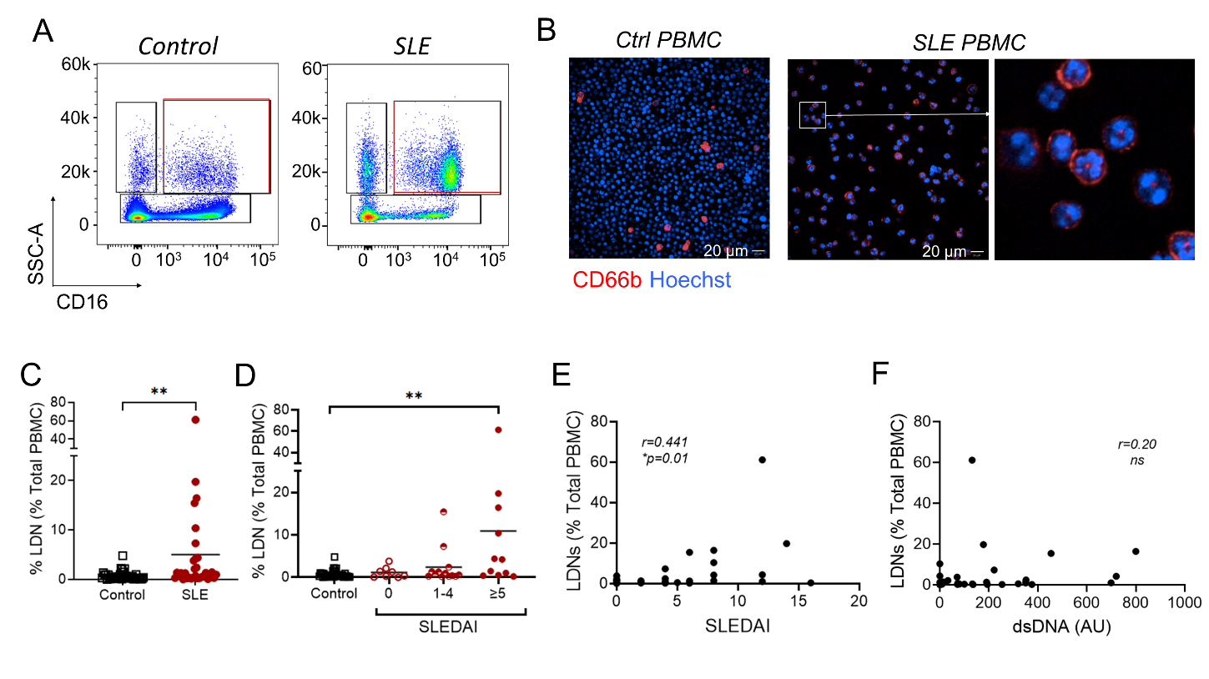
Figure 1. An increased prevalence of low-density neutrophils (LDNs) in SLE is associated with disease activity.
Peripheral blood mononuclear cells (PBMCs) were isolated as described from SLE donors and healthy donors, and LDNs were assessed using flow cytometry and confocal microscopy. (A) Representative analysis of lineage negative (LIN⁻; CD4⁻CD8⁻CD14⁻CD19⁻) PBMCs identifying SSC^{hi}CD14^{lo}CD16^{+/hi} LDNs in SLE patients and controls. (B) Representative confocal microscopic images of CD66b⁺ cells with polymorphonuclear morphology within PBMCs in an active SLE patient. (C) Cumulative data showing that LDNs are increased SLE patients (n=34) compared to healthy controls (n=41). (D-E) Cumulative data from healthy donors and SLE patients according to disease severity, as determined by SLEDAI score, showing that patients with severe disease have significantly higher frequencies of LDNs in their PBMC fraction. (E) Correlation analysis of the LDN frequency with SLEDAI score. (F) Assessment of LDN frequency according to serum anti-dsDNA levels. Significance was determined using a Mann-Whitney U test, Kruskal-Wallis test or Spearman’s rank-order correlation, according to outcomes of Gaussian distribution tests. *=P<0.05, **=P<0.01.

Figure 2.
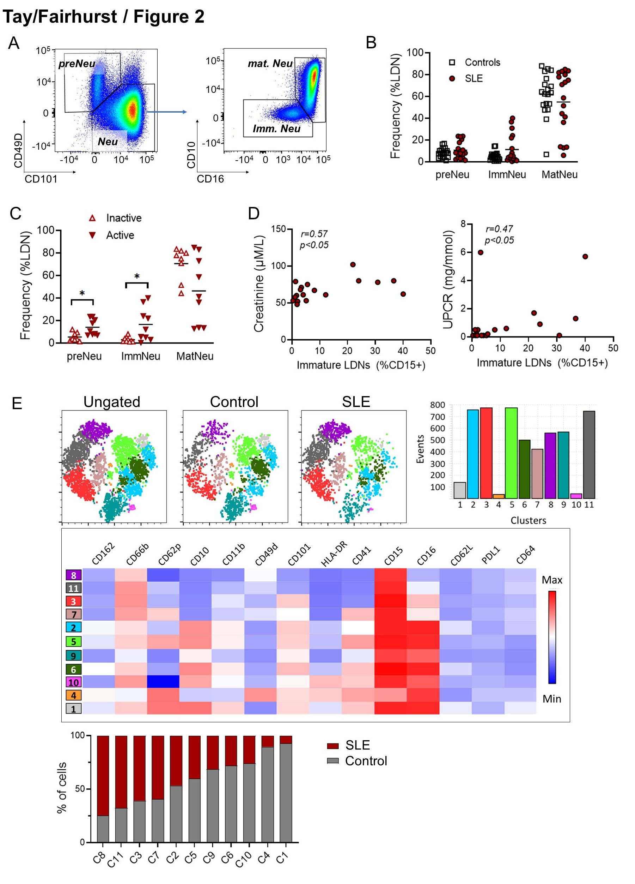
Figure 2. Immunophenotyping of LDNs reveals less mature phenotypes in active SLE.
(A) Immunophenotyping of LIN⁻CD15⁺ LDN subsets using flow cytometry in SLE patients and healthy donors. Pre-neutrophils (preNeu) were identified as CD101⁻CD49⁺, and the remaining neutrophils were divided into mature (matNeu; CD10⁺CD16^{+/hi}) and immature (ImmNeu; CD10⁻CD16^{low}) subsets. (B) Cumulative data showing the distribution of neutrophil subsets in LDNs from SLE patients (n=18) and healthy controls (n=19). (C) Data from SLE patients was stratified according to disease activity. LDNs from patients with active disease (SLEDAI>4, n=9) were less mature than LDNs from inactive (SLEDAI≤4) SLE patients (n=9). (D) Correlation analysis of renal disease with the frequency of immature LDNs. Left panel shows serum creatinine levels, and right panel indicates the urine protein-to-creatinine ratio (UPCR). (E) PhenoGraph revealed 11 clusters (C1-11). SLE LDNs, compared to control LDNs, clustered predominantly in C3, C7, C8 and C11 and expressed lower levels of CD16, CD10 and CD101. Significance was determined using two-way ANOVA and Spearman’s rank-order correlation. *=P<0.05.

Figure 3
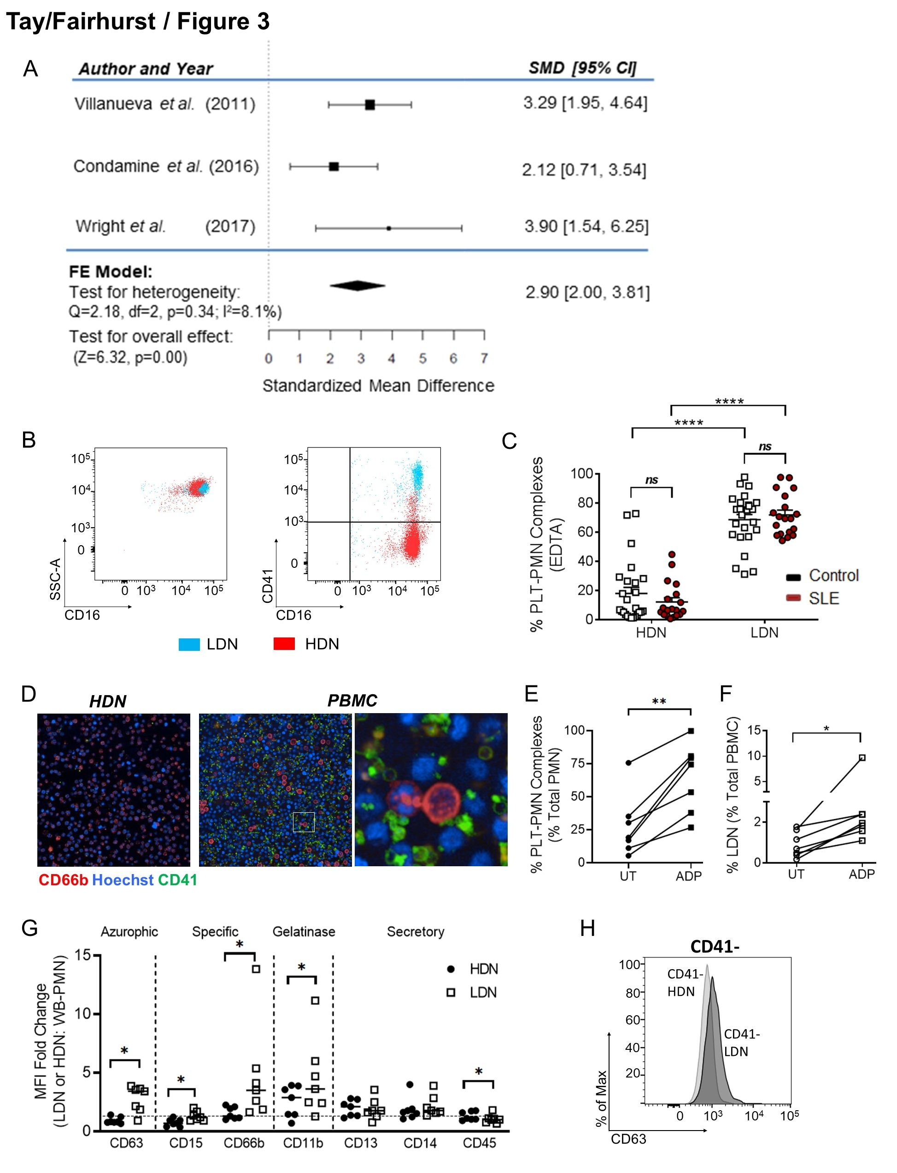Figure 3. Platelet-neutrophil complex (PNC) formation is upregulated in LDNs. (A) LDNs expressed more CD41 in a meta-analysis of 3 microarray and RNA-Seq gene expression datasets. (B) Representative flow cytometry plots illustrating PNCs in LDNs. (C) LDNs have more adherent platelets compared to HDNs on flow cytometry, using EDTA as an as anticoagulant. (D) LDNs from an active SLE patient were adherent to platelets. (E) ADP treatment leads to increased PNC formation compared to untreated neutrophils in whole blood (n=7 healthy donors). (F) ADP treatment leads to increased LDNs within the PBMC fraction (n=7 healthy donors). (G) LDNs expressed higher levels of degranulation markers such as CD63, CD15, CD66b and CD11b compared to HDNs. (H) Overlay of histograms from CD41⁻ neutrophils revealed that LDNs had increased expression of CD63, independent of platelet adhesion. Significance was determined using paired t-test and two-way ANOVA. *=P<0.05 and ****=P<0.0001.

Figure 4.
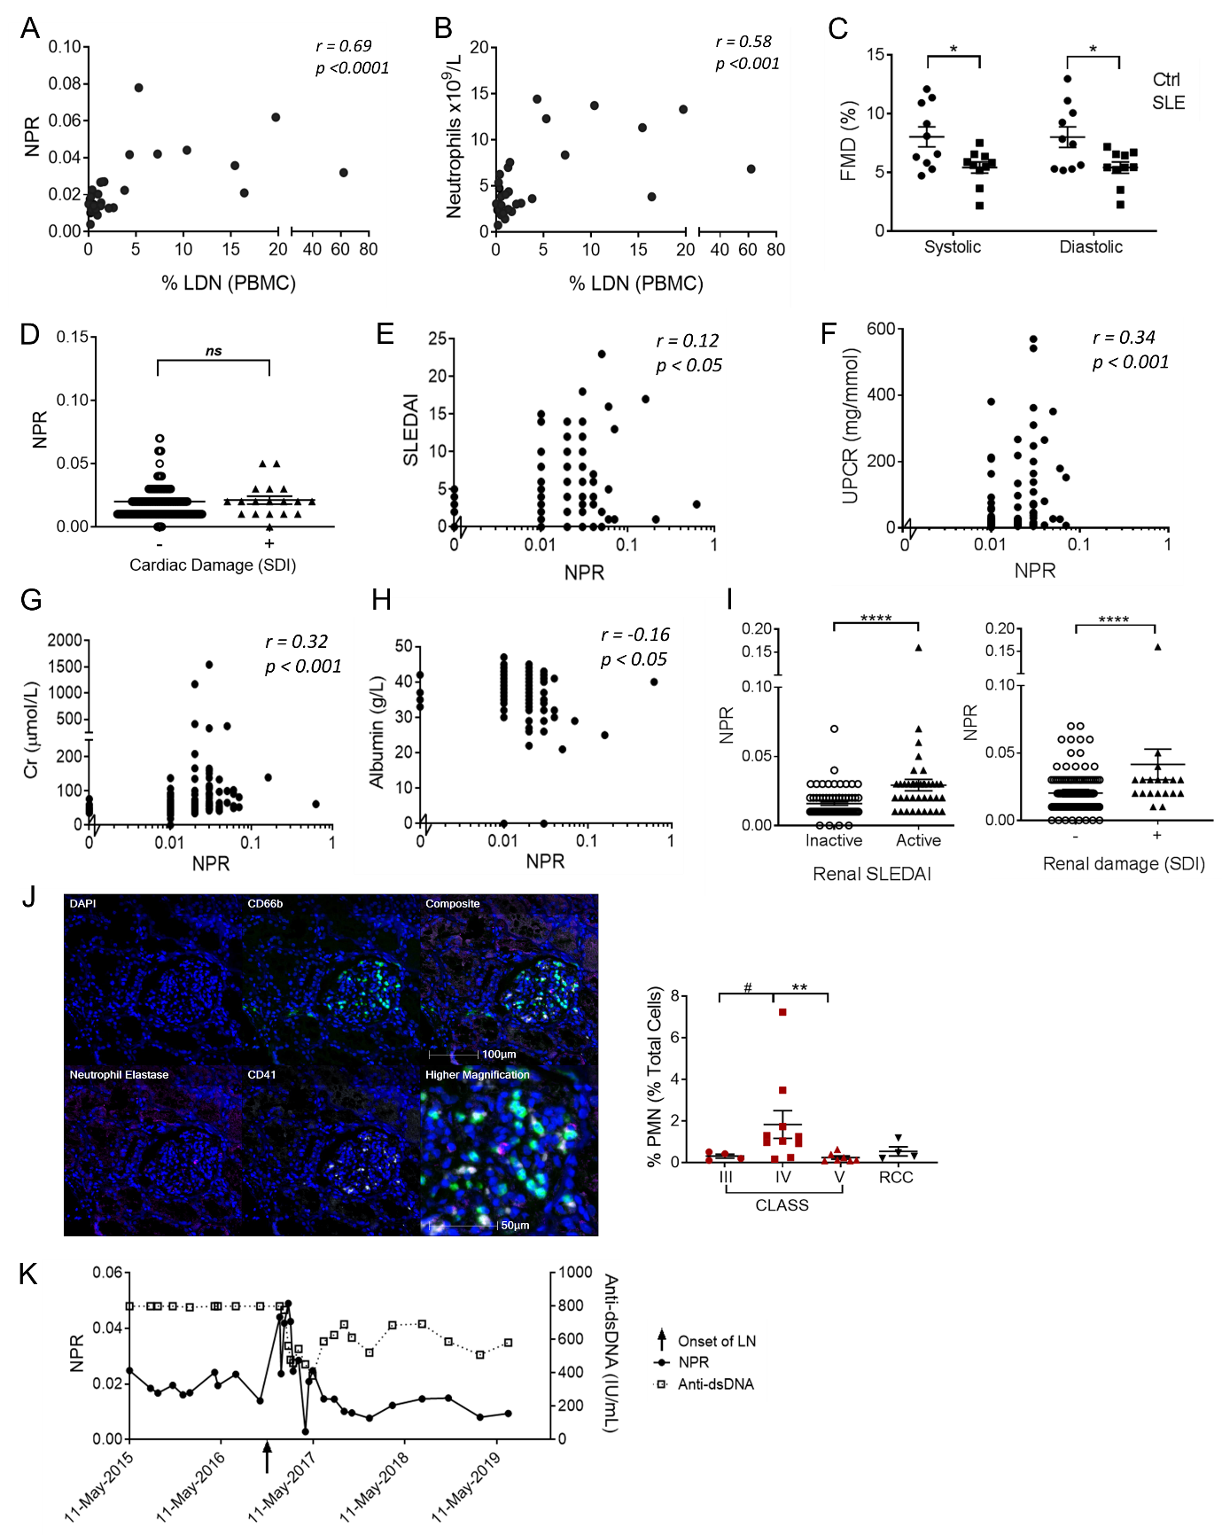
Figure 4. The NPR precedes lupus nephritis flares. (A-B) Correlation of LDN frequency measured using flow cytometry, with the NPR or neutrophil count obtained in the clinic (n=32). (C) SLE patients and age- and gender-matched healthy donors (n=10) without known cardiovascular risk factors were analyzed for endothelial function using flow-mediated dilatation (FMD) at the brachial artery. (D-I) NPR values from SLE patients in the NUH database (n=241) and associations (D) with or without cardiovascular damage; (E) SLEDAI; (F) urine protein-to-creatinine ratio (UPCR); (G) creatine, Cr; (H) albumin and (I) in patients SLE patients with or without renal activity (n=108, left panel) or renal damage (n=247 right panel). (J) Representative multiplex immunofluorescent images on formalin-fixed paraffin embedded kidney section from SLE Class IV nephritis; with region of interest at the glomerulus, with cumulative data of neutrophil infiltration from SLE patients with Class III (n=4), Class IV (n=10) and Class V (n=7) lupus nephritis or renal cell carcinoma (n=4). CD66b:green, CD41:white, neutrophil elastase:magenta, cytokeratin:epithelial cell adhesion molecule (CK/EpCAM):red and DAPI:blue. (K) NPR, and not anti-dsDNA, was associated with onset of lupus nephritis in a SLE patient. Significance was determined using two-way ANOVA, Spearman’s rank-order correlation and Mann-Whitney U test. ns=not significant, *=P<0.05 and ****=P<0.0001.

Figure 5.
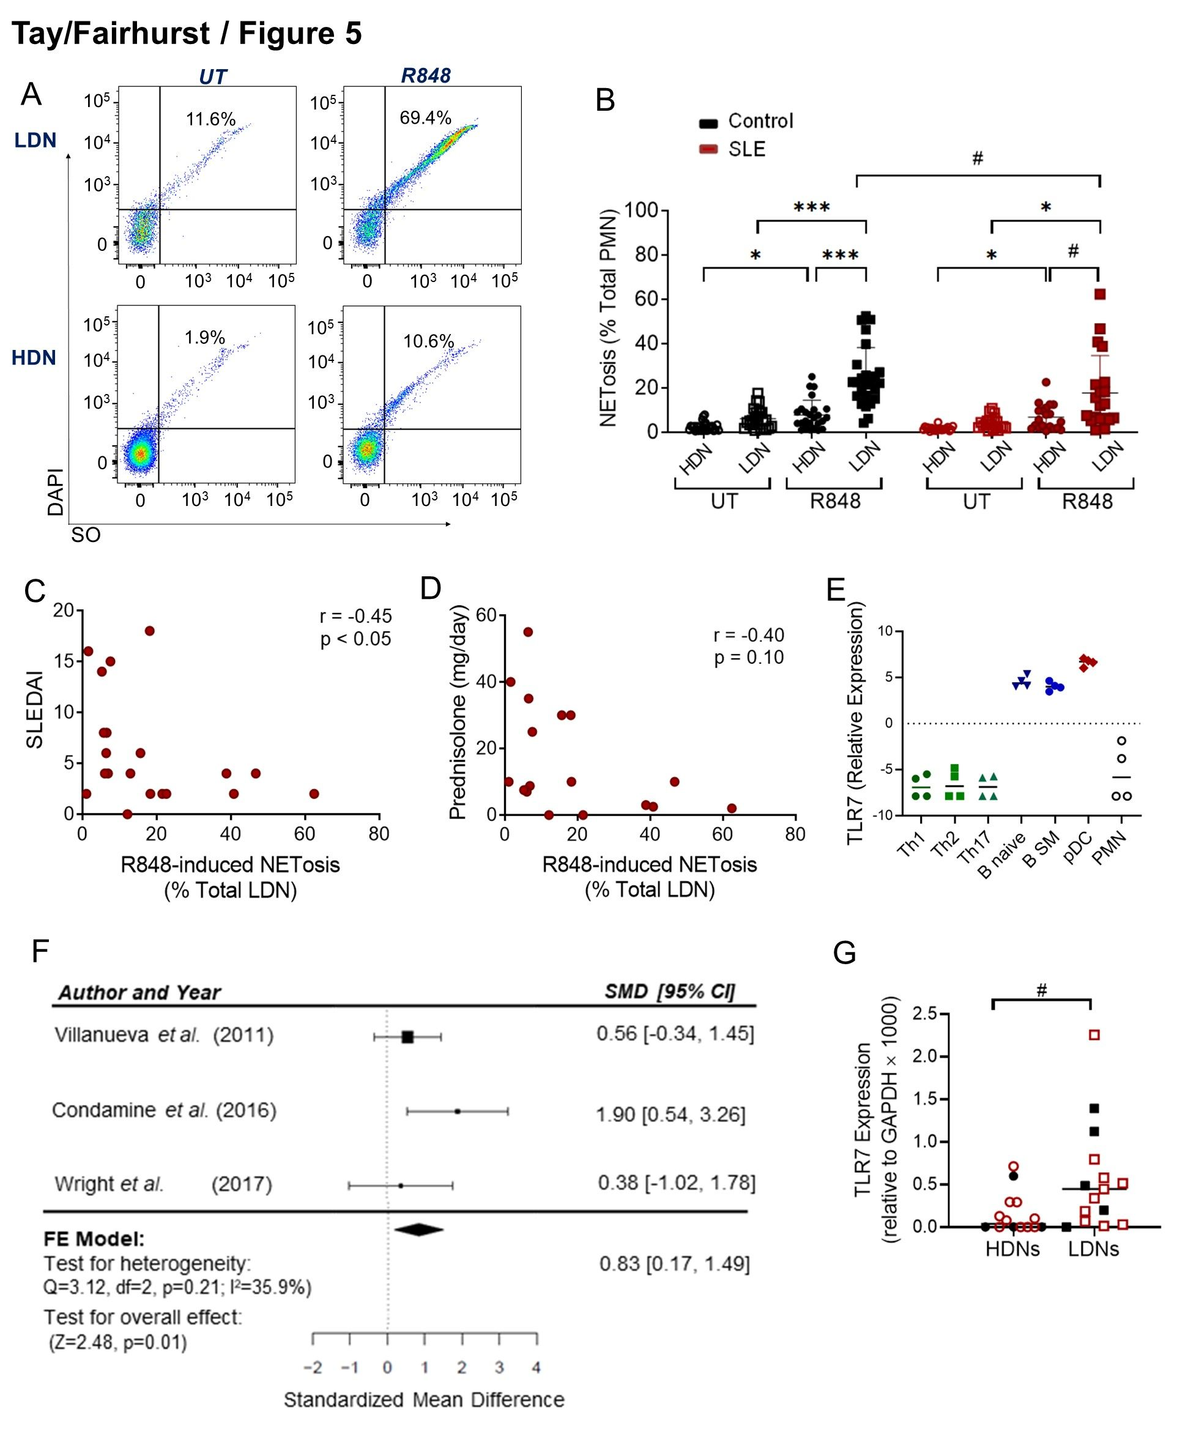Figure 5. Low-density neutrophils express detectable levels of TLR7 and undergo TLR7-induced NETosis. (A) Gating strategy showing that NET-appendant neutrophils detected by Sytox Orange and DAPI positivity were increased following R848 treatment in LDNs but not HDNs. (B) Cumulative data showing R848-induced NETosis in LDNs and HDNs from 10 SLE patients and 16 healthy controls. (C-D) Correlative assessment of R848-induced LDN NETosis with SLE disease activity and treatment. (E) RNA-Seq analysis of TLR7 mRNA expression in circulating HDNs and T CD4⁺ Th1, CD4⁺Th2 and CD4⁺ Th17 T cells (green), naïve and switched memory (SM) B cells (blue), and plasmacytoid dendritic cells (pDC)(red). (F) Meta-analysis of TLR7 mRNA expression in LDNs and HDNs from 3 microarray and RNA-Seq gene expression datasets. (G) Quantitative RT-PCR analysis of TLR7 mRNA expression in HDNs and LDNs in healthy controls (n=5) and SLE patients (n=10). Significance was determined using two-way ANOVA, Spearman’s rank-order correlation and Wilcoxon signed-rank test (#). */#=P<0.05 and ***=P<0.001.

Figure 6

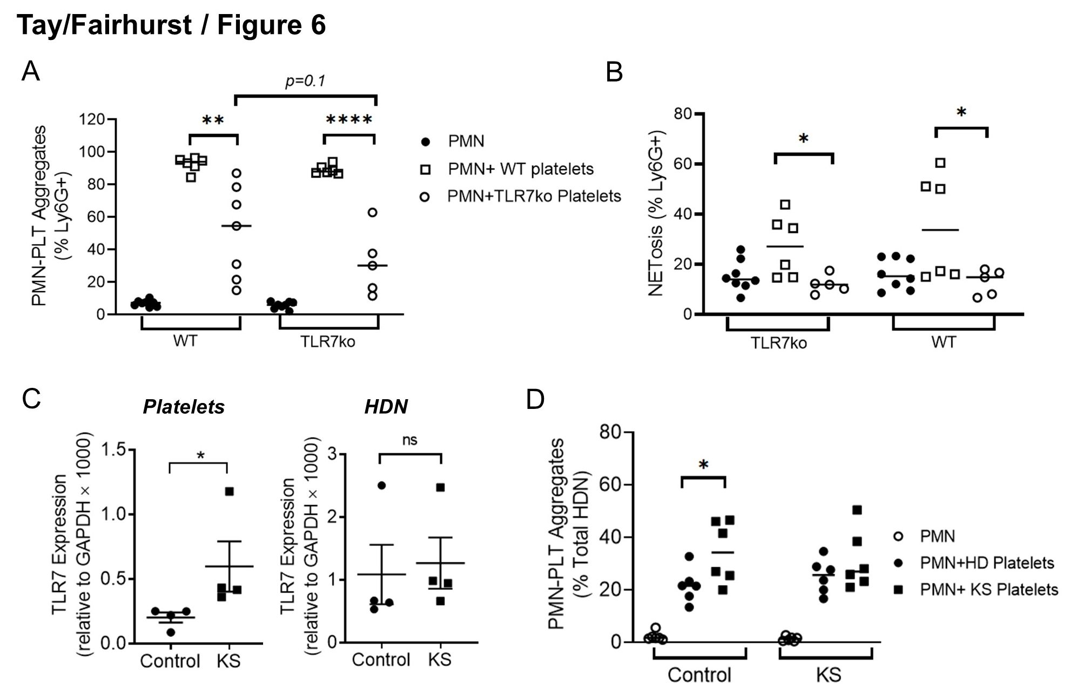Figure 6. Platelet-neutrophil complex (PNC) formation depends on platelet activation and TLR7 expression. (A-B) Murine platelets and HDNs (PMNs) were isolated from WT and TLR7ko mice and mixed as indicated for 3h. Cumulative data identifying (A) CD41⁺Ly6G⁺ PNCs and (B) neutrophil-appendant NET DNA, measured using flow cytometry (n=5-8 per group). (C) TLR7 mRNA levels in human platelets and HDNs from Klinefelter syndrome (KS) patients compared to healthy donor males (n=4 per group). (D) Platelets and HDNs were isolated from KS patients (n=6) and healthy controls (n=6) and mixed as indicated and CD41⁺CD66b⁺ PNCs measured using flow cytometry. Significance was determined using paired t-test and two-way ANOVA. ns=not significant, *=P<0.05, **=P<0.01 and ***=P<0.001.

REFERENCES
1 Marshak-Rothstein A. Toll-like receptors in systemic autoimmune disease. Nature reviews. Immunology 2006;6(11):823-35.
2 Podolska MJ, Biermann MH, Maueroder C, Hahn J, Herrmann M. Inflammatory etiopathogenesis of systemic lupus erythematosus: an update. J Inflamm Res 2015;8:161-71.
3 Hochberg MC. Updating the American College of Rheumatology revised criteria for the classification of systemic lupus erythematosus. Arthritis and rheumatism 1997;40(9):1725.
4 Aringer M, Costenbader K, Daikh D, et al. 2019 European League Against Rheumatism/American College of Rheumatology classification criteria for systemic lupus erythematosus. Annals of the rheumatic diseases 2019;78(9):1151-9.
5 Scherlinger M, Guillotin V, Truchetet ME, et al. Systemic lupus erythematosus and systemic sclerosis: All roads lead to platelets. Autoimmunity reviews 2018;17(6):625-35.
6 Page C, Pitchford S. Neutrophil and platelet complexes and their relevance to neutrophil recruitment and activation. International immunopharmacology 2013;17(4):1176-84.
7 Denny MF, Yalavarthi S, Zhao W, et al. A distinct subset of proinflammatory neutrophils isolated from patients with systemic lupus erythematosus induces vascular damage and synthesizes type I IFNs. Journal of immunology (Baltimore, Md. : 1950) 2010;184(6):3284-97.
8 Villanueva E, Yalavarthi S, Berthier CC, et al. Netting neutrophils induce endothelial damage, infiltrate tissues, and expose immunostimulatory molecules in systemic lupus erythematosus. Journal of immunology (Baltimore, Md. : 1950) 2011;187(1):538-52.
9 Banchereau R, Hong S, Cantarel B, et al. Personalized Immunomonitoring Uncovers Molecular Networks that Stratify Lupus Patients. Cell 2016;165(3):551-65.
10 Tay SH, Celhar T, Fairhurst AM. Low-Density Neutrophils in Systemic Lupus Erythematosus. Arthritis & rheumatology (Hoboken, N.J.) 2020.
11 Brinkmann V, Reichard U, Goosmann C, et al. Neutrophil extracellular traps kill bacteria. Science (New York, N.Y.) 2004;303(5663):1532-5.
12 Lood C, Blanco LP, Purmalek MM, et al. Neutrophil extracellular traps enriched in oxidized mitochondrial DNA are interferogenic and contribute to lupus-like disease. Nature medicine 2016;22(2):146-53.
13 Kahlenberg JM, Carmona-Rivera C, Smith CK, Kaplan MJ. Neutrophil extracellular trap-associated protein activation of the NLRP3 inflammasome is enhanced in lupus macrophages. Journal of immunology (Baltimore, Md. : 1950) 2013;190(3):1217-26.
14 Nickerson KM, Christensen SR, Shupe J, et al. TLR9 regulates TLR7- and MyD88-dependent autoantibody production and disease in a murine model of lupus. Journal of immunology (Baltimore, Md. : 1950) 2010;184(4):1840-8.
15 Santiago-Raber ML, Dunand-Sauthier I, Wu T, et al. Critical role of TLR7 in the acceleration of systemic lupus erythematosus in TLR9-deficient mice. Journal of autoimmunity 2010;34(4):339-48.
16 Teichmann LL, Schenten D, Medzhitov R, Kashgarian M, Shlomchik MJ. Signals via the adaptor MyD88 in B cells and DCs make distinct and synergistic contributions to immune activation and tissue damage in lupus. Immunity 2013;38(3):528-40.
17 Celhar T, Fairhurst A-M. Toll-like receptors in systemic lupus erythematosus: potential for personalized treatment. Frontiers in Pharmacology 2014;5.
18 Brown GJ, Cañete PF, Wang H, et al. TLR7 gain-of-function genetic variation causes human lupus. Nature 2022;605(7909):349-56.
19 Petri M, Orbai AM, Alarcon GS, et al. Derivation and validation of the Systemic Lupus International Collaborating Clinics classification criteria for systemic lupus erythematosus. Arthritis and rheumatism 2012;64(8):2677-86.
20 Gladman D, Ginzler E, Goldsmith C, et al. The development and initial validation of the Systemic Lupus International Collaborating Clinics/American College of Rheumatology damage index for systemic lupus erythematosus. Arthritis and rheumatism 1996;39(3):363-9.
21 Gladman DD, Ibanez D, Urowitz MB. Systemic lupus erythematosus disease activity index 2000. The Journal of rheumatology 2002;29(2):288-91.
22 Scofield RH, Bruner GR, Namjou B, et al. Klinefelter's syndrome (47,XXY) in male systemic lupus erythematosus patients: support for the notion of a gene-dose effect from the X chromosome. Arthritis and rheumatism 2008;58(8):2511-7.
23 Fairhurst AM, Wallace PK, Jawad AS, Goulding NJ. Rheumatoid peripheral blood phagocytes are primed for activation but have impaired Fc-mediated generation of reactive oxygen species. Arthritis Res Ther 2007;9(2):R29.
24 Carmona-Rivera C, Zhao W, Yalavarthi S, Kaplan MJ. Neutrophil extracellular traps induce endothelial dysfunction in systemic lupus erythematosus through the activation of matrix metalloproteinase-2. Annals of the rheumatic diseases 2015;74(7):1417-24.
25 Zharkova O, Tay SH, Lee HY, et al. A Flow Cytometry-Based Assay for High-Throughput Detection and Quantification of Neutrophil Extracellular Traps in Mixed Cell Populations. Cytometry. Part A : the journal of the International Society for Analytical Cytology 2019;95(3):268-78.
26 Hemmi H, Kaisho T, Takeuchi O, et al. Small anti-viral compounds activate immune cells via the TLR7 MyD88-dependent signaling pathway. Nature immunology 2002;3(2):196-200.
27 Condamine T, Dominguez GA, Youn JI, et al. Lectin-type oxidized LDL receptor-1 distinguishes population of human polymorphonuclear myeloid-derived suppressor cells in cancer patients. Science immunology 2016;1(2).
28 Wright HL, Makki FA, Moots RJ, Edwards SW. Low-density granulocytes: functionally distinct, immature neutrophils in rheumatoid arthritis with altered properties and defective TNF signalling. Journal of leukocyte biology 2017;101(2):599-611.
29 Monaco G, Lee B, Xu W, et al. RNA-Seq Signatures Normalized by mRNA Abundance Allow Absolute Deconvolution of Human Immune Cell Types. Cell reports 2019;26(6):1627-40.e7.
30 Petes C, Odoardi N, Gee K. The Toll for Trafficking: Toll-Like Receptor 7 Delivery to the Endosome. Frontiers in immunology 2017;8:1075.
31 Zhang X, Ding L, Sandford AJ. Selection of reference genes for gene expression studies in human neutrophils by real-time PCR. BMC Mol Biol 2005;6:4.
32 Vandesompele J, De Preter K, Pattyn F, et al. Accurate normalization of real-time quantitative RT-PCR data by geometric averaging of multiple internal control genes. Genome Biol 2002;3(7):RESEARCH0034.
33 Wang LZ, Ong RY, Chin TM, et al. Method development and validation for rapid quantification of hydroxychloroquine in human blood using liquid chromatography-tandem mass spectrometry. Journal of pharmaceutical and biomedical analysis 2012;61:86-92.
34 Rahman S, Sagar D, Hanna RN, et al. Low-density granulocytes activate T cells and demonstrate a non-suppressive role in systemic lupus erythematosus. Annals of the rheumatic diseases 2019;78(7):957-66.
35 Evrard M, Kwok IWH, Chong SZ, et al. Developmental Analysis of Bone Marrow Neutrophils Reveals Populations Specialized in Expansion, Trafficking, and Effector Functions. Immunity 2018;48(2):364-79.e8.
36 Carestia A, Kaufman T, Rivadeneyra L, et al. Mediators and molecular pathways involved in the regulation of neutrophil extracellular trap formation mediated by activated platelets. Journal of leukocyte biology 2016;99(1):153-62.
37 van Velzen JF, Laros-van Gorkom BA, Pop GA, van Heerde WL. Multicolor flow cytometry for evaluation of platelet surface antigens and activation markers. Thrombosis research 2012;130(1):92-8.
38 Naegelen I, Plançon S, Nicot N, et al. An essential role of syntaxin 3 protein for granule exocytosis and secretion of IL-1α, IL-1β, IL-12b, and CCL4 from differentiated HL-60 cells. Journal of leukocyte biology 2015;97(3):557-71.
39 Pirillo A, Norata GD, Catapano AL. High-density lipoprotein subfractions--what the clinicians need to know. Cardiology 2013;124(2):116-25.
40 Garcia-Romo GS, Caielli S, Vega B, et al. Netting neutrophils are major inducers of type I IFN production in pediatric systemic lupus erythematosus. Science translational medicine 2011;3(73):73ra20.
41 Gardet A, Pellerin A, McCarl CA, et al. Effect of in vivo Hydroxychloroquine and ex vivo Anti-BDCA2 mAb Treatment on pDC IFNalpha Production From Patients Affected With Cutaneous Lupus Erythematosus. Frontiers in immunology 2019;10:275.
42 Koupenova M, Mick E, Mikhalev E, Benjamin EJ, Tanriverdi K, Freedman JE. Sex differences in platelet toll-like receptors and their association with cardiovascular risk factors. Arterioscler Thromb Vasc Biol 2015;35(4):1030-7.
43 Koupenova M, Vitseva O, MacKay CR, et al. Platelet-TLR7 mediates host survival and platelet count during viral infection in the absence of platelet-dependent thrombosis. Blood 2014;124(5):791-802.
44 Wang JP, Bowen GN, Padden C, et al. Toll-like receptor-mediated activation of neutrophils by influenza A virus. Blood 2008;112(5):2028-34.
45 Odhams CA, Roberts AL, Vester SK, et al. Interferon inducible X-linked gene CXorf21 may contribute to sexual dimorphism in Systemic Lupus Erythematosus. Nature communications 2019;10(1):2164.
46 Jourde-Chiche N, Whalen E, Gondouin B, et al. Modular transcriptional repertoire analyses identify a blood neutrophil signature as a candidate biomarker for lupus nephritis. Rheumatology (Oxford, England) 2017;56(3):477-87.
47 Toro-Dominguez D, Martorell-Marugan J, Goldman D, Petri M, Carmona-Saez P, Alarcon-Riquelme ME. Stratification of Systemic Lupus Erythematosus Patients Into Three Groups of Disease Activity Progression According to Longitudinal Gene Expression. Arthritis & rheumatology (Hoboken, N.J.) 2018;70(12):2025-35.
48 Bennett L, Palucka AK, Arce E, et al. Interferon and granulopoiesis signatures in systemic lupus erythematosus blood. The Journal of experimental medicine 2003;197(6):711-23.
49 Hassani M, Hellebrekers P, Chen N, et al. On the origin of low-density neutrophils. Journal of leukocyte biology 2020;107(5):809-18.
50 Lood C, Arve S, Ledbetter J, Elkon KB. TLR7/8 activation in neutrophils impairs immune complex phagocytosis through shedding of FcgRIIA. The Journal of experimental medicine 2017;214(7):2103-19.
51 Bonegio RG, Lin JD, Beaudette-Zlatanova B, York MR, Menn-Josephy H, Yasuda K. Lupus-Associated Immune Complexes Activate Human Neutrophils in an FcgammaRIIA-Dependent but TLR-Independent Response. Journal of immunology (Baltimore, Md. : 1950) 2019;202(3):675-83.
52 Duffau P, Seneschal J, Nicco C, et al. Platelet CD154 potentiates interferon-alpha secretion by plasmacytoid dendritic cells in systemic lupus erythematosus. Science translational medicine 2010;2(47):47ra63.
53 Vial G, Gensous N, Savel H, et al. The impact of clopidogrel on plasma-soluble CD40 ligand levels in systemic lupus erythematosus patients: the CLOPUS phase I/II pilot study. Joint Bone Spine 2021;88(2):105097.

