Evaluation of protection and immunity induced by infectious bronchitis vaccines administered by oculonasal, spray or gel routes in commercial broiler chicks

Mohammed Al-Rasheed^{a,b,c}, Christopher Ballª, Sivamurthy Parthiban^{a,d} , and Kannan Ganapathy^{a,#}

ªInstitute of Infection and Global Health, University of Liverpool, Cheshire, UK
^{b}College of Veterinary Medicine, King Faisal University, Al-Ahsa, Saudi Arabia
^{c}Avian Research Center, King Faisal University, Al-Ahsa, Saudi Arabia
^{d}Department of Animal Biotechnology, Madras Veterinary College, Tamil Nadu Veterinary and Animal Sciences University, Chennai, India

#Corresponding author: Kannan Ganapathy
E-mail address: gana@liverpool.ac.uk
Full Postal Address: Institute of Infection and Global Health, University of Liverpool,
Leahurst Campus, Neston, Wirral-CH64 7TE, UK

Abstract
Broiler chicks’ responses following combined IBV live attenuated Massachusetts and 793B strains through gel, spray or oculonasal (ON) vaccination routes were cross-compared. Subsequently, the responses following IBV M41 challenge of the unvaccinated and vaccinated groups were also assessed. Post-vaccination humoral and mucosal immune responses, alongside viral load kinetics in swabs and tissues, were determined using commercial ELISA assays, monoclonal antibody-based IgG and IgA ELISA assays and qRT-PCR respectively. After challenged with IBV-M41 strain, humoral and mucosal immune responses, ciliary protection, viral load kinetics, and immune gene mRNA transcriptions between the three vaccination methods were examined and compared. Findings showed that post-vaccinal humoral and mucosal immune responses were similar in all three vaccination methods. Post vaccinal viral load kinetics is influenced by method of administration. The viral load peaked in the ON group within the tissues and the OP/CL swabs in the first and third weeks respectively. Following M41 challenge, ciliary protection and mucosal immune responses were not influenced by vaccination methods as all three methods offered equal ciliary protection. Immune gene mRNA transcriptions varied by vaccination methods. Significant up-regulation of MDA5, TLR3, IL-6, IFN-α and IFN-β genes were recorded for ON method. For both spray and gel methods, significant up-regulation of only MDA5 and IL-6 genes were noted. The spray and gel-based vaccination methods gave equivalent levels of ciliary protection and mucosal immunity to M41 virulent challenge comparable to those provided by the ON vaccination. Analysis of viral load and patterns of immune gene transcription of the vaccinated-challenged groups revealed high similarity between turbinate and choanal cleft tissues compared to HG and trachea. With regards to immune gene mRNA transcription, for all the vaccinated-challenged groups, similar results were found except for IFN-α, IFN-β and TLR3, which were up-regulated only in ON compared to gel and spray vaccination methods.
Keywords: Massachusetts; 793B; IBV vaccines; delivery methods; gel; spray; oculonasal; immune responses; protection
Abbreviations: IBV, Infectious bronchitis virus; ON, Oculonasal; SP, spray; OP, Oropharyngeal; CL, Cloacal swab; SPF, specific-pathogenic-free; ECE, embryonated chicken eggs (ECE), TOC; tracheal organ cultures; MDA, Maternally derived antibody; Nabs, Neutralizing antibodies; Unch, Unchallenged; ch, Challenged; Unv-Unvaccinated; HG, Harderian gland; TLR, Toll like receptor; MDA5, melanoma differentiation-associated protein 5; IL, Interleukin; IFN, Interferon; dpv, days post vaccination; dpc, days post-challenge

Introduction
Infectious bronchitis virus (IBV) is a globally noted pathogen of chickens. Belonging to genus Gammacoronavirus of family Coronaviridae, it causes highly contagious acute Infectious bronchitis (IB) disease in chickens of all age groups . IBV mainly affects respiratory, renal and reproductive systems and results in vast clinical outcomes and great economic loss to the poultry industry . The genome of IBV is single-stranded positive sense, non-segmented RNA with a size of 27.6 kb —the largest of all RNA virus genomes . Non-stringent proof-reading activity with natural mutations and recombination events contributes to the evolution of stable genotype groups and variable lineages . Based on variable S1 nucleotide sequences, IBVs are grouped into 7 genotype groups (Group I-Group VII) comprising of 35 distinct lineages, along with many unassigned inter-lineage recombinants .
Vaccination against IBV is a core practice to minimise losses due to virulent IBV infection. The gold standard approach for vaccination against IBV is through the oculonasal route (ON) , but this individual vaccination method incurs high labour charges and is not economical or practical for large-scale commercial farms. To overcome this, in commercial poultry farming, live attenuated IBV vaccines are usually mass administered by drinking water , coarse spray or aerosol methods at day-old or within the first week of age . While these methods are popular due to convenience, there may be technical limitations in achieving uniform application of the vaccine dose at the individual bird level . Gel based IBV vaccine delivery methods have been developed, evaluated in commercial poultry and proven effective . Jenkins et al evidenced that, gel-based delivery of Eimeria oocysts protects chickens against coccidiosis. In another study, combined vaccination of different IBV vaccine strains B-48 (Mass-like) and 1/96 (793B-like) by gel based method in day old chicks witnessed complete vaccine coverage with required vaccine titres for both IBV vaccine strains . Gel droplets are rapidly ingested by preening (cleaning feathers with beak), which is optimised due to the dye’s appealing colour and acts as a hydrating fluid to day-old chicks .
Different vaccine strains could induce a different level of protective immunity depending on the route of application . Serum (IgY) and mucosal (IgA) antibodies are essential determinants for effective clearance of the circulating virus and virus entry at mucosal points . The innate immune response is the first-line of defence against IBV infection in chickens, which can be directly activated upon initial exposure of the virus . Pattern recognition receptors (PRRs), like MDA5, play a prime role in sensing RNA ligands, such as Avian influenza virus (AIV), IBV or Newcastle disease virus (NDV), while TLR3 plays a complementary role in sensing these invading RNA sensors . Any receptor and ligand interaction induce interferon-mediated signalling pathways with non-specific killing and elimination of invading pathogens. Innate immune response differs according to the strain, target organs and between vaccinated and challenged birds .
Interferons (IFNs) are widely expressed cytokines during viral infections. They act as the first line of defence and induce an antiviral state in both the producing and neighbouring cells . IFN-α/β produced by a virus infected or an activated cell also helps in differentiation of an infected cell to a mature Dendrite Cell (DC) . These mature DCs initiate adaptive immune responses by strongly activating antigen specific naive T cells to produce T helper (Th) type 2 cytokines (IL-4, IL-5, and IL-10), and may also dictate the type of Th cell response . Interleukin (IL)-6 is a pleotropic cytokine produced by many cells, mainly macrophages, vascular endothelial cells, mast cells, dendritic cells, and T and B cells, in response to tissue damage and infections . IL-6 induces both pro- and anti-inflammatory effects , regulates differentiation of monocytes into macrophages , promotes CD4 T cells to secrete IL-4 and favours Th2 response by increasing B-cell specific immunoglobulin production . IL-6 also inhibits IFN-γ secretion in Th1 cells and mediates CD8 T-cell activation, contributing to all the arms of adaptive immunity . As of now, there is no foolproof understanding on the mRNA transcription profiles of these cytokines producing immune genes under controlled IB vaccination and challenge studies in broilers. Hence, the present study is designed to evaluate mRNA transcription profiles of immune genes, like MDA5, TLR3, IFN-α/β and IL-6, in order to understand the immunological protection offered by different IB live attenuated vaccine strains under different application methods.
The major challenges in IBV disease control include extensive genetic variability , heterogeneity of local strains and minimal cross-protection . At this regular vaccination juncture, IBV variants of global importance continue to evolve, making it impossible to develop vaccines against all of them. Hence, it is desirable to perform studies under controlled conditions to determine which IBV vaccine(s) and method could provide the best protection for commercial chicken. Previous studies have shown that combined vaccination of Mass and 793B vaccines provides heterologous protection . Franzo et al. evidenced that combined IBV vaccination offers cross protection against widespread strains, such as QX and Variant 2. Combined Mass and 793B vaccines are the most commonly adopted vaccination protocols in Europe and other parts of the world and offers immunity against a broad range of IBV field variants . To date, there is little to no comparative information on the efficacy and immune responses of gel, spray and oculonasal simultaneous IBV Massachusetts plus IBV 793B vaccination of day-old chicks. Hence, this study is undertaken to cross-compare the protective immunity induced by combined attenuated IBV vaccines administered to commercial broiler chicks by oculonasal, spray and gel methods. The underlying innate, mucosal, humoral and cellular responses in vaccinated and subsequently vaccinated-challenged birds were explored.

Material and methods

2.1 Ethical approval
All the experimental procedures were performed according to UK legislation governing experimental animals under the project licence P8E4FC2C9. Experimental procedures were approved by the University of Liverpool ethical review process.

2.2 Chicks
Day-old broiler chicks were sourced from a commercial hatchery. Unvaccinated and IBV-vaccinated (see below) chicks were transported in individual vehicles for each group from the hatchery to a nearby isolation unit at the University of Liverpool. Birds were kept until 26-days-old according to animal welfare guidelines and under strict biosecurity measures. Chicks were reared on deep litter with antibiotic-free water and feed, and both were provided ad libitum.

2.3 IBV vaccines used in this study
Two commercial live IBV vaccines of Massachusetts and 793B serotypes were procured from a local vaccine distributor and stored at 4 °C until required. Vaccines were reconstituted in sterile distilled water (SDW) according to the manufacturer’s instructions. For combined vaccination, one vial of each live vaccine was mixed after preparation, retained on crushed ice and used within 1 hr of preparation.

2.4 Experimental design
2.4.1 Vaccination and assessments: In the commercial hatchery, 45 unvaccinated (Group D) chicks were separated into a well-ventilated box in a room away from the vaccination area. For this control group, 100 μl of SDW was instilled via the oculonasal route. For the oculonasal route (Group C), each chick received 100 μl of the reconstituted vaccine. For the spray vaccination (Group B), chicks were vaccinated using the standard protocol as administered in the commercial hatchery with a droplet size of at least 100-150 microns. Chicks were left for at least 20 mins after spraying to optimise the effect of preening. For gel vaccination (Group A), the vaccines were reconstituted with a commercial ready to use gel (Gel-Pac® Animal Science Products Incorporated, USA) as per manufacturer’s instructions and administered to the group using a 100 μl multi-channel pipette over the body surface to mimic a commercial hatchery. After the gel vaccination, chicks were left for 30 mins in a quiet room. All groups of birds were observed daily for clinical signs.
2.4.2 Vaccination-challenge and assessment: The remaining chicks in all the study groups above were further sub grouped as A1- Gel unchallenged (Gel-unch), A2-gel challenged (Gel-ch); B1- Spray unchallenged (SP-unch), B2- Spray challenged (SP-ch); C1-Oculonasal unchallenged (ON-unch), C2-Oculonasal challenged (ON-ch), D1-Unvaccinated unchallenged (Unv-unch) and D2-Unvaccinated challenged (Unv-ch), with n=15 within each group. Chicks in groups A2, B2, C2 and D2 were challenged at 21 days post vaccination (dpv) with virulent IBV M41 (Massachusetts, lineage GI-1). The IBV M41 strain was maintained in our laboratory by propagation and titration in 10-days-old specific-pathogenic-free (SPF) embryonated chicken eggs (ECE) via the allantoic cavity route. Virus rich allantoic fluid was collected and titrated in chicken tracheal organ cultures (TOCs), and was confirmed to be free from other viruses, bacteria and fungal contaminants by culture and PCR . All the challenged birds received 0.1ml of virulent M41 allantoic fluid with titre of 10^{5.75} CD₅₀/bird through the oculonasal route.
2.5 Post-vaccination assessments
Humoral immune responses: Serum samples collected in 10 chicks from each group at 3, 7, 10, 14, and 21 days post vaccination (dpv) from all the four groups were evaluated for humoral immune response through IBV specific IgY commercial ELISA kit (IDEXX, Westbrook, Maine, USA) as per manufacturer’s guidelines. Antibody titres were determined by converting the sample/positive ratio according to formula provided by the manufacturer, with a positive ELISA titre cut-off determined as 396.

Mucosal immune responses: Lachrymal fluid collected from 3 birds from each group at 21 dpv was used for assessment of mucosal immune response through in-house developed and validated monoclonal antibody based IBV specific IgA and IgY antibody ELISA as per the prescribed protocol .
IBV RT-PCR and qRT-PCR of swabs and tissues: Oropharyngeal (OP)/Cloacal swabs (CL) and tissues like turbinate, choanal cleft, and trachea were collected from 3 chicks from each group at 3, 7, 10, 14, and 21 dpv and assessed for IB vaccine virus presence and load to understand IBV vaccine virus multiplication kinetics. Viral RNA was extracted from the swab and tissue samples, using the QIAamp viral RNA mini kit and the RNeasy Mini kit (Qiagen, UK) respectively, according to manufacturer’s instructions. Presence and quantification of viral RNA was carried out by qRT-PCR, using an IBV 3’ untranslated region (UTR) gene-specific primer and probe as previously described . Obtained Ct values were converted to log relative equivalent units (REU) of viral RNA by a standard curve generated from using five 10-fold dilutions of RNA extracted from M41 virus-positive allantoic fluid .
2.6 Post-challenge assessments
Mucosal immune responses: Lachrymal fluid collected from 5 birds from each group at 5 dpc was used for evaluation of mucosal immune response through in-house monoclonal antibody based IBV specific IgA and IgY antibody ELISA as described above.
Ciliostasis scores: At 5 dpc, tracheas were extracted from 5 birds of each of the three challenged groups and unvaccinated–challenged groups. The tracheas were then processed for ciliary protection assay as per the method previously described . In accordance with the European Pharmacopoeia 2007, individual birds yielding 50% or more ciliary activity in tracheal explants were considered protected by vaccination against the challenge virus .
IBV qRT-PCR in swabs and tissues: Oropharyngeal/Cloacal swabs, harderian gland (HG), turbinate, choanal cleft, and trachea collected in 5 birds from each group at 3 and 5 dpc were evaluated for virus load by qRT-PCR assay as described above.
Immune gene mRNA transcription analysis: RNA extracted from the HG, turbinate, choanal cleft, and trachea collected in 5 birds from each group at 3 and 5 dpc in all the challenged groups were assessed for mRNA transcription of immune regulating genes, such as innate immunity associated pattern recognition receptors TLR3 and MDA5, pro-inflammatory and humoral immune response activating cytokine IL-6, and both innate and adaptive immunity stimulating interferon alpha (α) and interferon beta (IFN-β), by qRT-PCR in LightCycler 480 using gene specific primers as previously described . Data was normalized using a relative standard curve method to housekeeping 18S ribosomal RNA mRNA transcription and data was presented as the Log₂ fold difference in gene mRNA transcription of virus against the unvaccinated-unchallenged control group.
2.7 Statistical analysis
Data connected to viral load, ciliary protection, serum IgY, mucosal IgA, IgY antibody responses and mRNA transcription profile of TLR3, MDA5, IFN-α IFN-β and IL6 were analysed and cross compared between the three vaccination methods. Statistical variations within the groups were also analysed and presented. Data were confirmed to be normally distributed and analysed using GraphPad™ Prism version 6.00. Significance of differences between groups was analysed using univariate ANOVA, along with the homogeneity of variance test, to confirm statistical differences within the data set, followed by post hoc Tukey’s testing to compare between each group. When groups had p<0.05 for the homogeneity of variance test, Tamhane’s T2 was applied post hoc instead of Tukey’s. Differences between groups were considered significant at p<0.05 unless stated.

Results

3.1 Post-vaccinal humoral immune responses in different vaccination methods
High levels of IBV maternal-derived antibody (MDA) were detected from serum at day-old (2594±33), and by 14 dpv, antibody titres had declined significantly to below the cut-off point (396) in the unvaccinated-unchallenged control group. In the spray and ON-vaccinated groups, antibody titres were positive at 3 dpv (1510±27 and 1803±415 respectively) and 7 dpv (1000±23 and 992±12 respectively), and then decreased significantly by 10, 14 and 21 dpv in the spray-vaccinated (205±46, 109±80 and 121±47) and ON-vaccinated birds (24±18, 23±22 and 111±41). Positive antibody titres were detected in the gel-vaccinated birds at 3, 7 and 10 dpv (2107±49, 562±12 and 433±96). Titres then significantly declined at 14 and 21 dpv (159±12 and 85±50). Serum IBV specific IgY levels in all the vaccinated and unvaccinated groups showed a similar declining pattern and were statistically not significant at any sampling point during post vaccination (Figure 1).
3.2 Post-vaccinal mucosal immune response in lachrymal fluid
The titres of anti-IBV IgA in gel, spray and ON vaccinated groups at 21 dpv were 1.23±0.19, 1.51±0.19 and 1.72±0.18 respectively, which were significantly higher than those of unvaccinated control groups. Anti-IBV IgY titre in gel, spray and ON vaccinated groups at 21 dpv were 0.25±0.04, 0.29±0.01 and 0.30±0.03 respectively, which were significantly higher than the unvaccinated control groups. There were no statistical differences in anti IgA and IgY levels between the three vaccinated groups.
3.3 Post-vaccinal detection of IBV viral load
IBV was not detected in OP and CL swabs, or in tissues of the unvaccinated-unchallenged group, throughout the study. IBV was detected in OP swabs in all vaccinated groups from 3 to 21 dpv (Table 1). For CL swabs, IBV was detected from 3 to 21 dpv in the gel and the ON-vaccinated groups. In the spray-vaccinated group, IBV was detected from 7 dpv.
3.4 Post-vaccinal viral load dynamics in natural orifices and tissues
Viral RNA copies in oropharyngeal and cloacal swabs were measured using RT-qPCR and expressed as log REU (Table 1 and Figure 2A and 2B). OP and CL swab samples collected from vaccinated groups were positive on all sampling days, with the unvaccinated control group negative throughout the study. Post vaccination Viral RNA load in OP swabs peaked at 21 dpv in birds vaccinated by gel and spray method (2.96 log REU and 2.81 log REU respectively), while the ON-vaccinated birds peaked earlier at 7 dpv (2.38 log REU). Virus presence in CL swabs peaked at 14 and 21 dpv in the birds vaccinated by gel and spray respectively (2.04 log REU and 3.34 log REU), while the ON-vaccinated birds peaked earlier at 10 dpv (2.82 log REU).
The viral RNA loads in the turbinate of ON-vaccinated birds peaked earlier at 3 dpv (3.50 log REU), while RNA loads peaked at 10 dpv in gel-vaccinated birds and at 14 dpv in the spray-vaccinated birds (3.77 log REU and 2.88 log REU respectively). The viral load in turbinate of the spray-vaccinated group was significantly lower compared with gel and the ON-vaccinated birds at 10 dpv (Figure 3 A1 and A2).
For the choanal cleft, viral RNA loads peaked at 3 dpv in spray and ON routes (3.22 log REU and 2.72 log REU respectively), and at 7 dpv (3.95 log REU) in the gel-vaccinated birds. The viral titre in the choanal cleft was significantly higher in the gel-vaccinated group compared to other routes at 7 dpv (Figure 3 B1 and B2).
The viral load level in the trachea peaked earlier in chickens vaccinated by the ON route at 3 dpv (2.57 log REU) followed by a significantly lower titre at 21 dpv than the previous days. The viral RNA loads in the trachea of gel-vaccinated bird peaked at 14 dpv (2.63 log REU) with significantly high titres at 14 and 21 dpv compared to the previous sampling days. The viral titre in the trachea of spray-vaccinated birds was significantly lower compared to that of other routes at all sampling points. In addition, the viral load in the trachea of gel-vaccinated birds was significantly high compared to the ON group at 14 and 21 dpv (Figure 3 C1 and C2).

3.5 Post-challenge ciliary protection
Chicks in all vaccinated groups (gel, spray and ON) showed ciliary protection of 97.5, 96.25 and 95.75 % respectively when compared to unvaccinated control group which showed 99.37 % ciliary protection. The vaccinated-challenged groups at 5dpc showed ciliary protection of 83.5, 83.5 and 94.4 % respectively when compared to unvaccinated-challenged control group which showed 1.5 % ciliary protection (Figure 4).
3.6 Post-challenge mucosal immune response in lachrymal fluid
The titres of anti-IBV IgA at 5 dpc in all gel, spray and ON vaccinated-challenged chickens were 1.35±0.19, 1.46±0.09 and 1.70±0.12 respectively, which were significantly higher than the unvaccinated-unchallenged group (Figure 5A). No statistical difference was observed between vaccinated-unchallenged and vaccinated-challenged groups at 5 dpc. The IgY level at 5 dpc in the gel, spray and ON vaccinated-challenged groups were 0.29±0.10, 0.35±0.2 and 0.33±0.03 respectively, which were significantly higher than the unvaccinated-unchallenged and vaccinated-mock challenged groups (Figure 5B).
3.7 Post-challenge IB viral load dynamics in OP swabs and tissues
Post-challenge Viral RNA load in the OP swabs from the gel- unchallenged and the ON- unchallenged birds peaked at 5 dpc (2.21 log REU and 2.69 log REU respectively), while the SP-unchallenged peaked earlier at 3 dpc (2.10 log REU). For the challenged groups, the ON-challenged and SP-challenged groups peaked at 3 dpc (2.22 log REU and 2.35log REU respectively), while the gel-challenged peaked later at 5 dpc (-2.48 log REU). The viral load at 5 dpc was lower in the SP-challenged and ON-challenged groups compared to the vaccinated-unchallenged groups. The viral RNA load in the CL swabs from the gel-unchallenged, spray-unchallenged and ON-unchallenged birds peaked at 3 dpc (3.09 log REU, 2.68 log REU and 2.21 log REU respectively). Similarly, viral RNA copies in all vaccinated-challenged groups peaked at 3 dpc (-2.84 log REU, 2.56 log REU and 2.39 log REU respectively). Viral loads in the gel and spray vaccinated-unchallenged groups were higher than in the respective vaccinated-challenged groups at 3 and 5 dpc, but this was not true for the ON-vaccinated groups (Figure 2C and 2D).
Viral copy numbers peaked at 3 dpc in the HG in the vaccinated-unchallenged birds. The viral titre in the HG was significantly higher in the respective vaccinated-unchallenged groups compared to the vaccinated-challenged group at 5 dpc (gel-vaccinated) and 3 dpc (spray- and ON-vaccinated). (Figure 6 A1 and A2).
In the turbinate, the viral RNA peaked at 5 dpc in all vaccinated-unchallenged groups. The turbinate viral load was significantly higher in the vaccinated-unchallenged groups compared to the gel- and spray-vaccinated-challenged groups at 5 dpc. However, the viral copy in the turbinate at 3 dpc was significantly higher in the ON vaccinated-challenged group compared to the vaccinated-unchallenged groups. A comparison between the methods demonstrates that the viral titre was significantly higher in the gel- and spray-vaccinated-unchallenged groups compared to the ON route at 3 dpc, while in the vaccinated-challenged groups, the significantly high titre was detected at 3 dpc in the ON route compared to the spray (Figure 6 B1 and B2).
In the choanal cleft, viral RNA in the vaccinated-unchallenged groups peaked at 3 dpc, with the exception of the ON-vaccinated group, which peaked later at 5 dpc. Similar to the turbinate, the viral replication titre in the choanal cleft was significantly higher at 3 dpc in the vaccinated-challenged compared to the vaccinated-unchallenged groups in the ON-vaccinated group (Figure 6 C1 and C2).
In trachea tissue, viral RNA levels in vaccinated-unchallenged chickens peaked at 3 dpc in gel and ON, and at 5 dpc in spray-vaccinated groups. The viral load of RNA in the trachea was significantly higher at 3 dpc in gel-vaccinated birds, and at 3 and 5 dpc in the spray-vaccinated birds compared to the vaccinated-challenged birds. However, the tracheal viral copy at 3 dpc was significantly higher in the ON-vaccinated-challenged group compared to the ON-vaccinated-unchallenged groups. A comparison between the different methods showed that the viral titre was significantly higher in the SP-unch at 5 dpc compared to other routes, while in the vaccinated-challenged groups, a significantly high titre was observed in the ON route at 3 and 5 dpc compared to the other methods. (Figure 6 D1 and D2).

3.8 Post-challenge immune gene mRNA transcription profile

3.8.1 TLR3 and MDA5 mRNA transcription: Harderian gland (HG)
TLR3 mRNA transcription in the HG was significantly down-regulated at 3 and 5 dpc in the groups vaccinated by gel and spray, and at 5 dpc in the ON-vaccinated group compared to the unvaccinated-unchallenged control group. In the vaccinated-challenged groups, there was significant down-regulation at 3-5 dpc in the Gel-challenged and SP-challenged groups, while in the ON-challenged group, a significant up-regulation was present at 3 dpc compared to the control group. There was a significantly high difference in the TLR3 mRNA transcription for the HG in the vaccinated-unchallenged group compared to vaccinated-challenged group at 5 dpc in the gel and spray-vaccinated groups, and at 3 and 5 dpc in the ON-challenged group (Figure 7 A1). Between all vaccination methods, a notably low mRNA transcription was seen in the ON-unchallenged birds at 5 dpc. However, in the vaccinated-challenged groups, TLR3 mRNA transcription was significantly higher in the ON-challenged group at all-time points (Figure 7 A2).
MDA5 mRNA transcription in the HG was significantly up-regulated at 3 and 5 dpc in the groups vaccinated by gel and spray and at 3 dpc in the ON-vaccinated birds compared to the control. In the vaccinated-challenged groups, significant up-regulation of the MDA5 was observed at 3 and 5 dpc in all the three Gel-challenged SP-challenged and ON-challenged groups compared to the control and vaccinated-unchallenged groups at 3 and 5 dpc (Figure 8 A1). Spray-vaccinated birds showed a significantly higher level of MDA5 mRNA transcription at 5 dpc compared to the other routes. Moreover, a significantly high difference in the mRNA transcription of MDA5 in HG was seen in the spray-vaccinated group at 5 dpc compared to others groups, whereas all the three challenged groups evidenced significant up regulation of MDA5 at 3 and 5 dpc (Figure 8 A2).
3.8.2 TLR3 and MDA5 mRNA transcription: Turbinate
Significant down-regulation was noted in TLR3 mRNA transcription at 3 dpc in the gel-vaccinated group, and at 3-5 dpc in both groups vaccinated via spray and the ON routes. The significant up-regulation was noted only in gel-vaccinated birds at 5 dpc compared with the control. With regards to the vaccinated-challenged groups, significant down-regulation was noted at all-time points in the Gel-challenged and SP-challenged groups. Conversely, this gene detected significant up-regulation in the ON-challenged birds at all-time points compared to the control. Significant differences were observed in the gel-vaccinated group compared to the Gel-challenged groups at 5 dpc, and in the ON-challenged compared with ON-vaccinated birds at 3 and 5 dpc (Figure 7 B1). A significant difference in the TLR3 mRNA transcription presented in the gel-vaccinated bird at 5 dpc and in the ON-challenged at all sampling days in the vaccinated-challenged groups (Figure 7 B2).
MDA5 mRNA transcription in the turbinate was significantly up-regulated at 5 dpc in the gel-vaccinated group, at 3 and 5 dpc in the spray-vaccinated birds and at 3 dpc in the ON group compared with the control group. In the vaccinated-challenged groups, there was significant up-regulation of the MDA5 5 dpc in the Gel-challenged and SP-challenged groups, and 3 dpc in the ON-challenged group compared to the control group. There was a significant difference in the SP-challenged compared with spray-vaccinated groups at 5 dpc (Figure 8 B1). A comparison between the different vaccine administrations showed a significant difference in the gel-vaccinated bird at 5 dpc. In the vaccinated-challenged groups, higher significant MDA5 mRNA transcription levels were seen in ON-challenged compared to SP and gel-challenged at 3 dpc. However, MDA5 mRNA transcription presented significantly higher in the SP and gel challenged groups at 5 dpc (Figure 8 B2).
3.8.3 TLR3 and MDA5 mRNA transcription: Choanal cleft
TLR3 mRNA transcription in the choanal cleft was significantly down-regulated at 3 and 5 dpc followed by significant up-regulation at 5 dpc in the gel-vaccinated group. In the groups vaccinated by spray and ON methods, results indicated a significant down-regulation at 3 and 5 dpc compared with control. In the Gel-challenged and SP-challenged groups, there was significant down-regulation at 3-5 dpc.. In addition, a significant high difference was detected at 5 dpc in the gel-vaccinated compared with the vaccinated-challenged group (Figure 7 C1). In comparison between all vaccination methods, a significant high TLR3 mRNA transcription was only noted in the ON-challenged group at all time points (Figure 7 C2).
MDA5 mRNA transcription in the choanal cleft was significantly down-regulated at 3 dpc, followed by a significant up-regulation at 5 dpc in both gel and spray-vaccinated chickens compared to the control group. In the vaccinated-challenged groups, a significant up-regulation of MDA5 was observed at 5 dpc in the SP-challenged group, and at 3 and 5 dpc in both the Gel-challenged and ON-challenged groups compared to the control group. A significant difference was seen in the ON-challenged group compared to ON-vaccinated birds at 3 -5 dpc (Figure 8 C1). A significant difference was detected in the MDA5 mRNA transcription at 5 dpc in the SP-challenged group (Figure 8 C2).
3.8.4 TLR3 and MDA5 mRNA transcription: Trachea
Significant up-regulation was noted in TLR3 mRNA transcription at 3 dpc and at 3-5 dpc in the gel and ON-vaccinated groups respectively. The significant down-regulation of this gene was observed at 3 dpc in birds vaccinated via spray method compared to the control. In the vaccinated-challenged groups, significant down-regulation was noted at all sampling days in the Gel-challenged and SP-challenged groups. The opposite was true for the ON-challenged where this gene was significantly up-regulated at all-time points compared to the control. Significant high differences were observed in the gel-vaccinated compared to Gel-challenged at 3 and 5 dpc, and in the ON-challenged compared to ON-vaccinated groups at 3 dpc (Figure 7 D1). A significant high difference in the TLR3 mRNA transcription was noted at 3 dpc in the gel and at 5 dpc in the ON-vaccinated groups, and at all sampling days in the ON-challenged for the vaccinated-challenged groups (Figure 7 D2).
MDA5 mRNA transcription in the trachea was significantly up-regulated at all sampling days in the vaccinated-challenged groups compared to the control group. Significant differences were detected between the gel- and spray-vaccinated groups at 5 and 3 dpc respectively, and at 3 and 5 dpc in the ON-challenged for the vaccinated-challenged group (Figure 8 D1). A significant difference in the MDA5 mRNA transcription was noted in the gel-vaccinated birds at 5 dpc. In the vaccinated-challenged groups, a significant difference was present at 3 and 5 dpc in all three of the challenged groups compared to control (Figure 8 D2).

3.8.5 IFN-α and IFN-β mRNA transcription: Harderian gland (HG)
Significant down-regulation of IFN-α mRNA transcription was seen on all sampling days in both vaccinated-unchallenged and vaccinated-challenged birds for all different vaccination routes compared to the control group. Significant difference was seen only at 3 and 5 dpc in the vaccinated-unchallenged compared to vaccinated-challenged birds in the gel- and ON-vaccinated groups respectively (Figure 9 A1). IFN-α mRNA transcription was significantly lower in spray-vaccinated birds at 3 and 5 dpc in the gel-vaccinated group compared to the different routes of vaccine in the HG (Figure 9 A2).
There was significant down-regulation in IFN-β mRNA transcription at 3 dpc in the spray-vaccinated group and at all sampling days in the vaccinated-challenged birds in both Gel-challenged and SP-challenged groups. However, in the ON-challenged birds, a significant down-regulation was observed at 5 dpc compared to the control group. Significant difference was detected in the vaccinated-unchallenged compared to vaccinated-challenged birds at 5 dpc in the gel and the ON, and at 3 dpc in the spray-vaccinated groups respectively (Figure 10 A1). IFN-β mRNA transcription was significantly higher in the ON-challenged group when compared to other vaccination routes at 3 dpc (Figure 10 A2).
3.8.6 IFN-α and IFN-β mRNA transcription: Turbinate
Significant down-regulation of IFN-α mRNA transcription was observed in all birds vaccinated by different methods and in the vaccinated-challenged groups at 3 dpc. Unaltered mRNA transcription was observed in all three vaccinated -challenged groups at 5 dpc compared to the control group. There was a significant difference in the SP-challenged group compared to spray-vaccinated group at 3 dpc (Figure 9 B1). Comparison between the different methods of immunisation showed that the IFN-α mRNA transcription was significantly lower in all three challenged groups at 3 dpc (Figure 9 B2).
IFN-β mRNA transcription in the turbinate was significantly down-regulated at 3 dpc in the gel and ON-vaccinated groups. Significant up-regulation was seen in the spray-vaccinated birds at 5 dpc. In the vaccinated-challenged groups, there was significant down-regulation at both 3 and 5 dpc in the Gel-challenged and SP-challenged groups, and at 5 dpc in the ON-challenged group compared to the control group. Significant differences were observed in the spray-vaccinated at 3 and 5 dpc compared to SP-challenged groups, and at 3 dpc in the ON-challenged compared to ON-vaccinated group (Figure 10 B1). Comparison between the different vaccination routes showed a significantly higher level of IFN-β mRNA transcription at 3-5 dpc in the spray-vaccinated group, and significant down regulation in all three challenged groups at 5 dpc (Figure 10 B2).
3.8.7 IFN-α and IFN-β mRNA transcription: Choanal cleft
There was significant down-regulation in the IFN-α mRNA transcription in all birds vaccinated by different methods and also in the vaccinated-challenged groups of Gel-challenged and SP-challenged at 3 dpc. There was a significant difference in the ON-challenged compared to ON-vaccinated birds at 3 dpc (Figure 9 C1). A significantly high level was noted in the ON-vaccinated group at 3 dpc, and in the ON-challenged group at 3 dpc (Figure 9 C2).
There was significant down-regulation of IFN-β mRNA transcription in both vaccinated-unchallenged and vaccinated-challenged groups for all different vaccination routes at 3 dpc (Figure 10 C1 and C2).
3.8.8 IFN-α and IFN-β mRNA transcription: Trachea
IFN-α mRNA transcription was significantly down-regulated at 3 and 5 dpc in the spray-vaccinated groups and at only 3 dpc in the ON-vaccinated groups. Significant up-regulation was present at 5 dpc in both gel- and ON-vaccinated birds. In the vaccinated-challenged groups, IFN-α was significantly down-regulated at 3 and 5 dpc in the Gel-challenged and the SP-challenged groups, and the mRNA transcription was unaltered at 3 and 5 dpc in the ON-challenged group compared with the control group. Significant differences were noticed at 3 and 5 dpc in the gel-vaccinated compared to Gel-challenged groups, and at 3 dpc in the ON-challenged compared to ON-vaccinated groups (Figure 9 D1). The IFN-α mRNA transcription was significantly higher at 3-5 dpc in the gel-vaccinated group, and at all sampling days in the ON-challenged group (Figure 9 D2).
IFN-β mRNA transcription was significantly down-regulated in all vaccinated groups at 3 dpc, followed by significant up-regulation at 5 dpc only in the ON-vaccinated birds. In the vaccinated-challenged groups, there was significant down-regulation of this gene in the Gel-challenged and SP-challenged 3 dpc, while in the ON-ch, IFN-β was up-regulated significantly at 5 dpc compared to the control group. Significant high differences were observed at 3 dpc in the ON-challenged compared to ON-vaccinated birds (Figure 10 D1). The IFN- β mRNA transcription was significantly higher at 5 dpc in the ON-vaccinated birds, and at 3 and 5 in the ON-challenged group (Figure 10 D2).

3.8.9 IL-6 mRNA transcription: Harderian gland (HG)
There was significant up-regulation of the IL-6 mRNA transcription at 3 and 5 dpc in the spray, and at 3 dpc in the ON-vaccinated groups. In the vaccinated-challenged groups, the IL-6 was observed to be significantly up-regulated at 3 dpc in SP-challenged group and down-regulated at 5 dpc in both Gel-challenged and spray-challenged groups compared to the control group. Significant differences were noticed at 3 and 5 dpc in spray-vaccinated compared to SP-challenged groups, and at 3 dpc in ON-vaccinated compared to ON-challenged chickens (Figure 11 A1). IL-6 mRNA transcription was significantly higher in the spray, ON-vaccinated birds at 3 dpc, and only at 5 dpc in the ON-vaccinated group. (Figure 11 A2).
3.8.10 IL-6 mRNA transcription: Turbinate
There was significant down regulation in the IL-6 mRNA transcription at both 3 and 5 dpc in the all vaccinated-challenged groups in birds vaccinated by all methods compared to the control group. (Figure 11 B1). IL-6 mRNA transcription presented significantly lower in the gel-vaccinated birds at 5 dpc, while in the vaccinated-challenged groups, IL-6 was higher at 3 dpc in the Gel-challenged (Figure 11 B2).
3.8.11 IL-6 mRNA transcription: Choanal cleft
There was only significant up-regulation in IL-6 mRNA transcription in the ON-vaccinated group at 3-5 dpc compared to the control and ON-challenged groups. Unaltered expression was present at both 3 and 5 dpc in all vaccinated-challenged groups compared to the control group (Figure 11 C1). The observed IL-6 mRNA transcription was significantly higher in the ON-vaccinated birds at 3 and 5 dpc compared to the other vaccination methods (Figure 11 C2).
3.8.12 IL-6 mRNA transcription: Trachea
There was a significant up-regulation of the IL-6 mRNA transcription at 3 dpc, followed by down-regulation at 5 dpc in the ON-vaccinated group. The significant up-regulation was noted at 3 and 5 dpc in the ON-ch, while Gel-challenged and SP-challenged groups showed down regulation compared to the control group. Significant differences were noted in the ON-challenged group compared to ON-vaccinated groups between at 3 and 5 dpc (Figure 11 D1). In comparison between the different methods of vaccination, IL-6 mRNA transcription was significantly higher in the ON-vaccinated birds at 3 dpc, and was down regulated at 3 dpc in the Gel-challenged and SP-challenged groups. In addition, significant differences were noticed in the ON-challenged at 3 and 5 dpc compared to other vaccination routes (Figure 11 D2).

Discussion
It appears that the vaccination methods had no impact on post-vaccination reactions in day-old chicks. Chicks in all vaccinated groups showed mild clinical respiratory signs such as head shaking, tracheal rales and snicks in the first week post vaccination. Similar findings have been reported in day-old broiler chicks vaccinated by eye-drop, coarse spray, or intratracheal instillation with other IBV vaccine strains . The current study demonstrated that the gel, spray or ON vaccination methods had little to no influence on the IBV maternally derived antibody (MDA) levels, as the pattern of decline in the MDA levels were similar in all vaccinated groups. A similar observation was reported by Chhabra, et al. with combined administration of Massachusetts plus 793B vaccines in day old chicks. For IBV, it has been demonstrated that antiviral defense through neutralizing antibodies (Nabs) alone is not considered as the sole protection . It might involve a combination of other parameters such as innate, humoral, mucosal and immune cell responses .
The pattern of post-vaccinal viral load in this study revealed an earlier peak in viral load — first in tissues and later, in OP and CL swabs in all the vaccination methods. This might be due to initial virus replication in cells at site of entry, and subsequently, in the post viremic phase, it might have been shed through natural orifices . The other possible reason is that the prompt mucosal response in tissues could have played a role in lowering the viral loads in respiratory tract surfaces, leading to less being detected by the OP and CL swabs, particularly in the initial days after vaccination . Findings of consistent and high levels of viral load in turbinate and Harderian gland demonstrated that although the primary site for IBV infection is the ciliated epithelium lining of trachea , IBV also multiplies well in other tissues .
The gel, spray and ON vaccination methods induced similar levels of mucosal immunity, as measured by anti-IBV IgA titres in the lachrymal fluid of the vaccinated birds. It appears that these vaccination methods provided almost equal levels of mucosal immunity . Previous work has reported that IBV-specific IgA found in tears, tracheal and oviduct and duodenal and caecal contents may offer local protection .
This study demonstrated that at five days post-challenge with virulent M41, all three vaccination methods offered similar ciliary protection, indicating equivalent efficacy of gel, spray or ON vaccination methods. Compared to the control, in the vaccinated-challenged groups, the anti-IBV IgA and IgY levels in the lachrymal fluid was significantly raised following M41 challenge, but there were no significant differences between different vaccination methods. This demonstrates that in all three vaccination methods, vaccine viral titres were sufficient to induce adequate IgA and IgY antibodies in lachrymal fluids. Lachrymal anti-IBV IgA and IgY levels play an important protective role against IBV infection of the upper respiratory tract . It was proposed that anti-IBV IgA and anti-IBV IgY (in lachrymal fluid), followed by tissue IFN response, play an important role in conferring protection against virulent IBV challenge .
Other than providing evidence of ciliary and mucosal protection, this study also examined the immune mechanisms underlying the protection in vaccinated-challenged chicks. This included determination of viral load and mRNA transcription profile of certain immune genes in a number of tissues. On viral load, all vaccinated-challenged groups in this study had a common pattern of significant reduction in viral RNA loads at 3-5 dpc in OP and CL swabs and in tissues, indicating a high degree of protection. This is likely due to induction of local innate, mucosal and cellular immune responses at the respiratory linings. Similar findings were reported in another study, where post-challenge viral IB RNA load in the trachea and conjunctiva-associated lymphoid tissues (CALT) were significantly reduced at 2 and 4 dpc . Though the specific reason for this was not clear, it is likely that handling of the birds on the 21 dpv for sampling and sham (virus-free allantoic fluid) inoculation may have triggered stress, and further replication of the vaccine strain of IBVs. Post-challenge, HG viral load was less in ON, gel and spray vaccination routes, and induced a greater resistance to challenge virus compared to other tissues at initial days of challenge. This finding is consistent with that of Ratanasethakul and Cumming [8], who found that vaccination by the conjunctival, intranasal and in-contact routes induced a greater resistance to challenge. It is correlated with lymphoid tissue nature of the HG, which may have expeditious trained immunity, and immunological memory. This might have induced a strong resistance to virulent challenge . In contrast to previous vaccination-challenge studies, where trachea and kidney tissues were the main focus , head-associated tissues such as the HG, turbinate and choanal cleft were included in this study for a better understanding of the immune responses’ dynamics . In this study, comparison of IB viral replication pattern and immune gene mRNA transcription profiles in different tissues revealed high similarity between turbinate and choanal cleft compared to HG and trachea. The suppression of the host’s IFN immune response in the Harderian gland (HG) following vaccination or challenge is unique. HG is known for its role in local immunity and quickly responds to pathogens and vaccines that enter via the ocular route. However, its role as lymphoid tissue is sparsely explored . They reported that for Newcastle disease, several mRNAs were noted to be highly expressed in the Harderian gland compared to bursa, spleen and thymus, which highlighted its unique immune properties . It appears that that for future IBV studies, inclusion of proteomic and transcriptomic analysis of tissues could provide valuable information.
The present study evidenced consistent up regulation of the MDA5 gene mRNA transcription at 3-5 days post challenge in all the study tissues, such as HG, turbinate, choanal cleft and trachea. Invariably, all three vaccination methods indicate that vaccination methods could not have influenced the innate sensing of IBV. For the TLR3, the gene was up-regulated only in the ON vaccinated-challenge group, reflecting that the transcription magnitude of this gene could be associated with route of vaccination. Yu et al. witnessed MDA5 signalling associated interferon (IFN) protective response against JS/2010/12 strain of IBV challenge in chicken embryo kidney (CEK) cells and chicken embryos. Okino et al. analysed early immune responses against varying virulent Brazilian IBV field isolates inoculated via oculonasal route in SPF chicks and documented TLR3 transcription up regulation at 1-8 dpi. However, this study did not analyse MDA5 levels, which are also critical for mRNA sensing . Manswr et al. investigated immunopathogenesis of IBV-Q1 strain in SPF chicks and recorded significantly higher up-regulation of IFN-α, TLR3, MDA5 and IL-6 mRNA transcription in 1-14 days post infection, which supports the present study. Al-Rasheed et al. studied early post-vaccinal immune responses to Mass H120 and 793B serotypes in commercial laying hens administered through both ON and drinking water (DW) routes and found that TLR3 and MDA5 was significantly up-regulated in the HG and trachea but not in turbinate at 5 days post vaccination following either ON or DW inoculation, which differs from the findings of this study, where MDA5 is uniformly up-regulated in all the studied tissues, including turbinate, invariably due to vaccination method.
The current study found that type 1 interferon mRNA transcriptions vary between individual and mass vaccination methods. IFN-α mRNA transcription was significantly up-regulated at 3 dpc and gradually down regulated at 5 dpc, whereas, IFN-β mRNA transcription was significantly down regulated at 3 dpc and gradually up-regulated at 5dpc in ON group. However, with both gel and spray methods, IFN-α, IFN-β mRNA transcriptions were down regulated from 3-5 dpc. Type I interferon (IFN-α, IFN-β) is predominantly produced from fibroblasts, which have anti-proliferative and antiviral properties and are commonly used for determining preliminary antiviral states post infection . Al-Rasheed et al. reported similar findings in layer hens vaccinated with Massachusetts and 793B serotypes by ON and drinking water (DW) routes. They reported that IFN-β mRNA transcription was significantly down regulated at 3 dpc, and subsequently up-regulated or down regulated at 5 dpc for ON or DW methods respectively. The DW route may be equal to that of oral gel method in the study, where oral ingestion is the main vaccine entry route. Both IFN-α and IFN-β share common structural and genetic similarities, but they vary in their differential binding affinity to interferon receptors (IFNAR1 and IFNAR2). IFN-α induces a significantly more potent antiviral state in chicken when compared to IFN-β. Apart from type 1 interferon, type II interferon (IFN-γ) from immune cells and type III interferon (IFN- λ) from epithelial cells may also play a crucial role in IBV antiviral defence . Both the mass vaccination methods in this study evidenced significant down regulation of type 1 interferon at 3-5 dpc compared to Individual (ON) method, which necessitates better understanding of the expression patterns of other antiviral cytokines, such as type II and type III interferon.
This study showed that IL-6 mRNA transcription was down regulated at 3 and 5 dpc in all tissues collected from the vaccinated-unchallenged groups, except for HG where IL-6 mRNA transcription was up-regulated in both at 3 and 5 dpc compared to control. But in all vaccinated-challenged groups, up-regulation of the IL-6 was observed at 3 dpc, whereas, at 5 dpc, it was unaltered and comparable to the control group. Since IL-6 is a pro-inflammatory cytokine that recruits cells and promotes inflammation and clearance of infection at the infection site , IL-6 promotes up-regulation of the Th17 cells, which affects Th17/Treg cells ratio. Thus, it is considered as a disruption and may favour development of chronic inflammation . IL-6, apart from being a pro-inflammatory cytokine, also favours Th2 cell differentiation, which plays a role in humoral immune response stimulation . The above facts may substantiate early up regulation of IL-6 to activate the immune system and development of inflammatory and cellular responses. Later, it is down regulated to reduce the inflammation. It appears that there were no clear differences in the magnitude of IL-6 responses between the vaccinated-challenged groups. Even though MDA5 and IL-6 mRNA transcriptions were upregulated in the HG of all the vaccinated-challenged groups, their levels were statistically lower than that of vaccinated-unchallenged groups. This finding reflects the better ability of the vaccinated group in resisting the challenge virus infection and subsequent inflammation processes. On the other hand, both IFN-α and IFN-β (type I interferon) mRNA expressions are significantly down regulated in HG, which behaves uniquely and needs to be explored further in IBV vaccination and challenge studies.
5. Conclusions
This study for the first time demonstrated that by 21 dpv, the spray and gel-based vaccination methods gave equivalent levels of ciliary protection and mucosal immunity to IBV M41 virulent challenge that is comparable to those provided by the ON vaccination. Following the vaccination, it is more likely that in the OP swabs, the vaccine viruses are detectable every week in the OP swabs. However, for the CL swabs, detection chances are higher at weeks 2 and 3 instead of weeks 1 or 2. At 21 dpv, the vaccine viral loads in turbinate and choanal cleft were almost the same at all sampling points (except at two occasions) for all the vaccination methods. Consistently lower viral load was found in the trachea of the spray-vaccinated group compared to the other two methods. Analysis of viral load and pattern of immune gene transcription of the vaccinated-challenged groups revealed high similarity between turbinate and choanal cleft tissues compared to HG and trachea. For the immune gene mRNA transcription in all the vaccinated-challenged groups, similar results were found, except regarding IFNα, IFNβ and TLR3, which were up-regulated via the oculonasal method, compared to gel and spray methods.
Acknowledgements
Mohammed Al-Rasheed is in receipt of a studentship from the Saudi Arabia government. The funders were not involved with the study design, analysis or decision to publish the data.

Authors’ contributions
MAR conducted sampling collection, laboratory analysis and manuscript preparation. CB aided with laboratory assays, data analysis and manuscript preparation. SP aided with data analysis and manuscript preparation. KG conceived and designed the experiment, supervised the laboratory and data analysis, and finalised the manuscript. All authors have read and approved the final manuscript.

Declaration of interests
The authors declare that they have no known competing financial interests or personal relationships that could have appeared to influence the work reported in this paper.

References
[1] Kariithi HM, Volkening JD, Leyson CM, Afonso CL, Christy N, Decanini EL, et al. Genome Sequence Variations of Infectious Bronchitis Virus Serotypes From Commercial Chickens in Mexico. Front Vet Sci. 2022;9:931272.
[2] Jackwood MW, De Wit S. Infectious bronchitis. Diseases of poultry. 2013:139-59.
[3] Peng S, Wang Y, Zhang Y, Song X, Zou Y, Li L, et al. Current Knowledge on Infectious Bronchitis Virus Non-structural Proteins: The Bearer for Achieving Immune Evasion Function. Front Vet Sci. 2022;9:820625.
[4] Gorbalenya AE, Enjuanes L, Ziebuhr J, Snijder EJ. Nidovirales: evolving the largest RNA virus genome. Virus Res. 2006;117:17-37.
[5] Rohaim MA, El Naggar RF, Abdelsabour MA, Mohamed MHA, El-Sabagh IM, Munir M. Evolutionary Analysis of Infectious Bronchitis Virus Reveals Marked Genetic Diversity and Recombination Events. Genes (Basel). 2020;11.
[6] De Wit J. Underestimation of the difficulties of vaccination against viral respiratory diseases by mass application methods. Proceedings of the XVIIIth International Congress of the World Veterinary Poultry Association, Nantes, France2013. p. 19-23.
[7] Gough RE, Alexander DJ. Comparison of duration of immunity in chickens infected with a live infectious bronchitis vaccine by three different routes. Res Vet Sci. 1979;26:329-32.
[8] Ratanasethakul C, Cumming RB. Immune response of chickens to various routes of administration of Australian infectious bronchitis vaccine. Aust Vet J. 1983;60:214-6.
[9] Pensaert M, Lambrechts C. Vaccination of chickens against a Belgian nephropathogenic strain of infectious bronchitis virus B1648 using attenuated homologous and heterologous strains. Avian Pathol. 1994;23:631-41.
[10] Matthijs MG, van Eck JH, de Wit JJ, Bouma A, Stegeman JA. Effect of IBV-H120 vaccination in broilers on colibacillosis susceptibility after infection with a virulent Massachusetts-type IBV strain. Avian Dis. 2005;49:540-5.
[11] Martin MP, Wakenell PS, Woolcock P, O'Connor B. Evaluation of the effectiveness of two infectious bronchitis virus vaccine programs for preventing disease caused by a California IBV field isolate. Avian Dis. 2007;51:584-9.
[12] Saif Y, Barnes H, Glisson J, FadlyAM M, Swayne D. Diseases of poultry 11thed. Iowa State University Press. 2003;56.
[13] Godoy A, Jordan B, El-Attrache J. Replication dynamics of a live Infectious bronchitis virus vaccine in broiler chicks vaccinated by different routes. XXth World Veterinary Poultry Association Congress Edinburgh2017.
[14] Jordan B. Vaccination against infectious bronchitis virus: A continuous challenge. Vet Microbiol. 2017;206:137-43.
[15] Jenkins MC, Parker C, Klopp S, O'Brien C, Miska K, Fetterer R. Gel-Bead Delivery of Eimeria oocysts protects chickens against coccidiosis. Avian Dis. 2012;56:306-9.
[16] Tucciarone CM, Franzo G, Bianco A, Berto G, Ramon G, Paulet P, et al. Infectious bronchitis virus gel vaccination: evaluation of Mass-like (B-48) and 793/B-like (1/96) vaccine kinetics after combined administration at 1 day of age. Poult Sci. 2018;97:3501-9.
[17] Chapman HD. Practical use of vaccines for the control of coccidiosis in the chicken. World's Poultry Science Journal. 2000;56:7-20.
[18] Rehmani SF. Newcastle disease vaccination: A comparison of vaccines and routes of administration in Pakistan. Preventive Veterinary Medicine. 1996;25:241-8.
[19] Toro H, Espinoza C, Ponce V, Rojas V, Morales MA, Kaleta EF. Infectious bronchitis: effect of viral doses and routes on specific lacrimal and serum antibody responses in chickens. Avian Dis. 1997;41:379-87.
[20] De Wit JJ, Swart WA, Fabri TH. Efficacy of infectious bronchitis virus vaccinations in the field: association between the alpha-IBV IgM response, protection and vaccine application parameters. Avian Pathol. 2010;39:123-31.
[21] Bhuiyan MSA, Amin Z, Rodrigues KF, Saallah S, Shaarani SM, Sarker S, et al. Infectious Bronchitis Virus (Gammacoronavirus) in Poultry Farming: Vaccination, Immune Response and Measures for Mitigation. Vet Sci. 2021;8.
[22] Yu L, Zhang X, Wu T, Su J, Wang Y, Wang Y, et al. Avian infectious bronchitis virus disrupts the melanoma differentiation associated gene 5 (MDA5) signaling pathway by cleavage of the adaptor protein MAVS. BMC Vet Res. 2017;13:332.
[23] Lee SB, Park YH, Chungu K, Woo SJ, Han ST, Choi HJ, et al. Targeted Knockout of MDA5 and TLR3 in the DF-1 Chicken Fibroblast Cell Line Impairs Innate Immune Response Against RNA Ligands. Front Immunol. 2020;11:678.
[24] Kc M, Ngunjiri JM, Lee J, Ahn J, Elaish M, Ghorbani A, et al. Avian Toll-like receptor 3 isoforms and evaluation of Toll-like receptor 3-mediated immune responses using knockout quail fibroblast cells. Poult Sci. 2020;99:6513-24.
[25] Okino CH, Mores MA, Trevisol IM, Coldebella A, Montassier HJ, Brentano L. Early immune responses and development of pathogenesis of avian infectious bronchitis viruses with different virulence profiles. PLoS One. 2017;12:e0172275.
[26] Yang X, Li J, Liu H, Zhang P, Chen D, Men S, et al. Induction of innate immune response following introduction of infectious bronchitis virus (IBV) in the trachea and renal tissues of chickens. Microb Pathog. 2018;116:54-61.
[27] Onoguchi K, Yoneyama M, Takemura A, Akira S, Taniguchi T, Namiki H, et al. Viral infections activate types I and III interferon genes through a common mechanism. J Biol Chem. 2007;282:7576-81.
[28] Kadowaki N, Antonenko S, Lau JY, Liu YJ. Natural interferon alpha/beta-producing cells link innate and adaptive immunity. J Exp Med. 2000;192:219-26.
[29] Banchereau J, Steinman RM. Dendritic cells and the control of immunity. Nature. 1998;392:245-52.
[30] Tanaka T, Narazaki M, Kishimoto T. IL-6 in inflammation, immunity, and disease. Cold Spring Harb Perspect Biol. 2014;6:a016295.
[31] Mauer J, Denson JL, Brüning JC. Versatile functions for IL-6 in metabolism and cancer. Trends Immunol. 2015;36:92-101.
[32] Scheller J, Chalaris A, Schmidt-Arras D, Rose-John S. The pro- and anti-inflammatory properties of the cytokine interleukin-6. Biochim Biophys Acta. 2011;1813:878-88.
[33] Chomarat P, Banchereau J, Davoust J, Palucka AK. IL-6 switches the differentiation of monocytes from dendritic cells to macrophages. Nat Immunol. 2000;1:510-4.
[34] Yang R, Masters AR, Fortner KA, Champagne DP, Yanguas-Casás N, Silberger DJ, et al. IL-6 promotes the differentiation of a subset of naive CD8+ T cells into IL-21-producing B helper CD8+ T cells. J Exp Med. 2016;213:2281-91.
[35] Green AM, Difazio R, Flynn JL. IFN-γ from CD4 T cells is essential for host survival and enhances CD8 T cell function during Mycobacterium tuberculosis infection. J Immunol. 2013;190:270-7.
[36] Valastro V, Holmes EC, Britton P, Fusaro A, Jackwood MW, Cattoli G, et al. S1 gene-based phylogeny of infectious bronchitis virus: An attempt to harmonize virus classification. Infect Genet Evol. 2016;39:349-64.
[37] Jackwood MW. Review of infectious bronchitis virus around the world. Avian Dis. 2012;56:634-41.
[38] Sjaak de Wit JJ, Cook JK, van der Heijden HM. Infectious bronchitis virus variants: a review of the history, current situation and control measures. Avian Pathol. 2011;40:223-35.
[39] Terregino C, Toffan A, Beato MS, De Nardi R, Vascellari M, Meini A, et al. Pathogenicity of a QX strain of infectious bronchitis virus in specific pathogen free and commercial broiler chickens, and evaluation of protection induced by a vaccination programme based on the Ma5 and 4/91 serotypes. Avian Pathol. 2008;37:487-93.
[40] Habibi M, Karimi V, Langeroudi AG, Ghafouri SA, Hashemzadeh M, Farahani RK, et al. Combination of H120 and 1/96 avian infectious bronchitis virus vaccine strains protect chickens against challenge with IS/1494/06 (variant 2)-like infectious bronchitis virus. Acta Virol. 2017;61:150-60.
[41] Franzo G, Massi P, Tucciarone CM, Barbieri I, Tosi G, Fiorentini L, et al. Think globally, act locally: Phylodynamic reconstruction of infectious bronchitis virus (IBV) QX genotype (GI-19 lineage) reveals different population dynamics and spreading patterns when evaluated on different epidemiological scales. PLoS One. 2017;12:e0184401.
[42] Awad F, Hutton S, Forrester A, Baylis M, Ganapathy K. Heterologous live infectious bronchitis virus vaccination in day-old commercial broiler chicks: clinical signs, ciliary health, immune responses and protection against variant infectious bronchitis viruses. Avian Pathol. 2016;45:169-77.
[43] Sultan HA, Ali A, El Feil WK, Bazid AHI, Zain El-Abideen MA, Kilany WH. Protective Efficacy of Different Live Attenuated Infectious Bronchitis Virus Vaccination Regimes Against Challenge With IBV Variant-2 Circulating in the Middle East. Front Vet Sci. 2019;6:341.
[44] Legnardi M, Baranyay H, Simon C, Molnár J, Bijlsma T, Cecchinato M, et al. Infectious Bronchitis Hatchery Vaccination: Comparison between Traditional Spray Administration and a Newly Developed Gel Delivery System in Field Conditions. Vet Sci. 2021;8.
[45] Bijlenga G, Cook JK, Gelb J, Jr., de Wit JJ. Development and use of the H strain of avian infectious bronchitis virus from the Netherlands as a vaccine: a review. Avian Pathol. 2004;33:550-7.
[46] Al-Rasheed M, Ball C, Manswr B, Leeming G, Ganapathy K. Infectious bronchitis virus infection in chicken: viral load and immune responses in Harderian gland, choanal cleft and turbinate tissues compared to trachea. Br Poult Sci. 2022;63:484-92.
[47] Fournier-Caruana J, Poirier B, Haond G, Jallet C, Fuchs F, Tordo N, et al. Inactivated rabies vaccine control and release: use of an ELISA method. Biologicals. 2003;31:9-16.
[48] Ganapathy K, Cargill PW, Jones RC. Effects of cold storage on detection of avian infectious bronchitis virus in chicken carcasses and local antibodies in tracheal washes. J Virol Methods. 2005;126:87-90.
[49] Jones RM, Ellis RJ, Cox WJ, Errington J, Fuller C, Irvine RM, et al. Development and validation of RT-PCR tests for the detection and S1 genotyping of infectious bronchitis virus and other closely related gammacoronaviruses within clinical samples. Transbound Emerg Dis. 2011;58:411-20.
[50] Chhabra R, Ball C, Chantrey J, Ganapathy K. Differential innate immune responses induced by classical and variant infectious bronchitis viruses in specific pathogen free chicks. Dev Comp Immunol. 2018;87:16-23.
[51] Cook JK, Orbell SJ, Woods MA, Huggins MB. Breadth of protection of the respiratory tract provided by different live-attenuated infectious bronchitis vaccines against challenge with infectious bronchitis viruses of heterologous serotypes. Avian Pathol. 1999;28:477-85.
[52] Kuchipudi SV, Tellabati M, Sebastian S, Londt BZ, Jansen C, Vervelde L, et al. Highly pathogenic avian influenza virus infection in chickens but not ducks is associated with elevated host immune and pro-inflammatory responses. Vet Res. 2014;45:118.
[53] Kuchipudi SV, Tellabati M, Nelli RK, White GA, Perez BB, Sebastian S, et al. 18S rRNA is a reliable normalisation gene for real time PCR based on influenza virus infected cells. Virol J. 2012;9:230.
[54] Andrade LF, Villegas P, Fletcher OJ. Vaccination of day-old broilers against infectious bronchitis: effect of vaccine strain and route of administration. Avian Dis. 1983;27:178-87.
[55] Chhabra R, Forrester A, Lemiere S, Awad F, Chantrey J, Ganapathy K. Mucosal, Cellular, and Humoral Immune Responses Induced by Different Live Infectious Bronchitis Virus Vaccination Regimes and Protection Conferred against Infectious Bronchitis Virus Q1 Strain. Clin Vaccine Immunol. 2015;22:1050-9.
[56] Ellis S, Keep S, Britton P, de Wit S, Bickerton E, Vervelde L. Recombinant Infectious Bronchitis Viruses Expressing Chimeric Spike Glycoproteins Induce Partial Protective Immunity against Homologous Challenge despite Limited Replication In Vivo. J Virol. 2018;92.
[57] Sadarangani M, Marchant A, Kollmann TR. Immunological mechanisms of vaccine-induced protection against COVID-19 in humans. Nat Rev Immunol. 2021;21:475-84.
[58] Ganapathy K. Infectious Bronchitis Virus Infection of Chicken: The Essential Role of Mucosal Immunity. Avian Dis. 2021;65:619-23.
[59] Baron S, Fons M, Albrecht T. Viral pathogenesis. Medical Microbiology 4th edition. 1996.
[60] Brandtzaeg P. Function of mucosa-associated lymphoid tissue in antibody formation. Immunol Invest. 2010;39:303-55.
[61] Meir R, Krispel S, Simanov L, Eliahu D, Maharat O, Pitcovski J. Immune responses to mucosal vaccination by the recombinant A1 and N proteins of infectious bronchitis virus. Viral Immunol. 2012;25:55-62.
[62] Okino CH, Alessi AC, Montassier Mde F, Rosa AJ, Wang X, Montassier HJ. Humoral and cell-mediated immune responses to different doses of attenuated vaccine against avian infectious bronchitis virus. Viral Immunol. 2013;26:259-67.
[63] Al-Rasheed M, Ball C, Ganapathy K. Route of infectious bronchitis virus vaccination determines the type and magnitude of immune responses in table egg laying hens. Vet Res. 2021;52:139.
[64] Deist MS, Lamont SJ. What Makes the Harderian Gland Transcriptome Different From Other Chicken Immune Tissues? A Gene Expression Comparative Analysis. Front Physiol. 2018;9:492.
[65] Manswr B, Ball C, Forrester A, Chantrey J, Ganapathy K. Immunopathogenesis of infectious bronchitis virus Q1 in specific pathogen free chicks. Microb Pathog. 2020;149:104535.
[66] Kameka AM, Haddadi S, Kim DS, Cork SC, Abdul-Careem MF. Induction of innate immune response following infectious bronchitis corona virus infection in the respiratory tract of chickens. Virology. 2014;450-451:114-21.
[67] Santhakumar D, Rubbenstroth D, Martinez-Sobrido L, Munir M. Avian Interferons and Their Antiviral Effectors. Front Immunol. 2017;8:49.
[68] Kimura A, Kishimoto T. Th17 cells in inflammation. Int Immunopharmacol. 2011;11:319-22.
[69] Diehl S, Rincón M. The two faces of IL-6 on Th1/Th2 differentiation. Mol Immunol. 2002;39:531-6.
[70] Korn T, Hiltensperger M. Role of IL-6 in the commitment of T cell subsets. Cytokine. 2021;146:155654.

Table1.Post-vaccinal IBV virus detection and viral load in swabs
Detection percentage and log REU of the IBV vaccine virus load in the Oropharyngeal (OP) and Cloacal (CL) swabs at 3, 7, 10, 14, and 21 dpv assessed by qRT-PCR, in all the vaccinated and Unvaccinated groups. No IB vaccine virus detected in unvaccinated control groups.

Days post vaccination  (DPV) | % of birds positive for IBV RT-PCR (IBV viral load in log REU)
Days post vaccination  (DPV) | Oropharyngeal (OP) swab |  |  |  | Cloacal (CL) swab
Days post vaccination  (DPV) | Gel | Spray | Oculonasal | Gel |  | Spray | Oculonasal
3 | 60 (2.65) | 70 (2.07) | 100 (2.22) | 40 (0.31) |  | 0 (0.00) | 10 (1.47)
7 | 70 (2.69) | 80 (2.13) | 100 (2.38) | 50 (0.85) |  | 10 (0.11) | 60 (1.77)
10 | 100 (2.80) | 90 (2.32) | 100 (2.06) | 80 (1.51) |  | 30 (0.44) | 90 (2.82)
14 | 100 (2.82) | 100 (2.81) | 100 (1.99) | 80 (1.95) |  | 90 (3.34) | 90 (2.46)
21 | 100 (2.96) | 100 (2.81) | 100 (1.73) | 100 (2.04) |  | 90 (2.72) | 100 (2.53)

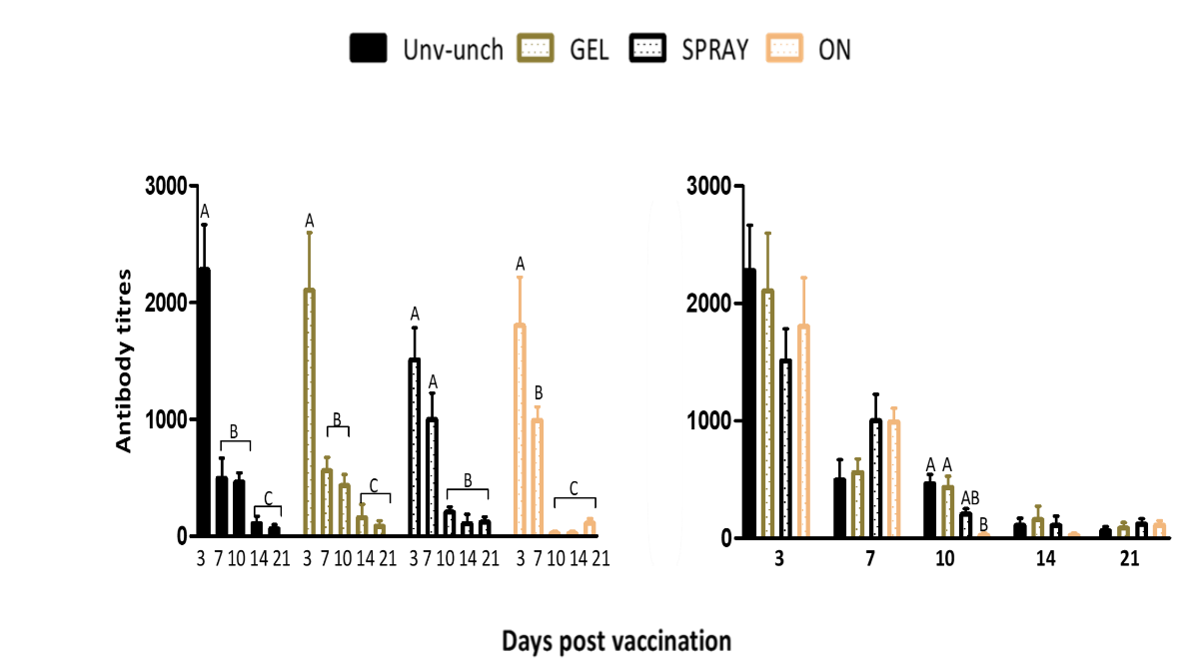
Figure 1. Post-vaccinal IBV specific-IgY responses
Infectious bronchitis virus (IBV) antibody titres (IgY) of the unvaccinated-unchallenged (Unvac-Unch) control and different vaccinated groups (ON-Oculonasal). Data are expressed as mean values ± SEM (n=10/group) at 3, 7, 10, 14 and 21 day-post vaccination. Significant differences between the groups were detected by one-way ANOVA test. The significant differences between the groups are indicated with different letters, and the non-significant differences are not alphabetically sorted.
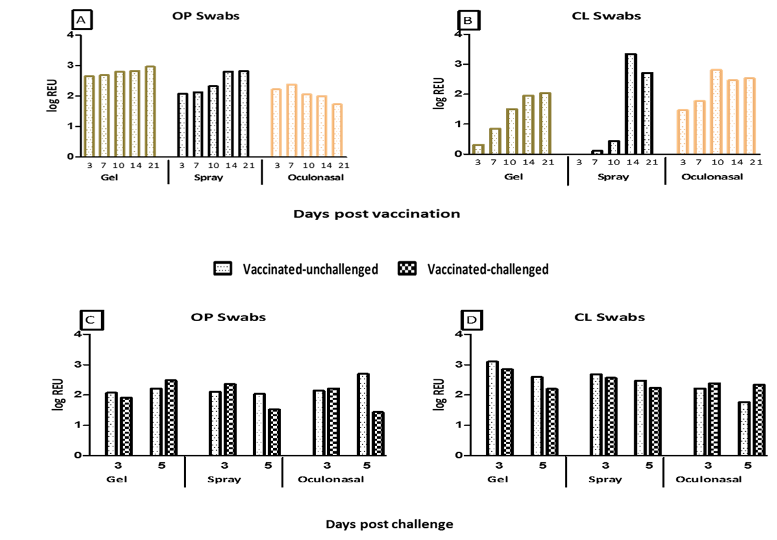

Figure 2. Post-vaccinal and Post challenge IBV viral load in swabs
Quantification of viral load expressed as log relative equivalent units (REU). (A and B) IBV loads at 3, 7, 10, 14 and 21 dpv in pooled OP and CL swabs. Chickens (n=10) were vaccinated with combined IBV strains (H120+CR88). (C and D) IBV loads at 3 and 5 dpc in the pooled OP and CL swabs respectively. Vaccinated birds were challenged with IBV M41 at a dose of 10^{5.75} CD₅₀/bird.
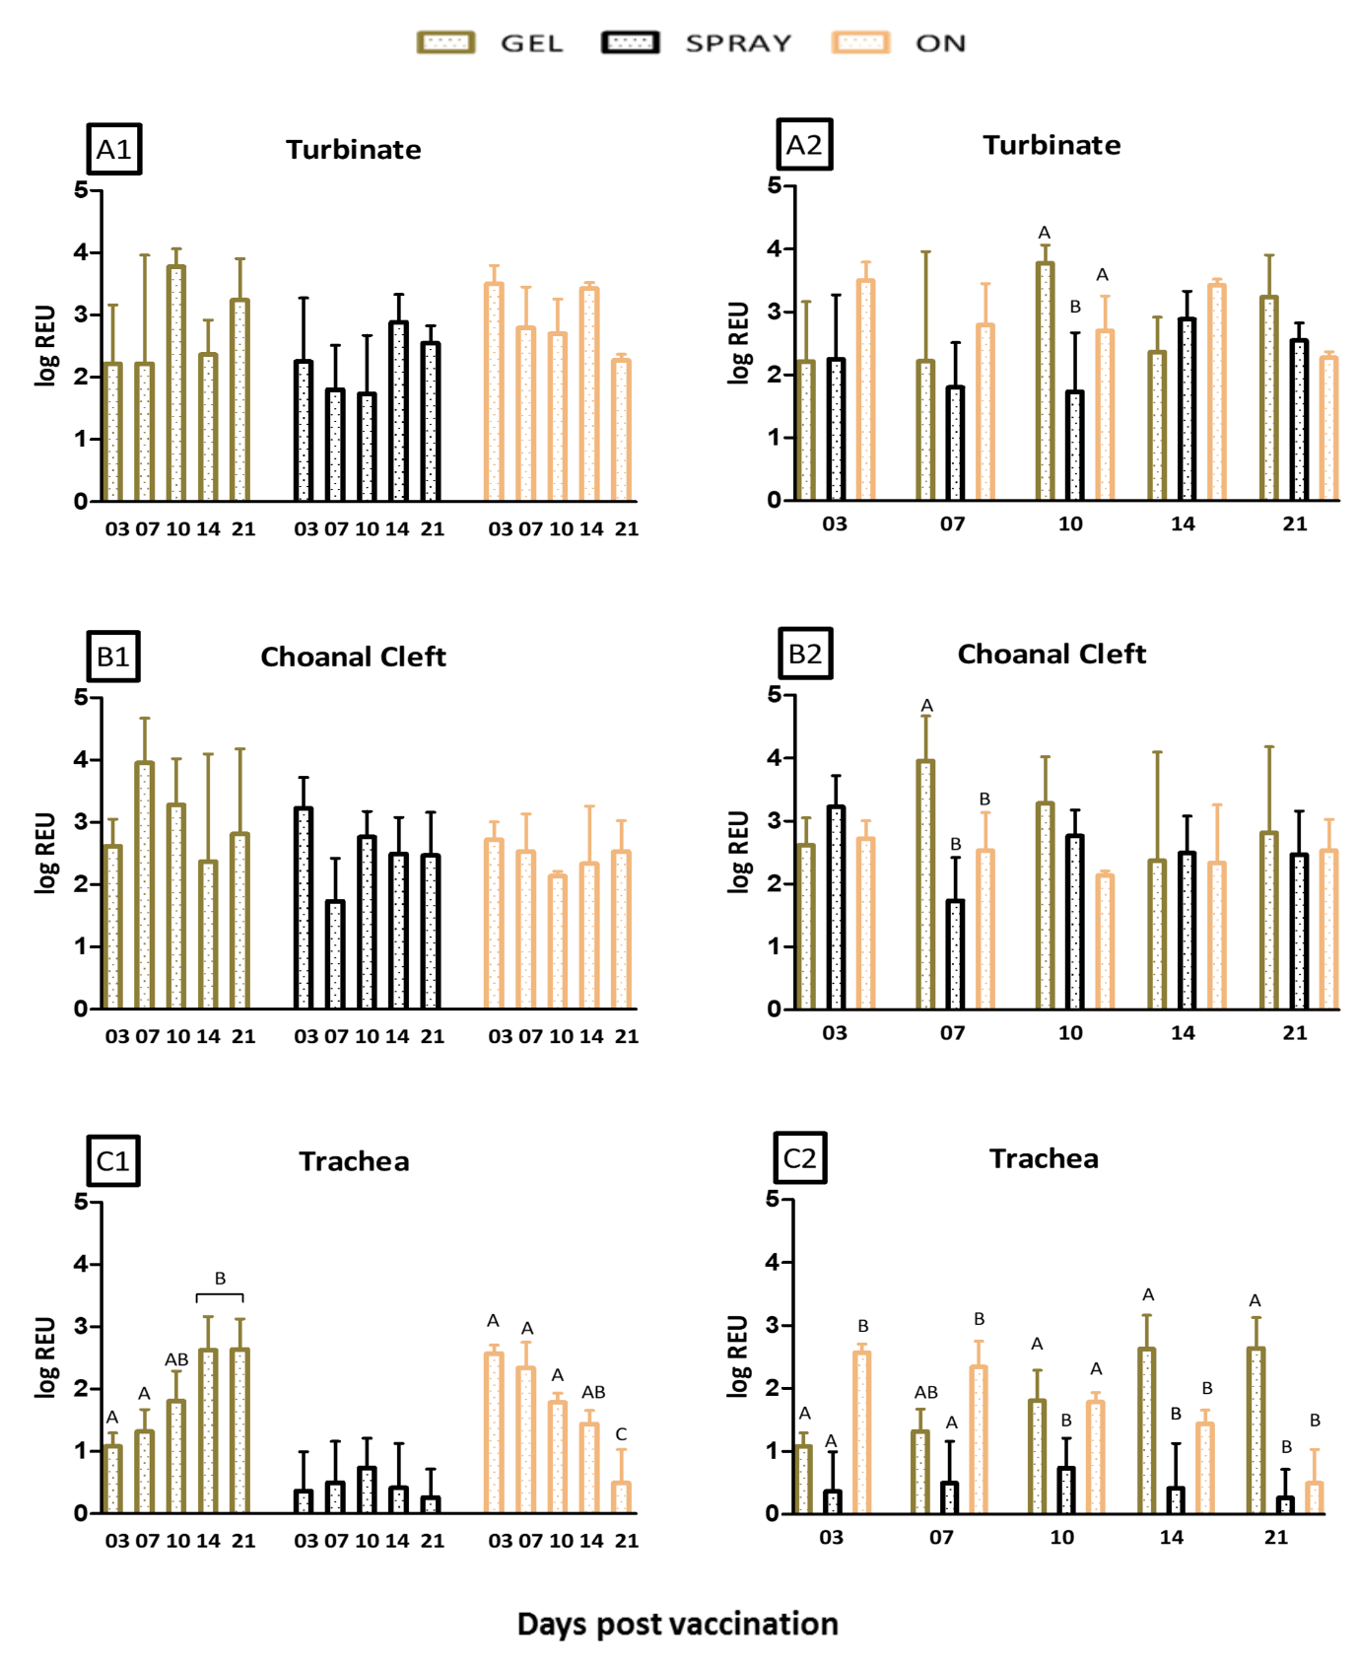
Figure 3. Post-vaccinal IBV viral load in tissues
Quantification of viral load expressed as log relative equivalent units (REU) in the (A1) turbinate, (B1) choanal cleft and (C1) trachea samples of chicken at 3, 7, 10, 14 and 21 dpv. (A2-C2) Comparison between the different routes on the same tissue and day. Chickens were vaccinated with combined IBV strains (H120+CR88). Significant differences were determined using one-way ANOVA. The significant differences between the groups (n=3) are indicated with different letters, and the non-significant differences are not alphabetically sorted.

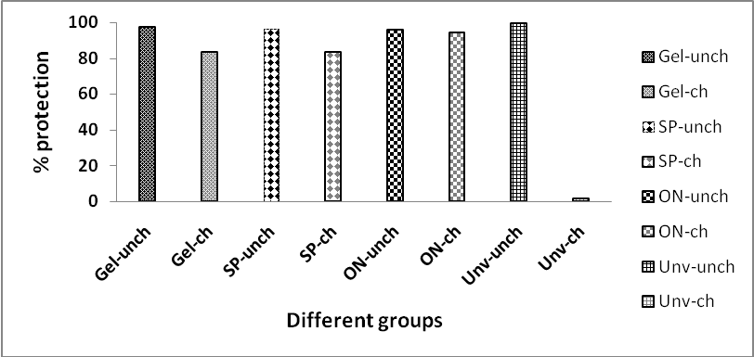
Figure 4. Post-challenge IBV ciliary protection
Ciliary protection against the IBV M41 challenge virus at 5 dpc according to the European Pharmacopoeia’s reference standards, individual birds yielding 50% or more tracheal explants with ciliary activity were considered to have been protected by the vaccine.

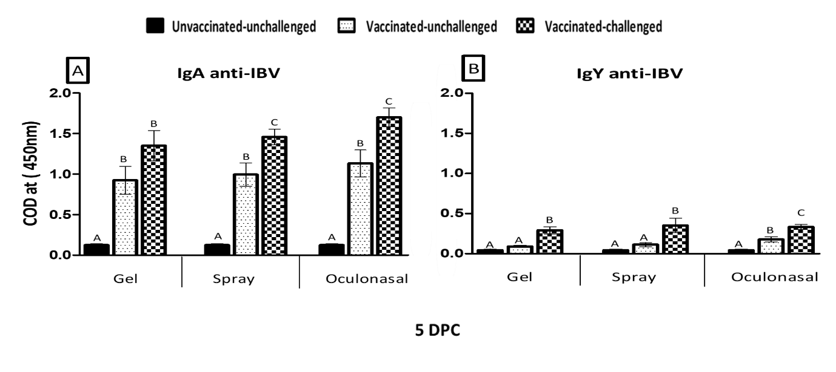
Figure 5.Post- challenge IBV specific mucosal antibody responses
Measurement of IBV-specific IgA and IgY titre using indirect ELISA from the lachrymal fluid. Mean IgA and IgY from lachrymal fluids collected at 5 dpc (n=5), data expressed as mean of corrected optical density (COD). The significant differences between the groups are indicated with different letters, and the non-significant differences are not alphabetically sorted.

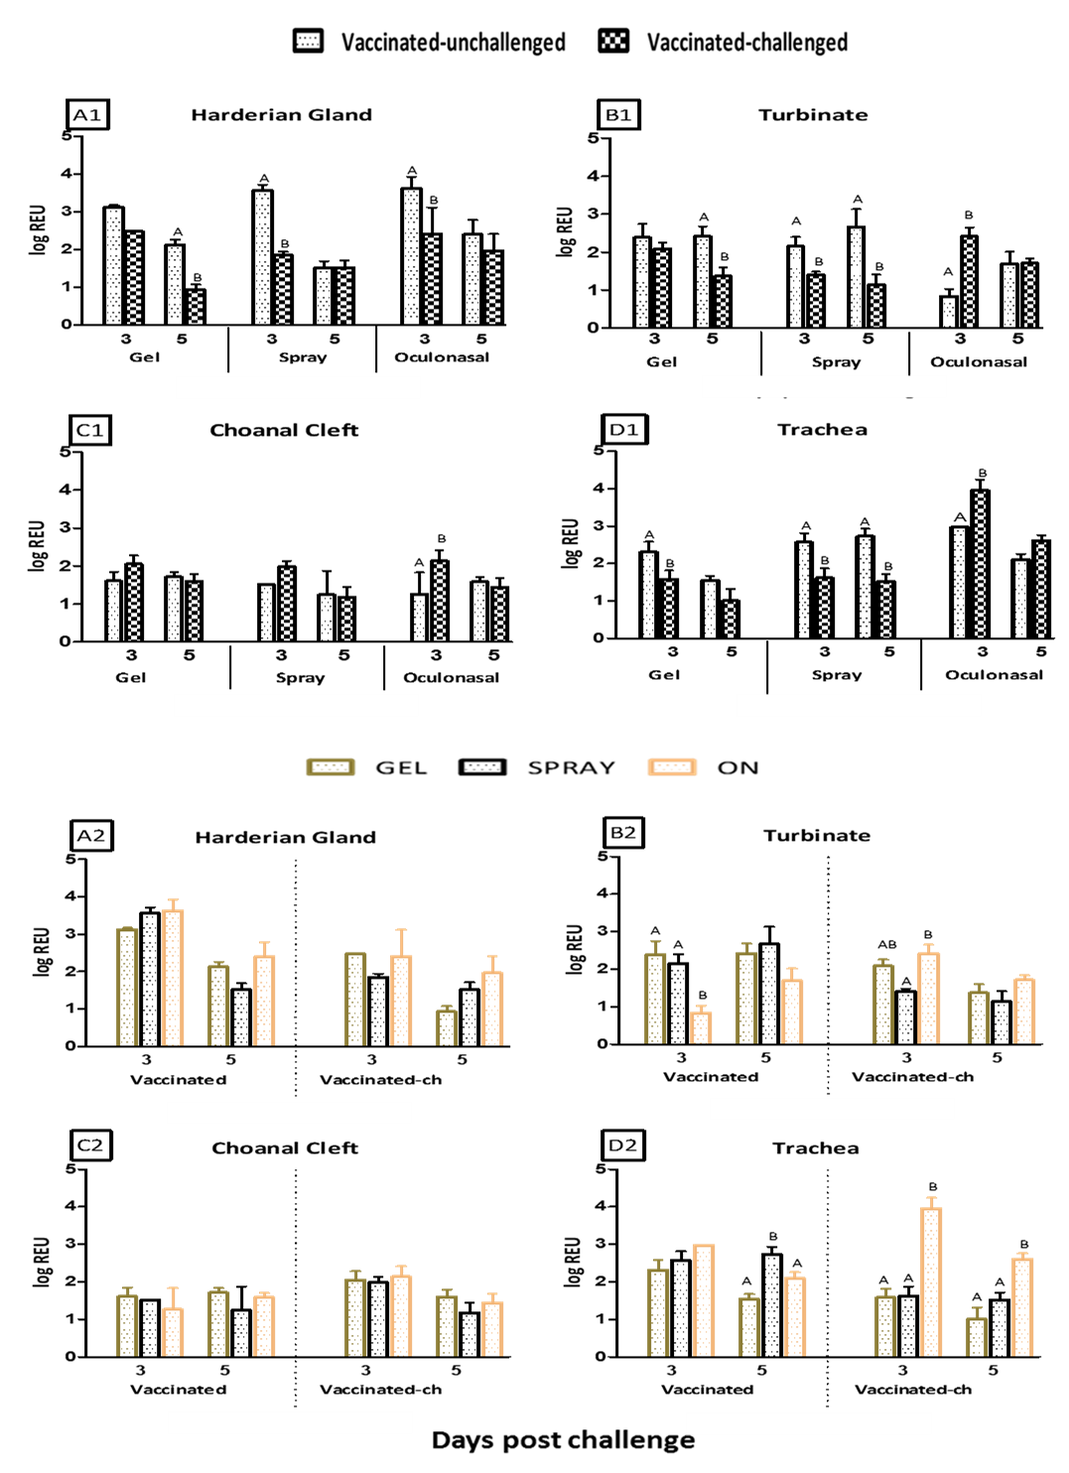
Figure 6. Post- challenge IBV viral load dynamics in tissues
Quantification of viral load expressed as log relative equivalent units (REU) in (A1) Harderian gland, (B1) turbinate, (C1) choanal cleft and (D1) trachea (dpc). (A2-D2) Comparison between the different routes on the same tissue and day. Vaccinated birds were challenged with IBV M41 at a dose of 10^{5.75} CD₅₀/bird. Significant differences were determined using one-way ANOVA. The significant differences between the groups (n=3) are indicated with different letters, and the non-significant differences are not alphabetically sorted.
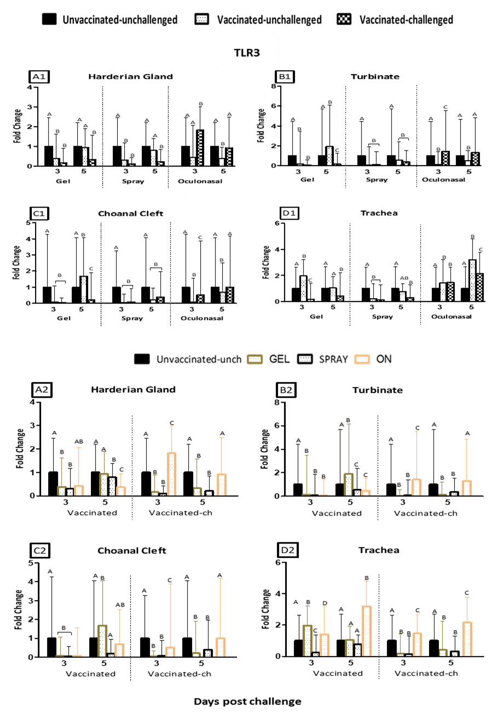
Figure 7. Post- challenge mRNA transcription profile of TLR3 in tissues
Relative mRNA transcription of TLR3; A1 to D1 in the Harderian gland, turbinate, choanal cleft and trachea sample respectively; A2 to D2- TLR3 mRNA transcription comparison between the different routes on the same tissue and day. Data represents the mean with error bars as standard error and are expressed as fold change relative to the unvaccinated-unchallenged control groups (n=3). The significant differences between the groups are indicated with different letters, and the non-significant differences are not alphabetically sorted. 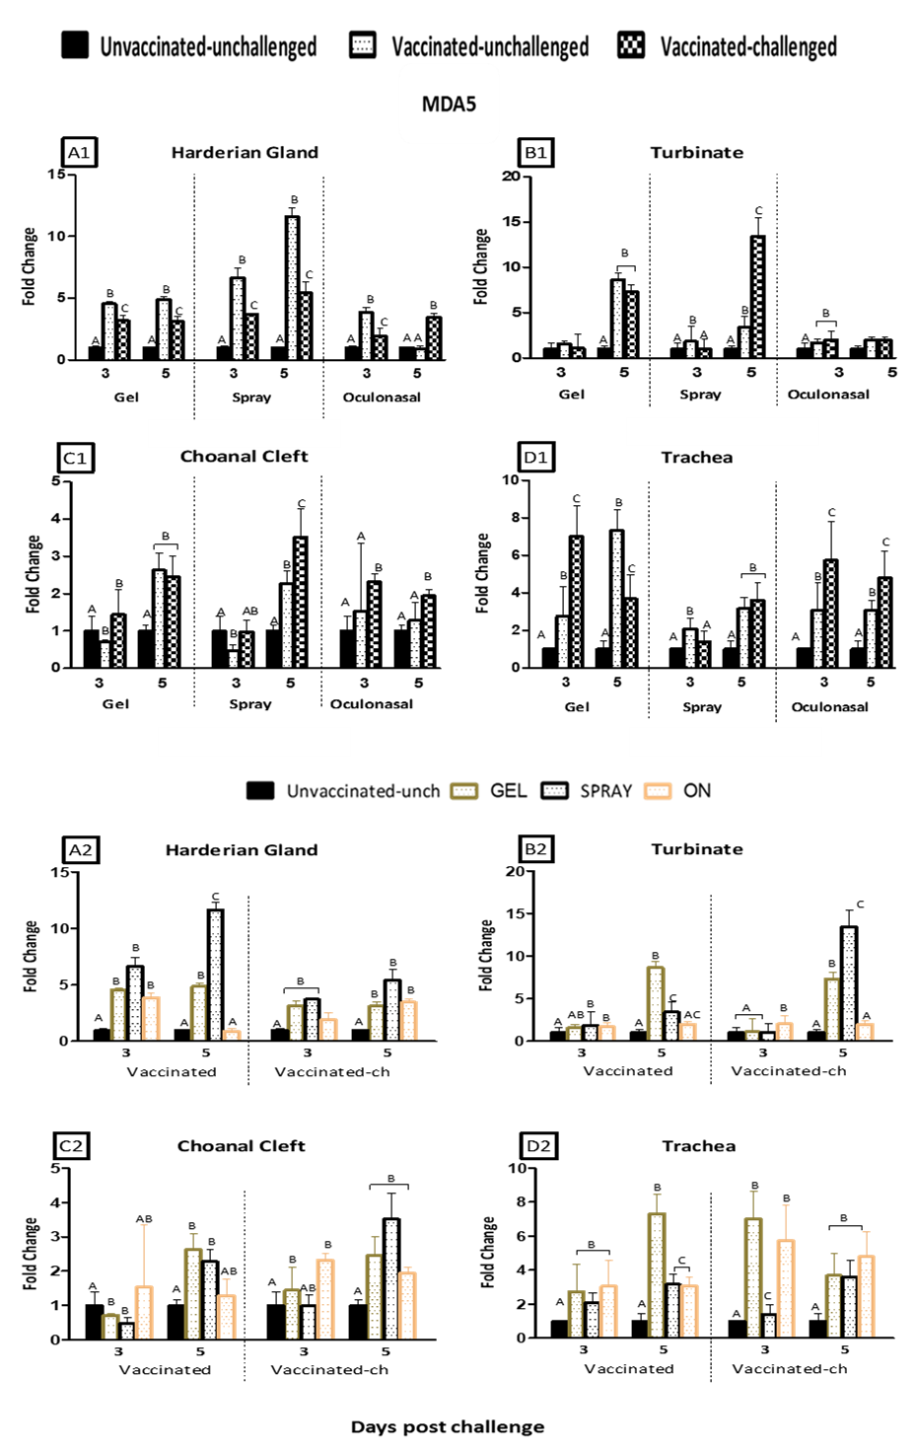
Figure 8. Post- challenge mRNA transcription profile of MDA5 in tissues
Relative mRNA transcription of MDA5; A1 to D1 in the Harderian gland, turbinate, choanal cleft and trachea respectively. A2 to D2- MDA5 mRNA transcription comparison between the different routes on the same tissue and day. Data represents the mean with error bars as standard error and are expressed as fold change relative to the unvaccinated-unchallenged control group (n=3). The significant differences between the groups are indicated with different letters, and the non-significant differences are not alphabetically sorted.
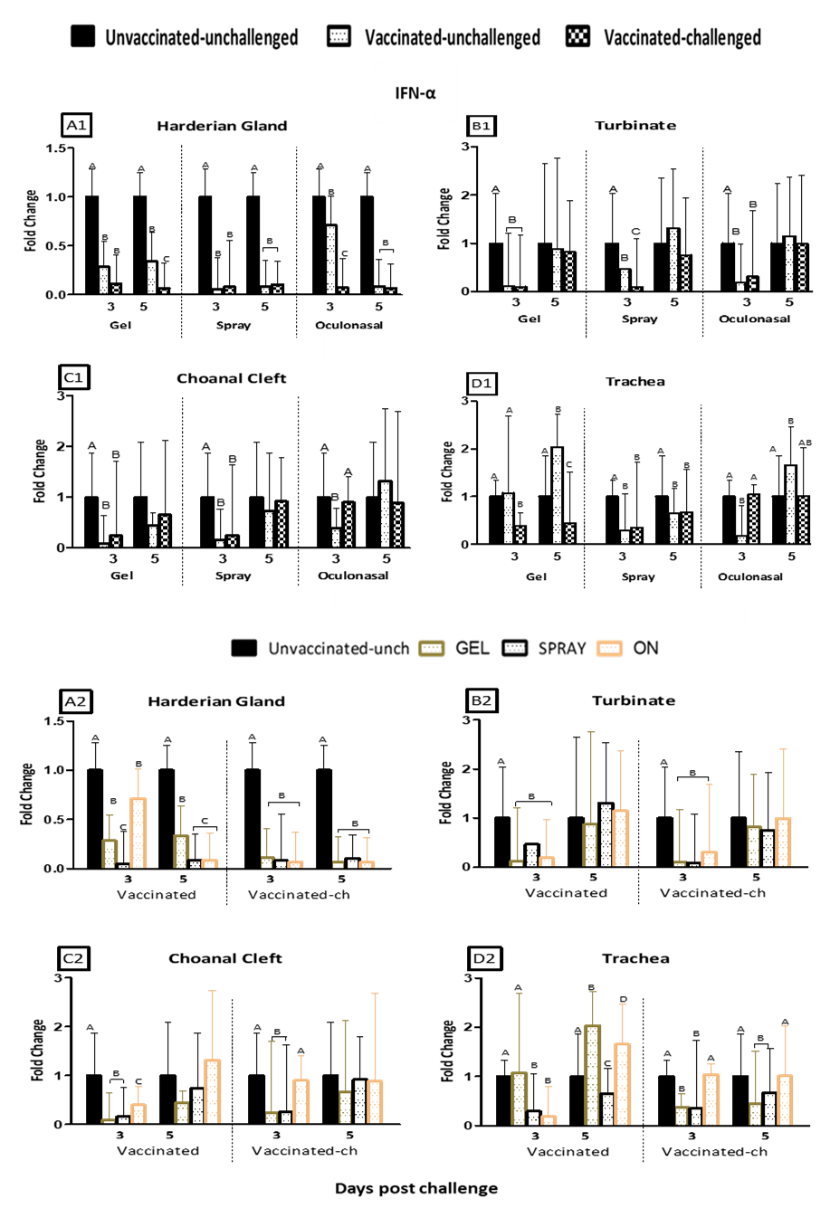
Figure 9. Post- challenge mRNA transcription profile of IFN-α in tissues
Relative mRNA transcription of IFN-α; A1 to D1 in the Harderian gland, turbinate, choanal cleft and trachea respectively. A2 to D2- IFN-α mRNA transcription comparison between the different routes on the same tissue and day. Data represents the mean with error bars as standard error and are expressed as fold change relative to the unvaccinated-unchallenged control group (n=3). The significant differences between the groups are indicated with different letters, and the non-significant differences are not alphabetically sorted.
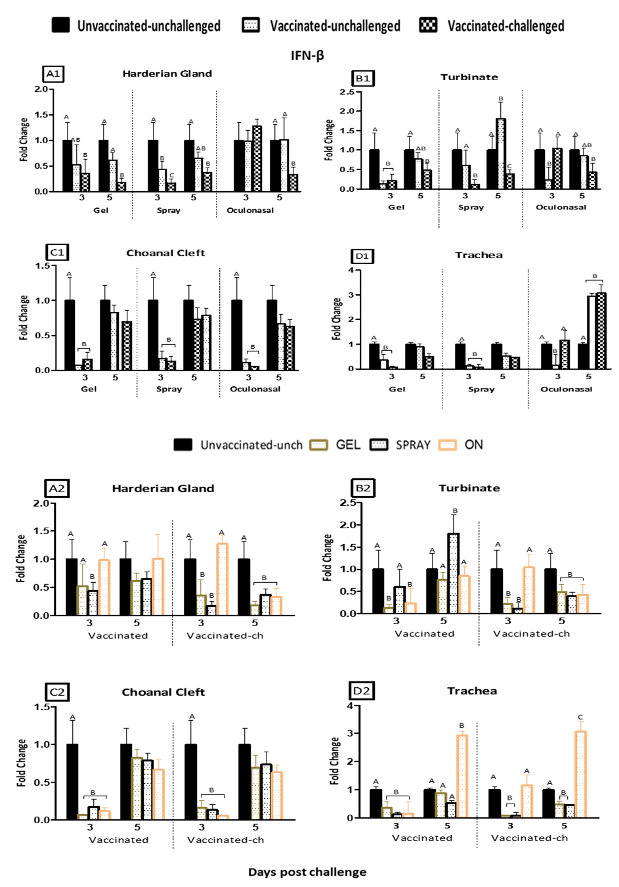
Figure 10. Post- challenge mRNA transcription profile of IFN-β in tissues
Relative mRNA transcription of IFN-β; A1 to D1 in the Harderian gland, turbinate, choanal cleft and trachea respectively. A2 to D2, IFN-β mRNA transcription comparison between the different routes on the same tissue and day. Data represents the mean with error bars as standard error and are expressed as fold change relative to the unvaccinated-unchallenged control group (n=3). The significant differences between the groups are indicated with different letters, and the non-significant differences are not alphabetically sorted.
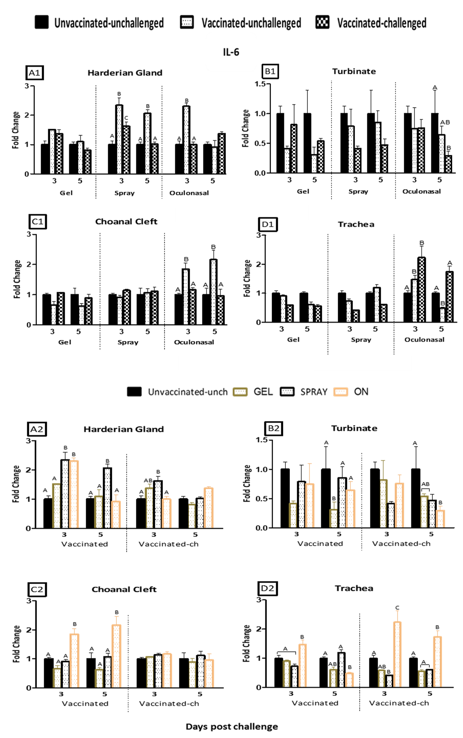
Figure 11. Post- challenge mRNA transcription profile of IL-6 in tissues
Relative mRNA transcription of IL-6; A1 to D1 in the Harderian gland, turbinate, choanal cleft and trachea respectively. A2 to D2-IL-6 mRNA transcription comparison between the different routes on the same tissue and day. Data represents the mean with error bars as standard error and are expressed as fold change relative to the unvaccinated-unchallenged control group (n=3). The significant differences between the groups are indicated with different letters, and the non-significant differences are not alphabetically sorted.

