A Material Recycling Unit for Fused Deposition Modelling Three-Dimensional Printing Systems
Mohammed Nuwaid Nattukallingal¹, Ziying Ran¹ and Ahmed Abass^{1*}

¹Department of Mechanical, Materials and Aerospace Engineering, School of Engineering, University of Liverpool, Liverpool L69 3GH, U.K.

*Correspondence: Dr Ahmed Abass, School of Engineering, University of Liverpool, Liverpool L69 3GH, U.K., Email: a.abass@liverpool.ac.uk, ORCID: 0000-0002-8622-4632

Author Contributions: MNA: Data curation, Writing the initial draft, Writing review & editing, Visualisation, Conceptualisation, Formal analysis, Software, Z.R.: Writing the initial draft, Writing review & editing, Visualisation, A.A.: Writing the initial draft, Writing review & editing, Conceptualisation, Project administration, Resources, Supervision, Validation.

Number of words: 5246

Keywords: Recycling; Fused Deposition Modelling; 3D Printing; Additive Manufacturing.

Abstract
The Fused Deposition Modelling (FDM) three-dimensional (3D) printing technology is one of the most common Additive Manufacturing (AM) technologies due to the relatively low cost of the printing units and materials. Although cost-effective, this technology is not conceived to convert 100% of the raw material into a complete product, creating a potential plastic waste problem. To recycle the plastic waste from the FDM machine into reusable filaments, the concept of a 3D printer material recycling machine (3DP-MRM) was developed on CREO Parametric software. A prototype with four systems: spooler system, extruder system, display system, and filament positioning system, was manufactured in-house with complete run experiments. The tests of the 3DP-MRM were applied, and the machine worked successfully among all the designed functions with minor issues.

Keywords: FDM; 3D printing; filament extruder; plastic wastage; recycling

- Introduction

Fused Deposition Modelling (FDM) is a melt extrusion process that exhibits the ability to fabricate intricate geometries through the deposition of molten materials in the form of a filament [1, 2]. It has gained substantial recognition as the preeminent commercially viable technique for three-dimensional (3D) printing [1, 3]. The 3D printed structure is created in a layer-by-layer approach, where the print head assembly is moved over a platform to extrude the molten filament tip in precalculated positions [3]. Materials such as Acrylonitrile Butadiene Styrene (ABS), Polylactide (PLA), Thermoplastic Polyurethane (TPU), etc., are commonly used in FDM manufacturing [1, 4].

Products of FDM are increasingly present in many biomedical [5-9], tooling [10-13], electronic [14], automobile and aerospace applications [15-17], etc., serving a rising role in the industry [14]. However, at the same time, the continued build-up of plastic waste in landfills has become a significant concern for environmental sustainability [18]. Ideally, FDM technology should exclusively employ materials that are essential for the final product. However, this is not feasible due to the requirement for support structures in various geometries and the frequent need to reprint defective objects, especially during prototyping [16]. To tackle the issue of plastic waste in FDM; several studies have explored support material generations, which focus on modifying the material behaviour or optimising the support structure without recycling [19-21]. Still, this option is highly restricted by the geometry of the 3D-printed object. Recycling plastic waste, especially post-consumer, is a different method [22]. On a global scale, plastic recovery and recycling rates tend to be lower compared to other commonly utilised materials such as paper, glass and metals, even in countries with advanced waste management systems and extensive recycling expertise [23-25]. This relatively low recycling rate can be attributed, in part, to the diverse range of plastics, additives and composites used in various applications [23]. In the realm of plastic recycling methods, while there have been advancements in chemical recycling, mechanical recycling remains the predominant technology used for recovering plastics waste, which involves employing mechanical processes to transform the plastic waste into new plastic products [26-29], which is a very effective method of plastic recycle based on time, economic cost and environmental impact [30]. Typically, recycling plastic mechanically involves melt blending, sorting, shredding, and reprocessing [23, 30].

The existing plastic recycling machines are expensive and occupy ample space. Their design target is to recycle wide-ranging plastic waste, not particularly FDM waste, into 3D printer filament or make filament [31, 32]. A comprehensive machine or machine attachment unit explicitly designed for recycling waste from 3D printers is not widely available on the market and is typically associated with high costs. The Filabot company (Vermont, U.S.) offers an all-in-one configuration for 3D recycling setups, which includes a reclaimer, extruder, airpath, spooler and pelletiser. This setup is available at a price of approximately 1,500 ponds and requires a large setup volume [33]. The ProtoCycler+ Filament Maker and Recycler introduced by ReDecTec (Toronto, Canada) is an all-in-one extruder machine with a built-in manual material shredder, mainly focusing on research purposes and is estimated to be an expensive unit [34]. Similar products were commercialised by Precious Plastic but require a large amount of setup space and are more suitable for the manufacturing end of recycling process [35]. In short, the commercially available FDM waste recycling machines are generally either expensive or not all-in-one in the configuration.

The current prototype creation study aims to design, manufacture, and test a prototype of a desktop-sized material recycling unit for FDM 3D printing systems at low cost. The 3D printer material recycling machine developed in this study will be referred to as (3DP-MRM) for the rest of this manuscript. The 3DP-MRM reuses the thermoplastic materials used in the FDM additive manufacturing process and allows recycling them into ready-for-use filaments.

- Materials and Methods
The design process of the 3DP-MRM is based on the Product Design Specification (PDS) method [36], which includes the full details of the design requirement. The process was started with parameterised goal settings by creating PDS and lateral monitoring progress under each goal, shown in Table 1.

Table 1 PDS table of the filament recycling machine designed and developed
Category | Details | Design intention
Performance | Material available | PLA and ABS.
 | Input material type | Plastic waste and industrial pellets.
 | Heating time (to 200°C) | Under 10 minutes.
 | Included options | Extruder, mixer, automatic spooler, and filament positioner to avoid tangled filament spool.
 | Heating element | Heating band.
 | Temperature | The maximum nozzle temperature is 300 °C
 | Filament thickness | 1.75mm
 | Tolerance | ± 0.06mm
 | Cooling system | Forced fan cooling
 | Extruder | Forced extrusion using compression screw
 | Sensors | Filament thickness, nozzle temperature, filament continuity sensor, motor speed controller.
 | Extrusion speed | 300 g/hr
 | Continuous operation | 4 Hours. Maximum production of 1200g of filament.
 | Supply voltage | Internal Power supply with electrical fuses built-in. 220V A.C.
 | Noise and vibration | Must be able to operate in an office or lab environment with minimum noise and vibration.
Size and weight | Weight | Under 8 kg
 | Dimensions | Maximum of 420mm × 370 mm × 240 mm To be usable in the desktop environment
Cost | Product cost | £250
Aesthetics | Chassis | Separate high-strength chassis to support all the major components.
 | Body | Semi-boxy design with all major components designed to be inside the cover panels. Aesthetically pleasing, to be used in a desktop or lab environment.
Manufacturing | Material | ABS, Aluminium, and Steel.
 | Method | FDM printing, Laser cutting, lathe turning.
Ergonomics | User interface | Easy to operate without complicated settings to choose from.
 | User training | No user training is required to operate the machine.
Safety | Safety guards | All the sharp moving components, hot surfaces, and high-current wires must be secured and out of reach during regular operation.
 | Heat protection | Heat protection tapes, heat protection guards, overheat shutoff, overheat warnings, heat protection padding around hot components, and ceramic separators to protect all components from hot parts.
 | Electrical Fuse | Electrically fused.
Transportation | Shipping | Minimum size and not easy-to-break components to minimise damage during shipping. Must be able to ship on land, air and sea.
 | Packaging | All the components are packaged and secured. The total volume and weight of the packaging must be low to be able to ship internationally using air or sea economically.
Environment | Working condition | To be used in a desktop and small space environment.

The 3DP-MRM has been developed into four major systems based on their function: spooler system, extruder system, display system (control unit), and filament positioning system. All these systems consist of multiple components considered as different sub-assemblies. Before being manufactured and tested, the concept model was designed on CREO parametric software (Parametric Technology Corporation, Boston, Massachusetts, U.S.).

  - Spooler system

The spooler system is the collector of recycled filament, which pulls and rolls the filament onto the replaceable spool. A 12V 30RPM D.C. motor with a gearbox is used to rotate the replaceable spool depending on the rate of material extrusion from the extruder system. A motor controller controls the speed of the motor. Figure 1 shows the fully assembled spooler system with all the components. Two different locking mechanisms are used to secure the replaceable spool to the spooler shaft, of which one mechanism locks the shaft in place but allows free rotation in the shaft axis. The spool can be removed from the shaft and replaced with a new one when required. The motor and the shaft can be twisted around the motor’s vertical axis in a predetermined path, as seen in Figure 1B, where the blue circle indicates the spool’s location and its movement path when it rotates. Most of the components were 3D printed with ABS material, and the other components of the spooler system were made from stainless steel and aluminium.
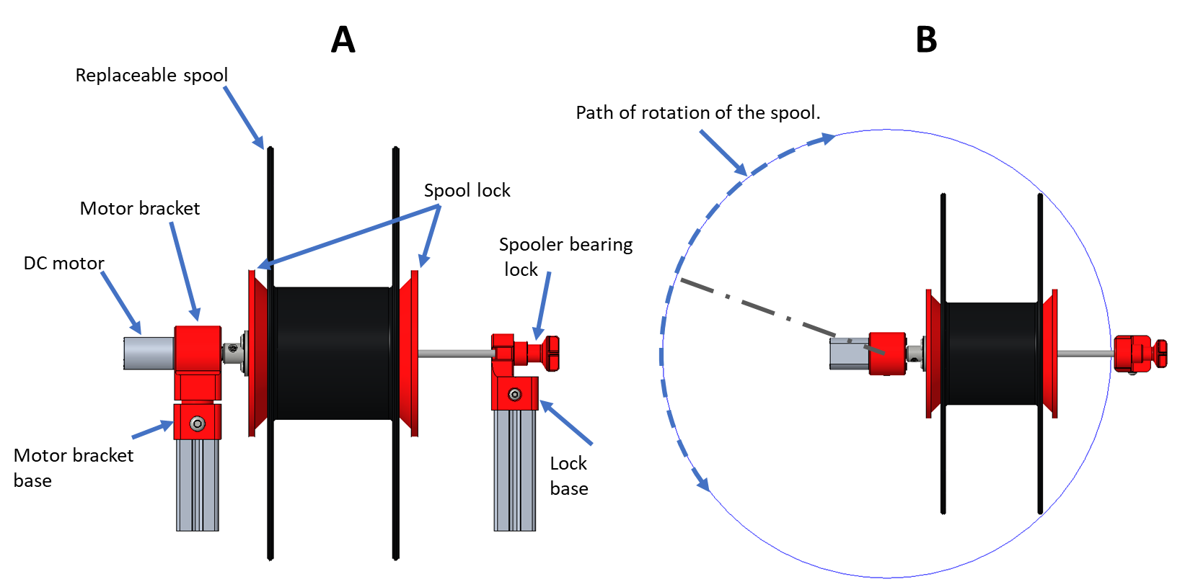
Figure 1: A) Sub-assembly of spooler system (front view), B) top view with a blue circle showing the clearance for the spool when turning around the motor axis.

A spooler bearing lock in this system was designed to avoid using the supports where overhangs are present, as shown in Figure 2. All 90° overhangs were avoided in the design, and 30° to 50° overhangs were used to enable 3D printing without supports (see Figure 2B). The cross-section view of the fully assembled part is shown in Figure 2C, where the second piece has been moved up to make space for the ball bearing. The ball bearing reduces the friction created by the rotating spooler shaft on the spooler bearing lock. Although the design of the spooler bearing lock has two individual plastic parts, it was designed to print as a single part by creating a 0.5mm gap between the walls to allow movement.
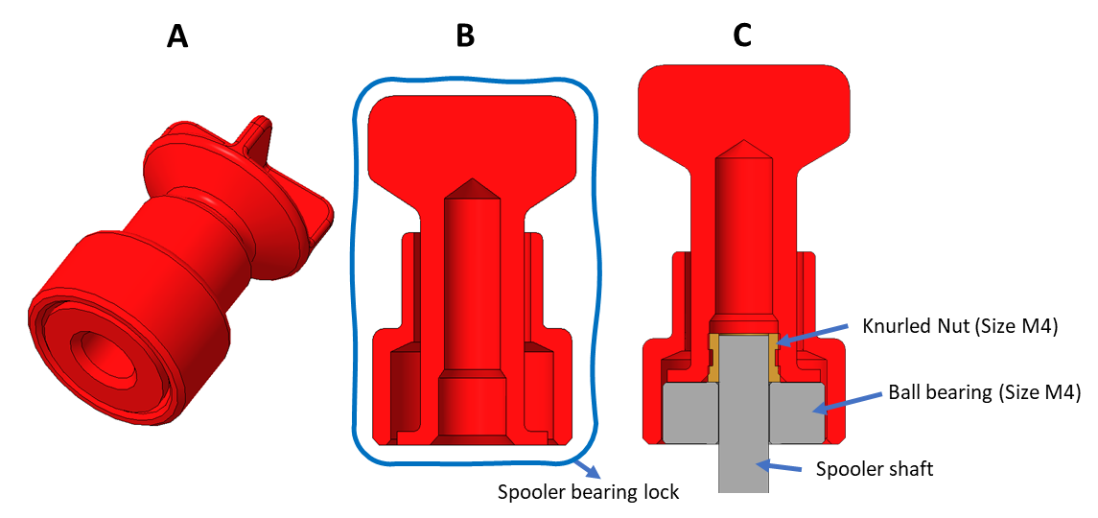
Figure 2: Single-piece design created for 3D printing: A) Model ready for 3D printing, B) Cross-sectional view of the model with no 90° roofs/overhangs, C) fully assembled model.

  - Extruder system

The machine’s most important part is the extruder system, which extrudes plastic chips into thin filaments for 3D printing. As seen in Figure 3, the extruder system consists of an extruder motor, chip collector, heating band, and auger bit inside the barrel. The auger bit acts as the compression screw, pushing and mixing the molten plastic through the barrel. The extruder motor is a high torque 12 V 20 RPM DC motor with a gearbox built into it. A temperature sensor is placed on top of the barrel of the extruder to avoid safety issues from the extruder temperature and the extruder overheating. A Teflon spacer is added between the hot barrel and extruder support brackets to create space isolating the heat. The 3D printing method with ABS material was applied to the parts, the Teflon spacer was made from a 1mm Polytetrafluoroethylene (PTFE) sheet, and the rest were mainly made of stainless steel.
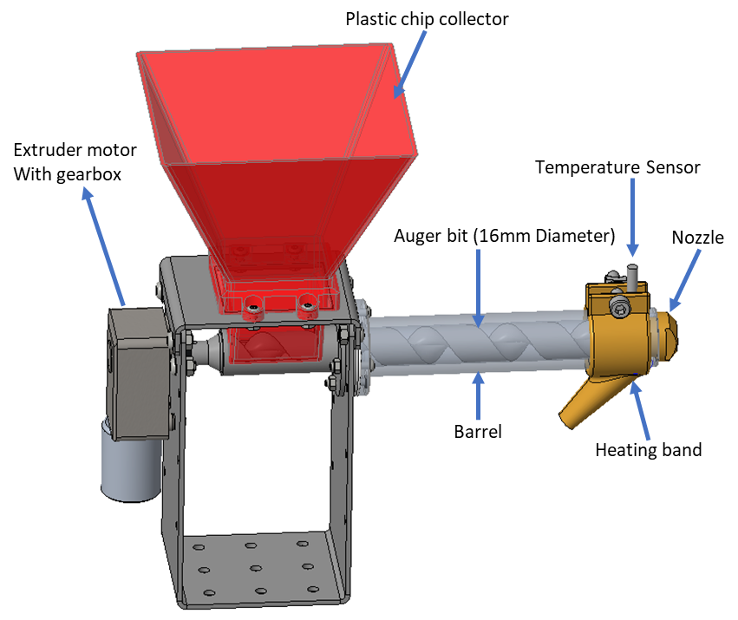
Figure 3: Sub-assembly of extruder system with transparency mode turned on for barrel to see the auger bit.

The chip collector in the system was designed to print without support material. Another part utilises an angled roof design to avoid using support structures, as shown in Figure 4. This model has a support structure inside the rectangular hole increases the possibility of the support structure fusing into the walls.
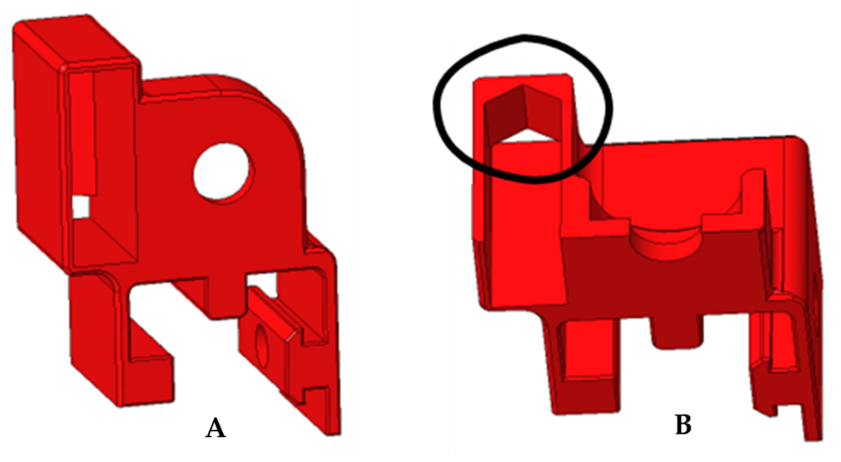
Figure 4: A) part front, which will be placed on the build plate, B) chamfered overhang/roof (circled) to be able to print without supports in tight spaces.

  - Display and control system

The display and control system worked as the brain of the machine. Figure 5B shows the components packed inside the case, including Arduino Mega open-source electronic board, display, two motor controls, main power switch, fuse holder and heating band solid state relay. Components are closely packed to allow air to flow through the interior. The outer display case was designed to eliminate the supporting materials’ use using round corners instead of sharp corners, as shown in Figure 6. The structure and support of this system are mainly ABS from 3D printing.
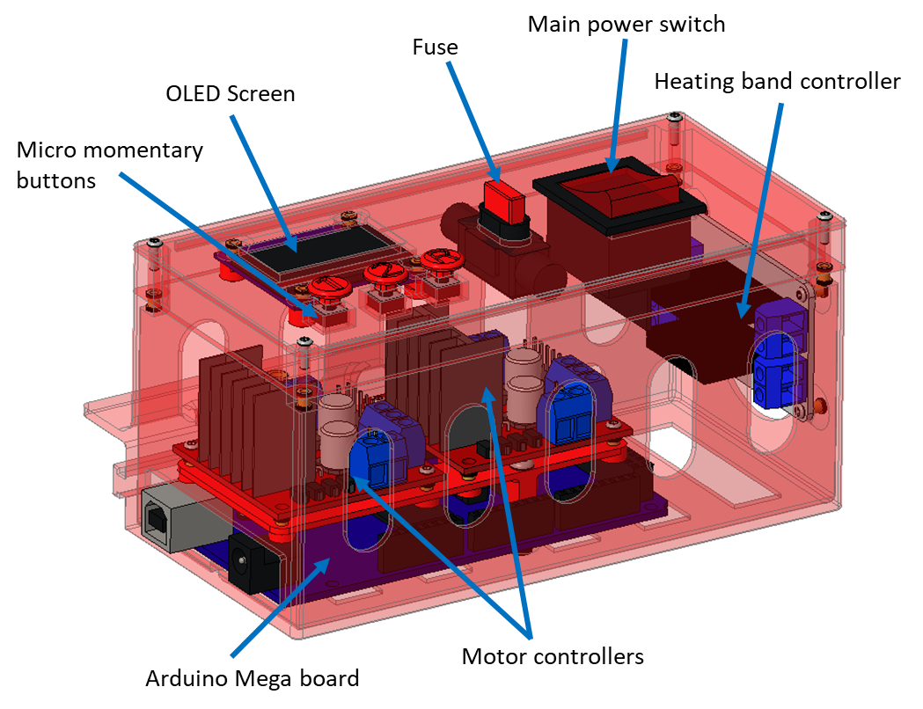
Figure 5: Sub-assembly of control and display system.

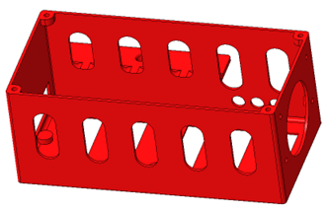
Figure 6: Outer displayed case with circular cut-outs.

  - Filament positioning system

The filament positioning system correctly positions the newly made filament by moving the filament break detector in the middle, as seen in Figure 7. The filament is inserted through the white PTFE tube and connected to the spool of the spooler system. A 12V D.C. motor through a gearbox drives the M4 threaded shaft connected filament break detector. Besides the PTFE tube, the filament position system was mainly ABS by 3D printing.
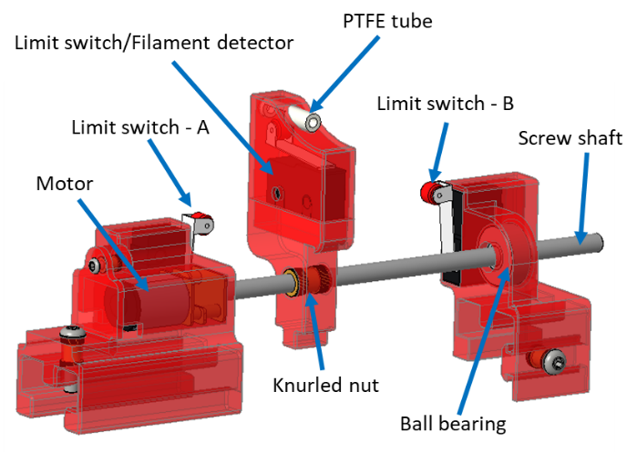
Figure 7: Sub-assembly of the filament positioning system with transparency mode turned on for outer casing to see the internal components.

Prototype and validation experiment

As individual system development finished, the four sub-assemblies formed the final concept assembly with the cooling fan, power supply, bare chassis etc. From the final concept in Figure 8A, the parts were either 3D printed or made in-house; all others were combined to assemble the final prototype, as shown in Figure 9.

The validation experiment used around 0.5 kg of FDM PLA wasted material that is crashed to a size that can be fed to the hopper. The machine was switched on in a well-ventilated room equipped with a smoke fire alarm and kept working for 30 min, during which it produced a limited-size filament for testing. At the same time, the operator fed the crashed FDM waste manually. While a small amount of smoke was visually noticed during the experiment, the room fire alarm was not triggered. Machine components were inspected before and after the experiment, and no damage was reported.

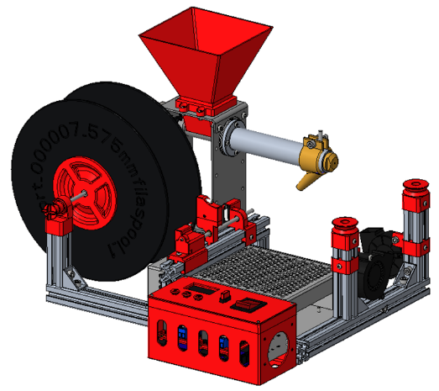 | 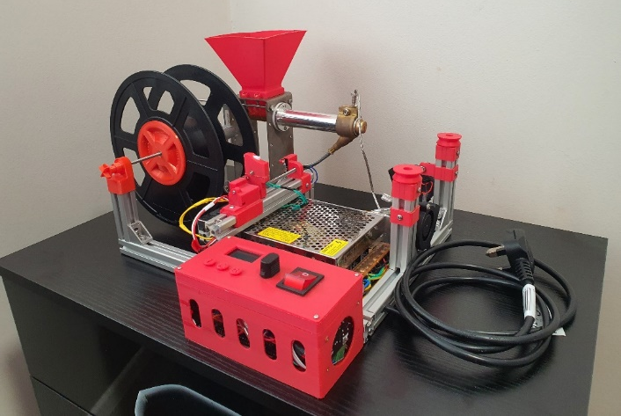
A | B

Figure 8: A) Final concept assembly and B) The prototype of the 3D printer filament recycling machine.

3 Results

The machine testing phase was instituted after completing the prototype assembly. The entire working procedure with each system of the machines was tested to ensure performance and safety.

3.1 Power supply and wiring

The machine motor requires 12 V 6 A to work appropriately and 240 V A.C. for the heating bands provided by the power supply unit, as shown in Figure 9. The wires were run through grooves of the aluminium extrusions to protect them and ensure safe aesthetics. The power supply produced 12.6 V D.C. constant output to support motors with 12 V after a 0.6 V drop in motor controllers. The main power switch installed on the display and control unit manages the power supply and the A.C. circuit.
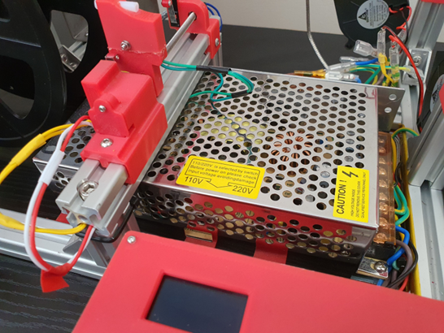
Figure 9: 12V 20A power supply used for the machine.

3.2 Display and control system

The fully assembled unit and the menu display are shown in Figure 10. The main menu has three options. Option “1” stands for extruding ABS, “2” for PLA and “3” or “R” for cleaning cycling. The main difference between all three options is the pre-set temperature. The PLA setting has the maximum extruder temperature of 180°C, ABS is set to 200°C, and the cleaning cycle added to eject any previous material in the barrel is set at 240°C.

 | 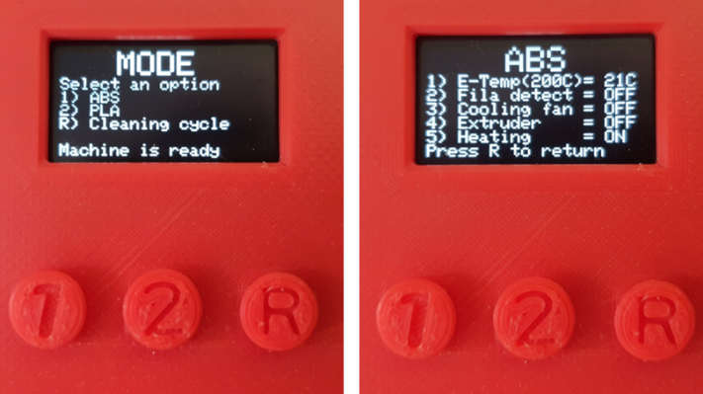
A | B
Figure 10: A) Display and control system, B) The main menu and extruding ABS menu.

The machine status on the bottom of the screen was changed from “Machine is not ready” to “Machine is ready” after the filament positioning system auto-home was completed. Only on this condition, the machine would take any input from the user. Then the machine turned on the heating band to increase the extruder temperature to the pre-set range. Once the temperature was reached, the extruder motor and cooling fan were automatically turned on. The system status is displayed on the screen and tested well.

3.3 Spooler system

Spooler system testing with the two stages of the spool change can be seen in Figure 11. Stage one: An empty spool is connected to the spooler shaft and secured using tightening the spool locking mechanism. This can be done by turning the outer spooler lock disc clockwise. Once the spool is locked, it will rotate with the spooler shaft as the motor operates.
Stage two: In order to replace the spool, firstly, the spooler bearing lock is removed from the shaft and the bracket to release the shaft. Then the shaft should be rotated while being pulled away from the machine. The outer spooler lock disc is rotated anti-clockwise to loosen the spool. The disc is completely removed from the shaft to replace the spool. With the design of the spooler system, various spools can be used with the machine despite the difference in internal diameter. The spool’s maximum inner diameter is 72mm, and the minimum is 57.5mm.
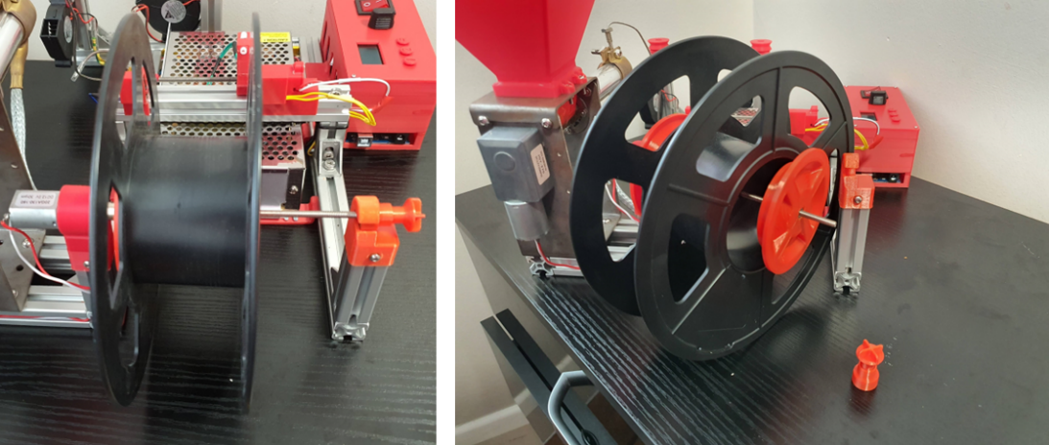
Figure 11: Left: spooler system when in operation. Right: spool is removed from the motor shaft.

3.4 Filament positioning system

Once the machine starts producing filament, the user must manually take the filament and run it around both V-groove pullies. The filament is later inserted through the filament break detection switch of the filament positioner and then connected to the spool. Then option “1” has to be pressed to turn on the filament detection option with the filament positioning system and spooler system. If the system detects a broken filament, the filament positioning system and spooler system are automatically turned off. A buzzer will start to beep intermittently to notify the user. After pressing button “2” to reset the break detection switch, the initial filament running procedure has to be followed. Once the rerun procedure is completed pressing “1” will restart the systems. Pressing “R” will reset the machine and return it to the main menu.
As seen in Figure 12, the M4 threaded shaft filament break detector is driven by a 12 V gearbox D.C. motor. This is done by controlling the motor through Arduino’s motor controller board. The motor will only run for half a second and wait 2 seconds before repeating the action.
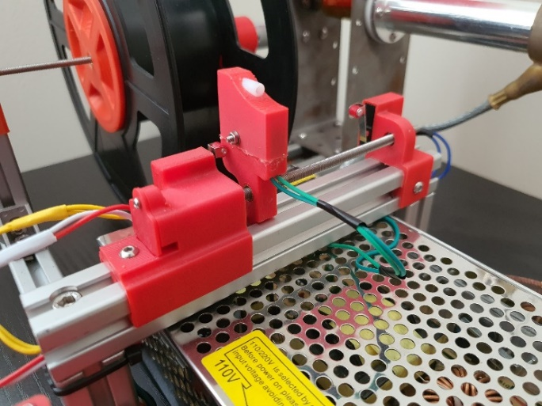
Figure 12: Filament positioning system in home position.

3.5 Extruder system

The extruder was tested using crushed PLA chips. Initially, the temperature for PLA was set at 200°C. The preheating process caused the temperature to peak around 215°C despite the heating bands being turned off. The temperature then drops to 200°C (±10°C) and is maintained. This occurrence caused the extruder to produce smoke due to overheating PLA. The temperature was then set to 180°C, which resolved the problem. Two cooling fans are used to direct cooled air to the filament to solidify molten plastic more quickly. The fans are set to turn on with the extruder when the barrel reaches the set temperature, Figure 13 B.

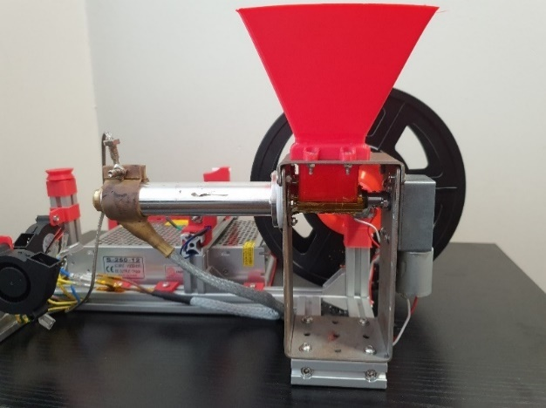 | 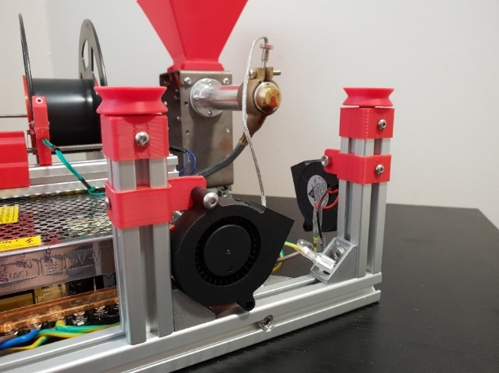
A | B

Figure 13: A) Fully assembled extruder system and B) two cooling fans pointing at the filament path for cooling down newly made filament.

To summary, the machined was tested thoroughly, and the recycled PLA was produced, as shown in Figure 14. The fully assembled machine with a spool has a volume of 414.3 mm × 362.8 mm × 232 mm, ideally suited for a desktop environment. The machine can be shipped disassembled, taking only 30% of the fully assembled volume.
During the validation test, some minor issues occurred: first, the auger bit inside the barrel was not on the axis of the barrel but sitting at an angle, Figure 15. Secondly, varying sizes and shapes of the PLA chips might cause the extruder motor to stall, which leads to a poor final product outcome.
Figure 14: Extruder in operation while extruding PLA for the first time.

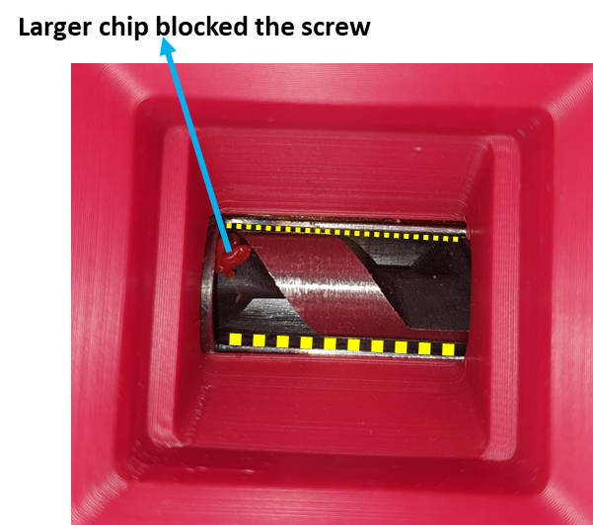
Figure 15: The auger bit position (the thickness of the yellow lines indicating the width of the gap).

4 Discussion

The prototype of the 3DP-MRM has been completed, with all systems working as expected with minor problems. The issue with the varying size of the chips is due to the chips in the barrel collector not having a consistent size that may stick in the gap between the auger bit and the barrel collector tube, causing the extruder motor to stall. As seen in Figure 16, type-A chips are larger than type-B chips, where type-A contains more large and flat chips that have higher probabilities of filling in the gaps between the auger and the chip collector tube that is required to be filtered. Shredding plastic to the required sizes was a challenge which caused a stop in the testing of the extruder system. With properly shredded and filtered plastic, the machine should be able to produce continuous filaments.
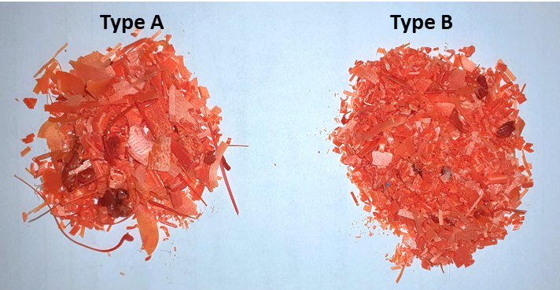
Figure 16: Type (A) Larger PLA chip size, Type (B) Ideal chip size for extruding.

A challenge faced during the machine assembly was that parts were not aligned as they were designed. When it came to the auger bit, it was not sitting on the barrel axis, mainly due to the extruder brackets made from sheet metals having flanges that were not parallel, which resulted from the sheet metal bending process. It caused additional friction between the auger bit and the barrel interior wall. Avoiding this misalignment will improve the auger bit movement and reduce the gap, which will help to push the chips to the nozzle. As seen in Figure 17A, the design was intended for the parts with minimum to no gap for chips to fall. Figure 17B revealed a 3 mm gap when parts were assembled due to the differences in sheet metal folding angle and flatness of the sheet, which can cause the chips to fall. The easiest fix to solve this issue used for this prototype was covering the gap using high-temperature-resistant PTFE tapes. While the current prototype has many synchronised processes, as seen in Figure 18, future design or manufacturing improvements could be applied.

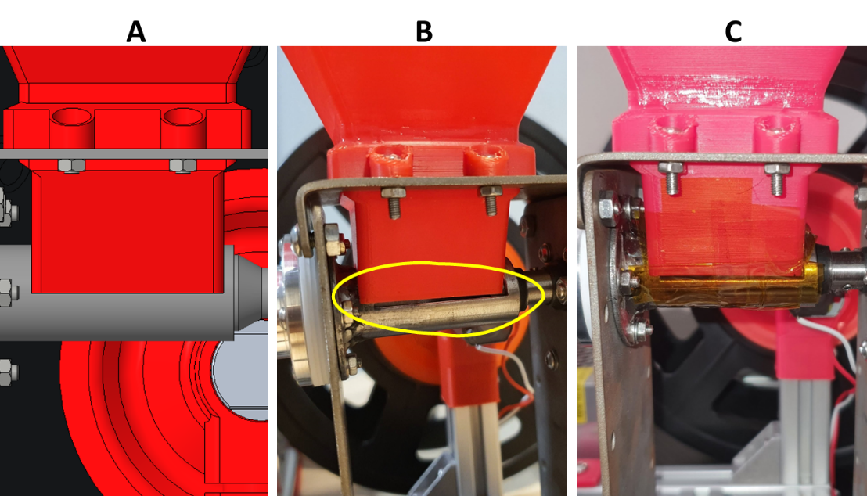
Figure 17: A) CAD model of the chip collector and collector tube, B) gap between the chip collector and tube shown in a yellow circle, C) high-temperature resistant PTFE tape is used to cover the gap.

Aside from the manufacturing issues, the prototype cost is calculated to be £908, which is relatively expensive, including producing and workshop service fee of £590, other parts purchase fee of £268, and miscellaneous fees of nearly £50. However, cost savings still must be considered for the product, even in the testing stage. The largest amount of money spent on this project was in the workshop for manufacturing barrels and other sheet metal parts; such expenses should be decreased in case of mass production. To justify the development of the machine, the cost of the final product has to be explained and understood. When mass production of parts is considered, it should decrease costs. Continuous production can be cheaper than making just 1 part. With this consideration, the cost of the barrel cap can be reduced to £7.36, and the extruder bracket can be decreased to £11.79, which proves the possibility that the machine will be introduced into the market with a lower final cost and price.
Using a lower-powered power supply can reduce the overall cost of the product. The user can replicate all the 3D printed parts of this machine, allowing the manufacturer to reduce the cost by making the STL files of 3D printed parts available to the customer. Customers can print and assemble the components themselves, bringing the price down. Any prints that fail during manufacturing can be recycled on the same machine. Future cost reduction could be considered.

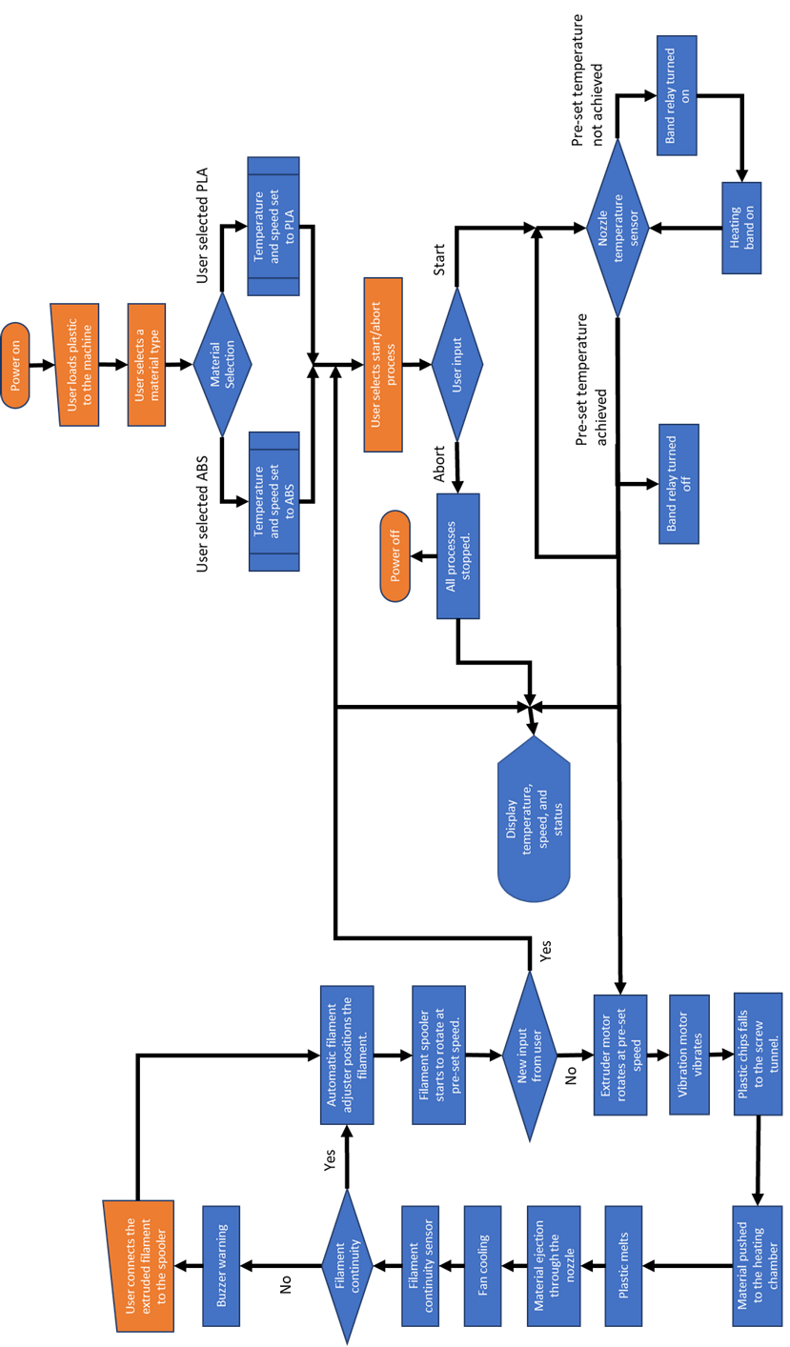
Figure 18: 3DP-MRM workflow chart

Undoubtedly, the consistent difficulty in building 3D facilities for research purposes and the ability to produce these facilities at an economical cost can be cracked by introducing practical cost analysis to research projects. Hence, technology improvement-based projects are being proposed by the University of Liverpool to achieve a net zero carbon by 2025. The current study opens the door to the cost-effective technology of recycling FDM 3D printing waste, which is relatively a lot in research institutions because of the nature of their research-based projects. The study’s results help form the future strategy of Filament Refill schemes, where 3D printing filament manufacturers offer refill procedures where customers can send back empty filament spools for refilling.

It is also important to mention that recycling FDM materials typically involves separating different types of thermoplastics to ensure compatibility during the recycling process. Mixing incompatible materials can result in poor print quality or even damage the 3D printer. Moreover, The quality of recycled filament can vary depending on the effectiveness of the recycling process. Contamination from foreign objects, debris, or incompatible materials can affect the mechanical properties and performance of the recycled filament. To maintain filament quality, it is essential to carefully clean and sort the materials before recycling them.

5 Conclusions

As the study aimed to develop a material recycling machine to reuse the thermoplastic materials used in the FDM Additive Manufacturing process and allow recycling them, the study achieved the aim by completing the following objectives. A plastic recycling machine concept has been developed on CREO Parametric with a simple user interface, and a prototype was manufactured in-house to test the concept. The machine allows the user to recycle the plastic waste from 3D printing and make new filaments. The prototype was completed successfully. The filament recycling machine was tested, and the machine worked successfully among all the designed functions with a few minor issues.

The overall development cost of the machine is calculated to be £908. The cost is relatively high as it is a one-time prototype machine; however, most of the cost was a manufacturing cost that can be reduced by considering mass production. Further development and testing can improve the machine’s capabilities, and mass-producing components could reduce the overall cost.

Lastly, it is worth noting that while recycling FDM materials can help reduce waste and promote sustainability, the process is still evolving, and the quality and reliability of recycled filament may not match that of virgin filament. Therefore, it is essential to consider the specific requirements of 3D printing projects when deciding whether to use recycled materials or opt for new filaments.

7 Reference

1. Vyavahare, S., et al., Fused deposition modelling: a review. Rapid Prototyping Journal, 2020. 26(1): p. 176-201.
2. Sood, A.K., R.K. Ohdar, and S.S. Mahapatra, Parametric appraisal of mechanical property of fused deposition modelling processed parts. Materials & Design, 2010. 31(1): p. 287-295.
3. Turner, B.N., R. Strong, and S.A. Gold, A review of melt extrusion additive manufacturing processes: I. Process design and modeling. Rapid prototyping journal, 2014. 20(3): p. 192-204.
4. Mohan, N., et al., A review on composite materials and process parameters optimisation for the fused deposition modelling process. Virtual and Physical Prototyping, 2017. 12(1): p. 47-59.
5. Pu’ad, N.M., et al., Review on the fabrication of fused deposition modelling (FDM) composite filament for biomedical applications. Materials Today: Proceedings, 2020. 29: p. 228-232.
6. Calì, M., et al., New filaments with natural fillers for FDM 3D printing and their applications in biomedical field. Procedia Manufacturing, 2020. 51: p. 698-703.
7. Kollamaram, G., et al., Low temperature fused deposition modeling (FDM) 3D printing of thermolabile drugs. International journal of pharmaceutics, 2018. 545(1-2): p. 144-152.
8. Rasoulianboroujeni, M., et al., Development of 3D-printed PLGA/TiO2 nanocomposite scaffolds for bone tissue engineering applications. Materials Science and Engineering: C, 2019. 96: p. 105-113.
9. Teixeira, B.N., et al., Evaluation of bone marrow stem cell response to PLA scaffolds manufactured by 3D printing and coated with polydopamine and type I collagen. Journal of Biomedical Materials Research Part B: Applied Biomaterials, 2019. 107(1): p. 37-49.
10. Singh, R. and S. Singh, Development of nylon based FDM filament for rapid tooling application. Journal of The Institution of Engineers (India): Series C, 2014. 95: p. 103-108.
11. Chohan, J.S., R. Singh, and K.S. Boparai, Thermal and surface characterisation of ABS replicas made by FDM for rapid tooling applications. Rapid Prototyping Journal, 2018. 24(1): p. 28-36.
12. Montgomery, R.H., et al., Photolithography-free PDMS stamps for paper microdevice fabrication. Rapid Prototyping Journal, 2018.
13. Danade, U.A., S.D. Londhe, and R.M. Metkar, Machining performance of 3D-printed ABS electrode coated with copper in EDM. Rapid Prototyping Journal, 2019. 25(7): p. 1224-1231.
14. Penumakala, P.K., J. Santo, and A. Thomas, A critical review on the fused deposition modeling of thermoplastic polymer composites. Composites Part B: Engineering, 2020. 201: p. 108336.
15. Bilkar, D., R. Keshavamurthy, and V. Tambrallimath, Influence of carbon nanofiber reinforcement on mechanical properties of polymer composites developed by FDM. Materials Today: Proceedings, 2021. 46: p. 4559-4562.
16. Sathies, T., P. Senthil, and M. Anoop, A review on advancements in applications of fused deposition modelling process. Rapid Prototyping Journal, 2020. 26(4): p. 669-687.
17. Klippstein, H., et al., Fused deposition modeling for unmanned aerial vehicles (UAVs): a review. Advanced Engineering Materials, 2018. 20(2): p. 1700552.
18. Suárez, L. and M. Domínguez, Sustainability and environmental impact of fused deposition modelling (FDM) technologies. The International Journal of Advanced Manufacturing Technology, 2020. 106(3): p. 1267-1279.
19. Gurrala, P.K. and S.P. Regalla. Optimisation of support material and build time in fused deposition modeling (FDM). in Applied Mechanics and Materials. 2012. Trans Tech Publ.
20. Cunico, M.W.M., Study and optimisation of FDM process parameters for support-material-free deposition of filaments and increased layer adherence: this paper investigates control factors and process parameters that allow the fabrication of negative surface features without a support material. Virtual and Physical Prototyping, 2013. 8(2): p. 127-134.
21. Volpato, N., J. Aguiomar Foggiatto, and D. Coradini Schwarz, The influence of support base on FDM accuracy in Z. Rapid prototyping journal, 2014. 20(3): p. 182-191.
22. Ragaert, K., L. Delva, and K. Van Geem, Mechanical and chemical recycling of solid plastic waste. Waste management, 2017. 69: p. 24-58.
23. Shen, L. and E. Worrell, Plastic recycling, in Handbook of recycling. 2014, Elsevier. p. 179-190.
24. Al-Salem, S., P. Lettieri, and J. Baeyens, Recycling and recovery routes of plastic solid waste (PSW): A review. Waste management, 2009. 29(10): p. 2625-2643.
25. Hopewell, J., R. Dvorak, and E. Kosior, Plastics recycling: challenges and opportunities. Philosophical Transactions of the Royal Society B: Biological Sciences, 2009. 364(1526): p. 2115-2126.
26. Shen, L., E. Worrell, and M.K. Patel, Open-loop recycling: A LCA case study of PET bottle-to-fibre recycling. Resources, conservation and recycling, 2010. 55(1): p. 34-52.
27. Gu, F., et al., From waste plastics to industrial raw materials: A life cycle assessment of mechanical plastic recycling practice based on a real-world case study. Science of the total environment, 2017. 601: p. 1192-1207.
28. Sahajwalla, V. and V. Gaikwad, The present and future of e-waste plastics recycling. Current Opinion in Green and Sustainable Chemistry, 2018. 13: p. 102-107.
29. Maris, J., et al., Mechanical recycling: Compatibilisation of mixed thermoplastic wastes. Polymer Degradation and Stability, 2018. 147: p. 245-266.
30. Schyns, Z.O. and M.P. Shaver, Mechanical recycling of packaging plastics: A review. Macromolecular rapid communications, 2021. 42(3): p. 2000415.
31. Oyinlola, M., et al., The potential of converting plastic waste to 3D printed products in Sub-Saharan Africa. Resources, Conservation & Recycling Advances, 2023. 17: p. 200129.
32. Mikula, K., et al., 3D printing filament as a second life of waste plastics—a review. Environmental Science and Pollution Research, 2021. 28(10): p. 12321-12333.
33. Recycling Setup - Filabot Reclaimer and Filabot Pelletizer. Available from: https://www.filabot.com/products/recycling-setup-filabot-reclaimer-and-filabot-pelletizer.
34. ProtoCycler+. Available from: https://redetec.com/.
35. Pro Machines - Precious Plastic. Available from: https://preciousplastic.com/solutions/machines/pro.html.
36. Pugh, S., Total design: integrated methods for successful product engineering. 1991: Addison-Wesley.

