Health effects from domestic use of gaseous and liquid fuels for cooking and heating in high, middle and low-income countries: A systematic review and meta-analysis

Elisa Puzzolo^{1*}, Nigel Fleeman², Federico Lorenzetti¹, Fernando Rubinstein¹, Yaojie Li³, Ran Xing³, Guofeng Shen³, Emily Nix¹, Michelle Maden², Rebecca Bresnahan², Rui Duarte², Lydia Abebe⁴, Jessica Lewis⁴, Kendra N. Williams⁴, Heather Adahir-Rohani⁴, Daniel Pope¹

- Department of Public Health, Policy and Systems, University of Liverpool, Liverpool, United Kingdom
- Liverpool Reviews and Implementation Group, University of Liverpool, Liverpool L69 3GB, United Kingdom
- Laboratory for Earth Surface Processes, College of Urban and Environmental Sciences, Peking University, Beijing 100871, China
- Department of Environment, Climate Change and Health, World Health Organization, Geneva, Switzerland

Correspondence to: Dr Elisa Puzzolo, Department of Public Health, Policy and Systems, University of Liverpool, Liverpool, L69 7ZX, UK. puzzoloe@liverpool.ac.uk

Department of Public Health, Policy and Systems (E Puzzolo PhD, F Rubinstein MD, E Nix PhD, F Lorenzetti MSc, D Pope PhD) and Liverpool Reviews and Implementation Group, (N Fleeman MPH, M Maden PhD, R Duarte PhD, R Bresnahan PhD), University of Liverpool, Liverpool, UK; College of Urban and Environmental Sciences, Peking University, Beijing, China (G Shen PhD, Y Li MSc, R Xing MSc); Department of Public Health and Environment, WHO, Geneva Switzerland (H Adhair-Rohani MPH, L Abebe PhD, J Lewis PhD, KN Williams PhD).

Summary
Background: Exposure to household air pollution from reliance on polluting fuels is a substantial public health burden. There is a global push for transition to clean fuels to address this burden. Systematically synthesizing evidence on the health impacts of liquid and gaseous fuel use is crucial to inform policies for clean household energy adoption at scale.

Methods: A systematic review and meta-analysis was conducted assessing health effects from cooking or heating with gas (natural gas, LPG and biogas) compared to polluting (e.g., wood, charcoal, kerosene) and clean (e.g., electricity) fuels.

Findings: Overall, 116 studies (215 effects estimates) met inclusion criteria for meta-analyses providing data for five grouped health outcomes. Compared to polluting fuels, use of gas significantly (p<0.05) reduced the risk of pneumonia (OR 0.56), wheeze, cough and breathlessness (OR 0.43, 0.44 and 0.40), chronic obstructive pulmonary disease (COPD) and bronchitis (OR 0.37 and 0.60), preterm birth and low birth weight (OR 0.66 and 0.70). Compared to electricity, use of gas significantly (p<0.05) increased the risk of pneumonia and COPD (OR 1.26 and 1.15) and slightly increased the risk of childhood asthma (OR 1.09; p=0.07) but significantly reduced the risk of bronchitis (OR 0.87). No association was found for adult asthma, wheeze, cough and breathlessness.

Interpretation: Switching from polluting to clean gaseous fuels for household energy significantly reduces the risk of key health outcomes that carry substantial morbidity and mortality. These findings are most relevant in lower-and-middle income countries where households have the greatest reliance on polluting fuels. Although gas was associated with a slightly higher risk of some negative health outcomes compared to electricity, clean gaseous fuels remain the best transitional option for countries where universal access to electricity for cooking/heating is not feasible in the near-term.

Funding: The review was commissioned by the World Health Organization.

Keywords: review; meta-analysis; cooking, heating, indoor pollution, gas, LPG, alcohol, clean fuels, health effects, household

Research in context

Evidence before this study
An extensive body of evidence has demonstrated that the use of certain fuels for household energy needs (e.g., biomass, coal, kerosene) are detrimental to health, causing significant disease burden. Liquified petroleum gas (stored in pressurized cylinders) is currently being promoted as a clean scalable energy alternative in developing economies and natural gas (methane) is extensively used in high-income countries for cooking and heating.

Added value of this study
This is the first systematic review with meta-analyses that has comprehensively assessed the health effects of use of gaseous fuels for household cooking and heating on a global scale. Previous systematic reviews have looked at single health outcomes (e.g., adverse pregnancy outcomes, acute lower respiratory illness (ALRI), asthma etc.) or focused on specific energy uses (e.g., only gas cooking) and have not considered both polluting (solid fuels and kerosene) and clean (electricity) reference options. By summarizing both potential positive and negative health impacts from household use of gaseous/ alcohol fuels, this synthesis provides important contemporary evidence to inform national clean energy policies needed to address the burden of disease from household air pollution in low and middle-income countries (LMICs).

Implications of all the available evidence
This review demonstrates a substantial reduction in risk for key health outcomes when switching from polluting solid fuels and kerosene to use of clean gaseous fuels for cooking or heating. It also identifies a modest increase in risk from use of gaseous fuels compared to electricity for a few health outcomes, including ALRI and asthma. For LMICs reliant on polluting solid fuels and kerosene, transitions to gaseous fuels for cooking or heating will produce significant health benefits. However, where transitions to clean energy such as electricity are a realistic option (i.e., scalable and accessible in the short term) further protection of health is possible.

Introduction

Exposure to household air pollution (HAP) from combustion of solid fuels (e.g. biomass and coal) and kerosene for household energy among the largest global environmental public health burdens, responsible for 3.2 million premature deaths annually.¹ Modern domestic liquid and gaseous fuels such as liquefied petroleum gas (LPG), biogas, natural gas, and alcohols (e.g., ethanol) are considered clean for health in terms of emissions at point of use² and have the potential for scale in lower-and-middle-income countries (LMICs)³, where the burden from reliance on polluting fuels is greatest⁴.

There is international recognition of the urgent need for rapid transition to clean domestic fuels to address HAP-related disease burden. A systematic synthesis of evidence on the health impacts (both positive and negative) from domestic use of liquid and gaseous fuels is required to inform policies for scale. The evidence is time-critical because the Sustainable Development Goals (SDG) 2030-time horizon is less than a decade away and SDG7 “clean modern energy for all” is crucial to meet other SDGs including health and wellbeing (SDG3), gender equality (SDG5) and climate action (SDG13).

This paper presents a systematic review with meta-analyses synthesizing evidence on the health effects of liquid and gaseous fuels for cooking and heating from LMICs and high-income countries (HICs), following a broader systematic review and evidence mapping commissioned by the World Health Organization and registered with PROSPERO (CRD42021227092). This wider review comprehensively searched for studies of all health effects and health-damaging pollutants (e.g., particulate matter (PM_{2.5}), carbon monoxide (CO), nitrogen oxides (NO_{x}), polycyclic aromatic hydrocarbons) associated with use of liquid and gaseous fuels for household energy. The process of evidence mapping and study selection across for various types of energy use has been previously published⁵ - all identified studies are available in an accessible database: the WHO Health Effects of Household Liquid & Gaseous Fuels Database (https://www.who.int/data/gho/data/themes/air-pollution/health-effects-of-liquid-and-gaseous-fuels-database). The current manuscript focuses on the systematic review process (and synthesis through meta-analyses) accessing the WHO database to assess the health effects of using gaseous and liquid fuels (focused on cooking and heating). Kerosene and other polluting liquid fuels used for lighting (e.g., diesel, gasoline) were excluded as their negative health effects have been extensively documented.⁶⁻⁸ In light of current research evidence on how gas for cooking and heating can potentially impact child asthma/ wheezing⁹⁻¹¹ and other respiratory health issues^{12,13} (through elevated emissions of NO₂)^{14,15}, the review highlights the state of evidence for these outcomes to help inform more robust effect estimates.

Methods

Search strategy and selection criteria
The main systematic review (WHO Health Effects of Household Liquid & Gaseous Fuels Database) has been described⁵. It comprised an extensive and comprehensive appraisal of published literature by experienced reviewers from Liverpool and Peking Universities. All liquid and gaseous household fuels used for cooking, heating and lighting, related to any objective measure of exposure to pollution or health effect/ symptom, were eligible for inclusion. Major international bibliographic databases were searched (1980 to 2021 with no language restriction: Ovid MEDLINE, PubMed, CENTRAL, Scopus, Environment Complete, Green File, Google Scholar, Web of Science, Wanfang DATA and CNKI). A 10% verification (duplicate appraisal) was applied at each stage of filtering eligible studies (titles, abstracts and papers).

The WHO database was appraised to identify studies focused on health impacts/ symptoms from cooking and heating with liquid and gaseous fuels for the current review and meta-analyses. Abstracts for relevant studies were screened by experienced reviewers (DP, FL, EP, NF) with inclusion criteria including (i) cooking and/or heating, (ii) any gaseous or liquid (alcohol) fuel and (iii) any health effects or symptoms. Injury outcomes (e.g. burns/scalds) and poisoning (carbon monoxide and accidental fuel ingestion) were not included. Studies of cooking and heating in populations from all countries and geographical contexts were eligible for inclusion. All comparisons of relevant gaseous and liquid fuels with another fuel alternative (either clean [e.g., electricity], or polluting [e.g., wood, charcoal or kerosene]) were eligible. In addition, studies for which the reference fuel was unclear were included in sensitivity analyses (e.g. gas users vs non-users). Studies that only compared vented gas versus unvented gas appliances were excluded. Studies which reported health outcomes that were exacerbations of existing underlying conditions (e.g., effects among asthmatic patients) were excluded.

Data extraction and quality appraisal
Data were extracted using a purposively designed form in Excel, extensively piloted and improved over fifteen rounds of data extraction to capture all study outcomes, type of fuels and comparators. Extracted data included article title, author/ year, study type and size, country/setting/context, fuel types, end-use (cooking and/or heating), population characteristics (sex, age), health outcomes/symptoms and summary of results. Data from studies presented in multiple publications were extracted and reported as a single study. Several reviewers were involved in data extraction (NF, FR, FL, EP, DP, RX, YL, EN). A 20% independent verification of extracted studies was applied with disagreements reconciled through discussion with the wider review team.

Each study was appraised for quality at the same time as data extraction the Liverpool Quality Assessment Tools (LQATs), which have been extensively used in previous systematic reviews and meta-analyses.¹⁶⁻¹⁹ Each tool is study design-specific, comprising key areas of methodological quality and potential bias: selection (including randomization for RCTs), response and follow-up bias, intervention/exposure measurement, outcome assessment, risk of confounding, adjustment for confounding and reporting of results. For each study, quality was scored as a percentage according to the number of quality aspects met (with a different denominator for each study design).

Data analysis
Key health outcomes/ symptoms were grouped for meta-analysis under five health effects, including (i) asthma (child and adult), (ii) acute lower respiratory infections (ALRI)/ pneumonia, (iii) chronic lung disease (including chronic obstructive pulmonary disease (COPD), chronic bronchitis, severe respiratory illness or death and abnormal pulmonary function (assessed through spirometry), (iv) respiratory symptoms (including wheeze, breathlessness and/or cough) and (v) adverse pregnancy outcomes. Gaseous fuels (e.g., LPG, natural gas) were combined for analysis.

For many other health outcomes (encompassing a wide range of conditions) information could not be pooled due to their heterogeneity or lack of quantitative data (Figure 1). Studies that provided an effect estimate with variance (e.g., odds ratios/ relative risk with 95% confidence intervals) for increased/ decreased risk for the key health outcomes/ symptoms from use of liquid gaseous fuels (as compared to polluting or clean fuels) were included in random-effects meta-analyses using Cochrane’s RevMan v5.4 software (www.cc-ims.net/Revman). Where effect estimates were not available, crude calculations of odds ratios (95% CIs) were undertaken if data (proportion exposed/ unexposed with/ without health outcome) were available. For meta-analysis, adjusted estimates were chosen over unadjusted. Random effects meta-analyses were conservatively adopted accounting for statistical heterogeneity (I² > 10%). Funnel plot asymmetry (as an indication of potential publication bias) was assessed visually (plots) and statistically (Begg and Egger’s tests) using Stata v15 software (http://www.stata.com).

Forest Plots were stratified by broad age group (children vs adults) for asthma and by condition for chronic lung disease and adverse pregnancy outcomes. Most studies focused on the use of gaseous fuels for cooking (with those concerning heating highlighted with a star in the Forest Plots). When studies provided estimates for both cooking and heating, the estimate for cooking was selected for meta-analysis (decided apriori by the review team for exposure proximity). Data from at least three studies were required for pooling through meta-analysis. Separate meta-analyses were conducted to contrast the pooled effects of comparing gaseous or liquid fuels to a clean (electricity) and polluting (e.g., wood, charcoal, kerosene) reference group. For studies where the reference group could not be ascertained (e.g., a non-gaseous or liquid fuel using group), sensitivity analyses were conducted adding these studies to comparisons with the clean reference group.

Role of the funding source
The WHO commissioned the review and defined its scope.

Results
The main review screened 1,103 full text articles (from 48,130 records) of which 587 studies (published 1980-2021) were included in the WHO Health Effects of Household Liquid & Gaseous Fuels Database⁵. For the current review, 12 additional studies were identified through further interrogation of key literature resulting in 599 studies for full-text screening. Of these, 216 studies met inclusion criteria for the systematic review, with 116 (215 effect estimates) appropriate for the meta-analyses (Figure 1).

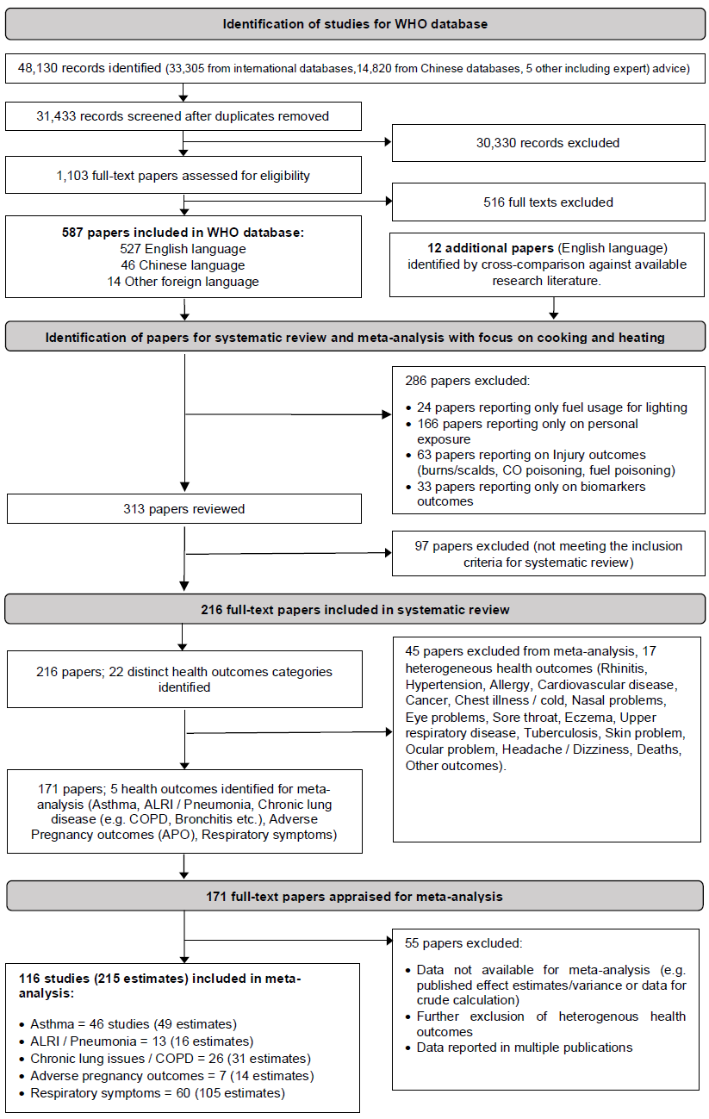

Figure 1: Study selection flowchart

The 116 studies (Supplementary Tables S1-S7) included in the meta-analyses consisted of two (1.7%) trials, 13 (11.2%) case-control studies, 23 (19.8%) cohort studies and 78 (67.2%) cross-sectional studies. Studies spanned 34 countries with 60 studies (51.7%) from LMICs, 54 studies (46.6%) from HICs and two studies (1.7%) involving multiple countries (LMIC and HICs). Most studies (92; 79.3%) investigated cooking, with 17 (14.7%) concerning heating and 7 (6.0%) assessing both (Table 1). Type of gaseous fuel use was not specified for 70 studies (assumed to be natural gas in HIC settings). Only one study investigated ethanol (related to stillbirth) and so liquid fuels were not included for meta-analysis. Health outcomes with a paucity of evidence for which meta-analysis was not undertaken are shown in Tables S8-S9.

Asthma: 46 studies (49 estimates) assessed asthma in children and/or adults. When compared to polluting fuels (Figure 1a), the use of gas for cooking/heating did not change the risk of asthma in children (OR 1.04, 95% CI 0.70-1.55), whereas it reduced the risk of asthma in adults by 35% (OR 0.65; 95% CI 0.43-1.00). Compared to electricity (Figure 1b), using gas for cooking/heating resulted in a small increase in risk of asthma in children (9%), although not statistically significant (OR 1.09; 95% CI 0.99-1.19). For adults, the observed 43% increase in risk of asthma from using gas for cooking/heating (compared to electricity) was not statistically significant (OR 1.43; 95% CI 0.90-2.27). Sensitivity analyses where studies of adults/children were stratified by geography (Table S10) found a small but significant increase in risk of asthma for gas versus electricity (11%) for HICs (OR 1.11; 95% CI 1.01-1.23). When focusing on studies that adjusted for at least one key confounder (active and/or passive smoking, ambient air pollution, socio-economic status), there was no effect from cooking/heating with gas on asthma compared to electricity (n=18: OR 1.05; 95% CI 0.97-1.14). A further sensitivity analysis comparing gas users to both electricity and ‘non-gas users’ (additional 38 estimates, Table S10) resulted in a small but statistically significant increase in risk of asthma for children in homes reporting gas for cooking/ heating (OR 1.13, 95% CI 1.04-1.22) and a 35% increase in risk of asthma for adults, also statistically significant (OR 1.35, 95% CI 1.00-1.83) (Figure S1). Again, including only studies of adults/children that adjusted for key confounders attenuated the pooled effect for asthma risk (OR 1.08, 95% CI 1.00-1.18) vs OR 1.29 95% CI 1.14 to 1.48 with no adjustment (Table S10).

Figure 1: Risk of Asthma in children and adults from use of gaseous/liquid fuels
1a – Comparison with polluting fuels (coal, biomass or kerosene) 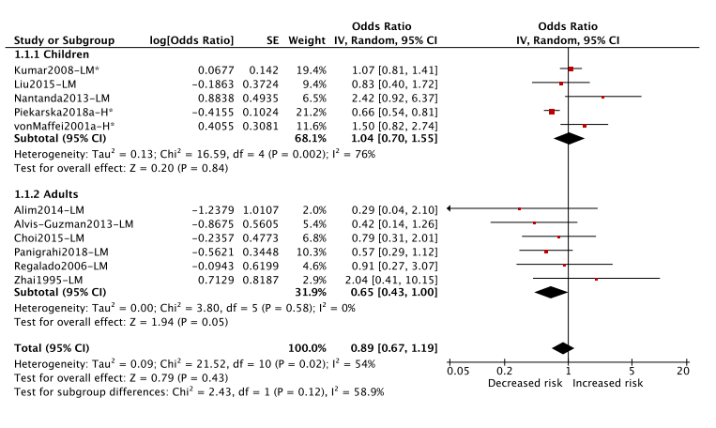
1b – Comparison with electricity
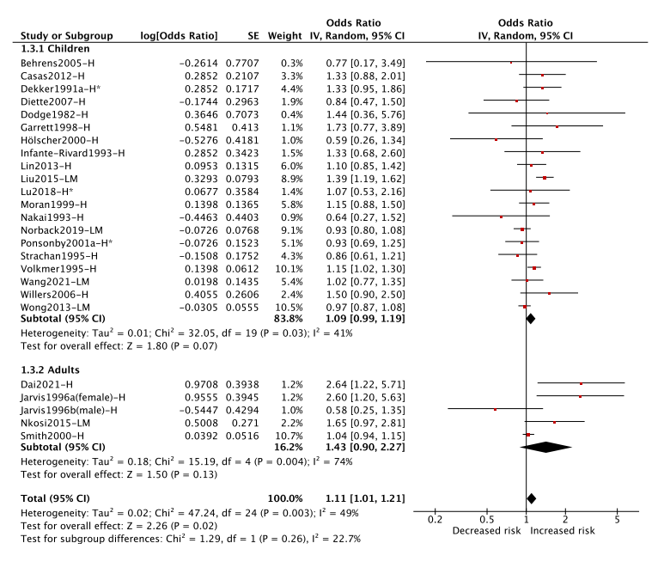Legend: H=High-income; LM=Low and Middle-income. (*) denotes fuel used for heating.

Acute Lower Respiratory Infections (ALRI)/ pneumonia: Thirteen studies (16 estimates) reported on ALRI/ pneumonia. The majority (9 studies [12 estimates] – 75%) concerned children (0 to 17 years). Almost all estimates (92%) related to cooking. Cooking with gas (relative to use of polluting fuels) was found to significantly reduce the risk of ALRI/ pneumonia by 44% (OR 0.56; 95% CI 0.36-0.86). Conversely, when compared to electricity, cooking with gas was found to increase the risk of ALRI/ pneumonia by 26% (OR 1.26; 95% CI 1.03-1.53). When including ‘non-gas users’ in the electricity reference group (n=9 estimates) in sensitivity analysis (Table S11), the increased risk (22%) was no longer statistically significant (OR 1.22, 95% CI 0.99-1.50) (Figure S2).

Figure 2: Risk of ALRI / pneumonia in children and adults from use of gaseous fuels

2a. Comparison with polluting fuels (coal, biomass or kerosene)
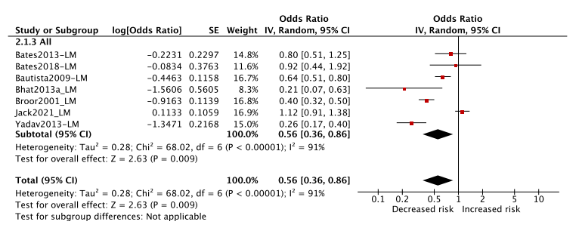2b: Comparison with electricity 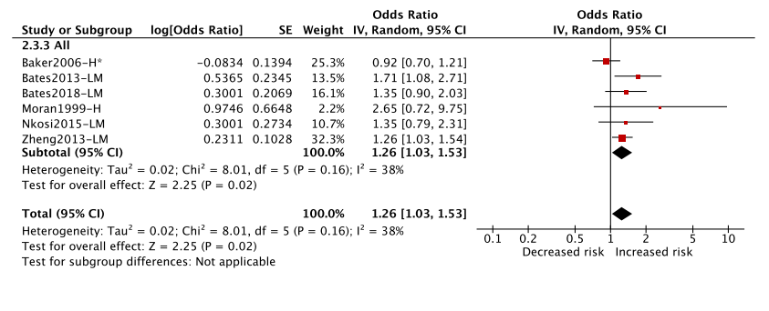Legend: H=High-income; LM=Low and Middle-income. (*) denotes fuel used for heating.

Chronic Lung Disease (CLD): Meta-analyses of CLD were stratified by condition: COPD (n=9; 9 estimates); bronchitis (n=9; 9 estimates); pulmonary function deficit/ abnormal spirometry (n=8; 8 estimates) and severe respiratory illness/ death (n=3; 3 estimates). For all CLD conditions, a statistically significant (p<0.05) reduction in risk was observed from using gas for cooking/ heating compared to polluting fuels (Figure 3a), ranging from a reduction of 40% (bronchitis) to 73% (for pulmonary function deficit and severe respiratory illness/ death). Overall, for all CLD conditions pooled, a statistically significant reduction in risk of 64% was observed (OR 0.36; 95% CI 0.27-0.48).

Studies comparing use of gas for cooking/ heating to electricity on CLD outcomes were limited (n=7; 7 estimates across all conditions) with substantial heterogeneity (Figure 3b). A small but statistically significant increase in risk for COPD (15%) was observed for cooking/ heating with gas compared to electricity (OR 1.15; 95% CI 1.06-1.25, n=3 estimates). Conversely, a small but significant reduction in risk (13%) was observed for bronchitis when cooking with gas relative to electricity (OR 0.87; 95% CI 0.81-0.93, n=4 estimates). When ‘non-gas users’ were added to the electricity reference group in sensitivity analysis (Table S12), the overall pooled estimate, across all conditions, found a 12% increase in risk of CLD from cooking with gas versus electricity (OR 1.12, 95% CI 0.97-1.30) (see Figure S3).

Figure 3: Risk of Chronic Lung Disease from use of gaseous/ liquid fuels

3a. Comparison with polluting fuels (coal, biomass or kerosene)
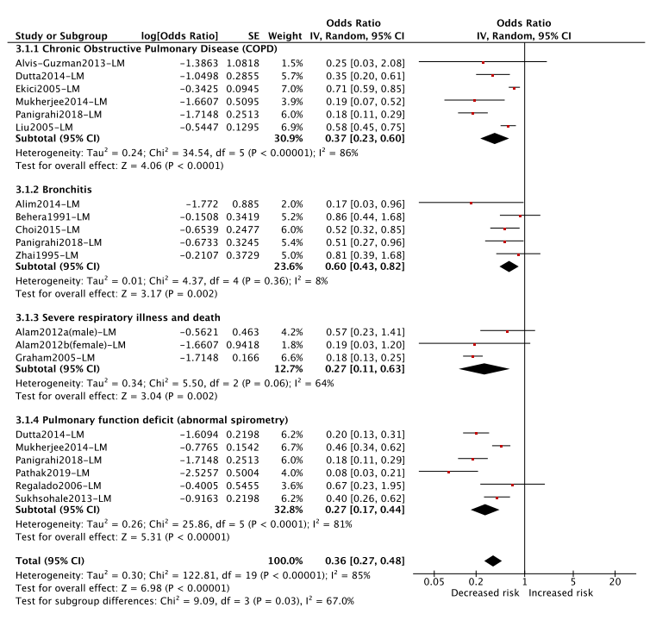

3b. Comparison with electricity
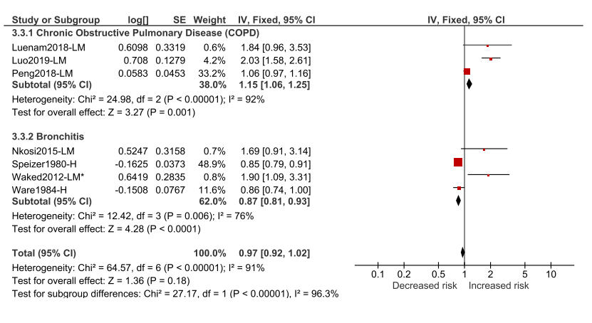Legend: H=High-income; LM=Low and Middle-income. (*) denotes fuel used for heating.

Adverse Pregnancy Outcomes (APO): All studies compared cooking with gaseous fuels to polluting fuels (n=7; 14 estimates) (Figure 4), and all were from LMICs. Significant reductions in risk were observed from using gas for cooking for pre-term birth (OR 0.66; 95%CI 0.45-0.97) and for low birth weight (OR 0.70; 95% CI 0.53-0.93). There was no change in the odds of small for gestational age at birth between cooking with gas and polluting fuels (OR 1.04; 95% CI 0.89-1.21). There were not enough studies/estimates to conduct sensitivity analysis.

Figure 4: Risk of Adverse Pregnancy Outcomes from use of gaseous/liquid fuels compared to polluting fuels (coal, biomass or kerosene)
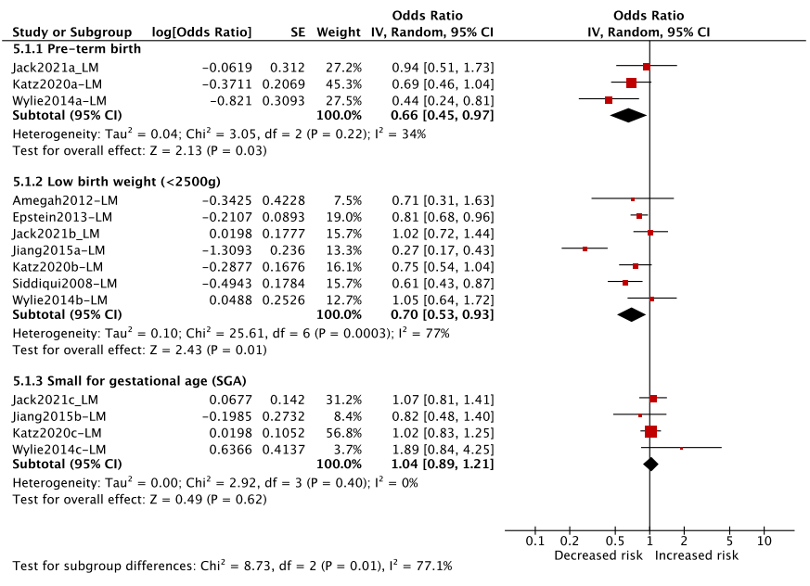Legend: H=High-income; LM=Low and Middle-income.

Respiratory Symptoms
Wheeze. 41 studies (40 estimates) investigated cooking/ heating with gas compared to polluting fuels (n=16; Figure 5a) or electricity (n=24; Figure 5b) and self-reported symptoms of wheeze. Cooking with gas was found to significantly reduce the risk of wheezing by 68% relative to polluting fuels (OR 0.42; 95% CI 0.30-0.59). No effect on wheezing risk was observed for gas compared to electricity (OR 1.05; 95% CI 0.98-1.13). A small but significant increase in odds of wheeze (OR 1.06, 95% CI 1.00-1.12) was observed for gas compared to electricity and ‘non-gas’ users in sensitivity analysis (Table S13, Figure S4c).

Figure 5: Risk of wheeze in children and adults from use of gaseous fuels

5a. Comparison to polluting fuels (coal, biomass or kerosene) 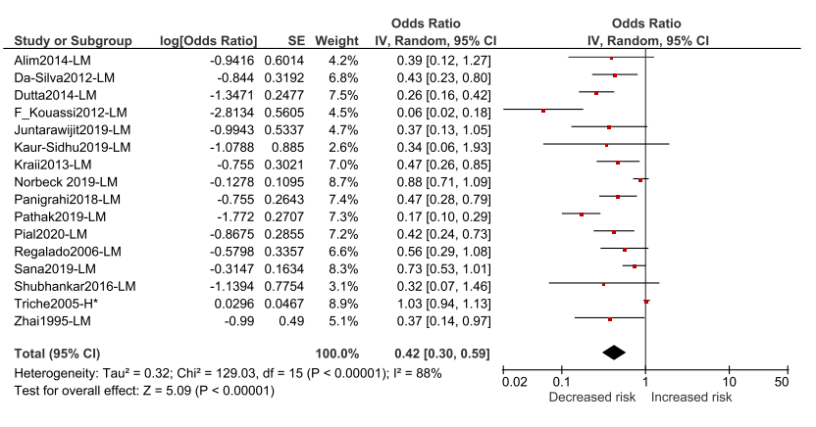5b: Comparison to electricity

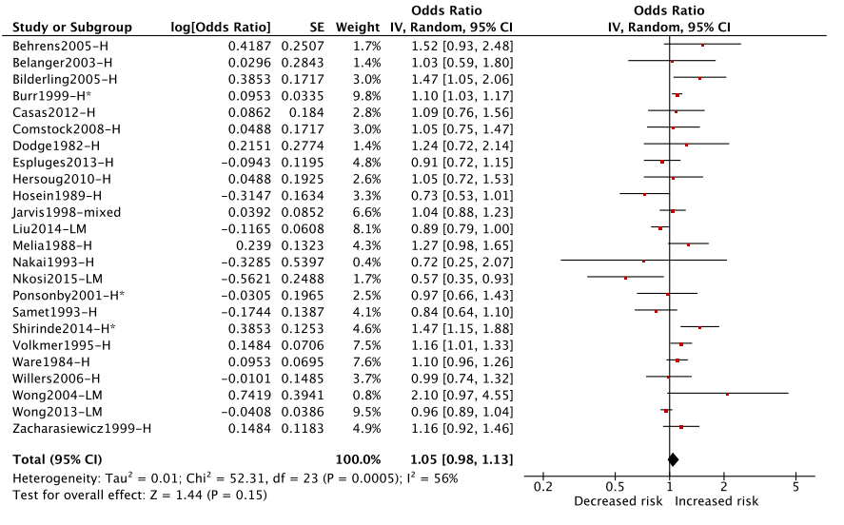

Cough. 32 studies (35 estimates) assessed cooking/ heating with gas and self-reported cough including 18 with a polluting reference fuel (Figure 6a) and 17 with electricity (Figure 6b). Cooking with gas (only one study assessed heating) was associated with a significant 54% reduction in risk of cough when compared to polluting fuels (OR 0.44; 95% CI 0.32-0.62). There was no difference in the risk between gas and electricity users (OR 1.06; 95% CI 0.96-1.18). In a sensitivity analysis including ‘non-gas users’ with electricity, there was no change in effect (OR 1.04; 95% CI 0.98-1.11 (Figure S4b, Table S14)).

Figure 6a: Risk of Cough from use of gaseous fuels

6a. Comparison with polluting fuels (coal, biomass or kerosene)
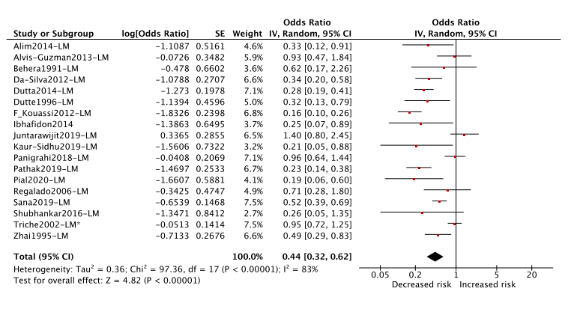
6b: Comparison with electricity

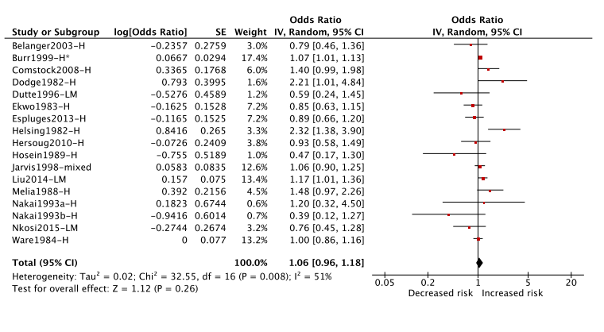Legend: H=High-income; LM=Low and middle-income. (*) denotes fuel used for heating.

Breathlessness: Ten studies (10 estimates) assessed cooking/ heating with gas and self-reported breathlessness/ chest tightness. Seven used a polluting reference fuel (Figure 7a) and three electricity as a reference (Figure 7b). Cooking with gas was associated with a significant 60% reduction in breathlessness/ chest tightness when compared to polluting fuels (OR 0.40; 95% CI 0.21-0.76). There was no difference in the odds of breathlessness between gas and electricity users (OR 0.97; 95% CI 0.81-1.17). When the additional studies of ‘non-users’ were added to the electricity reference group in sensitivity analysis, this lack of association remained (OR 1.08; 95% CI 0.97-1.21) (Figure S4a, Table S15).

Figure 7: Risk of Breathlessness from use of gaseous/liquid fuels

7a. Comparison with polluting fuels (coal, biomass or kerosene)
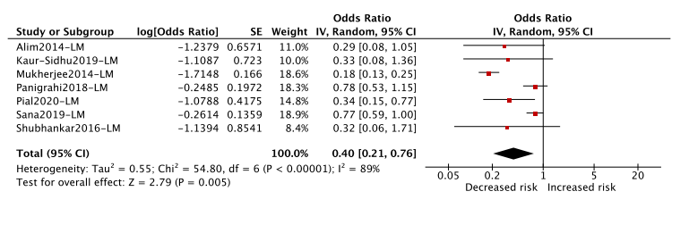7b. Comparison with electricity
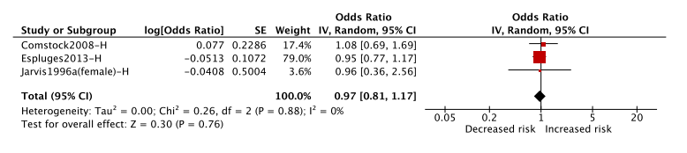Legend: H=High-income; LM=Low and middle-income

Discussion

This comprehensive synthesis of impacts from gaseous fuels for cooking/ heating on key health outcomes provides a valuable evidence base for health-related policies affiliated with the clean cooking agenda. The meta-analyses confirm the expected health gains that can be achieved from switching from polluting solid fuels and kerosene to clean gaseous fuels in terms of reduced emissions of PM_{2.5} and CO (Tier 5 for International Organization for Standardization (ISO) 19867-3 Voluntary Performance Targets²⁰). By investigating the potential health impacts of gas use for cooking or heating compared to electricity, this analysis also provides evidence to inform emerging concerns over the potential impacts of cooking with gas on asthma that are shaping current energy policy in the USA²¹ and Europe²².

Our meta-analyses indicate that cooking/ heating with gas substantially (and significantly) reduces the risk of ALRI/ pneumonia, adverse pregnancy outcomes, chronic lung disease, adult asthma (childhood asthma risk reduction was not statistically significant) and respiratory symptoms (including wheeze which is closely correlated with the occurrence of asthma) relative to use of polluting fuels such as wood, charcoal and kerosene – relied on by much of the developing world (Figure 8).

Comparing cooking/ heating with gas to electricity (a source of energy with zero emissions at point of use) resulted in mixed findings. A slight but significant increase in risk was observed for ALRI/ pneumonia (OR 1.26; p<0.05) and COPD (OR 1.15; p<0.05). However use of gas reduced the risk of bronchitis compared to electricity (0.87; p<0.05). For asthma, a small, non-significant increase in risk for children (OR 1.09; p>0.05) was found for use of gas compared to electricity, and a larger (non-significant) increase in risk for adults (OR 1.43; p>0.05). When including studies for with an unclear reference group (i.e., ‘non-users’ of gas) through sensitivity analysis, risk of childhood asthma slightly increased to 13%, achieving statistical significance (OR 1.13, 95% CI 1.04-1.22).

The results for asthma provide an important update (additional 27 studies, with 13 studies published since 2013) to the only other meta-analysis of cooking with gas and asthma (compared to ‘non-users’) conducted by Lin et al.⁹ The authors reported a 32% increased risk for current/ lifetime asthma (OR 1.32; 95% CI 1.18-1.48) based on 19 studies and noted that potential confounding could have exaggerated effects. To investigate the role of confounding in our meta-analyses, sensitivity analyses were conducted adjusting for key confounders (including active/passive smoking, ambient air pollution (proxies) and socio-economic status; Table S1). We confirmed that that risk of asthma from gas use was potentially exaggerated in studies with no or limited adjustment for confounders (OR 1.29; 95% CI 1.12-1.48) compared to those with adjustment for at least one key confounder (OR 1.05; 95% CI 0.97-1.14). In addition, our analysis found only a small, non-significant increase in risk of wheeze (similar in manifestation to asthma) for gas compared to electricity (OR 1.04; 95% CI 0.97-1.11). Calculations of excess population attributable risk for childhood asthma from use of gas for cooking compared to electricity/ non-use²¹ based on the older meta-analysis by Lin et al.⁹ are therefore likely to overestimate the true burden by 72% (OR 1.09: all studies) or 85% (OR 1.05: adjusted studies). While asthma carries a significant global disease burden with an estimated 455,000 global annual deaths²³, this is less than seven-times the global disease burden from exposure to PM_{2.5} associated with domestic use of solid fuels/kerosene for cooking. This is important when considering effective policies for rapid scale of clean cooking to address the public health burden from HAP in LMICs.²⁴

Our meta-analyses indicating the protective effect of gas for cooking in LMICs compared to polluting fuels for adverse pregnancy outcomes (preterm birth [OR 0.66; 95% CI 0.50-0.87] and low birth weight [OR 0.70; 95% CI 0.53-0.93] are not consistent with a recent finding from the largest randomized controlled trial of an exclusive LPG cooking intervention in four LMIC countries.²⁵ The Household Air Pollution Intervention Network (HAPIN) trial (published in 2022²⁶) identified no difference in low birth weight for infants born in homes using LPG (intervention: n=1593, 2921g) compared to those using solid fuels (control: n=1607, 2898g). One possible explanation for lack of effect postulated by the authors was the potential negative impact of pollution exposure during the first trimester of pregnancy that was not averted by the HAPIN trial (intervention implementation was during the second trimester).

Our meta-analyses are based on a comprehensive appraisal of international bibliographic databases (including Chinese literature), and we found no evidence of publication bias through statistical funnel plot asymmetry for the majority of analyses (p>0.1 for 14/15 (93%) for Begg’s test and 12/15 (80%) for Egger’s test). One potential limitation relates to the lack of granular evidence on factors that may influence exposure to emissions (e.g. presence of gas ventilation such as through hoods), which could influence pollutant concentrations and resulting health impacts.²⁷ In addition, we did not attempt to synthesize studies of personal exposure to indoor NO₂ (limited in number). Cooking/heating with gas has been shown to result in high NO₂ emissions (potentially confounded by outdoor/traffic pollution), which some studies have shown to be potentially higher than the recently reduced WHO guideline level for NO₂.^{28,29} It is important that the association between cooking/ heating with gas and exposure to NO₂ is carefully investigated and its relationship with key health outcomes, including asthma, elucidated.

In conclusion, this review demonstrates a substantial reduction in risk for key health outcomes, suggesting that switching from polluting solid fuels/ kerosene to gaseous fuels for cooking/heating could significantly reduce global disease burden from HAP (Figure 8). This health gain is critical to consider when designing strategies to scale adoption of clean cooking fuels/ technologies in LMICs where the disease burden from reliance on polluting fuels is greatest. In most of these contexts, gas (particularly LPG) represents the best option for effective scale in the short to medium term.²⁶ However, given that our review identified a modest increase in risk from use of gas compared to electricity for certain health outcomes including ALRI/ pneumonia and asthma (Figure 8), electricity might ultimately be the priority option for clean cooking. While further understanding the relationship between exposure to NO₂ and other pollutants emitted from gas combustion is necessary, our evidence suggests that gaseous fuels can be considered an important transitional clean fuel option in contexts without access to renewably sourced electric cooking and heating.

Figure 8: Summary of cumulative pooled effects from all included health effects in meta-analyses associated with the use of gas for cooking or heating compared to polluting fuels (panel A) and electricity (panel B).

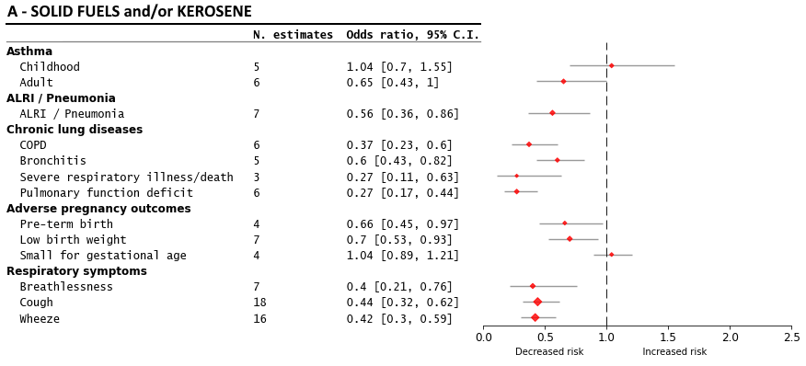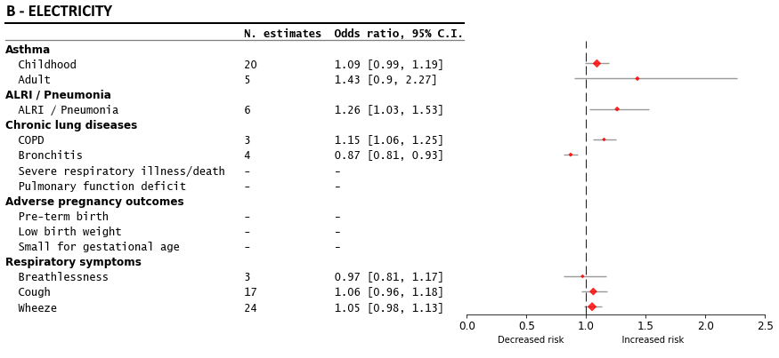

Contributions of authors
DP, EP, EN, HAR, LA and JL designed the study. EP, DP, GS, JL, KW, HAR coordinated and supervised the study. MM, NF, EN, EP, DP designed the literature searches. MM, NF ran the searches in the English/international databases. YL, RX ran the searches in the Chinese databases. NF, DP, EP, EN, RD, RB, YL, RX, AB, screened titles, abstracts and full records of publications. FR, FL, NF, EP, DP, JG, KE, RB, RD, YL, RX, EN extracted data, and assessed risk of bias. DP and FL conducted statistical analyses. EP, DP, NF, wrote the manuscript. All authors critically revised the manuscript.

Declaration of interests
All authors declare no competing interests.

Acknowledgment
This study was commissioned and funded by the World Health Organization, with support from the UK NIHR, Clean-Air (Africa) Global Health Research Group (17/63/155), and the National Natural Science Foundation of China (NSFC 42077328). We are grateful to the multiple people who have contributed to some stages of the review, including Angela Boland, Ashleigh White, Angela Bonsu, Janette Greenhalgh, and Katherine Edwards.
The authors alone are responsible for the views expressed in this article and they do not necessarily represent the views, policies or decisions of the institutions with which they are affiliated.

References

1. WHO. Household air pollution: Key facts. https://www.who.int/news-room/fact-sheets/detail/household-air-pollution-and-health [Accessed 1 March 2023] 2022.
2. WHO. Burning Opportunity: Clean Household Energy for Health, Sustainable Development, and Wellbeing of Women and Children, 2016.
3. Puzzolo E, Zerriffi H, Carter E, et al. Supply considerations for scaling up clean cooking fuels for household energy in low- and middle-income countries. GeoHealth 2019; 12(3): 370-90.
4. Lee K, Bing R, Kiang J, et al. Adverse health effects associated with household air pollution: a systematic review, meta-analysis, and burden estimation study. Lancet Glob Health 2020; 8(11): e1427-e34.
5. Nix E, Fleeman. N, Lorenzetti F, et al. Health Effects of Liquid and Gaseous Fuels for Household Energy Use: Systematic Evidence Mapping. Environ Res Lett 2022; 17(123003).
6. Lam N, Smith K, Gauthier A, Bates M. Kerosene: A Review of Household Uses and their Hazards in Low- and Middle-Income Countries. Journal of Toxicology and Environ Health, Part B: Critical Reviews 2012; 15(6): 396-432.
7. Elf JL, Kinikar A, Khadse S, et al. The association of household fine particulate matter and kerosene with tuberculosis in women and children in Pune, India. Occup Environ Med 2019; 76(1): 40-7.
8. Apple J VR, Yarberry A, et al.,. 2010. Indoor Air Characterization of particulate matter size distributions and indoor concentrations from kerosene and diesel lamps; 20(5): 399-411.
9. Lin W, Brunekreef B, Gehring U. Meta-analysis of the effects of indoor nitrogen dioxide and gas cooking on asthma and wheeze in children. Inter Journal of Epidemiol 2013; 42: 1724–37.
10. Hasselblad V, Eddy D, Kotchmar D. Synthesis of environmental evidence: nitrogen dioxide epidemiology studies. J Air Waste Manage Assoc 1992; 42(5): 662-71.
11. Lanphear B.P, Kahn R.S, Berger O, et al. Contribution of Residential Exposures to Asthma in US Children and Adolescents. Pediatrics 2001; 107.
12. Ponsonby A-L GN, Gatenby P, Mullins R, Mcdonald T, Hurwitz M, et al.,. The relationship between low level nitrogen dioxide exposure and child lung function after cold air challenge. Clin Exp Allergy 2001; 31(8): 1205–12.
13. Mölter A, Agius RM dVF, Lindley S, et al. Long-term exposure to PM10 and NO2 in association with lung volume and airway resistance in the MAAS birth cohort. Environ Health Perspect 2013; 121: 1232–8.
14. Zhu Y, Connolly, R., Lin, Y et al. Effects of Residential Gas Appliances on Indoor and Outdoor Air Quality and Public Health in California. Los Angeles. https://ucla.app.box.com/s/xyzt8jc1ixnetiv0269qe704wu0ihif7 (accessed March 8, 2022). 2020.
15. Kephartat J, Fandiño-Del-Rio M, Williams K, al. e. Nitrogen dioxide exposures from LPG stoves in a cleaner-cooking intervention trial. Environ Internat 2021; 146: 106196.
16. Ronzi, S.; Orton, L.; Buckner, S.; et al. How is Respect and Social Inclusion Conceptualised by Older Adults in an Aspiring Age-Friendly City? A Photovoice Study in the North-West of England. Int. J. Environ. Res. Public Health 2020, 17, 9246. https://doi.org/10.3390/ijerph17249246
17. Pope D. JM, Fleeman, N., Jagoe. K., et al. Are cleaner cooking solutions clean enough? A systematic review and meta-analysis of particulate and carbon monoxide concentrations and exposures. Environ Res Lett 2021; 16(083002).
18. Puzzolo E, Pope D, Stanistreet D, et al. Clean fuels for resource-poor settings: a systematic review of barriers and enablers to adoption and sustained use. Environm Research 2016; 146: 218-34.
19. Dherani M, Pope, D., Mascarenhas, et al. Indoor air pollution from unprocessed solid fuel use and pneumonia risk in children aged under five years: a systematic review and meta-analysis. Bull WHO 2008; 86: 390-8.
20. WHO. Defining clean fuels and technologies. Available at: https://www.who.int/tools/clean-household-energy-solutions-toolkit/module-7-defining-clean#:~:text=Clean%20fuels%20and%20technologies%20are,air%20quality%20guidelines%20(2021) [Accessed 22 March 2023], 2021.
21. Gruenwald T, Seals BA, Knibbs LD, et al. Population Attributable Fraction of Gas Stoves and Childhood Asthma in the United States. Int J Environ Res Public Health 2022; 20(1): 75.
22. CLASP. Phasing Out Gas Cooking in Europe. https://www.clasp.ngo/cook-cleaner-europe/ [Accessed 22 March 2023], 2023.
23. WHO. Asthma: Key facts. https://www.who.int/news-room/fact-sheets/detail/asthma [Accessed 1 March 2023] 2022.
24. Rosenthal J, Quinn, A, Grieshop, et al. Clean cooking and the SDGs: Integrated analytical approaches to guide energy interventions for health and environment goals. Energy for Sustainable Development 2018; 42: 152-9.
25. Clasen FT, Chang HH, Thompson LM, et al. Liquefied Petroleum Gas or Biomass for Cooking and Effects on Birth Weight. N Engl J Med 2022; 387: 1735-46.
26. Bruce N, Aunan K, Rehfuess E, et al. Liquefied Petroleum Gas as a Clean Cooking Fuel for Developing Countries: Implications for Climate, Forests, and Affordability. In: Materials on Development Financing, No. 7. Frankfurt: KfW Development Bank, 2017.
27. Lebel E, Finnegan C, Ouyang Z, et al. Methane and NOx Emissions from Natural Gas Stoves, Cooktops, and Ovens in Residential Homes. Environ Sci Technol 2022; 56(4): 2529–39.
28. Orellano P, Reynoso J, Quaranta N, et al. Short-term exposure to sulphur dioxide (SO2) and all-cause and respiratory mortality: A systematic review and meta-analysis. Environment International 2020; 142(105876).
29. WHO. WHO global air quality guidelines: particulate matter (‎PM2.5 and PM10)‎, ozone, nitrogen dioxide, sulfur dioxide and carbon monoxide Geneva: World Health Organization, 2021.

