The use of breast milk iodine concentration in the first week of lactation as a biomarker of iodine status in breastfeeding women

Shuchang Liu^{1,2}, Andrew Sharp^{2,*}, Xiaoqin Luo³, Steven Lane⁴, Elmer V Villanueva^{5,6}, Zhiliang Lu^{1,*} and Zheng Feei Ma^{5,7,*}

¹ Department of Biological Sciences, Xi’an Jiaotong-Liverpool, Suzhou 215123, China; zhiliang.lu@xjtlu.edu.cn
² Harris-Wellbeing Research Centre, Faculty of Health & Life Sciences, University of Liverpool, Liverpool L8 7SS, UK; shuchang@liverpool.ac.uk; a.sharp@liverpool.ac.uk
³ School of Public Health, Xi’an Jiaotong University, Xi’an 710006, China; luoxiaoqin2012@mail.xjtu.edu.cn
⁴ Health Data Science, University of Liverpool; slane@liverpool.ac.uk
⁵ School of Science, Xi’an Jiaotong-Liverpool University, Suzhou 215123, China;
⁶ Victoria University, Footscray Victoria 3011, Australia; elmer.illanueva@vu.edu.au
⁷ Centre for Public Health and Wellbeing, School of Health and Social Wellbeing, College of Health, University of the West of England, Bristol BS16 1QY, UK; zheng.ma@uwe.ac.uk

*To whom correspondence should be addressed to:
Zheng Feei Ma, zheng.ma@uwe.ac.uk; Zhiliang Lu, zhiliang.lu@xjtlu.edu.cn; Andrew Sharp, a.sharp@liverpool.ac.uk

Abstract

Background: Iodine is an essential micronutrient required to produce thyroid hormones. Pregnant and breastfeeding women have higher requirements for iodine, with breastfed infants entirely dependent on iodine consumed from breast milk. Urinary iodine concentration (UIC) is usually used to assess the iodine status in populations. However, UIC has a number of limitations with some studies showing that it is an inaccurate biomarker of iodine status in breastfeeding women. Breast milk iodine concentration (BMIC) is a promising indicator of iodine status in lactating women and breastfed infants.

Objectives: To assess iodine concentration in breast milk and urine samples in breastfeeding women.

Methods: Eligible pregnant women undergoing routine antenatal care in a large hospital in Shaanxi Province, China, were recruited from the third trimester of pregnancy (from 29+6 to 40+3 weeks) until the first week of lactation. Urine samples were collected during pregnancy and lactation. Breast milk samples were provided during lactation. Data on blood pressure, thyroid stimulating hormone (TSH), free thyroxine (FT4) and thyroid peroxidase antibody (TPOAb) during pregnancy were retrieved from the medical records. Iodine-specific food frequency questionnaire (FFQ) including supplement use was completed twice during pregnancy and lactation.

Results: A total of 200 women completed the study. Both TSH and FT4 values during pregnancy were within the normal range. The overall median BMIC was 89 μg/L, indicating iodine sufficiency (i.e., BMIC reference range between 60 and 465 μg/L). While women were classified as iodine sufficient during lactation (the overall median UIC was 113 μg/L, which was higher than the median UIC cut-off of 100 μg/L to indicate iodine sufficiency during lactation), they were mild-to-moderate iodine deficient during pregnancy (the overall median UIC 112 μg/L, which was lower than the median UIC cut-off of 150 μg/L to indicate iodine sufficiency). Only 7 women (3.5%) used supplements containing iodine during pregnancy and lactation. The receiver operating curve (ROC) for BMIC using UIC as a reference standard was 0.755 (95% CI: 0.644. 0.866).

Conclusions: This study demonstrated that women were iodine sufficient in the first week of lactation. Further studies are needed to explore the usefulness of using BMIC to assess iodine status in breastfeeding women during different lactation periods.

Keywords: breast milk iodine concentration; urinary iodine concentration; maternal iodine status; pregnancy; lactation

Introduction

Iodine is an essential micronutrient required for the production of thyroid hormones, which regulate metabolism, growth, and development {Andersson, 2022 #289}. Pregnant and lactating women have higher iodine requirements because they need to support the iodine needs of their fetus and baby {Bath, 2022 #290}. A recent meta-analysis reported that the overall worldwide prevalence of maternal iodine deficiency was 53% {Patriota, 2022 #302}. As a result, insufficient iodine intake can cause many iodine deficiency disorders which affect both mothers and infants, e.g., cretinism, intellectual disability, neonatal hypothyroidism or hyperthyrotropenemia and growth retardation {Brough, 2022 #291}.

The World Health Organization recommends assessing iodine status based on urinary iodine concentration (UIC) for pregnant women, defined as insufficient (UIC <150 μg/L), adequate (UIC 150-249 μg/L), more-than-adequate (UIC 250-499 μg/L), and excessive iodine status (UIC ≥500 μg /L) {World Health Organization (WHO), 2007 #46}. UIC is used to determine iodine status based on the principle that approximately 90% of ingested iodine is excreted in the urine {Zimmermann, 2012 #136}. However, using UIC to assess iodine status has some limitations. First, UIC is a short-term biomarker, which can be easily affected by recent iodine intake from the diet {Zimmermann, 2008 #282}. Second, UIC may be influenced by hydration status and circadian rhythm {Zimmermann, 2008 #282;Als, 2000 #281}. In lactating women, there is little evidence that supports the recommendation of a median UIC cut-off of <100 μg/L to indicate iodine deficiency because iodine is also excreted in breast milk and thus <90% of ingested iodine is excreted via urine {Andersson, 2007 #16; Brough, 2022 #291}.

BMIC has been reported to be a promising biomarker of iodine status in breastfeeding women {Dold, 2017 #80}, although there is no scientific consensus on whether BMIC can accurately reflect iodine status in breastfeeding women {Brough, 2022 #291}. The literature review has suggested that there have been inconsistencies in the relationship between BMIC and UIC in lactating women {Liu, 2022 #286}. Most of these studies were cross-sectional in design. Therefore, WHO suggested a number of research priorities including the assessment of iodine status during pregnancy and early infancy, which include the usefulness of BMIC {Andersson, 2007 #16}.

To date, there is limited information regarding BMIC in breastfeeding women and on the iodine status of pregnant women who are then followed until lactation. China has long been considered an iodine sufficient country based on the median UIC of studies involving school-aged children and non-pregnant adults {Sun, 2017 #22}. However, these findings may not reflect the iodine status of women during pregnancy and lactation, who, as stated earlier, have a substantially higher iodine requirement {Zimmermann, 2020 #292}. Therefore, the aim of our study was to assess iodine concentration in breast milk and urine samples in breastfeeding women.

Methods

Study population

The Women and Iodine Nutrition (WIN) study was designed as a prospective longitudinal, observational cohort study spanning from the third trimester of pregnancy to the first week of lactation, with a follow-up period of up to 3 months, in Shaanxi Province (in the western part of China). Pregnant women were recruited between May 2021 and May 2022 at Xianyang Central Hospital Affiliated with the Medical Department of Xi’an Jiaotong University.

Inclusion criteria were as follows: pregnant women during their third trimester (gestation weeks of 28 and above); aged between 18-50 years; healthy, not had medically diagnosed thyroid disease, not taking thyroid medication; singleton birth; intended to breastfeed for at least 7 days; of Chinese nationality; must live in Shaanxi at least one year; able to read and write in Chinese; had a healthy , singleton, full-term birth (pregnancy weeks 38-42); infant exclusively breastfed except for water. Exclusive breastfeeding is defined as ≥90% of the infant’s energy intake coming from breast milk {Manousou, 2021 #79}. Infants with fetal abnormality were excluded.

Written informed consent was obtained from all eligible women. Infants were consented by their participating mothers. Ethical approval for this study was approved by the Xi’an Jiaotong-Liverpool University Ethics Committee (reference no. 20-01-09) and Xianyang Central Hospital Affiliated to the Medical Department of Xi’an Jiaotong University (reference no. 20200009). The results of the WIN study were reported according to the STrengthening the Reporting of OBservational studies in Epidemiology (STROBE) guidelines for the cohort studies {Vandenbroucke, 2014 #234;Von Elm, 2014 #233}.

Socio-demographic data collection and other maternal and neonatal data

Women were required to complete a 57-item questionnaire including questions on socio-demographics, iodine knowledge and iodine-specific food frequency questionnaire (FFQ). The questionnaire has been previously validated and used in assessing iodine status of the Chinese pregnant population {Yu, 2020 #232}. Other socio-demographics of participants including age, marital status, ethnicity, education level, occupation and pre-pregnancy body mass index (BMI) were obtained during routine antenatal care. Women who graduated high school, junior high school and elementary school and below were categorised as “below university level”, those who graduated university or junior college and above were “university level and above”. The daily iodine doses were retrieved using the brand name of the supplement if applicable. Height and weight were recorded using a stadiometer to the closest 0.1 cm and 0.01 kg. BMI was categorised according to the criteria by the Chinese adults proposed by the WHO's recommendation as follows: underweight, < 18.5 kg/m2; normal weight, 18.5–24.9 kg/m²; overweight, ≥ 25.0 kg/m²; and obese, ≥ 30.0 kg/m² {Collaboration, 2016 #277}.

Data on blood pressure, thyroid stimulating hormone (TSH), free thyroxine (FT4) and thyroid peroxidase antibody (TPOAb) during pregnancy were retrieved from medical records. The normal reference ranges for TSH, FT4 and TPOAb were as follows: 0.27-4.20 µIU/mL, 0.93-1.70 ng/dL and <34.0 IU/mL. TSH, FT4 and TPOAb values were determined using electrochemiluminescence immunoassay on a Roche E602 immunochemistry analyser. In addition, total gestation weeks at delivery, sex, type of delivery, birth weight and length, and APGAR score (appearance, pulse, grimace, activity and respiration) at 1, 5 and 10 minutes were also assessed and obtained from neonatal records.

Urine sample collection

During the third trimester of pregnancy, participants were provided with instructions and equipment to collect one approximately 20 mL (non-fasting), mid-stream sample between 09:00 AM and 12:00 PM. During the first week of lactation, participants were asked to provide two (non-fasting), mid-stream samples between 09:00 AM and 12:00 PM on two separate days (i.e., the 3rd and 4th day of lactation period), to control for the intra-individual and within-day UIC variation, while minimising participant burden {Mulrine, 2010 #57}. The internationally recommended method to determine iodine status based on UIC is the collection of morning or spot urine samples in the non-fasting state {World Health Organization (WHO), 2007 #46}.

Breast milk sample collection

Women were asked to clean their breasts with water before collecting the breast milk sample manually. Approximately one 5 mL breast milk sample (non-fasting sample) was collected between 09:00 AM and 12:00 PM from women before their infants were fed at the 3rd day of lactation {Mulrine, 2010 #57;Jorgensen, 2016 #82}. Since the literature review does not show whether BMIC is affected by a recent meal, women were allowed to have their usual diet before breast milk collection {Semba, 2001 #73}. Currently, there is no evidence supporting the fact that BMIC differs with regard to fore or hind milk, left or right breast, or diurnal variation {Andersen, 2014 #59;Dorea, 2002 #72}.

Laboratory analysis

All urine and breast milk aliquots were kept frozen at -20°C from time of sampling in Xianyang Central Hospital Affiliated to the Medical Department of Xi’an Jiaotong University until analysis.

After thawing, samples were vortexed until homogenous. BMIC and UIC were measured colourimetrically based on the Sandell-Kolthoff reaction adapted for a 96-well microplate {Yan, 2006 #294}. Samples from the same woman were analysed in the same batch.

Assessment of BMIC and UIC in lactating women

The recommended UIC cut-offs during pregnancy and lactation to determine iodine sufficiency are ≥150 and ≥100 µg/L, respectively {World Health Organization (WHO), 2007 #46}.

There is no consensus on an acceptable BMIC cut-off to categorise iodine sufficiency during lactation, which is primarily due to the uncertainty about infant iodine requirements. Several BMIC cut-offs of 50, 75, 80, 92 and 100 μg/L have been proposed to ensure iodine sufficiency during lactation {Liu, 2022 #286}. However, these proposed BMIC cut-offs did not specify if they could be applied to breastfeeding women residing in iodine sufficient regions because some of these cut-offs may have been derived from iodine deficient breastfeeding women and therefore not suitable for iodine sufficient regions. For example, higher BMIC was reported in goitrous areas of Detroit than non-goitrous areas of Boston {Turner, 1933 #295}. Furthermore, no difference in BMIC was reported between goitrous and non-goitrous areas of Italy and New Zealand {Hercus, 1927 #296;Vermiglio, 1992 #56}. On the other hand, in a large multi-centre study of lactating women, Dold et al proposed a broad reference range of 60-465 μg/L, which could be used as indicative of sufficient iodine status in exclusively breastfeeding women residing in iodine sufficient regions {Dold, 2017 #80}.

Assessment of urinary creatinine (UCr)

UCr was analysed based on the kinetic Jaffé method {Fabiny, 1971 #225}. Equipment was calibrated according to the instructions of the manufacturer and quality control materials. The measurement of UCr was to control for hydration status in women.

Statistical analysis

SPSS statistical software package version 25.0 (IBM Corp., Armonk, NY) was used to perform the statistical analysis. Parametric data were expressed as mean and standard deviation, and non-parametric data were presented as median (25th, 75th percentile). Categorical variables were reported as counts and percentages Chi-square tests were used to assess differences in categorical variables. For related samples, comparisons of medians or means were performed using Wilcoxon sign rank tests for non-normally or paired t-test was used for normally distributed variables.

Receiver Operating Curve (ROC) curves were constructed to determine the diagnostic performance of BMIC using a UIC cut-point of 100 ug/L for lactating women. An optimal cut-off for BMIC was identified and sensitivity (proportion of cases correctly identified), Specificity (proportion of non-cases correctly identified) along with negative predictive value (NPV) and positive predictive value (PPV) were then calculated to assess the accuracy of the cut-off {Li, 2018 #297;Parikh, 2008 #298}. Sensitivity is defined as the proportion of those who are correctly identified as iodine deficient by BMIC (true positives), while specificity is defined as the proportion of those who are correctly identified as not iodine deficient by BMIC (true negatives) {Li, 2018 #297;Parikh, 2008 #298}. The NPV is expressed as the proportion of those with negative test results who are correctly identified as not iodine deficient. The PPV is reported as the proportion of those with positive test results who are correctly identified as iodine deficient {Li, 2018 #297;Maxim, 2014 #299}. As there is no gold standard to assess individual iodine status for lactating women, the mean of two spot urine samples collected from each lactating women was used as the reference standard for the determination of the sensitivity, specificity, NPV and PPV of BMIC. When the area under the ROC curve is ≥0.7, it is considered to have the acceptable discrimination for distinguishing iodine deficiency from iodine sufficient {Hosmer Jr, 2013 #300}.

Correlations of BMIC and maternal UIC with UCr were assessed using the Spearman correlation coefficient. Logistic regression analysis was used to assess the associations between the predictors of BMIC and maternal UIC with adjustment for covariates. Covariates adjusted in regression models included variables of age, UIC pregnancy, UIC lactation, delivery type, occupation and education. A P<0.05 was taken as level of significance.

For the calculation of 24-h breast milk iodine excretion (BMIE), a breast milk volume of 0.8 L/day was used {Andersson, 2022 #289;Russell, 2001 #241}. The estimated infant’s iodine intake is calculated as follows: total volume of breast milk consumed by the infant multiplied by BMIC. A BMIC of ≥92 µg/L has been suggested to meet the iodine requirement of the exclusively breastfed infant, which is based on the ingestion of 0.8 L of breast milk/day and an estimated average requirement (EAR) of 72 µg/day {Dold, 2016 #226}.

The primary outcome of this study was BMIC, and the sample size was calculated using G*Power 3.1 (Heinrich Heine University) based on data (mean and standard deviation) from a study of Chinese lactating women {Wang, 2018 #200}. Therefore, on the basis of the literature and using BMIC as the primary outcome, in order to detect an effect size of 0.5, with 90% power and 2-sided alpha (0.05), this meant at least 80 women would be needed in each group to detect a significant difference between the iodine deficient and iodine sufficient groups. After accounting for 20% attrition, a final sample size of 192 women was needed for the whole study.

Results

Study Population

A total of 200 pregnant women fulfilled the study criteria and were enrolled in the study. Table 1 summarises the basic characteristics of women and their infants included in the study. The mean age of the participants was 29.0 ± 4.2 years. The study population consisted of pregnant women with gestational ages ranging from 29 weeks and 6 days to 40 weeks and 3 days, with a mean gestational age of 37 weeks. All women were negative for TPOAb. The mean pre-pregnancy weight of the participants was 55.9 ± 8.4 kg, who had a mean weight gain of 14.9 ± 3.7 kg during pregnancy. Their mean systolic blood pressure was 115.1 ± 10.5 mm Hg and their mean diastolic blood pressure was 74.9 ± 7.3 mm Hg. Only 1.5% of participants (n=3) were smokers. The study population consisted of similar equal numbers of male and female infants, with 98 males (49.0%) and 102 females (51.0%). The mean birth weight was 3.3 ± 0.4 kg, and the mean birth length was 51.1 ± 1.4 cm. The median APGAR scores at 1 minute, 5 minutes, and 10 minutes were 10.0, 10.0 and 10.0 respectively. These scores indicate that the infants were generally healthy at birth. Sixty-six participants (33.0%) reported that they use supplements (including vitamin complex, vitamin D, Vitamin C, DHA, calcium, Runkang brand pregnancy supplements and Forceval brand pregnancy supplements), but only 7 of them used supplements containing iodine. The daily iodine dose in these supplements (n = 7) amounted to 150 µg. No infants had a birth weight <2500 g (i.e., low birth weight).

Table 1. Sociodemographic characteristics of women and their infants.
Characteristics of participants | Value*
Sample size, n | 200
Age (years) | 29.0 ± 4.2
Gestational age (week) | 37.0 ± 2.4
Delivery age (week) | 39.9 ± 0.8
Height (cm) | 161.0 ± 4.8
Pre-pregnancy weight (kg) | 55.9 ± 8.4
Pre-pregnancy BMI (kg/m²) | 21.5 ± 2.8
Weight gain | 14.9 ± 3.7
Blood pressure (mm Hg)
Systolic pressure | 115.1 ± 10.5
Diastolic pressure | 74.9 ± 7.3
Education level
Elementary school and below | 1 (0.5)
Junior high school | 24 (12.0)
High school | 44 (22.0)
University or junior college | 126 (63.0)
Graduate and above | 5 (2.5)
Occupation
Local enterprise employees | 67 (33.5)
Foreign-funded enterprises | 0 (0.0)
Government professional units | 7 (3.5)
Private SME owners and individual business owners | 21 (10.5)
Agriculture | 7 (3.5)
Freelance | 62 (31.0)
Other | 36 (18.0)
Delivery type
Caesarean section | 92 (46.0)
Vaginal birth | 108 (54.0)
Smoking status
Smoker | 3 (1.5)
Non-smoker | 197 (98.5)
Infants
Sex
Male | 98 (49.0)
Female | 102 (51.0)
Birth weight (kg) | 3.3 ± 0.4
Birth length (cm) | 51.1 ± 1.4
APGAR
1 min | 10.0 (10.0, 10.0)
5 min | 10.0 (10.0, 10.0)
10 min | 10.0 (10.0, 10.0)
*Data are means ± SD, median (IQR) or n (%). SME: small and medium-size enterprise.

Iodine Status

The iodine status of women is presented in Table 2. The overall median (IQR) BMIC was 89 μg/L (74, 117 μg/L). The overall median UIC during pregnancy was 112μg/L (85, 134 μg/L), which was indicative of iodine deficiency (median UIC <150 μg/L), while the overall median UIC during lactation was 113 μg/L (90, 133 μg/L), indicating iodine sufficiency (median UIC ≥100 μg/L). No significant (correlations) differences were found between UIC during pregnancy and lactation (p=0.784). The prevalence of iodine deficiency (as assessed by UIC) was significantly during pregnancy than that of lactation (69.8% vs. 30.2%) (P<0.001).

For those women who took iodine-containing supplements from pregnancy to lactation, all median UIC were below their respective median cut-off values: median UIC during pregnancy was 123 µg/L, median UIC during lactation was 99 µg/L (median cut-off value 100 µg/L). Besides, the median BMIC of women who took iodine-containing supplements was 97 µg/L.

Table 2. Iodine status of women.
 | Values | P-value
BMIC (µg/L) | 89 (74, 117) | -
Prevalence of iodine deficiency according to BMIC cut-off <60 µg/L, n (%) | 23 (11.5) | -
Median UIC (µg/L)
Pregnancy | 112 (85, 134) | 0.784
Lactation | 113 (90, 133)
Prevalence of iodine deficiency based on the UIC cut-off, n (%)
Pregnancy (<150 µg/L) | 169 (69.8) | <0.001
Lactation (<100 µg/L) | 73 (30.2)
Thyroid function during pregnancy
TSH (µIU/mL) | 2.11 ± 0.39 | -
FT4 (ng/dL) | 1.30 ± 0.08 | -
TPOAb (IU/mL) | 8.00 ± 3.80 | -
BMIE/ Infant iodine intake (µg/d) | 71.60 (58.60, 93.40) | -
Prevalence of infant iodine intake <92 μg/d, n (%) | 145 (72.5) | -
*Data are means ± SD or n (%) or median and interquartile ranges (IQR).

Table 3 shows BMIC by sociodemographic features of women. There was no difference in BMIC in terms of different categories of age, BMI, delivery type, education, occupation and smoking status.

Table 3. BMIC by sociodemographic characteristics of women.
 | BMIC | P-value
Age (years)
<30 | 87 (72, 116) | 0.278
≥30 | 95 (77, 117)
BMI (kg/m²)
Underweight <18.5 | 103 (77, 127) | 0.535
Normal weight 18.5-24.9 | 91 (74, 117)
Overweight & obese ≥25 | 82 (69, 112)
Delivery type
Caesarean section | 89 (74, 115) | 0.656
Vaginal birth | 89 (72, 119)
Education level
Below university level | 91 (75, 116) | 0.960
University level and above | 89 (72, 119)
Occupation
Employed | 90 (74, 117) | 0.391
Non-employed | 83 (68, 118)
Smoking status
Smoker | 88 (74, -) | 0.574
Non-smoker | 91 (73, 117)
* Data are median and interquartile ranges (IQR).

The correlations between (A) BMIC and UIC, (C) UIC and UCr and (D) BMIC and UCr in breastfeeding women and (B) UIC and UCr in pregnancy, were 0.369, 0.210, 0.206 and 0.225 (Figure 1). We observed a positive correlation between UIC and BMIC in breastfeeding women.

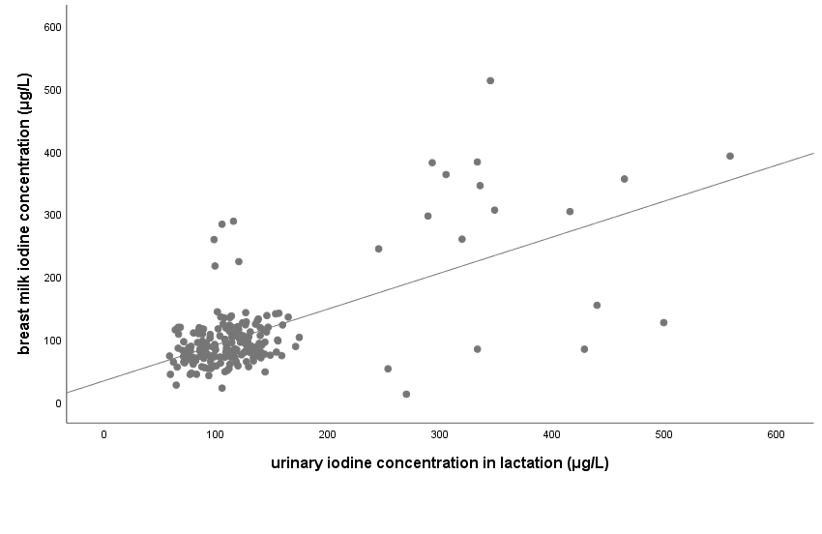
(A)
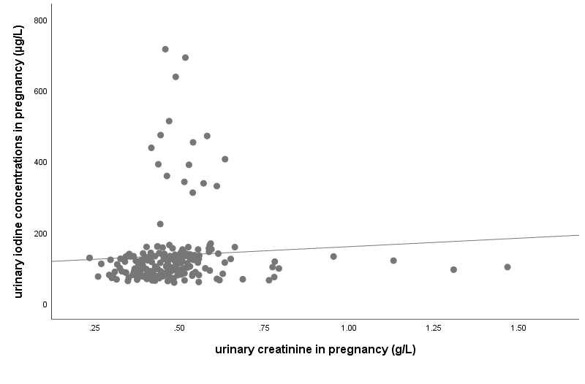

(B)

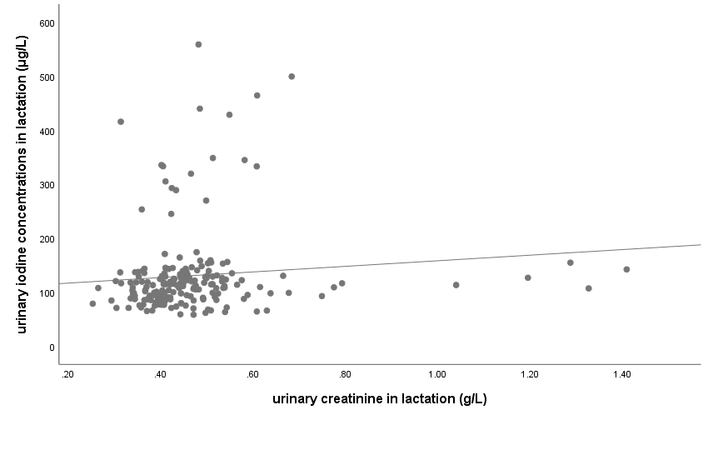
(C)
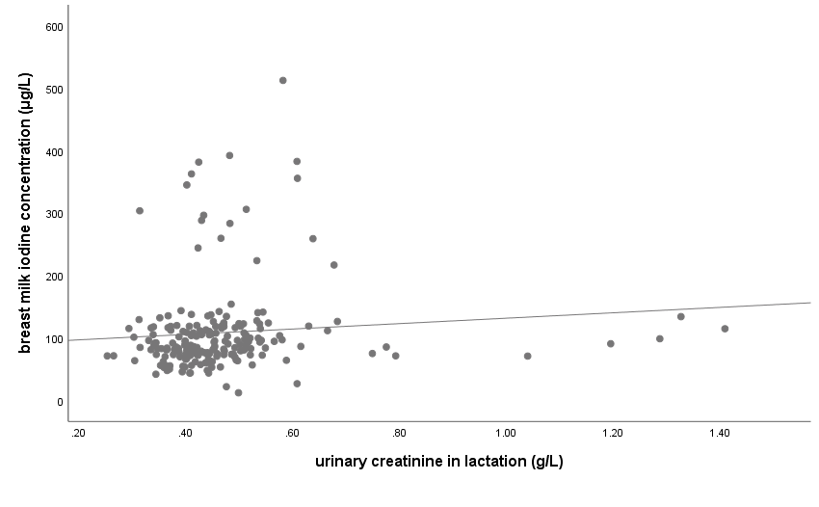
(D)

Figure 1. Scatter plots of 200 samples illustrating the correlation between (A) UIC during lactation and BMIC, (B) UCr and UIC during pregnancy, (C) UCr and UIC during lactation, and (D) UCr during lactation and BMIC.

Usefulness of BMIC in the assessment of iodine status

Figure 2 shows the area under the ROC curve for BMIC using UIC as a reference standard was 0.755 (95% CI: 0.644. 0.866), which was within the acceptable range (≥0.7) {Hosmer Jr, 2013 #300}. This suggested a 75.5% chance that BMIC would correctly distinguish iodine deficient breastfeeding women from iodine sufficient breastfeeding women. Therefore, BMIC could be used as a biomarker of iodine status in breastfeeding women.

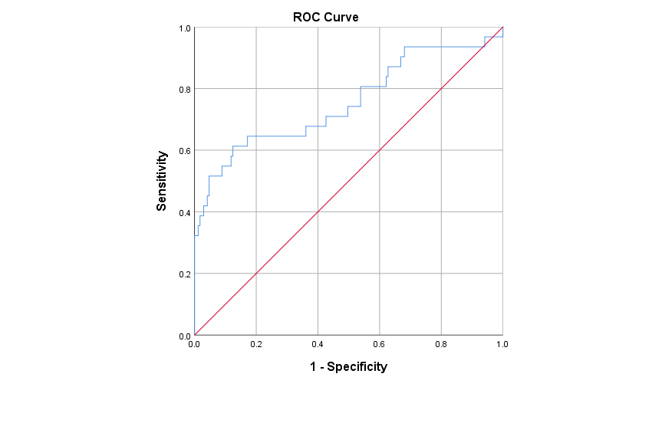
Figure 2. The ROC curve for BMIC using UIC as a reference standard, diagonal line indicates chance (area = 0.5)

Figure 3 indicates the optimal cut-off, in terms of optimising sensitivity and specificity of BMIC is 117 µg/L, with a sensitivity of 0.645 and a specificity of 0.828. This meant that if the cut-off value was used to test for iodine deficiency, it would correctly identify 64.5% of participants who were iodine deficient and correctly identified 82.8% of participants who were not iodine deficient. A NPV of 92.6% meant that 92.6% of participants who tested negative for iodine deficiency actually did not have the deficiency, while a PPV of 39.2% meant that 39.2% of participants who tested positive for iodine deficiency actually had the deficiency. These values indicated that the BMIC cut-off value of 117 µg/L was a good balance between accurately identifying iodine deficiency and avoiding false positives.

Figure 3. Plot of sensitivity and specificity, were lines cross is optimum value for classifying women as either being iodine sufficient or insufficient.

Table 4 shows the regression analysis for the predictors of BMIC in breastfeeding women. The only significant predictor of BMIC was UIC during pregnancy. This suggested that if a women had a UIC pregnancy level greater than the UIC cut-off value, the women was eight times more likely to have a BMIC above the optimal cut-off (i.e, 117 µg/L) when compared to a women with a UIC pregnancy level below cut-off. However, the 95% confidence level suggested that this difference may be as low as 3.5 times or as high as 18.6 times.

Table 4. Predictors of BMIC in women.
 | Unadjusted Coef. |  |  |  | Adjusted Coef. ^{h}
 | β | OR |  | 95% CI | β | OR | 95% CI
Age | 0.008 |  | 1.008 | 0.530, 1.915 | 0.273 | 1.313 | 0.634, 2.721
UIC pregnancy | 2.091 |  | 8.094 | 3.521, 18.608 * | 2.090 | 8.086 | 3.414, 19.154 *
UIC lactation | 0.550 |  | 1.733 | 0.863, 3.479 | 0.316 | 1.371 | 0.642, 2.930
Delivery type ª | -0.263 |  | 0.796 | 0.404, 1.464 | -0.311 | 0.732 | 0.356, 1.506
Occupation ^{b} | 0.143 |  | 1.154 | 0.513, 2.595 | 0.248 | 1.281 | 0.522, 3.144
Education ^{c} | 0.070 |  | 1.072 | 0.547, 2.101 | -0.139 | 0.870 | 0.413, 1.833
BMI ^{d} | 0.165 |  | 1.179 | 0.391, 3.550 | - | - | -
Pregnant history-Term | 0.198 |  | 1.218 | 0.642, 2.314 | - | - | -
Pregnant history-Preterm | -0.027 |  | 0.973 | 0.099, 9.572 | - | - | -
Pregnant history-Abortuses | -0.088 |  | 0.916 | 0.604, 1.388 | - | - | -
Pregnant history-Living | 0.142 |  | 1.153 | 0.607, 2.187 | - | - | -
Use of iodised salt ^{e} | 0.216 |  | 1.241 | 0.889, 1.733 | - | - | -
Use of supplement in preganancy ^{f} | 0.095 |  | 1.100 | 0.565, 2.141 | - | - | -
Use of supplement in lactation ^{g} | 0.183 |  | 1.201 | 0.612, 2.357 | - | - | -
ª Categories for delivery type: 0 = natural birth, 1 = cesarean birth. ^{b} Categories for Occupation: 0 = employed, 1 = non-employed. ^{c} Categories for education: 0 = completed high school or lower education, 1 = higher education. ^{d} Categories for BMI: 0 = normal weight, 1 = under/over weight. ^{e} Categories for use of iodised salt: 0 = use, 1 = not use/unknown. ^{f} Categories for use of supplement in pregnancy: 0 = use, 1 = not use. ^{g} Categories for use of supplement in lactation: 0 = use, 1 = not use. ^{h}Adjusted for variables of age, UIC pregnancy, UIC lactation, delivery type, occupation and education in the model. Dependent variable: BMIC (cut-off of 117 µg/L). * significant (P<0.05).

Discussion

This study was one of the first studies to use the BMIC reference range proposed by Dold et al., which is for exclusively breastfeeding women residing in iodine sufficient regions {Dold, 2017 #80}. Our study was conducted in an iodine sufficient region of China utilising a number of biomarkers of iodine status, including BMIC. The overall median BMIC in the first week of lactation was 89 μg/L, which was indicative of iodine sufficiency based on the BMIC reference of 60-465 μg/L suggested by Dold et al {Dold, 2017 #80}. WHO recommends that breastfed infants receive adequate amounts of iodine in their diet to ensure a normal growth and development. Breast milk is the only dietary source of iodine for breastfed infants. BMIC is primarily influenced by the maternal dietary iodine intake {Kirk, 2012 #187}. Women who had low iodine intake were reported to have a lower BMIC compared to women with sufficient iodine intake. Other factors such as stages of lactation and the geographical location of the women have been reported to affect BMIC. Women who lived in regions with naturally low soil iodine concentration were likely to have lower BMIC {Zimmermann, 2009 #25}. Due to the collection of breast milk on the 3rd day postpartum, it is possible that some women would still be producing colostrum, while others are likely to be producing transitional milk {Tudehope, 2013 #304}. In studies from the USA, Germany, Italy, China, New Zealand, Korea and Morocco, BMIC appeared to be highest in colostrum and decreasing throughout lactation, although not all studies have reported this pattern {Dror, 2018 #279;Andersson, 2012 #27;Mulrine, 2010 #57;Andersson, 2022 #289}. We could assume that BMIC will fall below the reference range for later mature milk,

This study reported that the area under the ROC curve for BMIC using UIC as a reference standard was 0.755, which was within the acceptable range. In addition, using the plot of sensitivity and specificity, our study reported an optimal BMIC cut-off of 117 µg/L might be used for categorising iodine sufficiency in lactating women residing in an iodine sufficient region. Although there have been many proposed BMIC cut-offs to determine iodine sufficiency in lactating women, the most commonly used BMIC cut-offs in the literature are 75 and 100 μg/L {Bazrafshan, 2005 #69;Azizi, 2009 #68;Semba, 2001 #73;Delange, 2007 #76;Dold, 2017 #80}. However, there is still no scientific consensus on the agreed BMIC cut-off. One of the possible reasons is because the iodine needs for infants are still inconclusive {Andersson, 2022 #289}. In addition, the breastmilk samples from the published studies had different collection periods of lactation (varied from days/weeks to months), making the comparison of BMIC between studies with different breast milk collection periods of lactation difficult. More studies assessing BMIC along with UIC and thyroid function in mother-infant pairs are warranted to define a median BMIC cut-off for assessing iodine sufficiency in lactating women residing in iodine deficient and sufficient regions.

This study found that while women were iodine deficient (median UIC <150 μg/L) during pregnancy, they were categorised as iodine sufficient (median UIC ≥100 μg/L) during lactation. Despite both the median UIC values of women during pregnancy and lactation were being similar (i.e., 112 μg/L and 113 μg/L, respectively), the categorisation of iodine status for pregnant and lactating women were different in this study. This suggested a change in the iodine profile of women through pregnancy and into lactation. This is because the median UIC cut-off to determine iodine sufficiency in lactating women is 100 µg/L, which is lower than pregnant women because in lactating women, ingested iodine is excreted both in urine and breast milk. Therefore, due to the variation in the partition of iodine between breast milk and urine, both BMIC and UIC are recommended to be included when assessing iodine status in breastfeeding women {Brough, 2022 #291}. On the other hand, the median UIC cut-off value for classifying iodine sufficiency during pregnancy is 150 μg/L, which was established on the basis of an average daily urine volume of 1.5 L {World Health Organization (WHO), 2007 #46}. However, during pregnancy there is an increase in the glomerular filtration rate, which leads to increased daily urine volume and subsequently lowers UIC, and this may overestimate the prevalence of iodine deficiency in pregnant women {World Health Organization (WHO), 2007 #46;Andersson, 2007 #16}.

It is challenging to recruit women in the early stages of lactation {Zhao, 2018 #283}. New mothers, particularly first-time mothers are unlikely to interrupt breastfeeding at the early stage of lactation because this is a critical period for the establishment of exclusive breastfeeding {Agostoni, 2009 #284;Zhao, 2018 #283}. Our study had 57.5% of first-time mothers. Furthermore, breast milk is considered precious and beneficial for infants in Chinese culture. For these reasons, it can be difficult to recruit women to take part in this type of research. Robust data on iodine status, especially BMIC is scarce {Liu, 2022 #286}. One of the challenges of this study was collecting breast milk samples from breastfeeding women due to limited volumes of breast milk produced. During the first week of lactation, only small volumes of breast milk (i.e., mean volume on the first 24 hours after birth and third day of lactation is 37.1 (range 7.0–122.5) g and 408 (range 98.3–775) ){Saint, 1984 #285}. Breastfeeding women encountered difficulties expressing enough milk. Our data should be interpreted with caution because spot samples of breast milk and urine were used to assess iodine status in our study. Future studies should consider collecting breast milk and urine samples over 24 hours total to calculate the daily iodine excretion from lactating women with different iodine intake levels. This will provide a more comprehensive assessment of iodine status in lactating women.

This study has several strengths. Firstly, two biomarkers of iodine status, BMIC and UIC were used in assessing iodine status of breastfeeding women. The UIC values during lactation were derived from spot urine samples collected from two consecutive days. Although it is suggested that at least ten spot urine samples are needed to reliably assess individual iodine status, it was not feasible to obtain in this study. It is suggested that two spot urine samples provide a better estimate of iodine status compared to a single spot urine sample {König, 2011 #143}. The participants in this study consisted of a rather homogenous group of women with similar age and BMI ranges. Second, breast milk samples were collected during the first week of lactation, which few studies have performed. Third, the urine and breast milk samples were collected during the same time period, which can reflect better comparability of the iodine status. In addition, to our knowledge, this was the first study to evaluate BMIC of breastfeeding women in China using the reference range of 60–465 μg/L proposed by Dold et al. {Dold, 2017 #80}.

Despite its considerable strengths, this study was limited by the failure to follow up for a longer period of time to obtain subsequent samples. This is because the pandemic of coronavirus disease 2019 (COVID-19) affected some aspects of this study, including recruitment of participants. In addition, women usually left the hospital and return home on the 4th day of postpartum, making continued follow-up and sample collection difficult.

Conclusions

This study demonstrated that women were iodine sufficient in the first week of lactation. In addition, these findings supported the proposed BMIC reference range of 60-465 μg/L for a group of exclusively breastfeeding women in our region. More studies on the usefulness of BMIC as a biomarker of iodine status are warranted in breastfeeding women and infants with varying iodine status and lactation stages.

Acknowledgements

We were extremely grateful to all the participants who took part in the cohort study.

This work was supported by the Research Development Fund (RDF) (reference no. RDF-18-01-15) from Xi’an Jiaotong-Liverpool University.

Conflict of interest

The authors declare no conflict of interest.

Author Contributions

S.L. (Shuchang Liu), A.S, S.S., X.L., E.V. and Z.F.M. were responsible for the study design. S.L. (Shuchang Liu) was responsible for research tool development, participant recruitment, field investigation, data collection, statistical analysis and wrote the first draft of the manuscript. S.L (Steven Lane) assisted with the statistical analysis. All authors read and approved the final manuscript. All authors reviewed the manuscript.

References

