An Inquiry into The Form-Giving Activity For The Design of Technology-Driven Products

Fazil Akin,
PhD Student, HfG Offenbach am Main
Lecturer, University of Liverpool

The research is part of a practical part of a PhD in Design. The PhD Program consists of one-third of a practical project, two third of a theoretical project. The theoretical project is concerned with human-technology relations, more specifically definition of the role of the mediating effect of technologies and their evolution.

The practical part, which is the subject of this short article, aims to question the role of the form of a technology-driven product. If we think of novel products which are a part of a larger system, such as personal speech assistants or mobile phones or entertainment products. The research would like to investigate the role of the form-giving activity of industrial designers in a complex product development system. Products are part of systems that are connected to other systems of technologies and also are connected to the experiences of humans or they are designed to get along with the experiences of humans.

  - Products as Touchpoints
Richard Buchanan (2001) famously defines the practice of design in four orders; from a symbol level to a level of thought, the designer's work becomes more complex. The designed artefacts are part of a complex system and therefore need attention from several dimensions. Polaine (2020) describes this phenomenon by indicating several layers of systems that a single touch point, in this case, a product, is part of.

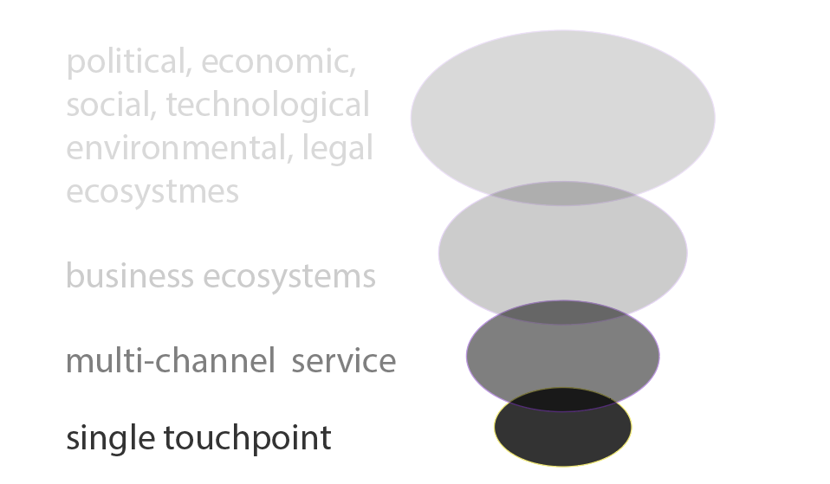

[redrawn from Polaine, 2020]

  - Products in the complex Systems
From a different dimension, philosopher Luciano Floridi (2014) suggests that the technologies we use in our daily lives could be categorised into three orders. The first-order technologies are between humans and nature, the second-order technologies between humans-technologies and other technologies such as a screwdriver and third-order technologies do not need a human; they are just in-between other technologies such as some robots or Internet-of-Things devices that are controlled by algorithms. Our smartphones, tablets, or smart assistants can be considered a cumulation of many third-order technologies. The object itself is still a second-order technology as it can take commands from humans. Kolko’s (2008) semantic zoom, as mentioned by Polaine (2022), may reveal this complexity by zooming out and zooming in on the systems in which the products are being operated in. If we think that the products are related to humans in terms of building an experience for the user in terms of aesthetic experience, experiences of meanings and emotional experience (Hekkert & Desmet, 2008), the complex duty of a designer begins to unfold. A work-in-progress framework for such a design task could be seen as follow:

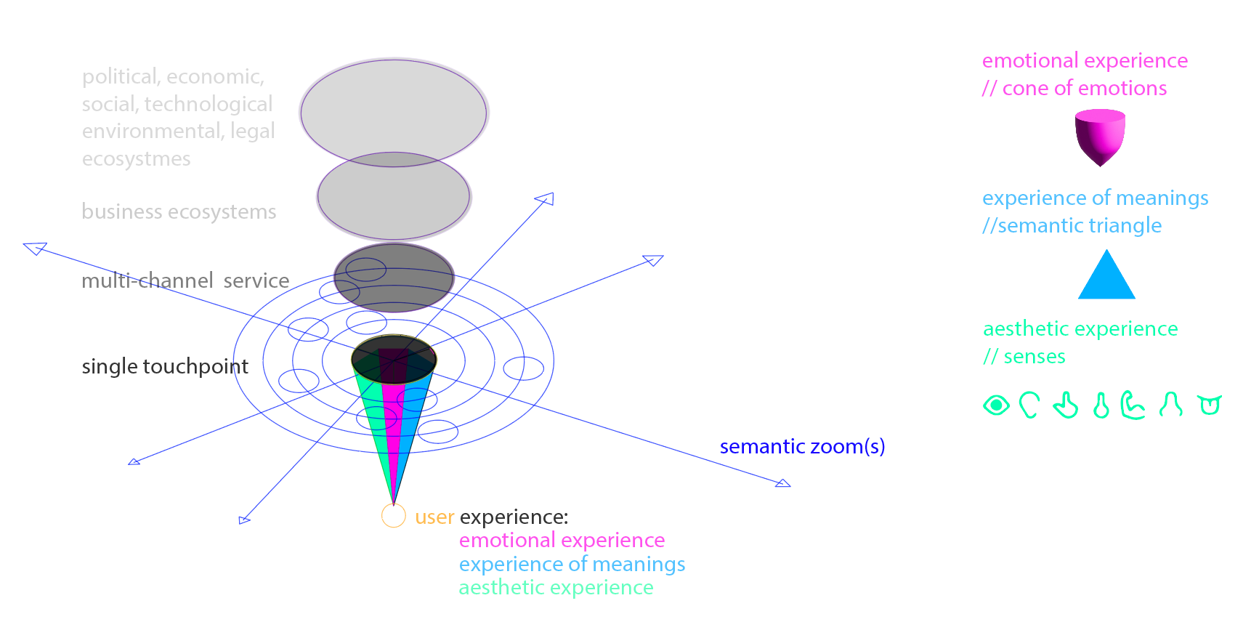
[a combination of ( Polaine, 2022); (Kolko, 2008); (Hekkert & Desmet, 2008) ]

This short article will focus on the forms of the products, which is the first part of the research. If we consider the systems the products are operating and the properties that the products have, their form of them is quite a limited part of the overall task of an industrial designer is pursuing to achieve. On the other hand, humans are considered ‘visual animals’. Rudolf Arnheim (1969) describes the role of visuals in cognitive processes. It wouldn’t be a surprise to think that designers are considering the visual perception of the products very precisely (Nefs, 2008). The challenge for such a design task is also related to the many abilities such products as technological devices nowadays have. If we can focus on the decisions made by the designers for the shape of such products, although this would be just a small part of the complex and thorough decisions they need to handle, we can say that those devices no longer have ‘signs’ (Krippendorf, 1989) that would guide the user on what kind of functions they may ‘afford’ (Norman, 2002). Therefore, many of them remain a black box in which the user cannot denote their function by looking at their form.

  - The Role of Form-Giving for Product Designer
The research aims to tackle this issue by asking the questions of ‘Do technological devices can have distinctive forms where they can communicate their complex abilities?’ and ‘Which kind of strategies could be used to widen the palette of the shapes such technological devices use?’ or ‘How could we underline the roles of these products in our daily life through distinctive forms?’.

One of the answers to these questions would be to consider these devices as ‘living tools’ (Floridi, 2014) and, from a perspective of animism, they can be defined as ‘zoomorphic robots’ (Löffler et al., 2020). Ko (2017) summarises the approach of animism with several features: “…form (affordance and familiarity), movement and motion (behaviour and perceived agency), adaptability (contextual awareness) and, maturability (temporal and emotional elements), and participation (use of various interaction modalities).” This approach can help to overcome the black box-ness many technological objects around us have.

  - Experiments for New Forms
The following steps of the research will include market research that reviews technological products with a zoomorphic form and lists their ‘animatic’ features of them. As a design problem, the research will develop strategies to widen the form palettes of existing black box products. One experimental way of doing this would be to design a second shell that would incorporate animistic features. Such second shells would allow a conversation about the form-giving practice of design without limiting the practice of design to forms. Another outcome would be to give a second life to obsolete technological products that are materially still well-preserved and functional.

A series of products that use zoomorphic shapes or shapes from animal metaphors, similar to those cited in Cila (2008), have been identified. The first prototypes of the second shells are designed and produced. The next step for the work is to develop these shells and identify a methodology for the form-giving aspect of design that could be integrated into the complex process of the design tasks for technological products.

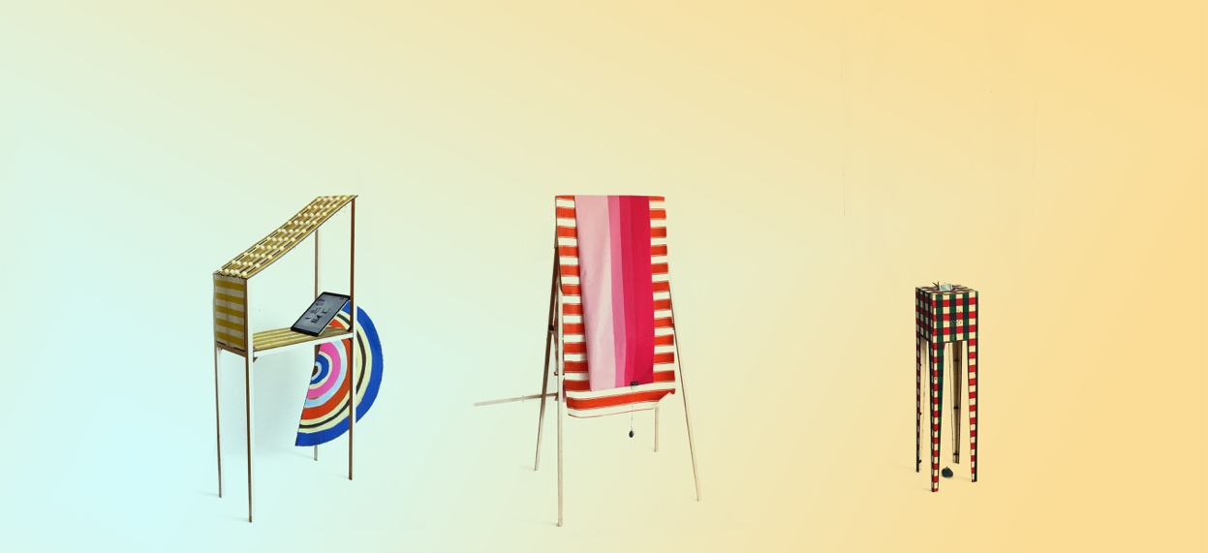
[first form experiments of the second shells)]

The final outcome of this research would be a methodological approach for widening the forms of technological products that could be integrated into the complex process of designing a product. The outcome would be to start a conversation about the forms of our technological products rather than solve a problem related to their forms. Mapping different tasks and responsibilities of industrial designers to develop technology-driven products is another core aspect of the outcome.

  - References
Arnheim, R. (1969) Visual Thinking. California: University of California Press.

Cila, N. (2013) Metaphors we design by: The use of metaphors in product design. PhD thesis. Delft University. Available athttps://repository.tudelft.nl/islandora/object/uuid%3Ab7484b0f-9596-4856-ae9d-97c696f9de79 (Accessed: 30th of March 2023).

Desmet, P. and Hekkert, P. (2007) ‘Framework of product experience’. International journal of design, 1(1), pp.57-66.

Floridi, L. (2014) The fourth revolution: How the infosphere is reshaping human reality. Oxford: Oxford University Press.

Ko, J. (2017) Designing with animism. MA thesis. Carnegie Mellon University. Available athttps://kilthub.cmu.edu/ndownloader/files/12258137 (Accessed: 29th of January 2023).
Krippendorff, K. (1989) ‘Product semantics: A triangulation and four design theories’, in S. Väkekä (ed.) Product semantic '89. Helsinki: University of Industrial Arts. Available at http://repository.upenn.edu/asc_papers/254 (Accessed: 29th of January 2023).
Löffler, D., Dörrenbächer, J. & Hassenzahl M. (2020) ‘The Uncanny Valley Effect in Zoomorphic Robots: The U-Shaped Relation between Animal Likeness and Likeability’. Proceedings of the 2020 ACM/IEEE International Conference on Human-Robot Interaction (HRI’20), March 23–26, 2020, Cambridge, UK. Available at https://doi.org/10.1145/3319502.3374788
Nefs, H. T. (2008) On the visual appearance of objects. In P. Hekkert & H. J. Schifferstein (Eds.), Product Experience (pp. 11-39). Amsterdam: Elsevier.

Polaine, A. (2020) Boiling the Ocean: Complexity, Service Design, & Systems Thinking. Available at https://www.youtube.com/watch?app=desktop&v=Css8rwBfIMw (Accessed: 30th of March 2023).

