Article
Citation: Bardell, D.; Rocchigiani, G.; Ressel, L., Milner, P. Histological evaluation of resected tissue as a predictor of survival in horses with strangulating small intestinal disease. Animals 2022, 12, x. https://doi.org/10.3390/xxxxx
Academic Editor: Firstname Lastname
Received: date
Accepted: date
Published: date
Publisher’s Note: MDPI stays neutral with regard to jurisdictional claims in published maps and institutional affiliations.
Copyright: © 2022 by the authors. Submitted for possible open access publication under the terms and conditions of the Creative Commons Attribution (CC BY) license (https://creativecommons.org/licenses/by/4.0/).
Histological evaluation of resected tissue as a predictor of survival in horses with strangulating small intestinal disease
David Bardell ^{1,} *, Guido Rocchigiani ², Lorenzo Ressel ² and Peter Milner ¹
¹ Department of Equine Clinical Sciences, Institute of Infection, Veterinary and Ecological Sciences, University of Liverpool, Leahurst Campus, Chester High Road, Neston, CH64 7TE.
² Department of Veterinary Anatomy Physiology and Pathology, Institute of Infection, Veterinary and Ecological Sciences, University of Liverpool, Leahurst Campus, Chester High Road, Neston, CH64 7TE.
* Correspondence: david.bardell@liverpool.ac.uk.
Simple Summary: Equine colic is a serious and potentially life-threatening clinical problem. This is particularly so when the condition is due to strangulation of the small intestine which requires part of it to be surgically removed (resected). Failure to re-establish functional motility post-operatively is a common reason for post-operative euthanasia, even if surgery has been successfully accomplished. Margins for resection are typically determined by gross appearance of the small intestine combined with appropriate preservation of vascular supply to the remaining tissue. We hypothesized that histological evaluation of resected intestine could highlight changes indicative of unhealthy gut tissue left in situ, which could predict likelihood of continued intestinal dysfunction and therefore likelihood of survival. We graded the histological appearance of grossly normal and abnormal tissue resected from horses with strangulating small intestinal lesions and control tissue taken from horses euthanised for reasons unrelated to intestinal disease. There was no difference between the histological scores of grossly looking normal regions of resected tissue and control tissues, nor was this associated with survival post-surgery. Grossly abnormal resected tissue was significantly different to control tissue and those horses in which the histological appearance showed greatest tissue disruption proximally (orally) demonstrated longer survival times.

Abstract: Strangulating small intestinal disease (SSID) in horses carries a poor prognosis for survival, especially following resection of ischaemic tissue. Margins of resection are principally based on visual appraisal of intestine during surgery. We hypothesized that histological evaluation of resected tissue may identify occult changes indicative of prognosis. Small intestine from 18 horses undergoing resection for SSID and nine horses euthanised for reasons unrelated to gastrointestinal pathology were utilised. Histological appearance was used to generate a ‘total damage score’ (TDS) for control tissue, grossly normal tissue at oral and aboral extremities (sections OR1 and AB1) of resected intestine and oral and aboral extremities of visually abnormal tissue (sections OR2 and AB2) from SSID horses. Relationship between TDS and long-term post-operative survival was investigated. TDS was not different between control tissues and OR1 and AB1 sections. Five surgical cases were alive at follow-up, the longest follow-up time being 2561 days. Based on median scores for SSID cases versus controls, cut-off values were generated to evaluate post-operative survival versus TDS. Only OR2 TDS was significantly associated with survival; a higher (worse) score indicating longer survival. More severe tissue insult may expedite rapid progression to surgery, improving post-operative outcomes.

Keywords: equine; colic; prognosis; ischaemic bowel disease; intestine; pathology

1. Introduction

Colic in horses is a serious and potentially life-threatening clinical challenge. Whilst both aetiology and anatomical location of the pathological processes can be very diverse, colic due to small intestinal obstruction is associated with significantly poorer survival than that due to caecal or large intestinal obstruction [1, 2]. Likelihood of survival is further decreased with strangulating rather than simple obstruction and if resection following ischaemic insult is required [3, 4]. If resection of compromised small intestine is deemed necessary, the oral and aboral margins of tissue bracketing the devitalized intestine are determined largely by subjective evaluation of gross appearance and surgeon experience, in conjunction with ensuring appropriate preservation of mesenteric vasculature to maintain effective perfusion of the intestine to be left in situ. Post-operatively, mortality is most likely to occur in the first 7-10 days, and is frequently consequent to recurrence of colic signs, post-operative ileus and cardiovascular instability consistent with endotoxaemic shock [5, 6, 7]. Despite successful surgery, failure to re-establish normal propulsive motile function in the early post-operative period can result in the destruction of the horse. Histological changes associated with ischaemia-reperfusion injury of small intestine have been investigated experimentally in several species, including mice [8], rats [9], dogs [10], pigs [11], man [12] and horses [13, 14, 15, 16, 17]. In the horse, histological changes in tissue resected from clinical cases of strangulating small intestinal disease (SSID) have been described [18, 19, 20], but information on correlation of these with outcomes is sparse. Meschter et al (1986) included 30 horses with a range of primary lesions, nine of which were classified as SSID. Of these only one survived, but the duration of survival/non-survival is not stated [18]. Gerard et al (1999) only evaluated mucosal and serosal layers, and reported six out of nine horses were alive two years later [19]. De Ceulaer et al (2011) reported morphological changes in mucosal and muscularis layers in 18 horses with SSID, but provide no information on outcome [20]. We hypothesized that histological evaluation of the margins of resected small intestine sections may identify occult changes which could act as prognostic indicators for survival following surgery. This study aimed to investigate if presence or severity of degenerative changes identified histologically in resected small intestinal tissue could provide a useful mechanism for predicting post-operative survival in horses suffering from SSID. The objective was to determine if tissue architecture of full thickness samples from oral and aboral margins and regions of transition from grossly normal to abnormal appearance of small intestine resected from horses with SSID differed from that of control tissue obtained from horses without gastrointestinal disease. Survival analysis was then performed to investigate the relationship between histological grading and post-operative survival.

2. Materials and Methods

This case-control study was conducted over a two year period, following institutional ethical approval (RETH000689; VREC219a). Horses admitted to the University of Liverpool Philip Leverhulme Equine Hospital for investigation of acute abdominal disease and taken to surgery with a presumptive diagnosis of small intestinal obstruction were considered eligible for inclusion. Clinical data collected at presentation included heart rate (bpm), total plasma protein (g/L), packed cell volume (PCV, %) and peripheral blood lactate (mmol/L). If small intestinal strangulation requiring resection was identified at surgery, horses were included in the study and tissue samples collected. Contents of the affected intestinal segment were evacuated aborally and bowel clamps applied orally and aborally to delineate the section for removal. Mesenteric vessels were then ligated and transected prior to removal of the intestinal segment by sharp dissection. The resected segment was then measured (cm), photographed and five millimeter thick, full circumference, cross sectional slices taken from four locations:

- Approximately 1 cm from the oral and aboral extremities (OR1 and AB1 respectively), avoiding tissue which had been compressed by the application of the intestinal clamps, to represent as closely as possible the condition of tissue left in situ.

- At the regions of most visually obvious change from normal to abnormal tissue (the transition zone), samples were taken of the tissue of most abnormal appearance adjacent to the transition zones at both oral and aboral ends (OR2 and AB2 respectively) (Figure 1).

Ileal involvement (yes/no) and type of anastomosis performed (jejuno-jejunal, jejuno-ileal and jejuno-caecal) was also recorded.

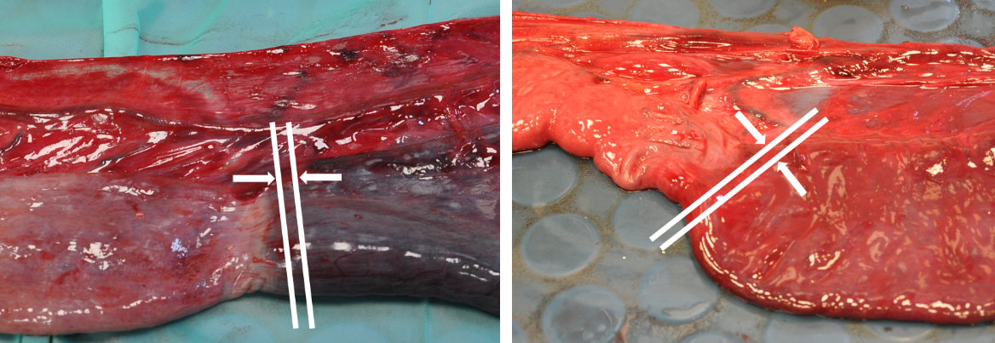

Figure 1. Representative images illustrating oral (left) and aboral (right) transition zones. White lines and arrows demarcate locations from where sections OR2 and AB2 were taken.

Control tissue was obtained from horses euthanised for conditions unrelated to the gastrointestinal system. Euthanasia was effected by injection of a combination of quinalbarbitone and cinchocaine (Somulose®, Dechra, UK) following placement of a jugular venous cannula specifically for this purpose. Once death had been confirmed, a ventral midline incision was made, a short length of small intestine exteriorized and a section approximately five centimeters long removed, from which a five millimeter thick, full circumference, cross sectional slice was taken for histological analysis.

Tissue slices were placed immediately into 10% formalin solution for 24 hours, before being transferred into tissue cassettes. Formalin fixation, dehydration and infiltration was then performed in a Tissue-Tek vacuum infiltration automatic tissue processor using the following protocol:

• 10% formalin for 1 hour 45 minutes
• 70% ethanol for 30 minutes
• 70% ethanol for 30 minutes
• 86% ethanol for 30 minutes
• 96% ethanol for 1 hour 30 minutes
• Absolute ethanol for 1 hour 30 minutes
• Absolute ethanol for 1 hour 30 minutes
• Xylene for 1 hour
• Xylene for 2 hours
• Wax 1 for 1 hour
• Wax 2 for 1 hour
• Wax 3 for 1 hour
• Wax 4 for 1 hour

Paraffin embedded samples were then cut into 4 µm thick sections using a Leica RM2125 RT microtome, placed on slides, dewaxed, rehydrated, stained using haematoxylin and eosin, and mounted in DPX.
Sections were examined at 10X objective magnification by light microscopy and histological appearance was graded according to the scheme give in Table 1. Examination and grading were performed blind, by a single operator (G.R.) who was unaware of origin of specimens and clinical outcomes of cases. Representative images are shown in Figures 2 to 5. Grades for each mural layer were then summed to produce a total damage score for each intestinal section.

Table 1. Grading scheme applied for histological scoring of sections. Percentages given are per five 10X fields; GS = Gruenhagen’s space.

Grade | Mucosal Damage | Submucosal damage | Muscularis Damage | Serosal Damage
0 | Epithelium >80% intact with GS¹, proprial haemorrhage and intraepithelial erythrocytes in less than 20% of villi.  Proprial oedema and subepithelial clusters of macrophages might be present. | No changes to mild degree of submucosal oedema. | No changes are observed. | Mild areas of oedema in <20%
1 | Epithelium ≥80% intact with GS and proprial haemorrhage, degeneration and necrosis of epithelial tips in 20-80% of villi. | Diffuse submucosal oedema with scattered small haemorrhages (in ≤20% of tissue examined) | Muscular bundles show increased intercellular space (oedema) with no haemorrhage. | Serosal oedema in ≥20% of tissue examined with no  haemorrhage.
2 | Epithelium 40-80%intact with multiple epithelial ulcers, necrosis and proprial haemorrhage. | Diffuse submucosal oedema with multiple, coalescing haemorrhages (20-60% of tissue examined). | Muscular bundles show increased intercellular space with haemorrhage in 20-40% of tissue examined. | Serosal oedema in 20-60% of tissue examined with occasional haemorrhage.
3 | Epithelium <40% intact with common haemorrhage and necrosis effacing vast part of the mucosa. | Common and extensive submucosal haemorrhages (>60% of tissue examined). | Muscular bundles show common haemorrhage in >40% of tissue examined. | Common (>60% of tissue examined) serosal haemorrhage.

Figure 2. Photomicrographs of equine small intestinal sections illustrating histological appearance of mucosa relative to grading system. 100X total magnification, haematoxylin and eosin (for descriptors of grades see Table 1). Scale bar = 100 μm.

Figure 3. Photomicrographs of equine small intestinal sections illustrating histological appearance of submucosa relative to grading system. 100X total magnification, haematoxylin and eosin (for descriptors of grades see Table 1). Scale bar = 100 μm.

Figure 4. Photomicrographs of equine small intestinal sections illustrating histological appearance of muscularis relative to grading system. 100X total magnification, haematoxylin and eosin (for descriptors of grades 0-3 see Table 1). Scale bar = 100 μm.

Figure 5. Photomicrographs of equine small intestinal sections illustrating histological appearance of serosa relative to grading system. 100X total magnification, haematoxylin and eosin (for descriptors of grades see Table 1).

Follow-up data on clinical outcomes from surgical cases was obtained either from the hospital clinical management software programme (Tristan Veterinary Software, Aberdeen, UK) or by telephone contact with the veterinary surgeon or practice responsible for the initial referral, to determine if the horse was still alive. If the horse had been euthanised following discharge from hospital, we ascertained whether euthanasia had been related to colic symptoms or an unrelated reason.

2.1 Statistical analysis.

Data were analysed using SPSS Statistics for Windows, Version 27 (IBM Corp. Armonk, NY). Normality of data was checked using the Shapiro-Wilk test. Non-normally distributed data (peripheral lactate) were log transformed.
Chi-squared analysis was used to explore differences in histological total damage scores, between small intestinal samples from control horses and regions OR1, OR2, AB1 and AB2 of resected tissue from horses undergoing surgery for correction of small intestinal strangulation. Mann-Whitney U test was used to investigate differences in total damage scores for regions OR1, OR2, AB1 and AB2 between horses which had died or were euthanised for colic-related reasons and those still alive at follow-up. Two-sided Fisher’s Exact Test was used to investigate whether presence or absence of thrombotic vessels or serosal fibrin in regions OR1, OR2, AB1 and AB2 was associated with post-operative survival.
Univariable data analyses (Chi-squared analysis for categorical data and Student’s t-test for continuous data) were conducted for each explanatory variable (sex, horse type (Cob versus non-Cob), heart rate (bpm), total plasma protein (g/L), packed cell volume (PCV, %) and log peripheral blood lactate (mmol/L) at time of admission, histological score, serosal fibrin (yes/no) and thrombosis (yes/no) at sites OR1, OR2, AB1 and AB2, length resected (cm), ileal involvement (yes/no) and anastomosis type (jejuno-jejunal, jejuno-ileal and jejuno-caecal) in relation to outcome (dead/alive at follow-up).
Survival analyses were conducted using SPSS (IBM). For each horse, time-to-first event (“death”) was determined from surgery (days) with the presence of death recorded as 0/1. Log-rank tests and Kaplan-Meier curves were used to determine median survival time following surgery. Cut-off values were used from the median damage score (categorical value) for each section with the next whole integer (since a whole number scoring system is used) above this value used as the cut-point. Univariable Cox Proportional Hazards Models were constructed to assess the significance of the effects of histological scores on outcome with likelihood ratio used to test the fit of the model. Hazard ratios and corresponding confidence intervals were calculated for each variable alongside the P-value.
data are described as mean (95% CI) or median (IQR) with statistical significance considered at P-values <0.05. Where multiple comparison testing was performed, the Bonferroni correction was applied. A post-hoc power analysis was performed using G*Power (version 3.1.9.7).

3. Results

Samples were obtained from 27 horses; 18 undergoing resection of a strangulating small intestinal lesion and nine controls.
Horses undergoing surgery consisted of 13 geldings and five mares with mean age of 15.9 +/- 4.5 years. Clinical cases were a mixed population of horses representative of the caseload at the clinic, including seven Cobs, three Welsh ponies, three Thoroughbreds, one warmblood, one Irish Sports Horse, one Connemara pony, one Dales pony and one Friesian horse. Mean heart rate at presentation was 64 (± 24) bpm with mean PCV of 40 (± 6) %, total plasma protein of 68 (± 10) g/L and peripheral blood lactate of 2.6 (± 2.1) mmol/L. Cause of intestinal strangulation was pedunculated lipoma in 11 cases, epiploic foramen entrapment in five cases and incarceration through a mesenteric rent in one case. In one horse the cause was undetermined. Mean length of resection of small intestine was 400 (± 220) cm with ileal involvement in 5/18 cases. Jejunojenunal anastomosis was performed in 12 cases, jejunoileal anastomosis in four cases and jejunocaecal anastomosis in two cases. Control horses consisted of five geldings, one entire male and three mares with mean age of 10.7 +/- 6.7 years. Breeds included four Irish Draft crosses, two Thoroughbred crosses, two Cobs and one Andalusian.

3.1 Histological grading of cases and controls

Median histological scores were significantly higher for regions OR2 and AB2 compared to scores from control cases. Scores for OR1 and AB1 were not different to controls (P = 0.56 and 0.47 respectively). Total damage scores between survivors and non-survivors were not different for regions OR1, OR2, AB1 or AB2 (Table 2).

Thrombotic vessels were not observed in any control or OR1 samples. Thrombotic vessels were identified in all other regions, from both survivors and non-survivors, with submucosal vessels being most frequently affected. Serosal fibrin was identified in one control sample and in samples from all regions investigated from colic cases. Neither variable demonstrated a significant association with post-operative survival. Results are summarized in Table 3.

Table 2. Analysis of histological total damage scores of regions OR1, OR2, AB1 and AB2 in horses with strangulating small intestinal disease (cases; n=18) compared to control samples (n=9), and regions OR1, OR2, AB1 and AB2 between horses still alive at follow-up (n=5) and those which died or were euthanised for colic-related reasons (n=13). P<0.05 was considered significant.
Total Damage Score
(median (IQR))
 |  |  | Control  (n=9) |  |  |  | Cases  (n=18) |  | P-value
Histological score |  |  | 2 (1, 3) |  | OR1  OR2  AB1  AB2 |  | 3 (2,3)  9.5 (9, 11)  4 (2.75, 6.75)  10 (8.75, 11) |  | 0.56  0.003  0.47  0.02
Total Damage Score
(median (IQR))
Region | Survivors  (n=5) |  |  |  |  | Non-survivors  (n=13) |  |  |  | P-value
OR1 | 3 (3,3) |  |  |  |  | 3 (1,4) |  |  |  | 0.83
OR2 | 11 (7, 12) |  |  |  |  | 9 (8, 11) |  |  |  | 0.19
AB1 | 3 (2, 3) |  |  |  |  | 4 (2, 10) |  |  |  | 0.25
AB2 | 10 (8, 11) |  |  |  |  | 10 (7, 12) |  |  |  | 0.39

Table 3. Incidence of thrombotic vessels and serosal fibrin in regions OR1, OR2, AB1 and AB2 from horses with strangulating small intestinal disease (n=18) which did (n=5), or did not (n=13) survive post-operatively. P<0.05 was considered significant.

Thrombotic vessels
Region | Survivors (n=5) |  | Non-survivors (n=13) |  | P-value
 | n | Location | n | Location
OR1 | 0/5 | N/A | 0/13 | N/A | N/A
OR2 | 4/5 (80%) | Serosa, submucosa | 8/13 (62%) | Submucosa, muscularis, serosa | 0.62
AB1 | 1/5 (20%) | Submucosa | 3/13 (23%) | Submucosa, muscularis | 1.0
AB2 | 2/5 (40%) | Submucosa | 5/13 (38%) | Submucosa, serosa | 1.0
Serosal fibrin
Region | Survivors (n=5) |  | Non-survivors (n=13) |  | P-value
OR1 | 4/5 (80%) |  | 3/13 (23%) |  | 0.05
OR2 | 3/5 (60%) |  | 5/13 (38%) |  | 0.61
AB1 | 2/5 (40%) |  | 7/13 (54%) |  | 1.0
AB2 | 2/5 (40%) |  | 5/13 (38%) |  | 1.0

3.2 Survival following surgery

Follow-up data were available for all 18 surgical cases. Five horses were alive at follow-up with the longest reported follow-up time as 2561 days. Summary survival data are presented in Table 4.

Table 4. Summary of outcome data for surgical cases (n=18), ranked in length of survival (days). PPID = pars pituitary intermedia dysfunction. Y = yes; N = no.
Horse No. | Alive at follow up? | Time to event  (days) | Cause of death
1 | N | 0 | Cardiovascular collapse
2 | N | 1 | Post-operative haemorrhage
3 | N | 2 | Persistent colic signs
4 | N | 3 | Persistent post-operative reflux
5 | N | 4 | Persistent post-operative reflux
6 | N | 4 | Persistent post-operative reflux
7 | N | 5 | Persistent post-operative reflux
8 | N | 8 | Persistent colic signs
9 | N | 25 | Collapse
10 | N | 63 | Recurrent colic
11 | N | 66 | Recurrent colic
12 | N | 1300 | Laminitis/PPID
13 | N | 1724 | Recurrent colic
14 | Y | 2400
15 | Y | 2475
16 | Y | 2478
17 | Y | 2505
18 | Y | 2651

Based on the median scores for surgical cases versus controls, cut-off values for OR1 of <4, AB1 of <5, OR2 of <10 and AB2 of <11 were used to evaluate survival of horses post-surgery versus histological total damage scores. Kaplan Meier plots for OR1, OR2, AB1 and AB2 are shown in Figures 6 to 9 respectively. Median survival time for OR1 score <4 was 66.0 (0.0, 1700.8) days and OR1 score ≥4 was 8.0 (0.0, 17.6) days. For OR2 <10 the median survival was 4.0 (2.6, 5.4) days and OR2 ≥10 was 1724.0 (485.1, 2962.8) days, whereas for AB1 <5 median survival was 25.0 (0.0, 2218.1) days and for AB1 ≥5 was 4.0 (0.0, 52.0) days. Finally, median survival for AB2 <11 was 63.0 (0.0, 166.5) days and AB2 ≥11 was 8.0 (0.0, 33.2) days. Only the model for OR2 histological score showed a significant difference in survival (Figure 7). A post-hoc power analysis based on a calculated effect size of 0.7, demonstrated the study to have a power of 0.97.

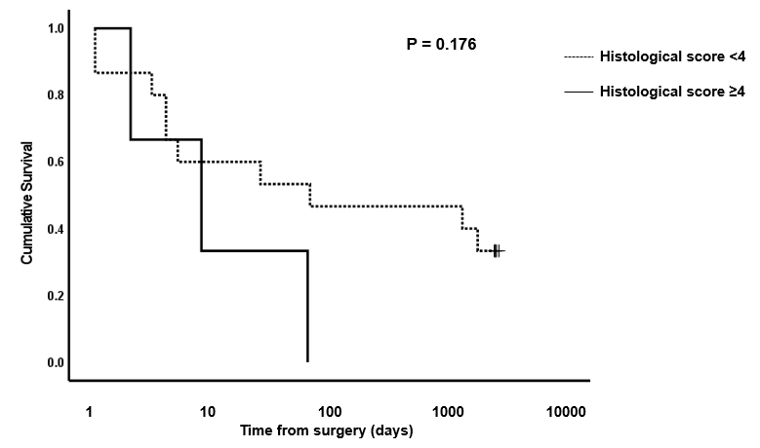

Figure 6. Kaplan-Meier survival plot for horses undergoing small intestinal surgical resection with histological scores of <4 or ≥4 at site OR1. P-value for log rank test between the two score boundaries is included. P<0.05 was considered significant.

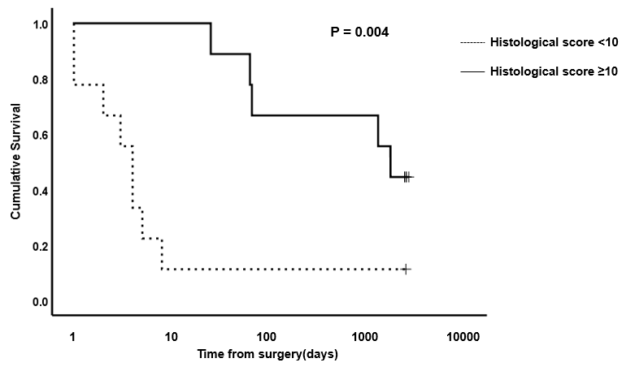

Figure 7. Kaplan-Meier survival plot for horses undergoing small intestinal surgical resection with histological scores of <10 or ≥10 at site OR2. P-value for log rank test between the two score boundaries is included. P<0.05 was considered significant.

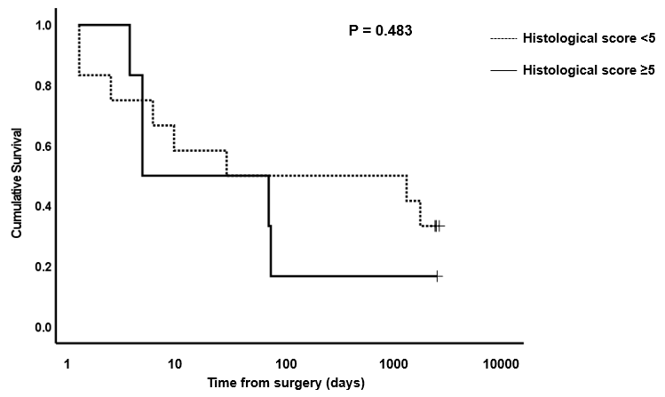

Figure 8. Kaplan-Meier survival plot for horses undergoing small intestinal surgical resection with histological scores of <5 or ≥5 at site AB1. P-value for log rank test between the two score boundaries is included. P<0.05 was considered significant.

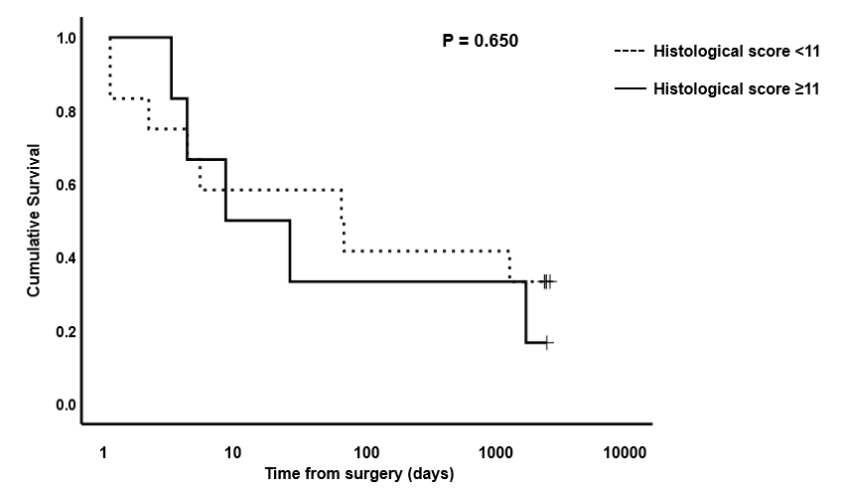

Figure 9. Kaplan-Meier survival plot for horses undergoing small intestinal surgical resection with histological scores of <11 or ≥11 at site AB2. P-value for log rank test between the two score boundaries is included. P<0.05 was considered significant.

4. Discussion

This study reports the association of histological grading of small intestine with survival in a population of horses suffering from strangulating small intestinal disease where resection was performed. We did not find an association with the histological appearance of the resected tissue adjacent to the margins left in situ (OR1 and AB1) with post-operative survival. Since the tissue adjacent to the margin left in situ was not significantly different to control tissue (using the grading system described in the present study), it suggests that the appraisal methods of tissue margins at surgery are appropriate means of determining structurally normal margins for resection. However, despite resection to grossly visually normal tissue, eight horses (44%) did not survive beyond 10 days, suggesting other factors such as ultrastructural and/or biochemical differences, not represented by our grading system, determine survival. Indeed, we did find that there was a relationship between tissue damage score at the most grossly abnormal section on the oral side (OR2) and survival, albeit that a higher (worse) score, was associated with longer survival, contrary to a previous study by Maescheter et al [18].

Survival to hospital discharge is a frequently used metric to describe successful surgical outcomes [4, 5], although this is an artificial and misleading metric to describe post-operative survival [6]. Of greater relevance to horse welfare, and the owner, is long term survival [5, 6, 21, 22], although ‘long term’ is variably interpreted as between 1 and 6 months [22], 24 months [5, 21], 2 years 9 months [6] and five years [23]. Where long term survival is reported, a triphasic survival curve has been described [5, 6, 21]. A high mortality rate is evident immediately following surgery, with a cumulative probability of survival of 0.87 by 10 days post-operatively, followed by a lower mortality up to approximately 100-120 days, then a further reduction interpreted as representative of the mortality equivalent to that of the general equine population [6]. These authors report a probability of survival for strangulating small intestinal cases of 0.7-0.8 by 100 days (depending on exact pathology). This triphasic survival curve is not dissimilar to our findings. In our study cohort 10/18 survived to hospital discharge, with median time to discharge being 12.5 (7-32) days. Of these 5 were still alive at follow up, survival beyond 66 days being associated with a low mortality rate (Table 4).

The finding that greater histological disruption was associated with increased post-operative survival is interesting, counterintuitive and difficult to explain. Ischaemic or necrotic bowel loses its bacterial barrier function, predisposing to development of peritonitis and septicaemia [24]. It is possible that more extensive disruption to barrier function resulted in greater bacterial and endotoxin translocation, in turn generating a more rapid and florid systemic inflammatory response, resulting in more extreme or rapidly progressive clinical signs which may have expedited the decision to proceed to surgery. It may thus be that these horses underwent more rapid surgical correction which impacted on their improved survival. Supporting the importance of a more active inflammatory response is our finding that, despite no difference in histological damage scores for this region between controls and colic cases, or between survivors and non-survivors, in region OR1 serosal fibrin was identified in 4/5 survivors compared to 3/13 non-survivors. However, it is important to recognize that this difference did not satisfy our criteria for achieving statistical significance (P=0.05, Table 3).

Failure to re-establish normal small intestinal propulsive motile function in the early post-operative period can result in the destruction of the horse. The interstitial cells of Cajal (ICC) are responsible for initiation of gastrointestinal slow wave activity and co-ordination of propulsive motility [25]. Significant reduction in density of these cells has been associated with multiple intestinal dysmotility syndromes in humans [25] and in equine dysautonomia [26]. Fintl and co-workers, however, reported no difference in small intestinal ICC density between control horses and those undergoing resection for small intestinal strangulating lesions, indicating other factors are more relevant [25]. We did not investigate ICC density in this study.

Both clinical and experimental reports have investigated structural disruption [13, 18, 19, 20], biochemical changes [19, 20, 27, 28] and cellular infiltration [17, 19, 20, 29] to assess severity of ischaemic GI insult. Disruption to electron transport chain function, reduced ATP, increased mucosal water content and decreased sodium and potassium content are reported after 2 hours of ischaemia-reperfusion in the ascending colon of ponies [27]. Our study focused on histological structural changes as histology represent a quick, practical and relatively cheap investigation compared to other techniques used for assessing ischaemic GI damage.

In equine non-survival studies, 30 minutes of ischaemic insult produces mild lesions, evident on routine histological evaluation, which progress both with continued duration of ischaemia, and once perfusion has been restored [13]. In canine ileal mucosal cells, ultrastructural degenerative changes are evident within 10 minutes of ischaemia, with light microscopy changes only detectable after 30 minutes [30]. One hour of ischaemia and reperfusion in equine jejunum produced extensive submucosal oedema, subepithelial and subserosal vesicle formation, with epithelial separation and sloughing [14]. Ultrastructural changes were less marked, with only mild intracytoplasmic vacuolation, intracellular organelles appearing within normal limits and cell to cell adhesion and basement membrane integrity largely unaffected [14]. These authors concluded that the main mechanism of damage is fluid accumulation into intercellular spaces and between enterocytes and the lamina propria, resulting in shedding of sheets of intact enterocytes. This is in broad agreement with White et al [13] who proposed mechanical disruption secondary to increased pressure from progressive fluid and haemorrhage accumulation. These changes progressed despite restoration of perfusion and evidence of muscular activity.

Assessment of cellular infiltrates can be difficult and subjective, particularly in mild or moderate disease, considering the variability in both numbers, proportions and distribution of normally resident leukocytes, and the presence of gut-associated lymphoid tissue aggregates [31]. Although typical leukocyte densities, types and distribution have recently been defined in the mucosa and submucosa of the main anatomical regions of small and large intestine of horses without evidence of GI disease [32], a diagnosis of GI tract inflammation must include assessment of architectural changes [31]. Indeed, architectural changes have been proposed as the most critical, and least subjective changes to evaluate in GI biopsies [31]. We were interested in changes throughout all layers, and particularly in grossly visually normal regions, where changes may be mild. We therefore chose to focus on structural changes in this study.

Several limitations to this study must be recognized. Firstly, this was a study utilizing clinical cases, therefore, lesion type, medication and management prior to admission to our hospital and surgical technique could not be standardized. Equally, duration of pathology could only be approximately determined, for a number of horses no more accurately than to within a 12 hour window, and was variable. Similarly, the length of time strangulated bowel was reperfused prior to resection differed and may have impacted on subsequent histological analysis. Location of tissue taken for analysis was based on visual appearance and obtained using as consistent techniques as possible, but there was some inevitable variation, particularly in relation to duration from surgical reduction of incarceration until acquisition of tissue samples. The gold standard for surgical gastrointestinal biopsies is that they are of sufficient depth, free of handling artefacts and orientated so that multiple full villus-crypt units with associated lamina propria can be evaluated [31]. The tissue collected for this study was full thickness, fully circumferential sections, which allowed assessment of all layers from mucosal to serosal epithelia. Consistent, stable positioning in tissue cassettes during processing additionally allowed visualization of multiple appropriately orientated sections to be evaluated. Due to routine surgical practices during small intestinal resection, however, handling artefacts could not be avoided, and it is possible that these may have influenced the interpretation of our findings.

The grading system used was a novel one, devised to assess changes in all layers of the equine small intestine, with the total damage score generated assuming equal weighting of injury from all layers, which may not accurately reflect biological reality. Previously published grading schemes have focused on mucosal and/or submucosal features [10, 13, 19], mucosal and smooth muscle cell degeneration [20], or serosal structure alone [33] and the authors are unaware of a previously reported system of objectively grading the architecture of all mural layers. Our results must therefore be interpreted in the context of application of an unvalidated assessment tool which may require further modification.

Finally, the small numbers involved in this study must be acknowledged. Whilst comparable studies have included equivalent or lower numbers of clinical cases [18, 19, 20], post-operative survival will be influenced by a large number of factors which cannot be controlled for in a population of client owned horses. It would be interesting to extend this work to a larger surgical population, to see if results can be reproduced. Additionally, grading cellular infiltration would be interesting to determine if this aspect can refine predictive power of survival.

5. Conclusions

In this study, we investigated the relationship of histological changes in small intestine resected from horses undergoing surgical correction of strangulating small intestinal disease with subsequent survival. Our survival analysis indicates a triphasic trajectory, in concordance with previous reports of long-term outcomes, and support the theory that more accurate prognostic information could be derived by routinely evaluating survival 2-3 months post-operatively. Our results were unexpected in two aspects; firstly, that histological appearance of tissue representative of normal-looking tissue left in situ is not useful in terms of predicting survival, and secondly that survival appears to be better in those horses displaying more severe tissue disruption towards the oral end of the strangulated segments. The reasons for this remain unclear, although it could suggest that more extensive damage to intestinal barrier function may have resulted in a more rapid progression to surgical correction, and hence improved survival. Our findings, however, must be interpreted with caution as we employed a novel, unvalidated grading scheme, in a small cohort of clinical cases. Further work could seek to expand the data set, include additional elements in the grading scheme, or to assess biochemical markers of intestinal viability as indicators of post-operative survival.

Supplementary Materials: None.
Author Contributions: Conceptualization, D.B and P.M.; methodology, D.B., P.M. and G.R.; validation, D.B and P.M.; formal analysis, D.B and P.M.; investigation, D.B., G.R; resources, D.B. and L.R; data curation, D.B, P.M. and G.R.; writing—original draft preparation, D.B and P.M.; writing—review and editing, D.B., P.M., G.R. and L.R.; visualization, D.B., P.M. and G.R.; supervision, D.B.; project administration, D.B., G.R and L.R.; funding acquisition, D.B. and P.M. All authors have read and agreed to the published version of the manuscript.
Funding: This research was funded by the University of Liverpool Veterinary Research Projects Support Fund (Ref VET002 VSRP).
Institutional Review Board Statement: This study was approved by the University of Liverpool Research Ethics Committee (Ref VREC219/VREC219a) on 21/05/2014.
Informed Consent Statement: This study was conducted under Institutional generic research consent form (RETH000689), following informed owner consent.

Data Availability Statement: Restrictions apply to the availability of these data. Data were obtained from clinical cases admitted to the University of Liverpool Philip Leverhulme Equine Hospital under Research Ethics Committee guidelines and are available from the authors with the permission of the University of Liverpool.
Acknowledgments: In this section, you can acknowledge any support given which is not covered by the author contribution or funding sections. This may include administrative and technical support, or donations in kind (e.g., materials used for experiments).
Conflicts of Interest: The authors declare no conflict of interest. The funders had no role in the design of the study; in the collection, analyses, or interpretation of data; in the writing of the manuscript; or in the decision to publish the results.

References

- Phillips, T.J. and Walmsley, J.P. Retrospective analysis of the results of 151 exploratory laparotomies in horses with gastrointestinal disease. Equine Vet J 1993, 25, 427-431.
- Christophersen, M.T., Dupont, N., Berg-Sørensen, K.S., Konnerup, C., Pihl, T.H. and Andersen, P.H. Short-term survival and mortality rates in a retrospective study of colic in 1588 Danish horses. Acta Vet Scand 2014, 56, 20.
- Allen, D., White, N.A. and Tyler, D.E. Factors for prognostic use in equine obstructive small intestinal disease. J Am Vet Med Assoc 1986, 189, 777-780.
- Mair, T.S. and Smith, L.J. Survival and complication rates in 300 horses undergoing surgical treatment of colic. Part 1: Short-term survival following a single laparotomy. Equine Vet J 2005, 37, 296-302.
- Freeman, D.E., Hammock, P., Baker, G.J., Goetz, T., Foreman, J.H., Schaeffer, D.J., Richter, R.A., Inoue, O. and Magid, J.H. Short and long term survival and prevalence of postoperative ileus after small intestinal surgery in the horse. Equine Vet J 2000, Suppl 32, 42-51.
- Proudman, C.J., Smith, J.E., Edwards, G.B. and French, N.P. Long term survival of equine surgical colic cases. Part 1: Patterns of mortality and morbidity. Equine Vet J 2002, 34, 432-437.
- Morton, A.J. and Blikslager, A.T. Surgical and postoperative factors influencing short-term survival of horses following small intestinal resection: 92 cases (1994-2001). Equine Vet J 2002, 34, 450-454.
- Lane, J.S., Todd, K.E., Lewis, M.P.N., Gloor, B., Ashley, S.W., Reber, H.A., McFadden, D.W., Chandler, C.F. Interleukin-10 reduces the systemic inflammatory response in a murine model of intestinal ischemia/reperfusion. Surgery 1997, 122, 288-294.
- Petrat, F., Rönn, T., de Groot, H. Protection by pyruvate infusion in a rat model of severe intestinal ischemia-reperfusion injury. J Surg Res 2011, 167, e93-e101. doi.org/10.1016/j.jss.2009.12.005.
- Chiu, C-J., McArdle, A.H., Brown, R., Scott, H.J., Gurd, F.N. Intestinal mucosal lesion in low-flow states. Arch Surg 1970, 101, 478-483.
- Blikslager, A.T., Roberts, M.C., Rhoads, J.M., Argenzio, R.A. Is reperfusion injury an important cause of mucosal damage after porcine intestinal ischemia? Surgery, 1997, 121, 526-534.
- Derikx, J.P.M., Matthijsen, R.A., de Bruïne, A.P., van Dam, R.M., Buurman, W.A., Dejong, C.H.C. A new model to study intestinal ischemia-reperfusion damage in man. J Surg Res 2011, 166, 222-226. doi:10.1016/j.jss.2009.09.046.
- White, N.A., Moore, J.N., Trim, C.M. Mucosal alterations in experimentally induced small intestinal strangulation obstruction in ponies. Am J Vet Res 1980, 41, 193-198.
- Arden, W.A., Slocombe, R.F., Stick, J.A., Parks, A.H. Morphologic and ultrastructural evaluation of effect of ischemia and dimethyl sulfoxide on equine jejunum. Am J Vet Res 1990, 51, 1784-1791.
- Horne, M.M., Pascoe, P.J., Ducharme, N.G., Barker, I.K., Grovum, W.L. Attempt to modify reperfusion injury of equine jejunal mucosa using dimethylsulfoxide, allopurinol and intraluminal oxygen. Vet Surg 1994, 23, 241-249.
- Tomlinson, J.E., Wilder, O., Young, K.M., Blikslager, A.T. Effects of flunixin meglumine or etodolac treatment on mucosal recovery of equine jejunum after ischemia. Am J Vet Res 2004, 65, 761-769.
- Dabareiner, R.M., White, N.A., Snyder, J.R., Feldman, B.F., Donaldson, L.L. Effects of Carolina rinse solution, dimethylsulfoxide, and the 21-aminosteroid, U-74389G, on microvascular permeability and morphology of the equine jejunum after low-flow ischemia and reperfusion. Am J Vet Res 2005, 66, 525-536.
- Meschter, C.L., Tyler, D.E., White, N.A., Moore, J. Histological findings in the gastrointestinal tract of horses with colic. Am J Vet Res 1986, 47, 598-606.
- Gerard, M.P., Blikslager, A.T., Roberts, M.C., Tate Jnr, L.P., Argenzio, R.A. The characteristics of intestinal injury peripheral to strangulating obstruction lesions in the equine small intestine. Equine Vet J 1999, 31, 331-335.
- De Ceulaer, K., Delesalle, C., van Elzen, R., van Brantegem, L., Weyns, A., van Ginneken, C. Morphological changes in the small intestinal smooth muscle layers of horses suffering from small intestinal strangulation. Is there a basis for predisposition for reduced contractility? Equine Vet J 2011, 43, 439-445.
- MacDonald, M.H., Pascoe, J.R., Stover, S.M., Maegher, D.M. Survival after small intestinal resection and anastomosis in horses. Vet Surg 1989, 18, 415-423.
- Fogle, C.A., Gerard, M.P., Elce, Y.A., Little, D., Morton, A.J., Correa, M.T., Blikslager, A.T. Analysis of sodium carboxymethylcellulose administration and related factors associated with postoperative colic and survival in horses with small intestinal disease. Vet Surg 2008, 37, 558-563.
- Archer, D.C., Proudman, C.J., Pinchbeck, G., Smith, J.E., French, N.P., Edwards, G.B. Entrapment of the small intestine in the epiploic foramen in horses: a retrospective analysis of 71 cases recorded between 1991 and 2001. Vet Record 2004, 155, 793-797.
- Wadman, M., Syk, I., Elmståhl, S. Survival after operations for ischaemic bowel disease. Eur J Surg 2000, 166, 872-877.
- Fintl, C., Hudson, N.P.H., Mayhew, I.G., Edwards, G.B., Proudman, C.J., Pearson, G.T. Interstitial cells of Cajal (ICC) in equine colic: an immunohistochemical study of horses with obstructive disorders of the small intestines. Equine Vet J 2004, 36, 474-479.
- Hudson, N., Mayhew, I., Pearson, G. A reduction in interstitial cells of Cajal in horses with equine dysautonomia (grass sickness). Autonom Neurosci Basic Clin 2001, 92, 37-44.
- McAnulty, J.F., Stone, W.C., Darien, B.J. The effects of ischemia and reperfusion on mucosal respiratory function, adenosine triphosphate, electrolyte, and water content in the ascending colon of ponies. Vet Surg 1997, 26, 172-181.
- Marañón, G., Manley, W., Cayado, P., García, C., Sánchez de la Muela, M., Vara, E. Alterations in the glutathione metabolism could be implicated in the ischemia-induced small intestinal cell damage in horses. BMC Vet Res 2009, 5, 10. doi:10.1186/1746-6148-5-10.
- Bauck, A.G., Grosche, A., Morton, A.J., Graham, A.S., Vickroy, T.W., Freeman, D.E. Effect of lidocaine on inflammation in equine jejunum subjected to manipulation only and remote to intestinal segments subjected to ischemia. Am J Vet Res 2017, 78, 977-989.
- Brown, R.A., Chiu, C-J., Scott, H.J., Gurd, F.N. Ultrastructural changes in the canine ileal mucosal cell after mesenteric arterial occlusion. Arch Surg 1970, 101, 290-297. doi:10.1001/archsurg.1970.01340260194029
- Hostetter, J.M., Uzal, F.A. Gastrointestinal biopsy in the horse: overview of collection, interpretation, and applications. J Vet Diagn Invest 2022, 34, 376-388.
- Rocchigiani, G., Ricci, E., Navarro, M.A., Samol, M.A., Uzal, F.A. Leukocyte numbers and intestinal mucosal morphometrics in horses with no clinical intestinal disease. J Vet Diagn Invest 2022, 34, 389-395.
- Dabareiner, R.M., Sullins, K.E., White, N.A., Snyder, J.R. Serosal injury in the equine jejunum and ascending colon after ischemia-reperfusion or intraluminal distension and decompression. Vet Surg 2001, 30, 114-125. doi: 10.1053/jvet.2001.21393.

