DEM investigation of strength and critical state behaviours of sand under axisymmetric stress paths with different shearing modes
Minyi Zhu¹, Guobin Gong^{2*}, Xue Zhang³, Jun Xia⁴, Charles K.S. Moy⁵
¹PhD student, Department of Civil Engineering, Xi’an Jiaotong - Liverpool University (XJTLU), P.R China, 215123; Department of Civil Engineering and Industrial Design, University of Liverpool, Liverpool, UK. E-mail: Minyi.Zhu@liverpool.ac.uk

²Associate Professor: Department of Civil Engineering, Xi’an Jiaotong - Liverpool University (XJTLU), P.R China, 215123. *Corresponding Author: E-mail: Guobin.Gong@xjtlu.edu.cn

³Lecturer: Department of Civil Engineering and Industrial Design, University of Liverpool, Liverpool, UK. E-mail: Xue.Zhang2@liverpool.ac.uk

⁴Associate Professor: Department of Civil Engineering, Xi’an Jiaotong - Liverpool University (XJTLU), P.R China, 215123. E-mail: Jun.Xia@xjtlu.edu.cn

⁵Assistant Professor: Department of Civil Engineering, Xi’an Jiaotong - Liverpool University (XJTLU), P.R China, 215123. E-mail: Charles.Loo@xjtlu.edu.cn

ABSTRACT
This paper investigates strength and critical state behaviours of sand under axisymmetric stress paths with different shearing modes using DEM. The stress paths include axial compression (AC) and axial extension (AE), and the shearing modes include conventional triaxial (CT) mode and constant mean pressure (CP) mode. A series of dense and loose sand samples are generated for this purpose with confining pressures ranging from 100 kPa to 900 kPa. The critical state is achieved for all samples after an axial strain of about 45%. Both macroscopic and microscopic behaviours are examined and compared under different stress paths as well as different shearing modes. It is found the critical state value of deviator stress is unique and irrespective of the packing densities for the samples with a given confining pressure, but the unique deviator stress under AC is generally larger than that under AE. The critical state values of the stress ratio are found to be independent of the shearing modes and the confining pressures, but dependent on the stress paths. It is also found that Mohr–Coulomb criterion or Matsuoka criterion is the most appropriate strength criterion in describing failure at critical state for axisymmetric stress conditions among the criteria discussed in this paper. The critical state value of void ratio is found to be unique and irrespective of the packing densities for a given confining pressure and shearing mode for a given stress path. The critical state values of void ratio are found to decrease with increases of confining pressures for each designated stress path with a given shearing mode. Critical state values of mechanical coordination number are observed and compared for the AC and AE stress paths with CT and CP shearing modes and the differences among these are found to be attributed to and associated with changes of effective mean pressures.

Keywords: DEM; Axisymmetric stress path; Shearing mode; Sand; Critical state; Failure criterion.

1. Introduction
The critical state theory (CST), was developed as a unifying model of soil behavior, combining two traditionally considered modes of behavior (shearing and volume change) into one framework. The CST was originally developed by Roscoe et al. [1958] and Schofield and Wroth [1968], and has been widely applied in describing the behaviour of granular materials. The critical state of soils normally refers to the state where the volume and stress tensor of soils remain constant while continuous shearing occurs at large strain. The critical state line (CSL) as used in the Cam-clay model can be treated as a logarithmic approximation, i.e., $e_{c}=e_{Γ}-λ\ln{(p_{c}^{'})}$, where $e_{c}$ is the critical state void ratio, $e_{Γ}$ is the void ratio associated with a stress level of 1 kPa at critical state, $λ$ is the compression index (inherent property) of soil and $p_{c}^{'}$ is the mean effective pressure at critical state. The attainability of critical state and the uniqueness of CSL have attracted profound research interest in recent years by means of experimental verifications [Oda et al. 1982; Chu 1995; Ali Rahman et al. 2018; among others] and computer simulations [Thornton and Zhang 2010; Huang et al. 2014; Zhou et al. 2017; Kodicherla et al. 2021; among others]. However, controversial findings were reported in literature regarding uniqueness of CSL. Been et al. [1991] and Eshtehard [1996] found that the CSL is nonlinear from their triaxial tests with strain control, while some observed a linear behaviour in $e_{c}-log⁡(p_{c}^{'})$ plane [Ali Rahman et al. 2018]. Zhao and Guo [2013] and Yang and Wu [2017] showed that the CSL is unique irrespective of the stress paths (triaxial compression or extension) in $e_{c}-log⁡(p_{c}^{'})$ plane, while Li [2006] and Kodicherla et al. [2021] suggested that the CSLs of triaxial extension tests apparently locates above those of compression tests in $e_{c}-log⁡(p_{c}^{'})$ plane.

The triaxial test is an effective way to investigate the critical state behaviour of soil. Conventional laboratorial tests normally have a limited strain range [Cuss et al. 2003; Reid et al. 2021], and it is difficult to test arbitrary stress situations for soils in nature. In recent years, the discrete element method (DEM), as developed by Cundall and Strack [1979], provides a platform to perform the numerical simulations on granular materials, which enables complex loading conditions to be implemented. To this end, extended study is needed in order to better examine the influence of stress paths on critical state behaviour and uniqueness of CSLs.

In this paper, a series of drained triaxial (axisymmetric) tests, including axial compression (AC) and axial extension (AE), with different confining pressures are conducted on sand samples using DEM. In contrast to the conventional triaxial (CT) laboratory tests assuming an axisymmetric constant radial shearing mode, the current study also includes a particular mode where the effective mean stress ($p^{'}$) remains constant (CP). All samples are sheared to large strains to examine and compare the critical state behaviours. Both the macroscopic and microscopic behaviours are considered.

2. Simulation Details

2.1. Model Characteristics
In the current DEM simulations, a sand sample, as a heterogeneous media, is mimicked by an assembly of disperse particles with contacts, and delimited with confining walls. The initial positions of particles and walls with constitutive contact laws are assigned. For each time-step, a force-displacement law is applied to each contact to determine the new contact force. Then, the displacements of particles are calculated based on Newton’s second law of motion in order to get the updated positions. This cycling process continues with an automatic time-step [Cundall 2001]. In this study, the commercial software particle flow code (PFC) in three-dimensional version 5.0, developed by ITASCA Consulting Group [Itasca 2014], was used to perform the numerical simulations of triaxial drained tests, based on the FISH programming language.

A total of 10000 particles with diameters ranging from 0.20 mm to 0.50 mm are generated in a cubic cell with a dimension of 7.55 × 7.55 × 7.55 mm in PFC 3D, as shown in Fig. 1. The notional density of particles is taken as 2650 kg/m³ and a density scaling system is applied to improve the simulation efficiency, which will not affect the quasi-static behaviour [Thornton 2000]. The grain size distribution of the DEM model is illustrated in Fig. 2. During the sample generation process, different initial interparticle friction coefficients ($μ_{i}$) are assigned in order to generate dense and loose sand samples, while the wall friction ($μ_{w}$) is always set to be 0. The interparticle friction coefficient is set back to a normal value of 0.5 during shearing stages.

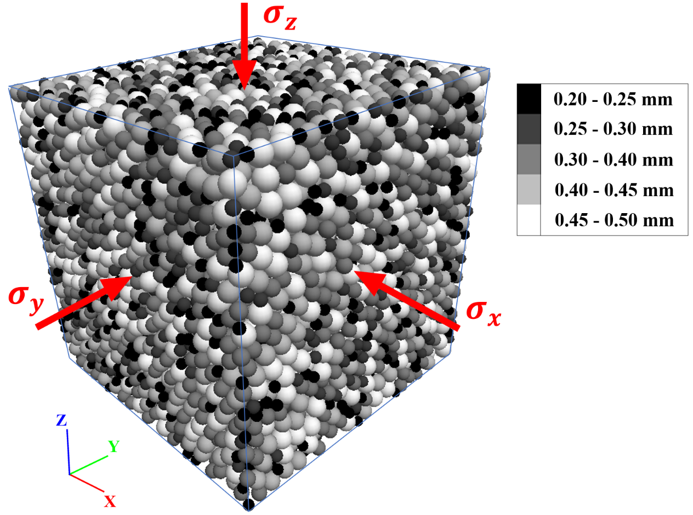
Fig. 1 Initial DEM cubic model of sand in PFC 3D with 10000 particles
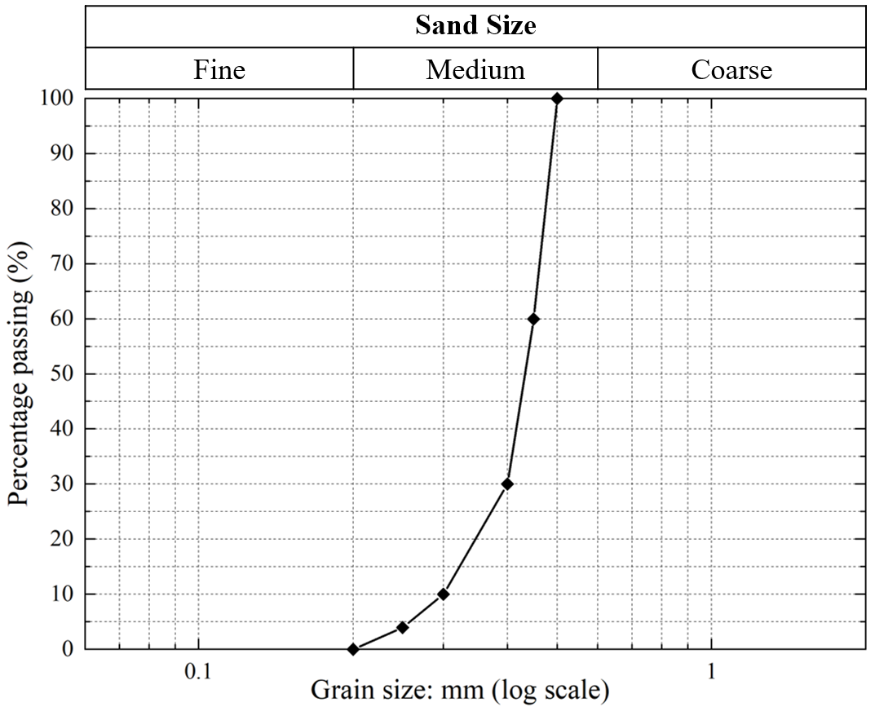
Fig. 2 Grain size distribution of the DEM model
Table 1 Input parameters of the DEM model of sand for the drained tests
Parameter | Value | Unit
Effective modulus $E_{e}$ | 1 × 10⁸ | Pa
Normal to shear stiffness ratio (particle and wall) $k_{n}/k_{s}$ | 1.33 | -
Interparticle friction $μ_{p}$ | 0.5 | -
Wall-particle friction $μ_{w}$ | 0 | -
Notional particle density $ρ$ | 2650 | kg/m³
Contact damping factor $ζ$ | 0.7 | -

A linear contact model is applied for both particle-to-particle and particle-to-wall contacts, which is reported as an effective model in the investigation of behaviour of granular media [Di Renzo and Di Maio 2004]. The gravitational field is not applied in the current DEM systems. The normal to shear stiffness ratio ($k_{n}/k_{s}$) is taken as 1.33, which is reasonable for granular materials [see also Goldenberg and Goldhirsch 2005; Gong and Liu 2017]. A viscous damping factor of contact ($ζ=0.7$) is used to dissipate the kinetic energy of the system. General parameters of particles and contacts are listed in Table 1. It should be noted that the interparticle friction coefficient $μ_{p}$ is the value used during drained triaxial tests. Before shearing, a servo-control system [Itasca 2014] in PFC 3D is used to apply isotropic compression on samples until an isotropic stress state with a target stress level is reached, with the maximum tolerance of stress level set to be 0.1%. The subsequent drained triaxial tests will all start from the isotropic state to ensure the same initial condition for each confining stress level.

2.2. Loading paths
In describing the simulation results of drained triaxial tests, compressive values of the principal stress components $σ_{i}$ are taken as positive, which differs from the traditional continuum mechanics convention [Mase and Mase 1999; Galindo-Torres et al. 2013]. For these axisymmetric drained tests, the effective mean pressure ($p^{'}$) and the deviator stress ($q$) are defined, respectively, as
 | $$p^{'}=\frac{σ_{1}^{'}+σ_{2}^{'}+σ_{3}^{'}}{3}$$ | (1)
 | $$q=σ_{1}^{'}-σ_{3}^{'}$$ | (2)
where $σ_{1}^{'}$ and $σ_{3}^{'}$ are the major and minor principal stress components, respectively ($σ_{1}^{'}≥σ_{3}^{'}$). The principal strain component ($ε_{i}$) and volumetric strain ($ε_{v}$) are defined as
 | $$ε_{i}=-\int_{L_{i,0}}^{L_{i}}{\frac{1}{h}}dh=\ln\left(\frac{L_{i,0}}{L_{i}}\right)$$ | (3)
 | $$ε_{v}=ε_{1}+ε_{2}+ε_{3}$$ | (4)
where, $L_{i,0}$ and $L_{i}$ are the initial length and real-time length of the sample corresponding to the $i^{th}$ strain component, and $ε_{1}$ and $ε_{3}$ are the major and minor principal strain components respectively.

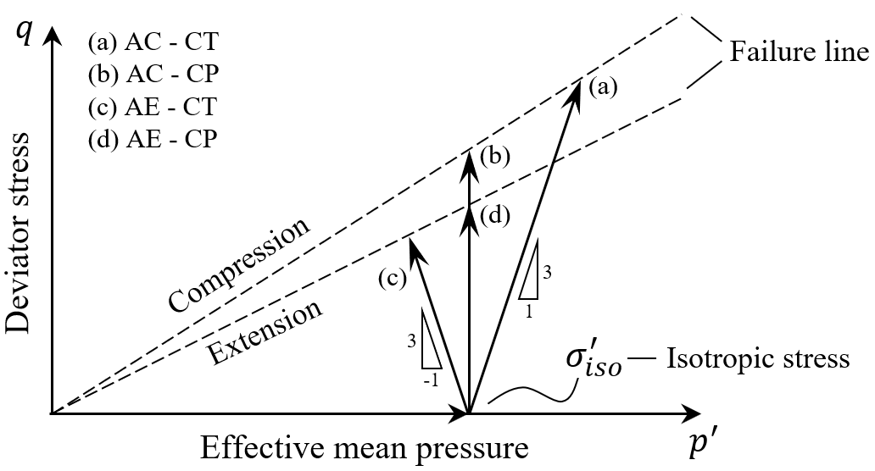
Fig. 3 Stress paths in ${q-p}^{'}$ plane
The drained triaxial simulations are conducted along different stress paths in ${q-p}^{'}$ plane, as illustrated in Fig. 3. The four stress paths in the current investigation are specified as follows:
(a) Axial compression (AC) with increasing axial stress and constant confining stress (CT);
(b) Axial compression (AC) with increasing axial stress and constant mean pressure (CP);
(c) Axial extension (AE) with decreasing axial stress and constant confining stress (CT);
(d) Axial extension (AE) with decreasing axial stress and constant mean pressure (CP).
It should be mentioned that in cases (a) and (b), the axial stress ($σ_{a}^{'}$, increasing) is the major principal stress ($σ_{1}^{'}$) and the radial stress ($σ_{r}^{'}$) is the minor principal stress ($σ_{3}^{'}$), where $σ_{2}^{'}=σ_{3}^{'}$. However, in cases (c) and (d), the axial stress ($σ_{a}^{'}$, decreasing) is the minor principal stress ($σ_{3}^{'}$) and the radial stress ($σ_{r}^{'}$) is the major principal stress ($σ_{1}^{'}$), where $σ_{2}^{'}=σ_{1}^{'}$. In the following discussions, AC and AE refer to stress paths while CT and CP refer to shearing modes.

2.3. Sample specifications
During the shearing process, the top and bottom walls are allowed to move towards each other (axial stress increases) for AC and move in opposite direction (axial stress decreases) for AE. The confining (radial) stresses $σ_{r}^{'}$ are controlled via a servo-control system in PFC 3D. For the conventional drained (CT) test, the servo-control will keep the confining stresses constant and equal to the stress at the end of isotropic compression ($σ_{iso}^{'}$), i.e., $σ_{r}^{'}=σ_{iso}^{'}$. For the constant mean stress (CP) test with changes in axial stress ($σ_{a}^{'}$), servo-control will simultaneously adjust the value of confining stresses to maintain the effective mean pressure as a constant, i.e., $σ_{r}^{'}=(3σ_{iso}^{'}-σ_{a}^{'})/2$.

Table 2 Samples for drained tests with key information at the end of isotropic compression
Group ID | Sample ID | Initial void ratio ($e_{0}$) | Group ID | Sample ID | Initial void ratio ($e_{0}$)
Group I | CTC-L-100 | 0.754 | Group V | CTE-L-100 | 0.754
 | CTC-L-300 | 0.739 |  | CTE-L-300 | 0.739
 | CTC-L-500 | 0.721 |  | CTE-L-500 | 0.721
 | CTC-L-700 | 0.706 |  | CTE-L-700 | 0.706
 | CTC-L-900 | 0.690 |  | CTE-L-900 | 0.690
Group II | CTC-D-100 | 0.608 | Group VI | CTE-D-100 | 0.608
 | CTC-D-300 | 0.589 |  | CTE-D-300 | 0.589
 | CTC-D-500 | 0.573 |  | CTE-D-500 | 0.573
 | CTC-D-700 | 0.558 |  | CTE-D-700 | 0.558
 | CTC-D-900 | 0.544 |  | CTE-D-900 | 0.544
Group III | CPC-L-100 | 0.754 | Group VII | CPE-L-100 | 0.754
 | CPC-L-300 | 0.739 |  | CPE-L-300 | 0.739
 | CPC-L-500 | 0.721 |  | CPE-L-500 | 0.721
 | CPC-L-700 | 0.706 |  | CPE-L-700 | 0.706
 | CPC-L-900 | 0.690 |  | CPE-L-900 | 0.690
Group IV | CPC-D-100 | 0.608 | Group VIII | CPE-D-100 | 0.608
 | CPC-D-300 | 0.589 |  | CPE-D-300 | 0.589
 | CPC-D-500 | 0.573 |  | CPE-D-500 | 0.573
 | CPC-D-700 | 0.558 |  | CPE-D-700 | 0.558
 | CPC-D-900 | 0.544 |  | CPE-D-900 | 0.544
(Note: CT - Conventional (constant confining pressure) drained test; CP - Constant mean pressure drained test; C - Axial compression; E - Axial extension; L - Loose sand; D - Dense sand; 100 ~ 900 - confining pressures in kPa)

Different samples for DEM simulations of drained tests are summarized in Table 2. A total of 40 simulations were performed with five different confining pressures ranging from 100 kPa to 900 kPa with an increment of 200 kPa. The different stress paths for samples with varying initial void ratios are also taken into consideration. To illustrate, the sample CPE-D-700 refers to the triaxial test of dense sand with constant mean effective stress, axial extension and confining pressure of 700 kPa. The initial void ratios (at the end of isotropic compression) of all samples are shown in Table 2. It can be observed that a sample’s initial void ratio is smaller when a higher confining pressure is implemented for each group. All simulations terminate when the axial strain $ε_{a}=50\%$ is attained, where the critical state behaviour can be apparently observed [see also Gong et al. 2012; Huang et al. 2014; Kodicherla et al. 2021].

3. Evolution of Macroscopic Responses

3.1. Deviator stress
Figures 4(a) and 4(b) present the evolution of deviator stress ($q$) against axial strain ($ε_{a}$) under AC and AE stress paths, respectively. It can be seen that all dense samples exhibit strain hardening until peak values of deviator stress ($q_{peak}$) are attained, followed by subsequent strain softening. For loose samples, only strain hardening can be observed. The critical state is attained for all samples after an axial strain ($ε_{a}$) of approximately 45%. It can be observed that, for a given shearing mode (CT or CP), the critical state value of deviator stress ($q_{cs}$) is unique and irrespective of the packing densities (dense or loose) for the samples with the same confining pressures before shearing, which is true for the AC and AE stress paths respectively. It is also found that, for the sample with the same packing density and the same confining pressure, the critical state values of deviator stress with different stress paths (AC or AE) and shearing modes (CT or CP) follow a pattern: AC-CT > AC-CP > AE-CP > AE-CT, which is consistent with the ${q-p}^{'}$ plot in Fig. 3. Further discussions and details can be found in Section 3.5 in relation to Table 3.

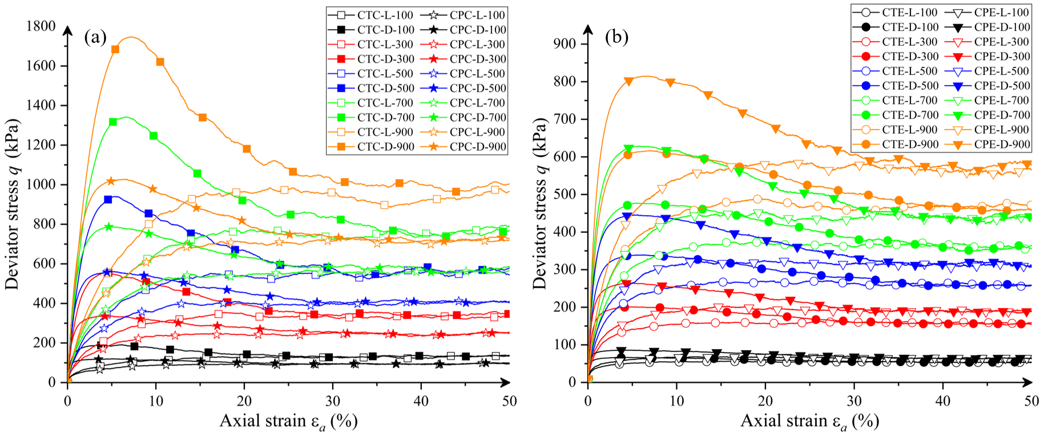
Fig. 4 Evolution of deviator stress: (a) Axial compression; (b) Axial extension

3.2. Stress ratio
The stress ratio ($η$) is defined as the real-time ratio of the deviator stress ($q$) against effective mean pressure ($p^{'}$), i.e., $η=q/p^{'}$. Figs. 5(a) and 5(b) present the evolution of stress ratio ($η$) against axial strain ($ε_{a}$) under AC and AE stress paths, respectively. It is found that, independent of the shearing mode (CT or CP) and the confining pressures, the $η$ values for different samples are similar with each other in terms of the peak value (for dense sand) and the critical state value respectively. However, these $η$ values depend on which stress path (AC or AE) is followed. For AC tests, the critical state stress ratio ($η_{c}$) is approximately 0.78 (ignoring the samples with a confining pressure of 100 kPa), while the critical state stress ratio ($η_{e}$) is about 0.62 for AE tests. The ratio ($η_{c}/η_{e}$) thus obtained is 1.26, which is quantitatively similar to the reported physical experimental and numerical results for sands [Yamamuro and Lade 1996; Kodicherla et al. 2020].

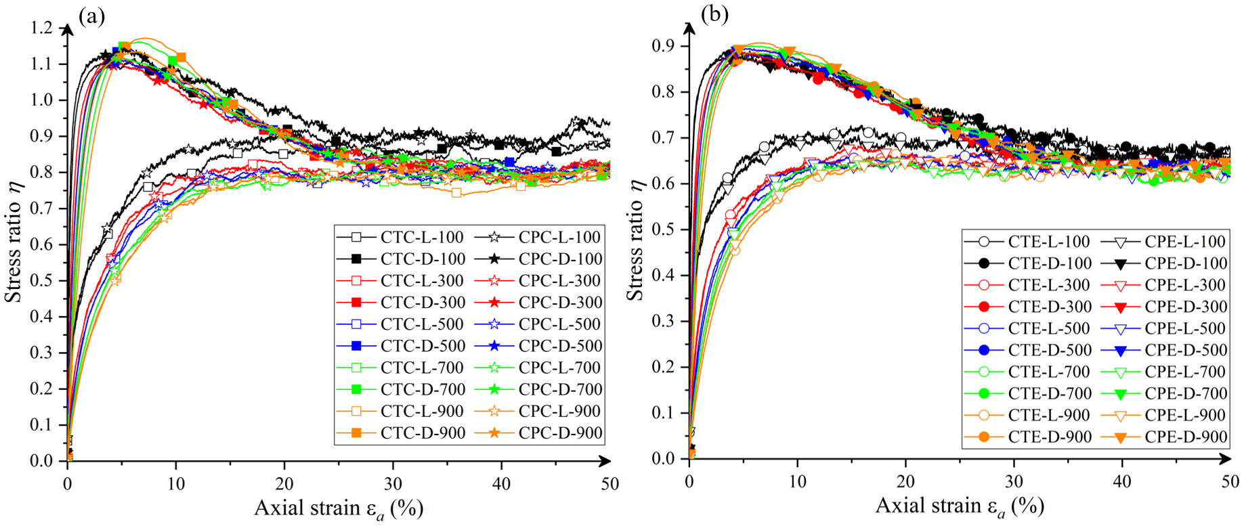
Fig. 5 Evolution of stress ratio: (a) Axial compression; (b) Axial extension

3.3. Void ratio
Figures 6(a) and 6(b) show the evolution of void ratio ($e$) against axial strain ($ε_{a}$) under AC and AE stress paths, respectively. It is interesting to find that, for dense samples, there is an initial drop of $e$ under the AC stress path with the CT shearing mode (AC-CT). No initial drops of $e$ are observed for dense samples under the other stress path or shearing modes, i.e., AC-CP, AE-CT and AE-CP. As can be seen from Fig. 3, the effective mean pressure ($p^{'}$) increases along AC-CT while $p^{'}$ decreases or remains unchanged for all other cases (AC-CP, AE-CT and AE-CP). Therefore, it can be inferred that the initial drop of $e$ is due to initial increase of $p^{'}$ for the case AC-CT. The critical state values are reached after an axial strain ($ε_{a}$) of approximately 45%. It can be observed that, for a given shearing mode (CT or CP), the critical state value of void ratio ($e_{cs}$) is unique and irrespective of the packing densities (dense or loose) for the samples with the same confining pressures before shearing, which is true for the AC and AE stress paths respectively. The critical state values of void ratio decrease with increases of confining pressures for each designated stress path with a given shearing mode. For a given confining pressure, the samples with the CT shearing mode show a lower $e_{cs}$ than the corresponding samples with the CP shearing mode, which is true for the AC stress path but opposite for the AE stress path.

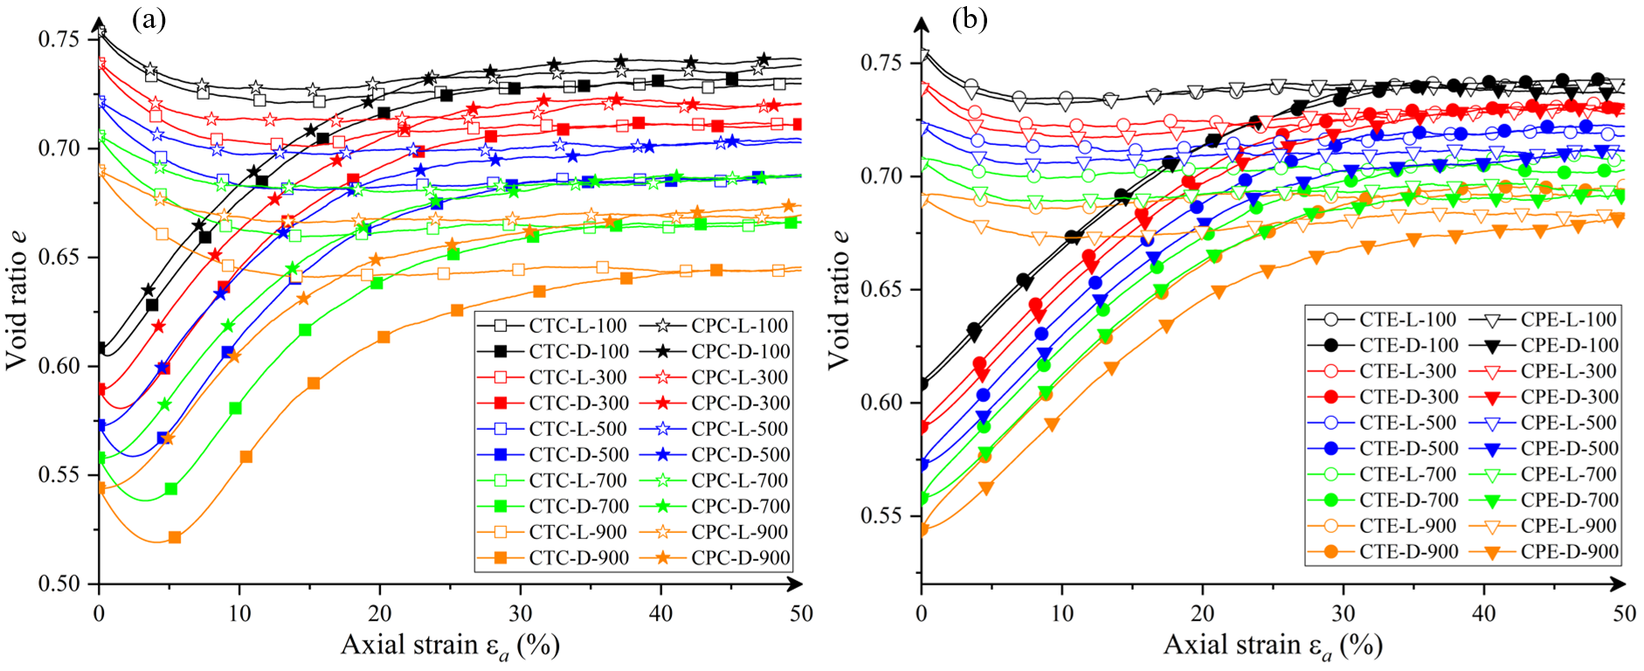
Fig. 6 Evolution of void ratio: (a) Axial compression; (b) Axial extension

3.4. Volumetric strain
Figures 7(a) and 7(b) show the evolution of volumetric strain ($ε_{v}$) against axial strain ($ε_{a}$) under AC and AE stress paths, respectively. A positive value of volumetric strain illustrates contraction and a negative value illustrates dilation in this demonstration. It can be seen that the general pattern for behaviours of dense samples and loose samples are dilation and contraction, respectively. Similar observations were reported before in laboratory and numerical studies [Jiang et al. 2013; Zhang et al. 2018; Dołżyk-Szypcio 2020; Rahman et al. 2021; among others]. It can also be seen that initial contraction is followed by dilation until critical state is reached for dense samples under the AC stress path with the CT shearing mode (AC-CT), which is similar to the discussion of void ratio in Section 3.3. In fact, a mathematical relationship between $ε_{v}$ and $e$ can be obtained as (see also Gong 2008)
 | $$ε_{v}=\ln{\frac{1+e_{0}}{1+e}}$$ | (5)
where $e_{0}$ is the initial void ratio.
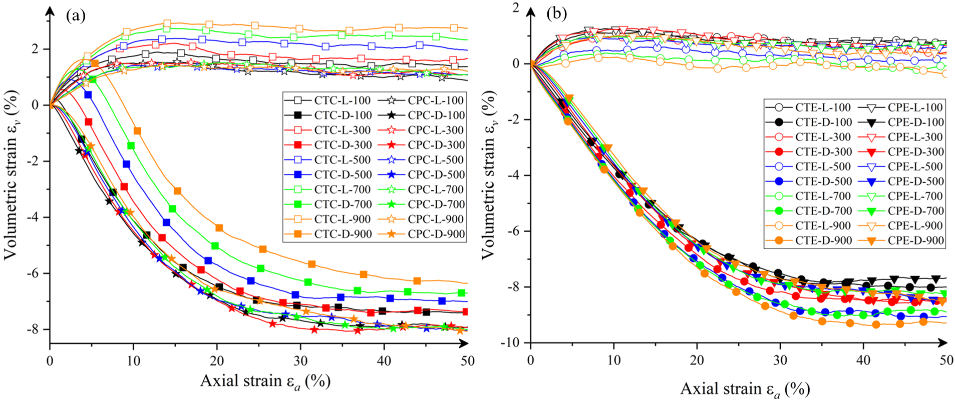
Fig. 7 Evolution of volumetric strain: (a) Axial compression; (b) Axial extension

3.5. Failure criteria
Different failure/strength criteria for soils have been proposed in literature and there is argument regarding which one is the most appropriate one for granular materials [Cornforth 1964; Lade and Duncan 1973; Matsuoka and Nakai 1974; Thornton and Zhang 2010; Gong et al. 2012; among others]. It is tempting to fit the DEM results into different stress-based failure criteria, as discussed below.

The Mohr–Coulomb failure criterion [see Schofield and Wroth 1968; Labuz and Zang 2012] is normally expressed by the sine value of the mobilized friction angle ($φ$) for cohesionless materials
 | $$\sin{φ}=\frac{σ_{1}^{'}-σ_{3}^{'}}{σ_{1}^{'}+σ_{3}^{'}}$$ | (6)
The shear strength of sand can be described by the peak value or the critical state value of $\sin{φ}$ [Cornforth 1964]. Projected on the octahedral plane (or 𝜋 plane), the Mohr–Coulomb failure envelope is a hexagon [see Galindo-Torres et al. 2013].

Matsuoka and Nakai [1974] defined a failure criterion, hereafter called Matsuoka criterion, which can be expressed by Matsuoka’s parameter ($γ_{M}$) as
 | $$γ_{M}=\frac{I_{1}I_{2}}{I_{3}}-9=\frac{{(σ_{1}^{'}-σ_{3}^{'})}^{2}}{σ_{1}^{'}σ_{3}^{'}}+\frac{{(σ_{1}^{'}-σ_{2}^{'})}^{2}}{σ_{1}^{'}σ_{2}^{'}}+\frac{{(σ_{2}^{'}-σ_{3}^{'})}^{2}}{σ_{2}^{'}σ_{3}^{'}}$$ | (7)
where $I_{1}$, $I_{2}$ and $I_{3}$ are the three characteristic invariants of stress tensor. For both AC and AE axisymmetric stress conditions, Matsuoka’s parameter can be simplified as $γ_{M}=8\tan^{2}{φ}$, indicating that Mohr–Coulomb criterion and Matsuoka criterion are essentially the same criterion for the axisymmetric stress conditions (AC or AE).

Lade and Duncan [1973] proposed a failure criterion, hereafter called Lade criterion, which can be expressed by Lade’s parameter ($γ_{L}$) as
 | $$γ_{L}=\frac{I_{1}^{3}}{I_{3}}-27=\frac{{\left(σ_{1}^{'}+σ_{2}^{'}+σ_{3}^{'}\right)}^{3}}{σ_{1}^{'}σ_{2}^{'}σ_{3}^{'}}-27$$ | (8)
It can be proven that for AC stress conditions, $γ_{L}$ can be transformed into $γ_{L,c}={\left(3-\sin{φ}\right)}^{3}/[\left(1+\sin{φ}\right){\left(1-\sin{φ}\right)}^{2}]-27$, while for AE stress conditions, $γ_{L}$ can be transformed into $γ_{L,e}={\left(3+\sin{φ}\right)}^{3}/[\left(1-\sin{φ}\right){\left(1+\sin{φ}\right)}^{2}]-27$. Since, for a given $\sin{φ}$, the values of $γ_{L,c}$ and $γ_{L,e}$ are not the same in general based on these expressions, the Lade criterion predicts different values of $γ_{L}$ for AC and AE stress paths, which will be further in what follows.
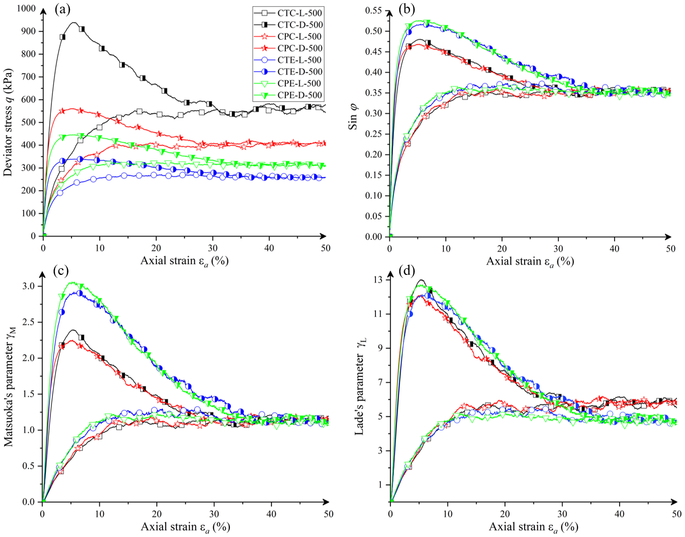
Fig. 8 Evolution of: (a) Deviator stress (b) $\sin{φ}$ (c) $γ_{M}$ (d) $γ_{L}$ for the samples with confining pressure of 500 kPa

Figure 8 presents the evolutions of different failure criterion parameters for the samples under AC and AE stress paths with CT and CP shearing modes all with the same confining pressure of 500 kPa. It should be mentioned that $q$ can be treated as Tresca’s parameter (describing maximum shear stress failure criterion).

Fig. 8(a) shows the evolution of deviator stresses for the samples under the AC and AE stress paths with the CT and CP shearing modes with the same confining pressure of 500 kPa, which is actually extracted from Fig. 4. It can be seen from Fig. 8(a) that the value of critical state strength in terms of deviator stress is unique and irrespective of the packing densities for a given shearing mode (CT or CP) under a given stress path (AC or AE). The values of critical state strength in terms of $q$ with different stress paths (AC or AE) and shearing modes (CT or CP) follow a pattern: AC-CT > AC-CP > AE-CP > AE-CT, which is consistent with the discussion in Section 3.1 in relation to Fig. 4. The peak values of strength in terms of $q$ for the dense samples follow the same pattern: AC-CT > AC-CP > AE-CP > AE-CT. These findings are consistent with the literature [Salvatore et al. 2017; Xie et al. 2017; Kodicherla et al. 2021] in that the values of critical state strength and peak strength under AC stress path are correspondingly larger than those under AE stress path.

Fig. 8(b) shows the evolution of $\sin{φ}$ for the samples under the AC and AE stress paths with the CT and CP shearing modes with the same confining pressure of 500 kPa. It is interesting to observe from Fig. 8(b) that the value of critical state strength in terms of $\sin{φ}$ is unique, which is irrespective of the packing densities and stress path (AC or AE) as well as shearing mode (CT or CP). The peak values of strength in terms of $\sin{φ}$ for the dense samples follow the pattern: AE-CP > AE-CT > AC-CT > AC-CP, which indicates that the peak value of $\sin{φ}$ for the dense sample under AE is larger than that under AC. The findings related to the peak strength in terms of $\sin{φ}$ agree with those reported by Ng [2004] and Huang et al. [2014] in general.

Fig. 8(c) shows the evolution of Matsuoka’s parameter ($γ_{M}$) for the samples under the AC and AE stress paths with the CT and CP shearing modes with the same confining pressure of 500 kPa. It is interesting to observe from Fig. 8(c) that the value of critical state strength in terms of $γ_{M}$ is unique, which is irrespective of the packing densities and stress path (AC or AE) as well as shearing mode (CT or CP). The peak values of strength in terms of $γ_{M}$for the dense samples follow the pattern: AE-CP > AE-CT > AC-CT > AC-CP, which indicates that the peak value of $γ_{M}$for the dense sample under AE is larger than that under AC. In fact, as pointed out in the early discussion in this section, the relationship between $γ_{M}$ and $φ$ can be expressed as $γ_{M}=8\tan^{2}{φ}$, which is true for both AC and AE axisymmetric stress conditions.

Fig. 8(d) shows the evolution of Lade’s parameter ($γ_{L}$) for the samples under the AC and AE stress paths with the CT and CP shearing modes with the same confining pressure of 500 kPa. It can be seen from Fig. 8(d) that the value of critical state strength in terms of $γ_{L}$ for each stress path (AC or AE) is unique and irrespective of the shearing mode (CT or CP), but the critical state value under AC is larger than that under AE. The peak values of strength in terms of $γ_{L}$for the dense samples follow the pattern: AC-CT > AE-CP > AE-CT = AC-CP.

Table 3 Peak and critical state values in terms of different failure parameters
Sample ID | Peak values |  |  |  | Critical state values
 | $q$(kPa) | $$\sin{φ}$$ | $$γ_{M}$$ | $$γ_{L}$$ | $q$(kPa) | $$\sin{φ}$$ | $$γ_{M}$$ | $$γ_{L}$$
CTC-D-100 | 192 | 0.471 | 2.28 | 12.29 | 138 | 0.389 | 1.43 | 7.32
CTC-D-300 | 556 | 0.474 | 2.32 | 12.52 | 354 | 0.367 | 1.25 | 6.33
CTC-D-500 | 940 | 0.481 | 2.41 | 13.06 | 579 | 0.353 | 1.14 | 5.75
CTC-D-700 | 1342 | 0.487 | 2.49 | 13.55 | 794 | 0.345 | 1.08 | 5.43
CTC-D-900 | 1747 | 0.490 | 2.53 | 13.80 | 983 | 0.343 | 1.07 | 5.36
CPC-D-100 | 121 | 0.481 | 2.41 | 13.06 | 101 | 0.390 | 1.44 | 7.38
CPC-D-300 | 337 | 0.466 | 2.22 | 11.92 | 256 | 0.358 | 1.18 | 5.95
CPC-D-500 | 561 | 0.469 | 2.26 | 12.17 | 412 | 0.349 | 1.11 | 5.59
CPC-D-700 | 789 | 0.472 | 2.29 | 12.37 | 567 | 0.345 | 1.08 | 5.43
CPC-D-900 | 1028 | 0.477 | 2.36 | 12.75 | 734 | 0.343 | 1.07 | 5.36
CTE-D-100 | 67 | 0.523 | 3.01 | 12.52 | 57 | 0.391 | 1.44 | 6.09
CTE-D-300 | 201 | 0.511 | 2.83 | 11.77 | 162 | 0.366 | 1.24 | 5.24
CTE-D-500 | 339 | 0.518 | 2.93 | 12.17 | 271 | 0.353 | 1.14 | 4.83
CTE-D-700 | 477 | 0.520 | 2.96 | 12.33 | 365 | 0.352 | 1.13 | 4.80
CTE-D-900 | 612 | 0.524 | 3.03 | 12.59 | 458 | 0.349 | 1.11 | 4.71
CPE-D-100 | 77 | 0.515 | 2.89 | 12.01 | 66 | 0.389 | 1.43 | 6.02
CPE-D-300 | 262 | 0.522 | 3.00 | 12.46 | 197 | 0.361 | 1.20 | 5.08
CPE-D-500 | 446 | 0.526 | 3.06 | 12.72 | 318 | 0.352 | 1.13 | 4.80
CPE-D-700 | 628 | 0.530 | 3.13 | 12.98 | 439 | 0.351 | 1.12 | 4.77
CPE-D-900 | 810 | 0.535 | 3.21 | 13.32 | 575 | 0.349 | 1.11 | 4.71

The samples with the other confining pressures share the similar trend as the samples with confining pressure of 500kPa. The plots under the other confining pressures are not shown here and the relevant peak and critical state values in terms of the different failure parameters are summarized in Table 3 instead.

It can be seen from Table 3 that the peak values of the $\sin{φ}$ and $γ_{M}$ for the dense samples appear to be more dependent on the stress path (AC or AE), than on the shearing mode (CT or CP). The samples exhibit higher peak values in terms of $\sin{φ}$or $γ_{M}$ under AE than those under AC. The increase of confining pressures can slightly increase the peak values in terms of $\sin{φ}$, $γ_{M}$ or $γ_{L}$, which may be attributed by the fact that the sample with a higher confining pressure has a higher packing density. It is interesting to find that the critical state values of $\sin{φ}$ appear to be independent of the stress paths and shearing modes, for a given confining pressure, the conclusion of which is true for the critical state values of $γ_{M}$ but not true for the critical state values of $γ_{L}$. It seems promising to contend that Mohr–Coulomb criterion or Matsuoka criterion is the most appropriate strength criterion in describing failure at critical state among those criteria discussed, which is at least true for the samples under axisymmetric stress conditions (AC or AE). The relevant strength parameter $\sin{φ}$ or $γ_{M}$ could be treated as a material constant for a given confining pressure from the simulation results as summarized in Table 3, and in fact these two parameters are correlated by $γ_{M}=8\tan^{2}{φ}$ as mentioned earlier.

3.6. Critical state lines
The critical state characteristics of the DEM results for both AC and AE stress path tests are presented in Fig. 9. The critical state is taken as the ultimate state that the soil reaches at large strains in these simulations. The CSLs in $e_{c}-q_{c}-p_{c}^{'}$ space can be projected in $e_{c}-\log{(p_{c}^{'})}$ plane and $q_{c}-p_{c}^{'}$ plane to form 2D views. Only data points of dense sand are included for this demonstration, since the critical state behaviours of loose and dense sand in each pair are similar, as shown in Figs. 4 and 6.

Fig. 9(a) shows the CSLs for AC and AE stress path tests with the CT and CP shearing modes in $e_{c}-\log{(p_{c}^{'})}$ plane. For a given stress path (AC or AE), the CSLs appear to be unique regardless of the shearing mode (CT or CP). The CSL for AC is found to be located below that for AE in $e_{c}-\log{(p_{c}^{'})}$ plane, which agrees with Li [2006] and Huang et al. [2014], but disagrees with Zhou et al. [2017], who argued that the CSLs for AC and AE coincides with each other in $e_{c}-\log{(p_{c}^{'})}$ plane.

Li and Wang [1998] proposed a linear approach for better describing the relationship between $e_{c}$ and $p_{c}^{'}$, as given by
 | $$e_{c}=Γ-λ{\left(\frac{p_{c}^{'}}{p_{a}}\right)}^{α}$$ | (9)
where $Γ$ is the intercept of the CSL when $p_{c}^{'}=0$; $λ$ is the absolute value of the slope of the CSL; $p_{a}$ is the atmospheric pressure taken as 101.325 kPa; $α$ is a material constant taken as 0.7 for standard Toyoura sand [Li and Wang 1998]. Fig. 9(b) shows the CSL with $e_{c}$ plotted against ${\left({p_{c}^{'}}/{p_{a}}\right)}^{0.7}$. Fig. 9(b) apparently shows dependency of the CSLs on the stress path (AC or AE). The critical state data for AC can be well fitted by a straight line, as presented by Equation (9) with $Γ_{c}=0.7601$ and $λ_{c}=0.0195$, while for AE, the data can only be roughly fitted by an approximately straight line with $Γ_{e}=0.7577$ and $λ_{e}=0.0156$ using Equation (9). Again, it is found that the CSL for AE lies above that for AC in Fig. 9(b), the conclusion of which is similar to that reported by Huang et al. [2014].

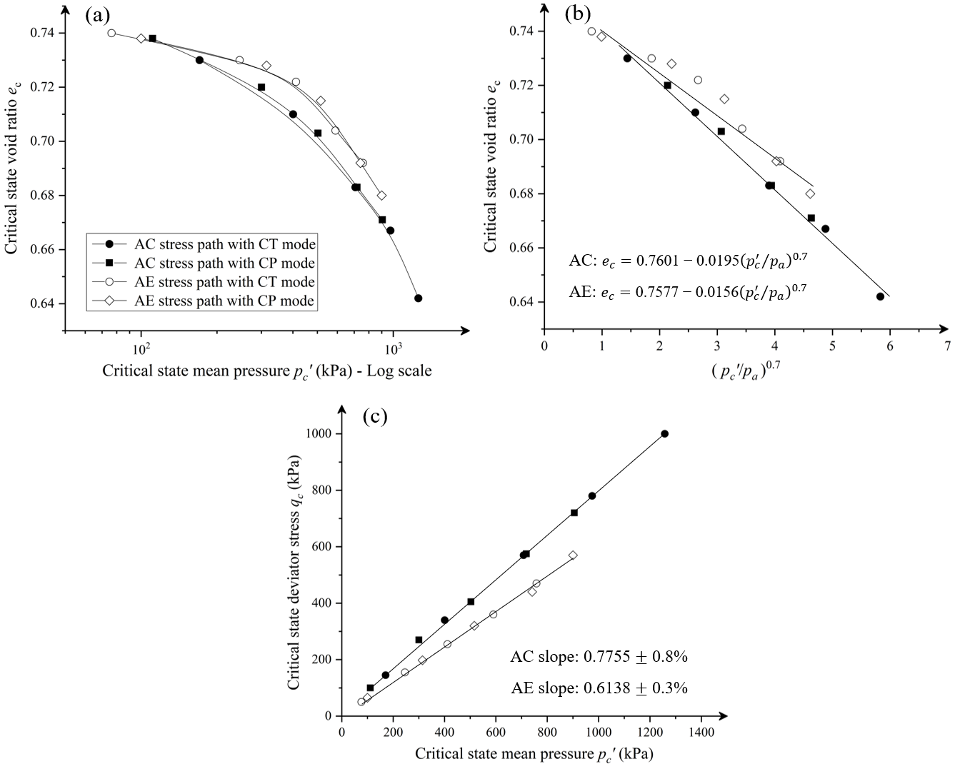
Fig. 9 Critical state behaviours of AC and AE tests: (a) $e_{c}-p_{c}^{'}$ (b) $e_{c}-{\left({p_{c}^{'}}/{p_{a}}\right)}^{0.7}$ (c) $q_{c}-p_{c}^{'}$

Figure 9(c) shows the CSLs for AC and AE stress path tests with the CT and CP shearing modes in $q_{c}-p_{c}^{'}$ plane. It can be clearly seen that the CSLs in $q_{c}-p_{c}^{'}$ plane are independent of the shearing mode (CT or CP), but dependent on the stress path (AC or AE). Both the CSLs for AC and AE are well fitted by two straight lines almost passing through the origin with the slopes of $η_{c}=0.7755$and $η_{e}=0.6138$ respectively. These observations are in agreement with the original critical state framework, as proposed by Roscoe et al. [1958], and also in line with those reported by Yin and Chang [2009], Huang et al. [2014], Yang and Wu [2017] and Kodicherla et al. [2021], among others. For axisymmetric stress conditions, the critical state stress ratios for AC and AE, i.e., $η_{c}$ and $η_{e}$, can be correlated to the mobilized friction angle ($φ$) by
 | $${\sin{φ}}_{c}=\frac{3η_{c}}{6+η_{c}} (compression)$$ | (10)
 | $${\sin{φ}}_{e}=\frac{3η_{e}}{6-η_{e}} (extension)$$ | (11)
By inserting the values of $η_{c}=0.7755$and $η_{e}=0.6138$,
 | $${\sin{φ}}_{c}≈{\sin{φ}}_{e}≈0.34$$ | (12)
It can be seen that the mobilized friction angle at critical state is independent of the stress path (AC or AE), which agrees with the values in Table 3 and also with the common fact that the mobilized friction angle is irrespective of the stress path [see Budhu 2010].

4. Evolution of Microscopic Responses

4.1. Coordination number
The average coordination number ($Z$) is a key indicator that describes the internal structural characteristics of a granular system [Kodicherla et al., 2021; Zhu et al., 2021]. It describes the number of contacts of a particle in an average sense, which can be expressed by
 | $$Z=\frac{2C}{N_{t}}$$ | (13)
where $C$ refers to the total number of contacts and $N_{t}$ refers to the total number of particles. In the current 3-D system, each particle has six degrees of freedom including three translations and three rotations, and each contact provides one normal constraint and two tangential constraints. Therefore, a limit value of $Z=4$, by having $6N_{t}=3C$, can be obtained to ensure the structural stability for the system [Zhu et al. 2021]. However, for granular systems, some particles may have only one contact or have no contact, none of which contributed to the stability of the system. This leads to an alternative indicator – mechanical coordination number ($Z_{m}$) [see Thornton 2000; Gong and Zha 2013], which can be expressed by
 | $$Z_{m}=\frac{2C-N_{1}}{N_{t}-N_{0}-N_{1}}$$ | (14)
where $N_{0}$ and $N_{1}$ are the number of particles with no contact and with only one contact, respectively.

Figures 10(a) and 10(b) show the evolution of mechanical coordination number ($Z_{m}$) against axial strain ($ε_{a}$) under the AC and AE stress paths respectively. It can be seen that there is an initial drop of $Z_{m}$ for all the dense samples under AC and AE at small strains until a steady value of $Z_{m}$ is obtained ($ε_{a}=25\%$). There is an initial increase in $Z_{m}$ for the loose samples under AC and AE, which may be induced by the volume contraction thus generating extra new contact numbers. It is found that $Z_{m}$ is larger than 4 for each sample during the entire simulation indicating the structural stability [see also Gong 2008].

It can be observed that, for a given shearing mode (CT or CP), the steady value (or critical state value) of $Z_{m}$ is unique and irrespective of the packing densities (dense or loose) for the samples with the same confining pressures before shearing, which is true for AC and AE stress paths respectively. It is also found that, for a given sample with the same packing density and the same confining pressure under the AC stress path, the critical state value of $Z_{m}$ under the CT shearing mode is larger than that under the CP shearing mode. The opposite observation occurs for the AE stress path, i.e., for a given sample with the same packing density and the same confining pressure under the AE stress path, the critical state value of $Z_{m}$ under the CT shearing mode is smaller than that under the CP shearing mode. The difference between these observations in terms of critical state values of $Z_{m}$ could be attributed to changes of effective mean pressures ($p^{'}$) under AC and AE. As can be clearly seen from Fig. 3, for a given sample with the same confining pressure, $p^{'}$ under AC-CT is larger than that under AC-CP, while $p^{'}$ under AE-CT is smaller than that under AE-CP. It is also found the values of $Z_{m}$ at critical state increase with increasing confining pressures for a given stress path (AC or AE) with a given shearing mode (CT or CP).

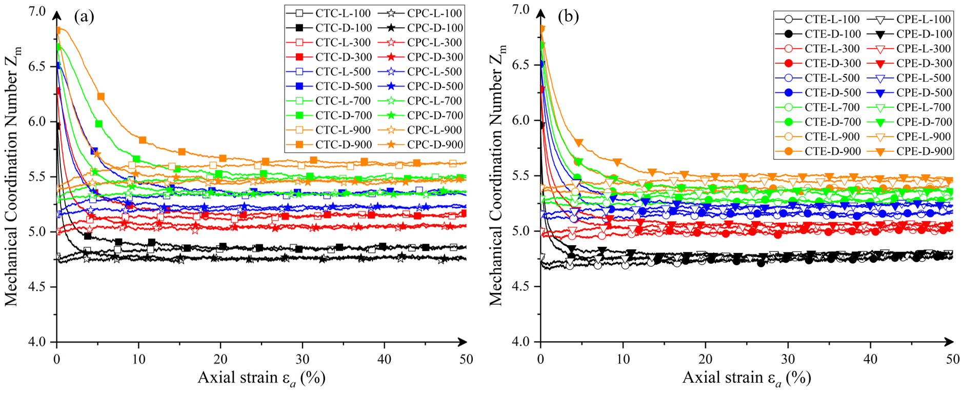
Fig. 10 Evolution of mechanical coordination number: (a) Axial compression (b) Axial extension

4.2. Deviator fabric
The fabric tensor is used characterize the fabric or structural anisotropy of granular assemblies [Oda 1982]. Yimsiri and Soga [2011] indicated that fabric can reveal the arrangements of particles in space, and a preferred fabric orientation can result in a higher static strength during shearing. In the simulations reported in this paper, a fabric tensor ($ϕ_{ij}$) proposed by Satake [1982] is used, which can be expressed by
 | $$ϕ_{ij}=\frac{1}{C}\sum_{1}^{C}{n_{i}n_{j}}$$ | (15)
where $C$ refers to the total number of contacts and $n_{i}$ refers to the unit normal vector component to the contact plane.

Thornton and Sun [1993] and Thornton [2000] introduced a deviator fabric for describing the degree of structural anisotropy under 3D axisymmetric stress conditions, which can be expressed by
 | $$ϕ_{d}=ϕ_{1}-ϕ_{3}$$ | (16)
where $ϕ_{1}$ and $ϕ_{3}$ are the major and minor principal values of fabric tensor.

Figures 11(a) and 11(b) show the evolution of deviator fabric ($ϕ_{d}$) against axial strain ($ε_{a}$) under the AC and AE stress paths, respectively. It is observed that under both AC and AE all the dense samples exhibit peaks of $ϕ_{d}$ at small strains and steady (critical state) values at large strains, the behaviours of which are similar to the strain hardening and softening as observed for evolutions of deviator stress in Fig. 4. For the loose samples, critical state values of $ϕ_{d}$are observed at large strains with no apparent peaks. A smaller value of $ϕ_{d}$ at critical state is observed when a higher confining pressure is used, which is true for the AC and AE stress paths and for CT and CP shearing modes.

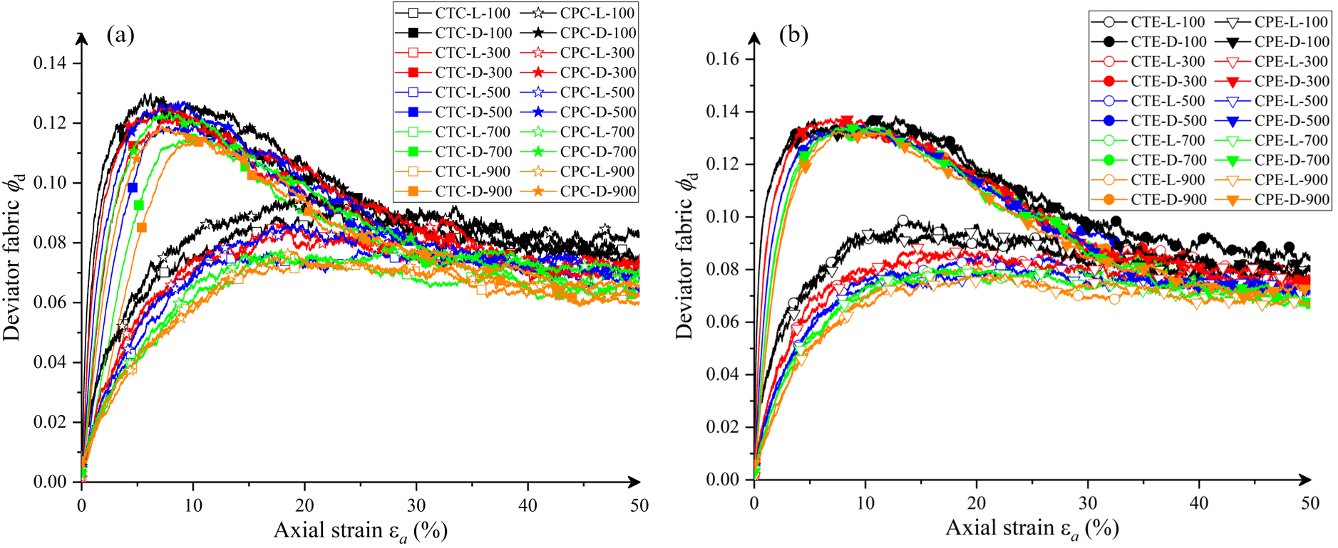
Fig. 11 Evolution of deviator fabric: (a) Axial compression (b) Axial extension

5. Conclusions
In summary, the behaviours of dense and loose sand are investigated via a series of DEM simulations of triaxial drained tests under two axisymmetric stress paths including axial compression (AC) and axial extension (AE), with two different shearing modes including conventional triaxial mode with constant confining stress (CT) and constant mean pressure mode (CP). Forty sand samples are generated with confining pressures ranging from 100 kPa to 900 kPa. The critical state is attained for all samples after an axial strain of about 45%. The macroscopic behaviours are examined via evolutions of deviator stress, stress ratio, void ratio as well as critical state line analysis and strength criterion indicators in terms of peak and critical state failures. The microscopic behaviours are examined in terms of mechanical coordination number and deviator fabric. The main conclusions are drawn below:
- For a given shearing mode (CT or CP), the critical state value of deviator stress is unique and irrespective of the packing densities (dense or loose) for the samples with a given confining pressure, which is true for the AC and AE stress paths respectively. For the sample with the same packing density and the same confining pressure, the critical state values of deviator stress follow a pattern: AC-CT > AC-CP > AE-CP > AE-CT.
- The peak values (for dense sand) and the critical state values of the stress ratio are both independent of the shearing mode (CT or CP) and the confining pressures, but dependent on the stress path (AC or AE). This also means that the critical state lines (CSLs) in $q_{c}-p_{c}^{'}$ plane are unique and irrespective of the confining pressures and shearing mode (CT or CP), but the critical state value of stress ratio under AC is larger than that under AE, which can also be inferred from that common fact that the mobilized friction angle is irrespective of the stress path. In $e_{c}-\log{(p_{c}^{'})}$ or $e_{c}-{\left({p_{c}^{'}}/{p_{a}}\right)}^{0.7}$ plane, the CSL under AE is found to lie above that under AC.
- The critical state values of $\sin{φ}$ appear to be independent of the stress paths and shearing modes, for a given confining pressure, the conclusion of which is true for the critical state values of Matsuoka’s parameter $γ_{M}$ but not true for the critical state values of Lade’s parameter $γ_{L}$. It can be concluded that Mohr–Coulomb criterion or Matsuoka criterion is the most appropriate strength criterion in describing failure at critical state among those criteria discussed, which is at least true for the samples under axisymmetric stress conditions (AC or AE).
- An initial drop of void ratio is observed only for dense samples under the AC stress path with the CT shearing mode, which is attributed to initial increase of effective mean pressure.
- The critical state value of void ratio is unique and irrespective of the packing densities for a given confining pressure and shearing mode (CT or CP), which is true for the AC and AE stress paths respectively. The critical state values of void ratio decrease with increases of confining pressures for each designated stress path with a given shearing mode. For a given confining pressure, the samples with the CT shearing mode show a lower critical state void ratio than the corresponding samples with the CP shearing mode, the conclusion of which is true for the AC stress path but opposite for the AE stress path.
- For a given shearing mode (CT or CP), the steady value of mechanical coordination number is unique and irrespective of the packing densities for the samples with the same confining pressures before shearing, which is true for AC and AE stress paths respectively. For a given sample with the same packing density and the same confining pressure under the AC stress path, the critical state value of mechanical coordination number under the CT shearing mode is larger than that under the CP shearing mode. The opposite observation occurs for the AE stress path. The difference between these observations in terms of critical state values of mechanical coordination number is found to be attributed to and associated with changes of effective mean pressures under AC and AE stress paths.

CRediT authorship contribution statement
Minyi Zhu: Software, Validation, Data curation, Writing – original draft.
Guobin Gong: Conceptualization, Supervision, Writing - review & editing.
Xue Zhang: Supervision, Writing - review & editing.
Jun Xia: Supervision, Writing - review & editing.
Charles K.S. Moy: Supervision, Writing - review & editing.

Declaration of Competing Interest
The authors declare that they have no known competing financial interests or personal relationships that could have appeared to influence the work reported in this paper.

Acknowledgements
The financial support from Xi’an Jiaotong – Liverpool University (RDF 18-01-23, PGRS 1906002 and REF-20-01-01) is gratefully acknowledged. The first and second authors would also like to appreciate the support by the Key Program Special Fund at XJTLU (Grant No: KSF-E-19).

Reference
Ali Rahman, Z., Toll, D.G. & Gallipoli, D. (2018). Critical State Behaviour of Weakly Bonded Soil in Drained State. Geomech. Geoengin. 13(4): 233–245.
Been, K. & Jefferies, M.G. (1985). A state parameter for sands. Géotechnique. 35(2): 99–112.
Been, K., Jefferies, M.G. & Hachey, J.E. (1991). The critical state of sands. Géotechnique. 41(3): 365–381.
Budhu, M. (2010). Soil Mechanics and Foundations. 3rd edition. John Wiley & Sons.
Chu, J. (1995). An experimental examination of the critical state and other similar concepts for granular soils. Can. Geotech. J. 32(6):1065–1075.
Cornforth, D.H. (1964). Some experiments on the influence of strain conditions on the strength of sand. Géotechnique. 14(2): 143-167.
Cundall, P.A. (2001). A discontinuous future for numerical modelling in geomechanics. P. I. Civil Eng-Geotec. 149(1): 41–47.
Cundall, P.A. & Strack, O.D. (1979). A discrete numerical model for granular assemblies. Géotechnique. 29(1): 47–65.
Cuss, R.J., Rutter, E.H. & Holloway, R.F. (2003). The application of critical state soil mechanics to the mechanical behaviour of porous sandstones. Int. J. Rock Mech. Min. 40(6): 847-862.
Di Renzo, A. & Di Maio, F.P. (2004). Comparison of contact-force models for the simulation of collisions in DEM-based granular flow codes. Chem. Eng. Sci. 59(3): 525–541.
Dołżyk-Szypcio, K. (2020). Stress–Dilatancy Relationship of Erksak Sand under Drained Triaxial Compression. Geosciences. 10(9): 353.
Eshtehard, A.A. (1996). Triaxial testing on very loose sands for flow liquefaction analyses. Master Dissertation. University of Alberta.
Galindo-Torres, S. A., Pedroso, D. M., Williams, D. J. & Mühlhaus, H. B. (2013). Strength of non-spherical particles with anisotropic geometries under triaxial and shearing loading configurations. Granul. Matter. 15: 531–542.
Goldenberg, C. & Goldhirsch, I. (2005). Friction enhances elasticity in granular solids. Nature. 435: 188–191.
Gong, G. (2008). DEM simulations of drained and undrained behaviour. Ph.D. thesis. Univ. of Birmingham, UK.
Gong, G. & Zha, X., (2013). DEM simulation of undrained behaviour with preshearing history for saturated granular media. Modelling Simul. Mater. Sci. Eng. 21 (2): 025001.
Gong, G., Zha, X., & Wei, J. (2012). Comparison of granular material behaviour under drained triaxial and plane strain conditions using 3D DEM simulations. Acta Mech. Solida Sin. 25(2): 186–195.
Gong, J. & Liu, J. (2017). Effect of aspect ratio on triaxial compression of multi-sphere ellipsoid assemblies simulated using a discrete element method. Particuology. 32: 49–62.
Huang, X., Hanley, K.J., O’Sullivan, C., Kwok, C.Y. & Wadee, M.A. (2014). DEM analysis of the influence of the intermediate stress ratio on the critical-state behaviour of granular materials. Granul. Matter. 16: 641–655.
Itasca (2014) Particle flow code in 3 dimensions (PFC3D) version 5. Minneapolis, MN, USA: Itasca Consulting Group, Inc.
Jiang, M.J., Li, L. & Yang, Q. (2013). Experimental investigation on deformation behaviour of TJ-1 lunar soil simulant subjected to principal stress rotation. Advanced Space Research. 52: 136–146.
Kodicherla, S.P.K., Gong, G., Fan, L., Wilkinson, S. & Moy, C.K.S. (2020). DEM investigations of the effects of particle morphology on granular material behaviour using a multi-sphere approach. J. Rock Mech. Geotech. 12(6): 1301-1312.
Kodicherla, S.P.K., Gong, G., Fan, L., Wilkinson, S. & Moy, C.K.S. (2021). Discrete element modelling of strength and critical state characteristics of granular materials under axial compression and axial extension stress path tests. Particuology. 56: 152-162.
Labuz, J.F. & Zang, A. (2012). Mohr–Coulomb Failure Criterion. Rock Mech. Rock Eng. 45: 975–979.
Lade, P.V. & Duncan, J.M. (1973). Cubical triaxial tests on cohesionless soil. J. Soil Mech. Found. Div. 99(10): 793–812.
Li, X. (2006). Micro-scale investigation on the quasi-static behaviour of granular material. Doctoral Dissertation, Hong Kong University of Science and Technology.
Li, X.S. & Wang, Y. (1998). Linear representation of steady-state line for sand. J. Geomech. Geoenviron. Eng. 124: 1215–1217.
Mase, G. & Mase, G.E. (1999). Continuum Mechanics for Engineers. 1st edition. CRC press.
Matsuoka, H. & Nakai, T. (1974). Stress-deformation and strength characteristics of soil under three different principal stresses. Proc. JSCE. 232: 59–70.
Ng, T.T. (2004). Shear strength of assemblies of ellipsoidal particles. Géotechnique. 54: 659–669.
Oda, M., Konishi, J. & Nemat-Nasser, S. (1982). Experimental micromechanical evaluation of strength of granular materials: Effects of particle rolling. Mech. Mater. 1(4): 269–283.
Rahman, M.M., Nguyen, H.B.K., Fourie, A.B. & Kuhn, M. R. (2021). Critical State Soil Mechanics for Cyclic Liquefaction and Postliquefaction Behaviour: DEM study. J. Geotech. Geoenviron. 147(2): 04020166.
Reid, D., Fourie, A., Ayala, J.L., Dickinson, S., Ochoa-Cornejo, F., Fanni, R., Garfias, J., Fonseca, A.V., Ghafghazi, M., Ovalle, C., Riemer, M., Rismanchian, A., Olivera, R. & Suazo, G. (2021). Results of a critical state line testing round robin programme. Géotechnique. 71(7): 616-630.
Roscoe, K.H., Schofield, A.N. & Wroth, C.P. (1958). On the yielding of soils. Géotechnique. 8(1): 22–53.
Salvatore, E., Modoni, G., Ando, E., Albano, M. & Viggiani, G. (2017). Determination of the critical state of granular materials with triaxial test. Soils Found. 57(5): 733–744.
Satake, M. (1982). Fabric tensor in granular materials. In Proceedings of the IUTAM Symposium on Deformations and Failure of Granular Materials. The Netherlands: Balkema, Rotterdam. pp. 63–68.
Schofield, A. & Wroth, P. (1968). Critical state soil mechanics. McGraw-Hill, New York.
Thornton, C. (2000). Numerical simulations of deviatoric shear deformation of granular media. Géotechnique. 50(1): 43-53.
Thornton, C. & Sun, G. (1993). Axisymmetric compression of 3D polydisperse systems of spheres. Powers and Grains 93, Thornton (ed.), 129-134.
Thornton, C. & Zhang, L. (2010). On the evolution of stress and microstructure during general 3D deviatoric straining of granular media. Géotechnique. 60(5): 333–341.
Xie, Y.H., Yang, Z.X., Barreto, D. & Jiang, M.D. (2017). The influence of particle geometry and the intermediate stress ratio on the shear behaviour of granular materials. Granul. Matter. 19(2): 35.
Yamamuro, J.A. & Lade, P.V. (1996). Drained sand behaviour in axisymmetric tests at high pressures. Journal of Geotechnical Engineering. 122(2): 109-119.
Yang, Z. & Wu, Y. (2017). Critical State for Anisotropic Granular Materials: A Discrete Element Perspective. Int. J. Geomech. 17(2): 04016054.
Yimsiri, S. & Soga, K. (2011). Effects of soil fabric on behaviours of granular soils: Microscopic modeling. Comput. Geotech. 38: 861–874.
Yin, Z.Y. & Chang, C.S. (2009). Non-uniqueness of critical state line in compression and extension conditions. Int. J. Numer. Anal. Met. 33: 1315–1338.
Zhang, J., Lo, S.C.R., Rahman, M.M. & Yan, J. (2018). Characterizing monotonic behaviour of pond ash within critical state approach. J. Geotech. Geoenviron. 144(1): 04017100.
Zhao, J. & Guo, N. (2013). Unique critical state characteristics in granular media considering fabric anisotropy. Géotechnique. 63(8): 695–704.
Zhou, W., Liu, J., Ma, G. & Chang, X. (2017). Three-dimensional DEM investigation of critical state and dilatancy behaviours of granular materials. Acta Geotech. 12: 527–540.
Zhu, M., Gong, G., Xia, J., Liu, L. & Wilkinson, S. (2021). Effects of deviator strain histories on liquefaction of loose sand using DEM. Comput. Geotech. 136: 104213

