Assessing the potential to use structure-borne sound to detect survivors in collapsed buildings

Carl Hopkins
Acoustics Research Unit, University of Liverpool
Liverpool L69 7ZN, UK

Marios Filippoupolitis
Acoustics Research Unit, University of Liverpool
Liverpool L69 7ZN, UK

ABSTRACT
When victims are trapped within a collapsed structure, it can be difficult to quickly locate survivors. Airborne sound tends to be highly attenuated hence there is greater potential to detect physical movement or signals from survivors by measuring the seismic response. Recent work has used Statistical Energy Analysis (SEA) and Finite Element Methods (FEM) to assess the feasibility of predicting structure-borne sound transmission across fragmented reinforced concrete structures. This has the potential to improve strategies for the detection of trapped survivors using structure-borne sound by search and rescue teams as well as seismic detection equipment. The main focus has been on vibration transmission between reinforced concrete elements that are in contact after the collapse. Laboratory experiments have been used to validate FEM models of reinforced concrete beam junctions with surface-to-surface contact conditions using Experimental Modal Analysis. This has given insights into the contact stiffness between reinforced concrete beams. FEM simulations of beams with surface-to-surface contacts as well as beam junctions with fragmentation at the junction indicate the potential to use SEA to give reasonable estimates of vibration transmission. This paper summarises the progress made to-date and considers the next steps that are needed in the research on this topic.

1. INTRODUCTION
Recent research in the Acoustics Research Unit has investigated structure-borne sound propagation in masonry/concrete fragmented structures. Examples of such structures include collapsed buildings after an earthquake or explosion. The reason for instigating this research was that structure-borne sound potentially plays an important role in the search for human survivors within a collapsed structure []. When victims are trapped inside a collapsed building, the challenge is to detect and locate survivors within a period of time that will allow them to be rescued. Typically, victims do not survive if they are not found within 72 hours. Airborne sound from survivors tends to be highly attenuated by layers of rubble and requires the existence of air paths for propagation to the surface. For this reason, there is greater potential to detect physical movement or signals by measuring vibration or structure-borne sound. Although it is a slight misnomer, this type of structure-borne sound detection is referred to by all search and rescue organisations as a ‘seismic’ search. Seismic sensors are the second most common type of search equipment used by search and rescue teams in the detection and location of buried survivors. Other common approaches are canine detection and the video camera but they both have disadvantages because they require access inside the collapsed structure which is often unsafe. An advantage with seismic detection is that it overcomes the distance limitation associated with thermal imaging cameras that can only detect body heat at short distances. In addition, seismic detection can be carried out near the perimeter of a collapsed structure which allows the operator to monitor the signals at a safe distance from the structure in case of further collapse. Detection by mobile phones can be unreliable due to network failures caused by the earthquake, phone battery life and the separation of the phone from its owner during the collapse.

After a mining accident there are often standard procedures whereby trapped miners start hammering after they hear a detonation device that has been triggered by the rescuers. This allows the rescuers to stop and listen for sound from the survivors. However, there are no such procedures for civilian victims trapped in collapsed buildings after earthquakes. For this reason, the operators of seismic equipment often encounter problems when the search area is not quiet and there are high levels of background vibration from sources other than the survivors. Usually there are mechanical diggers and emergency vehicles on site and other teams digging that do not want to simultaneously stop work to give a period of silence. Therefore, the equipment picks up these other extraneous sources of vibration. If the interfering signals are strong, survivors may never be detected. Filtering the signal to reduce the influence of background noise is currently avoided because of uncertainty about which part of the frequency range is most suited to detecting the victim in a specific situation. Anecdotal evidence from collapsed buildings such as the World Trade Centre indicates that an upper limit for detecting vibration signals at the surface from tapping and banging within the wreckage is approximately 3kHz (e.g. see []). The lack of a prediction model to estimate maximum vibration levels and spectra that can be expected in different collapsed structures means that valuable excavation time is lost every time that digging is stopped to try and detect vibration signals from survivors which are usually transient in nature. The above-mentioned problems occur because of a paucity of understanding on structure-borne sound propagation through fragmented structures.

Our research [,,,] has given insights into the propagation of structure-borne sound in collapsed and fragmented structures through the development, validation and use of prediction models. The physical medium has been assumed to consist of broken concrete or masonry because ≈80% of the people at risk of death or injury in earthquakes are the occupants of reinforced concrete frame buildings with infill-masonry walls [] – examples are shown in Figure 1. This paper summarizes the findings to-date on vibration transmission in fragmented structures and indicates areas which require further research.

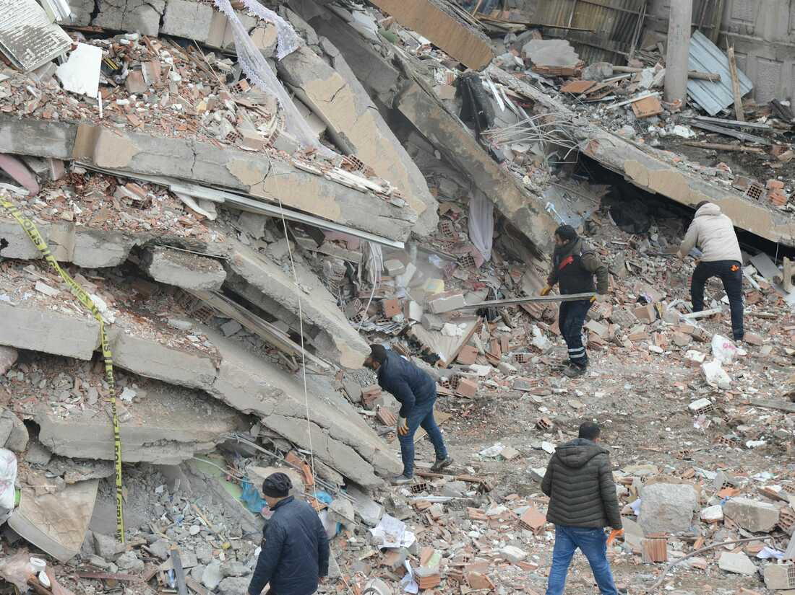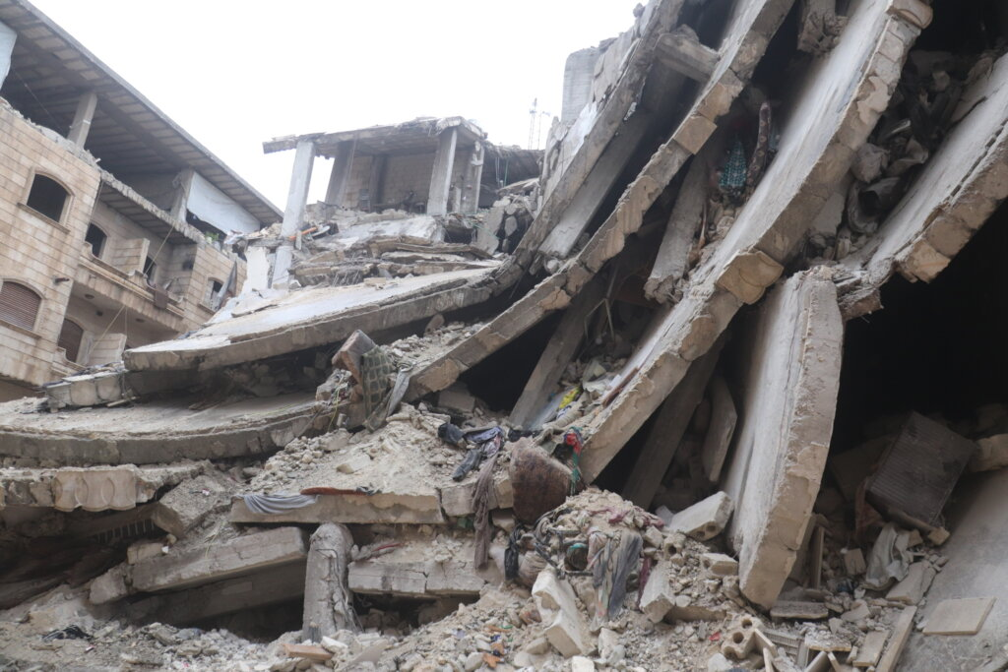
Figure 1: Examples of collapsed multi-storey buildings after an earthquake. (Sources: www.npr.org and www.globalgiving.org)

2. Vibration transmission between concrete elements in collapsed buildings
Modelling structure-borne sound transmission in concrete/masonry buildings often makes use of prediction models based on Statistical Energy Analysis (SEA) [,] that use wave theory or Finite Element Methods (FEM) [,,] to estimate the Coupling Loss Factor (CLF) across junctions of concrete or masonry plates/beams. This approach is commonly used to estimate the airborne or impact sound insulation between rooms in one-third octave frequency bands.

One of the main reasons to consider a statistical model such as SEA is that in a collapsed building there is an even higher level of uncertainty in describing the dimensions of the structural elements and only a statistical estimate can be made of the number and type of connections between the elements. In the low-frequency range, many walls, floors, beams and columns in heavyweight buildings have relatively low structural mode counts. This tends to increase the fluctuations in the predicted velocity levels. In addition, the modal overlap can be less than unity even though the overall damping is relatively high due to the high coupling losses. Despite this, the predicted mean velocity level in one-third octave bands still tends to be within 10dB of measurements [,]. In a collapsed building, the plates or beams that define a single room tend to be broken into smaller areas or lengths than in the original building. Therefore, the number of structural modes may be reduced further (although this is less problematic with long span concrete floors which tend to fracture into relatively large plates). Fortunately, there is no need to use one-third octave bands when trying to detect survivors in a collapsed building and therefore it is possible to use wider bandwidths that ensure a reasonable mode count. Research carried by the authors to-date has focused on reinforced concrete beams because they can be considered to provide a challenge to model with SEA due to low mode counts []. However, it has been shown that when each beam supports at least two local modes for each wave type that occurs in the frequency band of interest and the modal overlap factor is at least 0.1, FEM and measurements tend to have smooth curves such as those predicted with SEA using wave theory CLFs [,].

2.1. Modelling the contact conditions for structural coupling between reinforced concrete elements
Walls, floors and columns in collapsed buildings do not usually maintain their rigid connections at the junctions. In fact, many of these elements will be touching each other rather than being rigidly bonded together. Hence the initial research concerned the experimental validation of FEM models for reinforced concrete beams that had unbonded contacts, i.e. when touching without any bonding compound such as mortar [3]. The hypothesis was that vibration transmission could be modelled using a model for a lumped spring point connector. However, as there is no physical spring element at the contact point, the hypothetical spring stiffness needed to be determined experimentally.

The first stage was to experimentally validate FEM models of reinforced concrete beams with and without exposed steel reinforcement. This was necessary because in a collapsed structure it is common for there to be exposed sections on walls, floors, beams and columns where the concrete is broken away so that the visible steel reinforcement forms a ‘discontinuity’ in the concrete element. Results are compared here from experimental modal analysis and FEM for two reinforced beams with and without a discontinuity (see beams 2 and 3 in Figure 2). These are shown in terms of eigenfrequencies in Figure 3 and MAC in Figure 4. The modal responses can be classified as bending (in-plane or out-of-plane) and/or torsional in nature. There is close agreement in terms of the eigenfrequencies with the highest MAC values for beam 2 with all mode types and for beam 3 with out-of-plane bending modes. However, the discontinuity affects the accuracy of the torsional modes suggesting that the torsional stiffness of the reinforcement bars might need optimizing.

Figure 2: Reinforced concrete beams.

Figure 3: FEM and EMA eigenfrequencies for beams 1, 2 and 3.

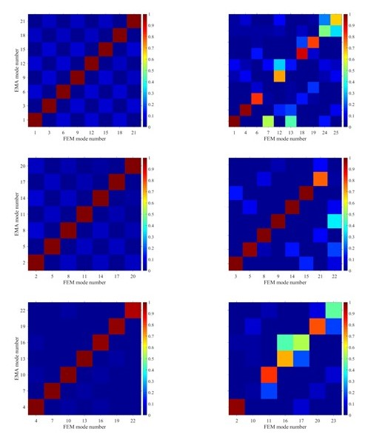
Figure 4: MAC from FEM and EMA for beam 2 (left) and beam 3 (right): (a) in-plane bending modes, (b) out-of-plane bending modes and (c) torsional modes.

Experimental modal analysis was carried out on stacked reinforced concrete beams to assess vibration transmission between them when in contact at different positions. Finite element models of five different junctions with beams 1, 2 and 3 were developed with surface-to-surface and edge-to-surface contact conditions between the beams. Surface-to-surface contact was implemented using the surface-to-surface contact algorithm of Abaqus-Standard with elastic normal behaviour. When one edge of a beam made contact over a line on the surface of the other beam, the linear spring element, SPRING2, was used to model the interaction.

The normal contact stiffness for each mode pair for three junctions with beams 1 and 2 (see Figure 5) were determined through model updating to give eigenfrequencies within 2% of the values identified with EMA. As shown in Figure 6 it was found that the normal contact stiffness had a mean value of 7.038E08 N/m and followed a lognormal distribution. To assess whether the FEM model was reasonable it was necessary to introduce the Partial Modal Vector Ratio (PMVR) as a supplement to the Modal Assurance Criterion (MAC) when there are correlation issues caused by the interaction of the beams.

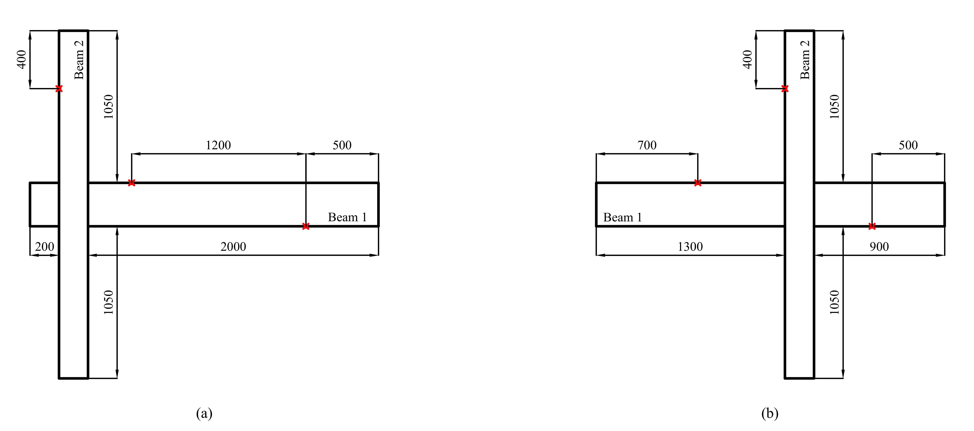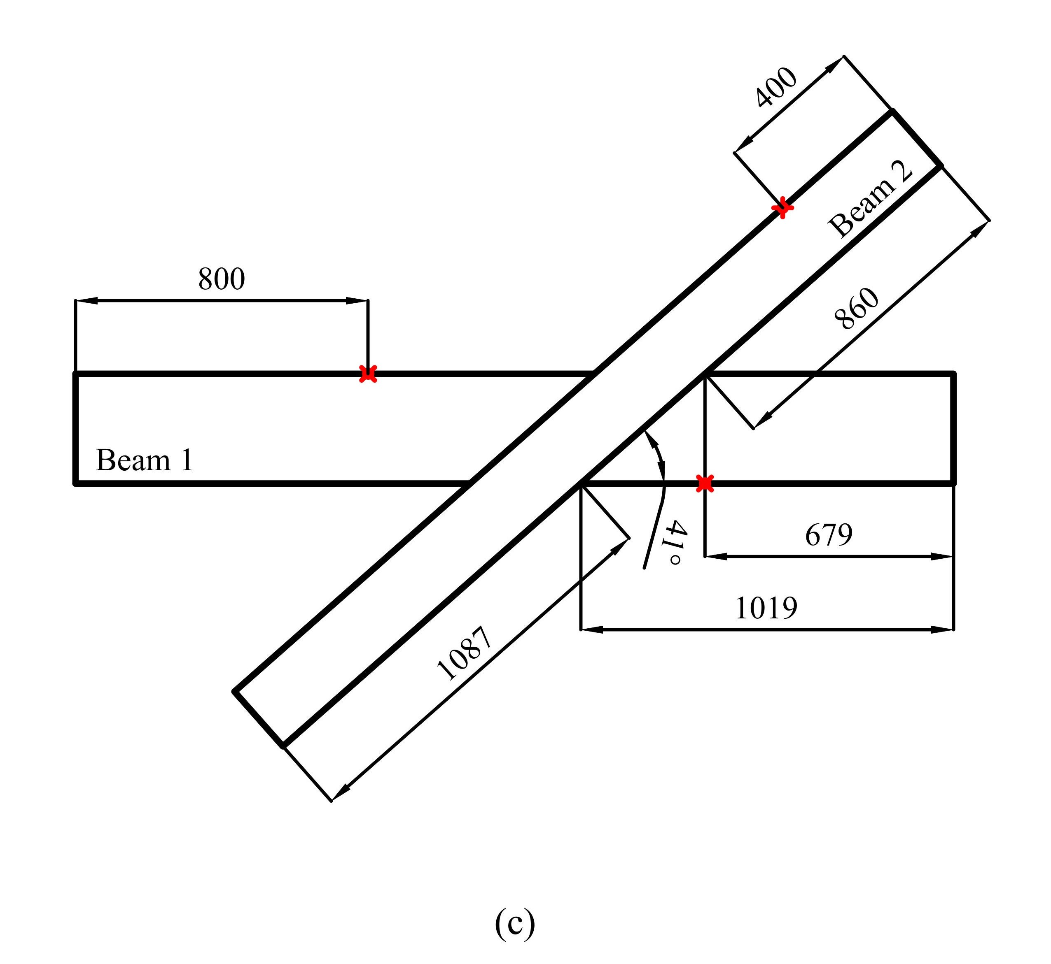

Figure 5: Junctions of beams with surface-to -surface contact.

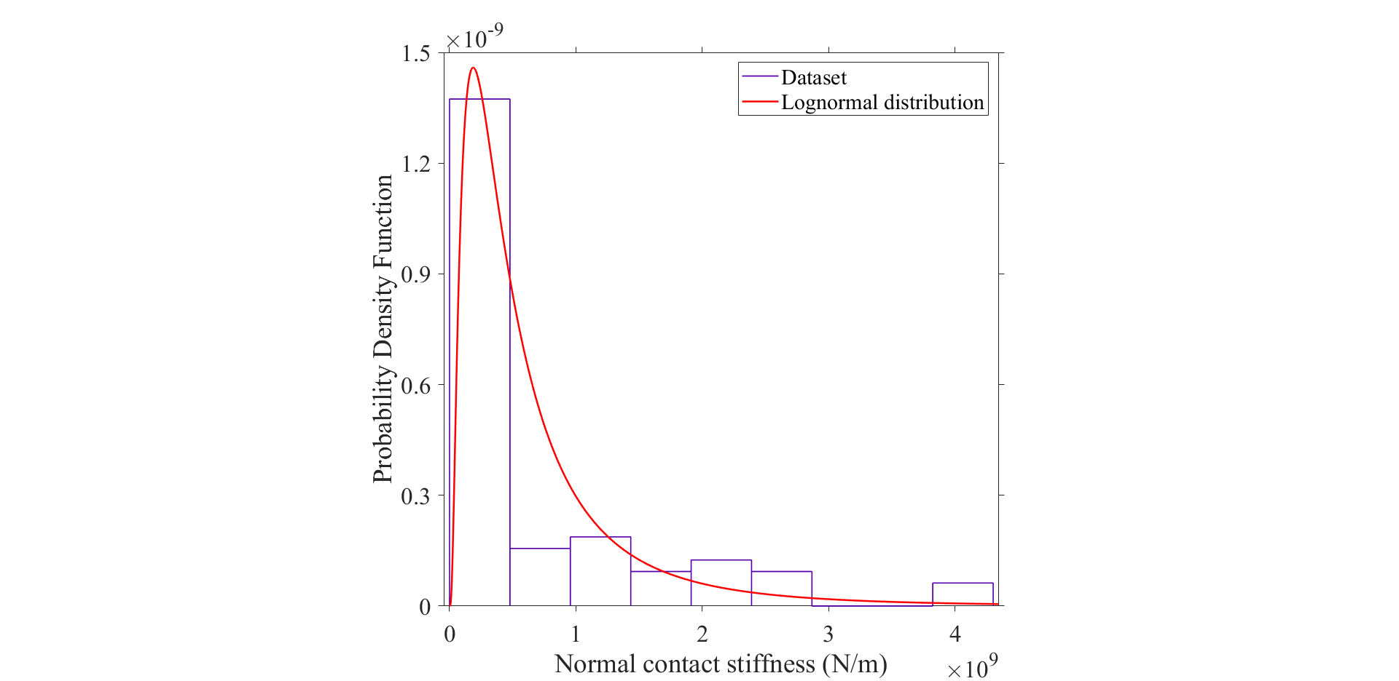

Figure 6: Distribution of the normal contact stiffness from the different structural modes.

To assess the use of the contact stiffness in an SEA prediction model, a Monte Carlo simulation with FEM and ESEA (Experimental SEA) [14] were used to create an ensemble of 30 junctions comprised of two beams (simply supported at each end), one on top of the other at an angle of 41° [6]. The surface-to-surface connection area was constant and equal to 0.091 m². This gave a mean CLF with 95% confidence intervals that could be compared with an analytical model for the CLF based on a simple, undamped, Lump Spring Connector (LSC) (see [8,9]). The LSC model requires the driving-point mobility for each beam; hence two calculations were carried out, one using the infinite beam mobility and the other using the mobility calculated with FEM. With FEM it is possible to choose (a) only bending modes, (b) only torsional modes, or (c) the combination of all modes for the analysis. The bandwidth was chosen to be 200Hz so there was at least one mode that falls in each band. Figure 7 shows the CLFs from only bending modes and only torsional modes for which the agreement between ESEA and the LSC model (both mobility approaches) is reasonable up to ≈2kHz. This is to be expected because above 1700Hz the longest dimension of the surface contact area is at least one-half of a bending wavelength; hence the assumption of a point connection for the spring in the LSC model will not be appropriate. The fact that reasonable predictions are produced using CLFs from the LSC model with infinite beam mobilities is a positive finding because this is much more efficient than using FEM.

Figure 7: Coupling loss factors between beams with a surface-to-surface contact for bending modes (upper graph) and torsional modes (lower graph).

2.2. Using the surface-to-surface contact condition with a simulated pile of reinforced concrete beams
To assess the use of the contact stiffness to predict vibration transmission in large SEA models of collapsed structures, a FEM simulation was made of a pile of 14 reinforced concrete beams (simply supported at each end) that were stratified in six layers – see Figure 8. The beams were arranged to allow multiple transmission paths between the layers of the beams as might occur between elements in a collapsed structure. All nodes of the lower surface of beam 1 (lower layer) were excited using rain-on-the-roof excitation and the out-of-plane response on all beams in the pile was extracted from all nodes on their lower surface.

The SEA matrix solution with 200Hz bandwidths was used to estimate the vibrational energy ratios between the source beam SS1 and the other beams using CLFs from the LSC model. The difference between energy level differences produced from SEA and FEM are shown in Figure 9 where the energy level difference, E₁/E_{i} refers to the energy of beam 1 (E₁) and the energy of each of the 13 other beams (E_{i}). Below 1kHz the differences were typically ±10dB except for two receiver beams, beam 9 (layer 4) and beam 12 (layer 5). The largest differences occurred with beam 9 because there were only two transmission paths that effectively dominated the transmission process. This provides more evidence that when there are many transmission paths the errors tend to be lower than when there are only a few paths. In a real collapsed structure, it is expected that there will be a large number of paths between an element inside the collapsed structure which is set into motion by the trapped person and an element on the surface of the collapsed structure.

Figure 8: Pile of 14 beams.

Figure 9: Pile of 14 beams: Difference between the energy ratios, E₁/E_{i} calculated from FEM and from SEA with CLFs from the LSC model using infinite beam mobilities.

2.3. Modelling vibration transmission across a T-junction in a lean-to-collapse
A lean-to-collapse [] frequently occurs with heavyweight floors in reinforced concrete buildings due to earthquakes – see Figure 10 (left). This type of collapse causes one end of a floor to be supported by a fragmented structural member or debris with the opposite end connected to the column. The angle between the anchored floor and the column is typically 45° – 55° [] and the only connection is made via the yielded steel reinforcement. Whilst models based on wave theory can be used for a rigid T-junction in an undamaged building, no such models are available for this damaged junction; hence the validated FEM models for reinforced concrete from the previous research were used to investigate vibration transmission between the beam and the column.

FEM models were built for an ensemble of 30 damaged beam-to-column junctions by assuming a uniform probability distribution for the angle between the beam and the column from -80° to +80° – see Figure 10 (right). Using 200Hz bandwidths, ESEA was used to determine the CLFs between the beam and the column with either bending modes or the combination of all mode types. For a rigid beam-to-column junction in an undamaged building it is common to assign three SEA subsystems (i.e. one for the column below the junction, one for the column above the junction and one for the beam) because the beam causes a significant impedance change for bending waves travelling along the column. However, when the only physical connection is due to the steel reinforcement it was found that only two subsystems were needed, one for the entire column and one for the beam [5].

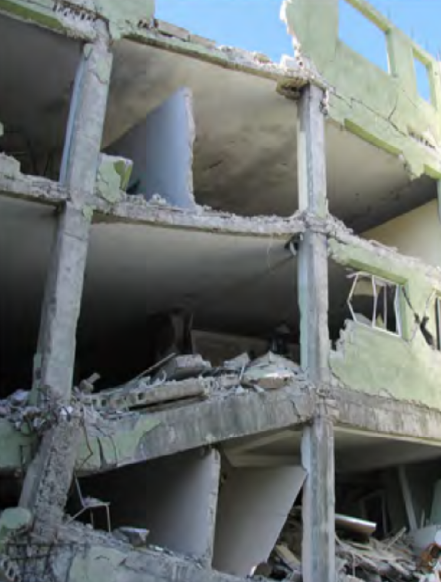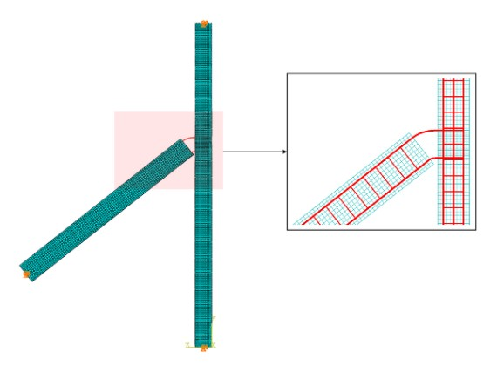

Figure 10: Photo of a lean-to-collapse from [] (left) and the damaged beam-to-column junction for the FEM simulation (right).

Figure 11 shows the CLFs between subsystem 1 (column) and subsystem 2 (beam) for the rigid, undamaged junction and the damaged junction. Below 200Hz it is common to assume only bending modes when predicting vibration transmission in concrete buildings [9] but to investigate up to higher frequencies, both bending modes only and all modes were considered. The results clearly show that the coupling is significantly reduced with the damaged junction compared to the undamaged junction regardless of mode type. In general, it is found that bending modes tend to dominate the transmission process and response. The 95% confidence intervals are relatively small for the wide range of angles between the beam and column in the ensemble; hence, FEM could be used to determine an average CLF because the exact angle between the beam and the column would rarely be known in practice.

Figure 11: Undamaged (Rigid) and damaged beam-to-column junction: Coupling loss factors η₁₂ and η₂₁ from FEM ESEA (error bars indicate 95% confidence intervals) using two subsystems with bending modes only (B) and the combination of all modes (A).

3. Future research directions
The following aspects require further work and they are interlinked; these are the prediction of structure-borne sound transmission, quantifying the type of transient forces that could be applied to the structure by the trapped victim and the detection of vibration signals on the outer surface of the collapsed building.

The research described above has shown the potential to use SEA to predict vibration transmission in fragmented structures. The next step could be to make use of software that simulates collapses of reinforced concrete buildings. This could help describe the statistical distributions of contact points so that more realistic simulations of vibration transmission can be carried out from deep within a collapsed structure. These SEA simulations were based on steady-state signal but in practice, the signals from survivors are usually transients such as from knocking or banging. However, the same CLFs can be used in a transient form of SEA (TSEA) to predict maximum vibration levels from transient excitation. This has been shown to be feasible in large masonry/concrete buildings [,,] but may need to be adapted because the Fast time-weighting was intended for the prediction of sound pressure levels and may not be optimal for a seismic search. To build the TSEA model it will be necessary to measure typical transient power inputs from a hand hitting, or a foot kicking a concrete element as well as concrete debris used to hit the element. This could be used to give guidance on the best way for a trapped person to excite the structure to ensure that the vibration signal can be picked up on the surface (perhaps using the vibration generated by a mobile phone).

In a seismic search, a small number of seismic sensors are moved over a regular grid so that the operators can be certain they have searched the entire site. Their placement and positioning is critical in detecting survivors. However, grid spacing and sensor placement are often decided simply by checking whether it is possible to detect transients generated by the operators in an adjacent grid area on the surface in places where the structure is safe to walk on [1,]. This is potentially misleading because horizontal propagation of vibration across the surface of a collapsed structure is only vaguely indicative of propagation into the depths of a collapsed structure. Hence there is a potential to improve the search procedures with knowledge about the propagation of vibration and alternative approaches to triangulation to find the location of the victim.

Current seismic detection devices incorporate relatively crude signal processing and typically have only three filters: mains hum removal, low pass, and high pass. No band-pass filtering is included due to a lack of knowledge of how vibration levels and frequency spectra change as structure-borne sound propagates over different distances in collapsed structures. Equipment might benefit from variable fixed bandwidth filters (rather than CPB filters) or a variable low-pass filter. For this reason, prediction models need to be used on different types of fragmented structures to provide information and guidance on signal levels and spectral content that can be used in the training of search and rescue teams and the development of improved seismic detection equipment. The results will also allow modelling of the effect of the propagation path on the survivor’s signal so that in the future it will be feasible to develop intelligent signal processing systems that can identify transients such as those from knocking and banging, or other signals such as from scratching and moving.

5. CONCLUSIONS
This paper summarizes the progress made to-date on predicting structure-borne sound transmission through collapsed concrete/masonry buildings after an earthquake, and indicates the areas where further work is needed. Researchers interested in developing these ideas in this field of research (particularly those from countries that are prone to earthquakes) are invited to get in contact (see details on front page) to discuss potential research collaborations.

ACKNOWLEDGEMENTS
Funded by EPSRC and ESRC Centre for Doctoral Training in Quantification Management of Risk & Uncertainty in Complex Systems and Environments (University of Liverpool). Grant no. 1521238.

REFERENCES

carl.hopkins@liverpool.ac.uk
. Bäckström, C-J and Christofferson, N. Urban search and rescue – an evaluation of technical search equipment and methods. Report No. 5197, 2006. Lund University, Sweden.
. Gabrielson, TB, Poese, ME and Atchley, AA. Acoustic and vibration background noise in the collapsed structure of the World Trade Centre (L). Journal of the Acoustical Society of America,113(1):45-48, 2003.
. Filippoupolitis, M and Hopkins, C. Experimental validation of finite element models representing stacked concrete beams with unbonded surface contacts. Engineering Structures, 227:111421, 2021.
. Filippoupolitis, M and Hopkins, C. Experimental validation of finite element models for reinforced concrete beams with discontinuities that form dowel-type joints. Vibration, 4, no. 3: 537-550, 2021.
. Filippoupolitis, M and Hopkins, C. Vibration transmission across seismically damaged beam-to-column junctions of reinforced concrete using Statistical Energy Analysis. Vibration, 6, no. 1: 149-164, 2023.
. Filippoupolitis, M. Detection of trapped survivors in collapsed reinforced concrete buildings using structure-borne sound transmission. PhD thesis. University of Liverpool, UK, 2020.
. Bendimerad, F (Director of the Earthquakes and Megacities Initiative). Reported at the 13th World Conference on Earthquake Engineering, August 2004.
. Craik, RJM Sound transmission through buildings using Statistical Energy Analysis, Hampshire: Gower Publishing Limited, 1996.
. Hopkins, C. Sound insulation. Oxford: Routledge, 2007.
. Hopkins, C. Vibration transmission between coupled plates using finite element methods and statistical energy analysis. Part 1: Comparison of measured and predicted data for masonry walls with and without apertures. Applied Acoustics,64(10):955-973, 2003.
. Hopkins, C, Crispin, C, Poblet-Puig, J, Guigou-Carter, C. Regression curves for vibration transmission across junctions of heavyweight walls and floors based on finite element methods and wave theory. Applied Acoustics, 113: 7-21, 2016.
. Poblet-Puig, J and Guigou-Carter, C. Using spectral finite elements for parametric analysis of the vibration reduction index of heavy junctions oriented to flanking transmissions and EN-12354 prediction method. Applied Acoustics, 99: 8-23, 2015.
. Craik, RJM, Steel, JA. and Evans, DI. Statistical energy analysis of structure-borne sound transmission at low frequencies, Journal of Sound and Vibration, 144 (1): 95–107, 1991.
. Hopkins, C. Statistical energy analysis of coupled plate systems with low modal density and low modal overlap. Journal of Sound and Vibration, 251(2): 193-214, 2002.
. Fahy, F.J.; Mohammed, A.D. A study of uncertainty in applications of SEA to coupled beam and plate systems. Part 1: Computational experiments. Journal of Sound and Vibration, 158: 45–67,1992.
. Wang, X and Hopkins, C. Bending, longitudinal and torsional wave transmission on Euler-Bernoulli and Timoshenko beams with high propagation losses. Journal of the Acoustical Society of America, 140: 2312–2332, 2016.
. Wang, X and Hopkins, C. Experimental and numerical validation of Advanced Statistical Energy Analysis to incorporate tunneling mechanisms for vibration transmission across a grillage of beams. Acta Acustica, 6: 51, 2022.
. NFPA 1670:2017; Standard on Operations and Training for Technical Search and Rescue Incidents. National Fire Protection Association: Quincy, MA, USA.
. Schweier, C and Markus, M. Classification of collapsed buildings for fast damage and loss assessment. Bulletin of Earthquake Engineering. 2006, 4, 177–192.
. Marshall, JD, Lang, AF, Baldridge, SM, Popp, DR. Recipe for disaster: Construction methods, materials, and building performance in the January 2010 Haiti earthquake. Earthquake Spectra, 27: 323–343, 2011.
. Robinson, M and Hopkins, C. Prediction of maximum time-weighted sound and vibration levels using transient statistical energy analysis. Part 1: Theory and numerical implementation. Acta Acustica united with Acustica, 100(1): 46-56, 2014.
. Robinson, M and Hopkins, C. Prediction of maximum time-weighted sound and vibration levels using transient statistical energy analysis. Part 2: Experimental validation. Acta Acustica united with Acustica, 100(1): 57-66, 2014.
. Robinson, M and Hopkins, C. Prediction of maximum fast time-weighted sound pressure levels due to transient excitation from the rubber ball and human footsteps, Building and Environment, 94(2): 810-820, 2015.
. Libby, G and Murray, P. Delsar - Seismic acoustic listening device. UK Urban Search and Rescue operations. UK Government. Document No. ND_USAR_SOP_SEA003. February 2007.

