**Efficient screening of adsorbed receptor for *Salmonella* phage LP31 and identification of receptor binding protein**

**Haojie Gea,b,c, Ling Yea,b, Yueyi Caic, Huimin Guoa,b, Dan Gua,b, Zhengzhong Xua,b, Maozhi Hua,b, Heather E. Allisonc, Xin'an Jiaoa,b*, Xiang Chena,b\***

aJiangsu Key Laboratory of Zoonosis/Jiangsu Co-Innovation Center for Prevention and Control of Important Animal Infectious Diseases and Zoonoses, Yangzhou University, Yangzhou 225009, China

bKey Laboratory of Prevention and Control of Biological Hazard Factors (Animal Origin) for Agrifood Safety and Quality of Ministry of Agriculture and Rural Affairs, Yangzhou University, Yangzhou 225009, China

cDepartment Clinical Infection, Microbiology and Immunology, Institute of Infection, Veterinary and Ecological Sciences, University of Liverpool, Liverpool, United Kingdom

*Author for correspondence: Tel: **+**86-514-87971136; chenxiang@yzu.edu.cn, jiao@yzu.edu.cn.

**ABSTRACT:** The adsorption process is the first step in the lifecycle of phages and plays a decisive role in the entire infection process. Identifying the adsorption mechanism of phages not only makes phage therapy more precise and efficient, but also enables the exploration of other potential applications and modifications of phages. Phage LP31 can lyse multiple *Salmonella* serotypes, efficiently clearing biofilms formed by *Salmonella enterica* serovar Enteritidis (*S*. Enteritidis), and significantly reducing the concentration of *S*. Enteritidis in chicken feces. Therefore, LP31 has great potential for many practical applications. In this study, we established an efficient screening method for phage infection-related genes and identified a total of 10 genes related to the adsorption process of phage LP31. After the construction of strain C50041Δ*rfaL*58−358, it was found the knockout stain had a rough phenotype, as an O-antigen deficient strain. Adsorption rate and transmission electron microscopy experiments showed that the receptor for phage LP31 was the O9 antigen of *S.* Enteritidis. Homology comparison and adsorption experiments confirmed that the tail fiber protein Lp35 of phage LP31 participated in the adsorption process as a receptor binding protein.

**IMPORTANCE:** A full understanding of the interaction between phages and their receptors can help with the development of phage-related products. Phages like LP31 with the tail fiber protein Lp35, or a closely related protein, have been reported to effectively recognize and infect multiple *Salmonella* serotypes. However, the role of these proteins in phage infection has not been previously described. In this study, we established an efficient screening method to detect phage adsorption to host receptors. We found that phage LP31 can utilize its tail fiber protein Lp35 to adsorb to the O9 antigen of *S*. Enteritidis, initiating the infection process. This study provides a great model system for further studies of a how a phage encoded receptor binding protein (RBP) interacts with its host’s RBP binding target, and this new model offers opportunities for further theoretical and experimental studies to understand of the infection mechanism of phages.

**KEYWORDS** phage, adsorption receptor, receptor-binding protein, *Salmonella*, O9 antigen

Members of the *Salmonella* genus are Gram-negative, facultative, intracellular bacteria comprising of more than 2500 serotypes (1, 2). They can infect animals including poultry and pigs, and may pose serious and life-threatening infection in humans (3, 4). *Salmonella* infections in humans are usually associated with consumption of *Salmonella* contaminated food or water, or due to direct contact with infected animals (5). According to the data released by the European Centre for Disease Prevention and Control, approximately 52,702 cases of *Salmonella* infections were reported in 2020, accounting for 22.5% of all foodborne human diseases (6). *Salmonella enterica* serovar Enteritidis (*S*. Enteritidis) is the most common cause of invasive human gastroenteritis disease and non-typhoidal *Salmonella* infections (2). *S*. Enteritidis ranked as the most common of 15 frequently identified serovars from human samples between 2001-2007 in laboratories from 37 countries (7). Between 2016 to 2018, 346 *Salmonella* strains were isolated from three large-scale chicken farms across different provinces of China. Of these 346 strains, 329 strains were *S.* Enteritidis, accounting for 95.09% of the *Salmonella* isolates (8). Therefore, prevention and control of *S.* Enteritidis infection is of great significance for the development of the poultry breeding industry and human health.

The overuse of antimicrobial drugs in agriculture and medicine in recent decades has led to the emergence of Multi-Drug Resistant (MDR) *Salmonella* (9-11). *S.* Enteritidis is the most serious antimicrobial-resistant serotype found in healthy chickens in central China, with high resistance rates to antibiotics, such as colistin, meropenem, and ciprofloxacin (12). Sun *et al.* (13) isolated 525 *S.* Pullorum strains from China that were resistant to at least one antibiotic, among which 280 strains (42.9%) were resistant to three or more antibiotics. The emergence of antibiotic resistance reduces the efficacy of antibiotics and increases the incidence and mortality of *Salmonella* infections in animals and humans (6). Due to the lack of new antibiotics on the market, the emergence of MDR bacteria makes it increasingly difficult to prevent and control *Salmonella* infections. In addition, China, the United States, and the European Union have banned the use of multiple antibiotics in animal husbandry, making biosecurity more difficult and expensive to maintain at low risk levels on farms (14, 15). Therefore, there is an urgent need for safe, effective, and low-cost means to control *Salmonella* infections in animal husbandry and the associated processes including food transportation and storage.

Bacteriophages or phages are viruses that can specifically infect and lyse bacteria and these viruses are widely distributed in nature (3, 16). In fact, most phages are very specialized in their interactions with bacteria, having evolved to recognize differences in bacterial species or even strains. Phages have been used as an alternative and ecologically friendly biological control agent for preventing and controlling MDR bacteria (17-19). However, the use of phages as therapeutic agents still faces challenges such as having an extremely narrow host range and being subject to interference by phage-resistance mechanisms in bacteria (20, 21). The limited host range is, in part, determined by the specificity of the host recognition system of phages. The phage receptor-binding proteins (RBPs) specifically recognize receptors on the surface of bacteria. Phages adsorb to the bacterial surface using these RBPs which then enable infection (22, 23). However, recognizing and being able to adsorb to the bacterial cell surface does not guarantee a phage will be able to infect a bacterial cell. Bacteria have multiple resistance mechanisms against phage infections, *e*.*g*. including blocking adsorption and blocking injection of phage DNA into the host cell, expressing restriction and modification systems, operating abortive infection systems, and expressing CRISPR-Cas systems (24-27). Among these phage defense mechanisms, the ability to block phage adsorption often occurs when the cell surface receptor of the bacterial host mutates, disabling the phages from recognizing the host (28). Therefore, understanding how phages recognize their specific hosts can impact upon several areas of phage utility: 1) detailed knowledge of phage recognition of the host receptor can enable scientists to modify phage with the specific aim of expanding their host range, 2) knowledge of phage (RBP) binding to the host’s receptor can be utilized to optimize the design of phages or phage tail components for rapid identification of bacteria, and 3) knowledge of phage RPBs interactions with host receptor molecules can be utilized to optimize the design of phages to treat bacterial infections or other problems.

Phage LP31 is a lytic phage. Our previous research has shown that LP31 is able to lyse multiple serotypes of *Salmonella*, and LP31 can also efficiently eliminate biofilms formed by *S*. Enteritidis and *S.* Pullorum. From our preliminary research, it was found that phage LP31 can significantly reduce the concentration of *Salmonella* both on metal surfaces and in chicken intestinal feces (29). Therefore, phage LP31 may have a significant role to play in the control of *Salmonella*-mediated food borne disease. In order to maximize our ability to efficiently utilize phage LP31 and others related phages, it is necessary to identify and characterize both the RBP of phage LP31 and surface receptor it binds to on *Salmonella*. In this study, an efficient method for screening phage receptors is established, and multiple mutants from a *S*. Enteritidis C50041 library are screened for phage resistance. The RBP of the phage (which in tailed phages is associated with the tail) was identified through receptor neutralization experiments, adsorption rate measurement assays, and transmission electron microscopy (TEM). This study provides some of the basic information necessary to understand *Salmonella* phage LP31 before it can be used in future targeted therapeutic or other biocontrol control strategies. In addition, an efficient new way to identify phage receptors of bacteria is provided.

**RESULTS**

**Screening for the LP31 phage resistant strains.** A random insertion, transposon mutant library of *S*. Enteritidis C50041 was constructed, and the library was mixed with the phage LP31. The phage was allowed to infect and kill susceptible cells. A significant reduction in the number of viable cells was observed (Fig. 1A). Colonies (200, now known as putative LP31 resistant mutants) were picked that survived this phage infection. Drop spot assays identified that phage LP31 could not form clear or translucent zones on 19 of 200 putative LP31 resistant mutant lawns (Fig 1B). Co-culture experiments *in vitro* revealed that while phage LP31 was able to effectively inhibit the growth of wild-type C50041 within 7 hours, it was unable to significantly inhibit the growth of the 19 mutant strains (Fig. 1C). Therefore, these 19 strains became known as true phage resistant mutants or simply LP31 resistant mutants.

**Identification of the lipopolysaccharide synthesis genes involved in phage adsorption.** Based on the results from PCR amplification and sequencing, we found that the transposon insertion sites in the LP31 resistant mutants mainly existed in 10 lipopolysaccharide (LPS) synthesis-related genes (Fig. 2A, 2B and Table 2). To verify the type of receptor phage LP31 recognizes on the bacterial surface, the adsorption capacity of phage LP31 before and after treatment of *S*. Enteritidis C50041 with sodium-periodate or proteinase K, respectively, was measured. It was found that the adsorption of the phage to the host bacteria after proteinase K treatment did not change significantly, but the adsorption to the bacteria after sodium periodate treatment decreased significantly (Fig. 2C). The results show that after digestion of surface exposed protein, the adsorption potential of phage LP31 remained unchanged, but after the polysaccharide was damaged, the adsorption potential of LP31 was significantly decreased. Indicating that the polysaccharide is necessary for phage LP31 adsorption. In addition, adsorption experiments were used to measure the impact on adsorption of each transposon insertion from the 19 LP31 resistant mutants; all were shown to possess a significantly reduced ability to support phage LP31 adsorption (Fig. 2D). Therefore, we speculated that LPS may be the receptor for phage LP31.

**The deletion strain C50041Δ*rfaL*58−358 shows phage resistance and rough phenotype** **with O-antigen deficiency.** An isogenic mutant of C50041, deficient in the production of the *rfaL* gene product was created, C50041Δ*rfaL*58-358 (Fig. S1) and the mutation was complemented by enabling the expression of *rfaL* from an inducible plasmid, C50041Δ*rfaL*58-358-p*rfaL* (Fig. S2) to verify whether LPS is the essential receptor for phage LP31. Phage LP31 was able to form clear and translucent plaques on the wild-type and complementation strains but not on the deletion strain (Fig. 3A). *In vitro* cultivation showed (Fig. 3B) that the growth curves of the wild-type, knockout, and complementation strains were roughly the same. After adding LP31 to the culture medium, the growth of the wild type and complementation strains was almost completely inhibited within seven hours, while the growth of the knockout strain was not affected significantly, indicating that the knockout strain C50041Δ*rfaL*58-358 is resistant to phage LP31.

To verify whether the deletion of the *rfaL* gene affects the integrity of LPS on the surface of bacteria, agglutination and auto-aggregation characteristics of the wild type, deletion, and complemented strains were tested. The results showed that an O9 mAB (monoclonal antibody against O-antigens) was able to support agglutination of the wild type and complemented strains but not the *rfaL* deletion mutant. However, acriflavine, which supports the agglutination of rough (LPS mutants) strains, did support the agglutination of the *rfaL* deletion mutants but not the wild type or complemented deletion mutant strains (Fig. 3C). Additionally, there was no auto-aggregation when the wild-type and complemented strains were incubated statically, while the deletion strain exhibited significant auto-aggregation with an aggregation rate of up to 78% (Fig. 3D). These results suggest that the deletion strain C50041Δ*rfaL*58-358 exhibits a rough phenotype with O-antigen deficiency.

**The O9 antigen of LPS as an adsorption receptor for phage LP31.** To determine whether the O antigen on the *S*. Enteritidis LPS is the adsorption receptor for phage LP31, adsorption assays and subsequent TEM imaging was performed to observe the effect of the O antigen of the *S*. Enteritidis LPS on phage adsorption. After incubation with smooth LPS (Sigma-Aldrich, purified from S. Enteritidis, 100 mg/ml), the adsorption capacity of phage LP31 to *S*. Enteritidis C50041 was significantly reduced (Fig. 4A), and no phage particles were observed on the surface of C50041 by TEM (Fig. 4C), indicating that phage LP31 bound to the soluble *S*. Enteritidis LPS, which affected the numbers of phage LP31 that were left to adsorb to the whole bacterial cells. In addition, the adsorption of phage LP31 tothe *S.* Typhimurium mutant D6Δ*rfbN*83−188, *S*. Enteritidis C50041Δ*rfbG*, and C50041Δ*rfaL*58−358 (all possessing an O-antigen deficiency) were significantly lower than that of wild-type strains (Fig. 4B). TEM images following the adsorption assay showed that a large amount of phage particles were adsorbed on the surface of the wild type *S*. Enteritidis C50041, but no phage particles were observed on the surface or even nearby the surface of C50041Δ*rfaL*58−358 (Fig. 4C). These results indicate that the adsorption process of phage LP31 requires the O9 antigen of *S*. Enteritidis LPS to participate.

**Identification of the receptor-binding protein Lp35.** To identify the RBP of phage LP31, all potential tail associated proteins encoded by phage LP31 we bioinformatically predicted (27). A total of 5 proteins were identified as phage tail or tail associated proteins (Lp24, Lp34 and Lp35) were cloned with fused histidine tags and purified (Fig. 5A and S3, Lp24 and Lp34 data not shown). The products of two genes, Lp30 and Lp23 were predicted to be a tape measure protein and the main tail protein, respectively, and were not chosen for further study. Adsorptions assays showed that only the purified recombinant Lp35 protein was able to significantly decrease adsorption of phage LP31 to *S*. Enteritidis C50041 (Lp35+H2O) (Fig. 5B). However, no significant change in the adsorption of phage LP31 was detected using either purified Lp24 or Lp34 (data not shown). Bioinformatic analysis of protein Lp35 (encoded by *lp35* gene) indicated that Lp35 shared the greatest level of homology to a tail fiber protein of phage vB_SenS_SE1 (Fig. 5C and 5D) (30). Subsequently, after incubating with LPS and Lp35 and then blocking C50041, we found that the adsorption of phage LP31 to C50041 was significantly higher than that of C50041 only blocked by Lp35 (Lp35+H2O) (Fig. 5B). TEM observation also showed that there was very limited phage binding to the surface of C50041 that was first blocked by Lp35(Lp35+H2O), but that phage LP31 could adsorb to C50041 that was first blocked by LP35 incubated with LPS (Fig. 4C). All of these results indicate that the tail fiber protein Lp35 of phage LP31 participates in the adsorption process as an RBP.

**DISCUSSION**

The life cycle of lytic phages generally consists of several stages: host adsorption, injection, DNA replication, gene transcription, protein translation, phage assembly, and finally lysis of host cells to release progeny phages (24). Adsorption of the phage to the bacterial surface is the first step in phage infection. The phage binds to a specific receptor on the surface of the host, allowing them to recognize a suitable host in a mixed population of bacteria. Meanwhile, bacteria can develop resistance to phage infection by mutating the specific receptors on their cell surfaces, thereby preventing phage adsorption (31). Therefore, specific receptors are crucial for the phage infection process. Currently, the development of phage therapy and phage display technology largely relies on the phage adsorption mechanism (32- 34). However, the traditional method of co-cultivating phages and hosts to induce host mutations and phage resistance, and to identify genes related to phage adsorption, is time-consuming and can only identify a limited number of target genes. In addition, predicting phage adsorption receptors through bioinformatic methods lacks experimental data support, making its accuracy and reliability for characterizing phage host interactions for therapeutic strategies less certain which is an important step in realizing the full potential of phage therapy in clinical trials and use (35). Previously, we screened for phage resistance strains from a mutant library using a drop method, which was laborious and time-consuming (screening 3 phage resistance strains from 5,000 mutant strains) (28). Therefore, in this study, we optimized the previous screening method (Added process 2 in Fig. 6 to the original method) and established an efficient screening method that only took three days, significantly improving efficiency (Fig. 6). Using this method, we screened 19 phage LP31-resistant mutants from 200 putative *S.* Enteritidis C50041 mutants (Fig. 1B and C). The mutated genes of these strains were all related to LPS synthesis (Fig. 2A, 2B and Table 2) (36). Common phage adsorption receptors in Gram-negative bacteria include LPS, outer membrane proteins (OMP), flagella, pili, and capsules (37). We deduced that the receptor for phage LP31 is a polysaccharide rather than a membrane protein due to the facts that the adsorption potential of phage LP31 to proteinase K treated C50041 *S.* Enteritis was almost unchanged, while the adsorption potential to sodium periodate treated C50041 decreased significantly (Fig. 2C) (38). The adsorption potential of LP31 to the transposon-mediated LPS synthesis mutants was also significantly reduced (Fig. 2D) (*P* < 0.01), also demonstrating that phage LP31's adsorption receptor is likely to be part of the LPS of *S.* Enteritidis.

LPS is the main component of the outer membrane of Gram-negative bacteria, consisting of O-antigen, core polysaccharide, and lipid A. The O-antigen can be classified into different serotypes types (34, 39). Loss of the O-antigen results in rough LPS, and rough *Salmonella* auto-aggregate and agglutinate with O antibody (40). Seven (*rfbF*, *rfbG*, *rfbH*, *rfbA*, *rfbB*, *rfbC* and *rfbP*) of the ten genes identified as being important in supporting phage LP31 adsorption are involved in O-antigen synthesis, and one (*rfaL*) is involved in connecting O-antigen to the LPS core polysaccharide. Two other genes (*rafJ* and *rfaQ*) are involved in the synthesis or assembly of LPS core polysaccharides (Fig. 2B and table 2) (36). The *rfaL* gene of *Salmonella* encodes O-antigen ligase, and a mutant defective in *rfaL* expression may lack the ability to decorate their LPS core antigen with the O-antigen, causing LPS to transition from a smooth to a rough type (41). To verify whether the assembly of O-antigen in *S*. Enteritidis is affected by deletionof the *rfaL* gene, we constructed a *S*. Enteritidis C50041Δ*rfaL*58-358 strain, which does not aggregate in the presence of O9 mAB but dose aggregate in the presence of acriflavine (Fig. 3C). In addition, the C50041Δ*rfaL*58-358 strain shows obvious auto-aggregation characteristics (Fig. 3D). The rough phenotype exhibited by this strain is similar to the phenotype of O9 antigen deficient strain *S*. Enteritidis C50041Δ*rfbG* (42) and *S*. Typhimurium D6Δ*rfbN*83-188 (28). Therefore, the knockout of the *rfaL* gene in *S*. Enteritidis C50041 results in the loss of the O9 antigen from LPS and the transition of LPS from a smooth to a rough type. The O9 antigen and core polysaccharide of *Salmonella* LPS have been reported to play a role as the receptor for some phage in adsorption (34). This study found that the binding ability of LP31 to the surface of C50041 was significantly reduced after incubation with smooth LPS *in vitro*, (Fig. 4A), indicating that a part of LPS can bind to the RBPs of LP31 *in vitro*. LP31 was also found to lack the ability to adsorb to the O9 antigen deficient strains D6Δ*rfbN*83-188, C50041Δ*rfbG*, and C50041Δ*rfaL*58-358, though phage LP31 did adsorb well to the wild-type strains surface (Fig. 4B and C). These data all support the concept that the adsorption process of LP31 requires the participation of O9 antigen. In conclusion, the O9 antigen of LPS is the receptor for phage LP31 adsorption.

RBPs of phages can specifically recognize receptors on the surface of bacteria and play an important role in their host range (43). Tail proteins of phages infecting Gram-negative bacteria often serve as RBPs to adsorb LPS (28). Bioinformatics analysis revealed that Lp35 had high homology with tail or tail associated proteins of six different *Salmonella* phages, and its closest homologue was the tail fiber protein of phage vB_SenS_SE1 (30), indicating that Lp35 is likely to be the tail fiber protein of phage LP31 (Fig. 5C and 5D). However, the tail fiber protein of phage vB_SenS_SE1 has not previously been confirmed to be the RBP. We expressed and purified the Lp35 protein (Fig. 5A) and found that it could bind to the receptor on the surface of *S*. Enteritidis C50041 and reduce the adsorption of phage LP31 to C50041 (Fig. 5B and Fig. 4C) supporting our hypothesis that Lp35 can bind to theLPS on the surface of *S*. Enteritidisto prevent the adsorption of phage LP31. To verify this hypothesis, we incubated C50041 with *S*. Enteritidis purified Lp35 or with purified Lp35 and purified LPS. Following these incubations an adsorption assay was performed with phage LP31. Purified Lp35 was capable of blocking the adsorption of phage LP31 to C50041 and Lp35 interference relieved by allowing Lp35 to first interact with LPS before setting up the phage LP31 adsorption assay (Fig. 5B and Fig. 4C), indicating that Lp35 is able to bind to *S*. Enteritidis LPS *in vitro*. In summary, the adsorption receptor of phage LP31 is the O9 antigen of *S*. Enteritidis LPS and the RBP is tail fiber protein Lp35.

The use of a lytic phage to screen a transposon library that have survived phage infection is a robust strategy to identify mutants that have lost genes important to supporting phage infection. We narrowed down the mutants from our library that did this through the loss of a receptor by demonstrating not just that the mutants didn’t support phage infection, but that they no longer supported phage adsorption. We confirmed this by making a clean deletion mutant and then complementing this mutant, which showed the appropriate gain and loss of adsorption at the cell population level (adsorption assays) and at the cellular level (TEM imaging). This clean mutant analysis actually provides proof that the O antigen is the receptor for phage LP31 and demonstrates that the strategy described here is a quick and effective method to define phage receptors. The second part of the study attempted to define what part of phage LP31 actually binds to the O antigen. The design of these experiments were informed by bioinformatic predictions. Once the number of predictions was limited to a testable number of potential RBPs, these genes could be cloned and their products purified to use in competition assays against the known receptor. These strategies are transferable to other phage host systems, and it is hoped that they can be used to rapidly expand our knowledge of phage host interactions and also enable more detailed studies of exactly how the RBPs interact with receptors by enabling the generation of site directed mutants in both RBPs and receptors that can be screened rapidly for function. Together this knowledge will help inform strategies to pick phage, build phage cocktails and utilise the potential power phages have to control bacteria in clinical, agricultural, industrial and other every day settings.

**MATERIALS AND METHODS**

**Bacterial strains and growth conditions.** All *Salmonella* and *E. coli* strains were cultured in LB at 37°C and stored in 20% glycerol at –80°C until use. Phage LP31 (GenBank accession no. OL436139) was stored in 20% glycerol at –80°C. The characteristics of the strains and plasmids used in this study are presented in Table 1. All primers used in this study are listed in Table S1. 2,6-diaminopimelic acid (DAP, 100 μg/ml), chloromycetin (Cm, 25 μg/ml), and kanamycin (Km, 50 μg/ml) were used when required. Expression of His-tagged proteins was induced by 1 mM iso-propyl β-D-1-thiogalactopyranoside (IPTG).

**Transposon mutagenesis and selection of phage-resistant mutants *S*. Enteritidis.** The transposon carrying plasmid, pSC189 from *E. coli* X7213 λpir was transferred to *S*. Enteritidis C50041 by conjugation (28). Phage LP31 (1 ml, 108 pfu/ml) was added to every 1 ml of mutant library mixture (108 cfu/ml), mixed well, and incubated at 37°C for one hour. The infected cells were recovered by centrifugation (2500 rcf, 5 min) and then washed 3 times in 1 ml LB medium to remove residual phages. Finally, the cells were spread onto selective LB agar plates containing Km and incubated at 37°C for 16 hours.

**Phage drop spot assays.** The method of dropping phage suspensions onto bacterial lawns to visualize phage killing has been reported previously (28).

**Growth rate assays.** The production of growth curves was performed as described previously Bohm *et al.* (36) with the following modifications. Phage resistant mutants were either uninfected or infected with phage LP31 at an MOI of 10 in a 96-well plate. The plates were incubated at 37°C/220 rpm for 8 h with optical density readings taken at 600 nm (O.D.600) every 1 h with vigorous shaking before each read. A microplate reader (Tecan) was used to monitor growth rates of cultures with and without phage as described. A smaller scale assay was also performed with only the wide type strain, C500041, its *rfaL* deletion mutant derivative (C50041Δ*rfaL*58−358), and the complemented strain (C50041Δ*rfaL*58−358-p*rfaL*) were incubated at 37°C/220 rpm in test tubes (5 ml LB) and the O.D.600 were determined by spectrophotometry.

**Determining transposon insertion sites.** The method refers to previous research (28). A first round of PCR amplification (primers: AB1, AB2, AB3, SP1, table S1) using genomic DNA from the phage resistant mutants as a template, a second round of PCR (primers: ABS, SP2, table S1) was performed using the PCR product from the first round as a template, and the second PCR product was sent to Tsingke Biotechnology Co., Ltd. for sequencing with primer pSC189-seq (Table S1). Blast analysis (https://www. ncbi.nlm.nih.gov) was performed to determine the mutant gene based on the sequencing results.

**Adsorption assays.** Adsorption assays were conducted as previously described (28). Briefly, to monitor phage adsorption, phage LP31 was mixed with fresh bacterium culture to reach an MOI of 1. After incubation at 37°C for 10 min, the phage-bacteria mixture was centrifuged at 10,000 rcf for 10 min. The free phage titer in the supernatant was determined by the double-layer agar plates method. $$Percent adsorption=\frac{{pfu}^{added}–{pfu}^{supernatant}}{{pfu}^{added}}$$

**Identification of phage receptor type by proteinase K or sodium periodate treatment.** To determine whether the phage receptor displayed on the host cell surface was more likely to be a protein or a carbohydrate, a total of 1.5 ml of *S*. Enteritidis C50041 culture (O.D.600 ≈ 0.4) was treated with either 15 μl proteinase K (20 mg/ml) or 1.5 ml Ac (NaIO4) (50 mM sodium acetate (pH 5.2) containing 100 mM NaIO4) at 37°C for 1 h (38, 44). The treated bacteria were then washed with PBS three times and tested in an adsorption assay for their ability to support phage LP31 binding.

**Mutant strain construction**. The *rfaL* gene-deletion mutant strain was constructed through directed homologous recombination. The DNA fragments homologous to upstream (primers: Up-F/R) and downstream (primers: Down-F/R) regions of the *rfaL* gene were amplified by PCR. The plasmid pDM4 was digested using the restriction endonucleases *Sac I* and *Xho I*. The amplified upstream and downstream sequences of *rfaL* were cloned into the digested pDM4 using ClonExpress Ultra One Step Cloning Kit (Vazyme) to construct the recombinant plasmid pDM4-Δ*rfaL*. The plasmid pDM4-Δ*rfaL* was introduced into *E. coli* DH5α and X7213 λpair through CaCl2 mediated transformation, in turn. Finally, the recombinant plasmid was introduced into *S*. Enteritidis C50041 by conjugation, and transconjugants were selected for on LB agar plate (15% sucrose) (the sucrose provided selective pressure for the *rfaL* gene deletion).

To complement the *rfaL* deletion, the *rfaL* gene was amplified (Primers: *rfaL*-F/-His-R [Table S1], template: genomic DNA from the C50041). The plasmid pMMB207 was digested by restriction endonucleases *Xba I* and *Hind III* and the amplified *rfaL* gene was cloned into pMMB207 using the ClonExpress Ultra One Step Cloning Kit, producing the recombinant plasmid pMMB207-*rfaL*-His. The plasmid pMMB207-*rfaL*-His was introduced into the *E. coli* DH5α and X7213 λpair by CaCl2 mediated transformation. Finally, the recombinant plasmid was introduced into the deleted strain by conjugation, and transconjugants were selected for on the LB agar plate containing Cm.

**Construction of vectors to produce histidine tagged recombinant proteins.** To confirm the identity of the BRP of phage LP31, the *LP31GM_0000035* (*lp35*) gene was amplified by PCR (Primers: *lp35*-F/-His-R [Table S1], template: genomic DNA from the phage LP31) and inserted into the pET28a vector to construct the recombinant plasmids pET28a-*lp35*-His. The plasmid pET28a-*lp35*-His was transformed into *E. coli* BL21 by CaCl2 mediated transformation and expression of His-tagged-Lp35 was then induced using 1 mM IPTG at 19°C for 24 h. The purification and identification of the protein were performed according to the instructions of the His-tag Protein Purification Kit (Beyotime).

**Auto-aggregation assay.** The auto-aggregation assay was performed based on the method previously described (42, 45). Overnight culture (30 µl) was used to inoculate 3 ml of LB medium which was then incubated at 37°C for 16 h. The upper 100 µl was carefully removed to measure its O.D.600, recorded as O1. The remaining culture in the test tube was then vortexed to resuspend the aggregated cells, and 100 µl of the suspension was removed and its O.D.600 was measured (recorded as O2).

**Agglutination assay.** The agglutination assay was performed based on the method previously described (42, 45). A O9 mAB (a monoclonal antibody that specifically recognizes O9 antigen) (20 µl, 50 µg/ml, BioChek) or acriflavine solution (20 µl, 5 mg/ml, Hopebiol) were dropped onto a slide. A small amount of bacterial colony was taken with an inoculation loop and mixed evenly into either the O9 mAB or the acriflavine solution. The slide was gently shaken, and agglutination, if present, was observed after 1 minute.

**Transmission electron microscopy (TEM).** Phage LP31 and appropriate bacterial culture were mixed at an MOI = 100 and incubated at 37°C for 10 minutes. The sample (20 μl) was pipetted onto a copper grid, left to sit at room temperature for 10 minutes, and then the excess liquid was carefully removed with filter paper. The sample was stained with a drop of 2% phosphotungstic acid for 1 minute, and then the stain was removed with filter paper. The phage's adsorption on the bacteria was visualized by TEM (Hitachi, HT7800, 100 kV, ×12k-20k) (46, 47).

**Adsorption assay for phage incubated with LPS *in vitro*.** Phage LP31 (500 μl of 104 pfu/ml) and *S*. Enteritidis LPS (500 μl of 100 mg/ml) were mixed and incubated at 37°C for 1 hour. The control group keeps other conditions the same but replaces the LPS solution with the same volume of ultra-pure water. An adsorption experiment was then performed as well as TEM imaging to observe whether LPS from *S*. Enteriditis could interfere with LP31’s ability to adsorb to *S*. Enteritidis C50041.

**Identification the RBP of phage LP31*.*** Purified protein (1 mg/ml, 500 μl) was incubated with 500 μl of *S*. Enteritidis LPS (100 mg/ml) or H2O at 37°C for 15 min. Then, *S*. Enteritidis C50041 (100 μl, 107 cfu/ml) were incubated with these two solutions separately at 37°C for 15 min. Finally, the bacteria were washed three times with PBS, and the remaining 200 μl of the pellet was used for adsorption determination and TEM observation.

**Alignment and Phylogenetic Analysis.** In order to identify the RBP of phage LP31, Jalview (Version 2.11.2.6) and MEGA 11 (Version 11.0.13) were used (48-50). The amino acid sequence of the tail protein Lp35 of phage LP31 was aligned and phylogenetically analyzed with proteins reported in literature that had a Per. Identity greater than 80% with the sequences in the GenBank database (https://www.ncbi.nlm.nih.gov/genbank/). The phylogenetic analysis of the tail fiber protein of phage LP31 was performed using the Neighbor-Joining (NJ) method with bootstrapping, n=500.

**Statistically Analysis.** All experimental data are presented as mean ± standard deviation of at least three independent experiments. Differences between the means of each data were analyzed using t-test with GraphPad Prism software (version 8.0.1). *P* < 0.05 was considered statistically significant.

**ACKNOWLEDGMENTS**

Our work was supported by grants from the National Key Research and Development Program of China (grant 2021YFD1800403), the Jiangsu Agricultural Science and Technology Independent Innovation Funds (CX(21)1004), the Science and Technology Program of Jiangsu (BE2021331), the 111 Project (D18007), the Priority Academic Program Development of Jiangsu Higher Education Institutions (PAPD), the Fund for Excellent Doctoral Dissertations from Yangzhou University, and the Yangzhou University International Academic Exchange Funds.

All authors read and approved the submitted version of the paper. We declare no conflict of interest.

**REFERENCES**

1. Zhang Y, Xian H, Jiang X, Yuan Y, Ji R, Jiao X, Li Q.2022. Identification of two Sel1-like proteins in SPI-19 of *Salmonella enterica* serovar Pullorum that can mediate bacterial infection through T3SS. Microbiol Res 262:127085. 10.1016/j.micres.2022.127085.

2. Gallichan S, Perez-Sepulveda BM, Feasey NA, Hinton JCD, Thomas J, Smith AM.2022. Multiplex PCR assay for clade typing of *Salmonella enterica* Serovar Enteritidis. Microbiol Spectr 10:e0318222. 10.1128/spectrum.03182-22.

3. Kosznik-Kwasnicka K, Stasilojc M, Grabowski L, Zdrojewska K, Wegrzyn G, Wegrzyn A.2022. Efficacy and safety of phage therapy against *Salmonella enterica* serovars Typhimurium and Enteritidis estimated by using a battery of in vitro tests and the Galleria mellonella animal model. Microbiol Res 261:127052. 10.1016/j.micres.2022.127052.

4. Svahn AJ, Chang SL, Rockett RJ, Cliff OM, Wang Q, Arnott A, Ramsperger M, Sorrell TC, Sintchenko V, Prokopenko M.2022. Genome-wide networks reveal emergence of epidemic strains of *Salmonella* Enteritidis. Int J Infect Dis 117:65-73. 10.1016/j.ijid.2022.01.056.

5. Yang C, Chen K, Ye L, Heng H, Chan EWC, Chen S.2022. Genetic and drug susceptibility profiles of mcr-1-bearing foodborne *Salmonella* strains collected in Shenzhen, China during the period 2014-2017. Microbiol Res 265:127211. 10.1016/j.micres.2022.127211.

6. Li Y, Lv P, Shi D, Zhao H, Yuan X, Jin X, Wang X.2022. A cocktail of three virulent phages controls multidrug-resistant *Salmonella* Enteritidis infection in poultry. Front Microbiol 13:940525. 10.3389/fmicb.2022.940525.

7. Hendriksen RS, Vieira AR, Karlsmose S, Lo Fo Wong DM, Jensen AB, Wegener HC, Aarestrup FM.2011. Global monitoring of *Salmonella* serovar distribution from the World Health Organization Global Foodborne Infections Network Country Data Bank: results of quality assured laboratories from 2001 to 2007. Foodborne Pathog Dis 8:887-900. 10.1089/fpd.2010.0787.

8. Zhang J, Luo W, Liu G, Wang Y, Geng S, Pan Z, Jiao X.2021. High genetic similarity of *Salmonella* Enteritidis as a predominant serovar by an independent survey in 3 large-scale chicken farms in China. Poult Sci 100:100941. 10.1016/j.psj.2020.12.038.

9. Vyas P, Harish.2022. Anti-CRISPR proteins as a therapeutic agent against drug-resistant bacteria. Microbiol Res 257:126963. 10.1016/j.micres.2022.126963.

10. Reddy S, Kaur K, Barathe P, Shriram V, Govarthanan M, Kumar V.2022. Antimicrobial resistance in urban river ecosystems. Microbiol Res 263:127135. 10.1016/j.micres.2022.127135.

11. Saini J, Kaur P, Malik N, Lakhawat SS, Sharma PK.2022. Antimicrobial peptides: a promising tool to combat multidrug resistance in SARS CoV2 era. Microbiol Res 265:127206. 10.1016/j.micres.2022.127206.

12. Wang X, Wang H, Li T, Liu F, Cheng Y, Guo X, Wen G, Luo Q, Shao H, Pan Z, Zhang T.2020. Characterization of *Salmonella* spp. isolated from chickens in Central China. BMC Vet Res 16:299. 10.1186/s12917-020-02513-1.

13. Sun F, Li X, Wang Y, Wang F, Ge H, Pan Z, Xu Y, Wang Y, Jiao X, Chen X.2021. Epidemic patterns of antimicrobial resistance of *Salmonella enterica* serovar Gallinarum biovar Pullorum isolates in China during the past half-century. Poult Sci 100:100894. 10.1016/j.psj.2020.12.007.

14. Zhang K, Ge H, He J, Hu M, Xu Z, Jiao X, Chen X.2022. *Salmonella* Typhimurium ST34 Isolate Was More Resistant than the ST19 Isolate in China, 2007 - 2019. Foodborne Pathog Dis 19:62-69. 10.1089/fpd.2021.0047.

15. Shafiq M, Ke B, Li X, Zeng M, Yuan Y, He D, Deng X, Jiao X.2022. Genomic diversity of resistant and virulent factors of *Burkholderia pseudomallei* clinical strains recovered from Guangdong using whole genome sequencing. Front Microbiol 13:980525. 10.3389/fmicb.2022.980525.

16. Xu Z, Shao S, Ding Z, Zhang Y, Wang Q, Liu X, Liu Q.2022. Therapeutic efficacies of two newly isolated Edwardsiella phages against *Edwardsiella piscicida* infection. Microbiol Res 263:127043. 10.1016/j.micres.2022.127043.

17. Ge H, Fu S, Guo H, Hu M, Xu Z, Zhou X, Chen X, Jiao X.2022. Application and challenge of bacteriophage in the food protection. Int J Food Microbiol 380:109872. 10.1016/j.ijfoodmicro.2022.109872.

18. Bao H, Zhang H, Zhou Y, Zhu S, Pang M, Zhang X, Wang Y, Wang J, Olaniran A, Xiao Y, Schmidt S, Wang R.2022. Dysbiosis and intestinal inflammation caused by *Salmonella* Typhimurium in mice can be alleviated by preadministration of a lytic phage. Microbiol Res 260:127020. 10.1016/j.micres.2022.127020.

19. Asghar S, Ahmed A, Khan S, Lail A, Shakeel M.2022. Genomic characterization of lytic bacteriophages A¥L and A¥M infecting ESBL *K. pneumoniae* and its therapeutic potential on biofilm dispersal and in-vivo bacterial clearance. Microbiol Res 262:127104. 10.1016/j.micres.2022.127104.

20. Grabowski L, Lepek K, Stasilojc M, Kosznik-Kwasnicka K, Zdrojewska K, Maciag-Dorszynska M, Wegrzyn G, Wegrzyn A.2021. Bacteriophage-encoded enzymes destroying bacterial cell membranes and walls, and their potential use as antimicrobial agents. Microbiol Res 248:126746. 10.1016/j.micres.2021.126746.

21. Ma D, Li L, Han K, Wang L, Cao Y, Zhou Y, Chen H, Wang X.2022. The antagonistic interactions between a polyvalent phage SaP7 and beta-lactam antibiotics on combined therapies. Vet Microbiol 266:109332. 10.1016/j.vetmic.2022.109332.

22. Nobrega FL, Vlot M, de Jonge PA, Dreesens LL, Beaumont HJE, Lavigne R, Dutilh BE, Brouns SJJ.2018. Targeting mechanisms of tailed bacteriophages. Nat Rev Microbiol 16:760-773. 10.1038/s41579-018-0070-8.

23. Ge H, Hu M, Zhao G, Du Y, Xu N, Chen X, Jiao X.2020. The "fighting wisdom and bravery" of tailed phage and host in the process of adsorption. Microbiol Res 230:126344. 10.1016/j.micres.2019.126344.

24. Dy RL, Richter C, Salmond GP, Fineran PC.2014. Remarkable mechanisms in microbes to resist phage infections. Annu Rev Virol 1:307-31. 10.1146/annurev-virology-031413-085500.

25. Anyaegbunam NJ, Anekpo CC, Anyaegbunam ZKG, Doowuese Y, Chinaka CB, Odo OJ, Sharndama HC, Okeke OP, Mba IE.2022. The resurgence of phage-based therapy in the era of increasing antibiotic resistance: from research progress to challenges and prospects. Microbiol Res 264:127155. 10.1016/j.micres.2022.127155.

26. Lu MJ, Henning U. 1994. Superinfection exclusion by T-even-type coliphages. Trends Microbiol 2:137-9. 10.1016/0966-842x(94)90601-7.

27. Hofer B, Ruge M, Dreiseikelmann B. 1995. The superinfection exclusion gene (sieA) of bacteriophage P22: identification and overexpression of the gene and localization of the gene product. J Bacteriol 177:3080-6. 10.1128/jb.177.11.3080-3086.1995.

28. Ge H, Zhang K, Gu D, Chen X, Wang X, Li G, Zhu H, Chang Y, Zhao G, Pan Z, Jiao X, Hu M.2021. The *rfbN* gene of *Salmonella* Typhimurium mediates phage adsorption by modulating biosynthesis of lipopolysaccharide. Microbiol Res 250:126803. 10.1016/j.micres.2021.126803.

29. Ge H, Lin C, Xu Y, Hu M, Xu Z, Geng S, Jiao X, Chen X.2022. A phage for the controlling of *Salmonella* in poultry and reducing biofilms. Vet Microbiol 269:109432. 10.1016/j.vetmic.2022.109432.

30. Lu M, Liu H, Lu H, Liu R, Liu X. 2020. Characterization and genome analysis of a novel *Salmonella* phage vB_SenS_SE1. Curr Microbiol 77:1308-1315. 10.1007/s00284-020-01879-7.

31. Labrie SJ, Samson JE, Moineau S.2010. Bacteriophage resistance mechanisms. Nat Rev Microbiol 8:317-27. 10.1038/nrmicro2315.

32. Gao NL, Zhang C, Zhang Z, Hu S, Lercher MJ, Zhao XM, Bork P, Liu Z, Chen WH.2018. MVP: a microbe-phage interaction database. Nucleic Acids Res 46:D700-D707. 10.1093/nar/gkx1124.

33. Strathdee SA, Hatfull GF, Mutalik VK, Schooley RT.2023. Phage therapy: from biological mechanisms to future directions. Cell 186:17-31. 10.1016/j.cell.2022.11.017.

34. Gao D, Ji H, Wang L, Li X, Hu D, Zhao J, Wang S, Tao P, Li X, Qian P.2022. Fitness trade-offs in phage cocktail-resistant *Salmonella enterica* Serovar Enteritidis results in increased antibiotic susceptibility and reduced virulence. Microbiol Spectr 10:e0291422. 10.1128/spectrum.02914-22.

35. Gordillo Altamirano FL, Barr JJ.2021. Unlocking the next generation of phage therapy: the key is in the receptors. Curr Opin Biotechnol 68:115-123. 10.1016/j.copbio.2020.10.002.

36. Bohm K, Porwollik S, Chu W, Dover JA, Gilcrease EB, Casjens SR, McClelland M, Parent KN.2018. Genes affecting progression of bacteriophage P22 infection in *Salmonella* identified by transposon and single gene deletion screens. Mol Microbiol 108:288-305. 10.1111/mmi.13936.

37. Taslem Mourosi J, Awe A, Guo W, Batra H, Ganesh H, Wu X, Zhu J.2022. Understanding bacteriophage tail fiber interaction with host surface receptor: the key "Blueprint" for reprogramming phage host range. Int J Mol Sci 23:12146. 10.3390/ijms232012146.

38. Chen P, Sun H, Ren H, Liu W, Li G, Zhang C.2020. LamB, OmpC, and the core lipopolysaccharide of *Escherichia coli* K-12 function as receptors of bacteriophage Bp7. J Virol 94:e00325-20. 10.1128/JVI.00325-20.

39. Zaatout N.2022. An overview on mastitis-associated *Escherichia coli*: pathogenicity, host immunity and the use of alternative therapies. Microbiol Res 256:126960. 10.1016/j.micres.2021.126960.

40. Guo R, Jiao Y, Li Z, Zhu S, Fei X, Geng S, Pan Z, Chen X, Li Q, Jiao X.2017. Safety, protective immunity, and DIVA capability of a rough mutant *Salmonella* Pullorum vaccine candidate in broilers. Front Microbiol 8:547. 10.3389/fmicb.2017.00547.

41. Li Q, Zhu Y, Ren J, Qiao Z, Yin C, Xian H, Yuan Y, Geng S, Jiao X.2019. Evaluation of the safety and protection efficacy of *spiC* and *nmpC* or *rfaL* deletion mutants of *Salmonella* Enteritidis as live vaccine candidates for poultry non-typhoidal Salmonellosis. Vaccines (Basel) 7:202. 10.3390/vaccines7040202.

42. Jiao Y, Guo R, Tang P, Kang X, Yin J, Wu K, Geng S, Li Q, Sun J, Xu X, Zhou X, Gan J, Jiao X, Liu X, Pan Z.2017. Signature-tagged mutagenesis screening revealed a novel smooth-to-rough transition determinant of *Salmonella* *enterica* serovar Enteritidis. BMC Microbiol 17:48. 10.1186/s12866-017-0951-4.

43. Farquharson EL, Lightbown A, Pulkkinen E, Russell T, Werner B, Nugen SR.2021. Evaluating phage tail fiber receptor-binding proteins using a luminescent flow-through 96-Well plate assay. Front Microbiol 12:741304. 10.3389/fmicb.2021.741304.

44. Gong Q, Wang X, Huang H, Sun Y, Qian X, Xue F, Ren J, Dai J, Tang F.2021. Novel host recognition mechanism of the K1 capsule-specific phage of *Escherichia coli*: capsular polysaccharide as the first receptor and lipopolysaccharide as the secondary receptor. J Virol 95:e0092021. 10.1128/JVI.00920-21.

45. Yin WL, Zhang N, Xu H, Gong XX, Long H, Ren W, Zhang X, Cai XN, Huang AY, Xie ZY.2021. Stress adaptation and virulence in *Vibrio alginolyticus* is mediated by two (p)ppGpp synthetase genes, *relA* and *spoT*. Microbiol Res 253:126883. 10.1016/j.micres.2021.126883.

46. Zong G, Cao G, Fu J, Zhang P, Chen X, Yan W, Xin L, Zhang W, Xu Y, Zhang R. 2022. MacRS controls morphological differentiation and natamycin biosynthesis in *Streptomyces gilvosporeus* F607. Microbiol Res 262:127077. 10.1016/j.micres.2022.127077.

47. Shan W, Zhang H, Kan J, Yin M, Zhang J, Wan L, Chang R, Li M. 2021. Acquired mucoid phenotype of *Acinetobacter baumannii*: Impact for the molecular characteristics and virulence. Microbiol Res 246:126702. 10.1016/j.micres.2021.126702.

48. Zhu Y, Dong W, Ma J, Zhang Y, Zhong X, Pan Z, Liu G, Wu Z, Yao H. 2021. Comparative genetic analyses provide clues about capsule switching in *Streptococcus suis* 2 strains with different virulence levels and genetic backgrounds. Microbiol Res 250:126814. 10.1016/j.micres.2021.126814.

49. Aynalem B, Muleta D, Venegas J, Assefa F. 2021. Isolation, molecular characterization and pathogenicity of native *Bacillus thuringiensis*, from Ethiopia, against the tomato leafminer, Tuta absoluta: Detection of a new high lethal phylogenetic group. Microbiol Res 250:126802. 10.1016/j.micres.2021.126802.

50. Rogalski E, Ehrmann MA, Vogel RF.2021. Intraspecies diversity and genome-phenotype-associations in *Fructilactobacillus sanfranciscensis*. Microbiol Res 243:126625. 10.1016/j.micres.2020.126625.

51. Guo Y, Gu D, Huang T, Li A, Zhou Y, Kang X, Meng C, Xiong D, Song L, Jiao X, Pan Z. 2023. *Salmonella* Enteritidis T1SS protein SiiD inhibits NLRP3 inflammasome activation via repressing the mtROS-ASC dependent pathway. PLoS Pathog 19:e1011381. 10.1371/journal.ppat.1011381.

52. Chiang SL, Rubin EJ. 2002. Construction of a mariner-based transposon for epitope-tagging and genomic targeting. Gene 296:179-85. 10.1016/s0378-1119(02)00856-9.

53. Wang SY, Lauritz J, Jass J, Milton DL. 2002. A ToxR homolog from *Vibrio anguillarum* serotype O1 regulates its own production, bile resistance, and biofilm formation. J Bacteriol 184:1630-9. 10.1128/JB.184.6.1630-1639.2002.

54. Morales VM, Backman A, Bagdasarian M. 1991. A series of wide-host-range low-copy-number vectors that allow direct screening for recombinants. Gene 97:39-47. 10.1016/0378-1119(91)90007-x.

**A 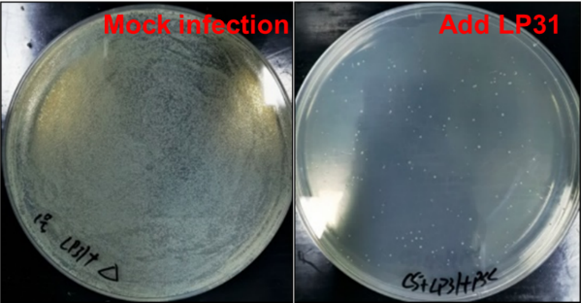 B** 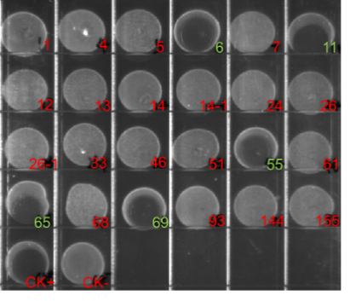

**C** 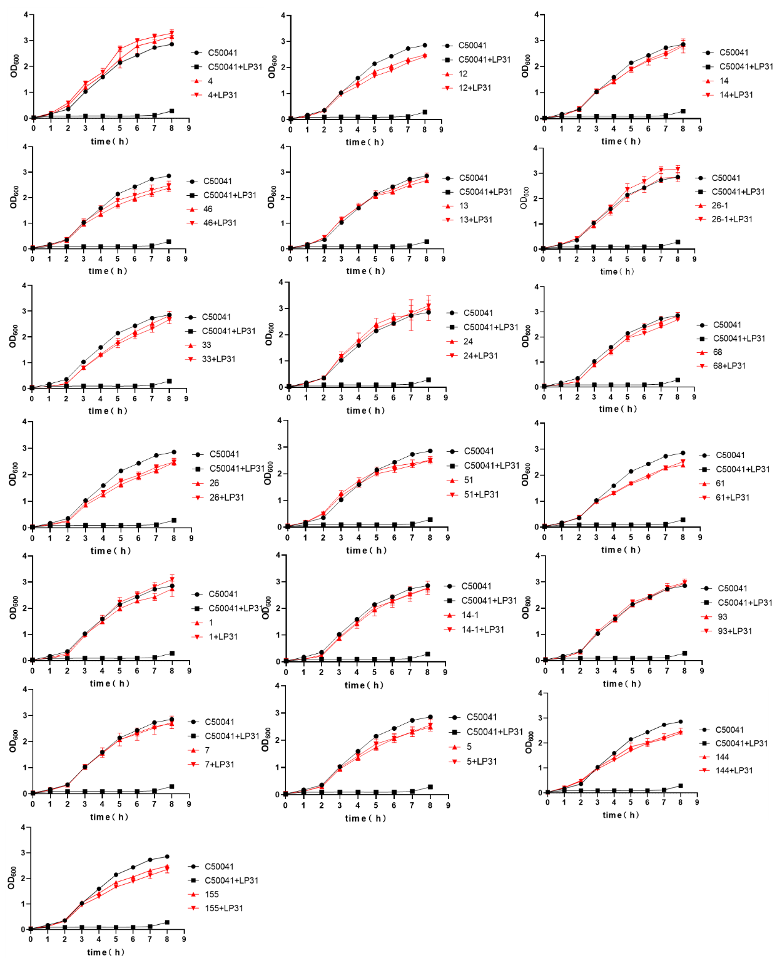

**FIG. 1** Screening of phage resistant strains. A. Comparison before and after killing sensitive bacteria with phage. B. Screening of the putative phage resistant mutants by drop spot assay. The red numbers are true phage resistant mutants; The green numbers are sensitive strains. C. Growth curves of wild type C50041 and LP31 resistant mutants with and without phage LP31, cultured *in vitro*.

**A** 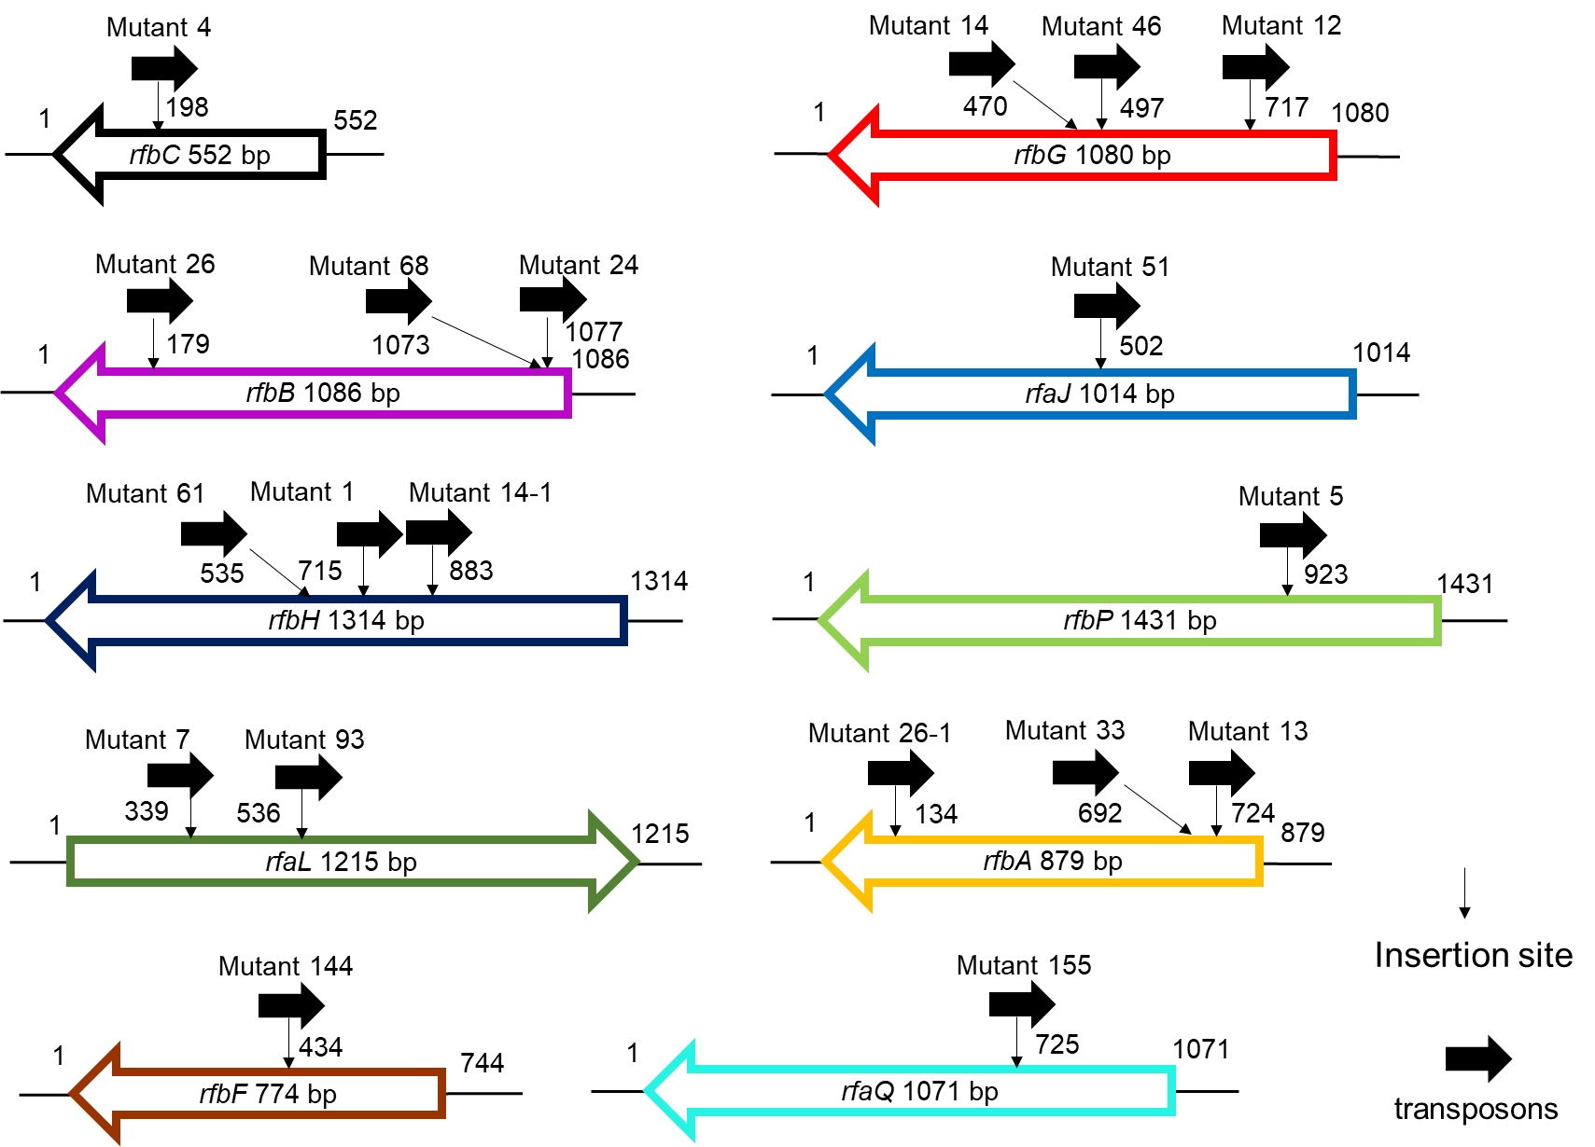

**B 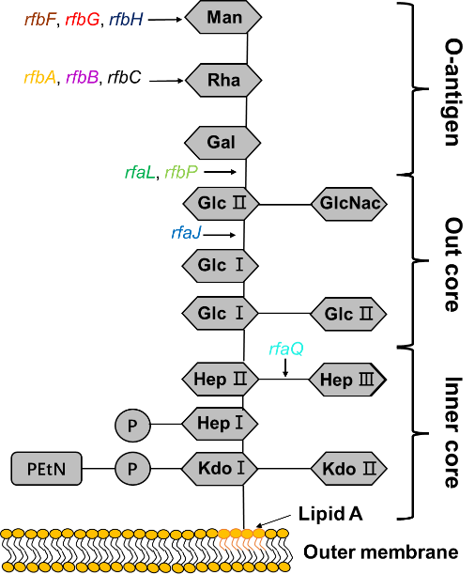 C** 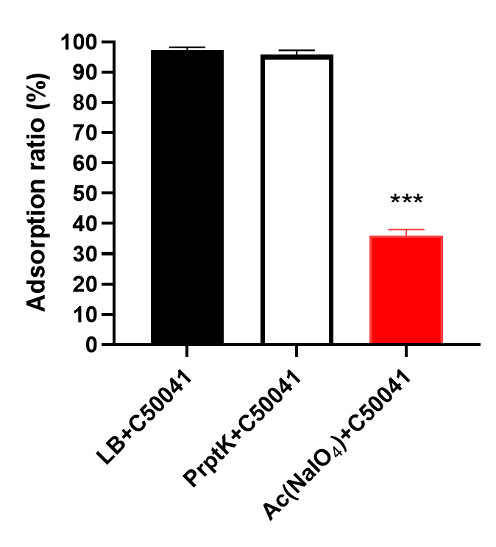

**D** 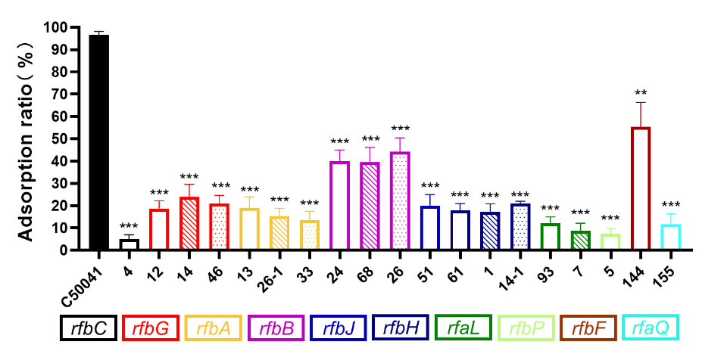

**FIG. 2** Screening of genes related to phage adsorption process. A. Analysis of transposon insertion sites in phage LP31 insensitive strains. B. Schematic structure of LPS, showing that different gene products (color-coded to match panel A) required for LPS synthesis affect the adsorption of phage LP31. Abbreviations are as follows: Glc, glucose; Rha, rhamnose; GlcNAc, N-acetylglucosamine; Man, mannose; Hep, heptose; Gal, galactose; Kdo, 2-keto-3-deoxyoctulosonic acid; P, phosphate; PEtN, phosphoethanolamine. The structure of LPS is that for *S*.Typhimurium, modified from references (31, 33). C. Adsorption properties of phage LP31 on *S.* Enteritidis C50041 or C50041 treated with proteinase K or Ac (NaIO4). D. Comparative LP31 adsorption measurements on different LP31 resistant mutants. The X-axis is labeled with the various Tn mutants, and they have been color-coded to match the gene identities defined in panel A. **\*\***: *P* < 0.01, **\*\*\***: *P* < 0.001.

**A** 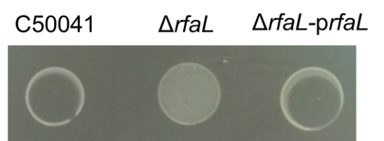

**B** 

**C** 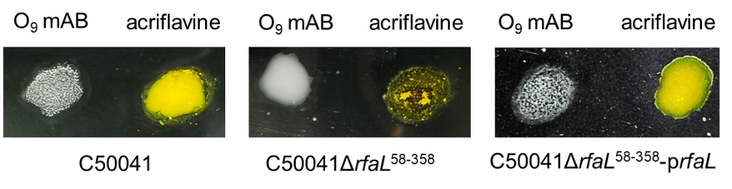

**D** 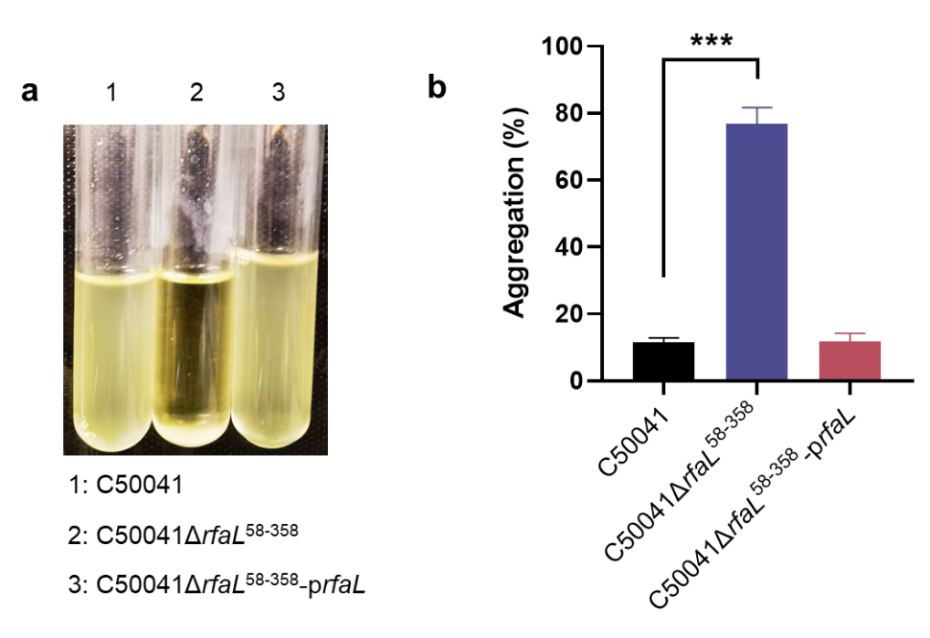

**FIG. 3** Characterization of *rfaL* gene deletion mutant (C50041Δ*rfaL*58-358) and complemented strain (C50041Δ*rfaL*58-358-p*rfaL*). A. The ability of phage LP31 to form clear spots on phage drop spot assays on the wild type C50041 strain, its *rfaL* gene deletion mutant variant, and the complemented strain. B. Growth curves of the wild type, *rfaL* deletion mutant and the complemented mutant cultured *in vitro* with or without phage LP31. C. Agglutination phenotypes of the wild type, *rfaL* deletion mutant and complemented mutant. *S*. Enteritidis with O antigen supports agglutination by an O9 mAB (monoclonal antibody against O-antigens), but does not agglutinate with acriflavine. The strain with the O antigen synthesis defect does not agglutinate with O9 mAB, but does agglutinate in the presence of acriflavine. D. The aggregation of different strains. a: Aggregation of bacteria during cultivation. b: Percent aggregation of different strains (***: *P* < 0.001).

**A**  **B** 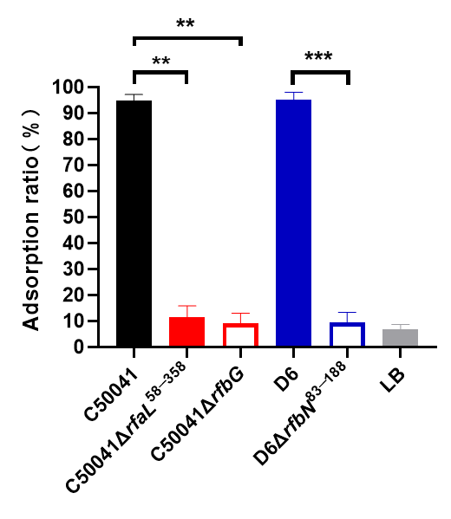

**C** 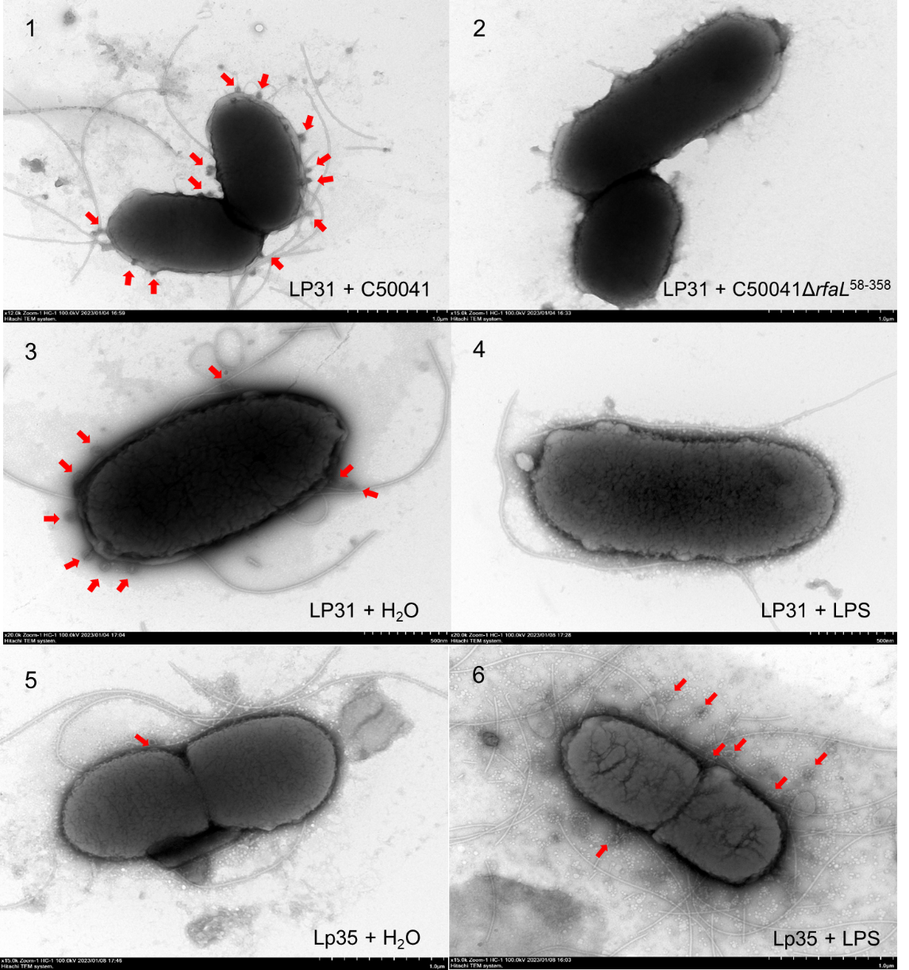

**FIG. 4** Characterization of phage LP31 adsorption.A. The adsorption of phage LP31 on different wild-type (with O9 antigen) and LPS mutant (without O9 antigen) strains of *S*. Enteritidis (C50041) and *S*. Typhimurium (D6). B. Effect of added *S*. Enteritidis LPS on the ability of phage LP31 to adsorb to of *S*. EnteritidisC50041. LP31 was added to *S*. Enteritidis (C50041) with either water or the same volume of LPS (100 mg/ml). C. Transmission electron microscopy of *S*. Enteritidis C50041 showing adsorbed phage LP31 (The red arrows are pointing at the phages). 1: Adsorption of phage LP31 to C50041; 2: Lack of adsorption of phage LP31 to C50041Δ*rfaL*58−358. 3: Adsorption of phage LP31 to C50041 after incubation with H2O. 4: Lack/decrease of adsorption of phage LP31 to C50041 after incubation with LPS. 5: Lack/decrease of adsorption of phage LP31 to C50041 after incubation with protein Lp35 (tail protein [RBP] of phage LP31) + H2O. 6: Impact on adsorption of phage LP31 to C50041 when first incubated with protein Lp35 (phage RPB) + LPS (host receptor). **\*\***: *P* < 0.01**, \*\*\***: *P* < 0.001.

**A 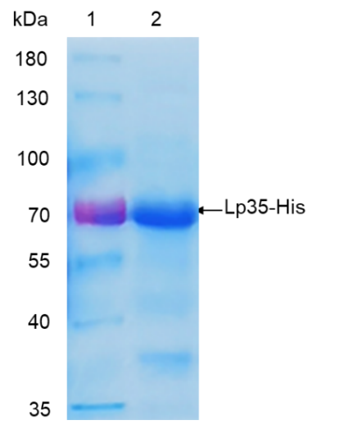 B** 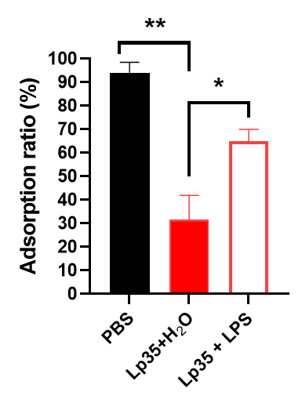

**C** 

**D** 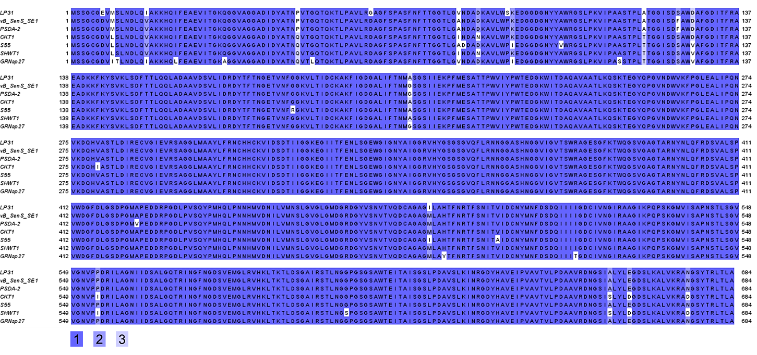

**FIG. 5** Prediction and identification of the receptor binding protein from phage LP31. A. The recombinant protein Lp35-His was purified from *E. coli* BL21-p*lp35* and detected by Coomassie blue staining of the SDS-PAGE gel. B. Adsorption identifies the function of Lp35 protein during the adsorption of *S*. Enteritidis C50041 by phage LP31. **\***: *P* < 0.05**, \*\***: *P* < 0.01. C. Evolutionary relationships of phage LP31 based on Lp35 phylogenetic analysis (Neighbor-Joining method with bootstrapping, n=500). D. Amino acid sequence alignment analysis. Identical residues are shaded in color 1, residues sharing > 75% homology are shaded in color 2, and those sharing > 50% homology are shaded in color 3. Color identities are given under the alignment. Numbering is based on the N-terminal methionine. The names of phages are indicated on the left.

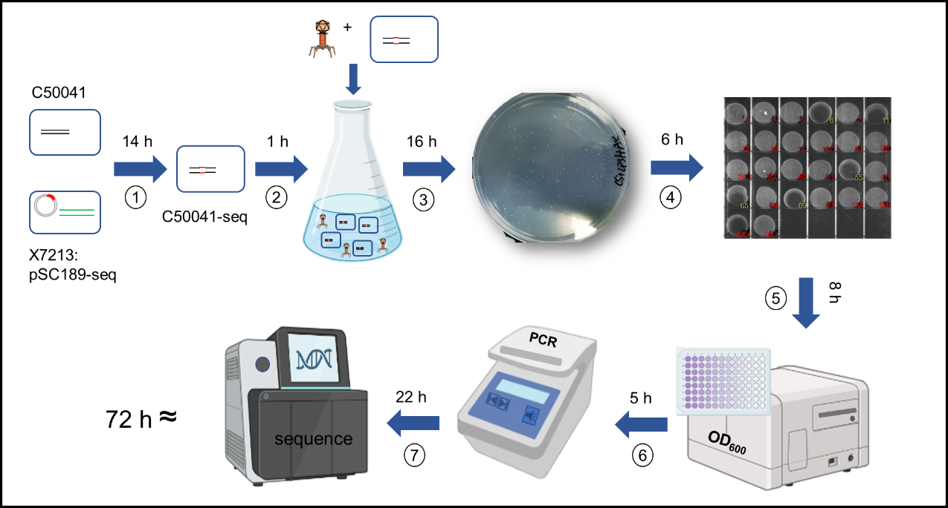

**FIG. 6** Diagramatic flow of the screening process to identify phage infection related genes. ① Construction of a random insertion transposon mutant library. The library was contructed by introduction of pSC189-Seq by conjugation, which carries the transposon, into the *S*. Enteriditis strain. The transposon randomly integrated into various locations across the *Salmonella* genome. ② The transposon library was cultured in liquid media and either mock infected or actually infected with phage LP31. After infection the cultures were incubated for one further hour at 37°C to enable the phage to kill most of the phage-sensitive cells. ③ Putative phage resistant mutants were recovered by centrifugation and the supernatant was discarded. The bacterial pellet was washed twice with LB medium before being spread onto an LB agar plate, and the putative phage resistant colonies were allowed to grow at 37°C for 16 hrs. ④Phage resistant phenotypes from putative phage resistant mutants were confirmed by picking individual colonies from step three and growing them in 1 mL broth cultures to an O.D.600 ≈ 0.3. Then 20 mL of these cultures were droped onto LB agar, allowed to dry and exposed to phage by spotting 4 mL of a LP31 (107 PFU/ml) phage suspension on top of the bacterial spots. The putative mutants were then screened for phage LP31 resistance and sensitivity. ⑤ Resistance of the putative LP31 resistant mutants was confirmed by mixing phage LP31 at an MOI = 10 in a 96 well plate, which was then incubated at 37°C for 8 h. The growth rate for each mutant and wild type with and without LP31 was measured using a microtitre plate reader. ⑥ The transposon insertion sites in the LP31 resistant mutant were located following PCR amplification of the transposon end sequences through to the sequences at the insertion positions using a primer set (Table S1). ⑦ The gene (s) interupted by the transposon were identified following sequencing and BLAST analysis of the PCR products. If the host bacterium is *Salmonella*, the entire screening process takes about 72 h.

**TABLE 1** Strains, plasmids and phage used in this study.

|  |  |  |
| --- | --- | --- |
| **Strain, plasmid and phage** | **Relevant characteristics** | **Reference** |
| ***Escherichia coli* strains** | | |
| X7213 λ*pir* | Host for π requiring plasmids, conjugal donor | Laboratory collection (51) |
| X7213 λ*pir*-pSC189 | X7213 λpir carrying pSC189, Kmr, Cmr | Laboratory collection (51) |
| DH5α | Δ(*lacZYA-argF*) U169 (Φ80 *LacZ* Δ*M15*) | Purchased from Takara |
| BL21 | F-, *ompT*, *hsdSB* (*rB-mB-*), *gal*, *dcm* | Purchased from Takara |
| BL21-p*lp35* | BL21 carrying pET28a*-lp35*, Kmr | This study |
| BL21-pET28a | BL21 carrying pET28a, Kmr | This study |
| ***Salmonella enterica* serovar Enteritidis** | | |
| C50041 | Wild type | Laboratory collection (42) |
| C50041Δ*rfaL*58−358 | C50041 strain deleting 58−358 aa (301 aa) of RfaL protein | This study |
| C50041Δ*rfaL*58−358-p*rfaL* | C50041Δ*rfaL*58−358 carrying pMMB207-p*rfaL*, Cmr | This study |
| C50041Δ*rfaL*58−358-pMMB207 | C50041Δ*rfaL*58−358 carrying pMMB207, Cmr | This study |
| C50041Δ*rfbG* | In-frame deletion in *rfbG* | Laboratory collection (42) |
| ***Salmonella enterica* serovar Typhimurium** | | |
| D6 | Wild type, Carbr | Laboratory collection (28) |
| D6Δ*rfbN*83−188 | D6 strain deleting 83−188 aa  (106 aa) of RfbN protein, Carbr | Laboratory collection (28) |
| **Plasmid** | | |
| pSC189 | Transposon delivery vector, R6K, Kmr, Cmr | (52) |
| pDM4 | A suicide vector with ori R6K *sacBR*; Cmr | (53) |
| pMMB207 | RSF1010 derivative, IncQ lacIq Cmr P*tac* *oriT* | (54) |
| pET28a | pBR322-based expression vector utilizing T7*lac* promoter, Kmr | Purchased from Novagen |
| **Phage** | | |
| LP31 | *Siphoviridae* | Laboratory collection (29) |

The antibiotics as follows: carbenicillin resistant (Carbr); chloramphenicol resistant (Cmr); kanamycin resistant (Kmr)

**TABLE 2** Transposon insertion information of phage insensitive mutants.

|  |  |  |  |
| --- | --- | --- | --- |
| **Strain number** | **Gene** | **Protein** | **Pathway** |
| 4 | *rfbC* | dTDP-4-dehydrorhamnose 3,5-epimerase | O antigen synthesis |
| 12, 14, 46 | *rfbG* | CDP-glucose 4,6-dehydratase | O antigen synthesis |
| 13, 26-1, 33 | *rfbA* | glucose-1-phosphate thymidylyltransferase | O antigen synthesis |
| 24, 68, 26 | *rfbB* | dTDP-glucose 4,6-dehydratase | O antigen synthesis |
| 51 | *rfaJ* | lipopolysaccharide 1,2-glucosyltransferase | LPS synthesis |
| 61, 1, 14-1 | *rfbH* | CDP-6-deoxy-D-xylo-4-hexulose-3-  dehydrase | O antigen synthesis |
| 93, 7 | *rfaL* | O-antigen ligase | LPS synthesis |
| 5 | *rfbP* | undecaprenyl-phosphate galactose phosphotransferase | O antigen synthesis |
| 144 | *rfbF* | glucose-1-phosphate cytidylyltransferase | O antigen synthesis |
| 155 | *rfaQ* | lipopolysaccharide core heptosyltransferase | LPS synthesis |

**Supplemental files**

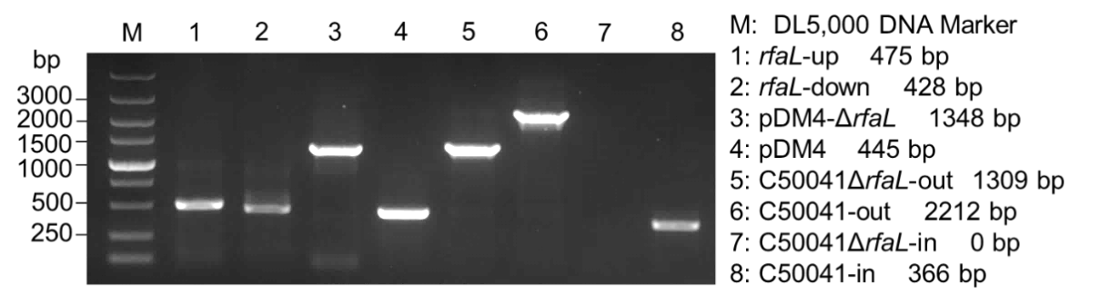

**FIG. S1** Identification of mutant C50041Δ*rfaL*58-358 by PCR. The lanes contain: PCR products for: (1) up- and (2) down-stream sequences of the *rfaL* gene using the primer pairs up-F/R and down-F/R, respectively. PCR products obtained from the recombinant plasmids (3) pDM4-*rfaL*Δ58-358 and (4) pDM4 the using primer pair pDM4-F/R. PCR products obtained from the genome of C50041Δ*rfaL*58-358 using (5) primer pair out-F/R and (7) primer pair in-F/R, respectively. PCR products obtained from the wild-type genome are also shown using (6) primer pair out-F/R and (8) primer pair in-F/R. (M) Molecular marker.

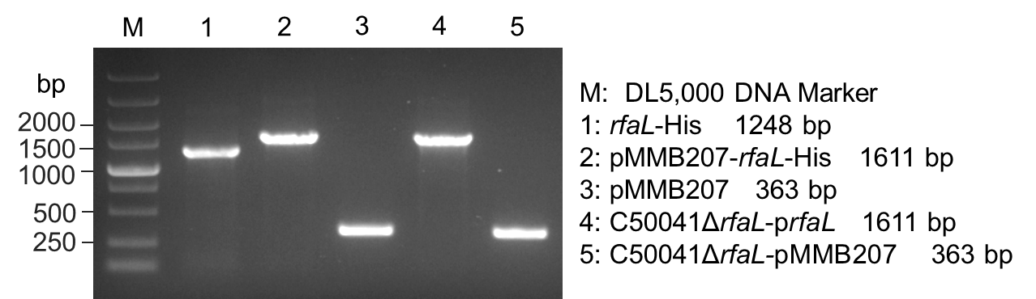

**FIG. S2** Identification of complemented strain C50041Δ*rfaL*58-358 carrying p*rfaL* (C50041Δ*rfaL*58-358-p*rfaL*) by PCR. Lanes contain PCR products for the *rfaL* gene (1) using primer pair *rfaL*-F/*-*his R. (2) PCR products for the recombinant, expressing plasmid pMMB207-*rfaL*-His and (3) pMMB207 using primer pair pMMB207-F/R. PCR products using primer pair pMMB207-F/R and (4) total C50041Δ*rfaL*58-358-p*rfaL* genome or (5) total DNA from C50041Δ*rfaL*58-358 carrying pMMB207 (C50041Δ*rfaL*58-358-pMMB207). (M) Molecular marker.

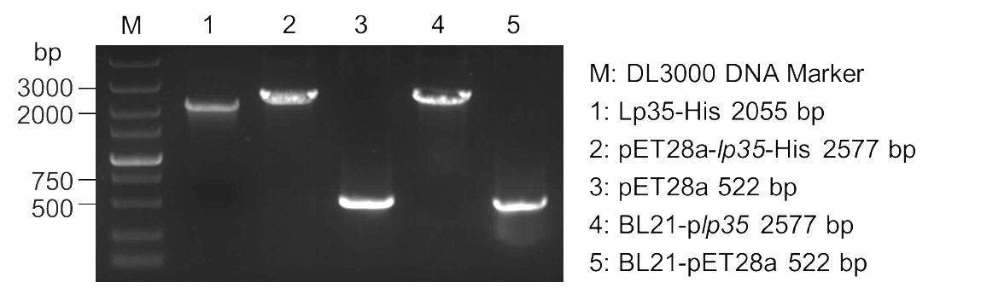

**FIG. S3** Identification of protein expression bacteria BL21 carrying p*lp35* (BL21-p*lp35*) by PCR. The lanes contain PCR products for the *lp35* gene using (1) primer pair *lp35*-F/R*-*his. PCR products for recombinant, expression plasmids (2) pET28a-*lp35*-His and (3) pET28a using primer pair pET28a-F/R. PCR products from the total DNA of (4) BL21-p*lp35* strain genome and (5) BL21 carrying pET28a (BL21- pET28a) using primer pair pET28a-F/R. (M) Molecular marker.

**TABLE S1.** Primers designed for and used in this study.

|  |  |
| --- | --- |
| **Primer name** | **Sequence (5’ → 3’)** |
| **Identification of transposon Insertion site** | |
| First round of PCR | |
| AB1 | GGCCACGCGTCGACTAGTACNNNNNNNNNNACGCC |
| AB2 | GGCCACGCGTCGACTAGTACNNNNNNNNNNCCTGG |
| AB3 | GGCCACGCGTCGACTAGTACNNNNNNNNNNCCTCG |
| SP1 | GCTGACCGCTTCCTCGTGCTTTACG |
| Second round of PCR | |
| ABS | GGCCACGCGTCGACTAGTAC |
| SP2 | CATCGCCTTCTATCGCCTTCTTGAC |
| Sequencing | |
| pSC189-seq | CGCGAAGTTCCTATTCCGAAGTTCC |
| ***rfaL* Gene deletion** | |
| Up-F | GAGCGGATAACAATTTGTGGAATCCCGGGACGAAGGCTTTGACTATGTGGAT |
| Up-R | GGCTTATCTCCGGTGAGCGTGAGACCTGATAAATC |
| Down-F | ACGCTCACCGGAGATAAGCCCCTACAATGCTCATC |
| Down-R | AGCGGAGTGTATATCAAGCTTATCGATACCCCAGCAAAAAAGGGGGGATTAG |
| In-F | GAAACAAAAGAAACGGTTGCGAA |
| In-R | GGCTAATAAAATGGCACCAACTC |
| Out-F | CCTGGGATACGATAAACCGCAGT |
| Out-R | GACGCCGCAAAAGAGATTGGAAC |
| pDM4-F | GGTGCTCCAGTGGCTTCTGTTTCTA |
| pDM4-R | CAGCAACTTAAATAGCCTCTAAGGT |
| ***rfaL* Gene complement** | |
| *rfaL*-F | CTCGGTACCCGGGGATCCTCTAGACTAAAGGAAGACGTTATGCTAACCACATCATTAACGT |
| *rfaL*-His-R | TCATCCGCCAAAACAGCCAAGCTTTAGTGATGATGATGATGATGTCTATTTCTTAGCGCCAACAG |
| pMMB207-F | CTCCCGTTCTGGATAATGTT |
| pMMB207-R | GGCGTTTCACTTCTGAGTTCG |
| **Protein expression** | |
| *lp35*-F | TAAGAAGGAGATATACCATGTCTAGTGGTTGCGGTGAGG |
| *lp35*-His-R | GTGGTGGTGGTGGTGCTCGAGTTATGCCAAAGTTAATCTTGTGTAGCT |
| *Lp24*-F | TAAGAAGGAGATATACCATGGCGTTACAACCATATAAGGG |
| *Lp24*-His-R | GTGGTGGTGGTGGTGCTCGAGGGCGTACTTAATGCGCTGGA |
| *lp34*-F | TAAGAAGGAGATATACCATGGCGTTACAACCATATAAGGG |
| *lp34*-His-R | GTGGTGGTGGTGGTGCTCGAGGGCGTACTTAATGCGCTGGA |
| pET28a-F | CACCATACCCACGCCGAAAC |
| pET28a-R | AAAAACCCCTCAAGACCCGT |