High-latitude marginal reefs support fewer but bigger corals than their tropical counterparts

Abstract
Anthropogenic impacts are typically detrimental to tropical coral reefs, but the effect of increasing environmental stress and variability on the size structure of coral communities remains poorly understood. This limits our ability to effectively conserve coral reef ecosystems because size specific dynamics are rarely incorporated. Our aim is to quantify variation in the size structure of coral populations across 20 sites along a tropical-to-subtropical environmental gradient on the east coast of Australia (~23°S to 30°S), to determine how size structure changes with a gradient of sea surface temperature, turbidity, productivity and light levels. We use two approaches: 1) linear regression with summary statistics (such as median size) as response variables, a method frequently favoured by ecologists; and 2) compositional functional regression, a novel method using entire size-frequency distributions as response variables. We then predict coral population size structure with increasing environmental stress and variability. Together, we find fewer but larger coral colonies in marginal reefs, where conditions are typically more variable and stressful, than in tropical reefs. Our model predicts that coral populations may become gradually dominated by larger colonies (> 148 cm²) with increasing environmental stress. Fewer but bigger corals suggest low survival of smaller corals, slow growth, and / or poor recruitment. This finding is concerning for the future of coral reefs, as it implies that current marginal populations, or future reefs in increasingly stressful environmental conditions may have low recovery potential. We highlight the importance of continuously monitoring changes to population structure over biogeographic scales.
Keywords:
compositional functional regression, coral reef, environmental gradient, probability density function, population structure, size-frequency distribution

Introduction
Population size has been a primary metric of population persistence and viability for decades (Shaffer, 1981; Dietzel et al., 2021). However, the size structure of a population (i.e., how many individuals of a given size range there are in the population) is as important, if not more so, for determining persistence and viability, especially in slow growing, sessile organisms (e.g., McClanahan et al., 2008; Riegl et al., 2012; Cousins et al., 2014). The structure of a population details important features regarding individual heterogeneity that ultimately predict population outcomes better than simply population size (Hunter et al., 2010; Radchuk et al., 2013). Consequently, in recent decades, population structure has become the focus of demographic models (Easterling et al., 2000; Caswell, 2001; Merow et al., 2014).
External abiotic factors such as climate change (e.g., Radchuk et al., 2013; Vetter et al., 2020) can lead to shifts in population structure when the underlying vital rates (e.g., survival, change in size, reproduction) are affected differently. For example, Radchuk et al. (2013) showed that increases in temperature improve the fecundity of female bog fritillary butterflies (Boloria eunomia) and the survival of most life stages, except for the overwintering larvae. Yet the viability of the butterfly population is highly sensitive to the survival of overwintering larvae (Radchuk et al., 2013), meaning that low larval survival, as a result of warming, would be detrimental to the viability of this population. However, warming is not constant, and is only one of many aspects of climate change (Dixon et al., 2021), to which species and population responses are complex and poorly understood (Lawson et al., 2015; Tavecchia et al., 2016). Therefore, creating meaningful and realistic experimental manipulations to understand future anthropogenic impacts on population structure might be resource-intensive and not always practical (Kreyling et al., 2014), and especially logistically challenging in the marine environment. An alternative approach to understand the directional effect of environmental change on populations is to sample from natural populations exposed to a gradient of environmental conditions (shift in mean conditions, increased variability and extremes), e.g., at the biogeographic scale (Beier et al., 2012; Kreyling et al., 2014; Elmendorf et al., 2015). Gradient approaches have been shown to give larger estimated effects than experimental studies conducted in terrestrial grassland ecosystems, likely because they reflect long-term responses, while experiments highlight short term plasticity (Wolkovich et al., 2012; Elmendorf et al., 2015). Since changes to population processes can take years before detection is possible (Evers et al., 2021), it is a reasonable approach for predicting the long-term effects of environmental change on population viability.
Coral reefs are challenged by many anthropogenic perturbations, with climate change being the dominant threat (Pandolfi, 2015; Hoegh-Guldberg et al., 2017; Hughes et al., 2017a). Climate change will continue to increase thermal stress (Dixon et al., 2022), flooding (Vitousek et al., 2017) and storm intensity (Reguero et al., 2019). These disturbances directly and indirectly influence coral mortality, changes in community composition (Hughes et al., 2012; Ceccarelli et al., 2020; Brunner et al., 2021) and coral population size structure (e.g., Hughes et al., 2018; Pisapia et al., 2019; Dietzel et al., 2020; Lachs et al., 2021). Considering that the vital rates of survival, growth, and reproduction follow consistent allometric scaling in corals (Dornelas et al., 2017; Madin et al., 2020), changes to coral population size structure will have major consequences for their population dynamics and viability. Indeed, small corals tend to have a higher probability of whole-colony mortality, while larger corals have higher partial mortality (i.e., shrinkage) and fission (Hughes & Connell, 1987; Hughes & Tanner, 2000; Madin et al., 2020). Large corals also have higher reproduction, but lower relative growth rates (Connell, 1973; Dornelas et al., 2017). Because of these allometric relationships, investigating differences in size structure across populations experiencing increased disturbance can help reveal the ecological mechanisms that underlie population viability, such as differences in survival, growth and reproduction rates. For example, over the length of the entire Great Barrier Reef, Dietzel et al. (2020) found decadal declines in the abundance of large coral colonies in the northern and central regions, but an increase in the southern region compared to historical baselines. The spatial variation in the decline of large corals might indicate the depletion of coral brood stocks in some regions (Hughes et al., 2019) but not others, thereby affecting population viability differently.
Previous studies have examined changes in coral population size structure using summary statistics such as mean size, variance, skewness, and kurtosis (e.g., Bak & Meesters, 1998; Anderson & Pratchett, 2014). These metrics characterize aspects of the shape of the size-frequency distribution. However, the summary statistics approach involves making arbitrary choices about which statistics to include, and does not use all the information in the distribution (Talská et al., 2018). Also, the ecological interpretation of measures such as kurtosis is not straightforward. Adjeroud et al. (2007) observed negative kurtosis (a flattened distribution, with a wide peak around the mean) for a fast-growing species, and the opposite for a slow-growing species. Since then, coral reef ecologists have related this metric to population growth and turnover rates (e.g., Anderson & Pratchett, 2014; Kramer et al., 2020), but the conditions under which the proposed relationship between kurtosis and growth rate holds are unclear. The assessment and comparison of entire coral size-frequency distributions as probability density functions can overcome these challenges. Recent advances in functional data analysis (Ramsay et al., 2009; Talská et al., 2018) remove the need to arbitrarily select a few summary statistics as response variables. Since the entire probability density function is treated as the response variable (Talská et al., 2018), the method can accurately quantify which coral sizes are most affected by the explanatory variables. This approach is likely to better capture the effects of long-term environmental stress on coral size-frequency distributions than summary statistics, allowing for improved comparisons and understanding of their dynamics.
Here, we examine the changes of scleractinian coral population size structure over 900 km in eastern Australia. Using the tropical to subtropical gradient as a proxy for increasing environmental stress (Kreyling et al., 2014), we aim to understand how coral population size structure responds to, or is locally adapted to increasingly marginal conditions. We use two methodologies: 1) linear regression with summary statistics as response variables, an approach classically favoured by coral reef ecologists, and 2) a novel compositional functional regression approach (Talská et al., 2018) that has never been used in this context. We use both methods here to demonstrate their respective strengths and weaknesses. At higher latitudes, where conditions are harsh due to extremes in temperature, light levels and storm events, we expect fewer small coral colonies, because coral mortality rates are generally highest for the smallest corals (Connell, 1973), and sexual recruitment rates are low in these comparatively harsher conditions (Harriott & Banks, 1995; Abrego et al., 2021; Cant et al., 2022). Potential differences in population size structure of corals along this environmental gradient might indicate the effect of stress on coral population dynamics, providing a lens to the future, where reefs might be affected by increased disturbances as a result of climate change.

Methods
Data collection
The eastern Australian biogeographic transition zone is a unique region in which to observe coral population dynamics. There, coral communities occur from tropical Queensland’s Great Barrier Reef (GBR) to the temperate, sometimes kelp-dominated rocky reefs in New South Wales (~23°S to 30°S). With increasing latitude, sea surface temperature and incident light intensity decline, while storm intensity and frequency increase (Pepler & Coutts-Smith, 2013), making the reef habitat increasingly marginal for tropical hard corals (Harriott & Smith, 2000; Sommer et al., 2018). Multiple oceanographic currents are present in the region, with the Eastern Australian Current (EAC) being the largest (Baird et al., 2008). The EAC runs approximately 50 km offshore (Malcolm et al., 2011), transporting warm, tropical waters from the Coral Sea poleward. The current may also be a source of fresh genetic material for the downstream reefs (Beger et al., 2014; Sommer et al., 2014). Though we note that a recent study suggested that coral larvae dispersed from the southern GBR have a low probability of being received at higher latitude reefs (Mizerek et al., 2021), where endemic coral species are increasingly found (e.g., Schmidt-Roach et al., 2013; Baird et al., 2017). Nonetheless, the eastern Australian biogeographic transition zone represents a natural laboratory that allows the examination of differences in coral population size structure with increasing marginality.
We sampled coral populations across 20 sites in the eastern Australian biogeographic transition zone using underwater photographic benthic transect surveys. 12 sites were sampled in September 2018, while the eight other sites were sampled in either 2010, 2011, 2012 or 2016 (Figure 1; Table S1). At each site, three 30 m belt transects were haphazardly run at 8-10 m water depth. Downward-facing photographs were taken every metre, from approximately 70 cm above the benthos. Each included a 50 cm calibration stick held at the level of the substrate (as in Sommer et al., 2011). Two cameras were used: a Canon S90 with a wide-angle lens at most sites, and a Sony RX100V with a Nauticam WWL-1 wide angle lens at Julian Rock Nursery, Cook Island and Flinders Reef. Since the field of view of the two cameras varied, images from the Sony RX100V were batch processed and cropped in ImageJ (Schindelin et al., 2012) to ensure comparability, such that each frame captured approximately 1 m² of seabed.
On each image, coral species were visually identified to the lowest taxonomic classification possible (usually genus) using Coral Finder 2021 (Kelley, 2021) and Corals of the World (Veron et al., 2016). Coral morphological types were also included and standardised following the classification of Sommer et al. (2021). Where variable growth forms are observed for the genera Montipora, Porites and Turbinaria, they were placed into categories of ‘branching,’ ‘encrusting, ‘laminar’ and ‘massive’. For Acropora, the categories were ‘arborescent,’ ‘corymbose,’ ‘digitate,’ ‘hispidose’ and ‘tabular,’ following Kelley (2021). For each coral colony, the following were recorded: 2D planar area, taxonomic identity, and whether the colony was partially out of frame. This procedure was conducted using the freely available ‘SizeExtractR’ (Lachs et al., 2022) workflow in ImageJ (Schindelin et al., 2012) and R (R Core Team, 2021). We traced each coral colony manually, added relevant alphanumeric annotations, and compiled the resulting size data into a single database. Transect images that did not visibly contain corals were skipped. In total, 16,598 coral colonies were examined across 1,426 images, capturing 41 coral taxonomic entities (species, genera, family, or groups with uniquely identifiable morphological characteristics; see Supporting Information S2).
Light limitation, temperature minima, and fluctuations determine the distribution and abundance of corals in our study region (Sommer et al., 2018). To characterise and compare long-term environmental trends among our study sites, we extracted 4 km monthly chla (chlorophyll a concentration – a proxy for productivity), kd490 (diffuse attenuation coefficient at 490 nm – a proxy for turbidity), and PAR (photosynthetically available radiation) from January 2003 to April 2019 (NOAA, 2022d, 2022b, 2022a); and 1 km monthly Sea Surface Temperature (SST) from June 2002 to May 2019 (NOAA, 2022c). The minima, maxima, means, and standard deviations of each environmental variable were calculated for each site, resulting in a total of 16 variables. A principal component analysis (PCA) was used for dimension reduction of these environmental factors (Figure 2). The first axis (PC1) explains 63% of the observed variance and reflects a gradient from warmer, brighter environments with low turbidity and productivity (negative PC1 scores) to darker, colder environments with high turbidity and productivity (positive PC1 scores). The second axis (PC2), explaining 17% of the variance, is driven by minimum productivity, turbidity, and variation in light availability. Negative PC2 scores reflect environments that have the lowest productivity and turbidity, yet unstable light regimes, while positive scores reflect sites whose lowest turbidity and productivity is the least extreme and have the most stable light regimes.
Coral taxonomic identity along the environmental gradient
For the purpose of quantifying population size structure, we did not differentiate between taxonomic groups and consider all corals from the same site a ‘population’ to overcome having small sample sizes in some marginal reefs. We acknowledge the limitations of this in the discussion. We used Canonical Correspondence Analysis (CCA) to examine differences in taxonomic composition along the environmental gradient (PC1 and PC2 scores), as environmental tolerances vary among species (Sommer et al., 2014). We showed that some taxa were shared among sites but along the gradient there were likely different dominant taxa for each morpho-taxa group (Figure S1; Supporting Information S2).
Data analyses
Colony sizes were natural log-transformed to normalise their distribution for subsequent analyses and increase the resolution of the highly abundant smaller size classes (Bak & Meesters, 1998). Throughout, log refers to natural logarithm. Colonies marked partially out of frame were excluded as we lacked their true size. This filter resulted in 12,224 coral colonies from 1,321 images, corresponding to 41 coral taxonomic entities. We used two methods to characterise the coral population size structure and establish its relationship with environmental covariates. The first was the calculation of summary statistics (Bak & Meesters, 1998; Adjeroud et al., 2007; Anderson & Pratchett, 2014) followed by linear regression with the scores of PC1 and PC2 and their interaction as explanatory variables. The model combinations were evaluated using Akaike’s Information Criterion (AIC). For each site, the summary statistics calculated were: 1) average coral size (both mean and median), a surrogate for coral age and fecundity (Soong & Lang, 1992). We used the median in linear regressions as it is not strongly influenced by extreme colony sizes, which are common in our study populations. 2) Coefficient of variation, which allows the comparison of size variation across different sites. 3) Skewness, which measures the asymmetry of size-frequency distributions, with left or right skew indicating the dominance of larger and smaller corals, respectively. 4) Kurtosis, which measures the relative peakedness of a distribution, and has been used to represent growth and recruitment rates (Bak & Meesters, 1998; Adjeroud et al., 2007; Anderson & Pratchett, 2014).
We then used compositional functional regression (Talská et al., 2018) to test the effect of environmental covariates (PC1 and PC2 scores) on the entire size-frequency distribution. The benefit of this approach is that it is possible to examine how the entire distribution changes, as opposed to a single summary statistic, which does not capture all relevant properties of the size distribution. Compositional functional regression is needed here because our response variable (coral size-frequency distribution) is a probability density function. Probability density functions must be non-negative everywhere and integrate to one (note that non-negativity is a property of the function, the probability density, rather than the value of the argument to the function, log coral size). Standard functional regression (where the response variable is a continuous function instead of a number (e.g., Yen et al., 2015) is already familiar to some ecologists, but does not ensure that the predicted response is a valid probability density function. Compositional functional regressions overcome this problem by working in a real vector space (Bayes space) (Egozcue et al., 2013), whose elements are continuous probability density functions (Egozcue et al., 2006; van den Boogaart et al., 2014) on which we can do “addition” and “scalar multiplication” operations, such that the result is always a probability density function (see Supporting Information S3 for more details). Once these operations are defined, we can write down a linear regression model for probability density functions. Consider the standard linear regression response = intercept + explanatory variable × coefficient + error; then the analogous compositional functional regression equation takes the form
$$\text{response function = intercept function}⊕\left(\text{explanatory variable}⊙\text{coefficient function}\right)⊕\text{error function,}$$
where the error function has a mean of zero. In our particular case, the regression model is
$$\begin{aligned}y_{i}=β_{0}⊕\left(x_{1,i }⊙β_{1}\right)⊕\left(x_{2,i }⊙β_{2}\right)⊕ε_{i}, \#\left(1\right)\end{aligned}$$where $y_{i}$ is the response, a probability density function representing the log coral size-frequency distribution at the $i$th site, the explanatory variables $x_{1,i}$ and $x_{2,i}$ are the PC1 and PC2 scores at the $i$th site, the intercept $β_{0}$ is the size-frequency distribution when each explanatory variable has the value 0, coefficients $β_{1}$ and $β_{2}$ are probability density functions describing the effect of a unit increase in PC1 and PC2 respectively on the size-frequency distribution, and the error $ε_{i}$ is a probability density function representing the residual or error at the $i$th site.
Estimating densities (continuous size-frequency distributions) to use as the response variable is a necessary step in compositional functional regression. We binned the individual log coral area observations from each site into a histogram, and smoothed the data to obtain a continuous approximation to the histogram, over the entire observed range across all sites (Talská et al., 2018). The number of bins for each site was chosen using Sturges’ rule (Sturges, 1926). Where there were empty bins, we replaced the zeros by $\left(\frac{2}{3}\right)×\left(\frac{1}{n_{i}}\right)$, where $n_{i}$ is the number of corals observed at that site (Martín-Fernández et al., 2003; Machalová et al., 2021, p. 1053). We followed typical practice in the field, but the theory on how density estimation affects subsequent results is not yet well developed (Petersen et al., 2022, sections 3 and 5). We therefore checked the robustness of our compositional functional regression results to different bin numbers used in histogram smoothing, as well as to sites with only very few corals (Supporting Information S6).
Then, the size-frequency distributions were centred log-ratio (clr) transformed to give standard addition and scalar multiplication operations, which allows for easier computation (van den Boogaart et al., 2014). The clr transformed size-frequency distributions were smoothed using cubic compositional splines (ZB spline basis functions (Machalová et al., 2021)) with four knots. The optimum smoothing parameter alpha was chosen by generalized cross validation for each site. The compositional regression model given in Equation 1 was fitted to the binned and smoothed size-frequency distributions (Machalová et al., 2021). Approximate 95% confidence bands were obtained using bootstrap approximations. We calculated pointwise and global R² which measure proportions of variation explained by the model in an analogous way to the usual coefficient of determination (Talská et al., 2018).
To determine whether the estimated effects of PC1 and PC2 could be distinguished from zero (no effect), pointwise and global permutation F-tests were performed with the observed pointwise F-statistic, and its maximum over the whole interval, respectively (Ramsay et al., 2009, p. 168). The F-tests were carried out by permuting rows of the ZB-spline coefficients and re-estimating the regression model 9,999 times. We compared observed pointwise and max F-statistics with the distributions of these statistics from permutations. The residual functions were plotted (and coloured by PC1 score) to check for systematic departures from the model. The coefficient functions $β_{0}$, $β_{1}$ and $β_{2}$ on the clr scale were plotted to visualize the size-frequency distribution at the mean of PC1 and PC2 ($β_{0}$) and the effects of each. On the clr scale, positive values of the coefficient functions $β_{1}$ and $β_{2}$ suggest an increase in density at a given log area per unit increase in the explanatory variable, and vice versa. Because PC1 seemed to capture most of the environmental variability in our study region, we visualised its effect by plotting the predicted coral size-frequency distributions at the mean value (0) of PC2, for ten equally spaced values of PC1 from its minimum to its maximum.
Size-biased sampling
Size-frequency distributions estimated from photographs are subject to sampling bias. The larger a coral colony, the less likely it is to fit entirely in the sampling window. Thus, including only those colonies that fit in the sampling window (“minus sampling” (Baddeley, 1998, p. 40)) as we have in this study, biases the estimated size-frequency distribution towards smaller colonies. There are ways to avoid such sampling bias but these require information from outside the sampling window (Baddeley, 1998; sections 2.2-2.4, 2.6; Zvuloni et al., 2008), which is unavailable in our data. In Supporting Information S4, we show that this sampling bias does not affect estimates of the coefficient functions for the effects of explanatory variables ($β_{1}$ and $β_{2}$) in a compositional functional regression, although the bias does affect the estimated intercept function $β_{0}$. These coefficient functions are only defined over the interval of sizes that could fit in the sampling window, so we have no information about effects on the density of colonies larger than the window. Summary statistics and the effects of explanatory variables on the summary statistics will also be subject to sampling bias, but we currently do not have simple solutions to account for these biases.
Model sensitivity to the 2016 bleaching event
In 2016, severe coral bleaching was recorded in northern and central GBR (Hughes et al., 2017b). Although bleaching was less severe in the southern GBR and at the high latitude Eastern Australian reefs (Hughes et al., 2017b; Kim et al., 2019), the anomalous thermal stress in the region could have had unobserved impacts on corals leading to potential changes in population size structure. For this reason, we examined the temporal effect of our data by adding a categorical explanatory variable of pre- or post- bleaching to both the linear regression and the compositional functional regression analyses (Supporting information S7).

Results
Summary statistics and linear regression
Sites had between 38 (Woolgoolga Reef) and 2,101 (Lady Musgrave Island) colonies (median 526, first quartile 148, third quartile 718). Statistical summaries of the coral size-frequency distributions are reported in Table S2. Colder, darker reefs with higher turbidity and productivity (high PC1 scores) had fewer coral colonies (F_{2,17} = 6.80, P = 0.007, R² = 0.379; Figure 3a; Table S3), but with larger median sizes (F_{1,18} = 10.7, P = 0.004, R² = 0.338; Figure 3c; Table S4), and were more negatively (left) skewed (F_{2,17} = 7.45, P = 0.005, R² = 0.404; Figure 3-4; Table S5). Reefs with more constant light levels and less extreme minima in turbidity and productivity (high PC2 scores) were associated with more coral colonies and a positive skew in the population size structure (Figure 3b and e; Table S3 and S5). Weak evidence showed that CV and kurtosis were lower at high PC1 scores, suggesting that colony size variation was lower (F_{1,18} = 2.35; P = 0.143; R² = 0.066), and that coral population size structure was flatter (F_{1,18} = 2.54; P = 0.128; R² = 0.075) at colder, darker reefs with higher turbidity and productivity compared to warmer, brighter and less turbid environments (Table S6-7; Figure S2-3).
Compositional functional regression
Compositional functional regression showed that as PC1 increased, reflecting the transition from warmer, brighter environments to more productive and turbid environments, a higher proportion of corals were bigger: the mode of the predicted distribution of log coral area moved to the right, and the predicted distribution became broader and flatter (Figure 5, red to blue lines). At the lowest PC1 score, the predicted modal log coral area was approximately 3.5 log cm² (33.1 cm², Figure 5, red), while at the highest PC1 score, the predicted modal log coral area was approximately 5 log cm² (148 cm², Figure 5, blue). Thus, large changes in coral size-frequency distributions along the environmental gradient were plausible. We further showed that increases in PC1 may be associated with lower densities of small to moderate sized corals (~2-4 log cm²) (Figure 6, interval where the 95% confidence band did not cross zero). The global R² for our model was 0.18, so that the model explained relatively little of the variation in size-frequency distributions, although with higher amounts of variation explained at coral sizes 2-4 log cm² (Figure S7). Similar peaks were observed for the pointwise F test statistics (Figure S8). However, because the maximum pointwise F statistic (Figure S8, dotted line) did not exceed the 0.95-quantile of the distribution of such maxima anywhere (Figure S8, dashed line; functional F-test, observed maximum F = 0.83, P = 0.08 from 9,999 permutations), it was plausible that from the compositional functional regression alone, neither PC1 nor PC2 affected coral size-frequency distributions (see discussion). For the effect of the intercept and PC2, model fit and residual diagnostics, see Supporting Information S5.

Discussion
Understanding the drivers of change in population size structure is fundamental to robust predictions of population dynamics (Edmunds & Riegl, 2020; Edmunds, 2021). Here, examining population size structure of corals across 20 reefs along the tropical to subtropical transition zone in Eastern Australia, we found fewer but bigger corals in sites characterised by greater environmental stress and temporal variability compared to sites that have a more stable environmental regime. It is plausible that the high coral cover in Australian high-latitude coral communities (Harriott et al., 1994; Sommer et al., 2014) is created by few large coral colonies. This supports the idea that the lower growth rates and higher fission rates of larger corals (Dornelas et al., 2017) could be the main driver of coral persistence in marginal reefs (Cant et al., 2022). We hypothesise that future reef persistence might be governed by low growth and recruitment, and be reliant on the survival and higher fecundity of larger corals (Bak & Meesters, 1999; Cant et al., 2020; Dietzel et al., 2020).
This is the first study to use compositional functional regression (Talská et al., 2018) to examine population size structure changes along a large biogeographic gradient. The ability to model the entire probability density curve allows us to determine the effects of environmental drivers on corals of different sizes. Specifically, we show that with increasing environmental stress and variability, we risk losing small to medium sized corals at 7-55 cm². This cannot be concluded from linear regressions of summary statistics. Furthermore, many ecologically important properties are functions of size, including carbonate production and linear extension for corals (Carlot et al., 2021). Compositional functional regression will allow us to link predictions about changes in size distributions to changes in these ecologically important properties. For example, given a predicted change in size distribution with respect to an environmental variable (e.g., increasing SST), and the relationship between the property of interest (e.g., carbonate production) and size, we can calculate the predicted population-level change in the value of the property (e.g., mean carbonate production per colony) with respect to the environmental variable. In contrast, generally it is not possible to do such calculations given estimated effects on a summary statistic. Similarly, size distributions, rather than summary statistics, are required for modern demographic techniques such as Integral Projection Models (IPMs) (e.g., Kayal et al., 2018; Cant et al., 2020).
Both linear regression and compositional functional regression results identified fewer but bigger corals in marginal reefs, although the evidence from the latter was weaker. Nevertheless, the observed change in summary statistics such as the median (for which there is strong evidence) imply changes in the size-frequency distribution, so that the combined evidence from both methods suggests an effect. The difference in strength of evidence could simply be methodological, i.e., having to consider the effect of the environmental covariates on the entire size-frequency distribution at each reef in compositional functional regression, as opposed to just a single value (of a summary statistic) in linear regression. It is possible that there is simply a relatively large amount of (random) variation in the density functions (size distributions) among our twenty sites. Although we did not find strong support for temporal effects considering the results from both methods, there was weak evidence that median coral size was smaller and CV was greater at sites surveyed after the 2016 bleaching event (Supporting Information S7). This finding suggests that where time series data are available, exploring how major disturbances affect size structure over time will be a worthwhile endeavour. Indices summarising local threat levels from human activity (e.g., Burke et al., 2011) might also explain some of the variation in size distributions.
In addition to the environmental parameters examined, other variables could also have acted on the coral size-frequency distributions. For example, storm waves can differentially overturn corals of different sizes and growth forms (Madin et al., 2014), indicating that high latitude environments could well select for larger, more stable horizontally spreading morphologies in our study region (Sommer et al., 2014); and the morphology, taxonomic identity and life-history of corals (Darling et al., 2012) can determine the sizes to which they could grow. There is already some evidence of this across our sites (Figure S1, Supporting Information S2). For example, both the encrusting Micromussa lordhowensis, and laminar Turbinaria are commonly observed on subtropical reefs in this region, but M. lordhowensis colonies are generally much smaller. Recent observations of speciation of endemic corals also indicate that evolutionary processes are at play in this region (Schmidt-Roach et al., 2013; Baird et al., 2017). Where sample sizes are large enough, it will be meaningful to investigate taxa specific population size structure (e.g., Rich et al., 2022; Bernard et al., 2023) along this environmental gradient. Reefs with higher rugosity and thus complexity could support more smaller corals (Crabbe, 2010), meaning reef topography could also be relevant. Competition for space can also reduce the rate at which corals grow (Chadwick & Morrow, 2011), including competition with other non-coral, sessile benthic organisms like algae, corallimorpharians and zoanthids that are abundant on high-latitude reefs (Abrego et al., 2021; Reimer et al., 2021).
Our work assessing coral population size structure over a large biogeographic scale offers a glimpse into a possible response of coral assemblages to environmental change. Our main finding of increasingly marginal conditions selecting for fewer but larger coral colonies, echoes previous findings that larger corals remain post-disturbance (Bak & Meesters, 1998; Dietzel et al., 2020; Lachs et al., 2021), but see also Pisapia et al. (2020) for examples of colonies becoming smaller. The demographic mechanisms that can lead to the prevalence of fewer but bigger corals are likely a combination of low recruitment, partial mortality and slow growth. As ongoing climate change leads to more variable and extreme environmental conditions (Spady et al., 2022), it is possible that some corals in biogeographic transition zones are adapting to changing conditions. Through this observational study, we hypothesise that on a population level, marginality could select mechanisms that shift the population size structure of reef corals towards a larger proportion of bigger individuals, or towards a composition with species that can reach larger sizes. Such a shift is concerning because coral populations with fewer smaller corals (juveniles) suggest recruitment failure, and thus a lowered recovery potential following further disturbances (Riegl et al., 2012; Pisapia et al., 2019; Dietzel et al., 2020; Lachs et al., 2021). In addition, small coral fragments broken off from mature colonies retain their reproductive capacity (Rapuano et al., 2023), but have a higher relative growth rate compared to the original colony, due to a reduction in size. This indicates that smaller corals (both coral recruits and those fragmented from larger corals by natural processes) could be disproportionately important for population persistence. Thus, we recommend improving our understanding of coral reproduction, dispersal and recruitment dynamics along latitudinal gradients (e.g., Mizerek et al., 2021), as it can provide an insight into how coral populations persist and recover despite suboptimal conditions. Further demographic work in this region would be insightful for continuous monitoring and the ground-truthing of our hypothesis.
Climate change will continue to affect population dynamics worldwide (Lawson et al., 2015). Thus, it remains pertinent for ecologists to examine changes in population size structure at biogeographic scales through time (e.g., Riegl et al., 2012; Dietzel et al., 2021). Advances in compositional functional regression (Talská et al., 2018) provide a comprehensive tool for ecologists to examine population size structure, allowing us to gain insight into how environmental extremes and variabilities affect population dynamics (Kreyling et al., 2014). Collectively, our work on the coral population size structure of reefs in the Eastern Australian biogeographic transition zone highlights fundamental differences along the ~ 900 km tropical to subtropical gradient, where bigger corals are likely selected for in marginal conditions. While the survival of larger corals allows for the persistence of reef habitats, the lack of smaller corals indicates recruitment failure and could signify a lowered resilience to further disturbances.
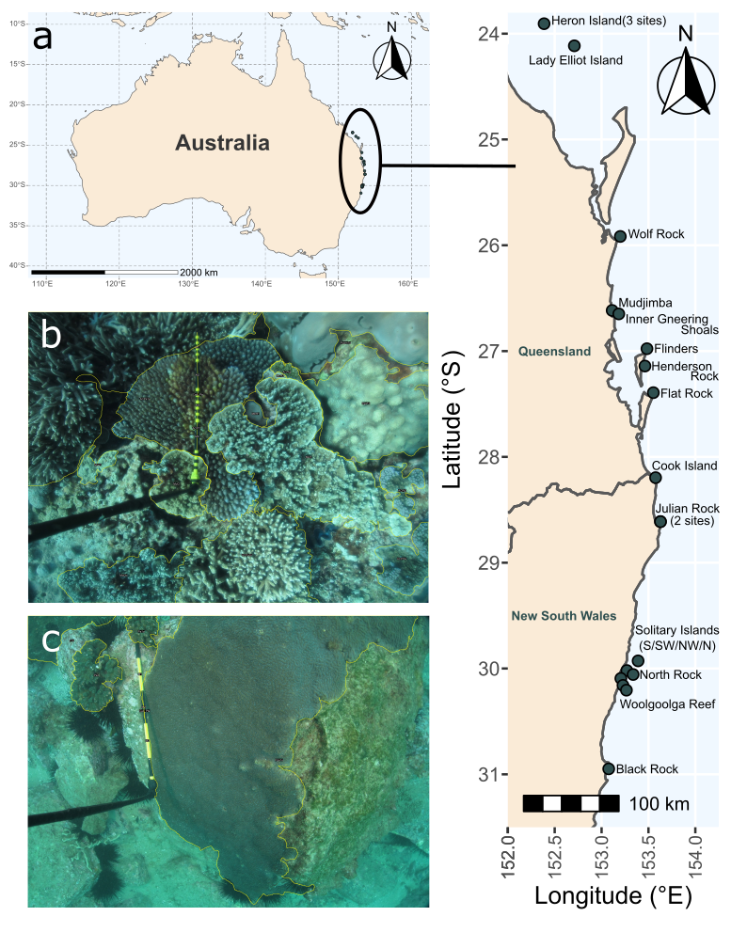
Figure 1. Survey design of the study, showing a) the location of the 20 sampling sites in eastern Australia; image examples of the outlined coral communities from b) Lady Elliot Island and c) Black Rock. The 0.5 m black and yellow graduated calibration stick is visible. Corals that were not completely in frame, like the largest one in c) were not included in the final dataset.

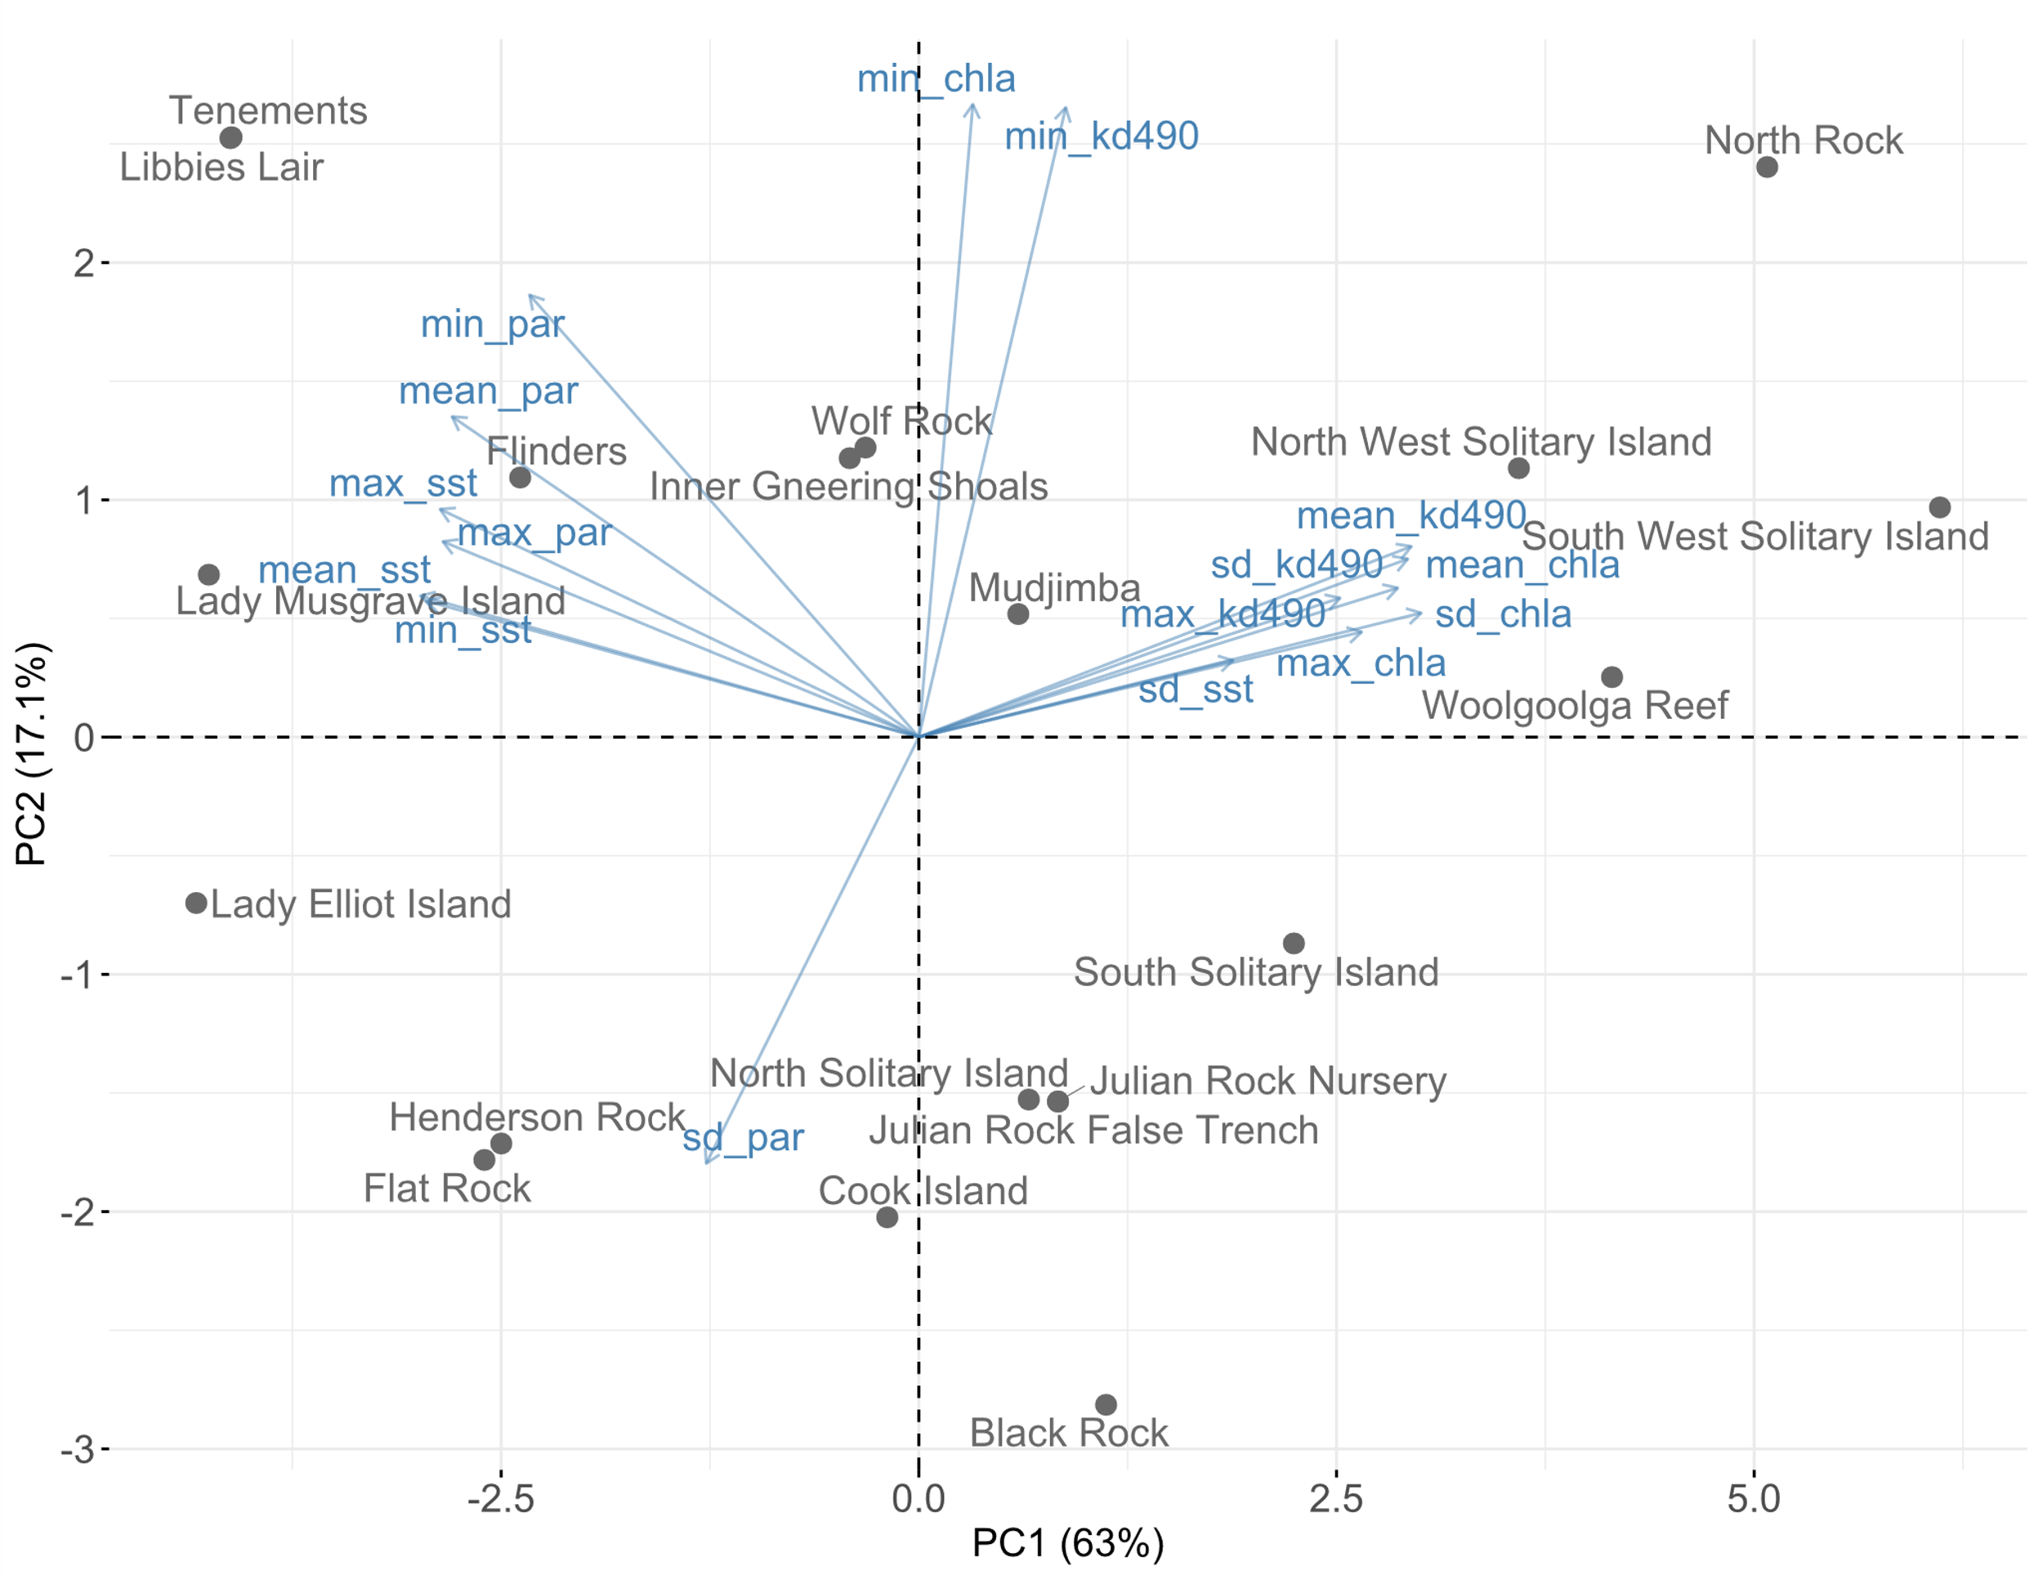
Figure 2. Biplot showing the PCA ordination of our 20 coral populations (Figure 1a) using the 16 environmental variables. Reef names are labelled in grey, the blue arrows are the environmental factors which include the minima (min), maxima (max), means and standard deviations (sd) of chlorophyll a concentration (chla), diffuse attenuation coefficient at 490 nm (kd490), sea surface temperature (sst) and photosynthetically available radiation (PAR). The first and second axes jointly explain 80% of the environmental variation in this region.

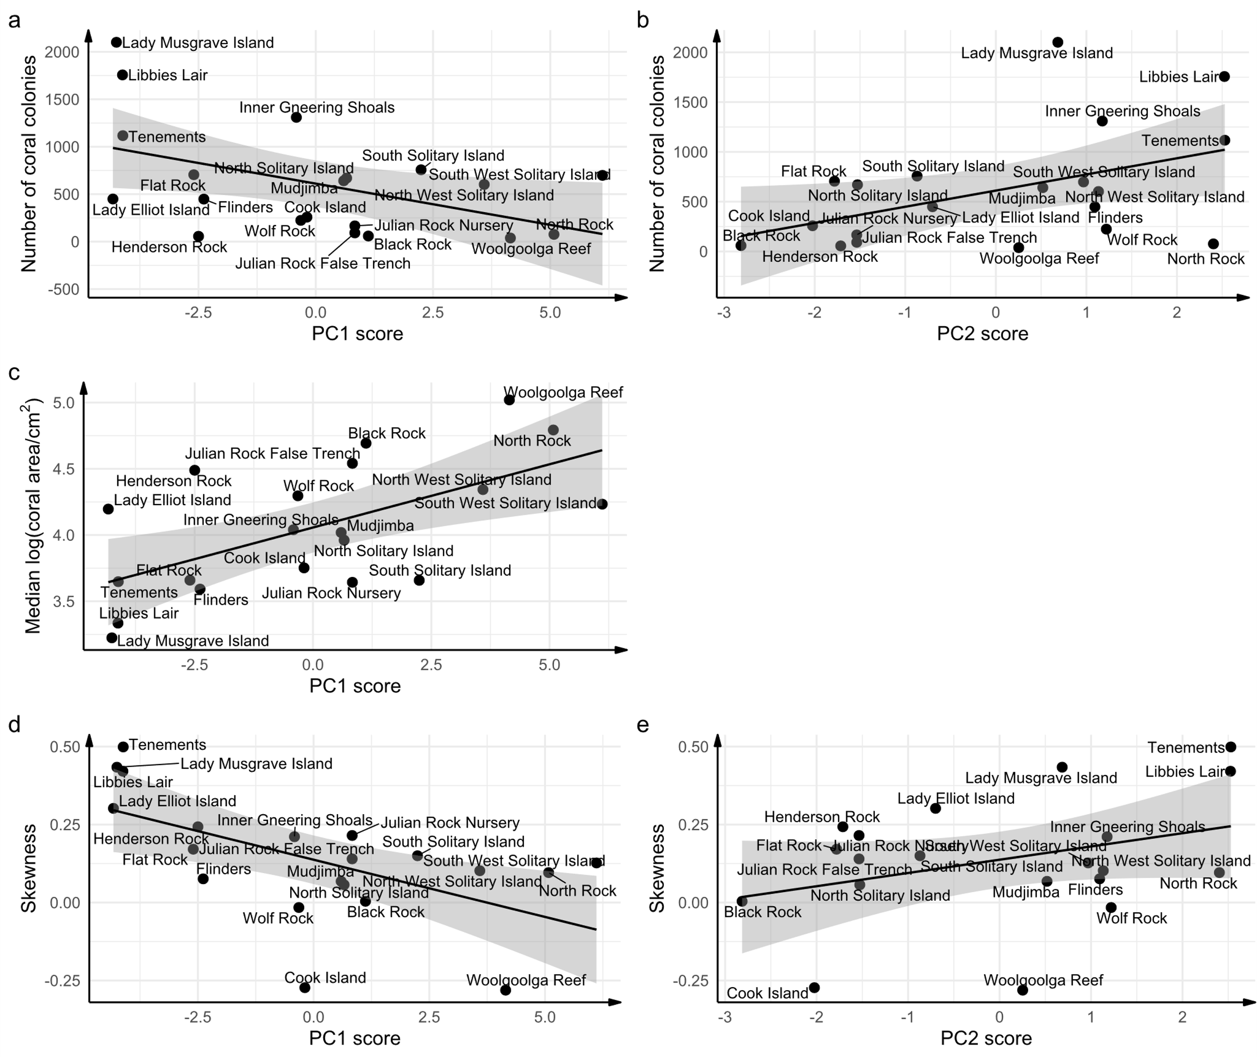
Figure 3a) The number of coral colonies decreases with PC1 and b) increases with PC2. c) Median coral colony size increases with PC1. d) Skewness of the coral size-frequency distribution decreases with increasing PC1 and e) increases with PC2. The black line is the line of best fit, and the grey region is the 95% confidence band. The explanatory variables plotted here were chosen based on model selection (Table S3-5). For a), c) and d), more positive PC1 scores represent lower sea surface temperature and photosynthetically available radiation (PAR), i.e., colder and darker, and high chlorophyll a concentration and turbidity (kd490), i.e., more productive and more turbid. In b) and e) more positive PC2 scores represent higher minima of chlorophyll a concentration and kd490 i.e., lowest turbidity and productivity is least extreme; and lower standard deviations of PAR i.e., more stable light regimes.

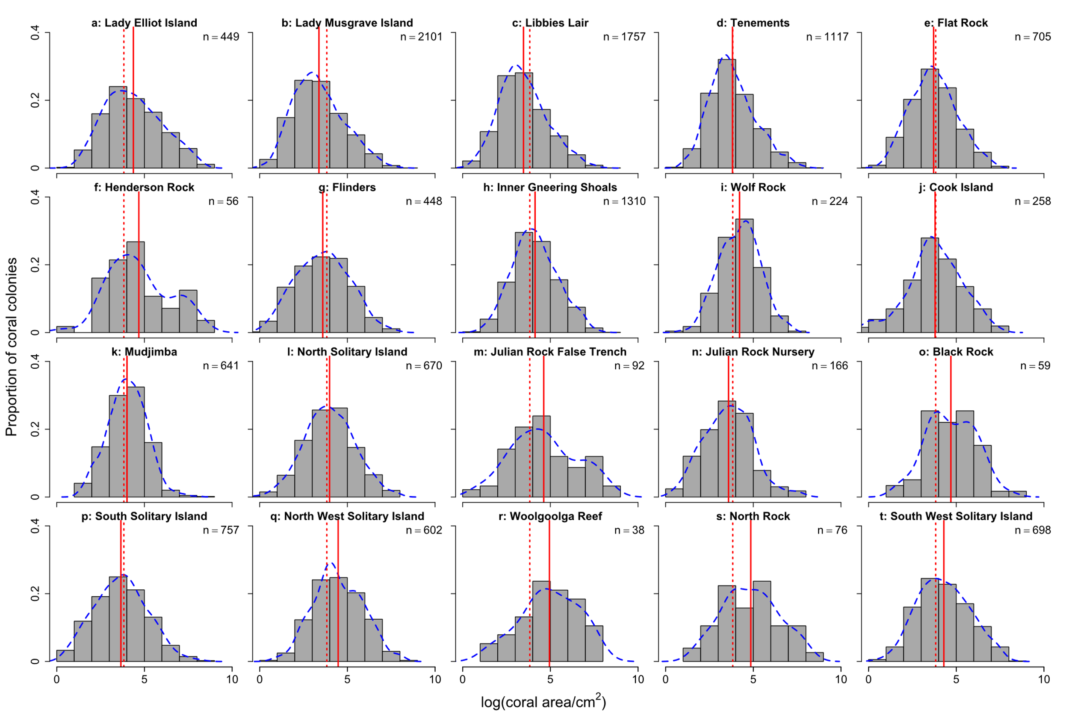
Figure 4. Histograms showing coral colony size structure for each of the 20 reefs. All plots are on the same scale. Blue dashed lines are density estimates. Red solid lines are the site-wise mean log coral colony size. Red dotted lines show the global mean log coral colony size (3.82 log cm²) over all 12,224 coral colonies. Panels (a-t) are ordered from low to high PC1 scores. Increases in PC1 represents increasingly marginal conditions (colder, darker, more turbid and productive waters).
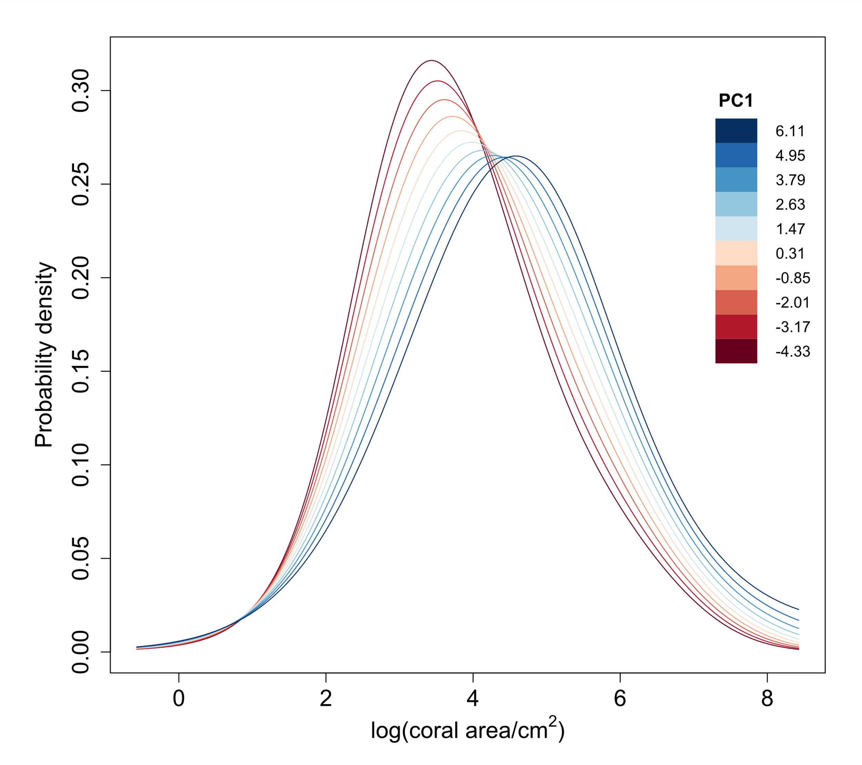
Figure 5. As PC1 increases, the predicted distributions of log coral area become broader and flatter, and the mode increases from ~3.5 to 5 log cm². Increases in PC1 represents increasingly marginal conditions (colder, darker, more turbid and productive waters). Red to blue lines correspond to predicted distributions for ten equally spaced PC1 scores, from the minimum (-4.33, darkest red) to the maximum (6.11, darkest blue). PC2 values are kept constant at 0 (the mean). The coefficient function $β_{1}$ determines how the shape of the distribution changes with PC1 but individual distributions are also affected by $β_{0}$ (the intercept) and thus by the sampling bias (S3: Size-biased sampling).

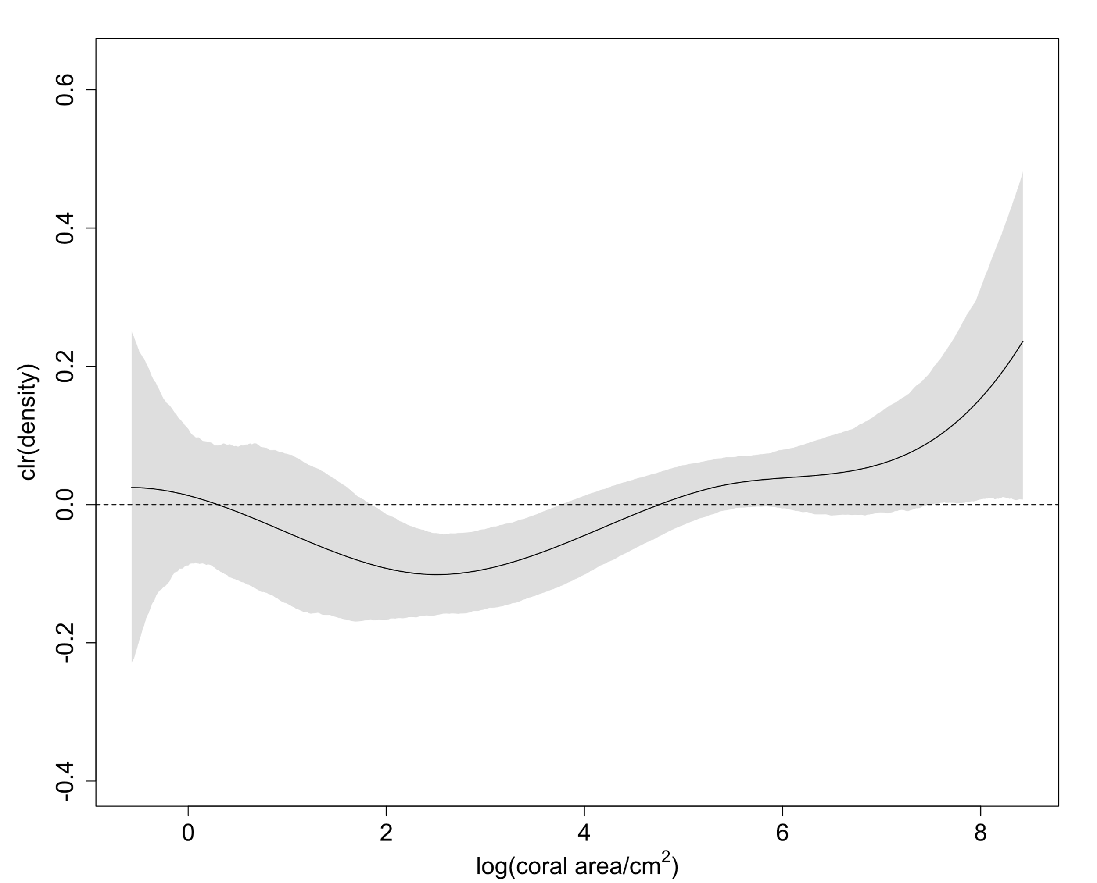
Figure 6. Increases in first axis (PC1) scores mean lower densities of corals at ~2-4 log cm². Increases in PC1 represents increasingly marginal conditions (colder, darker, more turbid and productive waters). The black line is the estimated centred log-ratio (clr) transformation of the coefficient function $β_{1}$, which measures the effect of a unit increase in PC1 on the probability density of a given log coral area. Positive values on the y-axis suggest that the corresponding log coral area on the x-axis becomes more likely as PC1 increases, and negative values suggest that the corresponding log coral area becomes less likely. The shaded region is the bootstrap 95% confidence band. The horizontal dashed line represents no effect of PC1 on the probability density of log coral area.

References
Abrego, D., Howells, E. J., Smith, S. D. A., Madin, J. S., Sommer, B., Schmidt-Roach, S., Cumbo, V. R., Thomson, D. P., Rosser, N. L., & Baird, A. H. (2021). Factors Limiting the Range Extension of Corals into High-Latitude Reef Regions. Diversity, 13(12), 632. https://doi.org/10.3390/d13120632
Adjeroud, M., Pratchett, M. S., Kospartov, M. C., Lejeusne, C., & Penin, L. (2007). Small-scale variability in the size structure of scleractinian corals around Moorea, French Polynesia: patterns across depths and locations. Hydrobiologia, 589(1), 117-126. https://doi.org/10.1007/s10750-007-0726-2
Anderson, K. D., & Pratchett, M. S. (2014). Variation in size-frequency distributions of branching corals between a tropical versus sub-tropical reef. Marine Ecology Progress Series, 502, 117-128. https://www.int-res.com/abstracts/meps/v502/p117-128/
Baddeley, A. J. (1998). Spatial sampling and censoring. In O. E. Barndorff-Nielsen, W. S. Kendall, & M. N. M. van Lieshout (Eds.), Stochastic Geometry: Likelihood and Computation (1st ed.). Routledge. https://doi.org/https://doi.org/10.1201/9780203738276
Baird, A. H., Hoogenboom, M. O., & Huang, D. (2017). Cyphastrea salae, a new species of hard coral from Lord Howe Island, Australia (Scleractinia, Merulinidae). ZooKeys, 662, 49-66. https://doi.org/10.3897/zookeys.662.11454
Baird, M. E., Timko, P. G., Middleton, J. H., Mullaney, T. J., Cox, D. R., & Suthers, I. M. (2008). Biological properties across the Tasman Front off southeast Australia. Deep Sea Research Part I: Oceanographic Research Papers, 55(11), 1438-1455. https://doi.org/https://doi.org/10.1016/j.dsr.2008.06.011
Bak, R. P. M., & Meesters, E. H. (1998). Coral population structure: the hidden information of colony size-frequency distributions. Marine Ecology Progress Series, 162, 301-306. http://www.jstor.org/stable/24859064
Bak, R. P. M., & Meesters, E. H. (1999). Population Structure as a Response of Coral Communities to Global Change. American Zoologist, 39(1), 56-65. https://doi.org/10.1093/icb/39.1.56
Beger, M., Sommer, B., Harrison, P. L., Smith, S. D. A., & Pandolfi, J. M. (2014). Conserving potential coral reef refuges at high latitudes. Diversity and Distributions, 20(3), 245-257. https://doi.org/https://doi.org/10.1111/ddi.12140
Beier, C., Beierkuhnlein, C., Wohlgemuth, T., Penuelas, J., Emmett, B., Körner, C., De Boeck, H., Christensen, J. H., Leuzinger, S., Janssens, I. A., & Hansen, K. (2012). Precipitation manipulation experiments - challenges and recommendations for the future. Ecology Letters, 15(8), 899-911. https://doi.org/10.1111/j.1461-0248.2012.01793.x
Bernard, G. G. R., Kellam, A. L., & Szereday, S. (2023). Differential colony size frequency distribution of hard corals across physical reef health gradients in Northeast Peninsula Malaysia. Regional Studies in Marine Science, 102872. https://doi.org/https://doi.org/10.1016/j.rsma.2023.102872
Brunner, C. A., Uthicke, S., Ricardo, G. F., Hoogenboom, M. O., & Negri, A. P. (2021). Climate change doubles sedimentation-induced coral recruit mortality. Science of The Total Environment, 768, 143897. https://doi.org/https://doi.org/10.1016/j.scitotenv.2020.143897
Burke, L., Reytar, K., Spalding, M., & Perry, A. (2011). Reef at Risk Revisited. World Resources Institute. Washington D.C., U.S.A.
Cant, J., Cook, K., Reimer, J., Takuma, M., Masako, N., O'Flaherty, C., Salguero-Gómez, R., & Beger, M. (2022). Transient amplification enhances the persistence of tropicalising coral assemblages in marginal high latitude environments. Ecography.
Cant, J., Salguero-Gómez, R., Kim, S. W., Sims, C. A., Sommer, B., Brooks, M., Malcolm, H. A., Pandolfi, J. M., & Beger, M. (2020). The projected degradation of subtropical coral assemblages by recurrent thermal stress. Journal of Animal Ecology, 00, 1-15. https://doi.org/10.1111/1365-2656.13340
Carlot, J., Kayal, M., Lenihan, H. S., Brandl, S. J., Casey, J. M., Adjeroud, M., Cardini, U., Merciere, A., Espiau, B., Barneche, D. R., Rovere, A., Hédouin, L., & Parravicini, V. (2021). Juvenile corals underpin coral reef carbonate production after disturbance. Global Change Biology, 27(11), 2623-2632. https://doi.org/10.1111/gcb.15610
Caswell, H. (2001). Matrix Population Models: Construction, Analysis and Interpretation (2nd ed.). Oxford University Press.
Ceccarelli, D. M., Evans, R. D., Logan, M., Mantel, P., Puotinen, M., Petus, C., Russ, G. R., & Williamson, D. H. (2020). Long-term dynamics and drivers of coral and macroalgal cover on inshore reefs of the Great Barrier Reef Marine Park. Ecological Applications, 30(1), e02008. https://doi.org/https://doi.org/10.1002/eap.2008
Chadwick, N. E., & Morrow, K. M. (2011). Competition Among Sessile Organisms on Coral Reefs. In Z. Dubinsky & N. Stambler (Eds.), Coral Reefs: An Ecosystem in Transition (pp. 347-371). Springer Netherlands. https://doi.org/10.1007/978-94-007-0114-4_20
Connell, J. H. (1973). Population ecology of reef-building corals. In O. A. Jones & R. Endean (Eds.), Biology and geology of coral reefs (Vol. 2, pp. 205-245). Academic Press.
Cousins, S. R., Witkowski, E. T. F., & Pfab, M. F. (2014). Elucidating patterns in the population size structure and density of Aloe plicatilis, a tree aloe endemic to the Cape fynbos, South Africa. South African Journal of Botany, 90, 20-36. https://doi.org/https://doi.org/10.1016/j.sajb.2013.09.012
Crabbe, M. J. C. (2010). Topography and spatial arrangement of reef-building corals on the fringing reefs of North Jamaica may influence their response to disturbance from bleaching. Marine Environmental Research, 69(3), 158-162. https://doi.org/10.1016/j.marenvres.2009.09.007
Darling, E. S., Alvarez-Filip, L., Oliver, T. A., McClanahan, T. R., & Côté, I. M. (2012). Evaluating life-history strategies of reef corals from species traits. Ecology Letters, 15(12), 1378-1386. https://doi.org/https://doi.org/10.1111/j.1461-0248.2012.01861.x
Dietzel, A., Bode, M., Connolly, S. R., & Hughes, T. P. (2020). Long-term shifts in the colony size structure of coral populations along the Great Barrier Reef. Proceedings of the Royal Society B: Biological Sciences, 287(1936), 20201432. https://doi.org/doi:10.1098/rspb.2020.1432
Dietzel, A., Bode, M., Connolly, S. R., & Hughes, T. P. (2021). The population sizes and global extinction risk of reef-building coral species at biogeographic scales. Nature Ecology & Evolution, 5(5), 663-669. https://doi.org/10.1038/s41559-021-01393-4
Dixon, A. M., Forster, P. M., & Beger, M. (2021). Coral conservation requires ecological climate‐change vulnerability assessments. Frontiers in Ecology and the Environment, 19(4), 243-250. https://doi.org/10.1002/fee.2312
Dixon, A. M., Forster, P. M., Heron, S. F., Stoner, A. M. K., & Beger, M. (2022). Future loss of local-scale thermal refugia in coral reef ecosystems. PLOS Climate, 1(2), e0000004. https://doi.org/10.1371/journal.pclm.0000004
Dornelas, M., Madin, J. S., Baird, A. H., & Connolly, S. R. (2017). Allometric growth in reef-building corals. Proceedings of the Royal Society B: Biological Sciences, 284(1851), 20170053. https://doi.org/doi:10.1098/rspb.2017.0053
Easterling, M. R., Ellner, S. P., & Dixon, P. M. (2000). SIZE-SPECIFIC SENSITIVITY: APPLYING A NEW STRUCTURED POPULATION MODEL. Ecology, 81(3), 694-708. https://doi.org/https://doi.org/10.1890/0012-9658(2000)081[0694:SSSAAN]2.0.CO;2
Edmunds, P. J. (2021). Vital rates of small reef corals are associated with variation in climate. Limnology and Oceanography, 66(3), 901-913. https://doi.org/https://doi.org/10.1002/lno.11650
Edmunds, P. J., & Riegl, B. (2020). Urgent need for coral demography in a world where corals are disappearing. Marine Ecology Progress Series, 635, 233-242. https://www.int-res.com/abstracts/meps/v635/p233-242/
Egozcue, J. J., Díaz–Barrero, J. L., & Pawlowsky–Glahn, V. (2006). Hilbert Space of Probability Density Functions Based on Aitchison Geometry. Acta Mathematica Sinica, 22(4), 1175-1182. https://doi.org/10.1007/s10114-005-0678-2
Egozcue, J. J., Pawlowsky-Glahn, V., Tolosana-Delgado, R., Ortego, M. I., & Van Den Boogaart, K. G. (2013). Bayes spaces: use of improper distributions and exponential families. Revista de la Real Academia de Ciencias Exactas, Fisicas y Naturales. Serie A. Matematicas, 107(2), 475-486. https://doi.org/10.1007/s13398-012-0082-6
Elmendorf, S. C., Henry, G. H. R., Hollister, R. D., Fosaa, A. M., Gould, W. A., Hermanutz, L., Hofgaard, A., Jónsdóttir, I. S., Jorgenson, J. C., Lévesque, E., Magnusson, B., Molau, U., Myers-Smith, I. H., Oberbauer, S. F., Rixen, C., Tweedie, C. E., & Walker, M. D. (2015). Experiment, monitoring, and gradient methods used to infer climate change effects on plant communities yield consistent patterns. Proceedings of the National Academy of Sciences, 112(2), 448-452. https://doi.org/10.1073/pnas.1410088112
Evers, S. M., Knight, T. M., Inouye, D. W., Miller, T. E. X., Salguero-Gómez, R., Iler, A. M., & Compagnoni, A. (2021). Lagged and dormant season climate better predict plant vital rates than climate during the growing season. Global Change Biology, 27(9), 1927-1941. https://doi.org/https://doi.org/10.1111/gcb.15519
Harriott, V., & Banks, S. (1995). Recruitment of scleractinian corals in the Solitary Islands Marine Reserve, a high latitude coral-dominated community in Eastern Australia. Marine Ecology Progress Series, 123, 155-161. https://doi.org/10.3354/meps123155
Harriott, V. J., Smith, S. D., & Harrison, P. L. (1994). Patterns of coral community structure of subtropical reefs in the Solitary Islands Marine Reserve, Eastern Australia. Marine Ecology Progress Series, 109, 67-76.
Harriott, V. J., & Smith, S. D. A. (2000). Coral population dynamics in a subtropical coral community, Solitary Islands Marine Park, Australia. Proceedings 9th International Coral Reef Symposium, Bali, Indonesia.
Hoegh-Guldberg, O., Poloczanska, E. S., Skirving, W., & Dove, S. (2017). Coral Reef Ecosystems under Climate Change and Ocean Acidification [Review]. Frontiers in Marine Science, 4(158). https://doi.org/10.3389/fmars.2017.00158
Hughes, Terry P., Baird, Andrew H., Dinsdale, Elizabeth A., Moltschaniwskyj, Natalie A., Pratchett, Morgan S., Tanner, Jason E., & Willis, Bette L. (2012). Assembly Rules of Reef Corals Are Flexible along a Steep Climatic Gradient. Current Biology, 22(8), 736-741. https://doi.org/https://doi.org/10.1016/j.cub.2012.02.068
Hughes, T. P., Barnes, M. L., Bellwood, D. R., Cinner, J. E., Cumming, G. S., Jackson, J. B. C., Kleypas, J., Van De Leemput, I. A., Lough, J. M., Morrison, T. H., Palumbi, S. R., Van Nes, E. H., & Scheffer, M. (2017a). Coral reefs in the Anthropocene. Nature, 546(7656), 82-90. https://doi.org/10.1038/nature22901
Hughes, T. P., & Connell, J. H. (1987). Population Dynamics Based on Size or Age? A Reef-Coral Analysis. The American Naturalist, 129(6), 818-829. https://doi.org/10.1086/284677
Hughes, T. P., Kerry, J. T., Álvarez-Noriega, M., Álvarez-Romero, J. G., Anderson, K. D., Baird, A. H., Babcock, R. C., Beger, M., Bellwood, D. R., Berkelmans, R., Bridge, T. C., Butler, I. R., Byrne, M., Cantin, N. E., Comeau, S., Connolly, S. R., Cumming, G. S., Dalton, S. J., Diaz-Pulido, G., Eakin, C. M., Figueira, W. F., Gilmour, J. P., Harrison, H. B., Heron, S. F., Hoey, A. S., Hobbs, J.-P. A., Hoogenboom, M. O., Kennedy, E. V., Kuo, C.-y., Lough, J. M., Lowe, R. J., Liu, G., McCulloch, M. T., Malcolm, H. A., McWilliam, M. J., Pandolfi, J. M., Pears, R. J., Pratchett, M. S., Schoepf, V., Simpson, T., Skirving, W. J., Sommer, B., Torda, G., Wachenfeld, D. R., Willis, B. L., & Wilson, S. K. (2017b). Global warming and recurrent mass bleaching of corals. Nature, 543(7645), 373-377. https://doi.org/10.1038/nature21707
Hughes, T. P., Kerry, J. T., Baird, A. H., Connolly, S. R., Chase, T. J., Dietzel, A., Hill, T., Hoey, A. S., Hoogenboom, M. O., Jacobson, M., Kerswell, A., Madin, J. S., Mieog, A., Paley, A. S., Pratchett, M. S., Torda, G., & Woods, R. M. (2019). Global warming impairs stock–recruitment dynamics of corals. Nature, 568(7752), 387-390. https://doi.org/10.1038/s41586-019-1081-y
Hughes, T. P., Kerry, J. T., Baird, A. H., Connolly, S. R., Dietzel, A., Eakin, C. M., Heron, S. F., Hoey, A. S., Hoogenboom, M. O., Liu, G., McWilliam, M. J., Pears, R. J., Pratchett, M. S., Skirving, W. J., Stella, J. S., & Torda, G. (2018). Global warming transforms coral reef assemblages. Nature, 556(7702), 492-496. https://doi.org/10.1038/s41586-018-0041-2
Hughes, T. P., & Tanner, J. E. (2000). Recruitment Failure, Life Histories, and Long-Term Decline of Caribbean Corals. Ecology, 81(8), 2250-2263. https://doi.org/10.2307/177112
Hunter, C. M., Caswell, H., Runge, M. C., Regehr, E. V., Amstrup, S. C., & Stirling, I. (2010). Climate change threatens polar bear populations: a stochastic demographic analysis. Ecology, 91(10), 2883-2897. https://doi.org/10.1890/09-1641.1
Kayal, M., Lenihan, H. S., Brooks, A. J., Holbrook, S. J., Schmitt, R. J., & Kendall, B. E. (2018). Predicting coral community recovery using multi-species population dynamics models. Ecology Letters, 21(12), 1790-1799. https://doi.org/https://doi.org/10.1111/ele.13153
Kelley, R. (2021). Coral Finder 2021. BYOGUIDES. https://byoguides.com/products/coral-finder-2021
Kim, S. W., Sampayo, E. M., Sommer, B., Sims, C. A., Gómez-Cabrera, M. d. C., Dalton, S. J., Beger, M., Malcolm, H. A., Ferrari, R., Fraser, N., Figueira, W. F., Smith, S. D. A., Heron, S. F., Baird, A. H., Byrne, M., Eakin, C. M., Edgar, R., Hughes, T. P., Kyriacou, N., Liu, G., Matis, P. A., Skirving, W. J., & Pandolfi, J. M. (2019). Refugia under threat: Mass bleaching of coral assemblages in high-latitude eastern Australia. Global Change Biology, 25(11), 3918-3931. https://doi.org/https://doi.org/10.1111/gcb.14772
Kramer, N., Tamir, R., Eyal, G., & Loya, Y. (2020). Coral Morphology Portrays the Spatial Distribution and Population Size-Structure Along a 5–100 m Depth Gradient [Original Research]. Frontiers in Marine Science, 7. https://doi.org/10.3389/fmars.2020.00615
Kreyling, J., Jentsch, A., & Beier, C. (2014). Beyond realism in climate change experiments: gradient approaches identify thresholds and tipping points. Ecology Letters, 17(1), 125-e121. https://doi.org/10.1111/ele.12193
Lachs, L., Chong, F., Beger, M., East, H. K., Guest, J. R., & Sommer, B. (2022). SizeExtractR: A workflow for rapid reproducible extraction of object size metrics from scaled images. Ecology and Evolution, 12(3), e8724. https://doi.org/https://doi.org/10.1002/ece3.8724
Lachs, L., Sommer, B., Cant, J., Hodge, J. M., Malcolm, H. A., Pandolfi, J. M., & Beger, M. (2021). Linking population size structure, heat stress and bleaching responses in a subtropical endemic coral. Coral Reefs, 40(3), 777-790. https://doi.org/10.1007/s00338-021-02081-2
Lawson, C. R., Vindenes, Y., Bailey, L., & Van De Pol, M. (2015). Environmental variation and population responses to global change. Ecology Letters, 18(7), 724-736. https://doi.org/10.1111/ele.12437
Machalová, J., Talská, R., Hron, K., & Gába, A. (2021). Compositional splines for representation of density functions. Computational Statistics, 36(2), 1031-1064. https://doi.org/10.1007/s00180-020-01042-7
Madin, J. S., Baird, A. H., Baskett, M. L., Connolly, S. R., & Dornelas, M. A. (2020). Partitioning colony size variation into growth and partial mortality. Biology Letters, 16(1), 20190727. https://doi.org/10.1098/rsbl.2019.0727
Madin, J. S., Baird, A. H., Dornelas, M., & Connolly, S. R. (2014). Mechanical vulnerability explains size‐dependent mortality of reef corals. Ecology Letters, 17(8), 1008-1015. https://doi.org/10.1111/ele.12306
Malcolm, H. A., Davies, P. L., Jordan, A., & Smith, S. D. A. (2011). Variation in sea temperature and the East Australian Current in the Solitary Islands region between 2001–2008. Deep Sea Research Part II: Topical Studies in Oceanography, 58(5), 616-627. https://doi.org/https://doi.org/10.1016/j.dsr2.2010.09.030
Martín-Fernández, J. A., Barceló-Vidal, C., & Pawlowsky-Glahn, V. (2003). Dealing with Zeros and Missing Values in Compositional Data Sets Using Nonparametric Imputation. Mathematical Geology, 35(3), 253-278. https://doi.org/10.1023/A:1023866030544
McClanahan, T. R., Ateweberhan, M., & Omukoto, J. (2008). Long-term changes in coral colony size distributions on Kenyan reefs under different management regimes and across the 1998 bleaching event. Marine Biology, 153(5), 755-768. https://doi.org/10.1007/s00227-007-0844-4
Merow, C., Dahlgren, J. P., Metcalf, C. J. E., Childs, D. Z., Evans, M. E. K., Jongejans, E., Record, S., Rees, M., Salguero-Gómez, R., & McMahon, S. M. (2014). Advancing population ecology with integral projection models: a practical guide. Methods in Ecology and Evolution, 5(2), 99-110. https://doi.org/https://doi.org/10.1111/2041-210X.12146
Mizerek, T. L., Madin, J. S., Benzoni, F., Huang, D., Luiz, O. J., Mera, H., Schmidt-Roach, S., Smith, S. D. A., Sommer, B., & Baird, A. H. (2021). No evidence for tropicalization of coral assemblages in a subtropical climate change hot spot. Coral Reefs. https://doi.org/10.1007/s00338-021-02167-x
NOAA. (2022a). "Chlorophyll-a, Aqua MODIS, NPP, L3SMI, Global, 4km, Science Quality, 2003-present (Monthly Composite)". NOAA NMFS SWFSC ERD. Retrieved 16th April, 2019 from https://coastwatch.pfeg.noaa.gov/erddap/griddap/erdMH1chlamday.html
NOAA. (2022b). "Diffuse Attenuation K490, Aqua MODIS, NPP, L3SMI, Global, 4km, Science Quality, 2003-present (Monthly Composite)". NOAA NMFS SWFSC ERD. Retrieved 12th June, 2019 from https://coastwatch.pfeg.noaa.gov/erddap/griddap/erdMH1kd490mday.html
NOAA. (2022c). "Multi-scale Ultra-high Resolution (MUR) SST Analysis fv04.1, Global, 0.01°, 2002-present, Monthly". NOAA NMFS SWFSC ERD and NOAA NESDIS CoastWatch WCRN. Retrieved 15th June, 2019 from https://coastwatch.pfeg.noaa.gov/erddap/info/jplMURSST41mday/index.html
NOAA. (2022d). "Photosynthetically Available Radiation, Aqua MODIS, NPP, L3SMI, Global, 4km, Science Quality, 2003-present (Monthly Composite)" NOAA NMFS SWFSC ERD Retrieved 12th June, 2019 from https://coastwatch.pfeg.noaa.gov/erddap/griddap/erdMH1par0mday.html
Pandolfi, J. M. (2015). Incorporating Uncertainty in Predicting the Future Response of Coral Reefs to Climate Change. Annual Review of Ecology, Evolution, and Systematics, 46(1), 281-303. https://doi.org/10.1146/annurev-ecolsys-120213-091811
Pepler, A., & Coutts-Smith, A. (2013). A new, objective, database of East Coast Lows. Australian Meterological and Oceanographic Journal, 63, 461-472. https://doi.org/10.1071/es13035
Petersen, A., Zhang, C., & Kokoszka, P. (2022). Modeling Probability Density Functions as Data Objects. Econometrics and Statistics, 21, 159-178. https://doi.org/https://doi.org/10.1016/j.ecosta.2021.04.004
Pisapia, C., Burn, D., & Pratchett, M. S. (2019). Changes in the population and community structure of corals during recent disturbances (February 2016-October 2017) on Maldivian coral reefs. Scientific Reports, 9(1), 8402. https://doi.org/10.1038/s41598-019-44809-9
Pisapia, C., Edmunds, P. J., Moeller, H. V., M. Riegl, B., McWilliam, M., Wells, C. D., & Pratchett, M. S. (2020). Chapter Two - Projected shifts in coral size structure in the Anthropocene. In B. M. Riegl (Ed.), Advances in Marine Biology (Vol. 87, pp. 31-60). Academic Press. https://doi.org/https://doi.org/10.1016/bs.amb.2020.07.003
R Core Team. (2021). R: A language and environment for statistical computing. In (Version 4.1.2) R Foundation for Statistical Computing. http://www.r-project.org/index.html
Radchuk, V., Turlure, C., & Schtickzelle, N. (2013). Each life stage matters: the importance of assessing the response to climate change over the complete life cycle in butterflies. Journal of Animal Ecology, 82(1), 275-285. https://doi.org/10.1111/j.1365-2656.2012.02029.x
Ramsay, J., Hooker, G., & Graves, S. (2009). Functional Data Analysis with R and MATLAB. Springer New York. http://ebookcentral.proquest.com/lib/hull/detail.action?docID=450961
Rapuano, H., Shlesinger, T., Roth, L., Bronstein, O., & Loya, Y. (2023). Coming of age: Annual onset of coral reproduction is determined by age rather than size. iScience, 26(5), 106533. https://doi.org/https://doi.org/10.1016/j.isci.2023.106533
Reguero, B. G., Losada, I. J., & Méndez, F. J. (2019). A recent increase in global wave power as a consequence of oceanic warming. Nature Communications, 10(1), 205. https://doi.org/10.1038/s41467-018-08066-0
Reimer, J. D., Wee, H. B., López, C., Beger, M., & Cruz, I. C. S. (2021). Widespread Zoanthus and Palythoa Dominance, Barrens, and Phase Shifts in Shallow Water Subtropical and Tropical Marine Ecosystems. In (pp. 533-557). CRC Press. https://doi.org/10.1201/9781003138846-7
Rich, W. A., Carvalho, S., Cadiz, R., Gil, G., Gonzalez, K., & Berumen, M. L. (2022). Size structure of the coral Stylophora pistillata across reef flat zones in the central Red Sea. Scientific Reports, 12(1). https://doi.org/10.1038/s41598-022-17908-3
Riegl, B. M., Bruckner, A. W., Rowlands, G. P., Purkis, S. J., & Renaud, P. (2012). Red Sea Coral Reef Trajectories over 2 Decades Suggest Increasing Community Homogenization and Decline in Coral Size. PLOS ONE, 7(5), e38396. https://doi.org/10.1371/journal.pone.0038396
Schindelin, J., Arganda-Carreras, I., Frise, E., Kaynig, V., Longair, M., Pietzsch, T., Preibisch, S., Rueden, C., Saalfeld, S., Schmid, B., Tinevez, J.-Y., White, D. J., Hartenstein, V., Eliceiri, K., Tomancak, P., & Cardona, A. (2012). Fiji: an open-source platform for biological-image analysis. Nature Methods, 9(7), 676-682. https://doi.org/10.1038/nmeth.2019
Schmidt-Roach, S., Miller, K. J., & Andreakis, N. (2013). Pocillopora aliciae: a new species of scleractinian coral (Scleractinia, Pocilloporidae) from subtropical Eastern Australia. Zootaxa, 3626, 576-582. https://doi.org/10.11646/zootaxa.3626.4.11
Shaffer, M. L. (1981). Minimum Population Sizes for Species Conservation. BioScience, 31(2), 131-134. https://doi.org/10.2307/1308256
Sommer, B., Beger, M., Harrison, P. L., Babcock, R. C., & Pandolfi, J. M. (2018). Differential response to abiotic stress controls species distributions at biogeographic transition zones. Ecography, 41(3), 478-490. https://doi.org/https://doi.org/10.1111/ecog.02986
Sommer, B., Butler, I. R., & Pandolfi, J. M. (2021). Trait-based approach reveals how marginal reefs respond to acute and chronic disturbance. Coral Reefs, 40(3), 735-749. https://doi.org/10.1007/s00338-021-02077-y
Sommer, B., Harrison, P. L., Beger, M., & Pandolfi, J. M. (2014). Trait-mediated environmental filtering drives assembly at biogeographic transition zones. Ecology, 95(4), 1000-1009. https://doi.org/https://doi.org/10.1890/13-1445.1
Sommer, B., Harrison, P. L., Brooks, L., & Scheffers, S. R. (2011). Coral Community Decline at Bonaire, Southern Caribbean. Bulletin of Marine Science, 87(3), 541-565. https://doi.org/10.5343/bms.2010.1046
Soong, K., & Lang, J. C. (1992). Reproductive Integration in Reef Corals. The Biological Bulletin, 183(3), 418-431. https://doi.org/10.2307/1542018
Spady, B. L., Skirving, W. J., Liu, G., De La Cour, J. L., McDonald, C. J., & Manzello, D. P. (2022). Unprecedented early-summer heat stress and forecast of coral bleaching on the Great Barrier Reef, 2021-2022. F1000Research, 11, 127. https://doi.org/10.12688/f1000research.108724.3
Sturges, H. A. (1926). The Choice of a Class Interval. Journal of the American Statistical Association, 21(153), 65-66. https://doi.org/10.1080/01621459.1926.10502161
Talská, R., Menafoglio, A., Machalová, J., Hron, K., & Fišerová, E. (2018). Compositional regression with functional response. Computational Statistics & Data Analysis, 123, 66-85. https://doi.org/https://doi.org/10.1016/j.csda.2018.01.018
Tavecchia, G., Tenan, S., Pradel, R., Igual, J.-M., Genovart, M., & Oro, D. (2016). Climate-driven vital rates do not always mean climate-driven population. Global Change Biology, 22(12), 3960-3966. https://doi.org/https://doi.org/10.1111/gcb.13330
van den Boogaart, K. G., Egozcue, J. J., & Pawlowsky-Glahn, V. (2014). Bayes Hilbert Spaces. Australian & New Zealand Journal of Statistics, 56(2), 171-194. https://doi.org/https://doi.org/10.1111/anzs.12074
Veron, J. E. N., Stafford-Smith, M. G., Turak, E., & DeVantier, L. M. (2016). Corals of the World. Retrieved 21 February from http://www.coralsoftheworld.org/page/home/
Vetter, S. G., Puskas, Z., Bieber, C., & Ruf, T. (2020). How climate change and wildlife management affect population structure in wild boars. Scientific Reports, 10(1). https://doi.org/10.1038/s41598-020-64216-9
Vitousek, S., Barnard, P. L., Fletcher, C. H., Frazer, N., Erikson, L., & Storlazzi, C. D. (2017). Doubling of coastal flooding frequency within decades due to sea-level rise. Scientific Reports, 7(1). https://doi.org/10.1038/s41598-017-01362-7
Wolkovich, E. M., Cook, B. I., Allen, J. M., Crimmins, T. M., Betancourt, J. L., Travers, S. E., Pau, S., Regetz, J., Davies, T. J., Kraft, N. J. B., Ault, T. R., Bolmgren, K., Mazer, S. J., McCabe, G. J., McGill, B. J., Parmesan, C., Salamin, N., Schwartz, M. D., & Cleland, E. E. (2012). Warming experiments underpredict plant phenological responses to climate change. Nature, 485(7399), 494-497. https://doi.org/10.1038/nature11014
Yen, J. D. L., Thomson, J. R., Paganin, D. M., Keith, J. M., & Mac Nally, R. (2015). Function regression in ecology and evolution: FREE. Methods in Ecology and Evolution, 6(1), 17-26. https://doi.org/https://doi.org/10.1111/2041-210X.12290
Zvuloni, A., Artzy-Randrup, Y., Stone, L., Van Woesik, R., & Loya, Y. (2008). Ecological size-frequency distributions: how to prevent and correct biases in spatial sampling. Limnology and Oceanography: Methods, 6(3), 144-153. https://doi.org/10.4319/lom.2008.6.144

