Impacts of high-speed rail on new firm formation – evidence from Suzhou urban districts, China

Chia-Lin Chen, University of Liverpool, UK, chia-lin.chen@liverpool.ac.uk
Roger Vickerman, University of Kent, UK, r.w.vickerman@kent.ac.uk

Abstract
The paper uses a detailed data set of new firm formation in a second-tier city in the Yangtze River Delta, China, to provide evidence on the extent to which HSR has facilitated urban economic restructuring. Using location quotients and a probabilistic analysis of the determinants of new firm location, the findings indicate a significant rise of new firm formation after the arrival of HSR and that new firms appear likely to be located in places closer to HSR stations, particularly those with a higher frequency of train service and interchange with metro services are present. As well as HSR other factors such as the designation of development zones, influenced new firm formation in certain locations. The resulting spatial patterns suggest a dynamism of both a reinforced old urban core and a decentralisation process in new urban districts. The paper reinforces the view that more research using disaggregated data is essential to understand the role of HSR in transforming cities and regions in China with implications for other countries using HSR as an instrument of restructuring and transformation.

Keywords: high-speed rail, firm location, spatial-economic patterns, knowledge-based economy, urban structure, Suzhou, China

Transport infrastructure and economic and urban change
Research on the economic impacts of high-speed rail (HSR) has largely focused on the impact on economic aggregates such as output and employment and on its contribution to the convergence or rebalancing of regions. Recently more attention has been given to a more detailed analysis of the way in which HSR has impacted on urban form and planning as well as the structural changes it has brought to individual cities acting as a major technological innovation, affecting the way firms and labour markets operate (de Urena et al., 2021). This paper uses a detailed data set of new firm formation in one city in China to explore how the development of HSR has reshaped both economic and urban structure. There is evidence of the role not only of external accessibility and connectivity, but also to internal connectivity within the city to HSR. The analysis is based on data from Suzhou, in the Yangtze River Delta Area (YRDA), one of the most advanced agglomerations in China. Suzhou is served by two types of HSR line (national trunk and inter-city) and has four HSR stations.

The relationship between transport infrastructure and economic development has been studied largely through the impacts on accessibility and cost and hence on agglomeration (Graham et al., 2021). These studies have focussed on the static impact of agglomeration on productivity. By ignoring the more dynamic impacts on location this leads to a prevailing view that HSR is likely to reinforce regional centres and spatial-economic inequality between cities connected by HSR whereas including these factors is likely to lead to a more nuanced outcome (Venables, 2017).
The increased accessibility generated by HSR affects sectors differently; those with a high knowledge content are more likely to need the interaction afforded by rapid inter-city communications (Tierney, 2012). This is part of the process with which large cities produce agglomeration economies bringing about higher productivity and growth (Glaeser et al., 1992; Glaeser, 2021)). As well as the concentration of firms in a specific industry, the variety of firms and industries and competition between firms helps to raise local development. Regional specialisation in the modern economy may involve the concentration of particular skills rather than the concentration of particular industries (Michaels et al., 2019).
Whilst knowledge flows may not require either proximity or good physical transport links, evidence on clustering confirms the importance of proximity, and good physical communications can extend that proximity over a wider area (Cheng et al., 2015; Chen and Vickerman, 2017).
A wide range of factors influence the formation of new firms, such as population growth and density, income levels and availability of human and financial capital. However, there is evidence suggesting that transport infrastructure impacts on the spatial distribution of firms and employment locations within metropolitan areas (Mejia-Dorantes et al., 2012; Iseki and Eom, 2019). Moreover, the number of new manufacturing plants increases in areas with good access to major transportation infrastructure (Holl, 2004a; 2004b; 2004c; Fotopoulos and Spence, 1999; Melo et al., 2010).

The location of HSR stations within cities is also important. HSR stations, especially when integrated with urban regeneration strategies in or near city centres, have generally been considered more successful (Menerault, 1997; Hall, 2009; Delaplace, 2012). In contrast, peripheral HSR stations, which generally provide poor accessibility, appear unattractive (Facchinetti-Mannone, 2013).

Case Study and Data
Suzhou is a prefecture-level city located to the west of Shanghai in the Yangtze River Delta Area (YRDA), China. The five urban districts investigated in this paper (detailed in Table 1), are Gusu District, at the core, and the four newer urban districts around it, including Suzhou Industrial Park (SIP) in the east (established in 1994), Huqiu in the west (2002), Xiangcheng in the north (2001), and Wuzhong (2000). Wujiang has been excluded from this study because of its recent annexation in 2011.

Suzhou has four HSR stations served by two HSR lines. The Intercity Huning line from Shanghai to Nanjing, opened in 2010. Operating at 250 kph, it was designed to serve the busy commuting and business corridor, enhancing the economic integration of cities located along that corridor. There are three new HSR stations in Suzhou: Suzhou New District (SND), Suzhou (SS), and Suzhou Industrial Park (SIP). Suzhou North (SN) station is on the 350kph National Trunk Jinghu line, which links Shanghai and Beijing, providing a gateway to Suzhou from a wider area. Each of the four HSR stations is a gateway to one of the urban districts.

Suzhou's metro system came into operation soon after the two HSR lines and has expanded to a network of 164 km, comprising four lines by 2019. Metro Lines 1 and 2 have an interchange with Suzhou HSR station, Line 2 also has an interchange with Suzhou North HSR station. A tramway network within the Huqiu District, has an interchange with Metro Line 1 (Chen, 2018).

Table 1 Basic Profiles of Suzhou Urban Districts
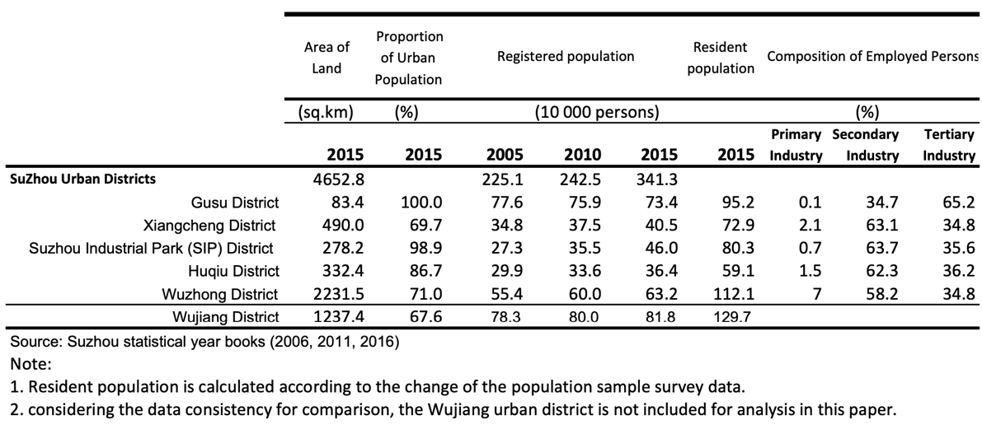

The travel time to Shanghai from each of the four HSR stations is similar (30-40 minutes), there are significant differences in the train frequencies (Chen, 2020). Suzhou (SS) station has 112 trains per day to Shanghai, SIP station has 21 trains and SND station has only 2. On the Jinghu line, only 60 of a total of nearly 200 trains daily stop in Suzhou North station.

This paper analyses annual new firm registration data for individual firms for the period 2005 to 2015 provided by the Suzhou administrative bureau for industry and commerce. 59,539 new registered firms in five urban districts (Gusu, Wuzhong, Xiangcheng, SIP, Huqiu) form the basis of the analysis, covering two observed periods for comparison: 2005-2010 (before HSR) and 2011-2015 (after HSR). Each new firm was codified by economic sector according to the Chinese standard industrial classification (SIC) and by ownership (state-owned or not). Each firm address was geocoded to allow for spatial analyses. The four HSR stations and metro stations (Lines 1 and 2) were geocoded to enable the calculation of distances between firms and nearby metro and HSR stations.

The number of new firms increased from a total of 15,222 in the pre-HSR years (2005-2010) to 44,315 between 2011 and 2015. All but one sector had an increase in new firm formation post-HSR, but there were significant differences in the rate of increase across sectors. Knowledge-based (Type KE) activities increased their share of new firms compared with a decrease in the share of manufacturing, with science and technology-related activities (Types M and I) showing the largest growth.

Table 2 shows the distribution of new firms in each industrial sector in each urban district in both periods. Before the arrival of HSR, Gusu showed the largest creation of new firms of all types, with nearly a quarter of new firm registrations, followed by Wuzhong. SIP showed a strong attraction of new firms in several KE activities. After the arrival of HSR, Gusu and Wuzhong still attracted the largest number of new firms. Gusu dominated all KE activities and attracted the largest percentage of new firms in 15 economic sectors. SIP was in second place, attracting new KE activities. With a general decline in the proportion of manufacturing activities, new manufacturing firms were largely created in the southern and northern districts of Wuzhong and Xiangcheng. Xiancheng had more than half of the agriculture firms. Huqiu showed a relatively modest growth in nearly all sectors.
Table 2 Distribution of New Firm Formation by Standard Industrial Classification in Urban Districts
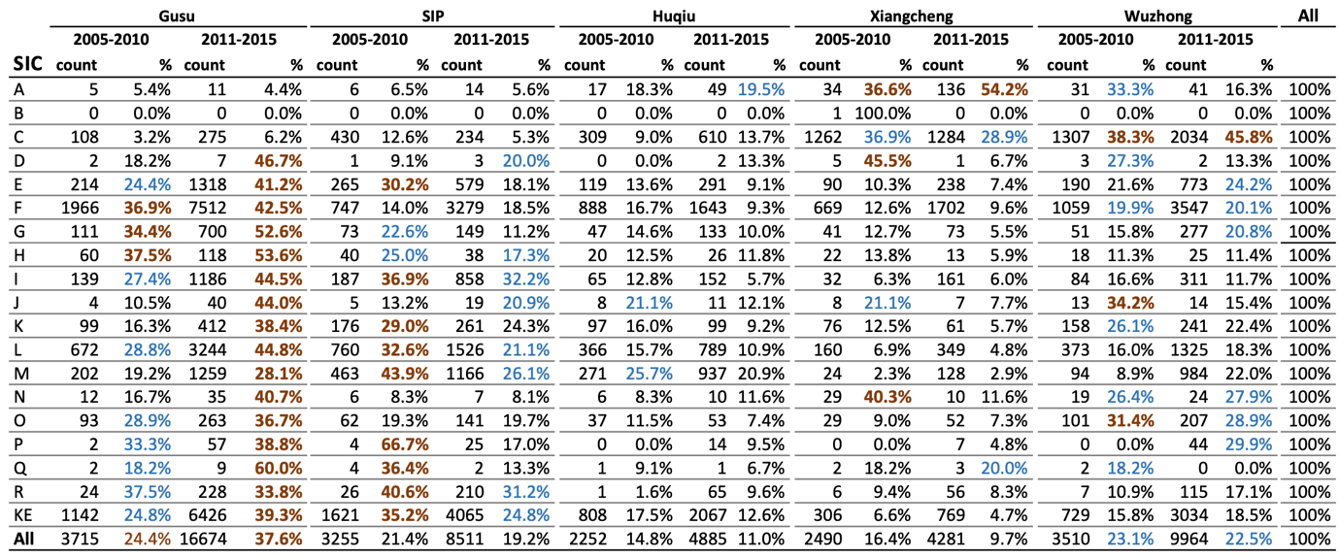
Note: The largest proportion of a SIC sector is highlighted in bold brick colour; the second largest proportion is in light blue.
Source: the authors.

Analysis
A variety of methods has been used to analyse the data. Here we restrict this to an analysis of location quotients (LQ) and a logit regression analysis estimating the probability of the impact of HSR and other factors on new firm formation.

3.1 Location quotients
Location quotients (LQ), as defined in equation (1), were used to measure industrial specialisation in each zone relative to the whole study area. The zones were defined as the five urban districts and 5km buffer zones around each HSR station.

LQ=$\frac{\frac{N_{aj}}{Na}}{\frac{N_{bj}}{Nb}}$ ………………………………………………………..………………………….(1)

where
$N_{aj}$ = number of firms of type j (manufacturing or knowledge-economy) in zone a
$N_{a}$ = number of all types of firms in zone a
$N_{bj}$ = number of firms of type j in the whole study area,
$N_{b}$ = number of all types of firms in the whole study area.

Table 3 summarises the measures of industrial specialisation for manufacturing and KE firms before and after HSR, in terms of five ranges of LQ scores from below 0.5 to more than 2. The whole study area acts as a reference, where LQ is set at 1 for both before and after HSR periods for comparison.

The results provide an insight into changes in the economic and urban structure of each urban district. For instance, after HSR, although it had the largest share of new firms across all KE sectors, Gusu did not show the highest LQ scores when compared with SIP. Gusu did, however, have higher LQ scores than some individual KE activities after HSR.

Analysis of the buffer zones explored whether zones around the HSR stations attracted specific types of firm; whether there were any differences between the four HSR stations; and whether LQ scores differed between the relevant urban district and its station gateway buffer area? The LQ scores from the Suzhou station (SS) buffer zone were similar to those for Gusu as a whole but with generally higher LQs before HSR and lower after HSR, suggesting that proximity to SS was not necessarily a key factor in firm location. The SIP station buffer zone showed the highest LQs for all KE firms, both before and after HSR, but LQ scores for most KE firms had dropped after HSR. The SND station buffer zone showed a minor increase in LQ scores across all types of firms after HSR, although the LQ scores for KE firms remained lower than 1, whilst that of manufacturing increased to 2.02. For the SN station buffer, a minor increase in LQ scores was shown across all types of firms except finance and real estate firms. The higher LQ scores in information transmission, finance, and culture/sports/entertainment firms in particular showed that the station area was more attractive than the overall Xiangcheng district.

Table 3 Industrial Specialisation of New Manufacturing and Knowledge-Based firms
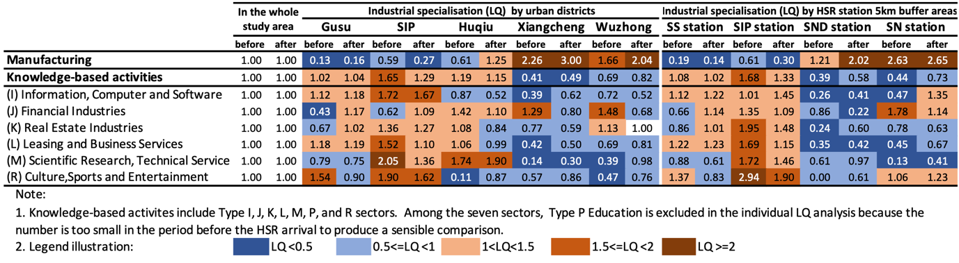
Source: the authors.

These findings reflect the arrival of HSR against a background of ongoing urban transformation, during which time the initial urban expansion from Gusu to the surrounding new districts had evolved to a new phase. Before the arrival of HSR, SIP and, to a lesser extent, Huqiu, in the east and west of Suzhou respectively, were the initial focus of urban expansion and foreign investment in manufacturing. This was followed by new development strategies targeting KE activities through strong intervention in newly designated development zones (Wang et al., 2015). New manufacturing firms were encouraged further south and north to relatively new urban districts, such as Wuzhong and Xiangcheng. A return to Gusu seemed to occur in new KE firms registered after the arrival of HSR.

The development of the urban transport network through the metro and tramway systems also improved accessibility to the HSR stations possibly lessening the need for proximity to an HSR station.

3.2 Logit regression analysis: the probability of new firms’ location
The probability of a new firm locating close to a HSR station can be expressed as a linear function of a range of explanatory variables as in equation (2):

$ln \left(\frac{ \text{P}}{1\text{-}\text{P}}\right)= ln\left(\frac{\text{ P (}\text{locate }\text{in the buffer zone)}}{\text{P (not}\text{ locate}\text{ in the buffer zone)}}\right){=}b_{0}+b_{1}X_{1}+b_{2}X_{2}+…+b_{k}X_{k}+error$ …. (2)

A set of five buffer zones ranging from 1km to 5km around each of the four HSR stations was used to generate a total of 20 logit regressions. The details of the explanatory variables are given in Appendix Table A1. Table 4 summarises the results of a firm of given characteristics locating at a particular place.

There are four key findings. First, two HSR buffer zones show a high probability of attracting new firms. Suzhou North (SN) station appears most likely to attract new manufacturing firms, and the closer a location is to the SN station, the higher the likelihood. The SN station buffer zone also shows the likelihood of attracting IT/computer/software and finance firms, which seems to reflect active state intervention in developing a new town with CBD functions around SN station (Chen, 2020). SIP station shows a very strong tendency to attract several kinds of new KE firms in the 2-5 and 3-5 km buffer zones consistent with the location quotient analysis.

Table 4 Summary of Logit Regression Results (Odds ratios)
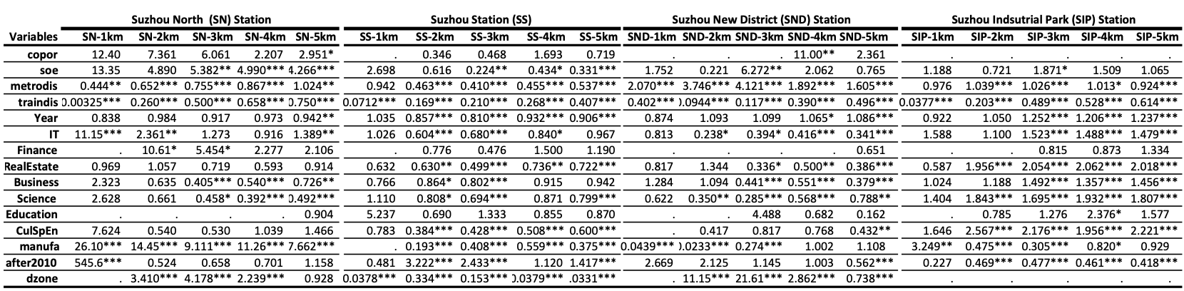
Note:
- The degree of statistical significance: * = p<0.05; ** = p<0.01; *** = p<0.001.
- This table summarises the logit regression results.
Source: the authors.

Second, new firms are generally more likely to locate near HSR stations. This is less true of proximity to metro stations, with the exception of Suzhou and SN Station, which have interchanges with metro lines, suggesting that interchanges between HSR stations and metro lines provide an attractive location for new firms.

Third, the results reflect the role of designated development zones in new firm formation; most clearly close to SN and SND stations. In contrast, the impacts of development zones are found outside the 1-5 km buffer zone of Suzhou station, and there is no significant impact on SIP station buffer zones.

Fourth, regarding the timing of firm creation, new firms were more likely to agglomerate around Suzhou station and SN station after the arrival of HSR in 2010, in contrast with the results found in SND and SIP station buffers. This result appears in line with the relative train frequencies available at these HSR stations.

Conclusions
This paper uses evidence on the location choices of individual firms to help understand the spatial-economic restructuring processes following the introduction of HSR. This territorial transformation shows both a reinforced old urban core and a decentralisation process in new urban districts. This occurs against a background of widespread economic restructuring, growth of service and knowledge-based sectors, and transformation of some older manufacturing sectors.

ail frequency and available interchange with metro services are shown to be critical factors enabling development beyond HSR hubs into wider urban districts and reinforcing existing key clusters. Meanwhile, the role of intervention (either HSR or non-HSR-focused) appears closely linked with development variations. It is also recognised that the interplay of national and local planning decisions is particularly significant in China, with HSR often being used as an instrument of urban restructuring (Wang, 2016). This paper reinforces the view that more disaggregated and qualitative research is essential to better understand the role of HSR in transforming cities and regions in China with implications for other countries using HSR as an instrument of restructuring and transformation.

References
Chen, C.-L. (2018). Tram Development and Urban Transport Integration in Chinese Cities – A case study of Suzhou, Economics of Transportation, 15, 16-31.
Chen, C.-L. (2020). High-speed rail and its wider spatial-economic impact on transformation of Chinese cities and regions: A multi-level analysis in C.-L. Chen, H. Pan, Q. Shen, and J. Wang (eds). Handbook on Transport and Urban Transformation in China, pp 60-82. London: Edward Elgar Publishing.
Chen, C-L. and Vickerman, R.W. (2017). Can transport infrastructure change regions’ economic fortunes? Some evidence from Europe and China, Regional Studies, 51, 144-160
Cheng, Y.-S., Loo, B. P. Y., and Vickerman, R. W. (2015). Highspeed rail networks, economic integration and regional specialization in China and Europe. Travel Behaviour and Society, 2, 1–14
Delaplace, M. (2012). Pourquoi les effets TGV sont-ils différents selon les territoires? L’hétérogénéité au cœur du triptyque Innovations, Territoires et Stratégies. Recherche Transports et Sécurité, 28, 290-302.
De Urena, J.M., Chen, C-L., Loukaitou-Sideris, A. and Vickerman, R.W. ed. (2021) Spatial Implications and Planning Criteria for High-Speed Rail Cities and Regions, Routledge, Abingdon, UK
Facchinetti-Mannone, V. (2013). Les nouvelles gares TGV périphériques, des instruments au service du développement économique des territoires?, Géotransport, 1-2, 51-66.
Fotopoulos, G., and Spence, N. (1999). Spatial variations in new manufacturing plant openings: Some empirical evidence from Greece. Regional Studies, 33(3), 219-229.
Glaeser, E. L., Kallal, H. D., Scheinkman, J. A., and Shleifer, A. (1992). Growth in cities. Journal of Political Economy, 100, 1126–1152. doi:10.1086/261856
Glaeser, E.L. (2021), Infrastructure and urban form, forthcoming in Infrastructure Economics and Policy: International Perspectives, ed. J. Gomez-Ibanez, Zhi Liu. Cambridge, Mass: Lincoln Institute of Land Policy
Graham D.J. Horcher, D. and Vickerman R.W. (2021). Infrastructure and the competitiveness of cities, forthcoming in Infrastructure Economics and Policy: International Perspectives, ed. J. Gomez-Ibanez, Zhi Liu. Cambridge, Mass: Lincoln Institute of Land Policy
Hall, P. (2009). Magic Carpets and Seamless Webs: Opportunities and Constraints for High-speed Trains in Europe. Built Environment, 35(1), 59-69.
Holl, A. (2004a). Manufacturing location and impacts of road transport infrastructure: empirical evidence from Spain. Regional Science and Urban Economics, 34(3), 341-363.
Holl, A. (2004b). Transport infrastructure, agglomeration economies, and firm birth: empirical evidence from Portugal. Journal of Regional Science, 44(4), 693-712.
Holl, A. (2004c). Start‐ups and relocations: Manufacturing plant location in Portugal. Papers in Regional Science, 83(4), 649-668.
Iseki, H. and Eom, H. (2019) Impacts of Rail Transit Accessibility on Firm Spatial Distribution: Case Study in the Metropolitan Area of Washington, DC. Transport Research Record, 1-13. Doi: 10.1177/0361198119844464
Mejia-Dorantes, L., Paez, A., and Vassallo, J.M. (2012) Transport infrastructure impacts on firm location: The effect of a New Metro Line in the Suburbs of Madrid. Journal of Transport Geography, 22, 236-250.
Melo P.C., Graham D.J., and Noland RB, (2010). Impact of Transport Infrastructure on Firm Formation Evidence from Portuguese Municipalities, Transportation Research Record, 2163, 133-143
Menerault, P. (1997). Dynamiques et politiques régionales autour du tunnel sous la Manche et du T.G.V.Nord. Annales de géographie, 106 (593), 5-33.
Michaels, G., Rauch, F. and Redding S. (2019) Task Specialisation in U.S. Cities from 1880-2000, Journal of the European Economic Association, 17, 754–798.
Tierney, S. (2012). High-speed rail, the knowledge economy and the next growth wave. Journal of Transport Geography, 22(C), 285-287.
Venables, A. J. (2017).. Expanding cities and connecting cities: Appraising the effects of transport improvements, Journal of Transport Economics and Policy, 51, 1-19.
Wang, L., Shen, J. and Chung, C. K. L. (2015). City profile: Suzhou - A Chinese city under transformation. Cities, 44, 60-72.
Wang, L. (2016). Studies on HSR New Town Planning and Development. Shanghai, China: Tongji University Press (in Chinese).
Appendix

Table A1 Measured Variables in Logit Regression Analyses
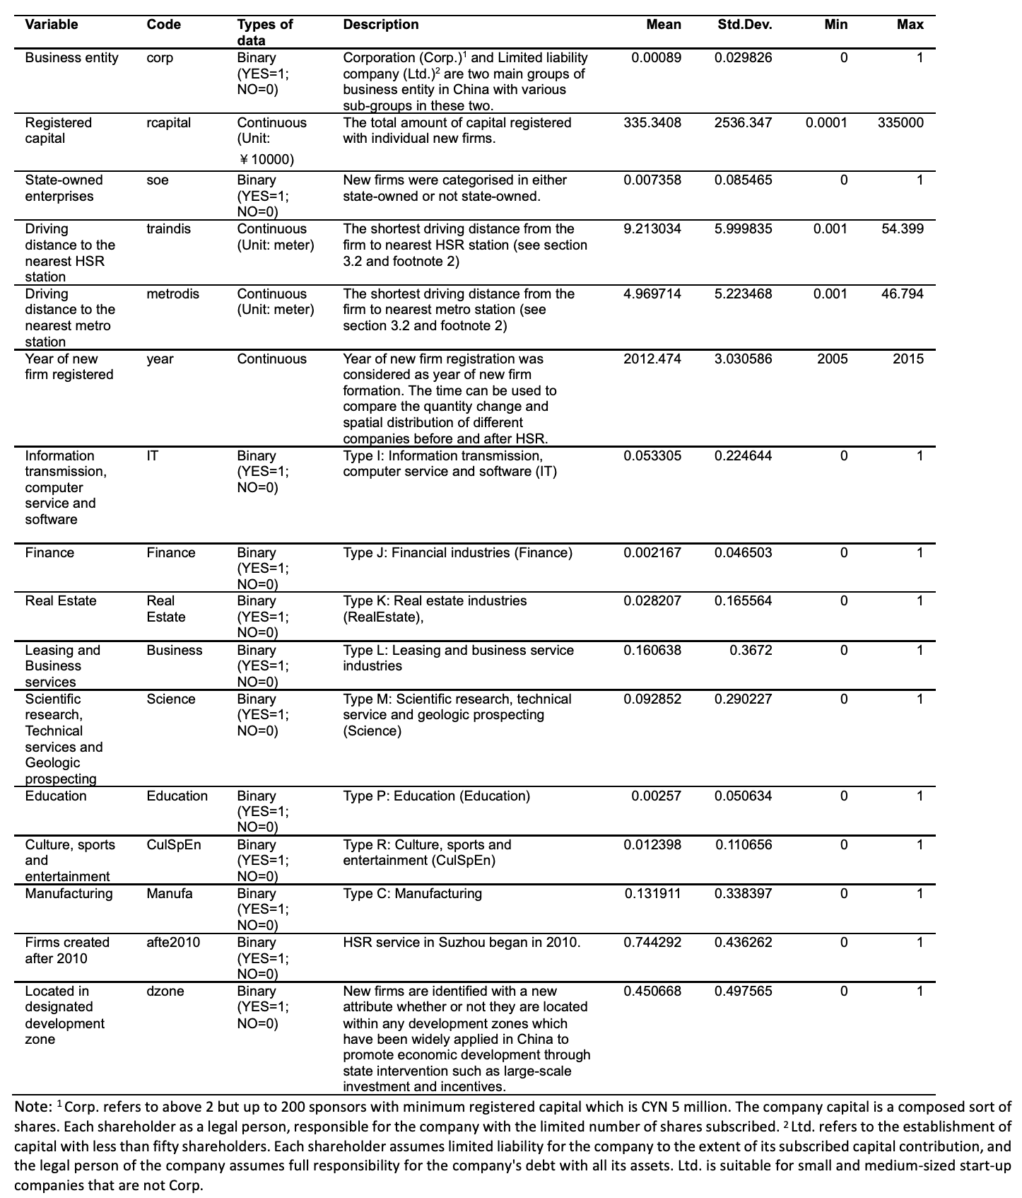

Source: the authors.

We are grateful for the contributions of Zhenhua Chen, Ohio State University and Po-Chen Lin, North Carolina State University, to the research reported in this paper

