Title: Forecasting the mortality burden of coronary heart disease and stroke in Germany: National trends and regional inequalities
Short running title: Forecasting cardiovascular mortality in Germany

Karl M. F. Emmert-Fees^{1,2,3,4}*#, MSPH; Shammi Luhar^{5#}, PhD; Martin O’Flaherty^{6#}, Prof.; Chris Kypridemos^{6¶#}, PhD; Michael Laxy^{1,3,4¶#}, Prof.
¹Institute of Epidemiology, Helmholtz Zentrum München, Neuherberg, Germany
²Institute for Medical Information Processing, Biometry and Epidemiology, Ludwig-Maximilians-Universität München, Munich, Germany
³German Center for Diabetes Research (DZD), Neuherberg, Germany
⁴Department of Sports and Health Sciences, Technical University of Munich, Munich, Germany
⁵Department of Population Health, London School of Hygiene and Tropical Medicine, London, United Kingdom
⁶Department of Public Health, Policy & Systems, University of Liverpool, Liverpool, United Kingdom

¶These authors contributed equally to this work.

#This author takes responsibility for all aspects of the reliability and freedom from bias of the data presented and their discussed interpretation.

Word count (with subheadings): 4225
Tables and Figures: 6

*Corresponding author information:
Karl M.F. Emmert-Fees (K.M.F.E.-F.)
Institute of Epidemiology
Helmholtz Zentrum München
Ingolstädter Landstraße 1
85764 Neuherberg, Germany
E-Mail: karl.emmertfees@helmholtz-munich.de
Phone: 0049 162 2063180

Funding: This work was funded by the German Federal Ministry of Education and Research (01EA1818H).
Keywords: Cardiovascular disease; mortality; population health; forecast; demography
Abstract
Background
The decline of cardiovascular disease (CVD) mortality has slowed in many countries, including Germany. We examined the implications of this trend for future coronary heart disease (CHD) and stroke mortality in Germany considering persistent mortality inequalities between former East and West Germany.
Methods
We retrieved demographic and mortality data from 1991 to 2019 from the German Federal Statistical Office. Using a Bayesian age-period-cohort framework, we projected CHD and stroke mortality from 2019 to 2035, stratified by sex and German region. We decomposed annual changes in deaths into three components (mortality rates, population age structure and population size) and assessed regional inequalities with age-sex-standardized mortality ratios.
Results
We confirmed that declines of CVD mortality rates in Germany will likely stagnate. From 2019 to 2035, we projected fewer annual CHD deaths (114,600 to 103,500 [95%-credible interval: 81,700; 134,000]) and an increase in stroke deaths (51,300 to 53,700 [41,400; 72,000]). Decomposing past and projected mortality, we showed that population ageing was and is offset by declining mortality rates. This likely reverses after 2030 leading to increased CVD deaths thereafter. Inequalities between East and West declined substantially since 1991 and are projected to stabilize for CHD but narrow for stroke.
Conclusions
CVD deaths in Germany likely keep declining until 2030, but may increase thereafter due to population ageing if the reduction in mortality rates slows further. East-West mortality inequalities for CHD remain stable but may converge for stroke. Underlying risk factor trends need to be monitored and addressed by public health policy.
- Introduction
In the past three decades, cardiovascular disease (CVD) has emerged as a major contributor to the global burden of disease. Between 1990 and 2019, the number of disability-adjusted life years attributable to stroke increased by 32.4% and coronary heart disease (CHD) by 50.4%.¹
Despite this shift to a predominance of non-communicable diseases (NCDs) driven by global population growth, population ageing and unhealthy lifestyles, age-standardized CVD mortality rates have decreased from the 1980s until recently, particularly through population-level reductions in key risk factors such as smoking and improvements in primary, secondary and tertiary prevention.²⁻⁵
In the last few years, the continuous decline of CVD mortality has slowed or even reversed for both men and women in some high-income countries, including Germany, contributing to slowing gains in life expectancy.⁶⁻¹² Possible explanations include an increasing prevalence of obesity and its cardiometabolic effects, such as hypertension, hypercholesterolemia and hyperglycemia, stagnating reductions or increases in smoking prevalence and political inertia to tackle the underlying environmental and socio-economic risk factors such as income inequality.^{5,13-15}
For Germany the CVD mortality dynamic is important since over one-third of the population is expected to be older than 60 years by 2035.¹⁶ Moreover, before German reunification in 1990, mortality from most causes was higher in the former German Democratic Republic (GDR, East Germany) than in the Federal Republic of Germany (FRG, West Germany).¹⁷⁻¹⁹ After reunification, this mortality gap narrowed considerably, and for some age groups closed, particularly among women. This is often attributed to different factors, such as different death certificate coding procedures in the 1990’s, improved access to healthcare, better living conditions, and reduced psychosocial stressors.^{17,20-24} Despite the evident convergence, mortality inequalities in CVD between East and West Germany persist until today, particularly for men.^{17,18}
The objective of this study is to unravel the past and future dynamic between these historical inequalities, population ageing, and mortality trends. In using modern statistical and demographic methods we aim to gain insights as to whether recent global trends in CVD mortality have continued in Germany and what their future implications are. Our projections of the future mortality burden can further support health policy priority setting and resource allocation.²⁵⁻²⁷
To achieve this, we perform three analytical steps. First, we describe past CHD and stroke mortality trends and project mortality rates including the respective future number of deaths in Germany to 2035 using a Bayesian approach which accounts for age, period, and cohort effects. Second, we use mortality decomposition methods to analyze the contribution of changes in population size, population ageing and mortality rates from 1991 to 2035. Third, we analyze regional inequalities in CVD mortality between the former East and West German states using directly standardized mortality ratios (SMR).

- Methods
  - Data
We retrieved population counts from 1991 to 2019 and population count projections from 2020 to 2035 from the German Federal Statistical Office (GENESIS, www.destatis.de) by sex, single years of age and German federal state. Official population counts before 2011 were adjusted for intercensal projections using published values.²⁸ This was necessary because before Germany implemented its first register-based census in 2011, no census was conducted for more than two decades, leading to a substantial overestimation of the population size.²⁸
Official death count estimates were retrieved from the German Information System of the Federal Health Monitoring (Gesundheitsberichterstattung des Bundes, www.gbe-bund.de) for CHD and stroke from 1991 to 2019 as defined by the European Shortlist for Causes of Death (ESCD) by German state, sex, and five-year age groups. The ESCD harmonizes death counts before 1997 (International Classification of Diseases, Ninth Revision; ICD-9) and after 1998 (ICD-10). CHD was defined with the ESCD category for ‘ischemic heart diseases’, corresponding to I20-I25 (ICD-10) and 410-414 (ICD-9), thus also including acute myocardial infarctions. Stroke was defined using the ESCD ‘cerebrovascular diseases’ category, corresponding to I60-I69 (ICD-10) and 430-438 (ICD-9).
We have not included mortality data from years after 2019 due to a lack of availability at the time of analysis and to avoid potential biases in the projection of long-term CVD mortality trends arising from several mechanisms related to the COVID-19 pandemic. Key mechanisms are a higher uncertainty in death coding procedures during the pandemic²⁹; elevated cause-specific mortality in vulnerable population subgroups which might have developed CVD in the future³⁰; and the disruption of health services³¹. Since no post-pandemic mortality data is available, the inclusion of mortality data from the pandemic would likely lead to more unreliable long-term forecasts.
German states were classified into two East and West German sub-regions based on their historic geographic affiliation with the FRG (West Germany) and the former GDR (East Germany).¹⁷ Berlin, which was split in an Eastern and Western part during the time of the GDR, was excluded from all analyses to avoid potential biases (see Supplementary Methods).

  - Bayesian age-period-cohort model
We used a Bayesian age-period-cohort (BAPC) model to project mortality rates and the total number of deaths from CHD and stroke in people aged 30 and older in Germany from 2019 to 2035. All forecasts were implemented stratified by sex and separately for the former East and West German states (i.e., sub-regions) to allow for separate time trends. To calculate the projected number of deaths, we multiplied BAPC mortality rate projections with the official population projections. National forecasts were aggregated from the sub-regional forecasts. Methodological details of the implementation of the BAPC model with the R package bamp that we used have been extensively described elsewhere.³² Similar methods were previously applied to forecast CVD mortality in England, Wales, the United States and Japan.³³⁻³⁵
Briefly, in the BAPC the observed logit risk of death is modelled as a linear combination of the general mortality level (intercept) and age, period, and cohort effects.³² Bayesian estimation is performed using Markov chain Monte Carlo sampling.³⁶ The forecast was directly applied to the observed number of deaths aggregated to five-year age groups for each sex, disease, and sub-region. Uncertainty in projected deaths was assessed with 80% and 95%-credible intervals (CrI). We assumed that uncertainty of the sub-region forecasts was uncorrelated when aggregating them to the national forecast. To improve readability and interpretation, the observed and projected number of deaths was aggregated to ten-year age groups for the reporting of results in tables.
The BAPC can handle both linear (i.e., second-order random walk) and constant time trends (i.e., first-order random walk) for the age, period, and cohort effects, with or without heterogeneity and overdispersion. This enables us to specify models according to several structures. To determine the best choice for each combination of sex, disease, and region, we projected the last 10-years of observed data (2010-2019) and selected best fitting model specification according to the mean absolute scaled error (MASE).³⁷ A lower MASE indicates better predictive performance (Supplemental Table S1). All analyses were conducted in R (v4.2.2) with the package bamp (v2.1.3).^{32,38} Details are shown in the Supplementary Methods.

  - Comparison with alternative models
To validate our model choice, we projected the last ten years of observed data (i.e., 2010-2019) with Lee-Carter (LC) and functional demographic (FD) models in addition to the BAPC. The LC model is an established demographic time-series forecasting method, which is generalized by FD models using functional data analysis methods. Both models were implemented with the R package demography (v1.22).²⁶ To compare the predictive performance of the three models we computed the MASE between the observed and projected total number of deaths by sex, disease, and region (Supplemental Table S1). Further details are described in the Supplementary Material.
  - Mortality decomposition
We followed Cheng et al. (2019) to decompose the difference in sex- and disease-specific total deaths between 1991 (i.e., reference year and population for the decomposition) and each subsequent observed or projected year into three components: Changes in population size, changes in the age structure (i.e., population ageing) and changes in age-specific mortality rates.³⁹ Beyond their main effects, this new method attributes all two- and three-way interactions between the components consistently and was shown to be more robust regarding the choice of the reference population compared to previous approaches.³⁹

  - Analysis of regional inequalities
To analyze mortality inequalities between East and West Germany over time, we computed the age- and sex-standardized number of deaths in East and West Germany for all observed and projected years (i.e., 1991 to 2035) using direct standardization to the 2019 national German population. Specifically, we estimated relative inequalities via yearly disease-specific SMRs by dividing standardized deaths in East Germany by those in West Germany. Uncertainty in SMRs was assessed using 95%-CIs which were calculated via published exact methods.⁴⁰ Absolute inequalities in 2019 and 2035 were calculated by computing the respective differences in standardized deaths. For consistency, we constructed the 95%-CIs for absolute inequalities based on the uncertainty of the SMRs. Details are presented in the Supplementary Methods.

- Results
  - Observed CHD and stroke mortality trends from 1991 to 2019
On a national level, the crude number of deaths from CHD declined from 85,300 in 1991 (mortality rate: 386 per 100,000) to 64,000 in 2019 (mortality rate: 238 per 100,000) among men and from 87,300 (mortality rate: 343 per 100,000) to 50,600 (mortality rate: 176 per 100,000) among women (Table 1). Likewise, deaths from stroke declined from 38,100 in 1991 (mortality rate: 172 per 100,000) to 22,100 (mortality rate: 82 per 100,000) in 2019 among men and from 67,800 (mortality rate: 266 per 100,000) to 29,200 (mortality rate: 102 per 100,000) among women. The decline in crude mortality rates was more pronounced in the first half of this period from 1991 until 2005 (Table 1). This finding holds for CHD and stroke mortality rates in men and women across all age groups (Supplemental Figures S9 and S10).
Over the whole period from 1991 to 2019 the crude CHD and stroke mortality rates for both men and women were higher in East compared to West Germany. For example, the CHD mortality rate in 1991 was 313 per 100,000 among women in West Germany, but 473 per 100,000 for their counterparts in the East. These differences have prevailed until 2019 and are consistent across age groups (Table 1, Supplemental Figures S11-S14).

  - Projected CHD and stroke deaths from 2019 to 2035
Overall, we projected a further decline in CHD and stroke deaths from 2019 to 2035 in Germany for both sexes in all age groups except for 70- to 79-year-olds. The total number of projected deaths in 2035 was 103,500 [95%-credible interval: 81,700; 134,000] for CHD and 53,700 [41,400; 72,000] for stroke (Figure 1, Table 2, Supplemental Table S9). For men, we projected a slight decrease in deaths from CHD from 2019 to 2035 by 3%, corresponding to a reduction of 2,100 [−21,300; 18,000] deaths, but an increase in deaths from stroke of about 16% or 3,600 [−4,800; 18,300] deaths (Figure 1, Table 2). For women, we projected a decrease in deaths from CHD and stroke of 20% (10,000 [−11,700; 23,000] fewer deaths) and 6% (1,700 [−10,200; 9,500] fewer deaths) from 2019 to 2035, respectively (Figure 1, Table 2). We found that, on a national level, CHD and stroke mortality rates are likely to stagnate in most age groups from 2030 onwards for both men and women, thus continuing the slowdown observed between 1991 and 2019 (Supplemental Figures S9 and S10). Due to population ageing this will lead to an inflection point around the year 2030 with rising CVD deaths thereafter (Figure 1).
A comparison between projections in West and East Germany revealed that mortality trends are mostly consistent across the two sub-regions. The only exception is stroke mortality in East German men where slight declines (Change from 2019 to 2035: −790 [−3230; 8740]), as opposed to an increase in West Germany (Change from 2019 to 2035: 3780 [−3500; 15570]), may be expected in the future. This finding is rooted in the underlying stroke mortality rates, which are projected to decline further among East German men but likely stagnate in most other strata (Supplemental Figures S11-S14).

Table 1: Crude total number of cardiovascular deaths and crude mortality rate by sex and German region in 1991, 2005 and 2019
 | 1991 |  | 2005 |  | 2019 |  | 1991 – 2019
 | Deaths | Mortality rate* | Deaths | Mortality rate* | Deaths | Mortality rate* | Deaths
Germany |  |  |  |  |  |  | Difference | Change
Men
CHD | 85300 | 386 | 69900 | 276 | 64000 | 238 | -21400 | -25%
Stroke | 38100 | 172 | 24200 | 95 | 22100 | 82 | -16000 | -42%
Women
CHD | 87300 | 343 | 74100 | 267 | 50600 | 176 | -36600 | -42%
Stroke | 67800 | 266 | 41300 | 148 | 29200 | 102 | -38600 | -57%
West Germany
Men
CHD | 65600 | 363 | 55000 | 263 | 49900 | 223 | -15700 | -24%
Stroke | 28700 | 158 | 19200 | 92 | 17900 | 80 | -10700 | -37%
Women
CHD | 64500 | 313 | 56300 | 246 | 38800 | 162 | -25700 | -40%
Stroke | 50400 | 245 | 31800 | 139 | 23300 | 98 | -27100 | -54%
East Germany
Men
CHD | 19800 | 490 | 15000 | 339 | 14100 | 311 | -5700 | -29%
Stroke | 9500 | 235 | 5000 | 113 | 4200 | 93 | -5300 | -56%
Women
CHD | 22800 | 473 | 17800 | 364 | 11900 | 246 | -10900 | -48%
Stroke | 17400 | 360 | 9500 | 194 | 5900 | 121 | -11500 | -66%

Legend: Absolute number of deaths rounded to hundreds and relative change rounded to the nearest integer. *Crude mortality rate per 100,000 persons. Abbreviations: CHD, coronary heart disease.

Figure 1: Total number of observed and projected cardiovascular deaths in Germany by sex
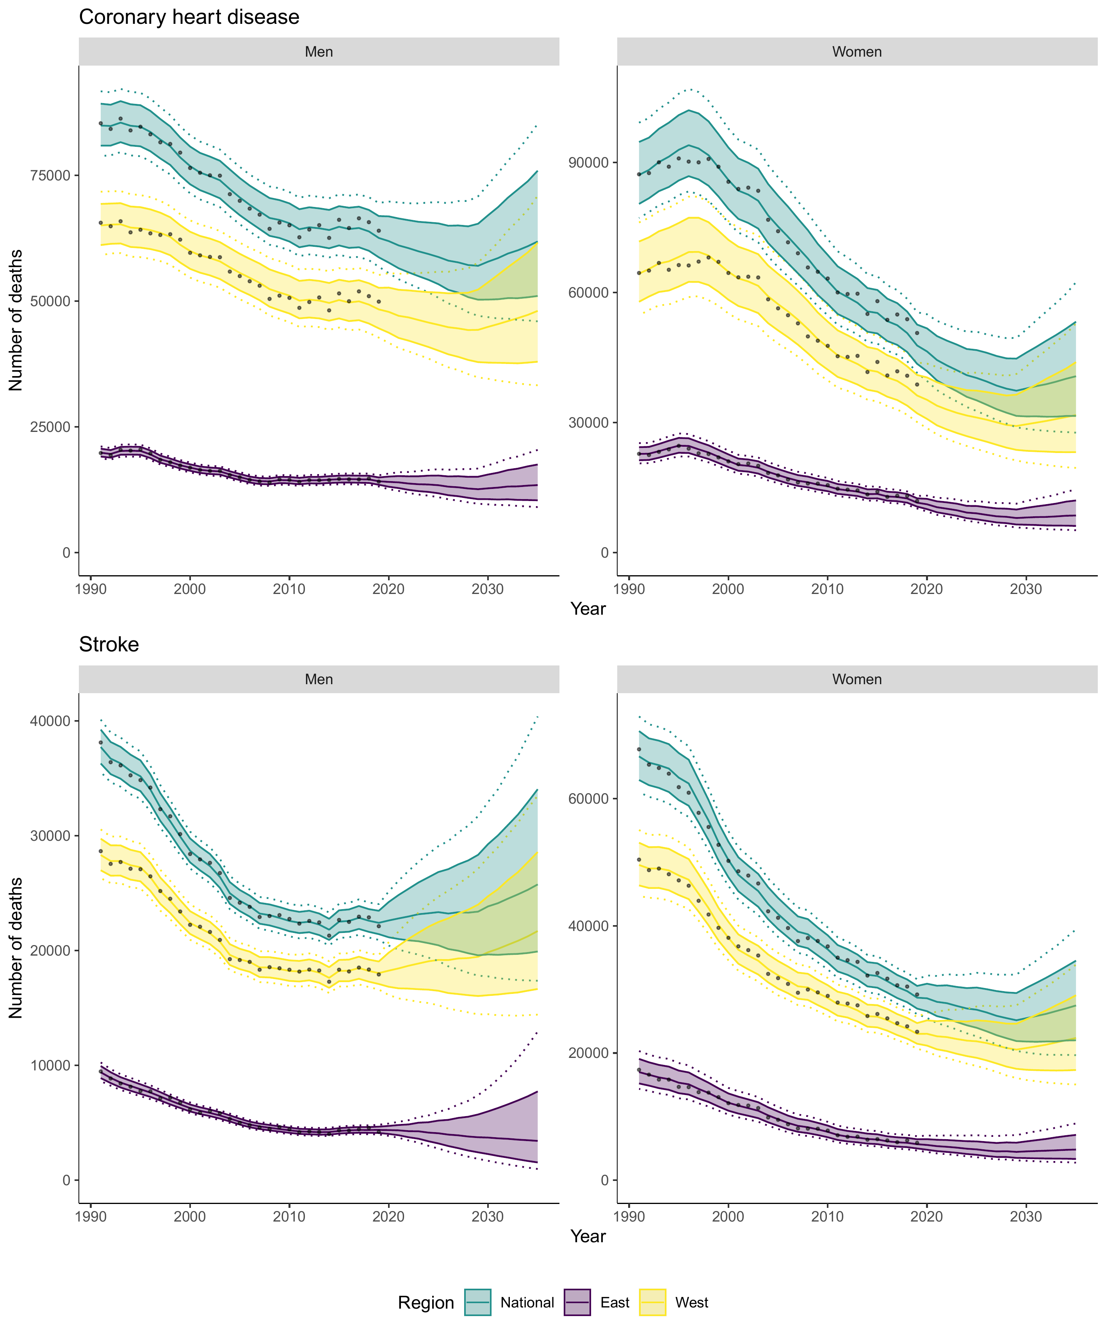
Legend: All panels – Total number of observed (black points) and projected cardiovascular deaths from the Bayesian Age-Period-Cohort model. Shaded areas indicate 80%-credible intervals. Dotted lines indicate 95%-credible intervals. National forecast is aggregated from sub-national estimates.

Table 2: Projected total number of cardiovascular deaths and absolute and relative change in Germany by sex from 2019 to 2035
 | 2019 | 2035 |  | 2019 – 2035
 | Observed deaths | BAPC |  | BAPC |  | BAPC
 |  | Median | 95%-CrI | Difference | 95%-CrI | Change % | 95%-CrI
Men
CHD
30-39 | 130 | 130 | [80; 190] | -10 | [-50; 50] | -5 | [-37; 41]
40-49 | 810 | 720 | [520; 1010] | -100 | [-290; 190] | -12 | [-36; 23]
50-59 | 3960 | 2220 | [1660; 3110] | -1750 | [-2310; -860] | -44 | [-58; -22]
60-69 | 8910 | 7320 | [5460; 10300] | -1590 | [-3450; 1390] | -18 | [-39; 16]
70-79 | 15420 | 20900 | [13680; 32240] | 5480 | [-1750; 16820] | 36 | [-11; 109]
80+ | 34750 | 30170 | [21000; 44550] | -4580 | [-13750; 9810] | -13 | [-40; 28]
All ages | 63980 | 61840 | [45960; 85230] | -2140 | [-18020; 21250] | -3 | [-28; 33]
Stroke
30-39 | 60 | 60 | [40; 100] | 0 | [-20; 40] | 3 | [-39; 69]
40-49 | 230 | 250 | [160; 390] | 20 | [-70; 160] | 7 | [-30; 68]
50-59 | 950 | 680 | [450; 1070] | -270 | [-490; 130] | -29 | [-52; 13]
60-69 | 2480 | 2430 | [1640; 3800] | -50 | [-840; 1330] | -2 | [-34; 54]
70-79 | 5770 | 7580 | [4680; 12630] | 1810 | [-1090; 6860] | 31 | [-19; 119]
80+ | 12640 | 14640 | [9130; 24550] | 2000 | [-3520; 11900] | 16 | [-28; 94]
All ages | 22120 | 25760 | [17370; 40390] | 3640 | [-4760; 18270] | 16 | [-21; 83]
Women
CHD
30-39 | 40 | 30 | [20; 50] | -10 | [-20; 10] | -22 | [-59; 29]
40-49 | 160 | 170 | [110; 250] | 10 | [-40; 100] | 8 | [-27; 61]
50-59 | 850 | 530 | [380; 780] | -310 | [-470; -70] | -37 | [-56; -8]
60-69 | 2500 | 2370 | [1690; 3480] | -130 | [-810; 980] | -5 | [-32; 39]
70-79 | 7010 | 9050 | [5520; 15320] | 2050 | [-1480; 8310] | 29 | [-21; 119]
80+ | 40100 | 28330 | [18290; 44950] | -11760 | [-21800; 4860] | -29 | [-54; 12]
All ages | 50640 | 40670 | [27650; 62360] | -9970 | [-22990; 11710] | -20 | [-45; 23]
Stroke
30-39 | 70 | 60 | [30; 90] | -20 | [-40; 20] | -21 | [-53; 23]
40-49 | 160 | 170 | [110; 240] | 0 | [-50; 80] | 2 | [-30; 46]
50-59 | 600 | 330 | [240; 470] | -270 | [-360; -130] | -45 | [-60; -22]
60-69 | 1470 | 1250 | [930; 1770] | -220 | [-540; 310] | -15 | [-37; 21]
70-79 | 4630 | 5830 | [3840; 8890] | 1200 | [-790; 4260] | 26 | [-17; 92]
80+ | 22270 | 19750 | [13630; 29190] | -2520 | [-8640; 6920] | -11 | [-39; 31]
All ages | 29200 | 27470 | [19660; 39430] | -1720 | [-9540; 10230] | -6 | [-33; 35]

Legend: Absolute and relative change was computed from the difference between the total number of deaths in 2035 and in 2019. All numbers rounded to tens, except %-changes which are rounded to the nearest integer. Potential inconsistencies are due to rounding. Abbreviations: CHD, coronary heart disease; CrI, credible interval.

  - Mortality decomposition
Decomposing the past and projected number of CVD deaths, we find that in Germany for both sexes the past reduction (1991 to 2019) in deaths from CHD and stroke was driven by declines in age-specific mortality rates (Figure 2, Supplemental Tables S10 and S11). However, population ageing, and population growth have partially mitigated this effect, particularly for men. According to our BAPC projections this trend will continue until around 2030 but is projected to reverse afterwards as the German population ages further and age-specific mortality rates continue to slow down and potentially stagnate (Figure 2, Supplemental Tables S10 and S11). These findings are largely consistent for both East and West Germany, albeit population ageing is more important for the mortality dynamic in the East as the population size is projected to decrease (Supplemental Figures S16 and S17, Supplemental Tables S10 and S11).

  - Regional inequalities
Age- and sex-standardized relative inequalities from CHD mortality have declined continuously from 1991 (SMR: 1.51 [1.40; 1.62]) to 2019 (SMR: 1.30 [1.14; 1.47]) (Figure 3). However, our projections indicated no further reduction until 2035 (SMR: 1.30 [1.12; 1.50]). This may be explained by stagnating CHD mortality rates across age groups in both East and West Germany (Supplemental Figures S11 and S13). In terms of absolute inequalities this results in a slight decrease from 33,700 excess deaths from CHD in East Germany in 2019 to 24,500 [9,600; 41,100] in 2035 (Table 3).
For stroke there was likewise a rapid and consistent decline in age- and sex-standardized relative inequalities from 1991 (SMR: 1.57 [1.43; 1.72]) to 2019 (SMR: 1.07 [0.87; 1.31]) (Figure 3). We projected inequalities from stroke mortality between East and West Germany to further decline until 2035 and potentially reverse (SMR in 2035: 0.85 [0.66; 1.08]). This is likely due to projected slightly decreasing mortality rates for some age-sex groups in the East, whereas mortality rates for their West German counterparts stagnate (Supplemental Figures S12 and S15). This translates to a decrease from 3,700 excess stroke deaths in East Germany in 2019 to 6,800 [−3,760; 15,600] excess stroke deaths in West Germany in 2035 (Table 3).

Table 3: Absolute inequalities of age-sex-standardized total number of deaths between East and West Germany in 2019 and 2035
 | 2019 | 2035 |  | 2019 - 2035
 | Observed* | Mean* | 95%-CI | Δ | 95%-CI
CHD | 33740 | 24450 | [9570; 41060] | -9290 | [-24170; 7310]
Stroke | 3740 | -6770 | [-15550; 3760] | -10510 | [-19290; 20]

Legend: *Total number of age-sex-standardized deaths in East Germany - West Germany. All numbers rounded to tens. Abbreviations: CHD, coronary heart disease; CI, confidence interval

Figure 2: Mortality decomposition of CHD and stroke in Germany by sex over time.
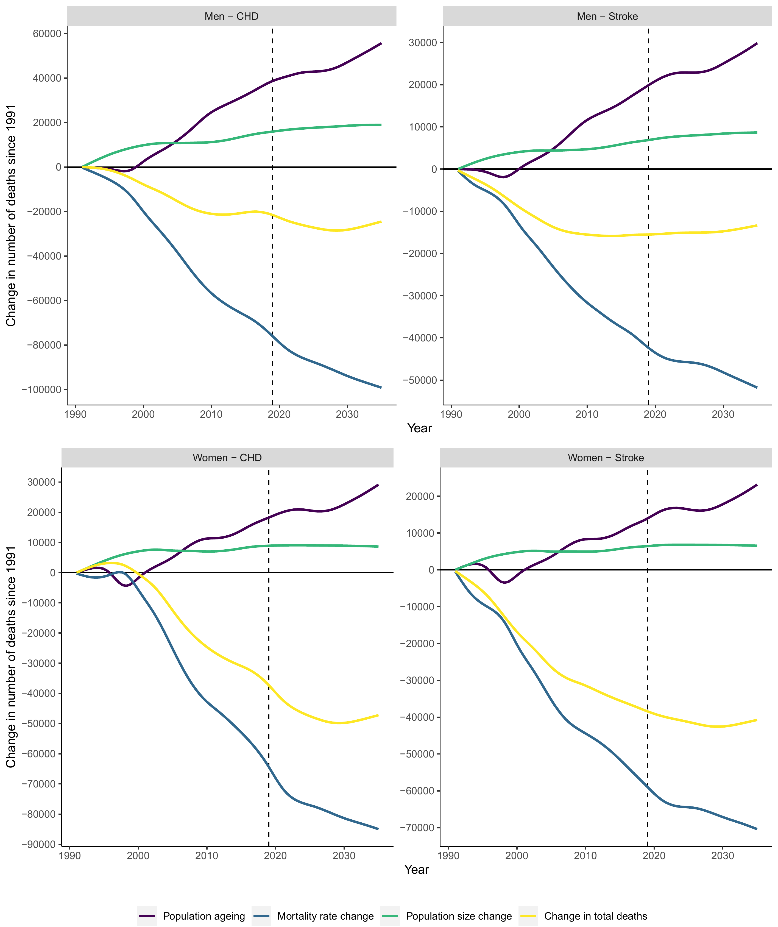
Legend: Smoothed version of original data using a generalized additive model. Solid lines: Observed change in deaths from 1991 to 2019 and projections from Bayesian age-period-cohort model from 2020 to 2035. Black lines: Total change in deaths over time. Red lines: Change of deaths due to population ageing. Green lines: Change of deaths due to population size. Blue lines: Change of deaths due to mortality rate.
Figure 3: Age-standardized mortality rate ratios of CHD and stroke between East and West Germany over time.
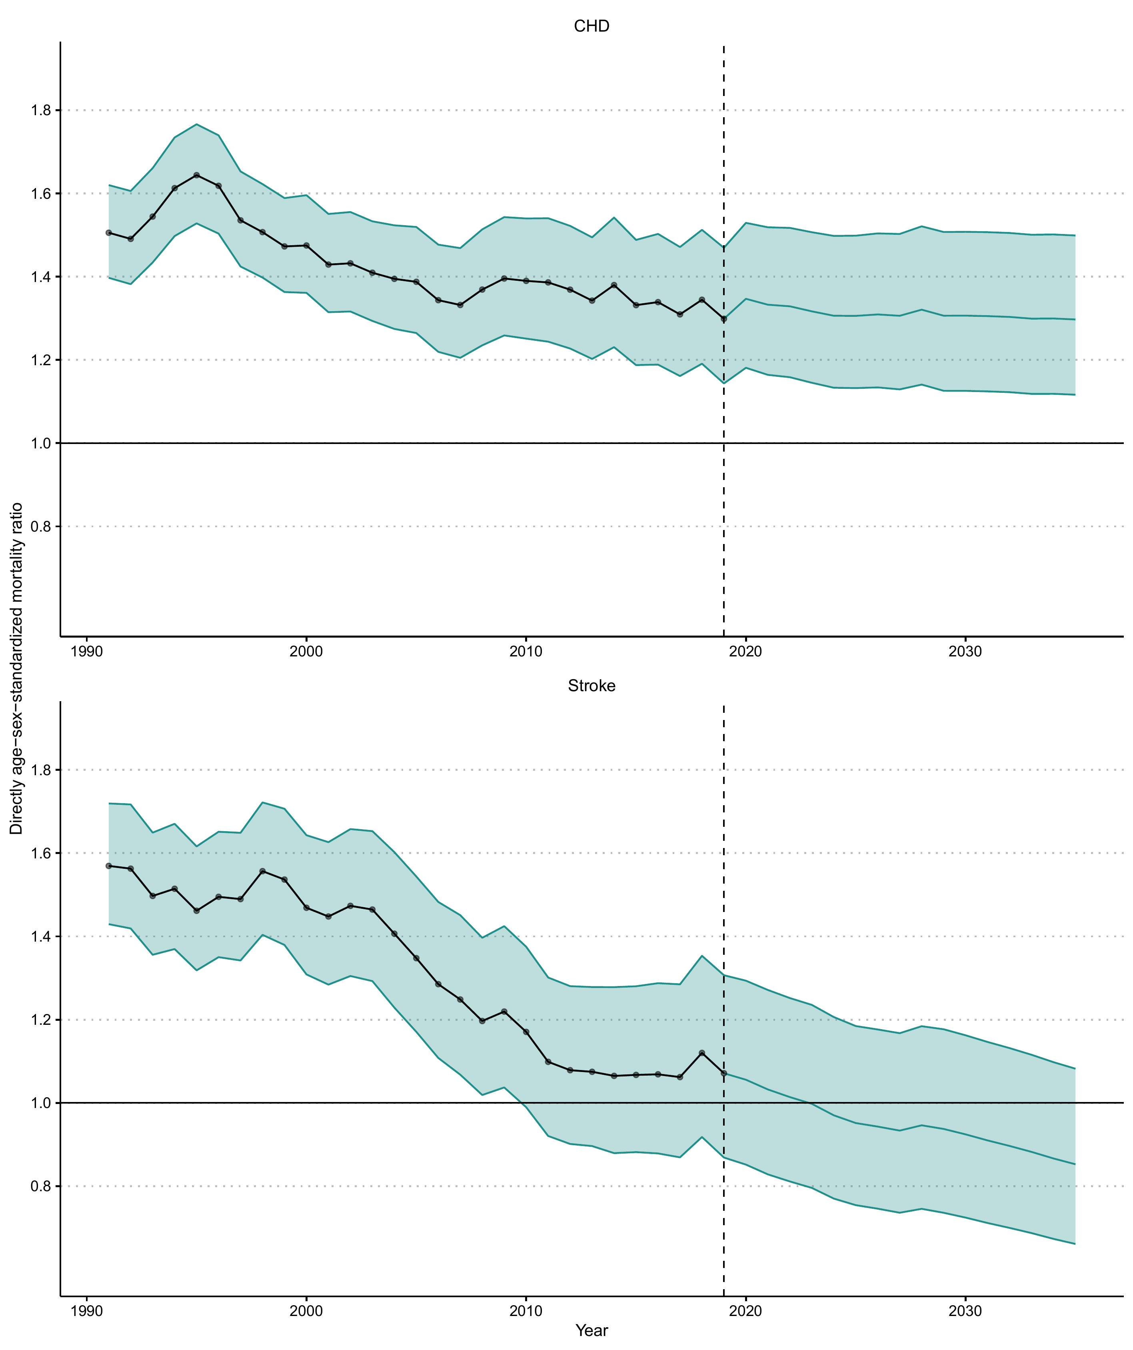
Legend: All panels – Observed (black) and projected (BAPC, turquoise) age-sex-standardized (Reference: 2019 German population) disease-specific mortality ratios (SMR) between East and West Germany from 1991 to 2035. Values >1 indicate higher mortality in East Germany. Vertical dashed line indicates begin of projection period in 2020. Shaded areas indicate 95%-confidence intervals.

- Discussion
From 1991 to 2019, CVD mortality rates in Germany have consistently declined for men and women across all age groups, albeit this decline has slowed or stopped in recent years particularly in East Germany. Likewise, despite population ageing, the total number of CVD deaths has also declined substantially among men and women across all age groups. Our BAPC projections from 2019 to 2035 indicate a further decline of CHD mortality in Germany by 10% (≈11,100 deaths). For stroke we project a slight increase in deaths of 5% (≈2,400 deaths) driven by stagnating mortality rates in West German men. Decomposing the changes in national CVD mortality since 1991, we show that projected declines in mortality from CHD and stroke will likely partially be offset by the effects of population ageing and increases in population size. However, this trend is likely to slow down and reverse after around 2030. Using SMRs to analyze regional mortality inequalities between East and West Germany over time, we find that these have consistently declined from 1991 until 2019. Based on our projections for stroke, this trend will likely continue further, potentially even leading to higher age-sex-standardized stroke mortality in West Germany until 2035. However, mortality inequalities for CHD are projected to stabilize around 2019 levels.
Two other studies have included Germany in their projections of the burden of cardiovascular disease. Wafa et al. (2020) projected the burden of stroke in Europe and estimated stroke deaths in Germany to decline to 35,000 by 2047, which implies a large reduction and is not consistent with our analysis.⁴¹ These differences are likely related to different forecasting methods. Wafa et al. (2020) used a regression-based approach to forecast mortality based on time and GDP, which does not take explicit age, period, and cohort effects into account. Similarly, as part of the Global Burden of Diseases, Injuries, and Risk Factors Study 2016, an analysis using a component model of cause-specific mortality projected stroke deaths in Germany in 2040 to decrease to 43,000 in the reference and 56,000 in the pessimistic scenario. However, the same analysis, while also projecting a decline in CHD deaths in the reference scenario, reported an about twofold higher absolute number of deaths in 2016 and 2040, which is potentially related to diverging case definitions.⁴²
Based on the observed CVD mortality from 1991-2019 we provide further evidence on recent trends that others have described for Germany and generally for the USA, UK, and other European countries. Namely a slowing decline or stagnation of mortality rates for CHD and stroke, which might be responsible for slowing improvements in life expectancy.^{6-9,11,12,15,17,43} The impact on the future CVD mortality burden of a continuation of these trends can be deduced from our projections. Using a Bayesian approach which incorporates age, period, and cohort effects we account for these recent shifts and project further stagnating mortality rates (Supplemental Figures S9-S14). In our mortality decomposition analysis, we show that these trends together with the effect of population ageing will likely lead to an increase in the number of cardiovascular deaths after 2030 (Figure 2). This is consistent with previous global projections and analyses from the US and the UK.^{2,33,34,44}
The underlying mechanisms of the observed shift in CVD mortality since 2010 have yet to be illuminated but are likely related to an increasing prevalence of diabetes, obesity, and unhealthy lifestyles, such as smoking, physical inactivity and diets consisting of large amounts of ultra-processed foods. Already implemented clinical prevention and treatment approaches might also have exploited their full potential and provide diminishing returns.³⁻⁵ The most recent German risk factor surveillance data shows a moderate decline in smoking prevalence among men and women since the mid-2000’s, consistent decreases in physical inactivity since the late 1990’s but consistent increases in obesity, particularly among younger age groups.⁴⁵⁻⁴⁷ Additionally, studies suggest that the prevalence of obesity, diabetes, and CVD in Germany is likely to increase over the coming decades.⁴⁸⁻⁵² Considering these trends together with recently observed mortality trajectories in Germany, the stagnation of CVD mortality rates and prospective increase in deaths, as projected in our study, seems plausible.
It must be acknowledged that future trajectories of CVD mortality could be affected by the COVID-19 pandemic due to several mechanisms. First, at the beginning of the pandemic, cause of death definitions were less reliable since coding procedures were not established.²⁹ Second, all-cause and cause-specific mortality was elevated compared to a historical baseline as COVID-19 affected primarily frail populations at a very high age and other vulnerable groups with specific risk factor profiles, such as patients with respiratory diseases or suppressed immune systems, some of which would have developed CVD in the future.³⁰ Third, in most healthcare systems services were interrupted which led to delayed diagnosis and treatment in routine care.³¹
The potential direction, degree, and persistence of these effects on future CVD mortality is likely complex. Inclusion of mortality data from the COVID-19 pandemic could have led to an underestimation of future CVD mortality trends because some of the expected future deaths will not happen. However, this period effect might be independent of long-term mortality trajectories as these are largely determined by behavioral factors, socio-economic circumstances, and healthcare access.⁵ To avoid potentially resulting biases, we have thus excluded mortality data from the years after 2019 in our projections. Future studies could use these projections to evaluate the impact of the COVID-19 pandemic on long-term CVD mortality trends once a substantial amount of post-pandemic mortality data has accrued.
Although health-related inequalities and the convergence of all-cause and disease-specific mortality between East and West Germany have been under scrutiny by researchers over the last decades, no projections like the ones presented in this study exist. Others analyzed sex and disease-specific pre- and post-reunification mortality trends^{17,19,22-24,43,53}, discussed the underlying potential economic, socio-cultural, and healthcare-related mechanisms of mortality convergence^{17,54}, estimated the impact of age selection⁵⁵ and discussed the impact of changes in East German smoking prevalence on future mortality in women of specific age groups.²⁰
We show that, if recent mortality trends continue, future mortality convergence (according to age-sex-standardized SMRs; Figure 3) is unlikely for CHD, but possible for stroke due to projected further decreasing mortality rates among East German men. Because long-term trends in regional mortality inequalities are related to underlying risk factor trajectories, they can be complex to analyze and understand. For example, Vogt et al. (2017) predicted that a great increase in smoking prevalence among East German women in the decade after the reunification will likely lead to a future lung cancer mortality divergence between East and West.²⁰ However, while smoking will impact lung cancer incidence and mortality decades later, effects on cardiovascular disease are more immediate.⁵⁶ To what degree, which risk factors might be responsible for regional health inequalities should thus be carefully analyzed in future studies.
Our projections highlight the importance for a close monitoring of cardiovascular and diabetes prevalence, incidence, and mortality trends in Germany to better understand implications for health policy and priority setting. The continuous surveillance of key related risk factors is equally important to attribute trends in disease epidemiology to their underlying causes and potentially identify unknown factors.^{57,58} Consistently collecting this data across regions and socioeconomic subpopulations is further key to understand health inequalities but not common in publicly available official German mortality data.
Granular epidemiological surveillance is also essential for the design and implementation of effective population-based preventive policies. Our results support the need for a comprehensive approach to strengthen existing NCD prevention efforts.⁵⁷ Moreover, risk reductions from population-level interventions can be expected even within few years.⁵⁶ Germany is among the countries with the highest prevalence of smoking in Europe and scores 5th worst on the Tobacco Control Scale, which indicates national-level implementation of tobacco control policies, out of the EU27 countries.⁵⁹ Additionally, Germany lacks implementation of key evidence-based nutrition policies to prevent obesity and other detrimental effects of unhealthy diets.⁶⁰

- Strengths and Limitations
Our study has several strengths. We used recent official data on death counts and population count projections and implemented published adjustments for intercensal projections for population counts before 2011.²⁸ Our application of a Bayesian forecasting method, calibration, extensive validation, and model comparison procedures leads to robust results. The analysis of the mortality dynamic in Germany including mortality inequalities between East and West supports health policy priority setting. Finally, the produced forecasts can be used in future applications of population health modelling in Germany.
Limitations of our approach include that the applied method does not explicitly account for changing population-level risk factor, treatment, and prevention patterns over time. Yet, it is reasonable to assume that these long-term trends and effects are implicitly included in the morality time series. As discussed, our approach also does not enable us to model any future disruptions, including the COVID-19 pandemic or economic crises. Although the short-term detrimental cardiovascular effects of COVID-19 are well documented⁶¹⁻⁶³, multiple years of post-pandemic mortality data would be needed to assess whether the COVID-19 pandemic induced long-term changes in mortality. Additionally, long-term mortality trends are largely determined by behavioral factors, socio-economic circumstances, and healthcare access.⁵ Our Bayesian framework, in which we model cause-specific mortality independently, is also unable to incorporate competing risks between stroke and CHD. This is a well-known problem in cause-specific mortality forecasting, particularly if the objective is to coherently aggregate cause-specific estimates to all-cause mortality forecasts. However, it can be argued that the impact of historical changes in non-CHD (or stroke) mortality are implicitly incorporated in the historic CHD (or stroke) mortality and population count time series. Thus, we expect the resulting bias for our projections to be small and likely much smaller than the estimated uncertainty intervals as we do not aggregate cause-specific mortalities and analyze only two causes. In our analysis of East-West mortality convergence we are further unable to explicitly account for migration between the two regions. However, migration is implicitly included in the official population projections and others have argued that this intra-national migration had a negligible effect on mortality differences in the past.^{17,53} Beyond the historic geographic division in East and West Germany, researchers have focused on more granular mortality differences within states and between urban and rural areas in Germany.⁶⁴ Due to the limited granularity of publicly available official death counts we were unfortunately not able to address these questions. Importantly, we must rely on the accuracy of cause-of-death definitions in these death counts. Although the German health reporting system has detailed procedures for documentation and reporting, a major limitation of using this data for mortality estimation is that multiple causes cannot be distinguished.

- Conclusions
We provide evidence that the CVD mortality decline in Germany has slowed in a similar way to other high-income countries. Using Bayesian methods, which take age, period, and cohort effects into account, we show that the total number of deaths from CVD is likely to decline further, offsetting population ageing. However, this trend is potentially reversed after 2030 based on whether CVD mortality rates will continue to stagnate or resume to decline; the former being consistent with current trends in key determinants of CVD risk such as obesity, diabetes, and smoking. This also has profound implications for East-West CHD mortality inequalities in Germany, which are not projected to decrease further. CVD risk factors should be carefully analyzed and addressed by comprehensive public health policy action for which Germany has much opportunity.

- Abbreviations
BAPC – Bayesian age-period-cohort model
CHD – Coronary Heart Disease
CI – Confidence interval
CrI – Credible Interval
CVD – Cardiovascular disease
ESCD – European Shortlist for Causes of Death
FRG – Federal Republic of Germany
GDR – German Democratic Republic
ICD – International classification of diseases
MASE – Mean absolute scaled error
NCD – Non-communicable disease
RW – Random walk
SMR – Standardized mortality ratio
UK – United Kingdom
US – United States
- Declarations
  - Ethics approval and consent to participate
Not applicable.

  - Consent for publication
Not applicable.

  - Data sharing statement
No primary data was collected for this study. The datasets used and/or analyzed during the current study are available from the corresponding author after publication of this study upon reasonable request.

  - Competing interests
The authors declare that they have no competing interests.

  - Funding
This work was funded by the Policy Evaluation Network (PEN) project. The PEN project (www.jpi-pen.eu) is funded by the Joint Programming Initiative “A Healthy Diet for a Healthy Life” (JPI HDHL), a research and innovation initiative of EU member states and associated countries. The funding agencies supporting this work are (in alphabetical order of participating countries): France: Institut National de la Recherche Agronomique (INRA); Germany: Federal Ministry of Education and Research (BMBF); Ireland: Health Research Board (HRB); Italy: Ministry of Education, University and Research (MIUR); The Netherlands: The Netherlands Organisation for Health Research and Development (ZonMw); New Zealand: The University of Auckland, School of Population Health; Norway: The Research Council of Norway (RCN); Poland: The National Centre for Research and Development (NCBR).

  - Role of the funding source
The funding source had no influence on the design of the study; the collection, analysis, or interpretation of the data; the writing and editing of the manuscript; and the decision to submit the paper for publication.

  - Authors’ contributions
K.M.F.E.-F., S.L., M.F, C.K. and M.L. drafted and critically revised the concept and methods of the study. K.M.F.E.-F. and S.L. had direct access to the data, performed data preparation, implemented the analysis, and verified the underlying data reported in the manuscript. K.M.F.E.-F. constructed the figures and tables. K.M.F.E.-F., S.L., M.F., C.K. and M.L. were responsible for the interpretation of the data. K.M.F.E.-F. and C.K. prepared the initial manuscript draft. S.L., M.F. and M.L. substantially revised the initial draft. All authors reviewed, edited, and approved the final manuscript.

  - Acknowledgements
Not applicable.
- References
1. Vos T, Lim SS, Abbafati C, et al. Global burden of 369 diseases and injuries in 204 countries and territories, 1990–2019: a systematic analysis for the Global Burden of Disease Study 2019. The Lancet 2020; 396(10258): 1204-22.
2. Roth GA, Forouzanfar MH, Moran AE, et al. Demographic and epidemiologic drivers of global cardiovascular mortality. N Engl J Med 2015; 372(14): 1333-41.
3. Bajekal M, Scholes S, Love H, Hawkins N, O'Flaherty M, Raine R, Capewell S. Analysing recent socioeconomic trends in coronary heart disease mortality in England, 2000-2007: a population modelling study. PLoS medicine 2012; 9(6): e1001237.
4. Unal B, Critchley JA, Capewell S. Explaining the decline in coronary heart disease mortality in England and Wales between 1981 and 2000. Circulation 2004; 109(9): 1101-7.
5. Mensah GA, Wei GS, Sorlie PD, et al. Decline in Cardiovascular Mortality: Possible Causes and Implications. Circ Res 2017; 120(2): 366-80.
6. Shah NS, Lloyd-Jones DM, O’Flaherty M, Capewell S, Kershaw K, Carnethon M, Khan SS. Trends in Cardiometabolic Mortality in the United States, 1999-2017. JAMA 2019; 322(8): 780-2.
7. Lopez AD, Adair T. Is the long-term decline in cardiovascular-disease mortality in high-income countries over? Evidence from national vital statistics. Int J Epidemiol 2019; 48(6): 1815-23.
8. Shah R, Wilkins E, Nichols M, Kelly P, El-Sadi F, Wright FL, Townsend N. Epidemiology report: trends in sex-specific cerebrovascular disease mortality in Europe based on WHO mortality data. Eur Heart J 2019; 40(9): 755-64.
9. Wilkins E, Wilson L, Wickramasinghe K, et al. European cardiovascular disease statistics 2017. Brussels: European Heart Network, 2017.
10. Gabet A, Chatignoux E, Ducimetiere P, Danchin N, Olie V. Differential trends in myocardial infarction mortality over 1975-2010 in France according to gender: An age-period-cohort analysis. Int J Cardiol 2016; 223: 660-4.
11. Ho JY, Hendi AS. Recent trends in life expectancy across high income countries: retrospective observational study. BMJ (Clinical research ed) 2018; 362: k2562.
12. Raleigh VS. Trends in life expectancy in EU and other OECD countries. 2019.
13. Di Girolamo C, Nusselder WJ, Bopp M, et al. Progress in reducing inequalities in cardiovascular disease mortality in Europe. Heart 2020; 106(1): 40-9.
14. OECD. Health at a Glance 2019; 2019.
15. OECD, Fund TKs. Is Cardiovascular Disease Slowing Improvements in Life Expectancy?; 2020.
16. Bundesamt S. Statistisches Bundesamt (DeStatis). 14. koordinierte Bevölkerungsvorausberechnung für Deutschland. DeStatis; 2022.
17. Grigoriev P, Pechholdova M. Health Convergence Between East and West Germany as Reflected in Long-Term Cause-Specific Mortality Trends: To What Extent was it Due to Reunification? Eur J Popul 2017; 33(5): 701-31.
18. Lampert T, Müters S, Kuntz B, Dahm S, Nowossadeck E. 30 years after the fall of the Berlin Wall: Regional health differences in Germany. Journal of Health Monitoring 2019; 4(S2): 1-23.
19. Pechholdová M, Grigoriev P, Meslé F, Vallin J. Espérance de vie : les deux Allemagne ont-elles convergé depuis la réunification ? Population & Sociétés 2017; 544(5): 1-4.
20. Vogt T, van Raalte A, Grigoriev P, Myrskyla M. The German East-West Mortality Difference: Two Crossovers Driven by Smoking. Demography 2017; 54(3): 1051-71.
21. Myrskyla M, Scholz R. Reversing East-West mortality difference among German women, and the role of smoking. Int J Epidemiol 2013; 42(2): 549-58.
22. Medenwald D, Vordermark D, Dietzel CT. Cancer mortality in former East and West Germany: a story of unification? BMC Cancer 2017; 17(1): 94.
23. Kibele EU, Klusener S, Scholz RD. Regional Mortality Disparities in Germany: Long-Term Dynamics and Possible Determinants. Kolner Z Soz Sozpsychol 2015; 67(Suppl 1): 241-70.
24. Klenk J, Rapp K, Buchele G, Keil U, Weiland SK. Increasing life expectancy in Germany: quantitative contributions from changes in age- and disease-specific mortality. Eur J Public Health 2007; 17(6): 587-92.
25. Riebler A, Held L. Projecting the future burden of cancer: Bayesian age-period-cohort analysis with integrated nested Laplace approximations. Biom J 2017; 59(3): 531-49.
26. Hyndman RJ, Shahid Ullah M. Robust forecasting of mortality and fertility rates: A functional data approach. Comput Stat Data Anal 2007; 51(10): 4942-56.
27. Bray F, Moller B. Predicting the future burden of cancer. Nat Rev Cancer 2006; 6(1): 63-74.
28. Klüsener S, Grigoriev P, Scholz RD, Jdanov DA. Adjusting Inter-censal Population Estimates for Germany 1987-2011: Approaches and Impact on Demographic Indicators. Comparative Population Studies 2018; 43(0).
29. Singh B. International comparisons of COVID-19 deaths in the presence of comorbidities require uniform mortality coding guidelines. Int J Epidemiol 2021; 50(2): 373-7.
30. Russell CD, Lone NI, Baillie JK. Comorbidities, multimorbidity and COVID-19. Nat Med 2023; 29(2): 334-43.
31. Roy CM, Bollman EB, Carson LM, Northrop AJ, Jackson EF, Moresky RT. Assessing the indirect effects of COVID-19 on healthcare delivery, utilization and health outcomes: a scoping review. Eur J Public Health 2021; 31(3): 634-40.
32. Schmid VJ, Held L. Bayesian Age-Period-Cohort Modeling and Prediction - BAMP. Journal of Statistical Software 2007; 21(8): 1 - 15.
33. Guzman Castillo M, Gillespie DO, Allen K, Bandosz P, Schmid V, Capewell S, O'Flaherty M. Future declines of coronary heart disease mortality in England and Wales could counter the burden of population ageing. PloS one 2014; 9(6): e99482.
34. Pearson-Stuttard J, Guzman-Castillo M, Penalvo JL, et al. Modeling Future Cardiovascular Disease Mortality in the United States: National Trends and Racial and Ethnic Disparities. Circulation 2016; 133(10): 967-78.
35. Kiyoshige E, Ogata S, O'Flaherty M, et al. Projections of future coronary heart disease and stroke mortality in Japan until 2040: a Bayesian age-period-cohort analysis. Lancet Reg Health West Pac 2023; 31: 100637.
36. Rue H, Martino S, Chopin N. Approximate Bayesian inference for latent Gaussian models by using integrated nested Laplace approximations. Journal of the Royal Statistical Society: Series B (Statistical Methodology) 2009; 71(2): 319-92.
37. Hyndman RJ, Koehler AB. Another look at measures of forecast accuracy. International Journal of Forecasting 2006; 22(4): 679-88.
38. Team RC. R: A Language and Environment for Statistical Computing. R Foundation for Statistical Computing, Vienna, Austria; 2021. p. R Core Team.
39. Cheng X, Tan L, Gao Y, Yang Y, Schwebel DC, Hu G. A new method to attribute differences in total deaths between groups to population size, age structure and age-specific mortality rate. PloS one 2019; 14(5): e0216613.
40. Liddell FD. Simple exact analysis of the standardised mortality ratio. Journal of epidemiology and community health 1984; 38(1): 85-8.
41. Wafa HA, Wolfe CDA, Emmett E, Roth GA, Johnson CO, Wang Y. Burden of Stroke in Europe: Thirty-Year Projections of Incidence, Prevalence, Deaths, and Disability-Adjusted Life Years. Stroke 2020; 51(8): 2418-27.
42. Foreman KJ, Marquez N, Dolgert A, et al. Forecasting life expectancy, years of life lost, and all-cause and cause-specific mortality for 250 causes of death: reference and alternative scenarios for 2016-40 for 195 countries and territories. Lancet (London, England) 2018; 392(10159): 2052-90.
43. Rucker V, Wiedmann S, O'Flaherty M, Busch MA, Heuschmann PU. Decline in Regional Trends in Mortality of Stroke Subtypes in Germany From 1998 to 2015. Stroke 2018; 49(11): 2577-83.
44. Cheng X, Yang Y, Schwebel DC, et al. Population ageing and mortality during 1990-2017: A global decomposition analysis. PLoS medicine 2020; 17(6): e1003138.
45. Schienkiewitz A, Mensink G, Kuhnert R, Lange C. Overweight and obesity among adults in Germany. Journal of Health Monitoring 2017; 2(2).
46. Lampert T, von der Lippe E, Muters S. Prevalence of smoking in the adult population of Germany: results of the German Health Interview and Examination Survey for Adults (DEGS1). Bundesgesundheitsblatt Gesundheitsforschung Gesundheitsschutz 2013; 56(5-6): 802-8.
47. Krug S, Jordan S, Mensink GB, Muters S, Finger J, Lampert T. Physical activity: results of the German Health Interview and Examination Survey for Adults (DEGS1). Bundesgesundheitsblatt Gesundheitsforschung Gesundheitsschutz 2013; 56(5-6): 765-71.
48. Waldeyer R, Brinks R, Rathmann W, Giani G, Icks A. Projection of the burden of type 2 diabetes mellitus in Germany: a demographic modelling approach to estimate the direct medical excess costs from 2010 to 2040. Diabetic medicine : a journal of the British Diabetic Association 2013; 30(8): 999-1008.
49. Foerch C, Misselwitz B, Sitzer M, Steinmetz H, Neumann-Haefelin T, Hesse Stroke Study G. The projected burden of stroke in the German federal state of Hesse up to the year 2050. Dtsch Arztebl Int 2008; 105(26): 467-73.
50. Milan V, Fetzer S, Hagist C. Healing, surviving, or dying? - projecting the German future disease burden using a Markov illness-death model. BMC public health 2021; 21(1): 123.
51. Siewert U, Fendrich K, Doblhammer-Reiter G, Scholz RD, Schuff-Werner P, Hoffmann W. Health care consequences of demographic changes in Mecklenburg-West Pomerania: projected case numbers for age-related diseases up to the year 2020, based on the Study of Health in Pomerania (SHIP). Dtsch Arztebl Int 2010; 107(18): 328-34.
52. Janssen F, Bardoutsos A, Vidra N. Obesity Prevalence in the Long-Term Future in 18 European Countries and in the USA. Obes Facts 2020; 13(5): 514-27.
53. Muller-Nordhorn J, Rossnagel K, Mey W, Willich SN. Regional variation and time trends in mortality from ischaemic heart disease: East and West Germany 10 years after reunification. J Epidemiol Community Health 2004; 58(6): 481-5.
54. Kibele EU, B. Regional Mortality Differences in Germany; 2012.
55. Vogt TC, Missov TI. Estimating the contribution of mortality selection to the East-West German mortality convergence. Popul Health Metr 2017; 15(1): 33.
56. Capewell S, O'Flaherty M. Can dietary changes rapidly decrease cardiovascular mortality rates? Eur Heart J 2011; 32(10): 1187-9.
57. Jagannathan R, Patel SA, Ali MK, Narayan KMV. Global Updates on Cardiovascular Disease Mortality Trends and Attribution of Traditional Risk Factors. Curr Diab Rep 2019; 19(7): 44.
58. Pineda E, Sanchez-Romero LM, Brown M, et al. Forecasting Future Trends in Obesity across Europe: The Value of Improving Surveillance. Obes Facts 2018; 11(5): 360-71.
59. Feliu A, Filippidis FT, Joossens L, et al. Impact of tobacco control policies on smoking prevalence and quit ratios in 27 European Union countries from 2006 to 2014. Tob Control 2019; 28(1): 101-9.
60. von Philipsborn P, Geffert K, Klinger C, Hebestreit A, Stratil J, Rehfuess EA, Consortium PEN. Nutrition policies in Germany: a systematic assessment with the Food Environment Policy Index. Public Health Nutr 2021: 1-10.
61. Raisi-Estabragh Z, Cooper J, Salih A, et al. Cardiovascular disease and mortality sequelae of COVID-19 in the UK Biobank. Heart 2023; 109(2): 119-26.
62. Nef HM, Elsasser A, Mollmann H, et al. Impact of the COVID-19 pandemic on cardiovascular mortality and catherization activity during the lockdown in central Germany: an observational study. Clin Res Cardiol 2021; 110(2): 292-301.
63. Clerkin KJ, Fried JA, Raikhelkar J, et al. COVID-19 and Cardiovascular Disease. Circulation 2020; 141(20): 1648-55.
64. Lampert T, Hoebel J, Kroll L. Social differences in mortality and life expectancy in Germany. Current situation and trends. Journal of Health Monitoring 2019; 4(1).

