Covalent Amide Bonding Interaction and π-π Stacking Constructed Carboxyl-Functionalized Diketopyrrolopyrrole Heterojunctions with Promoted Photocatalysis Performance
Xinman Liu, Zhiqiang Wang, Shufan Feng, Xiaolong Zhang, Huihui Xu, Guan Wei, Xueqing Gong, Xiaofeng Wu* and Jianli Hua*
For Table of Contents use only:
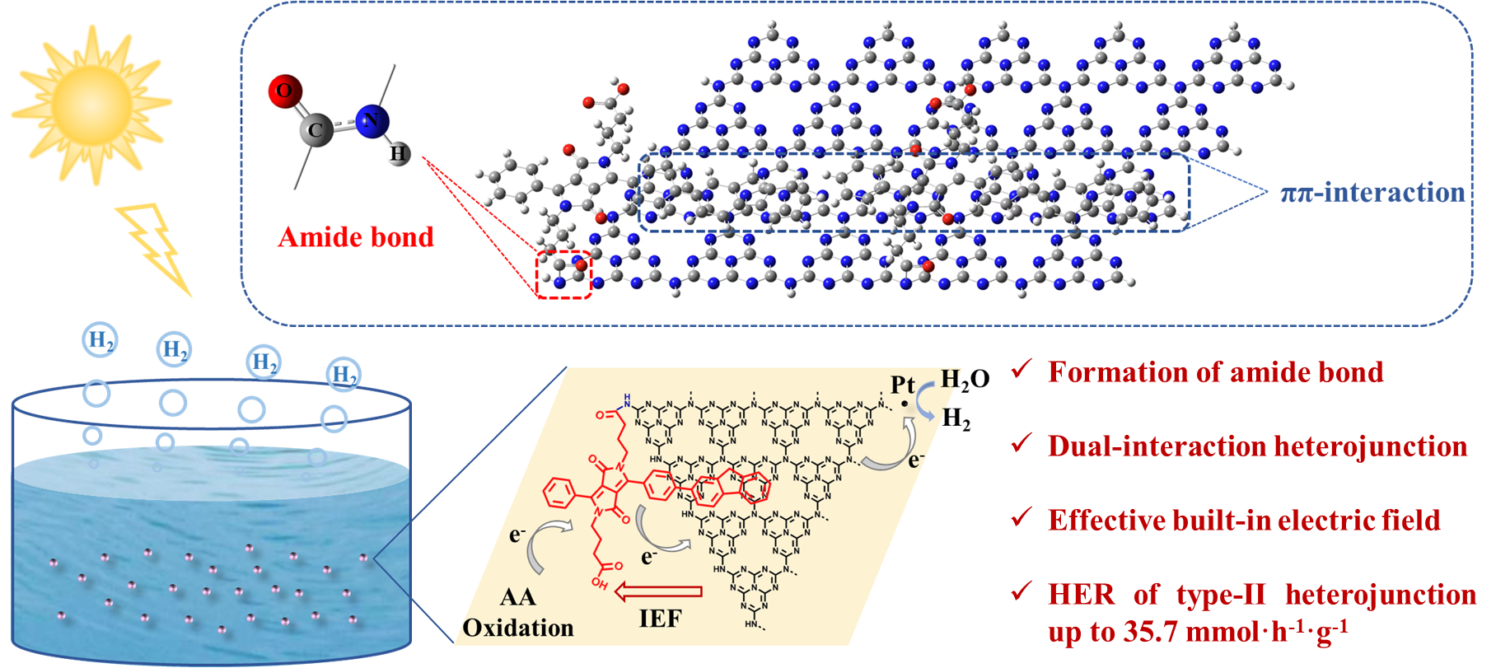
ABSTRACT
As semiconductor photocatalysts, heterojunction emerges as an attractive and promising research subject in the area of photocatalysis recently. However, insufficient interaction and unsatisfied stability are the pivotal problems that restrict photocatalytic performance. In this work, a new strategy to construct stable type Ⅱ heterojunctions by the introduction of carboxyl-functionalized Diketopyrrolopyrrole (DPP) coupled with fluorene/phenyl polymers into g-C₃N₄ was developed, affording efficient photocatalytic water-splitting hydrogen production. Assembling by π-π interaction and covalent bonding interaction, the effective internal embedded electric field (IEF) was successfully erected between DPP polymers and g-C₃N₄. Additionally, in-situ XPS spectroscopy confirmed the orientation of electron flow from polymer to g-C₃N₄ within the IEF under light illumination. Therefore, the HER up to 35.7 mmol·h⁻¹·g⁻¹ (0.89 mmol·h⁻¹, 25 mg photocatalyst) for PDWCOOH/g-C₃N₄ heterojunction was achieved with value of apparent quantum yields (AQY) at 28.2% under 550 nm. The HER of resultant heterojunctions is almost 40 times higher than the pristine g-C₃N₄, directing the design and construction of stable, efficient, and well-performed heterojunctions for photocatalysis.
INTRODUCTION
The unprecedented deterioration of environmental climate and fossil energy crisis have made it increasingly urgent to achieve carbon neutralization worldwide, altering with sustainable and renewable energies such as solar energy, wind energy, and hydrogen energy.¹ Solar energy as an inexhaustible and renewable energy has been extensively employed as source to store energy into chemicals.² More interestingly, hydrogen has been investigating as clean, renewable, harmless and carbon-free energy which can be transformed from solar energy³ and widely used in fuel cells,⁴ biomedical industry⁵ and various chemical reactions in the past decades.⁶ No matter H₂ generates either heat via combustion, or electricity by combining with oxygen in a fuel cell, water is the only by-product during those processes, making it recyclable and renewable.⁷ Therefore, photocatalytic water splitting to generate hydrogen with semiconductor-based photocatalysts under light irradiation is a straightforward strategy and an effective method. Since titanium dioxide first reported as a promising semiconductor electrode in water electrochemical photolysis in 1972,⁸ extensive researches based on inorganic semiconductor have been contributing to the development of new type photocatalysts. However, challenges in tuning and adapting of inorganic photocatalysts led to the development of molecular homogeneous systems, with the stability and efficiency of being problematic.⁹⁻¹¹
Considering the availability, diversity and performance, organic polymer semiconductor materials have attracted much attention as the alternative to those inorganic counterparts. Such photocatalysts can be constructed by earth-abundant elements with accessible and flexible process, making them cheaper and less toxic than inorganic semiconductors.¹² Wang’s group has investigated graphitic carbon nitride (g-C₃N₄) as a new class of organic photocatalysts.¹³ Owing to the simple preparation methods and high thermal stability of g-C₃N₄, further development have been devoted to the modification through morphological control,¹⁴ band structure engineering¹⁵ and heterojunction strategy,¹⁶⁻²⁰ ameliorating the drawbacks of plain visible-light capture capability (normally lower than 460 nm), strong charge recombination characteristic, and low charge mobility.²¹ Among those modifications, heterojunctions strategy has significant advantages and being of preferable. According to the band alignment of semiconductors, heterojunctions can be categorized into three classes, labelled as type Ⅰ, type Ⅱ and Z-scheme. Besides, type II heterojunctions of inorganic semiconductor/g-C₃N₄ for efficient H₂ evolution have been intensively explored.^{22,23} However, these types of heterojunctions usually contain metals, which may cause toxic metal transudation and secondary contamination during and/or after the reaction. To which end, the introduction of organic polymer semiconductors into g-C₃N₄ has emerged as an effective way to upend the status quo.
Conjugated organic polymers employed as semiconductor photocatalysts have experienced a few decades to be promoting materials, such as liner polymers,²⁴⁻²⁶ covalent triazine frameworks (CTFs),²⁷⁻²⁹ conjugated microporous polymers (CMPs)³⁰⁻³³ and conjugated organic frameworks (COFs).³⁴⁻³⁶ Compared to inorganic semiconductors, conjugated organic polymers are prone to be synthesized by various monomers and possess chemical and thermal stability as well as excellent electronic properties.^{37,38} Lately, Hua et al. designed and synthesized a series of D-A polymers/g-C₃N₄ heterojunctions to realize photocatalytic water splitting hydrogen production.^{16,39} However, vast majority of polymers/g-C₃N₄ heterojunctions were constructed through noncovalent interactions up to date, such as π-π stacking and electrostatic interactions.⁴⁰ The heterojunction engineering relies on both covalent and noncovalent interactions theoretically to be effective in strengthening the interfacial contact, albeit a scarce literature report.
As an efficient light-absorption moiety, DPP has been exploiting as privileged structural scaffolds for photocatalysts in the virtue of the strong electron-deficient and planar configuration.⁴¹⁻⁴⁵ Meanwhile, carboxyl group as the ending unit in many dye molecules were reported as the active moiety to promote the anchored and dispersed process to both TiO₂ and g-C₃N₄ system. ⁴⁶⁻⁴⁸ Given the interactions based on chelation effect or π-π stacking effect between polymers and the other semiconductor hardly beneficial to the construction of the intimate composites, a new strategy to construct dual-interacting heterojunctions with g-C₃N₄ and two D-A type conjugated organic polymers PDWCOOH/PDBCOOH with fluorene/phenyl as the electron donor and DPP containing n-butyric acid groups as the electron acceptor were was designed and implemented. A corresponding polymers PDWC/PDBC with butyl groups instead of n-butyric acid groups were synthesized for the purpose of comparison (Scheme 1). The g-C₃N₄ was selected as the other semiconductors, aiming the amide bond formation between the copious terminal amino group (-NH₂) and -COOH groups in the side chains of DPP. The resultant heterojunctions were fully characterized with FTIR, PXRD, TEM, SEM and XPS. Furthermore, XPS and FTIR spectra and data indicated the amide bond formation between the carboxyl-functionalized DPP polymers and g-C₃N₄. The photoelectrochemical properties of the heterojunctions also supported that the covalent bond and intermolecular π-π stacking interactions are benefit for charge separation and migration. Ultimately, The the performances of heterojunctions for H₂ production under visible-light irradiation (420 nm ≤ λ ≤ 780 nm) were tested conducted. It is found that the HERs of PDBC/g-C₃N₄/Pt, PDWC/g-C₃N₄/Pt, PDBCOOH/g-C₃N₄/Pt and PDWCOOH/g-C₃N₄/Pt under visible-light illumination and using ascorbic acid (AA) as sacrificial agent are 16.3, 18.4, 23.5 and 35.7 mmol·h⁻¹·g⁻¹, respectively, which are 18, 20, 26 and 40 times higher than the pristine g-C₃N₄/Pt, separately. In addition, an AQY of PDWCOOH/g-C₃N₄/Pt system reaches 28.2% at λ=550 nm. UPS, in-situ XPS experiment and spin-unrestricted density functional theory (DFT) calculations were performed to verify the mechanism. As seen shown in Figure 1, it is the first example of constructing polymer/g-C₃N₄ heterojunction through covalent amide bond and π-π interactions to facilitate photocatalytic water splitting hydrogen production, providing a new strategy to promote electron transfer characteristics of material surface in photocatalytic process.
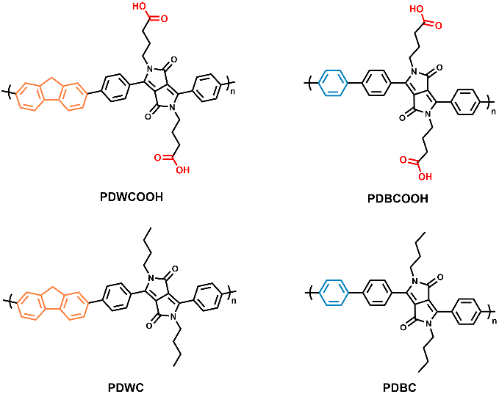
Scheme 1. The structure of PDWCOOH, PDBCOOH, PDWC and PDBC.
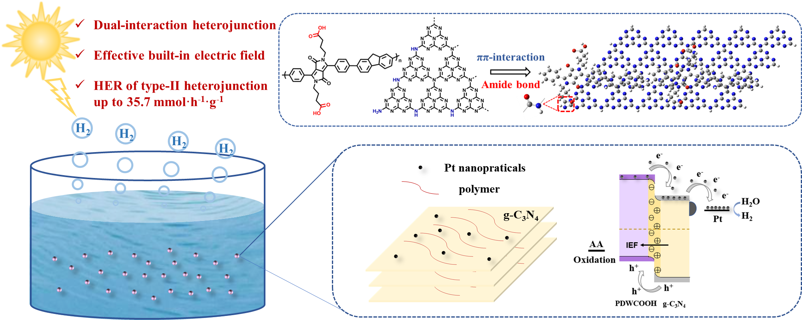
Figure 1. Diagram of PDWCOOH/g-C₃N₄ for photocatalytic water splitting.
EXPERIMENTAL SECTION
Materials and Measurements. The original compounds of 1,4-benzenediboronic acid bis (pinacol) ester and 2,7-dibromo-9H-fluorene were commercially purchased and used directly. The starting monomers DPPC4, DPPCOOH, polymers PDBC and PDBCOOH were synthesized following our previous work.³⁸ All other reagents used for synthesis were from commercial sources and used as received unless indicated otherwise. Glassware was dried in the oven at 100 °C for overnight prior to usage and all reactions were operated under argon atmosphere.
¹H spectra were measured on the Bruker AM-400 MHz. The FTIR spectra were measured on Bruker Alpha-P ATR spectrometer. Powder XRD patterns were carried out on a PANalytical X’Pert PRO MPD, using in high throughput transmission mode with Kα focusing mirror and PIXCEL 1D detector with a Cu X-ray source. DRS UV-vis absorption spectra were recorded at room temperature on a Varian Cary 500 spectrophotometer. High resolution transmission electron microscopy spectra (HRTEM) were recorded on the JEM-2100EX to obtain the sample morphologies. Scanning electron microscope (SEM) and energy dispersive spectroscopy (EDS) were carried out on Gemini SEM 500. Photoluminescence (PL) spectrum was carried out on Hitachi F-4500 fluorescence spectrophotometer at room temperature and the excitation wavelength of the PL emission spectra was 550 nm. XPS data were acquired on a Perkin-Elmer PHI 5000C ESCA system, the test condition is at 250 W (Al K α radiation). In-situ XPS was performed on Thermo Fisher Escalab 250Xi, the test condition is at 150 W (Al K α radiation) and the X-ray beam spot 500 μm. Fixed transmission energy of energy analyzer used 80 eV, full spectrum energy and fractional spectrum is 100 eV and 30 eV, respectively. All binding energies were based on the C 1s peak (284.6 eV). UPS data were tested by Thermo Fisher Escalab 250Xi with HeI (21.22 eV) as Pt.
Synthesis of Polymers. Synthesis of PDWC: 2,7-bis (4,4,5,5-tetramethyl-1,3,2-dioxaborolan-2-yl)-9H-fluorene) (418 mg, 1 mmol), and DPPC4 (558 mg, 1 mmol), tetrakis (tri-phenylphosphine) palladium (0) (11.5 mg, 0.01 mmol) and one drop of Aliquat 336 (methyltrioctylammonium chloride), employed as a phase transfer catalyst to accelerate the polymerization reaction, were dispersed in the mixture solvent of toluene (10 mL) and 2M aqueous solution of potassium carbonate (10 mL, 15 mmol) in a Schlenk tube. The Schlenk tube was quickly degassed with argon under vacuumed for three times and then heated under argon at 110 °C for 48 h. The mixture was then cooled to room temperature followed by dropping into methanol (500 mL) slowly. The precipitate was subsequently filtered and washed with the H₂O (100 mL) and methanol (100 mL) for three times. After Soxhlet extraction for 48 h with acetone to remote the oligomer and the starting materials, the resultant solid was dried in a vacuum oven, affording the pristine polymer PDWC with a yield of 50% (238 mg). ¹H NMR (400 MHz, Chloroform-d), δ 7.72−7.60 (d, 8H), 7.52 (s, 2H), 7.43−7.30 (d, 4H), 5.30 (s, 2H), 2.23 (d, 4H), 0.76−0.88 (m, 14H). GPC: Mn=6747, PDI=1.375.
Synthesis of PDWCOOH: 2,7-bis (4,4,5,5-tetramethyl-1,3,2-dioxaborolan-2-yl)-9H-fluorene) (418 mg, 1 mmol) and DPPCOOH (616 mg, 1 mmol) were used as the monomers of PDWCOOH. The synthesis procedures were as same as above. While for the workup process, concentrated HCl (30 mL) was added into the solution to adjust the pH to 2 after dropping the mixture into methanol. The resulted mixture was then stirred for 1 h at room temperature, affording solid precipitation. The solid was treated with the above-mentioned procedures. The pristine polymer PDWCOOH was obtained with a yield of 60% (250 mg). ¹H NMR (400 MHz, DMSO-d₆) δ 12.16 (s, 2H), 8.10−7.90 (d, 8H), 7.82−7.73 (s, 6H), 3.56−3.41 (m, 6H), 2.30−2.08 (m, 4H), 1.53−1.20 (m, 4H). GPC: Mn=25730, PDI=1.613.
Synthesis of g-C₃N₄. The method of graphitic carbon nitride (g-C₃N₄) preparation was adopted with reference to the reported literature.⁴⁹ 5 g of grounded urea was put in a crucible and heated under static air at 550 °C for 5 h with a ramping rate of 5 °C min⁻¹. The resultant yellow powder was collected for use without further treatment.
The g-C₃N₄ powder was then loaded with Pt nanoparticles by photodeposition.⁵⁰ 600 mg g-C₃N₄ was added into the mixed solution of H₂O (300 mL) and methanol (100 mL) by ultrasonic dispersion. After dropping 2400 μL H₂PtCl₆·6H₂O (1 g/100 mL) into the mixture with pipette gun, the well-dispersed solution was irradiated with a Xe lamp (300 W) for 5 h. Ultimately, the 1.5 wt% Pt/g-C₃N₄ composite was prepared by centrifugation, washed with H₂O (80 mL) and ethanol (80 mL) for three times and dried up under vacuum at 50 °C for 12 h.
Preparation of Polymers/g-C₃N₄ Heterojunctions Photocatalysts. All of the polymers/g-C₃N₄ was prepared by the same procedures. Taking PDWCOOH/g-C₃N₄-X (X represents the mass of polymers) for the example, X mg PDWCOOH was dissolved in the THF (50 mL) and then added 100-X mg g-C₃N₄/Pt, the resultant compound was dispersed by ultrasonification. The dispersion stirred at 45 °C in the darkness for 12 h. The even heterojunctions were constructed with planarized PDWCOOH and g-C₃N₄ through amide bond and noncovalent π-π interaction during the above process. Finally, after removing the solvent in the system and drying in the vacuum oven at 50 °C for 24 h, the light red heterojunctions photocatalysts PDWCOOH/g-C₃N₄-X (X=3, 5, 7, 9) could be used in the subsequent experiments.
Electrochemical Measurements. The electrochemical and photoelectrochemical measurements were carried on CHI650E electrochemical workstation with a traditional three-electrode system, which employed 0.2 M Na₂SO₄ as electrolyte solution, Pt wire and Ag/AgCl as counter and reference electrode, respectively. The working electrode was prepared as follows: the mixture of 5 mg samples (PDWCOOH), 15 μL Nafion (5%) aqueous solution and 50 μL deionized water were ground into slurry followed by uniformly coating onto cleaned fluorine-doped tin oxide (FTO) glass slide (1.6 cm × 1.2 cm) with an effective area of 0.25 cm² and the FTO glass were fired at 120 °C for 1 h to improve interface adhesion. Mott-Schottky plots were recorded with a scan rate of 5 mV s⁻¹. The I-t measurements were performed under the light on and off situations (300 W Xe lamp, λ > 420 nm) and the bias was 0 V versus Ag/AgCl. The electrochemical impedance spectra (EIS) measurements were executed with 10 mV as the open circuit voltage and 10²-10⁶ Hz as the frequency range.
Photocatalytic Tests and AQY Measurements. The photocatalytic performance was carried out in a closed gas circulation system (CEL-SPFLU-DFBZN) monitored with gas chromatograph (GC 2060, TCD detector and Ar) under 300 W Xe lamp (CEL-HXF 300). 25 mg polymers/g-C₃N₄ heterojunctions photocatalysts were dispersed in 50 mL deionized water containing 5 g AA as sacrificial agent for photocatalytic hydrogen evolution tests. Before the experiment, the closed gas system must be evacuated by a vacuum pump thoroughly and then the photocatalytic reactor was irradiated by a visible light source (300 W Xe lamp, 420 nm ≤ λ ≤ 780 nm) to carry out the photocatalytic tests. Furthermore, the apparent quantum yield (AQY) was estimated under monochromatic light irradiation (300 W Xe lamp, λ = 420, 450, 500, 550, 600, 630 nm) as the following formula:
$$AQY \left(\%\right)= \frac{2 ×number of evolved H2 molecules}{number of incident photons} ×100\% =\frac{2 ×C ×NA}{S ×P ×t \frac{λ}{h ×c}} ×100\%$$
where C is the amount of evolved H₂ per hour (μmol); NA is the Avogadro constant (6.022 × 10²³ mol⁻¹); S represents the irradiation area (12.56 cm²); P indicates the illumination intensity of monochromatic light (W/cm²); t is the illumination time (3600 s); λ is the wavelength of monochromatic light (nm); h is the Plank constant (6.626 ×10⁻³⁴ J·s); c is the speed of light (3 × 10⁸ m/s).
Density Functional Theory Computational Methodology. Density functional theory (DFT) was calculated with Gaussian 16 program package.⁵¹ The different molecules (PDBC, PDWC, PDBCOOH and PDWCOOH) of the frontier molecular orbitals were optimized without symmetry constrains at the B3LYP^{52,53} level, and the 6-31G* basis set⁵⁴ for C, H, N and O atoms.
Notably, the work function often needed to be considered in the calculation of Pt₁₃ cluster supported on g-C₃N₄ (Pt₁₃/g-C₃N₄) and PDWCOOH systems, and the larger the work function of the catalytic materials, the more difficult it is to donor electrons. So, the Vienna Ab-initio Simulation Package (VASP)⁵⁵ for the calculation of the work function of g-C₃N₄ and PDWCOOH systems was used. In the calculations, the spin-polarized projector augmented wave (PAW) methods⁵⁶ were applied together with the Perdew-Burke-Ernzerhof (PBE)⁵⁷ electron exchange correlation functional of the generalized gradient approximation (GGA).⁵⁸ The energy cut-off of the wave function in the plane-wave basis was set to 400 eV, the calculations were implemented until the maximum force upon each relaxed atom was less than 0.05 eV Å⁻¹. In order to study the work function of the PDWCOOH adsorbed on Pt₁₃/g-C₃N₄ surfaces, the following models: a 5 × 2 unit of monolayer g-C₃N₄ loaded with Pt₁₃ clusters and also with NH₂ group, and all atoms were allowed to relax were used. The Brillouin-zone integration was performed along with a 1 × 1 × 1 Monkhorst-Pack grid for the different surface slabs, and the vacuum height was set to 15 Å to eliminate the interaction between neighboring slabs. In addition, the different molecules (PDBC, PDWC, PDBCOOH and PDWCOOH) adsorption energies (E_{ads}) on g-C₃N₄ Pt₁₃/g-C₃N₄ sites were calculated as below,
E_{ads} = E_{total} – E_{Pt13/g-C3N4} – E_{molecule}
where E_{total} is the calculated total energy of the adsorption system, E_{Pt13/g-C3N4} is the calculated energy of the substrate, and E_{molecule} is the calculated energy of the gas-phase molecule.

Calculation of Built-in Electric Field Magnitude. The magnitudes of built-in electric field for the materials were calculated by using the following equation developed by Kanata et al.⁵⁹
F_{s} = (-2V_{s}ρ/εε₀)^{1/2}
Where F_{s} is the internal electric field magnitude, V_{s} is the surface potential, ρ is the surface charge density, ε is the low-frequency dielectric constant, and ε₀ is the vacuum dielectric constant. Obviously, the built-in electric field magnitude is mainly determined by the surface voltage and the surface charge density since ε and ε₀ are two constants.
In this paper, open circuit potential⁶⁰ and zeta potential⁶¹ tests were adopted to characterize surface voltage and surface charge density. If the value of IEF of is normalized as 1.0, then the relative values for PDWC/g-C₃N₄, PDBCOOH/g-C₃N₄ and PDWCOOH/g-C₃N₄ is are 1.05, 2.38 and 3.70, respectively.
RESULTS AND DISCUSSION
Synthesis. In order to elucidate how the structure of polymers within a heterojunction system could impact on the photocatalytic hydrogen production performance, the designed carboxyl functionalized diketopyrrolopyrrole-based polymers PDWCOOH/PDBCOOH and PDWC/PDBC without -COOH were synthesized through Suzuki-Miyaura coupling reaction using dibromo arenes and diboronic ester arenes as monomers. The details of synthesis can be seen in both experimental section and the supplementary information (Figure S1). and the obtained polymers were fully characterized, including ¹H NMR and FTIR spectroscopy.
It has been evidenced that the polymers/g-C₃N₄ was successfully constructed via π-π stacking force upon the polymers and g-C₃N₄ dispersed into THF, so were the amide bond formation among carboxyl groups in the polymers and the amino groups in g-C₃N₄. Thus, FTIR and PXRD identified the structure of g-C₃N₄ and polymers/g-C₃N₄, and the morphology and electronic structure were confirmed by HRTEM, SEM, EDS and XPS, respectively. Whilst Pt nanoparticles were loaded on g-C₃N₄ evenly by photodeposition to further enhance photocatalytic hydrogen production activity. The distribution of elements C, N, O and Pt in heterojunctions were displayed by EDS element mapping.
Structure and Morphology Characterization. The chemical structures of as-prepared polymers (PDBC, PDWC, PDBCOOH and PDWCOOH) were characterized by FTIR spectroscopy (Figure 2a). The sharp peaks at around 1670 cm⁻¹ and 1085 cm⁻¹ ascribed to C=O and C-N stretching vibrations, respectively, suggesting the existence of DPP core. Moreover, the stretching vibration of aromatic ring C=C at 1600 cm⁻¹ and bending vibration of C-H at 810 cm⁻¹ verified the existence of phenyl in polymers structure. The C-H stretching vibration can be seen at around 2800-3000 cm⁻¹. Notably, the new signals of 1706 cm⁻¹ and 1704 cm⁻¹ presumably belonged to the stretching vibration of carboxylate carbonyl in PDBCOOH and PDWCOOH, respectively. Compared to PDBC and PDWC, the broad peak at the wide range of 3000-3500 cm⁻¹ observed in PDBCOOH and PDWCOOH, attributing to the stretching vibration of O-H in carboxyl. As shown in Figure 2b, there are obvious difference in the FTIR spectroscopy of pristine g-C₃N₄ and heterojunctions. Thus, the N-H and O-H stretching vibrations at 3050-3350 cm⁻¹, C-N heterocycles stretching modes at 1240 cm⁻¹ to 1730 cm⁻¹ and heptazine rings bending vibrations at 800 cm⁻¹ evidenced the presence of g-C₃N₄ together with its’ typical structure. The C-H stretching peak of 2963 cm⁻¹ existing in heterojunctions but not in pristine g-C₃N₄ illustrated that the characteristic peak still can be displayed in the newly formed composites. It is noteworthy that the C-N stretching vibrations of PDBCOOH/g-C₃N₄ and PDWCOOH/g-C₃N₄ manifest shift to lower wavenumber in contrast to pristine g-C₃N₄, indicating the formation of polymers/g-C₃N₄ heterojunctions presumably due to the new amide bond between -COOH in polymers and terminal -NH₂ in g-C₃N₄ during chemical adsorption process. By contrast, a physical mixture of PDWCOOH and g-C₃N₄ by grinding at room temperature denied the formation of amide bond for the same reactants by a shoulder peak attributed to C=O of carboxyl group at 1704 cm⁻¹ in the FTIR spectrum (Figure S2). Whilst the same peak of C=O disappeared in PDWCOOH/g-C₃N₄ composite. Furthermore, the control experiment between modified DPP containing -COOH group and heptazine with terminal -NH₂ group was carried out under the same reaction condition, resulting similar newly-formed amide bond containing compound as expected (Figure S3). Thus, the new peak at 1770 cm⁻¹ of DPP-COOH/heptazine composite distinguished from the existed carboxylic carbonyl at 1704 cm⁻¹ of DPP-COOH probably should be the amide bond signal between DPP moiety and heptazine. These two results supported a successful formation of the amide bond in heterojunctions.
An insight to the possible transformation of structure among polymers, g-C₃N₄ and polymers/g-C₃N₄ was then attempted by the implement of PXRD spectroscopy. First, all of the materials based on g-C₃N₄ showed two different peaks at 13.0° and 27.4°. The weak peak at 13.0° represented an in-planar repeat period, and the strong peak at 27.4° was due to the stacking structure of conjugate aromatic system (Figure 2c).⁶³ Amorphous morphology was observed for all resultant polymers with no obvious diffraction peak in the spectra (Figure S4). Furthermore, no diffraction peak could probably also attribute to the low loading content of polymers in heterojunctions, indicating a remained intact basic structure of g-C₃N₄ in resultant heterojunction materials.
The surface morphology and structure of PDWCOOH/g-C₃N₄ were revealed by TEM and SEM. As shown in Figure 2d, g-C₃N₄ exhibited a lamellar structure and the layered structure can be clearly observed at its edge. While the single polymer PDWCOOH shows showed the tiny particles and amorphous structure in (Figure 2e). For the heterojunction PDWCOOH/g-C₃N₄, the samples represented the large-scale sheet structure similar to pristine g-C₃N₄ with the polymers attached to the surface of g-C₃N₄ (the slightly dark area), providing the good adhesion between PDWCOOH and g-C₃N₄ (Figure 2f). Figure 2g displayed the SEM and EDX images of PDWCOOH/g-C₃N₄ heterojunction. The corresponding mapping images compared to pristine polymer and g-C₃N₄ (Figure S5) showed the uniform distribution of C, N, O and Pt within heterojunction, proving the homogeneous distribution of PDWCOOH on g-C₃N₄. As evidenced by the above characterizations, the desired heterojunctions were confidently synthesized with good stability, apparently not only due to the Van der Waals interaction (π-π stacking) but also to covalent amide bond between -COOH in polymers and -NH₂ in g-C₃N₄. More interestingly, the covalent amide bond could facilitate the formation of inseparable heterojunctions to shorten the distance between two components of interfaces with π-π stacking interactions, accelerating the efficient electron separation and migration. This could be the echo to the promoted photocatalytic hydrogen evolution activity as discussed in the following sections.
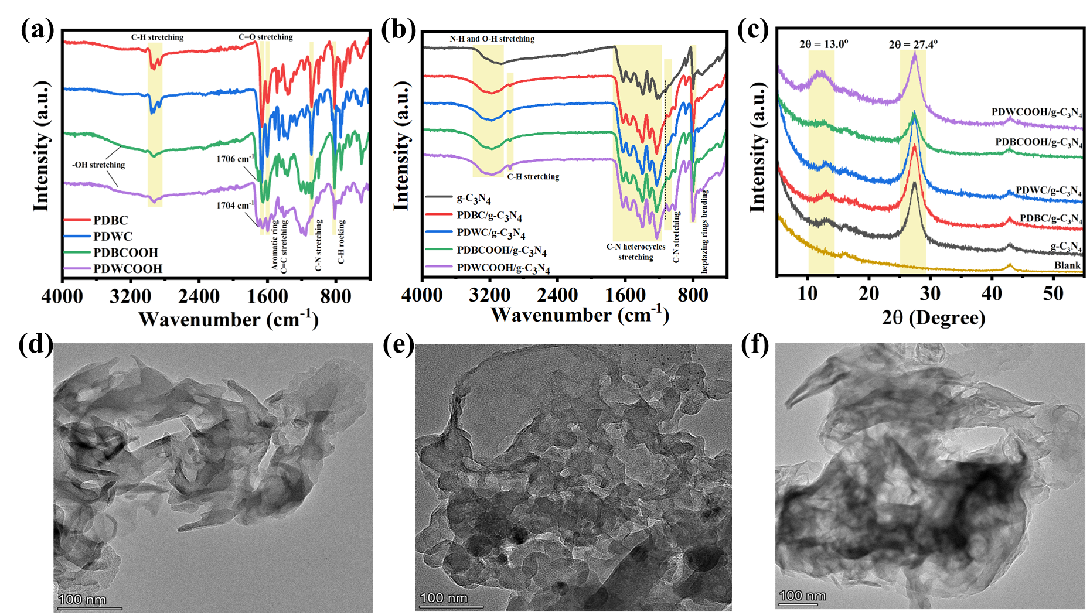
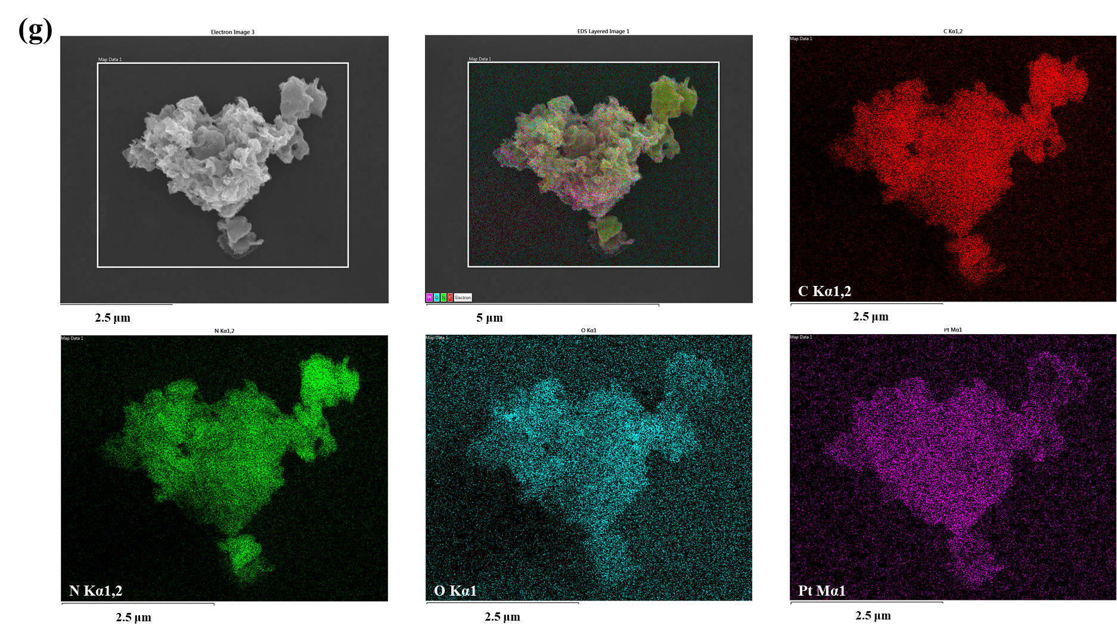
Figure 2. (a) FTIR spectra of the PDBC, PDWC, PDBCOOH and PDWCOOH polymers. (b) FTIR spectra of the as-prepared pristine g-C₃N₄, PDBC/g-C₃N₄, PDWC/g-C₃N₄, PDBCOOH/g-C₃N₄, and PDWCOOH/g-C₃N₄ heterojunctions. (c) Powder XRD patterns of the g-C₃N₄, PDBC/g-C₃N₄, PDWC/g-C₃N₄, PDBCOOH/g-C₃N₄, and PDWCOOH/g-C₃N₄ heterojunctions. (d) TEM image of g-C₃N₄. (e) TEM image of PDWCOOH. (f) TEM image of PDWCOOH/g-C₃N₄ heterojunction, scale bar: 100 nm. (g) SEM-EDX images of PDWCOOH/g-C₃N₄ heterojunctions.
Photoelectrochemical Properties. The optical properties of materials characterized by UV-vis diffuse reflectance spectra (DRS) were shown in Figure 3a. All of the four polymers exhibited strong and wide visible-light absorption peaks from 300 nm to 600 nm. The spectra of PDWCOOH had a red shift and broadening of the absorption spectra compared to the others (PDBC, PDWC and PDBCOOH), mainly due to the enhancement of electron donating ability of donors in the backbone of polymers. The same phenomenon was reported in the previous works referring to polymers with strong donor units.¹⁶ With copolymerizing fluorene as donor into the polymer, PDWCOOH and PDWC own displayed stronger intramolecular charge transfer (ICT) effect than PDBCOOH and PDBC, respectively albeit the narrow visible-light response range for pristine g-C₃N₄. In fact, four heterojunctions possessed excellent visible-light capturing capability. As seen in Figure 3b, the maximum absorption wavelength of PDBC/g-C₃N₄, PDWC/g-C₃N₄, PDBCOOH/g-C₃N₄ and PDWCOOH/g-C₃N₄ heterojunctions shifted positively to 550 nm. With that, the optical gap (Eg) values calculated from Tauc plots of: (αhv)^{1/2} = A (hv - Eg) were 1.94 eV for PDBC, 1.93 eV for PDWC, 1.88 eV for PDBCOOH and 1.85 eV for PDWCOOH, respectively (Figure 3c).
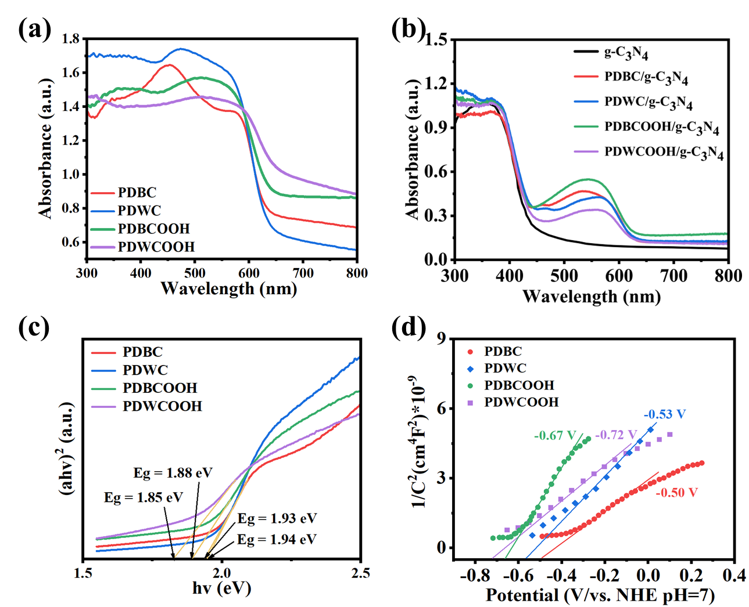
Figure 3. (a) UV-vis diffuse reflectance spectra of PDBC, PDWC, PDBCOOH and PDWCOOH. (b) UV-vis diffuse reflectance spectra of g-C₃N₄, PDBC/g-C₃N₄, PDWC/g-C₃N₄, PDBCOOH/g-C₃N₄ and PDWCOOH/g-C₃N₄ heterojunctions. (c) Tauc plots of PDBC, PDWC, PDBCOOH and PDWCOOH. (d) Mott-Schottky plots of PDBC, PDWC, PDBCOOH and PDWCOOH.
The conduction band edge of polymers can be obtained by the Mott-Schottky analysis. As shown in Figure 3d, three samples featured positive slope, disclosing n-type semiconductor materials for all four polymers. According to the literature, the CB potentials of n-type semiconductor is 0.2 V over than flat-band potentials and the value of φ⁰ (SCE) is around 0.24 V vs. NHE. The polymers’ CB potentials vs. NHE (pH = 7) can be estimated by the following formula: E_{CB} (NHE, pH = 7) = E_{FB} (SCE, pH = 7) + 0.24 – 0.2.⁶⁴ Consequently, the CB potentials of PDBC, PDWC, PDBCOOH and PDWCOOH were -0.50 V, -0.53 V, -0.67 V and -0.72 V (NHE, pH = 7), separately. The valance band (VB) potentials as calculated by formula (E_{VB} = E_{CB} + E_{g}), where E_{CB} and E_{g} were measured by Mott-Schottky curves and Tauc plots, were 1.44 V for PDBC, 1.40 V for PDWC, 1.21 V for PDBCOOH and 1.13 V for PDWCOOH, separately. Based on that, the HOMO energy level of PDWCOOH and PDBCOOH were slightly higher than those of other two polymers and the band gaps decreased as well. The introduction of strong donor unit fluorene also caused much more bathochromic-shift for PDWCOOH. Concurrently, ultraviolet photoelectron spectroscopy (UPS) also illustrated the relation among the width of the spectrum, sample work function Φ and photon energy hv. The spectrum width was determined by the distance between the sample inelastic cutoff and the Fermi edge⁶⁵ (Figure 4a, b). The incident photon energy (hv) was 21.22 eV, and Φ = hv - (E_{cutoff} - E_{f}), where E_{cutoff} - E_{f} was the maximum binding energy. The E_{cutoff} - E_{f} of PDWCOOH and g-C₃N₄/Pt was 16.0 and 17.0 eV, respectively. Therefore, the work function (Φ) of PDWCOOH and g-C₃N₄/Pt was 5.22 and 4.22 eV, separately. The binding energy of electrons at the valence band maximum was 0.67 and 2.0 eV for PDWCOOH and g-C₃N₄/Pt. Therefore, the VB of PDWCOOH and g-C₃N₄/Pt was 5.89 and 6.22 eV (vs. vacuum), respectively. Due to the vacuum energy level of NHE at 4.5 eV, it is apparent that the VB of PDWCOOH and g-C₃N₄/Pt was 1.39 and 1.70 eV vs. NHE, which is approximately the same as the results of test. Notably, the energy level alignments of the four polymers are were at the higher position than that of g-C₃N₄. On account of the above experimental and characterized results (Figure 4c), once again, we conjectured that the heterojunction structure was successfully formed between polymers and g-C₃N₄ based on the band alignment.
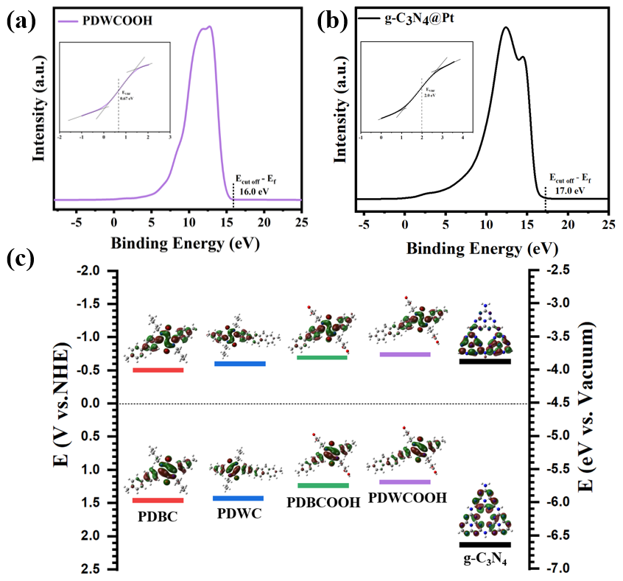
Figure 4. Ultraviolet photoelectron spectroscopy of (a) PDWCOOH and (b) g-C₃N₄. (c) Energy level of PDBC, PDWC, PDBCOOH, PDWCOOH and g-C₃N₄ (HOMO and LUMO electron distributions are from theoretical calculation).
Photocatalytic Performance and Stability. Based on the outstanding light absorption and proper band structure, the investigation of the photocatalytic activity for all resultant heterojunctions was conducted by using AA as electron sacrificial agent and 300 W Xe lamp (420 nm ≤ λ ≤ 780 nm) as light source. Firstly, the photocatalytic hydrogen evolution rate of four pristine polymers (PDBC, PDWC, PDBCOOH and PDWCOOH) was examined. Thus, the HER of PDBC, PDWC, PDBCOOH and PDWCOOH were 127.5 μmol·h⁻¹·g⁻¹, 165.6 μmol·h⁻¹·g⁻¹and 330.4 μmol·h⁻¹·g⁻¹ and 343.2 μmol·h⁻¹·g⁻¹, respectively (Figure 5a). The activity of both PDWCOOH and PDBCOOH were more than twice as those for PDWC and PDBC. This may be the contribution from the hydrogen bond formed between the oxygen atom of carboxylic acid group in PDWCOOH and PDBCOOH and water molecular, which can increase the hydrophilicity of polymer and subsequently accelerate the hydrogen evolution rate. This phenomenon also exists in other polymer employing O atom in polymers.⁶⁶ While PDWCOOH revealed further performance improvement in contrast to PDBCOOH, probably attributing to the broadened absorption spectrum of polymer with the introduction of fluorene as strong donor unit. The HER of pristine g-C₃N₄ with visible-light illumination was tested under the same reaction conditions, only presenting 0.9 mmol·h⁻¹·g⁻¹. Considering the proper band alignment of polymers and g-C₃N₄, this new construction strategy for heterojunction apparently facilitated the HER for their photocatalytic performance, mainly attributing to the improvement of the charge separation and migration ability.
Subsequently, the relationship between proportions of polymers in PDWCOOH/g-C₃N₄ heterojunction and HER was explored. As seen in Figure 5b, the HER of the heterojunctions experienced a moderate rise and peak at 7 wt% loading amounts, followed by a slight decline when the proportion of polymers increase to 9 wt%, which demonstrated a volcanic curve. The decrease of photocatalytic activity probably due to the active sites on g-C₃N₄ hindered by excess polymers.
As shown in Figure 5c, the activity of polymers/g-C₃N₄ heterojunctions were obviously higher than both g-C₃N₄ and pure pristine polymers, representing advantageous and beneficial of heterojunctions with broadened light absorption range, accelerated charge separation, and promoted photocatalytic hydrogen generation activity. Among the four samples, PDBC/g-C₃N₄ and PDWC/g-C₃N₄ showed slight improvement, whose HER of 16.3 mmol·h⁻¹·g⁻¹ and 18.4 mmol·h⁻¹·g⁻¹ were 18 and 20 times higher than pristine g-C₃N₄. HER of PDBCOOH/g-C₃N₄ approached to 23.5 mmol·h⁻¹·g⁻¹ (26 times of pristine g-C₃N₄). After replacing benzene with fluorene as a stronger donor, PDWCOOH/g-C₃N₄ heterojunction exhibited the highest HER of 35.7 mmol·h⁻¹·g⁻¹ which is 40 times of pristine g-C₃N₄. This could be the contribution from the strong light absorption ability and charge transfer efficiency caused by π-π stacking and amide bond. Therefore, we speculated that the dual-interaction between PDWCOOH and g-C₃N₄ collaboratively facilitated the HER performance of the resultant heterojunctions. Comparing with PDWC/g-C₃N₄ and PDBCOOH/g-C₃N₄, the single interaction of both amide bond and π-π stacking was not as effective as the dual-interaction. In the absence of light, sacrificial agent AA or photocatalyst, no hydrogen generation was detected, indicating that this system necessitated illumination and photocatalyst to promote the photocatalytic reaction and sacrificial agent consuming holes to inhibit charge recombination (Figure 5d). Moreover, the stability of photocatalysts was confirmed by the long-term experiments about 16 h and each period was for 4 h. It can be seen from Figure 5e that the stable hydrogen evolution rates of the heterojunctions almost remained during each period of four hours, evidencing the good photocatalytic stability for hydrogen production. The relationship between photocatalytic activity and the wavelength of light was demonstrated by AQY experiment using various monochromatic light irradiations (λ= 420, 450, 500, 550, 600 and 630 nm) with a 10 % filter. As shown in Figure 5f, the wavelength-dependent AQY values show showed that the hydrogen production process was photocatalytic reaction and the maximum AQY for PDWCOOH/g-C₃N₄ is 28.2% at 550 nm, being consistent with the maximum absorption peak value. For the comparison, the HER of PDWCOOH and g-C₃N₄ physical mixture was also tested. The results in Figure S6 showed that the HER of physical mixture was 0.36 mmol·h⁻¹·g⁻¹, even lower than pristine g-C₃N₄, possibly due to the limited absorption of g-C₃N₄ with the addition of polymer. Furthermore, the post characterizations of heterojunctions after photocatalytic reaction were carried out by FT-IR, PXRD, XPS and DRS spectroscopy (Figure S7-10). Thus, there were no obvious changes for the heterojunctions in FT-IR spectra after being used for 16 h, indicating retained functional groups of materials and structures after four cycles. PXRD patterns showed that the consistence of the heterojunction structures before and after photocatalytic reactions. XPS analysis proved the non-distinctly change of chemical states of elements in PDWCOOH/g-C3N4 after photocatalytic test. Whilst the DRS spectra of four materials demonstrate a similar tendency between the before- and after-photocatalysis curves, suggesting an unchanged light absorption capability. All these data confirmed the distinguished photostability of these designed heterojunctions.
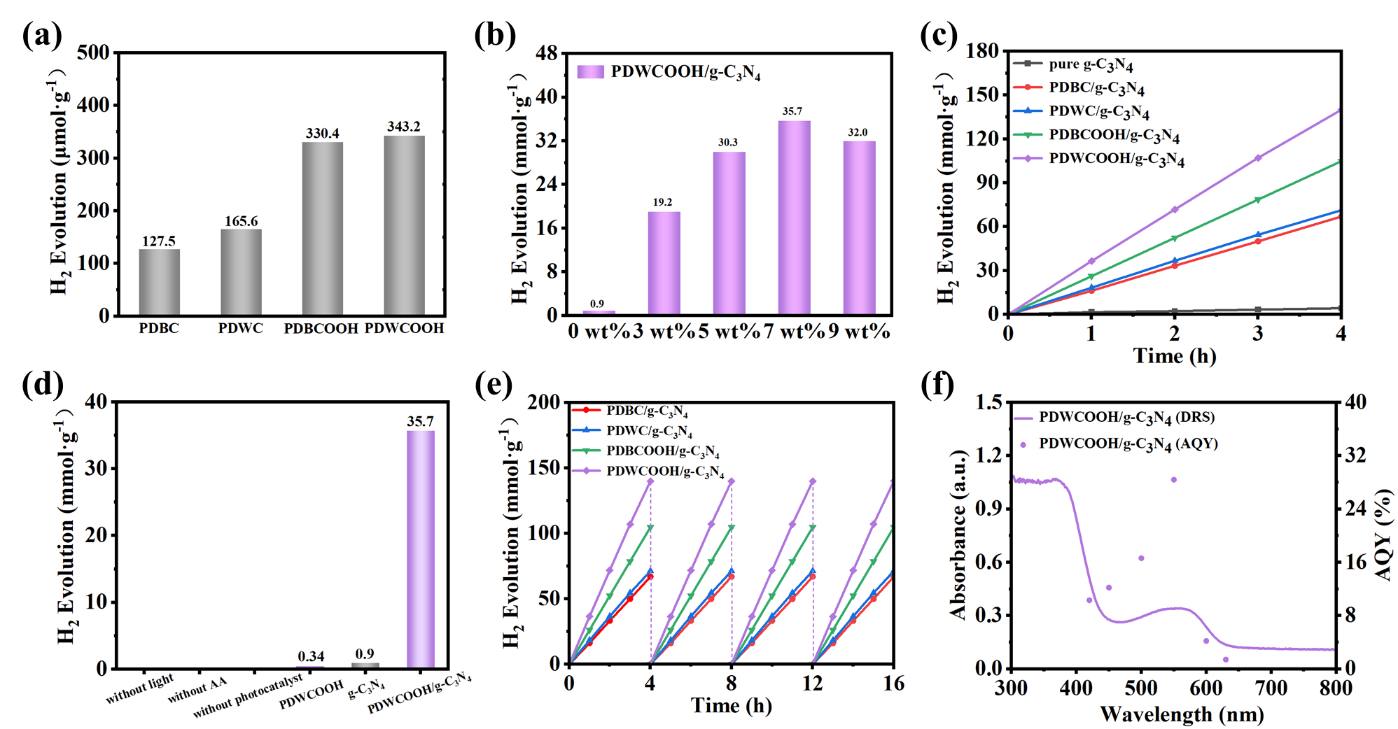
Figure 5. (a) Photocatalytic H₂ evolution rates of pristine polymers PDBC, PDWC, PDBCOOH and PDWCOOH. (b) Photocatalytic H₂ evolution rates of PDWCOOH/g-C₃N₄-X (X=3, 5, 7, 9). (c) Time-dependent photocatalytic hydrogen evolution over g-C₃N₄, PDBC/g-C₃N₄, PDWC/g-C₃N₄, PDBCOOH/g-C₃N₄, and PDWCOOH/g-C₃N₄ heterojunctions. (d) Photocatalytic H₂ evolution rates for different conditions. (e) Photostability for H₂ production of the PDBC/g-C₃N₄, PDWC/g-C₃N₄, PDBCOOH/g-C₃N₄, and PDWCOOH/g-C₃N₄ heterojunctions. (f) Wavelength-dependent AQY and DRS spectra of PDWCOOH/g-C₃N₄ (λ = 420, 450, 500, 550, 600 and 630 nm). Reaction conditions: 50 mL deionized water, 25 mg photocatalyst, 5 g AA under visible-light (420 nm ≤ λ ≤ 780 nm).
Photoluminescence (PL) spectroscopy, transient photocurrent responses (I-t) and electrochemical impedance spectra (EIS) were employed to reveal the internal charge transfer dynamics of the resultant heterojunction materials. Fluorescence quenching effect was related to the recombination of photoexcited electrons and holes inside the photocatalysts. Lower fluorescence intensity indicated higher charge separation efficiency. Therefore, the broad peak exists from 550 nm to 650 nm in the PL spectra of polymers and polymers/g-C₃N₄, could contributed to the recombination of electrons and holes (Figure 6a). Simultaneously, polymers/g-C₃N₄ heterojunctions displayed much more significant quenching effect than the pristine polymers, revealing t effectively inhibited recombination of electrons and holes by the construction of heterojunctions between polymers and g-C₃N₄, so were the promotion of photocatalytic efficiency. Among those heterojunctions, PDWCOOH/g-C₃N₄ exhibited the lowest PL spectra intensity, echoing to the most effective inhibition of charge recombination. This could also be the reason for the best and highest HER achieved with PDWCOOH/g-C₃N₄.
According to the I-t experimental data of polymers/g-C₃N₄ materials (Figure 6b). PDBCOOH/g-C₃N₄ and PDWCOOH/g-C₃N₄ exhibited much higher current density than PDBC/g-C₃N₄ and PDWC/g-C₃N₄ under light illumination, supporting the amide bond formation with its’ beneficial for charge separation and migration. The highest current density was obtained for PDWCOOH/g-C₃N₄ at ~7.8 μA·cm⁻², advantageously generating large amount of electron for the reduction of H⁺ to release H₂. Moreover, EIS spectra can be used to verify the transfer rate of electron. As expected, polymers/g-C₃N₄ manifested lower impedance than pristine g-C₃N₄ (Figure 6c). It is proved that PDWCOOH/g-C₃N₄ with lower PL spectra intensity and EIS data and higher current density possessed the highest photocatalytic hydrogen evolution activity. Consequently, the formation of amide bond and the broadening of its absorption spectrum could greatly promote the separation and transfer of photogenerated charges, being consistent with the experimental observations and results.
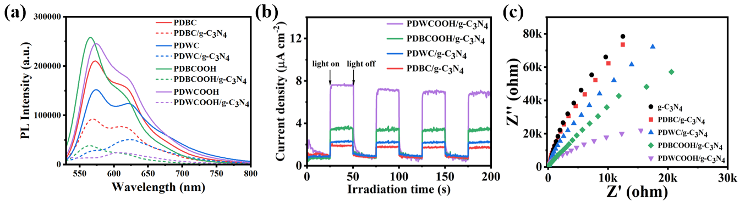
Figure 6. (a) Photoluminescence (PL) spectra of the PDBC, PDWC, PDBCOOH, and PDWCOOH in tetrahydrofuran solution and the fluorescence quenching function of g-C₃N₄. (b) Transient current responses to full time and on-off cycles photocurrent of illumination on PDBC/g-C₃N₄, PDWC/g-C₃N₄, PDBCOOH/g-C₃N₄ and PDWCOOH/g-C₃N₄ membrane electrodes, respectively (-0.2 V bias). (c) EIS Nyquist plots of g-C₃N₄, PDBC /g-C₃N₄, PDWC/g-C₃N₄, PDBCOOH /g-C₃N₄ and PDWCOOH/g-C₃N₄ heterojunctions at open circuit voltage.
Possible Photocatalytic Mechanism. With the heterojunction structure and the band position on hand, the interfacial electron transfer mechanism between polymers and g-C₃N₄ was investigated subsequently. XPS is a common and practical method to illustrate the route of electron diffusion based on the binding energy of electrons inside the atoms for various elements. Exemplified by PDWCOOH/g-C₃N₄, XPS measurements were performed on PDWCOOH, g-C₃N₄ and PDWCOOH/g-C₃N₄ with or without light illumination. Figure 7a showed the survey of the materials includes carbon (C), nitrogen (N) and oxygen (O) for g-C₃N₄, PDWCOOH and PDWCOOH/g-C₃N₄. The signal of platinum (Pt) can be detected from PDWCOOH/g-C₃N₄ heterojunction owing to the deposition of Pt particle. It should be aware that the peaks of silicon (Si) observed in the spectra of sample because of usage of Si-based materials as background.⁶⁷ Thus three peaks in the XPS spectra of C 1s (Figure 7b), were attributed to C=C, C-NH_{x} and N-C=N of g-C₃N₄ and their binding energy were 284.8 eV, 286.4 eV and 288.1 eV, respectively.⁶³ For the polymer PDWCOOH, the peaks of 284.8 eV, 286.5 eV, 287.6 eV and 289.0 eV belonged to C=C, O=C-N, C=O and O=C-O, severally.⁶⁸ The obvious peak at 292.6 eV could be attributed to π-π* satellite. Extended delocalized electrons in the sample containing aromatic rings could result in satellite structure, and binding energies of the main peaks shifting to higher values. When combining PDWCOOH with g-C₃N₄, all the characteristic peaks displayed in the heterojunction. Meanwhile, the peak of O=C-O diminished and C=O peak shifted to lower binding energy due to the formation of amide bond between carboxyl group and amino group. In the XPS spectra of O 1s (Figure 7c), the oxygen peaks of 530.6 eV and 532.3 eV were two chemical states of carbonyl oxygen and ester oxygen. However, the construction of heterojunction declined the binding energy of C=O presumably owing to the increase in the density of the electron cloud around the C atom in the side chain of the polymer, and the peak for O 1s of hydroxyl in carboxyl disappeared. These two phenomena combining with the change in C 1s spectra indicated again the formation of amide bond in the interface between PDWCOOH and g-C₃N₄. The weak peak of 532.7 eV in the O 1s spectra of g-C₃N₄ probably could be attributed to the CO₂ and H₂O absorbed on the surface. As seen shown in Figure 7d, the binding energy of N 1s for g-C₃N₄ can be fitted into three four main peaks at 400.4 eV, 401.9 eV, 403.0 eV and 405.8 eV, corresponding to C=N-C (sp²-hybridized nitrogen), N-(C)₃ (tertiary N bonded to carbon atoms), N-H (sp³-hybridized amine functions) and π excitations, respectively.³⁹ The peaks at 399.7 eV of PDWCOOH could be attributed to N-C=O. Nevertheless, the binding energy of both C=N-C and N-(C)₃ considerably increased after combining PDWCOOH with g-C₃N₄, the reason could be the lowered electron cloud density of N in g-C₃N₄.⁵⁰ According to the above XPS data, the intermolecular π-π stacking and amide bond interaction throughout the interface of heterojunction components dominantly ensured the electron diffusion from g-C₃N₄ to PDWCOOH in dark. It is the further approval for the successful of preparation of desired PDWCOOH/g-C₃N₄ heterojunction, preserving the structure of g-C₃N₄ along with all the above characterizations (FTIR, PXRD, TEM, SEM and XPS). More detailed XPS data of PDBC, PDWC and PDBCOOH can be found in Figure S11.
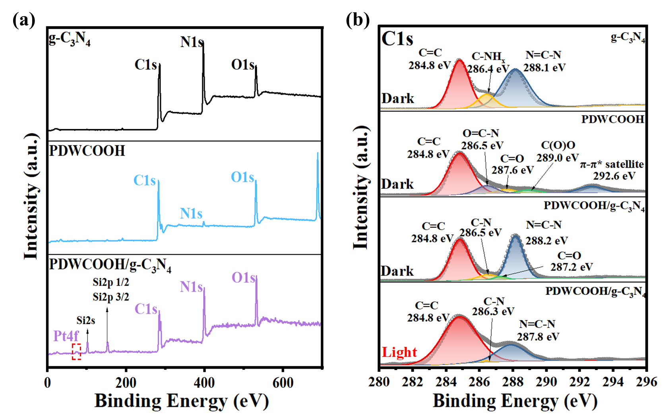
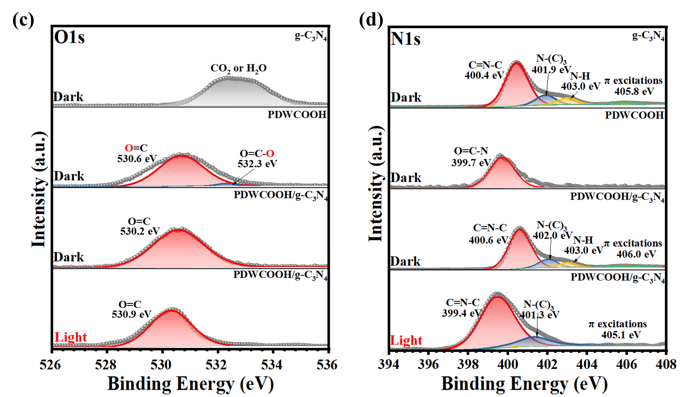
Figure 7. High-resolution XPS spectra of g-C₃N₄, PDWCOOH, PDWCOOH/g-C₃N₄ heterojunctions in the dark or with light illumination: (a) survey. (b-d) High resolution XPS spectra of the C 1s, O 1s and N 1s regions for g-C₃N₄, PDWCOOH, PDWCOOH/g-C₃N₄. The ratio of polymer in the composite photocatalysts for XPS measurement: 7 mg polymer, 100 mg photocatalysts.
It is noteworthy that the C1s and N1s signals of PDWCOOH/g-C₃N₄ have shifted oppositely before and after light illumination. For example, the C1s of N=C-N for g-C₃N₄ moved to higher binding energy when heterojunction was in the dark, while that of heterojunctions happened to be much lower under light. The O1s of O=C for PDWCOOH also displayed an opposite change in dark vs. light condition. The results implied that the photogenerated electron transferred from PDWCOOH to g-C₃N₄ under light illumination, following the type Ⅱ transfer pathway. This also confirmed mutually by the UPS measurement test of work function for PDWCOOH and g-C₃N₄. As the work function of PDWCOOH and g-C₃N₄ were 5.22 and 4.22 eV as mentioned above, the Fermi energy of g-C₃N₄ was higher than that of PDWCOOH. These data were also assessed by theoretical simulation (Figure S12). Therefore, when g-C₃N₄ contacting with PDWCOOH, the electrons spontaneously migrate from g-C₃N₄ to PDWCOOH until the E_{f} levels of two components reach thermodynamic equilibrium approached (Figure 8a). Then the built-in electric field could be established and the electrons were gathered around polymer region and the holes were congregated around g-C₃N₄ region. Briefly, the relative IEF intensity was measured by multiplying the value of the open circuit potential (vs. NHE) and zeta potential of each photocatalyst. As shown in Figure S13, the IEF of PDWCOOH/g-C₃N₄ showed the highest value among all of the heterojunctions on condition of normalizing the IEF of PDBC/g-C₃N₄ to 1.0, which was 3.70 times higher than PDBC/g-C₃N₄. For this reason, PDWCOOH/g-C₃N₄ presented rather higher photocatalytic HER owing to the intimate contact and high degree of charge separation.
Accordingly, when heterojunction photocatalysts were under illumination (λ ≥ 420 nm), both PDWCOOH and g-C₃N₄ absorbed photons and then produced photogenerated excitons followed by separating into electrons and holes. In other words, the photogenerated electrons gathered around g-C₃N₄ through π-π interaction and amide bond by the embedded electric field. Consequently, the electrons transited to Pt nanoparticles in the reduction reaction to produce H₂. Simultaneously, the holes were preserved in PDWCOOH and then captured by sacrificial agent ascorbic acid (AA) in order to regenerate PDWCOOH. The construction of the tight heterojunction was conducive to the separation of photogenerated electrons and holes spatially as well as migration to both ends through π-π interaction and amide bond. Efficient photogenerated charge separation and transfer could promote the proton reduction reaction, and further improve the activity of the photocatalyst. The possible photocatalytic hydrogen production progress was displayed in Figure 8b.
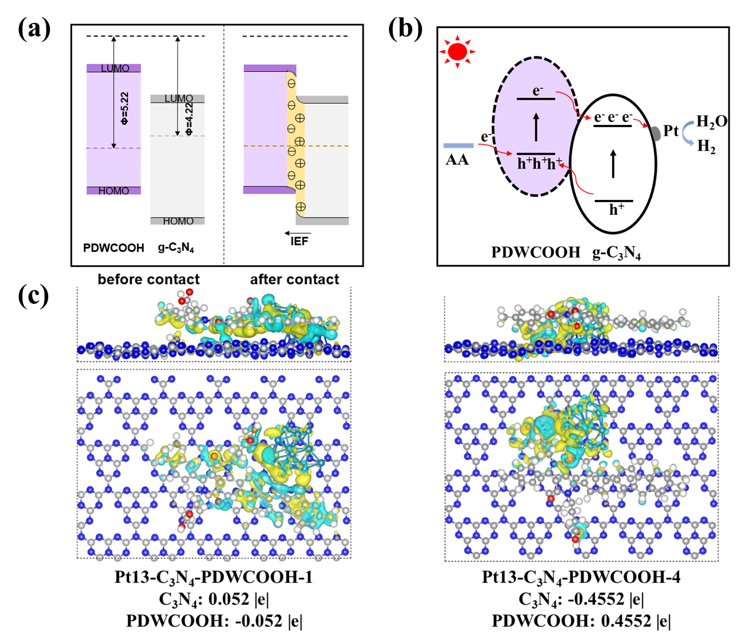
Figure 8. (a) Schematic illustration for band bending and IEF formation at PDWCOOH/g-C₃N₄ interface. (b) Possible photocatalytic hydrogen production progress. (c) Mulliken charges distribution of PDWCOOH/g-C₃N₄-Pt with and without amide bond.
Theoretical Calculation. To further understand the photocatalytic mechanism, a theoretical exploration based on spin-unrestricted DFT calculations was performed using the Gaussian 16 program package.⁵¹ First, we calculated the deep bonding orbital and electrostatic potentials distribution of g-C₃N₄ and polymers (Figure S14), suggesting the charge separation were improved caused by introducing fluorene as donor. The adsorption energy (E_{ads}) was also calculated to explain the relative interaction among the four heterojunctions (Figure S15). These calculated results can be divided into two groups on the basis of the donor of polymers with benzene or fluorene. Taking fluorene-based polymers as examples, only the single stacking mode of π-π interaction in PDWC/g-C₃N₄ could be found. In contrast, three interaction modes existed in the PDWCOOH/g-C₃N₄ system, i.e., π-π interaction between the planar reticular g-C₃N₄ and the conjugated polymer PDWCOOH, amide bonds only between the terminal -NH₂ of g-C₃N₄ and the -COOH of PDWCOOH, and both π-π interactions and amide bonds coexisted between g-C₃N₄ and the conjugated polymer PDWCOOH. For the two groups of heterojunctions, exothermic values of -1.16 and -1.25 eV for PDBCOOH/g-C₃N₄ and PDWCOOH/g-C₃N₄ were observed, respectively, when polymers and g-C₃N₄ combined with both π-π interaction and amide bond. These results indicated that the heterojunction structure is more stable when π-π interactions and amide bonds coexist. Much lower E_{ads} value of PDWCOOH/g-C₃N₄ than the other could be attributed to the strong ICT effect caused by stronger donor. This phenomenon also existed in the group of PDBC/g-C₃N₄ and PDBCOOH/g-C₃N₄. Notably, the HOMO and LUMO of heterojunction were mainly located on PDWCOOH and g-C₃N₄ (Figure S16), respectively. The calculated band gap values of PDWCOOH, g-C₃N₄ were much higher than that of PDWCOOH/g-C₃N₄, indicating broader visible-light spectrum response range for the heterojunction. The amide bond between polymer and g-C₃N₄ not only influenced the stability of heterojunction, but also impacted on the orientation and intensity of electron flow as well (Figure 8c). When the heterojunction combined only by π-π interaction, PDWCOOH was more negative due to the electron-withdrawing property of DPP moiety. However, when amide bond cooperated with π-π interaction in heterojunction, the electron cloud could be redistributed. Comparing with PDWCOOH, g-C₃N₄ was more negative and more electrons migrating within heterojunction. Therefore, an effective embedded electric field is was established, which probably inhibited the recombination of photogenerated electrons and holes and also accelerated the separation of them, leading to the excellent photocatalytic performance.
CONCLUSION
In this work, two carboxyl-functionalized DPP-based organic conjugated polymer PDWCOOH/g-C₃N₄ stable heterojunction was successfully constructed through intermolecular π-π stacking and amide bond, affording an effective internal embedded electric field between the polymer and g-C₃N₄, along with considerably promoted separation and migration of photogenerated electrons. The photocatalytic experiments showed that both the amide bond and π-π interaction were crucial. Among them, the dual-interaction heterojunction PDWCOOH/g-C₃N₄ exhibited higher HER than π-π interaction heterojunction PDWC/g-C₃N₄ and amide bond interaction heterojunction PDBCOOH/g-C₃N₄, respectively. The highest visible light-driven photocatalytic hydrogen production performance of 35.7 mmol·h⁻¹·g⁻¹ (0.89 mmol·h⁻¹, 25 mg photocatalyst) up to date was achieved, with AQY value of 28.2% at 550 nm, surpassing almost all type Ⅱ heterojunctions with organic polymer semiconductor for photocatalytic water splitting hydrogen production reported so far (Table S1). This work provides an innovative heterojunction engineering strategy for the design of stable, efficient and superior-performed organic polymer heterojunction materials for photocatalytic water splitting hydrogen production.
ASSOCIATED CONTENT
Supporting Information
Synthetic routes of PDWC and PDWCOOH; comparison of FT-IR spectra; comparison of FT-IR spectra for moiety composite; powder XRD patterns of polymers; SEM-EDX images of g-C₃N₄ and PDWCOOH; HER comparison of PDWCOOH/g-C₃N₄ composites; FT-IR, PXRD, XPS and DRS Spectra of PDBC/g-C₃N₄, PDWC/g-C₃N₄, PDBCOOH/g-C₃N₄ and PDWCOOH/g-C₃N₄ after photocatalytic test; high-resolution XPS spectra of g-C₃N₄, PDBC/g-C₃N₄, PDWC/g-C₃N₄ and PDBCOOH/g-C₃N₄ heterojunctions; the calculated work function of PDWCOOH and g-C₃N₄; characterization of built-in electric field; the deep bonding orbital and electrostatic potentials distribution of g-C₃N₄ and polymers; calculated structures and adsorption energies for heterojunctions; the bandgap of PDWCOOH and PDWCOOH/g-C₃N₄/Pt; and the ¹H NMR spectra of PDWC and PDWCOOH; and recent representative photocatalytic H₂ evolution activities of type Ⅱ PHJs (PDF).
AUTHOR INFORMATION
Corresponding Author
Xiaofeng Wu – a) Key Laboratory for Advanced Materials, Joint International Research Laboratory for Precision Chemistry, School of Chemistry and Molecular Engineering, East China University of Science and Technology, Shanghai 200237, P. R. China;
b) Leverhulme Centre for Functional Materials Design, Materials Innovation Factory, and Department of Chemistry, University of Liverpool, Liverpool, UK L69 7ZD;
orcid.org/0000-0001-5549-8836
Email: xfwu@liverpool.ac.uk
Jianli Hua − Key Laboratory for Advanced Materials, Joint International Research Laboratory for Precision Chemistry, School of Chemistry and Molecular Engineering, East China University of Science and Technology, Shanghai 200237, P. R. China; orcid.org/0000-0001-8113-0007;
Email: jlhua@ecust.edu.cn
Authors
Xinman Liu − Key Laboratory for Advanced Materials, Joint International Research Laboratory for Precision Chemistry, School of Chemistry and Molecular Engineering, East China University of Science and Technology, Shanghai 200237, P. R. China;
b) Leverhulme Centre for Functional Materials Design, Materials Innovation Factory, and Department of Chemistry, University of Liverpool, Liverpool, UK L69 7ZD;
orcid.org/0000-0001-5649-3818
Zhiqiang Wang − Key Laboratory for Advanced Materials, Joint International Research Laboratory for Precision Chemistry, School of Chemistry and Molecular Engineering, East China University of Science and Technology, Shanghai 200237, P. R. China; orcid.org/0000-0001-6293-1474
Shufan Feng − Key Laboratory for Advanced Materials, Joint International Research Laboratory for Precision Chemistry, School of Chemistry and Molecular Engineering, East China University of Science and Technology, Shanghai 200237, P. R. China
Xiaolong Zhang − Key Laboratory for Advanced Materials, Joint International Research Laboratory for Precision Chemistry, School of Chemistry and Molecular Engineering, East China University of Science and Technology, Shanghai 200237, P. R. China
Huihui Xu − Key Laboratory for Advanced Materials, Joint International Research Laboratory for Precision Chemistry, School of Chemistry and Molecular Engineering, East China University of Science and Technology, Shanghai 200237, P. R. China
Guan Wei − Key Laboratory for Advanced Materials, Joint International Research Laboratory for Precision Chemistry, School of Chemistry and Molecular Engineering, East China University of Science and Technology, Shanghai 200237, P. R. China
Xueqing Gong − Key Laboratory for Advanced Materials, Joint International Research Laboratory for Precision Chemistry, School of Chemistry and Molecular Engineering, East China University of Science and Technology, Shanghai 200237, P. R. China

Notes
The authors declare no competing financial interest.
ACKNOWLEDGMENTS
For financial support of this research, the authors thank the project supported by the National Natural Science Foundation of China (22271093 and 21971064), Shanghai Municipal Science and Technology Major Project (Grant No. 2018SHZDZX03), the Fundamental Research Funds for the Central Universities (222201717003 and 50321101918001) and the Programme of Introducing Talents of Discipline to Universities (B16017).
REFERENCES
(1) Nishiyama, H.; Yamada, T.; Nakabayashi, M.; Maehara, Y.; Yamaguchi, M.; Kuromiya, Y.; Nagatsuma, Y.; Tokudome, H.; Akiyama, S.; Watanabe, T.; Narushima, R.; Okunaka, S.; Shibata, N.; Takata, T.; Hisatomi, T.; Domen, K. Photocatalytic Solar Hydrogen Production from Water on a 100-m² Scale. Nature 2021, 598, 304−307.
(2) Creutzig, F.; Agoston, P.; Goldschmidt, J. C.; Luderer, G.; Netmet, G.; Pietzcker, R. C. The Underestimated Potential of Solar Energy to Mitigate Climate Change. Nat. Energy 2017, 2, 17140.
(3) Xiang, Q.; Yu, J.; Jaroniec, M. Synergetic Effect of MoS₂ and Graphene as Cocatalysts for Enhanced Photocatalytic H₂ Production Activity of TiO₂ Nanoparticles. J. Am. Chem. Soc. 2012, 134, 6575−6578.
(4) Dunn, B.; Kamath, H.; Tarascon, J. M. Electrical Energy Storage for the Grid: A Battery of Choices. Science 2011, 334, 928−935.
(5) Rauscher, S. A.; Moran, J. Hydrogen Drives Part of the Reverse Krebs Cycle under Metal or Meteorite Catalysis. Angew. Chem. Int. Ed. 2022, 61, e202212932.
(6) Bremmer, G.M.; Van Haandel, L.; Hensen, E. J. M.; Frenken, J. W. M.; Kooyman, P. J. The Effect of Oxidation and Resulfidation on (Ni/Co) MoS₂ Hydrodesulfurisation Catalysts. Appl. Catal. B 2019, 243, 145−150.
(7) Ball, M.; Weeda, M. The Hydrogen Economy-Vision or Reality? Int. J. Hydrog. Energy 2015, 40, 7903−7919.
(8) Fujishima, A.; Honda, K. Electrochemical Photolysis of Water at a Semiconductor Electrode. Nature 1973, 238, 37−38.
(9) Du, P. W.; Eisenberg, R. Catalysts Made of Earth-abundant Elements (Co, Ni, Fe) for Water Splitting: Recent Progress and Future Challenges. Energy Environ. Sci. 2012, 5, 6012−6021.
(10) Liu, S.; Lei, Y.-J.; Xin, Z.-J.; Lu, Y.-B.; Wang, H.-Y. Water Splitting Based on Homogeneous Copper Molecular Catalysts. J. Photochem. Photobiol. A Chem. 2018, 355, 141−151.
(11) Thoi, V. S.; Sun, Y. J.; Long, J. R.; Chang, C. J. Complexes of Earth-abundant Metals for Catalytic Electrochemical Hydrogen Generation under Aqueous Conditions. Chem. Soc. Rev. 2013, 42, 2388−2400.
(12) Banerjee, T.; Podjaski, F.; Kröger, J.; Biswal, B. P.; Lotsch, B. V. Polymer Photocatalysts for Solar-to-chemical Energy Conversion. Nat. Mater. 2021, 6, 168−190.
(13) Wang, X. C.; Maeda, K.; Thomas, A.; Takanabe, K.; Xin, G.; Carlsson, J. M.; Domen, K.; Antonietti, M. A Metal-free Polymeric Photocatalyst for Hydrogen Production from Water under Visible Light. Nat. Mater. 2009, 8, 76−80.
(14) Niu, P.; Yin, L. C.; Yang, Y. Q.; Liu, G.; Cheng, H. M. Increasing the Visible Light Absorption of Graphitic Carbon Nitride (Melon) Photocatalysts by Homogeneous Self-Modification with Nitrogen Vacancies. Adv. Mater. 2014, 26, 8046−8052.
(15) Bhunia, M. K.; Yamauchi, K.; Takanabe, K. Harvesting Solar Light with Crystalline Carbon Nitrides for Efficient Photocatalytic Hydrogen Evolution. Angew. Chem., Int. Ed. 2014, 53, 11001−11005.
(16) Yu, F. T.; Wang, Z. Q.; Zhang, S. C.; Ye, H. N.; Kong, K. Y.; Gong, X. Q.; Hua, J. L.; Tian, H. Molecular Engineering of Donor-Acceptor Conjugated Polymer/g-C₃N₄ Heterostructures for Significantly Enhanced Hydrogen Evolution Under Visible-Light Irradiation. Adv. Funct. Mater. 2018, 28, 1804512−1804524.
(17) Li, J. Y.; Zhang, Z. Y.; Cui, W.; Wang, H.; Cen, W. L.; Johnson, G.; Jiang, G. M.; Zhang, S.; Dong, F. The Spatially Oriented Charge Flow and Photocatalysis Mechanism on Internal van der Waals Heterostructures Enhanced g-C₃N₄. ACS Catal. 2018, 8, 8376−8385.
(18) Ran, J. R.; Guo, W. W.; Wang, H. L.; Zhu, B. C.; Yu, J. G.; Qiao, S. Z. Metal-Free 2D/2D Phosphorene/g-C₃N₄ Van der Waals Heterojunction for Highly Enhanced Visible-Light Photocatalytic H₂ Production. Adv. Mater. 2018, 30, 1800128−1800133.
(19) Fu, J. W.; Xu, Q. L.; Low, J. X.; Jiang, C. J.; Yu, J. G. Ultrathin 2D/2D WO₃/g-C₃N₄ Step-scheme H₂-production Photocatalyst. Appl. Catal. B 2019, 243, 556−565.
(20) Pan, J. Q.; Dong, Z. J.; Wang, B. B.; Jiang, Z. Y.; Zhao, C.; Wang, J. J.; Song, C. S.; Zheng, Y. Y.; Li, C. R. The Enhancement of Photocatalytic Hydrogen Production via Ti³⁺ Self-doping Black TiO₂/g-C₃N₄ Hollow Core-shell Nano-heterojunction. Appl. Catal. B 2019, 242, 92−99.
(21) Zhang, G. G.; Lan, Z.A.; Wang, X. C. Conjugated Polymers: Catalysts for Photocatalytic Hydrogen Evolution. Angew. Chem. Int. Ed. 2016, 55, 15712−15727.
(22) Liao, Q.; Pan, W.; Zou, D. S.; Shen, R. P.; Sheng, G. D.; Li, X.; Zhu, Y. L.; Dong, L. J.; Asiric, A. M.; Alamry, K. A.; Linghu, W. S. Using of g-C₃N₄ Nanosheets for the Jighly Efficient Scavenging of Heavy Metals at Environmental Relevant Concentrations. J. Mol. Liq. 2018, 261, 32−40.
(23) Zhang, D. L.; He, W.; Ye, J. M.; Gao, X.; Wang, D. B.; Song, J. B. Polymeric Carbon Nitride-Derived Photocatalysts for Water Splitting and Nitrogen Fixation. Small 2021, 17, 2005149−2005176.
(24) Ru, C. L.; Zhou, T.; Zhang, J.; Wu, X.; Sun, P. Y.; Chen, P. Y.; Zhou, L.; Zhao, H.; Wu, J. C.; Pan X. B. Introducing Secondary Acceptors into Conjugated Polymers to Improve Photocatalytic Hydrogen Evolution. Macromolecules 2021, 54, 8839−8848.
(25) Bai, Y.; Li, C.; Liu, L. J.; Yamaguchi, Y. C.; Bahri, M.; Yang, H. F.; Gardner, A.; Zwijnenburg, M. A.; Browning, N. D.; Cowan, A. J.; Kudo, A.; Cooper, A. I.; Sprick, R. S. Photocatalytic Overall Water Splitting Under Visible Light Enabled by a Particulate Conjugated Polymer Loaded with Palladium and Iridium. Angew. Chem. Int. Ed. 2022, 61, e202201299.
(26) Liu, L. J.; Gao, M.-Y.; Yang, H. F.; Wang, X. Y.; Li, X. B.; Cooper, A. I. Linear Conjugated Polymers for Solar-Driven Hydrogen Peroxide Production: The Importance of Catalyst Stability. J. Am. Chem. Soc. 2021, 143, 19287−19293.
(27) Wang, Z.; Yang, X.; Yang, T.; Zhao, Y.; Wang, F.; Chen, Y.; Zeng, J. H.; Yan, C.; Huang, F.; Jiang, J. X. Dibenzothiophene Dioxide Based Conjugated Microporous Polymers for Visible-Light-Driven Hydrogen Production. ACS Catal. 2018, 8, 8590−8596.
(28) Lan, Z. A.; Chi, X.; Wu, M.; Zhang, X. R.; Chen, X.; Zhang, G. G.; Wang, X. C. Molecular Design of Covalent Triazine Frameworks with Anisotropic Charge Migration for Photocatalytic Hydrogen Production. Small 2022, 18, 2200129−2200135.
(29) Chen, H. M.; Gardner, A. M.; Lin, G. A.; Zhao, W.; Bahri, M.; Browning, N. D.; Sprick, R. S.; Li, X. B.; Xu, X. X.; Cooper, A. I. Covalent Triazine-based Frameworks with Cobalt-loading for Visible Light-driven Photocatalytic Water Oxidation. Catal. Sci. Technol. 2022, 12, 5442−5452.
(30) Yu, F. T.; Zhu, Z. Q.; Wang, S. P.; Wang, J. Y.; Xu, Z. Z.; Song, F. R.; Dong, Z. M.; Zhang, Z. B. Novel Donor-acceptor-acceptor Ternary Conjugated Microporous Polymers with Boosting Forward Charge Separation and Suppressing Backward Charge Recombination for Photocatalytic Reduction of Uranium (VI). Appl. Catal. B 2022, 301, 120819−120829.
(31) Han, C. Z.; Xiang, S. H.; Ge, M. T.; Xie, P. Z.; Zhang, C.; Jiang, J.-X. An Efficient Electron Donor for Conjugated Microporous Polymer Photocatalysts with High Photocatalytic Hydrogen Evolution Activity. Small 2022, 18, 2202072−2202080.
(32) Zhao, Y. B.; Ma, W. Y.; Xu, Y. F.; Zhang, C.; Wang, Q.; Yang, T. J.; Gao, X. M.; Wang, F.; Yan, C; Jiang, J.-X. Effect of Linking Pattern of Dibenzothiophene‑S, S‑dioxide- Containing Conjugated Microporous Polymers on the Photocatalytic Performance. Macromolecules 2018, 51, 9502−9508.
(33) Mohamed, G. M.; Chen, T.-C.; Kuo, S.-W. Solid-State Chemical Transformations to Enhance Gas Capture in Benzoxazine-Linked Conjugated Microporous Polymers. Macromolecules 2021, 54, 5866−5877.
(34) Zhao, W.; Yan, P. Y.; Li, B. Y.; Bahri, M.; Liu, L. J.; Zhou, X.; Clowes, R.; Browning, N. D.; Wu, Y.; Ward, J. W.; Cooper, A. I. Accelerated Synthesis and Discovery of Covalent Organic Framework Photocatalysts for Hydrogen Peroxide Production. J. Am. Chem. Soc. 2022, 144, 9902−9909.
(35) Wu, C. J.; Li, X.-Y.; Li, T.-R.; Shao, M.-Z.; Niu, L.-J.; Lu, X.-F.; Kan, J.-L.; Geng, Y.; Dong, Y.-B. Natural Sunlight Photocatalytic Synthesis of Benzoxazole-Bridged Covalent Organic Framework for Photocatalysis. J. Am. Chem. Soc. 2022, 144, 18750−18755.
(36) Zhang, W. W.; Chen, L. J.; Dai, S.; Zhao, C. X.; Ma, C.; Wei, L.; Zhu, M. H.; Chong, S. Y.; Yang, H. F.; Liu, L. J.; Bai, Y.; Yu, M. J.; Xu, Y. J.; Zhu, X.-W.; Zhu, Q.; An, S. H.; Sprick, R. S.; Little, M. A.; Wu, X. F.; Jiang, S.; Wu, Y. Z.; Zhang, Y.-B.; Tian, H.; Zhu, W.-H.; Cooper, A. I. Reconstructed Covalent Organic Frameworks. Nature 2022， 604, 72−79.
(37) Chaoui, N.; Trunk, M.; Dawson, R.; Schmidt, J.; Thomas, A. Trends and Challenges for Microporous Polymers. Chem. Soc. Rev. 2017, 46, 3302−3321.
(38) Chen, J.; Dong, C. L.; Zhao, D.; Huang, Y. C.; Wang, X.; Samad, L.; Dang, L.; Shearer, M.; Shen, S. S.; Guo, L. Molecular Design of Polymer Heterojunctions for Efficient Solar-Hydrogen Conversion. Adv. Mater. 2017, 29, 1606198−1606208.
(39) Ye, H. N.; Wang, Z. Q.; Yu, F. T.; Zhang, S. C.; Kong, K. Y.; Gong, X. Q.; Hua, J. L.; Tian, H. Fluorinated Conjugated Poly(benzotriazole)/g-C₃N₄ Heterojunctions for Significantly Enhancing Photocatalytic H₂ Evolution. Appl. Catal. B 2020, 267, 118577−118588.
(40) Xiao, Z. H.; Xiao, J.; Sun, Q.; Wang, Y. F.; Pan, L.; Shi, C. X.; Zhang, X. W.; Zou, J.-J. Interface Engineering of Conjugated Polymer-Based Composites for Photocatalysis. Chem. Eur. J. 2022, 28, e202202593.
(41) Gao, Y.; Bai, J. H.; Sui, Y.; Han, Y.; Deng, Y. F.; Tian, H. K.; Geng, Y. H.; Wang, F. S. High Mobility Ambipolar Diketopyrrolopyrrole-Based Conjugated Polymers Synthesized via Direct Arylation Polycondensation: Influence of Thiophene Moieties and Side Chains. Macromolecules 2018, 51, 8752−8760.
(42) Tang, A.; Zhan, C.; Yao, J.; Zhou, E. Design of Diketopyrrolopyrrole (DPP)-Based Small Molecules for Organic-Solar-Cell Applications. Adv. Mater. 2017, 29, 1600013−1600051.
(43) Xu, J.; Tang, W. Q.; Yang, C.; Manke, I.; Chen, N.; Lai, F. L.; Xu, T.; An, S. H.; Liu, H. L.; Zhang, Z. L.; Cao, Y. J.; Wang, N.; Zhao, S. L.; Niu, D. F.; Chen, R. J. A Highly Conductive COF@CNT Electrocatalyst Boosting Polysulfide Conversion for Li-S Chemistry. ACS Energy Lett. 2021, 6, 3053−3062.
(44) Diao, R. M.; Ye, H. N.; Yang, Z. C.; Zhang, S. C.; Kong, K. Y.; Hua, J. L. Significant Improvement of Photocatalytic Hydrogen Evolution of Diketopyrrolopyrrole-based Donor-acceptor Conjugated Polymers through Side-chain Engineering. Polym. Chem. 2019, 10, 6473−6480.
(45) Xiao, W.-J.; Wang, Y.; Wang, W.-R.; Li, J.; Wang, J. D.; Xu, Z.-W.; Li, J. J.; Yao, J. H.; Li, W.-S. Diketopyrrolopyrrole-based Donor-Acceptor Conjugated Microporous Polymers for Visible-Light-Driven Photocatalytic Hydrogen Production from Water. Macromolecules 2020, 53, 2454−2463.
(46) Wei, G.; Niu, F. S.; Wang, Z. Q.; Liu, X. M.; Feng, S. F.; Hu, K.; Gong, X. Q.; Hua, J. L. Enhanced Photocatalytic H₂ Evolution Based on A Polymer/TiO₂ Film Heterojunction. Mater. Today Chem. 2022, 26, 101075−101087.
(47) Yu, F. T.; Wang, Z. Q.; Zhang, S. C.; Yun, K.; Ye, H. N.; Gong, X. Q.; Hua, J. L.; Tian, H. N-Annulated Perylene-based Organic Dyes Sensitized Graphitic Carbon Nitride to Form an Amide Bond for Efficient Photocatalytic Hydrogen Production under Visible-light Irradiation. Appl. Catal. B 2018, 237, 32−42.
(48) Liu, S. W.; Lin, P. X.; Wu, M.; Lan, Z.-A.; Zhuzhang, H. Y.; Han, M. M.; Fan, Y. H.l; Chen, X.; Wang, X. C.; Li, Q. Q.; Li, Z. Organic Dyes with Multi-branched Structures for Highly Efficient Photocatalytic Hydrogen Evolution under Visible-light Irradiation. Appl. Catal. B 2022, 309, 121257−121265.
(49) Zhang, X. H.; Peng, B. S.; Zhang, S.; Peng, T. Y. Robust Wide Visible-Light-Responsive Photoactivity for H₂ Production over a Polymer/Polymer Heterojunction Photocatalyst: The Significance of Sacrificial Reagent. ACS Sustainable Chem. Eng. 2015, 3, 1501–1509.
(50) Chen, X. B.; Shen, S. H.; Guo, L. J.; Mao, S. S. Semiconductor-based Photocatalytic Hydrogen Generation. Chem. Rev. 2010, 110, 6503–6570.
(51) Frisch, M. J.; Trucks, G. W.; Schlegel, H. B.; Scuseria, G. E.; Robb, M. A.; Cheeseman, J. R.; Scalmani, G.; Barone, V.; Petersson, G. A.; Nakatsuji, H.; Li, X. Gaussian 16, Revision C. 01, Gaussian, Inc., Wallingford CT, 2016.
(52) Becke, A. D. Density-functional Exchange-energy Approximation with Correct Asymptotic Behavior. Phys. Rev. A 1998, 38, 3098−3100.
(53) Perdew, J. P. Density-functional Approximation for the Correlation Energy of the Inhomogeneous Electron Gas. Phys. Rev. B 1986, 33, 8822−8824.
(54) Hehre, W. J.; Ditchfield, R.; Pople, J. A. Self-Consistent Molecular Orbital Methods. XII. Further Extensions of Gaussian-Type Basis Sets for Use in Molecular Orbital Studies of Organic Molecules. J. Chem. Phys. 1972, 56, 2257−2261.
(55) Kresse, G.; Furthmüller, J. Efficient Iterative Dchemes for Ab Initio Total-energy Calculations Using a Plane-wave Basis Set. Phys. Rev. B 1998, 54, 11169−11186.
(56) Blöchl, P. E. Projector Augmented-wave Method. Phys. Rev. B 1994, 50, 17953−17979.
(57) Perdew, J. P.; Burke, K.; Ernzerhof, M. Generalized Gradient Approximation Made Simple. Phys. Rev. Lett. 1996, 77, 3865−3868.
(58) Teter, M. P.; Payne, M. C.; Allan, D. C. Solution of Schrödinger’s Equation for Large Systems. Phys. Rev. B 1989, 40, 12255−12263.
(59) Zhang, Z. J.; Chen, X. J.; Zhang, H. J.; Liu, W. X.; Zhu, W.; Zhu, Y. F. A Highly Crystalline Perylene Imide Polymer with the Robust Built-In Electric Field for Efficient Photocatalytic Water Oxidation. Adv. Mater. 2020, 32, 1907746−1907751.
(60) Li, J.; Cai, L. J.; Shang, J.; Yu, Y.; Zhang, L. Z. Giant Enhancement of Internal Electric Field Boosting Bulk Charge Separation for Photocatalysis. Adv. Mater. 2016, 28, 4059−4064.
(61) Chen, X.; Wang, J.; Chai, Y.; Zhang, Z.; Zhu, Y. Efficient Photocatalytic Overall Water Splitting Induced by the Giant Internal Electric Field of a g-C₃N₄/rGO/PDIP Z-Scheme Heterojunction. Adv. Mater. 2021, 33, 2007479−2007485.
(62) Yu, F. T.; Cui, S. C.; Li, X.; Peng, Y. Y.; Yu, Y.; Yun, K.; Zhang, S. C.; Li, J.; Liu, J. G.; Hua, J. L. Effect of Anchoring Groups on N-Annulated Perylene-based Sensitizers for Dye-sensitized Solar Cells and Photocatalytic H₂ Evolution. Dyes. Pigm. 2017, 139, 7−18.
(63) Xu, L. P.; Tian, B. N.; Wang, T. Y.; Yu, Y.; Wu, Y. C.; Cui, J. W.; Cao, Z. N.; Wu, J. H.; Zhang, W. K.; Zhang, Q.; Liu, J. Q.; Li, Z. F.; Tian, Y. Direct Z-Scheme Polymeric Heterojunction Boosts Photocatalytic Hydrogen Production via a Rebuilt Extended π-Delocalized Network. Energy Environ. Sci., 2022, 15, 5059–5068.
(64) Wang, J.; Shi, W.; Liu, D.; Zhang, Z. J.; Zhu, Y. F.; Wang, D. Supramolecular Organic Nanofibers with Highly Efficient and Stable Visible Light Photooxidation Performance. Appl. Catal. B: Environ., 2017, 202, 289–297.
(65) Park, Y.; Choong, V.; Gao, Y.; Hsieh, B. R.; Tang. C. W. Work Function of Indium Tin Oxide Transparent Conductor Measured by Photoelectron Spectroscopy. Appl. Phys. Lett. 1996, 68, 2699−2701.
(66) Han, C. Z.; Xiang, S. H.; Jin, S. L.; Luo, L.-W.; Zhang, C.; Yan, C.; Jiang, J. -X. Linear Multiple-thiophene-containing Conjugated Polymer Photocatalysts with Narrow Band Gaps for Achieving Ultrahigh Photocatalytic Hydrogen Evolution Activity under Visible Light. J. Mater. Chem. A. 2022, 10, 5255−5261.
(67) Yu, J.; Chang, S. F.; Xu, X. X.; He, X. M.; Zhang, C. The Effect of Single Atom Substitution (O, S or Se) on Photocatalytic Hydrogen Evolution for Triazine-based Conjugated Porous Polymers. J. Mater. Chem. C. 2020, 8, 8887−8895.
(68) Waltman, R. J.; Pacansky, J. X-Rray Photoelectron Spectroscopic Studies on Organic Photoconductors: Evaluation of Atomic Charges on Chlorodiane Blue and p-(Diethylamino) benzaldehyde Diphenylhydrazone. Chem. Mater. 1993, 5, 1799-1804.

