Control/Tracking Number: 23-A-632-OARSI
Activity: Abstract
Current Date/Time: 10/15/2022 4:29:33 AM
FAT PAD ALTERATIONS WITH AGEING AND OSTEOARTHRITIS IN AN OVINE MODEL
Author Block: A. Bernard¹, J-M. Vandeweerd¹, V. Simon¹, D. Houbotte¹, M. J. Peffers², T. Welting³, F. Hontoir¹; ¹Univ. of Namur, Namur, Belgium, ²Univ. of Liverpool, Liverpool, United Kingdom, ³Maastricht Univ. Med. Ctr., Maastricht, Netherlands
Abstract:
Purpose: The infrapatellar fat pad (IFP, Hoffa fat pad) within the knee joint has been described, over the last 20 years, as space-filler, source of inflammatory cytokines, shock absorber, as well as source of mesenchymal stromal cells. The IFP and the synovium might play a role in the pathogenesis of osteoarthritis (OA). In the current study, we aimed to characterize IFP alterations in ageing healthy sheep and in research sheep after meniscectomy and cranial cruciate transection.
Methods: Sixteen healthy ewes (n = 16) (7 young adults, and 9 old adults, age cut-off 7 years-old) were euthanatized to assess the age-related changes of the fat pad. Synovial fluid was collected and assessed for volume, viscosity, colour and turbidity. Macroscopic and microscopic characteristics of synovium were assessed according to OARSI guidelines. Histological scoring of IFP on HES slices included: intimal hyperplasia (0-3), inflammatory cells infiltration (0-3), fat/fibrous tissue ratio (0-5), vascularity (0-3), with a total score from 0 (normal) to 14 (severe hyperplasia of the intima, cell infiltration, vascularization and more than 80% of fibrous tissue (fat/fibrous tissue ratio). Resection of the cranial part of the medial meniscus and transection of the cranial cruciate ligament were performed in 16 other ewes (n = 16) whilst only skin incision (sham surgery) was performed in 4 ewes (n = 4). Synovial fluid was collected at baseline. Animals were euthanized at different time points, i.e. 4 (n = 4), 6 (n = 8) and 28-weeks (n = 4), and macroscopic and microscopic assessment was performed on the synovium, the cartilage and bone according to OARSI guidelines. Fat pad changes were further documented with Toluidine Blue O Fast Green staining (to detect proteoglycan deposit), and Picrosirius Red staining (observed under polarized light microscopy, to assess collagen fibres organization).
Results: Synovial fluid from all young adult and old adult sheep was normal (viscous, clear, and transparent). Superficial roughening of the cartilage of the medial femoro-tibial compartment was associated with ageing and present in sheep after 7 years. After meniscectomy and cruciate ligament transection, moderate synovial fluid alteration was identified, as well as moderate to severe changes in synovium and mild to moderate changes in fat pad (discoloration, hypervascularity). Sham surgery led to slighter changes. Multivariate analysis revealed that score for synovium assessment, at histology, was influenced by the type of intervention (non-operated controlateral, sham, PTOA induction; P=0.02) but not by the age of the sheep (P=0.30). Scoring of fat pad at histology was influenced by age of the animal (P=0.03) and the type of intervention (P=0.003). Histological changes of fad pad included interstitial fibrosis (2 out of 7 young adults, 6 out of 9 old adults, 10 of 16 operated sheep, and 2 out of 4 sham sheep). Chondroid metaplasia was found in 6 old adults and in 6 operated sheep, and was observed as dense conjunctive tissue, with cells trapped inside lacunae, surrounded by organized collagen (picrosirius red) and partial blue staining (toluidine Blue). Correlation between fat pad scoring and synovium scoring was moderate (95% CI r=0.45-0.79, P<0.001).
Conclusions: Although considered as a space-filler or a cushion, the fat pad showed changes associated with ageing and surgery (partial medial meniscectomy and cranial cruciate ligament transection) in the sheep. Those changes (fibrosis, hypervascularization, cartilaginous metaplasia) could be involved in the pathogenesis of OA and alter the biomechanics and the secretory properties of the fat pad.
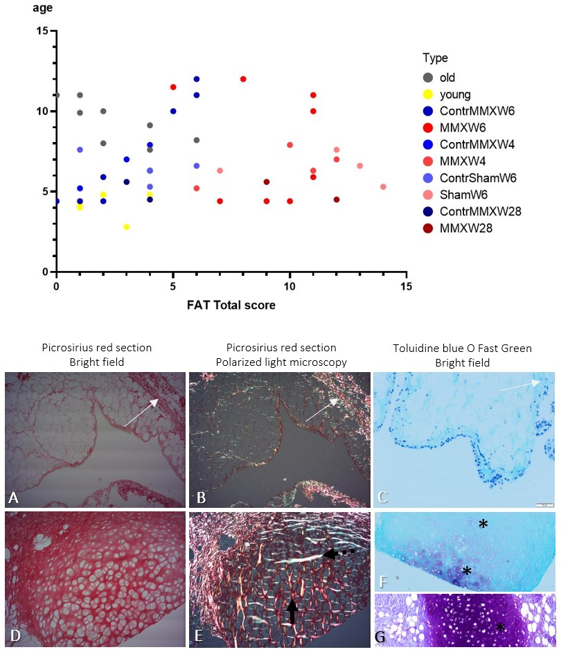
Legend: Graph: Total score at histology, for fat pad from young adults (yellow), old adults (grey), limbs after surgery (red dots, 4-, 6- or 28-weeks after PTOA induction or sham operated) and contralateral non-operated limbs (blue dots). Histology of normal fat pad (A-C) and fat pad with cartilaginous metaplasia (D-G). A-C: normal fat pad (white arrow) is featured by small amount of interstitial fibres (white arrows). D: In fat pad with cartilaginous metaplasia, lacunae are visible on Picrosirius red sections, under light microscope. E: Under polarized light microscope, the collagen fibres show some degree of alignment, shown as homogenous colour (vertical-red or horizontal-blue). F-G: Various toluidine blue intake (*) suggests different degree of metaplasia and proteoglycan deposition.
Category (Complete): Joint Related Tissues (Cartilage, Bone, Synovium, Meniscus, Muscle, etc.)
Keyword (Complete): Aging ; OA Animal Models ; Post-Traumatic ; Joint
Presentation Preference (Complete): Either Podium or Poster
Additional (Complete):
Type of Abstract (Required): Basic Science
Are you age 40 or under and within 5 years of your research degree? (Required): Yes
Do you want to be considered for a Need Based Travel Assistance Award? (Required): No
Payment (Complete): Your credit card order has been processed on Saturday 15 October 2022 at 4:27 AM.
Status: Complete

