Impedance spectroscopy of Sb2Se3 photovoltaics consisting of (Sb4Se6)n nanoribbons under light illumination

Jaemin Park,a‡ Thomas Shalvey,b‡ Thomas Moehl,c Kyoohee Woo,d Jon Major,b S. David Tilley,c Wooseok Yanga,e*

a. School of Chemical Engineering, Sungkyunkwan University (SKKU), 16419, Republic of Korea.

b. Department of Chemistry, University of Zurich, Winterthurerstrasse 190, 8057 Zurich, Switzerland

c. Stephenson Institute for Renewable Energy, Physics Department, University of Liverpool, Liverpool L69 7ZF, UK

d. Department of Printed Electronics, Korea Institute of Machinery & Materials, Daejeon 305-343, South Korea

e. SKKU Institute of Energy Science and Technology (SIEST), Sungkyunkwan University, Suwon 16419, Republic of Korea

‡These authors contributed equally.

AUTHOR INFORMATION

Corresponding Authors

wooseok.yang@skku.edu

**ABSTRACT**

Sb2Se3, consisting of 1-dimensional (Sb4Se6)n nanoribbons, has drawn attention as an intriguing light absorber in the photovoltaics (PVs) research community, but performance limiting factors in Sb2Se3 PVs are not fully understood yet. In this paper, we investigate the charge carrier behavior in Sb2Se3 PVs with impedance spectroscopy (IS) under light illumination. Two different directions of (Sb4Se6)n nanoribbons, one with a relatively vertical orientation while the other one with a relatively horizontal, were used to investigate the effect of the crystal structure. Regardless of the (Sb4Se6)n orientations, negative capacitance was observed at forward bias, representing a recombination pathway at the TiO2/Sb2Se3 interface. By comparing the recombination resistances and lifetime in two different Sb2Se3 PVs, it was found that a better interface could be formed when the (Sb4Se6)n ribbons are horizontal to the TiO2 layer. Based on these observations, we propose an ideal structure at the Sb2Se3/TiO2 interface to boost the performance of Sb2Se3 PVs toward its theoretical limit.

**TOC GRAPHICS**

**KEYWORDS**

Recombination, Solar Cells, Negative Capacitance, Antimony Selenide, Crystallographic Orientations

**1. Introduction**

In the field of semiconductor materials for thin film photovoltaics, antimony selenide (Sb2Se3) has recently sparked great attention owing to its unique properties. In addition to its inexpensive cost and simple composition, the fundamental properties of Sb2Se3, such as its band gap, light absorption coefficient, and mobilities, demonstrate the material’s promise as a promising light absorber. The more intriguing nature of Sb2Se3 is its 1-dimensional (1D) crystal structure consisting of (Sb4Se6)n nanoribbons packed with weak van der Waals forces. When the ribbons lie parallel to the grain boundary (GB), the GB of Sb2Se3 is known to be electrically benign, unlike other semiconductors in which the GBs are detrimental to the performance.[1] It was also reported that deep trap states within the band gap of Sb2Se3 are removed by atomic relaxation, so-called “self-healing” process not only at the GBs, but also at any crystallographic orientations of Sb2Se3.[2] With these interesting characteristics, efforts have been devoted to fabricating high-performance devices based on Sb2Se3, either in the solar cell[3] and water splitting[4] fields. Despite the increasing efficiencies, however, there is still plenty of room for further improvement of the performance, necessitating a deeper understanding of the performance limiting factors.

Impedance spectroscopy (IS) is one powerful characterization technique for optoelectronic devices. The power of impedance analysis lies in its ability to separate contributions for the performance from different layers or regions of overall devices.[5] For instance, by analyzing frequency-based current-voltage responses with small amplitude, IS is capable of extracting information such as resistances, capacitances, and time constants from each of the device regions individually.[6] This comprehensive understanding can provide valuable insights for optimizing and improving the performance of various devices by identifying limiting sources. Consequently, the IS technique has been applied to various materials systems and devices including (dye-sensitized) solar cells,[7-8] water-splitting devices,[9] batteries,[10] fuel cells,[11] and sensors.[12]

IS measurement is also widely used in the thin-film solar cells community to demonstrate various photo-physical processes. For instance, in halide perovskite-based solar cells, several models and mechanisms have been established including charge transfer, recombination-related resistance and capacitance, and the presence of negative capacitance.[13-14] However, systematic studies on IS of Sb2Se3 solar cells have not yet been reported. Most of the existing research showed only limited comparison among samples, while comprehensive exploration of IS data under various light and voltage conditions remains elusive.[15-19] Notably, the crystallographic orientation of the Sb2Se3 thin film is a pivotal role in the solar cell performance due to its anisotropic properties.[1] Electron mobility and GB characteristics can be altered by the orientation of the stacked 1D (Sb4Se6)n nanoribbons in Sb2Se3 film, which inevitably affects the device efficiencies.[20] Therefore, IS characterization of Sb2Se3-based solar cells including TiO2-electron transport layers with Sb2Se3 having different crystallographic orientations is significantly important as it forms the fundamental basis for improving the overall performance.

In this work, we first present the result of the in-depth IS characterization of Sb2Se3 solar cells. By examining the information obtained from analyzing the IS data of TiO2-ETL Sb2Se3 solar cells, we obtained insights about the semiconductor and TiO2/Sb2Se3 interfaces including recombination processes, lifetimes of carriers, and the flat band potentials under different light intensities and applied potentials. In addition, ‘negative capacitance’ was observed in Sb2Se3 solar cells that the recombination-related mechanism was proposed for the first time. Furthermore, IS data was carefully investigated depending on the crystallographic orientation, i.e., the orientation of (Sb4Se6)n nanoribbons. More favorable interface characteristics, a larger recombination resistance, and a longer lifetime were observed when the (Sb4Se6) ribbons were horizontal to the TiO2 layer. Based on these findings, we proposed a novel Sb2Se3 solar cell configuration that shows promising potential for future advancements and development.Our results manifest the power of the IS technique in discovering the efficiency limiting factor under operational conditions, paving the way for advancements of Sb2Se3-based solar cells.

**2. Results and Discussion**

The compact film-type Sb2Se3 film based PV with [hk1] oriented crystallographic orientation achieved higher efficiencies than [hk0] oriented devices because the carrier transport in Sb2Se3 along the [001] direction is more efficient than that along the other directions owing to its anisotropic crystallographic nature.[1] A two-step close space sublimation (CSS) method was employed to avoid the formation of the thermodynamically favorable 1D structure as well as the rearrangement of (Sb4Se6)n nanoribbons along [hk1] direction.[21] The seed layer was pre-deposited at a relatively low temperature (XX °C), where the grains grow from the seed at a high temperature (XX °C).[22] **Figure 1**a depicts the microstructures of compact Sb2Se3 thin films deposited on fluorine-doped tin oxide (FTO) substrate with a TiO2-electron transfer layer (ETL) by a two-step CSS deposition process. The cross-section scanning electron microscope (SEM) image of the corresponding Sb2Se3 film was presented in Figure S1 (Supporting Information). The experimental details are described in the Experimental Section. The crystallographic orientations of the Sb2Se3 film were investigated by X-ray diffraction (XRD) analysis (Figure 1b). The sample showed diffraction patterns corresponding to orthorhombic Sb2Se3 (Joint Committee on Powder Diffraction Standards, JCPDS 15-0861). In addition, the dominated [211] and [221] orientations of Sb2Se3 in the XRD patterns (Figure 1c) confirm the success of the seed-derived growth strategy for preferred [hk1]-oriented film growth by using a kinetically controlled growth.

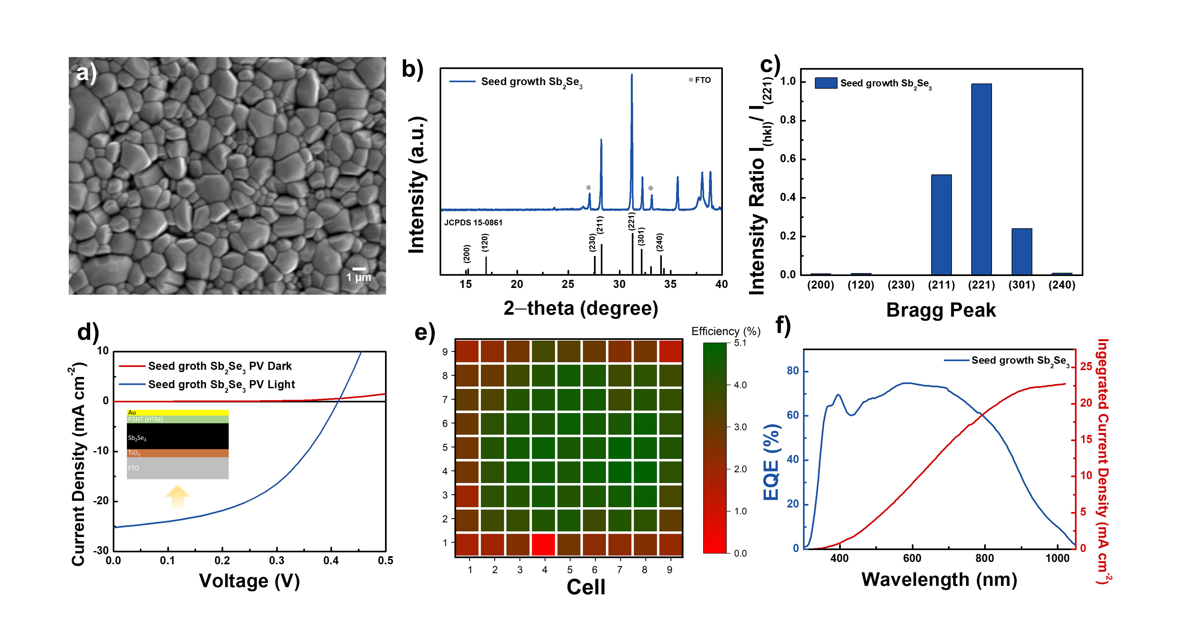

**Figure 1.** a) Top-view SEM images of the seed growth Sb2Se3 films. b) Diffraction patterns and c) peak intensities ratio (I(hkl)/I(221)) of the obtained Sb2Se3 films. d) J–V characteristics of champion Sb2Se3 PV. e) 2D plot of the PCE values of the large area Sb2Se3 PV (25 cm2) for each sub cell. f) EQE spectra of a seed growth Sb2Se3-based PV.

Sb2Se3 photovoltaics (PVs) devices were fabricated with Sb2Se3 film, poly(3-hexylthiophene) (P3HT) hole transfer layer (HTL), and Au electrode (*­*denoted seed growth Sb2Se3 PV, inset of Figure 1d). Figure 1d displays representative current density-voltage (J-V) curves of the Sb2Se3 PV. Typical J-V characterizations performed under 1 sun illumination yielded an optimal conversion efficiency of 5.01% for the Sb2Se3 PV with an open circuit voltage (VOC) of 0.41 V, short circuit current density (JSC) of 25.20 mA cm−2, and fill factor (FF) of 47.96%. To provide statistical information on the device performance, 81 individual devices in a 5x5 cm2 FTO glass were fabricated (Figure S2, Supporting Information). The subcells were completed by depositing HTL/Au layers. With the optimal depositing condition, we achieved an average of a VOC of 0.40 ± 0.05 V, JSC of 20.53 ± 3.67 mA cm−2, and FF of 43.53 ± 6.48% from the 81 subcells (Figure S3, Supporting Information), indicating the high uniformity of the device parameters in the seed growth Sb2Se3 PVs, except for edges which are more prone to pinholes (Figure 1e). Measurement of the external quantum efficiency (EQE) showed that the photocurrent contribution extended to over 1000 nm, consistent with the measured optical bandgap.[20] In addition, the photocurrent calculated by integrating the EQE over the light spectrum was nearly identical to the values determined via J-V characterizations.

IS analysis was performed with the seed growth Sb2Se3 PVs under white LED light illumination as a function of the applied potential. **Figure 2**a shows the current density during IS measurements at each potential. Here the light intensity is 10% sun, which is calibrated by a Si diode. It should be noted that the current density is not precisely 10% of what it was measured in 1 sun illumination with Xe lamp (Figure 1d), due to the difference in wavelength-dependent absorption between Si diode and Sb2Se3. Figure 2b-d show Nyquist plots at each applied potential. When the applied potential is more positive than the Voc (~0.32 V), an inductive response, which is mathematically equivalent to a “negative capacitance”, was observed at the very low frequency region (Figure 2b, c inset). Considering the definition of capacitance (*C*), *C=dQ/dV*, a negative capacitance would mean a decreased charge (*Q*) when the applied voltage (*V*) is increased. This negative capacitance behavior was observed in organic PV[23] and hybrid perovskite PV[14] devices. Mora-Sero et al. reported a negative capacitance in an inorganic CdSe-based device, which is not observed in a conventional monocrystalline Si solar cell.[24] They attribute the negative capacitance to an additional recombination pathway that opens up at forward bias and decreases the charge accumulation ability of the solar cells. It was also reported that such negative capacitance can originate from a time-dependent trap-assisted recombination process.[25] Note that a possible trap-mediated recombination process was proposed at the Sb2Se3/TiO2 interface in the previous IS study on Sb2Se3 photocathode for photoelectrochemical water splitting.[9] Thus, the recombination at the Sb2Se3/TiO2 interface, which is activated at forward bias, could be one origin of the negative capacitance.

**Figure 2.** a) Steady-state photocurrent densities obtained by the seed growth Sb2Se3 PV during IS measurement under 10% sun illumination. b–d) Nyquist plots of the seed growth Sb2Se3 PV at the designated applied potential.

Another apparent feature in the IS spectra of the Sb2Se3 PVs is the increasing semicircles as the applied potential approaches the short circuit (Figure 2b-d). The fact that higher resistance was observed at higher photocurrent regions implies that the resistance originated from a recombination process. In order to elucidate the nature of this resistance, IS spectra with higher light intensities were measured. **Figure 3**a shows the current densities with 10, 50, and 100% sun LED light illumination. The increasing resistance was observed as higher light intensities (Figure S4 Supporting Information). We fitted the Nyquist plots with the simple Voight circuit and the resulting resistance, capacitance, and RC time constant were displayed in Figure 3b-d. As shown in Figure 3b, the resistance decreased as the light intensity increased. The light intensity dependency indicates the resistance to recombination decreases (*i.e.*, the more chance to recombine) at a higher light intensity, further supporting that the resistance originated from the recombination process. process. The corresponding capacitance shows an inverse trend: a lower capacitance at a high photocurrent region (Figure 3c). The capacitance originates from the depletion region at the TiO2/Sb2Se3, evidenced by Mott-Shottky plots representing doping densities close to that of Sb2Se3 (Figure S5, Supporting Information). The higher doping density under higher light intensity may reflect the contribution of the photo-generated charges. The RC time constant can be obtained by multiplying the resistance and capacitance, as shown in Figure 3d. The time constant, which represents the lifetime of the photo-generated charge carriers, has higher values under lower light intensity, which plays another supportive role to prove faster recombination when the population of the photo-generated carrier is high.

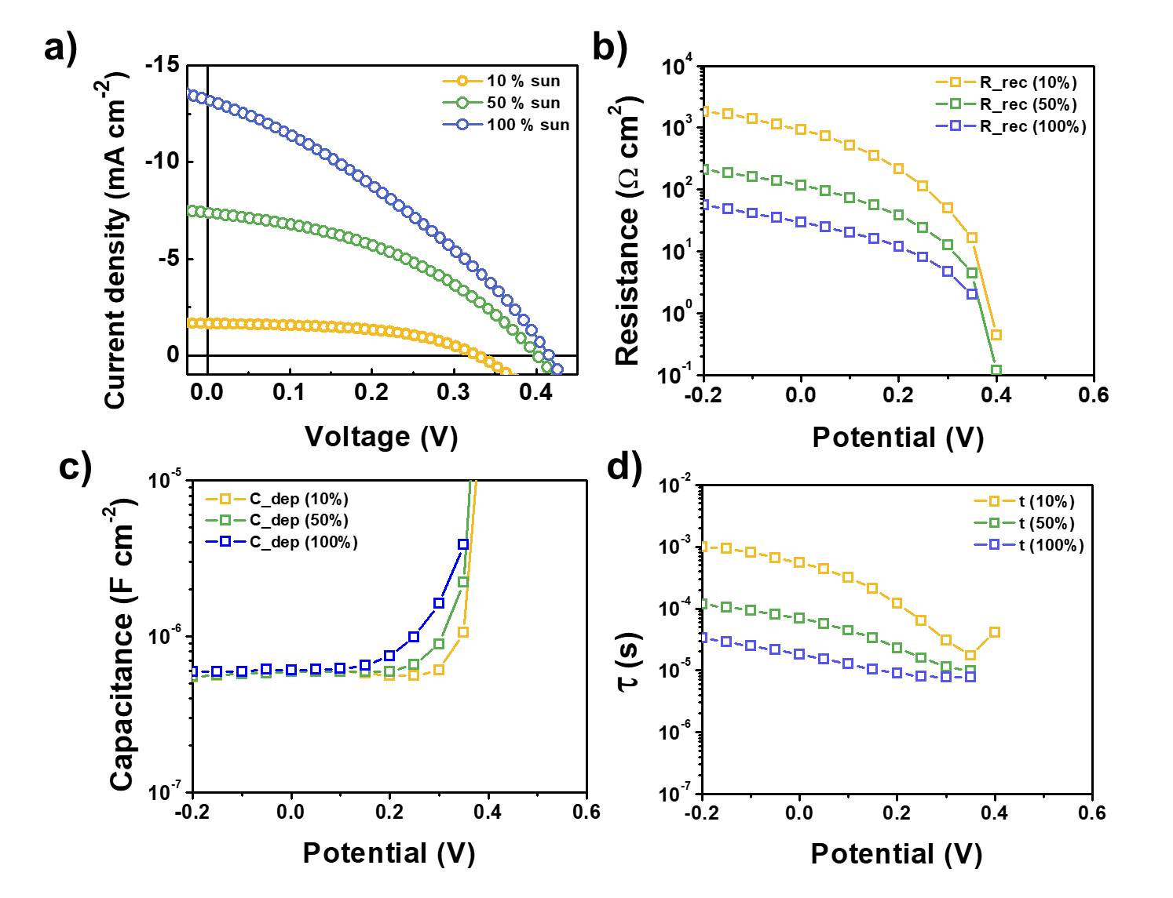

**Figure 3.** a) Steady-state photocurrent densities obtained by the seed growth Sb2Se3 PV during IS measurement under 10%, 50%, and 100% sun illumination. b) Resistances and c) Time constants for charge transfer of seed growth Sb2Se3 PV from the IS fitting procedure.

To investigate the carrier dynamics depending on the crystallographic orientation of the Sb2Se3 film, we prepared a reference Sb2Se3 film obtained by thermal evaporation without a seed layer (denoted rapid growth Sb2Se3) for a comparative study. As shown in **Figure 4a,b**, the values of XRD peak intensities of (hk0) planes/peak intensities of (221) planes increased compared to seed growth Sb2Se3 film, indicating that the more (Sb4Se6)n nanoribbons grew along the [001] direction were horizontally laid on the substrate. As shown in Figure S6 and S7 (Supporting Information), the attempts to use the rapid growth Sb2Se3 film for PV resulted in low efficiencies compared to seed growth Sb2Se3 PV, especially in photocurrent density. It seems that the carriers are required to hop across (Sb4Se6) ribbons held by van der Waals forces in rapid growth Sb2Se3 containing horizontally laid (Sb4Se6) ribbons. Moreover, as shown in the Figure S8 (Supporting Information), the rapid growth Sb2Se3 film contains more pin-holes than the seed growth Sb2Se3 film due to its narrow thickness. Exposure of substrate can result in direct contact between the n-type TiO2 and p-type P3HT, which acts as a recombination center. Therefore, poor photocurrent arose from the recombination of the photogenerated charge carriers in rapid growth Sb2Se3 film, owing to its inefficient carrier-transport behavior. As shown in Figure 4c, current densities with 10% white light intensities were measured and IS analysis was conducted with the rapid growth Sb2Se3 PVs under 10% light illumination as a function of the applied potential (Figure 4d-f). When the applied potential is more positive than the Voc (~0.3 V), a similar propensity was exhibited that inductive negative capacitance was observed at the very low frequency region (Figure 4d,e inset). Thus, it is believed that trap-mediated recombination at the Sb2Se3/TiO2 interface is also activated in rapid growth Sb2Se3­ at forward bias. Moreover, the increasing semicircles as the applied potential approaches the short circuit were also observed in the IS spectra of the rapid growth Sb2Se3 PVs, implying that the resistance originated from the recombination process similarly in the seed growth Sb2Se3 PVs.

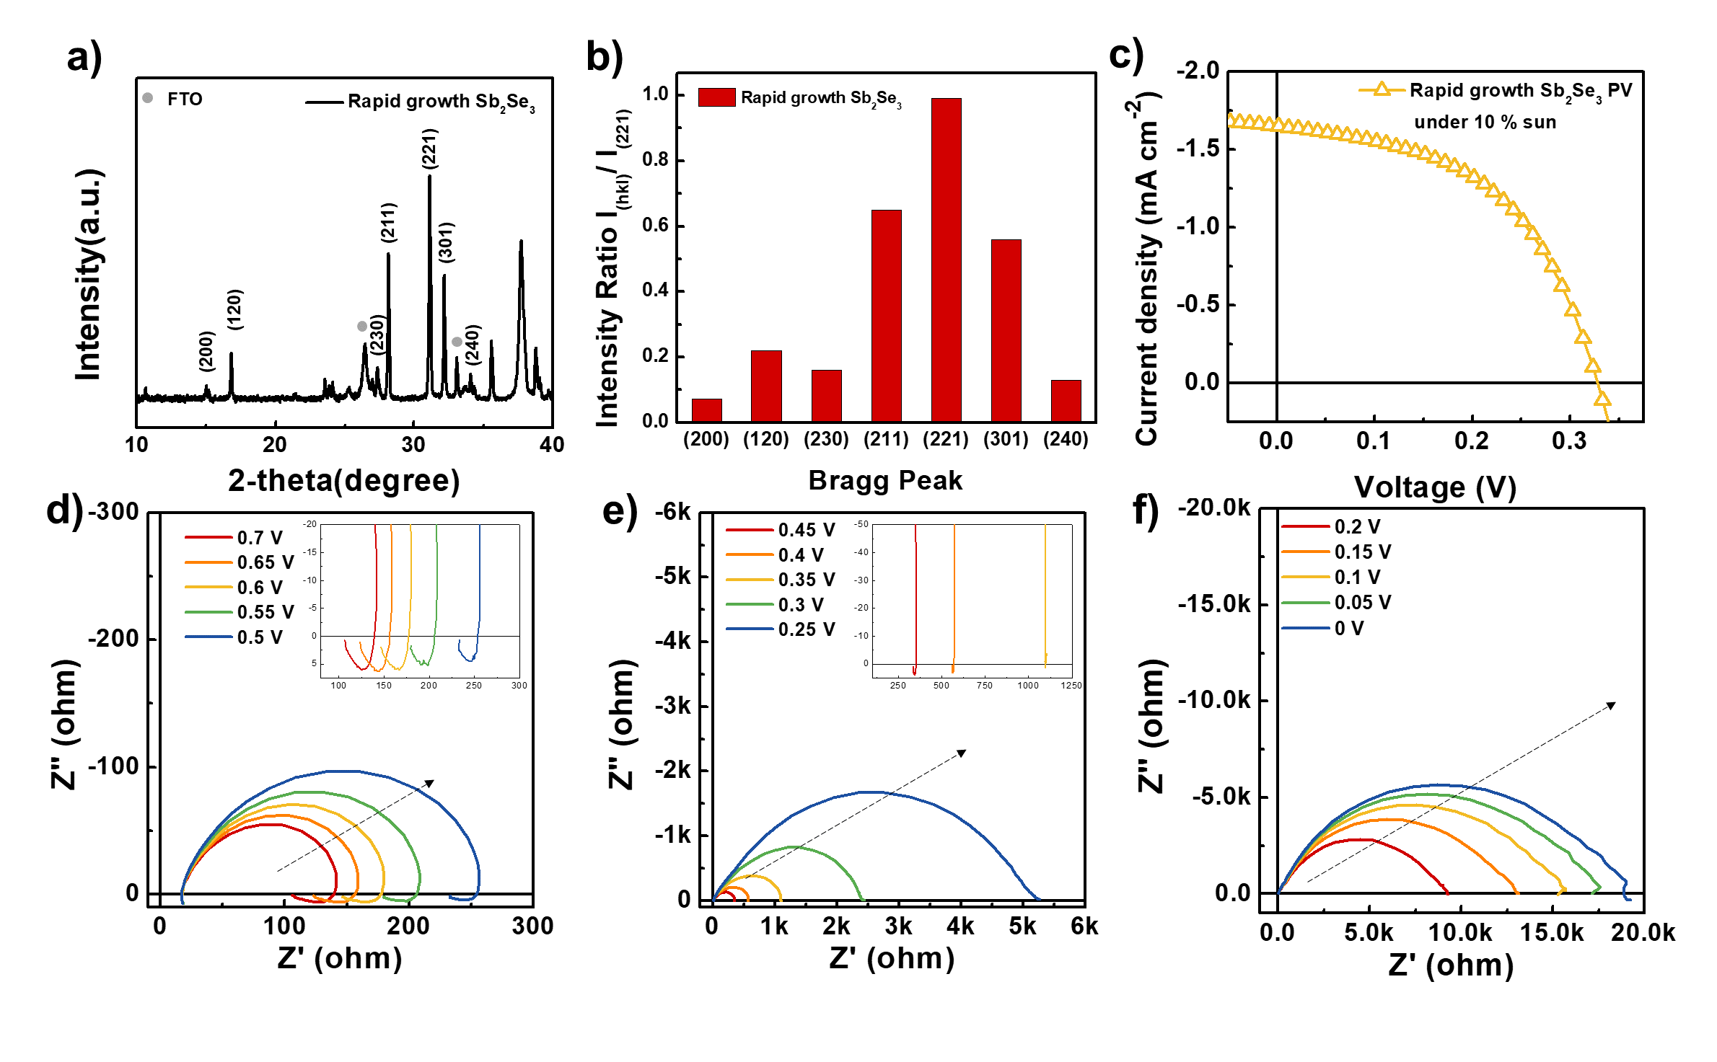

**Figure 4.** a) Diffraction patterns and b) peak intensities ratio (I(hkl)/I(221)) of the obtained rapid growth Sb2Se3 films c) Steady-state photocurrent densities obtained by the rapid growth Sb2Se3 PV during IS measurement under 10% sun illumination. d–f) Nyquist plots of the rapid growth Sb2Se3 PV at the designated applied potential.

As shown in **Figure 5**a, current densities with various LED light intensities were measured and IS spectra with higher light intensities were measured for the rapid growth Sb2Se3 PV. Increased resistance was observed as the applied potential moved toward the short circuit in all light conditions. Identical Voight circuits were used to fit the Nyquist plots and the resulting resistance, RC time constants, and capacitance were displayed in Figure 5b-d, respectively. The resistance and time constant also decreased as the light intensity increased, which proves the similar recombination-related mechanisms can be also applied in rapid growth Sb2Se3 PVs. Interestingly, a larger value of the recombination resistance was observed in the rapid growth Sb2Se3 PV than seed growth Sb2Se3 PV, which leads to having a 6.72 times longer RC time at 0 V under 100% illumination as shown in Figure 5c. As a larger recombination resistance indicates lower recombination, this phenomenon may be contradictory to the fact that the rapid growth sample exhibited a lower performance.

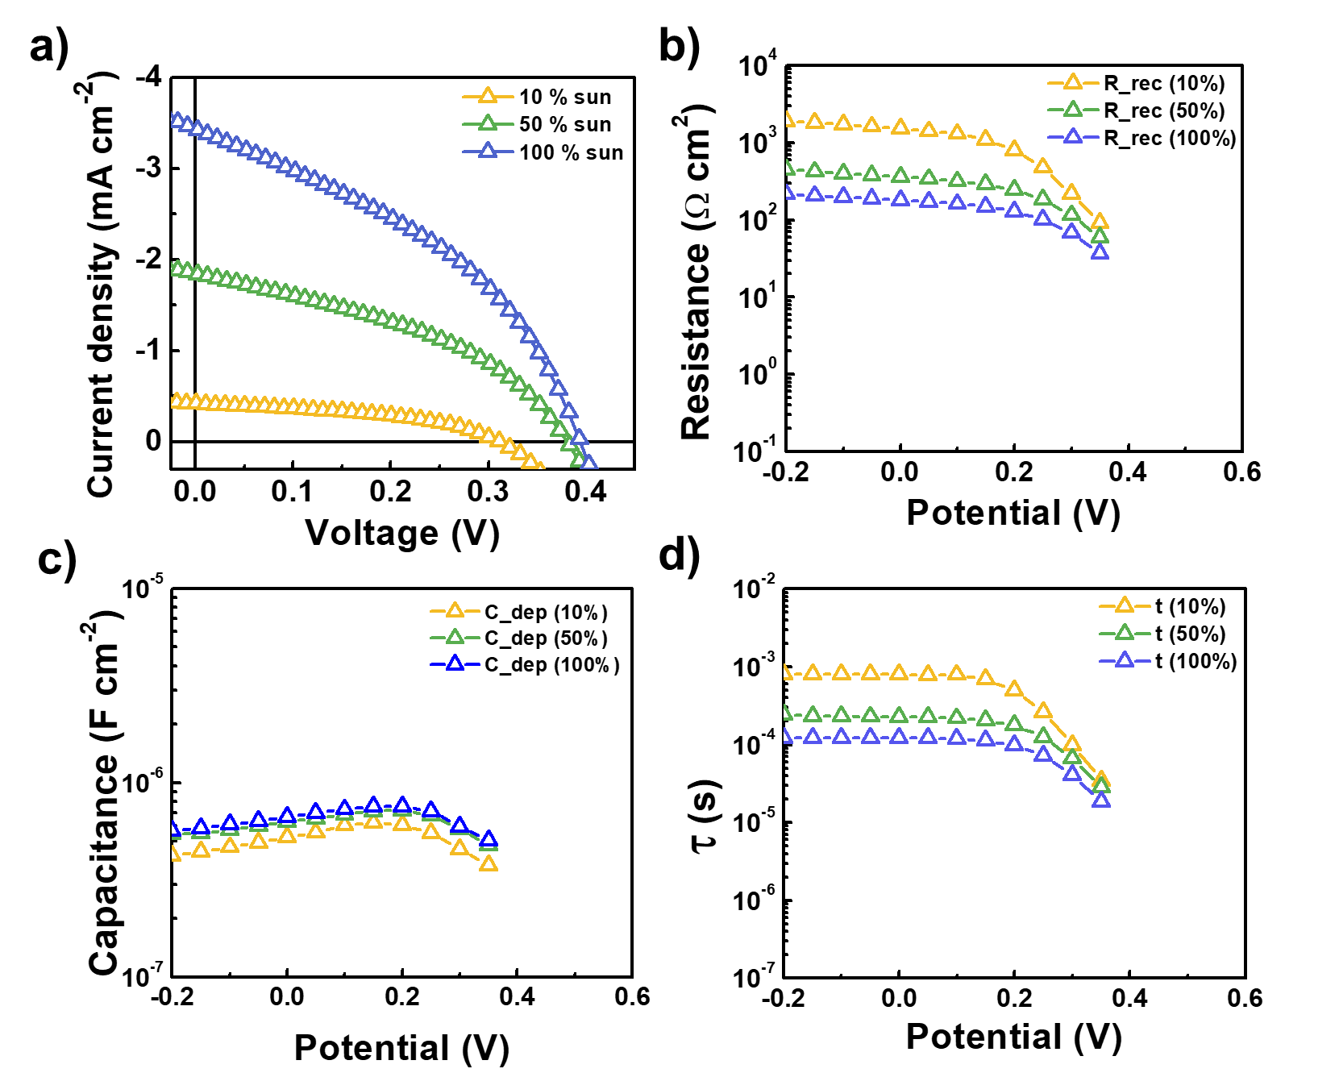

**Figure 5.** a) Steady-state photocurrent densities of the rapid growth Sb2Se3-based PV during IS measurement under 10%, 50%, and 100% sun illumination. b) Resistances, c) capacitance, and d) time constants for charge transfer of rapid growth Sb2Se3 PV from the IS fitting procedure.

A possible explanation for the longer lifetime in the rapid growth sample is the difference in the TiO2/Sb2Se3 interface. Since the time constant can be obtained by multiplying the resistance and capacitance originating from the depletion region at the TiO2/Sb2Se3, it is reasonable to assume that the calculated time constant represents the lifetime of the photo-generated charge carriers at the TiO2/Sb2Se3 interfaces. In rapid growth Sb2Se3 film, containing (hk0) plane, (Sb4Se6) ribbons lie parallel to the TiO2 layer. Hence, it is possible to form a high-quality Sb2Se3/TiO2 interface with Wan der Waals planes that has less amount of the trap site. On the contrary, more recombination centers can be created at the interface of the seed growth Sb­2Se3 film and TiO2 due to the dangling bond at the (hk1) planes. As a result, a shorter lifetime of the photo-generated carriers in the interfaces, even though carriers are readily collected in a vertical direction within the covalently bonded (Sb4Se6) ribbons along the [001] direction within Sb­2Se3 film only contains the (hk1) planes only. In other words, the interface of the rapid growth Sb­2Se3 film and TiO2 itself is better as the nanoribbons are combined with TiO2 horizontally, but the lower performance is observed because of the severe recombination derived from the pin-holes and inefficient charge transport. Therefore, a bilayer structure that is consisted of a bottom thin layer of (Sb4Se6) ribbons lie horizontally to the TiO2 layer, and the top film with vertically aligned-(Sb4Se6) ribbons having efficient charge transport and sufficient thickness to avoid pin-holes can be the ideal candidates for the optimal performance that can effectively transport the charge carrier without recombination and also passivate the interface defect.

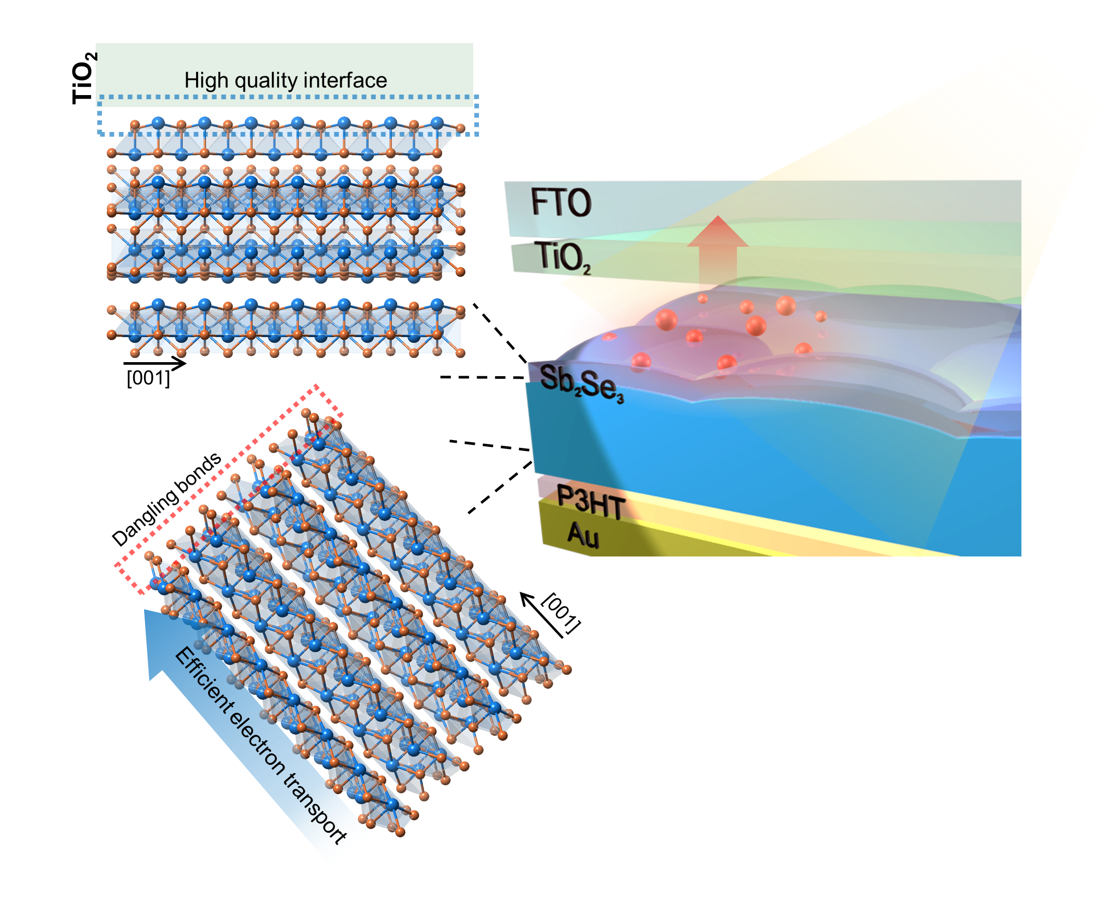

**Figure 6.** Schematic illustration of proposed novel bilayer Sb2Se3 configuration that can effectively transport the charge carrier without recombination and also form the high quality interface with TiO2 layer.

**3. Conclusions**

In summary, we performed IS characterization of Sb2Se3 PVs with two different (Sb4Se6) ribbon orientations under illumination. The seed growth Sb2Se3, having [hk1] preferred orientations, exhibited a better uniformity and performance, particularly in Jsc and efficiency. Both samples showed negative capacitance behaviors at large forward bias, indicating a trap mediate recombination pathway can be activated at the Sb2Se3/TiO2 interface regardless of the crystallographic orientation. Additionally, both samples showed a recombination-related resistance, manifested by the potential and light intensity dependencies. The seed growth Sb2Se3 revealed a smaller recombination resistance and shorter lifetime, presumably due to the terminated covalent bonds at the Sb2Se3/TiO2 interface. Based on these observations, we have proposed an ideal Sb2Se3/TiO2 interface consisting of two successive layers with different ribbon directions, parallel to the TiO2 layer for a longer lifetime and vertical to the TiO2 layer for better charge separation.

**4. Experimental Section**

*Fabrication of the Sb2Se3 PV:* The TiO2 layer was deposited on the fluorine-doped tin oxide (FTO) substrate using a ~ method. Preparation method for the Sb2Se3 thin films is identical to the previous report.[21] Seed growth Sb2Se3 ~~, Rapid growth Sb2Se3 ~~. Poly(3-hexylthiophene-2,5-diyl) (P3HT) hole transport layer (HTL) was deposited on Sb2Se3 film by~~. Finally, XX nm thickness of Au electrode was deposited on the HTL by ~. The resulting phase evolution of the Sb2Se3 films was examined using an XRD instrument (XX). The surface morphology and cross section image of the samples was obtained via field emission SEM (XX).

*Device characterization:* The photovoltaic performance of the Sb2Se3 PV was measured with ~ under irradiation from simulated AM 1.5G illumination. A standard Si reference cell was used to calibrate the 1-sun intensity. ~. Current density–voltage (J–V) scanning was performed with a dwell time of XX ms at each point over a range from −1 to 1 V at a rate of XX V s−1. The EQE was measured using ~ in the wavelength range 300–1100 nm.

*Impedance Measurements for Sb2Se3 PV:* IS measurements were performed with a BioLogic SP-300. The peak to peak AC voltage amplitude was Vpp= 15 mV (which gave a root mean square voltage Vrms= 5.3 mV) and the bias potential steps were approximately 50 mV and the equilibrium time at each bias potential step was 17 s. The frequency range used was 7 MHz to 0.1 Hz. In addition, a white light bias by LEDs (SP-12-W5, cool white Luxeon Rebel) was used for the IS measurements under illumination. The IS spectra were fitted with Zview software from Scribner.

**Supporting Information**.

Supporting Information is available from the Wiley Online Library.

Notes

**The authors declare no competing financial interests.**

**ACKNOWLEDGMENT**

This work was supported the National R&D Program through the National Research Foundation of Korea (NRF) funded by the Ministry of Science and ICT RS-2023-0025177.

References

[1] Y. Zhou, L. Wang, S. Y. Chen, S. K. Qin, X. S. Liu, J. Chen, D. J. Xue, M. Luo, Y. Z. Cao, Y. B. Cheng, E. H. Sargent, J. Tang, *Nat Photonics* **2015**, 9, 409.

[2] K. P. McKenna, *Adv Electron Mater* **2021**, 7.

[3] R. F. Tang, X. M. Wang, W. T. Lian, J. L. Huang, Q. Wei, M. L. Huang, Y. W. Yin, C. H. Jiang, S. F. Yang, G. C. Xing, S. Y. Chen, C. F. Zhu, X. J. Hao, M. A. Green, T. Chen, *Nat Energy* **2020**, 5, 587.

[4] W. Yang, J. Park, H. C. Kwon, O. S. Hutter, L. J. Phillips, J. Tan, H. Lee, J. Lee, S. D. Tilley, J. D. Major, J. Moon, *Energ Environ Sci* **2020**, 13, 4362.

[5] Y. Y. Proskuryakov, K. Durose, M. K. Al Turkestani, I. Mora-Sero, G. Garcia-Belmonte, F. Fabregat-Santiago, J. Bisquert, V. Barrioz, D. Lamb, S. J. C. Irvine, E. W. Jones, *J Appl Phys* **2009**, 106.

[6] I. Mora-Sero, G. A. Garcia-Belmonte, P. P. Boix, M. A. Vazquez, J. Bisquert, *Energ Environ Sci* **2009**, 2, 678.

[7] F. Fabregat-Santiago, J. Bisquert, G. Garcia-Belmonte, G. Boschloo, A. Hagfeldt, *Sol Energ Mat Sol C* **2005**, 87, 117.

[8] E. von Hauff, *J Phys Chem C* **2019**, 123, 11329.

[9] W. Yang, T. Moehl, E. Service, S. D. Tilley, *Advanced Energy Materials* **2021**, 11.

[10] D. Andre, M. Meiler, K. Steiner, C. Wimmer, T. Soczka-Guth, D. U. Sauer, *J Power Sources* **2011**, 196, 5334.

[11] S. M. R. Niya, M. Hoorfar, *J Power Sources* **2013**, 240, 281.

[12] B. Pejcic, R. De Marco, *Electrochim Acta* **2006**, 51, 6217.

[13] H. C. Kwon, W. Yang, D. Lee, J. Ahn, E. Lee, S. Ma, K. Kim, S. C. Yun, J. Moon, *Acs Nano* **2018**, 12, 4233.

[14] F. Ebadi, N. Taghavinia, R. Mohammadpour, A. Hagfeldt, W. Tress, *Nat Commun* **2019**, 10.

[15] J. Zhou, D. Meng, T. H. Yang, X. T. Zhang, Z. Q. Tang, Y. Cao, J. Ni, J. J. Zhang, Z. Y. Hu, J. B. Pang, *Appl Surf Sci* **2022**, 591.

[16] L. P. Guo, S. N. Vijayaraghavan, X. M. Duan, H. G. Menon, J. Wall, L. Y. Kong, S. Gupta, L. Li, F. Yan, *Sol Energy* **2021**, 218, 525.

[17] C. Liu, K. Shen, D. X. Lin, Y. Cao, S. D. Qiu, J. Z. Zheng, F. X. Bao, Y. Y. Gao, H. B. Zhu, Z. Q. Li, Y. H. Mai, *Acs Appl Mater Inter* **2020**, 12, 38397.

[18] Y. F. Liu, B. Li, X. Y. Liang, T. Liu, S. F. Wang, Z. Q. Li, *J Alloy Compd* **2023**, 932.

[19] G. Li, Z. Q. Li, X. Y. Liang, C. S. Guo, K. Shen, Y. H. Mai, *Acs Appl Mater Inter* **2019**, 11, 828.

[20] C. Chen, D. C. Bobela, Y. Yang, S. Lu, K. Zeng, C. Ge, B. Yang, L. Gao, Y. Zhao, M. C. Beard, J. Tang, *Frontiers of Optoelectronics* **2017**, 10, 18.

[21] L. J. Phillips, C. N. Savory, O. S. Hutter, P. J. Yates, H. Shiel, S. Mariotti, L. Bowen, M. Birkett, K. Durose, D. O. Scanlon, J. D. Major, *Ieee J Photovolt* **2019**, 9, 544.

[22] W. Yang, J. H. Kim, O. S. Hutter, L. J. Phillips, J. Tan, J. Park, H. Lee, J. D. Major, J. S. Lee, J. Moon, *Nat Commun* **2020**, 11.

[23] K. Shimizu, Y. Tanaka, Y. Noguchi, H. Ishii, *J Phys Conf Ser* **2017**, 924.

[24] I. Mora-Sero, J. Bisquert, F. Fabregat-Santiago, G. Garcia-Belmonte, G. Zoppi, K. Durose, Y. Proskuryakov, I. Oja, A. Belaidi, T. Dittrich, R. Tena-Zaera, A. Katty, C. Levy-Clement, V. Barrioz, S. J. C. Irvine, *Nano Lett* **2006**, 6, 640.

[25] E. Ehrenfreund, C. Lungenschmied, G. Dennler, H. Neugebauer, N. S. Sariciftci, *Appl Phys Lett* **2007**, 91.

**Impedance spectroscopy characterization of Sb2Se3 photovoltaics under light illumination**

Jaemin Park, Thomas Shalvey, Thomas Moehl, Jon Major, S. David Tilley, Wooseok Yang

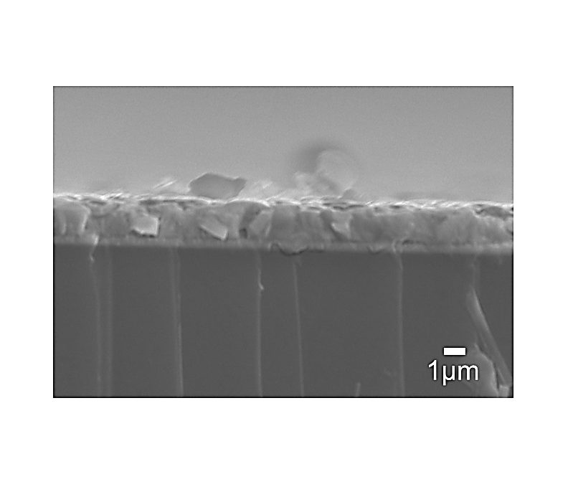

**Figure S1.** Cross-section SEM image of the seed growth Sb2Se3 film.

**Figure S2.** 81 individual Sb2Se3 PV devices in a 5x5 cm2 FTO glass.

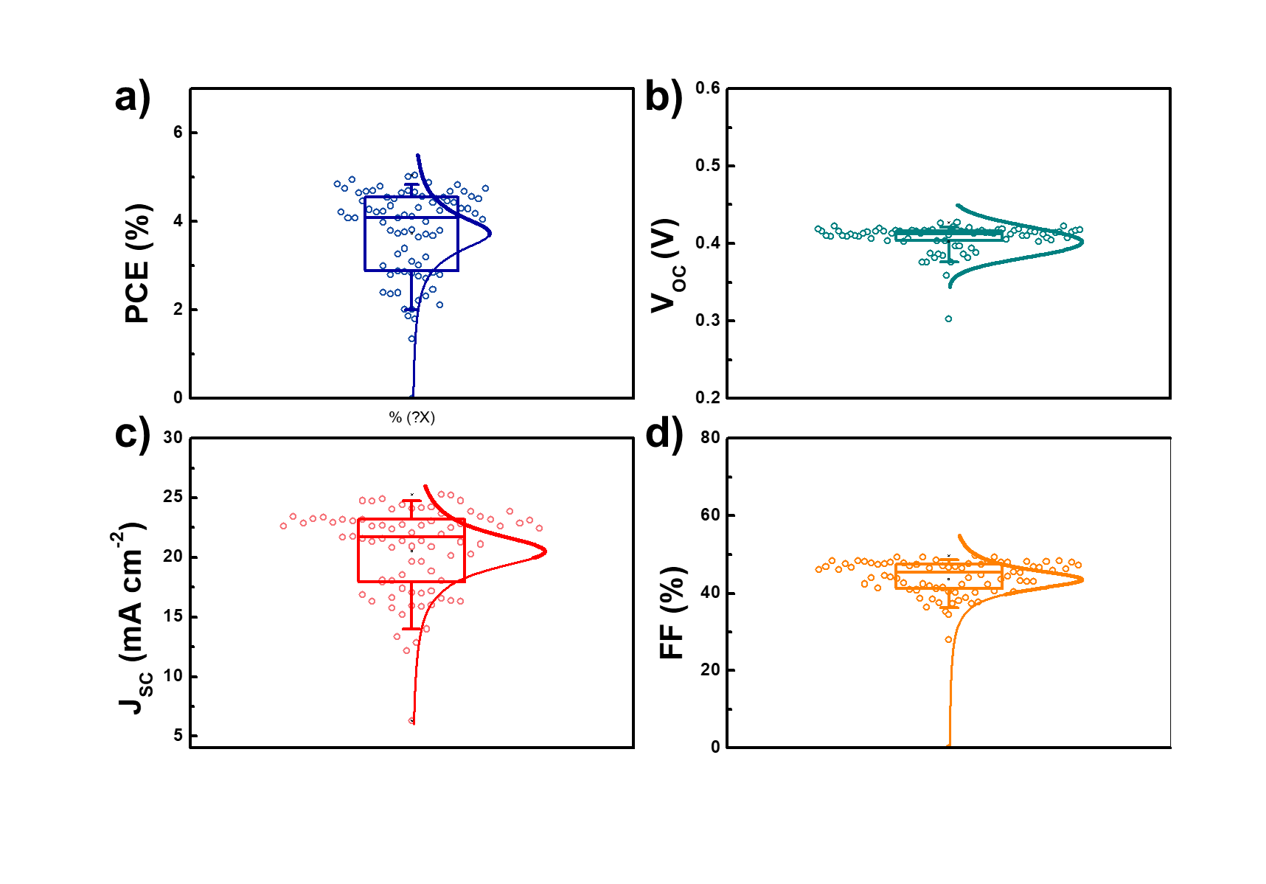

**Figure S3.** Device performance statistics of the a) PCE, b) VOC, c) JSC, and d) FF with 81 cells of seed growth Sb2Se3 PVs. The horizontal middle lines represent the median, the box edges represent the standard deviations.



**Figure S4.** Nyquist plots of the seed growth Sb2Se3 PV at 0 V under 50 and 100% light intensities.

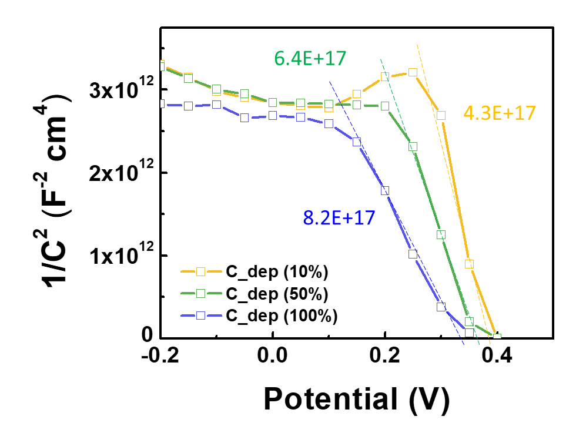

**Figure S5.** Mott-Schottky plots obtained by C_dep seed growth Sb2Se3 PVs under the 10, 50, and 100% light illumination. Doping density can be calculated from the equation S1, where $\text{ε}$ is the [dielectric constant](https://en.wikipedia.org/wiki/Dielectric_constant) of the semiconductor, �0 is the [permittivity of free space](https://en.wikipedia.org/wiki/Permittivity_of_free_space), A� is the area��, e� is the elementary charge, Nd�� is the density of dopants, V� is the applied potential, Vfb��� is the [flat band potential](https://en.wikipedia.org/wiki/Flat_band_potential), kB�� is the [Boltzmann constant](https://en.wikipedia.org/wiki/Boltzmann_constant), and T is the [absolute temperature](https://en.wikipedia.org/wiki/Absolute_temperature). Here, one-side junction is assumed due the higher doping concentration of TiO2.

= . S1)

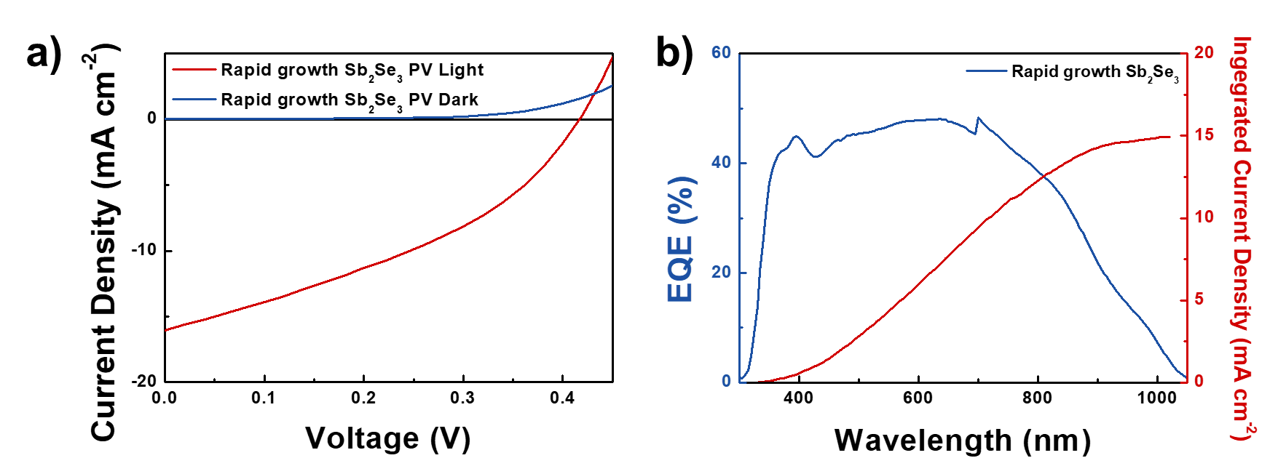

**Figure S6.** a) J–V characteristics of champion rapid growth Sb2Se3 PV. b) EQE spectra of a rapid growth Sb2Se3 based PV.

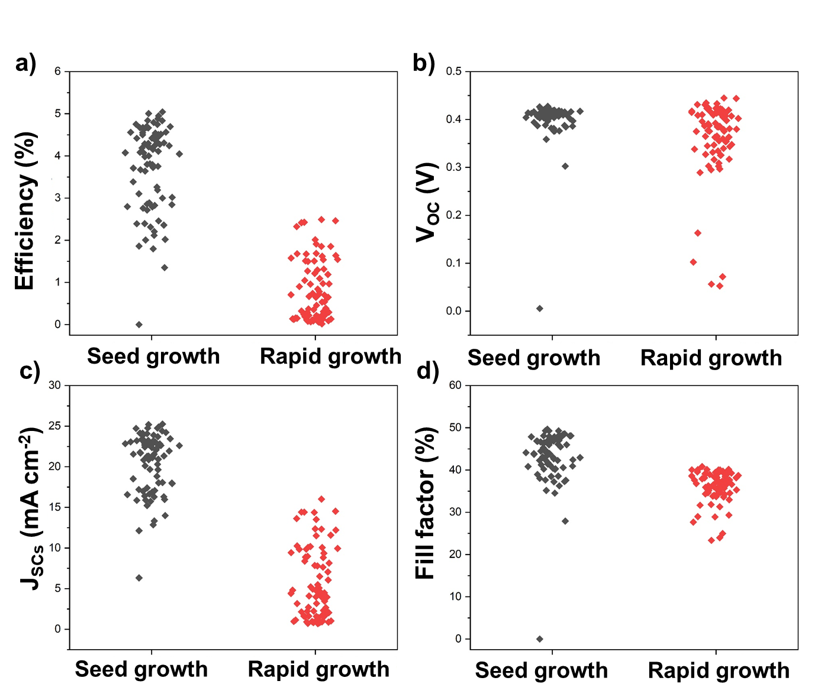

**Figure S7.** Device performance statistics comparison between seed growth and rapid growth Sb2Se3 of the a) PCE, b) VOC, c) JSC, and d) FF with 81 cells.

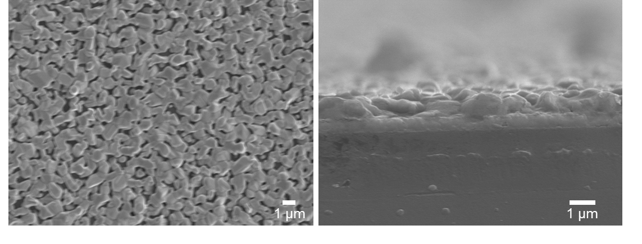

**Figure S8.** a) Top and b) cross-section SEM images of the rapid growth Sb2Se3 film.