Current word count: 4,413; Tables: 4; Figures: 3; Supplementary Files: 4; References: 46

TITLE: ‘Knowledge exchange’ workshops to optimise development of a risk prediction tool to assist conveyance decisions for suspected seizures – Part of the Risk of ADverse Outcomes after a Suspected Seizure (RADOSS) project.

AUTHORS: Adam J. Noble,¹ Beth Morris,¹ Laura J Bonnett,² Markus Reuber,³ Suzanne Mason,⁴ Jasmine Wright,⁵ Richard Pilbery,⁶ Fiona Bell,⁶ Tom Shillito,⁷ Anthony G. Marson,⁸ Jon M. Dickson.⁹

AUTHOR AFFILIATIONS:
¹ Department of Public Health, Policy and Systems, Institute of Population Health, University of Liverpool, Liverpool, UK.
²Department of Health Data Science, Institute of Population Health, University of Liverpool, Liverpool, UK.
³ Department of Neuroscience, School of Medicine and Population Health, University of Sheffield, Sheffield, UK.
⁴ Sheffield Centre for Health and Related Research, School of Medicine and Population Health, University of Sheffield, Sheffield, UK
⁵ Public contributor, UK.
⁶ Yorkshire Ambulance Service NHS Trust, Wakefield, UK.
⁷ Epilepsy Action, Leeds, UK.
⁸ Department of Pharmacology and Therapeutics, Institute of Systems, Molecular and Integrative Biology, University of Liverpool, Liverpool, UK
⁹ Population Health, School of Medicine and Population Health, The University of Sheffield, Sheffield, UK.

CORRESPONDING AUTHOR:
Dr Adam J. Noble, Department of Public Health, Policy and Systems, Institute of Population Health, Whelan Building, University of Liverpool, UK, L69 3GL. E-mail: adam.noble@liverpool.ac.uk; Tel: +44 (0)151 794 5993.

KEWORDS: seizure, ambulance, paramedic, risk prediction, stakeholder participation, uncertainty

ABSTRACT
Purpose: Suspected seizures present challenges for ambulance services, with paramedics reporting uncertainty over whether or not to convey individuals to emergency departments. The Risk of ADverse Outcomes after a Suspected Seizure (RADOSS) project aims to address this by developing a risk assessment tool utilizing structured patient care record and dispatch data. It proposes a tool that would provide estimates of an individual's likelihood of death and/or recontact with emergency care within 3 days if conveyed compared to not conveyed, and the likelihood of an 'avoidable attendance' occurring if conveyed. Knowledge Exchange workshops engaged stakeholders to resolve key design uncertainties before model derivation.

Method: Six workshops involved 26 service users and their significant others (epilepsy or nonepileptic attack disorder) , and 25 urgent and emergency care clinicians from different English ambulance regions. Utilizing Nominal Group Techniques, participants shared views of the proposed tool, benefits and concerns, suggested predictors, critiqued outcome measures, and expressed functionality preferences. Data were analysed using Hamilton’s Rapid Analysis.

Results: Stakeholders supported tool development, proposing 10 structured variables for predictive testing. Emphasis was placed on the tool supporting, not dictating, care decisions. Participants highlighted some reasons why RADOSS might struggle to derive a predictive model based on structured data alone and suggested some non-structured variables for future testing. Feedback on prediction timeframes for service recontact was received, along with advice on amending the 'avoidable attendance' definition to prevent the tool’s predictions being undermined by potential overuse of certain investigations in hospital.

Conclusion: Collaborative stakeholder engagement provided crucial insights that can guide RADOSS to develop a user-aligned, optimized tool.

(260 words)

INTRODUCTION
Suspected seizures are a common presentation to English ambulance services,[1-3] and paramedics say it can be challenging to decide which patients presenting with a suspected seizure should be conveyed to hospital.[4-7] RADOSS [8] aims to address this knowledge gap by developing a risk prediction tool to assist paramedics. In this paper, we report on findings from a series of Knowledge Exchange (KE) workshops attended by stakeholders to optimize tool development.
While suspected seizures can be dramatic and life-threatening, most cases attended by the ambulance service are uncomplicated manifestations of established conditions, mainly epilepsy and non-epileptic attack disorder (NEAD).[1, 2, 9] Conditions such as syncope, alcohol withdrawal, head injury, and hypoglycaemia account for the remaining minority of suspected seizure incidents.[2]
Despite the typically uncomplicated nature of suspected seizure incidents,[3] ~70% are conveyed to emergency departments (EDs) [1, 2, 9] and can result in 'avoidable attendances’. Avoidable attendances, as defined by England's National Health Service using O’Keeffe et al.’s criteria [10] (Table 1), are undesirable as they can increase demand on ambulance services, contribute to overcrowding in EDs, cause patient harm and are costly. [11] [12, 13] [14]
Decisions whether to convey a patient to hospital can be influenced by factors beyond clinical need.[15, 16] Some paramedics say they struggle to identify cases suitable for non-conveyance and want help in identifying the risks and benefits of conveying and not conveying individuals.[4-7] RADOSS seeks to address this by developing a risk prediction tool. Such tools use ≥2 pieces of patient data to generate a personalised estimate of the likelihood that an individual will experience certain endpoints within a
specified time frame.
RADOSS proposes the new tool provides estimates of two outcomes known to feature in paramedics’ decision making [17] – namely, likelihood of death and/or recontact with the urgent and emergency care system (within 3 days), as well as the likelihood of an attendance meeting the definition of an avoidable attendance if conveyed. The tool could be deployed when paramedics manage cases that do not present an obvious need for conveyance to ED.[3] Such tools show benefit in analogous situations. Moreover, paramedics use them for other presentations [3] and have expressed a desire for more tools like this to aid decision making.[18]
To support the development of robust risk prediction tools and facilitate use, statistical standards are available.[19] However, health innovations may not be adopted if user and recipient need, preference and workflow are not considered.¹⁹ With this in mind, four aspects needed exploration with stakeholders.
The first was perceived need. Both service users and clinicians have articulated the necessity for change (see[20]). Nevertheless, their perspectives regarding the potential of a risk prediction tool to meet this need, along with any associated concerns and expectations, remained unexplored.
The second was which items to test for inclusion in the tool, here referred to as ‘candidate predictors’. Whilst ‘on-scene’, paramedics lack access to a patient’s full medical record. What is available is the information they record within structured fields on the patient's care record (PCR) and what was recorded by call handlers in computer aided dispatch (CAD) systems. Lots of this information could potentially predict outcomes. However, there are statistical limits on how many variables RADOSS can test.[21] Insights from individuals with lived and clinical experiences, including expected strength of association with the outcomes, reliability, and accessibility during conveyance decision-making, could inform RADOSS’ selection for testing and subsequent prioritization.
The third area pertained to outcome measures. It was necessary to understand whether RADOSS’ definitions of them were considered suitable by clinicians to guide their decisions.
Finally, it was necessary to start to understand clinicians’ preferences for tool functionality and implementation. This exploration is particularly significant as clinicians' preferences could influence model derivation, including considerations like limits on variables clinicians are willing to input.
To address these knowledge gaps, KE was completed with urgent and emergency care clinicians (comprising of ambulance service paramedics and ED clinicians), service users, and their significant others.

METHODS
Design
Six KE workshops were conducted. Their design, led by Wilkins and Cooper's [22] KE definition, focused on a two-way exchange between researchers and research users. To secure comprehensive insights [23] and facilitate recruitment, an online group format was chosen. Reporting conforms with the Standards for Reporting Qualitative Research.[24]

Participants
Purposive and diverse samples of 20-30 service users and 20-30 clinicians were sought.
Service users needed to be aged ≥18 years and self-report having had contact with the ambulance service during the prior 12 months for a suspected seizure or be a significant other to a person who had (Table 2). They were identified by three patient groups affiliated with the target population circulating recruitment advertisements in March 2023: ‘FND Hope’ shared the study advert twice on their public social media platforms; ‘Epilepsy Action’, as well posting on social media twice, advertised the study on their volunteering and study opportunities webpages (see Acknowledgements); and finally, ‘Speak up Advocacy’ (Sheffield), a group run by and for people with learning disabilities and autistic people, sent the study advert to its members. All persons interested in participating conducted our study team by email or phone. The team confirmed individuals’ self-reported eligibility, sent them a Participant Information Sheet, answered any questions they had and secured written, informed consent. No medical records were accessed to confirm a person’s eligibility to participate, nor their diagnosis/es.
Eligible urgent and emergency care clinicians, comprised of ambulance service paramedics, or ED doctors and nurses (Table 2). To aid recruitment, England’s 10 regional ambulance services and the Royal College of Emergency Medicine Yorkshire and Humber board were asked to circulate an advertisement. Adverts were also placed within Facebook interest groups (Acknowledgements).

Ethics
The Health Research Authority (23/HRA/1439) and University of Liverpool Ethics Committee approved the study (11450). Participants were offered a £10 voucher.

Procedure
Workshops for service users and clinicians ran separately. All were facilitated by BM, a qualitative health services researcher. LJB was present at clinician workshops to assist with statistical questions. AN was at service user workshops to offer support.
Topic guides were developed on the basis of the literature [25] and uncertainties regarding the tool’s future implementation,[26] and were piloted with 8 service users (Supplementary File 1). Nominal Group Techniques[27] were used to facilitate open and constructive sharing and discussion of views.
Figure 1 shows workshop structure. They started with a presentation to orientate participants to the proposed tool (Supplementary File 2).
To gather predictor suggestions, service users and clinicians were presented with a slide displaying the information routinely recorded within structured data-fields and accessible to paramedics whilst ‘on scene’. Service users were asked which might indicate care needs following a seizure; clinicians were asked which might predict the likelihood of the outcomes. They could make suggestions for the outcomes separately or collectively. Groups were also asked to provide suggestions not included on the slide. All service user responses were recorded ‘live’ on screen by AN within a table (Supplementary File 1).
With participants’ consent, workshops were audio-recorded and transcribed. Participants did not review transcripts.

Analysis
Candidate predictors
The objective was to generate a list of candidate predictors prioritised by service users and a list for clinicians. Thus, for service users BM extracted the tables generated by their workshops and merged them. For the clinician list, BM reviewed transcripts, extracting candidate suggestions. All suggestions were classified according to whether they are captured within structured ambulance electronic PCR/ CAD data-fields (Table 3 footnotes gives further detail).

Perceived need, candidate justification and views on functionality/ implementation
Qualitative findings on these topics needed to be analysed with high methodological rigour but swiftly enough to inform model derivation. Thus, we employed Hamilton's Rapid Analysis method.[28] Instead of line-by-line coding, analysts review transcripts, populating a 'summary template' for each data collection episode with relevant data segments, creating 'episode profiles'.
For RADOSS, Rapid Analysis involved BM and AN independently populating a summary template for each workshop and then holding consensus meetings to consolidate their work and create a final, populated template for each. Templates were generated a priori (Supplementary File 3) and included domain headings based on the topic guide.
Matrices helped to support the identification of similarities, differences and trends across workshops and informants.[29] Aggregated results were presented to the wider team to facilitate cross-checking before finalisation and decisions being taken about their implications for the project.
Illustrative quotations from participants (P) are provided, with Supplementary File 4 providing additional ones. There has been minor editing of some to preserve anonymity and ensure clarity.

RESULTS
Participants
From 47 eligible service users responding to the advert, 33 were available for, and booked in to attend a workshop. A total of 26 ultimately participated (17 females, 9 males; aged 18 to 85). They included, 18 people with diagnosed seizure disorders and 8 significant others. Service users came from 7 of England’s 10 ambulance regions. Figure 2 shows the recruitment process, workshop details and composition of the groups.
From 60 clinicians contacting us, 32 were available for, and booked in to attend a workshop. A total of 25 ultimately participated (15 females, 10 males). They included 19 paramedics (from 6 ambulance regions) and 5 ED consultant doctors and 1 ED doctor in training (from 6 EDs).
Service user workshops occurred in April 2023, lasting 74 to 132 minutes, while clinician workshops occurred in June 2023, lasting 82 to 91 minutes.

Perceived need
Anticipated benefits
Service user and clinician participants supported the proposed tool’s development. Clinicians were keen for additional support for what they identified as complex decisions:
“We have to make decisions based on a patient presentation who has been with us for 30 minutes… in ED …they get…longer…It can be difficult.” (P31; Male, paramedic)
Service users shared instances of important care interventions by the ambulance service. Most though, said their prevailing experience was transport to ED when they believed it was not required. They felt the tool might mitigate against knowledge gaps they perceived some paramedics to have which contributed to this:

” I agree I think it’s a good thing…The number of paramedics that have pulled a phone out and ‘Googled’ what is NEAD...is frankly alarming... some…have been a bit shaky with epilepsy as well.” (P7; Female, person with epilepsy and NEAD)
Service users emphasised ED visits when not required were not ‘risk-free’. Indeed, some said there was a need to “de-medicalise” uncomplicated seizures:

“Need to recognise that going to ED when not necessary can be stressful which itself can elicit further seizures. When I wake up and find myself in ED it can be really distressing…” (P21; Male, person with epilepsy)

Potential concerns
Service users and clinicians did not want risk estimate/s from the proposed tool to dictate care choices. Rather, they wanted them to be one, albeit important, piece of information accounted for. Service users wanted their preferences to be heeded:

“the experience of the persons experiencing the seizures and the carers should not be dismissed... if paramedics had more experience than me, I would fall off my chair…” (P5; Female, significant other to person with epilepsy and NEAD).

Most clinicians said paramedics needed to still be permitted to use their judgement since there may be additional factors of importance:

“You still need to be allowed to use judgement…the tool assumes there is a safe alternative for those who on paper don’t need to have come to ED…it isn’t always available or possible...” (P41; Female, ED clinician)

Candidate predictors
Variables routinely available to paramedics at the time and recorded within structured fields
Stakeholders together suggested ten variables or variable ‘families’ which might be predictive of the likelihood of death/ recontact and occurrence of an avoidable attendance (Figure 3). These included, but were not limited to, vital signs, presence of a learning disability, incident time, location, who made the call and treatments provided. There was partial overlap in clinician and service user suggestions. Table 3 shows the reasons participants offered for their potential importance.
In certain instances, the variable was suggested to indicate a need for additional investigation or treatment in ED (e.g., significant injury, neurological deficit). In other cases, it complicated paramedics’ understanding of the person’s needs (e.g., caller identity) or limited their ability to provide care beyond ED (e.g., time of day). Although clinicians were encouraged to propose predictors for the two outcomes separately, most did not.

Variables not routinely available to paramedics at the time and/or not recorded within structured fields
Participants suggested 16 variables not currently captured within structured PCR data fields that might also be predictive (Figure 3). They included seizure type, presence of a witness, availability of alternative care options and the attending paramedic’s experience. Table 3 shows stakeholders’ reasons.
Clinicians mentioned that paramedics could record information on some of the variables in PCR free-text sections. The implications of RADOSS not accessing this information were debated. Some considered it a limitation, while others saw it as less significant. The latter argued that it does not reflect what is available to paramedics during conveyance decisions.

“…think how paramedics fill in the PCR…demographic information gets ‘pulled’ straight away… next thing is…the observations and…primary survey…. These might not be the most useful variables, but they’re the ones filled in…when…deciding whether to take them to hospital… If you are getting to the stage where you’re writing your free text up… you’re already in the ‘headspace’ of your…conveyance decision” (P51; Male, paramedic)

Matters complicating deriving a predictive tool
Clinicians and service users identified things they said might make it challenging to derive a model able to make precise predictions.
The first was some patients may be given inappropriate care. Thus, the information recorded on the PCR about the incident may not reflect patient need. The example participants gave was medication being inappropriately given to people with NEAD:

“….with the FND [functional neurological disorder] seizures I’ve been given diazepam a few times…that just makes it worse…” (P15; Female, person with epilepsy and NEAD)

Another reason the PCR might not reflect patient need was measures used by the ambulance service might not be sufficiently sensitive to differentiate between presentation severity:

“….[measures like the] Glasgow Coma Scale are not always the best tools…someone who’s post-ictal could have a GCS hovering around 13,14… for say 20 minutes. During that 20 minutes you are…seeing them becoming less postictal, but the GCS is still hovering at 14.” (P44; Male, paramedic).

A third challenge was potential inaccuracy of some information recorded within structured PCR/CAD fields. Inaccuracies could arise from information offered by bystanders and patients themselves:

“…people misinterpret, misunderstand, particularly observers…I’ve asked people at work [witnessing the same seizure] to describe it… You wouldn’t believe the variation you get in stories…...” (P22; Female, person with epilepsy)

“…I’ll often be saying something in the post-ictal phase, but it’s not what I think I’ve said.” (P24; Male, person with epilepsy)

A final issue participants said might complicate matters was that certain presentation features have different implications for care needs, depending on the person’s seizure disorder. An example provided by participants was the meaning of seizure activity:

“…With dissociative seizures I’ve had a seizure for 45 minutes…if that was epilepsy you would go straight to hospital whereas you wouldn’t necessarily need to go if it is a dissociative seizure...Its not just a list of things.” (P14; Female, person with epilepsy and NEAD)

For these reasons, participants discussed whether the tool should consider a person’s seizure diagnosis initially. However, most acknowledged that paramedics typically lack access to a person’s medical history for this purpose. Some users shared their efforts to overcome this, while those with recent diagnoses were surprised by the lack of routine access.

“Is that not something they [the ambulance service] have in place? I would have thought that would have been in place ‘donkeys years’ ago…that sounds crazy… (P23; Female, person with NEAD)

Outcome measures
Clinicians confirmed the outcomes’ importance. However, they raised issues with regards their proposed definitions.

Death and recontact
They advised that the significance of death and service recontact is not equivalent and so alongside the combined risk estimate, they said it would be prudent to articulate the proportion experiencing each element:

“…I think if you’re gonna use in the tool the words ‘death within three days’ it suddenly adds a massive emphasis…on risk…there’s a… difference between recontact and death….” (P44; Male, paramedic)

With regards service recontact, clinicians advised that it would be important for those using the tool to know what types of service recontact are and are not included (e.g., whether it needs to be seizure related).
They debated the suitable time frame for events post-incident, focusing on the duration within which recontact could be reasonably linked to previous care. Opinions varied. Some suggested 24 hours, others 3 days, and a minority 30 days. Some paramedics hesitated to offer suggestions, citing limited feedback on outcomes after ambulance care, hindering the formation of opinions. It was proposed that a range of estimates might be appropriate.

“…it would bother me less if they…recontacted at 3 days…But yeah, 24 hours and under…I would say I would probably think that I’ve…made a mistake.” (P31; Male, paramedic)

“…3 days in the kind of the grand scheme…is probably quite a short amount of time…for us to potentially being basing our decision making on it….I think…30 day[s]…” (P38; Female, paramedic)

Avoidable attendance
Concerning avoidable attendance, clinicians highlighted that a potential drawback in O’Keeffe et al.’s [10] criteria was its assumption that all recorded investigations, treatments, and admissions from ED were clinically ‘appropriate.’ They observed that some tests be administered for reasons beyond necessity for seizures, particularly blood tests and intracranial imaging. The former might be routinely collected to try to reduce patient waiting time. The latter could be overused due to staff misunderstanding. Clinicians stressed the importance of exploring and accounting for these issues if necessary.

“…tests can be done purely because somebody has arrived at the front door...might be because there's ‘preloading’….might be because an F2 [trainee doctor] sees that patient rather than a consultant….Also, there’s variation up and down the country…” (P27; Male, ED clinician)

To a lesser extent, it was also noted that the time and day on which a person visits an ED might be important, since it might impact likelihood of hospital admission:

“I think time of day people attend…and um day of week people attend…It's far harder to discharge someone at 3:00…in the morning, then is it at 3:00…in the afternoon.” (P33; Female, ED clinician).

Tool functionality and implementation
Clinicians provided a range of insights about their preferences. Table 4 details them.
Regarding functionality, a crucial aspect was the number of variables paramedics would input willingly, with the upper limit being ~10. This, however, depended on input complexity. Integrating the tool into electronic PCR systems, they noted, could eliminate any cap by allowing for ‘auto-population.’
Clinicians recommended additional features for the tool’s estimates, noting that the risk tolerance of clinicians might differ from that of service users. They suggested contextualizing risk estimates, color-coding them with ‘traffic lighting,’ and prompting clinicians to discuss these estimates with service users.

“…as clinicians we’re quite risk averse…the risks…we would take on behalf of patients are smaller than the risks patients…take for themselves, they’re more likely to say, yeah, that’s alright….” (P41; Female, ED clinician)

After development, clinicians suggested actions to increase uptake, emphasizing the importance of national ambulance guideline recommendation and regional service endorsement. They stressed the need to optimize alternative care pathway provision due to existing disparities among areas, potentially hindering widespread use.

“…what's good is that if somebody comes to my ED with a seizure…they get a referral to our neurology centre and they get reviewed…you don't want to set something up that is then detrimental to care….” (P27; Male, ED clinician)

DISCUSSION
Main findings and implications
Novel KE workshops were conducted with stakeholders. These provided important insights into service user and clinician priorities for the proposed risk prediction tool and indicated actions RADOSS can take to optimise how it intends to develop it.

Need and anticipated benefits
The first piece of important evidence related to need and anticipated benefits. Given tools should be developed to meet an identified need,[30] it was important to find that, in line with the preliminary evidence instigating RADOSS, that stakeholders supported tool development. They articulated anticipated benefits. Paramedics hoped it could enhance support for a complex decision. Service users believed it could address knowledge gaps they perceived paramedics had which contributed to perceived over-conveyance.

Candidate predictors
Stakeholders were shown the information routinely recorded within structured data-fields and accessible to paramedics whilst ‘on scene’. They discussed which items should be considered for testing. Ten were suggested, which clinicians also identified as being the maximum number it would be reasonable to expect a clinician to input.
Some were proposed by both users and clinicians, others were not. Some might have been possible to identify as candidates on the basis of the literature (e.g., vital signs, significant injury),[10, 15, 31] others could not have been (e.g., who made the call, presence of learning disability). This emphasizes the value of engaging with stakeholders and learning from their lived and clinical experience. RADOSS will seek to test all these suggestions, not least because a tool’s adoption can be hindered if it fails to account for factors users consider important.[32, 33]

Concerns
The workshops surfaced potential concerns. A starting assumption of RADOSS, aligned with the tenets of ‘person-centred care’, was that the proposed tool would support care decisions, not impose them. This was shared with participants via the presentation. Nonetheless, stakeholders primary concern was whether clinical judgement and patient preference would still factor in decisions. This emphasises the issue’s importance to stakeholders and that going forward, RADOSS needs to better communicate the tool’s assistive role.
Another reason such messaging is important relates to care plans and the seizure management instructions they contain. Should a paramedic find themselves with access to both the tool and a patient’s care plan, the latter should be prioritized as it will be more individualised. However, it is noteworthy that care plans, especially ones accessible to paramedics, remain uncommon. Paramedics describe finding such items as “like striking gold”.[6]

Outcome definitions
Clinicians clarified what adjustments should be made.
Concerning death and recontact, RADOSS proposed estimating their incidence within 3 days. Since death is rare (<1% of cases),[34] for statistical reasons, we anticipated combining it with service contact (~12% of cases within 3 days).[35] Clinicians advised that the tool should, in providing the combined estimate, also state the proportions experiencing the two types of events to guard against inadvertently facilitating risk averse decisions.
No consensus on the suitable prediction timeframe for death/service recontact emerged. To address varying perspectives, stakeholders recommended a risk dashboard with different time frames. Consequently, the RADOSS will estimate death/recontact within 3 days via its primary analysis and 1 and 30 days via secondary analyses.
Regarding avoidable attendances, O’Keeffe’s[10] criteria assumes all ED investigations and treatments are appropriate. Stakeholders noted potential overuse of intracranial imaging and full blood panel testing. The latter has not been identified before for UK EDs.[36] RADOSS needs to address these investigations’ use to prevent under classification of attendances as avoidable, compromising the tool’s utility. RADOSS will thus compare the proportion of conveyed incidents in the derivation dataset classified as "avoidable” when said investigations are considered versus when they are not. If a substantial difference (≥15%) is observed, the avoidable attendance definition will be amended to exclude these investigations.

Functionality/implementation
If RADOSS can create a validated tool, stakeholders provided insights on desired functionality and strategies to enhance uptake. Suggestions encompassed embedding the tool within electronic PCR systems and utilizing colour coding for interpretation. While more detailed input, such as preferences for risk information visualization, is needed before finalizing the tool,[25] the obtained evidence is proportionate to the development stage.

Future research
Within the wider literature, information routinely recorded by paramedics within structured fields has been found to help predict other outcomes (e.g.,[37]). Whether it can help predict the outcomes of interest to RADOSS remains to be determined. Stakeholders did pinpoint challenges for RADOSS in deriving a precise prediction model. However, they also proposed additional factors, currently absent from structured data fields, for future research consideration to potentially enhance the model (e.g., paramedic’s years of experience,[38] seizure type, duration). Information on some of these might be found in the PCR’s free-text section. If RADOSS indicates structured data alone is insufficient for predictions, then the case for accessing this free-text, which is complicated by its potential inclusion of patient identifiers,[39] may be strengthened.
Stakeholders proposed we test vital signs for their predictive value. Paramedics are expected to document at least one set of recordings of them. Others may be taken. RADOSS shall test both initial and any subsequent sets. If RADOSS identifies the latter as warranting inclusion in the predictive model, then future research should explore to what extent this means the tool is asking for information not available when conveyance decisions are being made. To help with this, RADOSS will quantity the proportion of cases in the derivation data set with more than one set of recordings, the typical time between them and the extent of change seen.

Strengths and limitations
The study's strengths encompassed a novel, transparently reported KE approach, efficiently engaging stakeholders in discussing complex topics. Standardized background sharing and diverse workshop group compositions were noted strengths. [40] Trade unions representing different health professions, including ambulance staff and junior doctors, undertook periods of strike action of varying durations when recruitment for our study occurred.[40] Recruitment success in the midst of this is thus notable. However, we did not recruit any nurses. This might have limited insights from the workshops. We also did not include users who presented to the ambulance service for a suspected seizure instigated by a cardiogenic event (which account for ~10% of incidents).[2], nor cardiology specialists.
Qualitative data analysis employed a version of ‘Rapid Analysis’. Such approaches are gaining popularity in implementation science for their efficiency,[41] delivering results in significantly less time than traditional approaches.[42, 43] It proved effective for RADOSS. However, Rapid Analysis does have potential trade-offs. Its more deductive nature may not uncover all relevant findings, as indicated by Taylor et al.[43], who found that it generated ~70% of the same findings compared to thematic coding. Our use of Rapid Analysis does not though, preclude other types of engagement with the data in the future.

Conclusions
By working collaboratively with stakeholders, this study has secured novel information that better positions the project to successfully derive a predictive model and maximise uptake of any tool ultimately based on it.

Acknowledgements
The authors would like to express their gratitude to those persons who so willingly took part in this study and thank Epilepsy Action, FND Hope, Speakup Self Advocacy, Emergency Medicine, UK NHS Paramedics /EMT Frontline and Paramedic CPD for circulating recruitment adverts. They would also like to thank the members of the Study Steering Committee: Professor Niro Siriwardena (chair), Mrs Jayne Burton, Mrs Carol Jackson, Mr Graham Jackson, Ms Kim Kirby, Dr Benjamin Thomas and Professor Arjune Sen. The study sponsor is the Yorkshire Ambulance Service (yas.research@nhs.net) .

Funding
This project is funded by the National Institute for Health Research (NIHR) Research for Patient Benefit (RfPB) programme (reference NIHR203530).

Disclaimer
The views and opinions expressed herein are those of the authors and do not necessarily reflect those of the University of Liverpool, the RfPB programme, the NIHR, the NHS or the Department of Health and Social Care.

Competing interests
None declared.
REFERENCES
[1] Dickson JM, Asghar ZB, Siriwardena AN. Pre-hospital ambulance care of patients following a suspected seizure: A cross sectional study. Seizure 2018;57: 38–44.
[2] Dickson JM, Dudhill H, Shewan J, Mason S, Grünewald RA, Reuber M. Cross-sectional study of the hospital management of adult patients with a suspected seizure (EPIC2). BMJ Open 2017;7: e015696.
[3] Joint Royal Colleges Ambulance Liaison Committee/ Association of Ambulance Chief Executives. JRCALC Clinical Guidelines Bridgwater: Class Professional Publishing; 2019.
[4] Burrell L, Noble A, Ridsdale L. Decision-making by ambulance clinicians in London when managing patients with epilepsy: a qualitative study. Emergency Medicine Journal 2013;30: 236–240.
[5] Kinney MO, Hunt SJ, McKenna C. A self-completed questionnaire study of attitudes and perceptions of paramedic and prehospital practitioners towards acute seizure care in Northern Ireland. Epilepsy & Behavior 2018;81: 115–118.
[6] Noble A, Snape D, Goodacre S, Jackson M, Sherratt F, Pearson M, Marson A. Qualitative study of paramedics’ experiences of managing seizures: a national perspective from England. BMJ Open 2016;6: e014022.
[7] Sherratt F, Snape D, Goodacre S, Jackson M, Pearson M, Marson A, Noble A. Paramedics’ views on their seizure management learning needs: a qualitative study in England. BMJ Open 2017;7: e014024.
[8] Noble AJ, Mathieson A, Ridsdale L, Holmes EA, Morgan M, McKinlay A, Dickson JM, Jackson M, Hughes DA, Goodacre S, Marson AG. Developing patient-centred, feasible alternative care for adult emergency department users with epilepsy: protocol for the mixed-methods observational 'Collaborate' project. BMJ Open 2019;9: e031696.
[9] Dickson JM, Taylor LH, Shewan J, Baldwin T, Grünewald R, Reuber M. Cross-sectional study of the prehospital management of adult patients with a suspected seizure (EPIC1). BMJ Open 2016;6: e010573.
[10] O'Keeffe C, Mason S, Jacques R, Nicholl J. Characterising non-urgent users of the emergency department (ED): A retrospective analysis of routine ED data. PloS one 2018;13: e0192855.
[11] O’Cathain A, Knowles E, Bishop-Edwards L, Coster J, Cum A, Jacques R, James C, Lawson R, Marsh M, O’Hara R, Siriwardena AN, Stone T, Turner J, Williams J. Understanding variation in ambulance service non-conveyance rates: a mixed methods study. Health Services and Delivery Research 2018;28: May.
[12] Hoot NR, Aronsky D. Systematic review of emergency department crowding: causes,
effects, and solutions. Annals of Emergency Medicine 2008;52: 126-136.
[13] Richardson DB. Increase in patient mortality at 10 days associated with emergency department overcrowding. Medical Journal of Australia 2006;184: 213–216.
[14] Dickson JM, Jacques R, Reuber M, Hick J, Campbell MJ, Morley R, Grünewald RA. Emergency hospital care for adults with suspected seizures in the NHS in England 2007-2013: a cross-sectional study. BMJ Open 2018;8: e023352.
[15] Ebben R, Vloet L, Speijers RF, Tönjes NW, Loef J, Pelgrim T, Hoogeveen M, Berben S. A patient-safety and professional perspective on non-conveyance in ambulance care: a systematic review. Scandinavian Journal of Trauma, Resuscitation and Emergency Medicine 2017;25: 71.
[16] Oosterwold J, Sagel D, Berben S, Roodbol P, Broekhuis M. Factors influencing the decision to convey or not to convey elderly people to the emergency department after emergency ambulance attendance: a systematic mixed studies review. BMJ Open 2018;8: e021732.
[17] Coster JE, Irving AD, Turner JK, Phung VH, A.N. S. Prioritizing novel and existing ambulance performance measures through expert and lay consensus: A three-stage multimethod consensus study. Health Expectations 2018;21: 249-260.
[18] Snooks H, Evans A, Wells B, Peconi J, Thomas M, Woollard M, Guly H, Jenkinson E, Turner J, Hartley-Sharpe C, 999 EMS Research Forum Board. What are the highest priorities for research in emergency prehospital care? Emergency Medicine Journal 2009;26: 549-550.
[19] Moons KG, Altman DG, Reitsma JB, Ioannidis JP, Macaskill P, Steyerberg EW, Vickers AJ, Ransohoff DF, Collins GS. Transparent Reporting of a multivariable prediction model for Individual Prognosis or Diagnosis (TRIPOD): explanation and elaboration. Annals of Internal Medicine 2015;162: W1-73.
[20] Noble AJ, Mason SM, Bonnett LJ, Reuber M, Wright J, Pilbery R, Jacques RM, Simpson RM, Campbell R, Fuller A, Marson AG, Dickson JM. Supporting the ambulance service to safely convey fewer patients to hospital by developing a risk prediction tool: Risk of Adverse Outcomes after a Suspected Seizure (RADOSS)-protocol for the mixed-methods observational RADOSS project. BMJ Open 2022;12: e069156.
[21] Riley RD, van der Windt D, Croft P, Moons KG. Prognosis research in healthcare: concepts, methods, and impact. Oxford: Oxford University Press; 2019.
[22] Wilkins T, Cooper I. Lessons from coordinating a knowledge-exchange network for connecting research, policy and practice. Research for All 2019;3: 204–217.
[23] Black N, Murphy M, Lamping D, McKee M, Sanderson C, Askham J, Marteau T. Consensus development methods: a review of best practice in creating clinical guidelines. Journal of Health Services Research & Policy 1999;4: 236-248.
[24] O'Brien BC, Harris IB, Beckman TJ, Reed DA, Cook DA. Standards for reporting qualitative research: a synthesis of recommendations. Academic Medicine 2014;89: 1245-1251.
[25] Bonnett LJ, Snell K, Collins GS, Riley RD. Guide to presenting clinical prediction models for use in clinical settings. British Medical Journal 2019;365: 173.
[26] Greenhalgh T, Maylor H, Shaw S, Wherton J, Papoutsi C, Betton V, Nelissen N, Gremyr A, Rushforth A, Koshkouei M, Taylor J. The NASSS-CAT Tools for Understanding, Guiding, Monitoring, and Researching Technology Implementation Projects in Health and Social Care: Protocol for an Evaluation Study in Real-World Settings. Journal of Medical Internet Research, Research Protocols 2020;9: e16861.
[27] James Lind Alliance. JLA Guidebook. In; 2021.
[28] U.S. Department of Veterans Affairs. Qualitative Methods in Rapid Turn-Around Health Services Research. In; 2013.
[29] Averill JB. Matrix analysis as a complementary analytic strategy in qualitative inquiry. Qualitative Health Research 2002;12: 855-866.
[30] Liu J, Wyatt JC, Altman DG. Decision tools in health care: focus on the problem, not the solution. BMC Medical Informatics and Decision Making. 2006;6: 4.
[31] Miles J. Predicting an avoidable conveyance to the Emergency Department for ambulance patients on scene. In: University of Sheffield; 2022.
[32] Kelly J, Sterling M, Rebbeck T, Bandong AN, Leaver A, Mackey M, Ritchie C. Health practitioners’ perceptions of adopting clinical prediction rules in the management of musculoskeletal pain: a qualitative study in Australia. BMJ Open 2017;7: e015916.
[33] Khairat S, Marc D, Crosby W, Al Sanousi A. Reasons For Physicians Not Adopting Clinical Decision Support Systems: Critical Analysis. JMIR Medical Informatics 2018;6: e24.
[34] Hughes-Gooding T, Dickson JM, O'Keeffe C, Mason SM. A data linkage study of suspected seizures in the urgent and emergency care system in the UK. Emergency Medicine Journal 2020;37.
[35] Tohira H, Fatovich D, Williams TA, Bremner AP, Arendts G, Rogers IR, Celenza A, Mountain D, P. C, Sprivulis P, Ahern T, Finn J. Is it Appropriate for Patients to be Discharged at the Scene by Paramedics? Prehospital Emergency Care 2016;20: 539-549.
[36] Burgess M, Mitchell R, Mitra B. Diagnostic testing in nontrauma patients presenting to the emergency department with recurrent seizures: A systematic review. Academic Emergency Medicine 2022;29: 649-657.
[37] Goodacre S, Sutton L, Thomas B, Hawksworth O, Iftikhar K, Croft S, Fuller G, Waterhouse S, Hind D, Bradburn M, Smyth MA, Perkins GD, Millins M, Rosser A, Dickson JM, Wilson MJ. Prehospital early warning scores for adults with suspected sepsis: retrospective diagnostic cohort study. Emergency Medicine Journal 2023;40: 768-776.
[38] Noble AJ, Lees C, Hughes K, Almond L, Ibrahim H, Broadbent C, Dixon P, Marson AG. Raring to go? A cross-sectional survey of student paramedics on how well they perceive their UK pre-registration course to be preparing them to manage suspected seizures. BMC Emergency Medicine 2023;23: 119.
[39] Tollinton L, Metcalf AM, Velupillai S. Enhancing predictions of patient conveyance using emergency call handler free text notes for unconscious and fainting incidents reported to the London Ambulance Service. International Journal of Medical Informatics 2020;141: 104179.
[40] StrikeCalendar. UK Strike Action Calendar In; 2023.
[41] Vindrola-Padros C, Johnson GA. Rapid Techniques in Qualitative Research: A Critical Review of the Literature. Qualitative Health Research 2020;30: 1596-1604.
[42] Gale RC, Wu J, Erhardt T, Bounthavong M, Reardon CM, Damschroder LJ, Midboe AM. Comparison of rapid vs in-depth qualitative analytic methods from a process evaluation of academic detailing in the Veterans Health Administration. Implementation Science 2019;14: 11.
[43] Taylor B, Henshall C, Kenyon S, Litchfield I, Greenfield S. Can rapid approaches to qualitative analysis deliver timely, valid findings to clinical leaders? A mixed methods study comparing rapid and thematic analysis. BMJ Open 2018;8: e019993.
[44] Miles J, Jacques R, Turner J, Mason S. The Safety INdEx of Prehospital On Scene Triage (SINEPOST) study: the development and validation of a risk prediction model to support ambulance clinical transport decisions on-scene-a protocol. Diagnostic and prognostic research 2021;5: 18.
[45] Ridsdale L, Virdi C, Noble AJ, Morgan M. Explanations given by people with epilepsy for using emergency medical services: a qualitative study. Epilepsy Behaviour 2012;25: 529–33.
[46] National Institute for Health and Care Excellence. Epilepsies in children, young people and adults. In; 2022.
[47] National Institute for Health and Care Excellence. Quality statement 4: Epilepsy care plan. In; 2013.

TABLE 1 Definition of an ‘avoidable attendance’ª

A person has been involved in an avoidable attendance if routine hospital coding for the attendance indicates it:

- did not result in the person being investigated | Except ^{b}: urinalysis; dementia test; pregnancy test; dental investigation; glucose measurement; peak flow; visual acuity testing
- did not result in the person being treated | Except ^{b}: new prescription, medication review, social assessment, psychosocial assessment, recording vital signs, dental treatment, activities of daily living assessment, mobility assessment, closure of a skin wound by tape, gluing of wound, application of a minor dressing; guidance/advice).
- AND the person was discharged | Be it to: home; residential care; custody.

Notes:
ª O’Keeffe et al.’s [10]definition has been iteratively refined. Presented here is an abbreviated version of a recent iteration[44];
^{b} Exceptions are those investigations/ treatment that a multidisciplinary expert group judged could plausibly have been provided in a non-emergency care setting, rather than requiring attending at a Type 1 emergency department.

TABLE 2 Inclusion and exclusion criteria for participant Knowledge Exchange workshops and rationale

Group | Inclusion criteria | Exclusion criteria | Notes on rationale
Service users | - Aged ≥18 years (no upper age limit);  - Attended to by an ambulance during prior 12 months for a suspected seizure/s  OR  - A significant other to such a person (e.g., family member, friend) who was aged ≥16 years;  - Incident could be related to a self-reported diagnosis of either epilepsy and/or NEAD.  - Able to provide informed consent and participate in a workshop independently in English;  - Lives in England. | - Severe current psychiatric disorders (e.g., acute psychosis);  - Terminal medical condition. | - Project protocol stated intention to recruit persons who had been attended to be an ambulance aged ≥16 years. This was to align with national ambulance guidelines [3] which note conveyance is only always required for those aged <16 years. Ethical approval, however, required persons taking part because they had been attended to by an ambulance needed to be aged ≥18.  - Significant others were recruited since they can be present when ambulances attend, and it is to them that patients can delegate care decisions.[45]  - Epilepsy and NEAD account for ~70% of suspected seizure ambulance incidents.[2]
Clinicians | - Aged ≥18 years (no upper limit);  - Paramedic, ED doctor or nurse;  - Works in England;  - Able to provide informed consent and participate in a workshop independently in English. |  | - Paramedics were recruited since it is their decision making the tool seeks to support.  - ED clinicians were principally recruited because their expertise in how seizures are managed in ED meant they could help identify challenges of using the avoidable attendance definition for them;
Notes: ED, emergency department; NEAD, non-epileptic attack disorder.
TABLE 3 Candidate predictors suggested by workshop participants and their reasons

Available from structured data fields ª |  |  |  | Not available from structured data fields
 | clinicians | Service users |  |  | clinicians | Service users
Variable | Suggested?  If so, reasons | Suggested?  If so, reasons |  | Variable | Suggested?  If so, reasons | Suggested?  If Y, reasons
Time of day | Yes  “…time of day is really important because there's… a lack of anyone around in the middle of the night, you know, be that family members, friends, somebody who kind of corroborate history…” (P37, Female, paramedic) | No  - |  | Known seizure diagnosis? | Yes  “First seizure would obviously always come into hospital [for full assessment]…”(P27, Male, ED clinician) | Yes  “What is that individual’s normal? ….somebody having a full, first time tonic clonic… that’s a different matter isn’t it…” (P9, Female, significant other to person with epilepsy)
Who made call | Yes  “…I spend time in ‘comms’… you can listen in to phone calls…a lot of jobs that go down the seizure code, I would say are probably not seizures.“ (P46, Female, paramedic) | Yes  “We’ve… had police involved because someone’s mistaken my son’s behaviour as being drunk” (P9, Female, significant other to person with epilepsy)  “If I’m at home it’s fine…but it stops you from being safe to go out…because the public don’t understand seizures.” (P22, Female, person with epilepsy) |  | If diagnosed, ‘normality’ of presentation | Yes  “…if…things are not normal…I'd be more comfortable with them having a… thorough assessment [at ED].” (P28, Male, paramedic)  “the main things to me…is normal versus abnormal, be that pre seizure, during and post…” (P39, Female, paramedic). ) | Yes  “…its crucial for the ambulance service to know whether this is a typical or non-typical seizure for that person…” (P23, Female, person with NEAD)
Location | Yes  “[sometimes]… the only reason they came in was because they had the ‘audacity’ of having a seizure in [shop].” (P27, Male, ED clinician) | Yes  “Its always a problem when its in a public place… We as a family feel outside pressures… I’m sure the paramedics do. That they should be…doing something … people don’t want somebody having a seizure where they are… (P9, Female, significant other to person with epilepsy))  “where it is happening is important…whether the environment is safe…” (P14, Female, person with epilepsy and NEAD) |  | Type of seizure | Yes  “whether they have clusters or not…when they do…that might make that patient more unsafe.” (P27, Male, ED clinician) | Yes  “So I get jamais vu…you don’t know where you are… people just think they are dealing with someone who is drunk or on drugs…whereas if you are on the floor having a fit it is much more obvious… “(P22, Female, person with epilepsy)
Vital signs | Yes  “most important are physiological variables and… observations… blood pressure, GCS, pulse…” (P51, Male, paramedic)  “Any abnormal vital signs…after a seizure you might have a bit of a tachycardia… rest should…soon return to normal… if there were things … that would be a red flag….”(P41, Female, ED clinician) | Yes  “In my daughter’s case …for an epileptic seizure there will be some form of respiratory distress… [for her] non-epileptic seizures that doesn’t happen. This can be important to distinguish her care needs” (P5, Female, significant other to person with epilepsy and NEAD) |  | Type of seizure disorder | Yes  “…the actual physiology behind what's made them seize…I’d be potentially less worried about psychogenic seizures versus an epileptic seizure from a brain injury perspective” (P40, Male, paramedic) | Yes  “…distinguish between whether a seizure is epileptic or non-epileptic. That will give them a…massive clue…” (P5, Female, significant other to person with epilepsy and NEAD)
Injury presence | Yes  “…a minor head injury in a postictal patient…the presence or absence… increases person's requirements for assessment or their likelihood of recontacting…” (P47, Male, paramedic)  “Presence of injuries makes a attendance more likely to happen.” (P41, Female, ED clinician) | No  - |  | Comorbidities^{b} | Yes  “Anybody who has a secondary seizure, so say…due to brain metastases… you should convey them.” (P33, Female, ED clinician) | Yes  “Be very aware of overlapping conditions, like PTSD, that can impact need and desire to go to ED…” (P7, Female, person with epilepsy and NEAD)
Neurological deficit | Yes  “…if there's a seizure with kind of ongoing focal neurology… that would be one that's… clearly risk of necessitating… conveyance to hospital.” (P34, Female, ED clinician) | No  - |  | Potential triggers | Yes  “…is there any indication of illness…diarrhoea and they're not absorbing their meds… something…which you would then want to investigate further.” (P42, Female, ED clinician) | Yes  “What are you doing before it’s happening?... understanding that if that happens again that the likelihood of me having a seizure again is very high. So maybe moving yourself out of that situation…” (P14, Female, person with epilepsy and NEAD)
Pregnancy | Yes  “…you need to be careful about not conveying somebody who's pregnant” (P33, Female, ED clinician) | No  - |  | User preference | Yes  “…what actually the patient wants…” (P27, Male, ED clinician)  “if we have a patient that we believe should be conveyed, but they refuse … it's important to think about that.” (P36, Female, paramedic) | Yes  “Paramedics need to actually listen…there have been instances where we have been disregarded…the paramedics are like they ‘know best’… consideration needs to be taken with regards what people are saying…” (P14, Female, person with epilepsy and NEAD)
Alcohol/ non-prescribed drugs | Yes  “important to think about drugs and alcohol… whether this was an alcohol related seizure, either withdrawal or just actually alcohol related” (P27, Male, ED clinician) | No  - |  | Competent carer (presence) | Yes  “…if they've got someone with them. So even if we think they may have another seizure, that might not necessarily mean we need to take them. But is there someone there that can help them or ring if they do?” (P28, Male, paramedic) | Yes  “….whenever my partners there she is a big advocate for me…she’s has to tell them ‘oh, she can’t have that’” (P15, Female, person with epilepsy and NEAD)
Treatments given | Yes  “…what type of treatment was given by the ambulance crew.. diazepam or was the seizure self limiting… that would probably change…the risk a little bit..” (P43, Male, paramedic)  “…if you're giving repeat doses…like it might indicate there's more risk for that patient.” (P49, Female, paramedic) | No  - |  | Witness | Yes  “…if nothing's been witnessed and they just sort of woke up on the floor, that complicates the picture a little bit.” (P29, Female, paramedic)  “…if there is a clear history given by bystanders that essentially is a reflective of the typical seizure pattern versus no available history, then I suppose that would be your predictor to …necessitating conveyance to hospital.” (P33, Female, ED clinician) | Yes  “…usually paramedics will just say ‘right that is you off to A&E’, whereas if you are with someone who has seen the seizure who can say right that is normal case, he can sleep it off…in my home environment…” (P21, Male, person with epilepsy)
Learning disability | No  - | Yes  -“My son has a significant learning disability…his most recent seizure was when he was out alone… it was his first tonic for 5 years… he was saying ‘please don’t take me to hospital, I am fine… that wasn’t right.. he had sustained quite a serious head injury…If they had relied on the patient…we would have been scared stiff…” (P9, Female, significant other to person with epilepsy) |  | Staff experience | Yes  “…a lot of people are taken to hospital still because it's the easy thing to do. …maybe older staff you know ‘you're never gonna get in trouble for taking the patient to hospital’… that should probably be taken into consideration.” (P28, Male, paramedic) | Yes  “The traditional medical model is …, I’m the paramedic – I tell you what to do’, you will find that with the older ones. The younger ones tend to be like ‘we’re going to help you take responsibility for it’ which actually is more empowering.” (P14, Female, person with epilepsy and NEAD).
 |  |  |  | Care plan ^{c} | Yes  “anybody who's got a care plan could be less likely to be… conveyed….” (P33, Female, ED clinician)  “The individual care plan…there can be…a red, amber, green section…What's normal for me? What's not normal for me?” (P32, Female, paramedic) | No  -
 |  |  |  | Alternative care pathway provision | Yes  “…available options, like alternative care pathways. Might depend on…time of day …” (P37, Female, paramedic)  “…if you're not going to convey them, you need to just think about how you can feed them into other services…” (P33, Female, ED clinician) | No  -
 |  |  |  | Previous ambulance contacts ^{d} | Yes  “…looking if they've had any previous admissions for this kind of thing.” (P32, Female, paramedic) | No  -
 |  |  |  | Previous HDU/ICU contact | Yes  “…be interested if they had any previous ICU and our HDU admissions due to seizures and therefore got potential to escalate from a normal self resolving [seizure].” (P39, Female, paramedic) | No  -
 |  |  |  | Relationship with ambulatory services | Yes  “…the quality of their relationship… with their healthcare providers…some know that the neuro team really well, they know…why they're potentially had a fit… versus this group of patients who just you know are not connected…”(P44, Male, paramedic) | No  -
 |  |  |  | Other prescribed medications | Yes  “…medications they are on that aren't for epilepsy, say so like anticoagulants etcetera, because obviously that would probably change… whether I need to go to ED or whether urgent care and stuff would be appropriate.” (P38, Female, paramedic). | No  -
Notes: A&E, accident and emergency department; comms, communications; ED, emergency department; GCS, Glasgow Coma Scale score; HDU, high dependency unit; ICU, intensive care unit; NEAD, non-epileptic attack disorder; neuro, neurology; P, participant; PTSD, posttraumatic stress disorder.
ª The grouping of the candidate predictors according to whether or not they are recorded within structured data fields was supported by a data-dictionary, generated by the Yorkshire Ambulance Service (YAS). It indicates the data its staff record within structured Patient Care Record (PCR) or computer aided dispatch (CAD) data fields for incidents and which will be accessible for the purposes of derivation via the ‘CURED+’ data set. CURED+ will be used by RADOSS to derive and validate the prediction model. Further details on CURED+ are available via RADOSS’ protocol.[20] In brief, CURED+ is being developed by the University of Sheffield’s Centre for Urgent and Emergency Care Research. It maps urgent and emergency care use by individuals served by the YAS from 2011 to 2022 and will contain records of all ambulance contacts which will be linkable to any subsequent ambulance, hospital (ED, inpatient) and death records.
We note that some of the variables might not be directly recorded within a structured data field but may be discernible from data recorded within one or more other structured fields (e.g., service user having a learning disability might be indicated by the CAD fields, ‘Where call has originated from’ and ‘Pickup Location Type’ or the PCR field ‘Incident Location Type’). In such instances, we have classified these variables as being available from a structured data field and accessible for derivation.
^{b} Information on comorbidities is potentially available via different sources. However, it is not routinely available for all patients, nor recorded for all.
^{c} Within England, guidelines state all adults with epilepsy should have an agreed and comprehensive written epilepsy care plan.[46] One section it should include is information on “first aid, safety and injury prevention at home and at college or work”.[47] Care plans – or pertinent information derived from them –are not routinely accessible to urgent and emergency care staff for people with seizure disorders.
^{d} This is potentially derivable for all, but it is usually only available for select patients, such as ‘frequent callers’, those with calls within the last 24 hours.
TABLE 4 Clinicians views on tool functionality and implementation considerations
THEME | PREFERENCE/ VIEW | Illustrative quote/s
Format | Paper and electronic | “So if it’s something that is workable on paper and can go in a essentially a pocket book…and can also be done digitally and embedded into an electronic patient record too - I'd say both.” (P28, Male, paramedic)
 | Electronic only | “pieces of paper are very much getting phased out in my service. There's a little box of them that sit in the side of the ambulance door and rarely move...I think it would have to be accessible on electronic device.” (P47, Male, paramedic)  “…the last thing I wanted to say was electronic. We need to save the planet.” (P43, Male, paramedic)
 | Whether paper or electronic depends on complexity of tool | “…if its going to be something that needs…interaction…it can't really be a paper based or, you know, just a an image based kind of tool.” (P47, Male, paramedic)
Number of variables | 6-10 | “…a maximum of maybe 10 [pieces of information to input]. Six or seven is…great, but perhaps I wouldn't go over 10.” (P28, Male, paramedic)  “…if it's going to take me more than about 90 seconds, I won't utilise it…Because…if you're in a in the back of an ambulance… the awkwardness of that would dissuade me from starting to engage in something on my iPad….” (P47, Male, paramedic)
 | Tolerance relates to complexity of input | “…sometimes it depends on the answer, what the answer to the question is. If it's a yes or no, you can have a few more than normal.” (P43, Male, paramedic)
 | Automated population could be considered | “…with our NEWS scores….it's just added up automatically from our observations. So I think if we can build it into the current patient report format…just draws the information out for you it would be much simpler and we'll be used a lot more.” (P36, Female, paramedic)
Messages to accompany estimates and support interpretation | Use colour coding to support interpretation | “we do seem to like traffic light systems… green being for nothing obvious to worry about and red being for something to be concerned about… just ‘cos they're simple and thats in a lot of our kind of guidance.” (P36, Female, paramedic)
 | Accompany estimates with potential actions | “…it's very nice to have kind of objective tools that give you an answer…rather than just saying now use clinical knowledge…[that] just feels like ‘oh what's the point using the tool’ if…it gets thrown back onto us kind of thing”. (P32, Female, paramedic)  “…suggestions should be made, but they remain guidance, because at the end of the days it should still be your clinical decision… you’ve still got a choice….” (P39, Female, paramedic)
 | Contextualise estimate against risk in other populations | “…you can provide… the background risk of that person having an adverse outcome in those three days or 30 days regardless of them having had a fit anyway. So what's the chance of the general public attending the ED 3 days after they've attended once already…” (P41, Female, ED)
 | Articulate limitations of tool | “…give the pitfalls and gives background behind it.” (P50, Female, paramedic)
How to promote use | Recommendation within national guidelines | “It’ll be really important that that tool is…in the JRCALC …it needs to be more than just put into the ether …it needs to be kind of ‘rubber stamped’(P31, Male, paramedic)
 | Included in local ambulance service tool repository | “…I find it a bit overwhelming like how many different tools there are… … each condition has got something extra to it that you have to remember…So I think for me like just make it really accessible…my ideal for me would be like integrated into existing systems.” (P49, Female, paramedic)  “…in [our ambulance trust] we've got a repository…you'll get it literally on your phone…I would say they are referred to far more…” (P31, Male, paramedic)

Notes: ED, emergency department; JRCALC, Joint Royal Colleges Ambulance Liaison Committee’s national guideline; NEWS, National Early Warning Score; P, participant.

FIGURE 1 Structure of (A) service user and (B) clinician workshops
A) B)
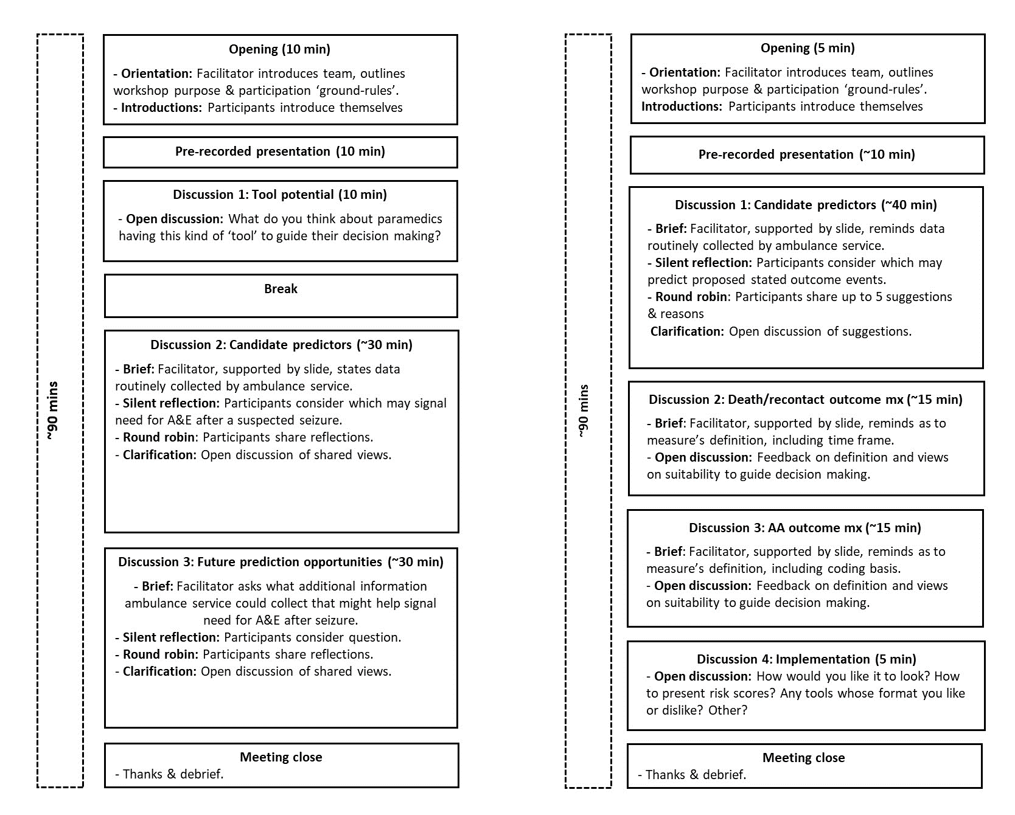
Notes: A&E, Accident and Emergency department; min/s, minute/s.
FIGURE 2 Recruitment flow diagram for, and composition of, workshops for (A) service users and (B) clinicians
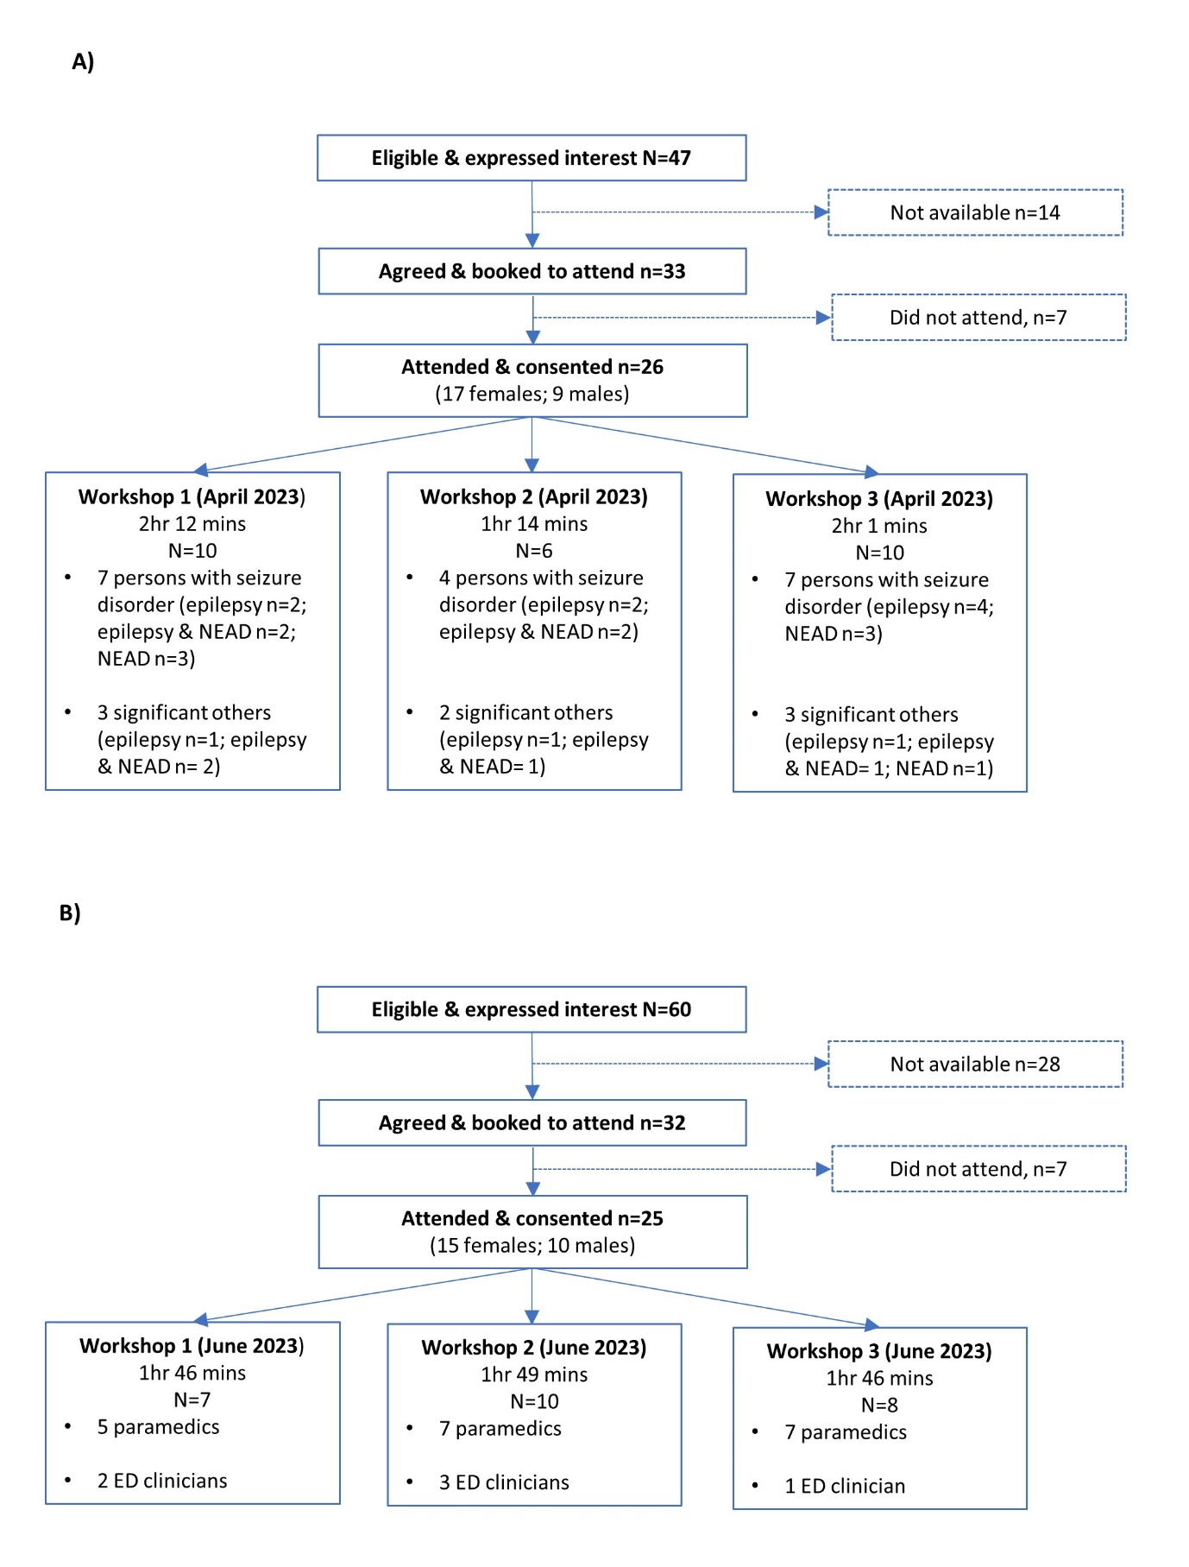

FIGURE 3 Candidate predictor suggestions made by workshop participants

A) Candidate predictors available from structured data fields
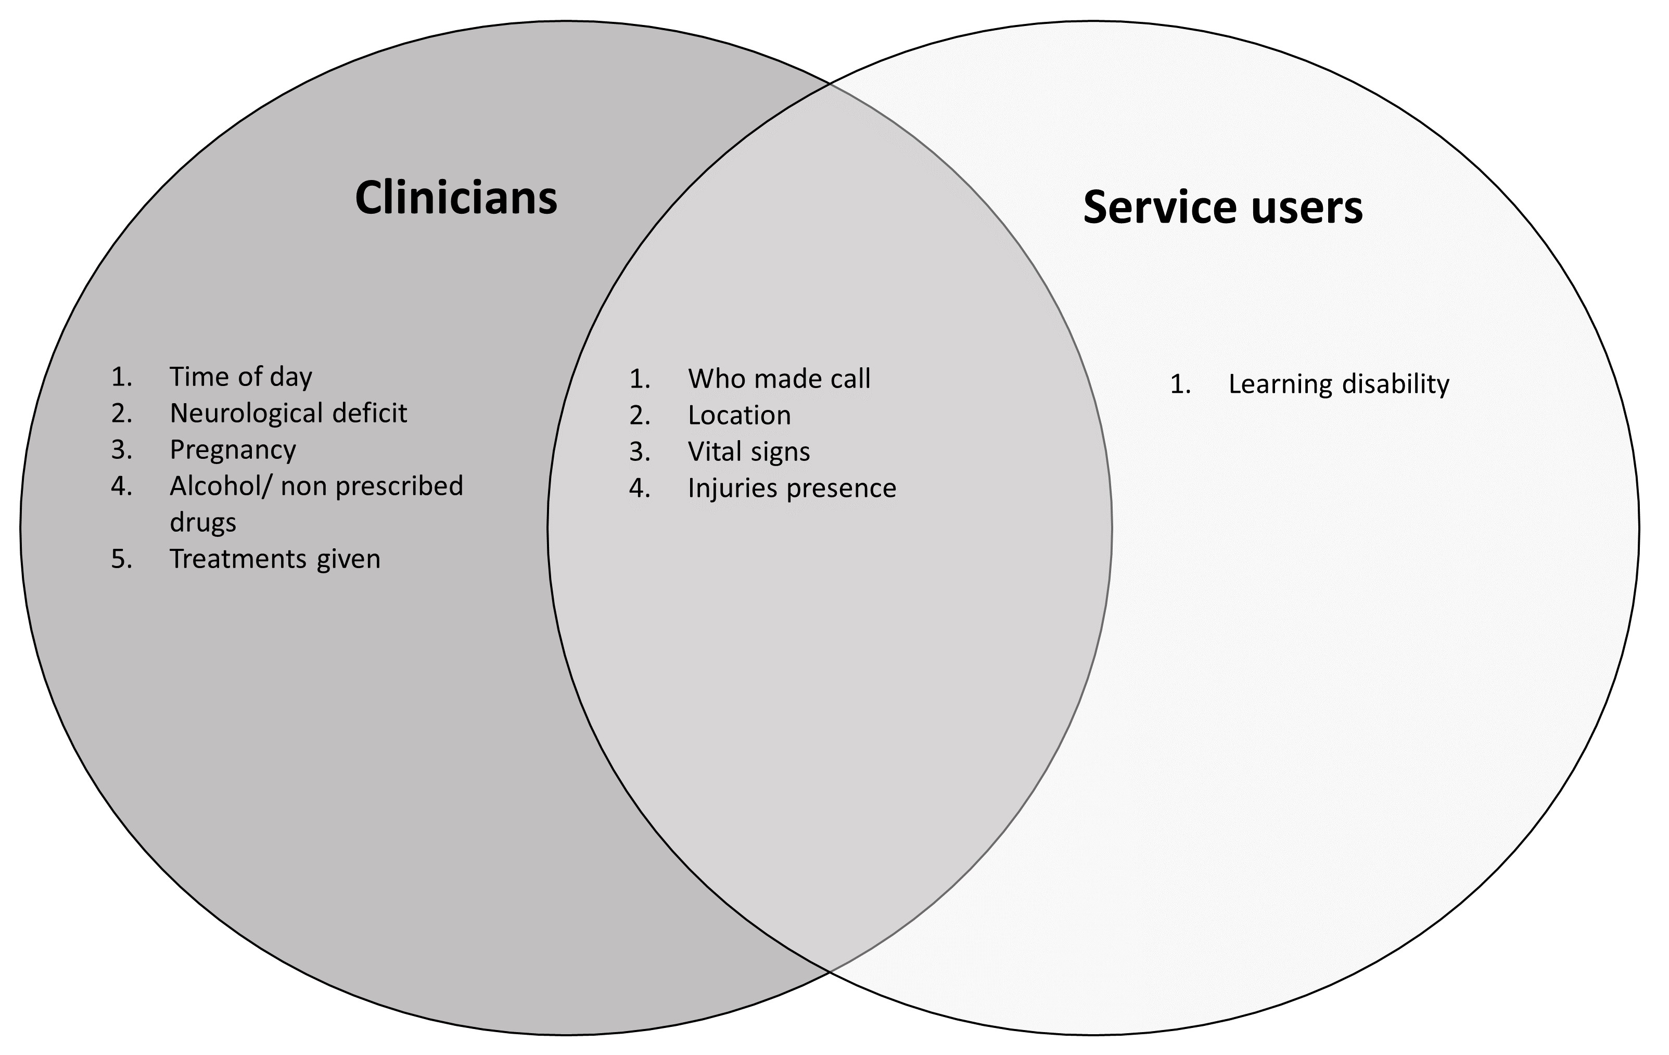
B) Candidate predictors not available from structured data fields
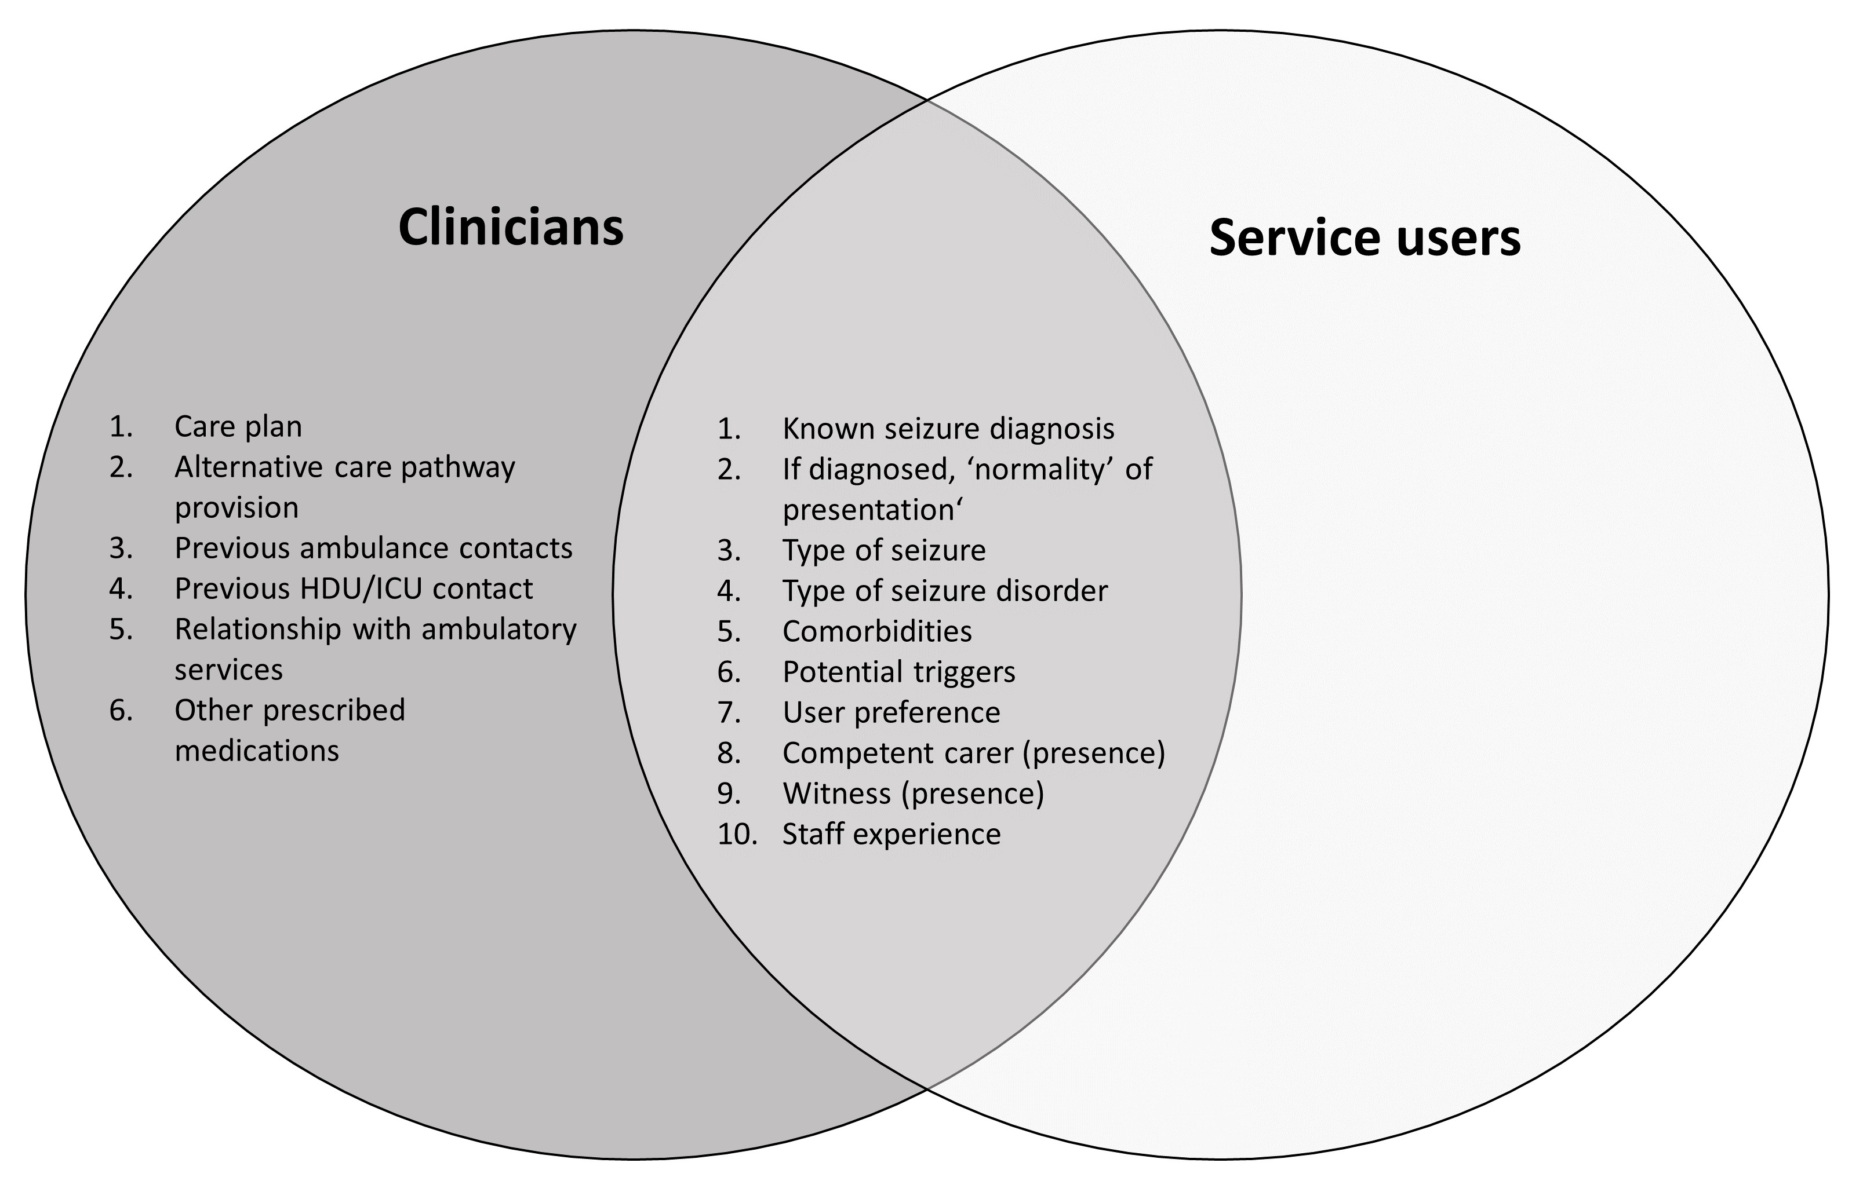

Notes: HDU, high dependency unit; ICU, intensive care unit. Table 3’s note provides details on the grouping of candidate predictors according to their availability via structured data fields.
Supplementary File 1 Topic guides for Knowledge Exchange workshops

A) For service user workshops

RADOSS team:
BM – Beth Morris
AN – Adam Noble

Unless stated otherwise, BM will give all directions listed in the topic guide
Opening
- welcome participants and outline purpose
- run through ‘house rules’
- introduce agenda/schedule for event

Pre-recorded presentation from AN will be played to participants
  - background to project
  - risk/benefit tool envisaged
  - what input would be appreciated on

Discussion 1 - Tool potential
- participants invited one by one to share thoughts on paramedics having tool to guide decision making when attending to someone suspected of experiencing seizure
- open discussion up for clarification and further comments

- participants invited to take 5-minute comfort break

Discussion 2 – Candidate predictors
- direct participants to consider information available to paramedics on scene (range provided on screen)
- invite participants to silently reflect for two minutes on what information available to paramedics could indicate need to attend A&E following suspected seizure
- participants invited one by one to contribute their ideas until everyone has had opportunity to speak
- AN will type suggestions into table on screen as they are contributed
- If required due to extensive list, open discussion to prioritise suggestions to generate top 20 from list in table

Discussion 3 – Future prediction opportunities
- Participants invited to silently reflect on information, not currently routinely collected by paramedics, but that could possibly be collected to indicate need to attend A&E following a suspected seizure
- open discussion/participants invited one by one to contribute their ideas

Meeting close
- Event brought to end with thanks for participation and information on how to access voucher
- participants reminded of researcher contact details
- event conclusion

To generate conversation
- Now that you’ve heard the thoughts of others in the group, were there any ideas shared that you hadn’t thought of before but that you agree might suggest the need to go to A&E or not?
- Can you tell when a seizure is going to be a ‘good’ or a ‘bad’ one?
- Do any signs tell you when recovery from a seizure will be more straightforward?
- Do any signs tell you when recovery from a seizure will be more complicated or require you to attend A&E?
- During the round robin, X was mentioned a number of times. Could this have good potential to suggest the need to go to A&E or not?

To prompt elaboration/ include others in conversation:
- … could you tell me more about
- …could you explain X further
- Why do you feel like this?
- That sounds important to you
- I wonder, do those with a different diagnosis/diagnoses feel the same?
- Does anyone have any differing experiences/points of view on that?

To keep people on topic:
- … that falls beyond the scope of today’s discussion/this project, but would certainly be of interest for future research
- Your points regarding X are very interesting and have been recorded for the research team to think about further following today’s workshop, but If I could just bring you back to the slide, what are your thoughts on…
- I am conscious of time, there are further things to discuss, so perhaps we could table this for now…

If people become upset/resolving conflict:
- I am really sorry to see you have become upset. If you wish, feel free to turn off your camera and microphone until you feel you are ready to re-join
- If I can just interject here,
- A lot of important points mentioned there, though perhaps we are getting off topic/conscious of time, think about moving on
- I can see how important that is to you
- If you would like, you can speak separately with my colleague AN in a different virtual room about what is on your mind…
Box A.1: Prompts

B) For urgent and emergency care clinician workshops
RADOSS team:
BM – Beth Morris
LB – Laura Bonnett

Unless stated otherwise, BM will give all directions listed in the topic guide

Opening
- welcome participants and outline purpose
- run through ‘house rules’
- introduce agenda/schedule for event

Pre-recorded presentation from AN will be played to participants
  - background to project
  - risk/benefit tool envisaged: predictors, outcomes, and format
  - what input would be appreciated on

Discussion 1 Candidate predictors
- slide presented to indicate types of information routinely collected by paramedics when on scene to aid brainstorming when thinking about what information might make a good predictor of the two different outcomes i) risk of recontact and mortality within 3 days; ii) risk of ED visit being classified as an ‘avoidable attendance’.
- participants will be invited to silently brainstorm for 2 minutes on which predictors they consider most important for two outcomes and generate up to personal top 5
- participants invited one by one to contribute their top 5 predictors and brief justification
- If necessary/ possible, participants invited to clarify and ratify choices to generate group view

Discussion 2 Death/recontact outcome measure
- participants directed to slide and reminded of way risk and benefit have been operationalised in project
- open discussion for participants to share thoughts on whether the way death/recontact outcome measure operationalised and time frames and asked for views, including whether sufficiently reassuring to guide decision making

Discussion 3 ‘Avoidable attendance’ outcome measure
- participants directed to slide and reminded of avoidable attendance definition in project
- open discussion for participants to share whether they have concerns regarding validity of avoidable attendance definition in their emergency department and others and why

Discussion 4 Implementation
- open discussion for participants to share any thoughts on implementation, i.e., how tool should look, how risk scores should be presented

Meeting close
- event brought to end with thanks for participation and information on how to access voucher
- participants reminded of researcher contact details
- event conclusion
To generate conversation
- Now that you’ve heard the thoughts of others in the group, were there any predictors suggested that you hadn’t thought of but that you agree might suggest a person’s need to go to ED or not?
- During the round robin, X was mentioned a number of times. Could this have potential to suggest the need to go to ED or not?

To prompt elaboration/ include others in conversation:
- … could you tell me more about
- …could you explain X further
- Why do you feel like this?
- That sounds important to you
- I wonder, do those with a different professional background feel the same?
- Does anyone have any differing experiences/points of view on that?

To keep people on topic:
- … that falls beyond the scope of today’s discussion/this project, but would certainly be of interest for future research
- Your points regarding X are very interesting and have been recorded for the research team to think about further following today’s workshop, but If I could just bring you back to the slide, what are your thoughts on…
- I am conscious of time, there are further things to discuss, so perhaps we could table this for now…

If people become upset/resolving conflict:
- I am really sorry to see you have become upset. If you wish, feel free to turn off your camera and microphone until you feel you are ready to re-join
- If I can just interject here,
- A lot of important points mentioned there, though perhaps we are getting off topic/conscious of time, think about moving on
- I can see how important that is to you

Box B.1: Prompts

Supplementary File 2 Screenshots and narration from presentations shown at start of workshops

A) Presentation shown to service users

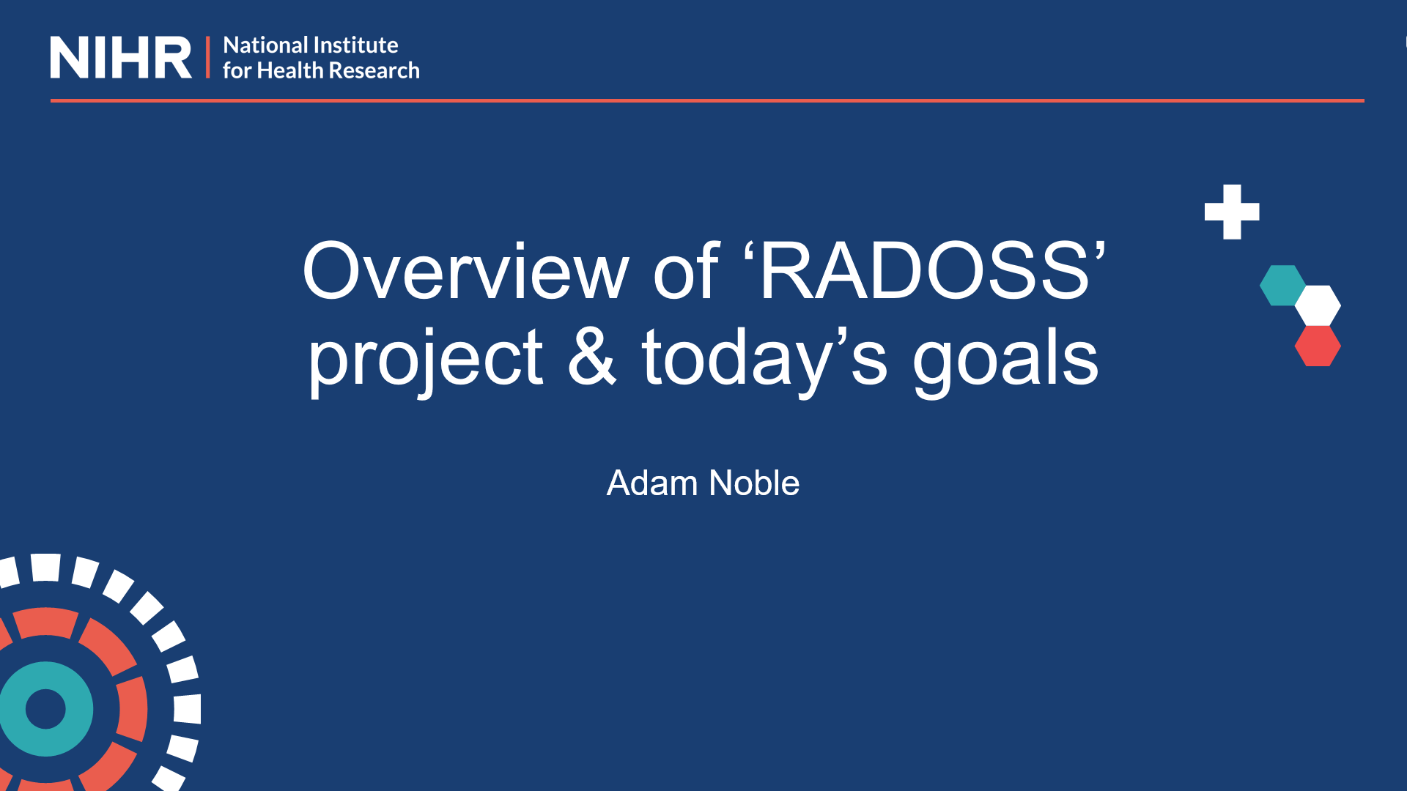 | 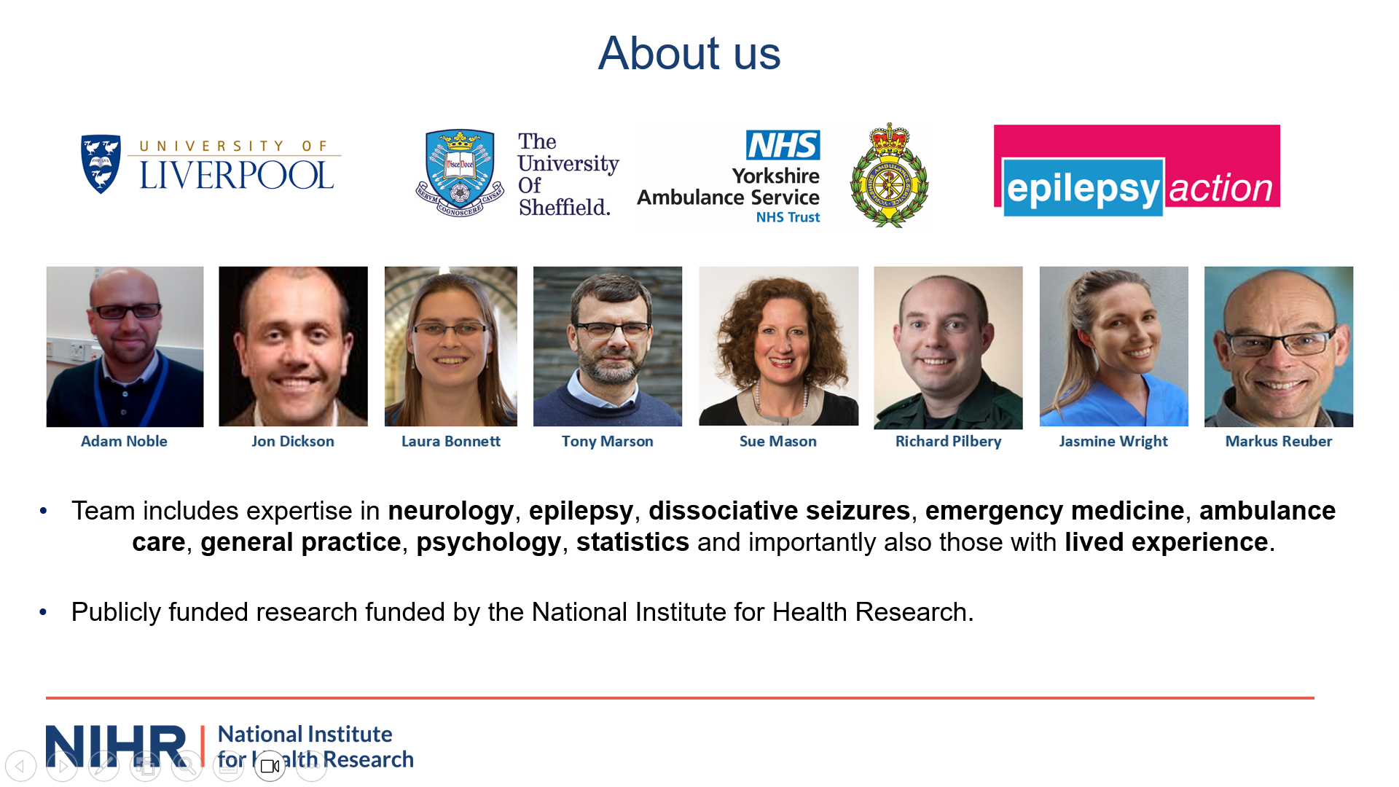
“Thank you for taking part in this  workshop for the RADOSS project. My name  is Adam Noble and I am one the investigators for the project, I'm going to briefly give an overview of  the RADOSS project and of today's goals” | “First a bit about us on the slide you can see the members of the team that the leading rados we come from the University of Liverpool, University of Sheffield, the Yorkshire Ambulance Service and Epilepsy Action.  The team includes expertise in seizures, neurology emergency medicine, ambulance care, general practice  statistics and importantly also includes those who themselves live with seizures”. | “The RADOSS project is looking to help ensure people who have experienced a seizure and are seen by the ambulance service get the right care, at the right time in the right place. Today we are asking for your help in achieving this goal. Just to say that RADOSS is publicly funded by the National Institute for Health Research. It is overseen by an independent panel of experts and all the findings from it will be made public for the benefit of everyone interested”
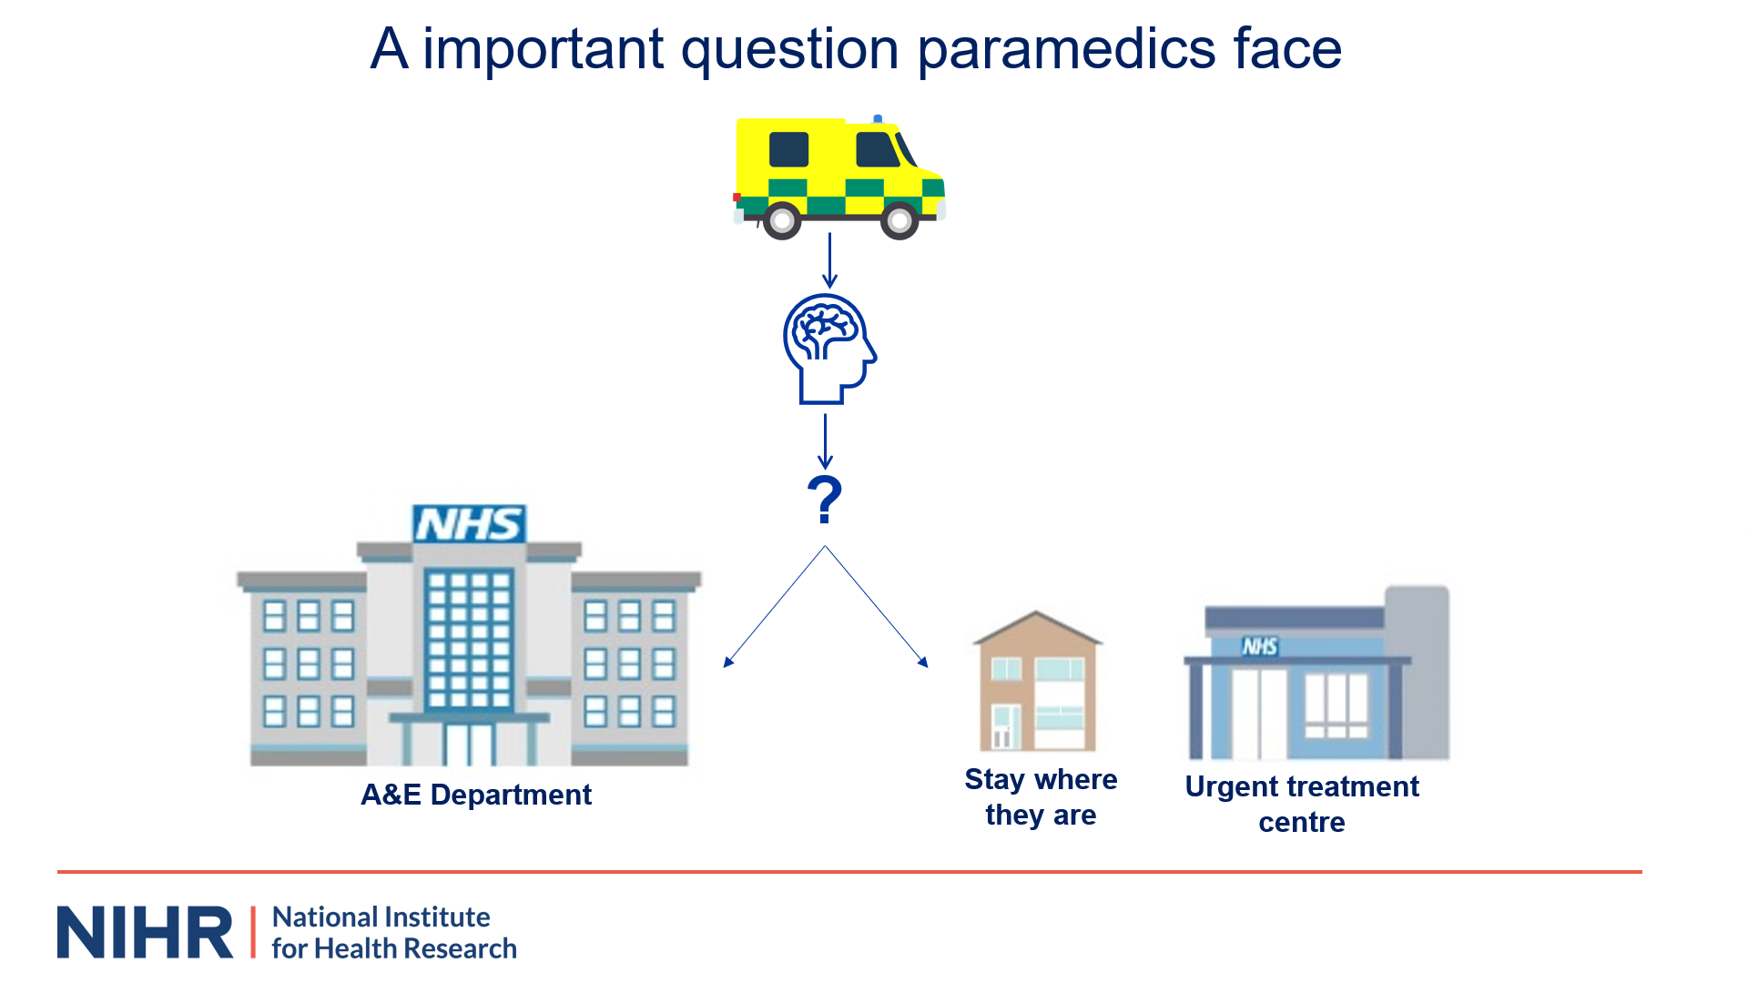 | 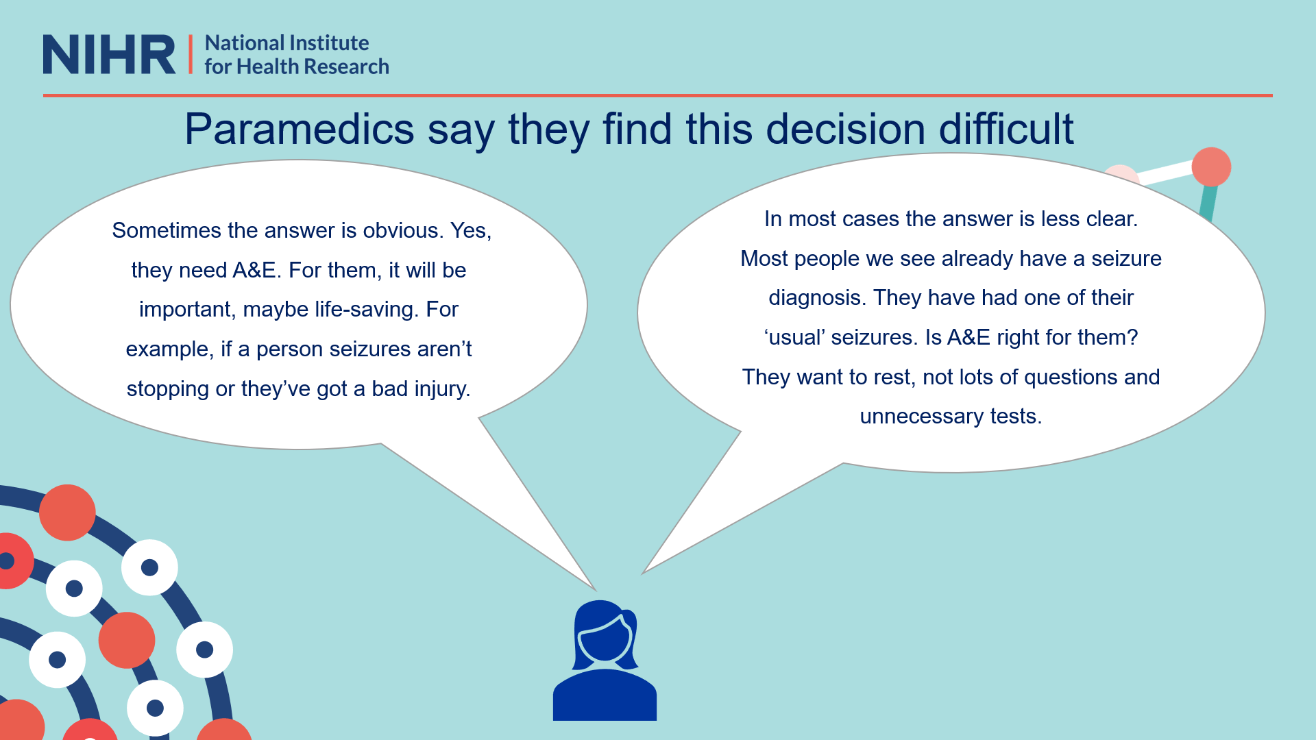
“So why are we doing the project? As you all know, ambulances are often called to people who have had a possible seizure. Once the paramedic has assessed the  patient and ensured they are not in immediate danger the Paramedic has an important decision to make. In short, should the patient be taken to a hospital accident and emergency department, A&E, or not. Or might it be more appropriate for the person to stay where they were, say at their home or perhaps be taken to one of  the NHS’ Urgent Care centers that now exist. | “Paramedics say answering this question can be difficult. I would like to read you some things paramedics have told us that describe things from their point of view.  in some instances they say the answer of whether the person needs a e is clear. As this paramedic here says sometimes the answer is obvious ‘yes they need A&E.  For them it will be important, maybe life-saving. For example, if a person’s seizures aren't stopping or they've got a bad injury’. However, paramedics say that actually for most people they see for a seizure, the answer is less obvious. As this paramedic here says ‘In most cases the answer is less clear, most people we see already have a seizure diagnosis they've had one of their usual seizures is a e right for them. They want to rest, not lots of questions and unnecessary tests’. | “Paramedics say they want to do what is right for the person. They want to take people to A&E who need to go there. At the same time, they are aware that for some people going to A&E after a seizure will be of little help and potentially  frustrating for them. As the paramedic here said, most people seen by an ambulance for a seizure actually already have a seizure condition that's already being diagnosed and for which they're being treated.”
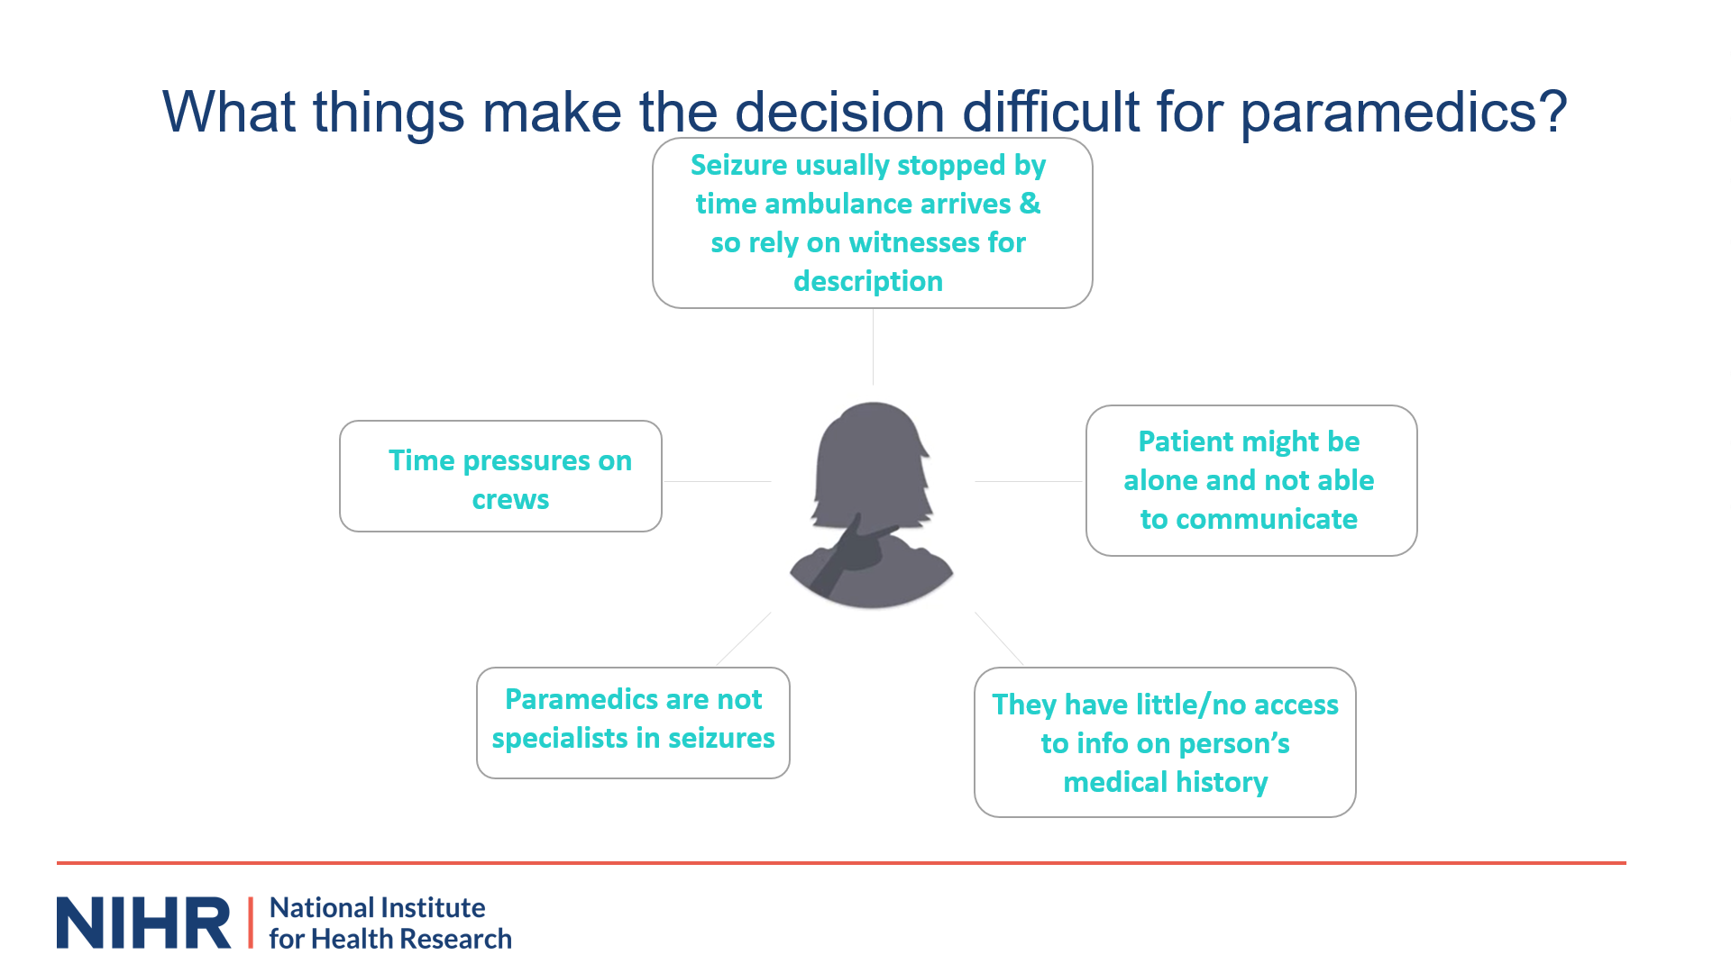 |  | 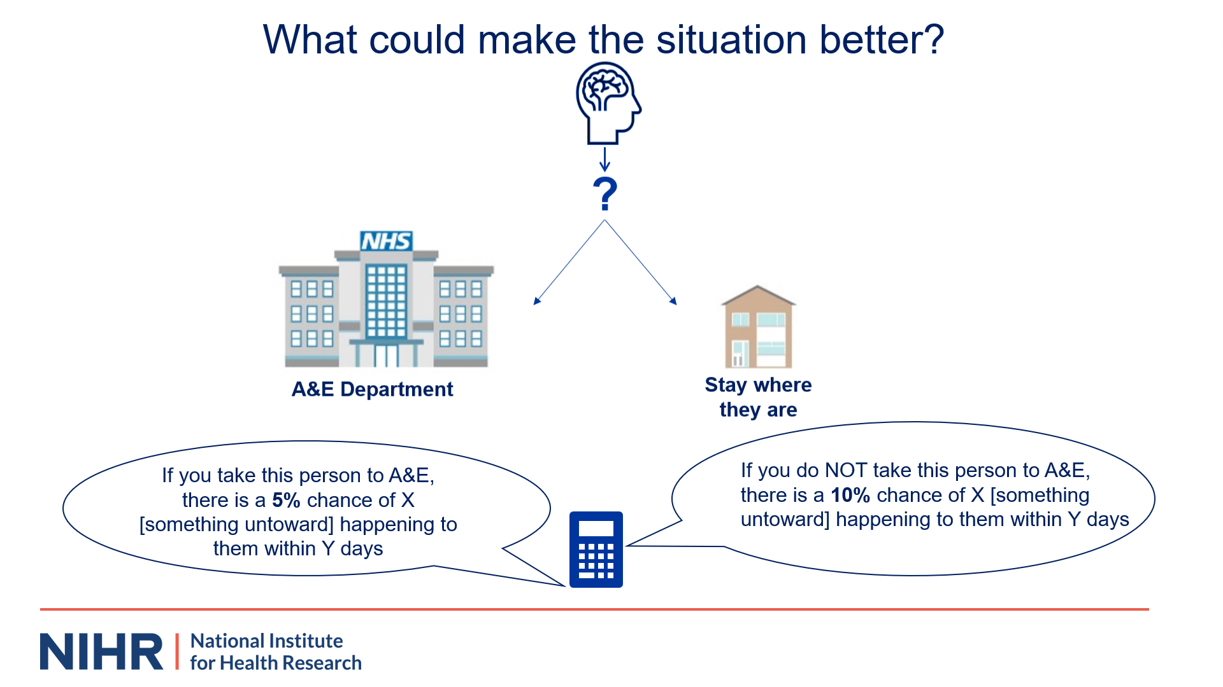
“What things make the decision difficult for paramedics? Well, there are a number of things. Firstly, people have typically stopped their seizure by the time the ambulance  has arrived and so the paramedics often rely on patchy information about what has happened from bystanders. Secondly, the patient might be alone and unable to communicate clearly about their needs medical history and what they want to happen. Thirdly, paramedics usually do not have access to the person's medical notes to let them understand how normal or not what has happened for the patient is. For instance, is this seizure just like their usual ones or not?“ | “Fourthly, paramedics are not health professionals who are specialists in seizures. They are not a condition that they are experts in and they can struggle to get one of these experts on  the phone to advise them at the time. Finally, on top of this paramedics work under real-time pressures. They want to do what is right for the person they're seeing. At the same time, they are aware that the longer they spend with their current patient the longer it is before they are back on the road and able to help others. This means they cannot wait with a patient for long periods of time. In the next slide we're going to hear how paramedics want to change things and make things better”. | “So, what could make the situation better? Well, let's return to that image I showed you earlier on about the decision paramedics have to make. In short, should  the paramedic take the person they have seen to A&E or perhaps instead let them stay where they are? Paramedics say what would be helpful is if they had more information on which of these options is likely best for that individual. They say they want a tool, a bit like a  calculator, that they can use when they're on scene that will tell them what the risks and benefits are of taking and not taking that person to A&E. They say they could use this information along with other things to help them be  more confident about what to do. They say they could share this information with the patient and also their significant others who are there so they too can have a say in what happens.”
 | 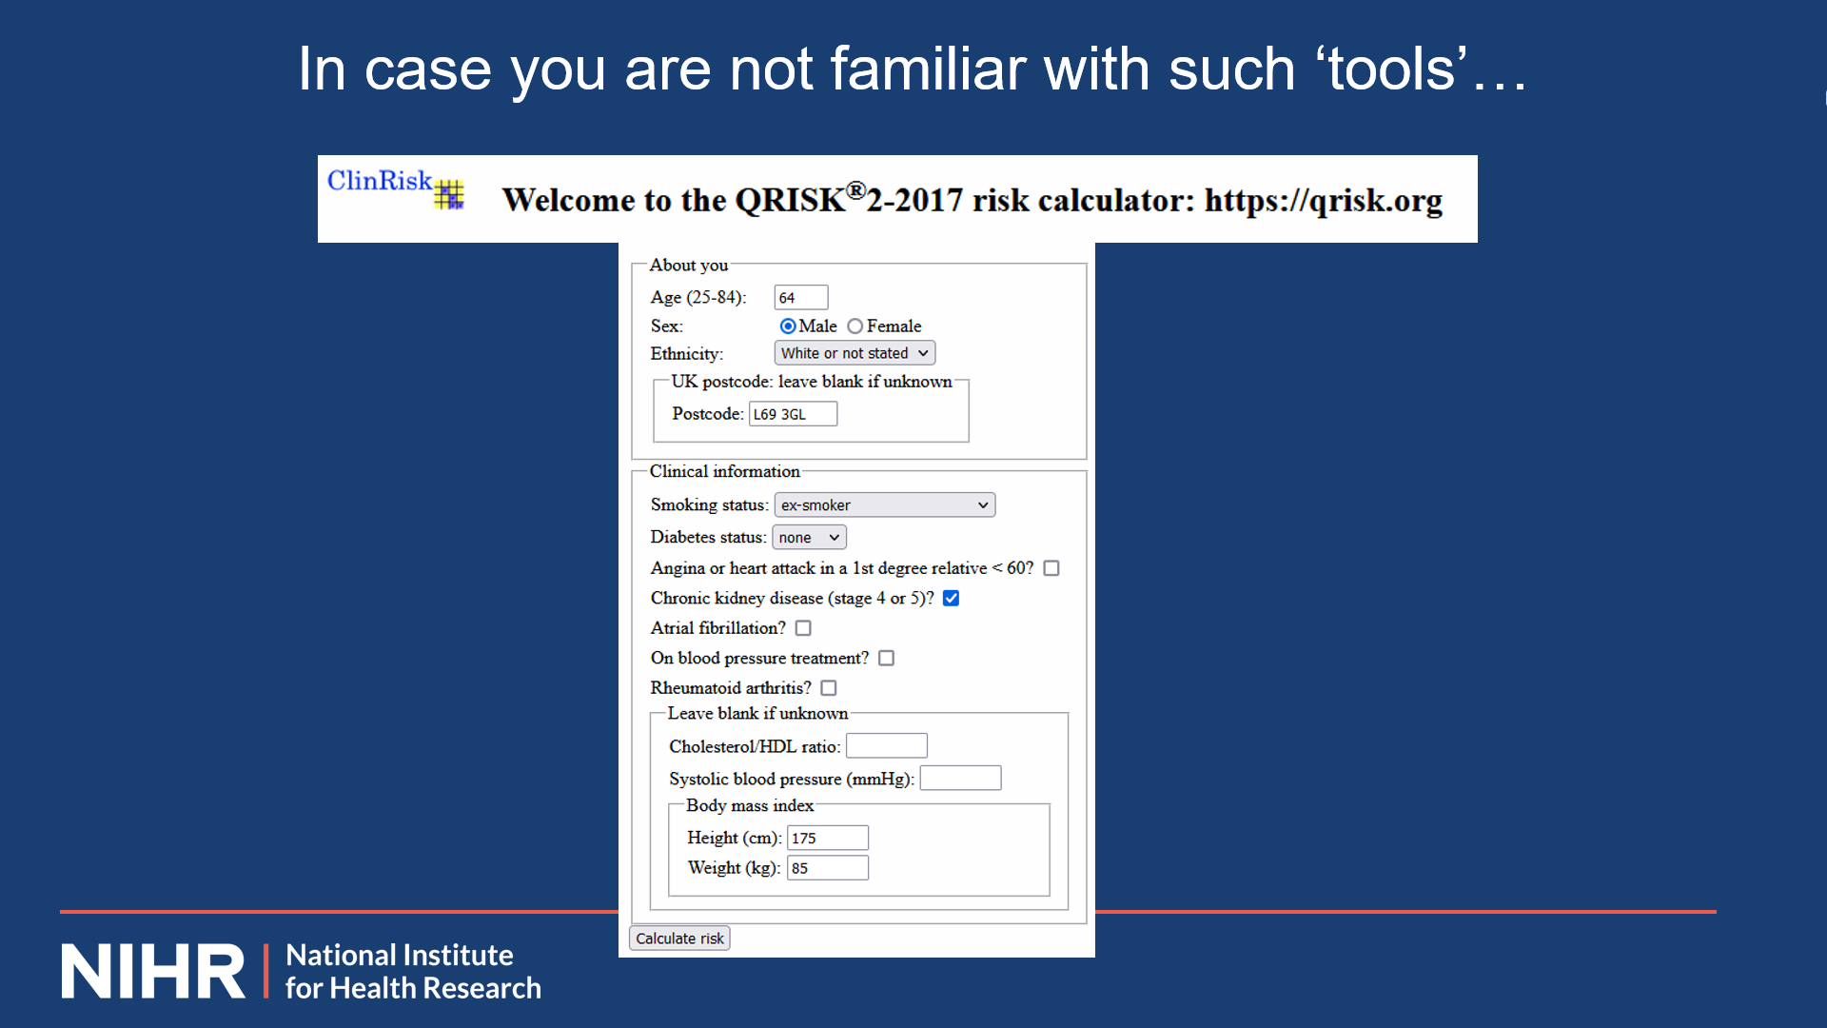 | 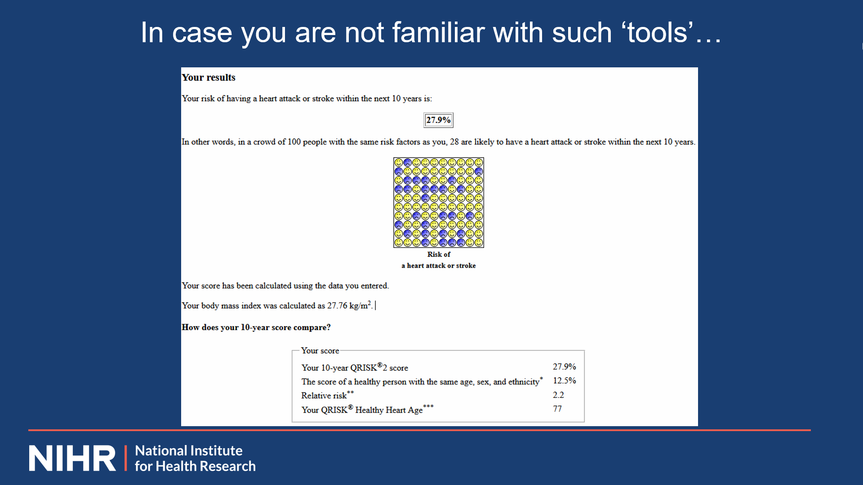
“Paramedics and other health professionals already use tools like this to guide them about what care to provide to patients experiencing other health difficulties. They just don't have one yet for seizures. So how do these tools work? Well they're based on mathematical models and they come in lots of forms, including ones that come in the form of an app on a phone. They allow the how professional to type in specific information about the person they are caring for and then the tool draws on this mathematical model to give the health professional an idea about how likely it is that that person will experience a certain health event in the future.” | “You may already be familiar with such tools. In case not, I wanted to show you one to give you a clearer idea of what they look like and do. So this one on screen now is used by GPs all over the country. They use it to try to find out which people they are caring for are at high risk of having a heart attack or stroke and so might need to  make changes to lifestyle to prevent this. Your family doctor might have used it with you or for example a family member recently. As you will see from the screen here, the GP types in specific information about the person they're caring for. So for instance, their age weight, ethnicity, diabetes and smoking history. The tool then works out the chance that this person may have a heart attack or stroke in the next 10 years.” | “We filled in the tool here using a made up person's details. You can see that for this particular individual the  tool tells the doctor and the patient that there is likely a 27% risk of them having a heart attack or stroke in the  next 10 years if they do not make any changes to their lifestyle. Or, in other words research on the lives of people in the past tells the doctor that out of a hundred people living the same lifestyle as this person, 27 of them went on to have a heart attack or stroke. With this  information, the GP and the patient can then think about what changes they might need to be making to that person's lifestyle to stop this happening. For instance, by starting certain medicines.”
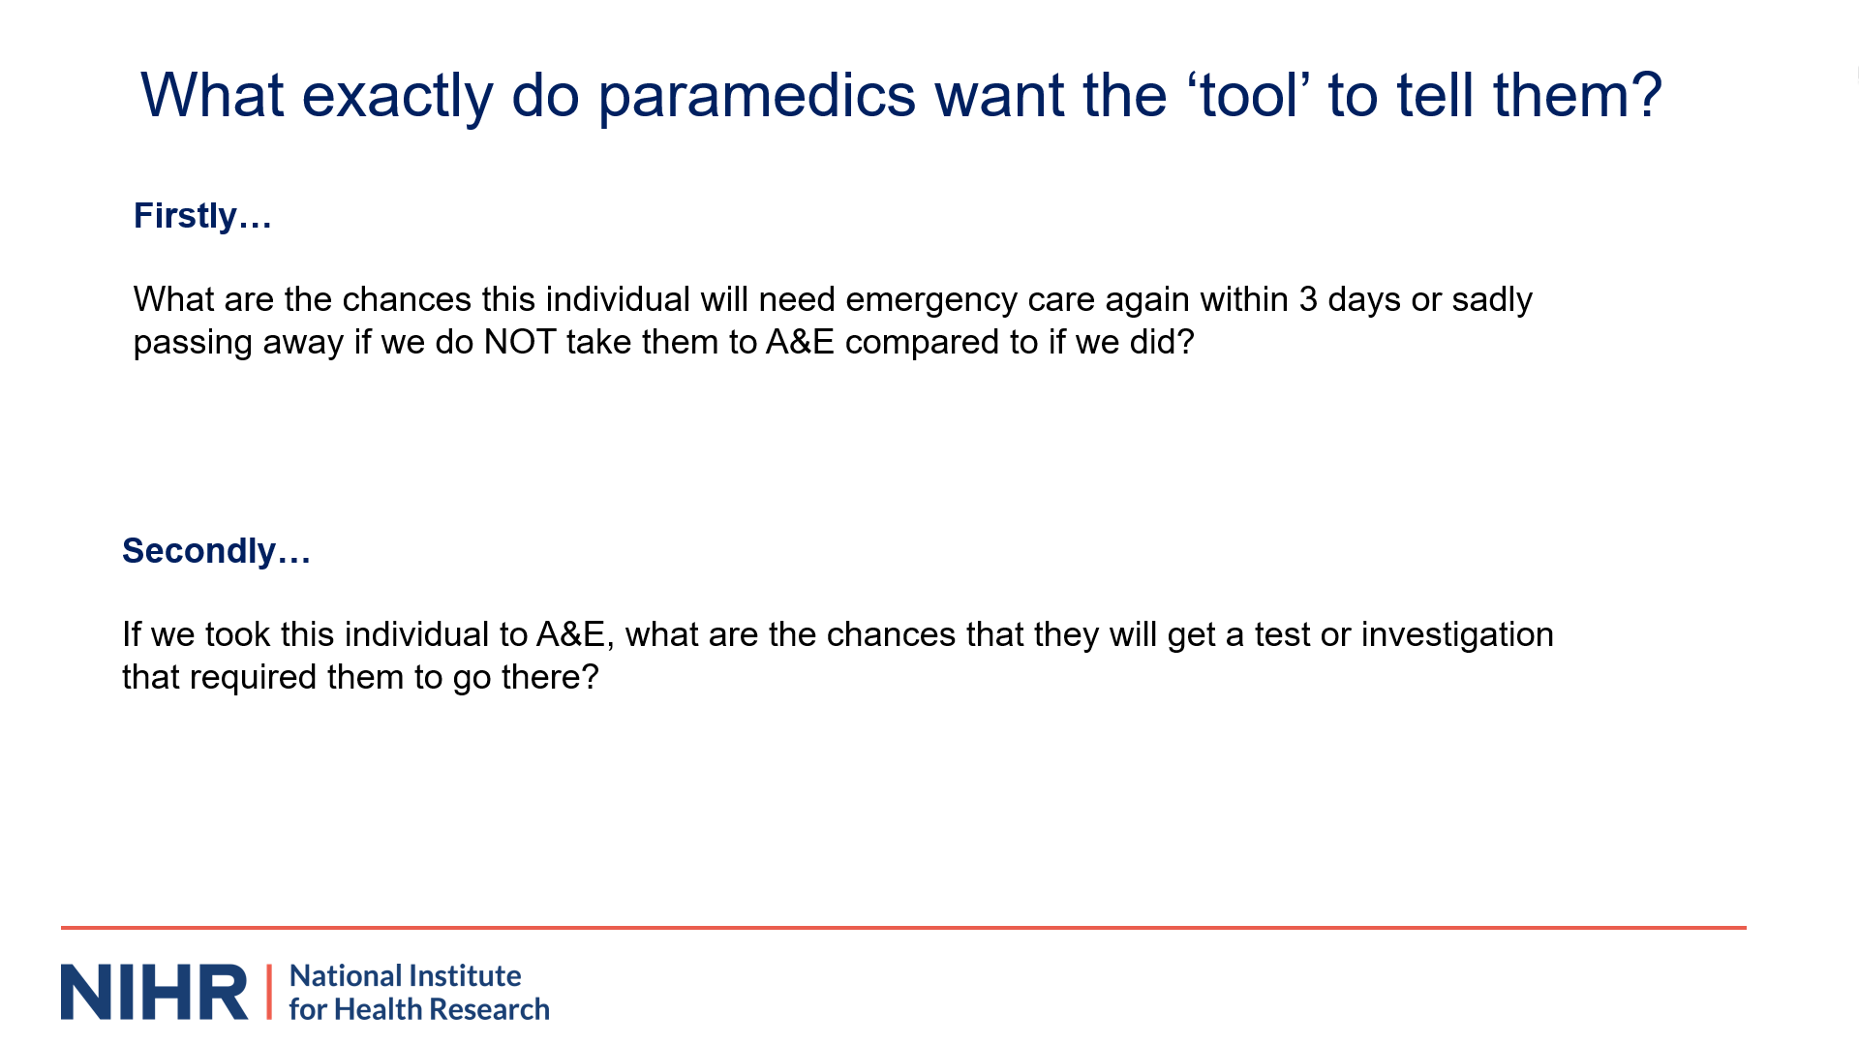 | 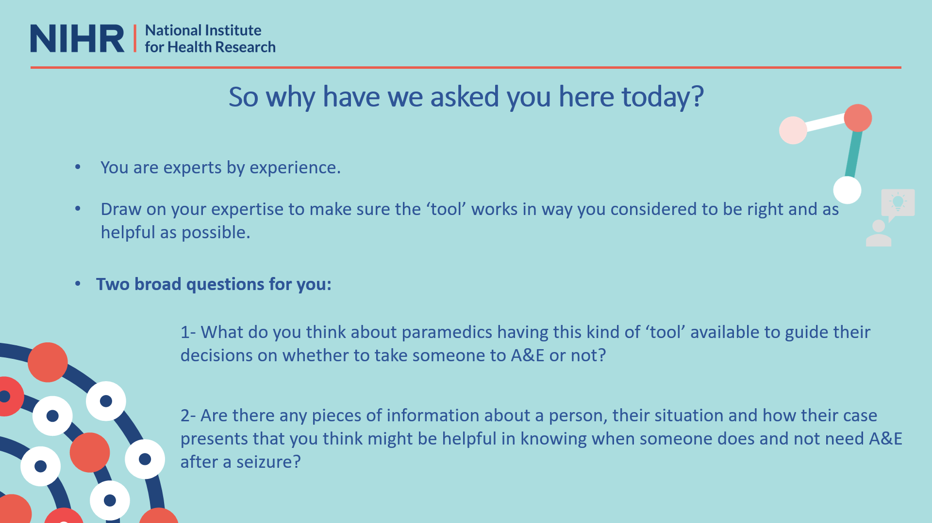
“Back to seizures. What exactly do paramedics want the tool to tell them? Well, they say they want it to tell them  two things that would be really helpful for their decision.  Firstly, they want to know what the chances are of the individual they are treating needing emergency care again within three days or suddenly passing away if they do not take them to A&E compared to if they did. So, what are the risks? The second thing they want to know is about benefits. They say, if we took this individual to A&E, what are the chances that they will get any test or  investigation that required them to go there? So, rather than then sitting there for a few hours and then being discharged home without anything happening, what are the actual chances that they get a test or investigation  they really needed? | “So, why have we asked you here today? Well, you are experts by experience. Your lives are or have been affected by seizures in some way. You have been in the situation of seeking ambulance care for a seizure. We would like to draw on your experience to make sure that the tool works in a way that you consider to be right and as helpful as possible. We want to ask you two broad questions. Firstly, given your personal experiences what do you think about paramedics having this sort of tool available to them to guide their decisions on whether  to take someone to A&E or not? And then secondly, we would like to hear whether there are any pieces of information about a person, a situation, or how their seizure presents that you think could be helpful in letting  paramedics know whether that person does or does not need A&E after a seizure. | “We would merge your thoughts with those of seizure specialists, paramedics and A&E doctors to help the mathematicians know what sort of information might be  helpful to put into the mathematical model to allow it to make precise estimates about a person's risks. Vefore we ask to hear your thoughts I wanted to say a bit more about this second question. This is because we're going to ask you to give us your answers in two parts. Firstly we're going to show you the sorts of information paramedics will have at the time about the person they're caring for who's had a possible seizure. We want you to tell us what things from this list you think may be helpful in knowing a person's risk. We're asking you here to base your thoughts on your experience of what things about your seizures or your loved ones could be good
“…signals about whether they will or will not need A&E. Having done this, we're then going to ask you a bit more about this, but we'd like to sort of take the shackles off a bit and ask you to do some ‘blue sky thinking’. This is because there may be some things which paramedics do not routinely record which you think might actually be
helpful in knowing about whether someone needs A&E or not after a possible seizure. For instance, do you get any clues about your seizures or the way they come about, that tell you whether you are or likely not going to need A&E.
Okay and thank you very much for your time over listening to this I'm gonna now hand back to Beth so we can begin to hear your thoughts”

Notes: This presentation was pre-recorded to reduce opportunity for technical difficulties and to standardise the evidence the different groups received. The presenter attended the workshop to address questions delegates had. Full version can be viewed here: https://youtu.be/jAydZsWy98I
B) Presentation shown to urgent and emergency care clinicians

 | 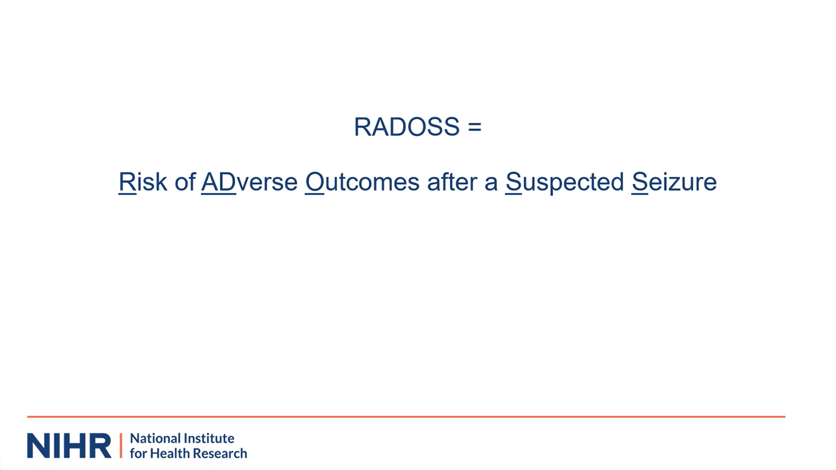
“Thank you for taking part in this workshop for the RADOSS project. My name is Adam Noble and I one of the investigators for the project. I'm going to briefly give an overview of the RADOSS project and of today's goals. | As you know, a key ambition of the NHS long-term plan is to ensure people get the right care, at the right time in the optimal care setting. To help achieve this, ambulance services should only be conveying people to hospital emergency departments if it's clinically appropriate or there is no alternative to provide safe and ongoing care for that patient. Our project seeks to figure out a way to support the ambulance service to do this. | “In this project, we are focusing on just one particular presentation, namely suspected seizures. That's why our project is called rados which stands for risk of adverse outcomes after a suspected seizure. Seizures are a topic of interest in their own right, but they're also acting here as an exemplar for other conditions where opportunities for more non-conveyance exist.
 | 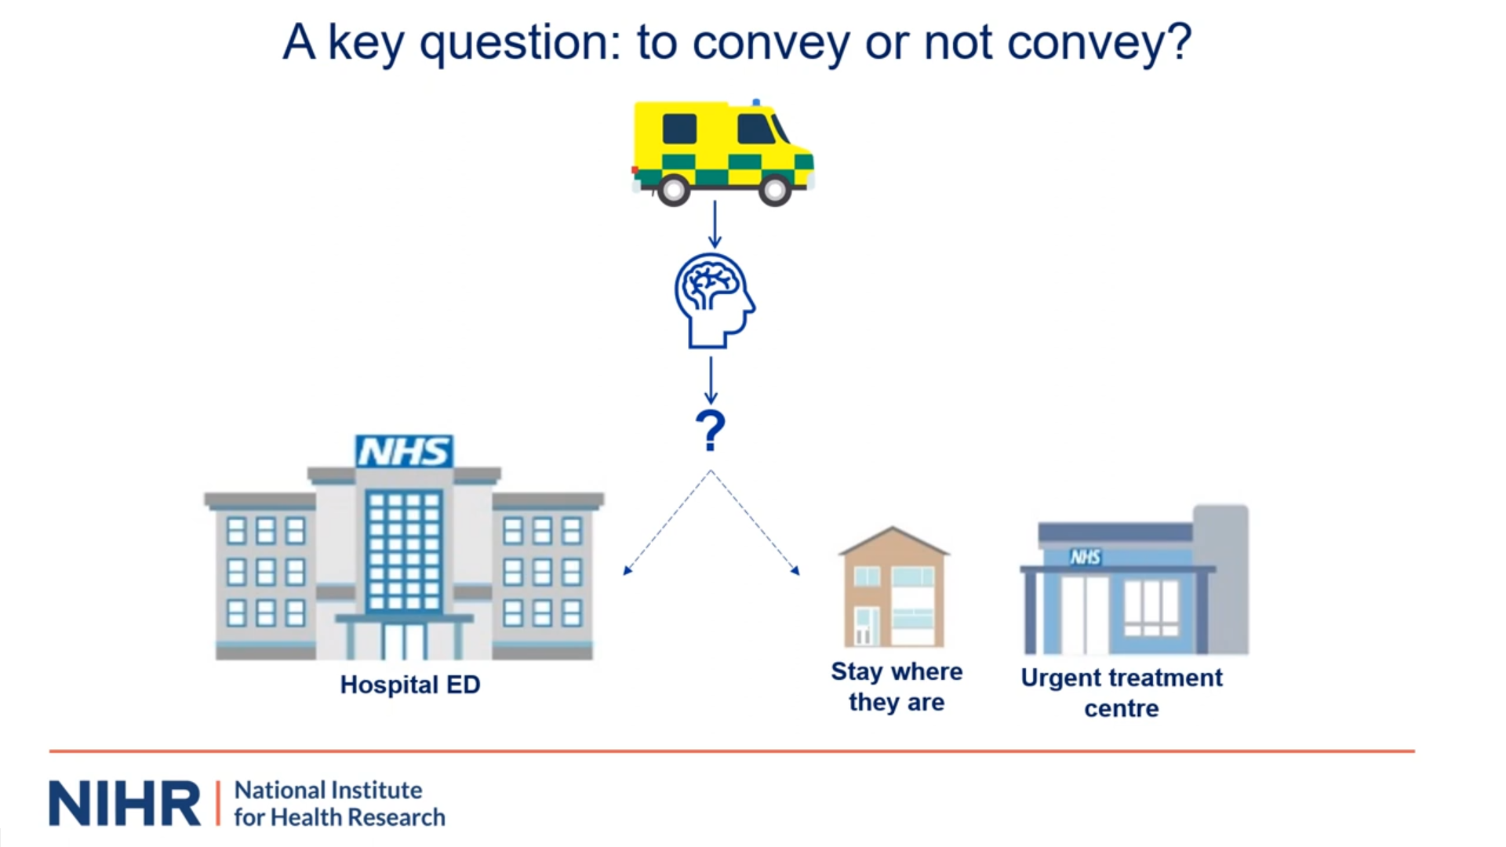
“Before I continue, first a bit about us. On the slide, you can see the members of the team leading RADOSS. We come from the Universities of Sheffield, Liverpool, the Yorkshire Ambulance Service and Epilepsy Action. The team includes expertise in neurology, emergency medicine, general practice, urgent and emergency care and its data sets. And, importantly also includes those  who themselves have liberal seizures. RADOSS is being funded by the National Institute for Health Research. | “So, back to why we're doing the project. As you all know, ambulances are often called to see people who've had a possible seizure. They are responsible for over  210,00 999 calls each year in England alone – making them the seventh most common presentation seen by crews. Nearly all of these get a face-to-face response. Once the paramedic has assessed the patient and ensure they're not in immediate danger, there's an important decision that needs to be made. In short,  should the patient be taken to a hospital emergency…” | “…department or not. Might it, for instance, be more  appropriate for the person to stay where they are. Say at their home, or perhaps be taken to one of the NHS' Urgent Treatment Centers. We know answering such a question is crucial for the patient, the paramedic, and the wider urgent and emergency care system. Leaving the wrong patient at scene could expose them to unnecessary risks. For instance, they might experience a complicated seizure and no longer be in close proximity to the help they need. On the flip side…”
 | 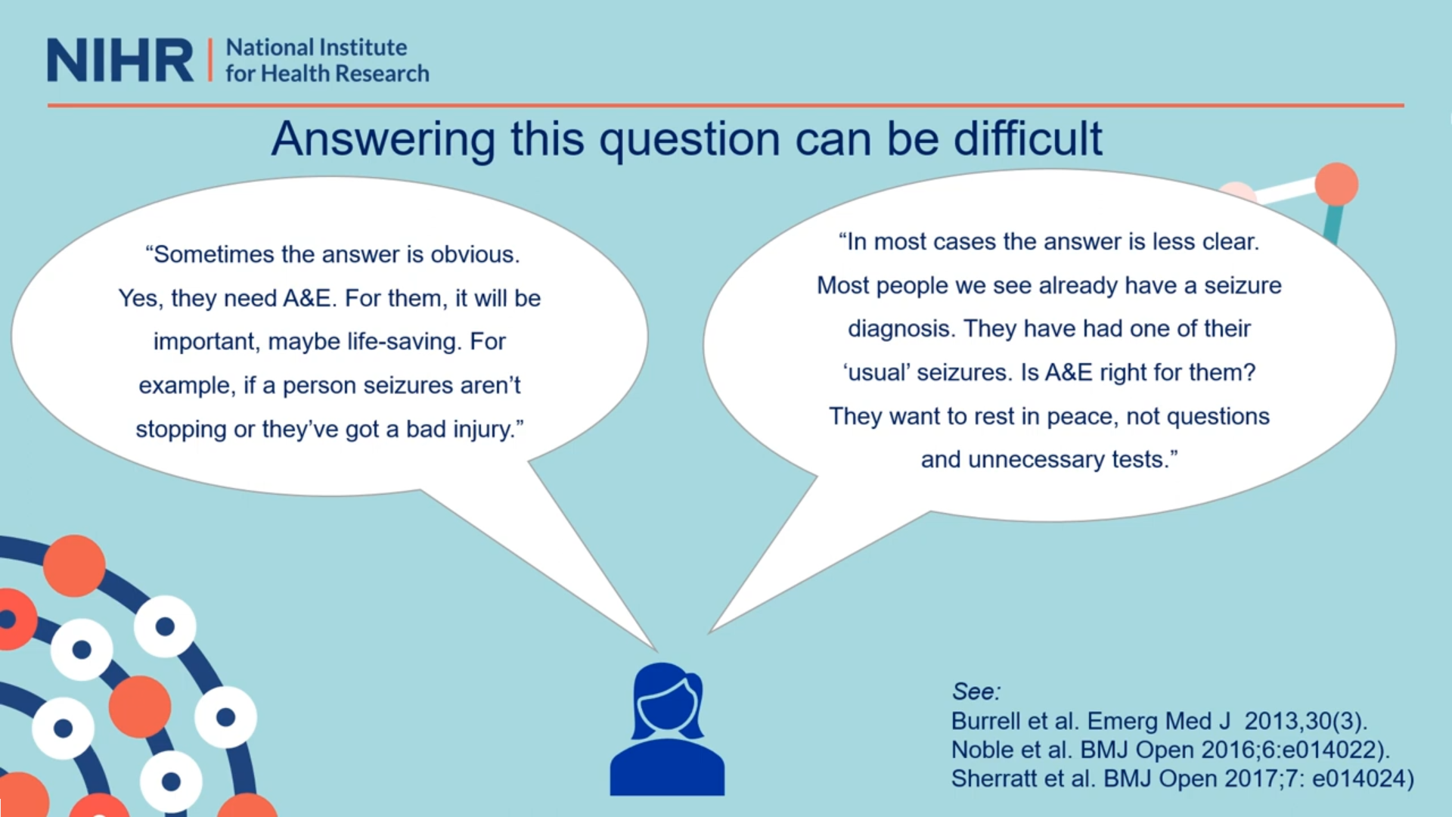
“…taking a person to a Type 1 ED who doesn't require its facilities, results in a so-called ‘Avoidable Attendance’ and we know these are not without harm. As well as being potentially inconvenient for the patient, they can  expose them to unnecessary tests and investigations. There are also implications for other patients since avoidable attendances restrict ED capacity.” | “Over the years, we have completed a number of interview studies of paramedics on the topic. This research consistently indicates that a decent proportion of paramedics can find answering this question of what  to do next quite difficult. Some express uncertainty regarding the accuracy of their assessments for non-conveyance to ED express concerns for patient …” | “…safety and their own personal reliability if an incorrect  decision is made and the patient passes away or experiences an adverse event. They've told us that in some instances the answer is quite obvious to whether  someone does need emergency department care or not. For instance, if the seizures just aren't stopping or the person has sustained a significant injury. However, …”
 |  | 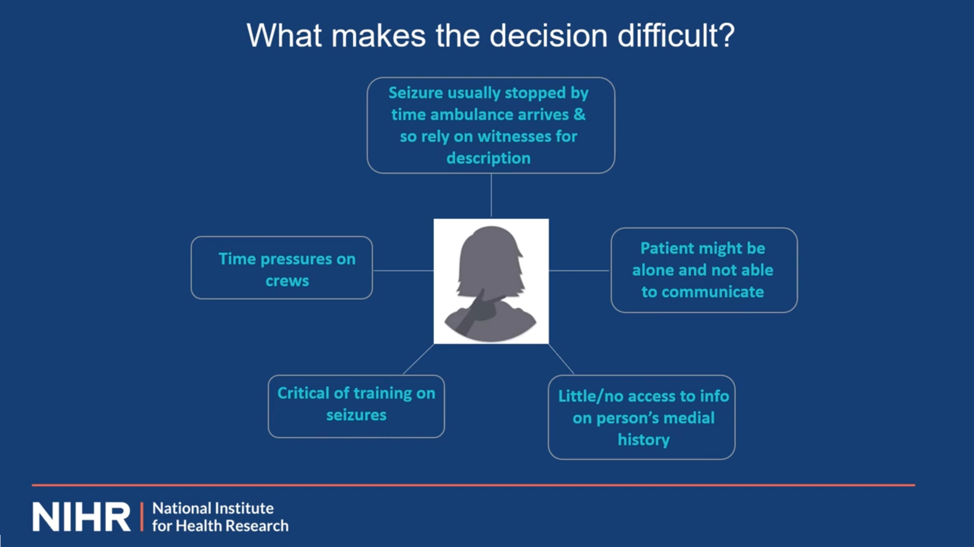
“…they say that this is for the minority of cases. For most people they say they see the answer is less obvious as they're not presenting with a blatant emergency care need. For instance, most people presenting to the service with a seizure actually already have an established diagnosis and are on treatment for it. The JRCALC national ambulance care guidelines note that most people presenting with a seizure in such a context will not require the emergency department. However, they too do acknowledge that various factors can make this decision much more complex in practice.  It is these factors that likely explain why other research by us and other groups shows that seizures are one…” | “…of the presentations currently being over conveyed to the hospital emergency department. Approximately one in five attendances at English emergency departments  meet the generic and relatively conservative definition of an avoidable attendance developed by Sue Mason and  her colleagues and which has been later adopted by NHS digital. We shall return to this definition later on. | “What makes the decision difficult? Well, as you well know there are a number of macro, meso, and micro factors. Those which been consistently highlighted to us as being important include the following. That in 9 out of 10 cases the person would have typically stopped seizing by the time the ambulance crew has arrived  and so paramedics would often have to rely on patchy information about what has happened from bystanders. That the patient might also be alone and unable to communicate clearly about their needs and what they want to happen. Be it because they are in a postictal  state, or perhaps have a profound learning disability...”
 | 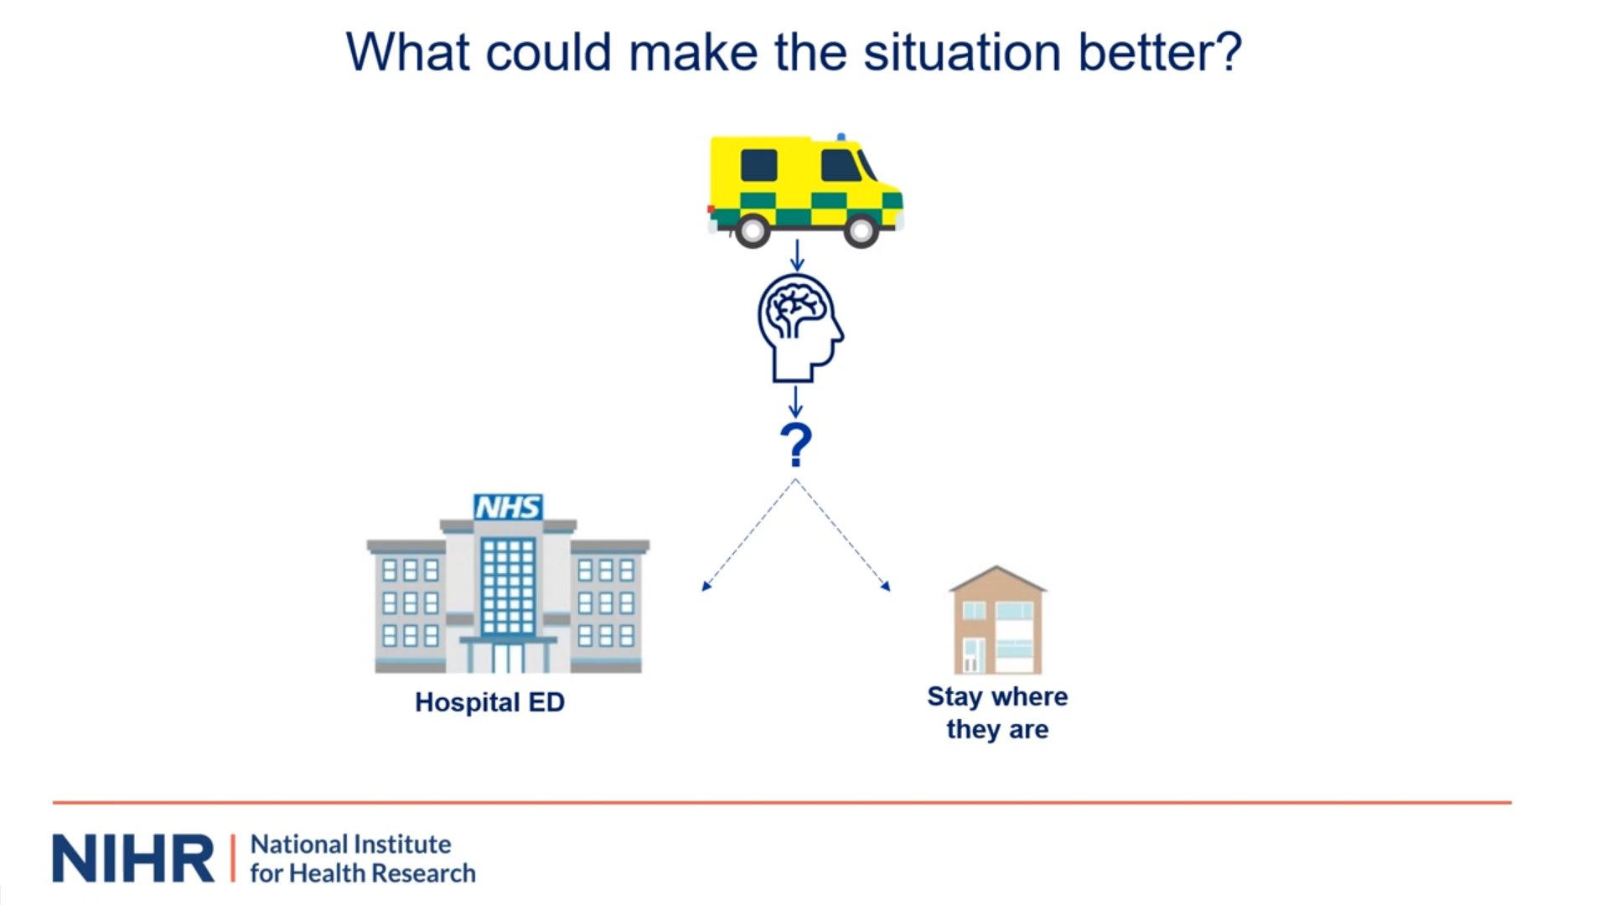 | 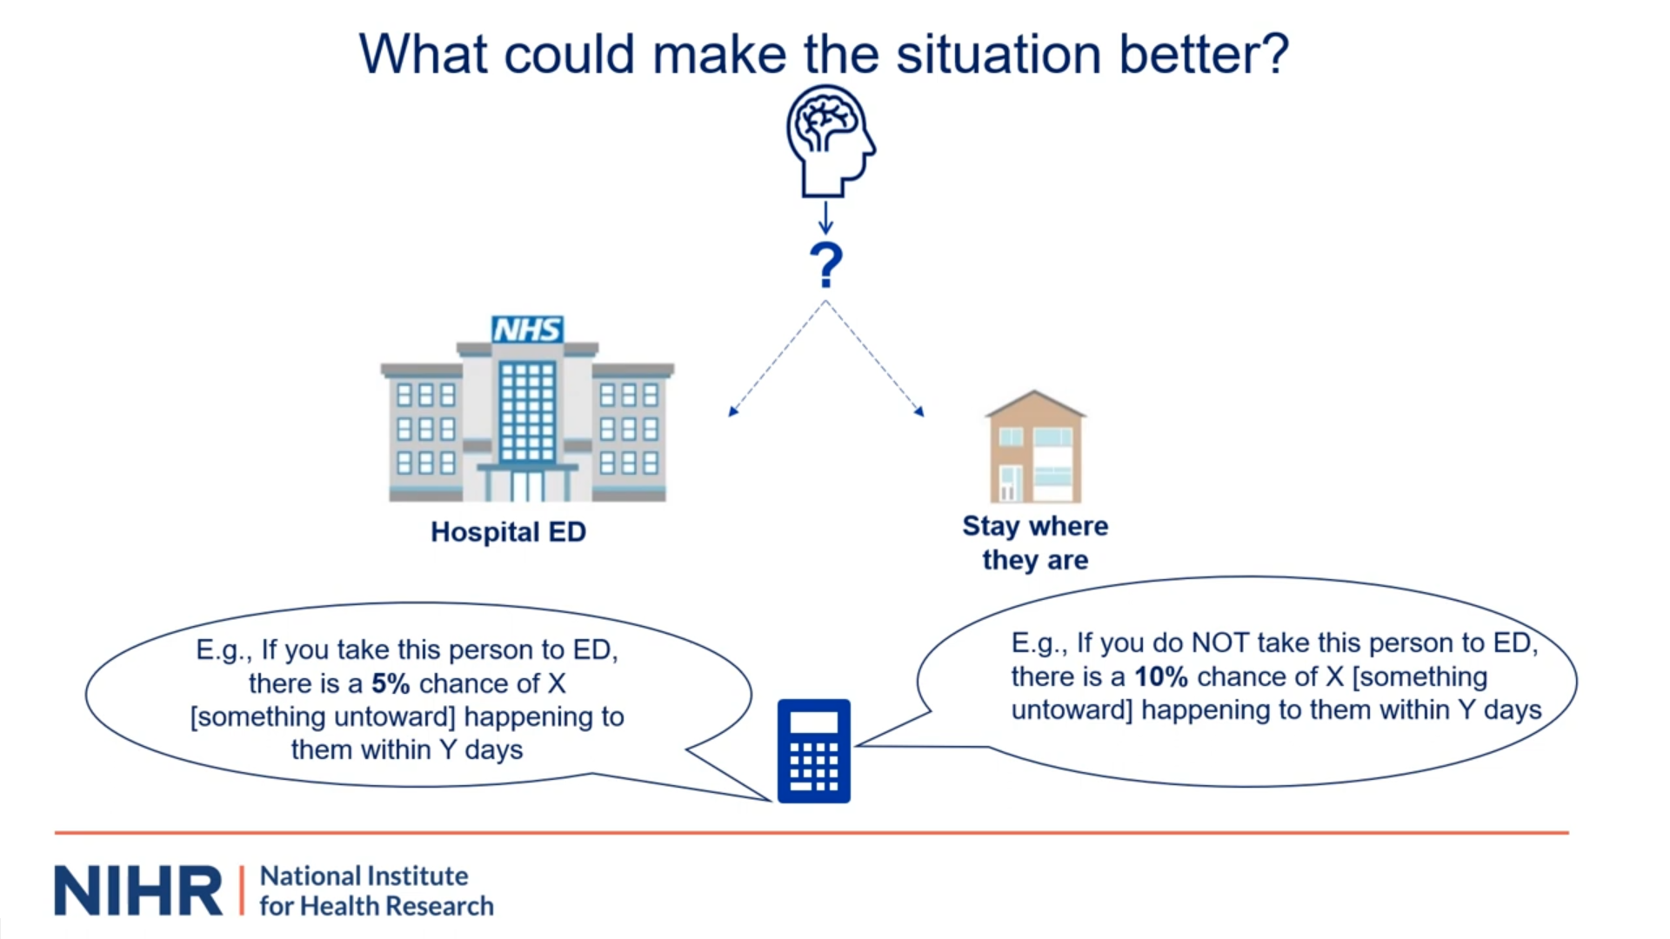
“…paramedics also don't usually have access to the person's medical history to allow them to interpret the normality or not of what has happened to them. Paramedics have also been critical of their pre-registration training with regard to seizures. And, they say they can struggle to get specialist advice when on scene about what has happened. Finally, on top of this paramedics are clearly working under real-time pressures. The longer they spend to see if the patient is recovering sufficiently to be left alone, the longer it is  before the crew can get back on the road to be able to help others.” | “So what can make the situation better? Well, paramedics we’ve interviewed have consistently said what they want is more on scene support. They're critical of non-conveyance guidelines and protocols, saying they are difficult to apply to the nuances of individual cases. They say that what is instead wanted is some sort  of tool that could help them differentiate the needs of the  individuals they are seeing.” | “Given this, RADOSS aims to develop and validate a risk prediction tool that could provide paramedics with estimates of the likely risks to the individuals they are caring for if they're left at seen and an estimate of the likely benefit those individuals would experience if taken to a hospital emergency department. Paramedics could then use these estimates along with other pieces of evidence to help them decide which option is likely best for the individual they are seeing. As you will know risk prediction tools use two or more pieces of patient information, such as clinical signs and characteristics, to generate a personalized estimate of the likelihood an individual will experience a certain endpoint within a specified time frame.
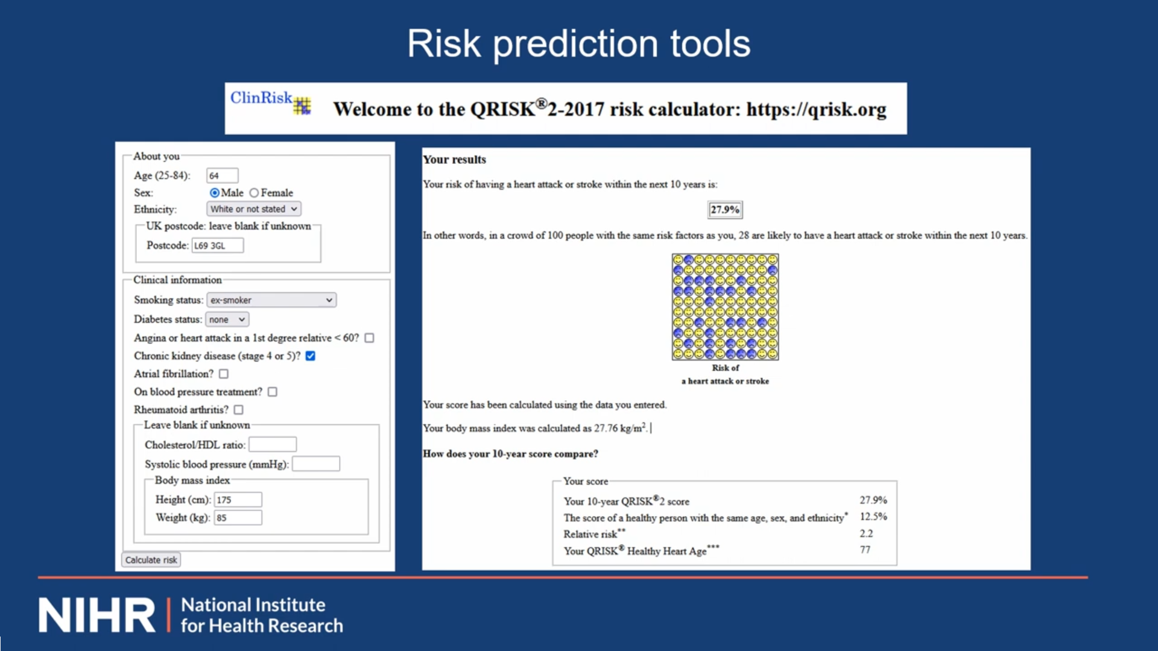 | 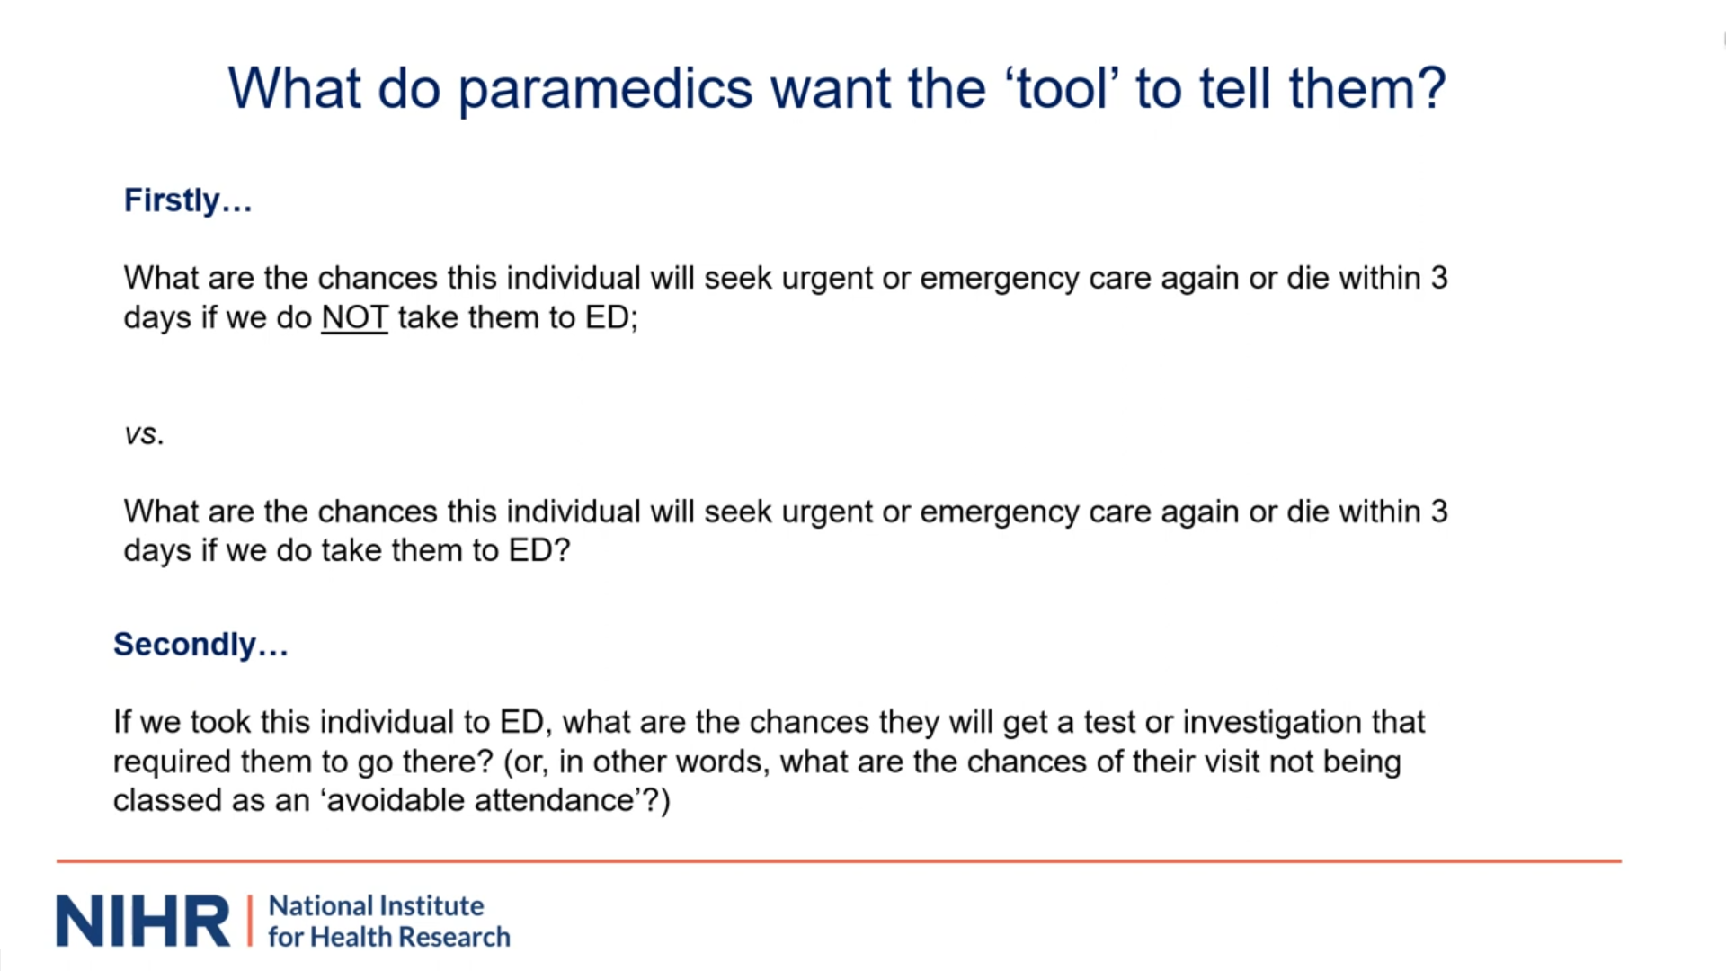
“Risk prediction tools do not replace clinical judgment but rather support it. They can convey risks and benefits  succinctly and promote shared decision making. Arguably, one of the most well-known is the Q-risk tool used by GPs. Having typed in information about the patient, the tool provides the GP with a personalized estimate of that individual's risk of cardiovascular disease within the next 10 years and so can be used to guide treatment and lifestyle changes. Ambulance clinicians, just like other health professionals already use risk prediction tools. JRCALC guidelines recommend 11 of them. Examples include NEWS and the Wells Criteria for embolism. However, no properly validated tool currently exists to help clinicians estimate likely benefit or risk of non-conveyance for a seizure.” | “So, back to seizures. What is our current understanding of what paramedics want a risk prediction tool for seizures to tell them? Well, we're here guided by work  by colleagues who completed the NIHR funded Phoebe project. Amongst other things it included expert consensus workshops that considered what information crews considered to be key when considering conveyance. We've translated this for seizures. Firstly, they wanted it to tell them what are the chances this individual will seek urgent or emergency care again or  sadly die within three days if they do not take them to the emergency department versus what are the chances this individual seek urgent or emergency care again or sadly die within three days if we do take them to the hospital emergency department….” | “…three days were seen as important as when looking at all types of presentations it is within this time window that the bulk, i.e.,75% of re-contacts with the Urgent and Urgency Care System occur. The second thing they wanted to know is if we took this individual to the hospital emergency department what are the chances they will get a test or investigation that required them to go there. Or, in other words what are the chances of their visit not being classed as an avoidable attendance. RADOSS is going to see if it's possible to develop a prediction tool which using information available to crews at the time can provide precise estimates of a person's risks of these outcomes. To do this, RADOSS will be working with the CURED+ database. For those who do not know about this. CURED+ was developed by Sue Mason and colleagues. It is essentially a cutting edge anonymized  linked database covering the period 2011 to 2022.
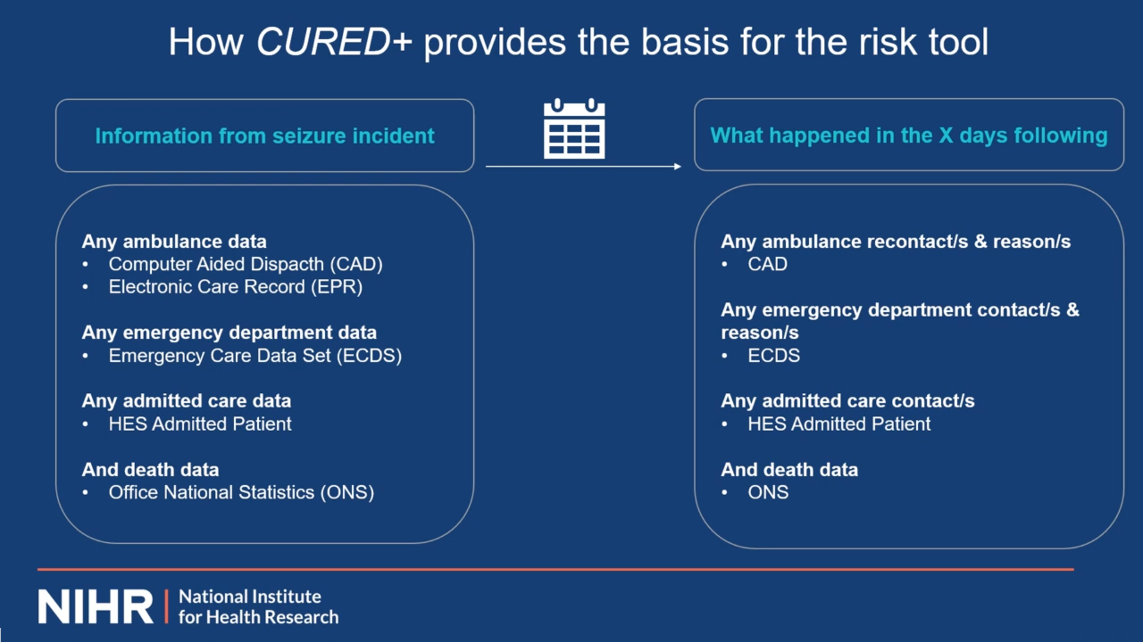 |  | 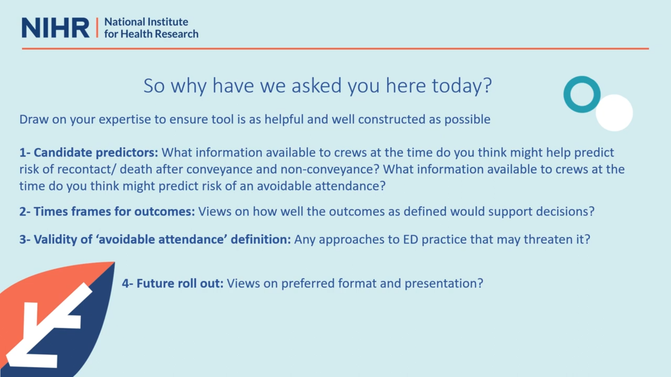
“CURED+ will provide the basis for the risk tool for RADOSS. For RADOSS what it will do is essentially  allow us to identify all people cared for by the Yorkshire Ambulance Service for a seizure over a period of 12 months and to what information crews had at the time when they were caring for these people whilst on scene.  For each seizure incident, we'll have access to any CAD and EPR data that the crews had. We'll also be able to know what happened to them. We'd know if they were conveyed or not. If they were conveyed, we'd know via the ECDS system what happened to them at the emergency department and whether any admissions occurred. We'd also have access to any death…” | “…data. Importantly we should also be able to track what happened to these people in the days afterwards. Thus, we should be able to know whether the person made any re-contact with the ambulance service or any other part of the Urgent and emergency care system within the subsequent days. Based on previous evidence we're  currently proposing that we track and see what happens to patients for three days after their contact with the  ambulance service and use this information for the risk tool. However, for a secondary analysis we suggest using a time window of 30 days. Later on we shall ask for your thoughts on the suitability of these time windows to inform decision making.” | “So why have we asked you here today. Well, in short, we need your frontline expertise to help us ensure we're  developing the model in an optimal way. You know better than anyone the data that CURED+ is pulling from. You know how it is collected, the nuances. You know what data elements you do and do not trust. For paramedics in the room, you also know what it is like to make conveyance decisions and so you can offer us guidance on how we can make the tool as helpful as possible for crews in the future. There are four broad things we want to ask you about. Firstly, candidate predictors to develop a predictive model. We need to decide what information available to crews we…”
“…should ask the statistician to seek to base the model on. In other words, what variables to test. For statistical reasons, we can only examine a limited number. We would like your views on which things you consider should be most prioritized for testing given your expertise and experience. You may have insights into  what might be predictive of the outcomes of interest. In making your suggestion you might also draw on your knowledge of which information sources are easiest to  use in practice, which are available when the decision actually needs to be made and which sources and measurements you feel are most reliable and trustworthy. we will merge your suggestions and reasons with those of seizure specialists and also service users. We ask for your thoughts on what…” | “…might predict risk of death and re-contact after conveyance and non-convenience and then what might predict chances of an avoidable attendance occurring if conveyed. The second thing we want to ask you is for your thoughts on the time frame of the outcome measures as currently proposed and whether this is ideal to inform crews decision making. Thirdly, we shall share with you the definition of an avoidable attendance we propose to use in the study. We would like to hear your views on potential threats to its validity due to possible ways in which some EDS are practicing. Beth's going to share the definition with you in due course. Finally, and if time permits, there will be a brief period for you to offer any thoughts you have on future rollout and  preferences for the format and presentation of any…” | “such tool in the future. We anticipate that your specialism and position in the patient care pathway ,ay  mean you feel more comfortable in responding to some of these questions than others and that is totally fine. Thank you very much for your attention. I should now hand back to Beth so we might begin to hear your views.” ..

Notes: This presentation was pre-recorded to reduce opportunity for technical difficulties and to standardise the evidence the different groups received. A co-investigator attended the workshop to address questions delegates had. Full version can be viewed here: https://www.youtube.com/watch?v=7_Fatqq-s04&t=39s

Supplementary File 3 Blank Rapid Analysis Summary Templates used for two types of workshops
A) Rapid Analysis Summary Template used for service user workshops -
Template completed by:
Date:
Data type description:
Participant characteristics

Patients:
Significant others:
Diagnostic mix:

Anticipated benefits of tool

Independence:

Avoidance of harms:

Minimise burden on significant others:

More guidance for paramedic decision making:

Other:

Possible concerns regarding tools use

Personalised care:

Accuracy of information (interpretation and records):

Precision of predictions:

Other:

Barriers to/ Considerations for tool use

Confidence in staff:

Availability of information (care plans/communication):

Other:

Candidate predictors (reflections on these and their possible utility):

‘Normality’ of seizure
Location
Other health conditions
Demographics
Vital signs
Previous involvement with adult social care
Diagnosis
Injury
Trigger
Prescribed medications
Treatment plan
Ability to communicate
Establish whether the person is seizing upon arrival or in a post-ictal state
Allergies
Other:

Other important quotations:

Other important observations:

Reflections on data collection episode:

B) Rapid Analysis Summary Template used for clinician workshops -
Template completed by:
Date:
Data type description:
Participant characteristics

Paramedics:
ED clinicians:
Different ambulance trusts drawn from:
Different EDs ‘drawn’ from:

Candidate predictors (reflections on these and their possible utility):

‘Normality’ of seizure

Location

Other health conditions

Demographics

Vital signs

Previous involvement with adult social care

Seizure condition

Injury

Trigger

Prescribed medications

Treatment plan

Ability to communicate

Allergies

Other candidate predictors raised

The way risk and benefit are operationalised

a) Death/recontact

Time frame

Nature of the recontact

Meaning of recontact

Other:

b) Avoidable attendance definition

Who they see
Where they are seen
When they are seen

Other

Implementation reflections

What is should look like?

Burden of use

What should it say?

How to promote us?

Other important quotations:

Other important observations:

Reflections on data collection episode:

Supplementary File 4 Additional illustrative quotations regarding perceived need, candidate predictors and outcome measures

Areas | Sub-theme | Illustrative quote
Anticipated benefits | Experience of avoidable attendance and hope tool could help | “We’ve spent hours and hours in A&E and nothing happens. They end up just sending you home anyway…should have just been left at home really.”  (P26, Female, significant other to person with epilepsy and NEAD)  “…they decided to take him and that ended up being a terrible decision…he ended up spending the whole night… I had to stay with him…losing a whole night sleep…we would have all been better if we were at home… it made it really hard for me caring for him next day”  (P25, Female, significant other to person with epilepsy)
 | ED visits are not risk free when attendance was not clinically necessary | “…sometimes like hospitals are quite scary places and that can bring on another seizure…I have just had countless tests done...I have had to stay in over the weekend [as the]… neurologist… was not available…that brought on another seizure.”  (P2, Male, person with NEAD)  “…shipped off to a hospital A&E and that in itself can get me quite aggressive…there is then confusion because I got aggressive on the way…it makes me anxious, frustrated…”  (P23, Male, person with epilepsy)
 | Addressing perceived knowledge gaps | “I have…had awful experience with paramedics… I beg everybody not to call them…In my circumstances all they do is tell me not to panic and they accuse me of having panic attacks… they really don’t understand FND”.  (P18, Female, person with NEAD)
 | Tool could increase confidence regarding ambulance care | “a tool would be perfect, not only for the ambulance service but also for myself…At the moment I’ve got 4 other siblings and I see them go out everyday and ‘oh I’m like I need either my friends who know what my seizures are like…or my family’. [with me]…so I reckon with a tool I could get my independence back.”  (P20, Female, person with epilepsy and NEAD)
Potential concerns | Need to also maximise alternative care pathway provision | “…we need to ensure that the…full range of um of destinations for patients are catered for... to ensure that we're not overwhelming general practise with patients who don't need any ED input…maybe they can be assessed at an urgent treatment centre for wound closure….”  (P43, Male,-paramedic)  “It's okay saying we're not gonna take them to ED cause nothing will happen there. But actually what does happen to these people?...even if they don't need ED treatment doesn't mean they don't need a review. So who who's doing that?”  (P46, Female, paramedic)
 | Additional education for paramedics on seizure management might be required | “Education for paramedics is absolutely required. They need to be better educated on seizures...”  (P5, Female, significant other to person with epilepsy and NEAD)  “I wouldn’t trust them to use the tool as they wouldn’t have that educational knowledge”.  (P24, M, person with epilepsy)
 | Tool should be just one piece of information considered | “…I would want to emphasise that it's [the tool] not doing the decision making ‘cos there are factors beyond those in the model and nuances that may need to also be accounted for”.  (P40, Male, paramedic)
 | Tool’s use should not mean patient preference is not considered | “if they [paramedics] had a tool, the shift in focus could be even further away from the patient and the carers...that would be my concern…overall positive but could be another pull back…”  (P7, Female, person with epilepsy and NEAD)  “…they [paramedics] are…professionals…and I am very grateful, but…the experience of the persons experiencing the seizures and the carers should not be dismissed…if paramedics had more experience that me with seizures I would ‘fall of my chair’…”  (P5, Female, significant other to person with epilepsy and NEAD)
 | Attempts by service users to overcome limited medical record access for paramedics | “…I have information in my wallet, on the fridge, on a lanyard, or a wristband and I only leave the house with a carer or a friend because of those issues…”.  (P7, Female, person with epilepsy and NEAD).  “I use the ‘sunflower lanyard’ [around my neck]…In it, I put my medical information, what medications I’m taking and what medical conditions I have....also my NHS number…that way the have half a chance….  (P2, Male, person with NEAD)
Candidate predictors | Tool should focus on information collected for all participants by most paramedics | “…if there's any questions within the tool, it needs to be able to be something that is within the scope of practise of the clinicians…[it] shouldn't be asking anyone to do…any type of assessment that isn't expected of them.”  (P43, Male, paramedic)
 | Predictions might be complicated unless persons medical history and diagnosis are not accounted for | “Without a serious look at medical history beforehand, I can’t see how it can get it right based on just looking at a person on, just on visuals really….” (P21, Male, person with epilepsy)  “What is that individual’s normal?... somebody having a full, first time tonic clonic…then yeah that’s a different matter isn’t it, but actually if a cluster of prolonged tonic clonic seizures that take 2 lots of emergency rescue medication to get any control is…that’s persons normal that is going to make a big difference [to their care needs]” (P9, Female, significant other to person with epilepsy)
 | Tool’s inability to access unstructured data might be a limitation | “trying to predict the need or the severity of a presentation in terms of like risk…[for] someone who's known epileptic involves looking at how this presentation differs from… normal… we don't capture that data in closed fields… it would all be in free text…that's probably hugely relevant for prediction….”  (P49, Female, paramedic)
 | Data record about an incident may not accurately reflect patient need | “it's mostly for me with the FND patients…if you don't know them and there's no one there that knows them, it's about looking at when we're giving them ‘diazies’ [diazepam] and stuff. If they're having like 3 consecutive seizures, but they don't need this…”  (P45, Female, paramedic)
 | Accuracy of information provided to paramedics may complicate predictions | “the information recorded by the ambulance service needs to be collected accurately. So, for example, the information from the 999 call if it is made by someone else is important because often sadly I have found it is not accurate. Sometimes people are massively exaggerating what is going on…On one occasion somebody said that I wasn’t breathing”  (P6, Male, person with epilepsy)
Outcome measures | Need to separate death and recontact or describe proportion experiencing each | “…0.1% chance of somebody dying within 30 days versus a 10% chance of them reattending or recontacting within 30 days, I would be looking at that mortality number and saying that's a much bigger problem for me… So I think that information needs to be really carefully communicated…”  (P40, Male, paramedic)
 | Lack of feedback paramedics receive means some not clear on ideal timeframe for outcome measure | “…it's very difficult for me to answer that question because famously paramedics we receive next to no feedback on our patient outcomes. So I've got no concept really of where a lot of patient safety incidents occur in terms of time….”  (P31, Male, paramedic)  “…we don't get a lot of feedback of what happens after we leave our patients… so it's actually kind of difficult to answer that question from like a paramedic perspective”  (P32, Female, Paramedic)
 | Sooner recontact occurs more likely to be related to original care | “…if somebody recontacts in 24 hours, you’d think ‘ohh, we probably have missed something that was a bit more urgent’, but if somebody contacts a couple of days later that actually might have been a really sensible management plan for them.”  (P29, Female, paramedic)  “…if you’re trying to make a decision…based on the risk of leaving a patient at home, surely the risk that something is gonna happen fairly soon is larger than, say, something happens in three weeks time… like no one can predict that far ahead…” (P42; Female, ED clinician)
 | Sometimes tests are given in ED for reasons beyond clinical need | “…if they get seen by a senior who's doing a rapid assessment at the front door or the ambulance door, then they might escape without having more tests done. But if that isn't happening because of staff availability or whatever, they're highly likely to have some tests done just to check…“…pressures of the four hours [wait target] mean many departments…get people ‘front loaded’ with investigations earlier on…they'll get blood test done before they get seen by clinicians to try and have the results ready when they are…It's harder and harder not to do things for people once they get to hospital…”  (P41, Female, ED clinician)

Notes: A&E, accident and emergency department; ED, emergency department; F, female; FND, functional neurological disorder; M, male; NEAD, non-epileptic attack disorder; NHS, National Health Service; P, participant; p/, person with; SO, significant other; ‘999’, official telephone number for emergency services the United Kingdom.

